

ANNEX

to the Proposal

for a Regulation of the European Parliament and the Council

amending Regulation (EC)1030/2002 of 13 June 2002 laying down a uniform format for residence permits for third country nationals

Pictures Front and Reverse of the card:

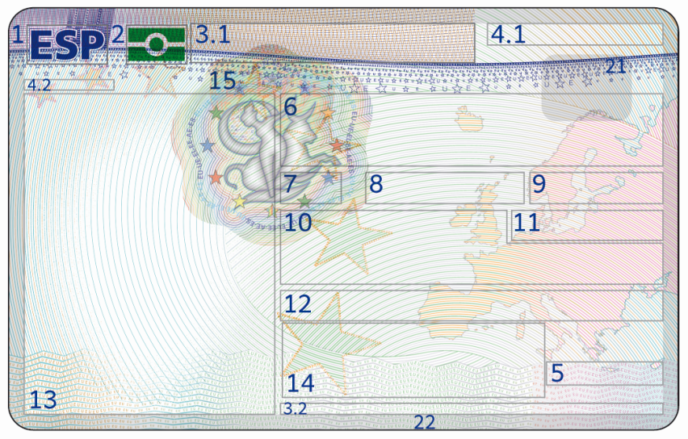

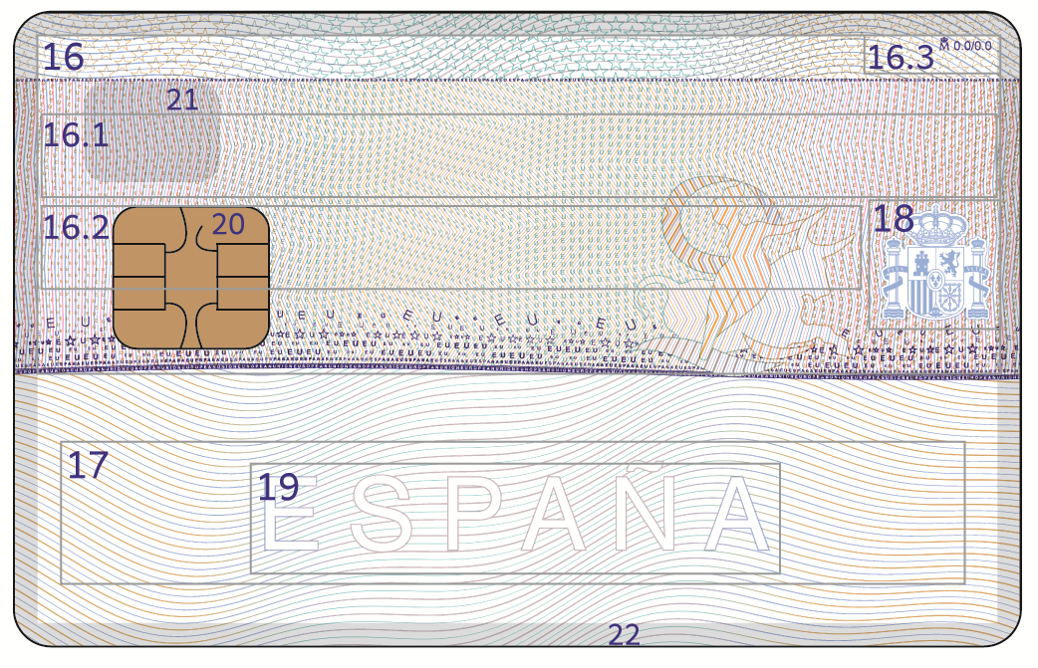

(a) Description

The residence permit including biometrics will be produced as a stand-alone document in ID 1 format. It will draw on the specifications set out in the ICAO documents on machine-readable travel documents (cards) (Document 9303, part 7). It will contain the following entries: [1][2]

Front side:

1. This box shall contain the three-letter country code of the issuing Member State as set out in ICAO Document 9303 on machine-readable travel documents, integrated in the background printing.

2. ICAO symbol for a machine readable travel document with contactless microchip (e-MRTD symbol), in optically variable colouring. Depending on the angle of view, it shall appear in different colours.

3.1. The title of the document (Residence Permit) will appear in the language(s) of the issuing Member State.

3.2 The document title referred to in number 3.1 is repeated in this box in at least one other (maximum two) official languages of the EU in order to facilitate the recognition of the card as residence permit for third country nationals

4.1 The document number.

4.2. The document number is repeated (with special security features) in this box.

5. The Card Access Number (CAN) is indicated in this box.

The headings referred to in numbers 6 to 12, should be indicated in the issuing Member State's language(s). The issuing Member State may add another official language of the European Union institutions, in the same line with a total of no more than two languages.

6. Name: surname(s) and forename(s) in that order[3].

7. Sex.

8. Nationality.

9. Date of birth.

10.[4] Type of permit: the specific type of residence permit issued by the Member State to the third-country national. The residence permit of a member of the family of a citizen of the European Union who has not exercised the right of free movement must contain the entry "family member". In the case of beneficiaries under Article 3(2) of Directive 2004/38/EC of the European Parliament and of the Council[5], Member States may enter "beneficiary under Article 3(2) of Directive 2004/38/EC”.

11. This box will indicate the relevant expiry date of the document.[6]

12.[7] Remarks: Member States may enter details and indications for national use necessary in the light of their national provisions on third-country nationals, including indications relating to any permission to work or unlimited validity of the permission to stay.[8]

13. An identity photograph will be securely integrated in the card body and secured by a Diffractive Optically Variable Image Device (DOVID).

14. Signature of the holder

15. DOVID for portrait protection.

Reverse side:

16. Remarks: Member States may enter details and indications for national use necessary in the light of their national provisions on third-country nationals, including indications relating to any permission to work[9], followed by **mandatory** fields:

16.1 **Date of Issue**, **Place of Issue/issuing Authority**: The date and place of issue of the residence permit. Where appropriate, the place of issue may be substituted with a reference to the issuing authority.

16.2 **Place of Birth**,

followed by *optional fields* such as “*Address of the holder*”.

16.3 *Information related to the production of the card*, such as name of the producer, version number etc. .

17. Machine-Readable Zone. The machine-readable area will conform to the relevant ICAO guidelines set out in Document 9303.

18. The printed area will contain the national emblem of the Member State to distinguish the residence permit and provide a safeguard of its national origin.

19. The machine-readable area will contain a printed text in the background printing indicating the issuing Member State. This text may not affect the technical features of the machine-readable area.

**Visible** national security features (with no prejudice to the annex of the technical specifications):

20.[10] A RF chip shall be used as a storage medium in accordance with Article 4a. Member States may also incorporate in the residence permit a dual interface or a separate contact chip for national use which shall be placed at the reverse of the card complying with ISO standards and shall in no way interfere with the RF chip.

21. Transparent window

22. Transparent border

(b) Colour, printing process

The Member States will establish the colour and the printing process in accordance with the uniform format set out in this Annex and the technical specifications to be established in accordance with Article 2 of this Regulation.

(c) Material

The card is made entirely of polycarbonate or equivalent synthetic polymer (lasting for a validity of at least 10 years).

(d) Printing techniques

The following printing techniques will be employed:

- Highly secure background offset printing

-UV-fluorescent printing

-Rainbow printing

The security design of the front of the card will be distinguishable from the back of the card.

-Numbering:

The document number appears at more than one position on the document (excluding the MRZ),

(e) Protection against copying

An upgraded DOVID providing a quality of identification and a level of security not less than the device used in the current uniform format for visas will be used on the front of the residence permit with advanced design and features including an enhanced diffractive element for advanced machine verification.

(f) Personalisation technique

To ensure that residence permit data are properly secured against attempts of counterfeiting and falsification, biographical data including the photograph, the holder's signature and the other main data will be integrated into the basic material of the document.

Laser engraving technology or other equivalent secure technology with integration inside the card body is used for personalisation.

(g) Member States may also add additional national security features, provided that these are included in the list established under Article 2(1)(f) of this Regulation and provided that they comply with the harmonised appearance of the models above and that the efficiency of the uniform security features is not diminished.

1. Where specific reference is made to a number in another EU legal act, the previous corresponding reference is indicated in a footnote.
2. The headings to be printed are specified in the technical specifications to be adopted according to Article 6 of the Regulation.
3. A single field is foreseen for Surname and Forename. The SURNAME in uppercase; the Forename in lowercase but starting with upper case. No separators between SURNAMES and Forenames are allowed. If it is necessary, first and second surnames can be combined in the same line, as well as SURNAMES and Forenames, in order to save space.
4. previously No 6.4.
5. Directive 2004/38/EC of the European Parliament and of the Council of 29 April 2004 on the right of citizens of the Union and their family members to move and reside freely within the territory of the Member States.
6. The entry should only be indicated in a date format (dd/mm/jjjj) and not in words such as “temporary” or “unlimited”.
7. previously No 7.5-9.
8. Remarks can be entered in 1 line on the front side (40 characters approx.) and 5 lines on the reverse side.
9. All the space available on the reverse of the card (except for the MRZ) will be reserved for the Remarks field. It will contain the actual remarks, followed by mandatory fields (date of issue, place of issue/issuing authority, place of birth), and followed by the optional fields each MS needs. Optional fields must be preceded by sub-captions.
10. previously No 16.