

# Introduction

The transition to a **circular economy** is a tremendous **opportunity** to transform our economy and make it **more sustainable**, contribute to **climate goals** and the **preservation of the world’s resources**, create **local jobs** and generate **competitive advantages** for Europe in a world that is undergoing **profound changes**. The importance of the circular economy to European industry was recently highlighted in the renewed EU industrial policy strategy[1]. The transition to a circular economy will also help to meet the objectives of the 2030 Agenda for Sustainable Development[2].

In the circular economy action plan[3], a circular economy is explained as an economy ‘*where the value of products, materials and resources is maintained in the economy for as long as possible, and the generation of waste minimised’*.

In the transition to a more circular economy, monitoring the key trends and patterns is key to **understand** how the various elements of the circular economy are developing over time, to help **identify success factors** in Member States and to **assess** whether sufficient action has been taken. The results of monitoring should form the basis for **setting new priorities towards the long-term objective of a circular economy**. They are not just relevant to policy makers, but should inspire all and drive new actions.

This is why the Commission, in the circular economy action plan, committed to come forward with a simple and effective monitoring framework. This has been echoed by the Council of the EU, in its conclusions on the circular economy action plan[4], where it stressed ‘*the need for a monitoring framework to strengthen and assess the progress towards circular economy, while minimising the administrative burden*’. Also, the European Parliament has called upon the Commission to develop indicators on resource efficiency to track progress towards the circular economy.[5]

This Communication implements this commitment by putting forward a monitoring framework composed of a set of key, meaningful indicators which capture the main elements of the circular economy.

The circular economy monitoring framework draws upon and complements the existing Resource Efficiency Scoreboard[6] and Raw Materials Scoreboard[7], which were developed in recent years by the Commission. The framework is presented on a **website**[8] where all the indicators are available and will be kept up to date.

# Monitoring progress towards a circular economy

**Monitoring progress towards a circular economy is a challenging task**. The transition towards a circular economy is not limited to certain materials or sectors. It is a systemic change that affects the entire economy and involves all products and services. Ideally, indicators should primarily capture trends in preserving the economic value of products, materials and resources as well as trends in waste generation.

Just as there is no one universally recognised indicator of ‘circularity’, robust off-the-shelf indicators to describe the most relevant trends are in short supply. With a single measure, or score, it would not be possible to appropriately capture the complexity and the many dimensions of the transition to a circular economy. For this reason, a set of relevant indicators will be used for this monitoring framework.

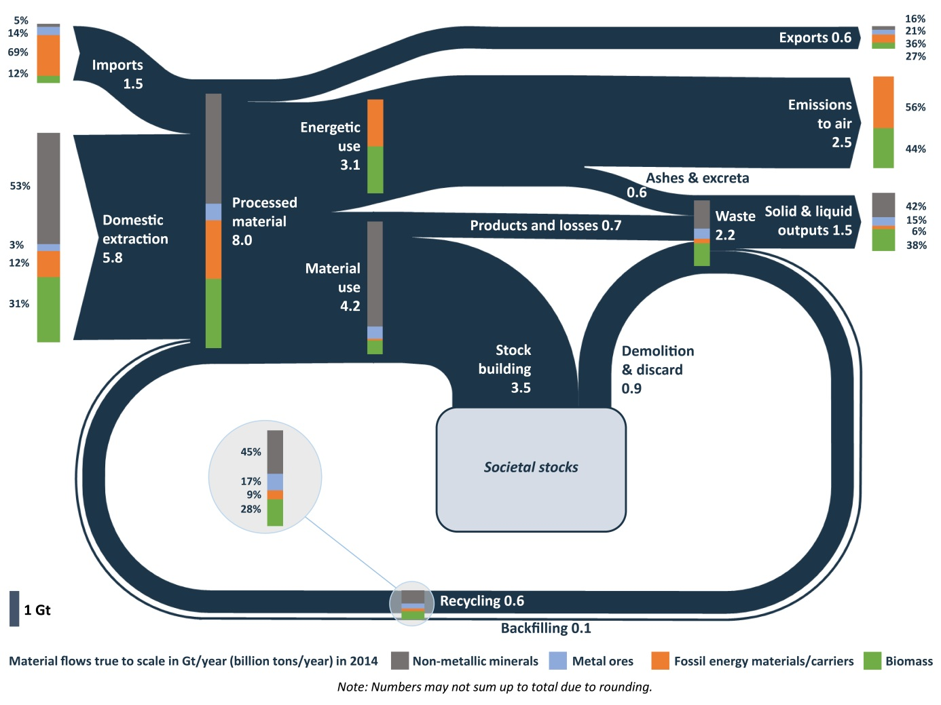One way of looking at the circular economy is to see how materials enter, flow within and (eventually) leave the economy. Such a visual overview can be provided by a material flows diagram, which shows all raw materials — aggregated as well as grouped by categories of materials — throughout the economy, from their extraction until they become waste.

*Figure 1: Material flows in the economy (EU-28, 2014)[9], [10]*

**Figure 1 presents an overview of material flows in the EU in 2014**. The input-side on the left shows that 8 billion tonnes of materials are processed into energy or products annually in the EU. Only 0.6 billion tonnes originate from recycling. On the output-side, it shows that out of the 2.2 billion tonnes of waste that are generated only 0.6 billion tonnes re-enter the system as recycled materials. The rest of the materials, equivalent to 1.5 billion tonnes, is waste. These aspects point to a **significant potential for improvement** in particular by increasing the share of materials recycled as secondary raw materials and decreasing the production of waste.

The monitoring framework aims at measuring progress towards a circular economy in a way that encompasses its various dimensions at all stages of the lifecycle of resources, products and services. This is why the monitoring framework has a set of **ten indicators** (see Table 1) grouped into **four stages and aspects of the circular economy:** (1) production and consumption, (2) waste management, (3) secondary raw materials and (4) competitiveness and innovation. This broadly follows the logic and structure of the circular economy action plan.

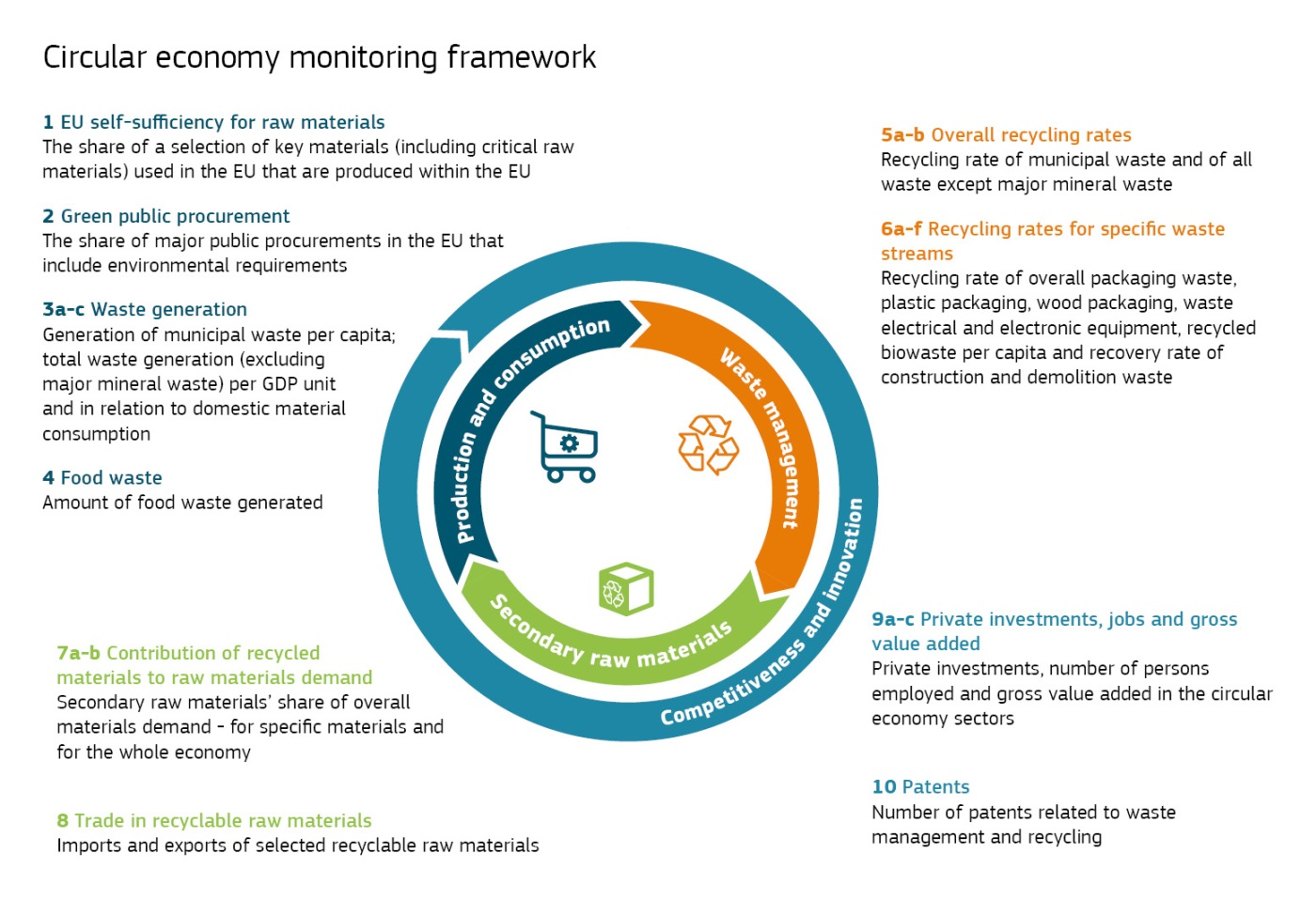

|  |  |  |  |
| --- | --- | --- | --- |
| **No** | **Name** | **Relevance** | **EU levers (examples)** |
| **Production and consumption** | | | |
| 1 | EU self-sufficiency for raw materials | The circular economy should help to address the supply risks for raw materials, in particular critical raw materials. | Raw Materials Initiative; Resource Efficiency Roadmap |
| 2 | Green public procurement* | Public procurement accounts for a large share of consumption and can drive the circular economy. | Public Procurement Strategy; EU support schemes and voluntary criteria for green public procurement |
| 3a-c | Waste generation | In a circular economy waste generation is minimised. | Waste Framework Directive; directives on specific waste streams; Strategy for Plastics |
| 4 | Food waste* | Discarding food has negative environmental, climate and economic impacts. | General Food Law Regulation; Waste Framework Directive; various initiatives (e.g. Platform on Food Losses and Food Waste) |
| **Waste management** | | | |
| 5a-b | Overall recycling rates | Increasing recycling is part of the transition to a circular economy. | Waste Framework Directive |
| 6a-f | Recycling rates for specific waste streams | This reflects the progress in recycling key waste streams. | Waste Framework Directive; Landfill Directive; directives on specific waste streams |
| **Secondary raw materials** | | | |
| 7a-b | Contribution of recycled materials to raw materials demand | In a circular economy, secondary raw materials are commonly used to make new products. | Waste Framework Directive; Eco-design Directive; EU Ecolabel; REACH; initiative on the interface between chemicals, products and waste policies; Strategy for Plastics; quality standards for secondary raw materials |
| 8 | Trade in recyclable raw materials | Trade in recyclables reflects the importance of the internal market and global participation in the circular economy. | Internal Market policy; Waste Shipment Regulation; Trade policy |
| **Competitiveness and innovation** | | | |
| 9a-c | Private investments, jobs and gross value added | This reflects the contribution of the circular economy to the creation of jobs and growth. | Investment Plan for Europe; Structural and Investment Funds; InnovFin; Circular Economy Finance Support Platform; Sustainable Finance Strategy; Green Employment Initiative; New Skills Agenda for Europe; Internal Market policy |
| 10 | Patents | Innovative technologies related to the circular economy boost the EU’s global competitiveness. | Horizon 2020 |

* Indicators under development

*Table 1: Indicators on the circular economy included in the monitoring framework*

These indicators were selected to capture the main elements of a circular economy. Data availability was taken into account when choosing them, building on the Resource Efficiency Scoreboard and the Raw Materials Scoreboard. The indicators are based on existing data as much as possible, thus limiting the administrative burden. Other criteria against which the indicators were assessed include relevance, acceptance, credibility, ease of use and robustness.

Responses to the public consultation on the roadmap[11] and discussions with Member States representatives and stakeholder experts[12] were also taken into account when selecting the indicators.

The Commission will be improving the knowledge base and **data availability** for measuring progress in the circular economy:

* Work is ongoing to **develop methodologies** and data collections that can be used for the indicators on green public procurement and food waste, with a view to publishing the data in the coming years. Meanwhile, Eurostat is producing some provisional estimates of food waste.
* As part of the 2015 circular economy package and broader efforts by the Commission to improve the quality of EU statistics on waste, the Commission has proposed to **harmonise the methodologies for calculating recycling rates** for municipal waste[13] and packaging waste[14]. Once adopted by the Council and the European Parliament and implemented by the Member States, these proposals will bring about more reliable and comparable statistics.
* Through Horizon 2020, the Commission is funding several **research projects** that will deliver better data to complement the official statistics, in particular via the EU raw materials information system[15].

# First findings

The ten indicators of the monitoring framework provide a broad picture of the key leverage points to increase the circularity of the EU’s economy. While it will take some time before the results of the actions on the circular economy are visible in the statistics, it is meaningful to start by **establishing baselines**. This will help to monitor future developments and inform policy making processes.

There is both a strong need and a significant potential for further improvements in the performance of the EU and its Member States. The role of the EU is greater in some areas (such as trade in recyclable raw materials) than in others (e.g. green public procurement).

***Production and consumption***

|  |
| --- |
| Some progress can be observed towards more circular trends in production and consumption e.g. in terms of waste generation. Nevertheless, there is still considerable room for narrowing the gap in performance between Member States and across materials. |

The indicator on **self-sufficiency** in the supply of raw materials shows that the EU is **largely self-sufficient** for most non-metallic minerals such as construction materials and industrial minerals. However, the indicator also confirms that for the EU’s **critical raw materials**[16] the EU is relying on imports to a large extent, which highlights the need for secure access and diversification of supply. Many of these materials are needed to achieve the EU’s objective of a sustainable, low-carbon, resource-efficient and competitive economy[17].

Public Procurement represents a large share of GDP and hence **green public procurement** – i.e. when public authorities use their purchasing power to choose environmentally friendly goods, services and works – can be a driver for the circular economy and for innovation.[18] Data is still to be developed for this indicator.

EU **municipal waste[19]** generationper capitahas **dropped** by 8 % between 2006 and 2016 to an average of 480 kg per capita per year. This is a clear example of an area where each citizen can make a positive contribution. However, large variations among Member States are observed (between 250 and 750 kg per capita per year) [20], and municipal waste generation is still growing in several Member States. The quantity of waste generated still correlates to a certain degree with GDP per capita. It is therefore positive that the data on **total waste** generation (including industrial and commercial waste but excluding major mineral waste) per unit of GDP shows a **decrease** of 11 % since 2006.

Reducing **food waste**[21] has an enormous potential for saving the resources we use to produce the food we eat. Food waste takes place all along the value chain: during production and distribution, in shops, restaurants, catering facilities, and at home. This makes it particularly hard to quantify. According to Eurostat’s preliminary estimates, EU food waste **decreased** from 81 to 76 million tonnes (i.e. by around 7 %) between 2012 and 2014, equivalent to a drop from 161 to 149 kg per capita.

***Waste management***

|  |
| --- |
| Waste management generally shows positive developments, yet with significant room for improvement and differences among Member States and across waste streams. |

Between 2008 and 2016, EU **recycling rates for municipal waste increased** from 37 % to 46 %. Five Member States recycle more than half of their municipal waste, while some countries are approaching the 2030 recycling target of 65 % proposed by the Commission[22]; however, five Member States are still below 25 %.[23]

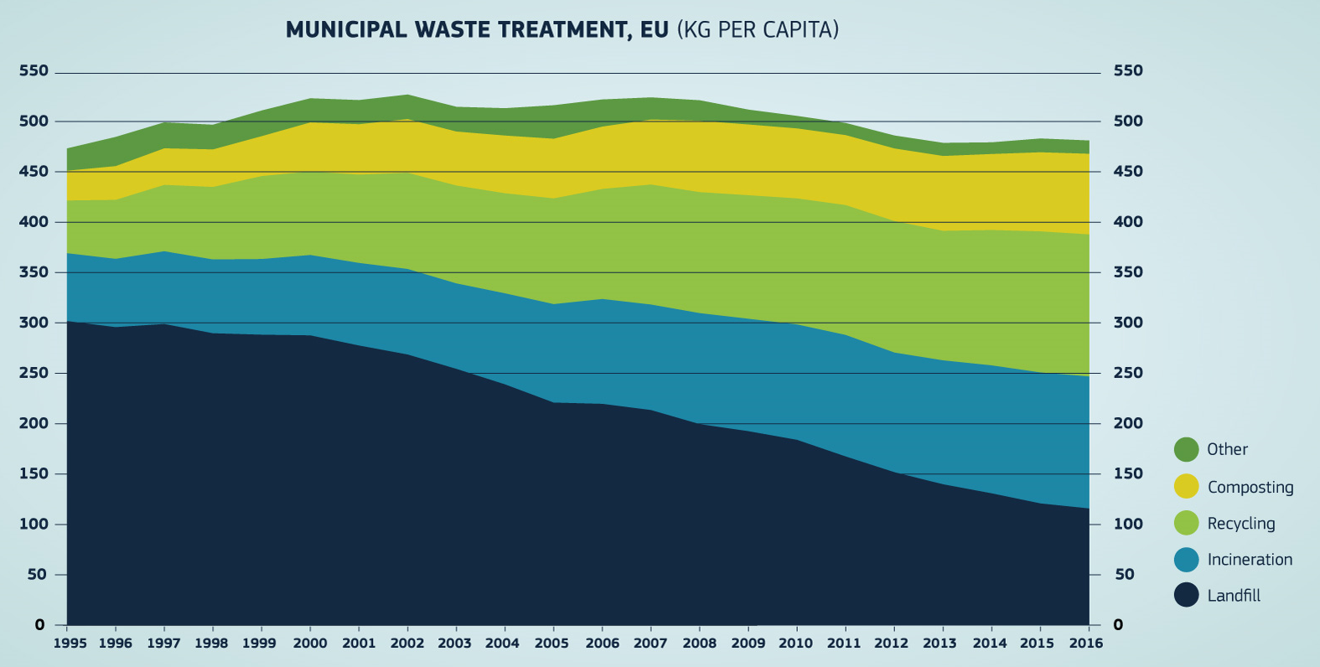

Source: Eurostat

Between 2008 and 2015, the **recycling rates for packaging waste also increased** in the EU, from 62 % to 66 %; it increased in almost all Member States, and in 2015 **almost all Member States had met the 2008 target of 55 %** (the Commission has proposed a target of 65 % by 2025 and 75 % by 2030[24]). For **plastic packaging,** the average recycling rate in the EU is significantly lower, at **40 %**, even though there have been improvements in recent years.

The **recycling** of municipal **biowaste** in the EU was 79 kg per capita in 2016, an **increase** of 23 % compared to 2007.

For the **recycling of waste** **electrical and electronic equipment** (WEEE), the data show that the level of collection and recycling varies considerably across EU Member States and indicate a great potential to improve resource efficiency and reduce illegal collection, treatment and shipment. In 2015, **only four Member States** recycled[25] over half of the electrical and electronic equipment that had been put on the market.

Finally, for **construction and demolition waste,** 20 Member States have reported that they already achieved the 70 % recovery target[26] set for 2020. Given that by weight this is the single biggest waste stream in the EU, it is a **positive** sign. However, it should be noted that the target includes backfilling[27], a practice that does not keep the value of the materials in the economy and is therefore not conducive to a circular economy. In addition, there are large differences in data reporting between Member States.

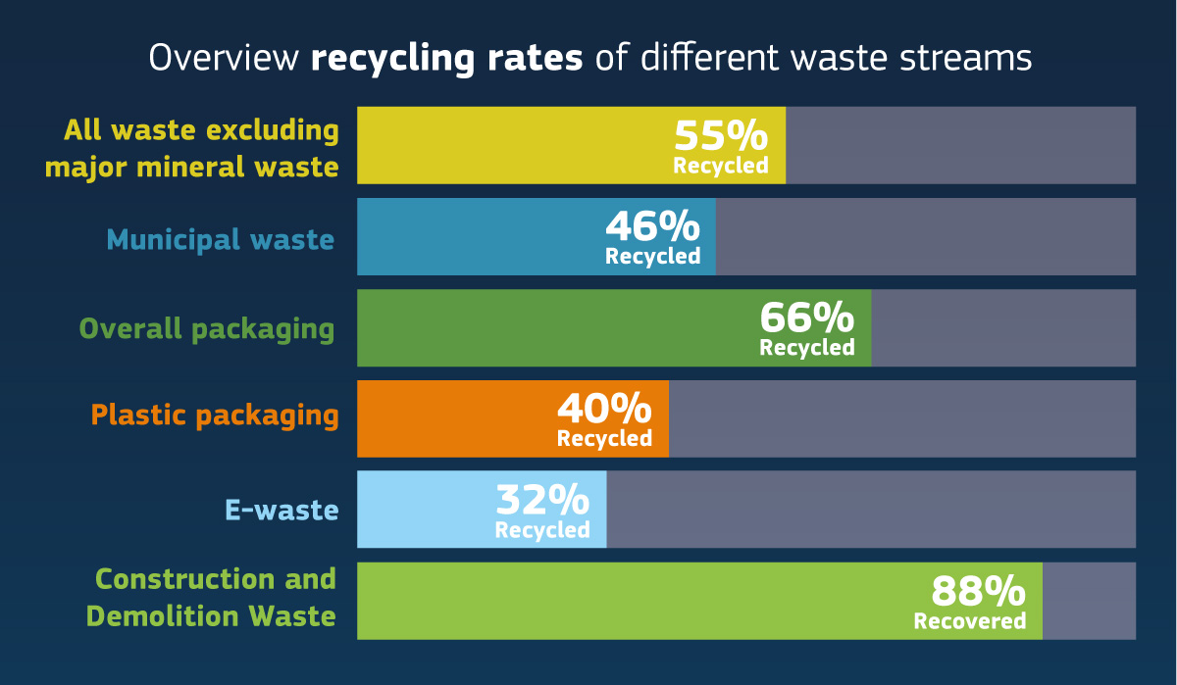

Source: Eurostat

***Secondary raw materials***

|  |
| --- |
| The contribution of recycled materials to overall materials demand is relatively low. Trade in secondary raw materials is increasing both in the EU and with third countries. |

In a circular economy, materials embedded in products and components are recycled when they reach their end-of-life and are then injected back into the economy as secondary raw materials. This reduces the environmental footprint of production and consumption and increases the security of supply of raw materials. In the EU, the level of demand for raw materials exceeds what could be supplied even if all waste were turned into secondary raw materials. Therefore, the supply of primary raw materials will remain necessary.

On average, **recycled materials** only satisfy **around 10 % of the EU demand for materials,** in spite of a steady improvement since 2004. For a number of bulk materials, secondary raw materials satisfy over 30 % of total demand for materials (e.g. copper and nickel). However, for a large number of materials, including almost all critical raw materials, the contribution of recycled materials to satisfying the demand for raw materials is still small to negligible. This may be because it is not profitable to recycle them, the technologies to recycle them are lacking, or the materials are embedded in products kept in use for a long time (e.g. rare earth elements used in wind turbines).

Furthermore, the indicator on trade in recyclable waste shows that **the EU is a net exporter of several major recyclable waste streams** such as plastics, paper and cardboard, iron and steel, copper, aluminium and nickel. **Trade within the EU** of plastics, paper and cardboard, copper, aluminium, nickel and precious metals waste **increased considerably** between 2004 and 2016, allowing economic operators to reap the benefits of the EU internal market for secondary raw materials.

***Competitiveness and innovation***

|  |
| --- |
| The transition to a circular economy increases investments, value added and jobs, and stimulates innovation. |

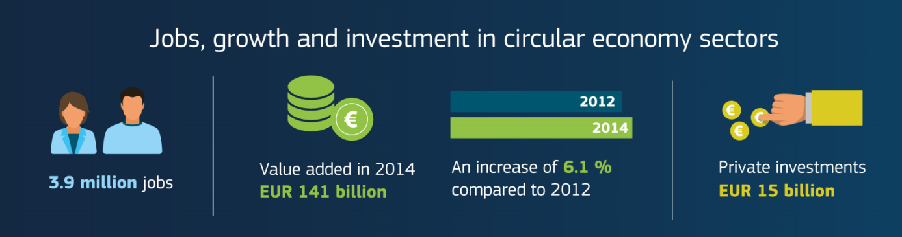

Source: Eurostat

In 2014, **private investments** in a subset of economic sectors relevant to the circular economy[28] are estimated to have been around **EUR** **15 billion** in the EU (i.e. 0.1 % GDP). The same year there were more than 3.9 million **jobs** in these sectors, an **increase of 2.3 %** compared to 2012. In spite of the economic and financial crisis, these circular economy sectors created around EUR 141 billion of **value added** in 2014, which represents an **increase of 6.1 %** compared to 2012. Several EU funding programmes are available to support the transition to a circular economy, such as the European Fund for Strategic Investments, the European Structural and Investment Funds, Horizon 2020 and the LIFE programme. In addition, in January 2017 a Circular Economy Finance Support Platform was launched.

For **patents** on recycling and secondary raw materials, the data show an **increase of 35 %** between 2000 and 2013. EU patents for glass recycling represent 44 % of the world total for such patents, while the EU’s share is 18 % for plastics and 23 % for paper.

# Conclusions

This monitoring framework captures, in a concise set of indicators, the main elements of the circular economy, including the lifecycle of products and materials, the priority areas and sectors, and the impacts on competitiveness, innovation and jobs. It will thus be a tool to follow key trends in the transition, to assess whether measures in place and the engagement of all the actors have been sufficiently effective, and to help identify best practices in Member States that can be disseminated.

The indicators will be continuously updated on the website dedicated to the monitoring framework[29]. This website also includes tools to monitor progress and documents the methodologies for the indicators, data sources, definitions and publishing standards. The Commission will continue to elaborate the indicators which need further development, in particular on food waste and green public procurement.

A dialogue with Member States and stakeholders will help to further improve the framework. In particular, the framework relies to a large extent on high quality statistics that the Member States provide to Eurostat. The Commission would also welcome the involvement of all EU institutions.

1. COM(2017) 479.
2. <https://ec.europa.eu/info/strategy/international-strategies/global-topics/sustainable-development-goals/eu-approach-sustainable-development_en>
3. COM(2015) 614.
4. <http://www.consilium.europa.eu/en/press/press-releases/2016/06/20/envi-conclusions-circular-economy/pdf>
5. European Parliament Resolution of 9 July 2015 on resource efficiency: moving towards a circular economy ([2014/2208(INI)](http://www.europarl.europa.eu/oeil/popups/ficheprocedure.do?lang=en&reference=2014/2208%28INI%29)).
6. <http://ec.europa.eu/environment/resource_efficiency/targets_indicators/scoreboard/index_en.htm>.
7. <https://publications.europa.eu/en/publication-detail/-/publication/1ee65e21-9ac4-11e6-868c-01aa75ed71a1>.
8. <http://ec.europa.eu/eurostat/web/circular-economy>
9. Source: Andreas Mayer, Willi Haas, Dominik Wiedenhofer, Fridolin Krausmann, Philip Nuss, Gian Andrea Blengini (forthcoming): Monitoring the circular economy in the EU28 - A mass-balanced assessment of economy wide material flows, waste and emissions from official statistics. In: Journal of Industrial Ecology
10. Energetic use covers raw materials used for combustion or production of food and feed.
11. <https://ec.europa.eu/info/law/better-regulation/initiatives/ares-2017-1830357_en> .
12. Producers of official statistics on environmental accounts and experts on resource efficiency/integrated product policy and on raw materials policy: <http://ec.europa.eu/transparency/regexpert/index.cfm?do=groupDetail.groupDetail&groupID=2673>, <http://ec.europa.eu/transparency/regexpert/index.cfm?do=groupDetail.groupDetail&groupID=470>, <http://ec.europa.eu/transparency/regexpert/index.cfm?do=groupDetail.groupDetail&groupID=2812>, <http://ec.europa.eu/transparency/regexpert/index.cfm?do=groupDetail.groupDetail&groupID=1353>.
13. COM(2015) 595 final
14. [COM(2015) 596 final](http://eur-lex.europa.eu/legal-content/EN/TXT/?uri=CELEX:52015PC0596).
15. <http://rmis.jrc.ec.europa.eu/>
16. COM(2017) 490.
17. E.g. cobalt for batteries used in electric cars, silicon for solar panels.
18. <http://ec.europa.eu/environment/gpp/index_en.htm>
19. Waste from households and in public spaces and similar waste from other sources.
20. Differences in the way Member States measure waste generation can explain some of the differences.
21. <https://ec.europa.eu/food/safety/food_waste/eu_actions_en>
22. COM(2015) 595 final .
23. Member States are using different methods to calculate recycling rates, which can explain part of the differences. The Commission has proposed a common method in its legislative proposal on waste.
24. [COM(2015) 596 final](http://eur-lex.europa.eu/legal-content/EN/TXT/?uri=CELEX:52015PC0596).
25. or prepared for reuse
26. The target covers not only recycling but also re-use and other material recovery, including backfilling of non-hazardous construction and demolition waste excluding naturally occurring material
27. A recovery operation where suitable waste is used for the purposes of reclamation in excavated areas or for engineering purposes in landscaping.
28. I.e. reuse and recycling activities. Renting and leasing activities can also contribute to circular economy, but are for now not included because current statistics may not distinguish with sufficient granularity those activities that clearly contribute to circular economy from those that do not. For further details, see the Staff Working Document.
29. <http://ec.europa.eu/eurostat/web/circular-economy>.