

**The first Clean Air Outlook**

1. **Introduction**

Air pollution remains a major environmental and health problem in the EU. Many European cities suffer from poor air quality and exceed the EU standards set out in the Ambient Air Quality Directive 2008/50/EC[1], and still more exceed the guidelines recommended by the World Health Organization (WHO). The European Environment Agency has estimated that around 400 000 people died prematurely in the EU in 2015 as a result of air pollution[2].

The EU review of air policy in 2011-2013 culminated in the Clean Air Policy Package of December 2013[3]. This comprised a communication – a Clean Air Programme for Europe[4] – and three legislative proposals, to control emissions from Medium Combustion Plants, adopted as Directive (EU) 2015/2193 ('the MCPD')[5]; to ratify the amendment of the 2012 Gothenburg Protocol setting emission reductions for 2020, adopted as Council Decision 2017/1757/EU[6]; and to set new national reduction commitments for 2030 in a new Directive on the reduction of emissions of certain atmospheric pollutants, adopted as Directive (EU) 2016/2284 (the 'NECD')[7].

The 2013 Clean Air Programme proposed that there should be a regular report on the air quality situation in Europe, covering the prospects for emission reduction and progress towards the EU's objectives.With the adoption of the NECD in December 2016, the analytical basis has been updated, and this first edition of the 'Clean Air Outlook' aims to fulfil that brief, and to provide context for Member States' work in developing the National Air Pollution Control Programmes due under the NECD by 1 April 2019.

1. **The state of air quality in the EU and progress towards compliance by 2020**
   1. **The current air emissions and air quality situation**

The positive trend in reduction of the main air pollutants in the EU has continued, as shown in Figure 1 below, as has the decoupling from economic growth. Overall, during the 2000-2015 period, the EU's combined GDP grew by 32% while emissions of the main air pollutants decreased by between 10% (for ammonia - NH3) and 70% (for sulphur oxides - SOx).

**Figure 1: Development in EU-28 emissions, 2000-2015 (as % of 2000 levels) [Source EEA]**

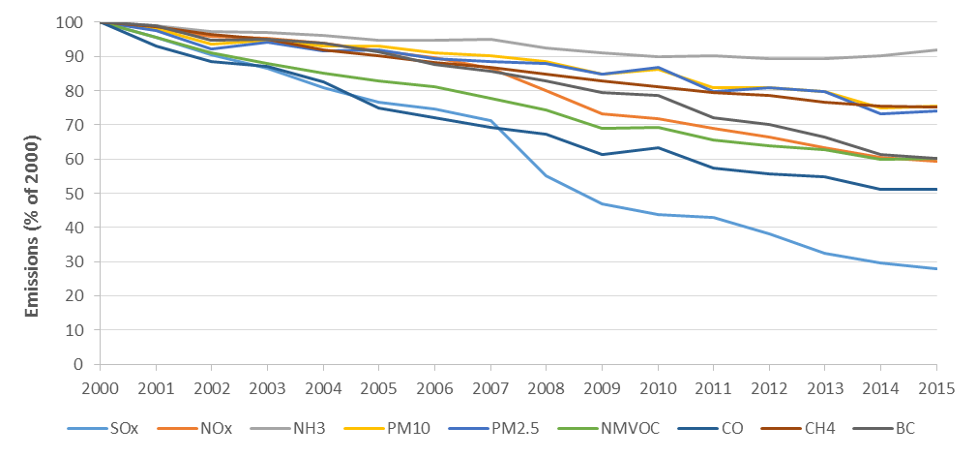

However, there are still major problems with exceedence of the EU's air quality limit values. For 2015, up to 20% of the EU-28 urban population was exposed to levels above the EU daily limit value for particulate matter (PM10). For fine particulate matter (PM2.5), up to 8 % of the urban population was exposed to concentrations above the EU limit value of 25 µg/m3, and more than 82% to levels above the much stricter WHO guideline value of 10 µg/m3.

For nitrogen dioxide (NO2) the annual limit value continues to be widely exceeded across Europe, with concentrations above the identical EU and WHO limit in 22 Member States, to which up to 9% of the urban population are exposed.

For ozone, 18 Member States registered concentrations above the EU target value, and up to 30% of the EU urban population lived in areas in which the target value was exceeded, with more than 95% living in areas where the stricter WHO guideline was exceeded[8].

* 1. **Progress towards compliance**

Nitrogen oxide (NOx) emissions from diesel-powered passenger cars and light duty vehicles, systematically much higher than the type-approved limit values, are a major contributing factor to the non-compliance with the NO2 limit value. The recent adoption, in 2017, of a new EU-wide test procedure reflecting the real-driving emissions of these vehicles[9] and the 2016 Commission proposal on a revised type approval system[10] will help make progress on this issue.

Measures promoting compliance with the PM10 limit value include the gradual penetration of particle filters to meet PM emission limits for passenger cars (included in Euro 5 and 6[11]), and the controls on combustion plants under the Industrial Emissions Directive (IED)[12] and the MCPD. Although the Ecodesign requirements on solid fuel stoves[13] and boilers[14] agreed upon at EU level in 2015 will only apply after 2020, a number of Member States have proactively introduced them in advance of the deadline (e.g. Poland) to assist in tackling emissions of PM, volatile organic compounds (VOC) and NOx. Moreover, Ecodesign and other requirements to improve energy efficiency (laid down notably by the 2010 Energy Performance of Buildings Directive[15], the 2012 Energy Efficiency Directive[16] and the 2017 Energy Labelling Regulation[17]) contribute to emission reductions of atmospheric pollutants by decreasing energy consumption. The recently-adopted Best Available Techniques (BAT) conclusions on Large Combustion Plants[18] under the IED will also have positive impacts on NOx, SO2, and PM. However, as solid biomass remains by far the largest contributor (82%) to renewable heat production[19] and bioenergy as a whole will continue to represent a large proportion of the EU renewable energy mix[20], improvements in emission control could be offset to some extent by increased numbers of emitters.

Much further effort is still needed to ensure exceedances of limit values are kept as short as possible. There are currently 30 infringement procedures open against Member States concerning Directive 2008/50/EC, 16 for exceedance of PM10 limit values, 13 for exceedance of NO2 limit values, and one for exceedance of SO2 limit values.

There is also significant EU funding support available to Member States to finance air pollution control measures (see section 3.2.5). In the broader context of the Commission's Environmental Implementation Review[21], the Commission is pursuing Clean Air Dialogues[22] with Member States, to better understand national approaches to implementation, share experience on solutions, promote synergies between policies and identify areas where EU funds can help. The dialogues have been particularly successful in promoting action involving all relevant ministries and stakeholders.

* 1. **The Fitness Check of the Ambient Air Quality Directives**

The 2013 Clean Air Programme concluded that it was not at that time appropriate to revise the Ambient Air Quality Directives 2008/50/EU and 2004/107/EC, stressing the need to ensure compliance with existing standards, and bring down emissions through the NECD.

In 2017 the Commission initiated a Fitness Check to examine the performance of the Ambient Air Quality Directives. It builds on the analysis underlying the Clean Air Programme and will draw on experience in all Member States, focusing on the period 2008 to 2018. It will look at the fitness-for-purpose of all the Directives' provisions, and in particular the monitoring and assessment methods, the air quality standards, the provisions on public information, and the extent to which the Directives have facilitated action to prevent or reduce adverse impacts.

Administrative costs, overlaps and/or synergies, gaps, inconsistencies and/or potentially obsolete measures will also be addressed, as well as the coherence of air quality governance between EU, Member State, regional and local levels. Under current planning the fitness check will be concluded in 2019.

1. **Implementation of the new National Emissions Ceilings Directive and additional source legislation**
   1. **Health and ecosystem targets**

The targets set in the Clean Air Programme were based on the reductions outlined in the Commission proposal[23] for the NECD. Now that the Directive has entered into force since December 31st 2016, and additional source legislation (i.e. measures regulating specific pollution sources such as vehicles, stoves, industrial plants) has been adopted since the Clean Air Programme of 2013, these figures can be updated as indicated in Table 1 below.

**Table 1: Air policy benefits projected for 2030 by the NECD and all source legislation adopted since 2014, as compared with the proposals in the Clean Air Programme (relative to 2005, the base year)**

|  |  |  |
| --- | --- | --- |
|  | Expected reduction in negative health impacts compared to 2005 (premature mortality due to particulate matter and ozone ) | Expected reduction in ecosystem areas exceeding eutrophication limits compared to 2005 |
| Clean Air Programme for Europe (December 2013) using a baseline which does not include source legislation adopted since 2014 | 52% | 35% |
| NECD impacts as estimated at the time of adoption in December 2016, using the same baseline as above | 49,6% | - |
| **NECD impacts using a baseline which incorporates the impact of source legislation adopted since 2014** | **54%** | **27%** |

Some explanation is in order, in particular of the calculated health impact reduction of 54% while the expected impact (at the time of adoption) was just under 50%. This is due to two factors.

The first is the effect of the specific additional source legislation that has been adopted since 2014. The 2015 MCPD emission controls apply to all new combustion plants from 20 December 2018, and to existing plants by 2025 or 2030 (depending on their size). The 2015 Ecodesign Implementing Regulations apply to new solid fuel boilers sold on the market from 1 January 2020, and to new solid fuel stoves from 1 January 2022. The 2016 Regulation on Non Road Mobile Machinery (NRMM)[24] applies to engines placed on the market from 1 January 2019, 2020 or 2021, depending on the class of engine. The 2017 Large Combustion Plants BAT Conclusions apply to new plants from 17 August 2017, and to all existing plants by 17 August 2021. The 2013 Clean Air Package stressed the potential contribution that the implementation of these initiatives could deliver by 2030, and the final versions of the laws are now incorporated in the analysis. A combined assessment of all such measures allows to conclude that greater reductions than those estimated at the time of adoption of the NECD are actually to be expected by 2030, provided full compliance with all relevant legal requirements is ensured.

The second factor is where measures introduced to reduce emissions of one pollutant deliver co-benefits for others (so-called 'co-control measures'). An example is controls on agricultural waste burning under the CAP[25] and Annex III of the NECD, often driven by the need to achieve NH3 reductions, but which also reduce PM and VOCs. In many cases these synergies lead to cost savings but in some other cases, they mainly lead to additional health benefits. The impact of this factor will depend on the combination of measures selected in practice by Member States.

These effects do not play out in the same way for eutrophication. Indeed, none of the additional pieces of EU source legislation adopted since 2014 tackles NH3, and co-control benefits are limited. Thus the relaxation in the required NH3 emission reduction between the Commission proposal and the adopted NECD (from 25% reduction to 19%) results in a broadly proportionate drop in the ecosystem improvement resulting from the emission reduction.

* 1. **Implementation of the NECD reduction commitments for 2020 and 2030**
     1. *Achievement of the 2020 reduction commitments*

The 2013 Impact Assessment projected that the EU's 2020 reduction commitments (set in the 2012 revision of the Gothenburg Protocol) would be achieved by the EU legislation already in force at that point. This is confirmed at EU level by the updated analysis, but the implications for individual Member States can vary and, depending on national circumstances, further action may be needed to ensure compliance.

* + 1. *Achievement of the 2030 reduction commitments*

The estimate for achieving the 2030 reductions in the Commission’s proposal for the NECD was €2,2bn.[26] The analysis shows that the cost of achieving the actual levels of reductions as agreed within the NECD as adopted in December 2016 are actually lower, i.e. €1,8bn. This is a consequence of the relaxation of level of reduction targets agreed by the co-legislators.

If the additional source legislation adopted since 2014 is taken into account, the costs attributable to the NECD are expected to reduce further to €960m (or 1.9€/person/year[27]). Most of the difference is in the domestic sector, resulting from implementation of the Ecodesign provisions for solid fuel stoves and boilers. If the estimated impact of the future EU 2030 climate and energy framework[28] is also included, a further drop (mainly in the power and industrial sectors) to €540m (ie 1.05€/person/year) is to be expected. Benefits are expected to largely exceed costs, notably by a factor varying between 14 (the conservative estimate) and 50.

The proportion of the implementation costs borne by individual Member States also changes, due to various factors including the contribution of new source legislation, and changes in projections of the 2030 national energy mix (in particular increased use of coal in some Member States).[29]

* + 1. *Areas where additional source legislation could be needed*

Figure 2a below shows the proportion of the reductions which are achieved by (a) the pre-2014 baseline, (b) the additional legislation adopted since 2014, (c) further measures required to fulfil the NECD Emission Reduction Requirements (ERRs) and (d) 'co-control measures' (see section 3.1 above). The most relevant co-control measures are a) the ban of agricultural waste burning included in Annex III of the NECD (which reduces PM2.5, VOC, NH3, as well as CO and CH4) b) control of emissions from wood stoves to Ecodesign standards (which reduces PM2.5, VOC, NOx and NH3, as well as CO and CH4) and c) control of emissions from coal stoves, also under Ecodesign (which reduces PM2.5, VOC, SO2 and NOx).

Broadly speaking the analysis confirms the overall validity of the approach taken in the original proposal. For SO2 and NOx deep reductions are achieved by the legislation already in force by 2013. The main effect of the reduction commitments is to consolidate these and ensure that changes in activity (e.g. increased coal use in some Member States) do not affect the overall reduction. For PM and VOCs, the impact of the NECD and of the additional legislation adopted since 2014 is substantially higher, reflecting the smaller reductions achieved by earlier legislation.

**Figure 2a: Contributions to the Emissions Reduction Requirements (ERRs) delivered by (i) the pre-2014 legislation baseline, (ii) the POST-2014 legislation measures, (iii) further measures that are required to meet the Emission Reduction Requirements, and (iv) co-controls from measures targeted at other emissions. SO2, NOx, VOC and PM2,5**



For NH3 the picture is different, as shown in Figure 2b. The reductions must be delivered almost entirely by the NECD, with little contribution from source legislation either in the baseline prior to 2014 or in the additional measures adopted since.

**Figure 2b: NH3 - contributions to the Emission Reduction Requirements (ERRs) delivered by (i) the pre-2014 legislation baseline, (ii) the post-2014 legislation measures, (iii) further measures that are required to meet the ERRs, and (iv) co-controls from measures targeted at other emissions.**



The sectors in which the required NH3 reductions could be delivered are shown in Figure 3 below. Measures to reduce emissions from application of mineral fertilisers, specifically urea, are identified as cost-effective in many Member States. A full ban on use of urea was not included in the NECD, as there are viable options including optimised timing and rate of application, use of commercially available urease inhibitors, or switching to other mineral fertilisers with lower NH3 loses (e.g ammonium nitrate). A substantial proportion of the reduction is to be achieved from manure management at pig and poultry farms, and the recent BAT conclusions on Intensive Rearing of Pigs and Poultry[30] (not yet included in the analysis) may contribute to the required reductions. Manure management measures beyond this scope are also widely cost-effective, and a simplified BAT-based scheme for manure management, e.g. inspired by the experience with the Industrial Emissions Directive, would provide substantial support for implementation. Synergies with the implementation of relevant EU legislation, such as the Nitrates Directive 91/676/EEC[31], should also be further strengthened by encouraging Member States to introduce management measures addressing the requirements of air, water and soil in an integrated way.

**Figure 3: Further reductions of NH3 emissions to reach the ERRs in 2030, beyond the 2017 legislation baseline, by sector**



* + 1. *Sectoral and macroeconomic impacts*

The economic effects of air pollution regulation extend beyond the direct benefits and costs presented in Sections 3.1 and 3.2.2. First, implementing pollution reduction technologies generates additional demand for the sectors delivering the abatement goods. Second, rising abatement costs may influence the competitiveness of sectors that are active on an international market. Third, impacts on a sector's output can generate economy-wide impacts by affecting the demand for intermediate goods and labour. The latter implies changes in employment and wages, affecting households' disposable incomes and welfare.

To account for these indirect effects, macro-economic and sector-specific impacts of achieving the 2030 commitments were calculated (using the JRC-GEM-E3 model). These are set out in Table 2 below and are broadly as identified in the 2013 Impact Assessment accompanying the Commission proposal for the NECD: the costs of achieving the 2030 reduction commitments are more than offset by health and agriculture benefits (reduced sick leave and improved crop yields), generating a small positive GDP impact. Sectors that incur a substantial share of the costs (e.g. agriculture) experience a slight decrease in output, while production rises in sectors that benefit from increased demand for abatement goods, such as electric goods, transport and other equipment goods.

**Table 2: Impact of achieving the 2030 emission reduction commitments on GDP and sector output. Source: JRC-GEM-E3.**

|  |  |  |  |  |  |  |
| --- | --- | --- | --- | --- | --- | --- |
| Benchmark* includes |  |  |  |  |  |  |
| Source legislation adopted since 2014? | No | No | Yes | Yes | Yes | Yes |
| Climate and energy package[32]? | No | No | No | No | Yes | Yes |
| Health and crop yield benefits included? | No | Yes | No | Yes | No | Yes |
|  |  |  |  |  |  |  |
| **GDP** | **-0.010** | **0.006** | **-0.005** | **0.006** | **-0.002** | **0.006** |
|  |  |  |  |  |  |  |
| Agriculture | -0.09 | -0.04 | -0.05 | -0.07 | -0.07 | -0.05 |
| Energy | 0.01 | 0.03 | 0.01 | 0.02 | 0.01 | 0.02 |
| Energy intensive industries | 0.00 | 0.02 | 0.00 | 0.02 | 0.00 | 0.02 |
| Other industry | 0.01 | 0.03 | 0.01 | 0.02 | 0.00 | 0.02 |
| Services | 0.00 | 0.01 | 0.00 | 0.01 | 0.00 | 0.01 |

* Results indicate percentage difference with the respective benchmark in 2030.

* + 1. *EU funding sources contributing to air quality*

Substantial resources are available from EU funds, including in areas such as transport, energy, agriculture and industry where environmental protection requirements should be mainstreamed. Under the European Structural and Investment Funds especially the funding linked to Thematic Objectives 4 Low Carbon Economy (€45bn), 6 Environment Protection & Resource Efficiency (€63bn) and 7 Network Infrastructure in Transport and Energy (€58bn) could be mobilised.[33] A recent study[34] has provisionally estimated that around €76bn has been allocated to actions contributing purely or partially to air quality in the European Regional Development Fund (ERDF), the Cohesion Fund (CF) and the European Agricultural Fund for Rural Development (EAFRD). On a smaller scale, the ERDF also provides funding opportunities for innovation, in line with regional or national smart specialisation strategies, some of which may be used for air quality.

Under the Connecting Europe Facility (CEF), €32bn is made available from the EU’s 2014-2020 budget to co-fund transport and energy projects in the EU Member States, out of which around €9bn, mostly from the transport pillar, have been committed for projects which may have some benefit for air quality. For research and innovation, up to €12bn in Horizon 2020 could benefit emission reductions and air quality. The LIFE programme supports pilot and demonstration projects as well as Integrated Projects for the implementation of air quality plans. It is estimated that around € 300M will have been available for projects with a direct or indirect air impact in the period 2014-2020. Of the €315bn provided for loans and financial instruments under the European Fund for Strategic Investments (EFSI), it is estimated that about 30 % of the uptake (around € 95bn) will have been allocated for projects with an air quality dimension such as energy and transport, and there are also opportunities provided by the European Investment Bank.

The financial provisions of the NECD (Article 7 and 11.1(c)) are designed to encourage better mainstreaming and more effective use of funding for air quality. Member States are encouraged to make maximum use of the available funding.

The Multiannual Financial Framework for 2021-2027, as proposed by the European Commission[35], will continue to support measures to improve air quality, including through the target of 25% of EU expenditure contributing to climate objectives and a strengthening of the LIFE programme.

* + 1. *Summary*

The updated analysis shows that the additional costs of implementing the NECD are substantially lower than expected, partly as a result of changes made by the colegislators, but also because of pieces of EU law adopted in the meantime which serve air quality goals, and the expected positive impact of the future EU 2030 climate and energy package, due for adoption soon.

However, it is important to avoid complacency. The analysis assumes full implementation and enforcement of legislation which Member States must ensure. It is also based on assumptions, in particular on activity and pollution control potential, which, despite our best efforts, may deviate from those of the Member States.

Thus, the analysis provides a broad EU-level perspective and should be treated with appropriate caution when developing national-level policy in the National Air Pollution Control Programmes.

1. **Prospects for attainment of long-term objectives**
   1. **WHO guideline values for PM2,5**

The EEA estimates that, in 2015, 82% of the EU population was exposed to concentrations above the WHO PM2,5 guideline of 10µg/m3. Implementation of the post-2014 policy will improve this substantially. Figure 4 shows the expected evolution between the NECD base year 2005 and the NECD target year 2030, based on the assumption of full implementation of the NECD. From 88% of the population exposed to concentrations above the WHO guideline value in 2005, the proportion goes to 13% in 2030, and exceedances are limited to a few areas in Europe, with most of those within 5µg/m3 of the limit value. Thus by 2030 most urban concentrations would be at or under the WHO guideline value, and while issues would persist at specific locations, these could be addressed by local measures not included in the analysis underlying this report.

**Figure 4: Distribution of population exposure in the EU to PM2,5 levels in 2005, and in 2030 assuming full implementation of NECD ERRs and all source legislation**



* 1. **Exceedance of critical loads**

The most significant environmental impact of air quality is eutrophication of land and water ecosystems. This is defined in terms of exceedance of ‘critical loads’ for deposition – the maximum deposited pollution that the ecosystem can bear without adverse ecological impacts. Figure 5 below shows the 27% reduction in ecosystem areas affected by eutrophication between 2005 and 2030 as a result of the implementation of the NECD (see Table 1).

**Figure 5: Percentage of ecosystem area with nitrogen deposition above critical loads for eutrophication (2005 left, vs full implementation of NECD 2030, right)**

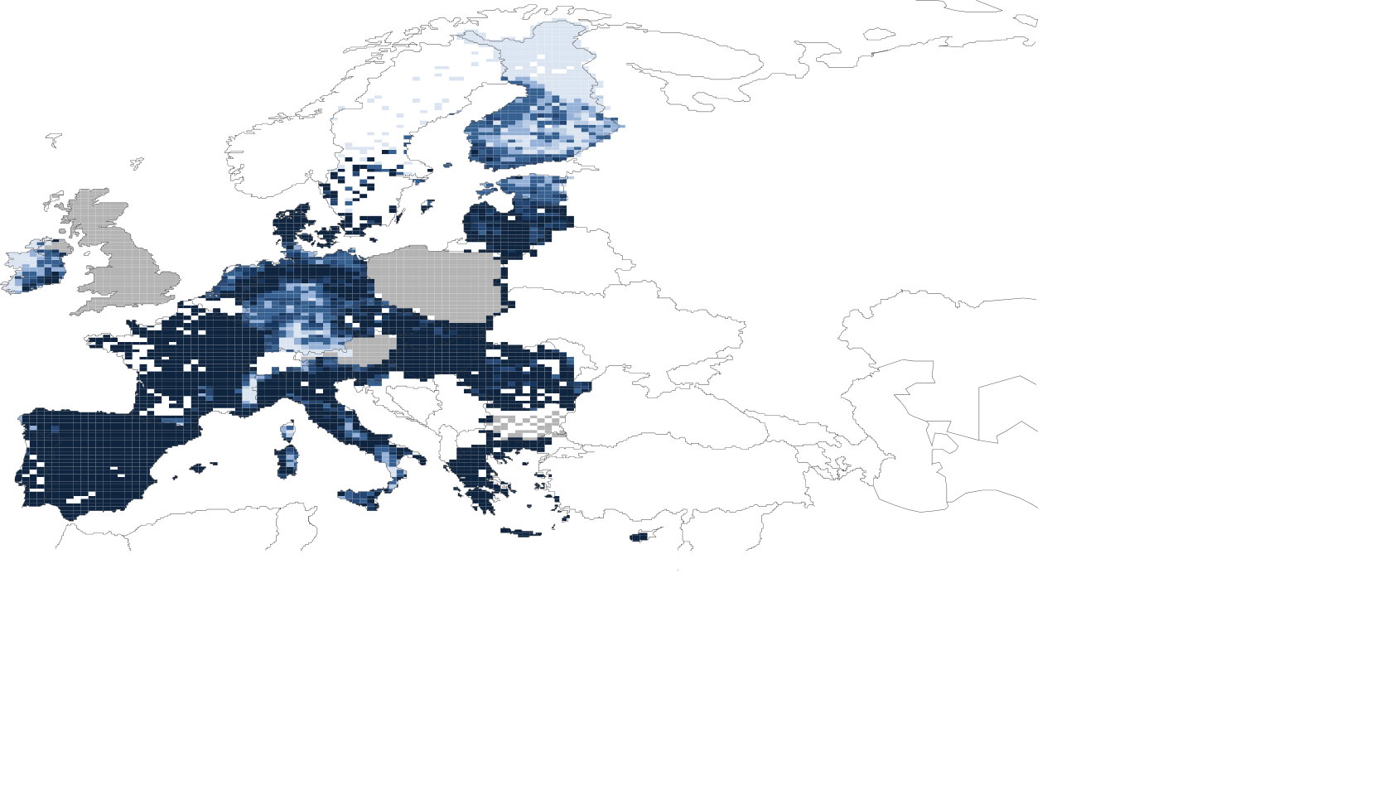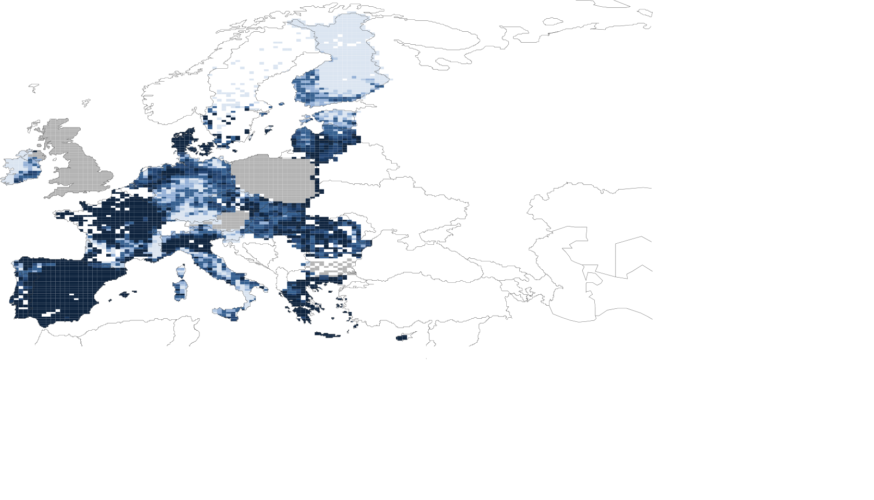

|  |  |
| --- | --- |
|  | 0 .. 3 |
|  | 3 .. 10 |
|  | 10 .. 30 |
|  | 30 .. 70 |
|  | 70 .. 90 |
|  | 90 .. 95 |
|  | 95 .. |
|  | n2k missing |

Excess nitrogen deposition is caused by deposition of NOx and NH3. NH3 dominates, and its relative importance by 2030 will grow further due to the relatively small reduction required in the NECD compared with NOx (19% versus 66%).

At the same time, there is further reduction potential for NH3. Full implementation of currently available technical measures would reduce excess deposition by more than 75%. While this would not meet critical loads everywhere, further improvements would be possible that have not been taken into account in the modelling underlying this report, in particular control of emissions from large point sources close to sensitive ecosystems, and structural shifts in production driven by wider social concerns for a healthy diet.

1. **Short-lived climate pollutants**

Black carbon, methane and ozone are of concern both for air quality and for climate.

The NECD requires Member States to prioritise measures that also reduce black carbon when addressing their PM2,5 reduction commitments. The measures to reduce PM2,5 (for example, in domestic solid fuel combustion, particulate pollution from diesel cars, agricultural field burning and energy generation) will also deliver black carbon reductions of 72% across the EU by 2030.

Methane and ozone are closely connected, as methane is a major contributor to background ozone concentrations. Because of methane's long lifetime, it is transported long distances over the northern hemisphere, with emissions in the USA, China and India affecting EU concentrations and vice versa. The Commission's Joint Research Centre will present later in the year a technical report on methane emissions and their contribution to ozone. Based on this work, the Commission will, in 2019, assess the potential for reductions across the northern hemisphere and their impacts on concentrations, with a view to identifying appropriate methane reduction objectives in the context of a future hemispheric approach, in cooperation with the UNECE Convention on Long Range and Transboundary Air Pollution, the Climate and Clean Air Coalition and the Global Methane Initiative, as appropriate.

Ozone concentrations would be exacerbated by temperature increases resulting from climate change, and this should be considered when assessing and mitigating air pollution in the longer term.

1. **The international dimension**

The adoption of the NECD allowed the EU to ratify, in August 2017, the 2012 revision of the Gothenburg Protocol. Ratifications by Member States can bring the revised Protocol into force and while eight Member States have already ratified,[36] the Commission encourages all others to do so as soon as possible.

The EU's main objective remains to stimulate wider ratification of the Protocol by non-EU countries, in particular the Eastern European, Caucasian and Central Asian states (EECCA). Flexible provisions for EECCA states were built into the revised Protocol to encourage ratification, but these are only usable if the Protocol enters into force before 2020 – another important reason for Member States to ratify quickly.

The Commission will continue to develop its own work to assist neighbouring countries with air policy, in particular through the Instrument for Pre-Accession Assistance (IPA) and the European Neighbourhood Instrument (ENI). Sharing experience beyond the EU and UNECE is also a priority, and the EU pushed successfully for wider regional and inter-regional cooperation through the 3rd United Nations Environment Assembly (December 2017) and will continue to do so bilaterally. The Commission is also funding assessment by the Arctic Monitoring and Assessment Programme (AMAP) of the reduction potential for black carbon emissions affecting the region.

1. **Conclusions**

* It is positive to note that, taken together, **the package of measures adopted by the co-legislators since the 2013 Clean Air Programme** – that is, not only the NECD but also the MCPD, the revised Non-Road Mobile Machinery Regulation and the implementing measures for the IED and Ecodesign Directive – **are expected by 2030 to more than achieve the health impact reduction of 52% set out in the Programme, and deliver PM2,5 concentrations in most of the EU which are below the WHO guideline value**.
* There is nonetheless an **urgent short-term need to take decisive action to achieve the objectives of the Ambient Air Quality Directives**, at all governance levels (national, regional, local) and with the full involvement of market actors, as highlighted in the recent Communication “A Europe that protects: Clean air for all”[37]. Even in the longer term, **complementary action at all these levels will be required to ensure that the EU's long-term objectives are met everywhere in Europe**
* The impact in 2030 depends on **full implementation by the Member States of all the measures, and in particular of robust National Air Pollution Control Programmes to deliver the NECD emission reduction commitments**. It requires effective coordination of these Programmes with the implementation of other policies, inter alia the Energy Union climate/energy measures, road transport policy and the upcoming reform of the Common Agricultural Policy. **Uptake of the substantial EU financial support available will also greatly facilitate implementation**.
* While, for most sectors and pollutants, source legislation supports NECD implementation substantially, **agriculture's NH3 emissions are an exception**. **Effective engagement of the sector will be needed to deliver the required reductions**. Even then, the current analysis shows that the EU will be far from its long-term objective of no exceedence of eutrophication critical loads, but there is substantial further reduction potential which could move the EU much closer. **The Commission will continue to support national efforts in this regard, including by maximising the use of Common Agricultural Policy funding and by promoting synergies with the implementation of relevant EU legislation, such as the Nitrates Directive 91/676/EEC.**
* As stated by the Commission at the time of adoption of the new NECD, **methane emissions should also be kept under review with regard to their impact on ozone concentrations in the EU and to promote methane reductions internationally**. On the basis of the reported national emissions, **the Commission will further assess the impact of methane emissions on achieving air policy objectives, consider measures for reducing those emissions and, where appropriate, submit a legislative proposal, based on the evidence at EU and global level**.

The next Clean Air Outlook will be published in 2020, and will include the Commission's analysis of the 2019 National Air Pollution Control Programmes.

1. OJ L 152 , 11.06.2008, p. 1 – 44
2. European Enviroment Agency (EEA), October 2017, ‘Air quality in Europe - 2017 report’
3. See: <http://ec.europa.eu/environment/air/clean_air/review.htm>
4. COM(2013)918 final
5. OJ L 313, 28.11.2015, p. 1–19
6. OJ L 248, 27.9.2017, p. 3 - 75
7. OJ L 344 of 17.12.2016, p. 1
8. European Environment Agency (EEA), October 2017, ‘Air quality in Europe - 2017 report’
9. Commission Regulation (EU) 2017/1151, as amended. OJ L 175, 7.7.2017, p. 1–643.
10. COM(2016)31 final.
11. Regulation (EC) No 715/2007. OJ L 171, 29.6.2007, p. 1–16.
12. Directive 2010/75/EU, OJ L 334, 17.12.2010, p. 17–119
13. Commission Regulation 2015/1185, OJ EU L 193, 21.07.2015.
14. Commission Regulation 2015/1189, OJ EU L 193, 21.07.2015.
15. Directive 2010/31/EU, OJ L 153, 18.6.2010, p. 13–35.
16. Directive 2012/27/EU, OJ L 315, 14.11.2012, p. 1–56.
17. Regulation (EU) 2017/1369, OJ L 198, 28.7.2017, p. 1–23.
18. Commission Implementing Decision (EU) 2017/1442, OJ L 212, 17.8.2017, p. 1–82.
19. COM(2017) 57 final- Renewable Energy Progress Report, p.5
20. COM(2016) 860 final- Communication Clean Energy For All Europeans, p.9
21. See: <http://ec.europa.eu/environment/eir/index_en.htm>
22. See: <http://ec.europa.eu/environment/air/clean_air/dialogue.htm>
23. COM(2013)920 final
24. Regulation (EU) 2016/1628 - OJ EU L 252, 16.09.2016
25. Annex II on cross-compliance of Regulation (EU) 1306/2013 on the financing, management and monitoring of the common agricultural policy, OJ L 347, 20.12.2013, p. 549.
26. The estimate for implementation costs of the original COM proposal is set out in the TSAP 16 report (IIASA). Available on <http://www.iiasa.ac.at/web/home/research/researchPrograms/air/policy/TSAP-reports.html>
27. Note that the per capita figure is an average which does not reflect differences in costs between economic operators and regions.
28. Commission proposals available on <https://ec.europa.eu/clima/policies/strategies/2030_en#tab-0-0>; formal adoption of 2017 co-decision agreements currently pending.
29. Detail is available in the accompanying report by the International Institute for Applied Systems Analysis, 'Progress towards the achievement of the EU's air quality and emissions objectives'.
30. Commission implementing decision (EU) 2017/302, OJ L 43, 21.2.2017, p. 231–279.
31. Council Directive 91/676/EEC, OJ L 375, 31.12.1991, p. 1.
32. Commission proposals for ETS and non-ETS (ESR) for 2030, <https://ec.europa.eu/clima/policies/strategies/2030_en>
33. See <https://cohesiondata.ec.europa.eu/>
34. Report by the company *Ricardo Energy and Environment* on a tracking methodology for air quality, forthcoming
35. COM(2018)321
36. CZ, FI, DE, NL, RO, SK, ES, SE. See also: <http://www.unece.org/env/lrtap/status/lrtap_s.html>
37. COM(2018) 330 final