

# Introduction

Energy is critical to our daily lives: from switching the lights on in the morning to driving home from work in the evening; from heating our homes and running hospitals, schools and offices to industrial operations. Transitioning to clean energy is essential to substantially address climate change. Our economic performance, our global geopolitical relations are shaped by energy. Thus, monitoring and understanding past and future drivers of energy prices and costs provide critical background information to energy and climate policy discussions and to economic developments across the EU.

The energy sector and energy policy are evolving to enable the clean energy transition. Across the EU and its Member States, plans and pathways to reach agreed 2030 energy and climate targets are being put in place, the design of electricity and gas markets is evolving and improvements are being implemented. Policies and measures to support innovation and investment are continuously under development and the European Commission has recently adopted its long-term strategy for greenhouse gas emissions reductions by 2050[1], in accordance with the Paris Climate Agreement commitments.

This report, and the accompanying staff working document, present detailed data and analyses of trends in energy prices and costs for households and industry, for electricity, gas and oil products, in the EU as a whole, in Member States and in our trading partners. The report also examines data on energy taxation, revenues and subsidies. The report’s data is mostly from Eurostat (supplemented by sectoral studies and other data collected specifically). Looking at trends in prices helps assess competition and the producer and consumer relationships in the energy markets. Looking at trends in costs helps assess the impact on energy poverty, on industrial competitiveness and the affordability of energy in general and on the efficiency of market designs. It also helps assess the efficacy of subsidy regimes, the consequences for national budgets and revenues and the needs for investment in the European energy sector in transition.

This report highlights the ongoing volatility of energy prices, particularly those for globally set fossil fuel prices, whose recent price increases have a significant impact on the EU economy and raise the EU energy bill. Price rises underline the strong economic rationale for decarbonising the EU and increase the economic benefits of decarbonisation. The report also assesses the ongoing improvements in the functioning of Europe’s energy markets and related legislative framework. This is important because efficient energy markets will lower energy costs, keep industry competitive, but also deliver revenues needed to finance future major investment in the sector.

The report’s exploration of energy costs highlights the need to protect vulnerable households and to ensure that industry is not disadvantaged and driven away. Addressing these transitional and distributional aspects of the energy transition will ensure that the transition and the EU’s delivery of its Paris Climate Agreement commitments provide economic opportunities for industry and households alike.

# Trends in energy prices

This report provides data and evidence on wholesale and retail price trends for electricity, gas and petroleum products, for the EU, Member States and certain G20 countries.

# Electricity prices

In the wholesale electricity market, increasing market coupling and interconnectors are clearly creating price convergence (an indication of more efficient markets[2]), except during extreme price spikes and troughs when local supply differences are too great to be bridged across Member States. While increasing renewable energy penetration generally lowers prices in spot markets, overall price trends are still dominated by coal and gas prices, which usually set the marginal price and are responsible, for instance, for the price rise since the summer of 2016 (exacerbated by the extreme winter of early 2017).

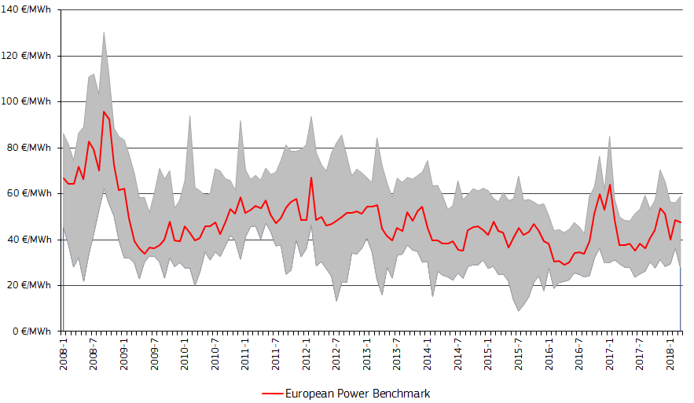

**Figure 1 — Monthly wholesale electricity prices; range of maximum and minimum prices — Sources: Platts, European power markets**

International comparisons continue to show that EU wholesale electricity real prices are higher than in the US, Canada or Russia (where power is provided through mostly indigenous hydro and fossil fuels) but lower than in China, Japan, Brazil and Turkey.

In 2017, EU household retail prices decreased for the first time since 2008. The trend of rises in network charges and taxes and levies stopped. Levies did not increase, partly due to the falling unit costs of renewable energy investments which reduced the revenues needed to invest. Taxes and levies make up 40 % of average EU electricity prices.



**Figure 2 — Household electricity prices in 2017 (most representative consumption band) — Source: DG ENER in- house data collection[3]**

Industry (non-household) prices have been falling since 2015 due to lower energy price components. Industry (for competitiveness reasons) is often exempt from or faces lower electricity taxes and levies than households and also faces lower network charges.

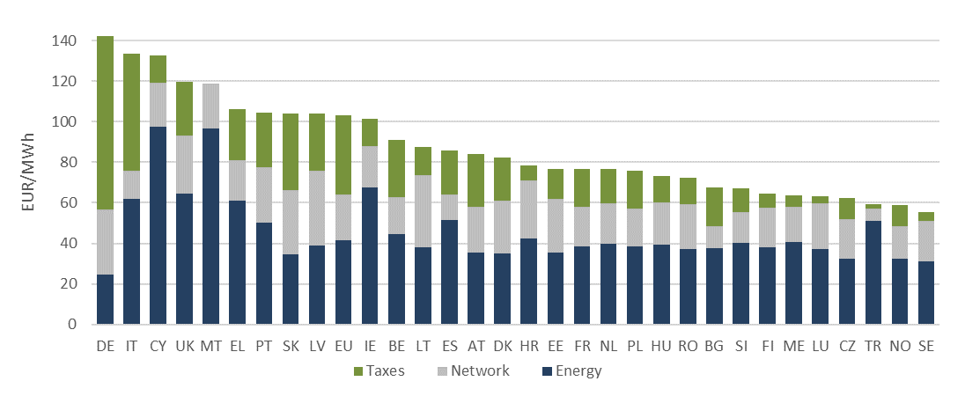

**Figure 3 — Industrial electricity prices in 2017 — Source: DG ENER in-house data collection**

Given the support provided to industry and the general concern that European industry should be able to compete fairly in international markets, it is also useful to explore comparisons of EU retail prices with those of international trading partners. Latest comparisons show that overall the historical trend remains the same: EU retail (real) prices are higher than in the US, Canada, Russia, China and Turkey but lower than in Japan and Brazil. Retail prices are generally less volatile than wholesale markets as retailers provide mostly fixed price contracts with little dynamic pricing as yet to reflect the true costs of energy supply visible in wholesale prices.



**Figure 4 — Retail electricity prices for industry — Sources: Eurostat, CEIC and IEA**

Changes in electricity prices are dominated by taxes and levies (rising until recently), though a recent slight decline came from a short-term fall in gas prices and stable network tariffs.

# Gas prices

While electricity prices are partly set as a result of fossil fuel prices (with other, more national or regional factors also shaping price), natural gas prices are based on global fossil fuel — including oil — prices. Clearly the great dispersion between gas prices in 2011-2014 has diminished with the growth of global LNG markets and other supplies; however more recently the economic recovery and rising oil prices have led to higher gas prices. As noted by President Juncker in July 2018, the EU continues to be a market open for increased US gas exports[4]. Convergence of the European and Asian prices in the spring and summer months could be particularly advantageous to replenish storage. Producer countries (US, Russia, Canada) continue to have lower prices than net importers (Japan, China, Korea), with the EU in between.

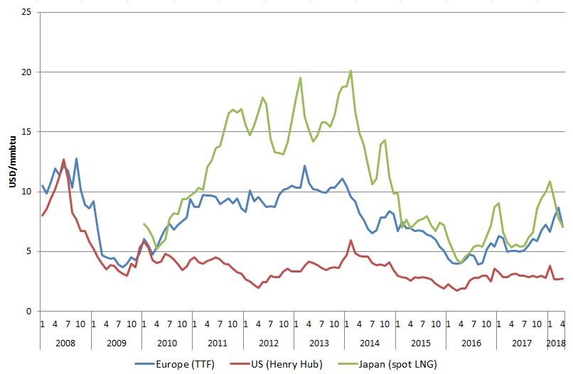

**Figure 5 — European, US and Japanese wholesale gas prices — Sources: Platts, Thomson Reuters**

EU retail gas markets are taxed at lower rates for business, for competitiveness reasons, and for households in some Member States, where gas has been the main source of household heating and therefore a primary need. Thus retail prices are largely determined by wholesale prices and the energy component accounts for up to 80 % of the price. In absolute terms the energy component decreased by 2.4 % annually for industrial consumers and became 11 % less spread-out over the last decade indicating progress towards the completion of the single gas market. It is also interesting to note the lower taxes and levies faced by large energy industrial consumers compared to medium energy industrial consumers.



**Figure 6 — Household gas prices in 2017 — Sources: DG ENER in-house data collection[5]**



**Figure 7 — Median and large industrial gas prices in 2017 — Source: DG ENER in-house data collection**

# Oil prices

After the fall in prices in 2014-2016, crude oil prices have broadly been rising again. The rise that began in spring of 2016 has been driven by global factors (demand growth, OPEC strategic behaviour, Middle East tensions, the announcement of US sanctions on Iran, etc.). Exchange rate developments also add to price uncertainty, as global energy markets are commonly denominated in US dollars rather than euro-based.

The relatively high tax shares of retail oil products prices in EU Member States dampen the impact of oil price volatility. Nevertheless, by mid-2018, retail prices had returned to 2015 levels.

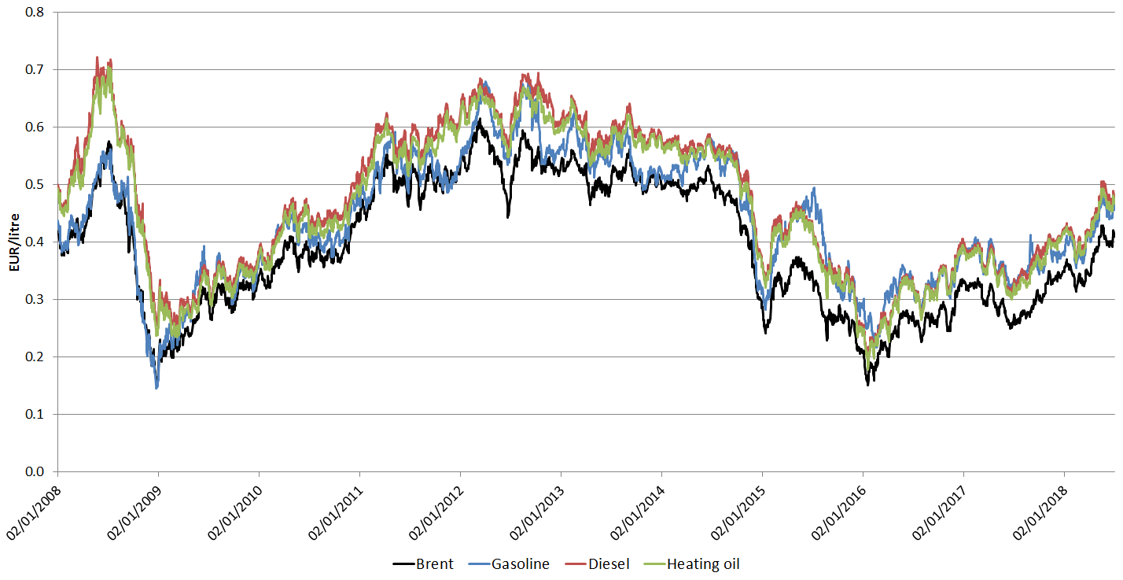

**Figure 8 — Crude oil (Brent) and European wholesale gasoline, diesel and heating oil prices — Source: Platts, ECB**

Rising fossil fuel prices are for the EU a reminder and an incentive to increase energy efficiency and speed up decarbonisation efforts and the energy transition. Oil and gas prices are set on global markets. They are volatile according to global supply and demand changes, and have been rising (overall) since 2016, reminding most EU Member States of their ‘buyer-dependant’ position as net importers. Electricity prices also fluctuate indirectly due to fossil fuel prices. Thus the EU continues to be exposed to external market forces and geopolitics, leaving industry and households vulnerable to price changes and affecting the trade balance and performance of the overall economy. The European Commission’s modelling shows that oil prices at 75 US$/barrel on average in 2018[6] would reduce EU GDP by around 0.4 % in 2018 and 2019 and increase inflation by 0.6 percentage points in 2018, compared to what would otherwise be expected if oil prices had stayed at 2017 levels[7].

EU policy responses to protect itself against such forces include improving the functioning of the internal market and decarbonising the European economy; EU energy and climate policy diminish dependence on global fossil fuel supplies.

# Energy costs

It is the overall cost of energy (not just the price) which is important when it comes to understanding the question of affordability and competitiveness, for Europe’s households and businesses. Unlike our ability to affect global fossil fuel prices, cost-effective options for reducing consumption and altering the type of energy we consume *are* available.

To understand what sectors and industries to support, and how to best provide policies and measures to mitigate the negative effects of energy costs, it is useful to explore in detail the nature of such costs for both households and business, including multiple energy intensive industries.

# The EU energy bill

To start from a macroeconomic perspective, a key indicator of the impact of global fossil fuel prices is the ‘import bill’ the EU pays to fossil fuel suppliers in other countries. In 2017, this was estimated to be EUR 266 bn, a rise of 26 % compared to 2016 (but 34 % less than the 2013 peak of EUR 400 bn). The rising oil price is the main cause of this increase with oil responsible for 68 % of the total import bill in 2017, gas for 28 %, and hard coal for 4 %.

The fossil fuel imports have a significant impact on the EU trade balance, reflecting the EU’s energy dependence and highlighting the economic cost of fossil fuel exposure. The cost impacts directly and significantly on overall economic growth. The EU is still heavily dependent on fossil fuel imports and subject to the impact of volatile global fossil fuel (especially oil) prices. A decline in coal imports and the coal contribution to the import bill is partly attributable to the growing penetration of renewable energy in the EU electricity mix. But while the energy bill declined with global oil and gas prices, it has started to rise again as prices rise. And the bill may grow even more rapidly depending on the uncertainty and volatility of US dollar-to-euro exchange rates. Denominating the transactions of the imported energy commodities in euros would help to reduce the uncertainty of their costs[8].

# Household expenditure on energy

Europe’s households spend a varying amount of their income on energy, depending on Member State's overall household expenditure. In 2015[9], 9.8 % of the expenditure of the poorest ten percent of households was spent on energy, excluding transport. Middle income households spent 6 % of their expenditure on energy, and higher income households less still. Variations also occur across the EU, with northern and western European households spending 4-8 % and central and eastern Europeans spending 10-15 %.

Measures to address energy poverty have traditionally focused on price support or price relief. Regulated prices have been used to fix energy prices across the board. This measure does not target low income households and also weakens price incentives for producers and consumers alike, while hampering the deployment of technologies such as smart meters. Increasingly retail market competition is expected to bring greater benefits for all households. In particular, retail electricity companies in several Member States have introduced ‘dynamic price contracts’ which take advantage of new technologies to provide flexible and market responsive pricing through automated services and smart metering. This can empower households and reduce their energy bill, even without requiring any change in behaviour. For households with modest electricity consumption, the use of such contracts has been estimated to bring annual savings in the range of 22 % to 70 % of the energy supply component in the annual bill. Only slightly lower benefits can be expected in the case of natural gas.

Beyond household pricing measures to manage energy prices, the EU leads the world in energy efficiency policies and measures to reduce costs. The use of energy efficiency appliances under the eco-design and energy labelling regime established by the EU, and building renovations facilitated by EU legislation and EU and national financing schemes, are all means to reduce energy consumption and thus household energy bills.

# Industrial energy costs

Significant as it is for Europe’s economic growth and prosperity, the costs of energy for European businesses also need to be monitored. The range and impact of energy costs varies widely across different sectors of the economy:

|  |  |
| --- | --- |
| **Table 1 — Energy share of industry production costs across sectors** | |
| Examples of sectors | Energy share of production costs (range) |
| *Average European business* | 0-3 % |
| *Computers and electronics, motor vehicles, other transport equipment* | 1 % |
| *Waste management and accommodation and restaurants* | 3-5 % |
| *Energy intensive sectors in manufacturing*  *Cement, lime and plaster, Clay building materials, Pulp and paper, Glass, Iron and steel, Basic chemicals, Non-ferrous metals* | 3-20 % |

**Source: Eurostat, Trinomics*****[10]***

Confirming earlier findings from the 2016 energy prices and costs report, energy cost shares in production costs have been falling for the vast majority of the sectors studied between 2008 and 2015 (latest available data), with the most significant declines appearing in some energy intensive sectors. The aggregated amount of the energy costs of the sectors studied fell by 8 % over 2010-2015. This happened despite increasing prices, stable output effects and partially due to improvements in energy intensity. Energy costs have not contributed to an increase in total production costs in the vast majority of manufacturing sectors analysed over the last years. However, this was not the case for all subsectors within energy intensive sectors. For instance, for primary aluminium, energy costs increased and represented 40 % of total production costs in 2017.

Energy intensity varies considerably across the sectors studied according to production processes. Energy intensity fell, overall, in steel, refineries, paper, land transport, electricity-gas, other mining and agriculture, and increased in cement, grain products, sawmills and chemicals, and remained relatively stable in the less energy intensive sectors. However, results can vary significantly across subsectors within the same industrial sector.

While finding comparable data across countries is difficult, the studies launched by the European Commission have allowed some comparisons. The data for the available sectors show that energy cost shares in production costs in the EU are usually higher than in Asia (Japan, South Korea) and comparable to the US (with the exception of aluminium or steel, with lower energy costs shares in the US). Energy intensity in the EU sectors studied is systematically lower than in China and Turkey and comparable to the US, although with considerable variation by sector.



**Figure 9 — Electricity prices for industry in EU and G20 in 2016 — Source: IMD, Eurostat, CEIC, ACCC**

There have been significant improvements in energy intensity in EU industry and recent falls in the energy share of production costs. However, other countries’ industries are sometimes more efficient than those in Europe, and volatile prices imply that the energy cost exposure of businesses can still deteriorate. In fact, Japanese and Korean industry’s exposure to higher energy prices has made them more energy efficient; energy producing countries (Russia, US) are less energy efficient. China is an exception. Thus, we see again that rising energy prices may in themselves spur the drive for reduced energy consumption and greater energy efficiency. However, such price signals need accompanying measures to facilitate the ongoing decarbonisation of industry. Such measures may be regulatory or financial, and thus the scope for government intervention in support of industrial innovation becomes a necessary part of the policy mix for the energy transition.

# government revenues from energy taxation and Energy subsidies

**Government Revenues From Energy Taxation**

In 2016, energy taxes collected by EU Member States amounted to EUR 280 bn or 4.7 % of total tax revenue. The relative importance of energy tax revenue has been rather stable since the 2008 economic crisis. Excise duties (of which more than 80% comes from oil products) constitute the largest part of energy taxes.

It is important to note the role that energy taxation plays in the economy. It first provides significant revenues to contribute to the general budget; important not only in times of fiscal constraints. High shares of taxes in energy prices can dampen the impact of volatile fossil fuel prices; the mitigation of the impact of unexpected price swings protects both consumers and industry. In addition, energy taxes and levies can be used for amplifying price signals to discourage certain behaviour (such as the excessive consumption of polluting or otherwise damaging fuels). Finally, government revenues can be used to counter market failures by subsidising desirable developments such as investment in areas not adequately addressed by the (energy) market. There is, therefore, a link between government energy taxes and levies, revenues and energy subsidies.

It is important to note in any discussion of subsidies that there are multiple legitimate reasons for intervening in the energy sector with financial or regulatory support, to correct imperfect markets and to give long-term strategic direction not provided otherwise. As noted above, the need to stimulate innovation in new sectors, materials or processes is a highly pertinent rationale in the context of decarbonisation and the energy transition. That said, it is also possible that there are subsidies, which changing circumstances have rendered redundant, or excessive. The EU (and the G20) have notably called for inefficient fossil fuel subsidies to be removed as they hamper the clean energy transition.

Overall European energy subsidies have increased in recent years, from EUR 148 bn in 2008 to EUR 169 bn in 2016, with the energy sector being the main beneficiary (EUR 102 bn in 2016), followed by the residential sector (EUR 24 bn), the energy intensive manufacturing industry (EUR 18 bn) and transport (EUR 13 bn). The increase was driven by the growth in renewable energy subsidies which reached EUR 76 bn in 2016. Over the period 2008-2016, free emission allowances fell from EUR 41 bn to EUR 4 bn, due to decreasing carbon prices and fewer eligible sectors for receiving free ETS allowances.

Clearly, in line with the Paris Agreement, a range of measures are in place at EU level and nationally, to facilitate decarbonisation and innovation in the energy sector, in households and in transport. However, despite this and the international commitments made in the context of G20 and G7, fossil fuel subsidies in the EU have not decreased and are estimated to be EUR 55 bn, remaining roughly stable across sectors and implying that EU and national policies might need to be reinforced to phase out such subsidies**.** According to the latest available international comparisons (2015 data), subsidies to fossil fuels are even higher outside the EU. Subsidies to petroleum products (mainly tax reductions) account for the largest share within fossil fuels.

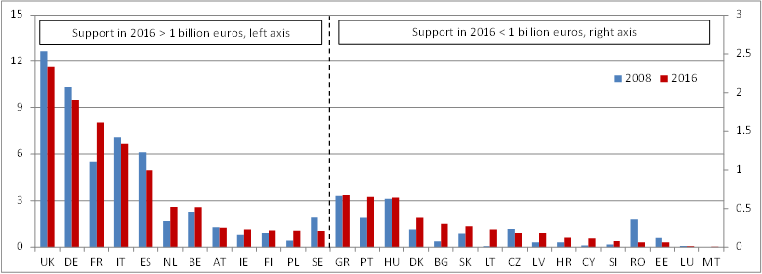 **Figure 10 — Financial support to fossil fuels in the EU- Source: EC, Trinomics**9

# Prices, costs and investment

The above discussion highlights the impact prices have on consumers of energy, but the role prices have in providing energy companies with revenues to cover their costs and investments is another important aspect. Despite price fluctuations and price rises, growing competition in the European energy market, market design weaknesses[11] and the need for significant new investments have meant that the market is not always capable of financing investment; prices are not always sufficient to cover costs. For this reason, it is important to explore the trends of energy and fuel prices in relation to the costs of energy investments, in particular in relation to the ‘levelised cost of electricity’ (LCOE) that captures both capital and operating costs that need to be covered. Currently, as discussed above, significant subsidies are paid to power generators, through renewable energy subsidies and capacity mechanism payments in particular, to cover costs of investment that are not financed through normal commercial transactions undertaken with the current electricity market design.

Despite the rising share of investment needed in renewable energy power production, the falling costs of such technologies, combined with the anticipated improved operation of the European power market, including an expected increasing contribution of storage and demand-side management[12], should result in the market providing revenues increasingly adequate to finance and cover the investment costs of all or most new capacities in the coming decade. At the same time, projections of fossil fuel prices, capital costs, carbon costs and reduced load factors suggest that future investments of fossil fuel power generation will find it less easy to cover the (levelised) costs of fossil fuel power generation capacity.



**Figure 11 — EU28: electricity prices and cost — Source: Left graph Platts, METIS(2030); right graph: PRIMES**

*Note 1: the box plots show the minimum observed in a given period (lower whisker), the first quartile (lower bar), the median (black line), the third quartile (upper bar) and the maximum (upper whisker).*

*Note 2: for visualisation purposes the left graph has been capped to 200 €/MWh.[13]*

*Note 3: costs for storage and additional interconnections are not accounted for in this Figure.*

*Note 4: historical prices are in current euros, values for 2030 are in 2013 euros. Prices and costs are averaged over the EU28.*

In a context of a slowly increasing demand for electricity, and an ageing fossil fuel fleet, the projected range for future electricity prices is similar to the range of costs of many renewable energy technologies. This means that, beyond market prices, less (or even zero) public support would be needed for enabling investments in the most mature renewable energy technologies.

# Conclusion

This report has illustrated how prices are rising and falling in different ways in different markets for different fuels. In fossil fuel markets, prices are largely driven by global forces or set in global regions by factors we can do little to control. Global oil prices rise and fall with OPEC, Middle Eastern, South American or US changes in production; gas prices may follow oil prices or also change due to new discoveries or new sources reaching European markets. In turn, electricity, while produced within the EU, and increasingly produced with indigenous renewable energy resources, is priced according to the price of the ‘marginal fuel’, often a fossil fuel such as gas. Such price exposure has implications for households and businesses but also more broadly for the EU’s balance of trade and macroeconomic performance.

The EU’s response to this situation has several dimensions. First, the creation of the single market helps to protect the EU from volatile prices affecting an individual Member State. With interconnections, gas (reverse flow) pipelines or LNG terminals, coupled markets and dynamic pricing, flexibility and growing trade between Member States provide a buffer against international price spikes. The broadly growing convergence in prices across Member States suggests that these efforts are bearing fruit. A second response of Member States has been taxation. Quite significant taxes and levies on electricity and petroleum products dampen the impact of price rises and at the same time provide revenues to governments. These revenues are used to finance general government expenditure and energy investments for the clean energy transition, support for low income households or businesses facing unfair international competition. Rising carbon prices can also strengthen the price signal to encourage greater investment in renewable sources of energy while fossil fuel subsidies are signals in the opposite direction and risk stifling the necessary investment and promoting wasteful consumption of energy.

A third response of the EU is to focus on the cost of the energy to households and businesses rather than the unit price. It is the overall cost which is important when it comes to understanding the question of affordability, and it is by considering cost that the question of consumption is brought into focus. If there is limited scope for affecting price, options for adjusting — reducing — consumption are readily available, and options for altering the type of energy we consume are also available. This is where EU objectives to improve security of supply, address climate change and stimulate innovative new industries come together. Energy efficiency measures, first adopted by (more price-sensitive) business, have resulted in European businesses being amongst the most energy efficient in the world. However, different levels of efficiency and energy intensity exist across Member States, and there continues to be room for businesses, especially SMEs, to become more energy efficient. For energy intensive industries the challenges are greater even if many measures have already been taken. However even here industry is producing plans to reduce fossil fuel consumption and to develop carbon neutral materials and production processes cost-effectively. For households, multiple EU policies and measures are in place to facilitate major reductions in energy consumption (while at the same time fostering EU companies developing new materials, processes and services in a growing global market).

Renewable energy growth also plays a direct role in mitigating and diminishing the negative impact of uncertain global fossil fuel prices and exchange rate risks. Thus, the ambitious 2030 renewable energy and energy efficiency targets recently agreed will help reduce the EU’s dependence on fossil fuel imports and vulnerability to global fossil fuel price shocks and uncertainty. At the same time, energy efficiency and renewable energy investments set the EU on the path to compliance with the Paris Agreement and will stimulate the innovation needed to achieve the energy transformation.

The fourth response explored in this report has been the EU investment strategy for energy. Improvements to market design are making markets more dynamic and flexible and, critically, more able to finance the investment needed — energy saving or renewable energy investment — from market revenues rather than from government support. In addition, EU financial instruments and the EU sustainable finance initiative is working to reorient global capital markets to have a better understanding of and thus facilitate the provision of investment capital for the low carbon technologies, infrastructure and service companies needed to complete the energy transition. Thus, a solid framework is in place, ranging from national taxes to EU energy, climate and capital market policies to ensure Europe’s energy prices and costs evolve in an efficient manner consistent with ensuring affordable and sustainable energy for all.

1. COM(2018)773
2. Electricity prices became 21 % less spread-out over the last decade and intra-EU trade increased.
3. The price of the ‘Most representative’ band is the price for which the most electricity was sold to households in each country. The most representative band varies across countries from Eurostat band DB to DE.
4. http://europa.eu/rapid/press-release_IP-18-4920_en.htm
5. Data for Greece is for 2015
6. And 70 US$/barrel in 2019.
7. Commission own calculations based on internal modelling (European Commission's global multi- country (GM) model). The annual average in 2018 may be slightly lower than this assumption.
8. COM(2018)796 ‘Towards a stronger international role of the euro’
9. Latest Eurostat data available on household energy expenditure (excluding transport)
10. Study on ‘Energy prices, costs and subsidies and their impact on industry and households’ by Trinomics et altri (2018).
11. See the impact assessment on revised rules for the electricity market (‘Market Design Initiative’):

    https://ec.europa.eu/energy/sites/ener/files/documents/mdi_impact_assessment_main_report_for_publication.pdf
12. More storage and flexible demand will help smoothing the prices, in particular driving the prices up when there is an abundant supply of variable renewables, thus counterbalancing the downward effect on prices an increasing production by wind and solar, both with close-to-zero variable production cost, will have at the time they produce.
13. Projections of spot prices are uncertain and actual prices will depend on a number of factors difficult to predict, including the weather conditions or unforeseeable events affecting the grid.