

### ANNEX I

Progress on the economic situation

The EU’s ambitious agenda for jobs, growth and investment and its work on the single market have contributed to a robust economic recovery. Europe’s economy has grown for six consecutive years. Some 12.6 million jobs have been created since the start of the Juncker Commission and unemployment is at a record low in this century. At the same time, the state of public finances has improved across the board and disparities in wealth distribution between Member States are also shrinking again.

###### ROBUST GROWTH AND INCREASED INVESTMENT

In recent years, Europe has moved from economic recovery to expansion.

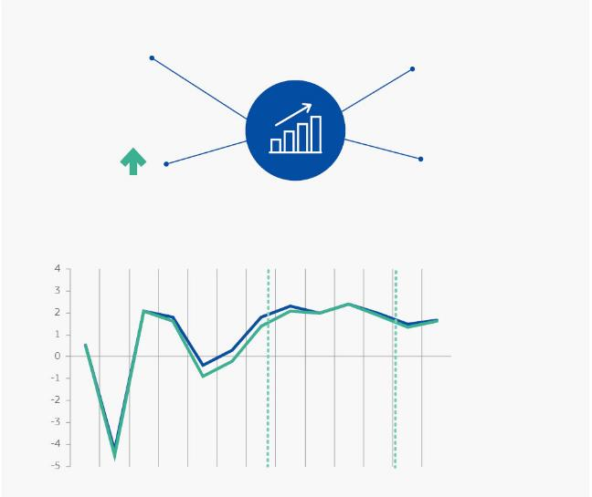

**ECONOMIC GROWTH**

in the EU and euro area

Growth has been around

**2%**

in the EU and the euro   
area in recent years

All Member States recorded growth in 2018

The EU and euro area have now grown for

**24**

**consecutive quarters**

In spite of global challenges, the EU is expected to **continue growing in 2019 and 2020**

**Gross domestic product (GDP) is expanding steadily**

% change in real GDP

The Juncker Commission takes office

*forecast*

2008

2009

2010

2011

2012

2013

2014

2015

2016

2017

2018

2019

*Source:* European Commission (Eurostat except forecasts).

0.5

0.5

2.0

1.9

1.4

Note: 2019 and 2020

data are forecasts.

EU 28

Euro area

2020

MORE AND BETTER JOBS

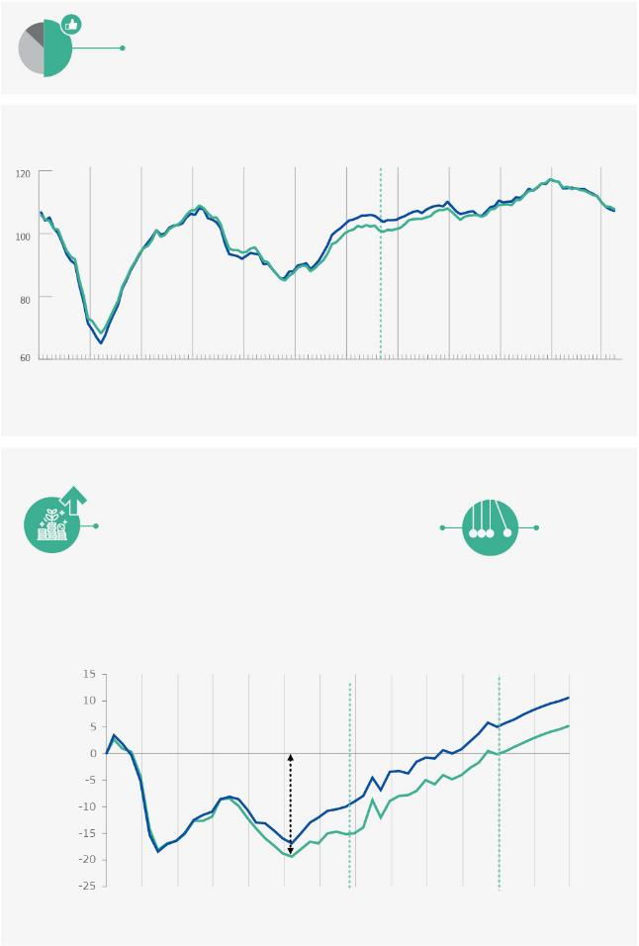

**49%**

Europeans have a **positive opinion** of the current situation of the European economy.

*Source*: Eurobarometer, Autumn 2018.

38% negative

13% negative

The Juncker Commission takes office

The Juncker Commission takes office

*forecast*

**Economic sentiment indicator at high levels**

2008

2009

2010

2011

2012

2013

2014

2015

2016

2017

2018

2019

EU 28

Euro area

**104.6**

**103.7**

**102.2**

**99.2**

**105.5**

**105.0**

*Source*: European Commission.

**Investment** has returned to **pre-crisis levels** and is **steadily** **increasing**

2008

2009

2010

2011

2012

2013

2014

2015

2016

2017

2018

2019

2020

**Fall by about**

**20% compared**

**to 2008**

EU 28

Euro area

**By 2020, the Juncker Fund is set to generate:**

**€500**

**billion**

in additional **investment** across Europe

**€1.4**

**million jobs**

**1.3%**

**increase**

in the EU’s GDP

*Source*: European Commission (Eurostat except forecasts).

Note: 2019 and 2020 data are forecasts.

**Investment picking up**

% change in the level of investment compared to 2008

**3.4**

**2.8**

**-10.0**

**-15.1**

**5.1**

**-0.1**

**10.5**

**5.2**

Economic growth is a means to an end. Growth has helped to deliver a more social Europe.

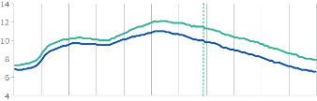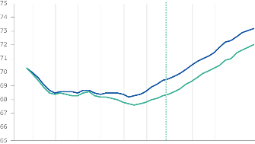

have been created in the EU since the start of the Juncker Commission

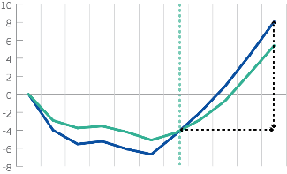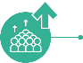

While still too high in certain Member States, **unemployment is at its lowest level** EU-wide since the start of the century.



**Unemployment is declining**

% of active population

11.5

7,3

6,9

10,0

The Juncker Commission takes office

2008

2009

2010

2011

2012

2013

2014

2016

2015

2017

2018

6,4

7,7

*Source:* European Commission (Eurostat).

68.5

72.0

70.3

70.3

The Juncker Commission takes office

69,4

73,2

*Source:* European Commission (Eurostat).

2008

2009

2010

2011

2012

2013

2014

2016

2015

2017

2018

**Employment rate is increasing**

% of working age population

**million**

**jobs**

**12.6**

**A job-rich recovery is taking hold**

Jobs created since 2008, in millions of people

The Juncker Commission takes office

*Source:* European Commission (Eurostat except forecasts).

**million people are working** across our Union

**Employment**

in Europe is at a **record high**

**240**

EU28

Euro area

EU28

Euro area

EU28

Euro area

12.6 million jobs created

2008

2009

2010

2011

2012

2013

2014

2016

2015

2017

2018

SOUND PUBLIC FINANCES

Significant progress has been made to ensure that Europe’s public finances are sound, sustainable and capable of absorbing future shocks.

IMPROVED FINANCIAL STABILITY

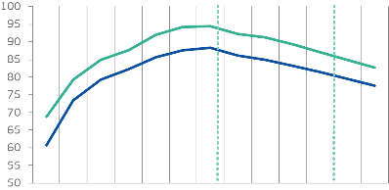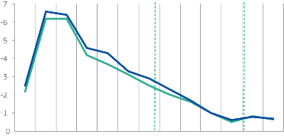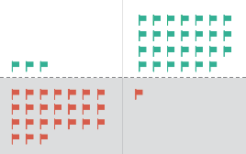

**Government deficit** in the EU decreased from

The ratio of government debt to GDP is falling from

**Government debt is on a downward path**

% of GDP

94.4

68,7

60.7

88.3

The Juncker Commission takes office

2008

2009

2010

2011

2012

2013

2014

2016

2015

2017

2018

81.5

87.1

-6.2

-2.9

-2.2

-2.5

-6.6

-2.9

*Source:* European Commission.

2009

**6.6% → 0.6%**

**Public deficit is decreasing in EU countries**

% of GDP

The Juncker Commission takes office

*Source:* European Commission (Eurostat except forecasts).

Member State is currently in the Excessive Deficit Procedure under the Stability and Growth Pact, down from 24 in 2011

EU28

Euro area

EU28

Euro area

2018

*forecast*

Note: 2019 and 2020 data are forecasts.



The use of flexibility within the rules of the Stability and Growth Pact made it possible to strike the appropriate balance between pursuing sound fiscal policies and supporting growth, notably through reforms and investment.

Estimates suggest that the use of flexibility has boosted EU GDP by 0.8% over the last four years and resulted in around 1.5 million jobs.

2011

2019

Excessive Deficit Procedure

**88.3%**

**81.5%**

2014

2018

to

2019

2020

*Source:* European Commission (Eurostat except forecasts).

Note: 2019 and 2020 data are forecasts.

*forecast*

-0.8

-0.8

-0.6

-0.7

-0.7

2008

2009

2010

2011

2012

2013

2014

2016

2015

2017

2018

2019

2020

-0.5

79.5

84.9

77.6

82.8

### Over a decade on from the financial crisis, European banks are stronger, safer and more secure.

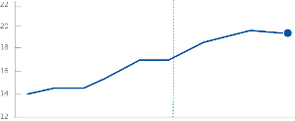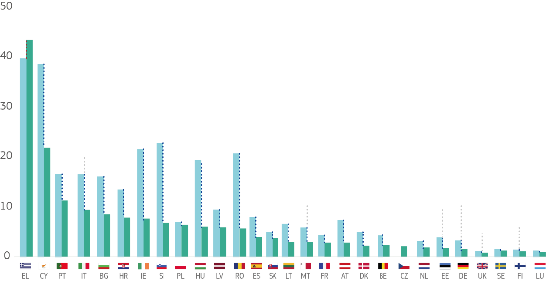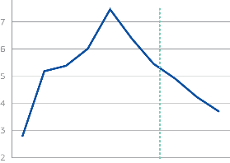

...are better

capitalised

and are approaching

The ratio of non-performing loans in EU banks has come down by more than half since 2014, reaching the lowest level since the last quarter of 2014

**EU total gross non-performing loans and advances**

in % of total gross loans and advances,

end-of-quarter values

2.8

5.5

The Juncker Commission takes office

2008

2009

2010

2011

2012

2013

2014

2016

2015

3.7

14.0

15.1

**20%**

**Banks’ total capital ratio,** in %

The Juncker Commission takes office

*Source:* European Commission.

EU28

EU28

*Source:* European Central Bank.

19.2

2009

2010

2011

2012

2013

2014

2016

2015

2017

2018

average total capital ratio:

for EU banks

(Q3 2018)

**EUROPEAN BANKS**



Since 2014 the stock of liquid assets has increased by €812 billion

...and therefore are better equipped

to finance the real economy

and withstand economic shocks

...have higher

liquidity buffers

**Gross non-performing loans**

**and advances per Member Sta**te

in % of total gross loans and advances

(3) After reaching a peak of 47.4% in Q3 2016, the non-performing loans ratio in Greece has declined to 43.5% in Q3 2018. This gradual improvement constitutes a decrease of 8.1%.

*Source:* European Central Bank.

2017

Proportionate drop

2018 Q3

2014 Q4

**9.6%(3)**



-43.3%

-31.7%

-63.2%

-5.8%

-34.0%

-35.4%

-69.6%

-63.3%

-54.5%

-49.1%

-44.1%

-47.9%

-59.7%

-62.3%

-42.7%

-46.2%

-41.6%

-9.7%

-68.3%

-72.3%

-38.2%

-57.4%

-51.9%

-31.7%

-51.1%

-30.1%

THE ROLE OF THE EURO

The euro brings stability and tangible benefits. Its global role is on the rise.

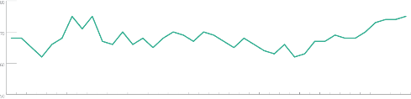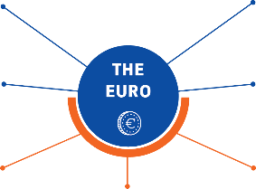

is used in

**The share of the euro in global payments**

in %

68%

67%

**19**

**Support for the euro among citizens of the euro area,** in %

The Juncker Commission takes office

75%

Three in four euro area citizens support the single currency. This is the highest share ever.

offers a predictable business environment

*Source:* European Commission.

Others

US Dollar

Euro

**340**

**60**

**2nd**

**175**



in the EU

in the world

is used in

million people in Europe

EU Member States

most used currency in the world

countries and territories

outside of the EU have

pegged their currency

directly or indirectly to the euro

million people

has a strong track record of price stability

*Source:* Eurobarometer, Autumn 2018..



2015

2017

2016

2018

2012

2011

2013

2014

2008

2010

2009

1999

2006

2007

2002

2004

2003

2000

2001

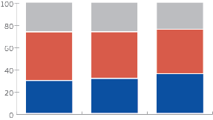

**29.4**

**31.3**

**35.7**

**price stability:** inflation on average under 2%

**more transparent and competitive markets:** prices easily comparable

**lower travel costs:** cost of exchanging money has disappeared

**more cross-border trade:** no more **exchange rate costs**

**interest savings for Member States resulting from the euro’s introduction:** up to €70 billion per year

**The euro has made life and business much easier for Europeans:**

2016

2015

2017



2005

### ANNEX II

The EU’s public opinion 2014-2019

Compared to 2014, public opinion in 2019 is more positive towards the European Union. Eurobarometer surveys demonstrate broad overall support for the European project and its achievements.

**EU Membership**

A continuously increasing majority of Europeans think that being a member of the EU is a good thing for their country. This is the highest level in 27 years.

Comparison with the latest pre-Brexit survey (September 2015)

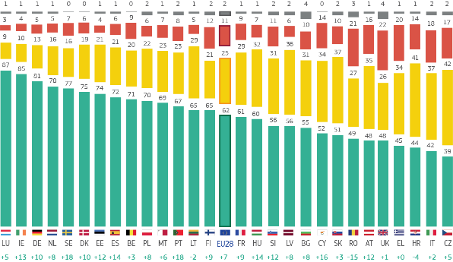

Generally speaking, do you think that (our country’s) membership of the EU is ... ?

A BAD THING

A GOOD THING

NEITHER A GOOD THING

OR A BAD THING

DON’T KNOW

Autumn 2018

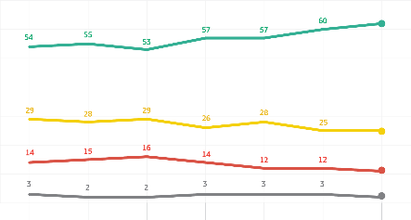

Nov.-Dec.

2014

Sept.

2015

Sept.-Oct.

2016

Sept.-Oct.

2017

April

2018

Sept.

2018

March

2017

62%

11%

25%

2%

0 %

10 %

50 %

20 %

30 %

40 %

60 %

*Source*: Eurobarometer 2019 (91.1), QA3s.

If a referendum was held tomorrow regarding (OUR COUNTRY)’s membership of the EU, how would you vote? (%)

VOTE TO LEAVE THE EU

VOTE TO REMAIN IN THE EU

DON’T KNOW WHAT TO DO

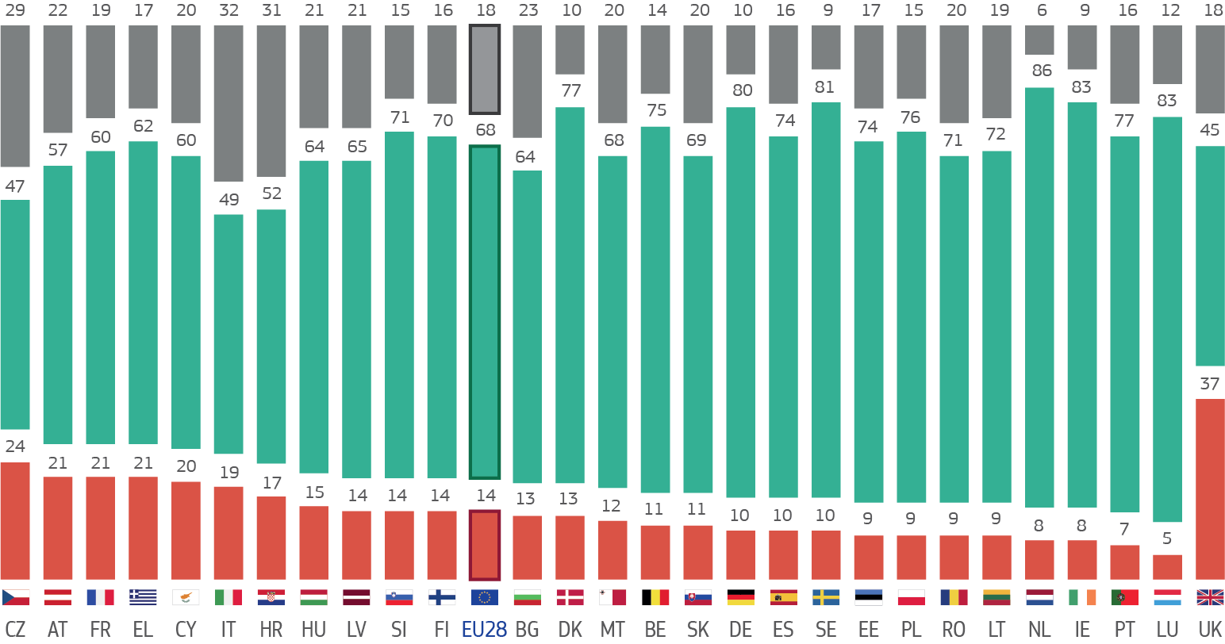

**Trust in the European Union**

Trust in the EU is higher than trust in national governments on average.

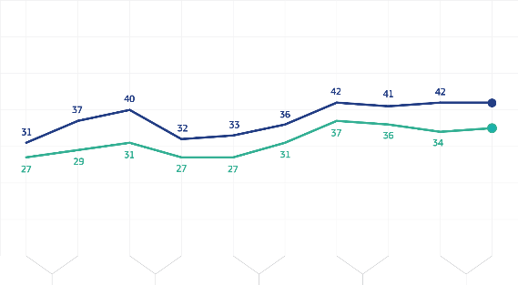

‘I tend to trust the following institutions’

TEND NOT TO TRUST

TEND TO TRUST

DON’T KNOW

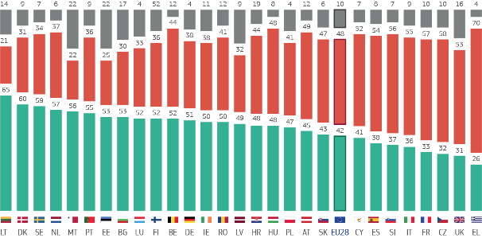

2014

2015

2017

2016

2018

35%

42%

(NATIONAL) Government

European

Union

0 %

10 %

50 %

20 %

30 %

40 %

How much trust you have in certain media and institutions. For each of the following media and institutions, please tell me if you tend to trust it or tend not to trust it.

**The European Union (%)**

Autumn 2018

### **Support for the euro**

75% of euro area citizens are in favour of the euro, the highest level since the introduction of the euro.

Are you for or against a European Economic and Monetary Union with one single currency, the euro?

AGAINST

FOR

DON’T KNOW



1999

2000

2002

2001

2003

**62%**

(EU28)

0 %

10 %

80 %

20 %

30 %

40 %

Autumn 2018

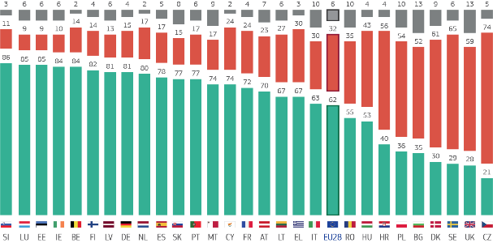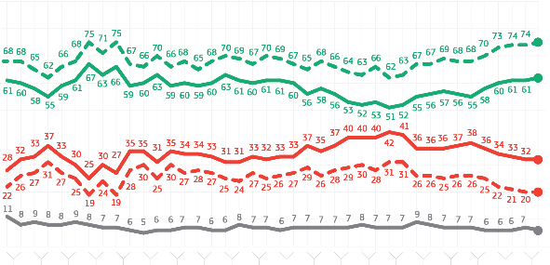

**75%**

(EURO

Area)

**32%**

(EU28)

6%

**20%**

(Euro Area)

70 %

50 %

90 %

60 %

2004

2015

2017

2016

2018

2009

2010

2012

2011

2013

2014

2006

2005

2007

2008

Sources:

* Standard Eurobarometer 90, Autumn 2018 (European Commission)
* Parlemeter 2018 (European Parliament)

### ANNEX III

The Top 20 EU achievements 2014 2019

1. **The European Fund for Strategic Investments**

To support recovery after the financial and economic crisis and create the conditions for jobs and growth, the Juncker Commission launched the Investment Plan for Europe in 2014, commonly known as the Juncker Fund for the Investment Plan for Europe. At its core is the European Fund for Strategic Investments, or EFSI. The objectives were three-fold: to reverse the downward investment trend by removing obstacles to investment; to provide visibility and technical assistance to investment projects and to make more efficient use of scarce public financial resources by mobilising private investment via a public guarantee.

Europe’s economy has now grown for six consecutive years. EFSI has already leveraged €392.6 billion in investments in small and medium-sized enterprises and in key areas such as infrastructure, research, renewable energy, environment and digital and social projects. The 2020 target is €500 billion, leading to the overall creation of 1.4 million new jobs in the EU. The InvestEU programme is set to build on this success in the next long-term budget.

### **Making use of the Stability and Growth Pact’s flexibility**

In its Communication of January 2015, the Commission set out how it intended to use the flexibility built into the Stability and Growth Pact’s rules. This approach was supported by the Council of Ministers and has helped Europe’s economic recovery by striking the appropriate balance between pursuing sound fiscal policies and supporting growth, notably through reforms and investment. Estimates suggest that the use of this flexibility has boosted the EU’s gross domestic product by 0.8% over the last four years and helped create 1.5 million jobs. At the same time, government debt decreased by 6.8 percentage points between 2014 and 2018, and the EU deficit decreased on average from about 3% to 0.6%.

### **Saving Greece’s membership in the euro area**

The Juncker Commission took office in the wake of a new Greek debt crisis. In addition to facilitating negotiations between all actors, the Commission launched in July 2015 a plan to help Greece stabilise its economy and maximise its use of EU funds to boost jobs, growth and investment, by mobilising up to €35 billion for Greece under various European Union funding programmes for the period 2014-2020. At the same critical juncture, a short-term loan of €7 billion was mobilised as bridge financing under the European Financial Stabilisation Mechanism, effectively preventing Greece from crashing out of the euro area. The Commission also offered far-reaching technical support to help build the necessary administrative support through the Commission’s Structural Reform Support Service created in 2015.

In August 2018, Greece emerged from its three-year stability support programme, which provided a total of €61.9 billion in loans based on the implementation of a comprehensive and unprecedented reform programme. Growth is now positive and, at about 2%, it is reaching its highest levels in ten years. While still too high, unemployment has also gone down significantly since its peak. Enhanced monitoring is in place to maximise EU support and ensure that this progress is pursued.

### **Paris Climate Agreement**

The EU played a leading role in brokering the historic, ambitious and global Paris Climate Agreement. 195 countries agreed on a simple goal: to hand over to future generations a healthier planet and more prosperous, modern and fair societies. The EU is the only large economy in the world that has fully translated into legislation the steps to meet its Paris Agreement pledges and will cut at least 40% of its greenhouse gas emissions by 2030 preparing for a climate-neutral economy.

This is an investment in our prosperity and in preparing for a sustainable, climate neutral and circular economy.

### **Ban on single-use plastics**

To reduce the 25 million tons of plastic waste produced annually and increase the recycling rate for plastics, currently at just 30%, the EUadopted the world’s first comprehensive Plastics Strategy. As part of the Strategy, strict measures were introduced for the 10 plastic products most often found on our beaches as well as abandoned fishing gear. This includes a ban on certain single-use plastics where alternatives are readily available, such as plastic cotton buds, cutlery, plates, straws, drink stirrers, or sticks for balloons. The measures will avoid the emission of 3.4 million tons of CO2 equivalent, reduce ocean litter and its negative environmental effects and bring us closer to a truly circular economy.

### **EU trade agreements with Japan and Canada**

The EU-Japan Economic Partnership Agreement is the biggest trade agreement ever negotiated by the EU and the first ever trade deal to include a commitment to the Paris Climate Agreement. The EU and Japan together account for nearly one third of global gross domestic product and the agreement will create an open trade zone covering over 600 million people. This agreement was complemented by the conclusion of a mutual adequacy arrangement with Japan that created the world’s largest area of free data flows, based on a high level of protection.

The EU has also concluded a modern trade agreement with Canada that opens up Canada’s goods, services and public procurement markets to European companies and helps protect labour rights and the environment. Particularly for smaller EU firms, the agreement will make it easier and cheaper to export more to Canada.

The customs duties abolished by both agreements bring savings of up to €1.59 billion per year to European companies.

### **25 July 2018 Joint EU-U.S. Statement**

Following rising trade tensions, President Juncker and President Trump launched a new phase in the EU–United States trade relationship at the White House on 25 July 2018.

Both sides agreed that no new tariffs would be imposed, while working towards the elimination of all existing industrial tariffs, and that cooperation in a number of sectors, including energy and regulatory issues, would be further developed. An EU–U.S. Executive Working Group established on that occasion is already working on implementing the Joint Statement.

### **EU-Turkey Statement**

Following the EU–Turkey Statement, both sides committed to providing humanitarian assistance to refugees – notably for those fleeing the Syrian civil war. Due to the improved management of migration flows, in 2018 arrivals in the Eastern Mediterranean were down 90% compared to 2015. In parallel, the EU supported refugees in Turkey with €3 billion in 2016-2017 and already made €1.2bn of a further €3 billion instalment available to continue providing this vital support in the future.

### **Resettlement of refugees and EU Regional Trust Fund**

Since 2015, successful EU resettlement programmes have helped over 50,000 of the most vulnerable people from around the world find refuge in the EU. By working together, Member States were able to target priority regions such as Syrian refugees in Jordan, Lebanon and Turkey or refugees evacuated from Libya. Last year, Member States made the largest collective commitment on resettlement the EU has ever seen, under the new EU 50,000 place, voluntary resettlement scheme proposed by President Juncker.

To provide education, protection, health and socio- economic support to over two million Syrians, the EU Regional Trust Fund has mobilised €1.5 billion to fund 46 projects in Iraq, Jordan, Lebanon and Turkey

### **Securing EU borders**

The new European Border and Coast Guard Agency means that more than 1,600 border guards are now deployed to help patrol the Union’s external borders in Bulgaria, Greece, Italy and Spain. The next step, now that agreement has been reached on the Commission’s proposal, is to scale up the Agency yet further and reinforce it with its own equipment and a standing corps of 5,000 border guards as of 2021 and 10,000 by 2027 at the very latest, as well as a stronger mandate to carry out returns. A set of new improved and interoperable information systems will keep our borders both safer and more convenient for travelers. The Entry/Exit System will speed up procedures for bona fide travelers and identify where there are doubts, and the European Travel Information and Authorisation System will allow for more efficient pre-travel checks on visa-free visitors. All relevant information will be exchanged between Member States in real time to ensure that the rules are properly applied.

### **Emergency Trust Fund for Africa and External Investment Plan**

The €4.2 billion Emergency Trust Fund for Africa is one of the EU’s most effective tools to finance migration- related projects and address the root causes of irregular migration. So far 193 projects have been approved with a broad focus ranging from economic development and governance to healthcare and migration, including targeted life-saving assistance for people in need of protection. In addition, the External Investment Plan, building on the experiences of the Juncker Fund, is set to mobilise over €44 billion in both public and private investments by 2020 in Africa and in the EU neighbourhood. The External Investment Plan and its European Fund for Sustainable Development focus on boosting investments in a number of priority areas such as: clean energy; the financing of micro, small and medium enterprises; agriculture; and digitalisation for inclusive development.

### **RescEU, the new EU CivilProtection Mechanism**

The European Union has faced a large number of increasingly frequent and complex disasters resulting in loss of life and other damaging consequences for citizens, businesses, communities and the environment. In 2018, almost 100 people were killed by natural disasters in Europe, and we witnessed wildfires in some European regions that had never been affected before. The economic costs are huge: close to €10 billion in damages in Europe were recorded in 2016. The EU must respond to this challenge and better protect its citizens from these disasters, increasing and improving prevention and preparedness. In 2018, countries from the EU requested assistance nearly 10 times, mainly for forest fires, medical support and marine pollution. RescEU provides civil protection capacities for those struck by disaster and most in need of help in Europe and across the world. This reserve of assets is to be used when countries require rapid assistance to cope with a disaster. These include fire-fighting planes as well as other means to respond to situations such as medical emergencies. In 2017 and 2018, the EU Civil Protection Mechanism was activated 52 times.

### **General Data Protection Regulation**

The General Data Protection Regulation, which entered into application on 25 May 2018, has not only made Europe fit for the digital age, it has also set a new global standard for privacy. This single, pan-European law safeguards citizens’ fundamental right to data protection while enabling individuals and companies to fully seize the opportunities of the digital single market without having to go through 28 different costly and bureaucratic procedures. The benefits are estimated at

€2.3 billion per year.

Citizens can now rely on stronger rights, such as the right to access their data, the right to rectification, the right to be forgotten and the right to data portability. With tough sanctions, the new rules protect Europeans from their personal data being abused, for instance in the context of the European election campaign.

For businesses, the reform provides clarity and consistency of the rules they have to apply and helps restore consumer trust. On an international scale, the EU is starting to shape data privacy rules: It has created the world’s largest area of free and safe data flows with Japan, while Argentina, Uruguay, Canada, Mexico, India, Israel, California and New Zealand have all started to work on privacy laws inspired by the new European standard.

Between May 2018 and January 2019, 95,180 complaints were notified to data protection authorities in Europe. High fines can be issued when the rules are not respected: in Austria, a sports betting café was fined €5,280 for unlawful video surveillance; in Germany, a social network operator had to pay €20,000 for failing to secure users’ data; and in France, Google had to pay €50 million for not asking for consent to advertisements.

### **The end of roaming charges**

Since 15 June 2017, all Europeans can call, send text messages and use mobile Internet without any extra charges when travelling in the EU. The complete end of roaming fees followed a decade of drastic and progressive price cuts, driven by the Commission’s roaming proposal. Between 2007 and 2016, roaming prices dropped by more than 90%. Europeans immediately seized the benefits of ‘Roam like at home’: the use of mobile data has grown 12 times while the number of phone calls made by travellers has doubled compared to the habits before June 2017.

As of 15 May 2019, the costs for calls abroad within the EU will follow suit and decrease dramatically, too: to a maximum of 19 cents per minute for a call and 6 cents per SMS, plus VAT - up to 10 times cheaper than before.

### **Reform of the Posting of Workers Directive and the European Labour Authority**

Workers should earn the same pay for the same work in the same place. To guarantee that this basic principle, enshrined in the European Pillar of Social Rights, also applies to the more than 2 million workers temporarily posted to a different Member State, the rules on the Posting of Workers were reformed.

To make sure that all EU rules on labour mobility are enforced in a fair, simple and effective way, a new European enforcement body was created. This European Labour Authority will support cooperation between EU countries in the cross-border enforcement of relevant Union law, including facilitating joint inspections. It will also facilitate access for individuals and employers to information on their rights and obligations as well as to relevant services.

### **European Public Prosecutor’s Office**

The European Public Prosecutor’s Office, which will help safeguard EU taxpayers’ money, is currently being set up with 22 Member States participating. It has a mandate to investigate and prosecute criminal cases where the EU’s financial interests are at stake, such as the misuse of EU funds or cross-border value added tax fraud that cost taxpayers every year at least €50 billion of lost revenues to national budgets. This revolutionises the EU’s role in this area by giving it a strong tool to act in law enforcement for the first time.

The Commission also put forward an initiative to task the European Public Prosecutor’s Office with an additional mandate to pursue cross-border terrorist crimes. As terrorism knows no borders, Europe needs to be able to prosecute terrorists in a more coordinated and effective way.

### **Reform of the Gas Directive**

The European Union’s dependency on imported natural gas is growing. This trend is likely to continue due to falling domestic gas production, which is only partly offset by falling gas demand due to energy efficiency and decarbonisation policies. The share of net gas imports as compared to the EU’s total gas consumption was 74.4% in 2017.

The reform of the Gas Directive ensures that the same rules are applied across EU territory (land and sea) and provides for effective oversight on the application of EU internal market rules. It improves transparency and cooperation among national authorities. This is a major step towards a well-functioning, transparent and competitive EU internal gas market where all suppliers act under the same EU rules.

### **Permanent Structured Cooperation and European Defence Fund**

Lack of cooperation between Member States in the field of defence is estimated to cost between €25 billion and €100 billion every year. There are 178 weapons systems in Europe compared to 30 in the United States, making defence spending much less efficient. This is why the EU is stepping up its role as a security and defence provider and building a European Defence Union. Permanent Structured Cooperation (PESCO) was launched to strengthen Europe’s security and defence, with 25 of the EU’s Member States participating. The European Defence Fund is up and running, with first projects fostering cross-border investments in state- of-the-art and fully interoperable defence technology and equipment in areas such as encrypted software and drone technology.

### **North Macedonia agreement**

In June 2018, Athens and Skopje reached a bilateral agreement (the ‘Prespa Agreement’) on the settlement of the differences between their countries, including on the name, resolving one of the oldest conflicts in the region. The Republic of North Macedonia formally notified the EU of the entry into force of the agreement in February 2019.

The European Union strongly supported this historic agreement signed by Prime Ministers Tsipras and Zaev, following negotiations under the auspices of the United Nations. This would not have been possible without the EU’s work in the country and the new incentive and impetus of the Western Balkan Strategy in 2018. It took political courage, leadership and responsibility on all sides to resolve one of the most entrenched disputes in the region. Both countries have seized this unique opportunity, which sets an example of reconciliation for Europe as a whole and will give a further boost to the European prospects of the region.’

### **Reform of the European Citizens’ Initiative**

Over 9 million Europeans have supported a European Citizens’ Initiative to date and the Commission has taken concrete action, including by proposing legislation, to follow up on initiatives that gathered at least 1 million signatures. The reformed rules will make this participatory instrument much more accessible and user- friendly. It will be easier for citizens to set up initiatives and sign them. An online collaborative platform was set up to provide advice and allow citizens from across Europe to get in touch to prepare their initiatives. The Commission will also provide a free service to organisers for the online collection of signatures.

### ANNEX IV

Unfinished business: the Top 10 EU issues awaiting final agreement

1. **Multiannual Financial Framework 2021-2027**

The Commission’s proposals for a new Multiannual Financial Framework 2021-2027, presented in May and June 2018, lay the groundwork for a more modern and efficient long-term budget that helps the EU focus on key priorities.

€1 out of every €4 will be spent on climate action, while programmes for youth, such as Erasmus, will receive more than twice as much funding.

The proposals put forward are both a vision for the Union we want as well as a pragmatic plan for how to get there. It is truly about EU added value, investing even more in areas where one single Member State cannot act alone or where it is more efficient to act together. This is why funding for research and innovation, European strategic investments, the single market and space programmes will receive a total of €187.4 billion, while funding for external action will receive €123 billion, funding for border management and migration related programmes will be increased to €34.9 billion and spending for security and defence will be increased to €27.5 billion.

1. **Reform of the Common European Asylum System**

Europe has made great strides on migration policy in recent years and was able to navigate through the crisis of 2015-2016. There is however, still a need to create an asylum system that is fully effective, humane and capable of dealing with any future crisis. The Common European Asylum System provides common minimum standards for the treatment of all asylum seekers. It consists of a legal framework covering all aspects of the asylum process as well as a support agency — the European Asylum Support Office (EASO). The set of proposals for reforming the asylum system presented by the Commission in May and July 2016 provided for a balance between solidarity and responsibility. These measures would benefit those seeking protection through more consistent conditions and simpler, quicker decision-making. They would reduce the incentives for secondary movements, discourage asylum shopping and support more efficient returns of those with no right to stay. The rules determining which EU country is responsible for an asylum claim would be made clearer and more effective, with a more structured and predictable system for supporting Member States under disproportionate pressure. The case for a modernised asylum system equal to the pressures of the future remains as strong as ever.

### **e-Privacy**

Europe leads the world in data protection standards, but its rules on online privacy are badly outdated – online services can read our communication over the internet and share it without our consent. 92% of Europeans surveyed in 2016 said the confidentiality of their emails and instant messages should be guaranteed. The Commission’s proposal presented on 10 January 2017 would deliver that protection.

### **e-Evidence and prevention of the dissemination of terrorist content online**

Criminals leave digital traces — in emails or cloud- stored documents — that can serve as evidence in courts. The Commission’s proposal presented on 17 April 2018 provides for new rules adapted to the digital world that would make it easier and faster for police and judicial authorities in different Member States to get the evidence they need to investigate, prosecute and convict criminals and terrorists. Big internet companies such as Facebook, Twitter and Google have been increasingly taking down terrorist content online over the past few years. However, the scale of the threat is outpacing the response. The Commission’s proposal, presented on 12 September 2018, would ensure a clear and harmonised legal framework to prevent the misuse of hosting services for the dissemination of terrorist content online, by imposing automatic removal of such content within one hour.

### **Schengen area – preserving both security and free movement**

The rules on the temporary reintroduction of border control within the Schengen area need to be updated. The Commission’s proposal presented on 27 September 2017 would ensure the right balance between facing current threats to internal security effectively, and making sure that internal border controls remain exceptional and do not unduly limit free movement in Europe.

### **Modern tax rules for a modern economy**

The Commission’s proposal for a common consolidated corporate tax base, presented on 25 October 2016, would make it easier and cheaper to do business across Europe’s single market. It would also close many paths for tax avoidance, helping to level the playing field for multinational businesses. It would not mean common rates of tax — every EU country would still decide that for themselves. International rules on corporate taxation are particularly out of date when it comes to digital services. The Commission’s proposal for a digital services tax, presented on 21 March 2018, would make it clearer that tax should be paid where the profit is made, even if there is no physical presence of giant technology companies. The Commission’s proposal for an EU single Value Added Tax (VAT) area, presented on 18 January 2018, would make the VAT system more fraud-proof and protect government revenues.

### **European Deposit Insurance Scheme and the Backstop to the Single Resolution Fund**

The Commission’s proposal for a European Deposit Insurance Scheme, presented on 17 November 2015, would complete the Banking Union and would be an essential component of afinancial system built on a common currency. It would complement the Economic and Monetary Union, improve protection of bank customers and further increase the stability and resilience of the financial system in the euro area and beyond. The backstop to the Single Resolution Fund — which is agreed in principle but not yet operational — would further increase trust in the EU’s banking system by providing a credit line to the Fund and minimising even further the risk that taxpayers will have to support failing banks. The Single Resolution Fund, which is pre- financed from contributions from euro area banks, has a target size of around €55 billion. The size of the Backstop will correspond to that of the Fund.

### **Access to safe drinking water**

The European Commission’s proposal on drinking water, presented on 1 February 2018, was the result of the first ever successful European Citizens’ Initiative. It would improve the situation of about two million people in the EU. At present, each year roughly 5% of the EU population is at risk from water-related health problems (this varies greatly between different EU countries). Water scarcity affects 11% of the EU population. The proposal would reduce the health risk to below 1% and ensure access to water for all. Safer tap water would lower bottled water consumption, saving money, plastic waste and CO2 emissions in the process.

### **Reform of social security coordination**

In 2017, 17 million Europeans — 3.3% of the EU population — lived or worked in a different Member State, which is nearly twice as many as a decade earlier. The interaction between the social security provisions in different EU countries is complex, causing a burden for workers, employers and social security administrations alike. The Commission’s proposal, presented on 13 December 2016, would make the rules simpler and fairer.

### **International Procurement Instrument**

The worldwide public procurement market is worth some €8 trillion each year, but more than half of it is closed to EU companies — which win only about €10 billion of contracts in third countries. Opening up the markets would be good for jobs and growth in Europe, but would also mean lower costs in the countries concerned. The Commission’s revised proposal, presented on 29 January 2016, would provide for a new tool to tackle the protectionism of many countries outside Europe — including as a last resort, disadvantaging companies from protectionist countries in bids for tenders in European countrie

### ANNEX V

Key figures for the EU 2014-2019

|  |  |  |  |
| --- | --- | --- | --- |
|  | **Support for the EU**  **2019**  **2014**  **50% 62%** |  | **Employment**  **Q4 2018 –** 240 million  **Q4 2014 –** 228 million |
|  | **62%** are in favour of the EU – compared to 50% before this Commission took office |  | **240 million** are working in the EU –  compared to 228 million in Q4 2014 |
|  | **Euro**  **175 million** people **in 60** countries across the world use the euro or have their currency linked to it |  | **Unemployment**  **2019**  **2014**  **10.6% 6.4%** |
|  |  |  | **6.4%** were unemployed in March 2019  compared to 10.6% in February 2014 |
|  | **Economic growth**  **2014**  **2019** |  | **Youth unemployment**  **21.7%**  **14%**  **2018**  **2014** |
|  | **6 years** of uninterrupted growth |  | Youth unemployment decreased from 21.7% in 2014 to **14%** at the end of 2018 in the EU |
|  | **Wages**  **EU 5.7%**  **Euro area 3.9%**  **2014-2019** |  | **Geographical indications**  **232**    **Since**  **2014**  **+19%** |
|  | Wages declined in the aftermath of the crisis, but have seen a strong upward trend in particular since 2017. Wages have grown **5.7%** in the EU and **3.9%** in the euro area between 2014 and 2019 |  | **232** more wines, spirits or food products (Choucroute d’Alsace – France, Salam de Sibiu – Romania, Cornish Pasty – UK) have been protected under EU rules against unfair competition since 2014; a **19%** increase |
|  | **Stable prices**    **1.7%** |  | **Exports** |
|  | since the introduction of the euro in 1999, inflation in the euro area has **averaged 1.7%** |  | **36 million** jobs in the EU — **1 in 7** — are supported by exports |
|  | **Trade agreements**  New agreements with **15 partners** (+4 concluded with an additional 13 countries) |  | **Largest trading partner**  1.  **80**  **EU**  **U.S**.  **20** |
|  |  |  | The EU is the largest trading partner and the **1st** for **80 countries**, while the United States is the top trading partner of just 20 countries |

|  |  |  |  |
| --- | --- | --- | --- |
|  | **Support for children in need**  Since 2014, EU funding gave education opportunities to over **6.5 million children** in 55 countries facing conflicts and disasters |  | **Gender-diverse management** |
|  |  |  | **39.9%** of management positions in the European Commission are now occupied by women, in comparison to 30% in November 2014; an increase of 30% |
|  | **Migration**  **2019**  **2015**    **-90%** |  | **Greater use of the Schengen Information System**  **2014**  **+200%**  **2018** |
|  | **90%** reduction in irregular arrivals since 2015 |  | Police officers and border guards consulted Schengen Information System more than 6 billion times in 2018 — a **200%** increase compared to 2014. This lead to 267,239 hits with a wanted person or object located |
|  | **European Research Council** |  | **EU Civil Protection Mechanism**  **52**  **2017-2018** |
|  | **5,500** top scientists have been funded by the European Research Council (ERC), **4** of them have been awarded the Nobel Prize |  | In 2017 and 2018, the EU Civil Protection Mechanism was activated **52** times |

|  |  |  |  |
| --- | --- | --- | --- |
|  | **Greenhouse gas emissions**  **-22%**  **1990**  **2017** |  | **Sustainable fisheries**  **2014 -** 27 Quotas fished sustainably  **2019 -** 59 Quotas fished sustainably |
|  | reduced by **22%** between 1990 and 2017, while gross domestic product grew by 58% over the same period |  | The number of quotas harvested sustainably in the Atlantic, North Sea and Baltic Sea has more than **doubled** since 2014 |
| **2014**  **2012**  **close to 1,600** | **Citizens’ Dialogues**  **2019**  **51** |  | **More European Citizens’ Initiatives registered**  **Registered not registered**    **29 33 20 4**  **2014 2019 2014 2019** |
|  | **EU humanitarian aid**  **130 million**  **4%**  **Less than** |  | **The EU as the world’s biggest development donor**  **57%**  EU with Member States  **€74.4 billion in 2018** |
|  | With less than **€4** per citizen, the EU helps save lives of **130 million people** stranded in humanitarian crises around the world each year |  |  |

|  |  |  |  |
| --- | --- | --- | --- |
|  | **Erasmus**  **1987 2019 2021 2027** |  |  |
|  | We have now reached 10 million students, apprentices and teachers since 1987  The Commission has proposed to double the budget of Erasmus for the EU’s next long-term budget. This should enable us to support an **additional 12 million people between 2021 and 2027** |  |  |