

**Evaluation of the 2015-2019 action plan on firearms trafficking between the EU and the south-east Europe region**

Contents

1. Introduction 2

1.1. Context 2

1.2. Content of the action plan 3

1.3. Aims of the evaluation and methodology 4

2. Implementation of the action plan 5

3. Conclusions of the evaluation 6

3.1. Relevance 6

3.2. EU Added value and sustainability 7

3.3. Effectiveness 9

3.4. Efficiency 12

3.5. Consistency 13

4. Conclusions 15

# Introduction

## Context

The EU has taken firm action in the Security Union to deny terrorists and criminals the means to act. It has made it harder for them to: (i) access firearms and explosives precursors, (ii) finance their activities and (iii) travel without detection.[1] An important aspect of this work are the measures to: (i) control the acquisition and possession of weapons[2] and (ii) restrict the supply of illegal weapons available to criminals and terrorists.[3] Trafficking in firearms and Small Arms and Light Weapons (SALW – hereafter small arms)[4] is part of the core business of organised crime groups and is closely connected to terrorism and requires an appropriate and strong response. The Western Balkans is the main source for firearms and arms smuggled into the EU[5] and has therefore been the focus of increasing cooperation on security matters between the EU and its partners in the region. This cooperation occurs through policy dialogue, operational and technical assistance.[6]

In December 2014, the EU and its Western Balkan partners endorsed an action plan on the illicit trafficking of firearms between the EU and the south-east Europe region for 2015-2019.[7] The action plan aims to provide a consistent framework for cooperation between the EU and the region by setting goals and actions to increase cooperation, based on those partners’ specific needs and help them to better fight against firearms trafficking.

The need for more in depth cooperation in this field, led to the adoption in 2018 of a regional roadmap by south-eastern European partners for a sustainable solution to the illegal possession, misuse and trafficking of Small Arms and Light Weapons and their ammunition in the Western Balkans by 2024, developed at the initiative of France and Germany and endorsed by the Council.[8]

The South-Eastern and Eastern Europe Clearinghouse for the Control of Small Arms and Light Weapons (SEESAC – hereafter the Clearinghouse), established in Belgrade in 2002 and funded by the European Union[9] as a technical support unit, has always been one of the major players in ensuring cooperation between different initiatives and use of EU funds in the Region. It notably coordinates meetings of the South-East Europe Firearms Expert Network (SEEFEN – hereafter Western Balkan Experts), involving representatives of police, customs, prosecutors and ballistics experts. It also embedded a subgroup – the South-East Europe Firearms Expert Group (SEEFEG) - that was set up following the adoption of the action plan.

## Content of the action plan

The action plan aims to: (i) improve the exchange of criminal information and intelligence; (ii) improve operational law enforcement co-operation; (iii) improve the collection and exchange of statistics; (iv) promote networking at all levels; and (v) harmonise Western Balkans’ partners national legislation on firearms with EU and international standards. It outlines several operational actions to be carried out in 2015-2019 to reach three strategic goals.

**Goal 1** is the modernisation of law enforcement agencies in the Western Balkans. There are three different actions planned to achieve this goal:

Action 1 requires every partner in the south-east Europe region to create a firearms focal point by the end of 2019. This focal point must use all available tools for tracing firearms, including iTRACE[10], iARMS[11] and the Europol Analysis System.

Action 2 is the creation of a pilot project on data collection.

Action 3 requires a study to be conducted on systems for the exchange of information to improve the strategic and operational analysis of information.

**Goal 2** is to increase mutual trust.

Action 1 calls for joint meetings of firearms experts to be organised. A Joint Committee of firearms experts from the EU and Western Balkans partners went a step further by inviting firearms experts from south east Europe to a meeting of the European Firearms Experts group.

Action 2 was dedicated to the yearly organisation of joint actions days[12], and to the involvement of Western Balkan partners in the European Multidisciplinary Platform Against Criminal Threats in the context of the EU’s policy cycle (EMPACT, hereinafter 'the Firearms Platform').

**Goal 3** is to build capacity by organising training activities related to firearms trafficking. The Joint Committee also requested a feasibility study on the continuation of voluntary surrenders of unregistered weapons.

## Aims of the evaluation and methodology

This report presents the action plan’s achievements in addressing the illicit trafficking of firearms and small arms between the EU and the south-east Europe Region since 2015. This evaluation relies primarily on the consultation of Member State enforcement authorities, Western Balkan partners, EU agencies such as the EU Law Enforcement Agency (Europol), the EU Border and Coast-Guard Agency (EBCGA), the EU Agency for Law Enforcement Training (CEPOL) and the international organisations involved on the ground such as the Clearinghouse and the United Nations Office on Drugs and Crime. This consultation included a questionnaire sent to these groups by the European Commission, in June 2018.

The Commission also organised four dedicated meetings organised by the Commission,[13] the outcome of which informed the evaluation of the Commission.

The report also takes into account the outcome of the meetings of the Western Balkan Experts; operational law-enforcement meetings; and the meetings of small arms commissions in the Western Balkans.

The Commission also took into consideration a number of external studies conducted by independent organisations.

The absence of performance indicators in the action plan made the evaluation of its implementation challenging. The analysis was also hampered by an uneven detail of reporting and limitations in terms of comparability of information at the EU level. The Commission relied mostly on qualitative reporting, based on testimonies rather than figures. However, when available, figures did confirm stakeholders’ opinions, and their convergence guarantees the conclusion’s reliability of and responds to the evaluation’s questions.

# Implementation of the action plan

Under Action 1, EU Member States and countries in the region worked to set up firearms national focal points. Assistance was given by the Clearinghouse, which provided targeted equipment, training and advice. In parallel, the EU adopted the best practice guidance for the creation of firearms focal points.[14] As of 31 December 2018, there were four focal points in the Western Balkans (the focal point in Kosovo* was fully operational; and the focal points in Albania, North Macedonia, Serbia had been set up but were not yet fully operational).

Under Action 2, the Clearinghouse developed a methodology for regional small arms surveys. The aim of this was to promote: (i) capacity building in the law- enforcement agencies and (ii) better data flow for coordinated assessment. All six partners provided input and they are now using this methodology. In order to implement this action, the European Commission allocated 1.5 M€ from the Internal Security Funds 2016 to UNODC for collecting data and generating relevant values to measure indicators involving Western Balkans partners.[15]

Under Action 3, the Clearinghouse conducted a feasibility study[16] on "Linking small arms & light weapons registration systems in south-east Europe". The study sought to improve the strategic and operational analysis of information of legal firearms and prevent diversion.

As part of Goal 2 on improving mutual trust, the Commission organised four coordinating meetings from 2016 to 2018 to assess the operational measures undertaken and steer the different activities to ensure better-coordinated intervention in the region.

The core of operational cooperation was carried out within the EU’s policy cycle Firearms Platform [17]. Coordinated checks on borders and in-land, targeting long-distance buses and firearms dealers, were organised every year and supported by Europol. The European Border and Coast Guard Agency (EBCGA) also provided support to strengthen border checks in and around the region, since firearms trafficking falls under the definition of "cross-border crime" the area for which it is responsible. The EBCGA has identified the Western Balkans as an important operational area and supports the coordinated data collection on firearms trafficking thanks to the indicators agreed under the Western Balkan Risk Analysis Network set by up by the EBCGA.

Cooperation agreements exist between Europol and Albania, Bosnia and Herzegovina, Montenegro, North Macedonia and Serbia[18]. These agreements provide the opportunity to exchange information and intelligence and to cooperate on operations. Five Western Balkan partners[19] have participated in 16 of 19 Operational Actions within the Firearms Platform.

Under Goal 3, CEPOL developed working arrangements with all Western Balkan partners on training and capacity building (except with North Macedonia, for which negotiations of the working arrangements are ongoing). It provided between two and four training activities and webinars per year, as well as online modules and an exchange programme. In addition, the Clearinghouse developed specialised training modules on firearms focal points for operational analysts, criminal investigators, criminal intelligence analysts, and forensic investigators. It also helped government institutions coordinate the small arms control activities, and align their national legislation with EU standards and their respective national action plans.

# Conclusions of the evaluation

## Relevance

Firearms trafficked to, within and from the Western Balkan remain a threat for the whole European continent. It is estimated that 2.3 million weapons in the hands of civilians in the Western Balkans are registered, and 3.8 million are unregistered.[20]

The diversion of illegally converted blank-firing or gas and alarm weapons into real firearms is an emerging trend and the region is a transit point for traffickers of these kinds of weapons.

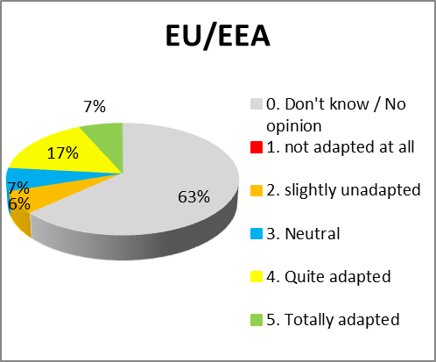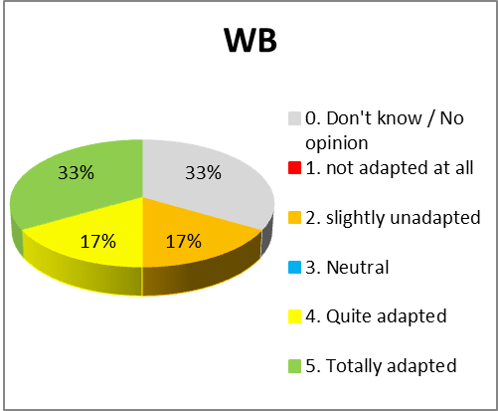

1. **Relevance of the action plan for current needs[21]**

In general, Western Balkan partners perceived the action plan and cooperation with the EU as more relevant and important than the EU Member States.

The consulted stakeholders have given a positive evaluation of the action plan for its focus on structures; law-enforcement cooperation and technical assistance and training. However, they said that cooperation with other countries like Moldova and Ukraine, where control of firearms is less rigorous, should be developed. The Firearms Platform has also accepted the expansion of the current Operational Action to those countries. The consulted stakeholders said that the action plan gave insufficient attention to criminal policy, the reinforcement of criminal sanctions and criminal procedures. Those topics appeared to be major issues because criminal sanctions in the Western Balkans often do not adequately address firearms trafficking as a separate crime, and is therefore rarely prosecuted by national authorities. Stakeholders also stressed the insufficient attention given to awareness-raising activities for stockpile management, surplus reduction or the gender dimension (underrepresentation of women, awareness of gender-based violence).

Overall, stakeholders said although the action plan had played an important role in improving cooperation against firearms trafficking it still needed to be improved and updated.

**Key findings**

* The action plan focused on the main issues of the fight against firearms trafficking by considering common administrative structures, agreed way of working and common training needs;
* The action plan promoted the coordinated collection of data for threat assessment and identified common threats.
* It promoted joint coordinated targeted controls supported by EU Agencies.
* The action plan gave insufficient attention to criminal policy, the reinforcement of criminal sanctions and criminal procedures.
* It does not sufficiently tackle future possible threats linked to trafficking to or from Ukraine and Moldova.
* Western Balkans partners are overall more involved than EU Member States
* The action plan does not sufficiently take into consideration the issue of criminal sanctions and policies, and of stockpile reduction.

## EU Added value and sustainability

No direct causal link can be drawn between the activities mentioned in the action plan and the current trends in firearms trafficking, which are influenced by a variety of other factors and individual or bilateral initiatives. The lack of performance indicators in the action plan, as well as an uneven level of details in the reporting, have also had an impact on the difficulty to quantify the EU added value of the action plan.

However, the majority of stakeholders involved recognised the action plan’s added value. The importance of the European Commission’s role as coordinator was positively considered as the Commission helps by providing a forum for law enforcement agencies to meet, develop connections and improve cooperation, with Western Balkan partners. The stakeholders commented that, in itself, this can be considered a major achievement in a region where there are significant political tensions.

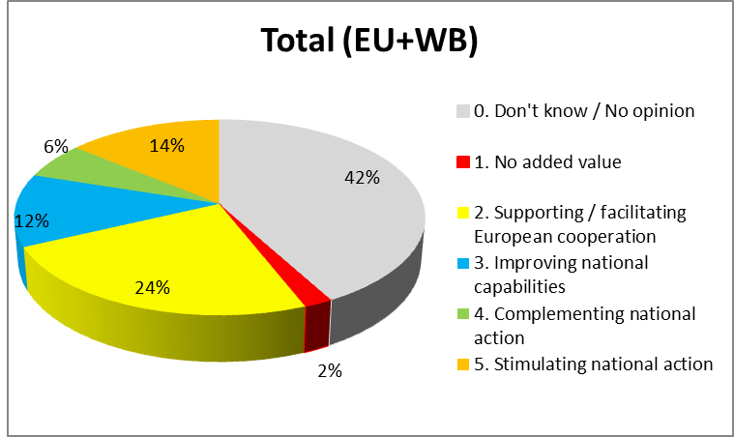

1. **Main areas of added value of the action plan[22]**

On operational cooperation, the organisation of joint coordinated targeted checks has been mostly praised as it facilitates intelligence collection, information sharing and identifies bottlenecks.

Most Western Balkans partners acknowledged Europol’s support to the operational cooperation through the involvement of its operation centre and its 24/7 intelligence reporting. At the same time, some Western Balkans partners expressed the view that Europol’s support did not provide timely feedback and useful intelligence analysis. Europol has only been able to produce a low number of intelligence cases related to the Western Balkans (5.4% of all cases in 2017, 7.6% in 2018).[23] Western Balkans partners considered that other Agencies, such as Eurojust and EBCGA had only provided a marginal contribution. No Joint Investigation Team on firearms trafficking was supported by Eurojust in the Western Balkans, and the involvement of the EBCGA and the use of the Eurosur[24] Fusion Services did not provide for sufficiently useful information to allow major seizures of firearms.[25]

All EU and Western Balkans stakeholders positively assessed the meetings of Western Balkan Experts, which facilitated the establishment of firearms focal points in the Western Balkans. In addition, these meetings facilitated the involvement of Western Balkans law-enforcement agencies in the Firearms Platform’s 2019 operational action plan.

The sustainability of the outcomes achieved under the action plan very much depends on whether and how the action plan will continue in the future. Its mere extension without taking into account the new realities and needs identified would probably not have any noticeable effect.

However, the action plan has been a dynamic document that provided general objectives and targets but also enabled the Joint Committee between EU Firearms Experts and south-east Europe partners’ experts to build on it conclusions and set out specific objectives and activities to implement it.

**Key findings**

* The action plan provided an overall framework for cooperation by ensuring a forum for law enforcement agencies to meet, develop connections and improve cooperation.
* Peer review and encouragement to set up National Focal Points and to receive joint training courses.
* Full involvement, on an equal footing with EU Member States, in EMPACT Firearms.
* Modest involvement of EU Agencies (Europol, Eurojust and EBCGA) to the activities of the action plan.

## Effectiveness

As explained also under section 3.2, two factors made it difficult to assess the effectiveness of the plan: the action plan’s lack of performance indicators and an uneven level of details in the reporting. When conducting its evaluation, the Commission had only limited access to operational information from Europol, EU member states and south-east Europe partners. Cases of seizures and joint operations very rarely provided detailed information that would allow an assessment of the trafficking routes and traffickers’ operational methods. The Commission also received contradicting figures that made the evaluation of the countries’ involvement difficult. Statistics on seizures, voluntary surrenders and destructions of weapons were not sufficiently detailed to allow for trend analyses and comparisons between jurisdictions.

Consulted stakeholders expressed mixed feelings about the action plan’s effectiveness. Activities related to the modernisation of law-enforcement agencies (Goal 1) were generally considered more effective than those related to building mutual trust and actual cooperation (Goal 2). Similarly, mixed feelings were also expressed on the activities on enhancing training and capacity building (Goal 3).

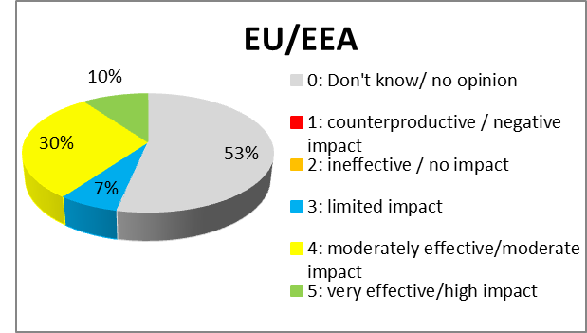 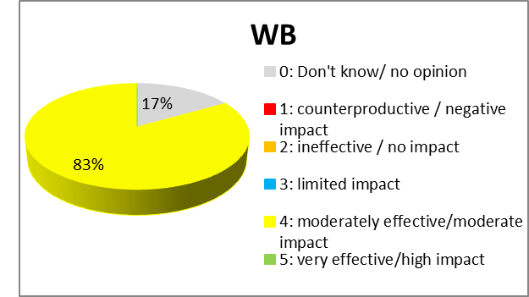

1. **Effectiveness of Actions under Goal 1[26]**

Under Goal 1, harmonised data collection on firearms seizures remains one of the main stumbling blocks both in the EU and in the Western Balkans. Only 16 EU Member States[27] and 4 Western Balkan partners[28] participate in the EU-funded UNODC's Global Firearms Study, which limits the study’s effectiveness . The reason for this low level of participation is that only a few focal points are sufficiently operational to provide the required data. A template with minimum standard intelligence requirements was not developed and enforcement agencies often considered that a template limited the usefulness of the information exchanged.

Western Balkans partners’ national legislation has generally been brought in line with EU law[29] but the revision of the Firearms Directive[30] and its implementing measures requires partners to make legislative amendments, especially on the standards for deactivation and marking firearms.

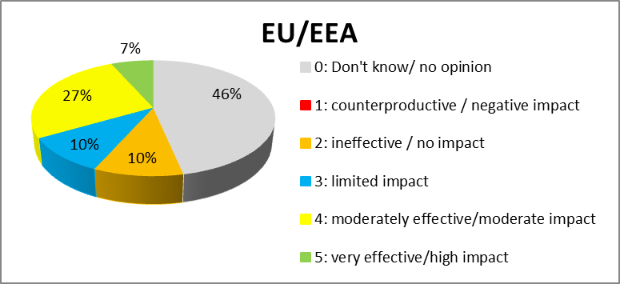 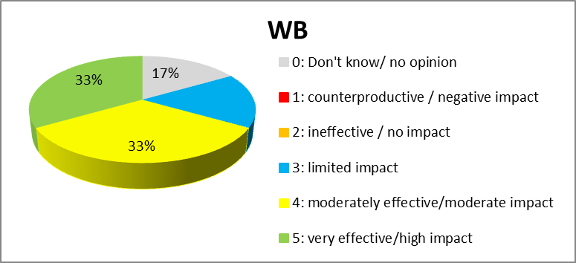

1. **Effectiveness of Actions under Goal 2[31]**

Under Goal 2, stakeholders were generally satisfied with the effectiveness of joint meetings, but noted that their effectiveness was sometimes hampered by participants being mid-ranking investigators who required authorisations and instructions to address international meetings, and were not always aware of broader developments in their respective institutions.

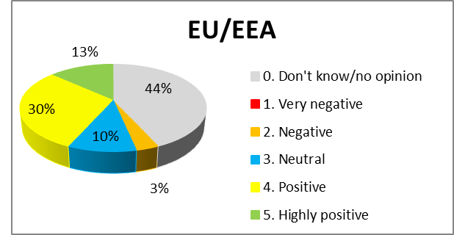 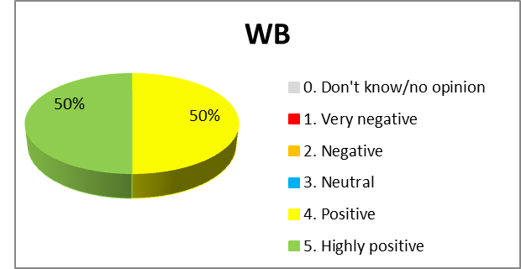

1. **Effectiveness of joint EU-WB meetings[32]**

A high turnover of staff in the national law-enforcement agencies of Western Balkans partners made daily cooperation and exchanges of information difficult. Nevertheless, available data demonstrated the ability of participants to learn from the difficulties encountered during joint coordinated targeted checks. This is demonstrated by the increased number of messages exchanged through the Secure Information Exchange Network Application (SIENA) within the joint targeted operations (as shown in Chart 6). The number of seized firearms (during the action days and in the follow-up investigations) has also been steadily increasing (as shown in Chart 7).

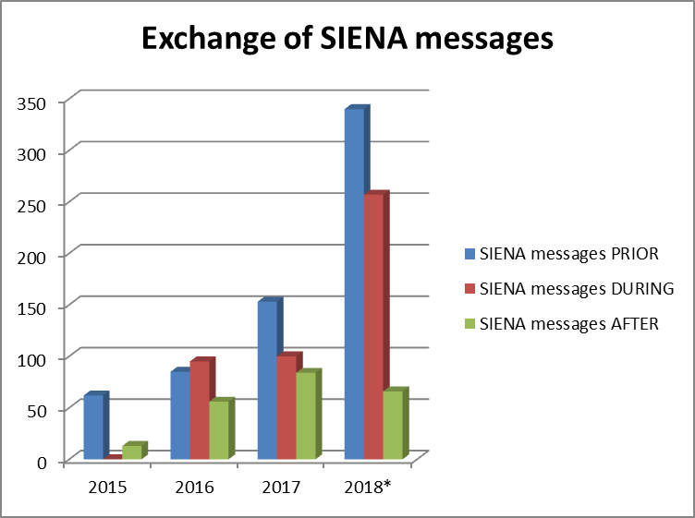 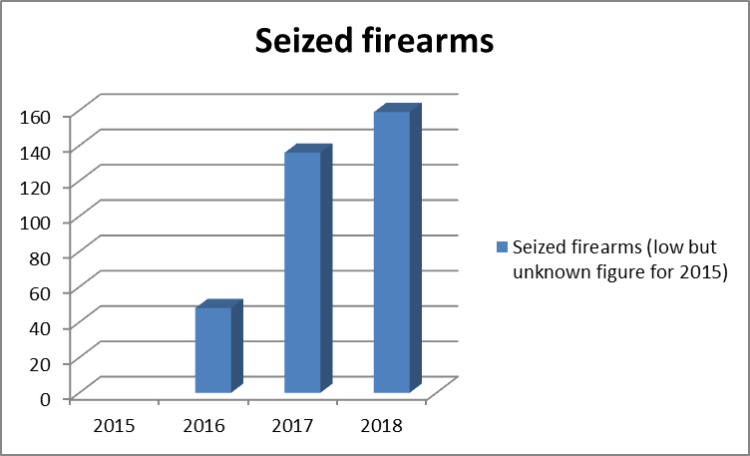

|  |  |
| --- | --- |
| 1. **[33]** | 1. **[34]** |

On the ground, border checks between Western Balkan partners have demonstrated their inadequacy. Although there is evidence that firearms travel across the Western Balkans, from and to the European Union, as recognised by all stakeholders and intelligence assessments, seizures rarely take place at border, but mostly inland. Several stakeholders also pointed out to shortcomings: border guards and customs officers do not sufficiently rely on risk profiling and prior intelligence; they are not specifically trained to detect firearms and not adequately equipped, and focus on border crossing points with no clear strategy to control the rest of the land borders used by smugglers.

The operational cooperation between EU and Western Balkans allowed identifying several weaknesses in criminal procedures of each country in both regions: special investigative techniques differ widely across countries and controlled deliveries are limited by a general reluctance to authorise those operations in the transit countries. They also considered that an enabling common legislative framework at national level could be conducive to more efficient exchanges of information for intelligence purposes outside of specific investigations.

In the field of forensics (notably ballistics), technologies vary widely across the region, which impedes exchanges and cross-comparison across borders. Ballistic analysis and international comparisons are carried out on a case-by-case basis, and are neither systematic nor fully automatised.

Under Goal 3, it is worth noting that participation of Western Balkan partners to trainings provided by CEPOL substantially increased. Figures show an uneven participation by EU Member States, with no specific identifiable trend, and a stable and low rate of participation.[35] Two countries stand out in participation: Greece and Portugal, with a substantially higher number of trainees effectively attending webinars (respectively 66 and 15 webinar trainees on average).

However, several stakeholders regretted the lack of sufficiently practical training; they also identified needs in the establishment of joint investigation teams and on specific issues such as convertible firearms, as well as specific awareness-raising activities for customs and border guards.

**Key findings**

* Activities carried out under the action plan to modernise law enforcement agencies.
* Approximation of legislation in the Western Balkans towards EU standards.
* The organisation of joint meetings for creating a unique space for dialogue and exchange of best practices between firearms experts.
* Steady improvement in the exchange of information and operational cooperation during joint coordinated targeted controls.
* Positive responsiveness of Western Balkan countries to training and capacity-building opportunities.
* Lack of key performance indicators that would have enabled a comprehensive assessment of progress towards achieving the objectives.
* National Focal Points still not established in all countries and not operational, and as a consequence:
  + still no harmonised data collection firearms seizures.
  + iArms database not systematically populated
  + no systematic tracing of weapons seized
  + no systematic or automatised ballistics analysis and cross-border comparisons
* Border checks across the Western Balkans have proven inadequate to detect firearms trafficking, mainly due to uninformed, untrained and unequipped border guards and customs officers.
* Inadequacy of investigative tools during cross-border operations due to diverging legal frameworks.

## Efficiency

Conducting a cost-benefits analysis of the action plan was limited by the fact that figures and hard data are almost non-existent, especially with respect to financial costs.

In principle, the Firearms Platform can provide substantial financial support to EU Member States and Western Balkan partners. This financial support can cover expenses such as the costs of participation in joint action days, rewards for the public to provide information, funding for special equipment; and rental of premises for covert operations. This financial support is available through different funds such as DG HOME's Internal Security Fund; Instrument for Pre Accession Assistance 2015-2020; Instrument contributing to stability and peace (2014-2020); Common Foreign and Security Policy (2017-2019). However, it appeared that EU Member States’ liaison officers in Western Balkans partners and national investigators are not fully aware of this facility and rely mostly on national funding and purely bilateral cooperation.

Over the years operational cooperation between the European Union and the Western Balkans partners did not improve or even had a negative trend. This is shown by the decreasing number of SIENA messages (outside joint control operations) from Western Balkan partners that moved down from 67% in 2017 to 29% in 2018. The same trend can be observed for cases shared with Europol: while the number increased between 2017 and 2018 for EU Member States (26 to 29), it decreased for Western Balkan partners (4 to 2).[36]

On trainings, CEPOL decided to cover the expenses of participants of each Western Balkan partner to its activities (6 in 2016 and 2017 and 4 in 2018), and they sent twice as many participants than they received funding for (while at the same time, EU member states sent 1.62 to 1.69 times more trainees than the number of participants funded by CEPOL).[37] This indicates a proportionally higher commitment and interest of Western Balkan partners than EU Member States in transnational training opportunities, and hence a high value for money. The Clearinghouse also provided useful practical training for law enforcement officers across the region. For example, it developed a weapon identification platform to help law-enforcement authorities to: (i) identify seized weapons, ammunition and explosives, and (ii) generate reports for further criminal investigations. The efficiency of trainings is however difficult to assess, since no analysis of cascading trainings (i.e. further trainings at national level provided by participants to regional trainings) was provided by the organisers. Most of the training audience consulted did not express any opinion about trainings they received. Those who did express an opinion stressed the lack of a practical advice on the setting up of joint investigations teams and on specific issues such as convertible firearms.

**Key findings**

* Useful support of EMPACT firearms to operational cooperation.
* High interest and participation rate of Western Balkan partners to training provided by CEPOL and SEESAC.
* Not enough data on concrete outcomes Lack of awareness of the support provided by EMPACT or by other EU tools.
* Exchanges of information between Europol and Western countries not providing satisfactory results to all parties concerned.

## Consistency

The European Commission has endeavoured to ensure that all stakeholders' actions are complementary. This will reduce the risk of overlaps and improve cooperation in investigations of trans-border crimes, in line with the Council conclusions of 13 December 2016.[38] Firearms trafficking was also included in the joint action plan on counter terrorism for the Western Balkans of 5 October 2018.[39] The Firearms Platform and the activities of the Clearinghouse were also enshrined within the Integrative Internal Security Governance (IISG) approach for the Western Balkans that has three pillars: counter-terrorism, fight against serious and organised crime and border security.[40]

The Clearinghouse was acknowledged by the coordinating body of the IISG as a facilitator of coordination of activities on arms control and the fight against illicit trafficking of firearms. This will ensure consistency with other streams of work and expert groups.

Cooperation between the EU and the south-east Europe region remains difficult due to the existence of a multitude of stakeholders, which are not always coordinated. Different countries and international organisations such as the Small Arms Survey, the Southeast European Law Enforcement Centre, the North Atlantic Treaty Organisation (NATO), UNODC or the Organisation for the Security and Cooperation in Europe (OSCE) are also active in the region. However, there is an unclear coordination of these groups’ activities with the Clearinghouse, the Firearms Platform, and the Internal Integrated Security Governance.

Many stakeholders have spoken of an unnecessary duplication of meetings, with similar participants having the same discussions. Conversely, due to a lack of internal coordination and information sharing, country representatives often attend different meetings with no prior knowledge of similar discussions or presentations having already taken place in similar formats.

Various funding channels (such as the Instrument for Pre-accession Assistance, including the Technical Assistance and Information Exchange Instrument (TAIEX) modality, the Internal Security Fund) initially created inconsistencies and lack of coordination. However, these issues have been addressed and overcome with the help of the Commission. One of the remaining challenges is that common foreign and security policy funding is sometimes granted without a global overview of other similar activities in the region.

Finally, consistency was ensured between the action plan and the regional roadmap. The Commission, the Firearms Platform, Europol and the Clearinghouse were all closely associated with the formulation of the regional roadmap’s needs assessment and drawing up of objectives.

**Key findings**

* strong consistency with other overarching strategies, including EU strategy on small arms and light weapons and the Regional Roadmap.
* close coordination ensured with legislative developments inside the EU on firearms control to ensure approximation of Western Balkan laws with EU standards consistency ensured with international instruments.
* weak coherence between activities of different stakeholders; many overlaps; lack of integrated steering structure in the organisation of different activities.
* lack of integrated and comprehensive budgetary approach at EU level.

# Conclusions

The EU and Western Balkan partners are facing common challenges.

The action plan’s added value was most visible in improving networking, exchange of information and putting in place the building blocks of future cooperation.

However, the action plan evaluation shows that several planned actions have not yet been fully implemented, which reduced the action plan’s effectiveness. This is notably the case for the establishment of firearms focal points, which are necessary for proper enforcement strategies, coordination, intelligence and exchanges of information, both nationally and at European level. There is also still no harmonised data collection for firearms seizures which would enable an evidence-based policy and proper and reliable assessment of trafficking trends. Similarly, stakeholders did not develop a standard reporting format for the exchange of information as planned by the action Plan.

The evaluation also demonstrates that the action plan’s effectiveness could be improved. For example, to allow the joint meetings to deliver concrete results they could benefit from clear instructions to participants, which should be authorised to deliver a position or an input on possible deliverables. Many stakeholders considered that trainings would be made more efficient by focusing on practical cases, the establishment of joint investigations and on specific issues such as convertible firearms.

With respect to the geographical scope, activities have been focusing on the Western Balkan, but future challenges may justify covering effectively the whole south-east Europe, including the Republic of Moldova and Ukraine, in order to develop future-proof solutions in the EU's Eastern neighbourhood.

Member States and Western Balkan partners should now turn their political commitments into operational priorities and deliverables. Closer co-ordination between Member States, Western Balkans partners, EU agencies and international organisations is needed in order to ensure better and concrete results in the joint fight against firearms trafficking. In that context, the regional roadmap presents a comprehensive assessment of the needs for a future policy in the region. It could be complemented by country-specific operational objectives, more detailed performance indicators and a clear steering and budgetary structure. The Commission is prepared to support Member States, Western Balkan partners, EU agencies and international organisations in delivering on these challenges. The different stakeholders consulted have expressed the need for an action plan. Overall, the evaluation of this Action Plan will need to be taken into account to ensure continuous cooperation in this area in the future.

1. For an overview, see the Eighteenth Progress Report towards an effective and genuine Security Union (COM(2019) 145 final, 20.3.2019).
2. See Directive (EU) 2017/853 (175.2017) amending Council Directive 91/477/EEC on control of the acquisition and possession of weapons.
3. See the December 2015 action plan against illicit trafficking in and use of firearms and explosives (COM(2015) 624 final, 2.12.2015).
4. Small arms and light weapons and their ammunition are military-grade weapons (SALW); they include: (a) small arms: assault rifles; military-grade semi-automatic rifles and carbines; military-grade revolvers and self-loading pistols; light machine guns; sub-machine guns, including machine pistols; (b) light weapons: heavy machine guns; cannons, howitzers and mortars of less than 100 mm calibre; grenade launchers; recoilless guns; shoulder-fired rockets and other anti-tank and air defence systems that fire projectiles, including MANPADS, all on condition they are man- or crew-portable; (c) SALW parts; (d) SALW accessories (such as night scopes, sound suppressors, etc.); and (e) SALW ammunitions.

   The term ‘firearms’ has a broader scope that covers both civilian and military-grade firearms. The UN firearms protocol of 11 July 2001 defines a firearm as any portable barrelled weapon that expels, is designed to expel or may be converted to expel a shot, bullet or projectile by the action of an explosive, excluding antique firearms or their replicas. It should be noted that some light weapons, such as rocket launchers, are not firearms. Hence the term ‘firearms’ does not cover all Small Arms.
5. Europol Serious and Organised crime Threat Assessment 2017, <https://www.europol.europa.eu/socta/2017/>
6. Albania, Serbia, Bosnia Herzegovina, Montenegro, North Macedonia and Kosovo*. In this document, any reference to Kosovo is without prejudice to positions on status, is in line with Security Council Resolution 1244 (1999) and the ICJ Opinion on the Kosovo Declaration of Independence.
7. 14 November 2014, Council Document 15516/14, adopted by the Council of 4 and 5 December 2014 (Council Document 16526/14); EU – Western Balkans Ministerial Forum on Justice and Home Affairs of 12 December 2014 in Belgrade.
8. Council Decision (CFSP) 2018/1788 of 19 November 2018 in support of the South-Eastern and Eastern Europe Clearinghouse for the Control of Small Arms and Light Weapons (SEESAC) for the implementation of the Regional Roadmap on combating illicit arms trafficking in the Western Balkans, OJ L 293, 20.11.2018, p. 11–23.
9. Council Decision 2002/842/CFSP of 21 October 2002 concerning the implementation of Joint Action 2002/589/CFSP with a view to a European Union contribution to combating the destabilising accumulation and spread of small arms and light weapons in South East Europe (OJ L 289, 26.10.2002, p. 1), extended and amended several times and lastly by Council Decision (CFSP) 2016/2356 of 19 December 2016 in support of SEESAC disarmament and arms control activities in South-East Europe in the framework of the EU Strategy to combat illicit accumulation and trafficking of Small Arms and Light Weapons and their ammunition, OJ L 348, 21.12.2016, p. 60–71.
10. iTrace is a European Union-funded project, which provides policy makers with dynamic, quantified data on transfers of diverted conventional weapons, ammunition, and related materiel.
11. The INTERPOL Illicit Arms Records and tracing Management System (iARMS) is a state-of-the art tool that facilitates information exchange and investigative cooperation between law enforcement agencies in relation to the international movement of illicit firearms, as well as licit firearms that have been involved in the commission of a crime.
12. A Joint Action Day is a day/s of coordinated controls carried out by law enforcement agencies of different countries targeting organised crime groups involved in firearms trafficking.
13. 26 January 2016, 30 November 2016, 26 January 2018 and 24 September 2018.
14. 15 May 2018, Council Document Nr 8586/18.
15. <https://www.unodc.org/unodc/en/firearms-protocol/data-collection-and-analysis.html>
16. <http://www.seesac.org/publication/p2.html>
17. Council conclusions on the creation and implementation of an EU policy cycle for organised and serious international crime (doc. 15358/10 COSI 69 ENFOPOL 298 CRIMORG 185 ENFOCUSTOM 94, 10.6.2011).
18. Respectively of 9 December 2013, 31 August 2016, 29 September 2014, 22 December 2011 and 16 January 2014.
19. Albania, Bosnia and Herzegovina, North Macedonia, Montenegro and Serbia.
20. *Strengthening Resilience in the Western Balkans*, op. cit.
21. Responses to the questionnaire sent to law enforcement Agencies in June 2018.
22. Responses to the questionnaire sent to law enforcement Agencies in June 2018.
23. Source: Europol.
24. European Border Surveillance System.
25. Albania, Bosnia Herzegovina, North Macedonia , Montenegro and Serbia.
26. Responses to the questionnaire sent to law enforcement Agencies in June 2018.
27. AT, BE, CZ, DK, EL, ES, FI, HR, LT, NL, PT, RO, SE, SI, SK, UK.
28. AL, BiH, MD, ME.
29. Notably Council Directive 91/477/EEC on control of the acquisition and possession of weapons, OJ L 256 13.9.1991, p. 51); Regulation (EU) No 258/2012 of the European Parliament and of the Council of 14 March 2012 implementing Article 10 of the United Nations’ Protocol against the illicit manufacturing of and trafficking in firearms, their parts and components and ammunition, supplementing the United Nations Convention against Transnational Organised Crime (UN Firearms Protocol), and establishing export authorisation, and import and transit measures for firearms, their parts and components and ammunition; OJ L 94, 30.3.2012, p. 1–15.
30. Directive (EU) 2017/853 of 17 May 2017 amending Council Directive 91/477/EEC on control of the acquisition and possession of weapons, OJ L 137, 24.5.2017, p. 22–39.
31. Responses to the questionnaire sent to law enforcement Agencies in June 2018.
32. Responses to the questionnaire sent to law enforcement Agencies in June 2018.
33. Sources: Europol, EMPACT. Figures for 2018 are not final.
34. Ibid.
35. Member States have sent on average 3.8 participants each year to all trainings (residential trainings and webinars), while Western Balkan Partners sent 2.7 participants.
36. Source: Europol.
37. Source: CEPOL.
38. Council Document 15536/16.
39. <https://ec.europa.eu/home-affairs/sites/homeaffairs/files/news/docs/20181005_joint-action-plan-counter-terrorism-western-balkans.pdf> ; see objective 5.
40. <https://wb-iisg.com/>