

**1. Introduction**

Every year the European Commission reports on how the EU Charter of Fundamental Rights (the Charter)[1] has been applied in the EU and its Member States. This report looks at **2018**. It also **marks the 10th anniversary of the Charter’s entry into force**.

This report shows that the Charter is living up to its promise as the most modern, sophisticated and comprehensive legally binding fundamental rights instrument. The Charter is most effective, with a real impact on people’s lives, when the entire enforcement chain applies it.

There is however room for improvement, especially at national level. Results of a recent Eurobarometer survey on Charter awareness[2] show that only 42% of respondents have heard of the Charter and 12% know what it is. 60% would like more information on Charter rights and on where to turn to if their rights are violated.

It is important to make sure the Charter delivers for everyone. National authorities, including the courts, are required to apply the Charter when implementing EU law. Civil society and rights defenders play a key role in raising awareness of the rights it contains and ensuring that everyone can effectively enjoy them. There can be no effective fundamental rights protection without vibrant civil society organisations and rights defenders. In 2018, the Commission took legal action to ensure that civil society organisations can work safely and independently[3]. It also proposed legislation to strengthen financial support for their work[4].

Looking ahead to the May 2019 European elections, the Commission took action[5] to make sure citizens can exercise their electoral rights freely and in a well-informed manner. A healthy democracy and respect for the rule of law are key conditions for promoting and protecting fundamental rights, and vice versa.

**2. Charter application in and by the EU**

***2.1 Promoting and protecting fundamental rights***

* + 1. ***Supporting civil society organisations and human rights defenders***

Civil society organisations active on fundamental rights, national human rights institutions and equality bodies play a key role in raising awareness of Charter rights and ensuring their effective implementation on the ground. Supporting and protecting them is all the more important when fundamental rights are under threat[6]. The situation of civil society organisations was at the heart of the **Commission’s 2018 Colloquium on fundamental rights**[7]. Participants highlighted that civil society organisations and rights defenders should be able to work safely, independently and transparently. They should also have access to sufficient financial means to help them make fundamental rights a reality in people’s lives.

On 30 May 2018, the Commission put forward a proposal for a **Justice, Rights and Values Fund providing further support for rights defenders and civil society organisations active in the protection and promotion of Charter rights**. It will for instance support civil society organisations in improving access to justice for all, in particular through rights awareness activities, exchanging best practices on litigation, and training on the Charter[8].It will also support organisations in ensuring the effectiveness of fundamental rights by funding activities on participation in the democratic life of the EU, equality and non-discrimination, and preventing and combating racism and violence[9].

The Commission also carried out consultations to implement a preparatory action requested by the European Parliament, on an **EU fund for financial support for litigating cases relating to violations of democracy, rule of law and fundamental rights**. The aim is to raise awareness among legal professionals and practitioners of Charter rights and how they can be enforced at national and European level.

Furthermore, the Commission included in its legislative proposal for EU funding polices under shared management for the post-2020 period[10] an **enabling condition on the effective application and implementation of the Charter**. It includes reporting arrangements to verify that operations supported by EU funds comply with the Charter.

On 22 June 2018, the Commission adopted a recommendation[11] encouraging Member States to set out measures to **improve equality bodies’ independence and effectiveness**. This is vital for them to work efficiently. The Commission also continued to monitor national legislation affecting the work of civil society organisations and took action where it identified a breach of EU law[12].

* + 1. ***Establishing whistleblower protection at EU level***

On 23 April 2018, the Commission proposed common minimum standards to guarantee a high level of **whistleblower protection** acrossthe EU[13]. They will have a clear positive impact to safeguard whistleblowers’ freedom of expression (Article 11 of the Charter). Protecting whistleblowers against retaliation is essential to safeguard media freedom and the watchdog role of investigative journalism in democratic societies.

Whistleblowers will be able to report on breaches of EU law covered by the directive through easily accessible and secure channels, both internally (within an organisation) and externally (to a competent authority). Whistleblowers will also be able to resort to public disclosures when those channels are not available or cannot reasonably be expected to work properly, or in cases of imminent or manifest danger to the public interest. These rules will furthermore ensure that retaliation is prohibited and punished and that if whistleblowers do suffer retaliation, they will have effective remedies.

* + 1. ***Promoting electoral rights***

President **Juncker** announced in his 2018 State of the Union Address[14] **measures to help EU citizens exercise their electoral rights** **under the Charter in an effective, free, fair and secure manner.** They follow recommendations issued in February 2018[15], in which the Commission highlighted practical steps to improve the efficient conduct of the 2019 elections to the European Parliament. Recent cases have highlighted the risks of mass online disinformation campaigns, non-transparent political advertising, misuse of citizens’ personal data, breaches of conventional electoral safeguards, cyberattacks and other efforts to interfere in elections and undermine democracy in Europe. The measures set out by the European Commission[16] aim to support joined up action among all involved participants in the democratic process, helping to:

* enable authorities to quickly detect potential threats, exchange information and ensure a swift and well-coordinated response.
* ensure greater transparency in online political advertisements and targeting, and security measures to protect networks and information systems from cybersecurity threats.
* support national authorities and European and national political parties correctly apply the new EU data protection obligations[17] in the electoral context.
* make it possible to impose financial sanctions[18] for breaching data protection rules to deliberately influence the outcome of the European elections.

As a follow-up to the **High Level Expert Group on Fake News**[19], the Commission adopted a **Communication on disinformation**[20] on 26 April 2018, inviting representatives of online platforms, the advertising industry and major advertisers[21] to draft a self-regulatory **code of practice on tackling disinformation[22]**. Commitments include ensuring transparency of political advertising, closing active fake accounts, labelling messages spread by ‘bots’, and improving the visibility of fact-checked content. The Commission and the High Representative complemented this Communication by setting out **a joint action plan[23] to tackle disinformation**. It includes improved data analysis and detection tools, a rapid alert system to share information on disinformation campaigns and coordinate responses, and monitoring of the implementation of the Code of Practice.

* + 1. ***Promoting a society where tolerance, pluralism and non-discrimination prevails***

In 2018, data published by the EU Agency for Fundamental Rights showed that racism and discrimination is still on the rise[24]. Against this background, the [**High Level Group on combating racism, xenophobia and other forms of intolerance**](http://ec.europa.eu/newsroom/just/item-detail.cfm?&item_id=51025) continued to develop responses to hate crime and hate speech in the EU[25]. A key deliverable was a guidance on the practical application of the EU Framework Decision on combating racism and xenophobia[26] to help Member States address the challenges they face in putting their legal obligations into practice for the benefit of the public[27].

The Commission also continued to monitor the impact of the **Code of Conduct on countering hate speech online**[28]. The results of the 2018 evaluations show tangible results on the removal of illegal hate speech[29]. IT companies remove on average over 70% of the content notified to them, compared to 59% in 2017 and 28% in 2016. In 2018, four additional companies, Instagram, Google +, Snapchat and Dailymotion, announced their participation in the code of conduct.

The Council adopted a declaration[30] on further action to combat **antisemitism**. The EU Agency for Fundamental Rights’ 2018 Antisemitism survey[31] shows that problems persist. 9 in 10 respondents feel that antisemitism increased in their country in the five years before the survey. More than 8 in 10 consider it a serious problem. The Commission continued to support initiatives combating all forms of antisemitism under the Rights, Equality and Citizenship programme. It hosted the 12th EU-Israel High Level Seminar on combating racism, xenophobia and antisemitism and continued to raise awareness among its own staff, with training on Holocaust remembrance and antisemitism. In November 2018, the EU became a permanent international partner in the International Holocaust Remembrance Alliance.

The Commission intensified its cooperation with key stakeholders and civil society on combatting **anti-Muslim hatred**. European Imams met on 28 March 2018 and a high-level conference on tackling intolerance and discrimination against Muslims in the EU was held on 3 December 2018[32]. At this conference, the EU Agency for Fundamental Rights launched a database on anti-Muslim hatred[33].

In 2018, the Commission adopted its report on the mid-term evaluation[34] of the 2011 EU Framework for National **Roma** Integration Strategies up to 2020. It highlights progress in particular in the area of education. As part of the European Semester, the Commission continued to monitor progress on Roma inclusion and proposed country-specific recommendations on inclusive mainstream education for Roma children in four countries (BG, HU, RO, SK). In its May 2018 proposals for 2021-2027 Structural Funds[35], the Commission proposed a strong link between policy and funding priorities related to Roma inclusion. The Rights, Equality and Citizenship programme also funded projects supporting Roma inclusion and fighting discrimination and anti-gypsyism across Europe.

## *2.2. Ensuring the respect of fundamental rights*

EU institutions, bodies, offices and agencies must comply with the Charter in all their actions. Cases of non-compliance can be brought before the Court of Justice of the EU. In 2018, the Commission continued to mainstream fundamental rights in its legislative and policy initiatives to ensure compliance with the Charter. Some examples include:

* Proposed Regulation to **prevent the dissemination of terrorist content online**[36]. This would create a harmonised legal framework to make sure that online hosting services are not used to share terrorist content. It clarifies the responsibility of Member States and hosting service providers in ensuring the safety of their services and in detecting and removing terrorist content. The Commission analysed the impact of the proposal on Charter rights and included safeguards to ensure the respect for these rights.
* The revised **Audiovisual Media Services Directive (AVMSD)**[37] reinforces the battle against illegal and harmful content in all audiovisual services, including on social media. Video-sharing platforms (e.g. YouTube) will need to put in place measures to protect children from harmful content and to protect the general public from incitement to violence or hatred and from certain content constituting criminal offences.
* Proposed measures on **artificial intelligence (AI)**[38]. AI developments need to comply with the Charter (‘fundamental rights by design’). On 7 December, the Commission put forward a coordinated plan with Member States to ensure that AI is applied in a way that respects fundamental rights and ethical rules. On 18  December 2018, the Commission’s High Level Group on Artificial Intelligence[39] produced draft ethical guidelines[40] that also cover the impact of AI on fundamental rights.
* **Funding instruments in the areas of migration, border management and security** for the next Multiannual Financial Framework (MFF)[41]: These proposals highlight the need to use funds in full compliance with Charter rights and principles. Actions implemented with the support of EU funds should take particular account of the fundamental rights of children, migrants, refugees and asylum seekers and ensure the full respect of the right to human dignity, the right to asylum, and the rights of those in need of international protection and protection in the event of removal.

## *2.3 Court of Justice scrutiny of EU institutions*

The **Mykola Yanovych Azarov v Council**[42] case related to an appeal against the freezing of funds and economic resources, in view of the situation in Ukraine. The appellant’s name was on the list of persons, entities and bodies covered by the freezing of funds and economic resources on the basis of a decision of a judicial authority of a non-EU country. The Council’s obligation was to verify that this decision had been adopted in full respect of the right of defence and the right to effective judicial protection. The Court found that it was not apparent from the statement of reasons that the Council verified that the Ukrainian judicial authorities had respected the appellant’s right of defence and right to judicial protection. Accordingly, the Court annulled the contested measures, as far as they concern the appellant.

**3. Charter application in and by Member States**

* 1. ***Developments in fundamental rights and the rule of law***

The Charter is addressed to Member States only when they are implementing EU law, as set out in its Article 51. Infringement procedures based on the Charter can therefore only be triggered when a sufficient link to EU law is established. The Commission receives many complaints every year on which it cannot act, as the situation does not fall within the scope of EU law[43]. This can lead to some frustration when individuals seek to invoke their rights.

In 2018, the Commission took action in the following cases relating to the Charter:

On 24 September 2018, the Commission referred Poland to the Court of Justice of the EU for violations of the principle of judicial independence by the new law on the Supreme Court. The Commission considers that the retirement regime for judges in the new law is incompatible with EU law as it undermines the principle of judicial independence, including the irremovability of judges (Article 19(1) of the Treaty on European Union read in connection with Article 47 of the Charter). On 17 December 2018, the Court of Justice of the EU issued a final order on interim measures, ordering the application of the retirement regime of the Supreme Court law to be stopped.

On 19 July 2018, the Commission launched an infringement procedure against a Hungarian law criminalising any assistance offered by any person on behalf of national, international and non-governmental organisations to people wishing to apply for asylum or for a residence permit in Hungary. On the same day, it referred Hungary to the Court of Justice of the EU for non-compliance of its asylum and return legislation with EU law. This follows an infringement launched in 2015 and consequent exchanges[44].

On 8 November 2018 the Commission launched an infringement procedure against Bulgaria on the incorrect implementation of EU asylum legislation. Concerns relate in particular to the accommodation and legal representation of unaccompanied minors, the identification and support of vulnerable asylum seekers, the provision of adequate legal assistance, the detention of asylum seekers and safeguards within the detention procedure[45].

Even when acting outside the framework of EU law, Member States must respect the values on which the EU is founded. In particular, respect for the rule of law is a precondition for the protection of fundamental rights. In 2018, the Council held three hearings in relation to the situation of the rule of law in Poland, following the Commission’s triggering of Article 7(1) of the Treaty on European Union in 2017. On 12 September 2018, the European Parliament decided to initiate an Article 7(1) procedure against Hungary.

## *3.2 Court of Justice guidance to Member States*

In 2018, the Court of Justice of the EU (CJEU) referred to the Charter in 356 cases (against 27 in 2010).

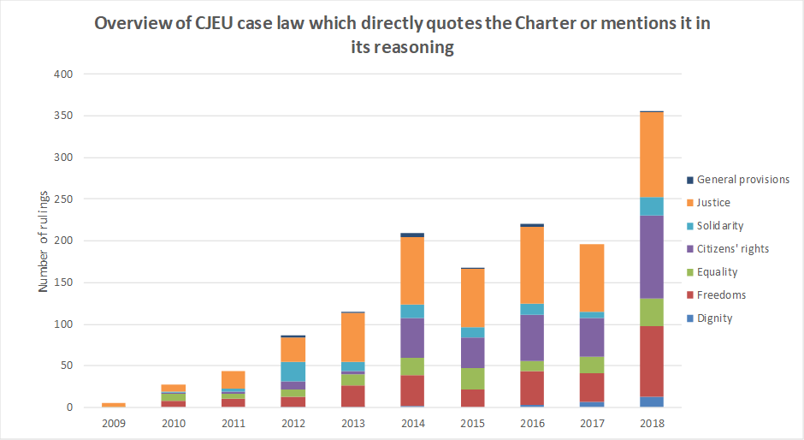

When referring questions to the CJEU (requests for preliminary rulings), national courts increasingly make reference to the Charter (84 in 2018, compared to 19 in 2010).

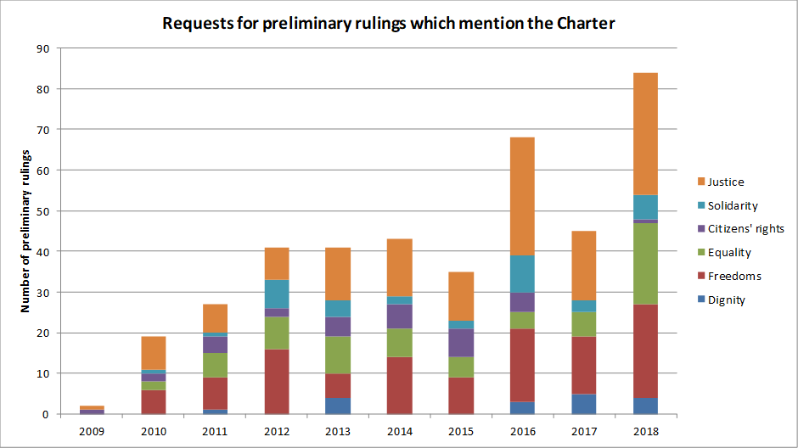

In 2018, the CJEU referred to the Charter in a number of cases concerning non-discrimination. In two cases where ethos-based organisations treated workers differently based on their religion[46], the Court clarified for the first time the interpretation of Article 4(2) of Directive 2000/78/EC[47], which provides for an exception to the non-discrimination principle on the grounds of religion where the employer is a church or another ethos-based organisation. The Court explicitly referred to Articles 10, 21 and 47 of the Charter and found that while Directive 2000/78/EC protects the fundamental right of workers not to be discriminated against on grounds of their religion, it also aims to take into account the right of autonomy of churches and ethos-based organisations, under Article 10 of the Charter.

In the *Coman*[48] case, the Court confirmed that the term ‘spouse’ in the provisions of EU law on free movement and residence of Union citizens refers to a person joined to another person by the bonds of marriage, is gender-neutral and may therefore cover the same-sex spouse of a EU citizen. The Court pointed out that the rights guaranteed by Article 7 of the Charter have the same meaning and the same scope as those guaranteed by Article 8 of the European Convention for the Protection of Human Rights and Fundamental Freedoms. The Court referred to European Court of Human Rights case law concluding that the relationship of a same-sex couple falls within the notions of ‘private life’ and ‘family life’ in the same way as the relationship of a heterosexual couple in the same situation.

In two cases concerning the application of the right to an effective remedy to EU rules on asylum and return[49], the CJEU held that Article 47 of the Charter, read together with Articles 18 and 19(2) of the Charter, requires that an applicant for international protection should be able to enforce his/her rights effectively before a judicial authority.

## *3.3. National case law quoting the Charter*

National judges play a key role in upholding fundamental rights. The EU Agency for Fundamental Rights found that national courts continued to make reference to the Charter in 2018, in particular in the area of asylum and migration, data protection and judicial cooperation in criminal matters[50].

The Charter only applies to Member States when they implement EU law (Article 51 of the Treaty on European Union). However, national judges do not only make reference to the Charter in cases within the scope of EU law. In the majority of judicial decisions referring to the Charter, the question of whether and why the Charter applies is not raised. Only rarely are Article 51 of the Charter and its field of application analysed by judges[51].

2018 confirmed past patterns in relation to references to specific articles of the Charter. The right to an effective remedy and to a fair trial (Article 47) remained the Charter provision most often referred to. National judges also referred to the right to the respect for private and family life (Article 7) and to the right to the protection of personal data (Article 8)[52]. The following cases provide some illustration:

In **Finland**[53], the Supreme Administrative Court noted that immigration services cannot require asylum applicants to provide photographs or video recordings of intimate acts in support of their claim of persecution on grounds of sexual orientation, as this would infringe the right to human dignity (Article 1 of the Charter) and the right to private life (Article 7 of the Charter).

In **the Czech Republic**[54], the Supreme Administrative Court ruled that paragraph 171(a) of the Act on the Residence of Foreign Nationals, according to which the refusal to grant a visa cannot be challenged before a court, violates Article 47 of the Charter (Right to an effective remedy and to a fair trial).

In **Portugal**[55]the Constitutional Court reviewed Article 7(3) of the Law 34/2004 governing the access to courts, which prohibits the granting of legal aid to entities operating for profit. The Constitutional Court declared the norm unconstitutional and stressed that the right to effective judicial protection guaranteed by Article 47 of the Charter may require the granting of legal aid for profit-making legal persons.

# 4. Focus section: 10th Anniversary of the entry into force of the Charter

A culture of fundamental rights has gradually developed in the EU institutions. Policy makers are increasingly aware of the importance of ensuring that their initiatives are Charter compliant[56]. Since the Charter entered into force, the EU has adopted a number of initiatives directly promoting and protecting people’s Charter rights[57]. References to the Charter by the CJEU have increased since 2010. Work must continue with a strong political EU agenda to promote and protect fundamental rights.

National courts are also referring to the Charter in their decisions and increasingly asking the CJEU for guidance[58]. The Charter is nevertheless still not used to its full potential and awareness remains low[59]. The EU Agency of Fundamental Rights points to a lack of national policies that promote awareness and implementation of the Charter[60]. The Eurobarometer on Charter awareness[61] shows that though the situation has slightly improved since 2012, only 42% of respondents have heard of the Charter and only 12% really know what it is.

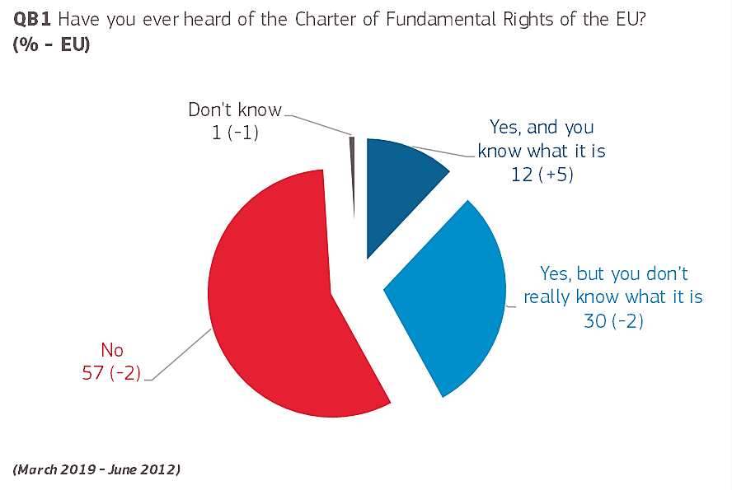

Results also show that six in ten respondents would like to have more information on the Charter and on where to turn to if their Charter rights are violated.

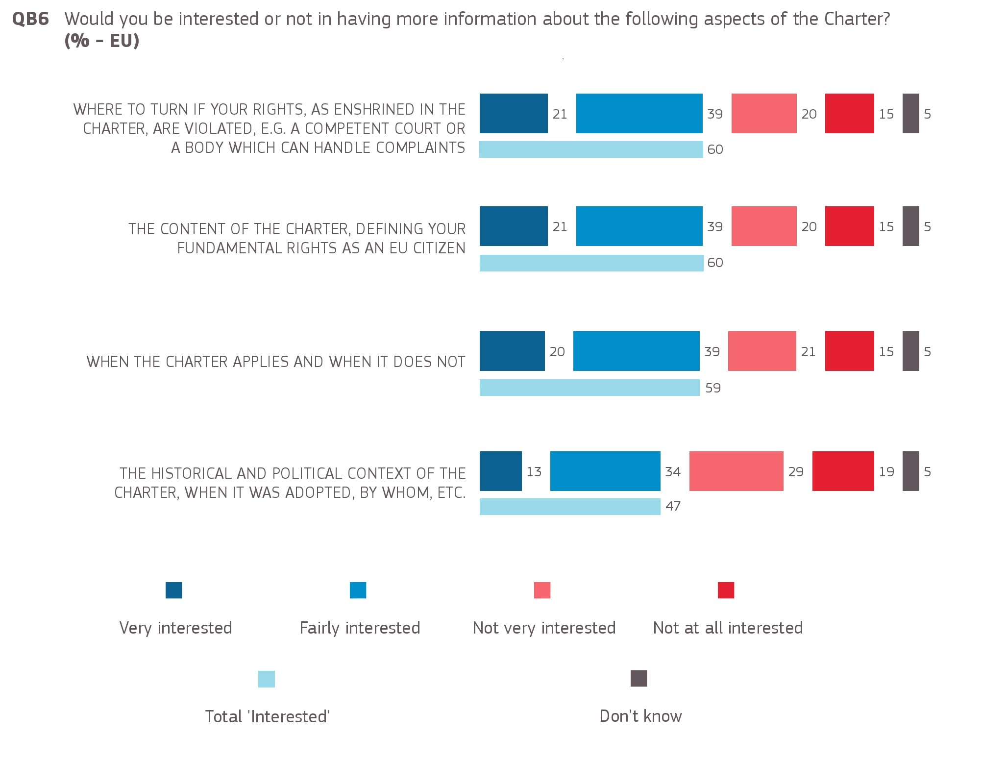

The Charter can only be effective in people’s lives if they know about their rights, if they know where to turn to when their rights are violated and if national courts, legislators and administrations implement their rights.

The Fundamental Rights interactive tool[62] helps people identify the competent national authority when their rights are violated. It was searched 3,871 times in 2018, and could be better publicised to increase usage.

Charter events organised by EU Presidencies in cooperation with the Commission and the EU Agency for Fundamental Rights[63] have highlighted best practice by national authorities to increase Charter awareness and develop tools[64] that will make it easier for policy makers to mainstream the Charter in their work. A new tool that helps verify if a specific case falls within the scope of the Charter — CharterClick[65] — has been available on the e‑Justice Portal since October 2018. The tool is complemented by a comprehensive tutorial on using the Charter[66].

Training on the Charter is central to ensuring its effectiveness. Through the European Judicial Training Network, the Commission continued to support the training of judges and prosecutors in 2018[67]. The Commission’s Justice programme also supported quality projects for training legal practitioners on the Charter[68].

The Commission’s proposal for a new Justice, Rights and Values Fund opens the possibility for funding Charter awareness activities for national authorities, besides judges and legal practitioners (i.e. ministries, police, and national parliaments).

The EU Agency for Fundamental Rights carried out a number of activities on Charter awareness and training in 2018. It issued key principles for communicating Charter rights[69] and updated and expanded *Charterpedia* (an online information tool with Charter article-by-article access to relevant European and national case law as well as relevant norms of constitutional, EU and international law[70]). This complements the information available on the e-Justice portal on the Charter, its scope of application, interpretation and effects. The Agency also produced a handbook on the Charter for legal practitioners and policy makers in October 2018[71], which serves as a basis for training given to national authorities[72]. Working with human rights institutions, the Agency developed material for training targeted to civil servants and civil society organisations. Training civil society organisations on the Charter is crucial, given the role they play in making it a reality in people’s lives. The results of a survey carried out by the Agency in 2018 among members of its platform of civil society organisations show that there is scope to improve awareness and use of the Charter.

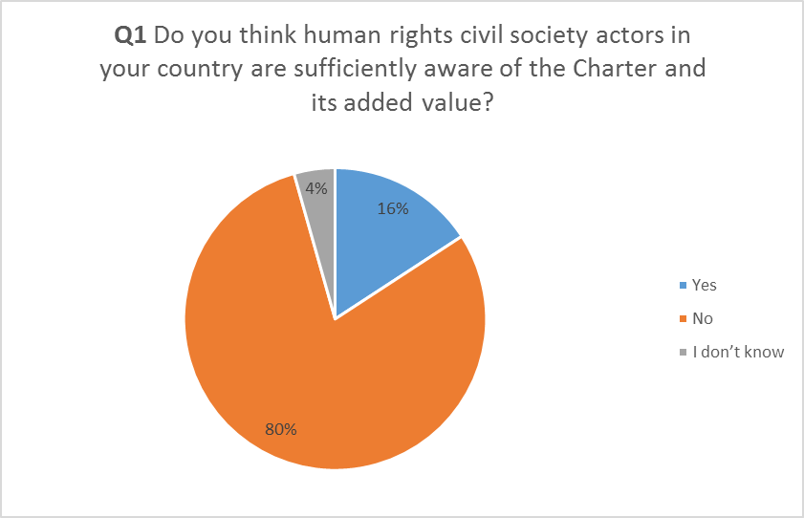 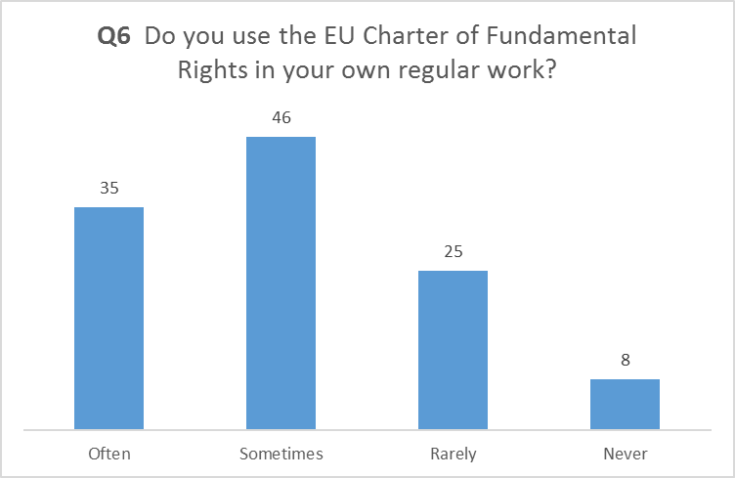

Source: Anonymous survey on the use of the Charter carried out by the EU Agency for Fundamental Rights amongst its Fundamental Rights Platform organisations in August 2018

The number of national human rights institutions (NHRIs) accredited under the Paris Principles[73], has risen significantly in the EU since 2010 (a 53% increase from 15 to 23 EU Member States). Among these, there was also a 50% increase in the number of ‘A-status’ NHRIs (fully compliant with the Paris Principles), from 10 to 16. Currently, only 5 Member States lack an accredited NHRI. The European Network of National Human Rights Institutions is working with relevant stakeholders to provide assistance in this regard. Since 2010, NHRIs have become increasingly active in monitoring and reporting on the implementation of the Charter at national level, providing awareness raising[74] and training[75] on the Charter to judges, lawyers and civil society organisations, advising[76] their government and Parliament on requirements under the Charter and strategic litigation[77] at national level and before the Court of Justice of the European Union. They are an important part of the enforcement chain.

The same goes for equality bodies, which have gradually emerged as key players in the EU’s non-discrimination infrastructure[78]. As a first point of contact for victims of discrimination, they have developed extensive understanding of how discrimination affects people in Europe and worked more strategically towards better awareness and implementation of the EU equal treatment legislation[79]. The majority of Member States went beyond the legally binding EU requirements and gave competence to their equality bodies to cover, in certain instances, the full range of grounds in Article 21 of the Charter[80]. The Commission’s 2018 recommendation on standards for equality bodies[81] aims to advise Member States on measures to help increase the effectiveness and independence of equality bodies.

**5. Conclusion**

This report shows that the Charter has proven to be a key instrument to make fundamental rights a reality in people’s lives. It is still a relatively young instrument when compared, for example, to the European Convention of Human Rights, which has existed for over 65 years.It will take time and sustained work for it to be used to its full potential, especially at local and national level.

Civil society and rights defenders play a key role in making the Charter a reality in people’s lives. Towards the end of 2019, the Commission, the Finnish Presidency of the EU and the EU Agency for Fundamental Rights will hold a 10 year anniversary conference to celebrate the Charter and reflect on how, with the help of civil society and rights defenders, it can become a meaningful part of everyday life. This will provide the new Commission with vital information and guidance.

1. Commission communication “Strategy for the effective implementation of the Charter of Fundamental Rights by the European Union”, COM(2010)573.
2. Special Eurobarometer 487b.
3. http://europa.eu/rapid/press-release_IP-18-4522_en.htm.
4. COM(2018)384, available at https://eur-lex.europa.eu/legal-content/EN/TXT/?uri=COM:2018:384:FIN; COM(2018) 383, available at https://eur-lex.europa.eu/legal-content/EN/TXT/?uri=COM%3A2018 %3A383 %3AREV1.
5. See section 2.1.3.
6. See EU Agency for Fundamental Rights publication of May 2018 on challenges faced by civil society organisations, available at <https://fra.europa.eu/en/publication/2018/challenges-facing-civil-society-orgs-human-rights-eu> and contribution to the Commission’s 2018 Colloquium on fundamental rights, available at https://fra.europa.eu/en/publication/2018/colloq-civil-society.
7. Documents and conclusions available at <https://ec.europa.eu/info/events/annual-colloquium-fundamental-rights_en>.
8. COM(2018) 384 (Justice programme).
9. COM(2018) 383 (Rights and Values programme).
10. COM(2018) 375.
11. COM(2018) 951.
12. See section 3.1.
13. COM(2018) 218. The European Parliament and the Council reached an agreement on this Proposal on 11 March 2019.
14. https://ec.europa.eu/commission/priorities/state-union-speeches/state-union-2018_en.
15. C(2018)900.
16. C(2018)5949, COM(2018) 638, COM(2018) 636 and COM(2018) 630.
17. The new EU data protection rules entered into application in May 2018. They apply to all European and national political parties and to other actors in the electoral context, like data brokers and social media platforms.
18. Sanctions would amount to 5 % of the annual budget of the European political party or foundation concerned. The sanction will be enforced by the Authority for European political parties and European political foundations.
19. https://ec.europa.eu/digital-single-market/en/news/final-report-high-level-expert-group-fake-news-and-online-disinformation.
20. COM(2018) 236.
21. Facebook, Google, Twitter and Mozilla as well as the trade associations representing online platforms and the advertising industry.
22. https://ec.europa.eu/digital-single-market/en/news/code-practice-disinformation.
23. JOIN(2018)36.
24. Results from the second wave of its minorities and discrimination survey (EU MIDIS II) available at <https://fra.europa.eu/en/publication/2017/eumidis-ii-main-results>; https://fra.europa.eu/en/publication/2017/second-european-union-minorities-and-discrimination-survey-eu-midis-ii-muslims; <https://fra.europa.eu/en/publication/2018/eumidis-ii-being-black>. <https://fra.europa.eu/en/publication/2018/2nd-survey-discrimination-hate-crime-against-jews>.
25. https://ec.europa.eu/newsroom/just/item-detail.cfm?&item_id=51025.
26. OJ L 328, 6.12.2008, p. 55.
27. https://ec.europa.eu/newsroom/just/document.cfm?doc_id=55607.
28. For more information see https://ec.europa.eu/newsroom/just/item-detail.cfm?item_id=54300.
29. https://ec.europa.eu/newsroom/just/item-detail.cfm?item_id=54300.
30. http://data.consilium.europa.eu/doc/document/ST-15213-2018-INIT/en/pdf/.
31. https://fra.europa.eu/en/publication/2018/2nd-survey-discrimination-hate-crime-against-jews.
32. https://ec.europa.eu/newsroom/just/document.cfm?doc_id=57312.
33. https://fra.europa.eu/en/databases/anti-muslim-hatred/.
34. COM(2018) 785 (2011-2017 period).
35. COM(2018) 382 and COM(2018) 375.
36. COM(2018) 640.
37. OJ L 303, 28.11.2018, p.69.
38. COM(2018) 237.
39. https://ec.europa.eu/digital-single-market/en/high-level-expert-group-artificial-intelligence.
40. https://ec.europa.eu/digital-single-market/en/news/draft-ethics-guidelines-trustworthy-ai.
41. COM(2018) 471, COM(2018) 473and COM(2018) 472.
42. Case C-530/17.
43. 45% of the letters from the public in 2018 were on matters for which the EU has no competence. See Staff Working Document page 4.
44. http://europa.eu/rapid/press-release_IP-18-4522_en.htm.
45. http://europa.eu/rapid/press-release_MEMO-18-6247_en.htm.
46. Cases C-414/16, *Egenberger v Evangelisches Werk für Diakonie und Entwicklung eV* and C-68/17, *IR*.
47. Council Directive 2000/78/EC of 27 November 2000 establishing a general framework for equal treatment in employment and occupation, OJ L 303, 2.12.2000, p. 16.
48. Case C-673/16.
49. Cases C-175/17, X v Belastingdients/Toeslagen and C-180/17, X and Y v Staatssecretaris van Veiligheid en Justitie.
50. EU Agency’s report on fundamental rights for 2019 (FRA Fundamental Rights Report 2019).
51. Ibidem.
52. Ibidem.
53. Finland, Supreme Administrative Court, [case 3891/4/17](http://www.finlex.fi/fi/oikeus/kho/vuosikirjat/2018/201801762), 13 April 2018.
54. Czech Republic, Supreme Administrative Court, [case 6 Azs 253/2016 – 49](http://nssoud.cz/files/SOUDNI_VYKON/2016/0253_6Azs_1600049_20180112133235_20180115134040_prevedeno.pdf), 4 January 2018.
55. Portugal, Constitutional Court, [case 242/2018](http://www.tribunalconstitucional.pt/tc/acordaos/20180242.html), 8 May 2018.
56. See 2011 Commission Operational Guidance on taking into account fundamental rights in impact assessments and the 2015 Better Regulation Package, which makes Charter mainstreaming an integral part of the impact assessment (Tool28). See also Council Guidelines on fundamental rights compliance check, Doc. 5377/15 of 20 January 2015 and the possibility for the European Parliament’s Committee on Civil Liberties, Justice and Home Affairs (LIBE) to submit an opinion on any legislative file (European Parliament’s rules of procedure – Rule 38).
57. Reported in sections 2.1. ‘promoting and protecting fundamental rights’ of the Commission’s annual reports on the application of the Charter, available at https://ec.europa.eu/info/aid-development-cooperation-fundamental-rights/your-rights-eu/eu-charter-fundamental-rights/application-charter/annual-reports-application-charter_en.
58. See section 3.2. above. See also CJEU Recommendations to national courts and tribunals on preliminary rulings, OJ C 257, 20.07.2018. See Burgorgue-Larsen, L. (2017), La Charte des droits fondamentaux saisie par les juges en Europe, Paris, Pedone. See EU Agency for Fundamental Rights, Challenges and opportunities for the implementation of the Charter of Fundamental rights, September 2018, available at https://fra.europa.eu/en/opinion/2018/charter-training. See also national country fiches on Charter application published by the EU Agency for Fundamental Rights in March 2018, available at <https://fra.europa.eu/en/charterpedia/fra-charter-resources>.
59. Challenges and opportunities for the implementation of the Charter of Fundamental rights, September 2018, available at <https://fra.europa.eu/en/opinion/2018/charter-training>. See also FRA Fundamental Rights Report 2019 on use of Charter in national legislative work and FRA national country fiches on Charter application, op.cit.
60. See FRA Fundamental Rights Report 2019 on lack of national policies aimed at the promotion of the Charter’s application.
61. Special Eurobarometer 487b.
62. https://beta.e-justice.europa.eu/459/EN/fundamental_rights_interactive_tool.
63. For example 2016 conference « The national policy application of the EU Charter of Fundamental rights » under Dutch EU Presidency or the 2018 conference « The national life of the EU Charter of fundamental rights » under Austrian EU Presidency.
64. See check-list highlighted by the EU Agency for Fundamental Rights in its handbook ‘Applying the Charter of Fundamental Rights of the European Union in law and policymaking at national level’, Part II, available at <https://fra.europa.eu/en/publication/2018/national-guidance-application-eu-charter>. See ‘Judging the Charter project’ co-financed by the European Commission that informs about the Charter and provides a one stop shop for training material, available at https://charter.humanrights.at/.
65. https://beta.e-justice.europa.eu/583/EN/does_the_charter_apply_to_my_case.
66. https://beta.e-justice.europa.eu/584/EN/charter_tutorial.
67. For example EJTN-FRA training on ‘Applicability and Effect of the EU Charter on Fundamental Rights in National Proceedings’, 19-20 April 2018, Vienna and the 2018-2019 EJTN training seminars for EU Member States’ judges and prosecutors on awareness of the Charter and CJEU jurisprudence.
68. For example, the EIPA training course ‘Fundamental rights protection in the context of criminal proceedings in the European Union: The application and relevance of the Charter of Fundamental Rights of the European Union and EU Legislation’, which was held in Barcelona on 13-14 March 2018, in Warsaw on 26-27 June 2018 and in Luxembourg on 2-3 October 2018.
69. https://fra.europa.eu/en/publication/2018/10-keys-effectively-communicating-human-rights.
70. https://fra.europa.eu/en/charterpedia.
71. EU Agency for Fundamental Rights handbook ‘Applying the Charter of Fundamental Rights of the European Union in law and policymaking at national level’, op.cit.
72. Including in the area of disbursement of EU funds based on guidelines developed by the Commission in 2016, available at [https://eur-lex.europa.eu/legal-content/EN/TXT/?uri=CELEX%3A52016XC0723 %2801 %29](https://eur-lex.europa.eu/legal-content/EN/TXT/?uri=CELEX%3A52016XC0723%2801%29).
73. International standards for assessing NHRIs, available at https://nhri.ohchr.org/EN/AboutUs/Pages/ParisPrinciples.aspx.
74. For example Slovak NHRI guide on raising awareness of human rights that dedicates a chapter to the Charter and the Slovak NHRI’s use of the Charter, available at http://www.snslp.sk/CCMS/files/Sprievodca_ludskopravnymi_temami_suvisiacimi_s_clenstvom_SR_v_EU.pdf.
75. For example the Croatian NHRI was a partner in the project ‘Judging the Charter’, op.cit.
76. For example the Portuguese NHRI recommended that the Parliament adopt a Code of Good Administrative Behaviour (based on Article 41 of the Charter). More information on this initiative can be found on http://www.provedor-jus.pt/?idc=35&idi=15267.
77. For example the Irish NHRI relied on the charter for its amicus curiae in national cases (e.g. P v. Chief Superintendent of the Garda National Immigration Bureau & Ors, more information available at https://www.ihrec.i.e./documents/p-v-chief-superintendent-of-the-garda-national-immigration-bureau-ors/. It also provided legal representation before CJEU to Garda Candidates who challenged age discrimination rules, relying on Charter provisions, more information on: https://www.ihrec.i.e./eu-court-of-justice-issues-landmark-equality-law-ruling/.
78. See 2018 report by the European network of legal experts in gender equality and non-discrimination, available at <https://www.equalitylaw.eu/downloads/4763-equality-bodies-making-a-difference-pdf-707-kb>.
79. Directive 2000/43/EC, Directives 2010/41, 2006/54, 2004/113.
80. http://www.equineteurope.org/IMG/pdf/updated_brochure-2.pdf. See also European Directory of Equality Bodies available at <http://www.equineteurope.org/-Members-Directory->.
81. Op. cit.