

**1. Introduction**

Effective justice systems are essential for implementing EU law and for upholding the rule of law and the values upon which the EU is founded. National courts act as EU courts when applying EU law. It is national courts in the first place that ensure that the rights and obligations provided under EU law are enforced effectively (Article 19 TEU).

Effective justice systems are also essential for mutual trust, the investment climate and the sustainability of long-term growth. For this reason, improving the efficiency, quality and independence of national justice systems continues to feature among the priorities of the European Semester – the EU’s annual cycle of economic policy coordination. The 2020 annual sustainable growth strategy, which sets out the economic and employment policy strategy for the EU and places sustainability and social inclusion at the heart of the EU's economic policymaking, reiterates the link between effective justice systems and the business environment in Member States. Well-functioning and fully independent justice systems can have a positive impact on investment and therefore contribute to productivity and competitiveness. They are also important to ensure effective cross-border enforcement of contracts and administrative decisions and dispute resolution, which are essential for the functioning of the single market ([1]).

Against this background, the EU Justice Scoreboard presents an annual overview of indicators focusing on the essential parameters of effective justice systems: efficiency, quality and independence. The 2020 edition further develops the indicators on all three elements. It does not reflect the consequences of the COVID-19 crisis, as the data covers the years 2012 to 2019, but not 2020.

*− The European Rule of law Mechanism –*

As announced in the political guidelines of President von der Leyen, the Commission has established a comprehensive European Rule of Law Mechanism to deepen its monitoring of the situation in Member States. The Rule of Law Mechanism will act as a preventive tool, deepening dialogue and joint awareness of rule of law issues. Its main features are detailed in the Commission's 2019 ‘Communication on further strengthening the rule of law within the Union – A blueprint for action’ The new Mechanism will rely on an annual Rule of Law Report, which will provide a synthesis of significant developments – both positive and negative – in all Member States. The Report will be based on a variety of sources, including the EU Justice Scoreboard.

***What is the EU Justice Scoreboard?***

The EU Justice Scoreboard is an annual comparative information tool. Its purpose is to assist the EU and Member States improve the effectiveness of their national justice systems by providing objective, reliable and comparable data on a number of indicators relevant for the assessment of the efficiency, quality and independence of justice systems in all Member States. It does not present an overall single ranking, but gives an overview of how all the justice systems function, based on indicators that are of common interest for all Member States.

The Scoreboard does not promote any particular type of justice system and treats all Member States on an equal footing.

Efficiency, quality and independence are essential parameters of an effective justice system, whatever the model of the national justice system or the legal tradition in which it is anchored. Figures on these three parameters should be read together, as all three elements are often interlinked (initiatives aimed at improving one of them may have an influence on the other).

The Scoreboard mainly focuses on litigious civil and commercial cases as well as administrative cases in order to assist Member States in their efforts to create a more investment, business and citizen-friendly environment. The Scoreboard is a comparative tool which evolves in dialogue with Member States and the European Parliament ([2]). Its objective is to identify the essential parameters of an effective justice system and to provide relevant annual data.

***What is the methodology of the EU Justice Scoreboard?***

The Scoreboard uses a range of information sources. Large parts of the quantitative data are provided by the Council of Europe’s European Commission for the Efficiency of Justice (CEPEJ) with which the Commission has concluded a contract to carry out a specific annual study. These data cover the period from 2012 to 2018, and have been provided by Member States according to CEPEJ’s methodology ([3]). The study also provides detailed comments and country-specific factsheets that give more context. They should be read together with the figures ([4]).

Data on the length of proceedings collected by CEPEJ show the ‘disposition time’ which is a calculated length of court proceedings (based on a ratio between pending and resolved cases). Data on courts’ efficiency in applying EU law in specific areas show the average length of proceedings derived from actual length of court cases. Note that the length of court proceedings may vary substantially between areas within a Member State, particularly in urban centres where commercial activities may lead to a higher caseload.

Other sources of data, which cover the period from 2010 to 2019 ([5]), are: the group of contact persons on national justice systems ([6]), the European Network of Councils for the Judiciary (ENCJ) ([7]), the Network of the Presidents of the Supreme Judicial Courts of the EU (NPSJC) ([8]), the Association of the Councils of State and Supreme Administrative Jurisdictions of the EU (ACA-Europe) ([9]), the European Competition Network (ECN)([10]), the Communications Committee (COCOM)([11]), the European Observatory on infringements of intellectual property rights([12]), the Consumer Protection Cooperation Network (CPC)([13]), the Expert Group on Money Laundering and Terrorist Financing (EGMLTF)([14]), Eurostat([15]), the European Judicial Training Network (EJTN)([16]), and the World Economic Forum (WEF)([17]).

Over the years, the methodology for the Scoreboard has been further developed and refined in close cooperation with the group of contact persons on national justice systems, particularly through a questionnaire (updated annually) and collecting data on certain aspects of the functioning of justice systems.

The availability of data, in particular for indicators on the efficiency of justice systems, continues to improve as many Member States have invested in their capacity to produce better judicial statistics. Where difficulties in gathering or providing data continue to exist, this is either due to insufficient statistical capacity or to the fact that the national categories for which data are collected do not correspond exactly to the ones used for the Scoreboard. Only in very few cases is the data gap due to a lack of contributions from national authorities. The Commission continues to encourage Member States to further reduce this data gap.

***How does the EU Justice Scoreboard feed into the European Semester?***

The Scoreboard provides elements for assessing the efficiency, quality and independence of national justice systems and thereby aims at helping Member States to improve the effectiveness of their national justice systems. By comparing information on the justice systems, the Scoreboard makes it easier to identify shortcomings and best practices and to keep track of challenges and the progress. In the context of the European Semester, country-specific assessments are carried out through bilateral dialogue with the concerned national authorities and stakeholders concerned. This assessment is reflected in the annual country reports within the European Semester and combines the insights from the Scoreboard with qualitative, country-specific analysis that reflects the characteristics of the legal systems and the broader context of the Member States concerned. Where identified shortcomings have macro-economic significance, the analysis under the European Semester may lead to the Commission proposing to the Council to adopt country-specific recommendations to improve the national justice systems in individual Member States ([18]).

***Why are effective justice systems important for an investment friendly business environment?***

Effective justice systems that uphold the rule of law have been identified as having a positive economic impact. Where judicial systems guarantee the enforcement of rights, creditors are more likely to lend, businesses are dissuaded from opportunistic behaviour, transaction costs are reduced and innovative businesses are more likely to invest. The beneficial impact of well-functioning national justice systems for the economy is supported by a wide range of studies and academic literature, including from the International Monetary Fund ([19]) the European Central Bank ([20]), the OECD ([21]), the World Economic Forum ([22]), and the World Bank ([23]).

A study has found that reducing the length of court proceedings by 1% (measured in disposition time ([24])) may increase growth of firms ([25]) and that a higher percentage of companies perceiving the justice system as independent by 1% tends to be associated with higher turnover and productivity growth ([26]). Another study has indicated a positive correlation between perceived judicial independence and foreign direct investment flows in Central and Eastern Europe ([27]).

In addition, several surveys have highlighted the importance of the effectiveness of national justice systems for companies. For example, in one survey,93% of large companies replied that they systematically review the rule of law conditions (including court independence) on a continuing basis in the countries they invest in([28]). In another, over half of small and medium-sized enterprises replied that cost and excessive length of judicial proceedings, respectively, were the main reasons for not starting court proceedings over infringement of intellectual property rights (IPR) ([29]). The Commission Communication “Identifying and adressing barriers to the Single Market” ([30]) and the Single Market Enforcement Action Plan ([31]) also provide insight into the importance of effective justice systems for the functioning of the single market, in particular for businesses.

***How does the Commission support the implementation of good justice reforms through the Technical Support?***

Member States can draw on the Commission’s technical support available through the Directorate-General REFORM under the structural reform support programme([32]) which has a total budget of €222.8 million for 2017-2020. Since 2017, 16 Member States ([33]) have already been receiving or have requested technical support in many areas. This includes for example technical support to improve the efficiency of the court system, to reform the judicial map, on court organisation, on the design or implementation of e-justice programmes and cyber justice, on case-management systems, on the selection and promotion process for judges, for the training of judges and for the out-of-court resolution of consumer disputes. In May 2020, the Commission also presented its proposals for a Recovery Plan ([34]). As part of the Recovery Plan, a **Technical Support Instrument** ([35]) was proposed as the continuation of the existing Structural Reform Support Programme. It builds on its success, allowing the Commission to help strengthening the institutional and administrative capacity of EU Member States. The Instrument will continue to allow Member States to ask for technical support in the area of, among others, the justice system.

**2. Context: Developments in justice reforms in 2019**

In 2019, a large number of Member States continued their efforts to further improve the effectiveness of their justice systems. Figure 1 presents an updated overview of adopted and planned measures across the different functional areas of justice systems in Member States engaged in reform activities.

**Figure 1: Legislative and regulatory activity concerning justice systems in 2019** *(adopted measures/initiatives under negotiation per Member State)**(source: European Commission (*[36]*))*

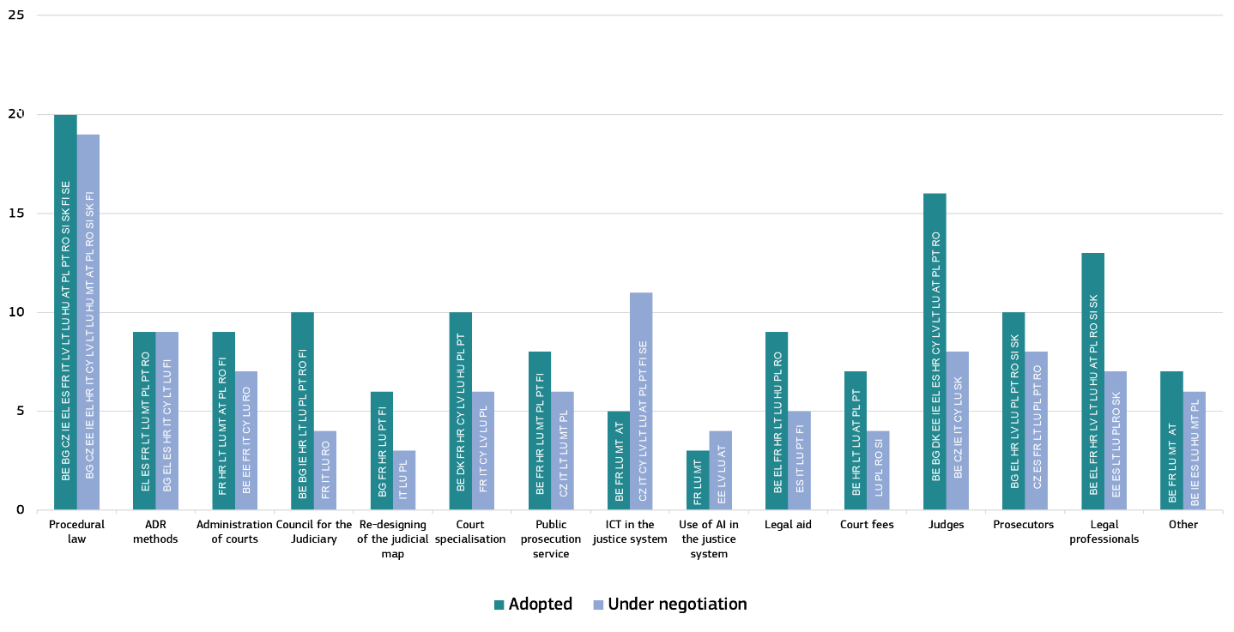

In 2019, procedural law continued to be an area of particular focus in a large number of Member States with a significant amount of ongoing or planned legislative activity. Reforms concerning the status of judges, the rules for legal professionals and prosecutors also saw elevated activity. Compared with the last edition of the EU Justice Scoreboard, the adoption of measures in areas such as the administration of courts and councils of the judiciary gathered further momentum as Member States followed up on earlier announcements. . Activity in other areas, such as information and communication technology (ICT) development in the justice system or re-designing judicial maps, slowed down. Some Member States are already actively using or at least planning to make use of artificial intelligence in their justice systems. Once more, the overview confirms the observation that justice reforms require their time – sometimes spanning several years – from their announcement until the adoption of the legislative and regulatory measures and their actual implementation on the ground.

**3. Key findings of the 2020 EU Justice Scoreboard**

Efficiency, quality and independence are the main parameters of an effective justice system, and the Scoreboard presents indicators on all three.

**3.1. Efficiency of justice systems**

The Scoreboard presents indicators for the efficiency of proceedings in the broad areas of civil, commercial and administrative cases and in specific areas where administrative authorities and courts apply EU law([37]).

**3.1.1. Developments in caseload**

The caseload of national justice systems decreased in a majority of Member States and remains largely below the 2012 levels, even if it continues to vary considerably between Member States (Figure 2). This shows the importance of remaining attentive to ensure the effectiveness of justice systems.

**Figure 2: Number of incoming civil, commercial, administrative and other cases, 2012 – 2018** (*)*(1st instance/per 100 inhabitants) (source: CEPEJ study (*[38]*))*

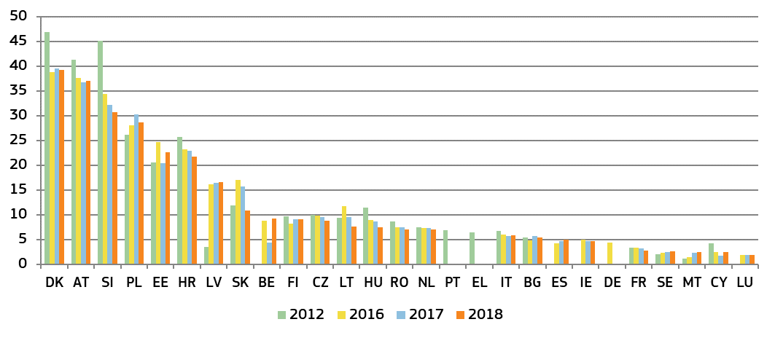

*(*) Under the CEPEJ methodology, this category includes all civil and commercial litigious and non-litigious cases, non-litigious land and business registry cases, other registry cases, other non-litigious cases, administrative law cases and other non-criminal cases. Methodology changes in* ***LV*** *(applied retroactively to 2016 and also 2017)* ***SK*** *and* ***SE*** *(data for 2016 and 2017 has been adapted to include migration law cases as administrative cases, in line with CEPEJ methodology).*

**Figure 3: Number of incoming civil and commercial litigious cases, 2012 – 2018** (*)*(1st instance/per 100 inhabitants) (source: CEPEJ study)*

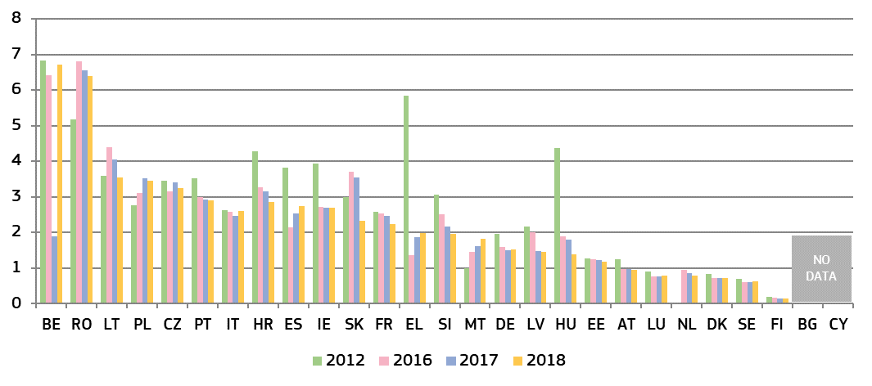

*(*) Under the CEPEJ methodology, litigious civil/commercial cases concern disputes between parties, e.g disputes about contracts. Non-litigious civil/commercial cases concern uncontested proceedings, e.g. uncontested payment orders. Methodology changes in* ***EL*** *and* ***SK****. Data for* ***NL*** *include non-litigious cases.*

**Figure 4: Number of incoming administrative cases, 2012 – 2018** (*)*(1st instance/per 100 inhabitants) (source: CEPEJ study)*

*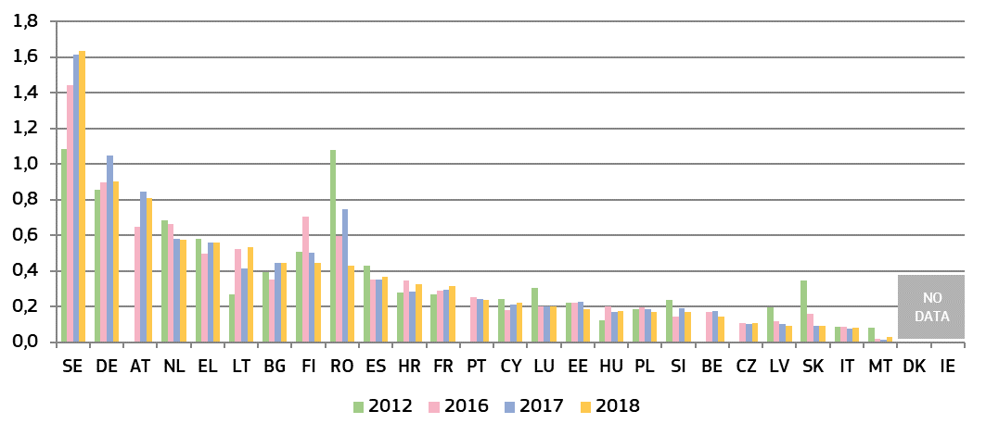(*) Under the CEPEJ methodology, administrative law cases concern disputes between individuals and local, regional or national authorities.* ***DK*** *and* ***IE*** *do not record administrative cases separately.* *Dejudiciarisation of some administrative procedures have occurred in* ***RO*** *in 2018. Methodology changes in* ***EL****,* ***SK and SE****. In SE, migration cases have been included under administrative cases (reotractively applied for 2016 and also 2017).*

**3.1.2. General data on efficiency**

The indicators on the efficiency of proceedings in the broad areas of civil, commercial and administrative cases are: estimated length of proceedings (disposition time), clearance rate; and number of pending cases.

*− Estimated length of proceedings* –

The length of proceedings indicates the estimated time (in days) needed to resolve a case in court, meaning the time taken by the court to reach a decision at first instance. The ‘disposition time’ indicator is the number of unresolved cases divided by the number of resolved cases at the end of a year multiplied by 365 (days) ([39]). It is a calculated quantity that indicates the estimated minimum time that a court would need to resolve a case while maintaining the current working conditions. The higher the value, the higher is the probability that it takes the court longer to reach a decision. Figures mostly concern proceedings at first instance courts and compare, where available, data for 2012, 2016, 2017 and 2018 ([40]). Two figures show the disposition time in 2018 in civil and commercial litigious cases, and administrative cases at all court instances, and one figure shows the average length of proceedings in money laundering cases at first and second instance courts.

**Figure 5: Estimated time needed to resolve civil, commercial, administrative and other cases, 2012 – 2018** (*)*(1st instance/in days) (source: CEPEJ study)*

*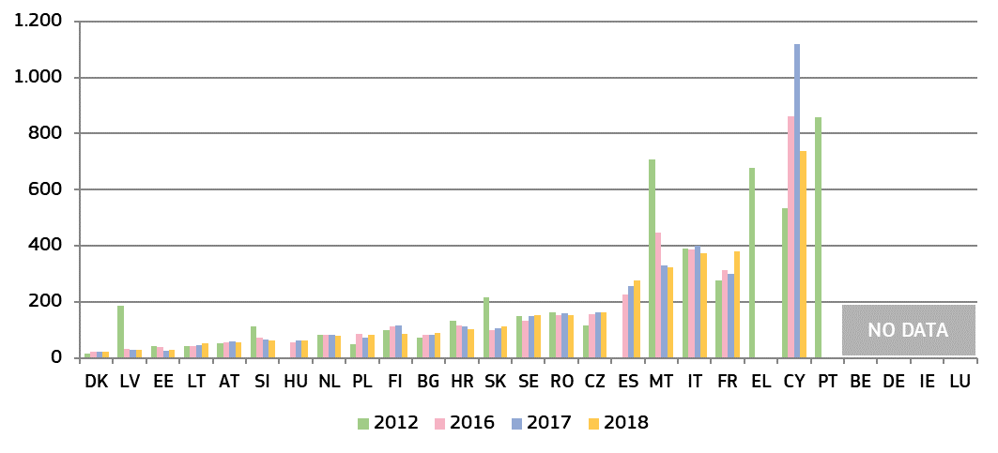(*) Under the CEPEJ methodology, this category includes all civil and commercial litigious and non-litigious cases, non-litigious land and business registry cases, other registry cases, other non-litigious cases, administrative law cases and other non-criminal cases. Methodology changes in* ***SK****. Pending cases include all instances in* ***CZ*** *and**, until 2016, in* ***SK****.* ***LV****: the sharp decrease is due to court system reform, and error checks and data clean-ups in the Court information system.*

**Figure 6: Estimated time needed to resolve litigious civil and commercial cases, 2012 – 2018**(*)*(1st instance/in days) (source: CEPEJ study)*

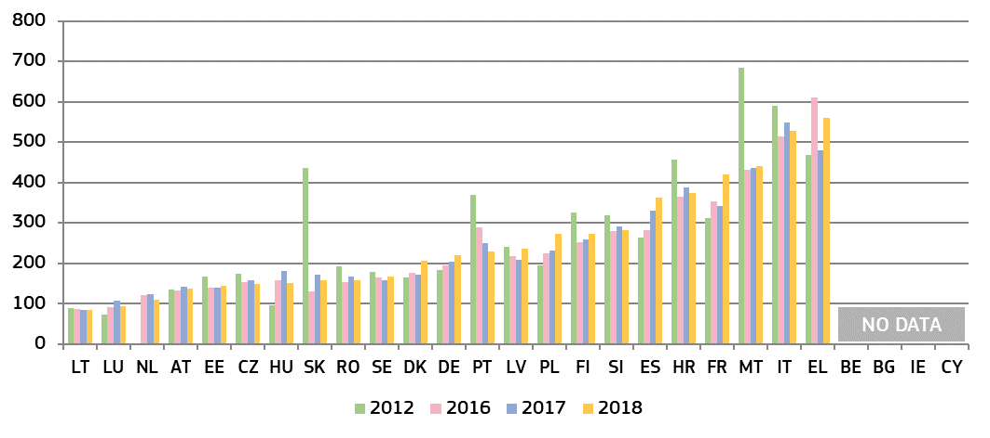

*(*)**Under the CEPEJ methodology, litigious civil/commercial cases concern disputes between parties, e.g disputes about contracts. Non-litigious civil/commercial cases concern uncontested proceedings, e.g. uncontested payment orders. Methodology changes in* ***EL*** *and* ***SK****. Pending cases include all instances in* ***CZ*** *and, until 2016, in* ***SK****.* *Data for* ***NL*** *include non-litigious cases.*

**Figure 7: Estimated time needed to resolve litigious civil and commercial cases** (*) **at all court instances in 2018** *(1st, 2nd and 3rd instance/in days) (source: CEPEJ study)*

*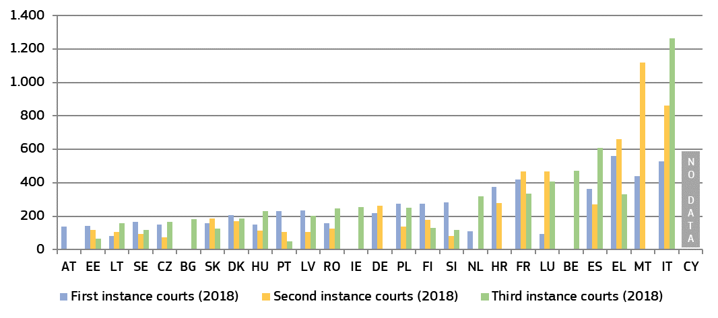(*) The order is determined by the court instance with the longest proceedings in each Member State. No data are available for first and second instance courts in* ***BE****,* ***BG*** *and* ***IE****, for second instance courts in* ***NL,*** *for second and third instance courts in* ***NL*** *and* ***AT*** *or for second instance courts in* ***DE*** *and* ***HR****. There is no third instance court in* ***MT****. Access to a third instance court may be limited in some Member States.*

**Figure 8: Estimated time needed to resolve administrative cases, 2012 – 2018** (*) *(1st instance/in days) (source: CEPEJ study)*

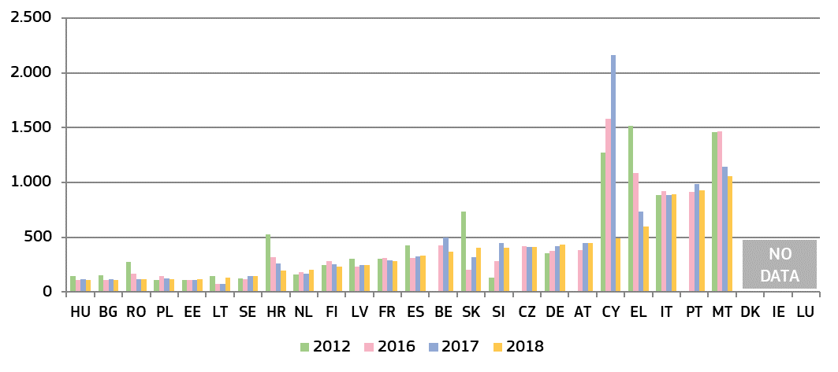

*(*)**Administrative law cases concern disputes between individuals and local, regional or national authorities, under the CEPEJ methodology. Methodology changes in* ***EL*** *and* ***SK****. Pending cases include all court instances in* ***CZ*** *and, until 2016, in* ***SK****.* ***DK*** *and* ***IE*** *do not record administrative cases separately.* ***CY****: in 2018, the number of resolved cases has increased as a consequence of cases being tried together, the withdrawal of 2,724 consolidated cases and the creation of an Administrative Court 2 years ago.*

**Figure 9: Estimated time needed to resolve administrative cases** (*) **at all court instances in 2018** *(1st and, where applicable, 2nd and 3rd instance/in days) (source: CEPEJ study)*

*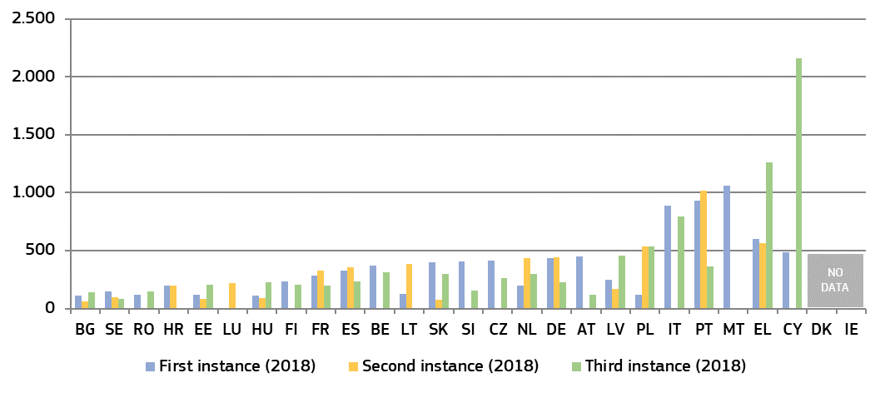(*)**The order is determined by the court instance with the longest proceedings in each Member State. No data available: for the first instance court in* ***LU****, for second instance courts in* ***MT*** *and* ***RO*** *and for the third instance court in* ***NL****. The supreme or another highest court is the only appeal instance in* ***CZ****,* ***IT****,* ***CY****,* ***AT****,* ***SI*** *and* ***FI****. There is no third instance court for these types of cases in* ***HR****,* ***LT****,* ***LU****, and* ***MT****. The highest Administrative Court is the first and only instance for certain cases in* ***BE****. Access to third instance court may be limited in some Member States.* ***DK*** *and* ***IE*** *do not record administrative cases separately.*

*− Clearance rate* –

The clearance rate is the ratio of the number of resolved cases over the number of incoming cases. It measures whether a court is keeping up with its incoming caseload. When the clearance rate is around 100% or higher, it means the judicial system is able to resolve at least as many cases as come in. When the clearance rate is below 100 %, it means that the courts are resolving fewer cases than the number of incoming cases.

**Figure 10: Rate of resolving civil, commercial, administrative and other cases, 2012 – 2018** (*)*(1st instance/in % — values higher than 100 % indicate that more cases are resolved than come in, while values below 100 % indicate that fewer cases are resolved than come in) (source: CEPEJ study)*

*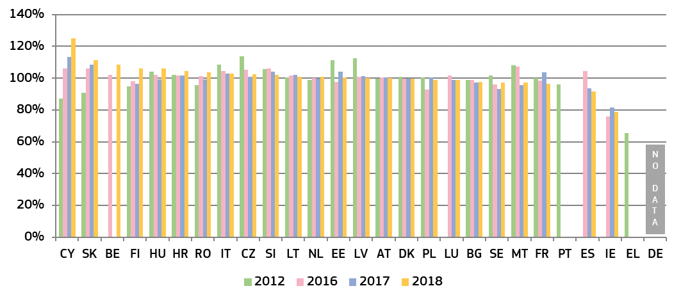(*) Methodology changes in* ***SK****.* ***IE:*** *the number of resolved cases is expected to be underreported due to the methodology.* ***IT****: different classification of civil cases introduced in 2013.*

**Figure 11: Rate of resolving litigious civil and commercial cases, 2012 – 2018** (*)*(1st instance/in %) (source: CEPEJ study)*

*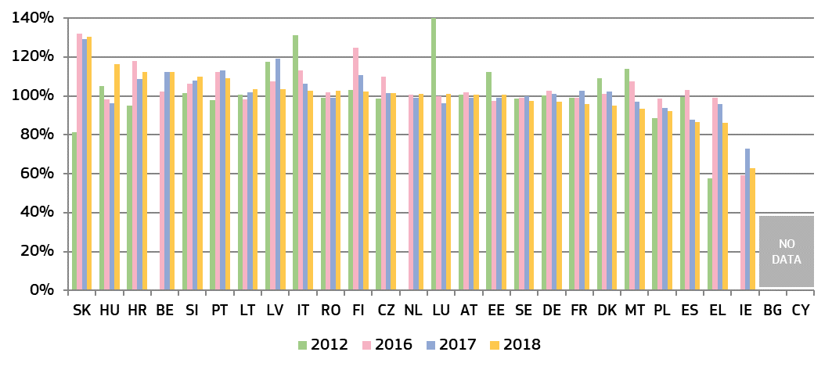(*) Methodology changes in* ***EL*** *and* ***SK****.* ***IE:*** *the number of resolved cases is expected to be underreported due to the methodology.* ***IT****: different classification of civil cases introduced in 2013. Data for* ***NL*** *include non-litigious cases.*

**Figure 12: Rate of resolving administrative cases, 2012 – 2018** (*)*(1st instance/in %) (source: CEPEJ study)*

*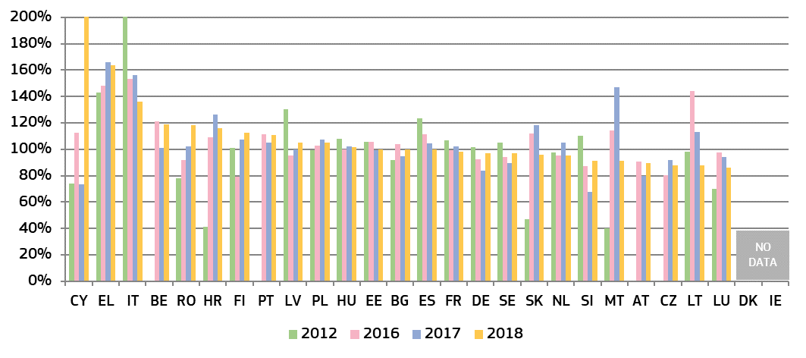(\**) *Past values for some Member States have been reduced for presentation purposes (****CY*** *in 2018 = 219%;* ***IT*** *in 2012=279,8 %); Methodology changes in* ***EL*** *and* ***SK****.* ***DK*** *and* ***IE*** *do not record administrative cases separately. In* ***CY*** *the number of resolved cases has increased as a consequence of cases being tried together, the withdrawal of 2,724 consolidated cases and the creation of an Administrative Court 2 years ago.*

*− Pending cases* –

The number of pending cases expresses the number of cases that remains to be dealt with at the end of the year in question. It also influences the disposition time.

**Figure 13: Number of pending civil, commercial and administrative and other cases, 2012 – 2018** (*)*(1st instance/per 100 inhabitants) (source: CEPEJ study)*

*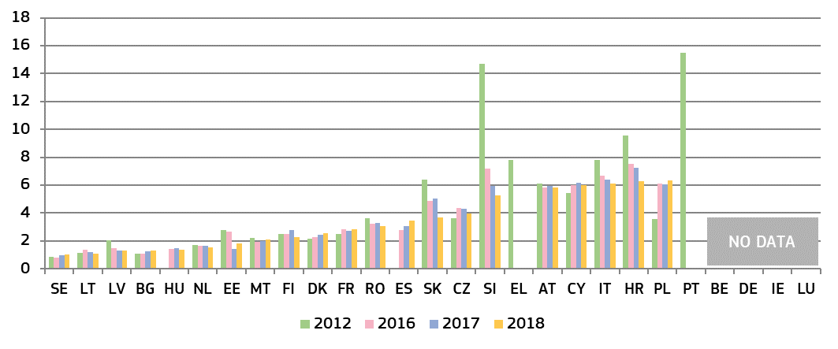(*) Methodology changes in* ***SK****. Pending cases include all instances in* ***CZ*** *and, until 2016, in* ***SK****.* ***IT****: different classification of civil cases introduced in 2013.*

**Figure 14: Number of pending litigious civil and commercial cases, 2012 – 2018** (*)*(1st instance/per 100 inhabitants) (source: CEPEJ study)*

*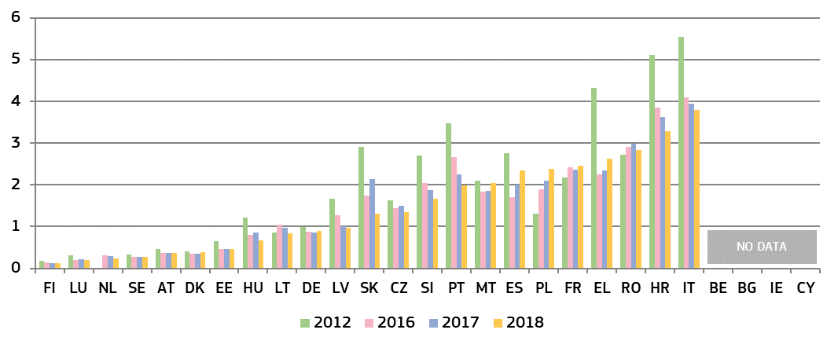(*) Methodology changes in* ***EL*** *and* ***SK****. Pending cases include all instances in* ***CZ*** *and, until 2016, in* ***SK****.* ***IT****: different classification of civil cases introduced in 2013. Data for* ***NL*** *include non-litigious cases.*

**Figure 15: Number of pending administrative cases, 2012 – 2018** (*)*(1st instance/per 100 inhabitants) (source: CEPEJ study)*

*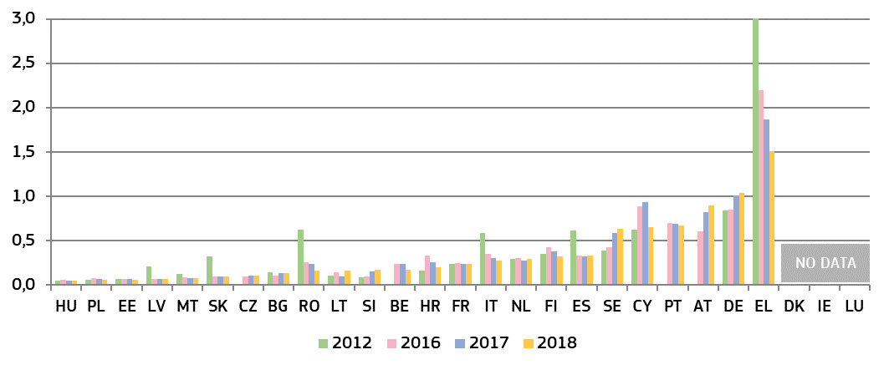(*)* *Past values for some Member States have been reduced for presentation purposes (****EL*** *in 2012=3.5). Methodology changes in* ***EL*** *and* ***SK****. Pending cases include all instances in* ***CZ*** *and, until 2016, in* ***SK****.* ***DK*** *and* ***IE*** *do not record administrative cases separately.*

**3.1.3. Efficiency in specific areas of EU law**

This section complements the general data on the efficiency of justice systems and presents the average length of proceedings ([41]) in specific areas when EU law is involved. The 2020 Scoreboard builds on previous data in the areas of competition, electronic communications, EU trademark, consumer law and anti-money laundering. The areas are selected because of their relevance for the single market and the business environment. In general, long delays in judicial proceedings may have negative consequences on rights stemming from EU law, e.g. when appropriate remedies are no longer available or serious financial damages become irrecoverable.

*– Competition –*

Effective enforcement of competition law ensures a level playing field for businesses and is therefore essential for an attractive business environment. Figure 16 presents the average length of cases against decisions of national competition authorities applying Articles 101 and 102 TFEU ([42]).

**Figure 16: Competition: Average length of judicial review, 2013-2018** (*) *(1st instance/in days) (source: European Commission with the European Competition Network)*

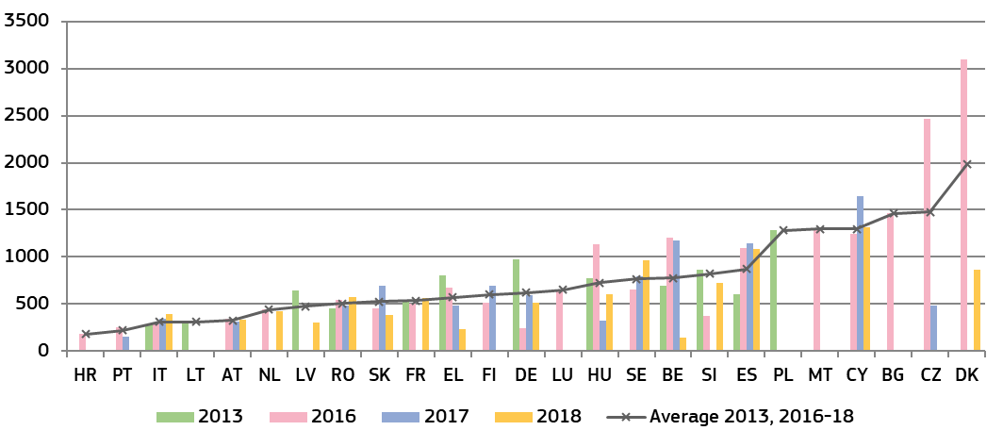

*(*)* ***EE:*** *no cases.* ***IE*** *and* ***AT:*** *scenario is not applicable as the authorities do not have powers to take respective decisions.* ***AT:*** *data includes cases decided by the Cartel Court involving an infringement of Articles 101 and 102 TFEU, but not based on appeals against the national competition authority. An estimation of length was used in* ***BG, IT.*** *An empty column can indicate that the Member State reported no cases for the year. The number of cases is low (below 5 per year) in many Member States, which can make the annual data dependent on one exceptionally long or short case. A number of the longest cases in the dataset included the time needed for a reference to the Court of Justice of the European Union (e.g.* ***LT****), a constitutional review (e.g.* ***SK****) or specific procedural delays (e.g.* ***CZ****,* ***EL****,* ***HU****).*

*– Electronic communications –*

The objective of EU electronic communications legislation is to raise competition, to contribute to the development of the single market and to generate investment, innovation and growth. The positive effects for consumers can be achieved through effective enforcement of this legislation which can lead to lower end-user prices and better quality services. Figure 17 presents the average length of judicial review cases against decisions of national regulatory authorities applying EU law on electronic communications([43]). It covers a broad spectrum of cases, ranging from more complex ‘market analysis’ reviews to consumer-focused issues.

**Figure 17: Electronic communications: Average length of judicial review cases, 2013-2018** (*) *(1st instance/in days) (source: European Commission with the Communications Committee)*

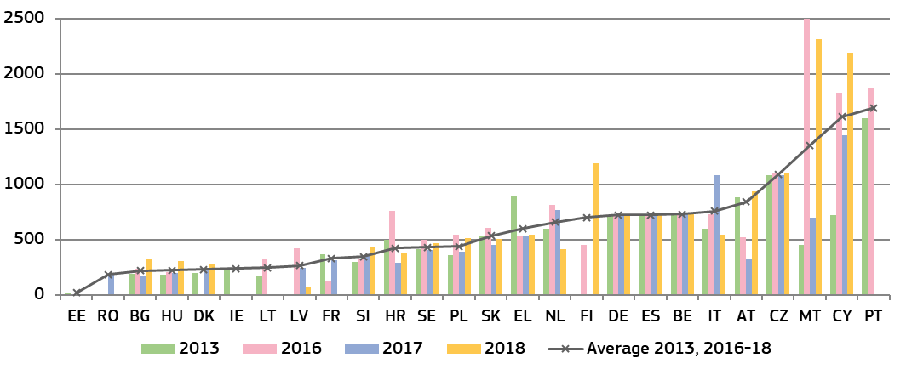

(*) *The number of cases varies by Member State. An empty column indicates that the Member State reported no cases for the year (except* ***PT*** *for 2017 and 2018, and* ***RO*** *for 2018: no data).* ***LU****: no cases. In some court instances, the limited number of relevant cases (****LV****,* ***LT****,* ***MT****,* ***SK****,* ***SE****) can make the annual data dependent on one exceptionally long or short case and result in large variations from one year to the other.* ***DK:*** *quasi-judicial body in charge of 1st instance appeals.* ***ES****,* ***AT****, and* ***PL:*** *different courts in charge depending on the subject matter.* ***MT:*** *an exceptionally long case of 2500 days was reported in 2016, which related to a complex issue whereby a local authority, together with several residents, filed proceedings in relation to alleged harmful emissions from base mobile radiocommunications stations.*

*– EU trademark –*

Effective enforcement of intellectual property rights is essential to stimulate investment in innovation. EU legislation on EU trademarks ([44]) gives a significant role to the national courts, which act as EU courts and take decisions affecting the single market. Figure 18 shows the average length of EU trademark infringement cases in litigation among private parties.

**Figure 18: EU trademark: Average length of EU trademark infringement cases, 2013-2018** (*) *(1st instance/in days) (source: European Commission with the European Observatory on infringements of intellectual property rights)*

*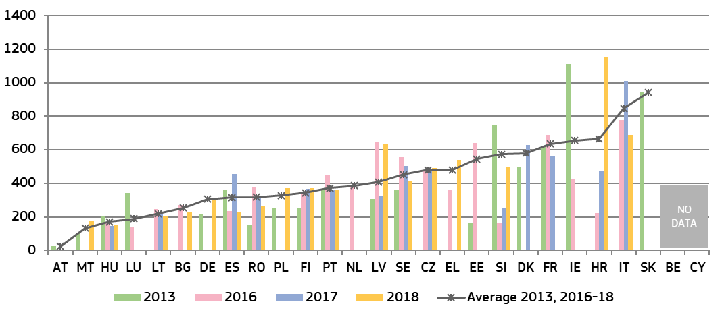(*)* ***FR****,* ***IT****,* ***LT****,* ***LU:*** *a sample of cases used for data for certain years.* ***BG:*** *estimation by courts used for 2016.* ***PL:*** *estimation by courts used for 2015. Particularly long cases affecting the average reported in* ***EE****,* ***IE****,* ***LV*** *and* ***SE****.* ***EL:*** *data based on weighted average length from two courts.* ***DK:*** *data from all trademark cases - not only EU - in Commercial and Maritime High Courts; for 2018, no data on average length due to new ICT system.* ***ES:*** *cases concerning other EU IP titles are included in the calculation of average length; for 2018, an estimation is used.*

*– Consumer protection –*

Effective enforcement of consumer law ensures that consumers benefit from their rights and that companies infringing consumer rules do not gain unfair advantage. Consumer authorities and courts play a key role in the enforcement of EU consumer law ([45]) within the various national enforcement systems. Figure 19 illustrates the average length of judicial review cases against decisions of consumer protection authorities applying EU law.

For consumers or companies, effective enforcement can involve a chain of actors, not only courts but also administrative authorities. To continue the examination of this enforcement chain, the length of proceedings by consumer authorities is presented again. Figure 20 shows the average length of administrative decisions by national consumer protection authorities in 2014-2018 from the moment a case is opened. Relevant decisions include declaring infringements of substantive rules, interim measures, cease and desist orders, initiation of court proceedings or case closure.

**Figure 19: Consumer protection: Average length of judicial review, 2013-2018**(*) *(1st instance/in days) (source: European Commission with the Consumer Protection Cooperation Network)*

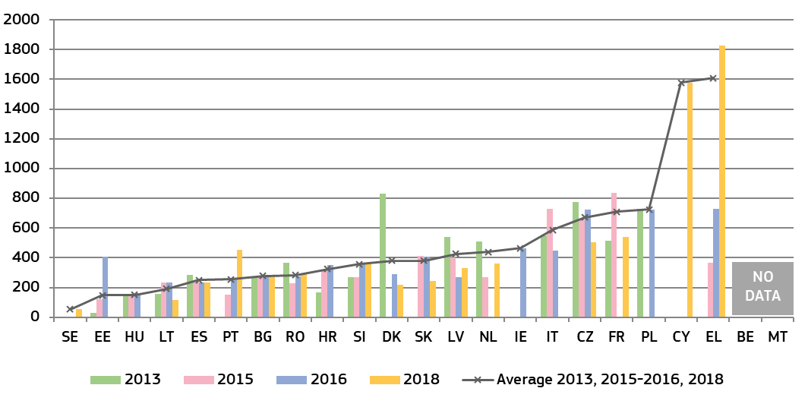

*(*)* ***AT****,* ***FI****,* ***DE****,* ***LU****: scenario is not applicable as consumer authorities are not empowered to decide on infringements of relevant consumer rules. The number of relevant cases is low (less than five) in* ***CY****,* ***IE****,* ***NL*** *and* ***SE****. An estimate of average length was provided by* ***EL*** *and* ***RO.***

**Figure 20: Consumer protection: Average length of administrative decisions by consumer protection authorities, 2014-2018**(*) *(1st instance/in days) (source: European Commission with the Consumer Protection Cooperation Network)*

*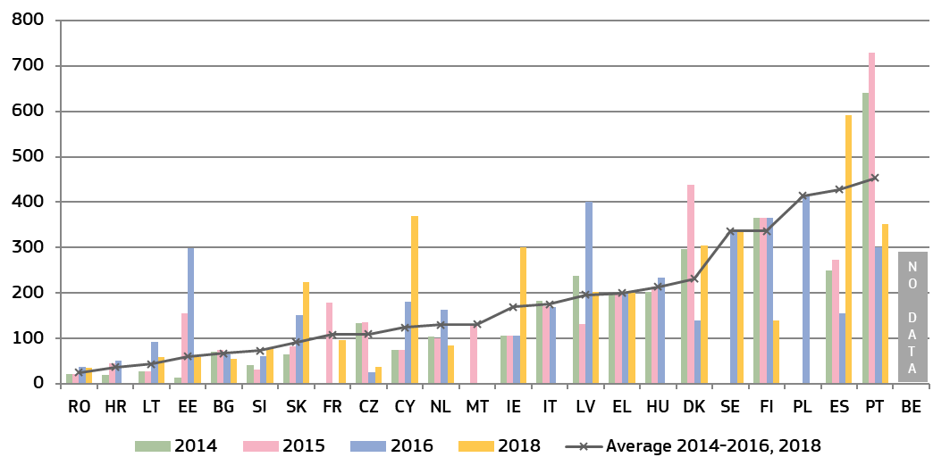(*)* ***AT****,* ***DE****,* ***LU****: scenario is not applicable as consumer authorities are not empowered to decide on infringements of relevant consumer rules. The number of relevant cases is low (less than five) in* ***NL*** *and* ***SE****. An estimate of average length was provided by* ***DK****,* ***FI****,* ***FR****,* ***EL****,* ***FR*** *and* ***RO****.*

*– Money Laundering –*

In addition to contributing to the fight against crime, the effectiveness of the fight against money laundering is crucial for the soundness, integrity and stability of the financial sector, confidence in the financial system and fair competition in the single market ([46]). As underlined by the International Monetary Fund, money laundering can discourage foreign investment, distort international capital flows and negatively affect a country’s macroeconomic performance, resulting in welfare losses, draining resources from more productive economic activities ([47]). The anti-money laundering Directive requires Member States to maintain statistics on the effectiveness of their systems to combat money laundering or terrorist financing([48]). In cooperation with Member States, an updated questionnaire was used to collect data on the judicial phases of the national anti-money laundering regimes. Figure 21 shows the average length of first instance court cases dealing with money laundering criminal offences.

**Figure 21: Money laundering: Average length of court cases, 2014-2018**(*) *(1st instance/in days) (source: European Commission with the Expert Group on Money Laundering and Financing of Terrorism)*

*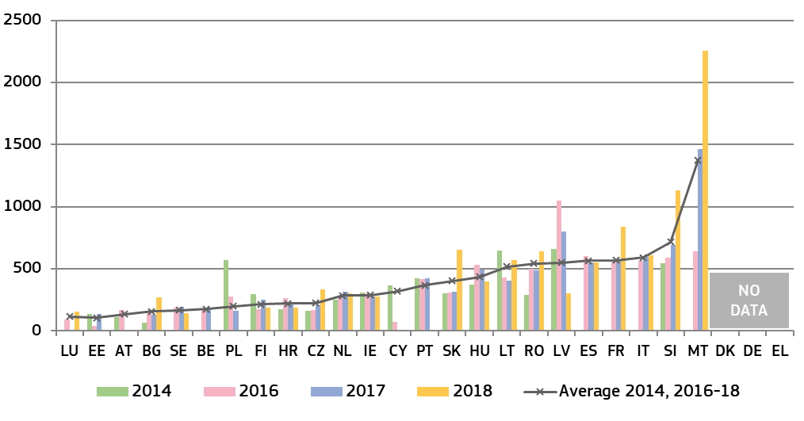(*) No data for 2018:* ***BE****,* ***EE****,* ***CY****,* ***AT****,* ***PL****, and* ***PT****.* ***ES, NL:*** *estimated length.* ***LV****: Due to a relatively low number of cases in 2016 various factors possibly impact the length of proceeding, e.g. a stay in a single case for objective reasons.* ***PL:*** *Calculation of length for 2016 based on a randomly selected sample of cases.****SE:*** *calculation in 2017 based on a sample of resolved cases; the data for 2018 are preliminary.* ***IT:*** *data refer to the responding courts, covering about 91% of the total proceedings in 2015, and about 99% in 2016 and 2017; data refer to both trial and preliminary court hearings.*

|  |
| --- |
| **3.1.4. Summary on the efficiency of justice systems**  An efficient justice system manages its caseload and backlog of cases, and delivers its decisions without undue delay. The main indicators used by the EU Justice Scoreboard to monitor the efficiency of justice systems are therefore the *length of proceedings* (estimated or average time in days needed to resolve a case), the *clearance rate* (the ratio of the number of resolved cases over the number of incoming cases) and the number of *pending cases* (that remains to be dealt with at the end of the year).  *General data on efficiency*  The 2020 EU Justice Scoreboard contains data on efficiency spanning seven years (2012-2018). This time-span allows to identify certain trends and to take into account that justice reforms often take time to show their impact.  Looking at the available data since 2012 in civil, commercial and administrative cases, efficiency has improved or remained stable in 11 Member States, while it decreased, albeit often only marginally, in eight Member States.  Positive developments can be observed in most of the Member States that have been identified in the context of the European Semester as facing specific challenges ([49]):   * Since 2012, in nearly all of those Member States, the **length of first instance court proceedings** in the broad ‘all cases’ category (Figure 5) and the litigious civil and commercial cases (Figure 6) has decreased or remained stable. In administrative cases (Figure 8), the length of proceedings since 2012 decreased or remained stable in most of these Member States. Overall, only a few Member States saw an increase in the length of proceedings in 2018. * The Scoreboard presents data on the **length of proceedings in all court instances** for litigious civil and commercial cases (Figure 7) and administrative cases (Figure 9). Data show that in a number of Member States identified as facing challenges with the length of proceedings in first instance courts, higher instance courts perform in a more efficient manner. On the contrary, for some other Member States facing challenges, the average length of proceedings in higher instance courts is even longer than in first instance courts. * In the broad ‘all cases’, and the litigious civil and commercial cases categories (Figures 10 and 11), the overall number of Member States where the **clearance rate** is more than 100% has increased since 2012. In 2018, nearly all Member States, including those facing challenges, reported a high clearance rate (more than 97%), which means that courts are generally able to deal with the incoming cases in these categories. In administrative cases (Figure 12), a larger variation of the clearance rate can be observed from one year to another and while it generally remains lower than in other categories of cases, some Member States have made good progress. In particular, most of the Member States facing challenges report an increase in the clearance rate in administrative cases since 2012. * Since 2012, progress is continuing in almost all Member States facing the most substantial challenges with their **backlogs** , regardless of the category of cases. Often substantial progress in reducing pending cases has been made for both litigious civil and commercial cases (Figure 14) and administrative cases (Figure 15). Despite these improvements, significant differences between Member States with comparatively few pending cases and those with a high number of pending cases remain, and in some Member States, backlogs appear to be building up.   *Efficiency in specific areas of EU law*  Data on the average length of proceedings in specific areas of EU law (Figures 16-21) provide an insight into the functioning of justice systems in these types of business-related disputes.  Data on efficiency in specific areas of law are collected on the basis of narrowly defined scenarios and the number of relevant cases may appear low. However, as compared to the calculated length of proceedings presented in the general data on efficiency, these figures provide for an actual average length of all relevant cases in specific areas in a year. It is therefore worth noting that several Member States which do not appear to be facing challenges on the basis of general data on efficiency report significantly longer average length of cases in specific areas of EU law. At the same time, the length of proceedings in different specific areas may also vary considerably in the same Member State.  The figures in specific areas of EU law show the following trends :   * For **competition cases** (Figure 16), although the overall caseload faced by courts across Member States increased slightly, the length of judicial review decreased or remained stable in six Member States, while it increased in five other Member States. In 2018 the positive trend continued, with only two Member States reporting an average length exceeding 1000 days (compared to three in 2017). * In the area of **electronic communications** (Figure 17), the case-loads faced by courts continued to increase, ending the positive trend in terms of reduced length of proceedings observed in previous years. In 2018, most Member States registered an increase in the average lengths of proceedings, both compared to 2017 and to 2013. * As regards **EU trademark infringement cases** (Figure 18), in 2018 trends in the average length of proceedings varied significantly. Some Member States registered sharp increases, while others managed to cope better with their caseload and reduced the time needed to resolve cases. * The possible combined effect of the enforcement chain consisting of both administrative and judicial review proceedings is presented in the area of consumer law (Figures 19 and 20). In 2018, seven Member States reported that their consumer protection authorities took on average less than three months to issue a decision in a case covered by EU consumer law, while in nine Member States they took more than 6 months.Where the decisions of the consumer protection authorities were challenged in courts, in 2018 the judicial review of an administrative decision took on average less than one year in the majority of Member States. * The effective fight against **money laundering** is crucial in protecting the financial system, fair competition and preventing negative economic consequences. Challenges in length of court proceedings when dealing with money laundering offences, may influence the effective fight against money laundering. The 2020 EU Justice Scoreboard presents updated data on the length of judicial proceedings dealing with money laundering offences (Figure 21), which show that while in around half of Member States the first instance court proceedings take up to a year on average, these proceedings take around two years on average in several Member States facing challenges regarding prosecution of money laundering offences ([50]). |

**3.2. Quality of justice systems**

There is no single way of measuring the quality of justice systems. The 2020 EU Justice Scoreboard continues to examine factors that are generally accepted as relevant for improving the quality of justice. As in previous years, they are grouped into four categories:

1) accessibility of justice for citizens and businesses;

2) adequate financial and human resources;

3) putting in place assessment tools; and

4) using quality standards.

**3.2.1. Accessibility**

Accessibility is required throughout the whole justice chain to enable people to obtain relevant information — about the justice system, how to initiate a claim and the related financial aspects, the state of play of proceedings up until their end — so that the judgment can be swiftly accessed online.

*– Giving information about the justice system –*

Citizen-friendly justice requires that information about the judicial system is not only easily accessible but is also tailored to specific groups of society that would otherwise have difficulties in accessing the information. Figure 22 shows the availability of online information on specific aspects of the judicial system and for specific groups of society.

**Figure 22**: **Availability of online information about the judicial system for the general public, 2019**(*)*(source: European Commission ([51]))*

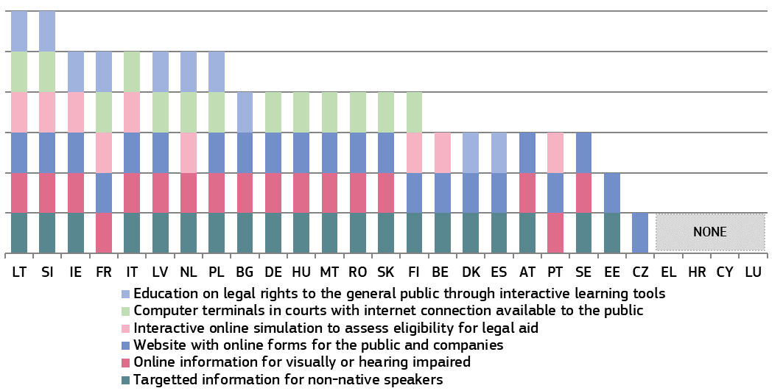

*(*)* ***DE****: Each federal state as well as the federal level decide individually which information to provide online.*

*– Legal aid, court fees and legal fees –*

The cost of litigation is a key factor for access to justice. High litigation costs, including court fees([52]) and legal fees([53]), may hamper access to justice. Litigation costs in civil and commercial matters are not harmonised at EU level. They are governed by national legislation and therefore vary from one Member State to another.

Access to legal aid is a fundamental right enshrined in the Charter([54]). It allows access to justice for those who would not be able to bear or advance the costs of litigation. Most Member States grant legal aid on the basis of the applicant’s income([55]).

Figure 23 shows the availability of full or partial legal aid in a specific consumer case involving a claim of €6,000. It compares the income thresholds for granting legal aid, expressed as percentage of the Eurostat poverty threshold in each Member State ([56]). For example, if the threshold for legal aid appears at 20 %, it means that an applicant with an income 20 % higher than the Eurostat poverty threshold in his or her Member State will be still eligible for legal aid. On the contrary, if the threshold for legal aid appears at below 0, it means that a person with an income below the poverty threshold may not be eligible for legal aid.

Some Member States operate a legal aid system that provides for 100 % coverage of the costs linked to litigation (full legal aid), complemented by a system covering partial costs (partial legal aid), the latter applying eligibility criteria different from that of the former. Other Member States operate either only a full or only a partial legal aid system.

**Figure 23: Income threshold for legal aid in a specific consumer case, 2019**(*)*(differences in % from Eurostat poverty threshold) (source: European Commission with the CCBE([57]))*

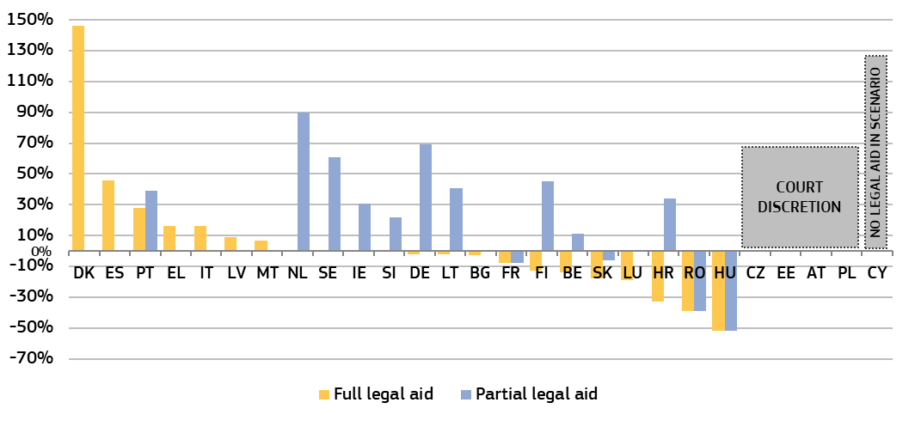

*(*)* ***EE:*** *decision to grant legal aid is not based on the level of financial resources of the applicant.* ***IE:*** *partial legal aid has to take into account also the disposable assets of the applicant.* ***LV:*** *thresholds vary by municipality, upper limit is represented in the chart.*

Most Member States require parties to pay a court fee when starting judicial proceedings. Recipients of legal aid are often exempt from paying court fees. Only in BG, EE, IE, NL, PL and SI are recipients of legal aid not automatically exempt from paying court fees. In CZ the court decides on an individual basis whether to exempt a legal aid recipient from paying court fees. Figure 24 compares for two scenarios the level of the court fee presented as a share of the value of the claim. If, for example, in the figure below the court fee appears at 10 % of a €6,000 claim, the consumer will have to pay a €600 court fee to start judicial proceedings. The low value claim is based on the Eurostat poverty threshold for each Member State.

**Figure 24: Court fee to start judicial proceedings in a specific consumer case, 2019**(*)*(level of court fee as a share of the value of the claim*) *(source: European Commission with the CCBE([58]))*

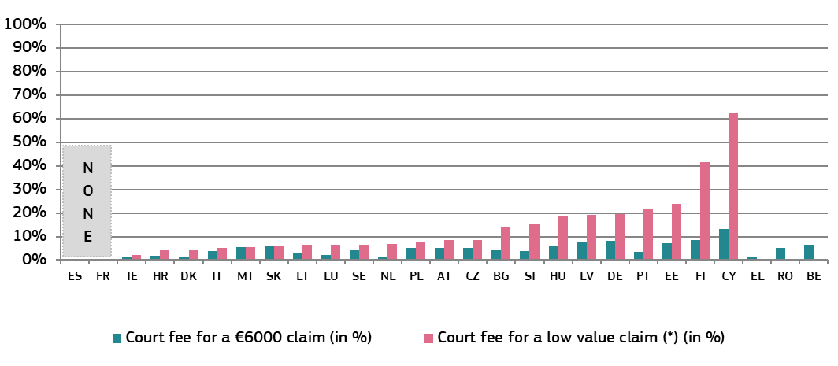

*(*) ‘Low value claim’ is a claim corresponding to the Eurostat poverty threshold for a single person in each Member State, converted to monthly income (e.g. in 2019, this value ranged from €164 in* ***RO*** *to €1,804 in* ***LU****).* ***BE****,* ***EL*** *and* ***RO:*** *no information on court fees for a low value claim was provided.* ***LU:*** *Litigants have to pay bailiff fees to start proceedings as a plaintiff unless they benefit from legal aid.* ***NL:*** *Court fees for income <€2275/month.*

Efficient contract enforcement is essential for the economy. The likelihood of recovering the actual costs of litigation strenghtens the position of the creditor seeking to enforce a contract. Typically, the creditor, as plaintiff, is required to pay a court fee for filing a case with the court. The courts generally order the defendant who loses to reimburse in full the court fees advanced by the plaintiff who has won. Figure 25 shows the level of court fee required for starting a judicial proceeding in a specific commercial case (see footnote 59).

**Figure 25: Court fee to start judicial proceedings in a specific commercial case, 2019**(*)(*in €*) *(source: European Commission with the CCBE([59]))*

*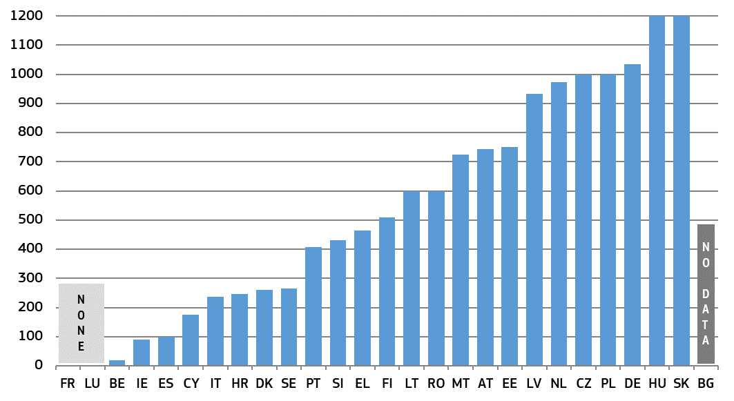(*) Recovery of court fees is decided on a case-by-case basis in* ***ES,******PT*** *and* ***RO****. There is no full recovery of court fees by the winning party in* ***EL*** *and* ***HU****.*

Normally, the creditor has to advance the fees of their own lawyer not only throughout the litigious phase but already in the pre-litigious phase. As regards reimbursement, most Member States apply the rule according to which a party that loses a lawsuit is expected to bear not only its own legal expenses, but also those of the winning party. Such a fee-shifting rule deters the ﬁling of low-probability-of-winning cases, whilst it encourages the filing of high-probability-of-winning cases. Figure 26 shows the amount the court would award to the successful plaintiff in a specific commercial case scenario (see footnote 60). Three main systems can be distinguished: (1) in Member States with a statutory fee system, reimbursement of legal fees depends on the level of statutory fee envisaged for the work carried out by the lawyer, which vary significantly between Member States; (2) in Member States without a statutory fee system, there is either full (HU, PT, FI) or partial (PL, LV, LU) reimbursement of the legal fee; and (3) in a number of Member States the reimbursement is decided by the court on a case-by-case basis.

**Figure 26: Recoverability of legal fees in a commercial trial, 2019** (*) (in EUR) *(source: European Commission with the CCBE(*[60]*))*

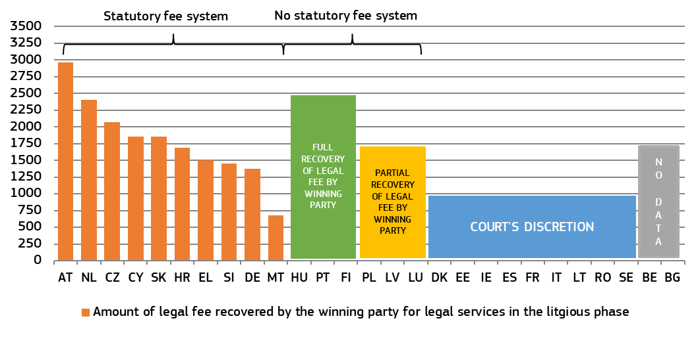

*(*) For this figure, legal fees do not include clerical costs and VAT, if payable. The hypothetical legal fee for the litgious phase provided for in the scenario is €1 650. Full recovery in systems without statutory fee means that this amount (€1,650) can be recovered. Member States with partial recovery (PL, LV, LU) are sorted by order of the recoverable legal fee (highest to lowest, amounts range from €1,275 – €500). The figure does not include information on the recoverability of legal fees for the pre-litigious phase, which is is not envisaged in all Member States.* ***AT****: scenario not fully applicable to ATs system of reimbursement.* ***MT****: there is no concept of an hourly legal fee in MT, reimbursement is determined based on the value of the claim.* ***IT****: there is a statutory fee in IT (€3235 in the scenario), but the court can decide on reimbursement within a set range.* ***LT****: court decides taking into account guidance by the Ministry of Justice, maximum amount in the scenario would be €3,350.*

*– Submitting and following a claim online –*

The ability to complete specific steps in the judicial procedure by electronic means is an important part of the quality of justice systems because the electronic submission of claims as well as the possibility to monitor and advance a proceeding online can ease access to justice and reduce delays and costs. ICT systems in courts also play an increasing role in cross-border cooperation between judicial authorities and facilitate the implementation of EU legislation, for example, on small claims procedures.

**Figure 27: Availability of electronic means, 2018** (\**)**(0 = available in 0% of courts, 4 = available in 100% of courts ([61])) (source: CEPEJ study)*

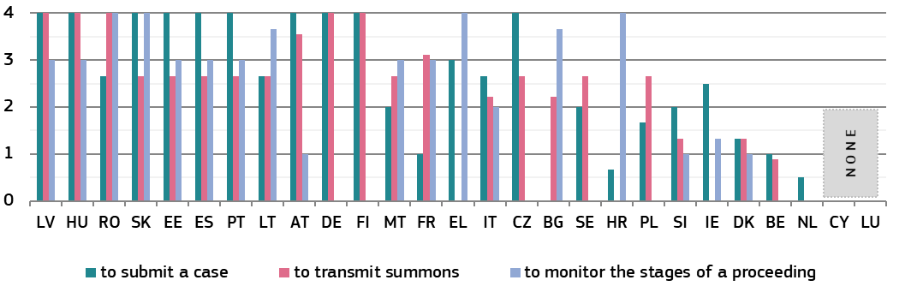

*(*) New methodology, data is not comparable to past years.* ***DK*** *and* ***RO:*** *cases may be submitted to courts by email.*

*– Accessing judgments –*

Ensuring online access to judgments increases the transparency of justice systems, helps citizens and businesses understand their rights, and can contribute to consistency in case-law. The arrangements for online publication of judicial decisions are essential for creating user-friendly search facilities ([62]) that make case-law more accessible to legal professionals and the general public. Seamless access to and easy reuse of case law enables innovative ‘legal tech’ applications supporting practitioners.

The online publication of court decisions requires balancing a variety of interests, within the boundaries set by legal and policy frameworks. The General Data Protection Regulation ([63]) fully applies to the processing of personal data by courts. A fair balance has to be struck between the right to data protection and the right to publicity of court decisions and transparency of the justice system when assessing what data are to be made public. This is particularly the case where there is prevailing public interest that justifies the disclosure of those data. In many countries, the law or practice requires the anonymisation or pseudonymisation ([64]) of judicial decisions before publication, either in a systematic manner or upon request. Data produced by the judiciary are also governed by European legislation on open data and the reuse of public sector information ([65]).

The availability of judicial decisions in a machine-readable format ([66]) facilitates an algorithm-friendly justice system ([67]).

**Figure 28: Online access to published judgments by the general public, 2019** (*)*(civil/commercial, administrative and criminal cases, all instances) (source: European Commission ([68]))*

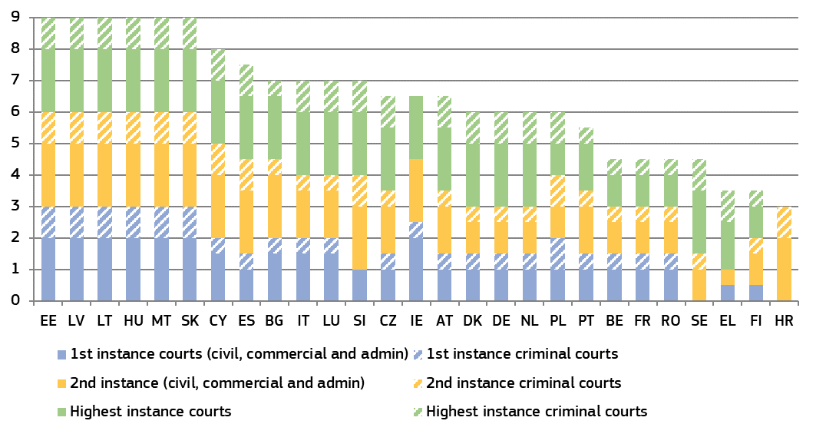

*(*) Maximum possible: 9 points. For each court instance, one point was given if all judgments are available for civil/commercial and administrative and criminal cases respectively and 0.5 points when some judgments are available. For Member States with only two court instances, points have been given for three court instances by mirroring the respective higher instance court of the non-existing instance. For those Member States that do not distinguish the two areas of law (civil/commercial and administrative), the same number of points has been given for both areas.* ***BE****: for civil and criminal cases, each court is in charge of deciding on the publication of its own judgments.* ***BG:*** *Court of Cassation criminal decision are all published except those containing classified information.* ***DE:*** *each federal state decides on online availability of first instance judgments.* ***IE:*** *for criminal cases, summary cases are not generally the subject of a written judgment.* ***CY:*** *for administrative and criminal cases, judges decide on which judgments to be published.* ***LU*** *and* ***SE:*** *courts do not publish judgments regularly online (only landmark cases).* ***AT:*** *for first and second instance, judges decide which judgments are published.* ***NL:*** *courts decide on publication according to published criteria.* ***PL:*** *for administrative cases, the chief of unit in every court decides on the publication.* ***PT:*** *for civil and criminal cases, a commission within the court decides on the publication.*

**Figure 29: Arrangements for producing machine-readable judicial decisions, 2019** (*) *(civil/commercial, administrative and criminal cases, all instances) (source: European Commission ([69]))*

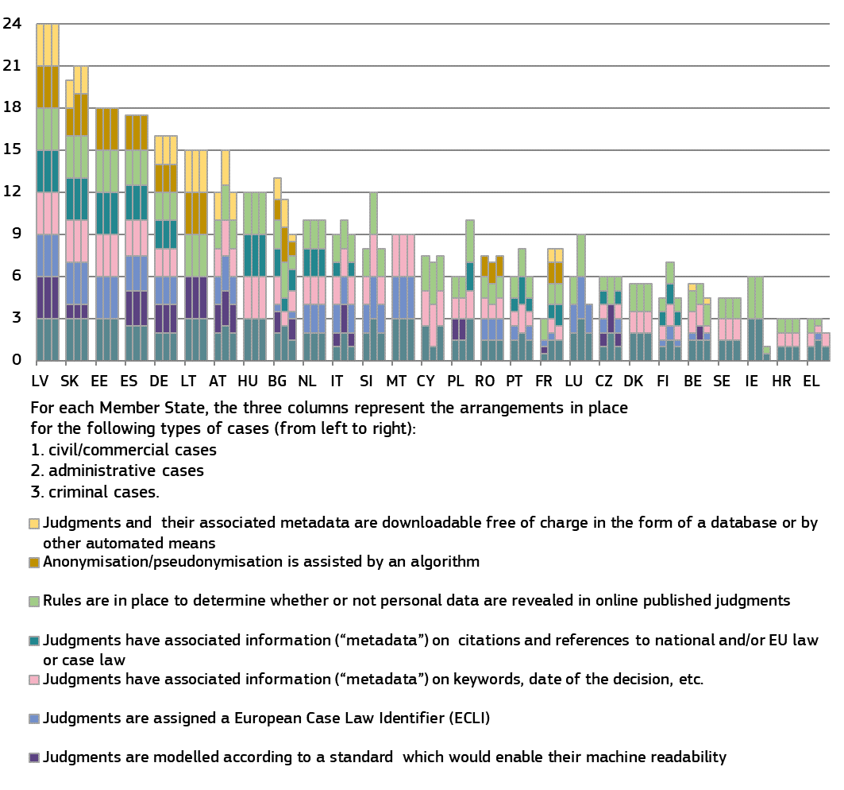

*(*) Maximum possible: 24 points per type of cases. For each of the three instances (first, second, final) one point can be given if all judicial decisions are covered. If only some judicial decisions are covered at a given instance, only half point is awarded. Where a Member State has only two instances, points have been given for three instances by mirroring the respective higher instance as the non-existing instance.* *For those Member States that do not distinguish between administrative and civil/commercial cases, the same points have been allocated for both areas of law.* ***ES:*** *The use of the General Council for the Judiciary (CGPJ) database for commercial purposes, or the massive download of information is not allowed. The reuse of this information for the elaboration of databases or for commercial purposes must follow the procedure and conditions established by the CGPJ through its Judicial Documentation Center.* ***FR:*** *Only the judgments published by the Cour de Cassation are accessible to the public, free of charge. Those published by the courts of appeal on Jurica are accessible through the private virtual justice network, and to legal publishers. Judgments transmitted by the first instance and high courts to the Cour de Cassation, are not subject to anonymisation or pseudonymisation. Open access to court judgments – excluding repetitive and systematice requests – has been established. The reuse of personal data of judges and judicial staff for evaluating, analysing, comparing or predicting their actual or supposed professional practices is punishable.* ***IE:*** *The Irish legal system does not have a specialised court jurisdiction to deal with administrative law cases.* ***LU:*** *In administrative cases, there are only two court levels.*

*– Accessing alternative dispute resolution methods –*

Figure 30 shows Member States’ efforts in promoting the voluntary use of alternative dispute resolution methods through specific incentives, which may vary depending on the area of law ([70]).

**Figure 30: Promotion of and incentives for using ADR methods, 2019** (*)*(source: European Commission ([71]))*

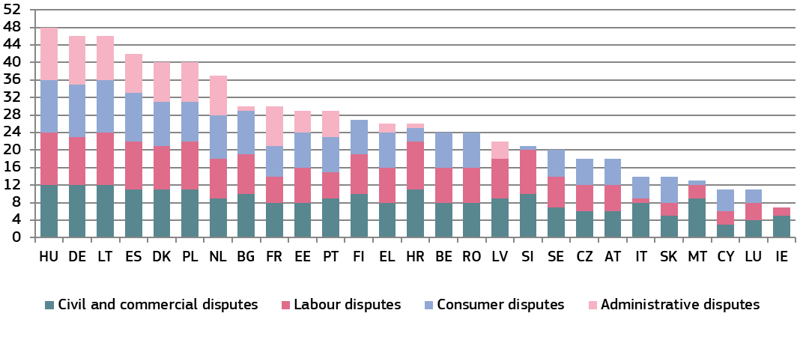

*(*) Maximum possible: 52 points. Aggregated indicators based on the following indicators : 1) website providing information on ADR, 2) Publicity campaigns in media, 3) Brochures for the general public, 4) Court provides specific information sessions on ADR upon request, 5) ADR/mediation co-ordinator at courts, 6) Publication of evaluations on the use of ADR, 7) Publication of statistics on the use of ADR, 8) Legal aid covers (partly or in full) costs incurred with ADR, 9) Full or partial refund of court fees, including stamp duties, if ADR is successful, 10) No lawyer for ADR procedure required, 11) Judge can act as mediator, 12) Agreement reached by the parties becomes enforceable by the court 13) Use of electronic tools to resolve the dispute through ADR methods. For each of these 13 indicators, one point was awarded for each area of law.* ***CZ:*** *data for administrative disputes is not available.* ***DK:*** *each court has an ambassador responsible for promoting the use of mediation. Administrative courts have the possibility to propose to the parties to turn to mediation.* ***IE:*** *administrative cases are subsumed within the category of civil and commercial cases.* ***EL:*** *ADR exists in the area of public procurement procedure before Administrative Courts of Appeal.* ***ES:*** *ADR is mandatory in labour law cases.* ***LT:*** *a secretary at the National Courts Administration coordinates the judicial mediation processes in courts.* ***PT:*** *for civil/commercial disputes, court fees are refunded only in case of justices for peace.* ***SK:*** *the Slovak legal order does not support the use of ADR for administrative purposes.* ***SE:*** *judges have procedural discretion on ADR. Seeking an amicable dispute settlement is a mandatory task for the judge unless it is inappropriate due to the nature of the case.*

*– Child-friendly justice –*

Figure 31 shows the various arrangements in Member States that make justice system more accessible for children and suited to their needs, for example by providing child-friendly information on proceedings or undertaking measures to prevent the child having to go throuh several hearings.

**Figure 31: Child-friendly justice, 2019** (*)*(source: European Commission ([72]))*

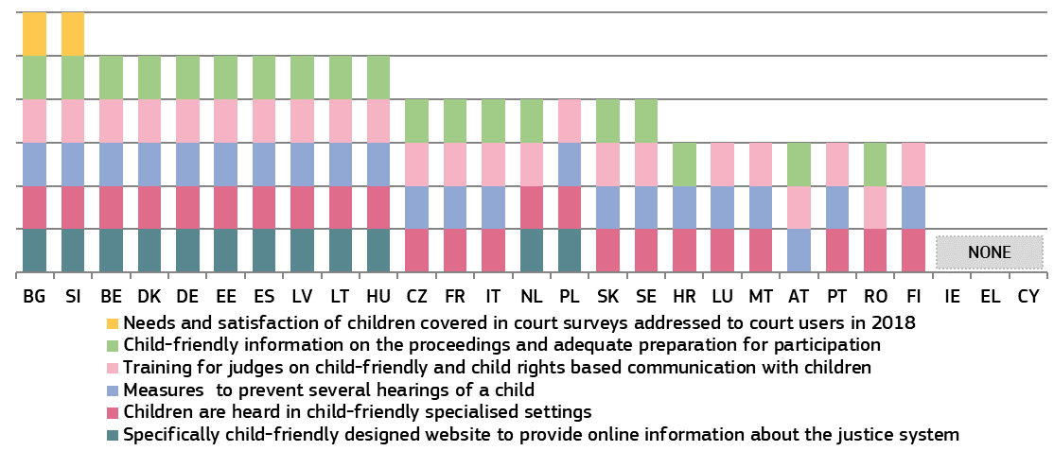

**3.2.2. Resources**

Sufficient resources, including the necessary investments into physical and technical infrastructure, and well-qualified, trained and adequately remunerated personnel of all categories, are necessary for the good functioning of the justice system. Without adequate facilities, tools or personnel with the required qualifications, skills and access to continuous training, the quality of proceedings and decisions is put at stake.

*– Financial resources –*

The figures below show the actual government expenditure on the operation of the justice system (excluding prisons), both per inhabitant (Figure 32) and as a share of gross domestic product (GDP) (Figure 33) and, finally, the main categories of expenditure on law courts (Figure 34) ([73]).

**Figure 32: General government total expenditure on law courts, 2012, 2016-2018** (*)*(in EUR per inhabitant) (source: Eurostat)*

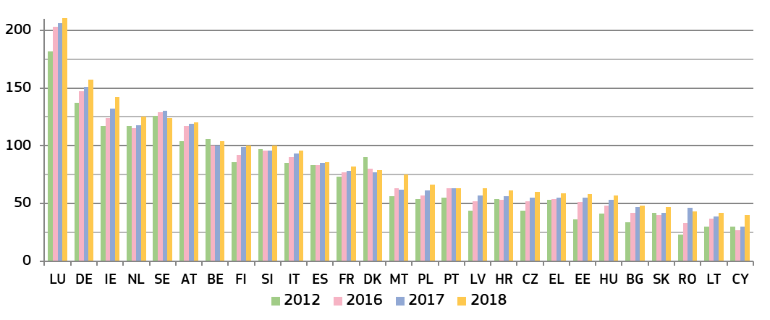

*(*) Member States are ordered according to the expenditure in 2018 (from highest to lowest). 2018 data for* ***ES****,* ***FR****,* ***HR****,* ***PT*** *and* ***SK*** *are provisional.*

**Figure 33: General government total expenditure on law courts, 2012, 2016-2018** (*)*(as a percentage of GDP) (source: Eurostat)*

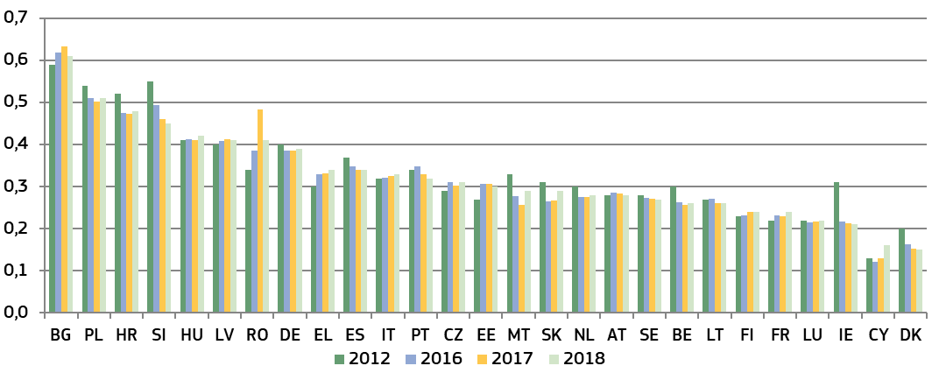

*(*) Member States are ordered according to the expenditure in 2018 (from highest to lowest). 2018 data for* ***ES****,* ***FR****,* ***HR****,* ***PT*** *and* ***SK*** *are provisional.*

Figure 34 shows the main economic categories comprising government expenditure on law courts: 1) wages and salaries of judges and court staff, including social contributions (‘compensation of employees’ ([74])), 2) operating costs for goods and services consumed by the law courts such as building rentals, office consumables, energy and legal aid (‘intermediate consumption’ ([75])), 3) investment in fixed assets, such as court buildings and software (‘gross fixed capital formation’ ([76])), and 4) other expenditure.

**Figure 34: General government total expenditure on law courts by category (*)** *(in 2018, as a percentage of total expenditure) (source: Eurostat)*

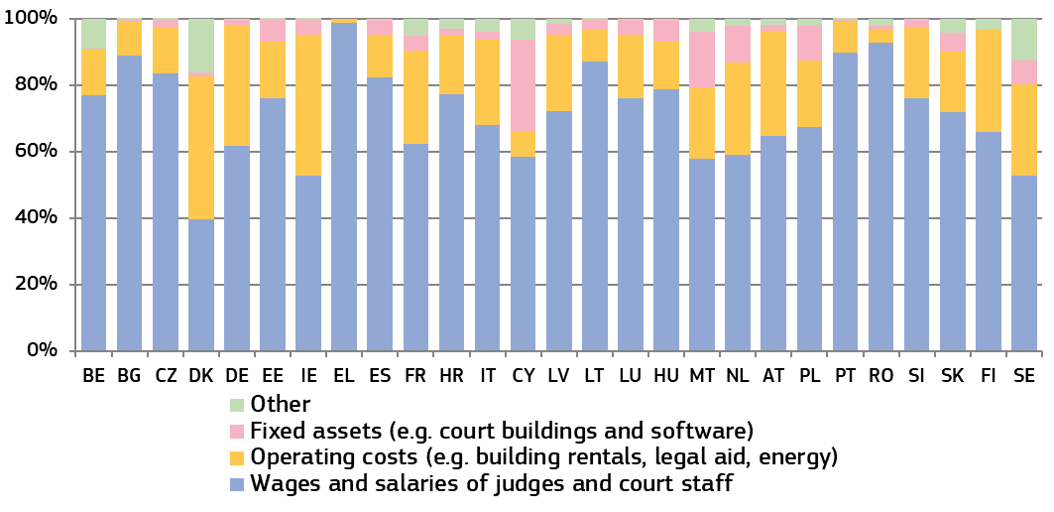

*(*) Data for* ***ES****,* ***FR****,* ***HR*** *and* ***SK*** *are provisional, data for* ***PT*** *are estimated.*

*– Human resources –*

Adequate human resources are essential for the quality of a justice system. Diversity among judges, including gender balance, adds complementary knowledge, skills and experience and reflects the reality of society.

**Figure 35: Number of judges, 2012-2018** (*)*(per 100,000 inhabitants) (source: CEPEJ study)*

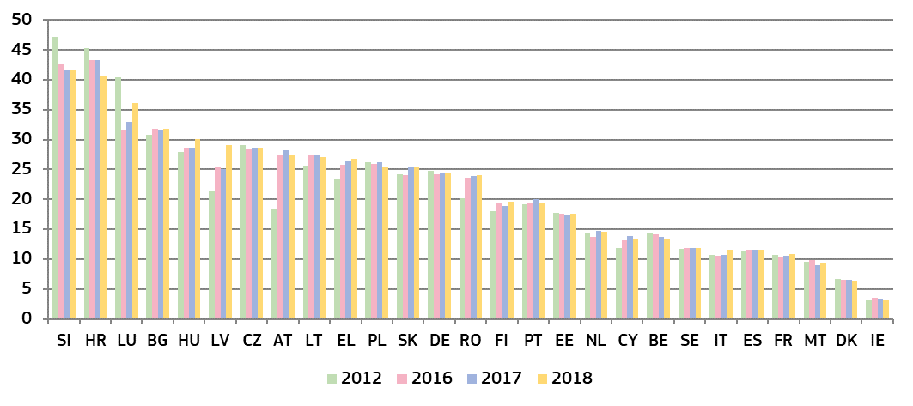

*(*) This category consists of judges working full-time, under the CEPEJ methodology. It does not include the Rechtspfleger/court clerks that exist in some Member States.* ***AT:*** *Data on administrative justice is introduced for 2016 cycle for the first time.* ***EL:*** *the total number of professional judges includes different categories over the years shown above, which partly explains their variation. Since 2016, data on number of professional judges includes all the ranks for criminal and political justice as well as administrative judges.* ***IT:*** *The regional audit commissions, local tax commissions and military courts are not taken into consideration.* ***LU:*** *numbers have been revised following an improved methodology.*

**Figure 36****: Proportion of female professional judges at Supreme Courts 2017-2019** (*) *(source: European Commission ([77]))*

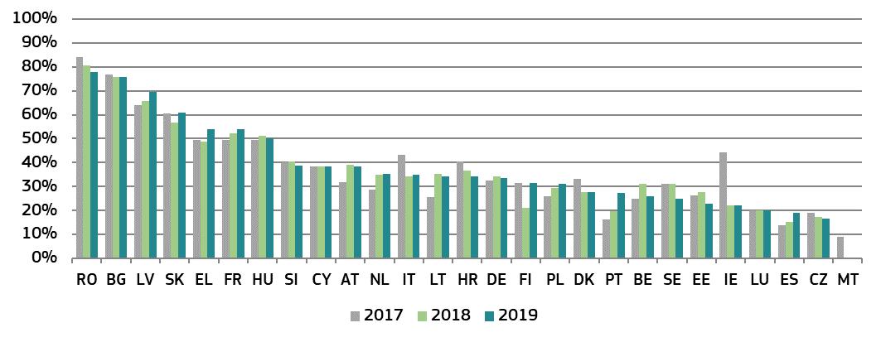

*(*) sorted by 2019 figures, highest to lowest.*

**Figure 37: Number of lawyers, 2012 - 2018** (*)*(per 100,000 inhabitants) (source: CEPEJ study)*

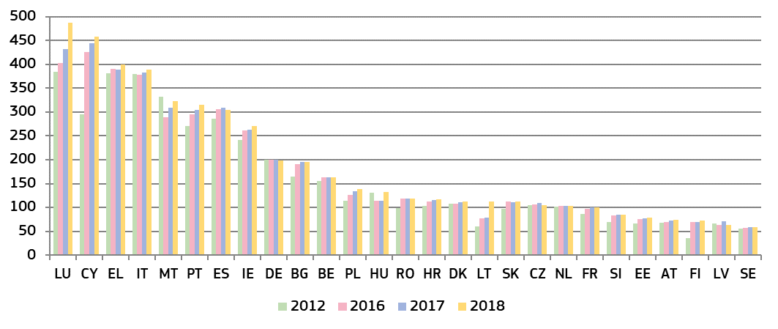

*(*) Under CEPEJ methodology a lawyer is a person qualified and authorised according to national law to plead and act on behalf of his or her clients, to engage in the practice of law, to appear before the courts or advise and represent his or her clients in legal matters (Recommendation Rec (2000)21 of the Committee of Ministers of the Council of Europe on the freedom of exercise of the profession of lawyer).* ***DE:*** *no distinction is made between different groups of lawyers in Germany, such as between solicitors and barristers.* ***FI:*** *since 2015, the number of lawyers provided includes both the number of lawyers working in the private sector and the number of lawyers working in the public sector.*

*– Training –*

Judicial training is important in contributing to the quality of judicial decisions and the justice service delivered to citizens. The data set out below cover judicial training in a broad range of areas, including communication with parties and the press and on judicial skills.

**Figure 38: Share of continuous training of judges on various types of skills, 2018** (*)*(as a percentage of total number of judges receiving these types of training) (source: European Commission ([78]))*

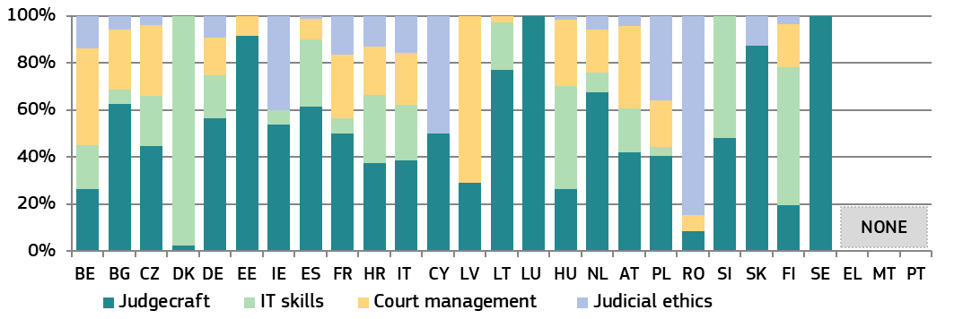

*(*) (*) Figure 38 shows the distribution of judges participating in continuous training activities (i.e. those taking place after the initial training period to become a judge) in each of the four identical areas as a percentage of the total number of judges trained in these types of training. Legal training activities are not taken into account. Judicial training authorities in* ***EL****,* ***MT*** *and* ***PT*** *did not provide specific training activities on the selected skills.* ***DK:*** *including court staff.* ***AT:*** *including prosecutors.*

**Figure 39: Availability of training in communication for judges, 2019** (*) *(source: European Commission ([79]))*

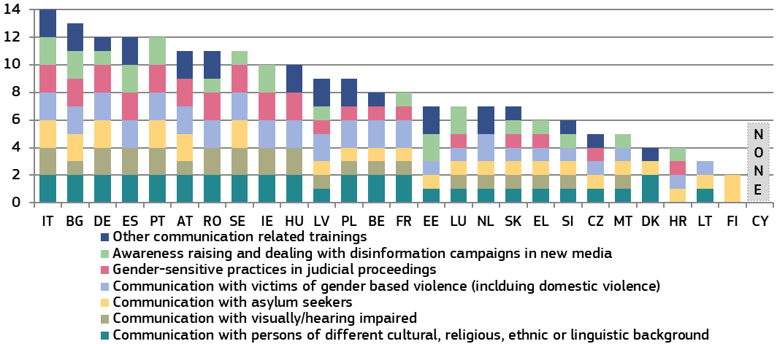

*(*) Maximum possible: 14 points. Member States were given 1 point if they have initial training and 1 point if they have continuous training (maximum of 2 points for each type of training).* ***DK:*** *no training is offered on communicating with people who are visually or hearing impaired because the state offers support in form of tools or an assistant in the courtroom to visually or hearing impaired people, e.g. a deaf interpreter. Other communication related trainings include: courses aimed at enhancing the public communication skills and communication with media (****BE, BG****,* ***EE, LV****,* ***NL****,* ***PL****,* ***RO****,* ***SK****); courses on questioning skills (****DE*** *and* ***AT****), courses on people management (****BE, ES****,* ***PL****) and soft skill trainings cover enhancing the clarity of court decisions and presentation methods (****CZ****,* ***DK, LV****,* ***HU****,* ***PL****,* ***SK****).*

**3.2.3. Assessment tools**

Monitoring and evaluation of court activities help to detect shortcomings and needs, and therefore help the justice system increase its quality. Regular evaluation could improve the justice system’s responsiveness to current and future challenges. Adequate ICT tools could provide real-time case management systems and could help to provide nationwide standardised court statistics. In addition, they could be used to manage backlogs and automated early-warning systems. Surveys are essential in assessing how justice systems operate from the perspective of legal professionals and court users. An adequate follow-up on the surveys’ findings is a prerequisite to improve the quality of justice systems.

**Figure 40: Availability of ICT for case management and court activity statistics, 2018** (*)   
*(0 = available in 0% of courts, 4 = available in 100% of courts ([80])) (source: CEPEJ study)*

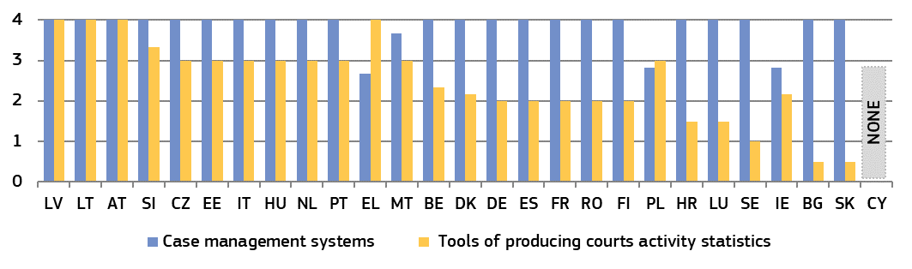

*(*) New methodlogy, data not comparable to past years.*

**Figure 41: Topics of surveys conducted among court users or legal professionals, 2018** (*) *(source: European Commission ([81]))*

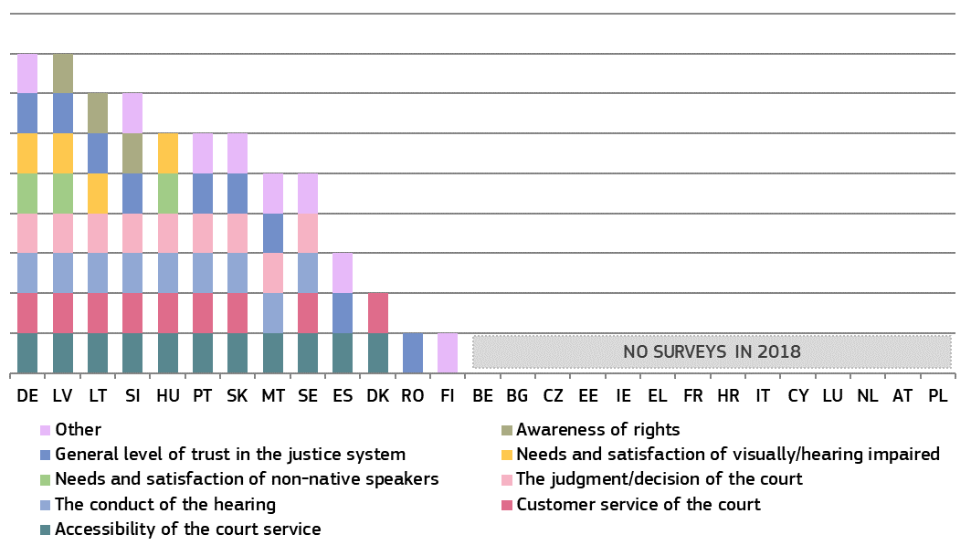

*(*) Member States were given one point per survey topic indicated regardless of whether the survey was conducted at national, regional or court level. ‘Other topics’ include: surveys among lawyers on the functioning of certain courts (****ES****); awareness of ICT measures as a means of improving user accessibility (****MT****); resources and material conditions of courts (****PT****); questions related to a project on procedural fairness (****SI****), possibilities for the improvement of the courts’ functioning (****SK****); conceptions of appropriate pubishment (****FI****); and satisfaction of legal professionals and court users with the services delivered by the judicial system (****SE)****. In* ***DE,*** *a number of**different surveys were carried out at the level of the federal states.*

**Figure 42: Follow-up of surveys conducted among court users or legal professionals, 2018** (*) *(source: European Commission ([82]))*

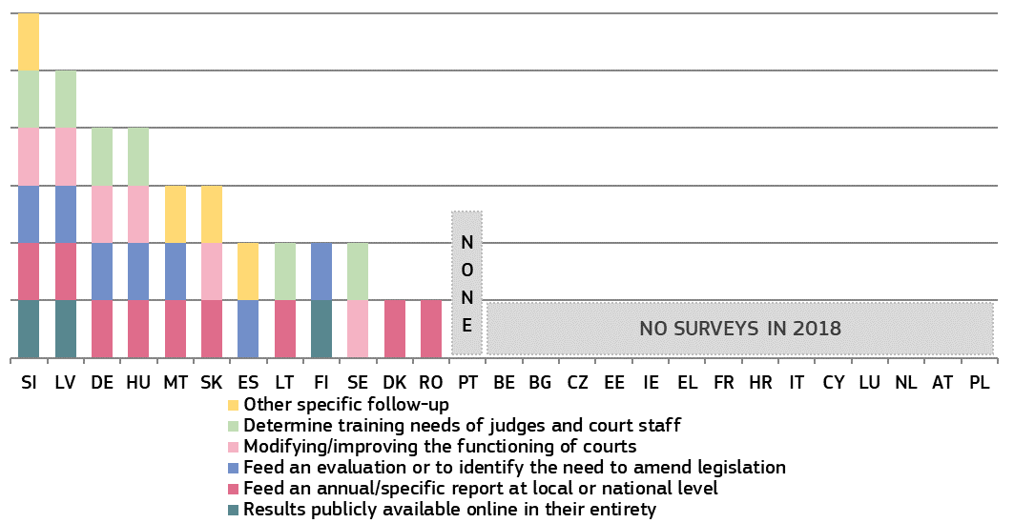

*(*) Member States were given one point per type of follow-up. The category ‘other specific follow-up’ included: inspection (****ES****); use as guidance for internal policy development (****MT****); publication of informative tools for the general (****SI****); and self-assessmemt reports of courts (****SK****)**.*

**3.2.4. Standards**

Standards can improve the quality of justice systems. Following the overview of standards on timing and information to parties in the previous editions, the 2020 EU Justice Scoreboard focuses on timing, backlogs and timeframes as a management tool for the judiciary ([83]). Figure 43 shows an overview of which Member States use standard measures on time limits, timeframes and backlogs and includes for the first time information broken down by the areas of laws and instances at which such standards exist. Time limits are quantitative deadlines, e.g. maximum number of days between the registration of a case until the first hearing. Backlogs are cases older than an identified period of time. Timeframes are measurable targets/practices e.g. specifying a pre-defined share of cases to be completed within a certain time period.

**Figure 43: Existence of standards on timing, 2019** (*) *(source: European Commission ([84]))*

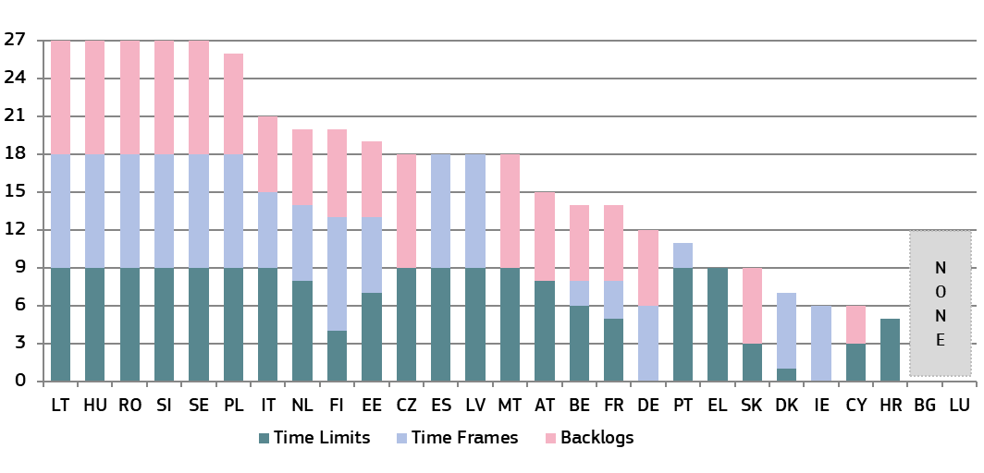

*(*) Member States were given 1 point per instance (first, second, final) for each area of law (civil/commercial, administrative and criminal) if a standard is defined. Maximum possible: 27 points. For Member States with only two court instances, points have been given for three court instances by mirroring the respective higher instance court of the non-existing instance. For those Member States that do not distinguish the two areas of law (civil/commercial and administrative), the same number of points have been given for both areas.*

|  |
| --- |
| **3.2.5. Summary on the quality of justice systems**  Easy access, sufficient resources, effective assessment tools and appropriate standards and practices are the factors that contribute to a high quality of justice systems. Citizens and business expect high quality decisions from an effective justice system.The 2020 EU Justice Scoreboard develops its comparative examination of these factors.  *Accessibility*  This edition looks again at a number of elements contributing to a citizen-friendly justice system:   * Almost all Member States provide access to **some online information** about their judicial system, including a centralised web portal with online forms and interactive education on legal rights (Figure 22). Differences appear on the content of the information and how adequate it is to respond to people’s needs. For example, only a limited number of Member States (9) enable people to find out whether they are eligible for legal aid through an interactive online simulation. However, information for non-native speakers as well as targeted information for visually or hearing impaired people is available in the majority of Member States. * The **availability of legal aid and the level of court fees**have a major impact on the access to justice, in particular for people in poverty*.* Figure 23 shows that in some Member States, consumers whose income is below the Eurostat poverty threshold would not receive legal aid. Compared to last year, accessibility of legal aid has remained stable. At the same time, over the years, legal aid has become less accessible in some Member States. The level of court fees (Figure 24) has remained largely stable since 2016, although the burden of court fees continues to be proportionally higher for low value claims. The difficulty in benefiting from legal aid combined with high levels of court fees in some Member States could have a dissuasive effect for people in poverty to access justice. * The 2020 EU Justice Scoreboard for the first time also includes information on **court fees and the recoverability of legal costs in a commercial case**. The level of court fees for commercial litigation (Figure 25) varies greatly among Member States (ranging from 0.1% to 6% of the value of the claim), with only two Member States having no court fee at all. Figure 26 shows, for the first time, to what extent legal costs can be recovered by the winning party in a commercial case. Large differences regarding the recoverablity of legal fees for the litigious phase appear both between Member States with and without a statutory fee system as well as within these groups (in particular between more and less generous statutory fee systems). In addition, in many Member States, recoverability of legal costs depends on the courts’ discretion. The level of generosity of the system for recovering legal fees can have either incentivizing or deterring effects on the probability of filing a case, and therefore on the overall access to justice. * The **availability of electronic means** during the judicial procedure contributes to easier access to justice and the reduction of delays and costs. Figure 27 shows that in more than half of the Member States, electronic submission of claims and transmission of summons is still not in place or is possible only to a limited extent, as was already seen in the 2019 EU Justice Scoreboard. Large gaps remain in particular as regards the possibility to follow court proceedings online, where no Member State has reached full deployment in all courts in all areas of law. * Compared to previous years, **online access to court judgments** (Figure 28) has remained stable, particularly for the publication of judgments at the highest instance: 19 Member States publish all civil/commercial and administrative judgments and the same number of Member States also publish criminal judgments at the highest instance.These positive numbers encourage all Member States to further improve as decisions at the highest instance play an important role for the consistency of case law. At lower instances, the number of Member States publishing all judgments is still significantly lower, both for criminal and civil/commerical and administrative judgments, a figure that has remained stable since 2017. * The 2020 EU Justice Scoreboard deepens the examination of **arrangements in place in the Member States that can facilitate producing machine-readable judicial decisions** (Figure 29). All Member States have at least some arrangements in place for civil/commercial, administrative and criminal cases. However a considerable variance among the Member States can be observed. It appears that administrative courts are relatively more advanced as regards creating the enabling factors for algorithm-friendly justice system. Justice systems where arrangements for modelling judgments according to standards enabling their machine readability have been put in place seem to have potential to achieve better results in the future. * The number of Member States promoting the voluntary use of **alternative dispute resolution methods** (ADR) (Figure 30) for private disputes has again continued to grow compared to previous years. This is mainly achieved by introducing more incentives for the use of ADR across different areas of law. Administrative disputes have now been taken into consideration for the second year in a row, showing a slight expansion as now more than half of the Member States allow ADR in this area. * For the first time, the 2020 EU Justice Scoreboard presents a consolidated overview of the measures taken by Member States for a **child-friendly justice system** (Figure 31). Almost all Member States make at least some accommodations for children, with measures for child-friendly hearings (including in the settings) and to prevent several hearings of a child particularly prevalent. However, less than half of Member States have dedicated child-friendly websites providing information about the justice system.   *Resources*  High quality justice systems in Member States require sufficient levels of financial and human resources, including the necessary investments into physical and technical infrastructure, appropriate initial and continuous training, as well as diversity among judges, including gender balance. The 2020 EU Justice Scoreboard shows the following:   * In terms of**financial resources**, the data show that, overall, in 2018, general government total expenditure on law courts continued to remain mostly stable in Member States, with significant differences in actual amounts, both in EUR per inhabitant and as a percentage of GDP between Member States persisting (Figures 32 and 33). Almost all Member States increased their expenditure per capita in 2018 (an increase compared to 2017) and a majority also increased their expenditure as percentage of GDP. * As in 2019, the 2020 EU Justice Scoreboard also shows the **breakdown of total expenditure into different categories** based on data gathered by Eurostat. Figure 34 shows major differences in spending patterns among Member States. On the one hand, while the wages and salaries of judges and court staff (including social contributions) represent the biggest share in most Member States, investment into fixed assets such as court buildings and software is generally very low, and even absent in some Member States. The expenditure on operating costs (e.g. building rentals, legal aid and other consumables), on the other hand, is significantly higher in a few Member States than in most others. This breakdown has remained relatively stable year-to-year (Figure 34). * **Women** still represent less than fifty percent of judges at the **level of Supreme Courts** in most Member States (Figure 36). The evolution over the three year period from 2017 to 2019 shows that trends diverge between Member States, but the proportion of female judges at Supreme Courts has grown since 2010 in most Member States. * On the **training of judges,** while almost all Member States provide at least some continuous training on judgecraft, fewer offer training on IT skills, court management and judicial ethics and the share of judges receiving such training remains low in most countries (Figure 38). On training to communicate with vulnerable groups of parties, there is a continued trend of improvement, in particular concerning persons who are visually or hearing impaired, victims of gender-based violence and asylum seekers (Figure 39). Training on awareness raising and dealing with disinformation has also become more widely available compared to last year.   *Assessment tools*   * While most Member States have fully implemented **ICT case management systems** (with a few exceptions), gaps continue to remain as regards tools of producing court activity statistics (Figure 40). These systems serve various purposes, including generating statistics, and are to be implemented consistently across the justice system. Some Member States have early-warning systems to detect malfunctions or non-compliance with case processing standards, which enables the finding of timely solutions. In some Member States, it is still not possible to ensure nationwide data collection across all justice areas. * The **use of surveys** among court users and legal professionals (Figure 41) has again decreased, with a rising number of Member States opting not to conduct any surveys. However, there seems to be some variance as to which Member States did not conduct surveys, inidcating that sometimes surveys are conducted only every other/every few years. Accessibility, customer service, court hearings and judgments, as well as the overall trust in the justice system, remain recurring topics for surveys, but only a few Member States inquired about the satisfaction of groups with special needs or about individuals’ awarness of their rights. Almost all Member States who used surveys also ensured follow-up (Figure 42), although the extent of this follow-up continued to vary greatly. Results generally fed into annual or specific reports and in many Member States they fed an evalution or were used to identify the need to amend legislation.   *Standards*  Standards can drive up the quality of justice systems. This edition of the EU Justice Scoreboard continues to examine in more detail certain standards aiming to improve the timing of proceedings and breaks down these standards in more granular manner taking into account the instance and areas of law where such standards exist.   * Almost all Member States use standards on timing, although they are not always developed to the same degree at all instances and in all areas of law. Standards fixing time limits (e.g. fixed time from the registration of a case until the first hearing) continue to become more wide-spread, while standards on time frames (e.g. specifying a pre-defined share of cases to be completed within a certain time) and backlogs remain comparatively less common (Figure 43). However, certain Member States facing particular challenges on efficiency are currently not using such standards or only to a limited extent. |

**3.3. Independence**

Judicial independence, which is integral to the task of judicial decision-making, is a requirement stemming from the principle of effective judicial protection referred to in Article 19 TEU, and from the right to an effective remedy before a court or tribunal enshrined in the Charter of Fundamental Rights of the EU (Article 47) ([85]). That requirement presumes (a) external independence, when the body concerned exercises its functions wholly autonomously, without being subject to any hierarchical constraint or subordinated to any other body and without taking orders or instructions from any source whatsoever, thus being protected against external interventions or pressure liable to impair the independent judgment of its members and to influence their decisions, and (b) internal independence and impartiality, when an equal distance is maintained from the parties to the proceedings and their respective interests with regard to the subject matter of those proceedings ([86]). Judicial independence guarantees that all the rights that individuals derive from EU law will be protected and that the values common to the Member States set out in Article 2 TEU, in particular the value of the rule of law, will be safeguarded ([87]). The preservation of the EU legal order is fundamental for all citizens and business whose rights and freedoms are protected under EU law.

The perceived independence of the judiciary is a growth-enhancing factor, as a perceived lack of independence can deter investments. In addition to indicators on perceived judicial independence from various sources, the 2020 EU Justice Scoreboard presents a number of indicators on how justice systems are organised to protect judicial independence in certain types of situations where independence could be at risk. Reflecting the input from the European Network of Councils for the Judiciary (ENCJ),the Network of the Presidents of the Supreme Judicial Courts of the EU (NPSJC), and from the Expert Group on Money Laundering and Financing of Terrorism, the 2020 EU Justice Scoreboard shows updated indicators in relation to legal safeguards on the disciplinary proceedings regarding judges, and the appointment of members of the Councils for the Judiciary, and two new overviews on the disciplinary proceedings regarding prosecutors.

**3.3.1. Perceived judicial independence**

**Figure 44: Perceived independence of courts and judges among the general public** (*) *(source: Eurobarometer ([88]) — light colours: 2016, 2018 and 2019, dark colours: 2020)*

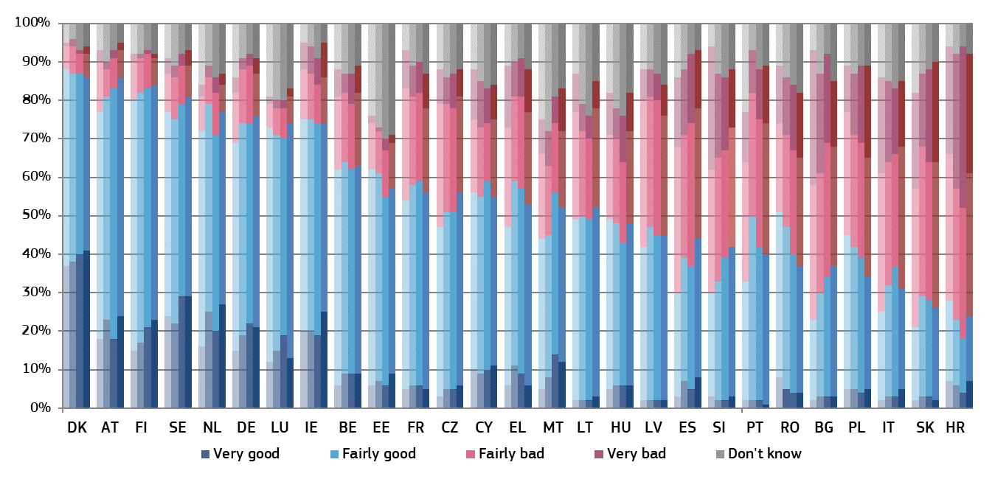

*(*) Member States are ordered first by the percentage of respondents who stated that the independence of courts and judges is very good or fairly good (total good); if some Member States have the same percentage of total good, then they are ordered by the percentage of respondents who stated that the independence of courts and judges is fairly bad or very bad (total bad); if some Member States have the same percentage of total good and total bad, then they are ordered by the percentage of respondents who stated that the independence of courts and judges is very good; if some Member States have the same percentage of total good, total bad and of very good, then they are ordered by the percentage of respondents who stated that the independence of courts and judges is very bad.*

Figure 45 shows the main reasons given by respondents for the perceived lack of independence of courts and judges. Respondents among the general public, who rated the independence of the justice system as being ‘fairly bad’ or ‘very bad’, could choose between three reasons to explain their rating. The Member States are listed in the same order as in Figure 44.

**Figure 45: Main reasons among the general public for the perceived lack of independence** *(share of all respondents* **—** *higher value means more influence) (source: Eurobarometer ([89]))*

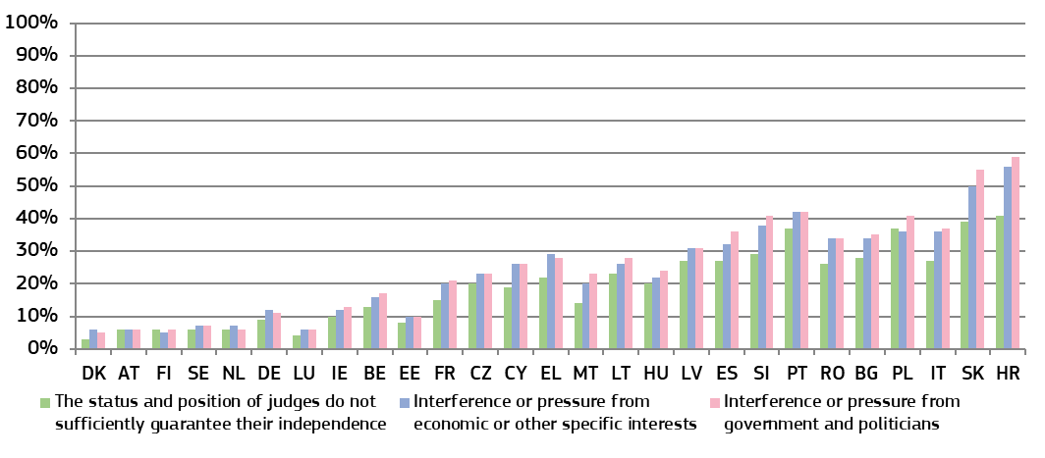

**Figure 46: Perceived independence of courts and judges among companies**(*) *(source: Eurobarometer ([90])* **—** *light colours: 2017, 2018 and 2019, dark colours: 2020)*

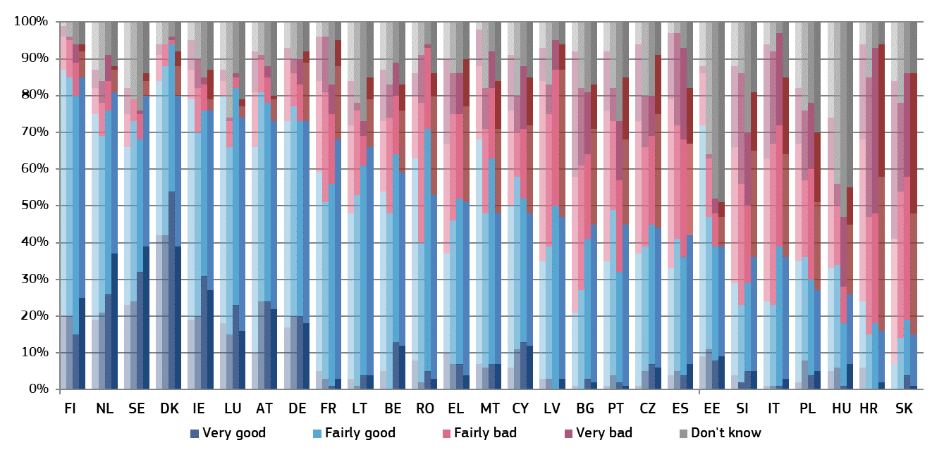

*(*) Member States are ordered first by the percentage of respondents who stated that the independence of courts and judges is very good or fairly good (total good); if some Member States have the same percentage of total good, then they are ordered by the percentage of respondents who stated that the independence of courts and judges is fairly bad or very bad (total bad); if some Member States have the same percentage of total good and total bad, then they are ordered by the percentage of respondents who stated that the independence of courts and judges is very good; if some Member States have the same percentage of total good, total bad and of very good, then they are ordered by the percentage of respondents who stated that the independence of courts and judges is very bad.*

Figure 47 shows the main reasons given by respondents for the perceived lack of independence of courts and judges. Respondents among companies, who rated the independence of the justice system as being ‘fairly bad’ or ‘very bad’, could choose between three reasons to explain their rating. The Member States are listed in the same order as in Figure 46.

**Figure 47: Main reasons among companies for the perceived lack of independence** *(rate of all respondents* **—** *higher value means more influence) (source: Eurobarometer ([91]))*

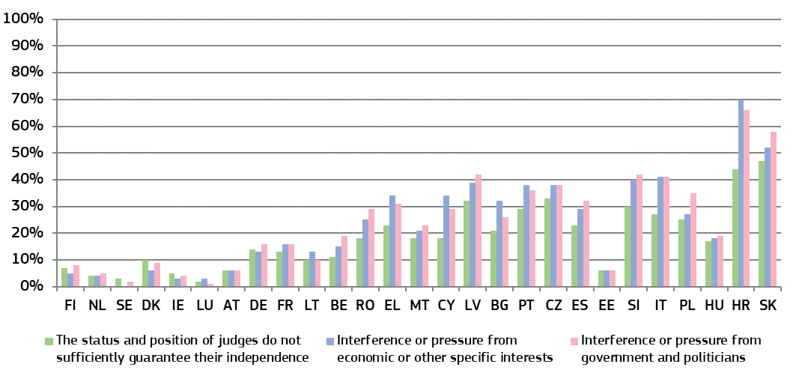

**Figure 48: WEF: businesses’ perception of judicial independence, 2010-2019** *(perception* **—** *higher value means better perception) (source: World Economic Forum (*[92]*))*

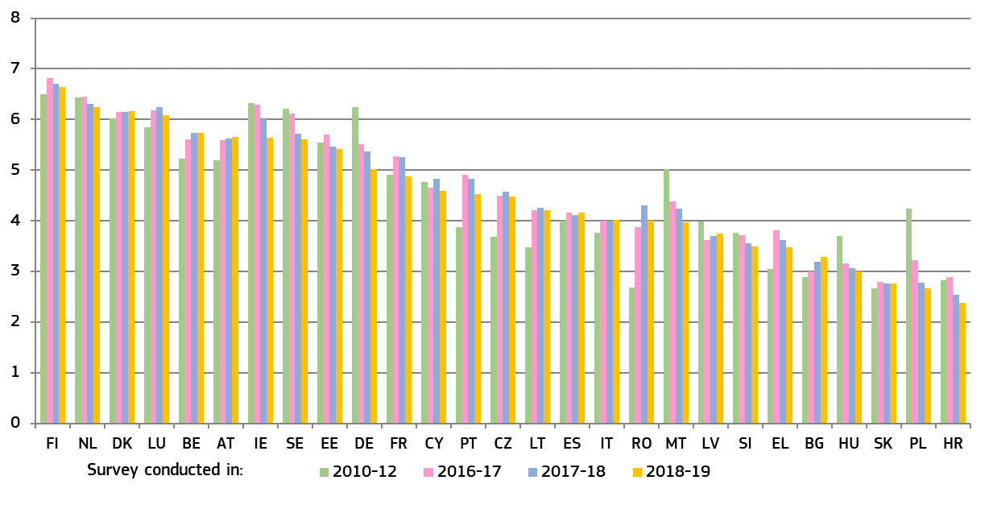

**3.3.2. Structural independence**

The guarantees of structural independence require rules, particularly as regards the composition of the court and the appointment, length of service and grounds for abstention, rejection and dismissal of its members, in order to dispel any reasonable doubt in the minds of individuals as to the imperviousness of that court to external factors and its neutrality with respect to the interests before it ([93]). Those rules must, in particular, be such as to preclude not only any direct influence, in the form of instructions, but also types of influence which are more indirect and which are liable to have an effect on the decisions of the judges concerned ([94]).

European standards have been developed, particularly by the Council of Europe, for example in the *2010 Council of Europe Recommendation on judges: independence, efficiency and responsibilities* ([95]). The 2020 EU Justice Scoreboard presents a number of indicators on how justice systems are organised to safeguard judicial independence.

This edition of the EU Justice Scoreboard contains updated indicators on bodies and authorities involved in disciplinary proceedings regarding judges (Figures 49 and 50), and on the appointment of members of the Councils for the Judiciary (Figures 51 and 52) ([96]). The 2020 EU Justice Scoreboard also presents information on bodies and authorities involved in disciplinary proceedings regarding prosecutors (Figures 53 and 54) and an updated more detailed figure on instructions to prosecutors in individual cases (Figure 55) ([97]). The figures present the national frameworks as they were in place in December 2019.

The figures presented in the Scoreboard do not provide an assessment or present quantitative data on the effectiveness of the safeguards. They are not intended to reflect the complexity and details of the safeguards. Having more safeguards does not, in itself, ensure the effectiveness of a justice system. It should also be noted that implementing policies and practices to promote integrity and prevent corruption within the judiciary is also essential to guarantee judicial independence. Ultimately, the effective protection of judicial independence requires a culture of integrity and impartiality, shared by magistrates and respected by the wider society.

*–* *Safeguards on disciplinary proceedings regarding judges –*

Disciplinary proceedings regarding judges are among the most sensitive situations in relation to judicial independence. According to the Court of Justice “the rules governing the disciplinary regime […] of those who have the task of adjudicating in a dispute must provide the necessary guarantees in order to prevent any risk of that disciplinary regime being used as a system of political control of the content of judicial decisions” ([98]). The set of guarantees identified by the Court of Justice as essential for safeguarding the independence of the judiciary include rules which define both conduct amounting to disciplinary offences and the penalties actually applicable, rules which provide for the involvement of an independent body in accordance with a procedure which fully safeguards the rights enshrined in Articles 47 and 48 of the Charter, in particular the rights of the defence, and rules which lay down the possibility of bringing legal proceedings challenging the disciplinary bodies’ decisions ([99]). The Court of Justice held that “Article 267 TFEU gives national courts the widest discretion in referring matters to the Court (…) at whatever stage of the proceedings they consider appropriate” ([100]). According to the Court of Justice, any national rule inhibiting this discretion “in order to avoid being (…) exposed to disciplinary penalties” is “detrimental to the prerogatives granted to national courts and tribunals by Article 267 TFEU and, consequently, to the effectiveness of the cooperation between the Court and the national court (…) established by the preliminary ruling mechanism” ([101]). The Court has also stated that “not being exposed to disciplinary sanctions for (…) sending a request for a preliminary ruling to the Court (…) constitutes a guarantee essential to judicial independence” ([102]).

According to the Council of Europe standards, disciplinary proceedings regarding judges may follow where they fail to carry out their duties in an efficient and proper manner ([103]). The interpretation of the law, assessment of facts or weighing of evidence carried out by judges to determine cases should not give rise to civil or disciplinary liability, except in case of malice and gross negligence ([104]). Moreover, disciplinary proceedings should be conducted by an independent authority as a court with all the guarantees of a fair trial. The judge under disciplinary proceeding should have the right to challenge both the decision and the sanction. Disciplinary sanctions should be proportionate ([105]).

Figure 49 presents an updated overview of the authorities that decide on disciplinary sanctions regarding ordinary judges, which can be either (a) regular independent authorities such as courts (Supreme Court, Administrative Court or Court President) or Councils for the judiciary, or (b) other authorities whose members are specifically appointed by the Council for the Judiciary, by judges or by the executive.

**Figure 49: Authority deciding on disciplinary sanctions regarding judges** (*) *([106])*

*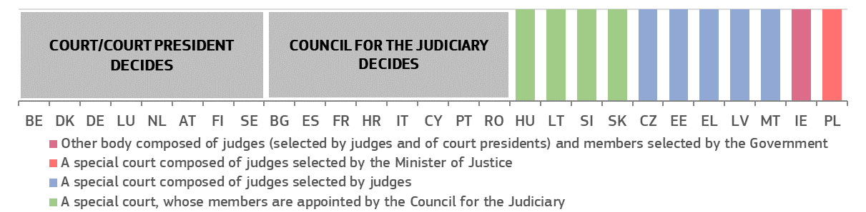(*)* ***BG:*** *Lighter disciplinary sanctions may be imposed by the Court President. Any decision on disciplinary measures are open to judicial review before the Supreme Administrative Court.* ***CZ:*** *Disciplinary cases are examined by disciplinary chambers of the Supreme Administrative Court. The members are proposed by the President of the Court from among a list of judges and are chosen by sortition.* ***DK:*** *The special Court of Indictment and Revision comprising five members, formally appointed by the Minister of Justice but nominated respectively by the Supreme Court, the High Courts, the Judges Association and the Bar Association in addition to a distinguished academic, decides on disciplinary sanctions.* *The* *president of a first instance court can issue a warning.* ***DE:*** *Disciplinary measures can be applied in formal disciplinary proceedings (see Section 63 German Judiciary Act for federal judges and the equivalent provision at the level of the Länder) by service courts (‘Dienstgericht des Bundes’ concerning federal judges and ‘Dienstgerichte der Länder’ concerning federal state judges), which are special panels in regular courts. The members of these panels are appointed by the judges (‘Präsidium’) of the particular court (the Federal Court of Justice or higher regional court or regional court). Less severe disciplinary measures, such as reprimands, can be issued in a disciplinary order (see Section 64 German Judiciary Act for federal judges and the equivalent provisions at the level of the Länder) by either a court president or the ministry of justice (both at the level of federal states and at federal level).* ***EE:*** *Disciplinary cases are examined by the Disciplinary Chamber of Judges appointed by the Supreme Court, and by the General Assembly of all Estonian judges.* ***IE:*** *The Judicial Conduct Committeee decides, which is established by the Judicial Council and is composed by three judges elected by their peers, five court presidents (members ex officio) and by five lay-members appointed by the government. Under the Constitution, a judge may be removed from office for stated misbehaviour or incapacity upon resolutions passed by both Houses of Parliament (the Oireachtas) calling for his/her removal.* ***EL:*** *The disciplinary authority over judges is exercised, in the first and second instance, by councils composed of regular judges of higher rank chosen by lot. Disciplinary authority over high ranking judges is exercised by the Supreme Disciplinary Council..* ***IT****: Decisions of the Council for the Judiciary on disciplinary measures are open to judicial review before the Supreme Court.* ***LV:******:*** *Disciplinary cases are examined by the Judicial Disciplinary Committee, whose members are appointed by the general meeting of judges.* ***ES:*** *Disciplinary decisions regarding minor disciplinary offences are made by the governance chamber of the respective Court of the district where the disciplined judge sits (High Court of Justice, National Court and Supreme Court,* *and even by the Presidents of Supreme Court, National Audience and Superior Court of Justice where the disciplined judge sits according 421.1.a) Organic Law of Judiciary).* ***LT:*** *At first instance, the Judicial Court of Honour, whose members and chairperson (judge, elected by the Council for the Judiciary) are laid out in the Ruling of the Council for the Judiciary, decides. It is composed of six judges selected and appointed by the Council for the Judiciary, two members appointed by the President of the Republic and two members appointed by the Speaker of the Seimas. At second instance, the Supreme Court decides.* ***HU:*** *Disciplinary cases are examined by the Service Court appointed by the National Judicial Council. The president of the court may impose the mildest sanction (‘warning’) that can be challenged before the Service Court.* ***MT:*** *The Committee for Judges and Magistrates, which is a subcommittee of the Commission for the Administration of Justice, decides. The Committee consists of three judges or magistrates elected by their peers.* ***PL:*** *The Minister of Justice selects disciplinary judges after a non-binding consultation with the National Council for the Judiciary. The Disciplinary Chamber of the Supreme Court, tasked with deciding i.a. on disciplinary cases of judges in second instance, was found to be not an independent court within the meaning of EU law in three rulings of the Supreme Court, implementing the judgment of the Court of Justice of 19 November 2019.* ***SI:*** *The disciplinary court is appointed by the Council for the Judiciary, from among members of the Council itself and from among judges proposed by the Supreme Court.* ***SK:*** *Presidents of first instance courts have the power to impose the disciplinary sanction of a ‘written warning’. Disciplinary panels are appointed by the Council for the Judiciary. For the President and Vice President of the Supreme Court, the Constitutional Court is competent for disciplinary proceedings.* ***SE:*** *A permanent judge may be removed from office only if they have committed a serious crime or repeatedly neglected their duties, and thereby show that they are manifestly unfit to hold the office. Should the decision to remove the judge from office have been made by another authority than a court (in practice by the National Disciplinary Offence Board), the judge concerned may call upon a court to review that decision. The decision can be challenged by the judge on their own in the district court or with a support of the trade union in the labour court as a first instance court.*

Figure 50 presents an updated overview of the investigative bodies, that carry out the formal investigation during disciplinary proceedings regarding judges. It does not concern preliminary enquiries to decide whether or not to initiate a formal disciplinary proceeding. The investigation phase is a particularly sensitive step within disciplinary proceedings, which could affect judicial independence. The investigative power can be exercised either (a) by regular independent authorities such as Court Presidents or Councils for the Judiciary, or (b) by other investigators who are specifically appointed -by the Council of the Judiciary, by judges or by other authorities- for conducting investigations in disciplinary proceedings regarding judges.

**Figure 50: Investigator in charge of formal disciplinary proceedings regarding judges** (*) ([107])

*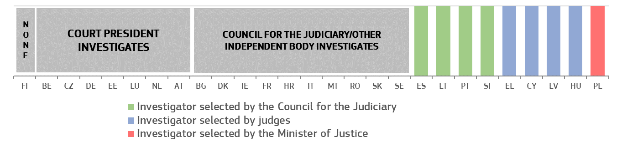(*)* ***BG:*** *The relevant administrative head of the court [for facts which might lead to the sanction of the reprimand] or the Judge’s College (disciplinary panel) to the Supreme Judicial Council of Bulgaria investigates. The Inspectorate at the Supreme Judicial Council carries out inspections on which basis it can make proposals for disciplinary proceedings.* ***CZ:*** *The minister of justice can also conduct some preliminary enquiries in order to prepare the motion to initiate disciplinary proceedings, normally consulting the president of the court where the concerned judge sits.* ***DK:****Anyone can bring a complaint to the Special Court of Indictment and Revision, which is located and administered at the Supreme Court, and which decides after hearing both parties. The Director of the Public Prosecution can also investigate.* ***DE:*** *There is no formal pre-investigatory phase. In disciplinary orders, concerning less severe disciplinary measures such as reprimand, the court president and the highest service authority (usually the ministry of justice, both at the level of federal states and at federal level) assess the facts. The highest service authority decides whether to launch a disciplinary proceeding before the court. Then the court carries out formal investigations.* ***EE:*** *The president of a court or the Chancellor of Justice (Ombudsman) can conduct an investigation.* ***IE:*** *Judges are not subject to a disciplinary body or disciplinary regime apart from the procedure under the Constitution under which a judge may be removed from office for stated misbehaviour or incapacity upon resolutions passed by both Houses of Parliament (the Oireachtas) calling for their removal.* ***EL:*** *For civil and criminal courts: The Judicial Inspection Body which is elected from among judges by lot. For administrative courts: The investigator is chosen by lot among the members of the Council of State.* ***ES:*** *The Promoter of disciplinary action is appointed by the General Council for the Judiciary; the Promoter is selected from a pool of judges of the Supreme Court and Magistrates with more than 25 years of legal experience, but exclusively exercises the functions of Promoter during their mandate.* ***FR:*** *The president of the Council for the Judiciary chooses one or two members of the Council for the Judiciary to conduct the relevant investigations. The ministry can ask a report to the Judicial inspection body before the decision to bring the case to the Council.* ***IT:*** *The Prosecutor General at the Supreme Court is entitled to conduct the investigation.* *The Inspectorate General at the Ministry of Justice is entitled to carry out administrative enquiries.* ***CY:*** *The investigative judge, appointed by the Supreme Court, investigates.* ***LV:*** *The Judicial Disciplinary Committee investigates.* ***HU:*** *The Disciplinary Commissioner, appointed by the Service Tribunal (disciplinary court), investigates.* ***LT:*** *The Judicial Ethics and Discipline Commission, whose members and chairperson (elected by the Council for the Judiciary) are laid out in the Ruling of the Council for the Judiciary, is composed of four judges appointed by the Council for the Judiciary, two members appointed by the President of the Republic, and one member appointed by the Speaker of the Seimas, investigates. The chairperson of the Judicial Ethics and Discipline Commission has the right to delegate the court president in which the judge is working or the president of the higher court to carry out the investigation and present the results of the investigation.* ***MT:*** *The Committee of Judges and Magistrates investigates.* ***NL:*** *The Prosecutor-General investigates.* ***PL:*** *The Minister of Justice appoints the Disciplinary Officer for ordinary court judges and his/her two deputies (they, in turn, appoint their own deputies from among judges) to investigate. The Minister of Justice can take over any ongoing investigation by appointing an ad hoc Disciplinary Officer of the Minister of Justice.* ***PT:*** *The Council for the judiciary appoints the Judicial Inspection Body, which investigates.* ***RO*** *The Judicial Inspection Body investigates.* ***SI:*** *The Judicial Council appoints a disciplinary prosecutor from among candidates proposed by the Supreme Court to investigate.* ***SK:*** *The Disciplinary Panel, appointed by the Council for the Judiciary, conducts the investigation.* ***SE:*** *The Parliamentary Ombudsman and the Chancellor of Justice act as prosecutors in cases of serious malpractice.*

*– Safeguards on the nomination of judges-members of the Councils for the Judiciary –*

Councils for the judiciary are essential bodies for ensuring the independence of justice. It is for the Member States to organise their justice systems, including deciding on whether or not to establish a Council for the Judiciary. However, well established European standards, in particular Recommendation CM/Rec(2010)12, recommend that ‘not less than half the members of [Councils for the Judiciary] should be judges chosen by their peers from all levels of the judiciary and with respect for pluralism inside the judiciary’ ([108]). The figure below shows whether the judiciary is involved in the appointment of judges-members of the Councils for the Judiciary.

**Figure 51: Appointment of judges-members of the Councils for the Judiciary: involvement of the judiciary** (*) ([109])

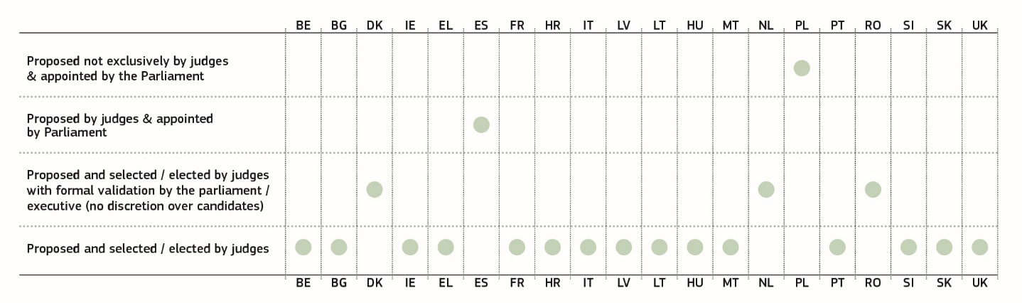

*(*) The Member States appear in the alphabetical order of their geographical names in the original language. The figure presents the national frameworks as they were in place in December 2019.* ***DK:*** *Judges-members of the Council are selected by judges. All members are formally appointed by the Minister of Justice.* ***EL:*** *Judges-members are selected by lot.* ***ES:*** *Judges-members are appointed by the Parliament — the Council communicates to the Parliament the list of candidates who have received the support of a judges’ association or of 25 judges.* ***NL:*** *Judges-members are selected by the judiciary and are appointed on the proposal of the Council, based among others on the advice of a selection committee (consisting mainly of judges and court staff). All members of the Council are formally appointed by Royal Decree, an administrative act that does not leave any room for discretion to the executive.* ***PL:*** *Candidate judges-members are proposed by groups of at least 2 000 citizens or 25 judges. From among the candidates, the deputies’ clubs select up to nine candidates, from which a committee of the lower chamber of the Parliament (Sejm) establishes a final list of 15 candidates, who are appointed by the Sejm.* ***RO:*** *The campaign and election of judges-members are organised by the Superior Council of Magistracy. Once the final list of elected judges-members is confirmed, the Senate will validate it "en bloc". The Senate may refuse to validate the list only in case of infringement of the law in the procedure for the election of the members of the council and only if the infringement has had an influence over the result of the election. The Senate cannot exercise discretion over the choice of candidates.*

The figure shows the composition of Councils for the Judiciary ([110]) according to the nomination process. In particular, it shows whether the members of the Councils are judges/prosecutors proposed and selected/elected by their peers, members nominated by the executive or legislative branch, or members nominated by other bodies and authorities. Not less than half the members of Councils should be judges chosen by their peers from all levels of the judiciary and with respect for pluralism inside the judiciary ([111]). The Figure is a factual representation of the composition of the Councils for the Judiciary and does not make a qualitative assessment of their effective functioning.

**Figure 52: Composition of the Councils for the Judiciary according to the nomination process (*)**

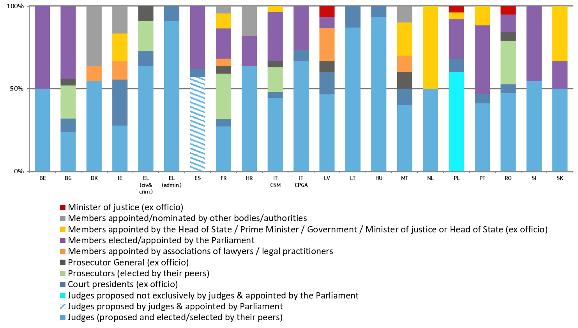









*(*)* ***BE:*** *Judicial members are either judges or prosecutors;* ***BG:*** *the Supreme Judicial Council is composed of the Judges’ Chamber (fourteen members of which the Chairmen of the Supreme Court of Cassation and of the Supreme Administrative Court, six members elected directly by the judges and six members elected by the National Assembly) and of the Prosecutors’ Chamber (eleven members of which the Prosecutor General, four members elected directly by the prosecutors, one member elected directly by the investigators and five members elected by the National Assembly);* ***DK:*** *all members of the National Courts Administration board are formally appointed by the Minister of Justice; the category ‘Appointed/nominated by other bodies/authorities’ includes two court representatives (nominated by the union for administrative staff and by the police union). In addition a Judicial Appointments Council exists, which prepares proposals for judicial appointments (half of its members are judges selected by their peers);* ***IE:*** *The figure reflects the composition of the Courts Service, member of the European Network of Councils for the Judiciary, according to the framework in force in beginning of December 2019. On 17 December 2019, a new Judical Council was formally established pursuant to the Judicial Council Act of 2019. The first plenary session of the Judicial Council, comprising all of the judges of Ireland, was held on 7 February 2020.* ***ES:******:*** *Members of the Council coming from the judiciary are appointed by the Parliament — the Council communicates to the Parliament the list of candidates who have received the support of a judges’ association or of twenty five judges;* ***EL(civil & criminal judiciary):*** *the council has the total of 11/15 members, out of which 7/11 are judges. Judges and prosecutors are chosen by a lot.* ***EL (admininistrative judicary):*** *the council has the total of 11/15 members, out of which 10/14 are judges, who are chosen by a lot.* ***FR:*** *The Council has two formations — one with jurisdiction over sitting judges, the other with jurisdiction over prosecutors; the Council includes one member of the Conseil d’Etat (Council of State) elected by the general assembly of the Conseil d’Etat;* ***IT-CSM:*** *Consiglio Superiore della Magistratura (covering civil and criminal courts, and the prosecution service); according to the Constitution, the President of the Republic, the first President at the High Court of Cassation and the Prosecutor General at the Hight Court of Cassation are members ex officio.* ***IT-CPGA:*** *Consiglio di presidenza della giustizia amministrativa (covering administrative courts);* ***MT:******:*** *The leader of the opposition appoints one lay member.* ***NL:*** *Members are formally appointed by Royal Decree on a proposal from the Minister of Security and Justice.* ***PL:*** *Candidate judges-members are proposed by groups of at least 2 000 citizens or 25 judges. From among the candidates, the deputies’ clubs select up to nine candidates, from which a committee of the lower chamber of the Parliament (Sejm) establishes a final list of 15 candidates, who are appointed by the Sejm. On 23 January 2020, the Supreme Court, implementing the preliminary ruling of the Court of Justice issued in joined cases C-585/18, C-624/18 and C-625/18, ruled that in its current composition the Council is not independent from executive and legislative powers and judges appointed at its request cannot adjudicate cases. On 17 September 2018, an Extraordinary General Assembly of the European Network of Councils for the Judicary decided to suspend the membership of the National Council for the Judiciary (KRS) because it no longer met the requirements of the ENCJ that it is independent of the Executive and Legislature in a manner which ensured the independence of the Polish Judiciary.* ***PT:*** *The figure refers to the composition of the Conselho Superior da Magistratura. In addition, a High Council for the Administrative and Tax Courts (Conselho Superior dos Tribunais Administrativos e Fiscais) and a High Council for the Public Prosecution (Conselho Superior do Ministério Público) also exist.* ***RO:*** *elected magistrates are validated by the Senate;* ***SI:*** *Non-judge members are elected by the National Assembly on a proposal from the President of the Republic.*

*– Safeguards relating to the functioning of national prosecution services in the EU –*

Public prosecution plays a major role in the criminal justice system as well as in cooperation between Member States in criminal matters. The proper functioning of the national prosecution service is crucial for the effective fight against crime, including economic and financial crime, such as money laundering and corruption. According to the Court of Justice case law, in the context of the Framework Decision on the European Arrest Warrant ([112]), the public prosecutor’s office can be considered a Member State judicial authority for the purposes of issuing a European arrest warrant whenever it can act independently, without being exposed to the risk of being subject, directly or indirectly, to directions or instructions in a specific case from the executive, such as a Minister for Justice ([113]).

The organisation of national prosecution services varies throughout the EU and there is no uniform model for all Member States. However, there is a widespread tendency to have a more independent prosecutor’s office, rather than one subordinated or linked to the executive ([114]). According to the Consultative Council of European Prosecutors, for the effective fight against corruption and money laundering and related economic and financial crime, greater independence and autonomy of the prosecution service, along with its accountability, can be a further guarantee for the respect of the rule of law ([115]). Whatever the model of the national justice system or the legal tradition in which it is anchored, European standards require that Member States take effective measures to guarantee that public prosecutors are able to fulfil their professional duties and responsibilities under adequate legal and organisational conditions ([116]) and without unjustified interference ([117]). In particular, where the government gives instruction of a general nature, for example on crime policy, such instructions must be in writing and published in an adequate way ([118]). Where the government has the power to give instructions to prosecute a specific case, such instructions must carry with them adequate guarantees ([119]). According to the 2000 Recommendation of the Committee of Ministers of the Council of Europe, instructions not to prosecute should be prohibited ([120]). Interested parties (including victims) should be able to challenge a decision of a public prosecutor not to prosecute a case ([121]).

The figures below present a factual overview of certain aspects of the framework applicable to the prosecution services and does not assess their effective functioning, which requires a qualitative assessment taking into account specific circumstances of each Member State.

Figure 53 presents an overview of the authorities that decide on disciplinary sanctions regarding basic-rank prosecutors. These can be either (a) independent authorities such as courts or Councils for the Judiciary or Prosecutorial Councils, or (b) other bodies or authorities, such as the Prosecutor General or a superior prosecutor, independent bodies, special bodies composed of prosecutors, or the Minister of Justice. Unless stated differently in the explanation below the figure, a decision of the authority on disciplinary measures regarding a prosecutor is open to judicial review ([122]).

**Figure 53: Authority deciding on disciplinary sanctions regarding prosecutors (*)** *(Source: European Commission with the Expert Group on Money Laundering and Financing of Terrorism)*

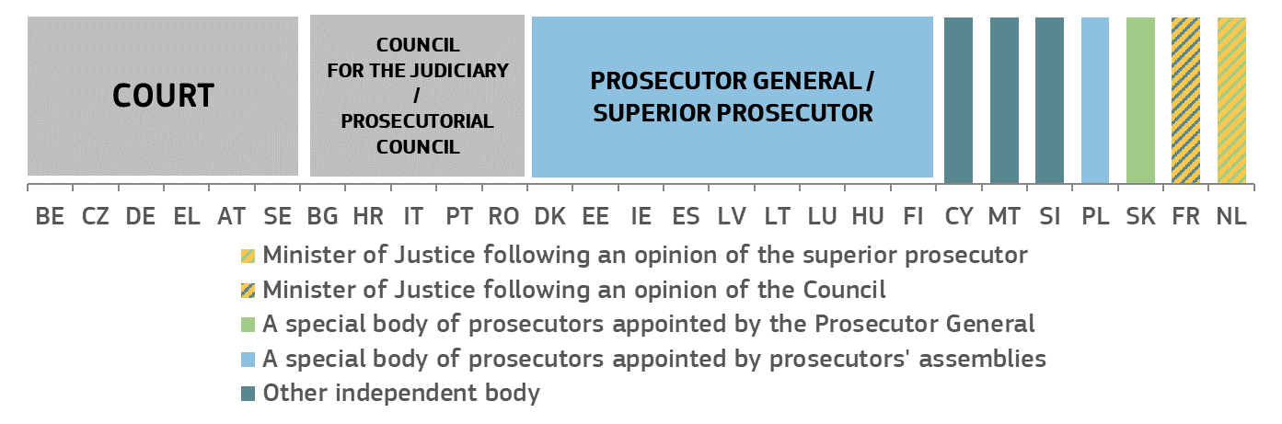

*(*)* ***BE****: The superior prosecutor (head of the prosecutor's office) has the power to decide on minor disciplinary sanctions, while major sanctions are imposed by the disciplinary court of first instance. Decisions on disciplinary measures are open to appeal before a disciplinary court of appeal.* ***BG****: The Prosecutorial Chamber of the Supreme Judicial Council is composed of the Prosecutor General, four members elected by prosecutors, one member elected by investigative magistrates and five members elected by the National Assembly. Its decisions on disciplinary measures regarding a prosecutor are open to judicial review before the Supreme Administrative Court. The administrative head of the prosecutor may only impose a reprimand, notifying this sanction to the Prosecutorial Chamber, which may confirm or revoke this sanction.* ***CZ****: Disciplinary cases are examined by a disciplinary chamber of the Supreme Administrative Court. The chamber is composed of two judges (a judge of the Supreme Administrative Court and a judge of the Supreme Court), two prosecutors, a lawyer, and a person of another legal profession. Members of the chamber are selected by lot by the President of the Supreme Administrative Court drawing from lists of candidates provided by representatives of the different legal professions (by the Supreme Administrative Court, the President of the Supreme Court, Prosecutor General, President of the Bar Association, and deans of law schools). No appeal is open against the decision of the disciplinary chamber.* ***DK****: The Danish Ministry of Justice has the power to decide on specific disciplinary measures against prosecutors. However, in practice the Ministry of Justice empowers the Prosecution Service to handle disciplinary measures against prosecutors. All decisions on disciplinary measures taken by the Prosecution Service can be appealed to the Ministry of Justice. Judicial review is open against disciplinary measures taken by the Ministry of Justice and a prosecutor may bring a complaint to the Parliamentary Ombudsman.* ***DE****: The superior prosecutor may impose a disciplinary measure of a lighter nature. Because of the competence of the states for regulating the disciplinary law of the state officials, there are various special features in the laws of the states.* ***EE****: The Prosecutor General decides on disciplinary measures, including dismissal, on the proposal of the Prosecutors’ Disciplinary Committee. Decisions on disciplinary measures are open to appeal before an administrative court.* ***IE****: The Deputy Director of Public Prosecutions decides on disciplinary measures concerning basic rank prosecutors. The recommendation from the relevant manager that a disciplinary measure should be adopted is open to appeal before an external Disciplinary Appeals Board, before the disciplinary decision is adopted.* ***EL****: Five-member Disciplinary Councils of Courts of Appeal are primarily responsible for adjudicating disciplinary offenses and imposing all disciplinary penalties on prosecutors except dismissal, which is decided upon by the plenary of the Court of Cassation. Decisions by the five-member Disciplinary Councils are open to appeal before a seven-member Disciplinary Board of the Supreme Court.* ***ES****: The Chief Prosecutors of the various bodies of the Public Prosecutor’s Office decide on disciplinary measures, which can be appealed to the Consejo Fiscal. This body consists of the Prosecutor General, the Deputy Prosecutor General, the Chief Inspector and six other prosecutors. Its decisions are open to judicial review at the Audiencia Nacional.* ***FR****: The Ministry of Justice decides on the measure after the Conseil Supérieur de la Magistrature issues a non-binding opinion. Decisions on disciplinary measures can be appealed before the Conseil d'Etat.* ***HR:*** *The State’s Attorney Council decides on disciplinary measures, which can be reviewed before the administrative courts.* ***IT****: Decisions of the Council for the Judiciary on disciplinary measures are open to judicial review before the Supreme Court.* ***CY****: Disciplinary measures are adopted by the Public Service Commission, a constitutional body consisting of five members appointed by the President of the Republic for a six-year period. Decisions on disciplinary measures are open to appeal before the administrative court, and subsequently before the Supreme Court.* ***LV****: The Prosecutor General can decide on any disciplinary measure against any prosecutor. Head Prosecutors can make an annotation or a reprimand to prosecutors under their management. In the event of a more serious violation, the Head Prosecutor may submit a proposal to the Prosecutor General to apply another disciplinary measure. Decisions on disciplinary measures adopted by a Head Prosecutor can be appealed to the Prosecutor General. Decisions on disciplinary measures adopted by the Prosecutor General are open to appeal before a Disciplinary Court.* ***LT****: The Prosecutor General decides on disciplinary measures. Decisions on disciplinary measures are open to appeal before an administrative court.* ***LU****: The Prosecutor General decides on disciplinary measures.* ***HU****: The Prosecutor General decides on measures to revoke a distinction, to demote by paygrade or by rank or to dismiss. The Head of Unit (superior prosecutor) may adopt lighter measures (reprimand, censure) regarding a prosecutor under their supervision. Decisions on disciplinary measures are open to appeal before a labour court.* ***MT****: The Committee on Advocates and Legal Procurators consists of an advocate appointed by the Commission for the administration of justice, an advocate appointed by the Attorney General and three legal procurators appointed by the Chamber of Legal Procurators. The Committee may impose a pecuniary penalty, issue and admonishment and make recommendations to the prosecutor. The Committee may request the Commission to recommend to the Prime Minister to advise the President of Malta to suspend or dismiss a prosecutor. Measures adopted by the Committee can be appealed to the Commission for the Administration of Justice.* ***NL****: The hierarchically superior prosecutor may impose certain measures of a lighter nature (written reprimand, reduction of annual leave, extra working hours). The Minister of Justice may decide on transfer without consent, suspension, a financial fine and measures relating to salary, after the hierarchically superior prosecutor has proposed this measure or issued an advice. The government has the power to dismiss a prosecutor, after the hierarchically superior prosecutor has proposed dismissal or given an advice. Decisions on disciplinary measures are open to appeal before the Centrale Raad van Beroep.* ***AT****: Special chamber of a court decides on disciplinary measures.* ***PL****: At first instance, disciplinary measures are generally decided upon by a disciplinary body at the General Prosecutor’s Office, consisting of three prosecutors appointed by assemblies of prosecutors. These measures are open to appeal before the Disciplinary Chamber of the Supreme Court, which in certain cases acts as the deciding authority at first instance. When acting as the court of second instance, this Chamber is composed of two Disciplinary Chamber judges and one lay judge. A prosecutor who has been sanctioned twice with a sanction different than a reprimand may be dismissed from office by the Prosecutor General (who is also the Minister of Justice) in case of commitment of a new disciplinary offence (which is not to be ascertained by the disciplinary court and without the possibility of judicial review of the Prosecutor-General’s decision.* ***PT****: The Disciplinary Section of the High Council of the Prosecution Service decides on the adoption of disciplinary measures. Its decisions can be appealed to the plenary of the High Council of the Prosecution Service, and subsequently to the Supreme Administrative Court.* ***RO****: The Superior Council of Magistracy decides on disciplinary measures. Decisions on disciplinary measures are open to appeal before the Supreme Court.* ***SI:*** *The**Disciplinary court appointed by the Prosecutorial Council decides on disciplinary sanctions. The Disciplinary court of first degree is composed of six state prosecutors proposed by the Prosecutor General and three judges proposed by the president of the disciplinary court of first instance for judges from among the members of this court. The disciplinary court of second instance is composed of six members appointed by the Prosecutorial Council: the president, deputy of the president and two members are proposed by the president of the disciplinary court for judges of second instance from among the members of this court; two supreme state prosecutors are proposed by Prosecutor General.* ***SK****: A disciplinary board composed of three prosecutors, appointed by the Prosecutor General from a database of at least 40 persons proposed by the Prosecutor’s Council, decides on disciplinary measures. These decisions are open to appeal before a Disciplinary Board of Appeal at the General Prosecutor’s Office, composed of five prosecutors appointed by the Prosecutor General from a database of persons proposed by the Council of Prosecutors. Judicial review against decisions of the Disciplinary Board of Appeal is open before the regional courts.* ***FI****: The Prosecutor General decides on disciplinary measures. Decisions to adopt disciplinary measures are open to appeal before an administrative court.*

Figure 54 presents an overview of the investigative bodies that carry out the investigation during disciplinary proceedings regarding prosecutors. Unless stated differently in the footnote to the figure, it does not concern preliminary enquiries to decide whether or not to initiate a formal disciplinary proceeding. The investigation phase is an important step within disciplinary proceedings, which may have an impact on the autonomy of the prosecution service. The investigative power can be exercised either (a) by regular independent authorities such as a court or the Council for the Judiciary or Prosecution, or (b) by the Prosecutor General or a superior prosecutor, or (c) by other bodies.

**Figure 54: Investigator in charge of formal disciplinary proceedings regarding prosecutors (*)** *(Source: European Commission with the Expert Group on Money Laundering and Financing of Terrorism)*

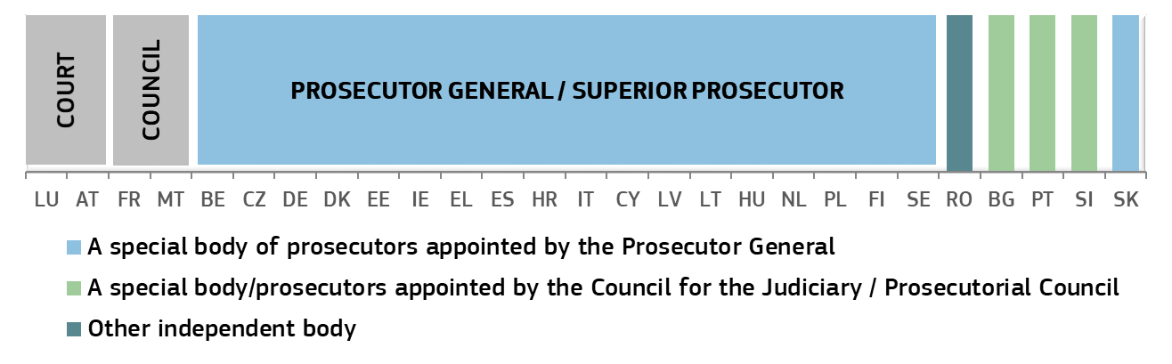

*(*)* ***BE****: The hierarchically superior prosecutor conducts the investigation.* ***BG****: The administrative head of the prosecutor investigates in case of a reprimand. For all other sanctions, the investigation is conducted by a three-member disciplinary panel elected by the Prosecutors Chamber of the Supreme Judicial Council from its members. The Prosecutorial Chamber of the Supreme Judicial Council is composed of the Prosecutor General, four members elected by prosecutors, one member elected by investigative magistrates and five members elected by the National Assembly. The Inspectorate at the Supreme Judicial Council carries out inspections on which basis it can make proposals for disciplinary proceedings.* ***CZ****: The Prosecutor General and Chief Public Prosecutor can look into the prosecutor´s case file, and ask for their statement.* ***DK****: The Prosecution Service conducts the investigation.* ***DE****: The head of the public prosecutor’s office not only decides whether to initiate disciplinary proceedings against a public prosecutor, but also conducts the disciplinary proceedings. Because of the competence of the states for regulating the disciplinary law of the state officials, there are various special features in the laws of the states.* ***EE****: The hierarchically superior prosecutor or the Prosecutor General conducts the investigation, depending on who initiated the disciplinary proceedings. They or she may also assign the task of gathering evidence and demanding explanations to another prosecutor, who is neither a member of the disciplinary committee, nor the prosecutor against whom the proceedings are initiated or a subordinate to that prosecutor. The case is heard by the prosecutors’ disciplinary committee, which is composed of two prosecutors of the Office of the Prosecutor General, two prosecutors from district prosecutors’ offices and one judge.* ***IE****: A hierarchically superior prosecutor conducts the investigation. In cases where the facts are complex or the suspected misconduct is serious, human resources department will arrange for an investigation to take place.* ***EL*** *The hierarchically superior prosecutor conducts the investigation.* ***ES****: The hierarchically superior prosecutor conducts the investigation.* ***FR****: Following an administrative enquiry, the Minister of Justice can decide to seize the Conseil Supérieur de la Magistrature to investigate the case.* ***HR:*** *The Superior State Attorney investigates.* ***IT****: The Prosecutor General at the Supreme Court isentitled to conduct the investigation. The Inspectorate General at the Ministry of Justice is entitled to carry out administrative enquiris.* ***CY****: The Attorney General appoints one or more officers of superior rank than the officer in question, who conduct the investigation and produce a report. The Attorney General then decides on the basis of the evidence whether to refer the matter to the Public Service Commission.* ***LV****: An official, who has the right to apply a disciplinary sanction (the Prosecutor General or head prosecutors), shall review all materials received and request an explanation from a prosecutor and, if necessary, organise the investigation of the fact of a disciplinary violation. Investigation can be conducted by prosecutor of the General Prosecutor’s Office or head prosecutors.* ***LT****: The Internal Investigation Division of the Prosecutor General’s Office or official inspection commission made pursuant to the order of the Prosecutor General.* ***LU****: A Council chamber of the Superior Court of Justice conducts the investigation.* ***HU****: The Disciplinary Commissioner investigating the case is a prosecutor appointed to investigate by the Head of Unit (superior prosecutor) of the prosecutor under investigation.* ***MT****: The Committee on Advocates and Legal Procurators investigates the case. This body consists of an advocate appointed by the Commission for the Administration of Justice, an advocate appointed by the Attorney General and three legal procurators appointed by the Chamber of Legal Procurators.* ***NL****: The hierarchically superior prosecutor conducts the investigation.* ***AT****: Special chamber of a court conducts the investigation.* ***PL:*** *The case is investigated by a Disciplinary Officer, who is a prosecutor appointed to that function by the Prosecutor General (who is also the Minister of Justice). The Minister of Justice may also appoint, on an ad hoc basis, a prosecutor as a Disciplinary Officer of the Minister of Justice empowered to take over any ongoing disciplinary investigation or initiate a disciplinary investigation or proceedings.* ***PT****: The Inspection of Public Prosecutors conducts the investigation. This body is composed of public prosecutors appointed by the High Council of the Public Prosecution Service.* ***RO****: The Judicial Inspection Body is a body within the Superior Council of Magistracy. The section investigating disciplinary measures concerning prosecutors is composed of 13 prosecutors, appointed by the Chief Inspector of the Judicial Inspection Body following a competition.* ***SI:*** *A disciplinary state prosecutor and his deputy investigate, who are supreme state prosecutors appointed by the Prosecutorial Council on the proposal of the Prosecutor General with their consent.* ***SK****: A disciplinary board composed of three prosecutors, appointed by the Prosecutor General from a database of at least 40 persons proposed by the Prosecutor’s Council.* ***FI****: The Prosecutor General conducts the investigation.* ***SE****: The Swedish Prosecution Authority conducts the investigation.*

Figure 55 shows in which Member States either the Prosecutor General or the Minister of Justice can give instructions to prosecutors in individual cases (authority that can instruct) and presents some of the safeguards that are in place if such instructions are given in an individual case. Apart from safeguards presented in the figure ([123]), there could be other in place. In countries where instructions from the minister of justice are allowed according to the law, this power may have been, or is only rarely, exercised in practice (see explanatory footnote below the figure).

**Figure 55: Instructions to prosecutors in individual cases: authority that can instruct and safeguards (*)** *(Source: European Commission with the Expert Group on Money Laundering and Financing of Terrorism)*

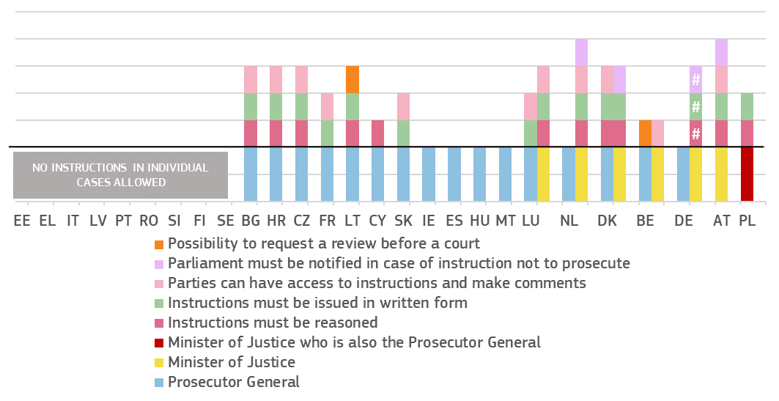Authority that can give instructions to prosecutors in individual cases:

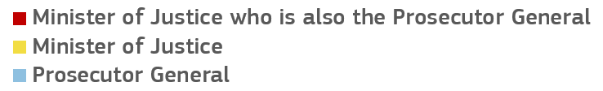

Selected safeguards in case instructions are given in an individual case:

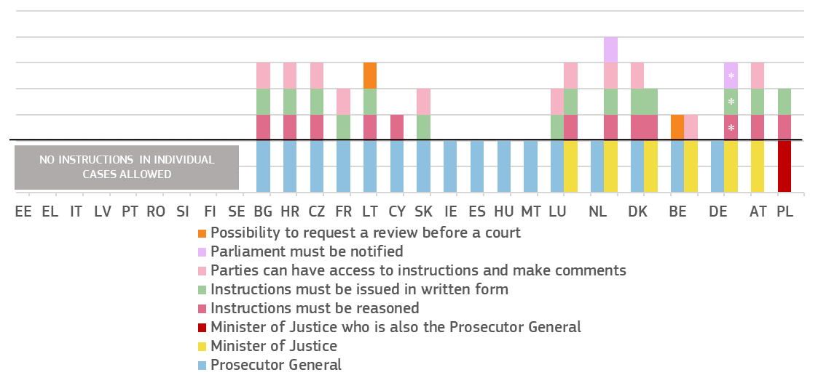

*(*)* ***BE:*** *Minister of Justice has the power to give instructions regarding prosecution in individual cases (a right of positive injunction to prosecute is foreseen in art. 364 of the Code of Criminal Procedure and art. 151 (1) of the Constitution). Instructions are enclosed to the case file but their reading by the parties depends on the occasion for ruling and the current stage of the case.* ***BG:*** *Appeal is possible except for the acts of the Prosecutor General.* ***CZ:*** *The Prosecutor General has a power to give instructions regarding prosecution in individual cases only within the Prosecutor General Office and towards high public prosecutor offices.* ***DE****: #: The safeguards differ depending on the federal or state level. The Federal Public Prosecutor General is the one public prosecutor at the federal level who is under the supervision and direction of the Federal Minister of Justice and Consumer Protection and the public prosecutors general of the 16 German states are under the supervision and direction of the respective state departments of justice. The right to supervision and direction includes the power to give instructions to the respective prosecutor general, but is limited by the principle of legality (i.e., principle of mandatory prosecution). Instructions in individual cases hardly ever occur. As examples, the federal ministry and the government parties of Saxony issued commitments not to exercise their rights to give instructions. The ministry of Thuringia committed itself not to give instructions in individual cases, the ministry of North Rhine-Westphalia and the government of Lower Saxony committed to give individual instructions only in exceptional cases. There are no federal laws but there are certain state laws as well as federal and state regulations and guidelines setting forth rules on instructions. As examples, instructions of the federal ministry and the ministries of North Rhine-Westphalia and Thuringia need to be in writing, in Thuringia they must also be reasoned, in Lower Saxony they need to be in written form if no agreement is reached and in Schleswig Holstein they need to be documented in written form and reported to the president of the parliament. At the federal and state level, instructions of a superior official are only binding within the internal employment relationship of the prosecutor and acts that are in breach with an instructions are still effective. As a prosecutor has a duty to comply with the laws he must refuse to follow illegal instructions. He may remonstrate and have instructions reviewed by the next higher superior official. If the instruction is confirmed and the prosecutor still has doubts as to its lawfulness, he may request a review by the next higher level official. If the instruction is again confirmed, the prosecutor must follow the instruction and he is not in breach of his duties if the instruction is illegal. However, as an exception, prosecutors must never comply with instructions if such acts would constitute a crime, administrative offence or violation of human dignity. There is no special legal remedy to have instructions reviewed by a court. However, courts may review the lawfulness of instructions during disciplinary proceedings against prosecutors, e.g. if they have to decide if non-compliance with instructions constitutes a breach of professional duties.* ***DK:*** *Minister of Justice has the power to give instructions regarding prosecution in individual cases (the administration of Justice Act, section 98 (3)). Different Ministers of Justice have, however, been very reluctant to use this option, and such an instruction has not been given since the 1990s. The President of the Danish Parliament must be informed about the instruction(s) in written form (the Administration of Justice Act, section 98(3)). The regional state prosecutors can review decisions from the police districts and the Director of Public Prosecutions can review decisions from the regional state prosecutors.* ***IE:*** *Not specified in Section 4.1 of the Prosecution of Offences Act, 1974.* ***ES:*** *The Attorney General sets internal orders and instructions appropriate to service and to the exercise of prosecuting functions, which may be general or related to specific matters.* ***LT:*** *Instructions from the Prosecutor General can be appealed at the court. The Prosecutor General cannot instruct on which decision to make.* ***LU:*** *Prosecutor General and Minister of Justice may instruct prosecution services to prosecute in a case (but cannot instruct not to prosecute). However, there have not been any instructions from the Minister of Justice since more than 20 years. There is no legal requirement to consult a prosecutor or seek the opinion of the Prosecutor General on such an instruction.* ***HR:*** *Instructions from the Prosecutor General can be reviewed regarding their legality. efficiency, etc.* ***HU:*** *According to Section 53 Act CLXIV of 2011 on the Status of the Prosecutor General, Prosecutors and Other Prosecution Employees and the Prosecution Career, the prosecutor may request the Prosecutor General to receive written confirmation of the instruction in an individual case. The prosecutor can explicitly deny the instruction, if it would constitute a criminal or an administrative offence or would put the prosecutor in danger, and if the prosecutor does not agree with the instruction he/she can request to transfer the case to another prosecutor and such a request cannot be rejected.* ***MT:*** *With reference to the questions regarding the role of individual prosecutors as opposed to the role of the Attorney General, the Constitution of Malta establishes the office of the Attorney General himself. It also confers upon him rights and obligation and gives him security of tenure as stipulated in terms of article 91 and 97 of the Constitution. In terms of Chapter 90 of the Laws of Malta - Attorney General Ordinance, the attorney general employs officers to represent him in his functions and duties in accordance with law. Such officers represent the Attorney General in his functions and discretion. When representing the Attorney General in his functions, the officers are endowed with the same protection at law. Hence, in terms of Maltese law the prosecutors are not specifically given guarantees because in the functions of their office in terms of law they are deemed to represent the Attorney General himself and in such functions they enjoy the protection that the law grants to the Attorney General himself.* ***NL:*** *Minister of Justice may instruct prosecution services to prosecute or not to prosecute in a case, but needs to beforehand obtain a written reasoned opinion of the Attorney General’s Council (College van procureurs-generaal) on the suggested instructions, and notification to Parliament is required in case of instructions not to prosecute. However, so far, there has only been one such case more than twenty years ago. There are no special regulations regarding instructions given by Prosecutor General in individual cases. The College of Prosecutors-General may give instructions to a prosecutor in a specific case. This body is composed of three to five members, and decides by majority with at least three members present. There are no specific safeguards in place, in cases where the College gives instructions in a specific case.* ***AT:*** *Minister of Justice has the power to give instructions regarding prosecution in individual cases, following a non-binding opinion of an independent body (Weisungsrat) established at the General Prosecutors office. The Minister of Justice has to report annually to Parliament about all instructions issued in individual cases, once the cases concerned have been concluded, including on the reasoning for not following an opinion of the Weisungsrat, if applicable (§29a.(3) of the Law on the Prosecution Service). For the period 2012-2017, 54 instructions in individual cases were reported (Weisungsbericht 2018).* ***PL:*** *Prosecutor General is also the Minister of Justice. If a public prosecutor disagrees with an instruction in individual case, he/she can request the instruction to be changed or himself/herself to be excluded from administering the act or from participating in the case. The exclusion is finally adjudicated by the public prosecutor who is the immediate superior of the public prosecutor who has given the order.* ***SK:*** *Instructions in individual cases must be attached to the case file so other parties can read them and make comments only under specific conditions.*

|  |
| --- |
| **3.3.3. Summary on judicial independence**  Judicial independence is a fundamental element of an effective justice system. It is vital for upholding the rule of law, the fairness of judicial proceedings and the trust of citizens and businesses in the legal system. For this reason, any justice reform should uphold the rule of law and comply with European standards on judicial independence. The Scoreboard shows trends in perceived judicial independence among the general public and companies. This edition also presents some selected indicators concerning legal safeguards in relation to the bodies involved in disciplinary proceedings regarding judges and prosecutors. The structural indicators do not in themselves allow for conclusions to be drawn about the independence of the judiciaries of the Member States, but represent possible elements which may be taken as a starting point for such an analysis.   * The 2020 Scoreboard presents the developments in **perceived independence** from surveys of the general public (Eurobarometer) and companies (Eurobarometer and World Economic Forum):   + All surveys generally show *similar results*,in particular as regards the composition of the two groups of Member States that have the highest and the lowest perceived judicial independence.   + The World Economic Forum survey (Figure 48), presented for the eight time, shows that businesses’ perception of independencehas *improved* or *remained stable* in about two-thirds of the Member States when compared to 2010 as well as to last year. Also among the Member States facing specific challenges ([124]), the perception of independence *improved* or *remained stable* in nearly three-fifths of those countries looking over the nine-year period.   + The Eurobarometer survey among the general public (Figure 44), presented for the fifth time, shows that the perception of independence has *improved* in about two-thirds of the Member States when compared to 2016. The general public’s perception of independence has *improved* in more than two-thirds among the Members States facing specific challenges looking over the five-year period. However, compared to last year, the general public’s perception of independence *decreased* in about two-fifths of all Member States and in about half of the Members States facing specific challenges, and in a few Member States, the level of perceieved independence remains particularly low.   + The Eurobarometer survey among the companies (Figure 46), presented for the fifth time, shows that the perception of independence has *improved* in over half of the Member States both compared to 2016 and in about three-fifths of Member States compared to the last year (compared to last year this was the case in about three-fifths of Members States facing specific challenges, and over two-thirds of other Member States). However, in a few Member States, the level of perceieved independence remains particularly low.   + Among the reasons for the perceived lack of independence of courts and judges, the *interference or pressure from government and politicians* was the most stated reason, followed by the pressure from economic or other specific interests. Compared to previous years, both reasons remain notable for several Member States where perceived independence is very low (Figures 45 and 47).   + Among the reasons for good perception of independence of courts and judges, nearly four-fifths of companies and of the general public (equivalent to 43% and 44 % of all respondents, respectively) named the *guarantees provided by the status and position of judges*. * The 2020 EU Justice Scoreboard presents updated overviews on the disciplinary authorities dealing with proceedings regarding judges as well as competence of the judiciary, the executive and the parliament in the selection of judges-members of the Councils for the Judiciary, as well as a few overviews regarding prosecution services: * Figure 49 presents an updated overview of the authorities in charge of **disciplinary proceedings regarding judges**. In the majority of Member States, the authority deciding on disciplinary sanctions is an independent authority such as a court (Supreme Court, Administrative Court or Court President) or a Council for the Judiciary, while in some Member States, it is a special court whose members are specifically selected or appointed (by the Council for the Judiciary, by Judges or, in one Member State, by the Minister of Justice) to act in disciplinary proceedings. * Figure 50 presents an updated overview of who is the **investigator in charge of disciplinary investigations regarding judges**. In the majority of Member States, the investigator is a Court President or a Council for the Judiciary. In some Member States, the investigator is specifically selected either by judges or by the Council of the Judiciary or, in one Member State, by the Minister of Justice. * Figures 51 and 52 show updated overviews of the the involvement of the judiciary in the **appointment of judges-members of the Council for the Judiciary** and the **composition of the Councils for the Judiciary.** It is up to the Member States to organise their justice systems, including whether or not to establish a Council for the Judiciary. However, where a Council for the Judiciary has been established by a Member State, the independence of the Council must be guaranteed in line with European standards. In almost all Member States, the judges-members of the Councils are proposed and elected, or selected by judges. * Figures 53 and 54 present overviews on the **disciplinary authorities dealing with proceedings regarding prosecutors**. Figure 55 shows an updated and more detailed overview of which bodies can give **instructions to prosecutors in individual cases** and presents some of the safeguards that are in place, if such instructions are given in a concrete case. |

**4. CONCLUSIONS**

The 2020 EU Justice Scoreboard shows a continued improvement in the effectiveness of justice systems in large majority of Member States. Nevertheless, challenges remain to ensure full trust of citizens in the legal systems of those Member States where guarantees of status and position of judges, and thereby their independence, might be at risk.

The EU Justice Scoreboard provides objective and comparable information on the independence, quality and efficiency of national justice systems, and is used as a reference in the European Semester, and will be one of the sources in the upcoming Rule of law Report. As announced in the Communication on further strengthening the rule of law within the Union – A blueprint for action, the EU Justice Scoreboard will be further developed in the relevant rule of law related areas.

1. See Communication from the Commission to the European Parliament, the Council, the European Economic and Social Committee and the Committee of the Regions “Identifying and addressing barriers to the Single Market” COM(2020)93 and accompanying SWD(2020)54.
2. e.g. European Parliament resolution of 29 May 2018 on the 2017 EU Justice Scoreboard (P8_TA(2018)0216).
3. To reduce the time-span, the 2020 EU Justice Scoreboard takes 2012 as the baseline year for CEPEJ data, while the 2019 edition used data from 2010.
4. <https://ec.europa.eu/info/strategy/justice-and-fundamental-rights/effective-justice/eu-justice-scoreboard_en>
5. One figure (48) still uses 2010 data, as in some Member States, the relevant Global Competitiveness Report survey on perceived independence was conducted in 2010, 2011 or 2012.
6. To help prepare the EU Justice Scoreboard and to promote the exchange of best practices on the effectiveness of justice systems, the Commission asked Member States to designate two contact persons, one from the judiciary and one from the ministry of justice. This informal group meets regularly.
7. ENCJ unites the national institutions in the Member States that are independent of the executive and legislature, and that are responsible for supporting the judiciaries in the independent delivery of justice: <https://www.encj.eu/>
8. NPSJC provides a forum that gives European institutions the opportunity to request the opinions of Supreme Courts and to bring them closer by encouraging discussion and the exchange of ideas: <http://network-presidents.eu/>
9. ACA-Europe is composed of the Court of Justice of the EU and the Councils of State or the Supreme administrative jurisdictions of each EU Member State: <http://www.juradmin.eu/index.php/en/>
10. The ECN has been established as a forum for discussion and cooperation of European competition authorities in cases where Articles 101 and 102 of the Treaty on the Functioning of the EU are applied. The ECN is the framework for the close cooperation mechanisms of Council Regulation 1/2003. Through the ECN, the Commission and the national competition authorities in all EU Member States cooperate with each other: <http://ec.europa.eu/competition/ecn/index_en.html>
11. COCOM is composed of representatives of EU Member States. Its main role is to provide an opinion on the draft measures that the Commission intends to adopt on digital market issues: <https://ec.europa.eu/digital-single-market/en/communications-committee>
12. The European Observatory on Infringements of Intellectual Property Rights is a network of experts and specialist stakeholders. It is composed of public- and private-sector representatives, who collaborate in active working groups. <https://euipo.europa.eu/ohimportal/en/web/observatory/home>
13. CPC is a network of national authorities responsible for enforcing EU consumer protection laws in EU and EEA countries: <http://ec.europa.eu/internal_market/scoreboard/performance_by_governance_tool/consumer_protection_cooperation_network/index_en.htm>
14. EGMLTF meets regularly to share views and help the Commission define policy and draft new legislation on anti-money laundering and terrorist financing: <http://ec.europa.eu/justice/civil/financial-crime/index_en.htm>
15. Eurostat is the statistical office of the EU: <http://ec.europa.eu/eurostat/about/overview>
16. EJTN is the principal platform and promoter of training and exchange of knowledge of the European judiciary. It develops training standards and curricula, coordinates judicial training exchanges and programmes, disseminates training expertise and promotes cooperation between EU judicial training institutions. EJTN has some 34 members representing EU Member States as well as EU transnational bodies. <http://www.ejtn.eu/>
17. WEF is an international organisation for public-private cooperation, whose members are companies: <https://www.weforum.org/>
18. In the 2020 European Semester, the Council, on Commission’s proposal, addressed country-specific recommendations to eight Member States relating to their justice system (HR, IT, CY, HU, MT, PL, PT and SK). In addition to those Member States that received proposal for country-specific recommendations, a further eight Member States (BE, BG, IE, EL, ES, LV, RO and SI) are facing specific challenges as regards their justice systems, including the rule of law and the independence of justice, which are being monitored by the Commission through the European Semester. These challenges have been reflected in the recitals of the proposed Country-Specific Recommendations and the country reports relating to these Member States. The most recent 2020 country reports, published on 26 February 2020, are available at: <https://ec.europa.eu/info/publications/2020-european-semester-country-reports_en>
19. IMF, Regional Economic Outlook, November 2017, *Europe: Europe Hitting its Stride,* pp. xviii, pp. 40, 70: <https://www.imf.org/~/media/Files/Publications/REO/EUR/2017/November/eur-booked-print.ashx?la=en>
20. ECB, ‘Structural policies in the euro area’, June 2018, ECB Occasional Paper Series No 210: <https://www.ecb.europa.eu/pub/pdf/scpops/ecb.op210.en.pdf?3db9355b1d1599799aa0e475e5624651>
21. See e.g. ‘What makes civil justice effective?’,, OECD Economics Department Policy Notes, No. 18 June 2013 and ‘The Economics of Civil Justice: New Cross-Country Data and Empirics’, OECD Economics Department Working Papers, No. 1060.
22. World Economic Forum, ‘The Global Competitiveness Report 2019’, October 2019: <https://www.weforum.org/reports/global-competitiveness-report-2019>
23. World Bank, ‘World Development Report 2017: Governance and the Law, Chapter 3: The role of law’, pp. 83, 140: <http://www.worldbank.org/en/publication/wdr2017>
24. The ‘disposition time’ indicator is the number of unresolved cases divided by the number of resolved cases at the end of a year multiplied by 365 (days). It is a standard indicator defined by Council of Europe's CEPEJ: <http://www.coe.int/t/dghl/cooperation/cepej/evaluation/default_en.asp>
25. Vincenzo Bove and Leandro Elia; The judicial system and economic development across EU Member States, JRC Technical Report, EUR 28440 EN, Publications Office of the EU, Luxembourg, 2017: <http://publications.jrc.ec.europa.eu/repository/bitstream/JRC104594/jrc104594__2017_the_judicial_system_and_economic_development_across_eu_member_states.pdf>
26. *Idem.*
27. Effect of judicial independence on foreign direct investment in Eastern Europe and South Asia; Bülent Dogru; 2012, MPRA Munich Personal RePEc Archive: <https://mpra.ub.uni-muenchen.de/40471/1/MPRA_paper_40322.pdf> . EU Member States included in the study were: BG, HR, CZ, EE, HU, LV, LT, RO, SK and SI.
28. The Economist Intelligence Unit: ‘Risk and Return – Foreign Direct Investment and the Rule of Law’, 2015 <http://www.biicl.org/documents/625_d4_fdi_main_report.pdf>, p.22.
29. EU Intellectual Property Office (EUIPO), Intellectual Property (IP) SME Scoreboard 2016: <https://euipo.europa.eu/tunnel-web/secure/webdav/guest/document_library/observatory/documents/sme_scoreboard_study_2016/Executive-summary_en.pdf>
30. COM(2020)93 and SWD(2020)54.
31. Communication from the Commission to the European Parliament, the Council, the European Economic and Social Committee and the Committee of the Regions “Long term action plan for better implementation and enforcement of single market rules”, COM(2020)94, see in particular actions 4, 6 and 18.
32. <https://ec.europa.eu/info/funding-tenders/funding-opportunities/funding-programmes/overview-funding-programmes/structural-reform-support-programme-srsp_en>
33. BE, BG, CZ, EE, EL, ES, HR, IT, CY, LV, HU, MT, PL, PT, SI and SK.
34. See press release IP/20/940, 27 May 2020, available at: <https://ec.europa.eu/commission/presscorner/detail/en/ip_20_940>
35. <https://eur-lex.europa.eu/legal-content/EN/TXT/?uri=COM:2020:0409:FIN>
36. The information has been collected in cooperation with the group of contact persons on national justice systems for 26 Member States. DE explained that a number of reforms are under way on judiciary, where the scope and scale of the reform process can vary within the 16 federal states.
37. The enforcement of court decisions is also important for the efficiency of a justice system. However, comparable data are not available in most Member States.
38. 2019 study on the functioning of judicial systems in the EU Member States, carried out by the CEPEJ Secretariat for the Commission: <https://ec.europa.eu/info/strategy/justice-and-fundamental-rights/effective-justice/eu-justice-scoreboard_en>
39. Length of proceedings, clearance rate and number of pending cases are standard indicators defined by CEPEJ: <http://www.coe.int/t/dghl/cooperation/cepej/evaluation/default_en.asp>
40. The years were chosen to keep the seven-year perspective with 2012 as a baseline, while at the same time not overcrowding the figures. Data for 2010, 2013, 2014 and 2015 are available in the CEPEJ report.
41. The length of proceedings in specific areas is calculated in calendar days, counting from the day on which an action or appeal was lodged before the court (or the indictment became final) until the day on which the court adopted its decision (Figures 16-21). Values are ranked based on a weighted average of data for 2013 and 2016‑2018 for Figures 16-18, data for 2013, 2015-2016 and 2018 for Figure 19, and data for 2014 and 2016‑2018 for Figures 20 and 21. Where data was not available for all years, the average reflects the available data, calculated based on all cases, a sample of cases or estimations.
42. See <http://eur-lex.europa.eu/legal-content/EN/TXT/PDF/?uri=CELEX:12012E/TXT&from=EN>.
43. The calculation has been made based on the length of cases of appeal against national regulatory authority decisions applying national laws that implement the regulatory framework for electronic communications (Directives 2002/19/EC (Access Directive), Directive 2002/20/EC (Authorisation Directive), Directive 2002/21/EC (Framework Directive), Directive 2002/22/EC (Universal Service Directive), and other relevant EU law such as the radio spectrum policy programme, Commission spectrum decisions, excluding Directive 2002/58/EC on privacy and electronic communications.
44. Regulation (EU) 2017/1001 of the European Parliament and of the Council of 14 June 2017 on the European Union trade mark (OJ L 154, 16.62017, p. 1-99).
45. Figures 19 and 20 relate to the enforcement of the Unfair Terms Directive (93/13/EEC), the Consumer Sales and Guarantees Directive (1999/44/EC), the Unfair Commercial Practices Directive (2005/29/EC) and the Consumer Rights Directive (2011/83/EC), and their national implementing provisions.
46. Recital 2 of Directive (EU) 2015/849 of the European Parliament and of the Council of 20 May 2015 on the prevention of the use of the financial system for the purposes of money laundering or terrorist financing.
47. IMF factsheet, March 8, 2018: <https://www.imf.org/en/About/Factsheets/Sheets/2016/08/01/16/31/Fight-Against-Money-Laundering-the-Financing-of-Terrorism>
48. Article 44(1) of the Directive (EU) 2015/849. See also the revised Article 44 in Directive (EU) 2018/843, which entered into force in June 2018 and had to be implemented by Member States by January 2020 at the latest.
49. HR, IT, CY, HU, MT, PT and SK, which received 2019 European Semester country-specific recommendations, and BE, BG, IE, EL, ES, LV, PL, RO, and SI for which the challenges have been reflected in the recitals of their 2019 country-specific recommendations and country reports.

    Variance in the results over the 7 years analysed may be explained by contextual factors (variations of more than 10% of incoming cases are not unusual) or systemic deficiencies (lack of flexibility and responsiveness or inconsistencies in the process of reform).
50. Directive (EU) 2018/1673 of the European Parliament and of the Council of 23 October 2018 on combating money laundering by criminal law will eliminate legal obstacles that may delay prosecution, such as that a prosecution for money laundering can only start when the proceedings for the underlying predicate offence have been concluded. Member States have to transpose the Directive before 8 December 2020.
51. 2019 data collected in cooperation with the group of contact persons on national justice systems.
52. Court fees are understood as an amount to be paid to initiate non-criminal law proceedings in a court or tribunal.
53. Legal fees are the consideration for services provided by lawyers to their clients.
54. Article 47(3) of the Charter of Fundamental Rights of the EU.
55. Member States use different methods to establish the eligibility threshold, e.g. different reference periods (monthly/annual income). About half of the Member States also have a threshold related to the personal capital of the applicant. This is not taken into account for this figure. In BE, BG, IE, ES, FR, HR, HU, LV, LT, LU, NL and PT, certain groups of people (e.g. individuals who receive certain benefits) are automatically entitled to receive legal aid in civil/commercial disputes. Additional criteria that Member States may use, such as the merit of the case, are not reflected in this figure. Although not directly related to the figure, in several Member States (AT, CZ, DE, DK, EE, ES, FR, IT, NL, PL, PT, SI) legal aid is not limited to natural persons.
56. To collect comparable data, each Member State’s respective Eurostat poverty threshold has been converted to a monthly income. The at-risk-of-poverty (AROP) threshold is set at 60 % of the national median equivalised disposable household income. European Survey on Income and Living Conditions, Eurostat table ilc_li01, available at: <http://ec.europa.eu/eurostat/web/income-and-living-conditions/data/database>.
57. 2019 data collected through replies by CCBE members to a questionnaire based on the following specific scenario: a dispute of a consumer with a company (two different values of the claim have been indicated: €6 000 and the Eurostat poverty threshold in each Member State). Given that conditions for legal aid depend on the applicant’s situation, the following scenario was used: a single 35-year-old employed applicant without any dependant and legal expenses insurance, with a regular income and a rented apartment.
58. The data refer to income thresholds valid in 2019 and have been collected through replies by CCBE members to a questionnaire based on the following specific scenario: a dispute of a consumer with a company (two different values of the claim have been indicated: €6000 and the Eurostat poverty threshold in each Member State).
59. The data have been collected through replies by CCBE members to a questionnaire based on the following specific scenario: a dispute between two companies in trans-border commercial litigation concerning the enforcement of contract. The value of the claim has been indicated as 20.000€. CCBE members were asked to provide information on the payable court fee to file the action in the case in the scenario.
60. The data have been collected through replies by CCBE members to a questionnaire based on the same hypothetical case as for figure 25 (cf. FN 58). The following scenario was used as a basis for calculating the legal fees: the company seeking to enforce the contact contracted a specialised and experienced lawyer, who carried out the following work: In the pre-litigious phase: 3 hours of work, one document produced for an hourly legal fee of 150€ (overall 450€). Litigious phase: 11 hours of work, 3 documents produced, 2 court hearings for an hourly legal fee of 150€ net (overall 1650€). CCBE members were asked to provide information on a) the statutory fee foreseen for the work in the (pre-) litigious phase, if existing and b) the amount of legal fee that the court would reasonably order to be reimbursed by the losing party.
61. Data concern 2018. Equipment rate from 100 % (device completely deployed) to 0 % (device non‑existing) indicates the functional presence in courts of the device covered by the graph, according to the following scale: (100 % = 4 points if applicable to all matters / 1.33 points per specific matter; 50-99 % = 3 points if applicable to all matters / 1 point per specific matter; 10-49 % = 2 points if applicable to all matters / 0.66 point per specific matter; 1-9 % = 1 point if applicable to all matters / 0.33 points per specific matter. “Specific matter” relates to the type of litigation handled (civil/commercial, criminal, administrative or other).
62. See *Best practice guide for managing Supreme Courts*, under the project Supreme Courts as guarantee for effectiveness of judicial systems, p. 29.
63. Regulation (EU) 2016/679 of the European Parliament and of the Council of 27 April 2016 on the protection of natural persons with regard to the processing of personal data and on the free movement of such data, and repealing Directive 95/46/EC (General Data Protection Regulation) (OJ L 119, 4.5.2016, p. 1).
64. Anonymisation/pseudonymisation is more efficient if assisted by an algorithm. However, human supervision is needed, since the algorithms do not understand context.
65. Directive 2003/98/EC of the European Parliament and of the Council of 17 November 2003 on the re-use of public sector information (OJ L 345, 31.12.2003, p. 90) and Directive (EU) 2019/1024 of the European Parliament and of the Council of 20 June 2019 on open data and the re-use of public sector information (OJ L 172, 26.6.2019, p. 56).
66. Judgments modelled according to standards (e.g. Akoma Ntoso) and their associated metadata are downloadable free of charge in the form of a database or by other automated means (e.g. Application Programming Interface).
67. See also Communication from the Commission to the European Parliament, the Council, the European Economic and Social Committee and the Committee of the Regions – A European strategy for data, COM(2020) 66 final, Commission White Paper on Artificial Intelligence – A European approach to excellence and trust, COM(2020) 65 final, and Conclusions of the Council and the representatives of the Governments of the Member States meeting within the Council on Best Practices regarding the Online Publication of Court Decisions (OJ C 362, 8.10.2018, p. 2).
68. 2019 data collected in cooperation with the group of contact persons on national justice systems.
69. 2019 data collected in cooperation with the group of contact persons on national justice systems.
70. The methods to promote and incentivise the use of ADR do not cover compulsory requirements to use ADR before going to court, as such requirements raise concerns about their compatibility with the right to an effective remedy before a tribunal enshrined in the EU Charter of Fundamental Rights.
71. 2019 data collected in cooperation with the group of contact persons on national justice systems.
72. 2019 data collected in cooperation with the group of contact persons on national justice systems.
73. General government total (actual) expenditure on the administration, operation or support of administrative, civil and criminal law courts and the judicial system, including enforcement of fines and legal settlements imposed by the courts and operation of parole probation systems, and legal aid as well as legal representation and advice on behalf of government or on behalf of others provided by government in cash or in services, excluding prison administrations (National Accounts Data, Classification of the Functions of Government (COFOG), group 03.3), Eurostat table *gov_10a_exp,* available at: <http://ec.europa.eu/eurostat/data/database>.
74. Compensation of employees consists of wages and salaries in cash or in kind (D.11) and employer's actual and imputed social contributions (D.121 and D.122). See: <https://ec.europa.eu/eurostat/statistics-explained/index.php?title=Glossary:Compensation_of_employees>.
75. Intermediate consumption is a national accounts concept which measures the value of the goods and services consumed as inputs by a process of production. It excludes [fixed assets](https://ec.europa.eu/eurostat/statistics-explained/index.php?title=Glossary:Fixed_assets) whose consumption is recorded as consumption of [fixed capital](https://ec.europa.eu/eurostat/statistics-explained/index.php?title=Glossary:Fixed_capital). The goods and services may be either transformed or used up by the production process.

    See <https://ec.europa.eu/eurostat/statistics-explained/index.php?title=Glossary:Intermediate_consumption>.
76. Gross fixed capital formation, abbreviated as GFCF, consists of resident producers’ investments, deducting disposals, in fixed [assets](https://ec.europa.eu/eurostat/statistics-explained/index.php?title=Glossary:Asset) during a given period. It also includes certain additions to the value of non-produced assets realized by producers or institutional units. Fixed assets are tangible or intangible assets produced as outputs from production processes that are used repeatedly, or continuously, for more than one year. See <https://ec.europa.eu/eurostat/statistics-explained/index.php?title=Glossary:Gross_fixed_capital_formation_(GFCF)>.
77. 2019 data. European Institute for Gender Equality, Gender Statistics Database, available at: <http://eige.europa.eu/lt/gender-statistics/dgs/indicator/wmidm_jud_natcrt__wmid_natcrt_supcrt>
78. 2018 data collected in cooperation with the European Judicial Training Network and CEPEJ. ‘Judgecraft’ includes activities such as conducting hearings, writing decisions or rhetoric.
79. 2019 data collected in cooperation with the group of contact persons on national justice systems.
80. 2018 data. Equipment rate from 100% (device completely deployed) to 0% (device non-existing) indicates the functional presence in courts of the device covered by the graph, according to the following scale: 100% = 4 points if applicable to all matters / 1.33 points per specific matter; 50-99% = 3 points if applicable to all matters / 1 point per specific matter; 10-49% = 2 points if applicable to all matters / 0.66 point per specific matter; 1-9% = 1 point if applicable to all matters / 0.33 points per specific matter. “Specific matter” relates to the type of litigation handled (civil/commercial, criminal, administrative or other).
81. 2018 data collected in cooperation with the group of contact persons on national justice systems.
82. 2018 data collected in cooperation with the group of contact persons on national justice systems.
83. In the EU Justice Scoreboard, the standards on time limits and timeframes go beyond the requirements stemming from the right to a hearing within a reasonable time as enshrined in Article 47 of the Charter of Fundamental Rights of the EU and in Article 6 of the European Convention on Human Rights.
84. 2019 data collected in cooperation with the group of contact persons on national justice systems.
85. See <http://eur-lex.europa.eu/legal-content/EN/TXT/PDF/?uri=CELEX:12012P/TXT&from=EN>
86. Court of Justice of the European Union, judgment of 19 November 2019, A. K. and Others, C 585/18, C 624/18 and C 625/18, ECLI:EU:C:2019:982, paras 121 and 122; judgment of 24 June 2019, Commission v. Poland, C-619/18, ECLI:EU:C:2019:531 paras 73 and 74; judgment of 27 February 2018, Associação Sindical dos Juízes Portugueses, C‑64/16, EU:C:2018:117, paragraph 44; judgment of 25 July 2018, Minister for Justice and Equality, C‑216/18 PPU, EU:C:2018:586, paragraph 65.
87. Court of Justice of the European Union, judgment of 24 June 2019, Commission v. Poland, C-619/18, ECLI:EU:C:2019:531 para 44.
88. Eurobarometer survey FL483, conducted between 7 and 11 January 2020. Replies to the question: ‘From what you know, how would you rate the justice system in (our country) in terms of the independence of courts and judges? Would you say it is very good, fairly good, fairly bad or very bad?’, see: <https://ec.europa.eu/info/strategy/justice-and-fundamental-rights/effective-justice/eu-justice-scoreboard_en>
89. Eurobarometer survey FL483, replies to the question: ‘Could you tell me to what extent each of the following reasons explains your rating of the independence of the justice system in (our country): very much, somewhat, not really, not at all?’.
90. Eurobarometer survey FL484, conducted between 7 January and 20 January 2019. Replies to the question: ‘From what you know, how would you rate the justice system in (our country) in terms of the independence of courts and judges? Would you say it is very good, fairly good, fairly bad or very bad?’, see: <https://ec.europa.eu/info/strategy/justice-and-fundamental-rights/effective-justice/eu-justice-scoreboard_en>.
91. Eurobarometer survey FL484; replies to the question: ‘Could you tell me to what extent each of the following reasons explains your rating of the independence of the justice system in (our country): very much, somewhat, not really, not at all?’.
92. The World Economic Forum (WEF) bases its indicator on survey answers to the question: ‘In your country, how independent is the judicial system from influences of the government, individuals, or companies? [1 = not independent at all; 7 = entirely independent]’. Responses to the survey came from a representative sample of businesses representing the main sectors of the economy (agriculture, manufacturing industry, non-manufacturing industry, and services) in all the Member States concerned. The survey is administered in a variety of formats, including face-to-face or telephone interviews with business executives, mailed paper forms, and online surveys. See <https://www.weforum.org/reports/global-competitiveness-report-2019>
93. See Court of Justice , judgment of 19 November 2019, A. K. and Others (Independence of the Disciplinary Chamber of the Supreme Court), C-585/18, C 624/18 and C-625/18, ECLI:EU:C:2019:982, paras 121 and 122; judgment of 24 June 2019, Commission v. Poland, C-619/18, ECLI:EU:C:2019:531 paras 73 and 74; judgment of 25 July 2018, LM, C-216/18 PPU, ECLI:EU:C:2018:586. para 66. See also paragraphs 46 and 47 of the Recommendation CM/Rec(2010)12 Judges: Independence, Efficiency and Responsibility (adopted by the Committee of Ministers of the Council of Europe on 17 November 2010) and Explanatory Memorandum, which provide that the authority taking decisions on the selection and career of judges should be independent of the executive and legislative powers. With a view to guaranteeing its independence, at least half of the members of the authority should be judges chosen by their peers. However, where the constitutional or other legal provisions prescribe that the head of state, the government or the legislative power take decisions concerning the selection and career of judges, an independent and competent authority drawn in substantial part from the judiciary (without prejudice to the rules applicable to councils for the judiciary contained in Chapter IV) should be authorised to make recommendations or express opinions which the relevant appointing authority follows in practice.
94. See Court of Justice , judgment of 19 November 2019, A. K. and Others (Independence of the Disciplinary Chamber of the Supreme Court), C-585/18, C-624/18 and C-625/18, ECLI:EU:C:2019:982, para 123; judgment of 24 June 2019, Commission v. Poland, C-619/18, ECLI:EU:C:2019:531 para 112.
95. See Recommendation CM/Rec(2010)12 Judges: Independence, Efficiency and Responsibility, adopted by the Committee of Ministers of the Council of Europe on 17 November 2010 and Explanatory Memorandum (hereinafter: ‘the Recommendation CM/Rec(2010)12’).
96. The figures are based on the responses to an updated questionnaire drawn up by the Commission in close association with the ENCJ. Responses to the updated questionnaire from Member States that have no Councils for the Judiciary, are not ENCJ members, or their ENCJ membership has been suspended (CZ, DE, EE, CY, LU, AT, PL and FI) were obtained through cooperation with the Network of the Presidents of the Supreme Judicial Courts of the EU.
97. The figures are based on responses to an updated questionnaire drawn up by the Commission in close cooperation with the Expert Group on Money Laundering and Financing of Terrorism.
98. See Court of Justice, judgments of 5 November 2019, Commission v. Poland, C-192/18, ECLI:EU:C:2019:924, para 114; of 24 June 2019, Commission v. Poland, C-619/18, ECLI:EU:C:2019:531, para 77, and of 25 July 2018, LM, C-216/18 PPU, ECLI:EU:C:2018:586, para 67.
99. See Court of Justice of the European Union, judgment of 24 June 2019, Commission v. Poland, C-619/18, ECLI:EU:C:2019:531, para 77, and judgment of 25 July 2018*, LM,* C-216/18 PPU, ECLI:EU:C:2018:586, para 67.
100. See Court of Justice , judgment of 5 July 2016, *Ognyanov,* C-614/14, ECLI:EU:C:2016:514, para. 17. See also Court of Justice of the European Union, judgment of 19 November 2019, A. K. and Others (Independence of the Disciplinary Chamber of the Supreme Court), C-585/18, C 624/18 and C-625/18, ECLI:EU:C:2019:982, para 103.
101. See Court of Justice, judgment of 5 July 2016, *Ognyanov,* C-614/14, ECLI:EU:C:2016:514, para. 25.
102. See Court of Justice, order of 12 February 2019, *RH*, C-8/19, ECLI:EU:C:2019:110, para. 47.
103. Para 69 of the Recommendation CM/Rec(2010)12.
104. Para 66 of the Recommendation CM/Rec(2010)12.
105. Para 69 of the Recommendation CM/Rec(2010)12.
106. Data collected through an updated questionnaire drawn up by the Commission in close association with the ENCJ. Responses to the updated questionnaire from Member States that have no Councils for the Judiciary, are not ENCJ members or whose ENCJ membership has been suspended, were obtained through cooperation with the NPSC.
107. Data collected through an updated questionnaire drawn up by the Commission in close association with the ENCJ. Responses to the updated questionnaire from Member States that have no Councils for the Judiciary, are not ENCJ members, or whose ENCJ membership has been suspended, were obtained through cooperation with the NPSC.
108. Recommendation CM/Rec(2010)12, para. 27; see also 2016 CoE action plan, C item (ii); Opinion no.10(2007) of the Consultative Council of European Judges (CCJE) to the attention of the Committee of Ministers of the Council of Europe on the Council for the Judiciary at the service of society, para. 27; and ENCJ, *Councils for the Judiciary Report 2010-11*, para. 2.3.
109. Data collected through an updated questionnaire drawn up by the Commission in close association with the ENCJ. Responses to the updated questionnaire from Member States that have no Councils for the Judiciary, are not ENCJ members, or whose ENCJ membership has been suspended, were obtained through cooperation with the NPSC.
110. Councils for the Judiciary are independent bodies, established by law or under the constitution, that seek to safeguard the independence of the judiciary and of individual judges and thereby to promote the efficient functioning of the judicial system.
111. *See* recommendation CM/Rec(2010)12 of the Committee of Ministers to Member States on judges: independence, efficiency and responsibilities, §26-27.
112. Council Framework Decision 2002/584/JHA on the European arrest warrant and the surrender procedures between Member States (OJ L 190, 18.7.2002, p. 1).
113. Court of Justice, judgment of 27 May 2019, *OG and PI (Public Prosecutor’s Office of Lübeck and Zwickau)*, Joined Cases C-508/18 and C-82/19 PPU, paras 73, 74 and 88, ECLI:EU:C:2019:456; judgment of 27 May 2019, C‑509/18, para 52, ECLI:EU:C:2019:457; see also judgments of 12 December 2019, *Parquet général du Grand-Duché de Luxembourg and Openbaar Ministerie (Public Prosecutors of Lyon and Tours),* in Joined Cases C-566/19 PPU and C-626/19, ECLI:EU:C:2019:1077; *Openbaar Ministerie (Swedish Prosecution Authority),* C-625/19 PPU, ECLI:EU:C:2019:1078,and *Openbaar Ministerie (Public Prosecutor in Brussels),* C-627/19 PPU, ECLI:EU:C:2019:1079. See also judgment of 10 November 2016, *Kovalkovas,* C-477/16 PPU, paras 34 and 36, ECLI:EU:C:2016:861, and judgment of 10 November 2016, *Poltorak,* C-452/16 PPU, para 35, ECLI:EU:C:2016:858, on the term ‘judiciary’, ‘which must […] be distinguished, in accordance with the principle of the separation of powers which characterises the operation of the rule of law, from the executive’. See also Opinion No. 13(2018) Independence, accountability and ethics of prosecutors, adopted by the Consultative Council of European Prosecutors (CCPE), recommendation xii.
114. CDL-AD(2010)040-e Report on European Standards as regards the Independence of the Judicial System: Part II — the Prosecution Service — Adopted by the Venice Commission — at its 85th plenary session (Venice, 17-18 December 2010), para. 26.
115. Opinion No. 14(2019), The role of prosecutors in fighting corruption and related economic and financial crime, adopted by the Consultative Council of European Prosecutors (CCPE), recommendation iii.
116. Recommendation Rec(2000)19 on the role of public prosecution in the criminal justice system, adopted by the Committee of Ministers of the Council of Europe on 6 October 2000 (the 2000 Recommendation), para. 4.
117. The 2000 Recommendation, paras 11 and 13. See also: Opinion No. 13(2018) Independence, accountability and ethics of prosecutors, adopted by the Consultative Council of European Prosecutors (CCPE), recommendations i and iii; Group of States against corruption (GRECO), fourth evaluation round “Corruption prevention - Members of Parliament, Judges and Prosecutors”, a vast number of recommendations ask for the introduction of arrangements to shield the prosecution service from undue influence and interference in the investigation of criminal cases.
118. The 2000 Recommendation, para. 13, point c).
119. The 2000 Recommendation, para. 13, point d).
120. The 2000 Recommendation, para. 13, point f). See also Opinion No. 13(2018) Independence, accountability and ethics of prosecutors, adopted by the Consultative Council of European Prosecutors (CCPE), recommendation iv.
121. The 2000 Recommendation, para. 34.
122. The 2000 Recommendation, para. 5, point e).
123. See 2000 Recommendation, para. 13, points d) – e).
124. See footnote 18.