

**1. Introduction**

The purpose of the European Criminal Records Information System (ECRIS) is to improve the security of citizens within the EU Area of Freedom, Security and Justice, by enabling an efficient exchange between the Member States of information on previous criminal convictions handed down by criminal courts in the EU. ECRIS became operational in April 2012. It is regulated by Council Framework Decision 2009/315/JHA of 26 February 2009 on the organisation and content of the exchange of information extracted from the criminal record between Member States[1], and by Council Decision 2009/316/JHA of 6 April 2009 on the establishment of the European Criminal Records Information System[2].

On 29 June 2017 the Commission adopted its first Statistical Report in accordance with Article 7 of Council Decision 2009/316/JHA, which covered the period from April 2012 to 31 December 2016. [3]

The present Report is the second statistical report of the Commission concerning the exchange through ECRIS of information extracted from the criminal records between the Member States. Its purpose is to present the compliance of the Member States' exchanges with the ECRIS legal framework and to identify any issues regarding the efficiency of the system, with a view to remedying the situation. The Commission reserves the right to take all appropriate action to ensure that the Member States fulfill these legal obligations as set in Framework Decision 2009/315/JHA.

**1.1. ECRIS statistics**

This report gives an overview on the use of ECRIS since **1 January 2017 to 31 December 2019, with an emphasis on 2019**. It is accompanied by Commission Staff Working Document SWD/2020/378 (further: SWD). While most of the tables and graphs in the report refer to 2019, the ones for 2017 and 2018 can be found in the accompanying SWD.Some statistics provided in the report give a general overview over the eight-year period of operation of ECRIS, since its “go live” in April 2012. However, the comparative statistical data on all Member States, and the individual Member States' statistical tables (provided in section 3 of the SWD) cover ECRIS exchanges in the years 2017-2019. Where relevant, the statistics of 2016 were used as a reference point. The report also includes data on the United Kingdom, as a EU Member State, until 2019.

The report is based on the statistics automatically generated by the system and sent by the Member States to the Commission. Out of the 233 statistical indicators established for ECRIS, a choice was made to publish only the most relevant and meaningful information. In addition, the Member States were requested to communicate statistics on the number of convictions of nationals of other Member States (EU non-nationals) handed down on their territory, in order to be able to provide an overview of the implementation of the notification procedure. The report includes conviction data received from 23 Member States[4].

**1.2. General principles of the ECRIS system**

ECRIS is based on a decentralised architecture, where criminal records information is exchanged electronically, exclusively between the Central Authorities of the Member States.

Each Member State having convicted a citizen of another Member State is obliged to notify through ECRIS the Member State in question (hereinafter Member State of nationality), as soon as possible, of all information related to the conviction (**notifications on new convictions**), and any subsequent updates (**notifications on updates**).

The Member State of nationality thus maintains a central repository of all convictions handed down against its nationals by criminal courts in the other EU Member States, in addition to any convictions handed down in the Member State itself. The Member State of nationality is then obliged to store and update all information received through ECRIS, and to provide full criminal records information (**replies to requests**) when requested by another Member State (**requests for information**), within **short deadlines of 10 or 20 days.[5]**

**2. ECRIS exchanges in numbers**

**2.1. Connected Member States**

ECRIS is a decentralised system where all Member States should be interconnected with each other. A Member State is considered connected to ECRIS if it exchanges criminal records information with at least one other connected Member State. **All Member States are currently connected to ECRIS** and exchange criminal records information **with** - **on average - 24 other Member States**.[6]

The total possible number of interconnections is 756 (27*28)[7]. Although all Member States are now connected to ECRIS, **only one Member State is effectively exchanging information with all the others through ECRIS (ES).** For the majority of the Member States, one or two interconnections are still missing.

The ECRIS system started in 2012 with a total of 173 interconnections out of 756 possible (with 28 Member States “live”). By the end of 2019, **670 interconnections** had been established, representing **90% of the total number of possible interconnections[8]**.

Nevertheless, the ultimate goal is not yet completely achieved, as not all Member States are connected to and exchange information with all the other Member States through ECRIS.

**2.2. Total number of messages exchanged**

The graph below illustrates the rapidly growing yearly volume of messages exchanged between the connected Member States since the ECRIS "go live" in April 2012 until 31 December 2019. It needs to be noted that there were only 8 months of activity in 2012.

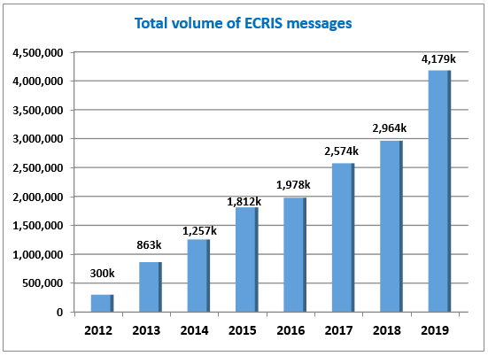

From 2 million messages exchanged by all interconnected Member States in 2016, the number reached nearly **4,2 million in 2019** with an **average of 348.000 messages per month**. All types of messages are included in these volumes: notifications, updates, requests, replies, denials, other replies, exchanges of additional information, etc.

The graph below presents the trend of notifications, requests and replies to requests over the eight years of ECRIS operation. Only notifications on new convictions were taken into consideration, without updates. Replies include request replies, request denials and other replies[9].

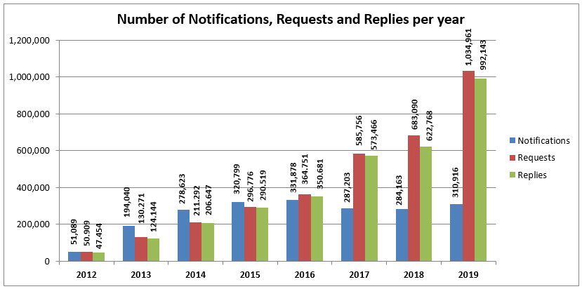

The last three years have brought a **radical change in the proportions between** the number of **notifications on new convictions, requests and replies** **to requests**. In 2016 the numbers were almost equal for each of these three categories and amounted roughly to 350.000 per year per category. In 2019 the number of requests for information and the related number of replies to requests were over three times higher than the number of notifications.

In 2017 **the number of notifications on new convictions has dropped** and remained at the level of around **310.000 until 2019**. This downward tendency is surprising in the light of the increasing number of interconnections between the Member States. As indicated in section 2.4. below, some Member States had problems with notifying all new convictions.

In contrast, the **number of requests for information** and the related replies to requests **has tripled since 2017 – and reached 1 million** for each of these categories in 2019. This **dramatic increase in the requests for information** is due mostly to the **shift in the use of ECRIS, which is not anymore mainly used for the purpose of criminal proceedings, but also more and more for purposes other than criminal proceedings**. For further details, see section 2.8. It is also a positive sign of rising awareness in the Member States of the need to use ECRIS to request information in the course of criminal proceedings in order to be able to take account of previous convictions, in line with Framework Decision 2008/675/JHA[10].

**2.3. Number of notifications, requests and replies per Member State**

The graph below illustrates the number of notifications on new convictions, requests for information and replies for all interconnected Member States in 2019.[11]

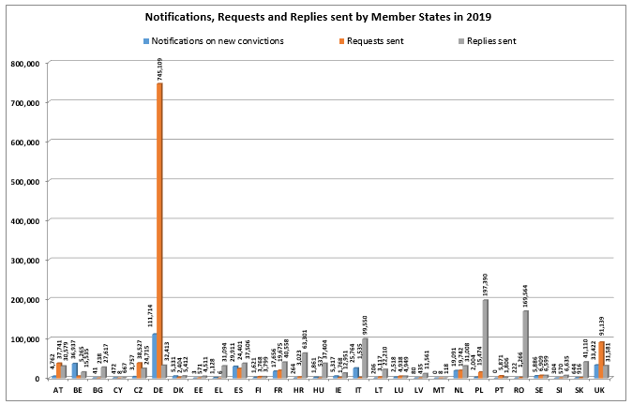

Similar to the previous years, the most active Member States in terms of the total volume of these three types of message were those indicated below.

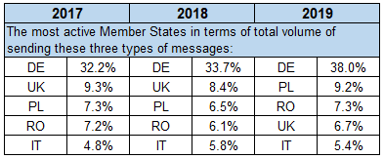

The figures demonstrate **significant differences between the Member States' ECRIS activities and workload**.

Some Member States **request information considerably more often than they are requested** to provide information,: e.g. DE (745.000 requests sent, 32.400 requests received), UK (91.000 sent, 31.500 received) and CZ (38.500 sent, 24.700 received). Other Member States are confronted with a **significant number of requests**, while they send fewer requests: e.g. PL (197.300 replies given, 15.400 requests sent), RO (170.000 versus 1.200), IT (99.500 versus 1.500), HR (63.300 versus 3.000), SK (41.000 versus 900), HU (37.400 versus 500). Some other Member States **send high volumes of notifications** on new convictions to the Member States of the offender's nationality, while they send fewer requests themselves: e.g. BE (36.300 notifications sent, 5.200 requests sent), IT (25.700 notifications, 1.500 requests).

**2.4. Notifications**

The graph below presents the volume of notifications issued by all interconnected Member States in 2019, broken down by notifications on new convictions and notifications updating previously sent notifications.[12]

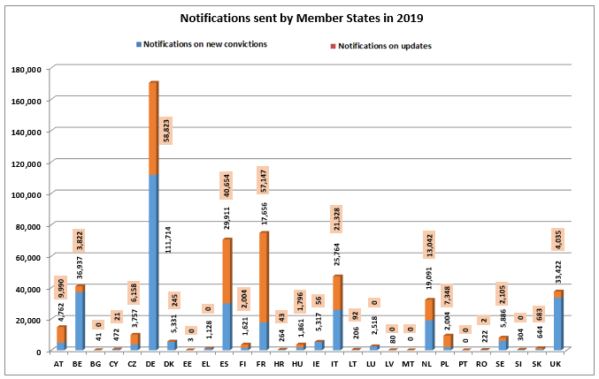

The **volume of notifications varies considerably among Member States**, from nearly 112.000 (DE) to zero notifications on new convictions (MT, PT) per year. There are mainly two factors to be taken into account in the analysis of these variations: the size of the country and the number of convictions of nationals of other Member States (EU non-national population)[13].

The **most active** Member States in terms of sending **notifications** on new convictions were the Member States indicated in the table below.

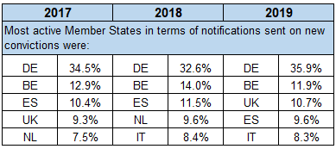

Taking into consideration all notifications sent, including notifications on updates, DE remains at the first position, but the ranking changes.



**Notifications on new convictions and notifications on updates** accounted respectively for **58% and 42%** in 2019. In total, **230.000 notifications of updates** were sent that year.[14] It is worth pointing out that before 2017, updates accounted only for about one fourth of all notifications. The present **significant** **increase in updates** for many Member States should be considered a positive sign of their awareness of the importance of communicating the subsequent changes on initial notifications.

**The proportion between notifications on new convictions and on updates differs significantly among the Member States**, from updates being three times as high as notifications (e.g. FR, PL) or twice as high as notifications (e.g. AT, CZ), through roughly equal amounts for both of these categories of messages (e.g. ES, NL, IT, HU, FI, SK) to updates constituting a tiny part of all notifications (e.g. CY, DK, IE, RO). For DE, FR and ES, which sent the highest number of all notifications, the updates amounted respectively to about 34%/ 76%/ 57% of all their notifications sent in 2019.

The first Statistical Report identified two main problems: i.e. (i) many Member States **do not send notifications on new convictions at all or send a low volume** and (ii) numerous Member States **do not send updates** on their previously sent notifications **at all or send a low volume**. These two problems also emerge from the detailed analysis of the statistical data for 2017-2019. However, this time these issues are even more prominent, as they concern a higher number of Member States.

Firstly, many Member States **do not send notifications on new convictions at all** (PT in 2019 and 2018, MT in 2019 and 2017, EE in 2018, EL in 2017) **or send a low volume** of such notifications in relation to their EU non-national population and the number of convictions (BG, EE, IE, LT, LU, NL, RO in 2019; BG, IE, LU, LT, RO, SI, SE, MT, EL, UK in 2018; BG, EE, IE, LT, LU, RO, SI, SE, PT, UK in 2017). **As a result, these non-notified convictions were not registered in the Member State(s) of nationality.**

Secondly, numerous Member States **do not send updates** on their previously sent notifications **at all** (BG, EE, EL, LV, LU, MT, PT, SI in 2019; BG, DK, EL, SI, PT, MT, LV, LU, IE, EE in 2018; DK, EE, EL, LV, LU, BG in 2017) or **send a low volume** of such messages (IE, RO, CY in 2019; RO, CY in 2018; SI, RO, PT, MT, IE, HR, CY in 2017). Failure to send updates by the convicting Member State **results in the processing of not updated, unrealiable information by the Member State of nationality**, including its dissemination.[15]

**2.5. Requests for information**

The graph below compares the volume of requests for information sent by all interconnected Member States in 2019 with the volume of replies received to these requests.[16]

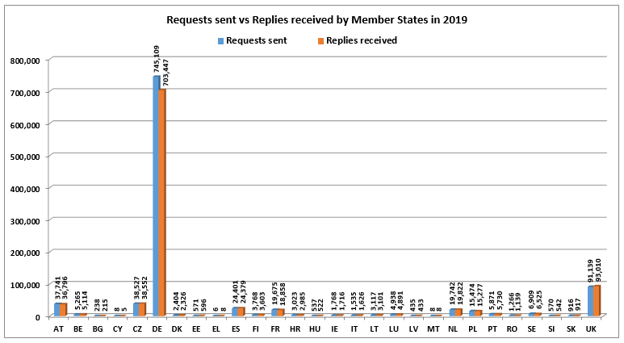

As presented above in section 2.2, the general **number of requests for information** **has tripled since 2017** – and reached **1 million** in 2019.

The **volume of issued requests varies considerably among Member States**, from 745.000 (DE) to 6 requests (EL) per year. The rise in the total number of requests is due mostly to DE, which has increased its number of requests by over 5 times. ES, LT, NL and PL have doubled their numbers. The main factor to be taken into account in the analysis of the variations between the Member States’ numbers of requests is the number of nationals of other Member States residing in a given Member State.

Similar to previous years, the **most active** Member States in terms of **issued requests** were the following.

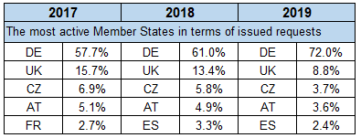

Despite the significant increase in the number of requests in general, the problem, already noted in the first Statistical Report, of some Member States **sending almost no requests at all** (EL, CY, MT) or **sending a low number** of requests in relation to their EU non-national population (BG, EE, HU, IT, LV, RO, SI in 2017-2019) still persists. This might lead to a situation where criminal courts could pass judgements without the knowledge of convictions handed down in other Member States, contrary to the requirements set out in Framework Decision 2008/675/JHA. In addition, the preventive effect of requesting criminal records certificates for purposes other than criminal proceedings, such as pre-employment checks, will be diminished.

It can be also concluded from the above data that **not all requests for information are responded to** (see also section 2.6.). In case of the Member States most active in sending requests, 5,6% of DE requests (41.662) and 2,5% of AT requests (945) in 2019 were never responded to, while for the UK and CZ the number of responses received that year exceeded the number of their requests.

**2.6. Replies to requests**

The graph below illustrates the volume of replies sent by all interconnected Member States in 2019 in comparison to the volume of corresponding requests for information received by them.[17]

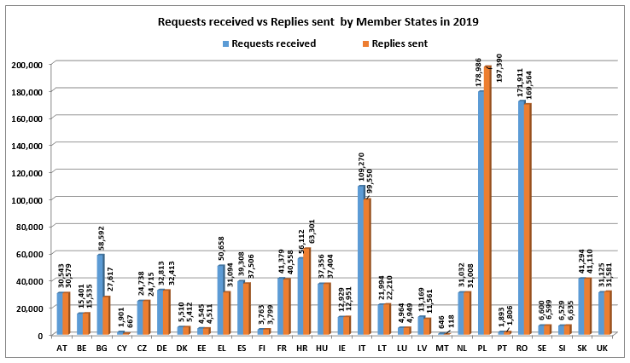

The **volume of requests received and** **sent replies** corresponding to them **varies significantly among the Member States**, from 179.000 (PL) to 646 requests (MT) per year. There are mainly two factors to be taken into account in the analysis of these variations: the overall population per Member State, and the number of its nationals residing in other Member States.

The Member States which **responded to the highest amount of requests** in absolute terms (not necessarily the highest in proportion to what they received) were:

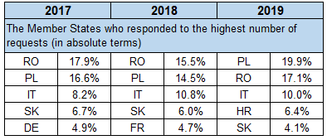

While all Member States respond torequests in general, in 2019 still **over 42.000 requests for information were not responded to**. In most of the cases, the number of sent replies was slightly lower than the number of received requests for information, with on average **around 4.1%, in comparison to 3,6% in 2016.**

Among the Member States which received the highest amount of requests in 2019, BG did not respond to 53% of requests received by them (30.975), EL to 38% (19.564), IT to 8,9% (9.720) and RO to 1.3% (2.347). For PL and HR the number of responses sent in 2019 was actually higher than the number of requests received, which might have been caused by sending a backlog of responses from the previous year.

In 2019, the **Member States with the highest percentage of requests not replied to** were: MT (82% of the requests received by them), CY (65%), BG (53%) and EL (38%). For a detailed analysis of individual Member State statistics on replies to requests - see the SWD, section 3.

The consequences of violating the obligation to respond to requests for information can be tragic, as pointed out in the previous points.

**2.7. Replies not meeting legal deadlines**

Another issue is that some requests are not replied to within the legal deadlines[18]. The graph below presents an overview for all Member States of the volumes of replies not meeting the legal deadlines in 2019, with indication of the replies sent after deadline and the requests with expired deadline to reply.[19]

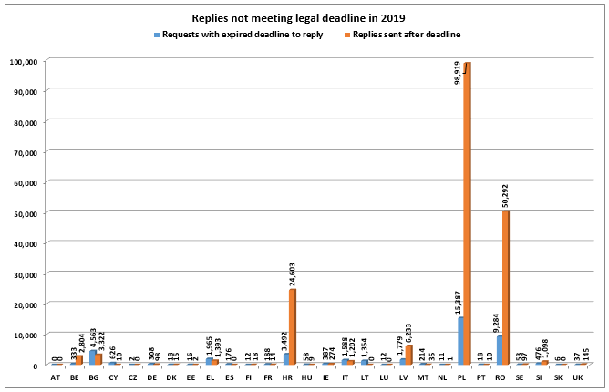

In 2019, **190.000 requests were replied to after the legal deadline,** which represents **18,4%** **of the total** number of requests. In addition, **42.000 requests with expired deadline to reply** were registered. These high numbers, paired with the reference data for 2016 (respectively: 13.800 (3,8%); 13.000), indicate an **alarming increase of replies not meeting the legal deadlines.**

**This tendency concerns only a few Member States,** in particular those that were **confronted with a huge volume of requests for information,** while the great majority of the Member States remains under 0,5% of late replies. The Member States having most problems to respect the deadlines in 2019 were: PL with 55% of their replies sent late (99.000), RO (30%; 50.000), HR (43%; 24.600), LV (47%; 6.200), BE (18%; 2.800) and BG (5%; 3.300). The problem of requests with an expired deadline to reply, which might result either in late replies or in requests not replied to, concerned 33% of requests received by MT and CY, 13,5% by LV and 8% of those received by PL.

**2.8. Requests for criminal proceedings and other purposes**

The graphs below represent the proportion between the requests for criminal proceedings and for other purposes than criminal proceedings from 2012 until 2019.

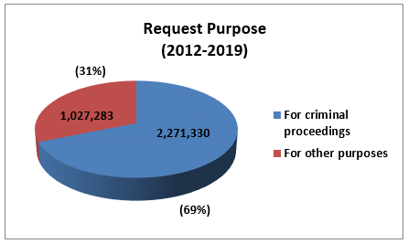

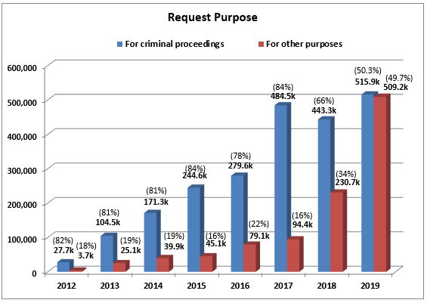

For many years the percentage of requests for other purposes than criminal proceedings was at the average level of 20% of all requests. As mentioned above, the years 2018-2019 brought **a complete shift in the use of the system, which started to be consulted equally often for criminal as for other purposes (50/50%).** The average for the whole ECRIS operation period is **69%** of all requests for the purpose of **criminal proceedings** and **31%** for **other purposes**.

The amount of **requests for** **other purposes exceeded 500.000 in 2019,** which is over **6 times more than in 2016**. The amount of **requests for criminal purposes** remained **at the stable level of around 500.000** as well.

The increase of requests for other purposes was caused mainly by the **strong growth of requests made by individuals on their own criminal records** –byover six times since 2016, amounting to a total of **356.000 requests**. The second contributing factor was the number of **requests for the purpose of recruitment** for professional or organised voluntary **activities involving direct and regular contact with children**, in implementation of **Directive 2011/93/EU[20].** These requests amounted to **115.000** in 2019, a **significant rise** from 7.800 in 2016. DE is the Member State mainly responsible for the increased number of requests for other purposes.

In 2019, most requests for other purposes than criminal proceedings were made by **individual** **persons** **to obtain information on their own criminal records** - **70% of requests for other purposes** and **35% of all requests** made. The next highest number of requests related to requests for **recruitment in accordance with Directive 2011/93/EU (22%** of the requests for other purposes and 11% of all requests made - in comparison with 10% of the requests for other purposes in 2016). The percentage of requests from a competent administrative authority for non-criminal proceedings dropped from 14% of requests for other purposes in 2016 to 3,8% in 2019 (and 2% of all requests), to be placed on the third position with 19.000 requests. The requests for obtaining a permit to carry weapons amounted to 1,1% of the requests for other purposes. Finally, the requests for the important purpose of obtaining a different nationality constituted only around 0,9% of requests for other purposes and 0,4% of all requests.[21]

**2.9. Requests concerning EU nationals and Third Country Nationals (TCN)**

The graphs below represent the proportion between requests concerning EU nationals and TCN per year[22] and on average during the whole ECRIS operation period.

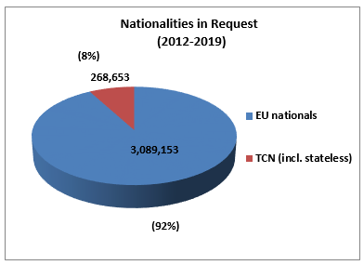

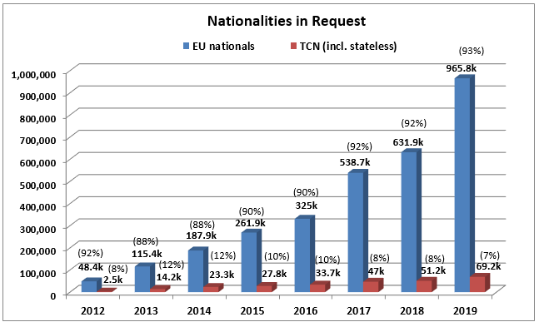

On average, **92 %** of all requests concern **EU nationals** and around **8% concern TCN**. The share of requests for stateless persons is marginal (0,02%).

Although the **percentage of requests for information on TCN** has **dropped** since 2016, from 10% to **7% of all requests in 2019**, the **actual** **number of such requests** has been steadily **growing**, to exceed **69.000 in 2019.** This phenomenon is caused by the significant increase in requests for purposes other than criminal proceedings that concern mostly EU nationals.

In 2019 supplementing legislation was adopted[23], establishing a centralised ECRIS-TCN system allowing for efficient identification of the Member State(s) holding criminal records information on TCN convicted in the EU. Once operarional in 2023, the system is expected to support more efficient exchanges through ECRIS of information on TCN and to lead to a considerable increase of such requests.

**2.10. Replies containing conviction information**

In the graphs below information is given on the proportion of the replies to requests containing one or more convictions, replies with no convictions and other replies per year[24], and on average during the ECRIS operation period.

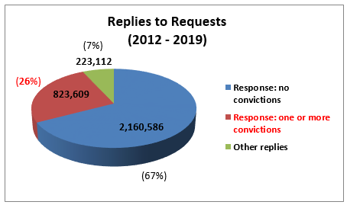

Since the first year of ECRIS operation, **26% of replies on avarage contained information on previous convictions.** This means that **in** **one case out of four the person concerned had been already convicted** one or more times, proving the value of ECRIS as a tool for obtaining criminal records information.

For many years, until 2018, this percentage remained at the stable level of around 30%, to suddenly **drop in 2019 till 19%**, in paralel to the dramatic growth of the number of requests for other purposes than criminal proceedings. It is a positive sign that the majority of persons, being subjects of requests for information related to, *inter alia*, recruitment, licenses, administrative purposes, have not had any previous convictions.

In **2019** this represented over **188.000 replies to all requests including conviction information** (in comparison with 105.000 in 2016).The replies with no conviction information constituted on average 74%, and other replies 7%.

**3. Main findings**

* **In 2019, all 28 Member States were active in using ECRIS, but 9.8% of the possible interconnections were still missing**

After eight years of ECRIS operation, **all 28 Member States** were **connected to ECRIS**. However, only one of them (ES) is exchanging information with the other 27 Member States. **On average, each Member State has 24 active connections** with the others. At the end of 2019, **90% of the total number of possible interconnections** was established.

* **The number of messages exchanged reached 4,2 million in 2019**

From 2 million messages exchanged by all interconnected Member States in 2016, the number **doubled** **in 2019 to reach** **4,2 million,** with an **average of 348.000 messages per month**. The last three years have brought a radical **change in the proportions** between the number of notifications, requests and replies to requests – with the **number of requests for information** becoming **over three times higher than the number of notifications**.

* **Drop in the number of notifications on new convictions - many convictions not notified**

In 2017 **the number of notifications on new convictions has dropped** and remained at the level of around **310.000 until 2019**. This downward tendency is surprising in the light of the ascending number of interconnections between the Member States.

**Some Member States did not send notifications on new convictions** in some years **at all** (PT, MT, EE, EL) and **many** **sent a low volume** of such notifications in relation to their EU non-national population and the number of convictions (BG, EE, EL, IE, LT, LU, MT, RO, SI, SE, PT, UK). Not sending notifications is contrary to the ECRIS legislation and may have serious consequences.

* **Strong increase in requests for information hitting 1 million**

The **number of requests for information** **has tripled since 2017 – to hit 1 million** in 2019 alone. Thishigh increaseis due mostly to the **shift in the use of ECRIS,** not used any more exclusively or even mainly for the purpose of criminal proceedings, but also – **on a regular basis - for purposes other than criminal proceedings (e.g. pre-employment screening, requests on one’s own criminal record, etc.).**

However, the **volume of issued requests varies considerably among the Member States**, from 745.000 (DE) to 6 requests (EL) per year. The rise in the total number of requests is caused mostly by an increase in DE requests.

* **ECRIS used for purposes other than criminal proceedings equally often as for criminal proceedings**

For many years the percentage of requests for other purposes than criminal proceedings was at an average level of 20%. With the new approach of the Member States to the use of ECRIS, noted since 2018, **the system started to be consulted equally often for both, criminal and other purposes (50/ 50%).** The amount of **requests for** **other purposes exceeded half a million in 2019 -** over six times more than in 2016.

This increase of requests was caused mainly by the **significant** **growth of requests made by individuals for their own criminal records (356.000** in 2019, which constituted **70% of requests for other purposes)**, as well as of **requests for the purpose of recruitment** for **activities involving contact with children**, in implementation of **Directive 2011/93/EU (115.000**requests - **22%** of requests for other purposes).

* **One reply in four reveals previous criminal convictions**

Since the first year of ECRIS operations, on avarage **26% of requests for information on previous convictions of a person were replied to with information on previous criminal convictions**. For many years, this percentage remained at a stable level of around 30%, to suddenly **drop in 2019 to 19%**, in parallel with the dramatic growth of the number of requests for other purposes than criminal proceedings. Yet again, in **2019,** over **188.000 replies to all requests contained information on previous criminal convictions**.

* **Despite the general increase in the number of updates, many updates are still not notified**

A **significant increase in the number of notifications on updates** has been registered, from 25% to **42% of all notifications**, amounting to **230.000** in 2019. It concerns, however, only some Member States.

At the same time, **numerous Member States** **did not send** **updates** on their previously sent notifications in some years **at all** (BG, DK, EE, EL, IE, LV, LU, MT, PT, SI) or **sent a low volume** of such messages (IE, RO, CY, SI, PT, MT).

* **ECRIS not always used to request information on previous convictions**

**Despite the dramatic increase in the number of requests in general**, the problem noted in the first Statistical Report of **some Member States sending almost no requests at all** (EL, CY, MT) or **sending a low number of requests** in relation to their EU non-national population (BG, EE, HU, IT, LV, RO, SI) still persists.

* **Requests responded to after the legal deadline**

In 2019, **190.000 requests were not replied to within the legal deadline,** which represents **18,4%** **of the total** number of requests. This number of late replies is alarming, as it **has** **grown almost 14 times** in comparison with 2016.

**This problem concerns** in particular the **Member States** that were **confronted with a huge volume of requests** for information: PL, RO, HR, LV, BE and BG.

* **Requests for information not responded to**

While all Member States respond torequests in general, in 2019 still **over 42.000 requests for information were not responded to**. This number corresponded to **4,1% of all requests,** in comparison with 3,6% in 2016. The Member States which did not reply to the highest percentage of requests received by them were: MT, CY, BG and EL.

* **Significant differences between the Member States' ECRIS activities and workload**

Some Member States send considerably more **requests for information than they receive** (DE, UK and CZ), while other Member States are confronted with a **significant workload replying to these requests** (PL, RO, IT, HR, SK and HU). The workload for some other Member States is produced mostly by sending a **high number of notifications** on new convictions to the Member States of the offender's nationality (BE and IT).

* **Current ECRIS still rarely used for TCN**

On average, **92%** of all requests concern **EU nationals** and around **8% concern third country nationals and stateless persons**. The amount of requests for information on TCN has been steadily **growing** since 2017 to exceed **69.000 in 2019**.

1. OJ L 93, 7.4.2009, p. 23 - as amended by Directive (EU) 2019/884, OJ L 151, 7.6.2019, p. 143.
2. OJ L 93, 7.4.2009, p. 33. This Decision will be replaced by Directive (EU) 2019/884 with regard to the Member States bound by this Directive - as from 28 June 2022.
3. COM/2017/341 final; SWD/2017/242 final.
4. The Commission did not receive data from Cyprus, Greece, Denmark, Lithuania and Slovenia.
5. For a detailed description of general principles of the exchange of information via ECRIS see the SWD, section 1.
6. For the history of connections to the ECRIS network see the SWD, section 2.1.
7. This amount takes into account 28 Member States.
8. For the evolution of the interconnections over the years see the SWD, section 2.1.
9. Other replies are for example replies with multiple persons found, with a person not being a national of the requested Member State, etc.
10. OJ L 220, 15.8.2008, p. 32.
11. For the years 2017 and 2018 see the SWD, section 2.2.
12. For the years 2017 and 2018 see the SWD, section 2.3.
13. See Eurostat-statistics: https://ec.europa.eu/eurostat/statistics-explained/index.php?title=File:Non-national_population_by_group_of_citizenship,_1_January_2019.png
14. For more details see the SWD, section 2.3.
15. For a detailed analysis of individual Member State statistics on convictions and notifications - see the SWD, section 3.
16. For the years 2017 and 2018 see the SWD, section 2.4.
17. For the years 2017 and 2018 - see the SWD, section 2.5.
18. See section 1.2 above.
19. For more details see the SWD: the table in section 2.6 and individual Member State statistics on late replies in section 3.
20. Directive 2011/93/EU on combating the sexual abuse and sexual exploitation of children and child pornography, OJ L 335, 17.12.2011, p. 1.
21. For more details on the volumes of requests for various categories of purposes in the years 2017 - 2019 see the SWD, section 2.7.
22. See also a table in the SWD, section 2.8.
23. Regulation 2019/816/EU establishing ECRIS-TCN, OJ L 135, 22.05.2019, p. 1; Directive 2019/884/EU amending Council Framework Decision 2009/315/JHA, OJ L 151, 7.06.2019, p. 143.
24. See footnote 9. See also the table in the SWD, section 2.9.