Annual
Management
and Performance
Report for
the EU Budget
Volume I

Introduction
The Annual Management and Performance Report for the EU Budget – Financial year 2020 together with its annexes is the Commission’s main contribution to the annual discharge procedure (0F) by which the European Parliament and the Council scrutinise the implementation of the EU budget. It fulfils the Commission’s obligations under the Treaty on the Functioning of the EU (1F) and the financial regulation (2F).
Implementing the EU budget is a shared responsibility. The Commission works hand in hand with the Member States and with other partners and organisations.
The report is composed of three volumes:
- Volume I provides the key facts and achievements of budgetary management for 2020.
- Volume II presents a more comprehensive picture of the implementation of the EU budget. Annex 1 provides a high-level overview of the performance of the EU budget in 2020. Annex 2 provides a high-level overview of internal control and financial management.
- Volume III contains technical annexes supporting the report. It includes Annex 3, detailed programme-by-programme performance information in the ‘Programme performance overview’.
This report is part of the broader integrated financial and accountability reporting package (3F), which also includes the annual accounts (4F), a long-term forecast of future inflows and outflows covering the next 5 years (5F), the report on internal audits (6F) and the report on the follow-up to the discharge (7F).

Annual Management and Performance Report

The EU budget and the response to the COVID-19 pandemic
Facing unprecedented challenges due to the COVID-19 pandemic, the EU relied on its strength of solidarity. It reacted swiftly and decisively to protect lives and livelihoods.
The EU budget was at the heart of this response. It took the Commission only 3 weeks from the designation of the COVID-19 outbreak as a pandemic by the World Health Organisation on 11 March 2020 to put forward proposals for a coordinated and comprehensive response through the EU budget. This involved mobilising financing quickly and flexibly to address the most pressing needs, without making any compromises on applying the highest standards of financial management. That response included the following measures (see Annex 1 for more details):
- the Coronavirus Response Investment Initiatives (CRII) under cohesion policy facilitating flexibility arrangements and mobilising some EUR 23 billion in liquidity to Member States. The initiatives help fighting the COVID-19 pandemic by supporting healthcare, small businesses and workers;
- the reactivation of the Emergency Support Instrument, with a budget of EUR 2.7 billion to fight the cross-border health emergency;
- EUR 415 million in additional financing for the Union Civil Protection Mechanism / rescEU to provide immediate disaster relief to the most affected areas;
- the extension of the EU Solidarity Fund to cover major health crises in addition to natural disasters; and
- a novel financial assistance instrument – the support to mitigate unemployment risks in an emergency programme (SURE) – with a budget of up to EUR 100 billion.
The European Parliament, the Council of the European Union and the Commission worked together seamlessly and rapidly to adopt these measures in record time and they had entered into force by the end of April 2020. The highly innovative SURE programme came into force on 19 May 2020.
The Commission’s objectives for combating the COVID-19 crisis
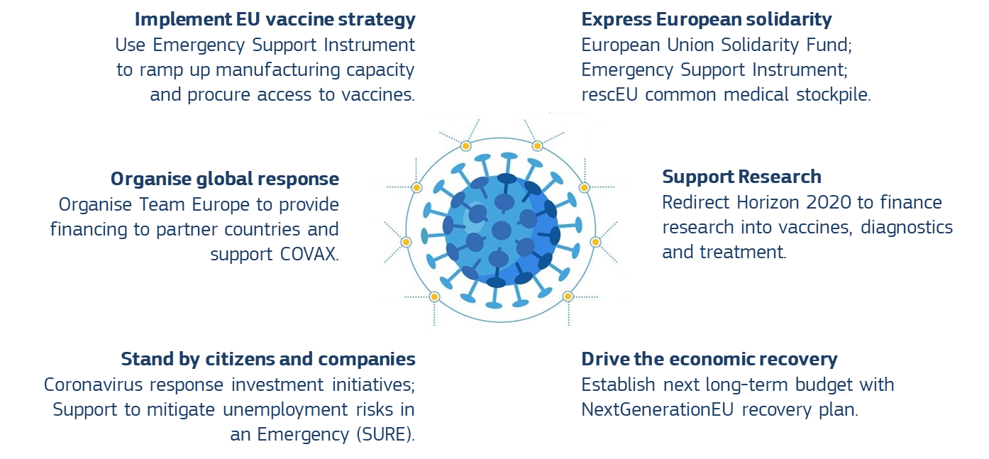
Financing these measures required the mobil0Tisa0Ttion of all means and flexibilities. In total, the 2020 budget was increased by EUR 10.2 billion in payments, activating all remaining resources under the 2014-2020 multiannual financial framework and redirecting EUR 70 billion overall towards addressing the COVID-19 crisis. In particular, the Coronavirus Response Investment Initiatives made it easier for Member States to tap liquidity and redirect cohesion funding quickly, while the Emergency Support Instrument allowed the Commission to coordinate and assist procurement efforts necessary to combat the crisis.
Proactive budgetary management ensured the speedy and effective implementation of the 2020 budget. Nine amending budgets were adopted as proposed by the Commission, more than in any other year in the 2014-2020 period and often in record time. Moreover, 28 budgetary authority transfers and hundreds of autonomous Commission transfers were made. As a result, the 2020 EU budget was spent almost entirely, in both commitments and payments – the best outcome since 2014, and achieved despite the challenging environment.
Crisis fighting and paving the way for a safe vaccine
The early response through the EU budget focused on immediate d0Tisa0Tster relief. The EU provided support in particular for logistical needs, such as the repatriation of EU citizens, delivery of medical goods from abroad, and the distribution across EU borders of medical goods and training of medical staff in areas such as intensive care.
- 90 000 EU citizens received help in returning home from abroad;
- 1 500 cargo operations by air, road, rail and sea were carried out, bringing essential medical supplies into the EU at a time when cargo transport availability was seriously limited;
- 15 000 medical professionals across 750 hospitals received training in intensive care and 3 500 medical staff were trained in coronavirus testing techniques;
- 200 disinfection robots that use ultraviolet light to disinfect patient rooms in hospitals in just 15 minutes are being sent to hospitals throughout the EU.
Securing a safe and effective vaccine was the cornerstone of the Commission’s strategy to contain the health crisis and enable a strong economic recovery.
- As early as 31 January 2020, Horizon 2020 published an emergency call to support research related to the new disease.
- By 18 June, the Commission and the Member States had agreed that the Commission would procure vaccines on behalf of all Member States. This first-of-a-kind agreement demonstrated the strength of solidarity among the Member States and their confidence in the agility of the EU budget and in the Commission as its manager. The coordinated approach ensured that Member States could share the inherent risk of investing in as-yet unproven vaccine development, giving access to a broad portfolio of potential vaccine technologies and companies.
- The Commission secured 2.6 billion doses of COVID-19 vaccines for all Member States (8F), using EUR 2.3 billion from the Emergency Support Instrument. As a result, the first EU citizens had already been vaccinated before the end of 2020, after the European Medicines Agency had confirmed the safety and effectiveness of the vaccine used. By the end of the year, Member States had made additional contributions of EUR 750 million in external assigned revenue available for the purchase of further vaccines.
For the EU, solidarity does not end at its borders. The Commission stood firm in its intention of making vaccines available globally. The EU took the lead in global efforts to fund a viable vaccine and make it available worldwide when the Commission organised a global pledging conference on 4 May 2020, collecting almost EUR 15.9 billion by the end of December 2020, including a contribution of EUR 1.4 billion from the EU budget as part of the wider Team Europe (9F) efforts. With over EUR 2.2 billion, Team Europe is one of the leading contributors to COVAX, a platform that is leading efforts to secure fair and equitable access to COVID-19 vaccines in low- and middle-income countries.
Economic and social relief
The Commission’s swift and ambitious reaction ensured that every available euro addressed the most pressing needs, as follows.
- The Coronavirus Response Investment Initiatives gave Member States the flexibility to reallocate EUR 23.3 billion () to the most urgent needs, using all available money from the European Structural and Investment Funds. Through this measure, by June 2021, EUR 8.4 billion was reallocated to health-related measures, such as the purchase of medical supplies, testing and hiring of additional health personnel. To contain the spread of the crisis and the damage caused, EUR 12.8 billion was made available in direct support for businesses and EUR 3.9 billion for people, including workers and vulnerable groups ().
- SURE provided financing to Member States at advantageous rates to alleviate the pressure on the economy and support employment. The budget is up to EUR 100 billion and by the end of 2020, more than EUR 90 billion in loan support had been requested and allocated to Member States. EUR 40 billion had already been paid out, mostly supporting short-term employment schemes in beneficiary Member States. By early 2021, between 25 and 30 million employees had benefited from support under SURE – a significant portion of the job market in beneficiary Member States, which saved an estimated EUR 5.8 billion in interest payments.
- Through Team Europe, the EU adopted a broader outlook, providing support beyond its borders. Team Europe secured financial support for partner countries amounting to more than EUR 40 billion in total, including EUR 15 billion from the EU budget. Team Europe’s focus is on addressing the immediate health crisis and humanitarian needs, strengthening partner countries’ health, water and sanitation systems and their research and preparedness capacities, along with mitigating the socioeconomic impact.
The EU crisis response turns a challenge into an opportunity. In 2020, the EU not only used its 2020 budget effectively but also agreed its new long-term budget for 2021-2027, amounting to EUR 1 074 billion in 2018 prices, reinforced by the temporary recovery instrument, NextGenerationEU, worth an additional EUR 750 billion in 2018 prices. This stimulus package of EUR 1.8 trillion, the largest ever financed by the EU budget, will provide the necessary scale and ambition to help repair the economic and social damage caused by the COVID-19 pandemic and lay the foundations for a greener, more digital and more resilient EU.

A high-performing budget driving the EU’s priorities
While fighting the pandemic, the EU continued to deliver on its political priorities. In 2020, the final year of the 2014-2020 multiannual financial framework, strong progress was made towards the programme objectives for the 2014-2020 period as a whole. Despite the delays in the launch of some programmes, progress is now accelerating across the board.
Progress with EU budget implementation is monitored through state-of-the-art control and performance frameworks. The programme performance overview in Annex 3 provides detailed reporting on the progress made and on the steps that have been taken to overcome challenges in the implementation. The information available at the end of 2020 presented in the programme performance overview shows that overall, the large majority of programmes – 40 out of 61 – are making very good progress towards achieving their objectives. These programmes correspond to 92% of the budget in terms of amounts in euro.

Percentage of programme indicators that are on track.
Source: European Commission.

The Commission ensures that all programmes deliver results until closure. Major programmes such as the European Structural and Investment Funds and the Connecting Europe Facility will continue to be a source of financing for a number of years. Together, these programmes represent roughly 50% of the budget. And while the 2020 budget was spent in full, almost 28% of overall payments under the 2014-2020 framework are still outstanding. That means that these programmes will continue to deliver results over the next few years. The Commission will work with all involved in budget implementation to ensure that these programmes continue to make a strong contribution to EU priorities (more details are provided in Annex 2). A full assessment of the 2014-2020 programmes will only be possible after this period – on the basis of final evaluations.

Pursuing the EU’s cross-cutting political goals through the EU budget
The EU budget is much more than the sum of its parts. Every spending programme is designed to tackle a particular set of challenges. However, the EU budget is at its most powerful when programmes work together to unlock synergies, catalyse private and public funding, and coherently promote the overarching political priorities which are central to the headline ambitions of the von der Leyen Commission (10F).
The EU’s goal to become climate neutral by 2050 as part of the European Green Deal (11F) is a prime example. Hitting this target will require leveraging all available means, both legislative and financial, cutting across different policy areas and programmes, as follows.
- The EU spent 20.1% of its 2014-2020 budget, or EUR 216 billion, on combating climate change, delivering on its objective of investing at least 20% of the 2014-2020 budget in this area.
- The EU has spent 8% of its 2014-2020 budget, or EUR 85 billion, on initiatives supporting or protecting biodiversity. This is well in line with the EU’s strong commitment to halting and reversing biodiversity enshrined in the European Green Deal. The EU biodiversity strategy (12F) outlines the scope of the major investments required, to which the EU budget can make a major contribution.
European Neighbourhood Instrument
EUR 2 082
Instrument for
Pre-accession Assistance
EUR 1 606
Horizon 2020
EUR 20 300
Connecting Europe
Facility
EUR 21 082
European Regional Development Fund
EUR 34 142
Cohesion Fund
EUR 16 733
European Social Fund
EUR 5 477
European Agricultural Guarantee Fund
EUR 45 505
European Agricultural Fund for Rural Development
EUR 57 694
Programme for the environment and climate action
EUR 1 616
Development Cooperation Instrument
EUR 5 230
Humanitarian aid
EUR 1 060
Other
EUR 3 572

Climate contribution in 2014 to 2020, in million EUR.
Source: European Commission.

- The EU budget has supported major investments in energy generation and usage – both key factors for the transition to a more sustainable economy. In particular, through cohesion funds, it has financed more than 2 000 megawatts of new renewable energy installation, along with energy efficiency measures leading to energy savings of 1 200 gigawatt hours per year. The EU budget also funds the experimental fusion project ITER, which could provide access to a potentially limitless source of clean energy.
Investing in the future requires not only a green but also a digital transition. The COVID-19 crisis has further accelerated the trend towards digitalisation. More important than ever in times of lockdown, the EU budget has supported investments in high-speed internet connections through, for example, the cohesion funds and the European Fund for Strategic Investments, connecting almost 25 million households to the internet through those two programmes. Digitalisation is also a key driver of innovation. To strengthen the EU’s industrial base, the EU budget is financing key projects such as satellite-based services (such as Galileo’s space-based location service or the innovative climate change service provided by Copernicus) or artificial intelligence (funded by Horizon 2020).
Excellence in research and innovation contributes to an economy that works for people. Horizon 2020 is part of this EU success story. The 2020 Nobel Prize in Chemistry was awarded to Horizon 2020 alumna Dr Emmanuelle Charpentier together with Jennifer A. Doudna for the development of a method for genome editing. Dr Charpentier is the 10th Horizon 2020-funded researcher to be honoured with a Nobel Prize to date.
The EU budget helps to foster EU values, both in the EU and more widely. For Erasmus+, 2020 was a year of formidable challenges caused by the COVID-19 pandemic, which resulted in almost 30% fewer people going abroad. Nonetheless, Erasmus+ still provided almost 700 000 people with the opportunity to experience life differently, in higher education, in vocational training and through various other exchange possibilities.
More broadly, the EU is committed to the United Nations sustainable development goals. They are already widely and deeply integrated into the EU budget. In 2020, 46 EU spending programmes, or 75% of the total, contributed to at least one of the 17 sustainable development goals. Those 46 programmes represented 96% of the entire EU budget.

A strengthened commitment to performance
The Commission is aware of the responsibility that comes with the increased budget. The multiannual financial framework plays a critical role in supporting the economic recovery and transformation. The Commission expects and welcomes the associated increase in scrutiny by stakeholders of the effectiveness of EU spending. This effectiveness is at the heart of the work that the Commission has already done to build a robust performance framework for the EU budget. Such a framework is key in order to monitor budgetary implementation, to steer the budget towards its objectives, to respond rapidly and effectively to unforeseen events and to generate data and information showcasing how the EU budget provides concrete value to EU citizens.
The Commission has adopted a communication on the performance framework of the EU budget (13F). The communication explains the framework’s guiding principles, describes recent improvements and outlines plans for its further development during the implementation of the 2021-2027 multiannual financial framework and beyond.

EU funds are well managed and protected in the context of a crisis
The Commission attaches great importance to the sound financial management of EU taxpayers’ money. It is fully committed to ensuring the highest standards of management.
Even under unprecedented and challenging conditions, the solid chain of assurance and accountability worked. Under the governance system used by the Commission, the College of Commissioners delegates the day-to-day operational management to the 51 Directors-General and Heads of Service. This safeguards a clear division of responsibilities, well-defined management responsibilities and solid reporting (see details in Annex 2, Section 2.1.3).
Strong organ0Tisa0Ttion allowed for a swift and efficient reaction – despite the circumstances of the COVID-19 pandemic. Thanks to good crisis preparedness, the Commission remained fully operational, with almost 30 000 people switching to teleworking within a few days. This allowed the Commission to play a leading role in all aspects of the crisis response, from public health to the economic recovery plan.
An early risk assessment ensured the checks for the effective and efficient use of the EU budget. Before summer 2020, the Commission analysed the risks arising from the COVID-19 pandemic and made sure that appropriate mitigating measures were in place. For instance, on-the-spot audits were replaced by desk reviews and remote audits, which proved to be effective. During the year, all services monitored these risks closely and in real time, with support and oversight from the Commission’s corporate governance bodies (Annex 2, Section 2.1.2).
The Commission helped beneficiaries and Member States to implement the budget under the difficult circumstances. It extended the deadlines for the implementation of projects or recoveries and supported Member States by providing some flexibility in the way they implement and control EU funds, without reducing the level of assurance. The European Anti-fraud Office issued targeted guidance to the services to help them identify and address new emerging threats from fraudsters abusing the opportunities provided the COVID-19 pandemic.
The measures allowed for the effective implementation of the budget despite the difficult situation created by COVID-19. As a result of the abovementioned initiatives, the level of assurance was maintained, and the time needed to pay beneficiaries remained similar to previous years. Moreover, the level of implementation of the budget increased to 99% (compared to 98% in 2019).

Robust corporate internal control framework
The Commission’s control framework withstood the test. The Commission relies on its multiannual control strategies to prevent, detect and correct errors and weaknesses. These strategies are also risk differentiated, i.e. adjusted to the different management modes, actors involved, policy areas and/or funding arrangements and their respective associated risks. This differentiation of the control strategies is necessary to ensure that the controls remain cost-effective, i.e. that they strike the right balance between a low level of errors (effectiveness), fast payments (efficiency) and reasonable costs (economy).
Hundreds of thousands of payments were checked and system audits performed. The Commission builds its assurance from the bottom up and at a detailed level. This means that hundreds of thousands of payments are checked every year by the Commission and the Member States, who share the management of 70% of the funds with the Commission.
Hundreds of thousands of payments are checked every year
In agriculture: | In cohesion: 
more than 900 000 on-the-spot checks were carried out by the Member States | Assurance packages for 508 programmes were reviewed
68 audits were carried out by the Commission | 89 audits were carried out by the Commission

Number of checks and audits by the European Commission in 2020, in agriculture and cohesion.
Source: European, Commission annual activity reports.

The root causes of errors are identified and addressed. The detailed level of information allows the Commission, as the manager of the EU funds, to find system weaknesses, to identify their root causes (e.g. complexity of rules) and to take targeted corrective actions. It also enhances preventive actions and ensures that any lessons learned are factored into the design of future financial programmes.
Preventive and corrective actions are implemented. As a result of its controls, the Commission applies financial corrections and recoveries. In 2020, the controls carried out before the payments along with other preventive measures have allowed EUR 301 million to be saved. For the controls carried out after the payments, the corrections and recoveries applied amounted to EUR 596 million and EUR 5.2 billion cumulatively since 2017.
Overall, the level of risk at payment is below the materiality threshold of 2%. The Commission estimates that, after its preventive controls, the remaining level of error – i.e. its risk at the time of payment – is 1.9%, representing a decrease compared to 2019. Given the multiannual character of the funding programmes, the Commission deploys substantial efforts to perform controls after the payments and to continue to make corrections until the closure of the programmes. These efforts are reflected in the estimated risk at the closure of the programmes. This corresponds to the risk at payment minus the Commission’s forecast future corrections, which are estimated at 1% in 2020 (see Annex 2, Section 2.2.2).
The Commission’s future corrections forecast is based on the historical average level of corrections. This average is adjusted to take out elements that are no longer relevant for the future, in order to make the best and most conservative estimate.
For 2020, the risk at closure is estimated at 0.9%. As this is below the threshold of 2% – also used by the Court of Auditors – the Commission considers that the budget as a whole is effectively protected. This is confirmed by the internal auditor’s opinion (14F).
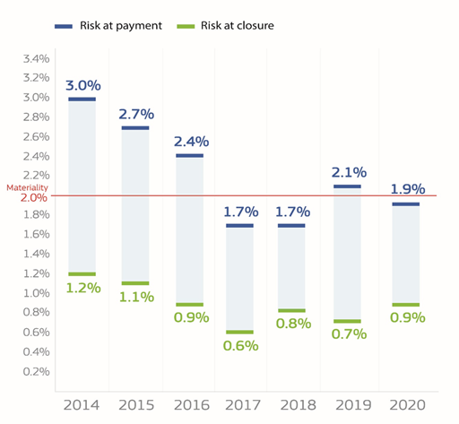
Risks at payment and closure for the European Commission for 2014-2020.
Source: European Commission, 2014-2020 annual management and performance reports for the EU budget.
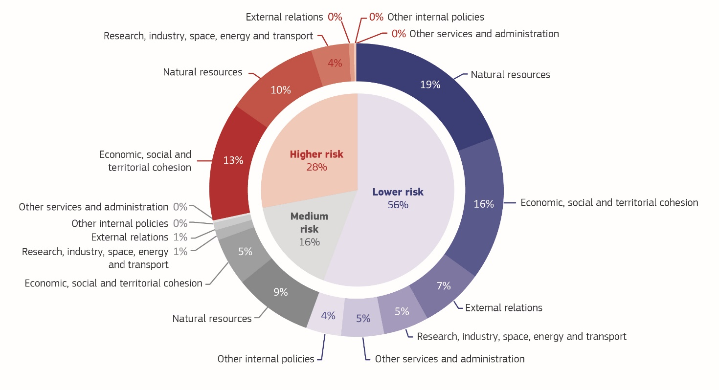
The Commission identifies which programmes are higher risk, allowing it to focus its action where it matters most. Thanks to its in-depth empirical approach, the Commission has robust evidence that demonstrates the differentiated situation for the funds managed. Based on the risk at payment, the Commission can precisely divide the annual expenditure into lower risk at payment (where the risk is below 1.9%), medium risk at payment (between 1.9% and 2.5%) and higher risk at payment (above 2.5%) (see Annex 2, Section 2.2.3). For natural resources and cohesion, this analysis is also done at the level of individual paying agencies and operational programmes in the Member States. This allows the Commission to focus its efforts appropriately, to provide its support efficiently and to address specific weaknesses even for policies which, taken globally, are low risk, such as the common agricultural policy.
The Commission’s categorisation of expenditure into higher-, medium- and lower-risk segments, as percentages of the total amount of relevant expenditure for 2020.
Source: European Commission, annual activity reports.
In particular, the following involve higher-risk expenditure: some operational programmes for cohesion policy funds that show serious deficiencies and/or have error rates above 2.5%; the grants for the research programme Horizon 2020; the paying agencies for the agriculture-related direct payments and market measures and rural development that have error rates above 2.5%; and other complex grants (15F). Where the level of risk remains high, this is reported transparently through the issuance of reservations (16F). For 2020, there are 19 reservations with a total financial impact of EUR 1 219 million, which is less than 1% of the total expenditure. They correspond to the expenditure identified as high risk.
In addition to applying financial corrections and recoveries, the Commission is taking action to address weaknesses leading to medium and higher risks. This includes targeted remedial actions, such as raising awareness of applicable EU rules among beneficiaries and implementing partners that are more error prone. It also means better use of controls and audit results to adjust the control strategies and focus them on expenditure, increasing the capacity of national authorities that have deficiencies in their management and control systems along with applying the lessons learned to the future programmes.

Further developments: outlook for 2021 and beyond
The Commission is committed to continuing to improve its management and control systems. For 2021, the Commission will pursue its efforts to address the weaknesses leading to the issuance of reservations and to higher levels of risk, especially for cohesion funds and the research programme for the 2014-2020 period. As the pandemic is still ongoing, the related risks and mitigating measures remain under constant monitoring and this will continue for as long as the crisis lasts.
The new multiannual financial framework for 2021-2027 takes into account lessons learned. The new programmes will benefit from many simplification measures that were introduced following the lessons learned from previous programmes (in 2014-2020 and 2007-2013).
New elements for the protection of EU funds will be rolled out in 2021 (see Annex 2, Section 2.4), such as the following.
- The new guidance on the avoidance of conflicts of interest (17F) to help managers of EU funds avoid conflicts of interest and to maintain a uniform interpretation and application of the rules among all stakeholders, along with the implementation of the regulation on a general regime of conditionality for the protection of the EU budget (18F) whereby, for the first time, the EU has a specific tool to protect its budget from breaches of the principles of the rule of law.
- The single data-mining tool the Commission makes available to Member States, for control and audit purposes under the European Structural and Investment funds will be extended to the common agricultural policy and the Recovery and Resilience Facility. This tool will allow for the identification of irregularities and fraud across all funds.
- Enhanced procedures for the assessment of implementing partners’ control systems, prior to entrusting them with EU funds, to obtain the certainty that they offer the same level of assurance as the Commission’s own control systems.
In 2021, the Commission will make the first disbursements under the Recovery and Resilience Facility. In 2020, the Commission took unprecedented measures to set up the facility in record time. This included putting in place a dedicated governance structure and the relevant internal processes and control strategies. These are tailored to the fact that disbursements to Member States are based on the fulfilment of predefined milestones and targets. Payments will therefore not be subject to controls on the costs actually incurred by the Member State. Unlike in shared management, the Member States are the beneficiaries of the EU funds, which, once paid, become fungible in the national budgets. Member States bear the responsibility for ensuring that the facility is implemented in compliance with EU and national rules and with the principles of sound financial management.
The Commission will complement the Member States’ controls. In order to build its assurance, the Commission will rely on the Member States’ controls and supplement them with its own controls as necessary. These will be applied at three stages: during the assessment of the Member States’ recovery and resilience plans; during the assessment of the Member States’ payment requests; and after disbursements. In addition to controls on the fulfilment of milestones and targets, the Commission may perform risk-based controls to verify the absence of serious irregularities (i.e. fraud, corruption or conflicts of interest) or serious breaches of obligations. If necessary, the Commission will recover proportionate amounts, if Member States themselves have failed to do so, or require early repayment of the loans.

Conclusion
The Commission ensures that the EU budget serves citizens. Thanks to the strong tools in place and to proactive management of the EU budget, the Commission has been able to deliver on its policy objectives and respond to the crisis. The Commission has provided its beneficiaries, implementing partners and the Member States with the necessary degree of flexibility, while ensuring sound financial management and maintaining an appropriate level of assurance on the management of the EU budget.

() The annual discharge procedure is the procedure through which the European Parliament and the Council give their final approval on the budget implementation for a specific year and hold the Commission politically accountable for the implementation of the EU budget (https://ec.europa.eu/info/about-european-commission/eu-budget/how-it-works/annual-lifecycle/assessment/parliaments-approval_en).
() Article 318 of the Treaty on the Functioning of the EU.
() Articles 247(1)(b) and 247(1)(e) of the financial regulation.
() Article 247 of the financial regulation.
() Article 246 of the financial regulation.
() Article 247(1)(c) of the financial regulation.
() Article 118(8) of the financial regulation.
() Article 261(3) of the financial regulation.
() Through the agreement of advance purchase agreements with the potential manufacturers (AstraZeneca, BioNTech/Pfizer, CureVac, Johnson and Johnson, Moderna and Sanofi/GlaxoSmithKline). 2 billion doses had been agreed before year-end 2020. A further 0.6 billion doses were agreed in the first half of 2021. The Commission agreed also the optional acquisition of 1.8 billion doses.
() Team Europe is a package launched by the EU in April 2020 to support partner countries in the fight against the COVID-19 pandemic and its consequences. Its overall financial allocation amounts to almost EUR 38.5 billion, and combines resources from the EU, its Member States, and financial institutions, in particular the European Investment Bank and the European Bank for Reconstruction and Development.
() Cumulative reprogramming since the creation of the initiatives until June 2021.
() Overall support for people of EUR 3.9 billion includes EUR 2.1 billion of direct support to citizens as allocations reflected under the EUR 7.4 billion health and under the EUR 12.8 billion enterprise reprogramming. It is therefore not double counted in the total of EUR 23.3 billion.
() See https://ec.europa.eu/info/files/political-guidelines-new-commission_en
() See https://ec.europa.eu/info/strategy/priorities-2019-2024/european-green-deal_en
() For Biodiversity strategy for 2030, see https://ec.europa.eu/environment/strategy/ biodiversity-strategy-2030_en
() Communication from the Commission to the European Parliament and the Council on the performance framework of the EU budget under the 2021-2027 MFF, COM(2021) 366, 8 June 2021.
() See Annex 2, Section 2.3.2, ‘Work of the Internal Audit Service and overall opinion’.
() See details in Annex 6.
() In the annual activity reports for each Commission department and the annual management and performance report for the Commission as a whole.
() Commission Notice – Guidance on the avoidance and management of conflicts of interest under the financial regulation (C/2021/2119) (OJ C 121, 9.4.2021, p. 1).
() Regulation (EU, Euratom) 2020/2092 of the European Parliament and of the Council of 16 December 2020 on a general regime of conditionality for the protection of the Union budget (OJ L 433I, 22.12.2020, p. 1) (https://eur-lex.europa.eu/legal-content/EN/ALL/?uri=CELEX%3A32020R2092).

