

REPORT FROM THE COMMISSION TO THE EUROPEAN PARLIAMENT AND THE COUNCIL

on the implementation of Regulation (EU) 2021/821 setting up a Union regime for the control of exports, brokering, technical assistance, transit and transfer of dual-use items

**1. Introduction**

In 2013 the Commission started publishing annual export control reports as provided for by Regulation (EC) No 428/2009 (“the Regulation”). The Regulation was repealed by Regulation (EU) 2021/821[1] (“the new Regulation”) on 9 September 2021.

This report, prepared by the Commission with input from Member States[2] in the Dual Use Coordination Group, provides information on the implementation of EU law concerning export control of dual-use items in 2020, and includes aggregated export control data for 2019.[3]

In order to contribute to a more thorough implementation of EU trade law, including EU law concerning export control of dual-use items, the Commissiom created a new post of Chief Trade Enforcement Officer (CTEO) in 2019. In order to support the CTEO in carrying out its enforcement tasks, the Commission has restructured the organization of DG TRADE. Among other changes, export control and foreign direct investment (FDI) screening have been merged under one unit in DG TRADE under the supervision of the CTEO. As a consequence and because export control and FDI screening are both tools for strategic trade and investment controls to ensure security in the European Union, this report is adopted simultaneously with the first annual report on FDI Screening.

**2. Evolution of the policy & regulatory framework**

**2.1. Export control policy review**

2.1.1. Legislative modernisation

2020 was a crucial year for the modernisation of EU export controls, with the Council and the European Parliament reaching political agreement on a new export control Regulation in November 2020. They agreed on a comprehensive “system upgrade”, that will make the EU export control system more effective by:

* introducing a novel ‘human security’ dimension so the EU can respond to the challenges posed by emerging dual-use technologies – especially cyber-surveillance technologies – that pose a risk to national and international security, including human rights;
* updating key notions and definitions in the Regulation (e.g. definition of “exporter” covering natural persons and researchers involved in dual-use technology transfers);
* simplifying and harmonising licensing procedures and allowing the Commission to amend – by a ‘simplified’ procedure, using delegated acts – the list of items or destinations subject to specific forms of control, thereby making the export control system more agile and able to evolve and adjust to circumstances;
* enhancing information-exchange between licensing authorities and the Commission with a view to increasing transparency of licensing decisions;
* coordinating and supporting robust enforcement of controls, including enhancing secure electronic information-exchange between licensing and enforcement agencies;
* developing an EU capacity-building and training programme for Member States’ licensing and enforcement authorities;
* strengthening outreach to industry and transparency with stakeholders, developing a structured relationship with the private sector through specific consultations of stakeholders by the relevant Commission group of Member States experts;
* setting up dialogues with third countries so as to enhance global security and promoting a level playing field at global level.

The new regulation has been published on 11 June 2021and entered into force on 9 September 2021.

2.1.2 Consultations and outreach

As part of a continuous outreach effort, the Commission conducted a series of targeted consultations to key industry and civil society stakeholders in the course of 2020.[4] In particular, an Export Control Forum was organised in a virtual format on 11 December 2020 as described further below.

**2.2. Amendments to Regulation (EC) No 428/2009**

2.2.1. Update to the EU control list

The EU Control List in Annex I to the Regulation provides a list of dual-use items, including software and technology, which can be used for both civil and military purposes, and it also includes all goods which can be used for both non-explosive uses and assisting in any way in the manufacture of nuclear weapons or other nuclear explosive device. It was amended once in 2020[5]. This amendment incorporated the decisions agreed in 2019 and until the end of February 2020 in the context of the multilateral export control regimes (in particular at the Wassenaar Agreement and the Australia Group). Annexes II and IV of the Regulation were also updated in line with the amendments to Annex I.

**Amendments to the EU control list in 2020**

The amendments introduced certain cyber-surveillance technologies, e.g. law enforcement monitoring "software" (5D001.e.1 and 2.) and "digital forensics" systems, equipment and components (5A004.b.1 and 2.) in the list of items subject to export control.

The 2020 EU control list also introduces controls on "sub-orbital craft" (9A004.h.), as well as new decontrol notes for certain carbon "fibrous or filamentary materials" (1A002 – Note 5) and "technology" for information security system (5E002.a.–Note).

Furthermore, it incorporates changes to the controls on:

- planar absorbers made of sintered ferrite (1C001.a – Note 1.d.2.),

- metal alloys (1C002 – Technical Note 3),

- fluids and lubricating materials (1C006.d.),

- anti-friction bearings and bearing systems (2A001),

- simulation software (3D003),

- information security system to refer to secure "cryptographic activation" (5A002.a.),

- space qualified components for optical system (6A004.c.4),

- some lasers (6A005.a.6.a.1. - .2.a.) and

- 'fan blades'.

As a result from decisions at the Australia Group, new controls on Middle East Respiratory Syndrome-related coronavirus (MERS-related coronavirus – 1C351.a.59), on 24 chemicals, including Novichok nerve agent precursors (1C350.66. to 1C350.89) as well as changes to the control on valves and components (2B350.g.1.a. - .2.a.) were introduced.

The updated and consolidated EU Control List entered into force on 15 December 2020, thereby allowing the EU to comply with its international commitments. It also supports EU exporters through timely adjustments of control parameters to technological developments. A "Comprehensive Change Note" was published as guidance providing an overview of all changes to the 2020 EU Dual-Use Control List[6].

2.2.2. Brexit

In the course of 2020, the Commission took a series of actions in view of the end of the transition period on 1st January 2021, when exports of dual-use items from the EU to the UK become subject to control under the Regulation, like exports to any other third country.

In September 2020, the Commission published a Notice to Stakeholders[7] to inform exporters of applicable rules in view of the end of the transition period and of the withdrawal of the United Kingdom from the EU.

In order to ensure the uniform application of controls throughout the Union, and to avoid undue administrative burden while protecting the Union and international security, the EU adopted Regulation (EU) 2020/2171 of 16 December 2020 amending Annex IIa to the Regulation. By adding the UK to the list of destinations covered by the Union General Export Authorisation No EU001[8] Regulation (EU) 2020/2171 provides for a simplification of controls on exports of most dual-items to the United Kingdom.

Specific arrangements apply under the Northern Ireland (NI) Protocol[9], which provides that the Regulation applies to, and in the United Kingdom in respect of Northern Ireland.[10], with the UK acting as a competent authority under the Regulation. The Commission developed a dedicated secure electronic tool to support the exchange of information with the UK competent authority in charge of applying the Regulation in and from Northern Ireland. This enables the UK competent authority to access information which supports the effective implementation and enforcement of controls on exports of dual-use items from Northern Ireland in line with the provisions of the Regulation. Therefore UK competent authorities are able to enter information on relevant denials into the Dual-use e-System (DUeS)[11], to consult, manage and browse UK denials already stored in DUeS as well as to receive the denial information that is relevant to a specific application for export of dual-use items from Northern Ireland.

**2.3. National implemention and enforcement measures**

2.3.1. Implementation measures

The Regulation is binding in its entirety and directly applicable in all Member States. However, it provides that Member States take certain measures for the implementation of specific provisions, and that information on those national measures should be published in the Official Journal of the European Union. Accordingly, the Commission published an Information Note on 17 January 2020[12] which provides an updated overview of measures taken by Member States including, inter alia, the extension of brokering and transit controls, the extension of controls to non-listed items for reasons of public security and human rights considerations, the introduction of national general export authorisations, the application of intra-EU transfer controls for non-listed items, as well as information relating to competent authorities. This ensures that exporters have access to comprehensive information on the applicable legal provisions, and supports the consistent and effective implementation of controls throughout the EU.

2.3.2. Enforcement measures

According to information made available to the Commission, there have been no new developments in 2020. The list of national enforcement measures published together with the 2019 annual export control report[13] therefore remains valid.

**3. Activities of the Dual-Use Coordination Group**

The Dual-Use Coordination Group (DUCG) brings together experts from the Commission and Member States to examine any issue concerning the application of export controls with a view to practically improving their consistency and effectiveness throughout the EU. The Regulation requires the Commission to submit an annual report to the European Parliament on the activities, examinations and consultations of the DUCG.

The DUCG held seven – mostly virtual - meetings in 2020, confirming its function as a forum for consultations on a number of topical issues described here.

**3.1. Consultations on implementation issues - general information exchange**

The DUCG conducted ***general information exchanges on export control issues***, including in support of the legislative modernisation of EU export controls explained above.

The DUCG exchanged information regarding ***national implementing measures*** and prepared the update of the official information notice on national measures.[14]

With regard to ***Brexit*** the DUCG not only contributed to the development of the IT tool supporting information-exchange for the application of controls under the Northern-Ireland Protocol but also reviewed changes to licensing requirements and contributed to the preparation of an updated ***"readiness notice"[15]*** on dual use for the attention of exporters.

The DUCG conducted a ***licensing data collection exercise*** on 2019 data in order to enhance information exchange between Member States - especially regarding the collection of data under global and general export authoritisations - and to increase public transparency on EU dual-use export controls (EU 2019 aggregated data was used in the preparation of this annual report).

The DUCG conducted a ***technical exchange of information on the application of controls on cyber-surveillance technologies*** in 2019.

The data collected from Member States shows a decrease in the number of licences (see Table 1), with a total of 44 licenses for listed cyber-surveillance items[16] issued in 2019. In the same period, 81 denials were issued for cyber-surveillance items.

Table 1: Number of individual licences for listed cyber-surveillance items.

The DUCG decided to continue efforts to monitor the implementation of controls, and initiated the exchange of information on the application of controls in 2019. The "Surveillance Technology Expert Group" (STEG) continued to exchange *ad hoc* information.

**3.2. Technical exchange of information – implementation issues**

The DUCG provided support to the preparation of updates to the EU control list and engaged in discussions on a number of specific implementation issues such as to enhance information exchange under EU General Export Authorisations (EUGEAs), information exchange under global licences or the development of a consultation mechanism between competent authorities concerning information on exporters using global licences.

**3.3. EU Guidelines on Dual-Use Export Controls**

The DUCG worked on the preparation of a revised version of the 2016 “EU Guidelines on dual-use export controls” which reflects improvements to the DUeS, in particular insofar as it supports information exchange and consultations between competent authorities.

The Technical Expert Group on the development of guidelines for dual use research (TEG-DUR) held six meetings in 2020 and prepared a draft guidance on research involving dual-use items. A public consultation[17] was held in October-November 2020, attracting 54 responses. The TEG DUR submitted the draft final guidance to the DUCG for consideration early 2021. The guidance was adopted as a Commission Recommendation in September 2021[18].

**3.4. Electronic exchange of information between competent authorities**

The Commission, supported by the DUCG, continued to develop the Dual-use e-System. In the course of 2020, the DUCG agreed on specific improvements to the DUeS:

• functionalities supporting denials notifications under Article 13(5) of the Regulation

• functionalities supporting bilateral consultations between competent authorities under Article 11 and Article 13(5) of the Regulation;

• preparations for a new functionality to support information-exchange on denials concerning intra-EU transfers;

• preparations for a functionality to support consultations under global licences;

• the list of items in the DUeS was updated to reflect the 2020 update of the EU control list;

• a new functionality to support information exchange with the UK competent authority under the Northern Ireland Protocol at the end of the transition period.

The DUCG continued to support, through a dedicated Technical Expert Group, the development of an "electronic licensing platform", which can be used by competent authorities. The TEG on e-licensing continuously liaised with experts from the Member States and supported the "eLicensing pilot project", which plans to deploy the eLicensing tool in Latvia, Romania, Italy, Greece and the Wallonia Region of Belgium in the course of 2021. The deployment of this electronic system will allow national competent authorities to manage the whole authorisation process in a completely paperless format and with the effectiveness and efficiency which is typical of modern eletronic systems. This will also allow economic operators and competent authorities to minimise the administrative burden related to the authorisation of dual-use items.

The DUCG also initiated discussions regarding the integration of dual-use eLicensing systems with the Commission’s customs’ Single Window initiative under the “CERTEX” project. This integration will allow an automated check of the authorisation for the export of dual-use items once an exporter indicates that the dual-use goods being exported are covered by an export authorisation issued by an EU competent authority.

**3.5. EU Dual-use Pool of Experts**

In 2020, the EU Dual-use Pool of Experts operated by Commission’s Joint Research Centre (JRC) and experts made available by Member States continued to provide support to competent authorities requesting technical advice to support the assessment of specific licensing cases. In total, technical advice on commodity classification was provided on nine occasions to six competent authorities over the reporting period.

**3.6. Implementation and enforcement**

The DUCG exchanged information on the implementation and enforcement of controls. According to available data, the EU export control network – comprising staff in Member States’ licensing competent authorities and the Commission – consisted of over 360 staff. With respect to enforcement, 144 breaches of export control regulations were recorded in 2019 while eight administrative penalties and 16 criminal penalties were applied by national law enforcement authorities.

**3.7. Capacity building**

In 2020, the DUCG supported the organisation by the Commission's JRC in collaboration with the US Department of Energy of the 13th JRC-National Nuclear Security Agency (NNSA) virtual technical seminar on 15 September and 5 October 2020.

**3.8. Transparency and dialogue with industry and academia**

With support of the DUCG an Export Control Forum was organised in a virtual format on 11 December 2020, jointly with the German Presidency of the Council of the EU. This provided an opportunity to exchange views on the implementation of EU export controls and the legislative process for a modernisation of EU export controls with more than 800 industry and civil society stakeholders[19] from industry associations, dual-use companies, academia and civil society organisations in light of the co-legislator's agreement on a new regulation. The virtual format allowed a far wider participation than has been possible in the past in a physical setting.

Apart from the support of outreach activities of the Commission, the DUCG also prepared documentation to support exporters' implementation of the regulations. In particular, a "Comprehensive Change Note Summary 2020"[20] summarises the amendments to Annex I of the Regulation to implement the changes in the control lists of the various international fora on non-proliferation regimes.

**4. EU export controls – Key Data**

It is difficult to obtain reliable information on overall dual-use exports (including non-listed dual-use items) as there is no corresponding defined economic sector. However, the Commission and Member States collect data that allow for approximate estimates of exports of dual-use goods based, on the one hand, on specific licensing data collected by competent authorities and, on the other hand, on statistics for customs commodities which include dual-use goods. 2019 export data estimates are presented below. It should be noted that the estimates presented do not include services nor intangible technology transfers associated with the trade in dual-use goods.

**4.1. EU dual-use trade: items and destinations**

In 2020, the Regulation primarily applied to the export of about 1884 dual-use items listed in Annex I (the "EU Control List") and classified in 10 categories (Figure 1). These dual-use items relate to circa 1000 customs commodities, including chemicals, metals and non-metallic mineral products, computers, electronic and optical products, electrical equipment, machinery, vehicles and transport equipment, etc. and typically fall at the high–tech end of this large, mixed commodity area.

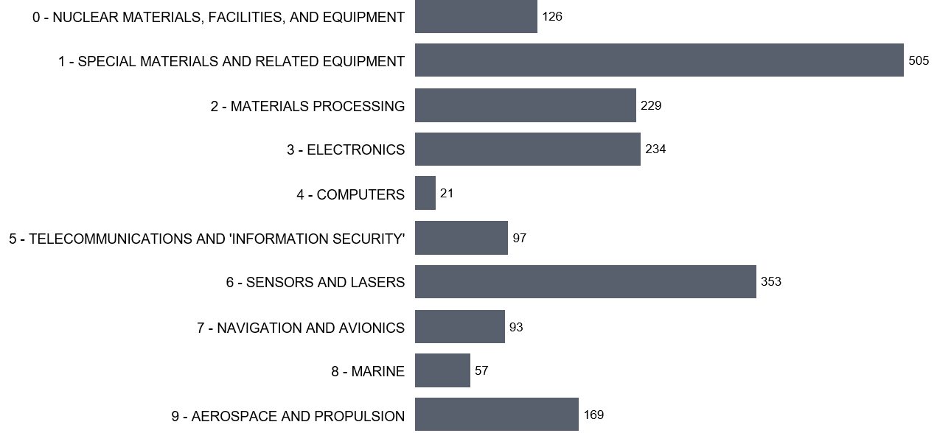

*Figure 1: Number of dual-use entries listed in the ten Categories of Annex I further to the adoption of Regulation (EU) 2020/1749.*

Statistical estimates of the relative importance of dual-use trade indicate that dual-use exports represent about 2.3% of EU27 total exports (intra and extra-EU), within a broad ‘dual-use export domain’[21] of customs commodities that may include, to varying degrees, certain dual-use items (Figure 2). This would put the value of dual-use trade at € 119 billion in 2019.

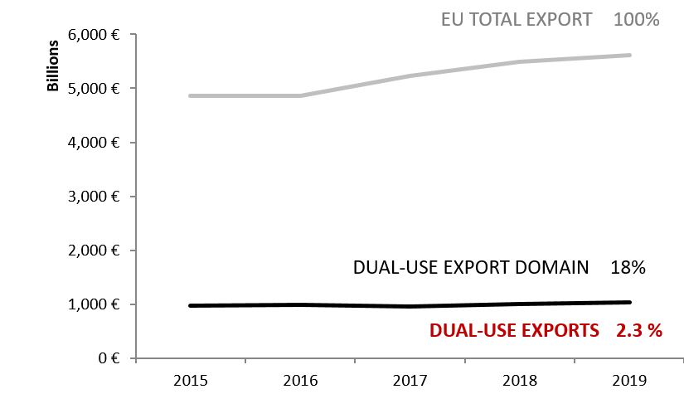

*Figure 2: Statistical estimates of dual-use intra and extra-EU exports.*

Statistical estimates also show the main export destinations and indicate that a large part of the dual-use exports are directed towards countries listed on Union General Export Authorisations (EUGEAs). The destination countries reflect the EU export market structure in the relevant commodities as well as trade facilitation under EUGEAs (Figure 3 and 4)[22].

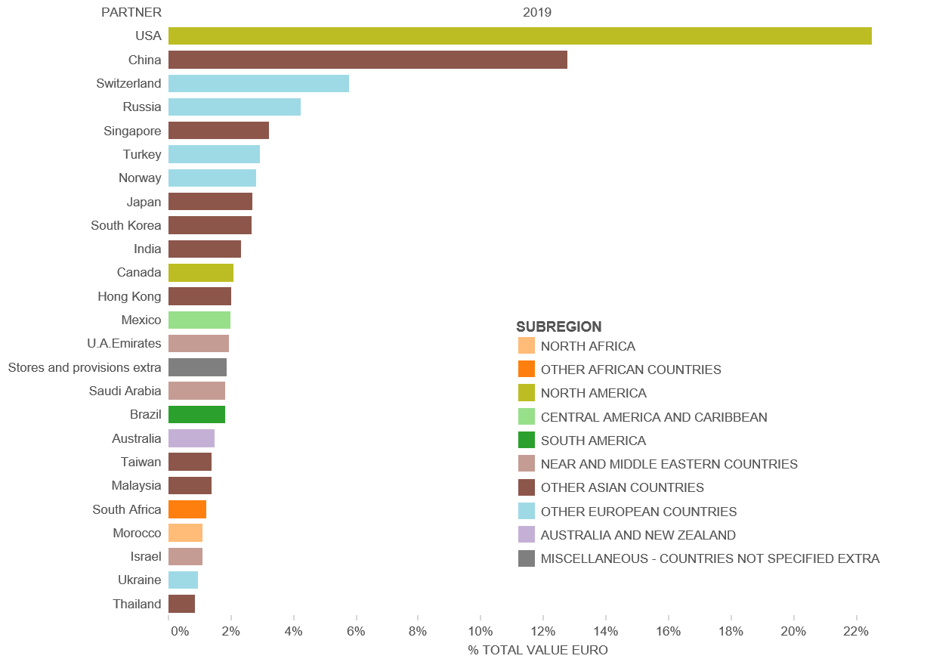

*Figure 3: EU dual-use export estimates: top 25 export destination countries and their sub-regions in 2019.*

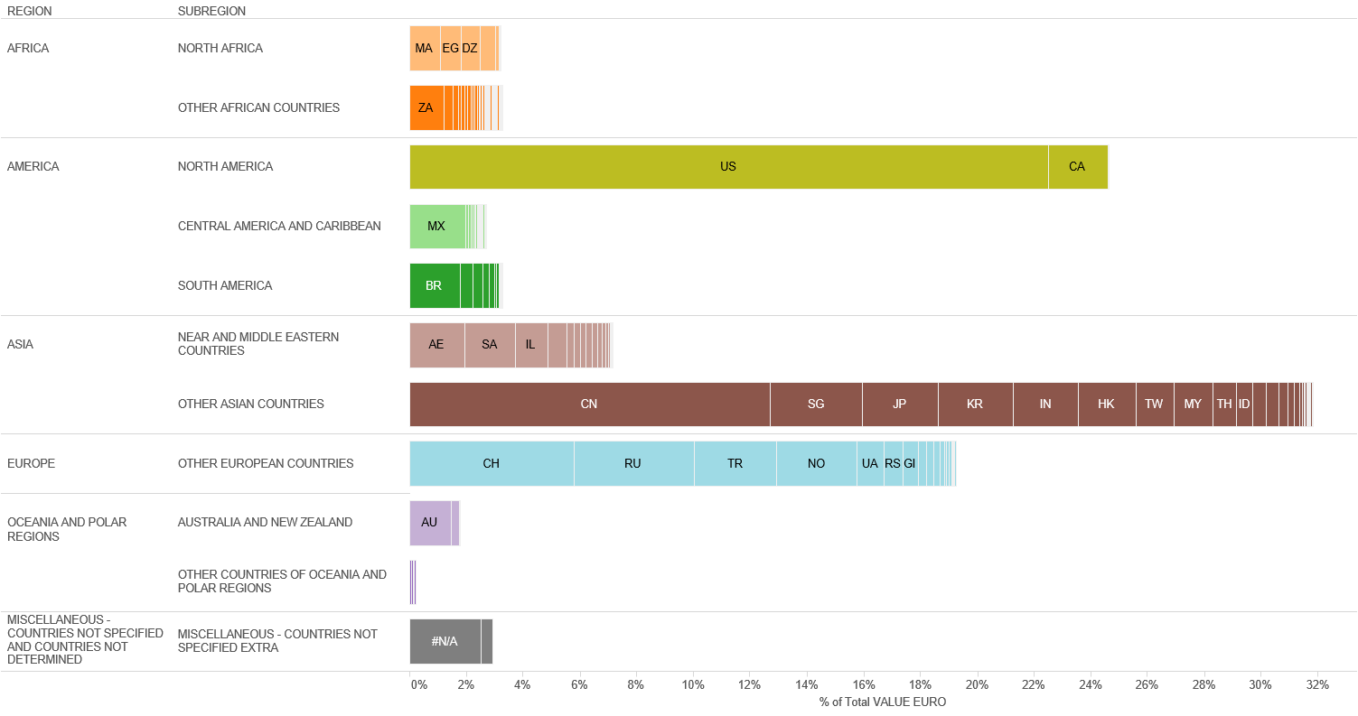

*Figure 4: EU dual-use export estimates: destination countries by regions and sub-regions in 2019.*

**4.2. EU dual-use licenses: applications, authorisations, denials**

In light of Article 19(2) of the Regulation, which stipulates that "*Member States shall take all appropriate measures to establish direct cooperation and exchange of information between competent authorities with a view to enhance the efficiency of the Community export control regime*", the DUCG has exchanged licensing data and information in order to improve the understanding of export controls and their economic effect. Some data collected for the reporting period is reported below; it should be noted, however, that not all Member States collect all data. The information provided below thus represents approximate estimates of aggregate quantities and values within the limits of the data made available by Member States.

The total value[23] of applications reached EUR 40 billion and controlled dual-use exports thus represented 2.2% of total extra-EU27 exports. Authorised dual-use trade amounted to EUR 31.5 billion, representing 1.7% of total extra-EU27 exports, with a majority of transactions authorised under individual licenses[24] (around 20,300 single licenses issued in 2019) and global licenses[25] (by their value). Only a small portion of exports were actually denied: 603 denials were issued in 2019, representing about 0.89% of the value of controlled dual-use exports in that year, and 0.02% of total extra-EU27 exports.

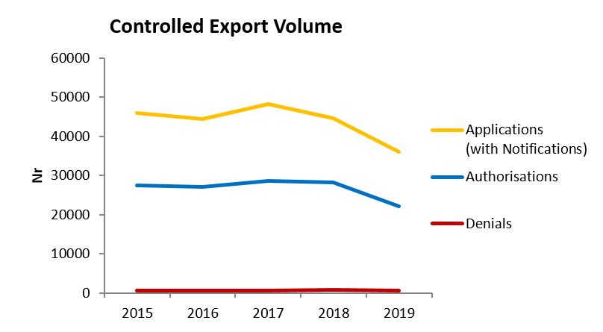

*Figure 5: Volume (number) of authorisations and denials in 2014-2019[26].*

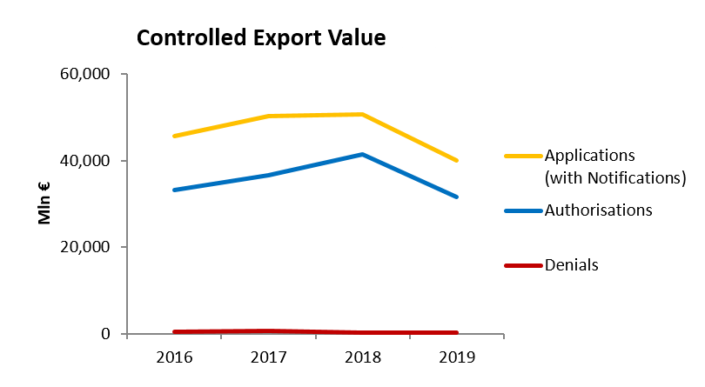

*Figure 6: Value (mln EUR) of authorisations and denials in 2014-2019.*

*Figure 7: Volume (number) of authorisations per type of licence in 2019.*

*Figure 8: Value (mln EUR) of authorisations per type in 2019.*

**5. Way Forward**

The new Regulation and the resulting system-upgrade brings about substantive changes to export control in the EU which is generating considerable preparatory work and actions to be taken by the Commission and Member States to make the most of the full potential that the new Regulation offers. These include:

* the new Regulation provides that *"the Commission, in close consultations with the Member States and stakeholders, should develop guidelines to support practical applications of controls",* and specifically calls for guidelines on transparency of licensing decisions and on exports of cyber-surveillance items;
* calls from industry regarding guidelines on e.g. technology transfers and cloud computing will also have to be addressed;
* in order to implement new information-sharing and transparency provisions that call for the development of information exchange between the Member States and the Commission, and for high-levels of transparency, including through the publication of an annual report including detailed information on licensing decisions, the Commission is, in particular, mandated to adopt guidelines for annual reporting. It is also developing IT tools to support the related data exchange;
* the new Regulation recognises enforcement as a key dimension of effective export control policies and calls in particular for the creation of an enforcement coordination mechanism;
* finally the Commission with the support of Member States will work on developing an EU capacity-building and training programme for Member States licensing and enforcement authorities and deepen dialogues with third countries to promote the global convergence of controls.

The Commission invites the European Parliament and the Council to take note of this report.

1. Regulation (EU) 2021/821 of the European Parliament and of the Council of 20 May 2021 setting up a Union regime for the control of exports, brokering, technical assistance, transit and transfer of dual-use items (recast) – (OJ L 206, 11.6.2021, p. 1) - <https://eur-lex.europa.eu/eli/reg/2021/821/oj>.
2. Some Member States’ competent authorities also publicly report on trade in dual-use items.
3. While the present report is published under the new Regulation, given it is covering 2020 the information collected refers to the situation under the previous Regulation.
4. This is also part of our "partnership with the private sector", which will be a key element of the modernisation of EU export controls.
5. Commission Delegated Regulation (EU) 2020/1749 of 7 October 2020 (OJ L 421, 14.12.2020, p. 1).
6. The Summary Note is available at: https://trade.ec.europa.eu/doclib/docs/2020/october/tradoc_158973.pdf.
7. https://ec.europa.eu/info/sites/default/files/file_import/dual-use-export-controls_en_0.pdf
8. https://trade.ec.europa.eu/doclib/docs/2021/january/tradoc_159247.pdf
9. OJ L 29, 31.1.2020, p. 7 (“Withdrawal Agreement”).
10. Article 5(4) of the NI Protocol and section 47 of annex 2 to that Protocol.
11. DUeS is a secure and encrypted electronic system hosted by the Commission, to support the enhanced exchange of information between competent authorities and the Commission as provided for by Article 19 of the Regulation.
12. <https://trade.ec.europa.eu/doclib/docs/2020/january/tradoc_158576.pdf>
13. https://trade.ec.europa.eu/doclib/docs/2020/october/tradoc_158962.pdf
14. The updated information notice was published on 17 January 2020, OJ Notice 2020/C16/4.
15. https://ec.europa.eu/info/publications/dual-use-export-control
16. Mobile telecommunications equipment, internet surveillance systems, intrusion software.
17. <https://trade.ec.europa.eu/consultations/index.cfm?consul_id=292>
18. <https://eur-lex.europa.eu/legal-content/EN/TXT/PDF/?uri=OJ:L:2021:338:FULL&from=EN>
19. <https://trade.ec.europa.eu/doclib/docs/2020/december/tradoc_159148.pdf>
20. <https://trade.ec.europa.eu/doclib/docs/2020/october/tradoc_158972.pdf>
21. The statistical methodology developed by the Commission's Joint Research Centre makes use of a correlation table, developed by DG TAXUD, between dual-use classification numbers and customs codes and of Eurostat’s COMEXT data, as well as of licensing data provided by EU27 Member States. The notion of *dual-use export domain* refers to a large mixed commodity area, which includes dual-use items. Trade in dual-use items takes place *within* this commodity area, but is not identical to it, since by far, not all of the commodities within the *dual-use export domain* are really dual-use.
22. "Stores and provisions extra" are defined as delivery of ships' and aircrafts' stores. ”Miscellaneous –countries not specified extra” includes countries and territories not specified within the framework of trade with third countries (i.e., these codes are usually used for goods delivered for offshore installations).
23. This figure includes value for licence applications and notifications under General Export Authorisations.
24. Individual licenses are licenses granted to one specific exporter for one end-user or consignee in a third country and covering one or more dual-use items.
25. Global licenses are licenses granted to one specific exporter in respect of a type or category of dual-use items which may be valid for exports to one or more specified end-users and/or in one or more specified third countries.
26. In Figures 5 and 6, "Applications" data include all applications for licenses, including notifications under general authorisations, thus providing an indication of "controlled exports", i.e. the value of extra-EU exports subject to an authorisation process. In cases where no application data is available, the charts make use of authorisation data as estimate for application data. "Authorisations" data refers to dual-use exports authorised under individual and global licences. It should be noted that applications do not necessarily correspond to the sum of authorisations and denials, as a number of applications may be cancelled and some applications may not be finalised within the same year. "Denial" refers to the volume and value of denied exports. Differences in data that indicate a decline in comparison to the previous years are due to Brexit and the fact that UK did not provide data for 2019.