

Contents

1. Acronyms and Abbreviations 2

2. EXECUTIVE SUMMARY 3

2.1. IT systems 4

2.2. Joint actions 5

2.3. Training and human competency 6

3. INTRODUCTION 8

3.1 Fiscalis 2020 in a nutshell 8

3.2 The Performance Measurement Framework 9

3.3 Mid-term evaluation of the programme 11

4. PROGRAMME YEAR 2020 – BASIC PARAMETERS (on budget and joint actions) 13

4.1 Budget 13

4.2 Participants in joint actions (excluding expert teams) 14

4.3 Joint actions (other than expert teams): proposals and actions 15

5. Progress in relation to the OPERATIONAL objectives 18

5.1 Cross-cut indicators of collaboration robustness between programme stakeholders 18

5.2 Objective 1: implement, improve, operate and support the European Information Systems for taxation 20

5.3 Objective 2: support administrative cooperation activities 29

5.4 Objective 3: reinforce skills and competences of taxation officials 36

5.5 Objective 4: enhance the understanding and implementation of Union law in the field of taxation 40

5.6 Objective 5: support the improvement of administrative procedures and the sharing of good administrative practices 42

# 1. Acronyms and Abbreviations

The following acronyms are used in this document:

|  |  |
| --- | --- |
| **Abbreviation** | **Meaning** |
| AEOI | Automatic Exchange of Information |
| AFF | Action Follow up Form |
| ART | Activity Reporting Tool |
| AWP | Annual Work Programme |
| CCN/CSI | Common Communications Network - Common Systems Interface |
| DAC | Directive on Administrative Cooperation |
| EAF | Event Assessment Form |
| eFCA | e-Forms Central Application |
| EIS | European Information Systems |
| EMCS | Excise Movement Control System |
| ET | Expert team |
| FPG | Fiscalis Project Group |
| F2020 | Fiscalis 2020 programme |
| JA | Joint Action |
| MANITC | Managed IT Collaboration |
| MFF | Multiannual Financial Framework |
| MLC | Multilateral Controls |
| MOSS | Mini-One-Stop-Shop |
| MSW | Member State Warning |
| N/A | Not available |
| PAOE | Presences in administrative offices / participation in administrative enquiries |
| PICS | Programmes Information and Collaboration Space |
| PMF | Performance Measurement Framework |
| SEED | System for Exchange of Excise Data |
| TEDB | Taxes in Europe Database |
| TIN | Taxation Identification Number |
| TSS | Taxation Statistical System |
| TOD | Turnover Data |
| VAT | Value Added Tax |
| ToW | TIN-on-the-Web |
| VIES | VAT Information Exchange System |
| VoW | VIES-on-the-Web |

# 2. EXECUTIVE SUMMARY

The Fiscalis 2020 programme aims to improve the functioning of the taxation systems in the internal market by enhancing cooperation between participating countries, their tax authorities and their officials. In this way, it aims to protect the financial and economic interests of the Union and its Member States including the fight against tax fraud, tax evasion and aggressive tax planning. The programme focuses to support tax policy and the implementation of Union law in the field of taxation, to foster tax cooperation to support administrative capacity building, including human competency and the development and operation of the European electronic systems. The vast majority of the programme funding is devoted to the implementation, improvement, operation and support of the European Information Systems followed by the organisation of joint actions (the cooperation and collaboration side) and the training activities.

2020 was the seventh and last year of activities under the Fiscalis 2020 programme[1]. Many of the activities carried out in 2020 served as analytical basis and early input to the policy proposals that the Commission presented in the field of taxation in 2020 and 2021, including the Action Plan for fair and simple taxation supporting the recovery strategy[2], the revision of the Energy Taxation Directive[3], the VAT e-commerce package[4], the Communication on business taxation for the 21st century[5] as well as the proposal for the Carbon Border Adjustment Mechanism[6], or allowed to prepare the necessary adaptations to the European electronic systems. In this way, it directly contributed to the Commission’s political priorities ‘An economy that works for the people’ and ‘European Green Deal’.

At the same time, Europe had to cope with the COVID-19 pandemic. Although, the Commission’s Directorate General for Taxation and Customs Union (DG TAXUD) reacted promptly and ensured the smooth transition from physical to online events, the unpredictability of the Covid-19 pandemic and of the consequent restrictive measures had a strong impact on the programme activities during the specific year.

In particular, the impact of the COVID-19 pandemic regarding the number of collaborative actions and events has been profound since March 2020. Even if many of the face-to-face meetings that were cancelled were replaced by on-line meetings, the total number of meetings decreased as several planned events were not automatically replaced by virtual meetings due to technical difficulties or uncertainty due to the confinement, particularly during the first period of the pandemic. However, it is worth noting that since September 2020, the number of (virtual) meetings has increased.

On a related note, while DG TAXUD ensured the smooth transition from the physical meetings to the online events, a period of adjustment was required from the participants’ side to the new on-line collaboration action, while for certain action types i.e. MLCs and working visits, only a limited interest was expressed to move specific activities in an on-line format. In this regard, it is worth mentioning that the new organisational structure of the collaborative activities in an on-line format impacted the network collaboration between tax officials, as the online events provided limited networking opportunities to the participants.

Additionally, throughout 2020, DG TAXUD worked intensely on the customs and taxation aspects of the withdrawal of the United Kingdom from the EU and the negotiations for a future relationship. The Withdrawal Agreement and the Protocol on Ireland and Northern Ireland attached to it[7] implied an impact assessment on all IT systems involved. Based on the findings, the artefacts of those systems have been adapted. This work covered preferential access, VAT, excise duties, and direct taxation IT systems.

However, the numbers of European Information Systems (and their availability) remained at high levels, testifying to a strong demand from business owners and national administrations for programme activities.

The key observations that can be deduced from the analysis of the Performance Measurement Framework indicators in 2020, supported by some of the conclusions of the mid-term evaluation of the programme[8], show that:

* A **strong demand** for programme support continued.
* The European Information Systems were **regularly operated** and resistant to **increased volume of data traffic**. The Commission continued to provide these services respecting the agreed service levels.
* The development of new European Information Systems and the improvement of existing ones pursued, thanks to the support of the programme. This was notably the case for the Excise Movement and Control System (EMCS) and the electronic Form Central Application (e-FCA) system. All the systems in production were **regularly maintained and updated** and the user support and training functioned properly.
* Major work was done to prepare the tax IT systems for the **withdrawal of the United Kingdom** from the EU and the implementation of the Protocol on Ireland and Northern Ireland. All IT systems involved have been adapted. Increased support from the programme, by means of **expert teams**, on different aspects of IT collaboration occurred.
* Very positive assessment of the **achieved results** of the joint actions, their **usefulness** and met **expectations** was confirmed by national tax officials who participated in them.
* Low level of long-lasting networking, as reported by the action managers in the Event Assessment Form.
* **Significant increase in the number of officials trained by using EU common training material** (255%) showed the great impact of the redeveloped and updated VAT programme for the administrations.

## 2.1. IT systems

In addition to the COVID-19 pandemic, several events had a significant impact on IT activities during 2020: “Brexit”[9] process and the delays in closing the negotiations for the post-2020 Fiscalis programme regulation led the Commission to adopt a cautious approach in the planning of the IT activities, focusing on maintenance rather than on developing new functions during the year. In budgetary terms, IT systems operation represented around 75% of programme spending.

The **European Information Systems** supported by the programme interconnect tax authorities and allow information to be exchanged rapidly and by secure electronic means. In addition, the European Information Systemsallow the use of a common format that can be recognized by all Member States and thus facilitate the coexistence of the different national taxation systems in the EU. At the end of 2020, there were a total of 28 European Information Systems and related applications in operation for taxation. During 2020, the programme continued to finance the operation of all these European Information Systems and it also supported the development of the EIS projects.

The functioning of these systems is enabled by a closed and secure **Common Communication Network - Common Systems Interface (CCN/CSI)** which since the launch of the programme has performed with high availability. The network registered over 8 373 million messages exchanged during 2020, compared to 6 902 million messages exchanged during 2019, which represents 21.3% growth of number of messages since the last year. In terms of traffic volume, the CCN network allowed the exchange of around 42 TB of Member States data during the period January 2020 to December 2020, compared to around 32 TB during 2019. This represents an increase of 31% of traffic volume. The high volume of information channelled via CCN/CSI and the other tax related IT systems (e.g. VAT Information Exchange System - VIES, Excise Movement Control System - EMCS) shows that the programme is a solid and robust enabler for the information exchange amongst tax authorities, moving towards a tax e-administration.

During the year, the programme continued to ensure the running and the maintenance of the existing EIS. An important element is related to e-Commerce, the implementation of which was supported by numerous activities under the programme. DG TAXUD, continued to ensure the daily update of the Mini One Stop Shop (MOSS) system which contributes to reducing the administrative burden on tax administrations and compliance costs for those taxpayers active in the telecommunications, broadcasting and electronic services and established within the Union, as it allows fulfilling their VAT obligations in a single place of compliance instead of in each country of the economic activity. Additionally, MOSS has been adapted according to the EU-UK Withdrawal Agreement and the implementation of the Protocol on Ireland and Northern Ireland. The **One Stop Shop (OSS)**, an extension of MOSS to all types of services, as well as to distance sales of goods, both intra-EU and from third territories or third countries to the EU, entered in conformance testing in preparation for the VAT e-Commerce Package and was launched in 2021.

The **Distributed Registry of IOSS VAT IDs (IOSS-DR)**, a high-performance/high-availability solution allowing national customs import systems to validate IOSS VAT IDs, entered in conformance testing in preparation for the VAT e-Commerce Package entering into force as of 1 July 2021.

With the **VAT Information Exchange System (VIES)**, tax administrations exchange monthly data of Intra-community supplies, while with **VIES-on-the-Web** economic operators no longer have to use the intermediary national administration to validate the VAT numbers of their trading partners, directly reducing the lead-time and the administrative burden and compliance costs for traders and national administrations. In 2020, a specific version 5.8 for VIES-on-the-Web was implemented and put in production at the end of the transition period to implement the EU-UK Withdrawal Agreement and Protocol on Ireland and Northern Ireland.

Moreover, conformance testing campaigns were launched and executed by Member States for VIES, VAT Refund and MOSS, while for the United Kingdom in respect of Northern Ireland the conformance campaign was launched for VIES and VAT Refund only.

The Excise Movement and Control System (EMCS) is a computerised system for monitoring and controlling in real-time the movement of excise goods (alcohol, tobacco and energy products) under excise duty suspension. It consists of EMCS Core business and EMCS Administrative cooperation and has a lifecycle in Phases. In particular, Phase 3.4 was successfully deployed in operations on February 2020. EMCS Converter was developed by DG TAXUD and provided to late runner Member States to ensure the business contingency of EMCS. Implementation of WA/NI Protocol took place during 2020, activities included coordination, specifications, development, Conformance Testing with MSAs and national and central deployment.

The electronic Form Central Application (e-FCA) is the key system for the administrative cooperation among Member States as it enables and fully supports the spontaneous exchange of information. In 2020, 20 new types of electronic forms have been implemented, along with a statistical module aimed to support Member States in producing yearly statistics on exchanges, and many enhancements and improvements of the application. Moreover, a Fiscalis Project Group was created leading to the requirements for the extension of the system in order to support e-commerce, call-off stock and implement the new implementing regulation on VAT e-forms, to be implemented in 2021.

In 2020, the Commission adopted a package for fair and simple taxation containing 25 taxation initiatives to make taxation fairer, simpler and more adapted to modern technologies. The Commission proposed to extend tax transparency requirements to online platforms (**DAC 7**)[10] and announced a further revision of the Directive on Administrative Cooperation to reflect the emergence of alternative means of payment and investment such as crypto-assets and e-money (**DAC 8**)[11]. During the course of the year, DG TAXUD also continued to evaluate the operational and governance aspects of the blockchain[12] technology. The end goal is to be able in the future to support new systems or new building blocks for existing systems using this technology. The work continued to create a Blockchain-based synchronisation solution for the IOSS-DR data.

## 2.2. Joint actions

In 2020, tax officials continued to exchange views and best practices in the field of taxation, mainly via the joint actions organised under the programme. As in the previous year, more than 97% of the responding participants in these joint actions assessed positively the usefulness of the activities from a professional point of view.

In the area of direct taxation, the programme funded different activities to support the **Automatic Exchange of Information (AEOI)** under Directive 2011/16/EU on administrative cooperation in the field of taxation (DAC and its subsequent revisions). The last of these revisions (DAC7) will introduce reporting by digital platform operators, but also strengthen administrative cooperation including by means of joint audits[13].

Accelerated exchange of information between VAT anti-fraud units continued to be supported via **Eurofisc,** a network for the swift exchange of targeted information between Member States to enhance multilateral administrative cooperation in combating organised VAT fraud and especially VAT carousel fraud. During 2020 there were 6 project groups relating to Eurofisc.

The programme also finances simultaneous controls (**Multilateral Controls** or MLC actions), coordinated controls of the tax liability of one or more related taxable persons, organised by two or more Member States with common or complementary interests. During 2020, the COVID-19 crisis had led to a considerable decrease of the number of multilateral controls (MLCs): only 44 multilateral controls were operational under the programme compared to 198 in 2019. In the same vein, a considerable drop is indicated regarding the **Presences in the Administrative Offices and Participation in Administrative Enquiries (PAOEs)**, with only 18 activities organised during 2020 (compared to 80 in 2019). PAOEs consist in one Member State requesting to be present in another Member States’ offices and/or during administrative enquiries carried out in the territory of the requested Member State. In addition to being present, Member States’ officials may interview individuals and examine records during administrative enquiries, under the condition that this is permitted under the legislation of the requested Member State.

During 2020, five **expert teams** were operational in the taxation area, however their outputs were affected by the COVID-19 pandemic context. 4 expert teams saw their initial timeline rescheduled and one recorded a change in the composition of the consortium. The **Managed IT Collaboration** expert team (MANITC IV) continued to promote, support and coordinate Member States’ collaborative initiatives in IT area. In addition, two expert teams continued to develop IT applications amongst Member States in parallel: the expert team for **Excise Duty Calculator** (EDC), and the expert team for **Mobile Application on Excise Movement and Control System** (m-EMCS). The **Transaction Network Analysis** expert team renewed its activities under the second phase (**TNA 2)** in order to group Member States’ resources to assist the Commission in the development of the Transaction Network Analysis software: this is a custom tool to facilitate information exchange and data analysis within the Eurofisc network, in order to enhance Eurofisc capability to use VIES and Eurofisc data to build links among known risky traders and detect fraudsters.

Moreover, in line with the Commission’s general objective of “An economy that works for people” and the specific objective to develop tax policy actions for a stronger, fairer and more efficient Single Market, at the end of 2020, a new group started to operate to leverage EU Member States’ expertise and resources to assist the Commission in the implementation and operation of the **Central Electronic System of Payment information[14]** (**CESOP**) and the relevant national components that are needed for the successful implementation of the specific legal package.

Finally, in accordance with the aforementioned objectives[15], DG TAXUD continued to support via the Fiscalis programme the network of the **Heads of Tax Administration Summit (TADEUS)**. TADEUS driven projects included setting up a new governance structure and strategy for Eurofisc and developing a Human Resources Management (HRM) maturity model. DG TAXUD also presented a new report with best practice recommendations on mutual tax recovery assistance between Member States[16].

## 2.3. Training and human competency

Fiscalis 2020 continued to support throughout 2020 a coherent implementation and application of tax policies (VAT competency/tax compliance building). This happened specifically through an update of the content of the **EU VAT eLearning programme** (composed of 12 VAT process-specific eLearning modules in 17 EU languages, a total of 204 modules) to make the courses Brexit compliant and a technical and content update of the EMCS courses, that makes this EU competency building training material fit for use by the national public and private sector across the EU for the years to come.

In 2018 an EU-wide survey on Human Capacity Building Maturity in national tax administrations was performed and resulted by end 2019 in the availability of the **first common EU TAX Competency Framework (TaxCompEU),** that provides national tax administrations with a common reference standard for optimal staff performance, based on identified common tax values, operational tax competencies, professional and management competencies and tax career paths. Implementation in national tax administrations’ HR structures was further accompanied and supported in 2020.

Overall, the involved stakeholders managed to implement the necessary adjustments and the COVID-19 pandemic did not significantly impact the EU training activities since the training was provided in e-Learning and e-Book formats while the CLEP events, which were organised in collaboration with experts from Member States, were replaced by webinar events.

# 3. INTRODUCTION

## 3.1 Fiscalis 2020 in a nutshell

Regulation 1286/2013 established the multiannual action programme Fiscalis 2020 for the period from 2014 to 2020 with the aim to improve the proper functioning of the taxation systems in the internal market by enhancing cooperation between participating countries, their tax authorities and their officials[17]. Total budget foreseen for this programme period is EUR 223.4 million. The programme represents a continuation of the earlier generations of programmes Fiscalis 2007[18] and Fiscalis 2013[19], which have significantly contributed to facilitating and enhancing cooperation between tax authorities within the Union.

Figure 1: Fiscalis 2020 programme objectives

|  |
| --- |
| **The Fiscalis 2020 specific objective:**   * The specific objective of the programme shall be to support the fight against tax fraud, tax evasion and aggressive tax planning and the implementation of Union law in the field of taxation by ensuring exchange of information, by supporting administrative cooperation and, where necessary and appropriate, by enhancing the administrative capacity of participating countries with a view to assisting in reducing the administrative burden on tax authorities and the compliance costs for taxpayers.   **The Fiscalis 2020 operational objectives:**   * to implement, improve, operate and support the European Information Systems for taxation; * to support the improvement of administrative procedures and the sharing of good administrative practices * to support administrative cooperation activities; * to reinforce the skills and competence of tax officials; * to enhance the understanding and implementation of Union law in the field of taxation; |

There are three types of activities that are organised and financed under the programme:

* **European Information Systems** **building** these IT systems and the IT capacity building are indispensable for the cooperation among taxation authorities. The programme covers the cost of acquisition, development, installation, maintenance and day-to-day operation of the Union components of European Information Systems.
* **Joint actions** **(JA)** bringing together officials from the participating countries; these are most commonly project groups, working visits, workshops and seminars. The programme covers the cost of organisation and participation in these activities.

Types of joint actions:

1. seminars and workshops;
2. project groups, generally composed of a limited number of countries, operational during a limited period of time to pursue a predefined objective with a precisely described outcome;
3. bilateral or multilateral controls and other activities provided for in Union law on administrative cooperation, organised by two or more participating countries, which include at least two Member States;
4. working visits organised by the participating countries or another country to enable officials to acquire or increase their expertise or knowledge in tax matters;
5. expert teams, namely structured forms of cooperation, with a non-permanent character, pooling expertise to perform tasks in specific domains, in particular in the European Information Systems, possibly with the support of online collaboration services, administrative assistance and infrastructure and equipment facilities;
6. public administration capacity-building and supporting actions;
7. studies;
8. communication projects;
9. any other activity in support of the overall, specific and operational objectives and priorities set out in Articles 5 and 6 of the Fiscalis 2020 regulation, provided that the necessity for such other activity is duly justified.

* **Human Capacity Building** - training materials and electronic learning modules play a vital part in developing the human competency component of the tax authorities in the EU. The programme covers the development cost of the common training materials, including electronic training modules.

The Commission and the participating countries (EU Member States and countries recognised as candidates or potential candidates for EU membership having concluded international agreements for their participation in the Fiscalis 2020 programme[20]) establish jointly the annual priorities of the programme by adopting each year the AWP. The implementation of the programme is under direct management by the Commission, meaning that it is centrally managed by DG TAXUD. It is implemented financially on the basis of grant agreements with the participating countries (joint actions), and procurements (mostly for European Information Systems, studies, and common training activities).

## 3.2 The Performance Measurement Framework

Article 16 of the Fiscalis 2020 regulation stipulates that the Commission shall monitor the implementation of the programme and actions under it on the basis of indicators and make the outcome of such monitoring public. The final evaluation of the Fiscalis 2013 programme[21] equally made the recommendation that "the Commission, in close cooperation with the Member States, should set up a results-based monitoring and evaluation (M&E) system for the Fiscalis programme".

In order to achieve this purpose, the Commission established in 2014 a Performance Measurement Framework (PMF) to be implemented with the start of the new programme. The PMF is based on the intervention logic (see Figure 2), which describes the logical step-by-step link between the wider problems and needs addressed by the programme and the programme's objectives, inputs, activities, outputs, results and impacts. The PMF relies both on the quantitative (indicators) and qualitative (reporting and interpretation) data for assessing the progress achieved.

**Figure 2: Intervention logic of the Fiscalis 2020 programme**

**Theory of change**(incl. EU added value)

F2020 finances supporting measures to ensure that the EU tax policy is applied in an effective, efficient, convergent and harmonised way, in particular by:

* Boosting the effectiveness of the work of participating countries’ national taxation administrations *(inter alia by facilitating exchange of information)*.
* Enhancing networks between tax officials across Member States through which information can be shared.

**Problems / needs**

1. Diverging application and implementation of EU tax law
2. Inadequate response to tax fraud, avoidance and evasion
3. Pressure on national tax administrations to exchange increasing quantities of data and information securely and rapidly
4. High administrative burden for tax payers and tax administrations
5. Slow technical progress in the public sector

**Inputs**

EUR 234 million to provide support in the form of:

* grants;
* public procurement contracts;
* reimbursement of costs incurred by external experts

Human resources (EC and national tax authorities)

**Activities**(grouped into projects)

**Joint actions**:

Seminars & workshops; project groups; working visits; bi/multilateral controls; expert teams; public administration capacity building and supporting actions; studies and communication projects.

Development, maintenance, operation and quality control of **IT systems**

Common **training** actions

**Outputs**

Joint actions:

* Recommendations / guidelines (including action plans / roadmaps)
* Best practices
* Analysis
* Networking & cooperation

IT systems:

* New (components of) IT systems at users’ disposal
* Continued operation of existing IT systems

Training:

* Common training content developed

**Results**

Collaboration between Member States, their administrations and officials in the field of taxation is enhanced.

The correct application of and compliance with Union law in the field of taxation is supported.

The European Information Systems for taxation effectively facilitate information management by being available.

Administrative procedures and good practices identified, developed and shared.

Skills and competences of tax officials reinforced.

Effective administrative cooperation.

**Impacts**

The functioning of the taxation systems in the internal market is improved.

Curbed tax fraud, tax evasion and aggressive tax planning.

Effective implemention of Union law in the field of taxation (by supporting administrative cooperation & exchange of information)

Reduced administrative burden on tax administrations and compliance costs for tax payers.

**Overall objective**

Improve the proper functioning of the taxation systems in the internal market by enhancing cooperation between participating countries, their tax authorities and their officials

The indicators can be divided into two categories:

**Output and result indicators** – these are first and second order effects that can be directly attributed to the programme. Outputs refer to those effects (most often tangible products) achieved immediately after implementing an activity, while the results look at the mid-term effects or the difference made on the ground thanks to the outputs. Both types of indicators are collected annually, reflected in the Progress Report and are linked to the operational objectives of the programme.

**Impact indicators** – they indicate the long-term effects of the programme by measuring its contribution to the broader policy areas, where programme activities are only one of the contributing factors. They mostly rely on the use of existing external indicators (not collected by PMF surveys) and are mainly assessed as part of the evaluations of the Fiscalis programme (mid-term and final evaluations), , as required by Article 18 of Regulation 1294/2013. They are linked to the higher-level specific objectives of the programme and the policies it supports.

The PMF uses both its own data collection tools and the data gathered externally. The external data is collected either by other organisations or inside DG TAXUD of the Commission. The PMF’s own data collection tools gather feedback from programme stakeholders and are summarised in the table below.

**Figure 3: PMF data collection tools**

|  |  |  |
| --- | --- | --- |
| **Tool** | **When is the data submitted?** | **Who is submitting the data?** |
| **Action Reporting Tool (ART) - Proposal form** | At the beginning of each activity | Action managers |
| **Action Follow up Form (AFF)** | In February, one form per action or one form each year for multi-annual actions | Action managers |
| **Action Follow up Form for working visits** | Participants to the working visit |
| **Event Assessment Form (EAF)** | 60 days after the end of an event or yearly in case of project groups or similar activities longer than 1 year | Participants to an event or members of a project group or similar activities |
| **Programme Poll** | Every 18 months – to be launched in:   * Mid-2015, * beginning 2017 * mid-2018 * end 2019 | The Programme Poll is addressed to all customs officials in the participating countries |

The PMF follows the annual reporting cycle. It takes into consideration a calendar year of activities initiated or organised under the programme. The drafting of the Annual Progress Report starts in the following year once the data collection process is finalised. Following data analysis and consultation with stakeholders, it is published during the following year. The Annual Progress Reports represent a summary of the main output and result indicators and gives an assessment of the overall progress achieved during the year.

The mid-term evaluation (in 2018) and the final evaluation (in 2021) of the programme make full use of the available Annual Progress Reports and report on the impacts of the programme’s intervention.

## 3.3 Mid-term evaluation of the programme

In accordance with Article 18 of the Fiscalis 2020 Regulation, DG TAXUD conducted a mid-term evaluation of the programme supported by an **external study**. The main objective of this evaluation has been to assess the programme's performance since the launch of the programme in 2014 until 2017, including strengths and weaknesses of activities; the continued relevance of problems and needs and the programme’s efficiency and value for money.

The study by the contractors was finalised at the end of 2018 and is available online, on the Publication Office of the EU[22]. This study supported the **Commission Report** on the mid-term evaluation of Fiscalis 2020 addressed to the European Parliament and the Council[23], which was adopted on 07 February 2019.

DG TAXUD, together with national taxation authorities, adopted in 2019 an **action plan** to address the recommendations. The implementation of the recommendations was regularly monitored. The final assessment of the follow-up of recommendations will be provided in the final evaluations of Customs and Fiscalis 2020 programmes.

Following one of the recommendations of the mid-term evaluation, DG TAXUD launched in 2019 an external study to review the PMF. The study aimed to reassess the current set of indicators, simplify them and fit the monitoring results better to decision-making needs. The study also addressed the European Court of Auditors recommendation to set appropriate reporting arrangements and indicators both on the overall level of implementation and on individual IT projects. The study was finalised in December 2020.

In parallel to this Progress report, the Commission is also performing the final evaluation of the Fiscalis programme, supported by an external study[24]. This final evaluation is expected to be published in the first quarter of 2022.

# 4. PROGRAMME YEAR 2020 – BASIC PARAMETERS (on budget and joint actions)

## 4.1 Budget

The overview in Figure 4 below summarises the programme funding according to the six main activity types. In order to make the table more meaningful, budgetary information from previous years has been added.

**Figure 4: Committed expenses per budgetary year and main action categories under the programme, in euros[25]**

|  |  |  |  |  |  |  |  |
| --- | --- | --- | --- | --- | --- | --- | --- |
|  | **2014** | **2015** | **2016** | **2017** | **2018** | **2019** | **2020** |
| **European Information Systems** | 2 053 874 | 24 691 254 | 23 244 421 | 24 824 594 | 22 375 306 | 24 768 693 | 25 020 819 |
| **Joint actions (other than expert teams and studies)** | 4 555 000 | 4 230 000 | 4 300 000 | 4 540 000 | 4 912 500 | 5 576 400 | 4 923950 |
| **Joint Actions - expert teams** | - | - | 988 040 | 519 915 | 899 585 | 330 000 | 1 165000 |
| **Training** | 908 585 | 600 003 | 1 205 600 | - | 1 352 000 | 1 374 000 | 1 483 000 |
| **Studies and communication** | 2 184 539 | 1 375 690 | 1 640 916 | 1 898 800 | 1 867 658 | 520 372 | 350 232 |
| **External experts** | 75 000 | 70 000 | 70 000 | 70 000 | 70 000 | - | 50 000 |
| **TOTAL[26]** | 30 776 999 | 30 966 94 | 31 448 978 | 31 853 309 | 31 477 049 | 32 569 465 | 32 993 000 |
| **AWP** | 30 777 000 | 31 025 000 | 31 449 000 | 31 809 000 | 32 043 000 | 32 570 000 | 32 993 000 |
| **EU Annual Budget** | 30 777 000 | 31 025 000 | 31 449 000 | 31 809 000 | 32 043 000 | 32 570 000 | 32 993 000 |
| **Amount MFF** | 30 777 000 | 31 025 000 | 31 449 000 | 31 809 000 | 32 043 000 | 32 570 000 | 32 993 000 |

In 2020, in light of the unpredictability of the COVID-19 pandemic, of Brexit and of the delays in the Multiannual Financial framework negotiations, a more cautious approach has been taken regarding the budget allocation and spending in order to ensure business continuity. More precisely, the vast majority of funding in 2020 went into the development and operation of European Information Systems (75.8 % of the budget and most of it was used for the maintenance of EIS), followed by the organisation of the joint actions (18.4%), and the training activities (4.5%).

The Commission undertakes IT capacity building activities through contracts following open public procurement procedures, in line with the Financial Regulation. The expenditure dedicated to IT systems has remained quite stable over the last years[27].

During the seven years of the programme, the committed expenses on joint actions (including expert teams and studies and communication activities) have increased year after year in line with the increase in the number of participants and actions. It is worth recalling that the expenses for joint actions are difficult to forecast in advance, given that actions and events are triggered by constantly evolving business needs.

The COVID-19 pandemic affected all grant activities due to the travel restrictions. During this period all activities turned virtually with the subsequent impact on the budget since no cost linked to travels where claimed. The Commission, in line with a sound financial management, decided to de-commit part of the grant allocations to beneficiaries that was the amount not yet paid by pre-financing payments.

Despite of the COVID-19 impact on grants, the later only represent approximately 17,6% of the Fiscalis programme. Moreover, not all eligible costs are linked to travels, which means that the impact on the programme is relatively low. The amounts dedicated to expert teams have been oscillating since 2016, when the first expert teams were launched. In 2020, there was an increase compared to 2019 as two new Expert teams were signed.

In 2020, the committed expenses for training activities have slightly increased compared to 2019.

On a related note, during the year the amount committed to finance the participation of external experts in the programme decreased compared to 2014-2018 period.

The programme also finances the conduct of studies, data collection and comparative analyses in taxation issues. Some of the initiatives finalised during the year were the following:

* In February 2020, the Commission published the evaluation of the taxation of tobacco in the EU[28] which assessed the performance of the directive against the evaluation criteria laid down in the Better regulation guidelines. The evaluation pointed out that while the current rules work well in terms of predictability and stability for Member State fiscal revenue in determining corruption a more comprehensive approach is needed.
* Also, in December 2020, the Performance Measurement Framework (PMF) Study for Fiscalis was finalised, representing a key contribution to elaborating the new PMF for the post-2020 programme. The study confirmed the conclusions of the mid- term evaluation on the current PMF by the criteria of its effectiveness, efficiency, coherence, relevance and alignment with the Better regulation Guideline’s principles. The study also identified areas of improvement such as the quality of indicators to meaningfully assess the performance of the programmes across the activities supported and the limited utility and visibility among stakeholders.
* Additionally, the final evaluation of Fiscalis 2020 was launched in the second half of 2020.

## 4.2 Participants in joint actions (excluding expert teams)

During 2020, the COVID-19 pandemic and restrictive measures had a strong impact on the joint actions and therefore to the number of participants taking part in the operational actions. Almost all face-to-face meetings were cancelled and many of them have been replaced by on-line meetings. The total number of meetings has decreased as several planned events have not been automatically replaced by virtual meetings due to technical difficulties or the uncertainty stemming from the confinement, in particular during the first period of the pandemic. However, it is worth noting that since September 2020, the number of (virtual) meetings has increased a lot. More precisely, the total number of actions for 2020 is 278 (53% less than in 2019), with 73 face-to face meetings and 205 virtual meetings during the specific year.

It is important to recall that the number of participants had been steadily increasing since the launch of the program. However, due to above mentioned circumstances during 2020, the total number of participants has decreased, reaching the number of 3591 (32.5% decrease comparing to 2019).

**Figure 5: Evolution in the number of participants[29] in joint actions under Fiscalis 2020**

It is also important to stress that the participation in programme activities is voluntary and was influenced by the global COVID-19 pandemic and Brexit in addition to the usual factors, such as the business need for organising activities, as well as the individual national administration's capacity and interest in participation over the course of 2020. Additionally, while DG TAXUD ensured the smooth transition from the physical meetings to the online events, a period of adjustment to new online- collaborative actions for the participants was required while for certain action types i.e. MLCs and working visits, only a limited interest was expressed to move these specific activities in an on-line format.

With regards to the distribution of participants by country, all the countries are making use of the programme, although some countries, considering the size of their administration, do more than others. This is in line with the voluntary nature of participation in the programme activities, where the number of participants from a given country depends partly on the level of interest and activity shown by the country’s administration in using the potential of the programme.

In absolute terms, the countries that had a higher number of participants during 2020 were Germany (242), Sweden (214) and Italy (207). However, in comparative terms to the previous year, the number of participants decreased for all countries, the most considerable decrease being in the participation of Germany (48%) and Sweden (34%).

**Figure 6: Overview of participants per country in 2020**

## 4.3 Joint actions (other than expert teams): proposals and actions

In 2020, the total number of **operational joint actions** was 138. This figure represents a decrease of 78.6% by comparison with 2019 (647 actions) with the project groups being the most popular action for 2020, followed by Multilateral Controls placed second and PAOEs as distant third.

This significant drop in the total number of operational joint actions comparing to 2019 is a result of the restrictive measures during the COVID-19 pandemic. Additionally, when analysing the evolution of the number of Joint Actions, it should be taken into consideration that in the last years many actions were to a greater extent organised in broader projects which are carried out multi-annually rather than annually. This may lead to less new initiatives and to a decrease in the total number of ongoing actions (and new proposals) for a specific year.

The situation with regard to the number of participants per activity type shows the project groups being the largest activity type in terms of participation, followed by workshops and Multilateral Controls. This is explained by the fact that there was a strong and continued interest expressed in on-line events for the project groups type of action following to the COVID-19 restrictive measures and that project groups are very often long-term / multiannual activities, under which several events are organised every year involving high number of participants.

In comparative terms, it can be pointed out that in 2020 the number of participants in project groups remains at the same level with a slight increase (from 2672 to 2678, i.e. 0.22% decrease). On the contrary, the number of participants in Multilateral Controls decreased significantly (from 1139 to 313, i.e.72.5 % decrease). Additionally, there was a decrease in the number of participants in PAOE (from 46 to 30, i.e. 34.7% decrease).

**Figure 7: overview of activity types and number of participants[30] per activity type**

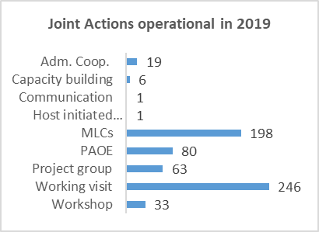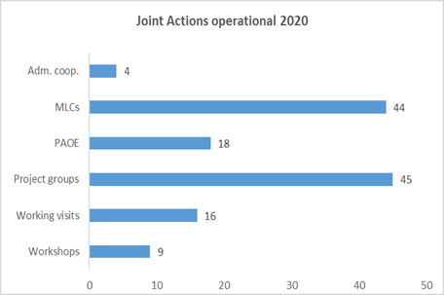

As regards the evolution of **new proposals** over time (Figure 8), the working visits should not be taken into account in order to get a comparative number[31]. As it is depicted from the figure below there an exceptionally high number of proposals in 2014, as it was the year of transition to the new programme and all proposals for ongoing activities had to be re-launched. The years from 2015 to 2019, reported a return to a standard number of proposals treated during a year. During 2020, 51 new proposals were approved, which represents a decrease of 15 proposals by comparison with the previous year. As previously explained, during the last year actions were to a greater extent organised in broader projects covering themes rather than specific interventions, which may led to a decrease in the number of proposals and activities.

Figure 8: Number of new proposals submitted during 2020 (without working visits)

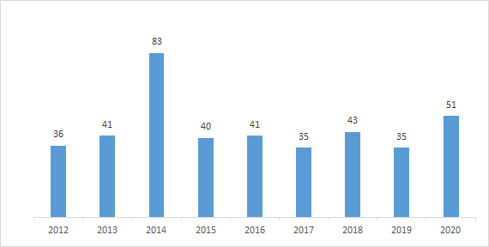

In 2020 the Commission maintained its lead in initiating proposals with 28 action proposals during 2020 (marked EU in Figure 9). However, it has to be added that while there is a single Commission proposal initiated in 2014 (covering the entire lifecycle of the programme) for MLCs and one covering PAOEs, the Member States initiated almost 30 multilateral control actions and 25 PAOE actions under them in 2020 (see related sections of the report)[32].

Figure 9: Overview of new proposals per initiating country in 2020 (including working visits)

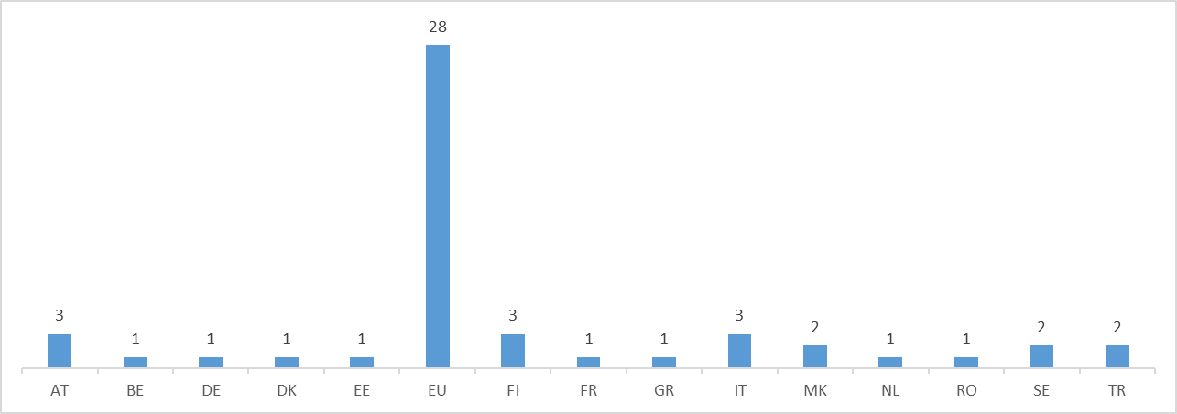

# 5. Progress in relation to the OPERATIONAL objectives

## 5.1 Cross-cut indicators of collaboration robustness between programme stakeholders

The first section of the Performance Measurement Framework contains a number of programme-wide indicators measuring awareness, networking, the use of outputs, and the achievement of results by the joint actions.

| **Indicator** | **Source** | **Baseline** | **Target** | **2014** | **2015** | **2016** | **2017** | **2018** | **2019** | **2020** |
| --- | --- | --- | --- | --- | --- | --- | --- | --- | --- | --- |
| Extent to which JA (that sought to enhance collaboration between participating countries, their administrations and officials in the field of taxation) have achieved their intended result(s), as reported by action managers: average score on the scale of 0 (not achieved) to 4 (fully achieved) | AFF (excl. Working Visits) | 2.65 (2014) | >3 | 2.65 | 3.25 | 3.11 | 3.11 | 3.67 | 3.19 | 3.62 |
| AFF Working Visits | 3.62 (2014) | >3 | 3.62 | 3.34 | 3.37 | 3.65 | 3.45 | 3.53 | 3.00 |

Firstly, in this section the achievement of results as reported by the action managers in the Action-Follow-up-Form. In the case of most project groups, the action managers are DG TAXUD policy experts, while for the working visits these are national tax officials. For the other types of actions, the actions managers are indistinctly coming from the Commission or national administrations. The level of achievement of results is evaluated against the anticipated results on a scale from 0 (not achieved) to 4 (fully achieved) at the end of the action. The level of achievement is impacted both by internal factors (if an activity lasts for several years, the results cannot be fully achieved immediately) and by external factors (such as political, business or technological developments). It is therefore advisable to set realistic targets for the achievement of results. In the case of most joint actions, such a target has been set at 3 or higher (3 corresponding to "results achieved to a large extent"). The obtained indicators for 2020 in comparison with the targets and the values in the preceding years, indicated that joint actions have been performing above target (3.62), with an increase of approx. half a point when compared with 2019 value. The feedback provided by action managers specifically for working visits (which follow an independent survey) has been very positive and well above targets during the overall reporting period 2014-2020 despite minor fluctuations, and is especially high for 2020 (3.00), indicating that the participants are broadly satisfied with the business value obtained.

| **Indicator** | **Source** | **Baseline**  **(2011 Poll)** | **Target** | **Mid 2015** | **End 2016** | **Mid 2018** | **End 2019** |
| --- | --- | --- | --- | --- | --- | --- | --- |
| Extent to which the target audience is aware of the programme | Prog. Poll | 66% | >75% | 54% | 59% | 48% | 45% |

**Raising awareness** about the programme and its potential among the target audience is an important precondition to fulfilling the programme’s objectives. The awareness is measured through the Programme Poll, which is distributed in all the tax administrations of the participating countries every 18 months. The Poll is distributed among both participants and non-participants to the programme’s activities, since its goal is to measure awareness among the whole of the target audience.

The last Programme Poll took place at the end of 2019, gathering replies from 3 948 officials working in 29 participating countries. We can observe that approximately 45% of all tax officials in Europe are aware of the Fiscalis 2020 programme, which represents a decrease of 3 percentage points compared to the previous poll results in 2018. The awareness in previous polls had also always been below the baseline (66%) and target (75%). In order to raise awareness, DG TAXUD defined in 2016 a new communication strategy for the Fiscalis 2020 programme, which included the use of new communication tools and channels, as well as a common effort between the EU and national programme teams in the distribution of information on the programme to the potential beneficiaries. However, there is an important potential for further raising awareness about the programme that should be explored at the level of national authorities.

In line with the annual action plan, several communication actions took place in 2020 at the initiative of the Commission:

* An online meeting for newcomers in the programme management community aiming to familiarise them with programme basics, in particular the new Fiscalis programme post 2020, and to integrate them into the network of national programme coordinators, supported by videos recorded by the CPMT.
* Publication of an updated Financial Guide for Joint Actions under the Fiscalis and Customs programmes.
* Three online network meetings for national programme coordinators, supported by surveys, with the objectives to discuss the role/function and position of the national programme coordinators, the implementation of the new Fiscalis programme, in particular the presentation of new concepts and financial information, and new ways of working.
* Three information sessions with national programme coordinators on the novelties of the post-2020 Fiscalis programme, on urgent operational issues, and on the next Multi Annual Work Programme draft.
* Several newsletters summarising the new programme highlights were published.
* In addition, a project was launched to investigate the replacement of PICS, the main knowledge sharing tool within the Customs and Fiscalis 2020 programmes, to improve the capabilities, performance and user-friendliness of the instrument, and to increase the awareness of all national officials and not only those participating in programme events.

| **Indicator: Degree of networking generated by programme activities** | **Source** | **Baseline**  **(2013)** | **Target** | **2014** | **2015** | **2016** | **2017** | **2018** | **2019** | **2020** |
| --- | --- | --- | --- | --- | --- | --- | --- | --- | --- | --- |
| Q1: **Did the activity provide you a good opportunity to expand your network of and contacts with officials abroad? (percentage agreeing)** | EAF[33] | 79.0% | >90.0% | 95.2% | 96.7% | 97.0% | 96.9% | 95.2% | 96.2% | 85.2% |
| **Q2: Have you been in contact for work purposes with the officials you met during this activity since the activity ended? (percentage agreeing)** | EAF | 75.0% | >80.0% | 68.0% | 72.8% | 69.0% | 74.8% | 62.2% | 69.6% | 56.8%[34] |

The collaboration between tax officials is a key sustainable success factor for implementing taxation policy in Europe. This networkingimproves the understanding and the implementation of the tax law in the area of fight against tax fraud, tax evasion and aggressive tax planning. It ensures the exchange of best practices and knowledge and creates the framework for joining efforts when IT solutions are developed.

The feedback from participants in joint actions collected under the Performance Measurement Framework shows that the collaboration robustness between programme participants overall remains at high levels. Regarding the **degree of networking generated by the programme**, the rates reached since the launch of the programme have been above target. Due to the COVID-19 pandemic and the consequent restrictive measures, the physical meetings were replaced by on-line events (in most cases but not systematically). In 2020, 85.2% of the responding participants declared that the programme provided a good opportunity for them to expand their network of (and contacts with) officials abroad: even if this still represents a good score, it is a considerable decrease from the rate reached in 2019 (95.2%) and it is most likely related to the replacement of physical meetings with on-line meetings due to COVID-19 pandemic. Additionally, in the same period, the number of respondents who declared that they have been in contact for work purposes with the officials they met during programme activities (**long-lasting networking**) averaged at around 70% from 2014 to 2016, rising to 74.8 % in 2017 and dropping to 62.2% in 2018. In 2020, the indicator dropped to 56.8% reaching the lowest level since 2014. This significant drop may indicate that the on-line events provided the participants with limited long-lasting networking opportunities. Additionally, this low level of long-lasting networking, which has always been below target, may be result of an unclear understanding of the different possibilities to “be in contact”, which more often includes collaborative tools beyond the traditional contacts (such as physical meetings or direct phone calls).

| **Indicator: Extent to which programme outputs (e.g. guidelines or training material) are shared within national administrations** | **Source** | **Baseline**  **(2014)** | **Target** | **2014** | **2015** | **2016** | **2017** | **2018** | **2019** | **2020** |
| --- | --- | --- | --- | --- | --- | --- | --- | --- | --- | --- |
| Q 1 (AFF): Were the outputs of the action shared in national administrations? (percentage agreeing) | AFF | 48.0% | >60.0% | 48.0% | 63.5% | 63.0% | 56.2% | 71.5% | 52,0% | 38.9% |
| Q 2 (EAF): Further to your participation in this activity, did you share with colleagues what you learned? (percentage agreeing) | EAF | 96.0% | >90% | 96.4% | 94.8% | 95.8% | 92.7% | 94.3% | 94.7% | 89.2% |

The levels of **sharing the programme outputs** (such as recommendations, guidelines, studies, etc.), as reported by action managers through the Action Follow-up Form, dropped in 2019 to 52.0%, and reached the lowest rate of 38.8% in 2020: this could have been most likely due to the restrictions imposed by the pandemic, but some improvement in sharing the outputs at national level should be considered. This decrease does not seem to affect the levels of sharing for the whole programming period that remained above the target levels as reported by the participants through the Event Assessment Forms: the knowledge acquired from joint actions was informally spread by participants among colleagues to a high extent (89.2%), slightly below the set target of 90.0% in 2020.

*N.B. Sections 5.2 to 5.6 below provide an analysis of the performance under the different operational objectives. It should be taken into account that, when referring to the number of joint actions, the figure includes the actions launched in previous years and continued their activities in 2020, together with the newly launched ones. When counting the number of actions that are operational in a year under a specific objective, it should also be taken into account that the indicator only counts the actions for which the objective in question was chosen as primary objective; this is done so to avoid counting twice the same action under different objectives.*

## 5.2 Objective 1: implement, improve, operate and support the European Information Systems for taxation

These European Information Systems (**EIS**) allow tax administrations to exchange information by electronic means. The great majority of the programme funding (approximately 75%) is spent on the development, acquisition, installation, maintenance and day-to-day operations of the Union components of these EIS.

The EIS supported by the programme interconnect tax authorities effectively and enable information to be exchanged rapidly and by secure electronic means, supporting cooperation amongst them. In addition, the EIS allows the use of a common format that can be recognised by all Member States and thus facilitate the coexistence of the different national taxation systems in the Union.

The information exchange is enabled by a closed and secure network, the **CCN/CSI** – one of the main outcomes of the programme. From 2014 to 2020, the CCN/CSI had high availability and the number of exchanged messages on the network has been rising over time.

This section provides information on the key performance indicators for EIS, together with detailed technical information on different IT aspects, such as continuity, deployment and development. Joint actions carried out to support the EIS are also covered (point VI).

Operational statistics of key EIS for taxation and its impact on enhancing administrative cooperation activities are analysed in section 5.3.

I – Overview of taxation IT systems in 2020

During 2020, DG TAXUD continued operating an important portfolio of IT systems (27 in total by the end of the year), supporting participating countries in their exchanges of information and also supporting legal and physical persons in their trade relations. However, and in light of the unpredictability of the Covid-19, of Brexit and of the delays in the Multiannual Financial Framework negotiations, a more cautious approach has been taken in order to ensure business continuity, focusing mainly on the maintenance of the IT systems than on the development of new ones.

In this context the 2020 key achievements in terms of system deployment and development have been:

a) Direct taxation systems:

* In the area of direct taxation, the programme funded different activities to support the automatic exchanges of information under the Council Directive 2011/16/EU on administrative cooperation in the field of taxation (DAC1) and its subsequent revisions[35].The last of these revisions (DAC7, transposition deadline 31 December 2022) provides, inter alia, for reporting income earned through digital platforms. During 2020, the DAC6 Central Directory (which provides for the reporting of potentially aggressive cross-border tax planning schemes) has been further improved to fulfil the GDPR requirements and enhance the system to system interactions with Member States IT systems.
* **TIN (Taxation Identification Number)-on-the-web**: the Brexit release was deployed in production in 2019 to respond to a potential withdrawal of the United Kingdom in a no-deal scenario (no withdrawal agreement).

b) Indirect taxation systems:

* The **VAT Information Exchange System (VIES)-on-the-Web** A specific version 5.8 for VIES-on-the-Web was implemented and put in production at the end of the transition period to implement the EU-UKWithdrawal Agreement and the Protocol on Ireland and Northern Ireland in 2020.
* The **Mini One Stop Shop (MOSS)** was updated in 2020 to comply with the EU-UK Withdrawal Agreement and the Protocol on Ireland and Northern Ireland.
* **One Stop Shop (OSS**), an extension of MOSS to all types of services as well as to distance sales of goods, both intra-EU and from third territories or third countries to the EU, entered in conformance testing in 2020 in preparation for the VAT e-Commerce Package entering into force as of 1 July 2021.
* Additionally, the **Distributed Registry of IOSS VAT IDs (IOSS-DR)**, a high-performance/high-availability solution allowing national customs import systems to validate IOSS VAT IDs, entered in conformance testing in 2020 in preparation for the VAT e-Commerce Package entering into force as of 1 July 2021.

c) Other:

* In 2020, DG TAXUD continued the exploration of **Blockchain** to evaluate the operational and governance aspects of this technology.

II - Key performance indicators for European Information Systems

|  |  |  |  |  |
| --- | --- | --- | --- | --- |
| **F2020 output indicators – New IT systems** | **2017** | **2018** | **2019[36]** | **2020** |
| Number of IT projects in the research phase (PP) | 14 | 15 | 1 | 2[37] |
| Number of IT projects in the development phase (P) | 8 | 4 | 1 | 4[38] |
| Number of new IT systems in operation (PROD) | 3 | 4 | 3 | 0 |
| Ratio of IT projects in status "green"[39] | 82% | 94% | 100% | 94% |
| **F2020 output indicators – Existing IT systems** | **2017** | **2018** | **2019** | **2020** |
| Number of European Information Systems in operation, as per Annex 1 of the Fiscalis 2020 Regulation | 25 | 27 | 27 | 28[40] |
| Number of modifications on IT systems in operation following:  a) business requests | Excise 23 Direct Taxes 104 VAT 57 Recovery 8 Other 205 | Excise 37 Direct Taxes 70 VAT 53 Recovery 10 Other 208 | Excise 29 Direct Taxes 98 VAT 173 Recovery 0 Other 618 | Excise 131 Direct 230  VAT 366  Recovery 0  Other 690 |
| b) corrections | Excise 199 Direct Taxes 264 VAT 170 Recovery 21 Other 312 | Excise 72 Direct Taxes 129 VAT 85 Recovery 17 Other 268 | Excise 50 Direct Taxes 134 VAT 120 Recovery 0 Other 397 | Excise: 65 Direct: 195 VAT: 364 Recovery: 0 Other 467 |
| Number of occurrences where the service desk is not joinable (Member States) | None | None | None | None |
| Percentage of service calls answered on time (Member States) | 99.45% | 97.33% | 95.91% | 94.7% |
| **F2020 result indicators – European Information Systems** | **2017** | **2018** | **2019** | **2020** |
| Availability of CCN (% of time) | 99.98% | 99.97% | 99.47% | 99.97% |
| Availability of VIES-on-the-Web (% of time) | 99.93%[41] | 99.99% | 99.98% | 99.95% |
| Availability of EMCS (% of time) | 99.61%. | 99.56%. | 99.62% | 99.63% |
| Volume of data exchanged on CCN (Customs and Taxation) | 22.89 Terabytes | 29.08 Terabytes | 32.23 Terabytes | 42.21 Terabytes |
| Number of messages on CCN Network (Customs and Taxation) | 4 348 million messages | 5 789 million messages | 6 902 million messages | 8 373 million messages |

II - IT Continuity

Ensuring the business and IT systems’ continuity is a major responsibility under the programme since disruptions in the operation of the European tax IT systems would affect national administrations, citizens and businesses across the entire EU, and hamper the functioning of the internal market. All the centralised IT systems, as well as their underlying infrastructure (CCN/CSI) – developed, managed and maintained by the Commission - were available from 2014 to 2020 more than 99% of the time meeting the expected targets.

In particular for 2020:

* the availability of CCN/CSI was 99.97%, which represents 0.50 percentage points more than in 2019 and above the target (99.90%).
* Systems critical for the functioning of the internal market, like the VAT Information Exchange System (VIES) and the VIES-on-the-WEB application were running without major interruptions, with a very high availability rate (99.95%).
* Another key system, the EMCS, had an availability of 99.63%, slightly above the rate of 2019.

III - Direct Taxation Systems

Main developments in 2020:

**DAC6 maintenance**: the IT framework for automatic exchanges of information was expanded to reportable cross border arrangements in 2020.

|  |
| --- |
| *Background DAC information:*  The Fiscalis programme has funded over the years different activities to support the mandatory AEOI under the Council Directive 2011/16/EU on Administrative Cooperation in the field of taxation (DAC1) and its subsequent revisions.  In December 2018 DG TAXUD published a report on “Overview and assessment of the statistics and information on the automatic exchanges in the field of direct taxation”[42], which confirmed that the automatic exchanges work well from the perspective of the common IT framework. All Member States have actively built and accommodated their IT systems that are linked to the common EU solutions, and all Member States have started secured automatic exchanges of the planned exchanges of information on:   * income from employment, pensions, directors fees, income and assets from immovable property and life insurance (commonly known as DAC1) * income and assets on financial accounts (DAC2), * advance tax rulings and advance pricing arrangements (DAC3) * country-by-country reporting of multinational enterprise groups (DAC4)   DAC6 provides for reporting of potentially aggressive cross-border tax planning schemes. For further details on the DAC6 see case study in section 6.2  DG TAXUD will continue to monitor the quality and timeliness of the data exchanges, and if possible, will provide support for the Member States in their efforts to enhance the use of the AEOI data received from other Member States. |

* **e-Forms Central Application (eFCA**): In 2020, 20 new types of electronic forms have been implemented, along with a statistical module aimed to support MSs in producing yearly statistics on exchanges, and many enhancements and improvements of the application.

|  |
| --- |
| *Background e-Forms information:*  The eFCA is a common application to support the exchange of information between Member States in taxation different domains in the context of the administrative cooperation. It is operational since 2014 and supports the exchange of information between Member States for VAT, recovery and direct taxation through a central portal. eFCA has led to significant improvements in maintenance and usability of the electronic forms. |

* **TIN-on-the-web (ToW**): Another version of ToW (v1.12.0) was deployed in Production on 30 January 2020.

|  |
| --- |
| *Background ToW information:*  Tax Identification Number on the web (ToW) is a system to provide a web-enabled interface allowing end-users to verify Taxes Identification Number (TIN) via the Internet for any Member States. It is operational since 2012. |

IV - Indirect Taxation Systems

Main developments in 2020:

* **VIES-on-the-Web:** Brexit releases followed the business decision on whether Brexit configuration should be enabled in production environment. In total, four VIES-on-the-web releases were delivered and tested with Brexit configuration. In 2020, a specific version 5.8 was deployed in production at the end of the transition period in order to implement EU-UK Withdrawal Agreement and the Protocol on Ireland and Northern Ireland.

|  |
| --- |
| *Background VIES information:*  **VIES (VAT Information Exchange System) on-the-web** is an electronic means of validating VAT-identification numbers of economic operators registered in the European Union for cross border transactions on goods or services. Thanks to VIES-on-the-web, economic operators no longer have to use the intermediary national administration to validate the VAT numbers of their trading partners, directly reducing the lead-time, the administrative burden and compliance costs for the traders and the national administrations. At the beginning of 2017, the number of VIES-on-the-web validations were more than 1260 million and this figure was further increased during 2018, up to 1 860 million messages (47.3% higher). In 2018, VIES on-the-web messages accounted for 63.46% of the total messages exchanged in the different VIES systems (Registry, Turnover Data and Member State Warning in addition to VIES on-the-web). |

* The development and the transition activities on the Member States administrations side for the **VIES Call-off stocks** scope, were initiated during 2019. The Functional Specifications were made available to Member States in March. The VIES Call-off stocks Conformance Testing Campaign started in September. 2019.
* **The migration of VAT** Refund domain into Conformance Testing Application took place on 4 April 2019, achieving one more milestone for the project. In 2020, conformance testing campaigns were launched for Member States and the United Kingdom in respect of the EU-UK Withdrawal Agreement and the Protocol on Ireland and Northern Ireland.
* The latest version of the **e-Forms Central Application (eFCA) VTA Domain** was deployed in production on 26 March 2019, five days earlier than the business milestone, which was set on 1 April 2019. National tax administrations officially start their operations on 10 April 2019 (including Norway), while the last administrations entered into eFCA VTA Domain production on 1 August 2019.
* **SEED (System of Exchange of Excise Data)**: two official Conformance Testing campaigns were launched for the Brexit no-deal scenario. In February, CA SEED stress tests were performed. Namely, EU27 Member State administrations were invited to perform two retrievals of the UK test data simultaneously from Central SEED Database in Conformance.

|  |
| --- |
| *Background EMCS/SEED information:*  The **EMCS** is a computerised system for monitoring the movement of excise goods under duty suspension within the EU. It records, in real-time, the movement between authorised consignors and consignees, of alcohol, tobacco, and energy products for which excise duties have still to be paid. More than 100 000 economic operators currently use the system, and it is a crucial tool for information exchange and cooperation between Member States.  **SEED (System of Exchange of Excise Data)** is a register of economic operators, part of which traders can consult online, to see whether a given excise number is valid and what categories of goods the operator in question is authorised to trade. It is a core component of the EMCS, as it allows Member States' administrations to validate authorisations of traders before giving them permission to move any excise goods under duty suspension. |

* The **Transaction Network Analysis (TNA)** Operational Team started using TNA in productions in May 2019, focusing on Data Process. The Beta release for the Member States’ users officially opened to users in October. Last version of TNA was deployed in production in December.

|  |
| --- |
| *Background TNA information:*  The **Transaction Network Analysis (TNA)** is a custom built software to facilitate information exchange and data analysis within Eurofisc network, whose core software was developed by the Commission.  This new electronic tool is expected to detect VAT fraud at an early stage: TNA is an automated data mining tool that interconnects Member States’ tax IT platforms; in this way, cross-border transaction information can be quickly and easily accessed, and suspicious VAT fraud can be reported nearly in real time.  Besides closer cooperation between the EU’s network of anti-fraud experts (“Eurofisc”), when analysing information on carousel VAT fraud, TNA also boosts cooperation and information exchange between national tax officials. Eurofisc officials can now cross-check information against criminal records, databases, and information held by Europol and OLAF.  The TNA was supported by the work of a Fiscalis expert team. See further details on the **TNA expert team** under section VI - Member States joint actions in the area of IT. |

V – Other IT systems

**Blockchain** is one of the potentially foundational technologies identified by the Commission to enable the Digital Single Market. After having started the Blockchain@TAXUD initiative in 2017, DG TAXUD evaluated further if this technology was suited for taxation (and customs) in collaboration with other Commission services.

At the beginning of 2020, the sharing of IOSS (Import One-Stop-Shop) numbers has been identified as a possible application of blockchain technology in a production system. Therefore DG TAXUD decided to assess the feasibility to deploy and operate such a system on the European Blockchain Services Infrastructure (EBSI). Over the course of 2020, DG TAXUD with other Commission services explored under which conditions the EBSI would be suitable as a platform to build this system. This analysis addresses: the validation of technical feasibility on the EBSI, through a Proof of Concept carried out in multiple iterations; the validation of organisational & operational feasibility on the EBSI and identification of constraints in terms of IT Service Management; the legal certainty and regulatory compliance (data protection, data retention and audit); the information security (business impact assessment & risk assessment for the recommended architecture following the Corporate ITSRM² methodology); and the cost elements and risks. The expected result of this initiative is a production-ready pilot project that allows national customs and taxation administrations to exchange information on the validity of IOSS VAT IDs over the EBSI platform.

VI - Member States joint actions in the area of IT

There was a slight increase in the number of joint actions organised during 2020 under the objective “Implement, improve, operate and support the European Information Systems for taxation”. This figure represents an increase of 9 % by comparison with 2019 (12 joint actions comparing to 11 in 2019). These joint actions were mostly project groups, and workshops. In addition, different trainings activities in the area of IT were organised (see Section 5.4 dedicated to the reinforced skills and competences of tax officials).

A number of **project groups** continued from previous years. These included the IT Collaboration Catalyst Group, the IT Technology and Infrastructure group, a project group on Blockchain technology and the IT systems trainings project group.

* The project group on **Implementation of VAT e-commerce package** continued its work on modernising VAT for cross-border B2C (business to consumer) e-Commerce with a view at simplifying the obligations for traders not established in the Member State of consumption. In particular, the project group focuses on the extension to all cross-border B2C transactions (goods and services) with big IT impacts: from the Mini One Stop Shop (MOSS) to the One Stop Shop (OSS). During the course of 2020, several Member States asked the Commission to postpone the data of entry into force of e-Commerce from 01/01/2021 to 01/07/2021. The reason invoked was that the COVID-19 crisis had a negative impact on their national implementation projects.
* The **Data Protection Compliance Network** project group (common to both Customs and Fiscalis programmes) continued its work on exchanging knowledge and experience between data protection experts in Member States and in the Commission and at identifying problem areas, discuss options and provide solutions for issues emerging during the data protection compliance activities.
* **Direct Taxation Data Analysis Tool on AEOI (FPG/107)** project group continued its work on building a data analysis tool to support efficient use of DAC data in order to ensure tax compliance in cross-border situations, and to reveal tax evasion or tax fraud.
* **Data Quality Community on AEOI** (FPG /108) project group continued its work on making the assessment of the quality of AEOI data by all countries on a common, comparable basis, which will be used to identify sources of low quality data. On such quantitative basis, corrective actions can be taken at national level. The expected business outcome on the medium-term is a global improvement of quality of AEOI data collected from domestic sources and thereafter being exchanged between national tax administrations, and hence a higher chance to detect fraudulent activities.

In addition, one **workshop** took place during 2020 in the EIS area bringing together 48 participants to discuss about the revision of the Excise Horizontal Directive leading to the requirements for the extension of the system in order to support e-commerce, call-off stock, and deliver the new implementing regulation on VAT e-forms, to be finalised in 2021.

**Expert teams** represent a recent tool from the Fiscalis 2020 programme toolbox supporting enhanced operational collaboration, either on a geographic or on a thematic basis. This tool allows willing Member States to bring their cooperation to a next dimension of European integration at the policy implementation level. The expert team approach allows taxation experts of Member States to have in depth cooperation on operational issues, which go beyond the traditional means of cooperation to realise the pre-identified objectives of a common long-term project.

The four existing expert teams MANITC 4, TNA, Mobile application for EMCS Controls (m-EMCS) and Excise Duty Calculator development EDC, continued with their work in 2020:

* **Managed IT Collaboration** **(MANITC 4)** expert team continued its activities in 2020. The team originally would run for 18 months, ending in March 2021, but due to the COVID effects, the period was extended with 8 months, until 30 November 2021.Other organizational changes did not apply for the group, however some negative effects occurred as the originally planned events/projects could not take place in 2020. The referred events as for example the workshop on Data Analytics was transposed to 2021.

The objective of this expert team for MANITC is to pool EU Member States resources to strategically and efficiently manage IT Collaboration initiatives in the field of taxation. In the context of **“IT Collaboration**” the overall objective is the joint implementation of IT systems, e.g. the development and knowledge sharing of IT software, IT solutions, IT components or other things that support an IT solution. The suggested structured approach to IT collaboration aims for maximum ownership of Member States. By supporting not only the activities of **FPG/037 IT Collaboration Catalyst Group** but also Member States actively involved in IT Collaborative projects, MANITC aims to increase the number of new IT Collaboration projects towards the common vision of making the approach the new standard way of doing IT in the taxation area.

Tangible achievements of the MANITC 4 in 2020 were the support for 6 ongoing projects (FPG/091, FPG092[43], FPG/102, FPG/106, FPG/107, FPG/108[44]) and creating 5 new actions under the Fiscalis programme: FPG/124, FPG/126, FPG/127, FPG/128 and FPG/129.One of the major event, the FWS/150 - Workshop on Data Analytics was postponed to 2021 and two other workshops had to be cancelled.

Participating countries: Romania, Ireland, Italy, Latvia, Portugal, Finland

Duration: 26 months.

* **TNA 2** expert team: the purpose of this second TNA expert team, covering the period from 2020 to 2022, is to continue the TNA development and to enlarge the competences of the new TNA Operational Team in supporting Eurofisc. TNA2 is a follow-up of the first TNA expert team and is expected to carry out studies and perform technical and development tasks that require specific business knowledge or access to Eurofisc operational data. An indicative example is the development of algorithms to be applied to Eurofisc operational data. In addition, the TNA2 will perform testing of TNA software with real or realistic data as well as other technical tasks like data management, system configuration, user management, usage supervision and user support. The overall objective is to study and implement an extension of TNA to other fraud types, covered by Eurofisc working fields (WF).

The expert team started its activities under the COVID period which naturally caused some delays from the beginning. The experts used to work in iterations during the meetings which was not possible after the lockdown in the EU. The Grant Agreement Coordinator signalled some concerns because of the absence of the tools in the action but finally the group could start its activities.

Participating countries: Belgium, Croatia, France, Hungary, Poland, the Netherlands

Duration: 24 months.

**Mobile application for EMCS Controls (m-EMCS)** expert team: its objective is to provide administration officers with a mobile solution allowing them to consult an electronic administrative document (e-AD) and, when applicable, generate a control report during a road control or any other control activity that occurs outside of their office. For example, during a road control, m-EMCS will allow officers to consult an e-AD, check its content against the goods on the truck and, if any irregularity is found, to report it immediately, using the same instrument that will be able to build a control report based on the e-AD, store it and disseminate it. The development of such solution required a focused and dedicated approach, which cannot be ensured by a Fiscalis project group, hence the need to set up an expert team. A group of Member States, as part of the expert team for MANITC II, prepared the expert team’s implementation plan and specifications. The duration of the expert team was extended to 36 months due to the delays caused by the effects of the pandemic occurred during 2020. The last minute changes of the Brexit caused an intense work for all the MSs, also for the ones that were taking part in this action, creating delays of the roll-out of the product. The start of the testing was interrupted by the lockdown and the planned workshop did not take place for involving the Member States. The Member States testing was postponed to 2021.

Participating countries: Belgium, Latvia, Portugal, Italy

Duration: 36 months.

* **Excise Duty Calculator (EDC)** expert team: the objective of this expert team is to provide traders and tax administration officers with a tool to automatically calculate excise duty for goods in movements under duty suspension in the EU. This will allow, for example, an operator to know the amount of tax for a specific excise product in another Member State by entering the minimal inputs and obtaining automatically the result without any need of manual calculation or documentation research.

The same effects of Brexit and the pandemic situation are applied to this action as for the m-EMCS, so the activities were re-shuffled and re-scheduled.

Participating countries: France, Italy, Belgium, Portugal

Duration: 36 months.

Finally, at the end of 2020, a new group started to operate to leverage EU Member States’ expertise and resources to assist the Commission in the implementation and operation of the **Central Electronic System of Payment information (CESOP)** and the relevant national components that are needed for the successful implementation of the specific legal package.

Overall, the stakeholders’ assessment of the IT related joint actions was very positive in 2020. There is a remarkable increase in the indicator measuring the level of achievement of results as reported by action managers: from 2.8 in 2019 to 4 in 2020 (maximum score).

Additionally, over 90% of participants consistently continued to consider that the events related to the IT systems were useful, met their expectations and achieved its objectives to ‘fully’ or to a ‘large extent’ well above target levels.

| **Indicator** | **Source** | **Baseline** | **Target** | **2014** | **2015** | **2016** | **2017** | **2018** | **2019** | **2020** |
| --- | --- | --- | --- | --- | --- | --- | --- | --- | --- | --- |
| Extent to which JAs (that sought to contribute to the availability, reliability and/or quality of (specific) Union components of EIS) have achieved their intended result(s), as reported by action managers: average score on the scale of 0 (not achieved) to 4 (fully achieved) | AFF  (excl. Working Visits) | 2.54  (2014) | >3.00 | 2.54 | 3.44 | 3.54 | 3.55 | 4.00 | 2.80 | 4.00 |
| Participants’ views on the extent to which a JA (that sought to contribute to the availability, reliability and/or quality of (specific) Union components of EIS) (has) achieved its intended result(s) (percentage of those who replied 'fully' or 'to large extent') | EAF | 91.2% (2014) | >80.0% | 91.2% | 97.5% | 94.8% | 97.1% | 97.7% | 95.8% | 94.5% |
| Participants’ views on the extent to which an event met their expectations (percentage of those who replied 'fully' or 'to large extent') | EAF | 92.6% (2014) | >80.0% | 92.6% | 95.9% | 92.8% | 96.4% | 93.5% | 95.1% | 91.5% |
| Participants’ views on the usefulness of an event (percentage of those who replied 'very useful' or 'useful') | EAF | 97.3% (2014) | >80.0% | 97.3% | 99.2% | 98.4% | 99.3% | 98.1% | 99.0% | 97.0% |

## 5.3 Objective 2: support administrative cooperation activities

Under this objective, the different activities that supported administrative cooperation between national tax authorities were scrutinised. Administrative cooperation is of vital importance as no single Member State can manage its internal taxation system without receiving information from other Member States. Administrative cooperation is facilitated by both joint actions and the use of the European Information Systems.

Joint actions linked to support administrative cooperation represented the biggest number of joint actions under the programme in 2020. Overall, there were in total 82 **joint actions** organised under this objective, 264 less than in 2019. The most numerous actions were Multilateral Controls (39), followed by PAOE (18), project groups (16) administrative cooperation activities (4) working visits (3) and workshops (2).

The assessment of action managers indicates that business owners are not very satisfied with the overall progress, with an average result of 2.64 (scale from 0 to 4) showing that the results are assessed as moderately achieved.

The specific Action Follow-up Form for working visits shows even a higher level of achievement of results (4, the maximum) regarding working visits organised in relation to support administrative cooperation activities. Participants' feedback on the 'achievement of results', 'usefulness' and 'met expectations' is asked in the Event Assessment Form (EAF). In the three areas covered, the participants have expressed high level of satisfaction, of achieved results and usefulness with values well above baselines and targets throughout the programming period 2014-2020 for which data is available.

| **Indicator** | **Source** | **Baseline** | **Target** | **2014** | **2015** | **2016** | **2017** | **2018** | **2019** | **2020** |
| --- | --- | --- | --- | --- | --- | --- | --- | --- | --- | --- |
| Extent to which JAs (that sought to enhance administrative cooperation) have achieved their intended result(s), as reported by action managers: average score on the scale of 0 (not achieved) to 4 (fully achieved) | AFF | 2.77 (2014) | > 3.00 | 2.77 | 3.18 | 3.06 | 3.05 | 3.71 | 3.18 | 2.64 |
| Participants’ views on the extent to which a JA (that sought to enhance administrative cooperation) (has) achieved its intended results (percentage of those who replied 'fully' or 'to large extent') | EAF | 87.6% (2014) | >80.0% | 87.6% | 93.1% | 93.4% | 96.1% | 96.6% | 92.1% | 93.6% |
| Participants’ views on the extent to which an event met their expectations (percentage of those who replied 'fully' or 'to large extent') | EAF | 86.2% (2014) | > 80% | 86.2% | 93.13% | 93.03% | 95.03% | 94.48% | 91.83% | 92.09% |
| Participants’ views on the usefulness of an event (percentage of those who replied 'very useful' or 'useful') | EAF | 95.3% (2014) | > 80% | 95.3% | 93.13% | 96.63% | 98.76% | 98.68% | 96.78% | 97.96% |

In 2020, MLCs continued to represent the highest number among different joint actions categories (39 out of 82). Multilateral control means a co-ordinated control of the tax liability of one or more related taxable persons, organised by two or more participating countries, which include at least one Member State and which have common or complementary interests. The Fiscalis 2020 programme supported MLCs by providing an organisational, methodological and financial framework for their implementation by having preparatory and follow-up meetings under the programme, which allow coordinating the actual audits that are carried out by national officials on their own territory. According to the results of the programme, MLCs are one of the most popular action types, with over 5 400 officials taking part in them in 2014-2020. Multilateral controls have consistently led to recovered revenue and increased compliance, which provides ample evidence that practical administrative cooperation not only takes place, but that it is also effective.

The second most numerous joint actions were the project groups. Amongst the project groups, 6 were dedicated to different aspects of Eurofisc, a network of national EU Member States’ analysts working in different areas of fraud risk. It was set up in 2010 to improve the capacity of Member States to combat organised VAT fraud, especially carousel fraud. Eurofisc allows Member States to exchange early warnings on businesses suspected of being involved in carousel fraud. More precisely, in 2020 the projects groups for each of the working fields of Eurofisc continued their work from the previous years on: missing trader intracommunity fraud; customs procedures and VAT fraud in intracommunity trade; VAT fraud observatory; TNA (Transaction Network Analysis) and Eurofisc governance.

| **Indicator[45]** | **Source** | **Baseline** | **Target** | **2014** | **2015** | **2016** | **2017** | **2018** | **2019** | **2020** |
| --- | --- | --- | --- | --- | --- | --- | --- | --- | --- | --- |
| Total number of MLCs operational | ART | 76 (2014) | Grow | 76 | 113 | 131 | 161 | 179 | 198 | 51 |
| Number of Member States participating in MLCs | ART | 23 (2014) | Grow | 23 | 27 | 28 | 27 | 28 | 27 | 27 |
| Number of Member States initiating MLCs | ART | 16 (2014) | Grow | 16 | 19 | 20 | 17 | 13 | 8 | 8 |
| Degree to which results were achieved, as assessed by the MLC coordinator | AFF | 2.78 (2014) | >3.00 | 2.78 | 3.08 | 2.70 | 2.71 | 3.42 | 2.40 | 3.5 |

In 2020, the number of Member States that initiated MLCs remained at the same level as in 2019. It is worthy to note that the number of Member States’ initiating MLCs has been declining since 2016, however it did not seem to have an impact on the overall number of operational MLCs with an exception in 2020 when a significant drop in the number of operational MLCs was registered due to COVID-19. On the contrary, the number of Member States that participated in the MLCs remained stable for the period 2014-2020.

| **Indicator** | **Source** | **Baseline** | **Target** | **2014** | **2015** | **2016** | **2017** | **2018** | **2019** | **2020** |
| --- | --- | --- | --- | --- | --- | --- | --- | --- | --- | --- |
| Number of presences in the offices and participation in administrative enquiries | ART | 49 (2015) | Grow or stable | 0 | 49 | 40 | 60 | 86 | 80 | 24 |

The Fiscalis 2020 programme introduced a new category of joint actions aimed at supporting administrative cooperation, the presences in the offices and participation in administrative enquiries (**PAOE**). In practice, this means that the tax inspectors from one Member State can be present in another Member State when colleagues from this other Member State carry out their duties in administrative offices or during administrative enquiries. This can be extremely useful, in particular where there are indications of irregularities or large-scale cross-border fraud in one or more Member States; in cases whose complexity makes the presence of officials desirable; or in cases for which the prescription period is due to expire and where the presence of officials can speed up the enquiry. There were 18 ongoing PAOE activities in 2020, which represents a significant decrease from the previous year (80 in 2019) and should be read in the context of general cancellation of any physical meetings for a significant part of the year due to the pandemic, with Finland (11 out 18) and Latvia (3 out of 18) launching most actions. Operative interventions in the form of multilateral controls and PAOEs are of great importance when pursuing international tax fraud, evasion and avoidance in an increasingly globalised world. The legal, methodological and practical framework, as well as the financial support from the programme, enable administrations to conduct cross-border investigations and controls, and build cases in cooperation with each other. There is a strong sense of these actions being based on a clear necessity for EU intervention (mainly, in order to provide the legal framework for exchanges) and a focus on operative solutions to problems, according to the conclusions of the study on the final evaluation of the Fiscalis 2020 programme.

Amongst the project groups, one was dedicated to the **Single platform** for the support and coordination of simultaneous controls, PAOEs and joints audits. It was set up in May 2019 and continued its work until September 2020. It consisted of 15 delegates from the Member States[46] and aimed at working on the implementation of a ‘Single platform’ for the promotion, implementation support and coordination of the Advanced International Administrative Cooperation (AIAC) instruments in order to avoid the proliferation of parallel platforms at EU level, with the objectives of streamlining the cross-cutting issues by ensuring efficiency, synergies and saving of resources.

Another important way of enhancing the administrative cooperation between tax authorities is through the **EMCS** - a computerised system for monitoring the movement of excise goods under duty suspension in the EU. It records, in real-time, the movement of alcohol, tobacco, and energy products for which excise duties have still to be paid.

At the level of usage performance, if we compare the operational statistics from 2019 and 2020 we can observe the following:

* Figure 10 (source: CS/MISE) shows the evolution in the number of EMCS Phase 3 Core Business Messages in 2020. In short, the following graph indicates that approximately 6.615.661 EMCS Core Business Messages were processed during 2020 (on average 271.104 per month) under control of the EMCS system. The number was decreased by 4.84% compared to 2019. The highest number of messages (645.403) was observed in October 2019.

**Figure 10: Evolution in the Number of EMCS Core Business Messages (2019 – 2020)**

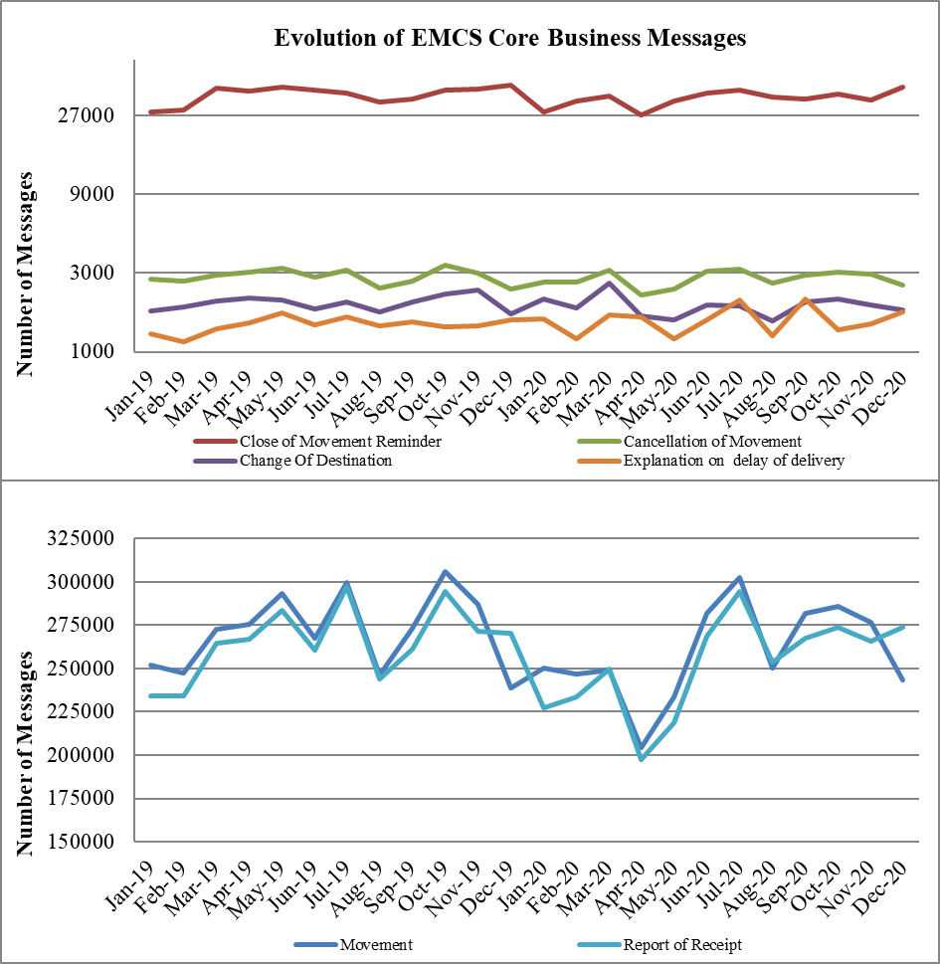

* Figure 11 (source: CS/MISE) shows the total average response time between the submission of movements and their corresponding Report of Receipts during the last twenty-four (24) months. The selection of the movements that are taken into consideration for the average response time is based on the submission time of the Report of Receipt. The total average response time during the last twenty-four (24) months is 8,33 days.

Figure 11: Total Average Response time (2019– 2020)

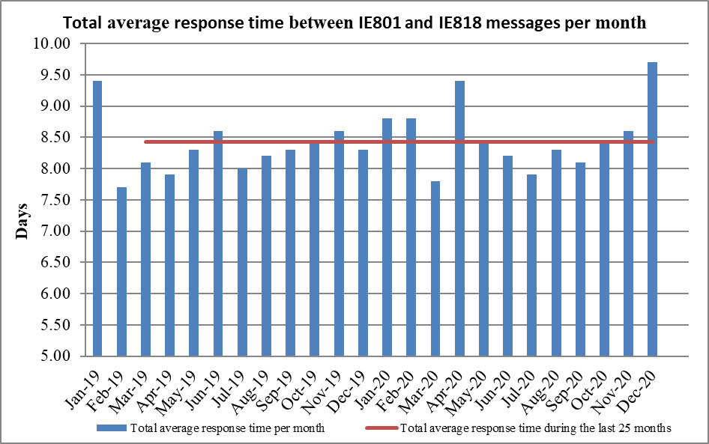

* Figure 12 shows the trend on the number of EMCS Follow-up and Collaboration Messages during 2019 and 2020. These requests are used to request information about movements and / or individual traders, as well as access to archived messages held in another Member State. The usage of the Administrative Cooperation Request messages was decreased by 15.02% compared to 2019 due to COVID-19 pandemic.

Figure 12: Evolution of EMCS Follow-up and Collaboration Messages – Administrative cooperation messages (2019 – 2020)

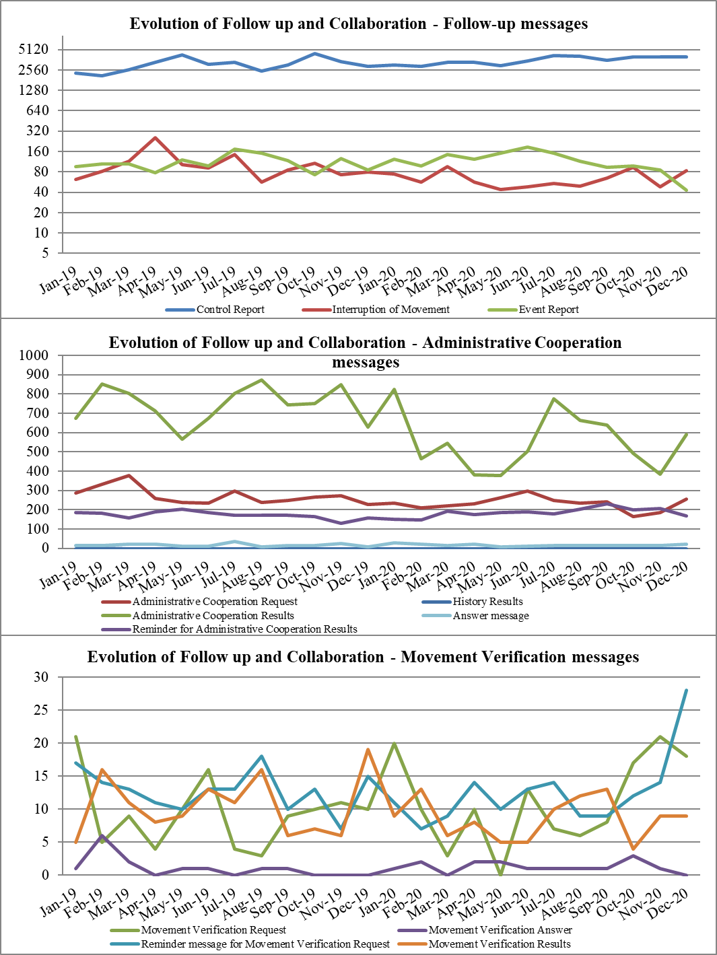

* In the area of **e-Forms exchanged** (number of messages exchanged by national tax authorities via the taxation mailboxes on CCN), the numbers of these messages for direct taxation in 2019 increased 44% by comparison with 2018. Figure 13a below provides further details regarding:
* MUTASSIST: mailbox used for the exchange of forms between Member States in the field of Direct Taxation under DAC.

DIRECT TAXATION: Exchange of information concerning the Savings Directive

Figure 13a: CCN/Mail3 – exchanges per quarter (Q1/2019 - Q4/2020) for direct taxation

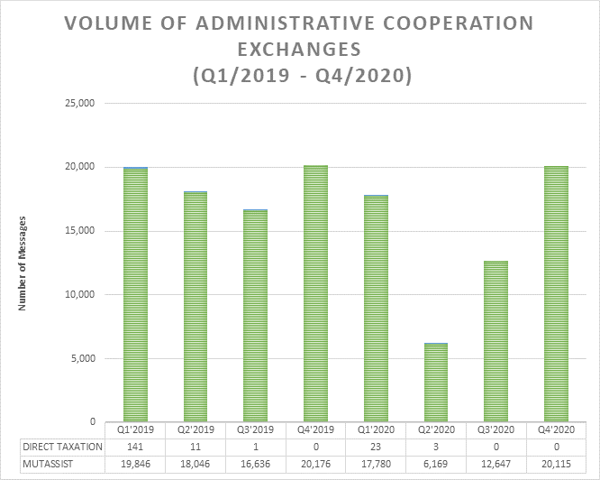

* Figure 13b below shows the usage pf CCN/Mail3 for indirect taxation, in particular regarding:
* CLO FOR VIES: Central Liaison Office for VAT Information Exchange System
* VAT ON e-SERVICES: Exchange of the information related to VAT on e-Services
* MLC: Exchange of information for VAT-related Multi-Lateral Controls
* MOSS: Exchange of information related to MOSS
* RECOVERY: Exchange of Recovery e-Forms and related information
* TAX AUTOMATIC: Automatic exchanges and Structured Automatic exchanges (Information on non-established traders, new means of transport, distance selling not subject to VAT)
* TAX FRAUD: Exchange of e-Forms related to specific cases of suspected fraud. Mailbox used by EUROFISC
* TAX SERVICE: Exchange of VAT Algorithms and other IT related information
* VAT REFUND: Exchange of information related to VAT Refund

Regarding the usage of CCN/Mail3, the number of messages exchanged via the Taxation mailboxes was decreased by 16,56 % (377.875 in 2020 compared to 452.868 messages in 2019). Recovery e-Forms messages account for 60,73 % of the total messages exchanged via the Taxation mailboxes during 2020.

According to figures showed in Figures 13a and 13b, it is observed that there is no specific trend or a recognizable pattern regarding the way that messages fluctuate over time.

**CCN/Mail3 – Exchanges per quarter (Q1/2019 – Q4/2020) for indirect taxation** *(source: CCN Portal)* below, it is observed that there is no specific trend or a recognisable pattern regarding the way that messages fluctuate over time:

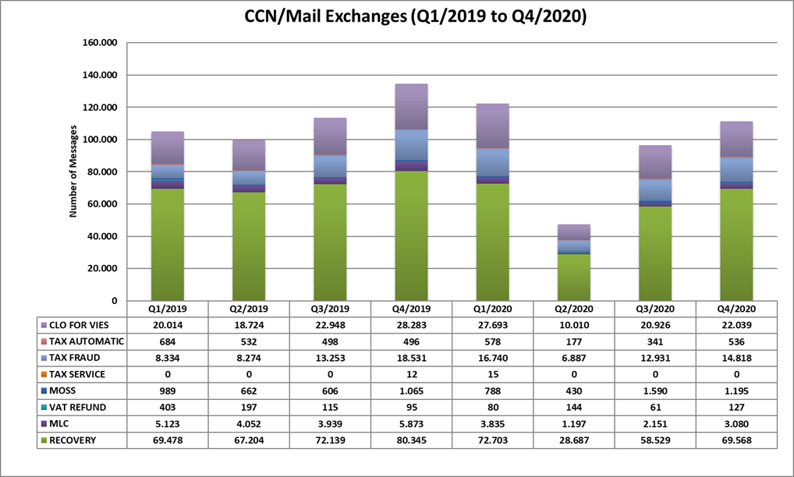

* When it comes to the **VAT Information Exchange Systems (VIES),** the table below shows an increase on the total number of various types of VIES messages, i.e. Registry, Turnover Data (TOD), and Member State Warning (MSW), by comparison with the previous year. The total number of VIES on the Web messages was around 2 446 million in 2020, meaning that an increase of 348 million messages representing 16.59% is observed compared to the 2.098 million messages in 2019.

Table on the evolution over the last two years of VIES Messages per quarter, in millions.

|  |  |  |  |  |  |  |  |  |
| --- | --- | --- | --- | --- | --- | --- | --- | --- |
| **Type of Messages** | **Q1'2019** | **Q2'2019** | **Q3'2019** | **Q4'2019** | **Q1'2020** | **Q2'2020** | **Q3'2020** | **Q4'2020** |
| **Registry Messages** | 158,3 | 220,3 | 142,8 | 152,1 | 192,9 | 179,9 | 207,8 | 226,2 |
| **TOD Messages** | 23,6 | 26,3 | 18,4 | 23,4 | 28,0 | 21,2 | 33,3 | 18,8 |
| **MSW Messages** | 120,2 | 88,5 | 70,2 | 133,9 | 113,4 | 161,8 | 127,7 | 122,9 |
| **VoW Messages[47]** | 439,2 | 452,9 | 533,2 | 673,2 | 573,6 | 669,0 | 705,9 | 497,6 |
| **Total Number** | **741,3** | **788,0** | **764,6** | **982,6** | **908,0** | **1.031,8** | **1.074,7** | **865,5** |

In the table, the types of messages relate to:

* Registry Messages: the trader VAT number is checked against the construction rule of the destination Member State
* TOD Messages: each Member State must collect on a monthly basis (or less frequently) the recapitulative statements issued by intra-community suppliers on its territory. The monthly recapitulative statement of a given supplier corresponds to the total value of his supplies to each of his purchasers in any other Member State, together with their intra-community VAT identification numbers
* MSW: after reception of an enquiry from a Member State Administration-A, the Member State Administration-B may reply with a Member State warning message notifying the Member State Administration-A that the enquiry cannot be satisfied. The message includes the type of the enquiry it replies to.

## 5.4 Objective 3: reinforce skills and competences of taxation officials

Under this objective, the indicators are measuring the use of the different types of training activities provided under the programme: the e-Learning courses and the IT trainings for European Information Systems. There are also other types of activities with a learning dimension organised under the programme, such as seminars, workshops and working visits. However, they are assessed in relation to their primary business objective and reported on in other chapters.

| **Indicator** | **Source** | **Baseline** | **Target** | **2014** | **2015** | **2016** | **2017** | **2018** | **2019** | **2020** |
| --- | --- | --- | --- | --- | --- | --- | --- | --- | --- | --- |
| Number of EU eLearning modules produced[48] | EC | 6 (2013) | Grow or stable | 6 | 6 | 18 | 36[49] | 192[50] | 210[51] | 45[52] |
| Number of EU eLearning modules used by participating countries (combined number of all modules used in each country) | EC | 60 (2014) | Grow | 60 | 62 | 170 | 123 | 165 | 182 | 146 |
| Number of tax officials trained by using EU common training material | EC | 4 862 (2013) | Grow or stable compared to baseline | 4 171 | 5 188 | 4 421 | 32 908 | 15 739 | 53 845 | 14 198 |
| Number of times publically available EU eLearning modules were downloaded from Europa.eu website | EC | 3 609 (2014) | Grow or stable compared to baseline | 4 332 | 3 416 | 18 456 | 8 592 | 6 772 | 7 344 | 26 144 |
| Average training quality score by tax officials | EC | 67.0 (2015) | >70.0 | 73.0 | 67.0 | 70.8 | 75.1 | 77.3 | 73.0 | 80.1 |

The Fiscalis 2020 programme finances the development of **eLearning courses** on topics of common interest in collaboration with tax administrations and representatives of trade. Such courses support the implementation of EU legislation and ensure the dissemination of good taxation practices throughout the European Union.

In 2020, in response to the COVID-19 pandemic, DG TAXUD with the support of Portugal, Sweden and Belgium provided the “Train the EU webinar trainer”, webinar aiming to train the national trainers on how to provide efficient webinar events and adapt to online methodology.

In addition, DG TAXUD an eLearning standards guide to Member States, a research of the state-of-the-art in digital learning, an authoring tool to create online training material was provided in order to ensure an effective online/digital learning. In 2020, due to the Covid-19 pandemic the eLearning courses which were organised in collaboration with experts from Member States has been replaced by on-line events.

In total, the number of officials trained has decreased compared with 2019, going back to the levels of the previous year. The VAT programme and other courses are already known for a few years in the national administrations and the number of countries who reported data has not been very high.

The training quality score of the EU Tax eLearning portfolio, is on average 80.1 points out of 100 (50-75 means “good” and 75-100 means “very good”) demonstrating a high appreciation from the learners. Given the life cycle of the courses and the quick development of technologies is difficult to keep an increase over the years, but during 2020 EU eLearning tax courses performed again extremely well with an increase in all areas. Both, national administrations and individual users have given high quality scores in the three main areas analysed: content, methodology and technology.

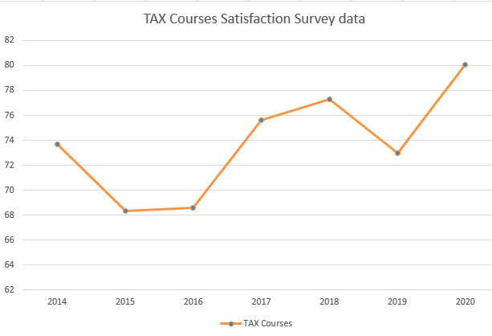

Traders and the public, who could download EU Tax eLearning courses freely from EUROPA website, downloaded EU Tax eLearning courses in total 26 144 times and reported 335 286 trainees on the EU tax courses. This represents a considerable number given that the EU VAT eLearning programme and other courses have been already in the portfolio for a few years. The Europa website team put in place a new “download portal” where it was possible to download several courses at the same time. This increased enormously the number of downloads, with most of the users downloading more than three eLearning courses at once. This facilitation measure for user has proved to be extremely useful and effective.

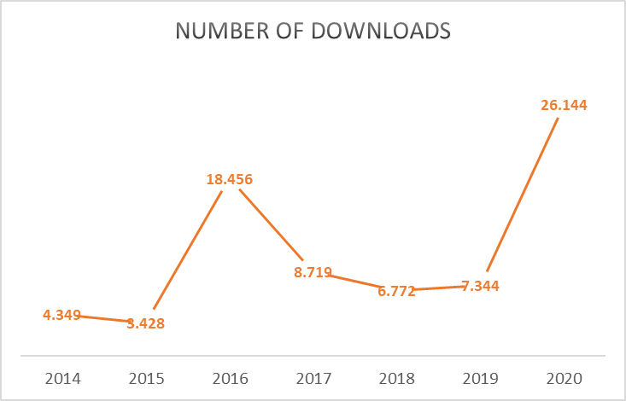

Overall, regarding the training activities, there is a positive trend throughout the period and the eLearning courses demonstrated an excellent way of reaching our target audience. Since 2018, the training activities remained at very high levels. The **content updates** during 2020 have been focused in giving the new courses a more immersive and better experience for the trainees thanks to the use of advanced scenarios and activities.

In 2020, in particular the EU VAT eLearning programme consisting of 12 eLearning modules (VAT Introduction, VAT Territory, VAT Taxable Person, VAT Transaction, VAT Place of Taxable Transactions, VAT Digital Services and MOSS, VAT Chargeable Event and Taxable Amount, VAT Rates, VAT Exemptions, VAT Right to Deduct, VAT Refund and VAT Obligations) was extensively used by economic operators. The EMCS courses were also highly appreciated by national administrations and economic operators. The EMCS programme was updated resulting in one Core module and 5 Business related modules. The effort and interest shown by national administrations for the localisation of the EMCS Programme has been appreciated by the users and administrations. In 2020 – and based on the findings provided through an EU-wide survey on Human Capacity Building Maturity in national tax administrations in 2019 – part 1 of the first common EU TAX Competency Framework (TaxCompEU) was further complemented by a Common Tax Training Curricula (part 2 of TaxCompEU) and the full package got translated into all EU languages and released for MS use by end November 2020 aiming to provide national tax administrations with a common reference standard for optimal staff performance, based on identified common tax values, operational tax competencies, professional and management competencies and tax career paths and further provide optimal tax training reference standards. The TaxCompEU’s further implementation in national tax administrations’ HR structures is expected to be implemented within the National Administrations

In 2020, only one CLEP (Common Learning Event Programme) event was offered in webinar format. The training webinar event was planned and delivered by Poland in April 2020: SAF-T in EU Member States. CLEP events were not planned in the area of taxation neither face to face nor online. It is challenging for MS to find common subjects in the area of taxation and to share knowledge, but more could be done to encourage knowledge sharing between taxation administrations. Webinars is the best tool for taxation since the training topics tend to be more theoretical. Specifically in the **area of IT**[53], during 2020 there were 5 training sessions organised by DG TAXUD for national tax officials on how to use various European tax and excise IT Systems, such as CCN CSI, CCN2, EMCS, recovery e-Forms Central Application and TNA. As it was the case for the other objectives, the Covid-19 pandemic and the restrictive measures impacted significantly the roll out of the trainings sessions for a significant period during 2020. In the same vein, the number of tax officials trained in IT trainings dropped from 301 in 2019 to 80 in 2020.

This number represents a significant decrease of 82% over the previous year, probably resulting from the restrictive measures adopted in the COVID-19 context. A considerable drop of (78%) applied to the number of participants respectively. However, the participants’ feedback remained very positive in terms of their usefulness and meeting the participants’ expectations, well above target.

| **Indicator** | **Source** | **Baseline** | **Target** | **2014** | **2015** | **2016** | **2017** | **2018** | **2019** | **2020** |
| --- | --- | --- | --- | --- | --- | --- | --- | --- | --- | --- |
| Number of IT training sessions organised for given systems / components (e.g. VAT refund, EMCS,VIES, MOSS) | ART | 12 (2014) | Grow or stable compared to baseline | 12 | 21 | 36 | 23 | 21 | 28 | 5 |
| Number of tax officials trained in IT trainings | ART | 106 (2014) | Grow or stable compared to baseline | 106 | 136 | 225 | 324 | 226 | 301 | 65 |
| Percentage of tax officials who found that the IT training met their expectations (percentage of those who replied 'fully' or 'to large extent') | EAF | 87.3% (2014) | >80.0% | 87.3% | 93.0% | 95.0% | 95.9% | 95.0% | 96.3% | 90.9% |
| Percentage of tax officials who found the IT training to be useful (percentage of those who replied 'very useful' or 'useful') | EAF | 95.8% (2014) | >80.0% | 95.8% | 98.0% | 98.0% | 97.5% | 96.6% | 97.6% | 93.9% |

## 5.5 Objective 4: enhance the understanding and implementation of Union law in the field of taxation

There were 7 **joint actions** operational under this objective in 2020, 36 less than 2019 well below the baseline (46). Out of the 7 joint actions, 4 were project groups and 3 were workshops. As was the case for the other operational objectives, the number of joint actions was considerably impacted by the Covid-19 pandemic and the consequent restrictive measures.

Four **project groups** were equally active during the year under this objective. One of them was launched in 2020, dealing with the audit of the one stop shop/ implementation of mandatory administrative enquiries. The remaining three already existing project groups on the provisions for small and medium producers of alcohol beverages, losses due to the nature of the goods and the European network of national promoters to support tax education for young people continued their activities during 2020.

Three **workshops** were organised during the year covering different areas. Two workshops were organised regarding **the transition to** **a greener economy** (one on Taxation in support of green transition: tax practices to reduce greenhouse gas emissions and one workshop on the Energy Taxation Indicators) in line with the Commission’s general objectives and DG's specific objectives of European Green Deal. Regarding VAT, the already existing workshop transaction-based VAT reporting as means of fraud proofing the definitive VAT system took place during 2020.

Union Law and Policy Application and Implementation Index

| **Indicator** | **Source** | **Baseline** | **Target** | **2014** | **2015** | **2016** | **2017** | **2018** | **2019** | **2020** |
| --- | --- | --- | --- | --- | --- | --- | --- | --- | --- | --- |
| Extent to which JAs (that sought to enhance the understanding and implementation of Union law in the field of taxation) have achieved their intended result(s), as reported by action managers: average score on the scale of 0 (not achieved) to 4 (fully achieved) | AFF | 2.66 (2014) | >3.00 | 2.66 | 2.87 | 3.75 | 3.75 | 3.00 | 3.20 | 3.5 |
| Participants’ views on the extent to which a JA (that sought to enhance the understanding and implementation of Union law in the field of taxation) (has) achieved its intended results (percentage of those who replied 'fully' or 'to large extent') | EAF | 93.5% (2014) | >80.0% | 93.5% | 91.6% | 85.4% | 85.5% | 89.0% | 96.6% | 92.8% |
| Participants’ views on the extent to which an event met their expectations (percentage of those who replied 'fully' or 'to large extent') | EAF | 94.5% (2014) | >80.0% | 94.5% | 92.7% | 86.6% | 84.7% | 88.0% | 94.9% | 88.1% |
| Participants’ views on the usefulness of an event (percentage of those who replied 'very useful' or 'useful') | EAF | 100.0% (2014) | >80.0% | 100.0% | 100.0% | 97.6% | 98.0% | 98.1% | 99.2% | 92.8% |
| Number of actions (JAs) that have supported or facilitated to enhance the understanding and implementation of Union law in the field of taxation | ART[54] | 46 (2014) | Grow or stable compared to baseline | 46 | 71 | 50 | 35 | 39 | 43 | 43 |
| Number of recommendations (R) / guidelines (G) / other outputs (O) issued further to a JA (under this objective) | AFF[55] | 2014:  0 (R)  0 (G)  15 (O) | On average at least one output per action | 0 (R)  0 (G)  15 (O) | 11 (R)  0 (G)  6 (O) | 0 (R)  1 (G)  5 (O) | 1 (R)  0 (G)  8 (O) | 0 (R)  0 (G)  6 (O) | 0 (R)  0 (G)  6 (O) | 8 (R)  1 (G)  4 (O) |

The Union Law and Policy Application and Implementation Indexprovides a comprehensive overview of the performance of the joint actions organised under this objective. The main indicator relates to the level of achievement of expected results, as they were identified prior to the activity and later evaluated by their action managers. The obtained value of 3.5 (on a range between 0 and 4) indicates that the action managers are satisfied with the progress obtained by the activities organised. This figure represents a slight improvement from 2019 and keeps the overall tendency initiated in 2016 by comparison with baseline and the first two years of the programme. The feedback provided by action managers supports this positive assessment.

Such a positive assessment is also confirmed by participants to joint actions, who have expressed high levels of satisfaction with the activities in terms of ‘meeting their expectations’ 88% (less than 6 percentage points than in 2019) and provided all the participants with the opportunity to actively participate. The number of officials participating to these activities who found them to be professionally 'useful' or 'very useful' has slightly decreased in 2020, together with the number of participants for which the intended results were achieved to a fully/large extent (92.8% well above the target).

The output indicators included in this group relate to the number of recommendations, guidelines and other types of outputs produced by the joint actions organised under this objective. It is worth clarifying that the recommendations and guidelines are counted here individually, rather than by the number of documents containing them. Under 'other outputs', there are studies, reports, measures, presentations and other reported types of outputs. There has been a significant fluctuation in this indicator between the three years, both positive and negative. Fluctuations in these indicators, however, need to be interpreted carefully, as not every recommendation or guideline is equally important. Furthermore, the number of outputs depends largely on the business need and the type of the subject matter addressed by the programme action. With these considerations in mind, it is difficult to set concrete targets for this indicator. For this reason, the initial target at the launch of the programme in 2014 was to have annual increase/stability in the score. A possible approach to a more concrete target could be to rather set a minimum target of at least one output per action in a given year. Such a target would demonstrate that on average all programme activities produce outputs. With 8 recommendations, 1 guideline and 4 outputs produced in 2020, we can see that the target has been achieved.

## 5.6 Objective 5: support the improvement of administrative procedures and the sharing of good administrative practices

The improvement of administrative procedures and the sharing of good administrative practices take place at several levels in the programme. It is mainly achieved through joint actions, the European Information Systems and the online collaboration platform PICS. The number of **joint actions** under this objective, with 61 joint actions operational in 2020, was below baseline (105 in 2014). On a similar note to the other operational objectives, as a result of the Covid-19 pandemic many actions were cancelled. Additionally, as was the case under other operational objectives, we should take into account that, while earlier years had more actions in total, and more actions specifically addressing concrete issues, in the last years many actions were to a greater extent organised in broader projects covering themes rather than specific interventions. Content-wise, the projects are usually multi-annual rather than annual, as the actions and processes they cover stretch over more than one year. This may lead to less new initiatives and in a decrease in the total number of actions for a specific year.

The vast majority of actions organised were working visits (11) followed by project groups (10), MLCs (5) and workshops (1).

During 2020, one workshop took place. This workshop dealt with the development of a sustainable framework for the use of behavioural insights in tax collection.

In addition, 10 project groups were active during 2020 under this objective, 4 of them were launched in 2020 and dealt with enabling building trust and ensuring compliance, IT Tool for elaborating DAC AEOI statistical data, addressing security concerns around cloud, Tax Administration Enterprise Risk Management collaboration and Taxation e-government reference architecture to advance IT collaboration in use of other ISA2 tools. The rest of them continued their activities from previous years, focusing on topics such as the VAT gap, compliance risk management in tax administrations, Data Governance Initiative, EU Tax HRM Readiness & Agility Model.

The project group dedicated to the **Strategic dialogue and cooperation among Heads of tax administrations of the EU (TADEUS)**, launched in 2018, continued its activities during 2020. TADEUS is a cooperation network for the EU Member States’ heads of tax administrations and the Commission. This form of cooperation at senior management level allows to better address common challenges faced by EU countries in today’s era of **globalisation** and **digitalisation**. TADEUS driven projects launched in 2019 included setting up a new governance structure and strategy for Eurofisc and developing Tax Gap methodologies on Personal Income Tax, Corporate Income Tax and specific VAT gaps on MTIC fraud and e-commerce. The Heads under TADEUS also expressed their strong support for further work on Compliance Risk Management under Fiscalis given its high strategic importance for tax administrations in the Union.

| **Indicator** | **Source** | **Baseline** | **Target** | **2014** | **2015** | **2016** | **2017** | **2018** | **2019** | **2020** |
| --- | --- | --- | --- | --- | --- | --- | --- | --- | --- | --- |
| Number of actions under the programme organised in this area | ART | 105 (2014) | Stable or grow comp. to baseline | 105 | 225 | 251 | 284 | 273 | 208 | 61 |
| Extent to which JAs (that sought to extend working practices and/or administrative procedures/guidelines in a given area to other participating countries) have achieved their result(s), as reported by action managers: average score on the scale of 0 (not achieved) to 4 (fully achieved) | AFF | 2.36 (2014) | > 3.00 | 2.36 | 3.58 | 3.16 | 3.15 | 3,30 | 3.55 | 3.33 |
| Participants’ views on the extent to which a JA (that sought to extend working practices and/or administrative procedures/guidelines in a given area to other participating countries) (has) achieved its intended result(s) (percentage of those who replied 'fully' or 'to large extent') | EAF | 95.3% (2014) | >80.0% | 95.3% | 96.1% | 90.1% | 94.2% | 98.0% | 94.7% | 87.9% |
| Participants’ views on the extent to which an event met their expectations (percentage of those who replied 'fully' or 'to large extent') | EAF | 93.2% (2014) | >80.0% | 93.2% | 94.7% | 92.3% | 93.5% | 92.2% | 92.8% | 86.7% |
| Participants’ views on the usefulness of an event (percentage of those who replied 'very useful' or 'useful') | EAF | 96.8% (2014) | >80.0% | 96.8% | 99.0% | 97.9% | 97.4% | 98.0% | 98.1% | 97.6% |
| Number of guidelines (G) and recommendations (R) issued by participating countries in their national administrations following programme activities (under this objective) | EAF | 2014:  63 (G)  134 (R) | On average at least one output per action | 63 (G)  134 (R) | 34 (G)  79 (R) | 36 (G)  69 (R) | 83 (G)  154 (R) | 31 (G)  88 (R) | 65 (G)  101 (R) | 24 (G)  31 (R) |
| Number of best practices / administrative procedures (AP) developed/shared | AFF[56] | 17 (2014) | 17 | 7 | 11 | 19 | 13 | 9 | 11 |

At the level of achievement of results of joint actions under this objective, the action managers have given a very high grade (3.33) from a range between 0 and 4. The feedback provided by action managers specifically for working visits (which follow an independent survey) supports this positive assessment, with a value of 3.83 on the achievement of results.

On the participants' side, we can see that their perception of the achievement of results (87.9% replied “fully” and “to a large extent”), the fulfilment of expectations (92.8%) and their perceived usefulness (86.7%) of the programme activities organised under this objective remained at high levels, with slight fluctuations when compared with the values of 2019.

The number of outputs (guidelines and recommendations) issued by participating countries in their national administrations during 2020 (55), represent a considerable decrease from 2019 (166). As previously explained, fluctuations in these indicators need to be interpreted carefully, as not every recommendation or guideline is equally important. Furthermore, the number of outputs depends largely on the business need and the subject addressed by the programme action. In the case of working practices / administrative procedures developed, the number continues to decrease after the peak reached in 2017.

| **Indicator** | **Source** | **Baseline** | **Target** | **2014** | **2015** | **2016** | **2017** | **2018** | **2019** | **2020** |
| --- | --- | --- | --- | --- | --- | --- | --- | --- | --- | --- |
| Percentage of participants that disseminated a working practice/administrative procedure/guideline developed/shared with the support of the programme in their national administration (under this objective) | EAF | 96.7% (2014) | >90.0% | 96.7% | 94.0% | 95.8% | 94.8% | 94.3% | 94.7% | 86.1% |
| Percentage of participants which declare that an administrative procedure/working practice/guideline developed/shared under the programme led to a change in their national administration’s working practices (under this objective) | EAF | 76.3% (2014) | >70.0% | 76.3% | 70.8% | 76.0% | 73.9% | 85.6% | 84.7% | 61.4% |

Besides the number of outputs, their dissemination and use in the national administrations were taken into consideration. The dissemination of programme outputs by the participants remained at high levels more than 86% of the participants declaring to have distributed programme outputs nationally. Additionally, the participants were asked whether these outputs have led to any change in the national administrations' working practices. In this regard more than 61.4% answered positively (a decrease from the result of 84.7 % in 2019), citing one or more of the following changes in the national administrations: increased knowledge of colleagues, improved working practices/administrative procedures and improved tools. However, there is an important potential for further improving the dissemination of these outputs that should be explored at national level, as well as to use such outputs for changing their national administration’s working practices.

| **Indicator** | **Source** | **Baseline** | **Target** | **2014** | **2015** | **2016** | **2017** | **2018** | **2019** | **2020** |
| --- | --- | --- | --- | --- | --- | --- | --- | --- | --- | --- |
| Number of face to face meetings (total for the programme) | ART | 443 (2013) | Grow or stable compared to baseline | 265 | 551 | 552 | 563 | 556 | 590 | 73 |
| Number of on-line collaboration groups (PICS) (total for the platform) | EC | 110  (2013) | Grow | 199 | 261 | 301 | 277 | 340 | 348 | 377 |
| Number of downloaded files from PICS (total for the platform) | EC | 13 564  (2013) | Grow or stable compared to baseline | 73 200 | 116 538 | 96 062 | 104 941 | 92 500 | 160 648 | n/a |
| Number of uploaded files on PICS (total for the platform) | EC | 3 445  (2013) | Grow or stable compared to baseline | 5 521 | 11 177 | 7 807 | 7 184 | 7 887 | 9 455 | n/a |

In the area of **online collaboration**, the use of the Programme Information and Collaboration Space (PICS) is measured. This platform is used by many DG TAXUD and national customs officials to facilitate the running of joint actions, but also for other, non-programme related collaboration needs and knowledge sharing in communities of practice. We can see that the total number of online collaboration groups on the platform increased in 2020 (377 groups on average during the year, 400 groups in total at the end of 2020). In relation to the number of new users that signed up to PICS, there is a clear trend since 2014, with an annual increase of approx. 1 000 new users. In terms of file sharing, both the number of downloaded and uploaded files increased considerable during 2019: 73.6% more of downloaded files and 19.8% more of uploaded files: due to a technical issue, the statistics on the number of downloaded/uploaded files on PICS during 2020 are not available.

In addition to online collaboration, due to COVID-19 pandemic and the consequent restrictive measures, almost all face-to face meetings in April 2020 were cancelled and many of them were replaced by on-line meetings. The total number of meetings dropped, when the physical meetings cancelled due to the pandemic were not immediately replaced by virtual ones, due to technical difficulties or uncertainty of the confinement. After the summer 2020, however, the number of virtual meetings increased.

1. In May 2021, the Fiscalis programme, the new EU cooperation programme in the field of taxation, has been adopted under the Multiannual financial framework 2021_2027 <https://eur-lex.europa.eu/legal-content/EN/TXT/PDF/?uri=uriserv%3AOJ.L_.2021.188.01.0001.01.ENG>
2. <https://ec.europa.eu/taxation_customs/system/files/2020-07/2020_tax_package_tax_action_plan_en.pdf>
3. COM/2021/563 final <https://eur-lex.europa.eu/legal-content/EN/TXT/PDF/?uri=CELEX:52021PC0563&from=en>
4. Commission Implementing Regulation (EU) 2021/965 <https://eur-lex.europa.eu/legal-content/EN/TXT/PDF/?uri=CELEX:32021R0965&from=EN>
5. COM(2021) 251 final <https://ec.europa.eu/taxation_customs/system/files/202105/communication_on_business_taxation_for_the_21st_century.pdf>
6. COM/2021/564 final <https://eur-lex.europa.eu/legal-content/en/TXT/?uri=CELEX:52021PC0564>
7. <https://eur-lex.europa.eu/legal-content/EN/TXT/?qid=1580206007232&uri=CELEX%3A12019W/TXT%2802%29>
8. COM(2019) 59 final <https://ec.europa.eu/taxation_customs/system/files/2019-04/mid-term_evaluation_swd_f2020.pdf>
9. The withdrawal of the United Kingdom from the European Union.
10. Council Directive (EU) 2021/514 of 22 March 2021 amending Directive 2011/16/EU on administrative cooperation in the field of taxation; OJ L 104, 25.3.2021, p. 1.
11. See the Inception Impact Assessment for DAC8 published on 23 November 2020: https://ec.europa.eu/info/law/better-regulation/have-your-say/initiatives/12632-Tax-fraud-&-evasion-strengthening-rules-on-administrative-cooperation-and-expanding-the-exchange-of-information_en
12. Blockchain is a method for data storage in sections in the form of blocks, which are linked to each other. It is essentially a digital ledger including digitally recorded data in different sections (blocks). Every block is related to the next block through a cryptographic signature
13. Include reference to adopted Directive
14. On February 2020, the Council has approved new measures to transmit and exchange payment data to fight e-commerce VAT fraud by launching a Central Electronic System of Payment information (CESOP). As of 2024, CESOP will keep records of cross-border payment information within the EU, as well as payments to third countries or territories, for a period of five years. This will allow tax authorities to properly control the correct fulfilment of VAT obligations on cross-border Business to Consumer (B2C) supplies of goods and services.
15. Annual Activity report 2020 DG Taxation and Customs Union
16. On 18.12.2020, the Commission presented a new report to the European Parliament and the Council on the use of Directive 2010/24 concerning mutual tax recovery assistance (COM(2020)813). This report was prepared with the help of Fiscalis Project Group 110 in which 13 Member States participated. <https://eur-lex.europa.eu/legal-content/EN/TXT/PDF/?uri=CELEX:52020DC0813&from=en>
17. <https://eur-lex.europa.eu/legal-content/EN/TXT/PDF/?uri=CELEX:32013R1286&from=EN>
18. OJ L 341, 17.12.2002, p. 1
19. OJ L 330, 15.12.2007, p.1
20. 34 participating countries: 28 Member States, Albania, Bosnia and Herzegovina, Republic of North Macedonia, Montenegro, Republic of Serbia, and Turkey.
21. https://ec.europa.eu/taxation_customs/sites/taxation/files/resources/documents/common/publications/studies/fiscalis2013_final_evaluation.pdf
22. <https://publications.europa.eu/en/publication-detail/-/publication/abf11482-33f8-11e9-8d04-01aa75ed71a1/language-en/format-PDF/source-search>
23. [COM/2019/579](https://ec.europa.eu/taxation_customs/sites/taxation/files/mid-term_evaluation_com_report_f2020.pdf)
24. Reference to be added when published
25. The table compares committed amounts since the launch of the programme, as the actual expenses are not finalised for all the previous years. Budgetary year X covers from 01/04/X to 31/03/X+1
26. It is to be noted that the total amount of appropriations may be higher when using foreseen financial contributions from candidate and potential candidate countries participating in the Fiscalis 2020 programme.
27. It should be noticed that the specific contracts are usually shared with the Customs 2020 programme.
28. https://ec.europa.eu/taxation_customs/system/files/2020-02/10-02-2020-tobacco-taxation-report.pdf
29. This is the number of total participants (which measures all instances of participation in activities and allows the same people to have taken part in multiple activities).
30. The graph on number of participants per action type does not cover participants not registered in ART.
31. This is because in the period before 2014 all the working visits were covered by a single proposal, while under the Fiscalis 2020 programme each business case for a working visit was treated as a separate proposal (thus increasing their number by a significant margin) up until 2020. Comparing the proposals in this way, outside working visits, we can see that their number was steady in the period 2011-2013.
32. Some of these were cancelled due to the Covid pandemic.
33. Data source changed from Programme Poll to EAF in order to improve data availability for years without poll.
34. The lasting networking measurement in this report for 2020 (56.8%) differs in 0.8 percentage points to the measurement on the 2020 Annual Activity Report of DG TAXUD (56%) and on the Programme Statement. This is due to the fact that the measurement for the Annual Activity Report is preliminary (it takes place in February, when data is still not complete; data collection ends in March).
35. Council Directive 2011/16/EU on Administrative Cooperation in the field of taxation (DAC1) and its subsequent revisions:

    The first automatic exchange of information took place in 2015 regarding non-financial items (e.g. income for employment) under the Council Directive 2011/16/EU on administrative cooperation in the field of taxation (DAC1). The first revision of the Directive (DAC2) provided for the automatic exchange of tax information on financial items on 2016 as of 2017; Fiscalis financed in 2014 and 2015 the definition of the technical and functional specifications. Taking into account the international context around this initiative (namely, the Foreign Account Tax Compliance Act - FATCA and the OECD CRS global standard), the developments registered under the programme in this area had a strong international resonance. The second revision of the directive (DAC3) provided for the automatic exchange of information on tax rulings and advance pricing arrangement as of 2017. The third revision (DAC4) provided for automatic exchanges of country-by-country reporting as of 2018, while the fourth revision (DAC5) provided for access to mechanisms, procedures, documents and information as regards beneficial ownership. The fifth revision (DAC6) introduced the first automatic exchange of cross-border arrangement as of 2020.
36. The figures reported for 2017 and 2018 in research phase included all projects not in development or production phase, i.e. including dormant ones such as Country profiles, Tobacco Track and trace, etc. The criteria was changed in 2019 and only those projects in PP were counted.
37. CESOP, Distance Selling
38. eCommerce, Effective Tax Rate, Amarant, EMCS Duty paid
39. Projects that are progressing in line with the requirements, time and budget limitations set-up.
40. As per the Fiscalis 2020 Regulation for 2019, explaining that 2 of the EIS were decommissioned (xxx and xxx), and 2 of the IT

    systems included in the Number of new IT systems in operations for 2018 were actually evolutions of xxx and xxxx, existing EIS.
41. For the month of January where the application suffered from a severe disruption of service, the availability was 99.58% or a total of about 3 hours of cumulative downtime over the month.
42. https://ec.europa.eu/taxation_customs/system/files/2018-12/report-automatic-exchanges-taxation-dac-844_en.pdf
43. FPG/091 - Exchange of Advanced Analytical Approaches for Tax Compliance and FPG/092 - Platform Architecture & Deployment Processes for advanced analytics have been prolonged from 2019
44. See more information on FPG/106, FPG/107, FPG/108 above in section VI - Member States joint actions in the area of IT
45. This indicator comprises MLCs organised under all operational objectives of the programme.
46. AT, BG, CZ, DK, FI, FR, DE, HU, IE, IT, LV, NL, PL, ES, and SE.
47. This number is not the actual traffic Member State Administrations are experiencing, since the number from blocked IP addresses is also included. The number is generated from TSS in consolidated mode and no distinction is possible at the moment.
48. This indicator counts the modules as English (master version) and further localised versions in EU languages as requested by participating countries, as the resources needed to develop each localised version request approx. 60% of the resources spend for the original English version.
49. The indication of '36 eLearning developments' in 2017 relates to re-development and updating of the EU VAT FRAUD course (in 12 languages) and the production of further national language versions of the EU VAT EU eLearning programme.
50. The indication of 192 eLearning modules produced in 2018 relates to the technical migration of the complete VAT eLearning Programme (12 modules) and the migration as well of the languages versions of each modules (available in 16 languages).
51. The indication of 210 eLearning modules produced in 2019 relates to the Brexit compliant update of the complete VAT eLearning Programme (12 modules) and the languages versions of each module (available in 17 languages) and the content and technical update of 2 EMCS modules (EMCS Core module and 5 modules of EMCS Business Programme).
52. The indication of 45 eLearning modules produced in 2020 relates to the update of EMCS modules in different languages except English (10 languages versions of EMCS Core module and 5 modules in 7 languages of EMCS Business Programme)
53. Training sessions in the area of IT are organised in the form of Project Groups.
54. Excluding working visits and expert teams.
55. Excluding working visits and expert teams.
56. Excluding working visits and expert teams