

# INTRODUCING the EUROPEAN HEALTH DATA SPACE:

Digitalisation is essential for the future of healthcare. The digital transformation is crucial to provide better healthcare to citizens, to build stronger and more resilient health systems, to support long-term competitiveness and innovation in the EU’s medical industry, and to help the EU recover from the pandemic.

Data is an indispensable part of today’s world. When used responsibly and in full respect of fundamental rights, it can bring incredible benefits to every aspect of our everyday lives, including our health. Member States’ health systems already generate, process and store a vast amount of data. Yet it often remains difficult for citizens to access their health data electronically and for researchers to use it to improve diagnosis and treatments.

Today, a vast amount of health data is generated every second, providing healthcare services and researchers with potential valuable insights. Health data reuse is estimated to be worth around EUR 25-30 billion annually. That figure is expected to reach around EUR 50 billion within 10 years[1]. However, the complexity and divergence of rules, structures and processes within and across Member States makes it difficult to easily access and share health data. This creates barriers to healthcare delivery and innovation, leaving patients unable to benefit from its potential. Moreover, health systems are becoming the target of cyberattacks. Therefore, the healthcare sector and relevant cyber security authorities need to consider cybersecurity as a key factor for ensuring the resilience and availability of key healthcare services[2].

In essence, today’s EU health sector is rich in data, but poor in making it work for people and science. The EU needs to tap into this huge potential to turn the wealth of health data across Europe into knowledge at the service of citizens, and to better prevent, diagnose and treat diseases. Health data can help achieve more efficient, higher-quality, safer and more personalised care, and help improve healthcare delivery. Health data[3] and data science could dramatically transform public health and revolutionise healthcare systems, enabling life-saving healthcare improvements. Health data can also play a crucial role in speeding up the development of new medical products and treatments for patients who need them most.

The COVID-19 pandemic has clearly demonstrated the importance of digital services in the health domain. It has shown that **up-to-date, reliable and FAIR[4] health data is key in providing an efficient public health response to crisis and in developing effective treatments and vaccines.** It has also significantly accelerated the uptake of digital tools, such as electronic health records (personal medical records or similar documents in digital form), e-prescriptions and digital health applications, as well as the sharing of research data. Digital health products and services, including telehealth[5], are no longer novelties. They are becoming a part of everyday care delivery.

Harnessing the power of health data through the digital transformation is especially relevant when patients move within or to other EU countries; and when researchers, innovators, policy-makers or regulators need critical data that can enable the power of science to help patients. Similarly, sharing health data in border regions where individuals access healthcare services across the border much more frequently will be far easier.

Increased interoperability for health data among healthcare providers could lead to significant savings for patients and health systems, given that around 10% of medical images taken in the EU Member States (costing around EUR 14 billion a year) are considered unnecessary[6]. Also, thanks to e-Prescriptions, errors in dispensing medical products could be reduced by 6% on average[7] and up to 15%[8] in more digitalised countries. It is also estimated that systematic use of **MyHealth@EU[9]** in the cross-border context, could result overall in **EUR 2-3 billion in savings** through the services of electronic cross-border **prescriptions** (corresponding to EUR 37-52 million additional dispensations over 10 years)[10].

In order to unleash the potential of health data the Commission is presenting a legislative proposal to create a **European Health Data Space**, to empower individuals to take control of their own health data and to allow its use for better healthcare delivery, and to enable the EU to make full use of the potential offered by a safe and secure exchange, use and reuse of health data, without the existing obstacles.

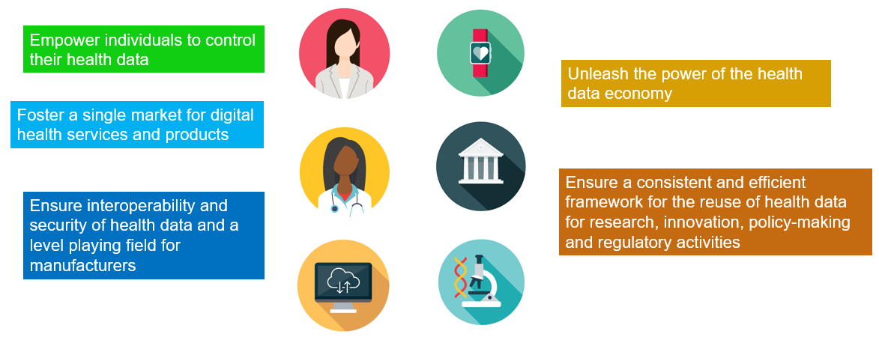

Figure 1 - Main objectives of the European Health Data Space

People are keen to share their data, if there is a framework that merits their trust**[11]**. EU citizens will be able to access and share their data in real time, while retaining greater control over it. The European Health Data Space will allow a **more effective, accessible and resilient healthcare and better quality of life,** while **giving individuals control over their health data and unleashing the potential of the data economy**. As such, the European Health Data Space will have a significantly positive impact on fundamental rights as regards personal data protection and free movement. Properly articulated with the European Open Science Cloud (EOSC) data space and the relevant European life sciences data infrastructures[12], it will enable researchers, innovators and policy-makers to more effectively use the data securely and in a way that safeguards privacy.

Through the **Conference on the Future of Europe**, citizens have explicitly called for the creation of a European Health Data Space. As such, the European Health Data Space is a key pillar of the strong **European Health Union** presented by the Commission on 11 November 2020 to strengthen preparedness and response during health crises and deliver resilient health systems. The European Health Union is about protecting everyone’s health – leaving no-one behind. It builds on the solidarity that is both the bedrock of the EU and the recipe for success in tackling COVID-19. The European Health Data Space, which is also one of the actions under the **European Pillar of Social Rights Action Plan**, will drive this forward – so that the European Health Union can deliver for everyone.

The European Health Data Space will link data sets and make them accessible, facilitating the search for the next game-changing health innovation. It is **the first common EU data space** in a specific area to emerge from the EU strategy for data[13] and is an integral part of the digital transition priority of the European Commission[14].

The European Health Data Space builds onthe **General Data Protection Regulation (GDPR)[15], proposed Data Governance Act[16]**, **draft Data Act[17]** and **NIS Directive[18]**. As horizontal frameworks, they provide rules (including security measures) that apply to the health sector. But the special sensitivity of health data has been recognised and is addressed by the current proposal[19]. The Commission also plans to adopt a proposal for a **Cyber Resilience Act** in 2022. This Act would set out the cybersecurity requirements for digital products and ancillary services. The security requirements set out in the European Health Data Space, notably as regards electronic health record systems, provide more specific requirements for the health sector, such as access control. The European Health Data Space complements these initiatives and provides more tailor-made rules for the health sector, where needed.

**Trust** is a fundamental enabler for the success of the European Health Data Space. Citizens must be confident that their health data is adequately protected. The European Health Data Space will provide a **trustworthy setting for secure access to and processing of a wide range of health data**. Data protection, cyber security, legality of processing data and personal control of data: these principles share the aim of ensuring that citizens can trust the system. They are the building blocks of the European Health Data Space.

# CHALLENGES IN harnessing the power of health data

Today, **individuals** face challenges in exercising their right to control their health data, including accessing and transferring their data within the same Member State and across borders, despite the relevant rules laid down in the GDPR. Not all Member States have set up systems to exchange electronic health records and there are significant deficiencies in the interoperability of the systems. Patient summaries and e-prescription services exist in two-thirds of all Member States and are most frequently accessed via an online portal, but only in a few Member States can they be sent or received across borders. Furthermore, 11 Member States are still using paper printouts for prescriptions[20]. Only ten Member States support access to patient summaries or e-prescriptions via MyHealth@EU[21] when data subjects use healthcare services of another Member State. Other data, such as medical images or laboratory results, are not exchanged yet[22].

Healthcare delivery and innovation are hampered by widely varying digital health solutions (often incompatible with each other, between Member States and sometimes even within Member States), fragmented standards and specifications, and various legal and administrative rules. Due to different standards and limited interoperability, industry faces barriers and additional costs both nationally and when entering the markets of other Member States. Moreover, due to implementation of the GDPR in a fragmented manner in this area, it is more difficult to carry out cross-border studies.

*Current challenges in using health data*

*People cannot always easily access their health data electronically, and if they want to consult doctors in more than one hospital or medical centre, they often cannot share the data with other health professionals. Today, a patient’s health data is often still recorded on paper, untraceable and scattered across various places (hospitals, general practitioners’ venues, medical centres, etc.).*

*The situation becomes even more difficult when crossing national borders. If a patient visits a doctor in another country, their medical information (including diagnostic images) is often not accessible, which can lead to delays and errors in diagnosis or treatment. In most cases, doctors cannot see the patient’s health data if they have undergone health interventions in another country. Continuity of care and rapid access to personal electronic health data is even more important for residents in border regions, crossing the border frequently to receive healthcare.*

*The open public consultation[23] for the European Health Data Space proposal showed that 88% of respondents think it should promote citizens’ control over their own health data, including access to health data and transmission of their health data in electronic format. 84% of respondents say that citizens should have the right to transmit one’s health data in electronic format to another professional or entity of their choice and 82% feel that they should have the right to request public healthcare providers to share their health data electronically with other healthcare providers/entities of their choice. 83% of respondents say that the European Health Data Space should facilitate delivery of healthcare for citizens across borders.*

*Researchers and industry, along with policy-makers and innovators, face important obstacles in accessing the data they need to develop new products, to take informed decisions or to monitor the side effects of medicinal products over the long term, based on real-world evidence, with impact on patient safety. In many cases, consent*[24] *is the only way to access data for research, policy-making and regulatory purposes. It is very costly and cumbersome for researchers to get consent from every patient to use the patient’s data in their research. Even when the patient consents, data holders are sometimes reluctant to provide data for reasons other than data protection and prefer to keep the health data for their activities. The current regulatory fragmentation between Member States hampers research and innovation by small players, as well as cross-border research.*

*89% of respondents in the public consultation believe that the European Health Data Space should support and accelerate research in health.*

The **digital health industry** faces problems when placing new products and services on the market, given the fragmentation of standards and specifications for storing and sharing data. This often forces healthcare providers to adopt new standards that erect barriers to new entrants. There is a variety of different standards and specifications of various organisations. Therefore, many producers of digital health products and providers of digital health services cannot market their products and services in other Member States without incurring additional costs to adapt them to the national standards. Moreover, industry has difficulties to access health data for secondary use, which impacts on their innovation capacity.

**Researchers and innovators** still face challenges in accessing critical data that can boost the faster translation of research results into benefits for patients, despite substantial progress through the establishment of European Research Infrastructures[25]. These have led, for example, to the creation of the European COVID-19 Data Platform[26].Fragmented and divergent legal and administrative rules, frameworks, processes, standards and infrastructure for reusing health data restrict researchers and innovators’ access to health data. They also limit the availability of innovative health products and service.

For **policy-makers and regulators**, the limited use of health data puts limits on making more efficient and effective healthcare and public health policy, which is crucial particularly for effective health crisis management. This was very evident during the COVID-19 pandemic, when the European Centre for Disease Prevention and Control and the European Medicines Agency struggled to obtain rapid access to data and evidence for decisions and scientific guidance on the response to the pandemic.

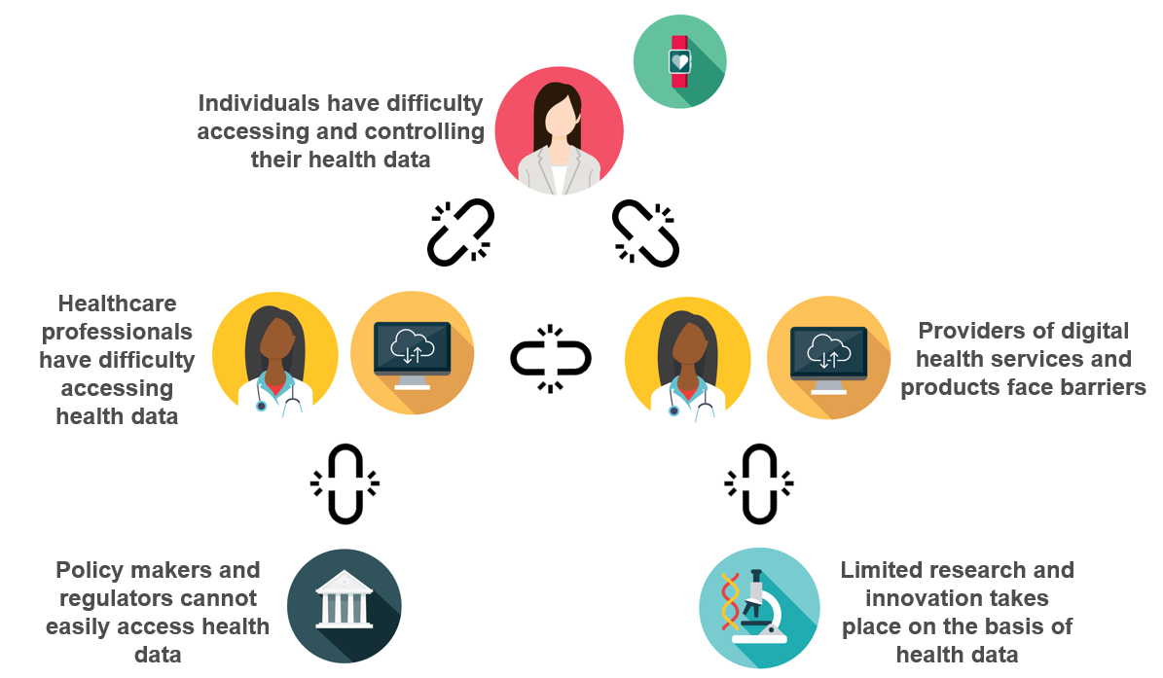

Figure 2 - Problems in controlling, using and sharing health data

Over half of Member States do not have specific legislation on reusing electronic health data for research, policy-making or regulatory purposes for instance, and rely on the general provisions of the GDPR, often using consent for processing health data[27]. This situation results in limited health data reuse. Not all Member States have a competent body for health data access, but where such a body exists, the number of requests to use health data for research or policy-making projects is rapidly increasing,[28] showing the interest in such a system and suppressed demand.

There is evidently a need for a regulatory framework that directly addresses the rights of individuals, reduces fragmentation in the digital single market and enables researchers, innovators and policy-makers to more effectively use the data securely.

EU-wide action is necessary and appropriate therefore, to promote the free, cross-border flows of personal health data and to foster a genuine internal market for personal health data and digital health products and services. In short, it will help deal with problems that would otherwise persist.

# the CONCEPT OF a European Health Data Space

***Trust as the foundation of the European Health Data Space***

Stakeholder consultations, and particularly the open public consultation[29], have shown that strengthening trust in the sharing of health data and ensuring security and privacy are key for citizens, and they must be the cornerstone of the European Health Data Space.

Unleashing the benefits of science and research requires structural solutions at EU level. And to strengthen trust in the sharing of health data, security and privacy are fundamental principles of the European Health Data Space. Accordingly, the European Health Data Space includes clear provisions on how data has to be kept secure.

Concretely, the European Health Data Space builds on strong **data protection** and **cybersecurity** elements. The proposal introduces security criteria for electronic health record systems, in addition to interoperability. It builds upon the possibility offered by the GDPR to put forward an EU law supporting the use of health data for diagnosis and treatment, but also for research, statistics or for public interest, such as protecting against serious cross-border threats to health or ensuring high standards of quality and safety of healthcare and of medicinal products or medical devices. Moreover, in the context of the European Health Data Space, processing electronic health data for secondary use is only possible in secure processing environments, which need to comply with very high standards of privacy and cybersecurity and no personal data can be downloaded from such environments.

***Boosting primary and secondary use of health data***

The European Health Data Space is a health specific ecosystem comprised of rules, common standards and practices, infrastructures and a governance framework that aims at:

1. empowering individuals through increased digital access to and control of their electronic personal health data and support to their free movement;
2. Fostering a genuine single market for electronic health record systems, relevant medical devices and high risk AI systems
3. providing a consistent, trustworthy and efficient set-up for the use of health data for research, innovation, policy-making and regulatory activities.

The development of a truly common European Health Data Space will require actions at national and EU level, along with strong cooperation between public and private stakeholders (for example, national digital health bodies, public health institutes, data protection authorities, healthcare providers, health professionals, academic and research institutions, and patient associations).

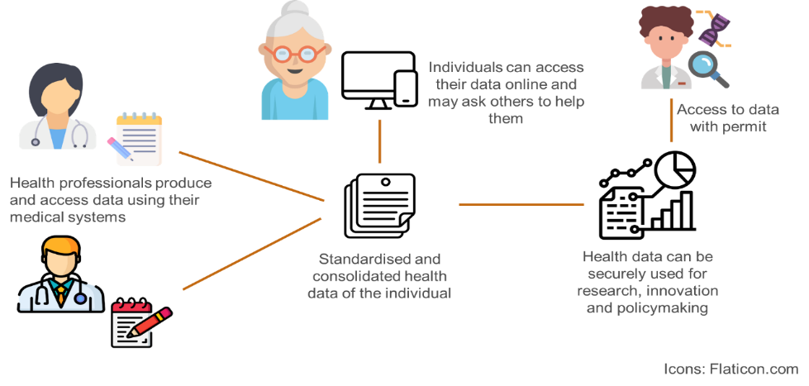

Figure 3 – Primary and secondary uses of electronic health records

This is where the two distinct uses of health data supported by the European Health Data Space - **primary and secondary use -** come into play.

The **primary use of electronic health data** supports the use of data for better healthcare at national and cross-border level. Medical data is typically stored in electronic health records, containing segments of a patient’s medical history (centrally or involving various healthcare providers). The European Health Data Space will allow people to access their health data and make their data available to a health professional of their choice, including when abroad and in the language of the health professional. Thus, the patient can get a better diagnosis and treatment with fewer medical errors and avoid unnecessary diagnostics.

The European Health Data Space will integrate three main product markets for primary use of health data:

1) electronic health records;

2) other health and medical software products (for example, medical imaging software, e-prescribing software, medical diagnosis software and telemedicine); and

3) wellness apps (with a voluntary labelling scheme informing consumers about interoperability with electronic health records).[30]

**Key aspects of European Health Data Space: Primary use of health data**

* Patients will **have their electronic health data available** via access points established by Member States. A cross-border digital infrastructure for primary use will connect Member States and allow patients to share their health data
* Patients will be **empowered to control** **and share** **their electronic health data** with a healthcare provider of their choice.
* Member States will be required to **make priority categories of data available in a common European electronic health record exchange format**, such as patient summaries, e-prescriptions, e-dispensations, medical images and image reports, laboratory results and discharge reports.
* Where personal health data has not been collected electronically prior to the application of this Regulation, Member States may decide not to convert it into an electronic format.
* **Health professionals** will be able to access electronic health records and should update the electronic health data of the patients they treat.
* To support data being shared between healthcare providers, **mandatory requirements** for interoperability, security, safety and privacy will be introduced, as well as **mandatory self-certification** of electronic health records covering interoperability and security.
* **All Member States will be required to participate in cross-border digital infrastructure** for the exchange of health data for healthcare delivery (**MyHealth@EU**)[31].
* A pilot project will support patients having access to their data on a mobile device in the language of the country of destination.
* To facilitate the implementation, **transitional periods** will apply for certain obligations including the registration of health data, access of health professionals to data, making data available in the European format, the participation in the cross border digital infrastructure, self-certification of electronic health record systems, as well as the voluntary label for wellness applications.
* Member States will have to set up a digital health authority to ensure that the additional rights for individuals are properly implemented.

The **secondary use of electronic health data** takes place when health data is processed to inform and assess public health policies or to conduct research. This can enhance patient safety and boost the development of new medicines and medical devices, as well as personalised medicine and products relying on artificial intelligence. In the context of European Health Data Space, the results of such research are made public in aggregated form duly preserving data privacy.

**Key aspects of European Health Data Space: Secondary use of health data**

* The European Health Data Space sets out a common **EU framework** allowing for use of health data for research, innovation, public health, policy-making, regulatory activities and personalised medicine. It will draw on the creation of a **new and decentralised EU-infrastructure for secondary use of health data (HealthData@EU)** that will connect health data access bodies which should be set up in all Member States.
* Those who wish to re-use health data will need to apply for a permit from a **health data access body**. The **data permit** sets out how the data may be used and for what purpose.
* The data can only be **accessed and** **processed in closed secure environments** to be provided by the health data access bodies with clear standards for cyber security.
* Only **anonymous data** can be extracted by the user who applied for the permit from the secure processing environment. Where researchers, companies or public institutions need access to personal electronic health data they can only access it in pseudonymised form, i.e. data offering information about the disease, symptoms and medication, without revealing to the user the identity of the individual. It is forbidden for the user to attempt to re-identify the data subjects.
* It will be **forbidden to use the data to take decisions detrimental to individuals**, to increase insurance premiums, to market health products towards health professionals or patients or to design harmful products or services.
* Health data access bodies will have to ensure **transparency**: information will be published about data access applications. In addition, data users must make public the results of their **electronic health data uses** and inform the health data access bodies of **any significant findings relevant for the health of individuals**.
* For simple cases, users can directly request data from a single health data provider as long as the same safeguards for privacy and security are ensured.
* Researchers and innovators from third countries can access data for secondary use under the same conditions and requirements as those from inside the EU.
* All Member States will be required to participate in **the** **EU-infrastructure** for secondary use (HealthData@EU) to facilitate cross-border studies. This infrastructure will be piloted in a EU4Health project starting in 2022[32].

***A common governance***

The proposal will also reinforce the existing governance at national and EU level as regards health data. It builds upon the current cooperation for primary use of data, within the eHealth Network, which proved very intensive[33], but also effective during COVID-19 pandemic, managing to build, in a record time, two EU-wide infrastructures (EU Digital COVID Certificate and contact tracing and warning apps) [34].

**EU governance mechanism**

* A new European Health Data Space Board chaired by the Commission will be created, composed of the representatives of digital health authorities and health data access bodies from all the Member States, and observers, depending on area of work.
* It will contribute to the consistent application of the Regulation throughout the EU, to coordinate and exchange best practices and will cooperate with other bodies at EU level.
* Member States will cooperate at EU level to ensure the smooth functioning of the two cross-border digital infrastructures (primary and secondary).

# THE EUROPEAN HEALTH DATA SPACE WORKING IN SYNERGY WITH OTHER HEALTH POLICY PRIORITIES

The European Health Data Space will become a powerful instrument for sharing data to support tailor-made prevention and treatment protocols and expertise across borders. Pooling large volumes of data is a prerequisite for refining our knowledge on how to address diseases.

The European Health Data Space will boost the work under **Europe’s Beating Cancer Plan**[35] and facilitate research and evidence gathering under the Horizon Europe Cancer Mission[36]. Pooling and sharing knowledge, experience and data helps develop practical solutions to benefit cancer patients – and, indeed, everyone in the EU.

The European Health Data Space will open up innovative approaches to cancer registration, with potential alternatives to gather timely, geo-localised information on various types of cancers. This could provide **a real-time state of play of cancers across the EU**. At the same time, it could identify **trends, disparities and inequalities** between Member States and regions. Importantly, this could make it easier to spot the challenges and specific areas of action needing investment and other action at EU, national and regional level.

With better **telemedicine** and remote monitoring tools in the European Health Data Space, we can make the most of virtual medical consultations, training and continuous education. This will help pool expertise for diagnosis and treatment, building on the European Reference Networks model[37]. It will also make **cancer screening and care** more targeted, more effective and accessible.

The European Health Data Space will open new opportunities for health data to make a vital contribution to innovation and research in medicines and treatments, thereby promoting the development of new therapies and medicinal products. This will help meet the aims of the **Pharmaceutical Strategy for Europe**[38] and the mandate of the European Health Emergency Preparedness and Response Authority (HERA).

Moreover, the European Health Data Space **will make continuity of care across EU** a reality. By enabling patients to share their health data (including vaccination data) with health professionals, in the professional’s own language, it will support better decision-making on treatment and care across the EU. It will also avoid unnecessary and costly repetitions of tests and other medical procedures.

The European Health Data Space recognises the long-standing qualification of medical device software under the Medical Devices Regulation and the In Vitro Diagnostic Medical Devices Regulation[39]. Where manufacturers can state that a medical device is interoperable with electronic health record systems, they will need to comply with the essential requirements on interoperability, implemented by the self-certification scheme for electronic health record systems.

# 5. Benefits of a EUROPEAN HEALTH data space

The European Health Data Space will benefit individuals, health professionals, healthcare providers, researchers, regulators and policy-makers.

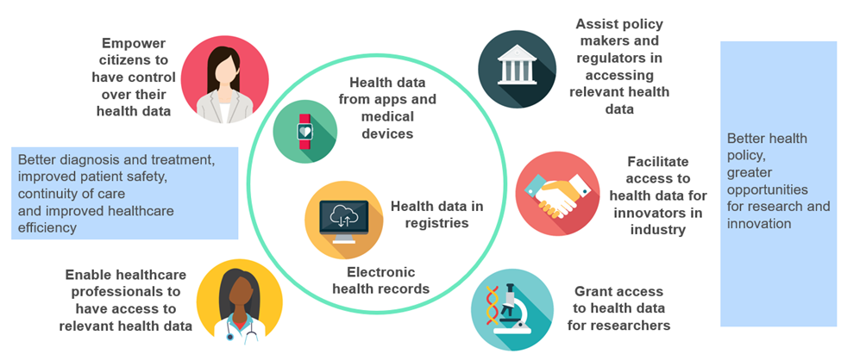

*Figure 4. Benefits for users of European Health Data Space*

**Individuals** will have greater control over their health data. If they wish, they will be able to provide their data to a healthcare professional of their choice rapidly and in an easy, transparent, common format. This will reduce the number of unnecessary tests and costs, and increase healthcare safety. The ability to access, analyse, and share health data will make healthcare more efficient, support better medical decisions and, therefore, improve health outcomes. The European Health Data Space will help attain the Commission’s vision for EU’s digital transformation by 2030, the Digital Compass[40] aim of providing 100% of citizens with access to their medical records and the Declaration of Digital Principles[41]. It will build on the Commission proposal for a European Digital Identity Framework and Wallet enabling citizens to have trustworthy cross-border access to their health data from mobile devices.

The European Health Data Space will respect the principle of non-discrimination, addressing the rights and needs of persons with disabilities (i.e. access to information, freedom to choose between in person or digital services) as well as those of rare diseases patients. The vast majority of people living with a rare disease are willing to share their health data to advance care and research.[42] The European Health Data Space will unleash the potential for better cross-border access to such data and will support the development of treatments and health services for rare disease patients. The examples of the European Reference Networks and its Clinical Patient Management Systems[43] show that patients located anywhere in a Member State can benefit from advice on the diagnosis and treatment of their **rare diseases** from the best specialists in the EU, using virtual consultation panels.

*The European Health Data Space, together with the GDPR, will give people the right to:*

*-* ***access*** *their health data in electronic form* ***immediately****,* ***free of charge*** *and in an* ***easily readable, accessible and commonly used format****. Data can be accessed using patient portals, on computers or smart phones, depending on how the Member States make available this information at national level. For people with disabilities to be able to enjoy their rights, the access must be accessible in line with the requirements of the European Accessibility Act (Directive 2019/882);*

*- share their data in electronic form with* ***other health professionals*** *when going to another hospital, without hindrance from previous healthcare providers or manufacturers;*

*-* ***add data*** *to their electronic health record for themselves**or for people who trust them, such as their children;*

*-* ***request changes to*** *erroneous data* ***online****;*

*-* ***restrict access*** *to their electronic health data or part of the data; in cases of vital interest, where their life is at stake, such data may however be made available with additional restrictions;*

*- easily obtain* ***information on which professional(s) accessed their data****;*

*Member States are required to designate digital health authorities that will have a fundamental role in enforcing the above-mentioned rights.*

**Health professionals’** work will be made easier and more effective with more efficient access to health data of their patients. Member States should support professionals in this endeavour. However, adapting legal frameworks to secure the right safeguards and ethical standards is only a first step. Comprehensive monitoring to assess the true impact of digital technologies on patient care and health outcomes is also needed. Training health professionals to use digital technologies is another precondition.

With improved interoperability, health professionals will be able to access a patient’s medical history, thus increasing the evidence base for decisions on treatment and diagnosis. This will make healthcare systems more efficient and reduce costs, because health professionals will spend less time copying data from multiple sources in multiple formats, and will no longer redo the same tests. The take-up of more advanced digital technologies needs to be promoted, involving and training the potential users.

Digital technologies can provide solutions to problems that health workers encounter in their routine tasks. Digital technologies can make daily workflows easier, reducing administrative burden and freeing up time for more patient-focused care. Above all, they can add value in clinical practice, helping achieve better health outcomes for patients. However, providing tools alone will not bring about a successful digital transformation. Health professionals need to be involved in the digital transformation and in co-designing digital health solutions.

**Healthcare providers** will perform fewer unnecessary tests, with positive effects for patients and healthcare expenditure. Optimising the use of health data has the potential to bring significant benefits and improve the effectiveness of healthcare systems. The health services sector represents approximately 10% of the EU’s GDP (2019) and includes both public and private providers[44]. It is a fundamental ecosystem for both the wellbeing of Europeans and the economy of the EU. With the right tools and solutions in place, it can be more efficient without hampering the performance of healthcare systems. One such solution is to avoid repeating unnecessary tests by strengthening interoperability to support data exchange between healthcare providers within countries and across borders. The Organisation for Economic Co-operation and Development estimates that automatic data-sharing, among other things, can lead to direct financial savings of as much as 15% of hospital expenditure[45]. This comes from avoiding costs of capturing data from paper and reducing errors when transcribing information. Telemedicine is also expected to make healthcare systems more efficient[46]. A 2018 market study on telemedicine[47] considered that its market potential in the EU was strong and expected to grow at a compound annual growth rate of 14% in the coming years. Overall, the benefits of primary use of health data can be quantified at EUR 5.5 billion over 10 years[48] including savings for healthcare providers and patients in health costs thanks to an increased uptake of telemedicine, faster deployment of cross-border sharing of health data and faster growth of the digital health and wellness applications markets.

**Researchers** will also benefit from a more direct way of obtaining access to data in the context of the European Health Data Space. By obtaining access to data through health data access bodies they will spend less time and money to get consent for various research projects. This will free up time to do the actual research. Researchers will have access to large troves of health data, in particular healthcare and real-world evidence (RWE) data, with the higher data quality and level of FAIR-ness[49] that medical breakthroughs require. Researchers will be able to know what data is available, where, and of what quality, in addition to what is already available at European Research Infrastructures. They will be able to access the data in a more effective and less expensive way, through a data access body that maintains privacy.

**Regulators and policy-makers** will have easier access to health data for the benefit of public health and the overall functioning of healthcare systems. This will improve health outcomes for patients and the broader public. For instance, in a medium-sized EU country, renegotiating a reduction of up to 5% on the prices of various medicinal products, based on better knowledge of their effects, could equate to EUR 50 million a year in savings[50]. These benefits would lead to better access to healthcare, reduced costs, increased efficiency, more resilient health systems, new research and innovation and better policy-making.

The solution for secondary use of health data proposed by the European Health Data Space is expected to result in a significant **economic benefit of at least EUR 5.4 billion over the next 10 years**[51]**.** This benefit will come from three key areas:

* efficiency gains in data access as a result of a less costly access to health data for users, be they researchers, innovators, regulators or policy-makers (EUR 3.4 billion);
* greater information transparency for policy-makers and regulators (EUR 0.8 billion); and
* better value for patients, healthcare providers and innovators, thanks to further reuse of health data. This will be possible with the development of innovative products and services in health using data-intensive technologies, such as AI-based systems (EUR 1.2 billion).

**Industry** will benefit from same standards and specifications for interoperability and security across Europe, which will open new markets, including for SMEs. It will benefit from greater availability of electronic health data through privacy preserving mechanisms for citizens including infrastructures that are trustworthy by design, and the use of anonymisation, aggregation and synthetic data. Industry will also benefit from data that could help them develop new medicinal products or new devices involving AI. Combined with AI technologies and access to real world conditions (such as through Testing and Experimentation Facilities), this will greatly boost innovation and accelerate the discovery, development and approval of new prevention approaches and treatments. Industry will be able to use the data for innovation; for developing products that could improve people’s health; and for producing new and innovative medicinal products and devices that can help provide better, more personalised care. However, it will be forbidden to attempt to re-identify the individuals whose data is used. Moreover, the European Health Data Space data cannot be used to target individuals or health professionals to sell products or health services, to increase insurance premiums or to develop harmful products. All in all, the European Health Data Space supports industry in producing useful innovations for society, while keeping health data safe.

# 6. Funding needs and coverage

Investing in digitalisation is investing in better healthcare and the resilience of our health systems. The EU and Member States need to take this bold step, together. To make the European Health Data Space a reality, rapid progress in the digitalisation of healthcare at national level is needed. This includes investments in electronic health records, telemedicine, interoperability, but also data quality, institutions and solutions for secondary use of health data. At the same time, interoperable EU-wide infrastructures to enable cross-border use of health data in the EU are also necessary.

To make the European Health Data Space work, financing needs to cover the costs of:

1. deploying and operating infrastructures, at national and EU level, meaning national infrastructures, as well as support for the EU gateways and additional EU services, such as the connection of Member States to the infrastructures supporting cross-border sharing of patients’ data in a language of the country of destination, supporting multi-country research and policy-making projects and compliance with cybersecurity and interoperability standards; and
2. governance for the European Health Data Space, meaning coordination of relevant bodies, financing joint actions, and supporting for EU level cooperation;
3. carrying out actions to support interoperability, protection of personal data, and data quality, meaning development and selection of standards and specifications for data sharing, support for Member States to code data, support for developing the standardisation of new data categories, etc.

At EU level, EUR 810 million is available to support the European Health Data Space. Over EUR 330 million have been earmarked for European Health Data Space activities and infrastructures: EUR 280 million under the EU4Health Programme and additional EUR 50 million under the Digital Europe Programme. Grants will be available to Member States:

1. to expand MyHealth@EU to more Member States and new services (patient summaries, e-prescriptions and e-dispensations, images, laboratory reports and discharge)**,** including also patients’ access to their health data. A pilot project under the 2021 EU4Health work programme will help patients obtain their health data on their smartphones, in the language of the country of destination;

2. to provide services by health data access bodies on secondary use of health data. An EU4Health pilot project under the 2021 EU4Health work programme will support the development of infrastructure for secondary use of health data.

More than EUR 480 million from Digital Europe Programme, Connecting Europe Facility and Horizon Europe can be used by Member States and entities involved in European Health Data Space, along with other sectors. Moreover, the Digital Europe Programme will support the deployment of infrastructures needed to make health data securely accessible across EU borders and to develop common data spaces (with over EUR 140 million from the work programmes 2021-2022). Where physical connectivity is lacking, the Connecting Europe Facility will promote the interconnection of cloud infrastructures in Member States, including those that are needed in the European Health Data Space (EUR 130 million). Horizon Europe will continue to support the needs of the European Health Data Space through specific research and innovation projects and coordination and support actions focusing on health data quality and interoperability and through the research infrastructures (around EUR 210 million allocated until 2022).

In addition, Member States have earmarked EUR 12 billion under the Recovery and Resilience Facility for investments in health, including digital health and the secondary use of health data. The European Regional Development Fund and InvestEU offer complementarities for additional investments in digital health based on national needs. The Commission will also support Member States through the Technical Support Instrument, upon demand, on designing and implementing strategies and action plans aiming to render health systems interoperable.

# 7. CONCLUSION

As the EU emerges from COVID-19 stronger, more united and better prepared for future crises, it has become abundantly clear that, **when Europe comes together, cooperates and pools resources, giant strides can be achieved**.

The digitalisation of healthcare in Europe is a challenge that requires such unity of purpose and common effort in a strong European Health Union that puts citizens’ health first. The European Health Data Space will be a key driver of this.

The unprecedented cooperation in digital health during the COVID-19 crisis positioned Europe as a global standard setter, for instance with regards to EU Digital COVID Certificate or contact tracing and warning apps. Europe must build upon these achievements and reinforce cooperation with partner countries and international organisations and leadership in this area for stronger global health systems.

We now have an opportunity to shift another paradigm and create an environment that is conducive to sharing and making data available, built on trust and common principles, and in the collective interest of everyone in the EU to truly harness the power of health data.

This project will be built on the foundations of secure and trustworthy access to data that is fully in line with the fundamental values underpinning EU.

It is an opportunity to empower us all, as individuals, to profit from stronger rights and safeguards over our health data. It will be easier to access and share our health data with other health professionals, without having to re-do the same tests unnecessarily. At the same time, easier access to interoperable data of high quality will also facilitate innovation and the development of new treatments, new vaccines and personalised medicine.

In short, we have an opportunity to unleash the potential of health data economy.

The time has come to seize that opportunity and make the European Health Data Space a reality.

1. Calculated as a share of the estimated value of data-sharing in the EU. For more information, see the impact assessment, Annex 5.
2. https://www.enisa.europa.eu/topics/critical-information-infrastructures-and-services/health.
3. Personal information on health status of an individual, or non-personal information related to health, such as statistics, anonymous or aggregated data. This includes both medical data (information provided by the patient, diagnosis, doctor referrals and prescriptions, medical examination reports, laboratory tests, radiographs, data acquired or processed in the context of health research or policy making, such as disease registries or data from registries with side effects of medicinal products or medical devices etc.), administrative and financial information about health (including invoices for healthcare services and medical certificates for sick leave management etc.), but also determinants of health (social, behavioral, environmental).
4. FAIR principles: findability, accessibility, interoperability, reusability (https://www.go-fair.org/fair-principles/).
5. Provision of healthcare services and medical information using innovative technologies (especially information and communication technologies), in situations where the health professional and the patient (or two health professionals) are not in the same location.
6. According to the impact assessment, p. 51.
7. https://www.hiqa.ie/sites/default/files/2018-05/ePrescribing-An-Intl-Review.pdf.
8. <https://www.hiqa.ie/sites/default/files/2018-05/ePrescribing-An-Intl-Review.pdf>.
9. Cross-border digital infrastructure for the exchange of health data, also known as the eHealth Digital Service Infrastructure (previously referred to as “eHDSI”).
10. According to the impact assessment, forthcoming, p 51.
11. https://ec.europa.eu/health/system/files/2021-02/ms_rules_health-data_en_0.pdf.
12. The European Strategy Forum on Research Infrastructures, through its strategic Roadmaps, facilitated the establishment of European research infrastructures dedicated to health research data, biobanking collections, medical imaging data, and others. Details available at: https://roadmap2021.esfri.eu/.
13. European Commission. *A European data strategy, 2020.* (<https://ec.europa.eu/info/strategy/priorities-2019-2024/europe-fit-digital-age/european-data-strategy_en>).
14. https://ec.europa.eu/info/strategy/priorities-2019-2024/europe-fit-digital-age/shaping-europe-digital-future_en.
15. <https://eur-lex.europa.eu/eli/reg/2016/679/oj>.
16. Proposal for a Regulation on European data governance (Data Governance Act) COM/2020/767, https://eur-lex.europa.eu /legal-content/EN/TXT/?uri=CELEX%3A52020PC0767.
17. Proposal for a Regulation on harmonised rules on fair access and use of data (Data Act) COM/2022/68 final.
18. <https://eur-lex.europa.eu/legal-content/EN/TXT/?uri=celex:32016L1148>.
19. <https://tehdas.eu/app/uploads/2021/06/tehdas-why-health-is-a-special-case-for-data-governance-2021-06-23.pdf>.
20. Thiel, R., Lupiáñez-Villanueva, F., Deimel, L., Gunderson, L. and Sokolyanskaya A. (2021). eHealth, Interoperability of Health Data and Artificial Intelligence for Health and Care in the EU. <https://ec.europa.eu/newsroom/dae/redirection/document/79897>.
21. Cross-border digital infrastructure for the exchange of health data, also known as the eHealth Digital Service Infrastructure (previously referred to as “eHDSI”), [https://eur-lex.europa.eu/legal-content/en/TXT/?uri= CELEX%3A32019D1765.](https://eur-lex.europa.eu/legal-content/en/TXT/?uri=%20CELEX%3A32019D1765.)
22. https://ec.europa.eu/health/ehealth-digital-health-and-care/electronic-cross-border-health-services_en.
23. https://ec.europa.eu/info/law/better-regulation/have-your-say/initiatives/12663-A-European-Health-Data-Space/public-consultation_en.
24. <https://tehdas.eu/app/uploads/2021/09/tehdas-summary-of-results-case-studies-on-barriers-to-sharing-health-data-2021-09-28.pdf>.
25. The European Strategy Forum on Research Infrastructures, through its strategic Roadmaps, facilitated the establishment of European research infrastructures dedicated to health research data, biobanking collections, medical imaging data, and others. Details available at: ESFRI Roadmap 2021.
26. COVID-19 Data Portal - accelerating scientific research through data (covid19dataportal.org).
27. Hansen J. et al, *Assessment of the EU Member States’ rules on health data in the linght of GDPR, available at* <https://ec.europa.eu/health/system/files/2021-02/ms_rules_health-data_en_0.pdf>.
28. According to the impact assessment accompanying the proposal (p 15), forthcoming.
29. https://ec.europa.eu/info/law/better-regulation/have-your-say/initiatives/12663-A-European-Health-Data-Space/public-consultation_en.
30. It is estimated that the European Health Data Space will produce a faster growth of the digital health and wellness applications markets, expected at 20-30% and 15-20% per year, respectively.
31. Ten Member States already support their patients in sharing data with foreign health professionals in professionals’ own language and all Member States are set to join these data exchanges. A pilot project under EU4Health will support patients’ access to their data in their own language.
32. <https://ec.europa.eu/info/funding-tenders/opportunities/portal/screen/opportunities/topic-details/eu4h-2021-pj-06>.
33. Over 400 on-line meetings of the eHealth Network and its subgroups have been organised since March 2020.
34. [https://ec.europa.eu/health/ehealth-digital-health-and-care/ehealth-and-covid-19_en.](https://ec.europa.eu/health/ehealth-digital-health-and-care/ehealth-and-covid-19_en)
35. <https://ec.europa.eu/health/system/files/2021-02/eu_cancer-plan_en_0.pdf>.
36. <https://ec.europa.eu/info/research-and-innovation/funding/funding-opportunities/funding-programmes-and-open-calls/horizon-europe/eu-missions-horizon-europe/cancer_en>.
37. [ERN CPMS - (ern-net.eu)](https://cpms.ern-net.eu/login/?next=/insight/).
38. <https://ec.europa.eu/health/medicinal-products/pharmaceutical-strategy-europe_en>.
39. Regulations (EU) 2017/745 and (EU) 2017/746 respectively.
40. https://ec.europa.eu/info/strategy/priorities-2019-2024/europe-fit-digital-age/europes-digital-decade-digital-targets-2030_en.
41. <https://ec.europa.eu/info/law/better-regulation/have-your-say/initiatives/13017-Declaration-of-Digital-Principles-the-%E2%80%98European-way%E2%80%99-for-the-digital-society_en>.
42. <https://ojrd.biomedcentral.com/track/pdf/10.1186/s13023-019-1123-4.pdf>.
43. <https://ec.europa.eu/health/european-reference-networks/work-erns_en>.
44. Healthcare expenditure statistics - Statistics Explained (europa.eu).
45. https://www.oecd.org/health/health-systems/Empowering-Health-Workforce-Digital-Revolution.pdf.
46. <https://www.oecd-ilibrary.org/docserver/8e56ede7-en.pdf?expires=1646391218&id=i> d&accname= guest&checksum=40DB0F3D91A7741CC0D072D9196F2AEE.
47. https://ec.europa.eu/health/system/files/2019-08/2018_provision_marketstudy_telemedicine_en_0.pdf.
48. According to the proposal’s impact assessment, p. 58.
49. FAIR principles: findability, accessibility, interoperability, reusability (https://www.go-fair.org/fair-principles/).
50. According to the proposal’s impact assessment., p. 56.
51. According to the proposal’s impact assessment, p. 58.