

Table of Contents

Table of Contents 1

1. Introduction 3

2. Forecast of outflows of the EU budget 2023-2027 3

2.1. Payments in relation to the commitments of the 2021-2027 MFF 5

2.2. Payments for the completion of pre-2021 commitments 7

2.3. De-commitments 8

2.4. NextGenerationEU 8

2.5. Evolution of the level of outstanding commitments 9

3. Forecast of inflows of the EU budget 2023-2027 10

4. Conclusions 12

Annex I – Results of the forecast* 14

Table 1.1 – Long-term forecast of future outflows over 2023-2027 for the MFF 14

Table 1.2 – Payments in relation to the commitments of the 2021-2027 MFF 15

Table 1.3 – Payments for the completion of pre-2021 commitments 16

Table 2 – Forecast de-commitments 17

Table 3 – Long-term forecast of outflows for NextGenerationEU 18

Table 4 – Change in the total outstanding commitments from 2023 to 2027 18

Table 5 – Long-term forecast of future inflows of the EU budget over 2023-2027 19

1. Introduction

This report provides projections for the inflows and outflows of the EU budget over the period 2023-2027[1]. It is the second edition of the long-term forecast for revenue and expenditure stemming of the Multiannual Financial Framework (MFF) 2021-2027[2] and NextGenerationEU[3], updating the estimates presented in the June 2021 report[4].

The forecast covers the next five years, in accordance with Article 247(1)(c) of the Financial Regulation[5]. The period largely overlaps with last year’s report, which exceptionally spanned over seven years from 2021 to 2027 to provide a comprehensive overview of the expected revenue inflows and the expenditure outflows under the ceilings of the then newly adopted MFF.

Along with the MFF estimates, this forecast updates the projections of payments on all programmes under NextGenerationEU. This expenditure, additional to the spending under the MFF, is financed exclusively by revenue proceeds from borrowing operations on the capital markets.

Payments from the EU budget follow commitments. The estimates in this report are based on the commitments of the financial programming accompanying the Draft Budget 2023[6]. These include the adjustment[7] of the MFF for the late adoption of rules and programmes under shared management under Article 7 of the MFF Regulation, the programme-specific adjustments under Article 5 of the MFF Regulation[8] as well as re-use of de-commitments under Article 15(3)[9] of the Financial Regulation. As regards revenue, the forecast is based on the revenue system of the Own Resources Decision[10]. The revenue projections also consider the Agreement on the withdrawal of the United Kingdom of Great Britain and Northern Ireland from the European Union and the European Atomic Energy Community[11] (the ‘Withdrawal Agreement’).

1. Forecast of outflows of the EU budget 2023-2027

The payments over the next five years of the MFF are expected to reach EUR 1 156 billion, including EUR 873 billion under the MFF payment ceiling and EUR 278 billion for NextGenerationEU non-repayable support.

The forecast includes estimates for the future programme-specific adjustments stemming from Article 5 of the MFF Regulation and for the re-use of de-commitments under Article 15(3) of the Financial Regulation, which will be allocated in the years 2024-2027. The programme-specific adjustments are expected to result in an automatic upward adjustment of the MFF ceilings for commitments and payments of EUR 9.4 billion in addition to the adjustments for 2022 and 2023 totalling EUR 3.3 billion[12]. The exact annual adjustment will depend on the revenue from competition fines in the previous year for an overall amount of EUR 11 billion (in 2018 prices) by 2027.

Chart 1 - Payments forecast by category (in EUR billion)

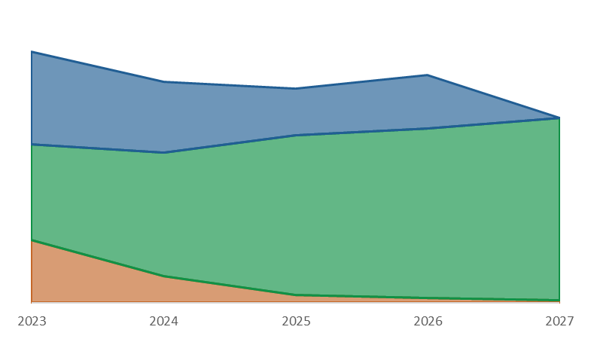

**NextGenerationEU**

MFF 2021-2027

Completion

**264**

**232**

**225**

**240**

**194**

*Annual average: 231*

The forecast payments from the EU budget are not evenly distributed across the reference period. They depend on the expected evolution of: 1) the phasing-in of payments for the new MFF programmes (66% of the total payments), 2) the pace of disbursements under NextGenerationEU (24% of the payments), and 3) the completion of commitments from the 2014-2020 period and earlier (10% of the payments). The estimated annual average of the outflows is EUR 231 billion, with EUR 56 billion to be financed by borrowing on the capital markets for NextGenerationEU programmes.

Payments over the period are expected to steadily decline after a peak in 2023, which is largely driven by the frontloading of NextGenerationEU. A temporary rebound in outflows is expected in 2026, when all final payments under NextGenerationEU will have to be completed. As of 2027 the forecast almost exclusively comprises payments under the 2021-2027 MFF programmes.

Zooming in on the expenditure under the current MFF and the completion of its predecessors, the forecast payments average EUR 175 billion, with 2023-2024 below average and 2026-2027 above. The difference between the peak year for payments (2027) and the trough (2024) is roughly EUR 36 billion. This pattern has also been observed in prior MFFs due to the progressive phasing out of closure payments of the previous financial frameworks and the new spending programmes effectively reaching cruising speed in the second half of the respective MFF.

The forecast margin under the MFF payment ceiling amounts to EUR 5.5 billion and EUR 11 billion in 2023 and 2024, respectively. For the period 2025-2027, the annual margin may appear negative compared to the current payment ceilings, with the forecast exceeding the ceiling by EUR 24.6 billion for the three years combined. These deviations across the years are simply a consequence of the payment ceiling set at a stable level in real terms, while implementation is expected to follow a variable path. Pursuant to the automatic adjustment mechanism of Article 11(1)(b) of the MFF Regulation, the amounts not spent in a given year will increase the ceilings for the future years. Therefore, the expected positive margins prior to 2025 will increase the ceilings in 2025-2027 (within the limits set by Article 11(3) of the MFF Regulation). Considering this adjustment and the future programme-specific adjustment under Article 5 of the MFF Regulation (which will increase the payment ceilings by an additional EUR 9.4 billion), the current payment forecast for the last three years of the MFF is compatible with the overall 2021-2027 MFF payment ceiling.

Chart 2 - Payments forecast vs MFF payment ceiling (in EUR billion)

Maximum Payments Ceiling: 2025-2027 incl. increase SMI Art. 11(3))

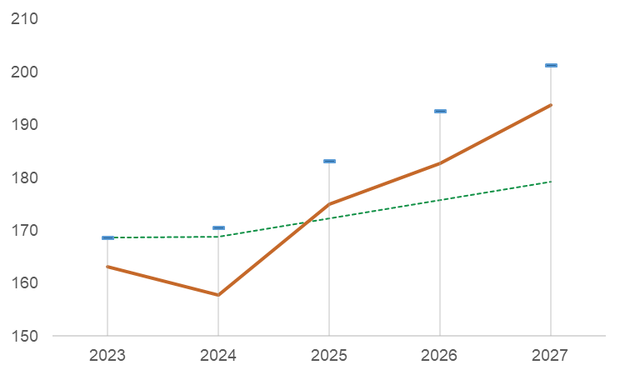

Forecast Payments (under the MFF ceiling)

Payment Ceiling (Technical Adjustment 2023)

* 1. Payments in relation to the commitments of the 2021-2027 MFF

Cohesion policy and the Common Agricultural Policy (CAP) account for more than half of the estimated payments stemming from the 2021-2027 MFF. The long-term forecast is therefore largely driven by the forecast implementation of these two policies.

Heading 2a - Cohesion policy

The payments forecast over 2023-2027 for the new cohesion policy programming stands at EUR 177 billion, around EUR 8 billion less than in last year’s forecast. The more pronounced delays[13] in the launch of the 2021-2027 programming period will shape the payments over the remainder of the MFF. No national programme was adopted in 2021, with all expected to be approved by the end of 2022. The COVID-19 pandemic and the need to integrate the recovery initiatives into the legislative package under negotiation in the course of 2020 led to a later adoption of the relevant legal acts, which largely explains the observed delays. Moreover, national authorities’ focus on implementing NextGenerationEU may also have played a role. The technical assumption for this forecast is that as of 2024 Member States will start to partially recuperate the delays accumulated over 2021-2023 and will reach a speed of implementation comparable to the 2014-2020 period towards the last years of the MFF. This assumption is made in a context of heightened uncertainty due to the current geopolitical and economic instability, as well as the absence of a relevant historical benchmark to project implementation over the long-term.

There are upside and downside risks to this forecast. Member States may put extra efforts to accelerate implementation as of 2023 and the speed of implementation of the previous programming period could be reached earlier. Payments may also accelerate in relation to the REPowerEU[14] initiative under which the Commission proposed that Member States have the possibility to transfer up to 12.5% of their cohesion allocations to the Recovery and Resilience Facility (which is not reflected in the forecast), building on the already available 5% transfer possibility and adding 7.5% transfer possibility for REPowerEU objectives only. By contrast, if Member States do not undertake additional efforts, a one-year delay will persist. Consequently, this would delay payments and potentially lead to unprecedentedly high level of de-commitments due to the N+3 de-commitment rules.

Chart 3 - Payments forecast for Heading 2a (2021-2027 MFF commitments), and upside and downside scenarios (in EUR billion)

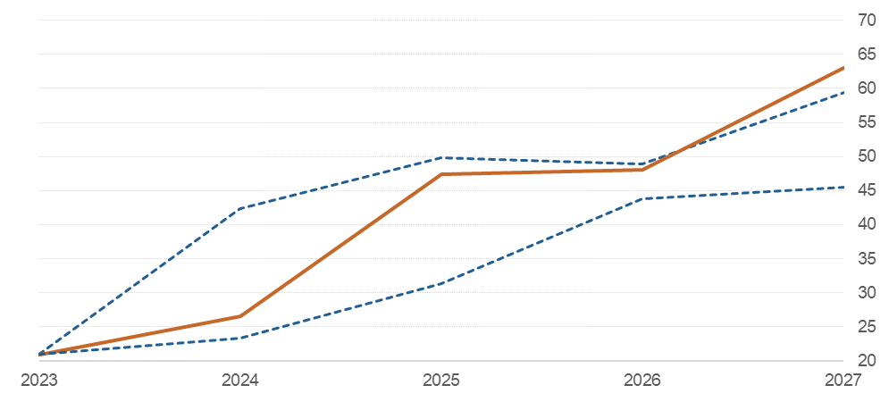

**Forecast**

**Payments**

Downside scenario

Upside scenario

Heading 3 - Common Agricultural Policy (CAP)

The payments forecast for Pillar I of the CAP – EUR 208 billion over 2023-2027 – reflect the most recent financial programming and Member States’ transfers between the two CAP Pillars.

Contrary to cohesion policy, there are no delays expected in the implementation of Pillar II – the European Agricultural Fund for Rural Development (EAFRD) – owing to the two-year transitional provisions, which extended the 2014-2020 programmes until 2022. Considering that all Member States have submitted their Strategic Plans for the new CAP, the effective implementation of the 2023-2027 programmes is expected to start already in 2023, one year earlier than assumed in the June 2021 forecast report.

The forecast of payments deriving from the 2021-2027 MFF also includes payments linked to the last two tranches (2021 and 2022) of the previous programming exercise. They are expected to be covered by payments until 2026 (see Point 2.2. Payments on pre-2021 commitments).

With the 2014-2022 EAFRD programmes running on track and the new CAP plans under approval, the implementation of the EAFRD is expected to run steadily. However, some annual deviations are expected over 2024-2027, with a particular concentration of payments in 2026 due to the overlap between the completion of the previous programmes (under N+3 de-commitment rule) and the quicker phasing in of the new ones (under N+2 de-commitment rule). Furthermore, EAFRD payments may be accelerated in relation to the REPowerEU initiative, similarly to the cohesion policy funds (see point above).

Other programmes and headings

There is an increase in the payments forecast over the five-year period across all other headings resulting from a combination of several factors:

* New initiatives such as the Union Secure Connectivity[15] and the European Chips Act[16] will frontload payments, mostly under Heading 1.
* The latest geopolitical challenges presuppose an acceleration of payments of the programmes under Heading 4 - Migration and Border Management, Heading 5 - Security and Defence, and Heading 6 - Neighbourhood and the World.
* The delayed start of some programmes in 2021 will lead to a redistribution of payments in later years. The more substantial change with respect to last year’s forecast concerns the Brexit Adjustment Reserve for which the adopted legal act[17]provides for a more even distribution of payments across the years compared to the Commission proposal for a large pre-financing instalment, which underpinned last year’s forecast.
  1. Payments for the completion of pre-2021 commitments

The forecast for payments for the completion of pre-2021 commitments (RAL for *reste à liquider*) is updated to take into account payments made in 2021 and planned in the 2022 budget. The forecast of EUR 110 billion for the next five years is largely in line with last year’s forecast with certain annual differences.

Heading 2a - Cohesion policy

Most payments on pre-2021 commitments (58%) relate to the previous programming period of the cohesion policy funds, which is running at full speed. The payment projections are based on the latest Member States’ forecast (January 2022) and recent information for the implementation on the ground. With the Cohesion’s Action for Refugees in Europe (CARE), proposed by the Commission on 8 March 2022[18], Member States will be able to speed up the deployment of all non-programmed funding under the 2014-2020 period, frontloading payment to 2022 and 2023. Compared to last year’s report, this translates into a reduction of the payments’ forecast in 2024.

The last accounting year for the European Structural and Investment (ESI) funds ends in June 2024, but most payments are projected by end-2023. For the closure, considering the retention rate and pre-financing clearance, payments are expected to be limited after 2024.

Heading 3 - Common Agricultural Policy

The expected completion of the 2014-2022 operational programmes is broadly in line with last year’s forecast. It includes, however, a novel element, which is the impact of the recently proposed[19] lump-sum payments to farmers and SMEs in the food-processing sector. Consequently, this frontloads payments by EUR 450 million from 2024-2025 to 2023.

Other programmes and headings

The vast majority (84%) of outstanding payments for the remaining parts of the budget is almost evenly spread between Headings 1 - Single Market, Innovation and Digital and Heading 6 - Neighbourhood and the World. While completion activities under Heading 1 are now expected earlier than previous estimations, the updated expectations for projects under Heading 6 are more backloaded towards 2025-2026.

* 1. De-commitments

The overall de-commitments’ forecast over 2023-2027 stands at EUR 7.6 billion, which is a slight reduction compared to last year’s forecast of EUR 8.4 billion. However, there are some notable changes.

Heading 2a - Cohesion policy

There is a considerable reduction in the de-commitments concerning the completion of the previous programmes under the ESI funds from EUR 3.7 billion down to EUR 0.4 billion. This is due to the 100% co-financing rate for the 2021-2022 accounting year under the CARE initiative, which will facilitate full absorption and minimise the risk of de-commitments during the closure process of the programmes.

There is some limited de-commitments’ risk in the new cohesion programmes from 2026 following the same technical assumptions used for the payment estimations. In the fifth year of the new programming period, the de-commitment targets for the commitments of 2022 and 2023 apply, yet the rate of submission of payment claims would still lag the historical pace due to the delays at the start of the programmes. The de-commitment risk could recede with sufficient acceleration in implementation in 2024. However, if no acceleration materialises, and the implementation speed remains close to the historical 2014-2020 rates (including the one-year delay), the risk of de-commitment would increase exponentially. In this extreme scenario, which excludes any significant catching up of the delay in the programming start, a large part of the re-programmed 2021 tranche could be effectively lost.

Heading 3 - Common Agricultural Policy

Nearly two thirds of the de-commitments forecast under MFF Heading 3 relate to the EAFRD. The forecast for the closure of the 2014-2022 EAFRD programmes continues to be built on the assumption that there will be improvement compared to the 2007-2013 period. The overall result is lower than the 2021 forecast considering the impact from the novel lump-sum payments for farmers and SMEs in the food-processing sector. The 2014-2022 EAFRD de-commitments are forecast to materialise towards 2026 during the closure process. De-commitments against the 2023-2027 CAP Strategic Plans are not expected before their closure (i.e. towards 2029-2030), and are not covered by this report.

Other programmes and headings

For the programmes centrally managed by the Commission, the forecast of de-commitments is based on the most recent project-level information. As a novel element, a forecast for de-commitments against the new MFF programmes, using as a basis the historical de-commitment rates of the relevant predecessor programmes, is considered. The de-commitments are forecast for the entire period covered by the report. The exact year of de-commitment would depend on the closure process of individual projects and actions and cannot be forecast with precision.

* 1. NextGenerationEU

NextGenerationEU is a temporary emergency instrument for crisis response, recovery, and resilience measures. The non-repayable part of NextGenerationEU constitutes external assigned revenue and is used to speedily support reform priorities and to reinforce a number of key programmes for the recovery. To present the impact of NextGenerationEU in a transparent manner, the estimates of the expected implementation of the external assigned revenue are drawn separately for each programme (see Table 3). The forecast is established based on the annual commitment instalments provided in the financial programming accompanying the Draft Budget 2023.

The centrepiece of NextGenerationEU is the Recovery and Resilience Facility (RRF), which accounts for 80% of the non-repayable allocations[20]. NextGenerationEU outflows are therefore largely determined by the pace of disbursements for the RRF. The Facility has entered the implementation phase, progressing quickly according to the timeline of reforms and investments set by the Member States. By the end of May, 2022, 26 Member States had formally submitted their recovery and resilience plans[21]. The Commission proceeded with a pre-financing payment of up to 13% of the financial contribution to 21 Member States that had requested it. In accordance with the RRF Regulation, no further pre-financing payment can be made for any Member State (after 31 December 2021). Disbursements follow the positive assessment of payment requests that under the RRF may be submitted up to twice a year upon achievement of the milestones and targets established in the Council Implementing Decisions adopted pursuant to the RRF Regulation. The forecast of payments over 2023-2027 is based on the adopted plans, as assessed by the Commission, on the data reported by Member States as part of their reporting obligations, and on developments in the implementation of the Facility until mid-May 2022.

REACT-EU is the second largest instrument of NextGenerationEU, representing 12% of the non-repayable support. It provides a bridge between the 2014-2020 and the 2021-2027 programming periods for cohesion policy, distributing additional resources in 2021 and 2022 through some of the existing cohesion policy funds. REACT-EU commitments take place over two years (2021-2022). Interim and final payments are concentrated over 2022-2024, in line with REACT-EU objectives to speed up the delivery by using existing programmes and providing full flexibility of the implementation rules. Compared to last year’s forecast, payments are even more frontloaded as Member States may use funding under REACT-EU to address recent flows of people fleeing Ukraine following the Russian invasion. To enable the acceleration of the disbursement of remaining funds, the legislation was amended to allow for[22] an increase of the pre-financing payments and simplified cost options. Some limited closure payments are expected by the end of 2025.

The other five programmes[23] supported through NextGenerationEU take up the remaining 8% of the non-repayable support allocation. The forecast of payments considers the experience with predecessor programmes, taking into account the shorter cycle of commitments and the focus on immediate recovery needs. The Just Transition Fund, which is completely new, is affected by the delays in the adoption of the MFF and programme-specific legislation. The adoption of most of the Member States’ programmes is expected towards the end of 2022, and almost all disbursements are projected to be spread over 2023-2026. For InvestEU, the forecast reflects the expected provisioning schedule of the budgetary guarantee as well as the payment forecast for the InvestEU Advisory Hub and the InvestEU Portal.

The forecast assumes that all NextGenerationEU resources for operational activities will be committed by the end of 2023 and covered by payments until the end of 2026, which are the time limits established by the applicable legislation. Therefore, no de-commitments are estimated.

* 1. Evolution of the level of outstanding commitments

The 2021-2027 period would see a historical peak of the RAL at the end of 2023, when it may exceed the level of EUR 458 billion. This is a temporary effect due to the implementation of NextGenerationEU. Starting in 2024, the RAL associated to NextGenerationEU will be progressively settled until the end of 2026 when the payments on NextGenerationEU commitments will have to be completed.

Considering only the RAL stemming from the MFF 2021-2027 and its predecessors, cumulatively a nominal increase of around EUR 55 billion (+21%) may be expected at the end of 2027 compared to the start of the reference period. This change in the RAL is comparable to the size of an annual commitment tranche in cohesion policy. As cohesion accounts for the biggest share in the stock of RAL, it is of particular relevance for its evolution. The agreement to maintain an N+3 de-commitment rule, in combination with the delays in the new programming process backload payments towards the end of the MFF and to the years beyond (see point 2.1). This also results in some overestimation of the RAL increase because it captures the change between a year with low RAL (at the end of 2022 large parts of the completion acitivities will be paid but most new commitments for cohesion policy are yet to be made) and a year with peak RAL (at the end of 2027 all the commitments for cohesion policy will be made but more than half of the payments will follow in the years to come).

When measured against the size of the EU economy, the RAL is actually decreasing. From the start of 2023 to the end of 2027, the RAL (excluding NextGenerationEU) is projected to decrease from a level of 1.7% to 1.6% of EU Gross National Income. This shows that the nominal growth of the RAL is largely outweighted by the nominal growth of the EU economy.

Chart 4 – Evolution of the level of outstanding commitments (RAL) over 2023-2027, measured in percentage of the Union’s Gross National Income

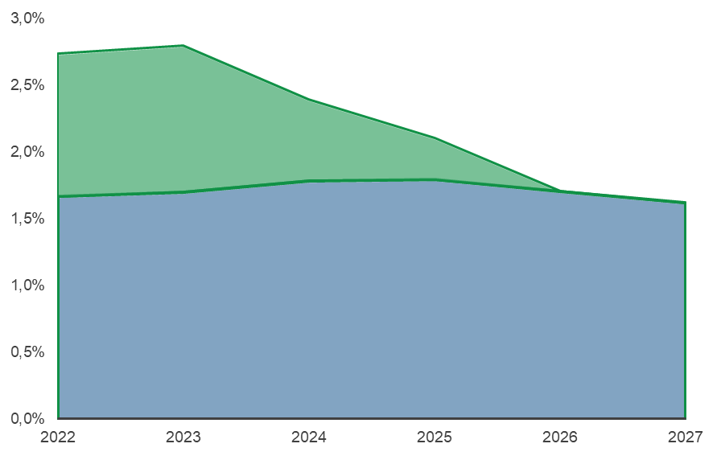

NextGenerationEU

MFF

1. Forecast of inflows of the EU budget 2023-2027

The EU budget is financed by own resources and other revenue. In addition, the Union has been empowered to borrow funds to finance NextGenerationEU. The Commission is mobilising the funds through operations on international capital markets, in line with the financing needs of NextGenerationEU’s spending programmes (see point 2.4). To this end, the Commission follows a diversified funding strategy[24] and, as part of this strategy, publishes annual borrowing decisions and six-monthly funding plans. The present forecast focuses on the revenue necessary to finance the budget expenditure within the MFF.

The overall amount of own resources needed to finance the budget is determined by the total expenditure less other revenue. Accordingly, the forecast of the EU budget revenue for 2023-2027 is based on the principle that expenditure must be matched by revenue; therefore total revenue equals total expenditure.

Since 2021, in line with the Withdrawal Agreement (part V), the United Kingdom has contributed to the EU budget in relation to outstanding commitments of previous multiannual financial frameworks. This includes the RAL at the end of 2020, as well as pensions and other liabilities laid down in the financial settlement. The United Kingdom’s contribution constitutes ‘other revenue’ of the EU budget and is not part of the Union’s own resources. It will progressively phase-out as the outstanding commitments will be settled.

Other miscellaneous elements not forming part of the Union’s own resources are assumed to remain nominally constant at the level of the 2023 Draft Budget.

The remaining financing – national contributions and customs duties – accounts for most of the revenue needed to balance the budget expenditure. The revenue forecast is based on the parameters of the Own Resources Decision 2020, which introduced a new own resource based on non-recycled plastic packaging waste. The projections further include the refined own resource based on the Value Added Tax as well as Member States’ increased retention rate of customs duties to cover their collection costs. They do not consider the Commission’s proposals on new own resources of 22 December 2021[25]. This also applies to future proposals that the Commission has committed to present in accordance with the interinstitutional agreement (IIA)[26].

On average for the period 2023-2027, national contributions are projected at EUR 146 billion per year or 0.8% of the EU’s Gross National Income. The spending cycle and the phasing out of the United Kingdom contribution mainly determine the development of national contributions over the forecast period. From 2025 onwards, increasing expenditure resulting from the new programmes entering cruising speed and the United Kingdom contribution to the RAL phasing out will keep national contributions increasing steadily through 2027.

Chart 5 - Revenue forecast for financing the MFF 2023-2027 (in EUR billion)

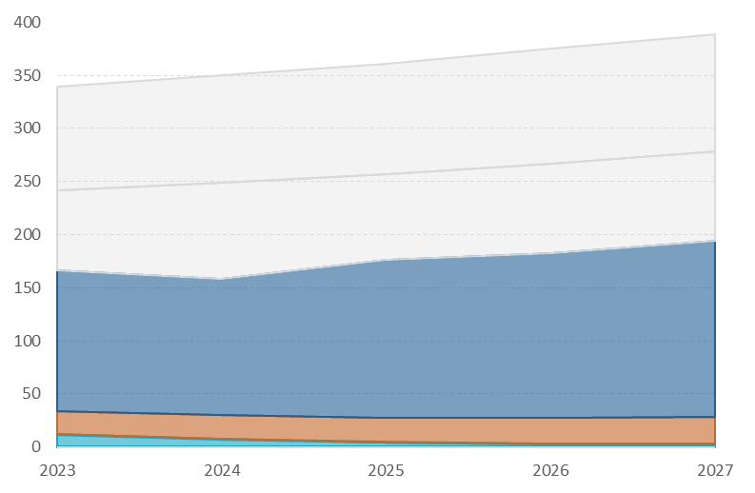

*Own Resources ceiling 2.00% GNI*

*Own Resources ceiling 1.40% GNI*

**National contributions**

**Traditional own resources (net)**

**Other revenue**

In any given year, the total own resources collected by the Union may not exceed the own resources ceiling set in the Own Resources Decision[27] of 1.40% of Gross National Income of the EU Member States, with an additional temporary increase of 0.6% of EU GNI for covering all liabilities of the Union from the borrowing on the capital markets to fund NextGenerationEU. While own resources are projected to grow steadily until 2027, the available margin under the Own Resources celling (so called “headroom”) is expected to remain largely stable as the Union’s Gross National Income is expected to increase gradually over the reference period[28]. The headroom stands on average at EUR 187 billion over the period, of which EUR 104 billion for the increase of NextGenerationEU.

The EU budget is providing for the payments of interests on the funds borrowed and allocated to non-repayable support under NextGenerationEU since borrowing started in 2021. The own resources necessary to finance those costs are counted within the temporary increase of 0.6% of EU GNI of the Own Resources ceiling. Over 2021-2027, a total of EUR 14.7 billion is planned to finance the costs of NextGenerationEU[29]. The planned costs follow a backloaded profile to reflect the progressive rollout of borrowing. At the same time, there are uncertainties related to the financing cost of NGEU in light of the rapid and substantial increase of interest rates on the financial markets since December 2021.

1. Conclusions

The present forecast is drawn up in a context of high uncertainty resulting from the war in Ukraine. The initiatives already put forward for supporting Member States and specific sectors facilitate full absorption and accelerated payments for ongoing programmes. External financing instruments are making more funding available for Ukraine and the neighbouring partner countries. Going forward, demands are expected to remain high implying advanced disbursements from the relevant EU budget instruments, as reflected in the forecast.

The MFF payment ceiling remains sufficient to cover the projected payments in each of the next five years thanks to the MFF mechanisms for automatic adjustment, notably the possibility to transfer unused amounts towards the end of the period when needs will peak. However, the net margin over 2023-2027 is roughly EUR 1.3 billion. Its size will have to be closely monitored going forwards, especially to measure the potential effects of new policy initiatives or of further acceleration of payments for ongoing programmes.

While the completion of ongoing programmes has advanced, the late adoption of the legislative package of the 2021-2027 MFF triggered by the COVID-19 pandemic has given rise to more delays at the start of the MFF and higher de-commitment risksthan previously anticipated for the majority of new programmes in shared management. This backloads payment needs to the remainder of the MFF. Another consequence is the higher risk of effective loss of funds in the later years of the programming period due to automatic de-commitments if Member States do not deploy efforts to recuperate the initial delays, starting already from the first years of effective implementation.

Thanks to NextGenerationEU’s support to investments and reforms, the EU budget will continue to be at the heart of the European post-COVID economic recovery in the next years**,** when the previous MFF programmes come to an end and before the new programmes reach cruising speed**.** The necessity to implement NextGenerationEU funds ahead of the deadline for disbursements by 2026 may affect Member States’ capacity to put additional efforts to accelerating the launch of the new programming period for funds in shared management under the MFF.

NextGenerationEU will also have a temporary effect on the level of the EU outstanding commitments**,** which will peak at the end of 2023 and then gradually will return to levels comparable with the start of the MFF period by the end of 2027. While the RAL nominally increases at the end of the MFF compared to 2023, when measured as a share of the EU Gross National Income the RAL is reduced, which shows that the nominal growth of the EU economy outweights the accumulation of outstanding commitments from the EU budget.

The forecast revenue (mostly EU own resources) necessary to finance the budget will steadily grow in line with the MFF expenditure. Yet, the size of the available margin under the Own Resources ceiling (the ‘headroom’) will remain relatively stable as the increasing revenue needs match the projected nominal growth of the EU economy.

Annex I – Results of the forecast*

*\*All values are in billions of EUR, current prices, unless otherwise specified. Some totals may not tally due to rounding.*

## Table 1.1 – Long-term forecast of future outflows over 2023-2027 for the MFF

|  |  |  |  |  |  |  |
| --- | --- | --- | --- | --- | --- | --- |
| Year | 2023 | 2024 | 2025 | 2026 | 2027 | Total |
| *Commitment Ceiling* | *182.7* | *184.3* | *187.9* | *179.7* | *185.4* | ***919.9*** |
| *Payment Ceiling* | *168.6* | *168.9* | *172.2* | *175.7* | *179.2* | ***864.5*** |
| *In addition, adjustment for Article 5 MFFR (estimate for future years)* | *0.0* | *1.7* | *1.7* | *1.8* | *4.2* | ***9.4*** |
| Commitments (programmed)* | *185.7* | *187.4* | *192.2* | *183.0* | *191.0* | ***939.4*** |
| Forecast Payments* | *166.3* | *158.0* | *176.3* | *182.8* | *193.9* | ***877.3*** |
| *Of which Special Instruments\*\** | *3.2* | *0.1* | *1.2* | *0.0* | *0.0* | ***4.6*** |

## Table 1.2 – Payments in relation to the commitments of the 2021-2027 MFF

|  |  |  |  |  |  |  |
| --- | --- | --- | --- | --- | --- | --- |
| MFF Heading | 2023 | 2024 | 2025 | 2026 | 2027 | Total |
| 1 Single Market, Innovation and Digital | 15.5 | 18.2 | 21.0 | 22.2 | 22.8 | **99.8** |
| 2 Cohesion, Resilience and Values | 11.8 | 25.5 | 53.3 | 58.9 | 76.1 | **225.6** |
| 2.1 Economic, Social and territorial cohesion | 5.4 | 16.9 | 44.0 | 48.1 | 63.0 | **177.4** |
| 2.2 Resilience and Values | 6.4 | 8.5 | 9.3 | 10.8 | 13.1 | **48.2** |
| 3 Natural Resources and Environment | 46.1 | 56.1 | 58.8 | 61.0 | 56.9 | **278.9** |
| 3.1 Market related expenditure and direct payments | 40.7 | 41.6 | 41.8 | 41.9 | 42.0 | **208.1** |
| 3.2 Other programmes of Natural Resources and Environment | 5.4 | 14.5 | 17.0 | 19.1 | 14.9 | **70.8** |
| 4 Migration and Border Management | 2.4 | 3.8 | 4.4 | 4.7 | 4.8 | **20.1** |
| 5 Security and Defence | 0.9 | 1.8 | 1.9 | 2.3 | 2.3 | **9.2** |
| 6 Neighbourhood and the World | 9.5 | 13.0 | 15.0 | 15.7 | 15.6 | **69.0** |
| 7 European Public Administration | 11.4 | 11.8 | 12.2 | 12.6 | 13.0 | **61.0** |
| Special Instruments | 2.7 |  | 1.1 |  |  | **3.8** |
| Total | **100.3** | **130.3** | **167.8** | **177.4** | **191.6** | **767.4** |

## Table 1.3 – Payments for the completion of pre-2021 commitments

|  |  |  |  |  |  |  |
| --- | --- | --- | --- | --- | --- | --- |
| MFF Heading | 2023 | 2024 | 2025 | 2026 | 2027 | Total |
| 1 Single Market, Innovation and Digital | *5.4* | *4.1* | *3.1* | *1.8* | *1.3* | ***15.6*** |
| 2 Cohesion, Resilience and Values | *44.0* | *18.0* | *1.3* | *1.2* | *0.2* | ***64.6*** |
| 2.1 Economic, Social and territorial cohesion | *43.7* | *17.7* | *1.2* | *1.1* | *0.2* | ***63.9*** |
| 2.2 Resilience and Values | *0.3* | *0.3* | *0.1* | *0.1* | *0.0* | ***0.7*** |
| 3 Natural Resources and Environment | *11.4* | *1.0* | *0.4* | *0.4* | *0.1* | ***13.3*** |
| 3.1 Market related expenditure and direct payments | *0.0* |  |  |  |  | ***0.0*** |
| 3.2 Other programmes of Natural Resources and Environment | *11.4* | *1.0* | *0.4* | *0.4* | *0.1* | ***13.3*** |
| 4 Migration and Border Management | *0.7* | *0.5* | *0.1* | *0.0* | *0.0* | ***1.3*** |
| 5 Security and Defence | *0.2* | *0.2* | *0.2* | *0.1* | *0.0* | ***0.7*** |
| 6 Neighbourhood and the World | *4.2* | *3.9* | *3.5* | *1.9* | *0.7* | ***14.2*** |
| Total | ***65.9*** | ***27.7*** | ***8.5*** | ***5.4*** | ***2.4*** | ***109.8*** |

*\* The total commitments and estimated payments include appropriations stemming from Article 5 of the MFF Regulation and Article 15(3) of the Financial Regulation. Unallocated margins are not included.*

*\*\* The amounts for special instruments cover the Solidarity and Emergency Aid Reserve, the European Globalisation Adjustment Fund, the Brexit Adjustment Reserve and the Flexibility Instrument. In the subsequent tables, the payments related to the mobilisations of the Flexibility Instrument are included within the respective headings.*

## Table 2 – Forecast de-commitments

|  |  |  |  |
| --- | --- | --- | --- |
| MFF Heading | Completion | MFF | Total |
| 1 Single Market, Innovation and Digital | *1.5* | *1.5* | ***3.0*** |
| 2 Cohesion, Resilience and Values | *0.7* | *1.0* | ***1.7*** |
| 2.1 Economic, Social and territorial cohesion | *0.4* | *0.4* | ***0.8*** |
| 2.2 Resilience and Values | *0.3* | *0.7* | ***0.9*** |
| 3 Natural Resources and Environment | *0.8* | *0.8* | ***1.5*** |
| 3.2 Other programmes of Natural Resources and Environment | *0.8* | *0.8* | ***1.5*** |
| 4 Migration and Border Management | *0.3* | *0.5* | ***0.8*** |
| 5 Security and Defence | *0.1* | *0.1* | ***0.1*** |
| 6 Neighbourhood and the World | *0.1* | *0.3* | ***0.4*** |
| Total | ***3.4*** | ***4.1*** | ***7.6*** |

## Table 3 – Long-term forecast of outflows for NextGenerationEU

|  |  |  |  |  |  |  |
| --- | --- | --- | --- | --- | --- | --- |
| Programme | 2023 | 2024 | 2025 | 2026 | 2027 | Total |
| Horizon Europe | *1.8* | *1.3* | *0.4* | *0.1* | *0.0* | ***3.5*** |
| InvestEU Fund | *1.2* | *1.2* | *1.0* | *1.2* | *0.0* | ***4.7*** |
| European Regional Development Fund (ERDF) | *10.0* | *3.5* | *1.1* | *0.0* | *0.0* | ***14.6*** |
| European Social Fund (ESF) | *5.5* | *6.2* | *2.4* | *0.0* | *0.0* | ***14.1*** |
| European Recovery and Resilience Facility | *76.4* | *56.9* | *38.5* | *50.6* | *0.0* | ***222.4*** |
| Union Civil Protection Mechanism (RescEU) | *0.5* | *0.8* | *0.2* | *0.2* | *0.2* | ***1.9*** |
| European Agricultural Fund for Rural Development (EAFRD) | *2.4* | *2.1* | *1.4* | *0.7* | *0.0* | ***6.6*** |
| Just Transition Fund | *0.2* | *2.4* | *4.0* | *4.1* | *0.0* | ***10.7*** |
| Total | ***98.0*** | ***74.5*** | ***48.9*** | ***56.8*** | ***0.2*** | ***278.4*** |

## Table 4 – Change in the total outstanding commitments from 2023 to 2027

|  |  |  |  |  |  |  |  |  |  |  |  |  |  |  |  |  |  |  |  |  |  |  |  |  |  |  |
| --- | --- | --- | --- | --- | --- | --- | --- | --- | --- | --- | --- | --- | --- | --- | --- | --- | --- | --- | --- | --- | --- | --- | --- | --- | --- | --- |
| |  |  |  |  |  |  | | --- | --- | --- | --- | --- | --- | | Source | RAL start-2023* (estimate) | Commitments 2023-2027 | Payments 2023-2027 | Decommitments 2023-2027 | RAL end-2027 | | MFF | 259.8 | 939.4 | 877.3 | 7.6 | 314.4 | | NGEU | 165.4 | 113.0 | 278.4 |  | 0.0 | | | Total | **425.1** | **1052.5** | **1155.6** | **7.6** | **314.4** | | |
| *\* The RAL at the start of 2022 includes EUR 3.3 billion generated from third-country contributions to specific programmes of the 2014-2020 MFF, which is not included in the table.* |

## Table 5 – Long-term forecast of future inflows of the EU budget over 2023-2027

|  |  |  |  |  |  |  |  |
| --- | --- | --- | --- | --- | --- | --- | --- |
|  |  | 2023 | 2024 | 2025 | 2026 | 2027 | Total |
| INFLOWS |  |  |  |  |  |  |  |
| *Own Resources ceiling in % of EU Gross National Income* |  | ***2,00%*** | ***2,00%*** | ***2,00%*** | ***2,00%*** | ***2,00%*** | ***n/a*** |
| *of which temporary increase for NGEU* |  | *0,60%* | *0,60%* | *0,60%* | *0,60%* | *0,60%* | *n/a* |
| *Own Resources ceiling expressed in EUR billion\** | *a* | *326,9* | *342,0* | *357,0* | *371,8* | *386,3* | ***n/a*** |
| *of which temporary increase for NGEU* | *a’* | *98,1* | *102,6* | *107,1* | *111,5* | *115,9* | *n/a* |
| Net amount of traditional own resources** | *b* | *21,6* | *22,6* | *23,6* | *24,6* | *25,6* | *118,0* |
| National contributions*** | *c* | *132,6* | *127,7* | *148,4* | *155,1* | *165,5* | *729,4* |
| Total own resources | *d =b+c* | *154,2* | *150,4* | *172,0* | *179,7* | *191,2* | *847,4* |
| *of which own resources related to NGEU liabilities* | *d’* | *1,0* | *2,1* | *2,7* | *3,7* | *5,0* | *14,5* |
| Other revenue (incl. provisional UK contribution) | *e* | *12,1* | *7,6* | *4,3* | *3,1* | *2,7* | *29,8* |
| TOTAL REVENUE | ***d+e*** | ***166,3*** | ***158,0*** | ***176,3*** | ***182,8*** | ***193,9*** | ***877,3*** |
| *Available margin under the Own Resources ceiling* | *a-d* | *172,7* | *191,6* | *185,0* | *192,1* | *195,1* | *n/a* |
| *of which margin under the temporary increase for NGEU* | *a’-d’* | *97,0* | *100,5* | *104,4* | *107,8* | *110,9* | *n/a* |

*\* Own Resources ceiling - calculated on the basis of the Spring 2022 economic forecast for the Gross National Income of the EU27 for 2023-2027*

*\*\* Traditional own resources are estimated on the basis of 25% retention rate for collection costs.*

*\*\*\* National contributions include the Gross National Income-based own resource, the reformed Value Added Tax-based own resource and the new own resource based on non-recycled plastic packaging waste.*

1. Unless otherwise specified, all amounts in the report are expressed in current prices.
2. Council Regulation (EU, Euratom) 2020/2093 laying down the multiannual financial framework for the years 2021 to 2027, OJ L 433I, 22.12.2020, p. 11.
3. Council Regulation (EU) 2020/2094 establishing a European Union Recovery Instrument to support the recovery in the aftermath of the COVID-19 crisis, OJ L 433I , 22.12.2020, p. 23 (‘NextGenerationEU’).
4. COM(2021)343, 30.6.2021.
5. Regulation (EU, Euratom) 2018/1046 of the European Parliament and of the Council of 18 July 2018 on the financial rules applicable to the general budget of the Union, amending Regulations (EU) No 1296/2013, (EU) No 1301/2013, (EU) No 1303/2013, (EU) No 1304/2013, (EU) No 1309/2013, (EU) No 1316/2013, (EU) No 223/2014, (EU) No 283/2014, and Decision No 541/2014/EU and repealing Regulation (EU, Euratom) No 966/2012, OJ L 193, 30.7.2018, p. 1.
6. COM(2022) 400 - June 2022.
7. COM(2022) 80 final, 28.1.2022.
8. Article 5 of the MFF Regulation provides for the additional allocation in commitment and payment appropriations for a pre-defined list of programmes, for an amount equivalent to the revenue from competition fines, as entered in the budget of the year n-1 in accordance with Article 107 of the Financial Regulation.
9. Article 15(3) of the Financial Regulation provides that commitment appropriations corresponding to the amount of de-commitments made in relation to research projects may be made available again to the benefit of the research programme the projects belong to or its successor in the context of the budgetary procedure.
10. Council Decision (EU, Euratom) 2020/2053 of 14 December 2020 on the system of own resources of the European Union and repealing Decision 2014/335/EU, Euratom, OJ L 424, 15.12.2020, p. 1.
11. OJ C66 I, 19.2.2019, p.1.
12. COM(2021)365, 7.6.2021 and COM(2022)266, 7.6.2022.
13. For reference, the 2021 long-term forecast expected a delay comparable to the 2014-2020 period when around half of the amounts due in the first year of implementation had to be postponed.
14. COM(2022) 231 final, 18.5.2022
15. COM(2022) 57 final, 15.2.2022.
16. COM(2022) 46, 8.2.2022.
17. Regulation (EU) 2021/1755 of the European Parliament and of the Council of 6 October 2021 establishing the Brexit Adjustment Reserve, OJ L 357, 8.10.2021, p. 1–26
18. COM(2022) 109 final, 8.3.2022.
19. COM(2022) 242 final, 20.5.2022.
20. Given its demand-driven delivery mechanism, no forecast is available for the loan component of the Recovery and Resilience Facility (similarly to other loan-based instruments implemented outside the budget).
21. With one Member State discussions take place on the basis of a draft plan.
22. Regulation (EU) 2022/613 of the European Parliament and of the Council of 12 April 2022 amending Regulations (EU) No 1303/2013 and (EU) No 223/2014 as regards increased pre-financing from REACT-EU resources and the establishment of a unit cost, OJ L 115, 13.4.2022, p. 38–41.
23. Just Transition Fund, European Agricultural Fund for Rural Development, Horizon Europe, InvestEU fund and the Union Civil Protection Mechanism (RescEU)
24. COM(2021) 250 final, 14.4.2021.
25. COM(2021) 570 final, 22.12.2021.
26. Annex II, part B of the Interinstitutional Agreement between the European Parliament, the Council of the European Union and the European Commission on budgetary discipline, on cooperation in budgetary matters and on sound financial management, as well as on new own resources, including a roadmap towards the introduction of new own resources Interinstitutional Agreement of 16 December 2020 between the European Parliament, the Council of the European Union and the European Commission on budgetary discipline, on cooperation in budgetary matters and on sound financial management, as well as on new own resources, including a roadmap towards the introduction of new own resources, OJ L 433I , 22.12.2020, p. 28–46.
27. Council Decision (EU, Euratom) 2020/2053 of 14 December 2020, OJ L 424/1, 15.12.2020
28. European Commission, European Economic Forecast Spring 2022: [European Economic Forecast. Spring 2022 | European Commission (europa.eu)](https://ec.europa.eu/info/publications/european-economic-forecast-spring-2022_en), (<https://ec.europa.eu/info/publications/european-economic-forecast-spring-2022_en>)
29. Without prejudice to introducing new own resources with a view to covering NextGenerationEU repayment and interest costs.