REPORT FROM THE COMMISSION TO THE EUROPEAN PARLIAMENT AND THE COUNCIL
on the implementation of Regulation (EU) 2021/821 setting up a Union regime for the control of exports, brokering, technical assistance, transit and transfer of dual-use items

1. Introduction
This report provides information on the implementation of EU export controls for dual-use items in 2021 and provides aggregated export control data for 2020. It was prepared by the Commission with input from Member States in the Dual Use Coordination Group (DUCG). 2021 saw the adoption of a new Export Control Regulation, which marks an important milestone in the development of EU export control policy.
This report is adopted together with the Annual Report on FDI Screening as export control and FDI screening both provide strategic trade and investment controls to ensure security in the European Union.
The report covers activities in 2021 and therefore does not cover aspects of export controls touched by, or measures taken in the form of export restrictions in response to, Russia’s war of agression in Ukraine. Those events have brought the issue of Russian and Belarusian access to dual use technologies into sharp political focus, albeit in the context of the application of sanctions, including export bans and restrictions, by the European Union.

2. Evolution of the policy & regulatory framework

2.1. Export control policy
2.1.1. Modernisation of EU export controls - new Export Control Regulation
Further to the adoption of a new Export Control Regulation on 19 May 2021 and its entry into force on 9 September 2021, the Commission and the Member States have initiated its effective implementation, in a number of new areas - e.g. transparency, enforcement, capacity-building. The DUCG played a key role, as described in chapter 3 below, and expanded the EU export control “institutional infrastructure” through the creation of a number of expert groups to develop new policies, guidelines, procedures, etc. The annex to this report sets out the various work strands and related indicative timelines.
2.1.2 Consultations and outreach

In 2021, the Commission conducted a series of targeted consultations of industry and civil society stakeholders including on priorities for the newly established EU-US Trade and Technology Council (“TTC”) - See section 2.1.3. The Commission also organised, jointly with the Slovenian Presidency of the Council of the EU, the annual Export Control Forum on 8 December 2021. This provided an opportunity to exchange views on the implementation of EU export controls and the modernised EU export controls regime with more than 800 industry and civil society stakeholders.

2.1.3 Cooperation with third countries

In June 2021, the EU and the U.S. established the Trade and Technology Council, which met for the first time in Pittsburgh on 29 September 2021 and agreed on an ambitious Joint Statement, including cooperation on export control. One of the ten Working Groups is dedicated to export controls, sharing information and working on themes like legislative and regulatory developments, risk assessments and licensing good practices, as well as on approaches to industry compliance and enforcement. Furthermore, this working group aims at promoting convergent control approaches on sensitive dual-use technologies, and perform joint industry outreach on dual-use export controls.

The TTC aims to ensure greater coordination in approaches on trade and technology issues, so that a holistic approach is taken across different work strands. In that context, aspects of other groups such as those on secure supply chains, and particularly, semi-conductors, or on the screening of foreign investment are also impacted by export controls.

Generally, the EU and U.S. agreed in Pittsburgh to enhance cooperation in the following areas:

- Technical consultations on current and upcoming legislative and regulatory developments, including regular adjustments to control lists and specific license exceptions/General Export Authorisations, development of guidelines;
- Technical consultations and development of convergent control approaches on sensitive dual-use technologies, and information exchange on risks associated with the export or transfer of sensitive technologies to destinations and entities of concern;
- Technical consultations on compliance and enforcement approaches and actions;
- Capacity building assistance to third countries to develop their legal frameworks support their capacity to implement and enforce control; and
- Technical consultations regarding multilateral and international cooperation, including in relation to multilateral export control regimes, as appropriate.

The TTC’s Export Control Working Group actively engaged with stakeholders in order to prepare its work. A joint Stakeholder Meeting was held on 27 October 2021 bringing together more than 200 representatives from industry and civil society and academic experts to discuss its priorities and this was followed by a public consultation during December 2021 and January 2022 – in parallel with the US.

On 26 October 2021, the Commission organised an export control dialogue with the six Western Balkan partners to support their efforts to align with the acquis communautaire including EU dual-use export controls. The EU reaffirmed its readiness to continue supporting alignment to EU export controls and offered to make the EU’s electronic licensing tool available to Western Balkan countries at their request.

2.2. Amendments under the Regulation (EU) 2021/821
2.2.1. Update to the EU control list

The EU Control List in Annex I to the Regulation essentially provides a list of dual-use items, including software and technology, which should be subject to controls given that it can be used for both civil and military purposes. It is updated on a regular basis to reflect changes in the Multilateral Export Control Regimes. It was amended once in 2021 to incorporate the decisions agreed from March to December 2020 in the context of those regimes (in particular under the Wassenaar Agreement and in the Australia Group).

Amendments to the EU control list in 2021

The amendments relate in particular to the control of biocontainment chambers, isolators, or biological safety cabinets (2B352.f.2 Note 2) in order to include any isolator meeting all of the characteristics mentioned in the description of the item, regardless of its intended use and its designation. The 2021 EU control list also introduces a change to the definition of "superalloys", in order to specify the ultimate tensile strength of such materials.

The updated and consolidated EU Control List entered into force on 7 January 2022, thereby allowing the EU to comply with its international commitments. The Commission published guidance providing an overview of all changes to the 2021 EU Dual-Use Control List summarised in a "Summary Note".

2.3. National implemention and enforcement measures
2.3.1. Implementation measures
The Regulation is binding in its entirety and directly applicable in all Member States. However, it provides that Member States may take certain measures for the implementation of specific provisions, such as whether a licence has to be requested for certain dual use items, where the exporter may suspect that the items are going to used in a way not allowed by the Regulation. It requires that information on those national measures are published in the Official Journal of the European Union. Accordingly, the Commission published an Information Note on 8 February 2021 which provides an updated overview of measures taken by Member States including, inter alia, the extension of brokering and transit controls, the extension of controls to non-listed items for reasons of public security and human rights considerations, the introduction of national general export authorisations, the application of intra-EU transfer controls for non-listed items. This Information Note reflects the EU's actions to ensure the transparency of applicable rule and efforts to support the consistent and effective implementation of controls by exporters throughout the EU.
2.3.2. Enforcement measures
The Commission was not informed of any new developments in 2021. The list of national enforcement measures published together with the 2019 annual export control report remains valid.

2.4 Exports from Northern Ireland
Exports of dual-use items from the EU to the UK became subject to control under the Regulation with the UK’s departure from the Union on 1st January 2021, just like exports to any other third country.

Specific arrangements are set forth in the Northern Ireland (NI) Protocol, which provides that the Regulation applies to, and in the United Kingdom in respect of Northern Ireland, with the UK acting as a competent authority under the Regulation for exports from Northern Ireland to third countries outside the EU. The Commission developed a dedicated secure electronic tool to support the exchange of information with the UK competent authority in charge of applying the Regulation in and from Northern Ireland. This enables this authority to access information on denials for essentially identical transactions issued by the EU Member State, and have bilateral consultation with issuing Member State, as foreseen by the Regulation.

3. Activities of the Dual-Use Coordination Group
The DUCG brings together experts from the Commission and Member States to examine any issue concerning the application of export controls. It held six meetings in 2021.

3.1. Consultations on implementation issues - general information exchange
The Commission and Member States’ representatives in the DUCG conducted general information exchanges on export control issues, including in support of the legislative modernisation of EU export controls.

The Commission coordinated an exchange of information among Member States in the DUCG regarding national implementing measures and prepared the update of the Information Note on national measures with the support of the DUCG.

With the entry into force of the new Regulation in September 2021, the DUCG started to work on its implementation, agreeing to regularly exchange information. For instance, the Commission invited Member States in the the DUCG to start reflecting on the new provisions of the Regulation, requiring publication of national measures and national control lists (Articles 9 and 10).

The Commission collected information on licensing data with the support of the DUCG in order to provide an overview of the implementation of export controls and to increase public transparency on EU dual-use export controls (EU 2020 aggregated data was used in the preparation of this annual report).

The DUCG conducted a technical exchange of information on the application of controls on cyber-surveillance technologies in 2020. The data collected from Member States shows a decrease in the number of licences for the export of these technologies (see Table 1), with a total of 39 licenses for listed cyber-surveillance items issued in 2020. In the same period, 32 denials were issued for cyber-surveillance items.

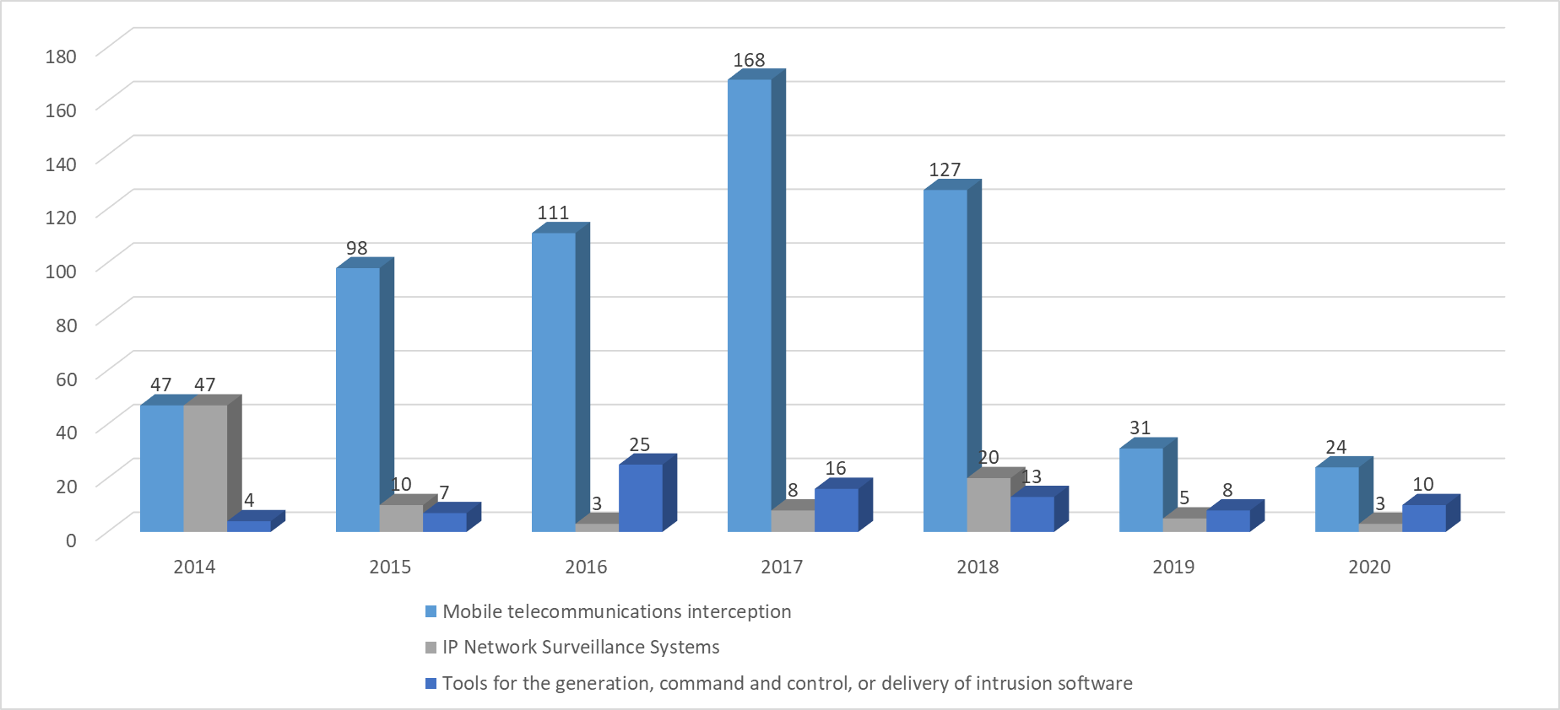

Table 1: Number of individual licences for listed cyber-surveillance items.

3.2. Technical exchange of information – implementation issues
Under coordination of the Commission, the DUCG took initiatives to address certain technical implementation issues and set up dedicated expert groups to implement the requirements of the new Regulation.

Member States’ competent authorities in the DUCG provided technical expertise supporting the updates to the EU control list, and engaged in discussions on a number of specific implementation issues such as the need to enhance information exchange under EU General Export Authorisations (EUGEAs) and under global licences, or the development of a consultation mechanism between competent authorities concerning information on exporters using global licences.

With respect to technical expert groups, whose role is now recognised in the new Regulation, the Surveillance Technology Expert Group (STEG) was reactivated and its Terms of Reference revised in order to reflect the new provisions of the Regulation. The STEG allows experts from Member States to contribute to the development of EU controls on exports of cybersurveillance technologies. The STEG's mandate involves information exchange on risks associated with exports of cyber surveillance items and technical discussions of specific cyber surveillance items, as well as the development of due diligence guidelines for exporters. In 2021, experts shared information relevant to certain products, such as monitoring centres and data retention solutions (DRS), surveillance vehicles, and Voice over the Internet Protocol (VoIP) systems - as part of their technical review of potential cybersurveillance technologies.

The Technical Expert Group on the development of guidelines for dual use research (TEG-DUR) finalised EU Guidance on internal compliance programmes for research involving dual-use items, which apply also to the transfer of technology and knowledge associated with that research. This guidance was adopted as a Commission Recommendation in September 2021 and aims at helping researchers, research managers and compliance staff in universities and research organisations to identify, manage and mitigate risks associated with collaboration with partners located outside the EU (or researchers from outside the EU) on research projects which can actually be subject to dual-use export controls. The EU guidance serves as a common reference tool for Member States competent authorities in the development of specific outreach programmes and for deciding on export authorisations for dual-use items listed in Annex I of the Regulation. The guidance is non-binding and research organisations and researchers maintain the responsibility to comply with their obligations under the Regulation. The DUCG subsequently started developing a plan of actions to support the implementation and monitoring of the guidance.

A new Technical Expert Group on emerging technologies (ETEG) was launched as a dedicated forum for information exchange on risks associated with exports of emerging technologies and the challenges associated with their control. The ETEG held its first meeting in October 2021.

The Commission also prepared draft Terms of Reference – endorsed by the DUCG - for a Technical Expert Group on data collection and transparency (TEG-Transparency) and for an Enforcement Coordination Mechanism (ECM), which will support exchange of information and development of best practices among licensing and enforcement authorities in the EU.

Finally, the DUCG held initial discussions regarding the setting up of a Technical Expert Group on capacity-building with a view to supporting regular training and sharing of expertise within the EU dual-use community.

3.3. EU Guidelines on Dual-Use Export Controls
Guidelines for Dual-Use Research mentioned in section 3.2 above were adopted by the Commission and published on 23 September 2021.
The new Regulation introduces provisions for the control of exports of non-listed cyber-surveillance items to be backed up by guidelines for exporters to support their effective implementation. Those controls address the risk of such items being used in connection with internal repression or serious violations of human rights and/or international humanitarian law, The STEG has been working on the preparation of those guidelines including, inter alia, due diligence measures assessing risks related to the export of such items to end-users and for specific end-uses.

3.4. IT Tools for Exchange of Information among Member States and for Electronic Licensing
The Commission, supported by the DUCG, continued to develop the Dual-Use e-System (DUeS) as the IT backbone of the EU export control network. This platform has a key role in the effective application of the Regulation, for example, the information sharing foreseen under Article 5.

New functionalities were developed to support the exchange of information on denials for intra-EU transfers, and to support the regular review and update of denials' information by the competent authorities.

In consideration of Brexit, a new functionality supporting information-exchange with the UK under the NI Protocol was introduced in January 2021.

After several years of preparations, 2021 marked the first year of operation of the dual-use eLicensing system, with its introduction in two Member States - Latvia and Romania. eLicensing allows competent authorities and exporters to administer controls on-line more efficiently and reduce the administrative burden associated with controls. It is aimed at replacing off-line systems or outdated national electronic systems, allowing for more agile exchange of information - including in the reporting of licensing data to the Commission – and bringing further potential for exchange of data across the EU. The development of the eLicensing system continued in 2021 with other competent authorities joining the pilot project (Italy and Belgium - Walloon Region going live in 2022 and Slovenia foreseen in early 2023). Beyond the EU, as part of its dialogues with partner countries, the Commission is examining options for providing the eLicensing tool to partners e.g. the national authority in Bosnia and Herzegovina which has shown interest in using the tool.

The eLicensing project is also developing in new directions to make controls more effective, for example, by connecting the eLicensing system with national customs systems via the Customs’ Single Window environment. This will make sharing information across borders and with customs authorities much easier, reducing the regulatory burden for operators and allowing automatic licenses quantity management. This would be done through the Certification Exchage - “CERTEX” platform managed by DG TAXUD.

At the request of Member States that already operate eLicensing systems, the Commission initiated a new "eLicensing bridge" project to allow to connect national licensing systems to customs systems.

3.5. Implementation and enforcement
The Commission supervised an exchange of information on the implementation and enforcement of controls with the support of the DUCG. According to available data, the EU export control network – comprising staff in Member States’ licensing competent authorities and the Commission – consisted of over 345 staff. With respect to enforcement at a national level, 78 breaches of export control regulations were recorded in 2020, while eight administrative penalties and seven criminal penalties were applied by national law enforcement authorities.
3.6. Capacity building
In 2021, the Commission’s Joint Research Centre, with the support of DG Trade and the DUCG contributed to the preparation of the 14th JRC-National Nuclear Security Agency technical seminar for licensing authorities. This was organised by the Commission’s Joint Reseach Centre and the U.S. Department of Energy. It was was held over several sessions from September through November 2021. The seminar was focused on cyber-surveillance, cryptocurrencies, block-chain and proliferation financing.
3.7. Transparency and dialogue with industry and academia
As mentioned in section 2.1.2, the Commission – with the support of the DUCG – organised the 2021 Export Control Forum, and prepared documentation to support exporters in implemententing the regulation, including Guidelines on dual-use research and a "Comprehensive Change Note Summary 2020" explaining the changes to the Control List.

4. EU export controls – Key Data
It currently remains difficult to obtain reliable information on overall dual-use exports (including non-listed dual-use items) as there is no official category of “dual-use items” in official economic / trade statistics. However, the Commission and Member States collect data that allows for approximate estimates of exports of dual-use goods based, on the one hand, on specific licensing data collected by competent authorities and, on the other hand, on statistics for export declarations to EU customs which include dual-use goods. 2020 export data estimates are presented below. It should be noted that the estimates presented do not include services nor intangible technology transfers associated with the trade in dual-use goods.

4.1. EU dual-use trade: items and destinations
In 2021, the Regulation primarily applied to the export of about 1884 dual-use items listed in Annex I (the "EU Control List") and classified in 10 categories from Annex I to Regulation (EU) 821/2021 (Figure 1). These dual-use items relate to circa 1.000 “commodities” from the “customs nomenclature”, including chemicals, metals and non-metallic mineral products, computers, electronic and optical products, electrical equipment, machinery, vehicles and transport equipment, etc. and typically fall at the high–tech end of this large, mixed commodity area.
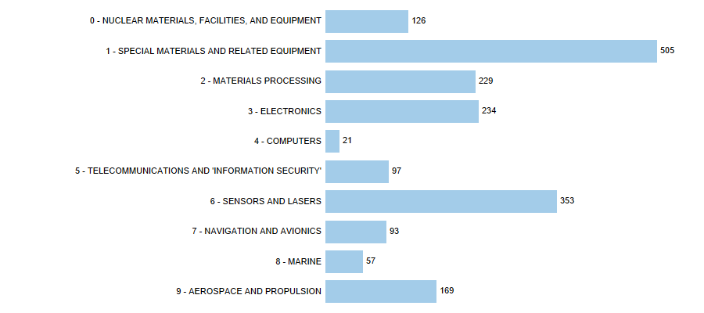
Figure 1: Number of dual-use entries listed in the ten Categories of Annex I of Regulation (EU) 2021/821.
Statistical estimates of the relative importance of dual-use trade indicate that dual-use exports represent about 2.7% of EU27 total exports (intra and extra-EU), within a broad ‘dual-use export domain’ of customs commodities that may include, to varying degrees, certain dual-use items (Figure 2). This would put the value of dual-use trade at € 128 billion in 2020.
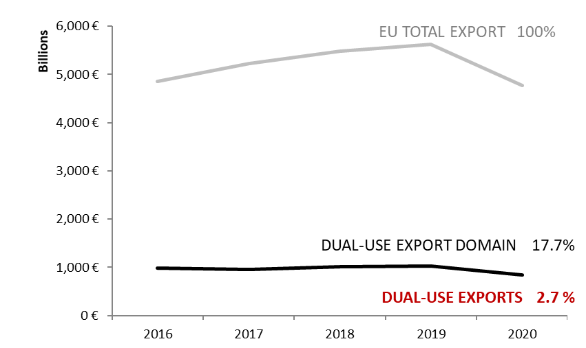
Figure 2: Statistical estimates of dual-use intra and extra-EU exports.
Statistical estimates also show the main export destinations and indicate that a large part of the dual-use exports are directed towards countries listed on European Union General Export Authorisations (EUGEAs). The ranking of destination countries reflects the EU export market in a basket of goods mostly related to dual-use items (Figure 3 and 4).
Figure 3: EU dual-use export estimates: top 25 export destination countries and their sub-regions in 2020.

Figure 4: EU dual-use export estimates: destination countries by regions and sub-regions in 2020

4.2. EU dual-use licenses: applications, authorisations, denials
In light of Article 23(2) of the Regulation, which stipulates that "Member States shall take all appropriate measures to establish direct cooperation and exchange of information between competent authorities with a view to enhance the efficiency of the Union export control regime", the Commission and Member States have exchanged licensing data and information in order to improve the understanding of export controls and their economic effect. This exchange has been supported by the DUCG. Some data collected for the reporting period is reported below; it should be noted, however, that not all Member States collect all data. The information provided below represents approximate estimates of aggregate quantities and values within the limits of the data made available by Member States.
In 2020 the total value of applications reached EUR 38.4 billion and controlled dual-use exports thus represented 2.3% of total extra-EU27 exports. Authorised dual-use trade amounted to EUR 31 billion, representing 1.9% of total extra-EU27 exports, with a majority of transactions authorised under individual licenses (around 19.412 single licenses issued in 2020) and global licenses (by their value). Only a small portion of exports were actually denied: 559 denials were issued in 2020, representing about 1.4% of the value of controlled dual-use exports in that year, and 0.03% of total extra-EU27 exports. Differences in data that indicate a decline in comparison to the previous years are due to Brexit and the fact that UK did not provide data since 2019. Concerning destinations for export licenses, the top 25 extra-EU destinations accounted for 94% of the licensed value, with the main destinations being China, the United States, Taiwan, South Korea and Russia. With respect to intra-EU transfers, the main destinations were France, Sweden, Finland, Germany, Spain and Belgium. Breaking down licenses by Categories of items in Annex I of the dual-use Regulation shows that the main category by value in 2020 was Category 5 on Telecommunication and ‘information security’, followed by Category 0 on Nuclear materials, facilities and equipment and Category 3 on Electronics.
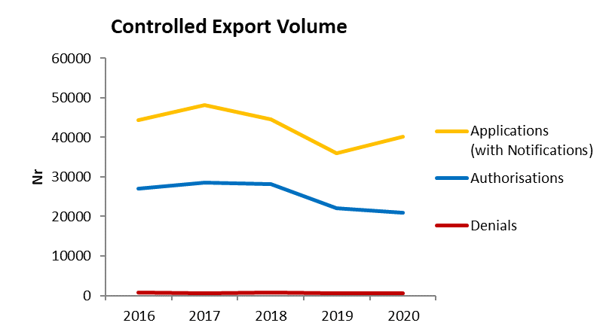
Figure 5: Volume (number) of authorisations and denials in 2016-2020.
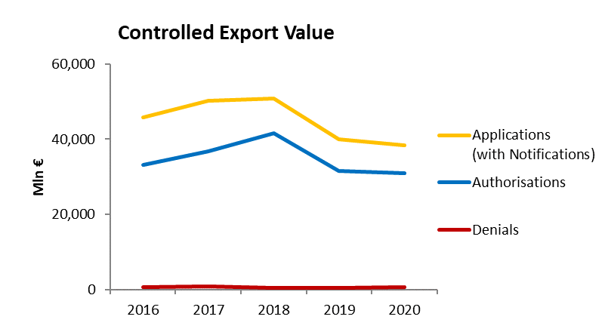
Figure 6: Value (mln EUR) of authorisations and denials in 2016-2020.

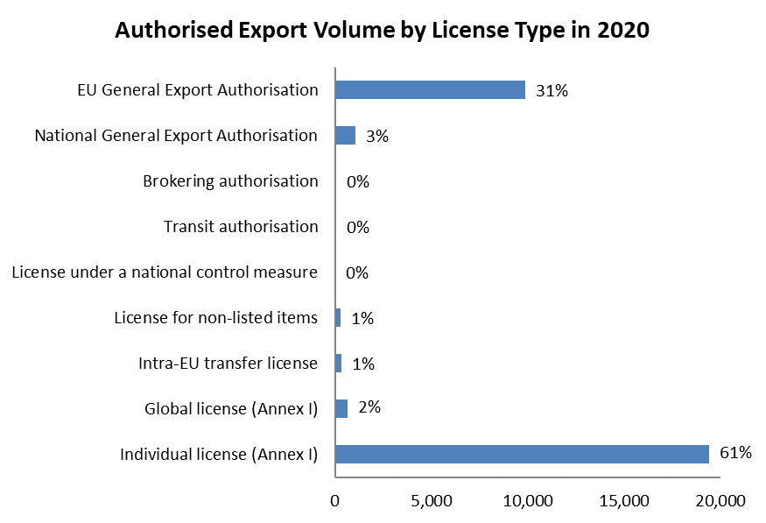
Figure 7: Volume (number) of authorisations per type of licence in 2020.

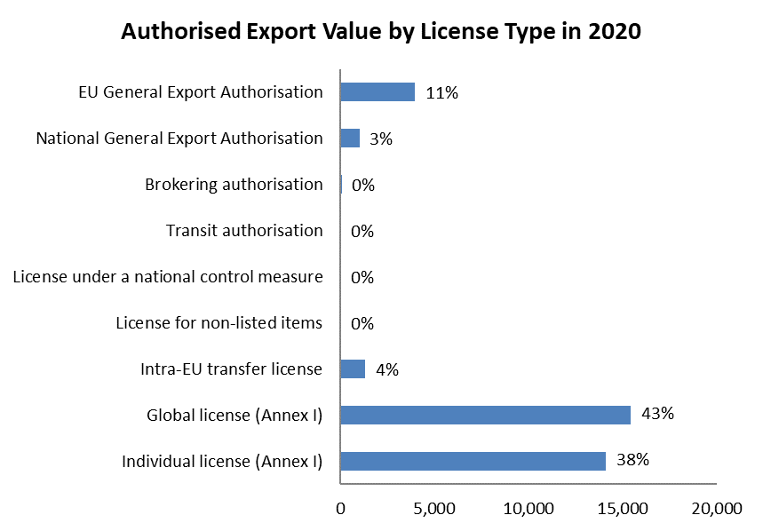
Figure 8: Value (mln EUR) of authorisations per type in 2020.

Figure 9:Main extra-EU destinations of authorisations in 2020.

Figure 10: Intra-EU destinations of authorisations in 2020.

Figure 11: Authorisations by the 10 Categories of Annex I of the dual-use Regulation.

5. Conclusion
Further to the various actions initiated in 2021, the Commission and the Member States will continue to focus on meeting the new requirements and mandates under the new Regulation. This includes continuing the work in the various technical expert groups towards enhanced controls on cyber-surveillance technologies, enhanced information-exchange and transparency, the enforcement of export controls, emerging technologies and the development of EU capacity-building and training programmes for Member States licensing and enforcement authorities.

These EU actions under the new Regulation will also allow the EU to cooperate more effectively with partners in order to promote the global convergence of controls, reduce trade frictions and increase predictability for businesses, promote EU values and uphold international peace and security.

2021 |  |  |  | 2022 |  |  |  | 2023
Q1 | Q2 | Q3 | Q4 | Q1 | Q2 | Q3 | Q4 | Q1 | Q2 | Q3 | Q4
 | Surveillance Technology Expert Group Reactivation | Due Dilligence Guidelines  Technical support to Art. 5 Controls / Publication of “EU Watchlist”
 |  | Set up Emerging Technology Expert Group | Technical support to the control of emerging technologies
Engaging with partners on cybersurveillance items, emerging technologies & other issues (US, Japan)
 |  |  | Set up Transparency TEG  Development of dedicated IT tools and development of Guidelines on Transparency |  |  |  |  | 2023 Annual Report (incl. 2022 data)
 |  | Set up Enforcement Group | Implement dedicated actions (e.g. information exchange tools, guidance notes, joint operations)
 |  |  | Set up Capacity-Building Group | Feasibility Study |  | EU Training Programme Curricula |  | Programme Kick-off

Some Member States’ competent authorities also publicly report on trade in dual-use items.
Regulation (EU) 2021/821 of the European Parliament and of the Council of 20 May 2021 setting up a Union regime for the control of exports, brokering, technical assistance, transit and transfer of dual-use items (recast) – (OJ L 206, 11.6.2021, p. 1) - https://eur-lex.europa.eu/eli/reg/2021/821/oj.
The previous annual report contains a description of key elements of the new Regulation (section 2.1.1. legislative modernisation).
This is also part of our "partnership with the private sector", which is a key element of the modernisation of EU export controls.
https://trade.ec.europa.eu/doclib/docs/2021/november/tradoc_159949.pdf.
https://ec.europa.eu/commission/presscorner/detail/en/STATEMENT_21_4951.
https://trade.ec.europa.eu/doclib/docs/2021/december/tradoc_159950.pdf.
https://futurium.ec.europa.eu/en/EU-US-TTC/wg7/documents/summary-public-feedback-consultation-working-group-7.
Albania, Bosnia and Herzegovina, Kosovo*, Montenegro, North Macedonia and Serbia.
Commission Delegated Regulation (EU) 2022/1of 20 October 2021 (OJ L 3, 6.1.2022, p. 1).
The Summary Note is available at: https://trade.ec.europa.eu/doclib/docs/2021/november/tradoc_159903.pdf
https://trade.ec.europa.eu/doclib/docs/2022/februarT/tradoc_160037.pdf
https://ec.europa.eu/transparency/documents-register/detail?ref=COM(2019)562&lang=en
OJ L 29, 31.1.2020, p. 7 (“Withdrawal Agreement”).
Article 5(4) of the NI Protocol and section 47 of annex 2 to that Protocol.
The DUCG approved this newDUeS functionality.
This report is also the annual report required by the new Regulation on the activities, examinations and consultations of the DUCG.
The updated information note was published on 8 February 2022, OJ Notice 2022/C66/27.
Mobile telecommunications interception equipment, IP network surveillance systems, intrusion software.
Commission Recommendation (EU) 2021/1700 of 15 September 2021 on internal compliance programmes for controls of research involving dual-use items under Regulation (EU) 2021/821 of the European Parliament and of the Council setting up a Union regime for the control of exports, brokering, technical assistance, transit and transfer of dual-use items
https://eur-lex.europa.eu/legal-content/EN/ALL/?uri=uriserv:OJ.L_.2021.338.01.0001.01.ENG
The list of categories reflects the Wassenaar Arrangement list, to which category 0 on nuclear items was added.
The statistical methodology developed by the Commission's Joint Research Centre makes use of a correlation table, developed by the Commission’s Customs and Taxation Department (DG TAXUD), between dual-use classification numbers and customs codes and of Eurostat’s COMEXT data, as well as of licensing data provided by EU27 Member States. The notion of dual-use export domain refers to a large mixed goods area, which includes dual-use items. Trade in dual-use items takes place within this goods area, but is not identical to it, since the products and items covered in that customs category will be much wider and cover many items that have purely civilian uses, or are not dual use.
"Stores and provisions extra" are defined as delivery of ships' and aircrafts' stores. ”Miscellaneous –countries not specified extra” includes countries and territories not specified within the framework of trade with third countries (i.e., these codes are usually used for goods delivered for offshore installations).
This figure includes value for licence applications and notifications under General Export Authorisations. General Export Authorisations allow exports of dual-use items to certain destinations under certain conditions while Global licenses can be granted by competent authorities to one exporter and may cover multiple items to multiple countries of destination or end users.
Individual licenses are licenses granted to one specific exporter for one end-user or consignee in a third country and covering one or more dual-use items.
Global licenses are licenses granted to one specific exporter in respect of a type or category of dual-use items which may be valid for exports to one or more specified end-users and/or in one or more specified third countries.
In Figures 5 and 6, "Applications" data include all applications for licenses, including notifications under general authorisations, thus providing an indication of "controlled exports", i.e. the value of extra-EU exports subject to an authorisation process. In cases where no application data is available, the charts make use of authorisation data as estimate for application data. "Authorisations" data refers to dual-use exports authorised under individual and global licences. It should be noted that applications do not necessarily correspond to the sum of authorisations and denials, as a number of applications may be cancelled and some applications may not be finalised within the same year. "Denial" refers to the volume and value of denied exports. Differences in data that indicate a decline in comparison to the previous years are due to Brexit and the fact that UK did not provide data since 2019.

