

1. **Introduction**

The Strategic Compass on Security and Defence[1], which the European Council endorsed in March 2022, emphasised that: “Russia’s military aggression against Ukraine has confirmed the urgent need to substantially enhance the military mobilityof our armed forces within and beyond the Union.” In view of “new commitments with the aim to substantially enhance and invest in military mobility”, it called for an “ambitious, revised Action Plan by the end of 2022”. This Action Plan on Military Mobility 2.0 responds to this call.

Military mobility is vital for our European security and defence. The EU Member States’ forces need to be able to respond quickly and with sufficient scale to crises erupting at the EU’s external borders and beyond. Moreover, in the context of the Russian aggression against Ukraine we have learned how important it is to move military aid as quickly and smoothly as possible.

Member States’ experience in the Ukraine context shows that the Union has taken steps forward on military mobility. For example, relevant arrangements developed by the European Defence Agency have helped Member States to shorten times for cross-border movement. Given the exceptional circumstances, Member States have often been ready to make exemptions to solve issues on a case-by-case basis to overcome their national restrictions. It is time to move from a case-by-case approach towards structural solutions. At the same time, we have also witnessed limitations - for example the different rail systems between Ukraine and EU Member States as well as within the European Union prevented optimal mobility solutions. The strong dependence on contracted civilian transportation solutions also became apparent.

Building on the progress made since the military mobility initiative was launched in 2017[2], this new Action Plan **opens the next chapter of work on military mobility for the period 2022-2026**. Enlarged in scope and proposing **additional measures,** it will contribute to a **well-connected military mobility network**, with **shorter reaction times** and **capable, secure, sustainable and resilient transport infrastructure and capabilities**.

The Action Plan addresses the need to further improve the capacity of transport infrastructure to handle the weight, size and scale of military movement with new measures to prioritise our work and include the fuel supply chain requirements for military transports. It continues the effort to streamline and harmonise complex, lengthy and diverging national rules and procedures, including by introducing new actions to support the further digitalisation of the administrative processes. It adds a new preparedness and resilience pillar that encompasses the development of strategic lift capabilities in line with the Coordinated Annual Report on Defence (CARD) Report of November 2020. It proposes measures to enhance the protection of the transport sector against cyber-attacks and other hybrid threats, and to promote its climate resilience and energy security. The new partnership pillar outlines proposals to strengthen dialogue, cooperation and connectivity with a range of external partners.

The **building blocks that have been put in place since 2018 provide a solid foundation** for this new Action Plan:

* The Council has approved the Military Requirements for Military Mobility within and beyond the EU, including technical specifications and main military routes.[3]
* There is a budget of EUR 1.69 billion for dual-use transport infrastructure projects under the Connecting Europe Facility (CEF) between 2021-2027.[4]
* The first CEF Work Programme for 2021-2023 and the Implementing Regulation on the dual-use requirements for these projects were adopted in August 2021.[5] This paved the way for the adoption of the first wave of projects worth EUR 339 million on 24 May 2022 while the second call was launched earlier in the same month. These dates were accelerated compared to the originally envisaged timelines in light of the war in Ukraine, in order to accelerate the implementation of infrastructure projects that will improve military mobility.
* The Commission has put forward a proposal for a revised trans-European transport network Regulation[6] which reflects for the first time also military mobility in the trans-European transport network. Coherence between the EU military network and the TEN-T networks has been improved and new infrastructure standards, that will directly improve military mobility, have been proposed in all modes of transport.
* Regulatory and procedural aspects have been addressed as well: the customs formalities for cross-border military movements have been simplified. Transport of dangerous goods in the military domain has been harmonised. A new directive (2019/2235) provides for an exemption of VAT and excise duty for goods or services used or acquired in the context of a defence effort carried out for the implementation of a Union activity under the Common Security and Defence Policy . Twenty-four EU Member States and Norway have joined the European Defence Agency Programme on “Optimising Cross-Border Movement Permission procedures in Europe”.
* In the framework of the Permanent Structured Cooperation (PESCO), Member States have launched different collaborative projects. The project on Military Mobility brings together twenty-five Member States and third countries[7] to coordinate relevant national measures including those agreed by the Member States in the so-called ‘military mobility pledge’ of 25 June 2018[8]. The project on Logistical Hubs involves 17 Member States working together to connect their logistical depots and capabilities to reduce reaction time and optimise the use of capacities.

1. **strategic Approach**

Following the direction set by the Strategic Compass and taking into account both the guiding principles spelled out in the 2018 Action Plan[9] and the changed strategic context, this Action Plan provides a comprehensive framework to enhance military mobility. It proposes further actions to enable the **swift, efficient and unimpeded movement of potentially large-scale forces**, including military personnel and their equipment, both in the context of the EU Common Security and Defence Policy, as well as for national and multinational activities, notably in the framework of NATO.

To ensure the coherence of these actions, reflect the enlarged scope of “military mobility 2.0” and facilitate an effective involvement of a wide range of stakeholders, a strategic approach is required. The strategic approach of this Action Plan is centred on the need to develop a***well-connected military mobility network*** consisting of:

* **multi-modal transport corridors**, including roads, railways, air routes, and inland waterways with dual-use transport infrastructure capable of handling military transports;
* **transport nodes and logistical centres** that provide the required host- and transit nation support and sustainment to facilitate the deployment of troops and materiel;
* **harmonised rules, regulations, procedures**, and **digitalised administrative arrangements**;
* enhanced **sustainability**, **resilience and preparedness** of civilian and military lift and logistical capabilities.

In line with this approach and reflecting the essential role of the Member States, the Action Plan sets out **recommended actions that the Member States are invited to take forward** in a complementary and coherent manner, and in full respect of the sovereignty of EU Member States over their national territory and national decision-making processes regarding military movements. This includes Member States’ activities through projects in the PESCO framework.

A coherent and coordinated approach to military mobility is a shared interest with NATO. Military mobility continues to be a **“flagship” for enhanced and intensified cooperation between both organisations**, in line with EU-NATO guiding principles, with efficient interaction and information exchange within the well established staff-to-staff Structured Dialogue.

1. **IDENTIFIED ACTIONS**

Following the strategic approach, the identified actions are structured along **four main pillars: the multi-model corridors and logistical hubs, regulatory support measures, resilience and preparedness, and partnerships.**

**3.1 Multimodal Corridors and Logistical Hubs: investing in dual-use transport infrastructure**

At the heart of military mobility is the need to upgrade the dual use transport infrastructure along the military mobility network – comprising multi-modal transport routes connected by logistical hubs – so that it is capable of handling potentially heavy and large-scale military transports at short notice. The EU Member States largely use the same transport infrastructure for both civilian and military movements and transportation. A strengthening of dual-use transport infrastructure across the trans-European transport (TEN-T) therefore involves the development of multi-modal transport corridors and transport nodes. As a result, development of dual-use transport infrastructure through co-funding from the Connecting Europe Facility (CEF) funding instrument continues to be an essential pillar of this Action Plan.

In accordance with the Strategic Compass, the EU will continue to strengthen dual-use transport infrastructure across the trans-European transport network in order to promote rapid and seamless movement of military personnel, materiel and equipment for operational deployments and exercises, working in close cooperation with NATO and other partners.

One of the actions implemented under the first military mobility action plan was to co-fund dual-use transport infrastructure projects located on both the EU military network as well as the TEN-T network. The current TEN-T, which was adopted by the European Parliament and the European Council in 2013, includes notably roads, railways, ports and airports in the European Union. In 2019, the Commission services and the European External Action Service (EEAS) conducted a gap analysis to compare the TEN-T and the EU military network. In addition, the gap analysis of 2019 compared the military requirements for transport infrastructure to the technical requirements for TEN-T transport infrastructure. For the comparison between the military network of the Member States and the TEN-T, there was an overlap of 93% between the two networks. This means that the transport infrastructure investments on the trans-European transport network directly improve military mobility. The objective is to realise the core network of the trans-European transport network by 2030.

On 14 December 2021, the Commission proposed to revise the TEN-T Regulation of 2013. It proposed notably to extend the core network corridors to the Western Balkan partners. When revising the TEN-T Regulation, the Commission included additional roads and railway sections in the existing geographical network to reduce the gaps with the military network. The aim was to enhance the synergies between the civilian and the military sectors’ use of the existing transport infrastructure. In addition, the Commission has proposed to raise several technical standards for the TEN-T infrastructure. This will directly benefit the movements of military troops and materiel, and thus foster military mobility within and beyond the EU. On 27 July 2022, the Commission adopted an amended TEN-T proposal to reflect the new geopolitical context following Russia’s war of aggression against Ukraine. Four European Transport Corridors are proposed to be extended to Ukraine and the Republic of Moldova to improve connections between the Union and its neighbouring partner countries. The Commission proposal also addresses the issue of different rail track gauges used in Ukraine, Moldova and in certain Member States (Baltic States, Finland, Iberian Peninsula), which hinders rail interoperability and, therefore, resilience of the network. The Commission proposed measures for a progressive migration of railway lines to the European standard track gauge.[10]

The following maps illustrate the current TEN-T networks for roads, railways, ports and airports in the Union in the European Union (Regulation (EU) 1315/2013).

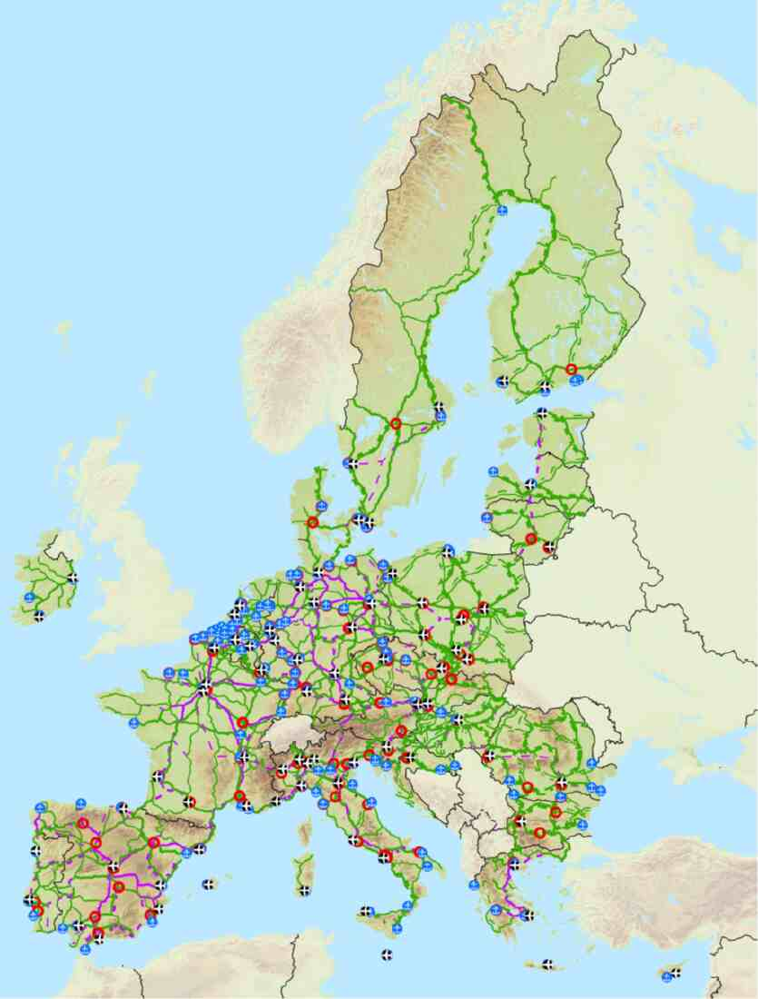

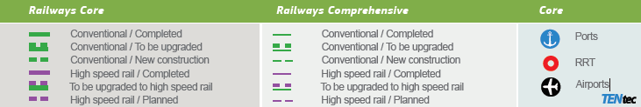



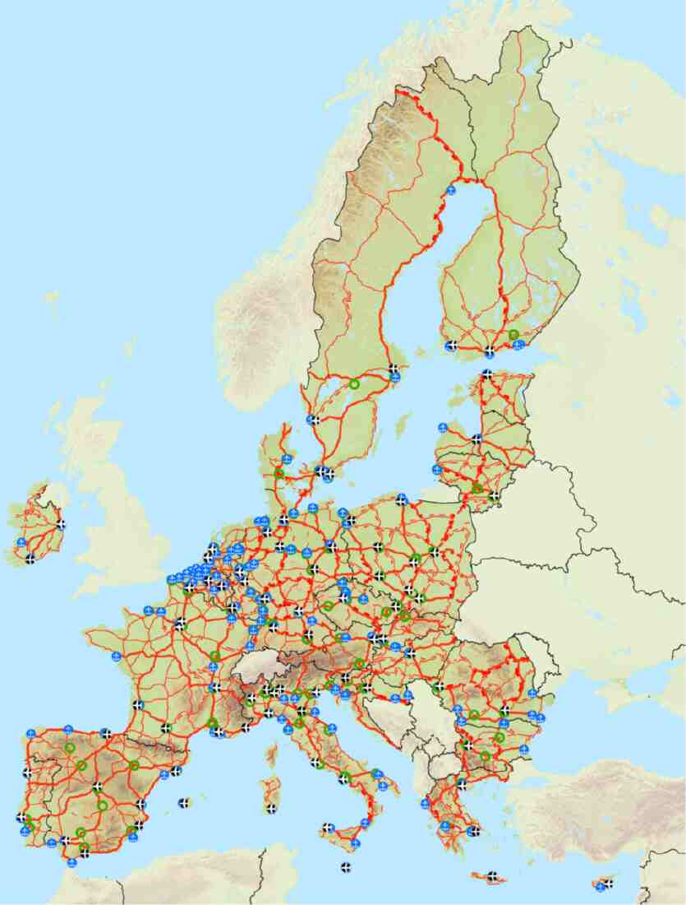

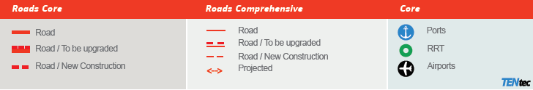

Further efforts are also required to identify the gaps and bottlenecks in the physical transport infrastructure in Member States. Thus far, the Commission services and the EEAS (including the EU Military Staff) have worked on reducing the gap between the TEN-T and the EU military networks in the TEN-T revision and by securing funds in CEF military mobility to support dual-use projects. Efforts should now focus on ensuring that the infrastructure can be used in the most effective way when military forces have to move. The objective is to increase the capacity of the infrastructure and optimise its use, for both civilian and military purposes. This requires high resilience of the infrastructure, supporting technologies and access to energy, allowing military forces to move substantial capacity within very short notice.

Therefore the Military Requirements within and beyond the EU need to be updated to enable further alignment of the standards for the trans-European transport network and the EU military transport network. As part of this update, the scope of the Military Requirements should be broadened to cover a Fuel Supply Chain Infrastructure. When moving large-scale forces over a long distance in times of crisis, it is essential to have a secure supply of fuel available along the way. In addition, as the clean energy transition progresses, there is a geostrategic interest in ensuring that large-scale forces are less reliant on fossil fuels. Furthermore, the Military Requirements should also address the infrastructures and systems for an effective access to airspace and use of air navigation systems. Further increase of TEN-T capacity requires also exploring links to the development of logistics hubs.

There is a need to identify to what extent the EU military transport network practically meets the Military Requirements for infrastructure. Building on the Gap Analysis between civilian and military requirements (first presented in 2019 and then updated in 2020), an assessment needs to be done to what extent the physical *infrastructure* meets the *military requirements*. Such an assessment would allow identifying in which regions there are gaps, and what types of gaps, in consultation with NATO as appropriate. It would then be easier to prioritise infrastructure development and funding at the EU level to accelerate the development of dual-use infrastructure and to ensure the resilience of transport network. Such measures will help to create a seamless connection of the military logistical depots and infrastructure with the EU-wide transport network. Infrastructure ensuring rapid deployment of military forces will also directly benefit civilian uses, for example new infrastructure capacity that could be used by Member States mutually assisting each other for urgent interventions to combat wildfires.

To facilitate the coherence and linkages between Member States’ activities – including through the relevant different PESCO projects, notably on Military Mobility and Logistical Hubs – and EU-level work strands across the full range of topics, an **annual event could be established** to bring together different stakeholders from EU institutions, relevant PESCO projects and partners such as NATO. A first event could take place in the second half of 2023.

|  |
| --- |
| **Key actions at EU level:**   * By the end of 2022, the EEAS (including EUMS) in coordination with Member States, Commission services and EDA, will update the Military Requirements within and beyond the EU. The Military Requirements will be expanded to cover Fuel Supply Chain Infrastructure and include the dual use of the air traffic management communication, navigation and surveillance systems and infrastructures, allowing effective access to airspace and use of air navigation services[11]. Coherence with NATO will continue to be ensured as appropriate. * EDA and Commission services will continue their cooperation in ensuring access to airspace and air navigation services for civil and military aviation in the context of the Single European Sky (SES) and the related Air Traffic Management Research (SESAR). * By mid-2023, Commission services together with the EEAS will carry out a study to identify possibilities for short-notice, large-scale movements to improve fuel resilience, long-term infrastructure planning and optimal use of this infrastructure. The study will include an analysis to what extent the physical EU military transport network meets the infrastructure requirements as identified in the Military Requirements, in consultation with NATO as appropriate. Based on input by national authorities, the Commission services and EEAS will analyse possible gaps and suggest actions to address them. * By summer 2023, the EEAS, in consultation with Commission services and the EDA, will liaise with a willing Member State to organise the first annual event on military mobility bringing a whole of Government approach with relevant stakeholders. * As indicated in the Joint Communication on the Defence Investment Gaps Analysis and Way Forward, the Commission will, within the overall review of priorities in the mid-term review of the Multiannual Financial Framework (MFF), consider strengthening the military mobility budget through the Connecting Europe Facility to implement dual-use infrastructure projects within the constraints set by the MFF. |

|  |
| --- |
| **EU Member States are invited to:**   * Maintain and develop the network of national points of contact for military mobility. * Develop and submit dual-use infrastructure project proposals in all transport domains that improve military mobility in line with the CEF and its stated priorities with a particular focus on transport actions that at the same time address climate action, including projects to improve energy security. * Contribute to the update of the Military Requirements for Military Mobility within and beyond the EU and submit proposals for new areas to be included. * By mid-2023, present to the Commission services and EEAS their national assessments of the physical networks’ ability to meet the infrastructure requirements identified in the Military Requirements, to feed into the aforementioned study. * Look for synergies on energy efficiency in their national strategies to prepare the armed forces for climate change before the end of 2023, as called for in the Strategic Compass. |

**3.2 Regulatory Support Measures**

Harmonised procedures and removal of procedural barriers will facilitate swift military movement. Such measures should respect the sovereignty of EU Member States over their national territory and of national decision-making processes. The work ahead should focus on implementing and complementing the various work strands launched since 2018 with the objective of helping Member States to fulfil their “military mobility pledge” of 2018[12].

***3.2.1 Cross-border movement permissions***

To assist movement of military personnel and assets, the EU has facilitated crossing borders by using different modes of transport. The EDA’s programme on “Optimising Cross-Border Movement Permission Procedures in Europe” (CBMP) was established to harmonise and simplify cross-border movement procedures, addressing both regulatory and procedural issues. In November 2021, two Technical Arrangements were signed, one for the surface[13] and one for the air domain[14]. These arrangements specify the procedures that have to be followed for movement during crisis times, preparation for crises, training and day-to-day.

In certain cases, Member States still need to integrate these arrangements into national processes. EDA is currently facilitating their implementation, also through the National Point of Contact (NPOC) network established by the PESCO project Military Mobility. This will shorten the movement permission processes and thus help the participating Member States to meet the agreed goal of responding within five working days. EDA also started work to develop a third cross-border movement permission arrangement in the maritime domain.

***3.2.2 Customs***

In July 2020, legal amendments[15] came into force to simplify the customs formalities for military goods and to establish a legal framework for the EU Form 302[16].

The EDA Category A Programme Arrangement “Harmonise Military Requirements Related to Customs” was signed in May 2021 by 23 contributing Member States plus Norway. It aims at the digitalisation of military-related customs activities and at making the resulting dataset available for exchange with civilian customs authorities. To date, the work has focused on the first objective of the programme, which is an assessment of the needs, gains and risks for the development of a military customs system used by the contributing Member States. The latter, supported by EDA, are working in close coordination with Commission services to ensure compliance with the customs procedures as described in the Union Customs Code (UCC). The results of this assessment will provide the foundation for next steps, particularly to define specifications and requirements for the digitalisation of military customs, including notably electronic data processing techniques for the exchange of information between customs and military forces.

The Commission would work, if needed, on the legal amendments and on the monitoring of the development of the digital system for the secure and quick exchange of information related to military mobility to ensure that there is a legal framework covering the use of the System by the Member States and that the System is aligned with the customs procedures as established in the EU Customs Legislation.

***3.2.3 Digitalisation of administrative processes***

As set out above, under the 2021 annual work programme, the European Defence Fund (EDF) included a proposal for the development of a digital system for the quick and secure exchange of information related to military mobility. A consortium consisting of companies from nine Member States plus one partner country[17] has been pre-selected to receive funding for the development of this digital system, which could be available in mid-2025.

The Commission would assist the contractor developing the system and would ensure its use by all the Member States.

***3.2.4 Enhanced logistics***

Enhanced logistics is a critical enabler in all operational domains of Member States’ Armed Forces. Heterogenous national logistics systems and processes tailored to individual needs are a major challenge for the coherence of the European capability landscape. Therefore, EDA is supporting the development of common standards for an EU-wide logistics IT network,[18] in line with the respective EU Capability Development Priority and a specific work strand of the CARD focus area Enhanced Military Mobility. Such an IT network would enable an effective management of stocks and supplies, including a cooperative warehouse management and Track & Trace capability to improve awareness of the logistic supply chain.

Furthermore, common standards for military Additive Manufacturing (AM) solutions should be developed, to take advantage of the technology, which can potentially ensure rapid military movements by speeding up the provision of spare parts within the logistic supply chain. Additionally, AM as a key technology contributes to both sustainability and industrial competitiveness. Finally, reducing the logistical footprint – such as the required (re)-supply, maintenance, and other logistics required when moving a military unit and/or materiel – would free up capacities and resources, and thus make military movements more efficient and faster. For example, the inspection and maintenance of mutually used equipment and certification of military equipment, such as ammunition, could be done in a collaborative manner either on site or at logistical hubs, using existing standards. Enhanced Host Nation Support or other forms of multinational cooperation could help reduce the logistical footprint in this regard.

|  |
| --- |
| **Key actions at EU level:**   * By 2024, EDA will support participating Member States to fully implement the technical arrangements for cross-border movement permissions procedures for surface and air by monitoring their usage as well as by identifying and resolving bottlenecks and obstacles; identify fields not covered in the signed Technical Arrangements and improve their content; and develop a Technical Arrangement for the maritime domain. * By the end of 2024, EDA will assess how to increase synergies between the work done by the PESCO project “Military Mobility” and the PESCO project “Network of LogHubs in Europe and Support to Operations”. * The Commission will identify topics under the European Defence Fund in future annual work programmes that will enhance Military Mobility where they are in line with the objectives and criteria of the EDF. * The Commission will monitor the development of the digital system for the secure and quick exchange of information on military mobility and, if needed, will prepare legal amendments to the EU Customs Legislation to ensure that there is a legal framework for the use of the System by the Member States and that the System is aligned with the customs procedures as established in the EU Customs Legislation. * By 2024, EDA will elaborate a concept for an EU-wide logistics IT network to enable the exchange of logistic data amongst various participants. By 2023, EDA will present the findings of a study on mapping of national and commercial logistics IT systems, including the Track & Trace and Enterprise Resource Planning (ERP) software, which will serve as a basis for initiating further actions. * By 2024, EDA will define a first package of common standards to promote military use of Additive Manufacturing solutions in an interoperable manner. |

|  |
| --- |
| **EU Member States are invited to:**   * Meet, by the end of 2023, the maximum 5 working days objective for border crossing procedures as part of the military mobility “pledge” agreed by the Council in June 2018 and explore the possibility of reducing the time to 3 working days for rapid reaction units, with a view to a possible update of the “pledge”. * Participate in and provide the necessary data for relevant studies undertaken at EU level. * Actively support the development of a Technical Arrangement for Cross Border Movement Permissions for the maritime domain. |

**3.3 Resilience and Preparedness**

A well-functioning military mobility network needs to be resilient, including in the context of cyber, climate change and other hybrid threats that may target critical nodes in the transport system used by the military. For example, a cyber-attack on systems used in airports, harbours or railroads or a cyber-attack on military assets could have major consequences. Thus, digitalising processes and procedures, including for the necessary civilian and military cooperation, will require to harden the CIS/IT systems against cyber threats. Member States will need to take action in that respect, building on the EDA’s work. Furthermore, beyond ensuring the prerequisites for military mobility, Member States should enhance the mobility and deployability of their armed forces, to ensure that they can rely on both civilian and military transport infrastructure and capabilities in times of crisis.

***3.3.1 Strategic lift capabilities***

Strategic lift capabilities are critical to ensure that Member States can deploy their forces and equipment swiftly within and beyond the EU. The first Coordinated Annual Review on Defence Report, approved by EU Ministers of Defence in November 2020[19], includes “Enhanced Military Mobility” as one of its focus areas. It highlights the need for improved resilience, strategic lift capabilities and logistics, taking into account hybrid threats to military movements, and put forward suggestions to address such threats in a holistic manner.

In line with the Enhanced Military Mobility focus area, the EU needs to identify and address gaps and deficits in our logistical capacity, including land (also inland waterways), sea, and airlift capabilities, required for an effective and efficient movement of large-scale forces. In this respect, improved European strategic airlift capacities in the critical area of outsized or specialised cargo (e.g. transporting ammunition) are needed. The EDA framework could support in the adaptation of civil outsized cargo assets for military purpose, thereby maximising civil-military synergies and taking into account activities of the PESCO Project “Strategic Air Transport for Outsized Cargo (SATOC)”.[20] Furthermore, possible requirements for sealift and specialised rail transport assets should be identified.

To make optimal use of airlift capabilities, the EU should enhance the coordination of movement capacity, including by liaising with the different multi-national movement coordination structures in Europe[21]. This includes developing links between the EEAS and EDA and such structures, to address concrete requests and coordinate broader logistical challenges.

Finally, lessons drawn from Russia’s war in Ukraine show the limited capacity of the civilian sector to meet the urgent and possibly large-scale demand of the military in times of crisis. To overcome the “first-come, first-served” principle, emergency measures need to be put in place to ensure that, when a security crisis is recognised at EU level, the military can be provided with priority access to transport infrastructure, capacities or routes – for example building on framework contracts and other practical steps to prepare for such situations and in full respect of the sovereignty of EU Member States over their national territory and decision making processes regarding military movements. Also in this context, dependency on fossil fuel should be reduced where possible. Following this rationale, The EU could assess possibilities to secure access to strategic lift capacities, for example through framework contracts with civilian providers, including for dual use in disaster relief scenarios (e.g. to ship medical and CBRN-decontamination infrastructure). To ensure sufficient lift capabilities, alignment with civilian partners is key, starting with a mapping of all relevant civilian actors per transport mode.

***3.3.2 Exercises***

Exercises in different formats are indispensable to test our infrastructural and procedural improvements, while identifying remaining hurdles and bottlenecks. A scenario-based discussion on military mobility was held in January 2021 as a side event to the EU Crisis Management Exercise Integrated Resolve 2020.[22] We should continue these table-top exercises and inject military mobility objectives in ‘live exercises’ including those proposed in the context of the Rapid Deployment Capacity put forward in the Strategic Compass or by participating in other multinational exercises including in the NATO context as appropriate.

***3.3.3 Protection against security risks in the transport sector***

Increasing vulnerabilities in our military transport system may be exploited to disrupt military mobility. There is an urgent need therefore to address the resilience of the network that we are putting in place, to protect it against hybrid and other threats, including with regard to the civilian and commercial transport sector. Further work in this area will benefit from the ongoing actions to counter hybrid threats[23] and on critical infrastructure protection, including in the light of the recent Proposal for a Council Recommendation on a coordinated approach by the Union to strengthen the resilience of critical infrastructure (2022/0338 (NLE)).[24]

In particular, the EU should enhance cooperation to address the following issues:

* To strengthen the physical resilience against natural and man-made threats of those entities that provide essential services in the transport sector. This includes implementing the Directive on the resilience of critical entities[25] (CER Directive) in the transport sector as well as facilitating the swift adoption and subsequent implementation of the Proposal for a Council Recommendation on a coordinated approach by Union to strengthen the resilience of the critical infrastructure, where transport is one of the key sectors[26].
  + The cybersecurity of the civilian transport sector and its support systems, including traffic control systems (air, rail, sealift), container terminal management systems, control systems for locks, bridges, tunnels etc. This includes accelerating the transposition and implementation of the recently adopted revised Directive on Measures implementing of the Network and Information Security Directive (NIS2 Directive)[27] in the transport sector and the work done on resilience baselines in the context of countering hybrid threats. In case of a cybersecurity crisis, it is essential to ensure a proper exchange of necessary information to ensure the fullest possible situational awareness among the military and civilian transport sectors. This should also include cooperation between relevant sectoral authorities responsible for transport, competent cybersecurity authorities and CSIRTS, and, in line with its tasks as envisaged in the Directive NIS2, through the European Cyber Crises Liaison Organisation Network (EU – CyCLONe). Synergies with TEN-T should be explored[28]. Member States are also invited to make use of the Commission short-term support programme implemented with ENISA to step up preparedness of essential entities in the transport sector, for instance through penetration testing.
  + Foreign Direct Investments by non-EU entities into infrastructures and transport operations within the EU that are also critical for military transport may represent a security risk for the EU and its Member States. Foreign Direct Investment by third countries in dual-use infrastructure within the EU could pose risks to its security and public order. This is especially the case when third countries use financial measures to negatively impact connectivity, or when sensitive intelligence becomes available for third-country investors. A strong overlap between civilian and military infrastructure means additional vulnerability in the context of FDI. Such investments will be carefully screened in the framework of the FDI Screening Regulation[29] and TEN-T[30].
  + The impact of climate change and green energy transition on the resilience and energy security of EU Member States’ military transport infrastructure and capabilities. Rising sea levels and more extreme weather events add new requirements to military installations while reducing dependency on fossil fuels in military transport also has implications for the security and availability of renewable energy sources and related technologies[31]. This work will draw on relevant results of the Consultation Forum for Sustainable Energy in the Defence and Security Sector (CF SEDSS), including research studies on climate change adaptability and hybrid threats’ impact on defence, and will identify opportunities for using renewables in military transport, e.g. hydrogen.

Resilience can also be enhanced by exploring the possibilities for civil and military configurations of aircraft models to mutually recognise their spare parts. Currently, the European Union Aviation Safety Agency (EASA) certifies civilian aircraft and their components used for maintenance and repairs, while military aircraft and components are certified by the Member States for national security reasons. This approach causes duplication: military aircraft should be able to exchange their spare parts with those certified for civilian use if they are identical. Without changing the competences of EASA or the Member States, a new mechanism could be envisaged to simplify the procedures of aircraft certification and maintenance by allowing components and parts certified by EASA to be pooled for joint usage by military and civilian operators, thus significantly reducing the costs of military aircraft maintenance while simultaneously increasing flight safety. A pilot study should be launched to identify synergies between the two certification mechanisms. In addition, operations in the air domain heavily rely on the effective exchange and sharing of digital data among relevant civil and military stakeholders and operators.

This calls for a joint civil-military endeavour to ensure a resilient and robust data sharing network with a high level of cybersecurity.

***3.3.4. Space-based solutions for military mobility***

The current and future space-based navigation (Galileo/EGNOS) secured communication and Earth Observation (Copernicus) have the potential to significantly benefit military mobility. We should assess how to harness this potential.

The Public Regulated Service (PRS) is the most secure Galileo navigation service suitable for governmental applications that must be reliable even under crisis situations, equivalent to the GPS M-Code. Galileo PRS could bring direct benefits to military mobility by providing uninterrupted secure and accurate Position Navigation and Timing information in contested environments, fulfilling critical operational needs in the theatre of operations, and contributing to informed decision-making and command and control.

The European Geostationary Navigation Overlay Service (EGNOS), even though not designed to operate in a conflict zone, can offer important operational benefits for logistics and transport operations. In adverse weather conditions, it can enable secure access to air bases and regional airports not having other means.

The new Union Secure Connectivity Programme, for which the Commission proposed a Regulation on 15 February 2022, aims at ensuring worldwide access to secure governmental satellite communication services. A range of use cases have been studied in this context, including on traffic management and military missions. From this analysis, it is clear that secure connectivity is increasingly a strategic asset for the use of autonomous vehicles and aircraft. Military mobility needs need to be duly taken into account in the definition of the service portfolio of the secure connectivity system.

The EU's Earth observation programme Copernicus offers information services that draw from satellite-based Earth Observation (from the Copernicus Sentinel satellites or commercial satellites) and in-situ (non-space) data in three main areas: 1) environmental monitoring (land: land cover and use, Digital Elevation Model, EU river network and water bodies reference data; marine; atmosphere; climate change), 2) emergency management (in case of natural or man-made disasters, e.g. flood, earthquakes, forest fires), and 3) security (border and maritime surveillance, and support to EU external action). Possible links to military mobility could be further explored.

CASSINI- the Commission’s initiative to foster space entrepreneurship in the EU will stimulate the development of disruptive technologies, industrial processes and services. The emergence of new commercial players will expand the range of space-enabled solutions, including for military mobility.

|  |
| --- |
| **Key actions at EU level:**   * EDA, in close consultation with Member States, EEAS and Commission services, will follow-up on the CARD focus area Enhanced Military Mobility, to address the gaps and deficits with regard to the resilience as well as the logistical and lift capacity required for the movement of large-scale forces, including notably outsized or specialised cargo (e.g. dangerous goods requiring specific measures). * By 2023, the EEAS will assess the logistical footprint for CSDP missions and operations, notably with regard to certifications and inspections, as well as identify possible gaps in the lift capacity, and provide recommendations on collaborative opportunities. * By 2023, EDA will explore the adaption of civil outsized cargo assets for military purposes, taking into account activities of the PESCO Project “Strategic Air Transport for Outsized Cargo (SATOC)”. * By 2024, EDA will identify possible requirements for specialised rail transport assets and strategic sealift capabilities. * EEAS, EDA and Commission services will explore how to strengthen the coordination of movement capacity, including by seeking synergies with multi-national movement coordination centres. * By the end of 2024, Commission services will provide an overview per transport mode of all key actors in the civilian domain for emergency and crisis planning and coordination purposes. * By 2024, EDA, together with Commission services and EEAS (including EUMS), will assess the benefit of strategic lift capacities for dual use, such as disaster relief. * The EEAS, Commission services and EDA will exploit multinational exercises to mainstream military mobility activities (deployment, sustainment and redeployment of the forces), including EU live exercises and Parallel and Coordinated Exercises with NATO, as well as through EU participation in NATO exercises, as appropriate. * The EEAS, together with Commission services and the EDA, will organise scenario-based exercises involving Member States’ experts. * EDA and Commission services will continue their efforts to ensure reliable and effective exchange and sharing of digital data between relevant civil and military aviation stakeholders. * The Commission services, the EEAS and the NIS cooperation group, in coordination with relevant civilian and military bodies and agencies and established networks will conduct on a regular basis risk evaluation and risk scenarios from a cybersecurity perspective, focusing on priority critical sectors. This will be carried out to ensure complementarity with the stress testing of critical infrastructures, as set out in the presidential 5-point plan and the subsequent proposal for a Council recommendation on critical infrastructure resilience. * EDA, together with EEAS and Commission services, will build on ongoing initiatives to enhance the climate resilience and energy security of military installations and transport capabilities that are necessary for military mobility, and put forward recommendations to Member States as part of the work on climate and defence. Synergies with TEN-T will also be explored. * By the end of 2023, Commission services together with EASA, and in collaboration with the military aviation authorities and industry, will launch a pilot project establishing a mechanism of mutual recognition of parts used by civil and military configurations of aircraft models. The project should include the elaboration of a civilian-military interface agreement to define the responsibilities of the different parties. The pilot project should be finalized no later than two years after the adoption of the Action Plan. * Commission services, EDA and EEAS will explore a set of emergency measures that would provide the military with prioritised access to transport infrastructure, capabilities and routes, when necessary, in times of crisis recognised at EU level To enhance civil/military synergies, they will assess possibilities to secure access to strategic lift capacities, for example through framework contracts with civilian providers. |

|  |
| --- |
| **EU Member States are invited to:**   * Ensure the cyber-resilience of the future digital processes and procedures, building on the EDA’s work and exploring the possibility of developing functional requirements related to security |

**4. PARTNERSHIP DIMENSION**

The EU and NATO have a shared interest in ensuring the swift movement of military personnel and their equipment for both routine peacetime activities and in times of crisis. Ensuring coherence and mutual reinforcement with regard to respective strands of work has therefore been an integral part of the military mobility initiative since its launch. In light of the war in Ukraine, new questions have arisen regarding the need to connect transport routes to neighbouring countries and regions, including Ukraine.

***4.1 EU-NATO***

Partnership with NATO is an integral part of this Action Plan. The Structured Dialogue on Military Mobility is the main format to promote dialogue and cooperation at staff level through regular meetings and will continue to rely on the reciprocal exchange of information between the two organisations. The investments in dual-use transport infrastructure for military movements are to the benefit of both the EU and NATO. The technical and geographical requirements overlap, and the technical standards have been developed through cooperation. Thanks to this cooperation, the EU Military Requirements for Military Mobility are consistent with NATO’s requirements to a level of around 95%.

The intent is to ensure a coherent approach and synergies between the EU and NATO and to effectively address existing barriers, including legal, infrastructure and procedural, in order to facilitate and expedite movement and border crossing of military personnel and material, in full respect of sovereign national decisions. This applies in particular to efforts with regard to infrastructure improvements and the related requirements, reducing procedural and regulatory barriers, enhancing resilience, and cross-participation in military mobility-related exercises.

Interactions on military mobility will be taken forward in line with the guiding principles of enhanced and intensified cooperation, notably full openness and transparency, respect of the decision-making autonomy and procedures of both organisations, inclusiveness and reciprocity, without prejudice to the specific character of the security and defence policy of any EU Member State.

***4.2 Connecting to other partners***

The EEAS, together with Commission services and the EDA will explore cooperation with other partners in different formats on issues related to military mobility.

This includes discussing military mobility- related developments in the security and defence dialogues with relevant key EU partners, such as those participating in the PESCO project on Military Mobility, notably the U.S., Canada and Norway. The United Kingdom is also expected to join soon this PESCO project, upon completion of relevant procedures . This will contribute to transatlantic cooperation on such matters and tothe EU-NATO partnership.

Moreover, there is scope to explore the dual-use possibilities of the ongoing work on better connecting Member States’ main transport routes to key partner countries such as Ukraine, as envisaged in the Communication on “solidarity lanes” between the EU and Ukraine and the Commission proposal of 27 July 2022 extending four European Transport Corridors to Ukraine and Moldova.[32] In addition, the amended proposal for a revised TEN-T Regulation in July 2022 includes a provision to standardise the European track gauge for railways to improve interoperability between Ukraine, Moldova and the EU.

Finally, the EU is ready to share best practices from the progress it has made in enhancing military mobility with regional partners and enlargement countries, such as in the Western Balkans, for example with regard to the whole-of-government approach, dual-use approach and practical steps to reduce the administrative burden and delays.

|  |
| --- |
| **Key actions at EU level:**   * The EEAS together with Commission services and EDA will continue the EU-NATO Structured Dialogue on military mobility with a view to sharing information and ensuring coherence of respective work strands. * The EEAS together with Commission services and EDA will include military mobility where necessary in the security and defence dialogues with relevant partners, notably with Canada, Norway and the US. * The Commission services and the EEAS will explore dual use possibilities of the ongoing work on better connecting Member States’ main transport routes with a particular focus on Ukraine and Moldova. * The EEAS and Commission services will explore possibilities to promote dialogue with regional partners, in particular enlargement countries, on best practices. |

**5. WAY FORWARD**

The Action Plan on Military Mobility is submitted by the High Representative and the Commission to the EU Member States for consideration and endorsement, so that it can be implemented in a timely and coordinated manner.

Periodic joint progress reports on the implementation of this Action Plan will be presented to the EU Member States, with the first to be submitted by November 2023.

1. A Strategic Compass for Security and Defence - For a European Union that protects its citizens, values and interests and contributes to international peace and security (7348/1/22).
2. On the basis of the Joint Communication ‘Improving Military Mobility in the European Union’ (JOIN(2017) 41 final) and the Joint Communication ‘on the Action Plan on Military Mobility’ (JOIN(2018) 5 final.
3. Military Requirements for Military Mobility within and beyond the EU, update (ST 10921/19), 4 July 2019, approved by the Council on 15 July and consolidated with the remaining part on 19 July (ST 11373/19).
4. Special meeting of the European Council (17, 18, 19, 20 and 21 July 2020) – Conclusions,<https://www.consilium.europa.eu/media/45109/210720-euco-final-conclusions-en.pdf>, p. 53.
5. Commission Implementing Regulation (EU) 2021/1328 of 10 August 2021 specifying the infrastructure requirements applicable to certain categories of dual-use infrastructure actions pursuant to Regulation (EU) 2021/1153 of the European Parliament and of the Council, C/2021/5859, *OJ L 288, 11.8.2021, p. 37*.
6. Regulation (EU) No 1315/2013 of the European Parliament and of the Council of 11 December 2013 on Union guidelines for the development of the trans-European transport network and repealing Decision No 661/2010/EU*, OJ L 348, 20.12.2013, p.1.*
7. Canada, Norway and the United States
8. Council conclusions on Security and Defence in the context of the EU Global Strategy, 25 June 2018, paragraph 18, <http://data.consilium.europa.eu/doc/document/ST-10246-2018-INIT/en/pdf>
9. Joint Communication ‘on the Action Plan on Military Mobility’ (JOIN(2018) 5 final.
10. Amended proposal for a Regulation of the European Parliament and of the Council on Union guidelines for the development of the trans-European transport network, amending Regulation (EU) 2021/1153 and Regulation (EU) No 913/2010 and repealing Regulation (EU) 1315/2013, COM(2022) 384 final
11. Air traffic management (ATM) (network management, interoperability, provisions of air navigation services, use of airspace by civilian and military users) in the Union is addressed in the single European sky initiative and the SESAR project. The underlying regulatory framework affects the dual-use of ATM systems and infrastructure.
12. Conclusions Foreign Affairs Council, 25th June 2018, paragraph 18: “Calls on Member States to take action nationally to improve the efficiency of military mobility, and to simplify and standardize relevant rules and procedures in coherence with the Action Plan and the Military Requirements for Military Mobility within and beyond the EU, in accordance with national legislation of the Member States, as soon as possible but no later than 2024, and aim at the following first steps to be achieved by the end of 2019:

    a) develop national plans for military mobility and give their implementation high priority;

    b) in accordance with relevant standardized procedures and subject to national decision making and criteria, accelerate border crossing procedures, and to that end work with competent national authorities towards granting cross border movement permissions, including requests for entry and movement permission for all modes (surface, air and sea) and aspects of military movement and transportation, for routine activities within 1 working days; and consider to bring this period further down for rapid reaction units;

    c) facilitate and speed up communication and procedures, and to that end create a strong interconnected network of National Points of Contact for all aspects relating to military mobility to, amongst others, be able to quickly handle requests for cross-border movements;

    d) use suitable existing national and multinational exercises to practice more regularly military mobility, including during live exercises, and short notice movements”.
13. The Technical Arrangement on Surface Movement aims to enhance the military mobility for road, rail and inland waterways by harmonising and simplifying administrative procedures and fostering movement permissions. It has been signed by 23 contributing Member States and Norway.
14. The Technical Arrangement for Air Transport aims at encompassing a wider range of missions, complementary to the existing Diplomatic Clearance (DIC) Technical Arrangement, including air-to-air refuelling, Remotely Piloted Aircraft System (RPAS) platforms, training missions, fighter jets and rotary wings. It has been signed by 22 contributing Member States and Norway.
15. As a result of two years of work done by the Commission, in cooperation with EDA and the EU Member States, several amendments to the Commission Delegated Regulation (EU) 2015/2446 and to the Commission Implementing Regulation 2015/2447, namely the Delegated and Implementing Acts of the Union Customs Code (UCC), were published in the Official Journal.
16. https://eur-lex.europa.eu/legal-content/EN/TXT/PDF/?uri=CELEX:02015R2446-20220101&from=EN
17. Estonia, Lithuania, Germany, Bulgaria, Poland, Luxemburg, Rumania, Czech Republic, Latvia plus Norway
18. Logistics is a closed and resilient system, where all suppliers, consumers and third parties are contributing mutually to the supply chain. Logistics composed of Procurement, Movement & Transport, Training, Distribution and Supply Management. The aim of Logistics is to provide the demanded quantity and quality of goods at the requested time and location.
19. The Capability Development Plan revision approval and implementation, EDA Steering Board Document 2018/15, 28 June 2018.
20. The overall aim of the project Strategic Air Transport for Outsized Cargo is to fill the critical shortfall for Strategic Air Transport for Outsized Cargo by developing a European solution for the transport of outsized and heavy cargo.
21. Such as: European Airlift Transport Command (EATC), Movement Coordination Centre Europe (MCCE; all modalities), and the Athens Multinational Sealift Coordination Centre (AMSCC). The EU’s liaison with these structures will be done in full respect of the principles of inclusivity of all Member States in multinational structures as reaffirmed in the Council Conclusions on Security and Defence of 17 June 2020 (paragraph 21)
22. The event brought together participants from the EU Member States, the European External Action Service including the EU Military Staff, the Commission services, the European Defence Agency, as well as key EU partners – NATO staff and three NATO Allies – the United States of America, Canada and Norway.
23. Joint Staff Working Document Fifth Progress Report on the implementation of the 2016 Joint Framework on countering hybrid threats and the 2018 Joint Communication on increasing resilience and bolstering capabilities to address hybrid threats {SWD (2021) 729 final}.
24. Joint Staff Working Document Fifth Progress Report on the implementation of the 2016 Joint Framework on countering hybrid threats and the 2018 Joint Communication on increasing resilience and bolstering capabilities to address hybrid threats {SWD (2021) 729 final}.
25. COM (2020) 829 final. A political agreement has been found on the CER Directive in June 2022 and its entry into force is expected in early 2023. CER Directive will replace the Directive 2008/114/EC of 8 December 2008 on the identification and designation of European critical infrastructures and the assessment of the need to improve their protection.
26. The proposal for a Council recommendation was adopted on 18 Oct 2022. https://ec.europa.eu/commission/presscorner/detail/en/ip_22_6238
27. This Directive will be repealed and replaced by a Directive on measures on high common level of cybersecurity across the Union (NIS2 Directive)
28. COM (2020) 829 final. A political agreement has been found on the CER Directive in June 2022 and its entry into force is expected in early 2023. CER Directive will replace the Directive 2008/114/EC of 8 December 2008 on the identification and designation of European critical infrastructures and the assessment of the need to improve their protection.
29. Regulation (EU) 2019/452 of the European Parliament and of the Council of 19 March 2019 establishing a framework for the screening of foreign direct investments into the Union.
30. See Article 47, Proposal for a Regulation of the European Parliament and of the Council on Union guidelines for the development of the trans-European transport network, amending Regulation (EU) 2021/1153 and Regulation (EU) No 913/2010 and repealing Regulation (EU) 1315/2013, COM(2021) 812 final.
31. Through CF SEDSS III, EDA is conducting, in collaboration with DG JRC and DG ENER, research studies to explore the impact of climate change on defence-related critical energy infrastructures (CEI) and how to increase their resilience against hybrid threats. In this context, a table-top exercise will be held in 2023 to identify vulnerabilities and promote synergies with the civilian sector to enhance defence resilience
32. Communication from the Commission to the European Parliament, the Council, the European Economic and Social Committee and the Committee of the Regions: An action plan for EU-Ukraine Solidarity Lanes to facilitate Ukraine's agricultural export and bilateral trade with the EU, COM(2022) 217 final