

**Commission Report linked to the State of the Energy Union – Energy subsidies in the EU**

# Introduction and main findings

This is the third annual report on monitoring Member States’ progress towards phasing out energy subsidies – and more specifically fossil-fuel subsidies– in the EU. Phasing out these subsidies is a requirement under the Regulation on the Governance of the Energy Union and Climate Action[1]. This report builds on the two previous reports[2] on subsidies annexed to the State of the Energy Union published by the European Commission in 2020 and 2021.

The first two reports were principally based on direct data collections from national authorities and revealed some significant data gaps in the 2020 national energy and climate plans (NECPs). However, the annual continuity of the data collection will contribute to the improvement of data quality in the NECP progress reports due in 2023.

The European Union has the target of reducing its GHG emissions by 2030 by at least 55% compared to 1990 and to be climate neutral by 2050. This implies the need to end subsidising fossil fuels, while creating favourable conditions for energy efficiency and renewable sources of energy and taking into account the need of vulnerable customers in the energy transition.

In November 2021, the Glasgow Climate Pact[3] called for ‘accelerating efforts towards the phasedown of unabated coal power and phase-out of inefficient fossil-fuel subsidies, while providing targeted support to the poorest and most vulnerable in line with national circumstances and recognizing the need for support towards a just transition’[4].

The Russian military aggression in Ukraine has resulted in new short-term policy actions in the European Union. The REPowerEU communication in March and the REPowerEU plan[5] in May 2022 mostly strengthened the objectives of the clean transition, laid down in the European Green Deal and enshrined in the EU Climate Law. However, with the phasing-out of fossil-fuel imports from Russia, changes in subsidies for fossil-fuel energy will probably be more significant in the future. National action to bring coal-based and oil-based power generation back online will also have a temporary impact.

A Commission Sustainable Finance Taxonomy Delegated Regulation[6] was also adopted in June 2021. This set the technical screening criteria for determining the conditions under which an economic activity qualifies as contributing substantially to climate-change mitigation or climate-change adaptation, while ensuring that the respective economic activity causes no significant harm to any of the EU’s other environmental objectives. This was complemented by an additional delegated regulation, adopted in March 2022[7], covering a number of economic activities in certain energy sectors, namely certain natural gas and nuclear energy-related activities.

For the preparation of the current report, the Commission conducted a study[8] to gather data from Member States and expand and/or correct earlier datasets which contained incomplete results from 2020 and 2021[9]. When the Commission study was completed (July 2022), 2021 data were not complete and were therefore subject to significant estimates. For this reason, 2021 numbers should be treated cautiously in the current report[10]. To ensure good data quality, Member States were asked to cross-check the new database. The Commission study has also carried out an initial stocktaking of how energy subsidies relate to the taxonomy criteria.

The results of this study confirm that a significant – albeit slightly decreasing – amount of subsidies was spent on fossil-fuel energy in recent years. This means that the EU and its Member States must step up their efforts to meet their international commitments on fossil-fuel subsidies and achieve climate neutrality by 2050. In 2020, overall energy subsidies in the EU reached EUR 173 billion, rising by 7%, or EUR 14 billion, between 2015 and 2020. Subsidies for renewables rose by 15%, reaching EUR 81 billion in 2020, and energy-efficiency subsidies increased by 20% (EUR 15 billion in 2020) in the same 2015-2020 period – a favourable development that will help the EU to attain its objectives for clean-energy transition.

In 2021, total subsidies for all types of energy (fossil fuels, nuclear and renewables) continued to rise. This was due to increasing demand for energy as the economic recovery continued following 2020, a year characterised by COVID-19 related restrictions. As data estimates from 2021 show, total energy subsidies rose by EUR 11 billion in 2021 compared to 2020, reaching EUR 184 billion. Of these energy subsidies, subsidies for energy demand[11] reached EUR 65 billion in 2021, around EUR 8 billion higher (+14%) than in 2020 and subsidies for energy efficiency reached EUR 19 billion, around EUR 3 billion higher (+29%) than in 2020. At the same time, subsidies for renewables fell by almost EUR 3 billion (-3.5%) compared to the previous year (falling to EUR 78 billion in 2021), owing to increasing wholesale electricity prices, implying lower feed-in premia.

Fossil-fuel subsidies, reaching EUR 50 billion in 2020, fell by 1.5% (or -EUR 0.7 billion) between 2015 and 2020, as the result of: (i) a decrease in non-fuel-specific subsidies (-EUR 1.4 billion); (ii) a fall in coal subsidies (-EUR 0.9 billion); (iii) a rise in gas subsidies (+EUR 0.5 billion); and (iv) a rise in subsidies for oil and petroleum products (+EUR 1.2 billion). Fossil-fuel subsidies decreased in most Member States in this period. However, in a few countries, like Belgium, Bulgaria, Finland, France, the Netherlands, Poland and Slovakia, fossil-fuel subsidies rose significantly between 2015 and 2020. At EU level, the share of fossil-fuel subsidies within the GDP remained practically unchanged between 2015 and 2020.

In the transport sector, fossil-fuel subsidies (primarily on oil products) increased dramatically (by 29%, or EUR 3.1 billion) between 2015 and 2019 and fell back by EUR 3 billion in 2020. In 2021, even amid the increase in transport activities following the end of COVID-19 restrictions, fossil-fuel subsidies remained stable overall compared to 2020 as fossil-fuel subsidies fell in other sectors of the economy, for example in the energy sector.

Fossil-fuel subsidies in agriculture also increased (by 13%, or +EUR 0.7 billion) between 2015 and 2020, overwhelmingly in the form of fuel consumption support (e.g. reduction or exemption of fuel taxes).

Fossil-fuel subsidies for households increased by 15% (EUR 0.4 billion) in the same period, principally in the form of subsidies for heating-oil and natural-gas consumption. In 2021, fossil-fuel subsidies for households continued to increase from their 2020 levels.

Subsidies for natural gas grew by 6% (EUR 0.5 billion) between 2015 and 2020, representing around 19% of fossil-fuel subsidies, and in 2021 they rose further by an estimated EUR 0.7 billion (+10%) compared to 2020. Subsidies on coal and lignite, representing 18% of the total fossil fuel subsidies, fell by 9% (-EUR 0.9 billion) in the EU between 2015 and 2020, but rebounded by an estimated 6% (EUR 0.6 billion) in 2021.

In the coming years, bearing in mind the probable impact of greater coal use, subsidies for coal might increase in the energy sector. And the expected fall in gas use over the medium-to-long term points to decreasing gas subsidies in the future, even though high gas prices at present might point to increasing gas subsidies in the short term. Subsidies for nuclear energy in the form of compensation for early closure and early decommissioning of nuclear facilities (mainly in Germany and France) rose further in 2021 due to planned shutdowns. Subsidies for renewables will strongly depend on wholesale energy prices, but we can expect higher prices to imply lower subsidies via feed-in premia or contracts for difference[12].

# Energy subsidies and fossil-fuel subsidies in the EU

## 2.1. Energy subsidies in the EU

Subsidies in this report are defined following the methodology set forth by the World Trade Organization (WTO)[13], which was used in the supporting Commission study[14] and the previous two energy-subsidy reports (2020 and 2021). This methodology groups subsidies into four categories: (i) government measures involving the direct transfer of funds; (ii) government revenue that is otherwise foregone (not collected); (iii) governments providing goods and services or purchasing goods; and (iv) price and income supports.

In this report, energy subsidies are also examined from different perspectives, for example: (i) by the goal they seek to promote (production, consumption/demand, infrastructure or energy efficiency); (ii) by fuel type (fossil fuels, renewables, nuclear); (iii) by economic sectors (the energy sector, transport, industry, agriculture[15], residential, services, etc.); or (iv) by the types of instrument used to impose subsidies (tax reliefs, grants, price supports, income supports, etc.).

Looking at changes in energy subsidies in the EU, total financial support amounted to EUR 173 billion in 2020, up by 7% (+ EUR 14 billion) since 2015. Subsidies for energy production grew by 11% (+EUR 9 billion) during the same period, principally owing to subsidies for the generation of renewable energy (EUR 81 billion in 2020), whereas subsidies for energy-efficiency measures were up by 20% (+EUR 2.5 billion in the same period, reaching EUR 15 billion in 2020).

The improving pandemic situation and permanent easing of containment measures in 2021 allowed the EU economy a chance to recover. In that year, the EU economy recovered faster than initially expected, a recovery which also upwardly impacted energy consumption and subsidies on energy products. As estimated data show, energy subsidies in the EU rose to EUR 184 billion in 2021 (up by EUR 12 billion, or 7% compared to 2020). Subsidies related to energy demand[16] rose by 14% (+EUR 8 billion) in 2021 compared to 2020, principally owing to increasing energy consumption amid economic recovery. This showed that the fall in energy-demand subsidies in 2020 was only temporary. The impact of measures taken by Member States starting in the second half of 2021 to support businesses and the public – even if only temporarily – amid high energy prices can already be seen in increasing energy-demand-related subsidies for this time. However, it will only be possibly to quantify precise details in the next edition of the energy subsidies report.

Subsidies for energy-efficiency measures, after a temporary fall in 2020, rose again in 2021, reaching EUR 19 billion. This amounted to a 54% increase (+EUR 6.5 billion) compared to 2015. Furthermore, the estimated amount of subsidies for industry restructuring rose to EUR 4.6 billion in 2021 (up from EUR 2.3-2.4 billion in each of the previous 2 years), principally owing to increased financial support for the decommissioning of coal and lignite mines and related economic transformation measures. However, subsidies for energy production fell by 5% (-EUR 5 billion), as subsidies on renewables (principally solar) fell substantially amid higher wholesale electricity-market prices, which impacted feed-in-premium and contract-for-difference types of support schemes.

**Figure 1 – EU energy subsidies by purpose**

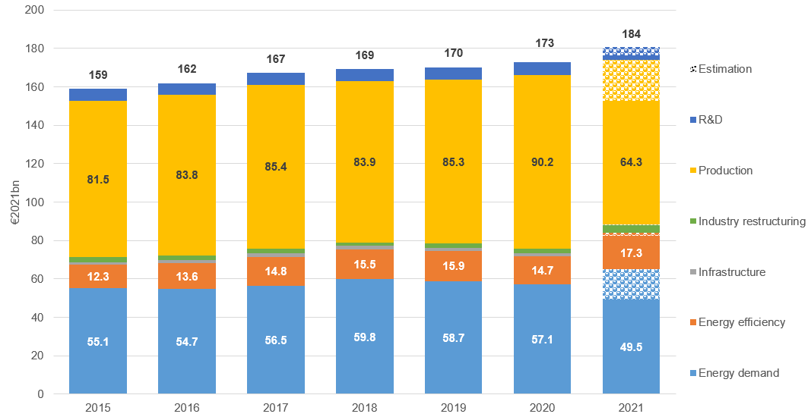

Source: Study on energy subsidies and other government interventions in the European Union – 2022 edition. Throughout this document, sphered stack bars show that these 2021 data are based on estimations, and each category should be interpreted as adding a sphered bar (estimations) to the filled bar (factual data) to compare with earlier years.

As an indicator of the energy-subsidy intensity of the economy, energy subsidies in comparison to GDP in EU Member States can be used to make cross-country comparisons. This is because absolute subsidy values also depend on the size of a given country’s economy. In 2020, energy subsidies in comparison to GDP varied significantly across Member States, ranging from 2.9% of GDP in Latvia to only 0.3% of GDP in Luxembourg. Energy subsidies as a percentage of GDP in the EU amounted to 1.2% in 2020 on average, showing a high degree of stability in 2015-2020 in the EU in general and in most Member States as well.

The analysis also shows that different countries use subsidies to support different policies and measures, and that these different policies and measures impact the objectives for the EU’s clean-energy transition differently. For example, Latvia spent 2% of its GDP on subsidies for energy-efficiency measures in 2020[17] (and 0.4% of its GDP on both fossil fuel and renewable subsidies), while Germany, Italy and Greece spent around 1% of their GDP on subsidising renewables. Germany and Italy respectively spent 0.4% and 0.3% of their GDP on fossil fuel subsidies.

At the same time, other countries still tend to spend more on fossil fuels[18] than on measures incentivising the clean-energy transition. In 2020, Cyprus spent about 1.3% of its GDP on subsidising fossil fuels (and only 0.2% on renewable subsidies), and in Greece and Belgium this share was close to 1%, discouraging the clean-energy transition. Nevertheless, these latter two countries respectively spent 0.9% and 0.5% of their GDP on renewables. In 2021, energy subsidies as a percentage of GDP remained stable (or decreased slightly compared to 2020) in most EU Member States.

**Figure 2 - Subsidies for different energy sources, as a percentage of GDP in 2015 and 2020, and in billion euros in 2020**

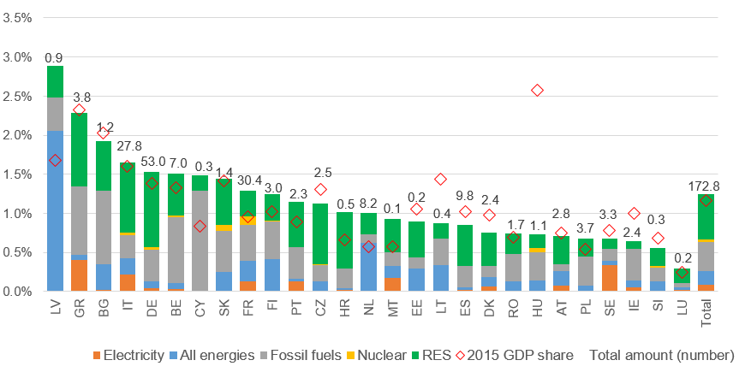

Source: Study on energy subsidies and other government interventions in the European Union – 2022 edition. Electricity refers to general, non-technology-specific support for electricity, while ‘All energies’ represents subsidies not directly attributable to energy carriers or fuels (e.g. energy-efficiency measures and energy-demand/consumption incentives, irrespective of the energy carrier; investment grants; and particular R&D expenditures). For more details, see the Commission study.

Subsidies for **renewable sources of energy,** representing around 44% of the overall value of energy subsidies in recent years, grew by 7% (+EUR 5.5 billion) in 2020 compared to 2019. However, in 2021 these subsidies decreased by 3% (-EUR 2.8 billion, impacted by higher wholesale energy prices and consequently, lower feed-in premia or contract for differences), as estimated numbers show. On the other hand, fossil-fuel subsidies, which have accounted for 31% of the total value of energy subsidies in recent years, decreased by 5.5% (-EUR 2.9 billion) in 2020 and remained practically stable in 2021. In 2021, in spite of a recovery in fuel consumption for transport, overall fossil-fuel subsidies did not increase as they did in other sectors, such as energy. On the contrary, fossil-fuel subsidies for transport fell.

Subsidies on **electricity[19]** fell slightly between 2015 and 2020, whereas subsidies for ‘all energies’ (multiple energy sources or measures not directly attributable to energy products) rose from EUR 20 billion to EUR 26 billion (+30%). In 2021, both subsidies on electricity and ‘all energies’ increased, implying an increase in tax expenditure on energy products that cannot be attributed to a given carrier (relating to support for energy demand).

Subsidies for **nuclear energy**, after being stable for several years since 2015 (averaging at EUR 4.2 billion), reached almost EUR 5 billion in both 2019 and 2020. However, in 2021 they rose further to EUR 7.2 billion, although even after this increase nuclear subsidies still only represented 4% of total energy subsidies in the EU. This increase was mainly linked to financial instruments to compensate for the early closure and decommissioning of nuclear facilities, principally in Germany and France. Compensation schemes are mainly based on paying for electricity that will not be generated (due to the early closure) or for ‘stranded’ assets[20]. In Germany, compensation of EUR 2.4 billion was paid in November 2021, which substantially impacted the total amount of subsidies for nuclear energy in Europe.

**Figure 3 – EU energy subsidies by fuel type**

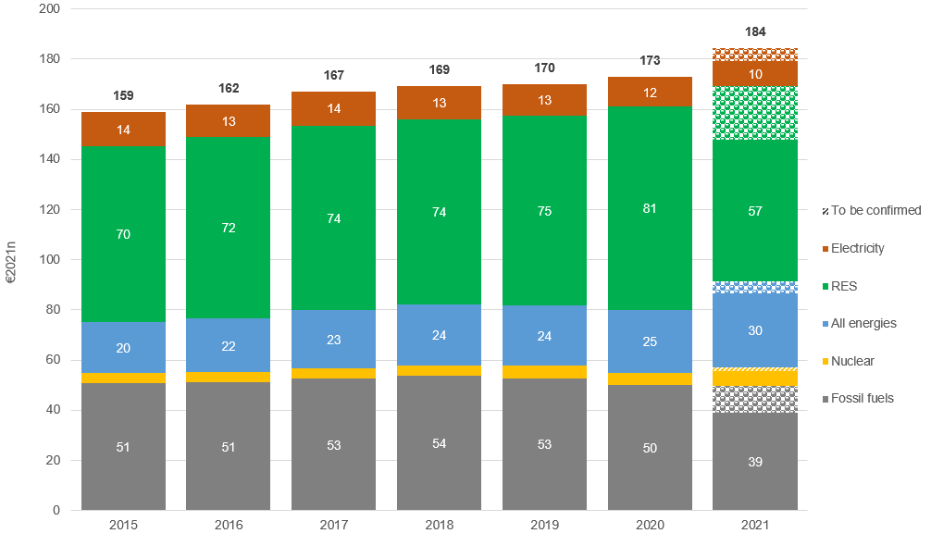

Source: Study on energy subsidies and other government interventions in the European Union – 2022 edition. ‘All energies’ represents subsidies not directly attributable to energy carriers or fuels (e.g. energy-efficiency measures, representing around 55% of ‘all energies in 2021’ and energy-demand/consumption incentives irrespective of the energy carrier; investment grants; and particular R&D expenditures).

The share of energy subsidies that could directly be linked to the **energy sector**[21](i.e. the electricity-generation sector, coal miners, and oil and gas companies) was around 56-58% in 2019 and 2020, whereas in 2021 this fell to 54%. In the same period, the share of energy subsidies paid to households showed an increasing trend, reaching around 12-13%, while the share of industry was just above 10%, and that of transport was slightly below 10%. Between 2015 and 2020, subsidies rose by almost EUR 10 billion in the energy sector (+10%), and non-sector-specific energy subsidies also increased by EUR 2.7 billion over the same period. At the same time, energy subsidies in the commercial sector fell by EUR 1 billion.

In 2021, energy subsidies paid to the household sector increased by an estimated EUR 5 billion compared (+26%) to 2020, as high energy prices induced more financial support from governments for households. In the industrial sector, energy subsidies increased by EUR 1.7 billion (+8%), whereas in the energy sector they fell by EUR 2.1 billion (-2%).

**Figure 4 – EU energy subsidies by economic sector**

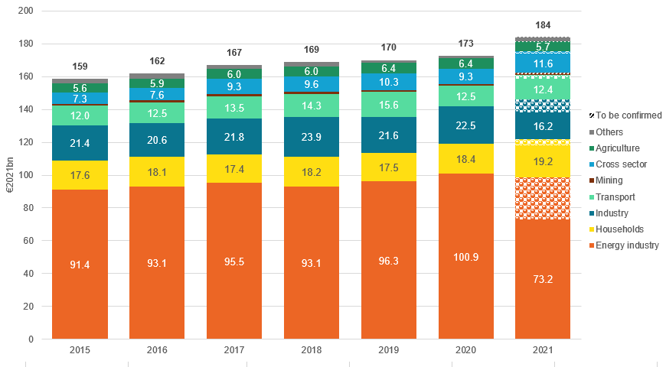

Source: Study on energy subsidies and other government interventions in the European Union – 2022 edition

The overall majority (around 90%) of **renewable subsidies** in the EU (EUR 81 billion in 2020) were in the energy sector. Around 38% of renewable subsidies could be linked to solar energy in 2020, whereas wind power generation accounted for around 27% of renewable-energy subsidies, and the share for biomass was around 22%. This left only a small share for hydro, geothermal and other renewables (13%). In 2021, the share of solar renewable subsidies captured by solar decreased to 34%, whereas the share captured by wind and biomass was around 24% each.

The most significant **renewable-energy subsidy instruments** in the EU Member States are feed-in tariffs[22] (amounting to EUR 54 billion or 67% of the total renewable subsidies in 2020). These feed-in tariffs reflect subsidies stemming from long-term contracts mostly concluded more than a decade ago, as recent contracts no longer apply feed-in tariffs with the exception of some small producers. Feed-in premia and renewable quotas with trading certificates accounted for less (respectively EUR 8 billion, or 10% and EUR 7 billion, or 8% in 2020). Tax-relief instruments (mainly in the form of tax reductions and exemptions) also contributed around EUR 6 billion (7%) to the total amount of renewable subsidies.

**Energy-efficiency subsidies** in the EU increased between 2015 and 2019, whereas in 2020 they fell back slightly (falling by 6% to EUR 1 billion), reaching EUR 15 billion, although they were still up almost 20% compared to 2015. In 2021, energy-efficiency subsidies rebounded, reaching an estimated EUR 19 billion (+29% compared to 2020), increasing particularly in households (+EUR 1.3 billion) and in industry (+EUR 0.5 billion). Grants were particularly significant, accounting for 39% of all energy-efficiency subsidies in 2020-2021. The next most significant categories of energy-efficiency subsidy were tax expenditures (30%), soft loans (18%), and energy-efficiency obligations (13%). In 2021, many EU Member States started to implement recovery plans[23] that became a significant source of energy-efficiency investments. The increase in support for energy efficiency between 2020 and 2021 has largely been driven by the building sector.

Increasing energy-efficiency subsidies is aligned with the ‘energy-efficiency first’ principle of EU energy policies, and these subsidies have also contributed to the decreasing energy intensity of the EU economy. Amid economic recession, EU GDP in 2020 showed only 2.6% growth compared to 2015, even though EU final energy consumption had fallen by 5% in the same five-year period, implying that the energy intensity of the EU economy decreased by 7.4% over this time. Although GDP grew by 5.3% in the EU in 2021, it is unlikely that the decreasing trend of energy intensity reversed. Further shifts from subsidies that incentivise energy consumption towards subsidies for energy-efficiency measures could help to maintain this decreasing trend.

**Figure 5 – Energy-efficiency subsidies in the EU**

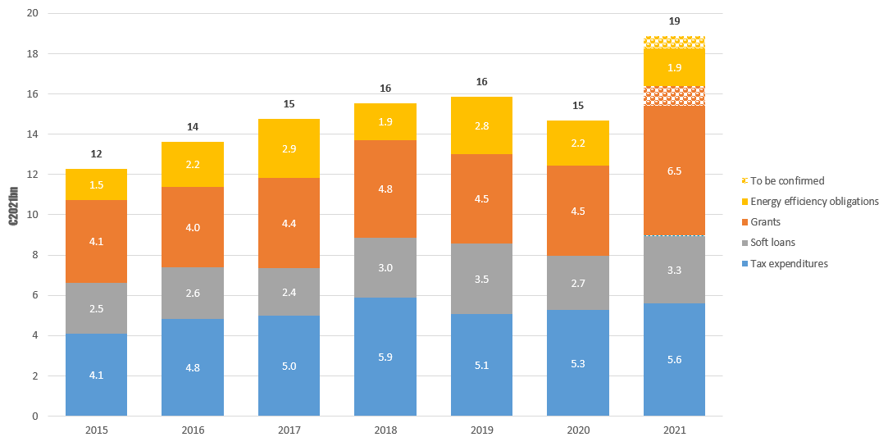

Source: Study on energy subsidies and other government interventions in the European Union – 2022 edition

Looking at other sectors, **households** received around 11% of total energy subsidies in 2020 allocated to all economic sectors. More than half of subsidies for households could not directly be attributable to energy carriers (e.g. subsidies for energy-efficiency measures). Support to electricity, and fossil-fuel (e.g. heating oil, gas, coal) consumption also represented significant shares (respectively 26% and 17%)[24]. For industry, most of the subsidies could directly be attributed to electricity, gas, oil products and renewables; whereas for the transport sector, subsidies were predominantly attributable to oil products.

**Price regulation** on the consumer side (consumer price guarantees) declined in significance between 2015 and 2020. However, in 2021 the cost of these guarantees rose above EUR 5 billion from only EUR 1.8 billion in 2020, probably due to increasing energy-price supports for households and industry, amid rising energy prices. At the same time, support on the producer side (producer price guarantees, such as purchase agreements, fuel-cost guarantees, etc.) remained in the range of EUR 4-5 billion over the past few years in the EU.

**Capacity-payment subsidies** showed a high degree of stability in 2015-2020, averaging around EUR 2.1 billion in this period and rising to an estimated EUR 2.6 billion in 2021. Capacity mechanisms mostly paid for electricity generation from fossil fuels in this period.

Subsidies on **hydrogen** have increased greatly in recent years, climbing from EUR 195 million in 2015 to EUR 329 million in 2021. In 2021, two thirds of this support was in the form of support for R&D expenditure, with the remainder mainly made up of direct transfers[25]. In the years to come, and as preliminary data already show, a significant increase in subsidies for hydrogen is expected.

Different **subsidy categories** might incentivise different energy technologies. However, it is not always possible to determine which subsidy categories are most typical for specific energy groups. As Table 1 shows, tax-expenditure subsidies (exemptions, reductions, etc.) are significant for fossil fuels, as they cover around two thirds of fossil-fuel subsidies. In contrast, income and price supports (e.g. feed-in tariffs/premia) account for 85% of the total support for renewable energies (and account for 41% of total energy subsidies). Tax-expenditure subsidies are also significant for electricity (86%) and the ‘all energies’ (40%) category (the ‘all energies’ category also includes energy-efficiency subsidies), while for ‘all energies’, direct-transfer subsidies also play an important role (around one third within total subsidies for ‘all energies’).

**Table 1 – Distribution of subsidies across different energy carriers and instruments**

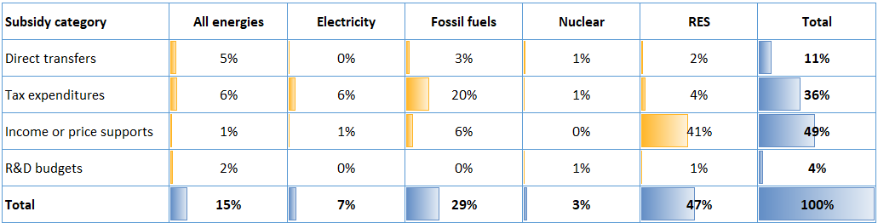

Source: Study on energy subsidies and other government interventions in the European Union – 2022 edition

## Fossil-fuel subsidies in the EU

**Fossil-fuel subsidies** fell by 1.5% in the EU in the 5 years since 2015, reaching EUR 50 billion in 2020[26]. In 2020, fossil-fuel subsidies were EUR 3 billion less than in 2019, principally owing to reduced transport activities. However, looking at the estimated 2021 data, overall fossil-fuel subsidies in the EU did not show a sharp upturn with the economic rebound, but instead stayed close to their 2020 level. This was the result of differences in fossil-fuel subsidies in different economic sectors, as it is outlined in the following paragraphs.

Fossil-fuel subsidies in the **energy sector** fell by EUR 1.9 billion (-11%) between 2015 and 2020, mainly as a consequence of decreasing subsidies on non-fuel-specific and multi-fossil-fuel subsidies, whereas subsidies specifically assigned to coal, lignite and natural gas remained practically unchanged. All in all, decreasing subsidisation of fossil fuels in energy production is a positive development for the EU’s climate objectives and international commitments. In 2021, fossil-fuel subsidies continued to decrease in the energy sector, and were 25% lower than in 2015.

In the **transport sector,** fossil-fuel subsidies (primarily on oil products) increased dramatically (by 29%, or EUR 3.1 billion) between 2015 and 2019, before falling back in 2020 by EUR 3 billion (primarily owing to lower petroleum consumption) and rebounding in 2021 by EUR 0.9 billion (+9% compared to 2020). According to estimations in the context of the study, consumption of kerosene in aviation in 2021 was still lower than in 2019.

Fossil-fuel subsidies in **agriculture also increased** (by 13%, or +EUR 0.7 billion) between 2015 and 2020, and the sector received subsidies overwhelmingly in the form of support for consumption of petroleum products (e.g. reduction or exemption of fuel taxes). Fossil-fuel subsidies **for households** increased by 15% (EUR 0.4 billion) in the same period, principally in the form of subsidies for heating-oil and natural-gas consumption. In 2021, fossil-fuel subsidies for households continued to increase from their 2020 levels.

In contrast, fossil-fuel subsidies in **industry**, provided mainly in the form of tax reductions and exemptions for energy use, fell by EUR 0.2 billion (-2%) between 2015 and 2020. Subsidies on coal decreased by EUR 1.4 billion, whereas subsidies on gas and oil grew by EUR 0.5 billion and EUR 1.1 billion respectively in the five-year period.

**Figure 6 – Fossil-fuel subsidies in different sectors in the EU**

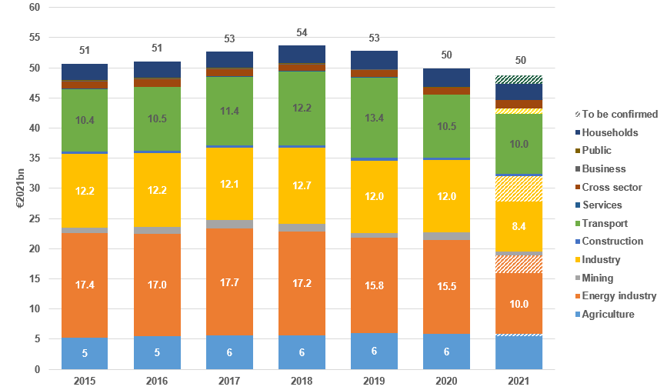

Source: Study on energy subsidies and other government interventions in the European Union – 2022 edition

Subsidies on **oil and** **petroleum products**, representing more than half of total fossil-fuel subsidies in the EU, grew by 6% (+EUR 1.2 billion) between 2015 and 2020, although these subsidies fell by EUR 3.1 billion in 2020 owing to the COVID-19 related lockdowns. Subsidies on diesel fuel rose by 44% (+EUR 3.4 billion) between 2015 and 2020 in the EU, with the biggest contributors being Belgium (+EUR 1.8 billion, more than tripling) and France (+EUR 1.2 billion, or +74%). Oil and petroleum subsidies grew by an estimated EUR 0.8 billion in 2021 compared to 2020.

Subsidies on **coal** **and lignite** fell by 9% (-EUR 0.9 billion) in the EU between 2015 and 2020, owing to decreased use of solid fuels in several sectors such as industry. However, in electricity generation, coal subsidies did not show any significant change in this five-year period. In the future, subsidies for the coal sector might increase for a limited time, owing to both the expected short-term increase of coal in electricity-generation mixes and compensation schemes for coal and lignite plant closures planned in several Member States. However, there may be changes in the plans for these compensation schemes given the current challenges for energy security and supply. The biggest drop in solid-fuel subsidies in this five-year period could be observed in Germany (by 11% or -EUR 0.8 billion), whereas in Poland coal subsidies increased by 65% (+EUR 0.6 billion). Coal subsidies in the EU increased by an estimated EUR 0.6 billion in 2021 across the EU compared to 2020.

Subsidies for **natural gas** grew by 6% (EUR 0.5 billion) between 2015 and 2020, representing around 19% of fossil-fuel subsidies, slightly more than the share of subsidies accounted for by coal and lignite (18%). Subsidies on gas rose in the industrial sector during this period, while there was no change in subsidies in the electricity-generation sector. Natural-gas subsidies rose by around EUR 0.5 billion both in Germany (+9%) and France (+113%) in this period, whereas the change between 2015 and 2020 showed a mixed picture in other countries.

Increasing coal prices amid extreme high gas prices made it more difficult to replace gas with coal in the power mix of many EU Member States, but they encourage replacement with cheaper renewable energy sources. As a result of the current geopolitical situation, the EU has introduced two initiatives. The first initiative is the REPowerEU plan to reduce reliance on gas consumption (principally aiming at: (i) diversifying gas supplies away from Russia; (ii) boosting energy efficiency and energy savings; and (iii) accelerating the rollout of renewables. The second initiative is the ‘Save gas for a safe winter’ plan to reduce gas consumption in winter 2022-2023[27]. In the future, these two initiatives will probably impact subsidies on natural gas[28]. Gas subsidies across the EU rose by an estimated EUR 0.7 billion (+10%) in 2021 compared to 2020.

Subsidies on fossil fuels have **different significance in different EU countries** depending on the size of national GDP. In 2020, Cyprus spent 1.3% of its GDP on subsidising fossil fuels (principally oil products). Bulgaria also spent 0.9% of its GDP on fossil-fuel subsidies that year (mostly on measures not assigned to particular fuels). On the other hand, Luxembourg and Austria spent less than 0.1% on fossil-fuel subsidies in 2020, whereas the EU average was 0.3% of GDP. After Cyprus, Belgium and Greece spent the most on oil-product subsidies (0.7% and 0.5% of their GDP respectively), while Slovakia and Poland spent 0.3% of GDP on coal subsidies.

Compared with 2015, the intensity of fossil-fuel subsidies (the amount spent on fossil-fuel subsidies per euro of GDP) rose by 0.9 per cent in Cyprus, and by 0.4 per cent in Bulgaria in 2020, whereas it decreased by 0.5 per cent in Latvia, and by more than 0.3 per cent in Lithuania and Ireland. At EU level, this intensity of fossil-fuel subsidies remained practically unchanged between 2015 and 2020. In 2021, the intensity of fossil-fuel subsidies decreased slightly compared to 2020 in most Member States.

**Figure 7 – Fossil-fuel subsidies in the EU Member States, as a percentage of GDP and in billion euros in 2020, compared with fossil-fuel subsidies as per cent of the GDP in 2015**

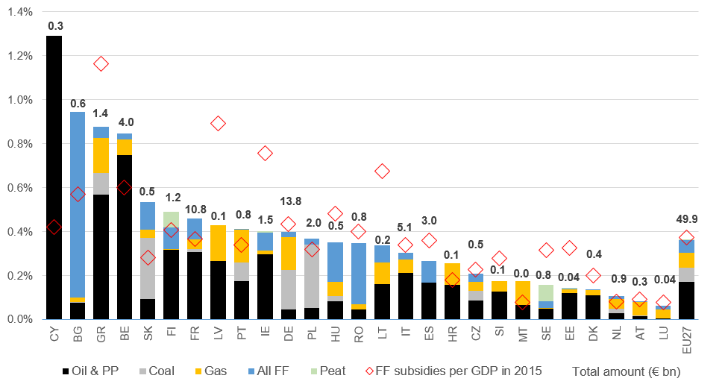

Source: Study on energy subsidies and other government interventions in the European Union – 2022 edition

# Consistency of different energy subsidies with the energy taxonomy

The EU taxonomy might have an impact on subsidies in the future, providing tools to identify sustainable activities. It could facilitate EU and national policies to target activities that contribute substantially to climate-change mitigation and adaptation, without significantly harming other environmental objectives. The Commission study has carried out the first stocktaking exercise on how energy subsidies are consistent with underlying economic activities defined in the taxonomy[29].

To classify subsidies, the Commission study set out four different categories[30]. The first category is ‘consistent’ and can be applied to cases where subsidies benefit activities known as ‘taxonomy-eligible economic activities’, such as renewables or energy efficiency in general. The second category is ‘not consistent – transitional’, and covers subsidies benefiting activities not eligible under the EU taxonomy, but which might also support the energy transition, such as decommissioning of fossil-fuel assets. The third category is ‘not consistent’, and covers all subsidies supporting directly or indirectly the production or consumption of fossil fuels. The final category is ‘not applicable’and covers subsidies that cannot be classified under previous categories such as market mechanisms (e.g. capacity market or security reserves).

As the data from the Commission study show, the vast majority of subsidies on renewables (EUR 79 billion out of the total EUR 81 billion in 2020) belongs to the ‘consistent’ category (the remaining EUR 2 billion of subsidies is distributed among non-consistent and not applicable categories, covering mainly tax or surcharge reductions on renewable electricity for some industries). In contrast, most of the fossil-fuel subsidies are classified under the ‘not consistent’ category. In the two other categories, (‘not consistent – transitional’ and ‘not applicable’) we can find, for example, subsidies for coal-mine restructuring and benefits for the social transition of people employed in the mining sector. These two other categories accounted for EUR 2.8 billion of the total EUR 50 billion in fossil-fuel subsidies in 2020. In the ‘All energies’ category, around 63% of the total amount of EUR 26 billion in subsidies fell under the ‘consistent’ category in 2020, while other measures (e.g. tax reductions on energy and grants for certain activities and investments) were in the other three categories. For both electricity and nuclear generation, the vast majority of subsidies (more than 80%) fell into the ‘not consistent-transitional’ category in 2020.

**Figure 9 – Classification of subsidies relating to consistency with taxonomy classification in 2020**

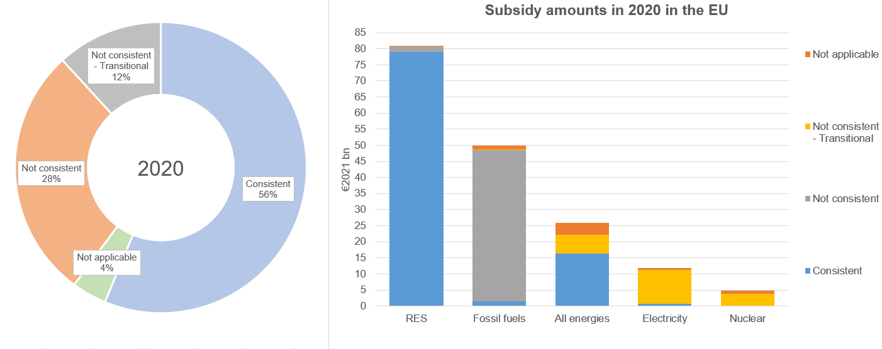

Source: Study on energy subsidies and other government interventions in the European Union – 2022 edition

# Conclusions

Recent geopolitical developments and elevated energy prices have called for new policy initiatives in the European Union. These new initiatives are exceptional in their nature, but could fundamentally impact the energy market and energy infrastructure. Less energy consumption and continuously reducing reliance on fossil fuels in the residential, power, transport and industrial sectors will help to reduce imports of fossil fuels, speeding up the clean-energy transition and increasing security of energy supply in the EU. This implies a reduction in associated fossil-fuel subsidies, and redirecting resources to renewables and energy efficiency remains a tool to achieving these and the EU climate policy objectives. A significant mid-term decrease in gas consumption will most likely entail a decrease in gas subsidies. The current high gas prices and the expected temporary increase in coal-fired generation should not lead to substantially higher fossil-fuel subsidies. At the same time, in the forthcoming few years, policy considerations for affordability also need to be taken into account. Coal- and lignite-fired electricity-generation capacity – as well as some nuclear plants – are likely to remain a part of electricity generation in some EU Member States for longer than was previously expected.

In order to implement the clean-energy transition, avoid lock-in and stranded assets in fossil-fuel technologies and minimise the use of fossil energy, further investments are needed in renewables and energy efficiency. This will likely require shifting the focus of energy subsidies towards renewables and efficiency, including demand response. Newly emerging technologies, such as renewable hydrogen, will become increasingly significant, implying higher subsidies. Energy efficiency will play a key role in implementing the objectives of REPowerEU and the ‘Save gas for a safe winter’ plan. The necessary investments for these programmes may imply greater financial support for energy efficiency in the form of increased subsidies.

At the same time, EU Member States have taken a number of measures to reduce the impact of high retail prices for energy. These measures are likely to be translated into higher energy-demand subsidies for households and businesses, at least in the short and medium term.

The detailed results of the Commission study on subsidies will be published jointly with this report to provide a comprehensive picture of the situation.

1. Article 35, point n of the Regulation on the Governance of the Energy Union (2018/1999/EU), hereinafter: the Governance Regulation.
2. <https://ec.europa.eu/energy/sites/default/files/annex_to_the_state_of_the_energy_union_report_on_energy_subsidies_in_the_eu.pdf>, hereinafter: previous Commission studies on subsidies (2020 and 2021).
3. <https://unfccc.int/sites/default/files/resource/cma2021_10_add1_adv.pdf>.
4. Furthermore, Council Recommendation on ensuring a fair transition towards climate neutrality (2022/C 243/04) stresses that ‘the composition of tax-benefit systems and social protection systems should be examined against the specific needs stemming from the green transition, reflecting also the ‘polluter pays principle’ and the need that accompanying policies do not introduce subsidies to fossil fuels consumption, do not lock in consumers to a specific technology, do not decrease incentives for building renovations and thermal energy system substitutions and do not decrease incentives within general energy efficiency measures.’
5. <https://ec.europa.eu/commission/presscorner/detail/en/IP_22_3131>.
6. <https://eur-lex.europa.eu/legal-content/EN/TXT/PDF/?uri=CELEX:32021R2139&from=EN>.
7. https://eur-lex.europa.eu/legal-content/EN/TXT/PDF/?uri=CELEX:32022R1214&from=EN.
8. Study on energy subsidies and other government interventions in the EU – 2022 edition, hereinafter ‘the Commission study’ <https://op.europa.eu/en/publication-detail/-/publication/34a55767-55a1-11ed-92ed-01aa75ed71a1>
9. Due to both re-assessment of the subsidy inventory for the earlier years, and the change in the monetary basis (‘expressed in 2021 euros’ in the current report) total amounts on the charts of this report may differ from the last energy-subsidy report published in 2021 or earlier.
10. For some subsidy items, if 2021 values were not available, 2020 values were taken as an estimate for 2021. In most cases, 2021 data are referred to in this report. However, if only 2020 data are robust enough for the analysis, they are taken as being the latest dataset available.
11. Subsidies related to energy demand incentivise energy consumption in various economic sectors, for example via: (i) tax reductions or refunds on energy consumption; (ii) regulated prices in certain sectors; and (iii) direct payments aiming at alleviating consumer burdens stemming from energy costs. Some energy-demand subsidies have social implications, going beyond purely economic considerations. In times of high energy prices, especially vulnerable consumers should be taken into consideration in policy decisions on subsidies.
12. For more information on concepts, definitions, purposes, sectors, instruments, fuel types, etc. see Annex 5 of the Commission study.
13. World Trade Organization (WTO) Agreement on Subsidies and Countervailing Measures. <https://www.wto.org/english/tratop_e/scm_e/scm_e.htm>.
14. See more on energy-subsidy methodology in the Commission study.
15. In the current report also including subsidies for fishing.
16. Subsidies related to energy demand incentivise energy consumption in various economic sectors, for example via: (i) tax reductions or refunds on energy consumption; (ii) regulated prices in certain sectors; and (iii) direct payments aiming at alleviating consumer burdens stemming from energy costs. Some energy-demand subsidies have social implications, going beyond purely economic considerations. In times of high energy prices, especially vulnerable consumers should be taken into consideration in policy decisions on subsidies.
17. These measures were principally linked to European Regional Development Fund (ERDF) programmes in the 2014-2020 period, aiming at shifting to low-carbon developments in all economic sectors. As of 2021, preliminary data showed that these ERDF measures had ended, bringing down the overall subsidy amount.
18. Overall, most fossil-fuel subsidies still aim at incentivising consumption and/or energy production from such fuels, whereas the share of subsidies aiming at reducing reliance on fossil fuels is minimal.
19. Subsidy amounts for electricity use have been re-allocated to their energy-generation sources (e.g. fossil fuels, nuclear, renewables) based on the national energy balances.
20. Stranded assets are assets that have suffered from unanticipated or premature write-downs, devaluations or conversion to liabilities
21. For more information on definitions, purposes, sectors, instruments, fuel types, etc. see Annex 5 of the Commission study.
22. More information on the concepts and the role of different instruments can be found in the Commission study
23. The national recovery and resilience plans were prepared and adopted in 2021. Their impact will probably be felt only in the coming years. Beyond energy-efficiency spending, the RRPs allocate significant sums for other purposes, such as renewable energy.
24. Mainly in the form of reduced VAT. Special forms of financial support to vulnerable households needs to be made with care, as it goes beyond considerations strictly related to the energy market. However, in the current subsidy report and the underlying study data are only provided for the household sector as whole, deeper socio-economic breakdown (e.g. income level, age, household composition, etc.) is not available
25. Breakdown of data on different hydrogen-generation technologies and sources (e.g. renewables or fossil) is not available.
26. To follow a consistent methodology across Member States, energy carriers, sectors and subsidy instruments, some items considered as a subsidy in other sources were not counted in the total numbers in the Commission study. For example, many Member States apply different excise rates for petrol and diesel, so subsidies on these products might be significant. Similarly, extra-EU international aviation and maritime transport are not covered. As capital infusions or purchases by the government are not included in the scope of the Commission study, some financial support given to enterprises consuming fossil fuels (e.g. financial rescue packages for airline companies) are also not included among fossil-fuel subsidies. The database also does not contain information on abated and unabated fossil-fuel generation technologies.
27. On the top of these initiatives, other important legislative acts, having impact on gas consumption and subsidies, have been adopted by the EU, such as the Gas demand reduction regulation, Gas storage regulation, etc.
28. Subsidies on gas only refer to subsidies for the production and consumption of gas and energy from gas. They do not include support to potential infrastructure developments, such as upgrading the European gas grid to enable better gas flows, building new LNG regasification terminals, or expanding existing terminals, etc.
29. It is important to keep in mind that at the time of the drafting of the Commission study, that the Complementary Climate Delegated Act, addressing nuclear and gas energy activities, has already been proposed by the European Commission, but the adoption process by the co-legislators, has not been finished, and as the Delegated act did not yet enter into force
30. The detailed description of each classification can be found in Chapter 5.1.2 on EU taxonomy classification of the Commission study