

Contents

INTRODUCTION 1

Scope of the first State of Health Preparedness Report 3

PROGRESS MADE IN THE EU IN RELATION TO THE EARLY LESSONS FROM THE COVID-19 PANDEMIC 4

EU PREPAREDNESS FOR FUTURE HEALTH EMERGENCIES – STATE OF PLAY AND PLANNED ACTIONS ON MEDICAL COUNTERMEASURES 6

1. Threat assessment and intelligence gathering 6

1.1 Threat prioritisation 6

1.2. Threat detection 7

1.3. Support capacities for epidemiological surveillance 8

2. Advanced research and development of medical countermeasures 10

2.1. Vaccines 11

2.2. Therapeutics 12

2.3. Diagnostics, medical devices and other innovative technologies 13

3. Access to medical countermeasures - resilient supply chains and production capacities 14

3.1. Building resilient supply chains 15

3.2. Ensuring manufacturing capacities for medical countermeasures in a crisis 16

3.3. Ensuring access and equitable distribution of medical countermeasures 18

3.4. Stockpiles 18

4. International coordination and global activities 19

CONCLUSION 21

**INTRODUCTION**

**The disruption caused by the COVID-19 pandemic[1] to our lives, our societies and our economies was unprecedented and recalled the gravity of serious-cross border health threats for our economies and societies.** As of November 2022, nearly 7 million deaths due to COVID-19 have been officially reported globally[2], with estimates suggesting an actual death toll exceeding 20 million people worldwide[3]. In the EU COVID-19 has caused the death of more than 1.1 million people and this is likely to be an underestimate of the actual death toll of the pandemic in the EU[4]. COVID-19 has also affected millions of people living with longer term effects of the disease.

The ad-hoc measures taken by the EU to reduce the spread of COVID-19 were effective and responsive. However, at early phase of the pandemic the Union was not **sufficiently prepared to ensure the efficient development, manufacturing, procurement and distribution of crisis-relevant medical countermeasures[5]**. The pandemic in 2020 also demonstrated how vital preparedness and response capabilities in the field of health is for other areas such as energy, transport, industrial policy and the internal market more broadly. The pandemic also revealed insufficient oversight of research activities and manufacturing capacities as well as vulnerabilities related to supply chains[6]. The situation has changed since then especially with the creation of the European Health Emergency Preparedness and Response Authority (HERA) in 2021. As a central pillar of the European Health Union[7], HERA is strengthening the EU preparedness and response capabilities in the field of medical countermeasures.

**Moreover, since 2020, the EU has improved its health security architecture by reinforcing existing and creating new structures, boosting preparedness, revamping emergency response mechanisms and demonstrating the benefits of coordinated actions at the EU-level**. Protecting EU citizens from cross-border health threats should remain a standing priority. The EU and its Member States should have a stronger capacity to ensure the sufficient and timely availability and supply of crisis relevant medical countermeasures. These capacities are needed to protect EU citizens from ongoing and emerging health threats stemming from pathogens with high pandemic potential, chemical, biological, radiological and nuclear (CBRN) threats, underlying threats such as antimicrobial resistance (AMR) or other unknown threats.

**The Commission has a long-standing experience in collaborating with relevant expert groups to ensure risk preparedness and cross-border coordination. The experience gained has shown that investing in advance in health emergency preparedness pays off considerably.** The cost of inaction and insufficient preparedness far outstrips the cost of effective, systematic and coordinated investment in preparedness and planning[8]. The strategic and coordinated approach to preparedness at the EU-level should help to avoid, or, at the very least, significantly decrease the adverse effects of health crises in terms of human lives, impacts on health services, negative growth, unemployment, threats to security of energy supply or market disruptions. Ultimately, increased capacities to prevent, detect and rapidly respond to future health emergencies should allow to safeguard the economic and social stability of the EU and of its Member States.

Next serious cross-border health threats, like COVID-19, may come to the EU from abroad. This means that the strategic and coordinated approach to preparedness must not stop at EU borders and must not be limited to the health and medical sector as such. The pandemic demonstrated that preparedness and planning were under-funded and under-developed in almost every region and country across the world. Therefore, it is crucial that preparedness capacities are improved and increased globally. In this respect, this Communication (hereinafter referred to “State of Health Preparedness Report” or “report”) should be read in conjunction with the new EU Global Health Strategy[9] which deepens the EU’s leadership and reasserts its responsibility to strengthen global preparedness for future health emergencies

|  |
| --- |
| **Defining serious cross-border threat to health** (Regulation of the European Parliament and of the Council on serious cross-border threats to health and repealing Decision No 1082/2013/EU) **:**  *Serious cross-border threat to health’ means a life-threatening or otherwise serious hazard to health of biological, chemical, environmental or unknown origin, as referred to in Article 2(1), which spreads or entails a significant risk of spreading across the national borders of Member States, and which may necessitate coordination at Union level in order to ensure a high level of human health protection* |

This is the first State of Health Preparedness Report. It was announced in June 2021 in the Commission Communication “Drawing the early lessons from the COVID-19 pandemic”[10]. It reflects the changing risk landscape in the EU and the state of health preparedness to address those threats. The report covers the main health threats which the EU may have to face in the future.

The State of Health Preparedness Report will focus on different aspects of preparedness every year. **The** **first edition focuses on preparedness capabilities related to medical countermeasures.** First, the report presents an overview of the progress made throughout the past three years to reinforce preparedness in the EU. Second, it outlines the state of play and actions that are planned to fill the gaps in relation to ensuring sufficient availability and supply of medical countermeasures. It draws on combined contributions of HERA and various Commission services.

Future editions will focus on other elements, beyond medical countermeasures, which are indispensable to reaching sufficient levels of health preparedness. They should also present preparedness indicators based on reporting from Member States.

**Scope of the first State of Health Preparedness Report**

**Medical countermeasures have protected and continue to protect European citizens and individuals globally from serious cross-border threats to health**. COVID-19 vaccines helped to avoid 20 million deaths worldwide and half a million deaths in Europe in the first year of the roll out of vaccination programmes[11]. Diagnostics, therapeutics and protective personal equipment (PPE) have also contributed to detect, monitor, treat and prevent COVID-19 disease progression. The development of and equitable access to new medical countermeasures will effectively contribute to containing future health threats.

**The pandemic has demonstrated that shortcomings related to the access and availability of medical countermeasures were not only a challenge for the EU but touched almost every country across the world.** Uncoordinated stockpiling, high dependencies on third countries, disruptions in pharmaceutical supply chains, suboptimal production capacities linked with trade disruptions and unanticipated demand surges have undermined the timely supply of lifesaving medical countermeasures[12].

**Enhanced coordination between Member States, structured cooperation with stakeholders and robust end-to-end solutions ensuring ultimately the availability and accessibility of medical countermeasures** is pivotalto strengthen preparedness for health threats. With the establishment of HERA, the Commission is bringing together Member States, industry and all relevant stakeholders to support the development, production, procurement and distribution of breakthrough medical countermeasures and crosscutting manufacturing technologies. It also reinforces the cooperation with global partners to enhance health preparedness and response capabilities in the field of medical countermeasures globally (see Fig.1).

**Figure 1: HERA’s mission to ensure availability and access to medical countermeasures by reinforcing the whole value chain:**

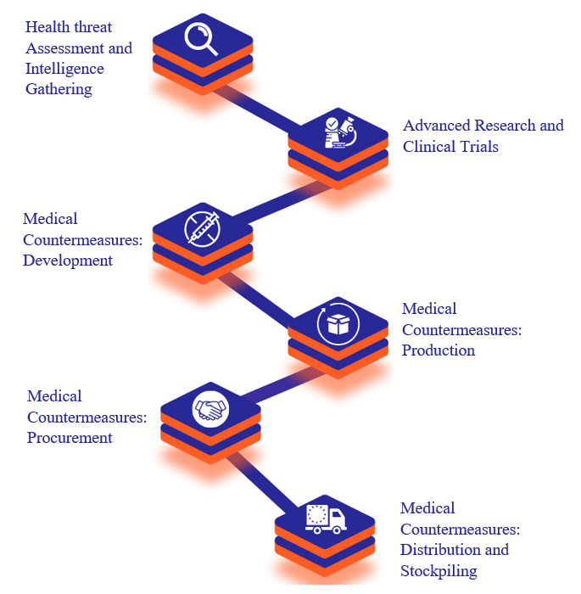

**PROGRESS MADE IN THE EU IN RELATION TO THE EARLY LESSONS FROM THE COVID-19 PANDEMIC**

**Over the past twenty years, the EU has been repeatedly confronted with health emergencies of varying magnitudes. These have led to the gradual reinforcement of health security capabilities at the national and European level.** The European Centre for Disease Prevention and Control (ECDC) was created after the SARS outbreak in 2003 and a Joint Procurement Mechanism for medical countermeasures was created following the H1N1 influenza outbreak in 2009. The EU ramped up investment in vaccine and vaccination research and innovation, which, among other things, contributed to the development of an Ebola vaccine[13]. Member States had developed pandemic preparedness plans and made investments in preparedness research and innovation. Yet, the pandemic showed that these steps, even combined, were not enough and stressed the need to significantly improve coordination and develop a strategic approach to pandemic preparedness at the EU level.

In its Communication Drawing the early lessons from the COVID-19 pandemic[14], the Commission identified 10 lessons to turn emergency actions into structural changes and develop long term solutions to enhance our preparedness for future health emergencies (further details can be found in Annex 2). 18 months later, considerable progress has been achieved to reach the objectives laid out in the Communication:

1. **Faster detection and response depend on stronger global surveillance and more comparable and complete data:** The ECDC’s EpiPulse portal has improved surveillance within the EU, and ECDC grants are strengthening Member States’ ability to carry out genome sequencing and testing. The Commission and the ECDC are working with international partners – notably the WHO and Africa CDC to improve global threat detection and analysis.
2. **Clear and coordinated scientific advice facilitates policy decisions and public communication:**The EU continues to improve the interaction between science, policy-making, and the development of medical countermeasures. In addition to its ongoing Rapid Risk Assessments, the ECDC has launched the European COVID-19 Scenario Hub to increase the quality of the modelling and forecasting available to EU policymakers. The European Medicines Agency (EMA) continues to work intensively with developers: as of 19 October 2022, it had provided detailed scientific advice on the development of 48 potential COVID-19 vaccines and 111 potential COVID-19 therapeutics.
3. **Preparedness needs constant investment, scrutiny and review:** The Commission has secured nearly EUR 30 billion to enhance preparedness and health systems resilience[15]. The ECDC has worked with Member States to identify specific preparedness capacities and capabilities that were essential in the response to the pandemic and should thus be included in preparedness assessment tools. Moreover, every three years, the ECDC will assess the implementation of Member States’ preparedness plans and present recommendations accordingly.
4. **Emergency tools need to be ready, faster and easier to activate:** The Emergency Framework Regulation[16] now gives the EU a legal framework to work with on day one of a future health emergency, enabling rapid activation of funding, research and innovation plans, the EU FAB facilities, and the governance structure for emergency response. The Commission has proposed adaptations to the EU’s financial rules for crisis situations to allow for swifter mobilization of necessary resources.[17]
5. **Coordinated measures should become a reflex for Europe:** The EU health security framework has been strengthened with a new Regulation on serious-cross-border threats to health adopted in October 2022. The regulation calls for the creation of a Union Prevention, Preparedness and Response plan, complementary to Member States’ plans which will promote an effective and coordinated response to serious cross-border threats to health. The Emergency Framework Regulation will allow the establishment of a Health Crisis Board. This Board will rapidly coordinate at EU level the supply of and access to crisis-relevant medical countermeasures. The EMA’s strengthened mandate will allow it to monitor and mitigate shortages of critical medicines in a public health emergency. The ECDC’s extended mandate gives the agency a stronger role in supporting Member States in preparedness, response, prevention and control when it comes to infectious disease threats. In all this work a horizontal cooperation among key stakeholders and sectors will be ensured.
6. **Reinforced public-private partnership and stronger supply chains are needed for critical equipment and medicines:** In 2021 the Commission brought together actors in the pharmaceutical manufacturing value chain, public authorities, patient and health non-governmental organisations and the research community in a Structured Dialogue on the security of the supply chains of medicines. The Commission is building on this work to strengthen the continuity and security of supply in the EU, in particular for those medicines considered to be most critical to health systems.
7. **A pan-European approach is essential to make clinical research faster, broader and more effective***:* The Commission has sustained its support for EU-wide clinical trial networks for new medicines and medical countermeasures VACCELERATE for vaccines and EU-RESPONSE[18] for therapeutics. The new Clinical Trials Regulation[19] harmonises the assessment and supervision of clinical trials throughout the EU, notably via the establishment of a Clinical Trials Information System (CTIS).
8. **Capacity to cope in pandemic depends on continuous and increased investment in health systems:** The Commission is supporting Member States to strengthen the resilience of their health systems as part of their Recovery and Resilience Plans, with more than EUR 40 billion earmarked for national health systems under current plans[20]. Specific support is also being provided under programmes such as EU4Health for training of the health workforce and for supporting the design of resilience tests for Member States to regularly review health crisis preparedness and check their health system’s resilience.
9. **Pandemic preparedness and response is a global priority for Europe:** As of November 2022, the EU and its Member States had, through a Team Europe[21] approach donated 500 million doses of COVID-19 vaccines to third countries, mainly via COVAX. The EU is now deeply involved in strengthening global preparedness capacities via specific initiatives to build capacities in third countries such as the EU Initiative on Health Security, or via overarching initiatives to reinforce global health security governance such as the ongoing negotiations for a new WHO convention, agreement or other international instrument on pandemic prevention, preparedness and response (“Pandemic Treaty”). This is reflected in the new EU Global Health Strategy.
10. **A more coordinated and sophisticated approach to misinformation and disinformation should be developed:** The European External Action Service (EEAS) and the Commission have developed the Foreign information manipulation and interference (FIMI) toolbox in 2022. And the EU works closely with Member States, (via the Rapid Alert System) with international partners (particularly G7 Rapid Response Mechanism and NATO), as well as with civil society and industry to address misinformation and disinformation. Altogether, these actions contribute to improving communication, and tackling disinformation, community engagement and information exchanges with Member States[22].

**EU PREPAREDNESS FOR FUTURE HEALTH EMERGENCIES – STATE OF PLAY AND PLANNED ACTIONS ON MEDICAL COUNTERMEASURES**

The EU is building and reinforcing preparedness capabilities for the development, manufacturing, procurement and distribution of medical countermeasures, underpinned by reinforced surveillance capacity. The level of implementation for these actions is summarised in the table annexed to this report (See Annex 1).

1. **Threat assessment and intelligence gathering**
   1. **Threat prioritisation**

At the beginning of the pandemic the EU and its Member States lacked a permanent and integrated approach to research, development, market authorisation, production and supply of medical countermeasures to be prioritised in the light of the most pressing health threats.

To ensure that a long term and systemic approach to preparedness is put in motion and efforts are focused on the most relevant medical countermeasures, the Commission put forward, its first ever list prioritising **three threat categories**[23]. The list prioritised life-threatening or otherwise seriously harmful hazards to health, which have the potential to spread across the Member States and require action on Union level in relation to medical countermeasures (Annex 1 Action 1.1).

These categories were identified in close collaboration with Member States, global partners and other relevant stakeholders. Throughout 2022, the Commission has consulted Member States, Union and national agencies, Chief Medical Officers, international actors and experts on the threat prioritisation exercise. Preliminary results were presented to the HERA Advisory Forum and to the HERA Board on 8 July 2022.

|  |
| --- |
| ***WHAT’S NEW?*** |
| In July 2022, the Commission established **a list of 3 priority health threats**. The list includes **pathogens with high pandemic potential** covering mainly respiratory RNA viral families, c**hemical, biological, radiological, and nuclear (CBRN) threats** originating from accidental or deliberate release and **antimicrobial resistance (AMR)**, referred to as the silent pandemic. |

The prioritised threats were identified in an “all hazards approach” and considering several criteria, such as the mode of transmission, the risk of spreading to the community, and the availability of treatment. The list will be updated annually based on the analysis of newly available information and taking into account exogenous events that may influence the prioritisation of threats.

On this basis, the Commission drew up a preliminary list of threat specific medical countermeasures (Annex 1 Action 1.2). This list is currently being finalised in coordination with Member States. This list should inform and guide the EU and Member States’ actions related to monitoring, research, development, production and the procurement of medical countermeasures to addressing those threats.

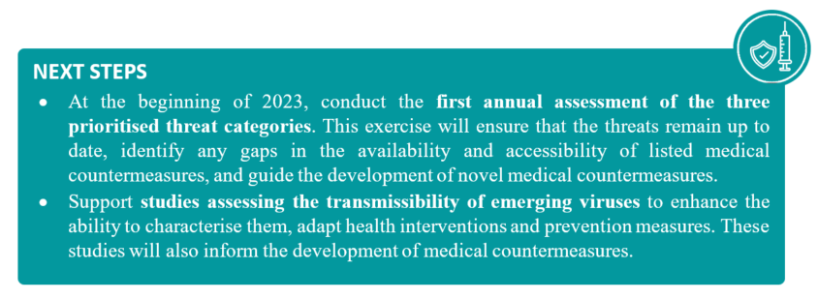

* 1. **Threat detection**

At the beginning of the pandemic, the EU lacked comparable and complete data on which to base decision-making. The pandemic demonstrated the usefulness of interconnected and cross-sectoral intelligence gathering systems and foresight. In addition, the EU did not have an integrated system to detect other priority threats such as AMR and CBRN threats and the relevant medical countermeasures needed to address them.

In light of this, the Commission has started working on the development of an **Intelligence Gathering and Threat Assessment** tool, the Medical Countermeasures Intelligence Platform (HERA MCMI platform) to strengthen the link between health threat detection and the availability of relevant medical countermeasures to address the health threats in question.

The MCMI platform aims at making use and complementing existing epidemic intelligence resources by combining intelligence on health threats and on medical countermeasures. The platform intends to collect information from producers and Member States on the production, stockpiles of crisis-relevant raw materials, equipment and infrastructure. The future proof cybersecurity MCMI platform should be interoperable with existing mapping platforms monitoring the supply situation for authorised medicinal products such as the related EMA tools, or tools under development such as EUDAMED to ensure complementarity and avoid any duplication.

|  |
| --- |
| ***WHAT’S NEW?*** |
| The **HERA MCMI platform*,*** would:   * Establish and regularly update a list of high-impact health threats requiring medical countermeasures preparedness; * Map and analyse existing and developing medical countermeasures, and remaining gaps; * Detect early health threats that may require medical countermeasures response; * Evaluate rapidly health threats in order to identify the relevant medical countermeasures response. * Identify and manage supply chain risks for relevant medical countermeasures |

The MCMI platform will cover strict security requirements to facilitate the exchange of information with other secured platforms while preserving the integrity of the whole IT architecture, including robustness to cyber threats and the protection of commercial data. Data protection is an important aspect in the context of the MCMI platform. With regards to personal data, when relevant such as for technical support or user access to the platform purposes, its protection will be ensured in accordance with the Regulation on Protection of individuals with regard to the processing of personal data by EU institutions, bodies, offices and agencies[24].

Through HERA, the Commission is also working on establishing partnerships with relevant stakeholders with the aim to advance real-time data and intelligence exchange on threats and collaborative surveillance in order to improve threat detection capacities in relation to medical countermeasures. It is supporting the technological development of the Epidemic Intelligence from Open Sources (EIOS) Platform hosted within the WHO Hub for Pandemic and Epidemic Intelligence. The EIOS platform is designed to bring together existing initiatives, networks and systems to create a unified all-hazards approach to early detection, verification, assessment and communication of public health threats.

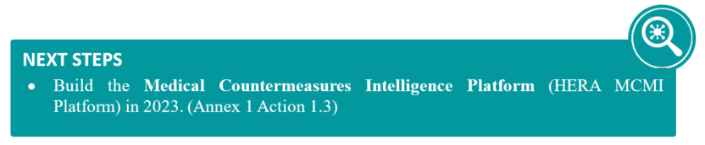

* 1. **Support capacities for epidemiological surveillance**

The lack of swiftly available, comparable and complete surveillance data at the start of the **pandemic posed a challenge to the monitoring of the evolution of the virus over time and** across Member States.

Building on the initiatives put in place in response to the pandemic, additional actions have been taken to bolster surveillance capacity and update surveillance systems in the EU to better assess and anticipate the need for medical countermeasures. Firstly, the Commission, in collaboration with ECDC, is supporting Member States to **reinforce their testing and genome sequencing capacities with EUR 39 million** worth of grants under the EU4Health 2022 programme to be implemented in 2023 and 2024. This should help improve national surveillance systems and capacities with the aim of providing more detailed information on the pathogens circulating and improve surveillance data generated at the EU level to inform actions in relation to medical countermeasures. It should also result in better fed intelligence gathering and decision support systems for priority health threats including AMR.

Secondly, the Commission is supporting **intelligence gathering from the surrounding environment.** During the pandemic it supportedthe reinforcement of wastewater surveillance capacities with EUR 20 million grant awarded in December 2021 from the Emergency Support Instrument (ESI). As of March 2022, there were 1370 wastewater treatment plants under regular surveillance across the EU[25]. This has enabled to strengthen Member States’ capacity to track viral presence in wastewater samples. The Commission now seeks to institutionalise wastewater surveillance across the EU. The Commission will also support the development of an EU-level wastewater sentinel system to allow for the testing of samples through centralised partner laboratories for a number of serious cross-border health threats. The first pilot of the system should start in early 2023.

Thirdly, the Commission will soon establish **a network of laboratories and research institutes with global reach** to contribute to the early detection of emerging health threats, to achieve a better level of preparedness and to coordinate response activities. The network will improve epidemiological analysis by providing access to a wide range of biological samples and by helping to characterise emerging pathogens. It will feed this data into the intelligence gathering systems. The network will inform the Commission’s decision making with respect to medical countermeasures by providing a timely, targeted, and tailored input on the identified health threat and rapid identification and assessment of relevant diagnostic, preventive, protective and therapeutic medical countermeasures, existing and under development.

In addition to actions at EU level, the Commission is **contributing to global initiatives** **to improve global surveillance.** More specifically, the Commission is supporting the development of sequencing capacity in Africa,in collaboration with the African Centre for Disease Control and Prevention (ACDC) and the Pathogen Genomics Initiative, as well as data collection on emerging pathogens in Africa in collaboration with WHO AFRO.

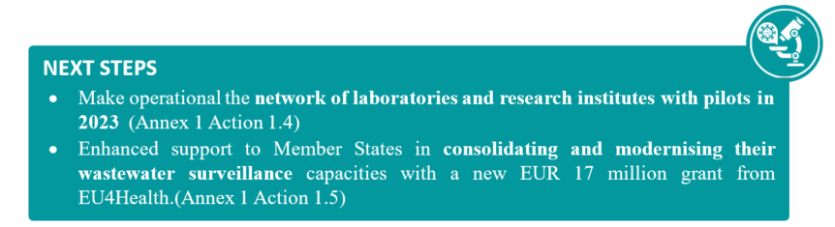

1. **Advanced research and development of medical countermeasures**

The unprecedented development of life-saving medical countermeasures during the pandemic drew on years of prior research into vaccine technology and coronaviruses medical countermeasures. It also benefited from the rapid, mass mobilisation of funds to enable the swift development of vaccines, therapeutics, and diagnostics.

Since then research and development of stronger detection, prevention, and tackling of infectious diseases and COVID-19 has increased at national, EU, and global level. However, the pandemic demonstrated the need to establish a strategic and consolidated **research and innovation plans to better coordinate funding for research and innovation at the EU, national, (and regional) level in order to develop effective, safe, affordable medical countermeasures for pathogens with high pandemic potential, CBRN threats and AMR. As regards pathogens with high pandemic potential, the Commission is developing, with all relevant stakeholders, a Strategic Research and Innovation Agenda for pandemic preparedness at EU level**.

|  |
| --- |
| ***WHAT’S NEW?*** |
| The Commission is expanding investment in the development of innovative medical countermeasures through “HERA INVEST”. With the support of the EIB and through InvestEU mechanisms, the Commission would invest, as of 2023, into innovative and strategic projects developing and producing, where relevant, medical countermeasures (e.g. diagnostics, therapeutics, preventives) against priority cross-border health threats (i.e. pathogens with high pandemic potential, AMR, CBRN). |

The pandemic has also made clear that there was insufficient investment in medical countermeasures that pose a high risk for investors with regard to market-uptake. Currently, the Commission has no standalone funding instrument to support the end-to-end development and production, where relevant, of innovative medical countermeasures. Hence, in 2023 the Commission will be providing EUR 100 million to top up Invest EU efforts in de-risking private investment (“HERA INVEST”) which should stimulate innovation for medical countermeasures for which currently there is insufficient market incentives. This financing instrument takes into account the experience gained in previous and existing programmes such as the Innovative Medicines Initiative (IMI1 and IMI2), the European Innovation Council (EIC) and the European Institute of Innovation and Technology (EIT).

It is a priority for the Commission and Member States to continue to coordinate and support the rapid approval of clinical trials to generate high-quality clinical data. The Commission will continue to develop and fund large-scale multi-centre clinical trials such as European pandemic clinical trial platforms (such as EU-RESPONSE and VACCELERATE), with an established trial infrastructure and coordination mechanism for research preparedness. Moreover, in the coming years, the European regulatory environment for clinical trials will facilitate, streamline, speed up and increase transparency for multinational clinical trials also for possible new COVID-19 therapeutics and vaccines. In addition, it will ensure that the EU offers an attractive and favourable environment for carrying out clinical research on a large scale, with high standards of public transparency and safety for clinical trial participants.

The Commission will also further participate in global coordination in the area of research and development of innovative medical countermeasures to coordinate actions at the global level and maximise the efficiency of investments to bring them to the market.

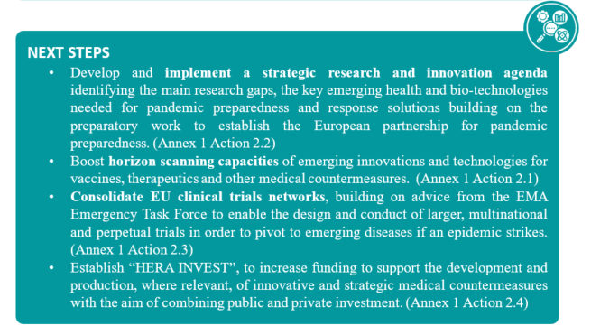

* 1. **Vaccines**

Vaccines are critical tools to limit the impact of epidemics and pandemics. The swift development of COVID-19 vaccines together with accelerated marketing authorisation procedures were made possible by building on years of continued investment and research in vaccines technologies and coronaviruses supported through EU framework research programmes. Under the EU Vaccines Strategy, the EU secured the world’s largest portfolio of vaccines, which was crucial to get the pandemic under control and to protect citizens in the EU and beyond from the most severe health impacts of the COVID-19 virus.

Member States continue to have access to safe and effective vaccines, including adapted vaccines, under the EU’s contracts. These will continue to meet the EU’s COVID-19 vaccination needs in the short-term. However, we should continue to look for new vaccines which can offer additional advantages over those currently available. Examples of such advantages could include longer duration of protection (thus increasing the time needed between booster vaccinations), a broader spectrum of protection against variants (reducing the need to constantly re-tool and adapt vaccines), greater protection against transmission (reducing the spread of the virus as well as its impact on individuals), and better storage and handling conditions (making stockpiling and global distribution significantly easier).

Via the Horizon Europe and EU4Health programmes, the EU is therefore **fostering the development of next generation vaccines** with alternative administration techniques (e.g. intranasal, intradermal), using novel platforms and combination vaccines that elicit broader, stronger and longer-lasting immune response **as well as new vaccines targeting other infectious diseases with pandemic or epidemic potential**.

In December 2022, the Commission will bring together Member States, scientists and stakeholders to discuss a new generation of vaccines, including for COVID-19. This will help to identify priorities for support and help accelerate the research and development of promising candidates. The Commission intends to mobilise up to EUR 80 million in support of particularly promising “COVID-19 Vaccines 2.0” projects in 2023, using all available means.

Moreover, the Commission will also support projects aimed at increasing knowledge on immunity induced by vaccines against viruses with a high pandemic potential and projects aiming at defining optimal vaccine design for certain pathogens.

To support this strategic approach to vaccines development, the Commission will focus on strengthening **vaccine trials** to continuously assess the efficiency of vaccines against new emerging COVID-19 variants and to facilitate the swift development of vaccines targeting other infectious diseases beyond COVID-19.

The Commission is also pursuing this strategic and coordinated approach to supporting vaccines research and development at global level. The Commission awarded EUR 100 million under Horizon 2020 to the Coalition of Epidemic Preparedness Innovations (CEPI) to support the development of COVID-19 vaccines, including variant-proof vaccines. Further funding has been awarded under Horizon 2020 and Horizon Europe to allow rapid progression of advanced clinical vaccine candidates for Chikungunya through late-stage clinical development as well as candidate vaccines for Rift Valley Fever moving from preclinical to clinical Phase I/II.

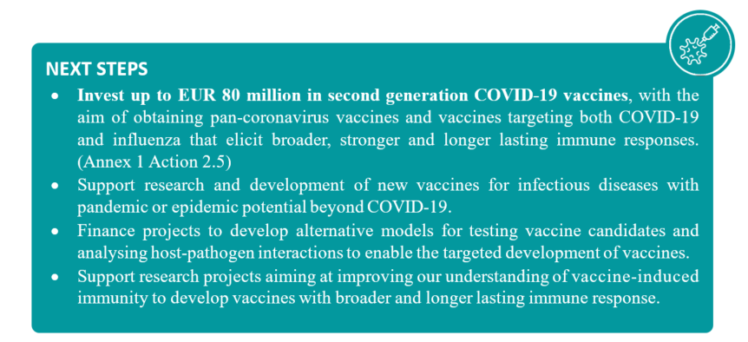

* 1. **Therapeutics**

Therapeutics have played a key role in the response to recent health emergencies and will be equally important for future crises and pandemics. The EU is making progress on **developing and repurposing therapeutics, such as antivirals and monoclonal antibodies beyond COVID-19**. The Commission is coordinating research to best leverage resources at the EU level, and HERA has started to implement initiatives to set-up development pipelines for expedited access to select novel or repurposed crisis medicines for pandemic preparedness and to combat antimicrobial resistance.

On **broad spectrum antivirals** for pandemic preparedness, the Commission has been engaging with European and global research, regulatory and funding organisations to map the landscape for research, development and production.

To achieve these goals,the Commission has already published a report on a COVID-19 therapeutics innovation booster[26] and is currently developing an **EU-wide roadmap to support pre-clinical and clinical research for the better integration into novel and repurposed broad-spectrum antivirals**. Under Horizon Europe, the Commission will support projects to **accelerate the development of new treatments** and **identify molecules** that would work against circulating and future viruses to combat infectious diseases with epidemic potential.

The Commission is also expanding the European pandemic trial platform for Therapeutics called EU-RESPONSE. It is a modular trial network of hospitals conducting clinical trials in patients with COVID-19 and other emerging infectious diseases. In August, up to EUR 17 million has been mobilised from Horizon 2020 and Horizon Europe to support EU-RESPONSE for clinical trials and cohort studies on MPOX therapeutics. The Commission has worked with all stakeholders to support a coordinated European research strategy for MPOX therapeutics, collect additional safety and efficacy data and avoid trial fragmentation.

In any event, the Commission intends to focus its efforts on AMR. The Commission is currently **assessing new economic models** and other options to stimulate antimicrobial discovery, development and access to combat AMR in the EU and globally, while reconciling these incentives with responsible use. The Commission is notably considering the proposal designed by the EU co-funded Joint Action on AMR and Health Care Associated Infections (EU JAMRAI) in its “strategy for implementing multi-country incentives in Europe to stimulate antimicrobial innovation and access” on 31 March 2021.

**At global level**, the Commission is working with international stakeholders and partners to coordinate research agendas and develop common guidelines for clinical trials. To this end, the Commission is supporting the development of international guidelines to help set up and conduct large, multiregional clinical trials during crisis times, developed by the International Coalition of Medicines Regulatory Authorities. The Commission is also cooperating with the WHO and the Global Antibiotic Research and Development Partnership (GARDP) with the aim of speeding up the development of and market access for new antimicrobials.

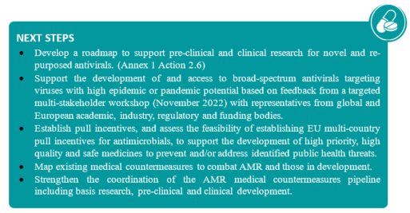

* 1. **Diagnostics, medical devices and other innovative technologies**

Diagnostics are essential medical countermeasures both for pandemic preparedness (e.g. epidemiological surveillance) and for adequate response (e.g. diagnostics allowing to identify the most suitable treatment, through pathogen identification or antimicrobial susceptibility testing). During the pandemic the Commission has funded projects under Horizon 2020 to develop effective, rapid point-of-care diagnostics. Other medical devices and personal protective equipment are also essential to ensure adequate pandemic preparedness, as clearly observed during the pandemic where critical medical devices were not available when most needed.

The Commission is currently identifying the existing diagnostics, medical devices and personal protective equipment and those in the pipeline that could be needed to respond to the prioritised health threats, including AMR. To complement this exercise, a study in 2023 will provide insights on accessibility and availability of these diagnostic solutions.

On the basis of this information, through EU4Health, the Commission will support access to medical devices and diagnostics for serious cross-border threats to health by financing organisations that can facilitate the development, production, and distribution of these devices and will speed up the development of, access to and uptake of innovative technologies.

The Commission is also supporting the swift **development – and distribution – of easy-to-use, inexpensive, multi pathogen tests, using novel testing methods** that are less invasive. This is key to enhancing our preparedness for future health emergencies.

Moreover, as part of the Joint implementation and preparedness plan for Regulation (EU) 2017/746 on in vitro diagnostic medical devices (IVDR), the Commission intends to **identify and explore regulatory pathways for diagnostics** to ensure both an appropriate level of control and speedy access to the market in case of an emergency.

In addition to these activities, other actions include research aimed at **preventing CBRN incidents and improving European crisis management**. To this end, the Commission will support the expansion of international networks of training centres for the validation and testing of CBRN tools and technologies as well as the development of tools and procedures to manage and minimise the effects of an attack with biological toxins.

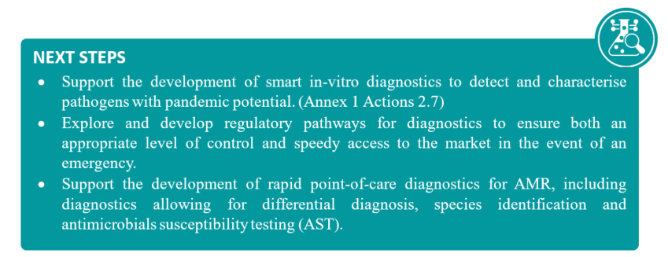

1. **Access to medical countermeasures - resilient supply chains and production capacities**

The pandemic, Russia’s war of aggression against Ukraine and the current energy crisis have further shed light on questions related to the EU’s dependency on third countries for medicines, raw materials, materials and ingredients used for manufacturing medical countermeasures. These dependencies have impacted the EU’s production capacity. Moreover, the surge in demand for lifesaving medical products such as medicines, ventilators, and masks has become a major obstacle to an effective response to the unfolding crisis[27].

The Commission took action to improve the EU’s industrial resilience and expand its ability to manufacture vital supplies of medical countermeasures to contain and better respond to the next pandemic. It has also joined forces with international partners to increase manufacturing capacities globally to ensure more equitable access to medical countermeasures. It will continue to work on those fronts to improve the situation.

* 1. **Building resilient supply chains**

The pandemic exposed the EU’s dependencies on external supplies of key medical countermeasures including vials, syringes, PPE and other products essential for the production of therapeutics, vaccines, and diagnostics. In its Pharmaceutical Strategy for Europe[28] published in November 2020, the Commission clearly highlighted the need to strengthen the security of medicines supply across the EU and avoid shortages. As part of these efforts, the Commission published in October 2022, a Staff Working Document[29] shedding light on ongoing and new actions to identify critical medicines, strategic dependencies, optimise regulatory pathways, promote manufacturing, improve procurement, intelligence and global cooperation to strengthen supply chains for medical countermeasures.

The recently adopted Health Union legislation also provides the EU with strong tools to identify supply chain issues during a crisis. Through its extended mandate, EMA will gather information on sites manufacturing active pharmaceutical ingredients, crisis relevant medicinal products, and relevant medical devices, in order to identify risks of shortages and supply chain bottlenecks. Depending on the emergency measures that are activated under the Emergency Framework Regulation, the Commission may monitor upstream issues in the supply chains of raw materials and other components necessary in manufacturing crisis relevant medical countermeasures. Furthermore, the Commission’s proposal for a Single Market Emergency Instrument[30] also aims at preserving the free movement of goods, services and persons and the availability of essential goods and services in the event of future emergencies. In addition, to cater for the rapidly increasing demand of certain raw materials, a legislative initiative on critical raw materials has been announced for the first quarter of 2023.

Moreover, in order to identify strategic dependencies of crisis relevant medicines, the Commission has created in coordination with industry and Member States a **questionnaire to identify vulnerabilities**, **strategic dependencies** in the production as well as to generate demand forecasts. The questionnaire should support surveillance of the availability of critical medical countermeasures during periods of preparedness and of crisis.

The Commission has carried out specific work to address **shortages of antimicrobials** and other medical countermeasures needed to improve our response to antimicrobial resistance. HERA is developing a methodology to regularly assess antimicrobial supply chain vulnerabilities, and stockpiling options to address the vulnerabilities identified.

The Commission is also coordinating supply chain surveillance via dedicated fora. In 2021, it created the **Task Force for Industrial Scale-up of COVID-19 vaccines (TFIS),** to help scale up the production of COVID-19 vaccines. Working closely with the industry, it helped release a number of supply chain bottlenecks. Globally, the Joint EU-US COVID-19 Manufacturing and Supply Chain Taskforce coordinated EU and US action to prevent and mitigate disruptions in manufacturing processes and supply chain shortages.

In 2022, a **Joint Industrial Cooperation Forum (JICF)** has been set up as a sub-group of the HERA Advisory Forum. The JICF which brings together the Commission, Member States, and industry and works to identify, anticipate and advise Member States and the Commission on how to address future bottlenecks in the supply chains of medical countermeasures. Further JICF discussions will include exploring options to boost the EU’s open strategic autonomy for the supply of raw materials relevant for medical countermeasures, as well as identifying and addressing supply chain vulnerabilities for the production of critical medical countermeasures.

With input from these fora, the Commission will take further measures to map supply chain risks and criticalities, to develop a **supply chain risk management framework** and to increase the resilience of supply chains, not only for critical medical countermeasures, but also for key raw materials and ingredients.

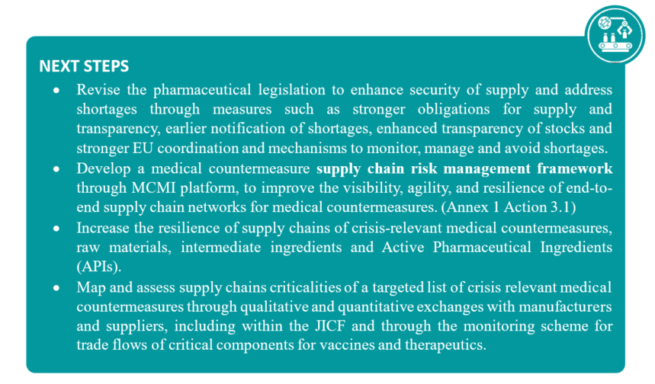

* 1. **Ensuring manufacturing capacities for medical countermeasures in a crisis**

During the pandemic, the EU played a key role in expanding manufacturing capacities of medical countermeasures. However, while the EU and its Member States were successful in rapidly increasing manufacturing capacity to reach a production capacity of around 300 million vaccine doses per month[31], the crisis also demonstrated that manufacturing capacities were insufficient to rapidly meet demand both at the EU and global level. This situation has emphasized the need to expand and maintain sustainable manufacturing capacities for medical countermeasures during preparedness times.

The Commission is therefore **restoring and expanding production capacity for medical countermeasures** in the EU. In April 2022, the Commission announced the creation of EU FAB, a network of manufacturing facilities reserving capabilities for the production of vaccines. With EU FAB, the aim is to invest EUR 160 million annually in the EU to ensure that sufficient and agile manufacturing capacities for different vaccine types are available and can be activated quickly in the event of a public health emergency.

|  |
| --- |
| ***WHAT’S NEW?*** |
| **EU FAB** consists of a network of vaccine manufacturing sites with an “ever-warm” capacity to produce 500-700 million vaccine per year to ensure that vaccines are rapidly available once a crisis hits. Contracts with suppliers will be signed in 2023. |

In parallel, the EU has commissioned a study to provide policy options for future actions relating to the **flexible manufacturing of vaccines and therapeutics**, in particular to facilitate surge manufacturing capacity to improve preparedness for future health emergencies. The study will set out a number of potential approaches by which the EU can equip itself with flexible manufacturing capacity, along with an analysis of the issues to tackle to ensure that a given approach is successful. It is due to be finalised in early 2023 and then to feed into work on future investments strategies.

The EU is also ramping up its **engagement to increase the manufacturing of medical countermeasures worldwide** to boost global preparedness. During the EU - African Union Summit in February 2022, the EU confirmed its support for Africa’s ambition to become more autonomous in the production of medicines, diagnostics, and therapeutics and health products. A Team Europe Initiative on manufacturing and access to vaccines, medicines and health technologies in Africa plays an important role in this regard. The EU is supporting the construction or upgrade of manufacturing plants in Rwanda, Senegal, South Africa and Ghana - together with African and international partners. It has forged a partnership in this domain with the WHO and is collaborating with the African Union and its bodies. The Commission and Member States, via a Team Europe approach, are a lead contributor to WHO’s mRNA technology transfer hub. It is also forging a new partnership with Latin America and the Caribbean in this context.

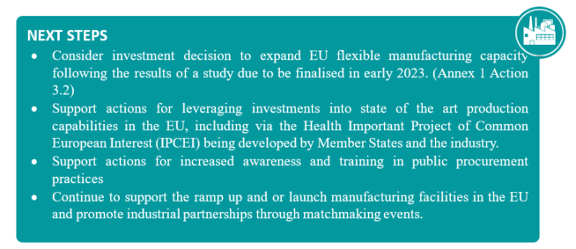

* 1. **Ensuring access and equitable distribution of medical countermeasures**

Over the past three years, the Commission has used joint procurement agreements, direct procurement and advance purchase agreements to ensure swift and equitable access to medical countermeasures for all EU citizens in response to ongoing health emergencies. Joint procurement procedure were also opened to European Free Trade Association States and EU candidate countries and potential candidates. Recently access has been extended to additional countries demonstrating the EU’s continuous work to strengthen equitable access to medical countermeasures in the EU and throughout Europe.

This has proven to be a great success, by making antivirals, diagnostics and vaccines available at an early stage. During the COVID-19 pandemic, the Commission has operated a central procurement system to ensure that all Member States get equitable access to life-savings vaccines as early as possible and at the scale needed. Amendments to EU COVID-19 vaccines contracts negotiated with the vaccine companies at the request of Member States have helped to swiftly respond to the emergence of the new Omicron variant with the possibility to accelerate orders of vaccines to meet urgent demand and for Member States to receive adapted vaccines as soon as they were authorised.

The EU intends to ensure that it has **reservation contracts or purchasing contracts** in place for critical medical countermeasures before a new outbreak occurs to enable rapid availability of lifesaving tools in the EU. In July 2022, the Commission concluded a joint reservation contract for 85 million doses of pandemic influenza vaccines[32]. To underpin its efforts to ensure access to essential medical countermeasures, the Commission is currently evaluating its joint procurement process to better match Member States procurement needs. The Commission also intends to use reservation contracts to support innovation and access to AMR countermeasures.

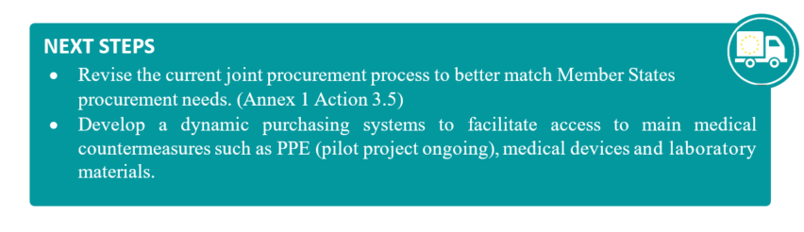

* 1. **Stockpiles**

The pandemic highlighted the lack of reserve capacities of essential medical countermeasures, such as PPE. Russia’s war of aggression against Ukraine further stressed the need for strategic stockpiles to ensure the availability and equitable access to critical medical countermeasures to protect EU citizens, in particular should CBRN attacks or accidents materialise.

The Commission is developing a strategic approach to EU-level stockpiling of medical countermeasures to be used in health emergencies, covering the relation between national and EU-level stockpiles and topics such as the sustainability of EU-level stockpiles. The stockpiling strategy is aiming at coordinating and bridging gaps in EU medical countermeasures stockpiles, addressing the geographic positioning of the stockpiles, their distribution within Europe, their sustainability and shelf life and their market impact At the international level, the Commission is closely engaged in discussions with partners, such as the US and the WHO, to identify best practices around the stockpiling of medical countermeasures.

As a first step in 2022, the Commission allocated EUR 580 million to support Member States in the establishment of ‘rescEU’ stockpiles of CBRN relevant medical countermeasures such as antidotes against nerve agents, vaccines and therapeutics against specific biological threats, and different countermeasures for radio-nuclear events. The selected Member States are expected to start building the proposed stockpiles by early 2023.

Furthermore, the Commission is currently reinforcing stockpiling capacity by **building EU-level stockpiles of medical countermeasures** to act as a safety net and ensure sufficient supplies in cases of demand spikes or disruptions of supply chains. In doing so, the Commission complements Member States’ stockpiling to mitigate any gaps and ensure an enhanced level of preparedness throughout the EU.

|  |
| --- |
| ***WHAT’S NEW?*** |
| During the MPOX outbreak, the Commission engaged in **direct procurement of medical countermeasures** donated or at the disposal of all Member States. The Commission purchased and made available through EU4Health 334,540 doses of vaccine and 10,008 treatment courses of TPOXX to Member States. The Commission is working on mid and long-term contracts through Joint Procurement. |

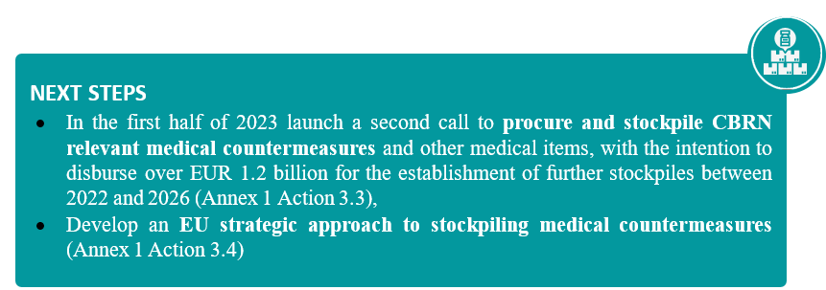

1. **International coordination and global activities**

COVID-19 exposed structural shortcomings not only in the EU’s health security architecture, but also in the global health security architecture. As the evolution of the pandemic has shown, only a united global response can provide a long-term response to the virus.

**With a Team Europe approach, the EU and its Member States** have **played a decisive role in the global response to the pandemic so far**. Between 2021 and 2022, 127 activations of the Union Civil Protection Mechanism (UCPM) for medical and in-kind assistance were received, including requests for the deployment of European emergency medical teams (EMTs). The Commission is currently developing additional EMTs. A Team Europe approach was also essential in vaccines donations. As of November 2022, the EU and its Member States, through a Team Europe approach, has shared close to 500 million doses of COVID-19 vaccines with partner countries via COVAX and bilaterally, including through the UCPM. Thanks to these efforts the challenges of equitable distribution of vaccines have shifted towards the challenges of promoting resilient availability and access to medical countermeasures globally.

The EU and its Member States, via a Team Europe approach, are **supporting the strengthening of regional manufacturing capacities for vaccines and other medical countermeasures** and enhancing equitable access particularly in low- and middle-income countries. These actions will be implemented in synergy with a Team Europe Initiative with Africa on sustainable health security using a One Health approach.

The Commission is also **building partnerships to improve coordination and collaboration to ensure the availability and access to medical countermeasures** at the global level. The Commission is seeking to strengthen its cooperation with countries and international organisations that have shown a clear edge in terms of preparedness and response capacities focusing on intelligence gathering and threat assessment, innovation and manufacturing and stockpiling and emergency response. As part of this effort, on 9 June 2022, the Commission and the relevant United States authorities signed an administrative arrangement on preparedness and response to public health threats. This arrangement will step up the sharing of information and knowledge and technical cooperation on epidemic and supply chain information. It will help to identify promising solutions for research innovation and the production of medical countermeasures and it will coordinate support to third countries. Additionally, the Commission and the relevant US authorities will continue their close cooperation on the development of next generation vaccines. Similar partnerships are being negotiated with South Korea, Japan and the WHO.

These actions should be read in conjunction with the new **EU Global Health Strategy,** whichbuilds on a holistic approach to global health. It covers different aspects of the work involved in strengthening health systems, from leadership and governance, to service delivery, financing, the health workforce, medical products, vaccines, technologies and digital health information systems. In this context, the Commission is strongly engaged in the ongoing negotiations for the establishment of a WHO convention, agreement or other international instrument on pandemic prevention, preparedness and response (“Pandemic Treaty”) and the revision of the International Health Regulations. The Commission is also contributing to efforts to increase funding for pandemic preparedness response (PPR) globally. So far, the Commission has, through a Team Europe approach, pledged EUR 427 million to the new Financial Intermediary Fund (FIF) for Pandemic, Prevention, Preparedness and Response (“Pandemic Fund”).

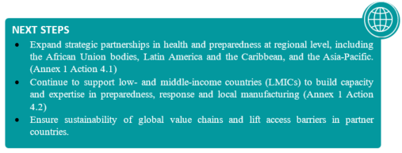

**CONCLUSION**

This report opened by stating that no country was fully prepared for COVID-19. Fortunately, lessons have been drawn from the COVID-19 pandemic, in the EU and also outside the EU, with regard to the ways in which preparedness and our capacity to respond effectively to future health emergencies could be improved.

Within the EU, numerous important steps have already been taken, including legislative ones, and a number of initiatives have been launched or are in the pipeline. Significant investments have been made or are planned. New ways of working and institutional capacities, including embedding strategic foresight into EU policymaking, are being developed, and legal frameworks are being or have been reviewed and adopted. The report demonstrates that comprehensive processes have been ongoing to reinforce the EU’s collective preparedness capabilities when it comes to threat detection and the research, development, production, procurement and distribution of medical countermeasures. In particular, with the development of an intelligence gathering and threat assessmenttool (“HERA MCMI platform”), the Commission is filling the gap between threat detection and surveillance and the medical countermeasures needed to address them. Contributing to the development of the strategic medical countermeasures, which could effectively deal with priority health threats (“HERA INVEST”), and a strategic and coordinated approach to vaccines research and development (“COVID-19 Vaccines 2.0”) should significantly improve the EU’s health emergency preparedness. Ultimately, EU FAB should contribute to the development of robust manufacturing capacities in the EU.

This State of Health Preparedness Report summarises what has already been achieved, but also refers to the intended next steps needed to provide for a coordinated approach as regards medical countermeasures. However, the availability and accessibility of medical countermeasures is only a part of the preparedness work to increase health security in the EU. Therefore, future reports will be broader in scope and address the establishment of a strategic health preparedness and response system reaching beyond medical countermeasures. To deliver such system, the Commission will continue to work intensively with all stakeholders concerned, including the Member States, the European Parliament and international partners.

The biggest challenge is to ensure that all these efforts are coordinated, financed and sustained over the long term. Preparedness is not a sprint - it is a marathon. It is not an individual endeavour, but a collective effort. All actors concerned at EU level need to contribute, so that the end-result significantly enhances the capacity of the EU to respond to future health emergencies collectively. Preparedness is costly, but every euro spent on preparedness will ultimately provide the best insurance policy for the future of EU citizens

1. The COVID-19 pandemic is referred to as « the pandemic » throughout the report.
2. <https://covid19.who.int/>
3. <https://www.economist.com/graphic-detail/coronavirus-excess-deaths-estimates>
4. <https://worldhealthorg.shinyapps.io/euro-covid19/>
5. Medical countermeasures means medicinal products for human use as defined in [Directive 2001/83/EC](https://eur-lex.europa.eu/legal-content/EN/TXT/PDF/?uri=CELEX:32001L0083&from=en) of the European Parliament and of the Council , medical devices and other goods or services that are necessary for the purpose of preparedness for and response to serious cross-border threats to health; [Article 3, paragraph (10) of the Regulation on serious-cross-border threats](https://data.consilium.europa.eu/doc/document/PE-40-2022-INIT/en/pdf)
6. See COM/2020/493 final, which, also in light of these vulnerabilities exposed by the COVID-19 pandemic, put forward resilience as a new strategic compass for all EU policies
7. <https://ec.europa.eu/info/strategy/priorities-2019-2024/promoting-our-european-way-life/european-health-union_en>
8. <https://ec.europa.eu/info/sites/default/files/communication150621.pdf>
9. Link of the Global Health Strategy once available
10. <https://ec.europa.eu/info/sites/default/files/communication150621.pdf>
11. <https://www.gavi.org/vaccineswork/covid-19-vaccines-have-saved-20-million-lives-so-far-study-estimates>
12. <https://ec.europa.eu/info/sites/default/files/strategic-dependencies-capacities.pdf>
13. <https://research-and-innovation.ec.europa.eu/research-area/health/ebola/ebola-research-and-innovation-strategy_en>
14. <https://ec.europa.eu/info/sites/default/files/communication150621.pdf>
15. <https://eufundingoverview.be/funding/health-emergency-preparedness-and-response-authority-hera#:~:text=Budget,to%20almost%20%E2%82%AC30%20billion>.
16. Council Regulation on a framework of measures for ensuring the supply of crisis-relevant medical countermeasures in the event of a public health emergency at Union level
17. <https://ec.europa.eu/commission/presscorner/detail/en/ip_22_3023>
18. <https://eu-response.eu/> and <https://vaccelerate.eu/>
19. <https://eur-lex.europa.eu/legal-content/EN/TXT/HTML/?uri=CELEX%3A32014R0536&from=NL>
20. <https://eur-lex.europa.eu/legal-content/EN/TXT/PDF/?uri=CELEX:52022DC0452>
21. The European Union, its Member States, and financial institutions, in particular the European Investment Bank and the European Bank for Reconstruction and Development, acting together as ‘Team Europe’.
22. Via training of journalists, fact-checkers, campaigns and coordination and sharing mechanisms such as those which underpinned the Re-open EU platform.
23. <https://ec.europa.eu/commission/presscorner/detail/en/IP_22_4474>
24. <https://eur-lex.europa.eu/legal-content/EN/TXT/?uri=celex%3A32018R1725>
25. <https://joint-research-centre.ec.europa.eu/jrc-news/coronavirus-response-monitoring-wastewater-contributes-tracking-coronavirus-and-variants-across-all-2022-03-17_en>
26. [Commission presents a Therapeutics Innovation Booster to identify and support new treatments for COVID-19 (europa.eu)](https://research-and-innovation.ec.europa.eu/news/all-research-and-innovation-news/commission-presents-therapeutics-innovation-booster-identify-and-support-new-treatments-covid-19-2022-05-23_en)
27. [communication150621.pdf (europa.eu)](https://ec.europa.eu/info/sites/default/files/communication150621.pdf)
28. <https://eur-lex.europa.eu/legal-content/EN/TXT/PDF/?uri=CELEX:52020DC0761&from=EN>
29. [Staff Working Document on Vulnerabilities of the global supply chains of medicines – Structured Dialogue on the security of medicines supply (europa.eu)](https://health.ec.europa.eu/latest-updates/staff-working-document-vulnerabilities-global-supply-chains-medicines-structured-dialogue-security-2022-10-17_en)
30. <https://single-market-economy.ec.europa.eu/document/d1d0b38a-cec8-479d-be70-1ffae7e227a5_en>
31. Part of the EUR 2.7 billion from the Emergency Support Instrument (ESI) were used as up-front payments for COVID-19 vaccines Advance Purchase Agreements (APAs). These up-front payments contributed to increase the speed and scale of manufacturing successful vaccines.
32. https://ec.europa.eu/commission/presscorner/detail/en/IP_22_4363