

1. **Introduction**

Gas markets already started to show considerable tension in 2021, and gas prices increased significantly. Russia’s military aggression against Ukraine, which started in February 2022, triggered a succession of gas supply disruptions and made gas prices in global markets much more volatile. For the EU and its immediate neighbours, which were dependent on the Russian gas supply, these developments required a strong reaction and measures to tackle supply and demand.

The extent of imbalances on the gas market and fear of severe supply disruptions, followed by potentially serious supply constraints for both industry and households, have led to an unprecedented regulatory response. This has contributed to the security of gas supply and ensured that gas prices moderated in winter 2022/2023.

Gas storage was already an important part of the Commission’s gas preparedness plans to overcome winter 2022/2023 and for the coming years, as also highlighted in the REPowerEU plan[1] and the Commission Communication *Save gas for a safe winter*[2]. Specifically, well-filled gas storages ensure that gas is available both for private households and businesses during the winter heating period.

As a further measure, the Regulation on Gas Storage[3], adopted by the co-legislators on 27 June 2022, requires all Member States with gas storage capacity to ensure their underground gas storage is filled up to at least 80% of capacity by 1 November 2022. From 2023 onwards, gas storage will have to be filled to 90% by 1 November of each year.

As an additional safeguard for an adequate filling level of gas storage in the coming years, the Gas Storage Regulation stipulates that each storage system operator in the EU has to be certified. This certification should be refused or lead to remedies if relevant authorities conclude that a person or entity that directly or indirectly controls or exercises any right over the storage system could endanger the security of the EU’s energy supply.

This report takes stock of the implementation of the Gas Storage Regulation based on information by Member States on their gas storage measures and their certification procedures, complemented by data from Eurostat, in accordance with Article 17a of Regulation (EU) 2017/1938. It is accompanied by a staff working document, which provides detailed information on measures taken by Member States to ensure their gas storage sites are filled and an analysis of gas prices in the context of implementing the Storage Regulation.

1. **Legal basis and context of the annual report**

On 1 November 2022, 94.9% of the EU’s gas storage was filled. This was well above the target of 80%, with all Member States achieving their target set by the Regulation[4]. On 31 December 2022, the filling level was still 83.4% in the EU. In terms of storage, the EU appeared well prepared for winter 2022/2023.

Article 6d (5) of the Storage Regulation states that the Commission has to submit annual reports to the European Parliament and the Council. These reports must include:

* an overview of the measures taken by Member States to fulfil the storage obligations;
* an overview of the time needed for the certification procedure set out in Article 3a of Regulation (EC) No 715/2009;
* an overview of the measures requested by the Commission to ensure compliance with the filling trajectories and filling targets;
* an analysis of the potential effects of this Regulation on gas prices and potential gas savings in relation to Article 6b (4).

The report contributes to broadening the knowledge base on best practices for filling storage sites.

1. **Overview of measures taken by Member States to fulfil the storage obligations**

The Gas Storage Regulation provides that Member States have to take all necessary measures to meet the filling targets. They should aim to use market-based measures where possible to avoid unnecessary market disruption. However, measures may include regulatory measures, financial incentives or compensation to market participants.

The Storage Regulation provides an illustrative list of potential measures and tools that Member States may take for that purpose. To get feedback on these suggestions, the Commission sent a questionnaire to the relevant Member State authorities in autumn 2022, asking them about the measures and tools they have used to ensure that their storage sites are filled. The questionnaire also asked the views and assessments of Member States on the effectiveness of their measures, their strengths and weaknesses.

According to Member States, the following measures have effectively contributed to filling their storage sites in time:

1. Imposing an obligation on the storage facility operators on the minimum filling level to achieve, in line with the national objective;
2. Tendering the capacities to market participants;
3. Having a mechanism in place for when the total capacity subscribed is below the minimum filling level, for example pre-agreed terms with market participants for the complementary volume;
4. Ensuring that the capacities booked are effectively used by applying a ‘use it or lose it’ mechanism or imposing penalties for non-compliance;
5. Finally, if the measures mentioned above are unlikely to produce the desired results, designate an entity to purchase the missing capacity from the wholesale market.

Furthermore, with reference to Annex Ib of Regulation (EU) 2022/1032, Austria and Germany have concluded an agreement on the filling target and the filling trajectory pursuant to Article 6a, as those Member States share the responsibility for the storage facilities Haidach and 7Fields[5].

The burden-sharing mechanism of the Regulation provides that Member States without storage facilities on their territories store gas volumes in neighbouring countries corresponding to at least 15% of their annual consumption. However, Member States have made limited use of coordinated instruments to fill gas storages.

In September 2022, Italy and Greece signed a memorandum of understanding on gas storage. It allows shippers from the Greek National Natural Gas Transmission System to store up to 1.14 TWh of gas in Italy. Agreements like this one are crucial for Member States that have no gas storage capacity on their own territories. The Estonian government arranged the purchase of 1 TWh as a national strategic reserve to be stored at a storage site in Latvia.

During the seminar[6] on the implementation of the Gas Storage Regulation, many European associations that are members of the Gas Coordination Group, while recognising the effectiveness of the Regulation, recommended more use of market-based tools to implement it in an efficient way, especially to reduce storage costs.

Member States have made unprecedented investments throughout 2022 to make the European gas infrastructure more resilient and increase access to liquefied natural gas (LNG) in regions highly dependent on Russian gas. The situation in 2023 has therefore evolved significantly and Member States can now make better use of market-based tools and rely less on more ‘interventionist’ tools that were necessary due to the lack of infrastructure or to prevent market manipulation from non-EU storage operators.

As a result of all measures, the 80% filling target for 2022 was exceeded. By 1 November 2022, 94.9% of the EU’s gas storage was filled, with all Member States having reached more than 80% (see table and figure below). Latvia, which was the only Member State with a figure lower than 80%, qualified for a reduced storage obligation due to the large storage capacity compared with national consumption. The filling level reached by Latvia largely exceeded its reduced November target set in relation to its own consumption.

Table: Filling levels on 1 November2022

|  |  |  |
| --- | --- | --- |
|  | Filling level (%) | Working (gas) volume (TWh) |
| AT | 93.1 | 95.5 |
| BE | 100 | 7.6 |
| BG | 90.4 | 5.8 |
| CZ | 94.9 | 43.8 |
| DE | 99.2 | 245.2 |
| DK | 99.3 | 9.9 |
| ES | 94.8 | 35.3 |
| FR | 100 | 132.6 |
| HR | 97.0 | 4.8 |
| HU | 86.0 | 67.7 |
| IT | 95.5 | 193.4 |
| LV | 57.7 | 24.1 |
| NL | 91.8 | 138.9 |
| PL | 98.9 | 36.4 |
| PT | 98.3 | 4.0 |
| RO | 96.8 | 32.8 |
| SE | 92.9 | 0.1 |
| SK | 91.3 | 38.8 |
| **EU** | **94.9** | **1116.21** |

Source: AGSI database on 1 November 2022

Figure: EU storage filling level and EU trajectory 2022

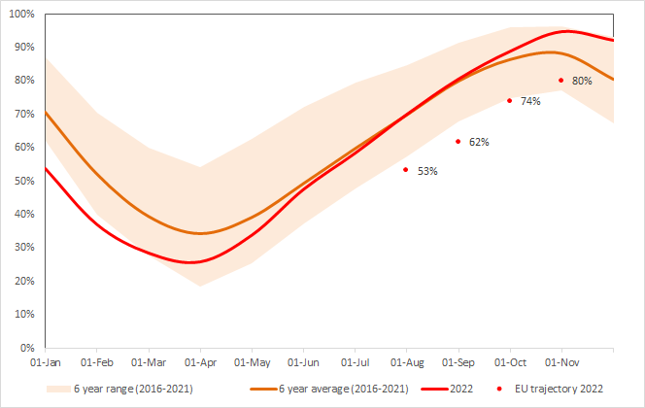

1. **Storage sites in the EU formerly owned or operated by Gazprom**

In 2021, Gazprom owned or operated approx. 10% of EU storage capacity. The Gazprom storage sites, which were not refilled before the start of winter 2021/2022 and were almost depleted at the end of the season when gas is withdrawn from storage. These Gazprom sites, were responsible for reducing the average filling level of EU storage sites by 6 to 8 percentage points at the end of 2021 compared with previous years.

The following graph shows the development of gas volumes in storage sites owned or operated by Gazprom (orange dashed line) and the other EU sites (blue dashed line). The black line shows the gas in storage of all EU sites together.

Figure: Development of gas volumes in storage sites owned or operated by Gazprom

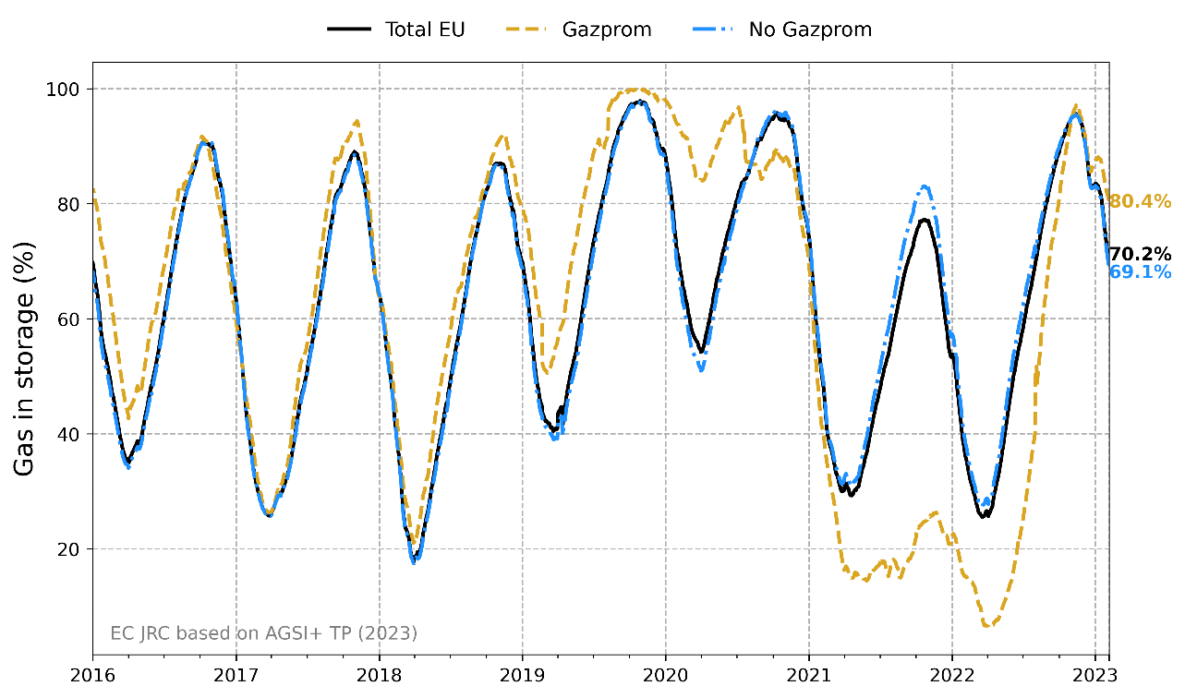

In summer 2022, Member States with storage sites owned or operated by Gazprom took measures to protect their energy security:

* Germany nationalised its Gazprom sites, formerly owned by Gazprom Germania. The new entity’s name is SEFE Securing Energy for Europe GmbH.
* Austria’s site was given to another operator under newly introduced ‘use it or lose it’ rules. On 17 February 2023, Germany and Austria signed an agreement to take on joint responsibility for using and filling the natural gas storage facilities Haidach and 7Fields and to transport stored gas volumes in case of shortages. The deal follows a memorandum of understanding agreed between Berlin and Vienna in July 2022. The two storage facilities, located in Austria, had already been used by both German and Austrian companies in the past.
* In the Netherlands, the government appointed a state-run entity called Energiebeheer Nederland to transport gas to the Bergermeer storage facility using unused storage capacity, including capacity owned by Gazprom.
* Czechia applied the ‘use it or lose it’ principle to force market participants with spare storage capacity, above a certain threshold, to give back injection slots to the government. Under this principle, Gazprom’s storage capacity at the Damborice site has been withdrawn and placed under the government’s special auction measures. These include the possibility of free auctions and payments to traders in exchange for storing gas.

As a result of the measures, the storage sites formerly owned or operated by Gazprom were filled up to 94% on average by 1 November 2022 compared to a filling level of 26% on 1 November 2021.

The table below demonstrates the effectiveness of Member States’ measures, which abolished or reduced Gazprom’s influence on gas storage. It compares the aggregated storage capacity owned or operated by Gazprom per country in November 2021 and November 2022.

Table: Capacity of storage sites owned or operated by Gazprom by country in 2021 and corresponding filling levels in November 2021 and November 2022

|  |  |  |  |
| --- | --- | --- | --- |
| **Country** | **Gazprom owned/operating capacity 2021 (TWh)** | **Filling level 1 Nov. 2021** | **Filling level 1 Nov. 2022** |
| AT | 32.3 | 20% | 91% |
| CZ | 2.2 | 45% | 85% |
| DE | 58.2 | 27% | 94% |
| NL | 19.3 | 30% | 99% |
| TOTAL | 112.0 | 26% | 94% |

1. **Demand aggregation tool pursuant to Council Regulation (EU) 2022/2576**

Regulation (EU) 2022/2576, adopted by the Council on 19 December 2022 following a proposal from the Commission[7], provides for a demand aggregation tool that will support EU countries in ensuring sufficient gas supplies in time for winter 2023-2024. Furthermore, the joint purchasing mechanism introduced by the Regulation will be key to avoiding that European companies bid for the same gas and inflate prices as a consequence.

EU countries are requested to aggregate demand for gas volumes equivalent to 15% of their respective storage filling obligations. Beyond 15%, aggregation will be voluntary but based on the same mechanism.

For this purpose, the Commission has contracted a service provider to put in place the necessary services with the aim to aggregate gas demand from European companies and match it with the most competitive supply offers in time for the next storage filling season. After demand has been matched with supply, companies can voluntarily conclude purchasing contracts with the gas suppliers, either individually or jointly. This is particularly beneficial for smaller companies and companies from landlocked countries with less global reach or negotiating power. Joint purchasing could also be beneficial for industry that consumes gas, like fertilisers and ceramics.

To set up the joint purchasing mechanism, EU Member States, Energy Community Contracting Parties and industrial players from the EU join forces in different fora in order to provide their expertise and advice to the Commission. They do so through an ad hoc steering board, regional groups and an industry advisory group.

1. **Overview of the time needed for the certification procedure**

Member States should ensure that each storage system operator, including storage system operators that are controlled by transmission system operators, is certified by the national regulatory authority or by another authority designated by the Member State. This is to ensure that the security of energy supply or any other essential security interest in the EU or any Member State is not endangered by influence over the storage system operator.

The Storage Regulation provides that the certifying authority issues a draft certification decision on storage system operators that operate underground gas storage facilities with a capacity of over 3.5 TWh where, irrespective of the number of storage system operators, total storage facilities were filled on 31 March 2021 and on 31 March 2022 at a level which, on average, was less than 30 % of their maximum capacity or within 150 working days of the date of receipt of a notification. For these storage sites, the certifying authority should have already attempted to issue a draft certification decision by 1 November 2022.

For all other storage system operators, the certifying authority has to issue a draft certification decision by 2 January 2024 or within 18 months of the date of receipt of a notification.

The Commission has to deliver an opinion on the draft certification decision to the certifying authority within 25 working days of such a notification. The certifying authority must then take the utmost account of the Commission’s opinion.

The certifying authority has to issue the certification decision within 25 working days of receipt of the Commission’s opinion.

In 2022, only one draft certification decision was submitted to the Commission, by the Belgian Federal Commission for Electricity and Gas Regulation (CREG) in October 2022.

To support Member States with issuing draft certifications, the Commission organised a special session of the Gas Coordination Group to provide certifying storage operators and owners with practical guidance. The Commission recalled that certification should reduce any risk to the security of gas supply at regional, national or EU-wide level resulting among other things from:

(a) ownership, supply or other commercial relationships that could negatively affect the incentives and ability of the storage system operator to fill the underground gas storage facility;

(b) the rights and obligations of the EU with respect to a non-EU country arising under international law, including any agreement concluded with one or more non-EU countries to which the EU is a party and that addresses the issue of the security of energy supply;

(c) the rights and obligations of the Member States concerned with respect to a non-EU country arising under agreements concluded by the Member States concerned with one or more non-EU countries, in so far as those agreements comply with EU law; or

(d) any other specific facts and circumstances of the case.

Emphasis is put on the risk of security of supply stemming from the ownership that could negatively affect the ability to fill the storage facilities. One central element for the draft certification decision is the concept of ‘decisive influence’, which is the ownership or right to use all or part of the assets of an undertaking, or rights or contracts that confer decisive influence on the composition, voting or decisions of the organs of an undertaking.

1. **Overview of the measures requested by the Commission to ensure compliance with the filling trajectories and filling targets**

The Gas Storage Regulation provides for a monitoring and enforcement mechanism to keep track of filling levels in Member States. It ensures continuous progress in refilling storage while leaving a certain degree of flexibility to inject more or less gas depending on the market prices at the time. This requirement introduces intermediary two months targets, but allows a deviation within a tolerance margin of 5 %.

If a Member State deviates in a substantial and sustained way from the filling trajectory and it endangers the filling target, the Commission will, after consulting the Gas Coordination Group and the Member States concerned, issue a Recommendation to that Member State or to the other Member States concerned on measures to be taken immediately. If there are continued failures on respecting the minimum filling targets following the Recommendation, the Commission may issue a Decision on the follow-up.

All Member States complied with the intermediary targets set for 2022 and their minimum filling level did not experience a substantial nor sustained deviation from the target. The Commission therefore did not have to take measures in 2022 to ensure compliance with the filling trajectories and filling targets.

On 25 November 2022, the Commission set out by means of an Implementing Regulation[8] the intermediate gas storage filling targets that Member States must meet in 2023 in order to reach the 90% gas storage target by 1 November 2023. As envisaged under the Gas Storage Regulation, the Implementing Regulation defined the intermediate targets for 1 February, 1 May, 1 July and 1 September 2023 for those Member States with underground storage on their territory and connected to their market area. These targets were based on the proposals made by Member States, the filling rates of the previous 5 years and the Commission’s assessment of the general security of supply situation.

The Commission also consulted the Gas Coordination Group and the recently established Gas Storage Committee. Also for the year 2023, subject to a margin of five percentage points, these binding targets are the minimum thresholds that need to be respected by Member States to ensure a certain level of security of supply and the refilling of storage facilities for winter 2023-2024.

Table: Intermediate targets for 2023 for Member States with underground gas storage facilities, as adopted by Commission Implementing Regulation (EU) 2022/2301

|  |  |  |  |  |
| --- | --- | --- | --- | --- |
| **Member State** | **1 February intermediate target** | **1 May intermediate target** | **1 July** **intermediate target** | **1 September** **intermediate target** |
| **AT** | 49% | 37% | 52% | 67% |
| **BE** | 30% | 5% | 40% | 78% |
| **BG** | 45% | 29% | 49% | 71% |
| **CZ** | 45% | 25% | 30% | 60% |
| **DE** | 45% | 10% | 30% | 65% |
| **DK** | 45% | 40% | 60% | 80% |
| **ES** | 59% | 62% | 68% | 76% |
| **FR** | 41% | 7% | 35% | 81% |
| **HR** | 46% | 29% | 51% | 83% |
| **HU** | 51% | 37% | 65% | 86% |
| **IT** | 45% | 36% | 54% | 72% |
| **LV** | 45% | 41% | 63% | 90% |
| **NL** | 49% | 34% | 56% | 78% |
| **PL** | 45% | 30% | 50% | 70% |
| **PT** | 70% | 70% | 80% | 80% |
| **RO** | 40% | 41% | 67% | 88% |
| **SE** | 45% | 5% | 5% | 5% |
| **SK** | 45% | 25% | 27% | 67% |

To set the filling levels, the Commission considered the estimates of Member States and an assessment of the minimum technical level required, taking into account the filling and withdrawing capacity of each site in order to reach a level of 90% by 1 November 2023.

1. **Analysis of the potential effects on gas prices and gas savings**

A rigorous causal analysis would require data from a counterfactual scenario, where the Storage Regulation did not exist but other factors (e.g. global developments) that influence European gas supply and demand during the period in which the Storage Regulation has been in force were unchanged. Information for a counterfactual scenario was not available in a sufficiently detailed manner. Accordingly, the Commission has carried out a prescriptive and less causal analysis.

Although the highest price peak occurred in mid/late August, no direct link could be established between the filling of gas storages and the price increase. For instance, the price spikes occurred at a moment of rather usual and flat storage injection rates. In contrast, when getting closer to the final deadline for meeting the filling target on 1st November, which resulted in additional efforts for storing gas due to the start of the heating season, prices were already substantially lower in October and November compared to the preceding months.

The figure below shows the ratio of 2022 values over the 2019-2021 average for both storage injections and prices. A price ratio of 1 means that the 2022 prices were equal to the 2019-2021 average. A ratio greater than 1 means that prices were higher in 2022; a ratio of 5 means that prices were five times higher in 2022 than the 2019-2021 average. The same calculation applies to the line on storage injection.

According to this figure, the relative price peaks did not coincide with relative storage injection peaks. In contrast, available data indicate that supply fluctuations may have played a more significant role in price spikes of gas.

Nevertheless, we cannot exclude that resolute storage filling by operators with or without regulatory interventions from Member States as part of the Storage Regulation has facilitated a temporary overshooting of prices. The Commission is aware of claims that a more gradual replenishment of storage, including by using the flexibility left by the 2022 intermediary targets set at EU level, could have helped mitigate the price developments.

Based on available data, no clear conclusions on a potential link between the storage targets and price developments are possible. The continued injection of storage reduced the risk of potentially lowering storage levels to a dangerous level.

The staff working document that accompanies this report provides further details on the methodology and quantitative results of the analysis.

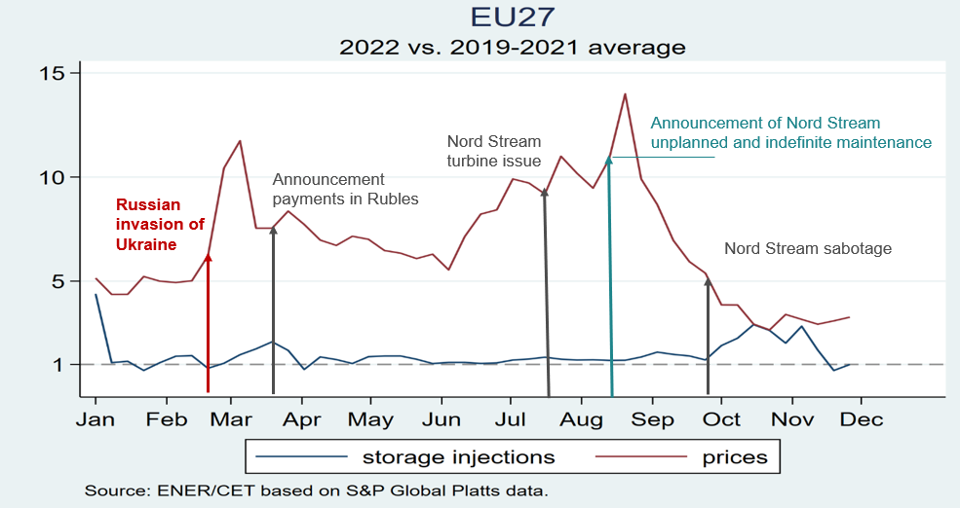

Furthermore, following the adoption of the Regulation on Gas Demand Reduction[9], Member States reduced their gas demand by 19% between August 2022 and January 2023 compared to the average of the last 5 years (see figure below). This significantly made up for the lack of Russian gas, with 42 billion cubic metres of gas saved between August 2022 and January 2023, and provided flexibility to the gas market. Against a background of tension on the gas market, it was acknowledged at the Gas Coordination Group meeting in February 2023 that demand reduction was the most efficient measure as the increase of supply is limited by global production capacities and is subject to global competition.

Over the summer of 2022, demand reduction facilitated storage injections, while the demand reduction measures limited withdrawals during winter 2022/2023. This therefore ensured there were sufficient storage levels to cope with winter cold spells.

Since the beginning of winter 2022/2023, the flexibility created by demand reduction therefore helped drive gas prices down from record highs to pre-war levels in February 2023.

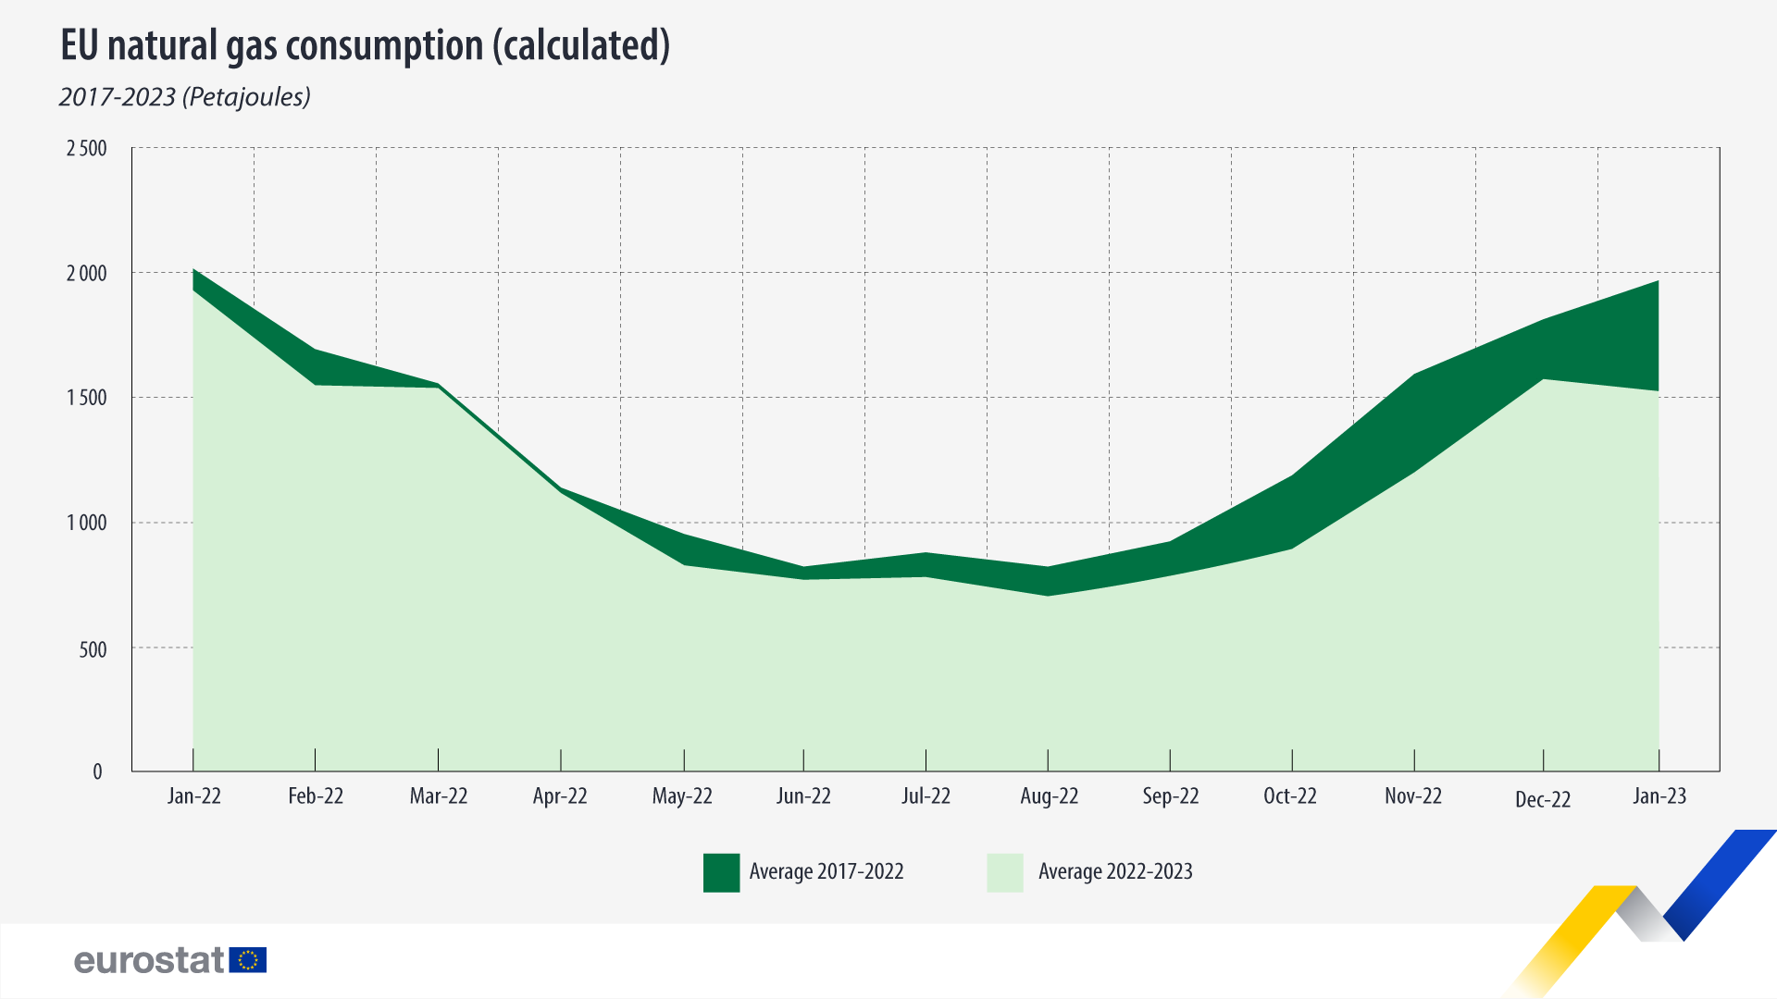

1. **Conclusion**

Member States made substantial and unprecedented efforts in 2022 to refill storage. The 80% target of the EU Storage Regulation for 2022 was exceeded. By 1 November 2022, 94.9% of the EU’s gas storage was filled. At the end of 2022, the average level was still high, at 83.4%. This high level of filling greatly helped strengthen the security of supply in winter 2022/23, which in turn reduced the risk premium in the gas market at the end of the year.

Member States took all necessary measures to meet the filling targets, including the intermediary targets. Some Member States reached filling levels well above their targets. All Member States reached their minimum EU filling trajectories and filling targets in 2022. The mechanism of minimum intermediary targets has helped leave ample room for Member States to set their own measures.

All Member States with storage used a basket of measures, as provided in the Storage Regulation. The weight of the different measures differs between Member States. As a first choice they used market-based measures. Further preferred measures included the obligation to store some minimum volumes of gas, the tendering of capacities to market participants, together with incentives to fill the storage facilities and ensure that the contracted capacities are effectively used.

With the obligation to certify storage operators and owners, the Storage Regulation aimed to help avoid any detrimental influence of non-EU countries on the filling of storage sites. In 2022, one draft certification was submitted to the Commission, followed by a positive opinion.

Although no other storage sites have been certified, Member States have taken measures at an early stage to prevent non-EU countries from negatively influencing the filling of storage sites. They reported on storage owners being nationalised and the appointment of state entities in charge of the filling. Even though Member States still need to submit their draft certification decisions to the Commission, there is currently no evidence that filling storage facilities for security of supply is still at risk. Most of the certifications will have to be issued in 2023 to ensure the absence of detrimental influence on storage owners and operators.

Based on available data, it is impossible to conclude whether and to what extent the filling targets set by the Gas Storage Regulation have had an effect on gas prices. They depend on many non-storage related factors such as pipeline supplies, LNG availability, gas savings, the weather and the premium linked to the security of supply risks perceived by the market. Based on contributions received, there seems to be scope for national measures that implement the EU targets in more efficient ways to avoid filling trajectories that influence price development in a negative manner.

With the Storage Regulation, this is the first time that Member States undertake and implement storage measures in a common framework that enables and encourages combinations of market-based and regulatory measures to ensure a minimum level of filling. Even if it is still limited, this is also the first time that Member States develop specific arrangements to share storage resources and related costs across borders. At the end of winter 2022/2023, the Commission intends to ask Member States to report on their experiences with these arrangements.

1. COM(2022) 639 final.
2. COM(2022) 360 final.
3. REGULATION (EU) 2022/1032 OF THE EUROPEAN PARLIAMENT AND OF THE COUNCIL of 29 June 2022 amending Regulations (EU) 2017/1938 and (EC) No 715/2009 with regard to gas storage, OJ L 173, 30.6.2022, p. 22.
4. [Gas infrastructure in Europe – Aggregated Gas Storage Inventory (agsi.gie.eu)](https://agsi.gie.eu/)
5. Published agreement in the official register of Austria: <https://www.ris.bka.gv.at/eli/bgbl/III/2023/16>.
6. [Register of Commission expert groups and other similar entities (europa.eu)](https://ec.europa.eu/transparency/expert-groups-register/screen/expert-groups/consult?lang=en&groupID=1096)
7. Council Regulation (EU) 2022/2576 enhancing solidarity through better coordination of gas purchases, reliable price benchmarks and exchanges of gas across borders, Official Journal L 335, 29.12.2022, p. 1.
8. Commission Implementing Regulation (EU) 2022/2301 of 23 November 2022 setting the filling trajectory with intermediary targets for 2023 for each Member State with underground gas storage facilities on its territory and directly interconnected to its market area (C/2022/8593) OJ L 305, 25.11.2022, pp. 5–8.
9. Council Regulation (EU) 2022/1369 of 5 August 2022 on coordinated demand-reduction measures for gas

   ST/11568/2022/INIT, OJ L 206, 8.8.2022, pp. 1-10.