

Table of Contents

Executive Summary 3

**Part 1.** Overview of the own resources system and recent developments on the revenue side of the EU budget 4

1.1 Recent developments of the EU own resources system. 4

1.1.1. The own resources system: main elements of reform 4

1.1.2. Simplification of the own resources system: Value Added Tax own resource 5

1.1.3. Diversification of revenues: the plastics-based own resource 7

1.2 The increase in “other revenues” 9

**Part 2.** Potential New Own Resources – Types and Evaluation 13

2.1. Assessment framework for new own resources candidates 13

2.1.1. Political context 13

2.1.2. Selection of criteria 13

Revenue potential 14

Simplicity 14

Fast mobilisation of new revenue sources 14

2.2 Stakeholder and other institutions’ views 16

2.3. Evaluation of potential new own resources – individual factsheets 17

2.3.1. Corporate taxation (BEFIT), including financial sector 18

2.3.2. Statistical own resource based on company profits 19

2.3.3. Financial Sector - Financial Transaction Tax (FTT) 20

2.3.4. EU ‘fair border Mechanism’ 21

2.3.5. Tax on crypto assets 22

2.3.6. Statistical own resource based on gender pay gap 23

2.3.7. Statistical own resource based on food waste 24

2.3.8. Statistical own resource based on e-waste 26

**Part 3.** The new own resources package 29

3.1. Emissions trading scheme (ETS) own resource 29

3.1.1. The 2021 proposal on ETS – an overview 29

3.1.2. Ensuring fairness – the Valuation Mechanism and Solidarity Adjustment Mechanisms 31

3.1.3. The evolution of the carbon market 33

3.2. The statistical own resource based on company profits 34

3.2.1. Characteristics of the statistical based own resource on company profits 35

3.2.2. How would it work? 37

# Executive Summary

**In 2020, the revenue side of the EU budget was significantly reformed.** The Recovery plan for Europe put in place to address the economic and social damage brought about by the COVID-19 crisis and the empowerment to borrow up to around EUR 750 billion (2018 prices) on the markets to finance it was a step change for the EU. At the same time, adding a new own resource based on non-recycled plastic packaging waste, the first one since the introduction of the GNI-based own resource in 1988, was an important step in the direction of supporting EU policy priorities, such as the circular economy, and diversifying the revenue sources of the EU budget. Finally, the revenue side of the EU budget became less complex with the simplification of the VAT own resource and the budgetary rebates.

**The commitment to repay the *NextGenerationEU* borrowing as from 2028 emphasises the urgent need for new own resources to protect EU budget expenditures** for existing policies and new challenges. The Commission has proposed a first package in December 2021 with three new sources of revenues for the EU budget, i.e. contributions from the emissions trading system, from the EU Carbon Border Adjustment Mechanism and from a share of residual profits from multinationals that will be re-allocated to EU Member States under the recent OECD/G20 agreement (“Pillar One”). The inter-institutional agreement of 16 December 2020 among the European Parliament, the Council, and the Commission foresees another package to be presented by the Commission.

Against this background, this document takes stock of the current situation and analyses a set of potential candidates for the Commission adjusted proposal on new own resources.

**Three criteria are used to evaluate potential new own resources – revenue potential, simplicity, and fast mobilisation of revenues.** As found in the literature, they summarise different considerations relevant to designing new own resources optimally, such as the ability to generate sufficient revenues, ease of administration in terms of revenue collection and compliance. They also reflect the political context and the need to act urgently. The ability to implement any new sources of revenues quickly is an important dimension which takes account of the needs of the EU budget.

**The analysis covers eight potential new own resources, scoring each option on a qualitative and quantitative basis.** The eight candidates are: corporate taxation (BEFIT), including the financial sector; a statistical own resource based on company profits; a tax on the financial sector with an assessment of a financial transaction tax (FTT); an EU ‘fair border mechanism’; a tax on cryptocurrencies; a statistical own resource based on gender pay gap; a statistical own resource based on food waste; and a statistical own resource based on e-waste. Having due consideration of the current economic environment, with high inflation creating pressures on the EU budget, the analysis shows that only few candidates would be suitable under the current circumstances; others could not be mobilised in the short run or are too complex to implement.

# **Part 1.** Overview of the own resources system and recent developments on the revenue side of the EU budget

**Until 2020, the EU own resources system has remained fairly stable, providing reliable revenue to the EU budget.** Between 1988 and 2021, the main categories of own resources remained the same: traditional own resources (customs duties), contributions from the Member States based on value added tax (VAT) and on gross national income (GNI). This stable system has however increasingly relied on the own resource based on GNI, which had been introduced in 1988 as a residual item. Throughout the decades, various attempts have been undertaken to reform this system and to introduce new own resources([1]). The reform of 2020 introduced significant changes which pave the way for the modernisation of the own resources system.

**In parallel, other streams of revenues (‘other revenues’) have increased their share in the revenue side of the EU budget.** ‘Other revenues’ coming from various sources described in part 1.2 have also provided a stable revenue source. Since 2021, ‘other revenues’ also include the amounts for non-repayable support assigned to the European Recovery Instrument and borrowed for *NextGenerationEU* (NGEU), for which an exceptional and temporary authorisation was established in the Own Resources Decision([2]). Complemented with an increasing role of financial instruments, NGEU issuances explains recent increases in the share of ‘other revenues’.

## 1.1 Recent developments of the EU own resources system.

### 1.1.1. The own resources system: main elements of reform

**In 2020, in response to the severe COVID-19 crisis, Member States agreed on far-reaching reforms, including on the system of own resources.** The Recovery plan for Europe put in place to address the economic and social damage brought about by the Covid-19 crisis has introduced significant changes on the revenue side of the EU budget. To give the Union the means to achieve its objective, the Own Resource Decision([3]) adopted in December 2020 empowers the Commission to borrow up to EUR 750 billion (2018 prices) on an exceptional and temporary basis. In order to do so, it also substantially increases the own resource ceiling, enabling such EU borrowing on an exceptional and temporary basis. In particular, the Own Resource Decision has added a separate and additional compartment in the own resource payment ceiling equal to 0.6% of EU GNI, to enable *NextGenerationEU* borrowing.

**Although the 2020 reform introduced a new own resource (based on recycled plastic packaging waste), the balancing GNI-based own resource remains the dominant source of revenue for the EU budget.** Broadly stable revenues from both Traditional Own Resources and the VAT-based, combined with a slowly rising total budget, have translated into a growing weight of the GNI-based own resource (Graph 1). The introduction of the new plastics-based own resource makes a small dent in the GNI dominance, without significantly altering the overall picture.

Graph 1. The evolution of own resources, 2000-2022

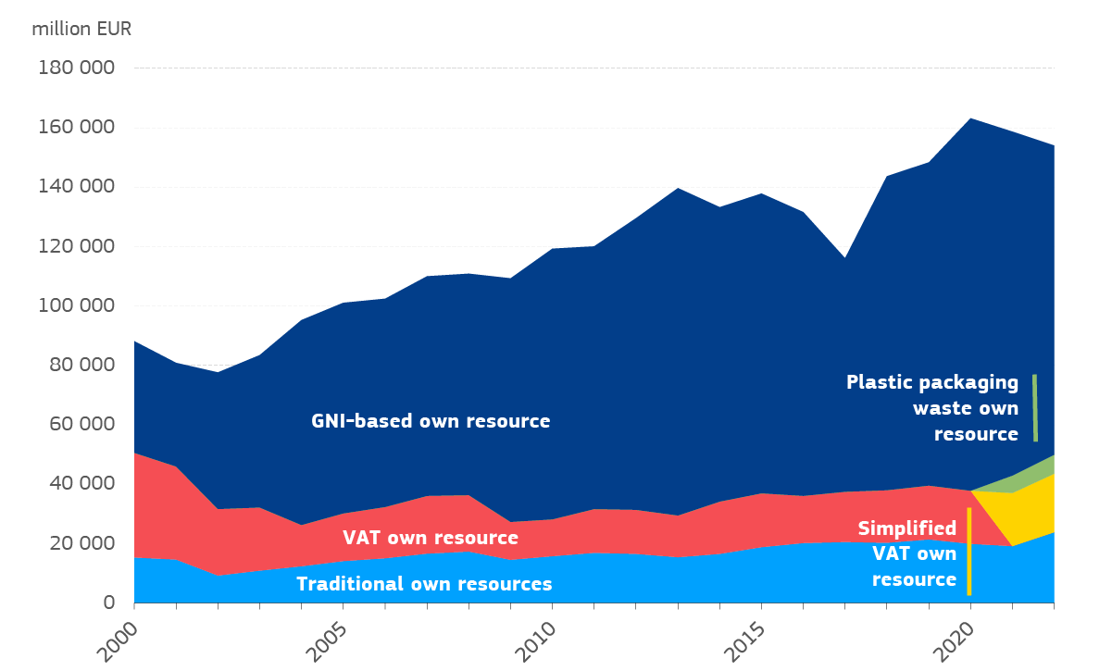

*Source:* Commission services, Expenditure and Revenue Tables 2000-2021 ([Spending and revenue (europa.eu)](https://commission.europa.eu/strategy-and-policy/eu-budget/long-term-eu-budget/2014-2020/spending-and-revenue_en)); source Budget 2022: financing tables 2022, including Draft Amending Budget 5

**A system of rebates is maintained for the period 2021-2027, but it is now simpler and more transparent.** The system of rebates on national contributions, initially introduced in 1984, was meant to reduce the excessive net budgetary burden on some Member States, while at the same time adding complexity to the revenue system. With the withdrawal of the United Kingdom, the UK rebate ceased to apply. As from 2021, gross lump sums are deducted from the GNI-contributions of Austria, Denmark, Germany, the Netherlands, and Sweden, and they are financed by all Member States, i.e. including the five beneficiaries, which reduces the net amount of their rebates. As these lump sums are indexed to inflation, they imply large windfall gains in the current inflationary environment. The retention rate for traditional own resources, also known as ‘collection costs’, increases from 20% to 25%.

### 1.1.2. Simplification of the own resources system: Value Added Tax own resource

**The Value Added Tax-based own resource was simplified for the first time in 2020.**The previous system used to rely on a notional harmonised value added tax base requiring complex calculations to adjust for the derogations and exemptions in the VAT Directive. Following the reform, the value added tax base is now calculated in a simpler way, by dividing the national receipts by a weighted average rate based on a reference year ([4]). The adjustment for derogations and exemptions have been removed, thus simplifying the calculations A uniform call rate of 0.3% applies to the value added tax bases of all Member States.

**On average, the removal of complex calculations had a limited impact on Member States. The objective of corrections and compensations was to offset the potential exemptions and derogations foreseen in the value added tax Directive that were applied by some Member States** ([5]). **First, the VAT national receipts were corrected from non-VAT elements, leading to the so-called ‘net receipts’. Over the period 2016-2019, corrections represented on average 0.5% of total value added tax receipts in the EU27 as a whole. The difference between receipts and net receipts (representing the amounts of corrections) was limited in most Member States (Graph 2). Second, more complex, the compensations included a statistical treatment of derogations and exemptions for levying VAT, allowing the calculation of the final base. Compensations represented around 0.2% of the EU’s value added tax base on average. The difference between intermediate and final base (corresponding to the statistical compensation) was limited for most Member States (Error! Reference source not found.). Finally, as the annual weighted average rate did not fluctuate considerably over time, the reform proposed to remove the complex calculations of the annual weighted average rate, and to take the weighted average rate of 2016 (Graph 4)**([6])**.**

**Graph 2. Corrections to VAT receipts, EUR billion, average 2016-2020**

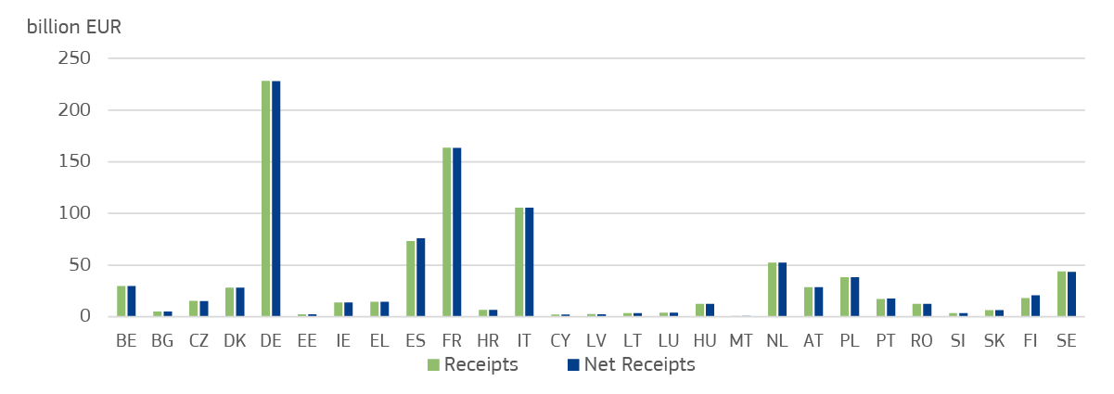

*Note*: Net receipts exclude corrections from receipts. Corrections aimed to take out non-VAT elements from VAT receipts and to add potential VAT receipts accounted for elsewhere or not at all. The small differences between receipts and net receipts show the small impact of removing the corrections.

*Source:*Commission services calculations based on national VAT statements.

**Graph 3. Compensations to the VAT base, EUR billion, average 2016-2020**

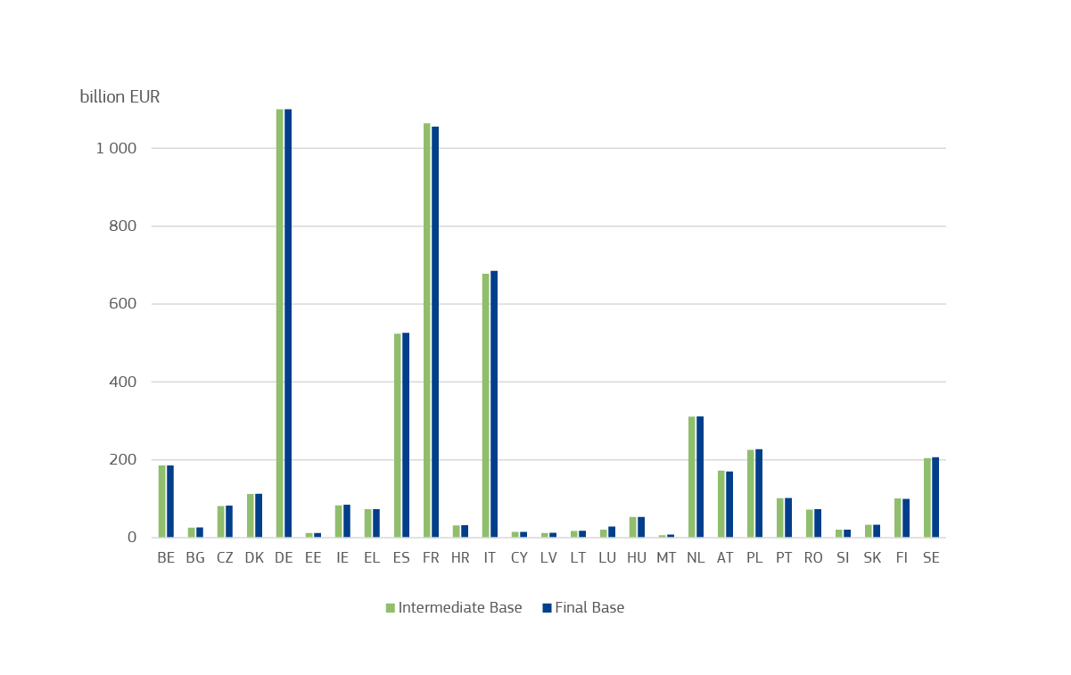*Note*: Compensations were made until 2020 to harmonise the notional VAT base, as calculated from the VAT receipts reported by Member States. They correspond to the full application of the VAT Directive (no derogations, no exemption). VAT bases are displayed before capping at 50% of GNI.

*Source:* Commission services calculations based on national VAT statements.

**Graph 4. Weighted Average VAT Rates, %, 2016-2020**

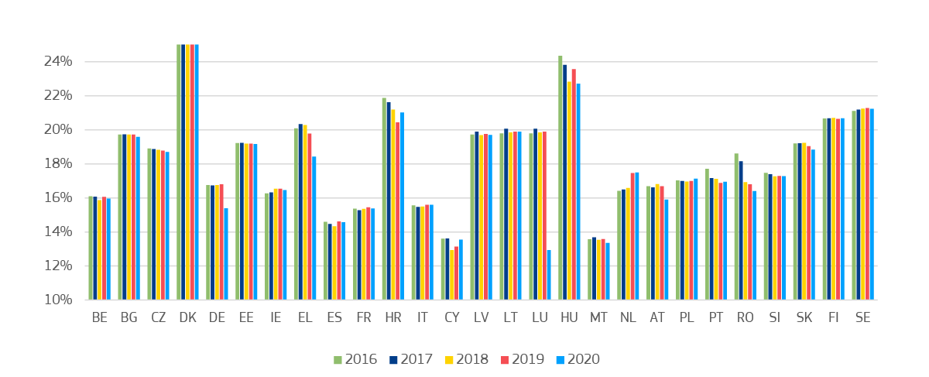

*Source:*Commission services calculations based on national VAT statements.

**Finally, to ensure fairness among Member States, the capping mechanism was maintained.** The mechanism prevents Member States with high consumption shares and large value added tax bases from paying a disproportionate contribution, by capping the value added tax base for the VAT own resource at 50% of their GNI.

### 1.1.3. Diversification of revenues: the plastics-based own resource

**The most notable novelty concerning own resources is the own resource based on non-recycled plastic packaging waste, entered into force in 2021.** The introduction of this new own resource is not only historic, as it is the first new own resource since the introduction of the GNI-based own resource in 1988, but also an important step in the direction of supporting EU policy priorities, such as the circular economy, with the revenue side of the budget. The new own resource contributes some 3% of total EU revenues, which represents a small but important change in the mix of revenues.

**As a statistical-based own resource, the plastics-own resource changes the contribution key of Member States, thereby encouraging them to implement or reinforce recycling policies.** The own resource contribution is proportional to the quantity of plastic packaging waste that is not recycled. Member States contribute EUR 0.80 per kilogramme of plastics packaging waste that is generated in their territory and not recycled (i.e. is put in a landfill or incinerated with or without energy recovery). As such, it provides Member States with a direct financial incentive to reduce waste generation and recycle more. It however leaves them free to choose the appropriate way of achieving this, which may include a tax or other measures, such as deposit systems and communication campaigns to encourage recycling([7]).

**In the years before the Covid-19 crisis, both plastic packaging waste generation and recycling have risen in the EU.** The quantity of plastic packaging waste that each Member State generates annually depends on its demographic and economic size. In the past, it has broadly evolved in sync with real GNI growth (Graph 5).

**Graph 5. Plastic packaging waste (PPW) generated and recycled vs GNI, EU27**

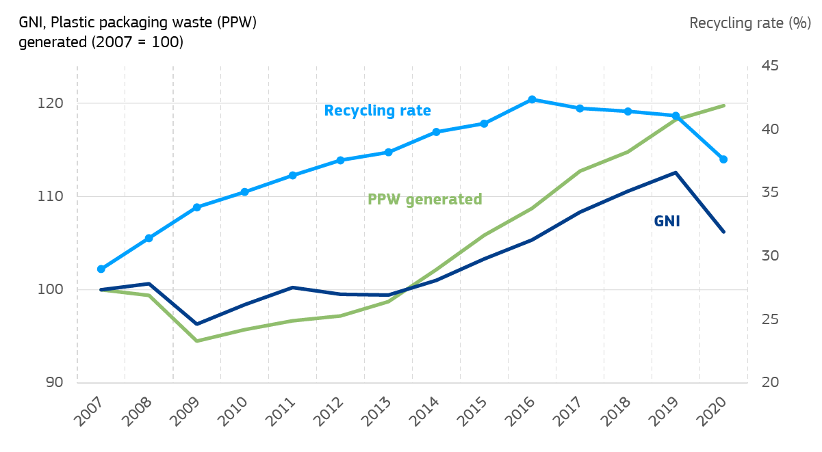

*Source:* Eurostat database (Tables: env_waspac & nama_10_gdp).

*Note:* Recycling rates series feature a break due to a change in measurement. This break explains the fall in the series in recent years, as measurement is stricter.

**The proportion of plastic packaging waste that is recycled varies widely across the EU.** Whereas in two Member States in 2020 it had already reached the 50% EU target([8]) for 2025, in others it remained quite far below that level. Overall, recycling rates have also increased from an EU average of 31.4% in 2008 to 37.6% in 2020, although with wider fluctuations in several countries (Graph 6).

**Graph 6. Recycling rate: plastic packaging waste recycled in % of total generated, 2020**

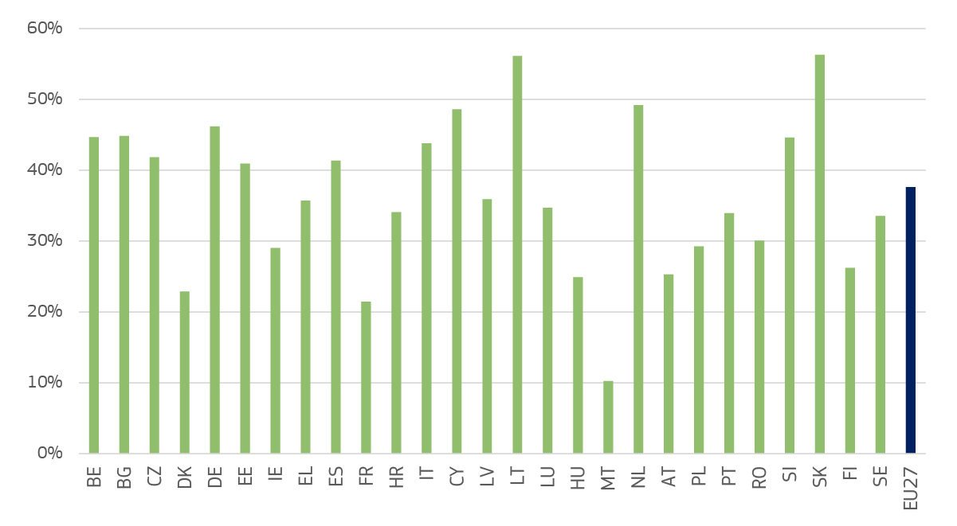

*Source:* Eurostat database (Tables: env_waspac).

**The plastics-own resource encourages decoupling non-recycled plastic waste from economic growth.** The new own resource is expected to support Member States’ efforts to reduce the generation of plastic packaging waste and to increase its recycling.Both effects would contribute to decouple the dynamics of non-recycled waste from economic developments. However, the incentives become smaller over time as the “price” for the non-recycled plastic packing waste in the Own Resources Decision is fixed in current prices while the overall price levels increased substantially due to high inflation rates.

## 1.2 The increase in “other revenues”

**In addition to own resources, “other revenues” present another income stream for the EU budget.** These revenues come from various sources such as surpluses from the previous year or contributions from third countries. They can also be directly generated by the implementation of EU policy and the enforcement of common Union rules, such as fines in the context of competition policy or taxes paid by EU civil servants (see Box 1). By default, other revenues, provided they are not assigned, are budgeted as general revenues. Until 2020, other revenues have so far represented less than 10% of total own resource revenues, on average (Graph 7).

**Graph 7*.* Evolution of the share of other revenues and own resources in total budget revenue, 2000-2022, %**

|  |
| --- |
|  |

*Note:* Light colour */* green bars include revenue from own resources, i.e. traditional own resources (TOR), VAT, plastic packaging waste (PPW) and GNI. Dark colour / blue bars include other revenues as per Box 1, including the revenues from borrowing activities linked to non-repayable part of NGEU.

*Source:* Commission services, Expenditure and Revenue Tables 2000-2021 ([Spending and revenue (europa.eu)](https://commission.europa.eu/strategy-and-policy/eu-budget/long-term-eu-budget/2014-2020/spending-and-revenue_en)), source Budget 2022: financing tables 2022, including Draft Amending Budget 5.

**Components of other revenue (excluding NGEU) such as surplus, administrative revenues or fines have remained quite stable over time.** They account for a small share of total revenues (i.e. 4.5% in 2016 and 3.1% in 2021) and depend to a large extent on the implementation of the EU budget and the revenues actually collected during the financial year. Income stemming from interests and fines or penalties due to infringement law are more difficult to predict and can vary from one year to another.

**Compared to the last decade, the share of revenues from “budgetary guarantees, borrowing and lending operations” have increased to reach 23% of total revenues in 2021** (graph 8). This is solely related to the borrowing for the new NGEU instrument, where proceeds for the non-repayable expenditures are channelled to the budget via external assigned revenues. On the contrary, the increasing role of financial instruments over the past years, contributing to incentivising both private and public investment in the EU, or the increased support to some countries through facilities such as the balance of payment assistance or external lending related to the past economic and financial crisis do not feature prominently on the revenue side.

**Graph 8. Budget revenue, 2016 (lhs) vs 2021 (rhs)**

|  |
| --- |
|  |

*Source:* Consolidated annual accounts of the European Union 2016 and 2021.

|  |
| --- |
| **Box 1. Other revenues and assigned revenues**  The annual budget includes the yearly general statement of revenues, including ‘other revenue’ described in Titles 2 to 6 below, which are subdivided further into Chapters, Articles, and Items.   * Title 2 (Surpluses, balances, and adjustments) includes the surplus from the previous financial years as well as own resources balances, and other adjustments such as for the non-participation of certain Member States in specific policies. * Title 3 (Administrative revenue) comprises in particular revenues from taxes and levies on the remuneration of staff. * Title 4 (Financial revenue, default interests and fines) refers mainly to fines in the field of competition. * Title 5 (Budgetary guarantees, borrowing and lending operations) covers *NextGenerationEU* (NGEU) funds for the non-repayable support as well as guarantees and interest and repayments of loans granted. * Title 6 (Revenue, contributions and refunds related to Union policies) covers mainly revenue from financial corrections related to structural and agricultural funds and includes the participation of third countries in research programmes, the clearance of accounts in agricultural funds and other contributions and refunds to EU programmes/activities.   Expenditure can be financed by general revenue or revenue that is assigned to specific expenditures. Assigned revenues therefore represent an exception to the principle of universality. The complete list of items constituting assigned revenue is given in Article 21 of the Financial Regulation. The sums borrowed for *NextGenerationEU* are assigned to specific programme spending (in particular the Recovery and Resilience Facility).  The number of “Other revenue” sources are expected to increase in the near future. Recent policies generating other revenues for the EU Budget include EU policies such as the European Travel Information and Authorisation System - ETIAS ([9]), the CO2 emission standards for cars and vans Regulation ([10]), the CO2 emission standards for heavy duty vehicles ([11]). |

# 

# **Part 2.** Potential New Own Resources – Types and Evaluation

The own resource package is framed by a specific political context – the inter-institutional agreement signed in December 2020 where the three institutions agreed on a roadmap towards the introduction of new own resources.

This part explores criteria to assess new own resources, taking account of the current economic and political context, and applies these criteria to potential candidates, scoring them, to propose or discard new own resources in the short term.

## 2.1. Assessment framework for new own resources candidates

### 2.1.1. Political context

**In December 2021, the Commission proposed three new sources of revenues for the EU budget with contributions from the Emissions Trading System (ETS), from the EU Carbon Border Adjustment Mechanism (CBAM) and from a share of the residual profits of the largest multinational enterprises that would be reallocated to the EU under the OECD/G20 Pillar 1 agreement. This basket of own resources was consistent with the proposed sectorial legislation on both the revised ETS Directive and on the Carbon Border Adjustment Mechanism (CBAM) proposed earlier in the same year. Since then, the discussions on own resources have made limited progress and the recent agreement on the underlying sectoral legislation – ETS Directive and CBAM Regulation – paves the way for relaunching the discussions (see part 3).**

**The inter-institutional agreement of 16 December 2020 among the European Parliament, the Council, and the Commission foresees another batch of own resources, mostly linked to the corporate and financial sectors. The European Parliament as well as other institutions have identified a large number of potential candidates, including in the field of corporate and financial taxation (see section 2.2).**

**The delays in the implementation of the December 2021 proposals increase the urgency of additional resources. Issues of both timing and sufficiency related to ETS, CBAM, and the OECD/G20 Pillar 1 make it now necessary to supplement this selection with additional new own resources. This document intends to provide Member States, the Parliament, and stakeholders at large with a full overview of the analysis underpinning the Commission’s proposal, so that all elements are available to resume and swiftly progress in the discussions on the proposed new own resources.**

### 2.1.2. Selection of criteria

**Against this political background, the assessment framework must account for the need to act quickly and provide the necessary means to the EU budget, but also of ways** **to design new own resources optimally.** For this purpose, selection criteria are established according to the literature**,** but only own resource candidates able to generate significant resources quickly and without heavy implementation are considered, to respond to the challenges the EU budget is facing. **Therefore, the assessment framework relies on three criteria** related to (1) revenue potential, (2) simplicity in terms of compliance and administrative burden, and (3) fast mobilisation. These are in line with the economic literature, while taking account of the specificities of the EU budget at this juncture (Table 1 and Box 2).

**Table 1. Assessment framework**

|  |  |  |  |
| --- | --- | --- | --- |
| Assessment framework | | | |
| 1. Revenue potential | 1. **Simplicity** | 1. **Fast mobilisation** of new revenue sources |

### Revenue potential

The *revenue potential* evaluates the amounts of money the own resource can generate. Linked to revenue potential are also the stability of these revenues over time and their predictability.

### Simplicity

*Simplicity* refers to budget revenue collection and theease of implementing new own resources, from an administrative angle, including the availability of statistics. It also contributes to improving transparency, which is particularly important to preserve accountability to citizens and stakeholders. In the past, the EU own resources system had grown increasingly complex and opaque due to factors such as the cumbersome calculations of the UK rebate, the “rebates on the rebate”, and heavy steps to calculate a notional harmonised value added tax base([12]). The reforms of 2020 - simplifying the VAT base([13]) and introducing a plainer system of lump-sum rebates led to a simpler revenue collection for both Member States and the Commission.

### Fast mobilisation of new revenue sources

*Fast mobilisation of new revenue sources* reflects the ability to implement new sources of revenues quickly. The EU does not levy taxes and therefore, it relies on sources of revenues stemming from other legislation. This criterion entails the political and legal practicalities of raising new own resources quickly. It includes considerations such as a need for minimal extra pieces of new legislation. In this sense, the criterion may account for the current state of negotiations of different measures at EU or international level or for the prospects of agreement of sectoral legislation serving as prerequisite for the implementation of a new own resource.

|  |
| --- |
| **Box 2. Criteria: What does the literature tell us?**  There is an extensive literature on tax and economists have been assessing taxation from various perspectives concerning for example policy, administration, and compliance. Comparatively, the literature on EU revenues is more limited, given the specificities of the EU budget compared to national budgets. The EU budget does not levy taxes and is financed by revenues from common policies (i.e. customs duties) and national contributions (see Part 1). These revenues are currently collected by Member States and transferred to the EU budget. Therefore, the application of criteria used in the tax literature would need to be further adjusted to reflect these specificities.  Equity, efficiency, and a practical/simple administration are three principles traditionally used to evaluate the rationale for raising revenue as done through national budgets. These objectives originate in the early economic theory of Adam Smith and continue to gather wide acceptance among modern theorists today. They reflect various aspects of governance, tax policy, and tax administration, including the extent to which the two main roles traditionally defined for taxes under national budgets - redistribution and revenue raising for the collective provision of goods and services, including insurance (Smith, 2015([14])) - are fulfilled.  Some key conceptual considerations are listed below and refer to the criteria for a good tax, as found in the literature([15]).  - Effectiveness in raising revenues will determine revenue sufficiency. In the literature, effectiveness refers to a tax or revenue design which is dependable ([16]) and predictable from year to year; for instance, tax / revenue systems applying to a broad tax base at a low tax rate are known to be most effective in raising revenues.  - Efficiency is important as public authorities aim to avoid distortions often associated with the loss of economic activity (‘deadweight loss’) that may arise when taxes drive a wedge between economic agents. Economic distortions are behavioural changes which can occur when taxes change relative prices and consumers can turn to substitute products. Such distortions would prevent from concluding or supress a transaction which would have occurred in absence of the tax([17]).  - Equity is a major issue in taxation and it can encompass several dimensions, such as the ability to pay, progressivity and redistribution from the better off to the worse off (vertical equity); equal treatment of agents in the same situation (horizontal equity), ‘the polluter pays’ principle and correction of other negative externalities (Smith, 2015).  - Simplicity or ease of administration refers to revenue collection, implementation, and compliance. This criterion, which also features among those qualifying `good' tax systems (Smith, 2015, Stiglitz, 2000([18])), De Mooij et al., 2014), essentially concerns administering a tax or revenue system at low collection costs (Begg and Grimwade, 1998; Heinemann et al., 2008; Schratzenstaller, 2014). Generally speaking, the proof of simplicity is whether revenues are reliably collected every year without excessive administrative burden or legal and procedural controversy.  - Transparency concerns the different stakeholders’ understanding and ease of access to information, including through clear calculation methods of different budget revenues. Stakeholders may include taxpayers / citizens, civil society, parliaments. Transparency is even more vital in multi-level governance systems (Begg et al., 2008). |

## 2.2 Stakeholder and other institutions’ views

**The European Parliament supports the proposal of new own resources.** In its report adopted on the 10 May 2023([19]), the European Parliament responded to the Commission’s proposal of 22 December 2021 on three additional sources of revenues for the EU budget based on carbon border adjustment mechanism (CBAM), emission trading scheme (ETS) and reallocated profits of multinationals. This report called on the Member States in the Council to adopt the new own resources from the first package of 14 December 2021. Moreover, concerned on the sufficiency of new own resources “to cover all NGEU repayments and borrowing costs”, to avoid cuts to existing EU programmes and policies, it “urged all actors to continue the efforts to identify fresh and new, preferably genuine, own resources and other revenue sources for the EU budget”.

This report discussed several possible measures as a basis for own resources, supporting, among others, corporate taxation (BEFIT), a tax on cryptocurrencies, a tax related to the digital economy, a financial transaction tax (FTT), an EU ‘fair border tax’, and saw high potential in all statistics-based own resources. On the latter, the European Parliament report proposes a bio-waste statistical own resource fostering the reuse of bio-waste([20]) and an own resource on gender pay gap statistics.

Finally, the Parliament report also mentions revenue sources other than own resources, such as those in the form of levies, fees charged for visa waivers under the European Travel Information and Authorisation System (ETIAS) when it comes into operation, excess emission premiums, competition fines, infringement penalties or similar, which should be listed transparently in the annual budget documents, as well as proceeds generated in the context of criminal justice sentences and assets confiscated in the event of non-compliance with EU sanctions (e.g. Russian frozen assets).

**The Council technically explored the Commission’s proposals since 2021, but little progress has been made concerning the adoption of new own resources. Further to the inter-institutional agreement of 16 December 2020, the Council monitored the Commission’s proposals of December 2021 on CBAM, ETS, and reallocated profits of multinationals, including their share in the ‘Fit-for-55’ package of July 2021, and the related implementing Regulations proposed in March 2022. In this context, in 2022, the Council reached a general approach and started negotiations with the European Parliament on the sectoral Regulations of CBAM and ETS. These took place mostly during the 2nd half of 2022, under the Czech Presidency(**[21]**). Few delegations took a fully-fledged position on the own resources’ package, given that not all Commission proposals were on the table. Consequently, there was no substantial progress in their adoption so far.**

**The European Court of Auditors’ position is also broadly favourable.** The latest European Court of Auditors opinion on the Commission’s proposal of December 2021 dates from July 2022([22]). While the opinion recognised the progress made towards the introduction of new own resources, it saw a need for more consistency in the rules for managing own resources.

**The European Economic and Social Committee (EESC) also supported the Commission’s December 2021 proposal for new own resources, but was concerned with the competitiveness of EU businesses and the subsistence of households.** The Committee deemed new own resources were necessary to cover the debt repayment resulting from *NextGenerationEU* borrowing and acknowledged the higher flexibility of an extended own resources model, with funds reacting more effectively to economic shocks. It stressed the importance of equity and fairness, efficiency, transparency, simplicity, and stability in the new system, as well as of a focus on competitiveness and applying solidarity to support households and businesses, where necessary. A targeted impact assessment by country and sector (industry) was also mentioned, together with preserving a level playing field of EU businesses in the international tax system, avoiding competitive disadvantages([23]).

**The European Committee of the Regions (CoR) noted the Commission's proposal, with a nuanced position.** In its opinion of 30 November – 1 December 2022([24]), the Committee noted that the introduction of a first basket of new own resources would send a positive message to investors on the financial markets and rating agencies; similarly to other institutions, it also stressed the need to establish new resources not only to repay the NGEU debt without jeopardizing EU programmes in the next MFF, but also to increase the EU budget's financial autonomy in a permanent, sustainable way for the Member States' budgets. The Committee also underlined that additional new own resources would be needed given that, overall, the three new own resources proposed in December 2021 would yield up to EUR 17 billion / year from 2026 to 2030 (European Commission estimates), an amount insufficient to cover both the costs of repaying the NGEU debt (EUR 15 billion / year) and finance the Social Climate Fund (EUR 9.7 billion / year). Furthermore, the Committee called upon the Commission to consider credible, territorial impact assessments regarding potential costs European companies and consumers may incur.

## 2.3. Evaluation of potential new own resources – individual factsheets

**This section presents eight potential options for new own resources based on either Commission’s existing or forthcoming sectorial proposals – such as BEFIT – or** the European Parliament’s own initiative report (see section 2.2)**.** Each of the eight assessments elaborates on the three criteria – revenue potential, simplicity, and fast mobilisation of revenues – and scores each option on a qualitative basis and using expert judgement (for the methodology, see Box 3). A summary evaluation is presented in Table 2.

A tax on the digital economy is not part of this assessment, given the ongoing international discussions in the context of the OECD. The EU has always considered the OECD’s Two-pillar Solution to Address the Tax Challenges Arising from the Digitalisation of the Economy a paradigm-changing reform of the international corporate tax system. Its implementation remains a key priority in the area of corporate taxation for the EU and its Member States. Enormous progress has been made following the October 2021 agreement. Certain building blocks now remain to be completed to pave the way for the signature of the Multilateral Convention before the end of the year.. Against such backdrop, the EU will not consider further measures on the digital sector, as long as the OECD’s Pillar One is in preparation or in place.

The European Parliament called for the establishment of a bio-waste-based own resource. Since there are no specific statistics on bio-waste, but rather several statistical systems, the assessment considers two separate own resources based on the waste from electrical and electronic equipment – ‘e-waste’ – and on food waste.

The eight candidates are: corporate taxation (BEFIT), including the financial sector (section 2.3.1); a statistical own resource based on company profits (section 2.3.2); a tax on the financial sector with an assessment of a financial transaction tax (FTT) (section 2.3.3); an EU ‘fair border mechanism’ (section 2.3.4); a tax on cryptocurrencies (section 2.3.5); a statistical own resource based on gender pay gap (section 2.3.6); a statistical own resource based on food waste (section 2.3.7); and a statistical own resource based on e-waste (section 2.3.8).

|  |  |  |  |  |  |  |
| --- | --- | --- | --- | --- | --- | --- |
| **Box 3. Evaluation and scoring of new own resources**  Each potential new own resource is scored along the three criteria – 1) revenue potential, 2) simplicity of collection and implementation, and 3) fast mobilisation of new revenue sources to the EU budget.  Each criterion is marked from 0 to 4 points (quarters of a circle), with 0 standing for no compliance and 4 standing for full compliance of the new measure with the criterion considered. With a maximum of 4 points per criterion, any given new own resource proposal can score a maximum number of 12 points (3 criteria * number of points/criterion).   |  |  |  |  |  |  | | --- | --- | --- | --- | --- | --- | | **Scoring** | None | Modest | Adequate | Good | Full |   As in Monti et al., 2016 and Schratzenstaller et al., 2016, this scoring assessment is largely qualitative and reflects the expert judgment with each potential new measure. |

### 2.3.1. Corporate taxation (BEFIT), including financial sector

**Description: Rationale and design**

The initiative Business in Europe: Framework for Income Taxation (BEFIT) would improve the functioning of the Single Market by simplifying corporate tax rules and tax compliance, and levelling the playing field for businesses, as well as stimulating growth and investment. BEFIT aims to address double taxation and reduce tax compliance costs that businesses, chiefly those with cross-border activity, currently face in the Single Market. This will help make the EU more attractive to investment and support growth. BEFIT will cover both the financial and non-financial sectors and will be mandatory for large groups, i.e. those with global combined annual revenues of EUR 750 million or more and therefore in scope of the Directive on ensuring a global minimum level of taxation for multinational groups in the Union (‘Pillar 2’) which will enter into force on 1 January 2024. It will remain an option for all other groups of companies that file consolidated financial statements and have a taxable presence in the EU.

The BEFIT-based own resource could levy e.g. a call rate on the share of the aggregated tax base[25], of all groups within the mandatory scope of BEFIT allocated to the Member States, using a formulary apportionment.

**Assessment**

1. **Revenue potential**

A BEFIT-based own resource would link the financing of the EU budget to the benefits enjoyed by companies operating in the Single Market and make for a strong and stable resource over time. Under a BEFIT-based own resource, Member States would transfer part of their corporate income tax revenues to the EU budget. Applying even a potentially small call rate could raise substantial revenues.

1. **Simplicity of collection and implementation**

Member States would contribute based on a call rate that will be applied to the apportioned share of each member of a group within the mandatory BEFIT scope. Since the calculation of the apportioned shares is already part of the BEFIT system, only the aggregation of the tax base at Member State level would be required for the purpose of raising the own resource amount.

1. **Fast mobilisation of new sources of revenue to the EU budget**

The Commission will come forward with a proposal on BEFIT during the second half of 2023. The own resource element could be implemented only after the Directive on BEFIT comes into effect. Negotiations on the sectorial BEFIT proposal in Council requires Member States’ unanimous vote.

### 2.3.2. Statistical own resource based on company profits

DESCRIPTION: RATIONALE AND DESIGN

A statistical own resource based on company profits would not be a tax on companies, nor would it increase their compliance costs. It would be a national contribution linked to the corporate sector. A national contribution could be designed based on a “statistical proxy” of corporate income or corporate profits. The measure could apply to financial and non-financial corporations (see part 3, for more details). One such statistical indicator is gross operating surplus, as defined in the European System of Accounts 2010 (ESA 2010)([26]).

This statistical indicator covers both profit generation due to the physical presence of companies and their related economic activities, and - at least partially - the shifting of profits for tax reasons. Member States attracting company profits that are in principle potentially taxable would in principle contribute more on this statistical own resource.

Assessment

1. **Revenue potential**

The own resource base could comprise both financial and non-financial companies and would reflect the gross operating surplus of both sectors. The own resource base would be substantial and reach around EUR 3 000 billion in current prices on average for 2018-2020.

The call rate could be low: a call rate between 0.1% and 0.5% applied on the sum of gross operating surplus for the sectors of financial and non-financial corporations could bring revenues between EUR 3 billion and 16 billion per year on average over the period 2028-2030 (in 2018 prices).

1. **Simplicity of collection and implementation**

In terms of implementation, the statistics on which this own resource would be levied already exist. As a matter of efficiency and effectiveness, the implementing measures for the supervision related to this own resource could take into account the existing obligations on Member States under the GNI control framework.

1. **Fast mobilisation of new sources of revenue to the EU budget**

This own resource could be implemented quickly. This statistical own resource could be temporary and cease to apply once Member States agree on both the forthcoming Directive related to the BEFIT initiative, and to draw a Union own resource from that tax base (e.g. as described in factsheet *2.3.1*).

### 2.3.3. Financial Sector - Financial Transaction Tax (FTT)

Description: Rationale and design

The financial sector is perceived as being undertaxed. It faces different non-harmonised national taxes across the EU and is VAT exempt. To ensure a just and stable contribution of the financial sector to public finances, a contribution from the financial sector as a basis for an EU own resource could balance contributions from other sectors.

In the wake of the 2008-09 financial crisis and subsequent sovereign debt crisis, the introduction of a harmonised framework of national financial transaction taxes (FTTs) at EU level became part of the Commission’s political priorities in the field of taxation policy. The FTT was targeted at curbing excessive speculation and volatility, making the financial sector bear part of the costs of its rescue from the financial crisis and fostering harmonisation, as some Member States were considering introducing (or had already introduced) FTTs. The Commission put forward two FTT proposals, one in 2011 (for all Member States) and one in 2013 under enhanced cooperation. The latter proposal, still under discussion, is similar to a stamp duty and would apply only to purchases of shares issued by domestic listed companies with a market capitalisation higher than EUR 1 billion.

**Assessment**

1. **Revenue potential**

It was estimated that the initial 2011 Commission proposal would have generated revenues up to EUR 57 billion per year. Design changes in the compromise FTT proposal that was put forward under enhanced cooperation would mean a much lower revenue potential. The significantly changed design and limited number of participating Member States would mean that, under the current design, the revenues to the EU budget would be rather limited.

1. **Simplicity of collection and implementation**

A uniform tax rate would be applied to transactions of financial assets in scope of an FTT in addition to the price and intermediary fees. The revenues would be collected by the financial intermediary and allocated to the relevant Member States. Part of that revenue would then accrue to the EU budget at a set call rate.

1. **Fast mobilisation of new sources of revenue to the EU budget**

After years of negotiation, no agreement has been found on the FTT proposal, progress has been very slow, the enhanced cooperation is reduced to ten Member States, and the prospects of reaching an agreement in the future are limited given that the last substantial discussions took place under the Portuguese Council Presidency in 2021. There is little expectation that any proposal would be agreed in the short term.

### 2.3.4. EU ‘fair border Mechanism’

Description: Rationale and design

The EP report on own resources ‘A new start for EU finances. A new start for Europe’ (2022/2172(INI)) suggested establishing an EU Fair Border ‘Mechanism’. It should help fight the social dumping of commodities made by underpaid people in developing countries and imported into the EU market. The companies importing products into the European Union would be required to pay a charge for any worker in their global supply chain who is paid a wage below the relevant poverty line of third countries.

The European Parliament refers to the example of textile production in Bangladesh. Bangladesh is a part of an EU programme that allows developing countries to export goods to the EU at lower or no tariffs, under the [Generalised Scheme of Preferences](https://politico.us8.list-manage.com/track/click?u=e26c1a1c392386a968d02fdbc&id=5fc22d4cd4&e=0273d76ab1) (GSP). The GSP is one of the key EU trade instruments to assist developing countries to integrate into the world economy, reduce poverty, and support sustainable development through the promotion of core human and labour rights, environmental protection, and good governance. A specific salary level is not part of the EU’s GSP conditionality. Therefore, the contemplated idea of a fair border tax could not be implemented via the GSP, but only as an additional selective tariff.

Such mechanisms are uncommon in the world, and in particular do not include any trade measures. In California, for instance, a Garment Worker Protection Act is in place since January 2022 ([27]). It foresees that employees engaged in garment manufacturing in California must be paid an hourly rate not less than the minimum wage and forbids pay per piece, except in specific cases. These conditions seem to concern domestically produced garments, with no specific reference to trade. In the EU, the Commission proposed in 2022 two pieces of legislation - a Regulation aiming to prohibit products made using forced labour and a Directive on corporate sustainability due diligence (CSDDD). The Regulation covers cases of systematic and deliberate withholding of wages, as well as working involuntarily because of very low or no wage; it will empower national authorities to withdraw from the EU market products made with forced labour or to stop such imports at EU borders. The Directive aims to foster sustainable and responsible corporate behaviour throughout global value chains, requiringcompanies to identify and, where necessary, prevent, end or mitigate adverse impacts of their activities on human rights, such as exploitation of workers.

Assessment

1. **Revenue potential**

The EU Fair Border Mechanism would bring fresh money. If introduced, the duties paid on certain imported garments/goods will likely be classified as customs duties and thus Traditional Own Resources. Under the current own resources’ rules, the Member States would be able to retain 25% of the duties as collection costs.

The issue of how the charge would be determined and calculated across complex value chains should be considered – the production of garments has a fairly simple supply chain; however, more complex products have infinitely more complicated supply chains (e.g. a typical motor vehicle has over 20.000 parts and thousands of suppliers and suppliers to those suppliers). Therefore, the quantification of potential revenue is difficult to establish.

1. **Simplicity of collection and implementation**

The desired design of the charge is not clear – such as on what base the wage difference would need to be applied for a given assignment. Another question would be to know whether the importer would need to pay the difference in the wages on each piece of garment or would the difference be divided by the average daily output. Moreover, the effect of the tax or charge on increasing the salaries in third countries seems to be uncertain – the importer is usually not the producer and has limited control over the production part of the supply chain.

1. **Fast mobilisation of new sources of revenue to the EU budget**

The ‘Fair Border Mechanism’ would be a trade policy tool which would be introduced by the Commission as a legislative proposal under Article 207(1) and (2) TFEU. It would need to be compatible with the WTO Agreement and EU bilateral trade agreements. The tariff must be justified under an exception in the WTO’s General Agreement on Tariffs and Trade (GATT) because it would exceed the EU’s scheduled tariff commitments (Article II GATT, i.e. the maximum permitted tariff which normally is already applied) and there would inevitably be discrimination between countries (most-favoured-nation obligation).

This justification could theoretically be Article XX of GATT which allows WTO Members to restrict trade when this is necessary to protect public morals or human life or health, provided they do not unjustifiably or arbitrarily discriminate between countries or use this as disguised restriction on trade. Using this article to justify a “Fair Border Mechanism” would be a major political and legal challenge. Properly designing and operating such a scheme would also create a high administrative burden on public authorities and the private sector, raising the question of whether poverty alleviation can be achieved more effectively and more efficiently through other means.

### 2.3.5. Tax on crypto assets

**Description: Rationale and design**

The global market in crypto assets has grown rapidly over the past years. Crypto assets are increasingly used and citizens are increasingly investing in the crypto market, while businesses intensify their investments – whether in the necessary infrastructure or in tradable assets. There are many kinds of crypto assets, including cryptocurrencies with fluctuating prices (e.g. Bitcoin), “stablecoins” pegged to a currency (e.g. Tether pegged 1:1 to the USD), and “non-fungible tokens” (NFTs) representing a unique digital item (e.g. a cyber artwork). While crypto assets also have a hybrid or dual nature as an investment product (similar to financial assets) and payment method (similar to currency), to date, at the level of the EU Member States, the main tax implication arising from them has been as speculative assets that can deliver capital gains (and losses).

In view of the constantly evolving nature of the crypto market and the importance of its future potential, as well as the risks it brings to bear, this market’s evolution will need to be continuously assessed and monitored. As a first step, the recent adoption of MiCA (Markets in Crypto-assets)Regulation in April 2023 has already improved the opaque nature of the market. Transparency will continue to improve with the entry into force of the DAC8 (Directive on Administrative Cooperation) proposal ([28]) on the automatic exchange of information, which will help boost crypto-asset related information sharing and tax compliance.

Most Member States already tax capital gains and other income related to crypto assets as part of their national tax systems; however, they do so in a heterogeneous way. The European Parliament has suggested several ideas, including a harmonised direct tax on capital gains arising from increases in the value of crypto assets, applying across the EU, and accruing to the EU budget. Any work at the EU level on this front should ensure that the taxation of crypto assets is coherent with national tax systems. It should, moreover, be considered only over the medium-term, based on further analysis and close coordination with Member States.

**Assessment**

1. **Revenue potential**

According to a study of the European Parliament ([29]) and based on limited data availability, the value of the European cryptocurrency market had already reached EUR 4.3 billion in 2019 and it is expected to grow to EUR 12.9 billion by 2026.

The yield would fundamentally depend on the evolution in the price of crypto assets. It would also depend on what tax and call rates are ultimately applied. Although there are concerns about under-reporting of income from crypto-assets (which DAC8 will contribute to alleviate), it should be noted that the crypto-asset market is characterised by high levels of price volatility, which introduces uncertainty as to the stability of revenue generation over time.

1. **Simplicity of collection and implementation**

There are currently significant variations across the EU in the classification of crypto assets, what counts as a taxable event, tax rates and thresholds, how to value individual assets and gains on disposal, and the treatment of losses. What Member States already have in place varies greatly ([30]); and is interlinked with the national tax treatment of capital gains on other asset classes. Such issues would, therefore, have to be explored in greater detail and best practices shared to inform appropriate decisions.

Irrespective of the DAC8 proposal, a possible change in the taxation of crypto assets into a mechanism for the taxation of gains harmonised at the EU level would entail significant resources to set up, in operating systems and collection mechanisms, all issues that would require careful consideration.

An EU own resource call rate could then be applied e.g. to the capital gains tax base, provided Member States apply a harmonised tax base across the EU.

1. **Fast mobilisation of new sources of revenue to the EU budget**

Given the policy design and administrative challenges, the innovative and evolving nature of the crypto market and tradable assets, as well as the precedent that the application of any measure at EU level would set, further work is required to map and explore solutions to a plethora of challenging questions.

### 2.3.6. Statistical own resource based on gender pay gap

Description: Rationale and design

The strict prohibition of any discrimination on grounds of sex and the right to equal treatment between men and women in all areas, including employment, work and pay is directly enshrined in article 157 of the Treaty on the Functioning of the European Union, according to which “*Member States shall ensure that the principle of equal pay for male and female workers for equal work or work of equal value*” and in Directive 2006/54/EC.

Although these provisions have direct effect and can be enforced by national courts,currently, the gender pay gap in the EU stands at 12.7 % in 2021 and has only changed minimally over the last decade. It means that women earn 12.7 % on average less per hour than men ([31]).

In principle, an own resource based on the difference between the hourly earnings of women and men could incentivise Member States to take more action.

Assessment

1. **Revenue potential**

The relevant data are submitted to the Commission every year. The gender pay gap indicator is the relative difference between the average earnings of women and men:

$$\frac{Mean (gross) hourly earnings of men-Mean (gross) hourly earnings of women }{Mean (gross) hourly earnings of men}$$

This indicator takes account of the fact that the two groups do not work the same number of hours on average. However, it does not take into account other characteristics of male and female employees, i.e. the difference in terms of qualifications, which is higher for women in most of the Member States, and occupation as well as the concentration of one sex in certain economic activity and sectors.

Although the exact design of a related own resource would need to be developed, it seems that an own resource would generate a relatively limited amount of revenue.

1. **Simplicity of collection and implementation**

Although the quality of statistics is considered as satisfactory, the gender pay gap statistics published on a yearly basis by the Commission do not measure discrimination as such. Indeed, differences in pay between males and females can be explained by other dimensions such as the differences in the overall structure of male versus female employment. Statistical work is ongoing to adjust the pay gap and compare the returns paid to women versus those paid to men with the same average characteristics([32]).

1. **Fast mobilisation of new sources of revenue to the EU budget**

Though work to improve the related statistics is ongoing, it is not sufficiently developed, nor tested, to propose a gender pay gap own resource within a reasonable timeframe.

### 2.3.7. Statistical own resource based on food waste

Description: Rationale and design

Food waste is a part of bio-waste, but there are two separate reporting obligations. According to Eurostat estimates, around 10% of food made available to EU consumers (at retail, food services and households) are wasted. Reducing food waste would consequently provide many economic and environmental benefits as it would lower the carbon and overall environmental footprint of food production and consumption. It would also increase food security.

In June 2023, the Commission [will propose/proposed] an amendment to the Waste Directive and [will introduce/introduced] binding reduction targets for food waste (a percentage as from the reference year). An own resource proportional to the annual quantity of food waste in every Member State would complement this sectorial legislative proposal.

Assessment

1. **Revenue potential**

This new own resource would also apply to a statistical base, which is the quantity of food wasted in a year, valued in euro, as reported by Eurostat. In 2022, there were nearly 59 million tonnes of food waste (131 kg / inhabitant / year,around 10% of the food produced in the EU)([33]). This had an associated market value estimated at EUR132 billion / year (2020).

Under the new own resource, the national contribution would be directly proportional to the quantity of food waste generated in each Member State (statistical base). Concretely, a call rate between EUR 0.05 – 0.20 per kg could apply to this base and could generate between EUR 3 and 12 billion/year. ([34])

1. **Simplicity of collection and implementation**

The waste framework Directive ([35]) imposes on Member States an obligation to submit data to the Commission on the amount of food waste generated. The measurement of waste is harmonised throughout the EU by a Commission Delegated Act ([36]).

A food waste own resource could make use of this existing statistical system. It should however be noted that the statistical system was just set up, and the results are still regarded as estimates rather than solid data, due to lack of data series([37]). The collection of the own resource could be similar to the plastic based own resource, however the system for food waste will be much more complex, less precise and require longer time to establish quality data series.

In particular, waste is generated throughout the whole food supply chain from production until consumption and the types of food waste and factors contributing to its generation. Moreover, important amounts of food waste are currently not measured due to lack of methods for measuring which would ensure sufficient levels of confidence and comparability – e.g. food waste which is usually discarded with wastewater or food waste recycled by home composting.

1. **Fast mobilisation of new sources of revenue to the EU budget**

As announced in the Commission Work Programme for 2023([38]), the Commission proposes a revision of food waste and textiles aspects of the EU waste framework Directive. As regards the statistics, the complexity of the issue may require significant further work.

### 2.3.8. Statistical own resource based on e-waste

Description: Rationale and design

A new own resource based on waste from electrical and electronic equipment could support the EU priorities on the circular economy and the recent proposal of the Commission on Critical Raw Materials (CRM)([39]) which aims to ensure EU access to a secure and sustainable supply of critical raw materials. This initiative underlines the necessary contribution of waste from electrical and electronic equipment to the efficient use of resources and to the retrieval of secondary raw materials, including critical ones.

The EU faces the challenge of further increasing e-waste collection, recycling, and reuse in Member States. An own resource based on the collection of e-waste could incentivise Member States to put in place measures to incentivise consumers to discard electrical and electronic equipment that it is hoarded in households in several ways. A call rate could be applied on the quantity of waste electrical and electronic equipment not collected, calculated by subtracting waste collected from waste generated. The use of waste generated compared to what is placed on the market has an important advantage, as it accounts for the lifespan of EEE products.This is particularly important in the current context of the energy crisis.

Assessment

1. **Revenue potential**

The base to which such measure could apply, the quantity of e-waste not collected, would represent approximately 4 million tonnes per year (2016-2018). This statistical base would be calculated by subtracting e-waste collected from e-waste generated and would be based on the existing EU Directive on Waste Electrical and Electronic Equipment (WEEE Directive ([40]))**.**

A call rate in the range of EUR 1 to EUR 2 / kg could be applied on the difference between the generation and the collection of waste of electric and electronic equipment. It would lead to a range of revenues between EUR 4-8 billion / year (average 2016-2018).

While the quality of e-waste statistics, including e-waste trade, are still being improved, economic efficiency distortions linked to the firms’ incentives to report e-waste, including exports/imports as such cannot be excluded. These could affect the base of this potential new own resource, warping the related revenues across EU countries. Therefore, particular attention should be paid to the reporting of companies when importing or exporting e-waste.

1. **Simplicity of collection and implementation**

In terms of implementation, Member States already have the obligation to provide data necessary to calculate the own resource to Eurostat in the context of the electronic and electric equipment waste Directive (WEEE Directive([41])).The quality of statistics would need to be further improved on several levels. First, it needs to be ensured that waste generation data is available for all Member States. Second, internet trade - in cases where producers outside the EU or importers of used goods do not report on the whole amount of electrical and electronic equipment placed on the market – needs to be taken into account. Third, specific issues relate to second hand articles sold to another Member State, which are currently not reported (no tracking system of trade of electronic appliances between physical or legal persons after placing on the market or their storage before being wasted), and the treatment of electronic and electric equipment waste as metal scrap under sub-standard conditions. Fourth, the quality of statistics for e-waste generated and not collected also reflects country-specific coefficients for the lifespan of products. Not least, addressing illegal and sub-standard activities such as illegal exports and scavenging of electronic and electric equipment waste constitute key challenges to implementing this measure / electronic and electric equipment waste Directive([42]).

1. **Fast mobilisation of new sources of revenue to the EU budget**

This own resource could generate revenues from the start. As announced in the Critical Raw Materials communication([43]), the Commission will review the electronic and electric equipment waste Directive to, inter alia, address critical raw materials-rich equipment in provisions relating to information requirements and recovery targets. The evaluation of the electronic and electric equipment waste Directive is already ongoing and should be available in 2024. Furthermore, significant work on the quality and comparability of statistics would need to be done.

**In conclusion, the analysis shows that, in principle, all candidates could become an own resource, but not all could be mobilised in the short run.** Indeed, candidates display different features and some could be too complex to propose from a technical and/or political perspective. The table below presents the scoring of the own resource candidates according to the three criteria.

It shows that statistical based own resources are in general easier to implement and to mobilise quickly. Depending on the call rates, they can generate substantial revenues. However, the quality of statistics differs among them, in particular when it comes to environmental own resources. As for the statistical own resource on company profits, this relies on a harmonised system of European statistics and therefore does not raise any major comparability issues.

Tax candidates can be attractive as they can generate significant amounts of revenues. However, they would require unanimous agreement on the underlying sectoral legislation, which may take time. Experience on some existing proposals such as the Financial Transaction Tax shows the difficulties to reach swift political consensus on that matter.

The EU fair border mechanism seems to raise substantial challenges at international level and would certainly need to be further explored and analysed.

**Table 2: Evaluation of the own resources examined**

|  |  |  |  |  |  |
| --- | --- | --- | --- | --- | --- |
|  | Revenue potential | Simplicity | | Fast mobilisation | |
| 1. Corporate taxation (BEFIT) | Good | Good | Modest | |
| 1. Statistical own resource based on Company profits | Good | Good | Full | |
| 1. Financial sector - Financial Transaction Tax (FTT) | Adequate | Adequate | Modest | |
| 1. EU ‘fair border mechanism’ | Modest | Modest | Modest | |
| 1. Tax on cryptocurrencies | Modest | Adequate | Modest | |
| 1. Statistical own resource based on Gender pay gap | Adequate | Adequate | Modest | |
| 1. Statistical own resource based on Food waste | Adequate | Adequate | Good | |
| 1. Statistical own resource based on E – waste | Adequate | Adequate | Good | |

|  |  |  |  |  |  |
| --- | --- | --- | --- | --- | --- |
| **Scoring:** | None | Modest | Adequate | Good | Full |

*Notes:* (1) for more information about the scoring system, see Box 3.

*Source:* European Commission.

# **Part 3.** The new own resources package

**Following the agreement on the Fit for 55 package**, **the Commission proposes to adjust the first basket of new own resources** proposed in December 2021. In line with the inter-institutional agreement, the Commissions proposes to adjust its proposal and puts forward a corporate-related own resource. The assessment made in part 2 shows that the statistical own resource based on company profits could generate revenues and be implemented quickly and has therefore been assessed to be a good candidate.

This part describes in detail the package proposed by the Commission.

## Emissions trading scheme (ETS) own resource

### 3.1.1. The 2021 proposal on ETS – an overview

**In December 2021, the Commission proposed to make part of the revenues from the ETS an own resource.** This proposal built on the revised ETS architecture of the ‘Fit-for-55’ package tabled a few months earlier. In this package, major changes were proposed, including the creation of a separate emission trading system encompassing road transport and building emissions with full auctioning from the start, accompanied by a Social Climate Fund.

**In principle, allowances designated for auctioning with revenues accruing to Member States fall under the scope of the proposed own resource.** A uniform share of 25 % per allowance auctioned would accrue to the EU budget, as per the proposal of December 2021. This leaves outside the scope those allowances auctioned to mobilise resources for both the Innovation Fund and the Modernisation Fund (2% of the ETS cap for power and industry, as well as an additional 2,5% as of 2024 from the ETS cap for power, industry, and maritime transport).

**Following interinstitutional negotiations, the revised ETS Directive has entered into force in June 2023, creating the legal basis for an ETS-based own resource.** In parallel and in response to the challenges faced by the energy sector resulting from the Russian invasion in Ukraine, the *REPowerEU* Plan has led to another change in the ETS Directive, directing EUR 20 billion of ETS auction revenue to the Recovery and Resilience Facility in the coming years, which are also outside the scope of the own resource.

**Graph 9. Scope of the Emission Trading Own Resource, illustrative representation**

**ETS for stationary, aviation and maritime sectors (ETS 1)**

|  |
| --- |
| **ETS for road transport, buildings, and fuels in additional sectors (ETS 2)** |

*Notes:* (1) In both graphic representations, the relative size of the boxes may not be to scale. (2) In the graphic representation of ETS for stationary, aviation and maritime sectors (ETS 1), the breakdown does not account for the operation of the Market Stability Reserve. (3) In the graphic representation of ETS for road transport, buildings, and fuels in additional sectors(ETS 2), the use of the option represented in dark blue is uncertain.

*Source*: Commission services.

**Making a part of the ETS revenue an own resource builds on and does not necessitate a change to the well-functioning auction infrastructure.** Auctions take place on a daily basis. Collection and administration of ETS revenue is ensured at national level by authorities designated by Member States. Collecting part of the revenue as an own resource would not entail any major additional tasks. All categories of allowances in the own resource scope are to be auctioned based on the infrastructure established by the ETS Auctioning Regulation with a common auction platform at its centre. The simplest and leanest approach is to arrange for the transfer of part of this revenue to the EU level from the auction platforms used by Member States. This minimises administrative efforts for both Member States and the Commission.

### 3.1.2. Ensuring fairness – the Valuation Mechanism and Solidarity Adjustment Mechanisms

**The scope of the own resource includes allowances that may not be auctioned.** The ETS Directive foresees several mechanisms to support energy intensive sectors (such as the power sector), in particular in carbon-intensive economies, and helps them invest in climate-friendly technologies. For that purpose, the ETS legislation allows several individual Member States to exercise national discretion and not auction some allowances designated to be auctioned (see table 3 for an overview which Member States have made use of discretionary choices in the existing ETS).In particular,some Member States have decided to make use of the derogation to provide free allocation for the modernisation of the energy sector([44]). Some Member States have given up auctioning allowances to increase their resources in the Modernisation Fund([45]). Some Member States have already decided to use some ETS allowances for compliance with their targets under the Effort Sharing Regulation([46]). In the context of the own resource proposal, these allowances would be subject to an equivalent contribution as allowances auctioned – the so-called valuation mechanism (Graph 10).

**Table 3: Discretionary choices in ETS legislation - Non-auctioned allowances in own resources scope**

|  |  |  |  |  |  |
| --- | --- | --- | --- | --- | --- |
|  | Effort Sharing Regulation flexibility | | Transfer for free to the power sector (10c) | Transfer to the Modernisation Fund | |
| BE |  | |  |  | |
| BG |  | |  |  | |
| CZ |  | |  |  | |
| DK |  | |  |  | |
| DE |  | |  |  | |
| EE |  | |  |  | |
| IE |  | |  |  | |
| EL |  | |  |  | |
| ES |  | |  |  | |
| HR |  | |  |  | |
| FR |  |  | | |  |
| IT |  |  | | |  |
| CY |  |  | | |  |
| LV |  |  | | |  |
| LT |  |  | | |  |
| LU |  |  | | |  |
| HU |  |  | | |  |
| MT |  |  | | |  |
| NL |  |  | | |  |
| AT |  |  | | |  |
| PL |  |  | | |  |
| PT |  |  | | |  |
| RO |  |  | | |  |
| SI |  |  | | |  |
| SK |  |  | | |  |
| FI |  |  | | |  |
| SE |  |  | | |  |

*Source:* Commission services

**Several changes in revised legislation reaffirm the importance of the valuation mechanism.** Firstly, in an amendment of the Effort Sharing Regulation (ESR) the discretionary flexibility for some Member States to cancel ETS allowances and use the volumes for compliance with national targets has been extended. Eligible Member States may notify changes by end 2024 and again end 2027 to the discretionary choices made and notified in 2019. In addition, the two eligible Member States who initially had not notified the Commission to use this flexibility may decide by end 2023 to make use of it. Secondly, the derogation pursuant to Article 10c of the ETS Directive will end in 2024. The three Member States who had notified the Commission to make use of it will have the possibility to transfer by mid-May 2024 some or all of these allowances to the Modernisation Fund, or to auction them. Thirdly, pursuant to Article 30e(3), Member States with a national carbon tax applied to some or all the emissions covered by ETS 2 have the discretionary option not to apply up to 2030 the ETS 2 to these emissions and cancel allowances. As the purpose of the valuation mechanism is to ensure that discretionary choices at the disposal of individual Member States are made on climate policy merits and not on budgetary considerations, the extended choices confirm the need for this mechanism.

**The Commission additionally proposed a temporary solidarity adjustment mechanism to ensure a fair emissions trading-based own resource contribution from all Member States.** Until 2030, an upper and lower boundary for the own resource contribution applies, in relation to the gross national income key. This avoids that some Member States contribute disproportionally to the EU budget in comparison to the size of their economy during the period of transition to more sustainable economies and societies and ensures a just contribution from all. The upper and lower boundary have been proposed to be fixed at 150% and 75%, respectively. While the lower boundary applies to all Member States, the application of the upper boundary is limited to lower income Member States.

**Graph 10. The effect of the Solidarity Adjustment Mechanism on Member State contribution**

|  |
| --- |
|  |

*Source:* Commission Services.

### 3.1.3. The evolution of the carbon market

**Recent evolutions on the carbon markets have increased the revenue potential of the Emission Trading System.** In contrast to price assumptions used at the time the proposal was made and encapsulated in the accompanying impact assessment([47]), the market value of allowances in the existing ETS has significantly increased in the months following the proposal and exceeded the price level of EUR 55 (in 2020 prices) up to 2030 considered in the impact assessment. In 2022, allowance auctions cleared on average slightly below EUR 80. Member States’ annual revenue in 2022 reached an unprecedented level of almost EUR 30 billion. Independent market analysts([48]) expect that market prices will remain above EUR 55 in the coming years (Graph 11).

**Graph 11. Carbon price, 2018-2023, eur**

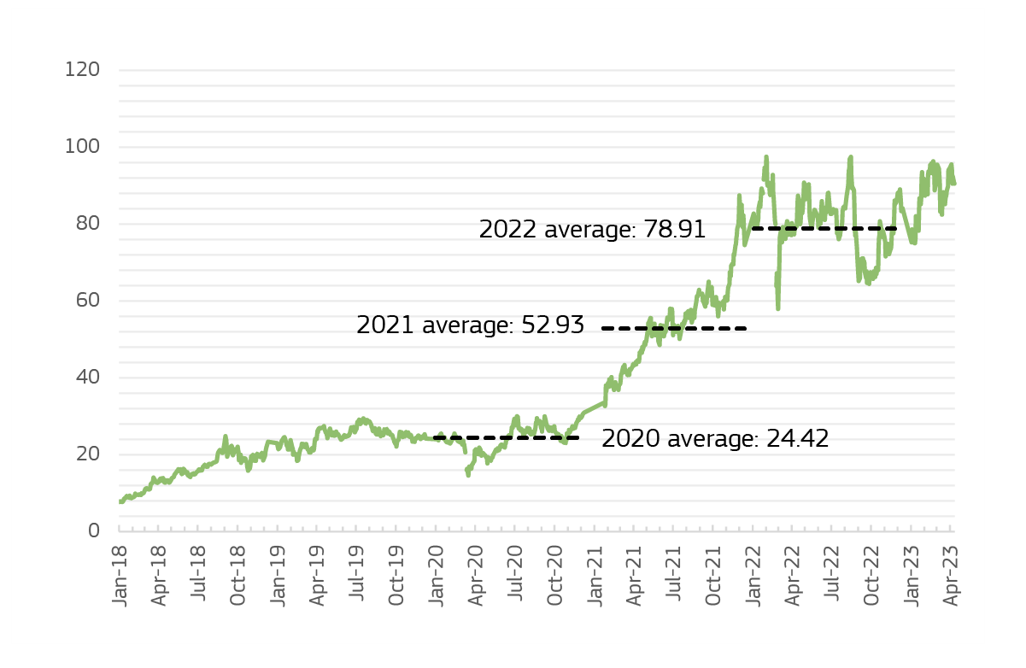

*Source:* EEX auction clearing prices.

## The statistical own resource based on company profits

**Insufficient tax harmonisation in the EU allows large multinational enterprises to exploit loopholes and mismatches in national tax systems. Large Multinational enterprises (MNE’s) are able to account part of their activities in different Member States and benefit from tax differentials. They can reduce their effective tax burden by allocating functions in several countries in the areas of financing and intellectual property rights. They can shift profits through the pricing of intra-group transactions. They can also limit their physical presence in some high-tax jurisdictions. Since a few years, the EU has been adopting measures to reduce this phenomenon and ensure a fairer taxation to preserve the Single market.**

**At global level, the process launched by the OECD and supported by the European Commission aimed at addressing these challenges and ensuring a fair taxation among tax jurisdictions. In a continued effort to put an end to tax practices of MNE’s, which allow them to shift profits to jurisdictions where they are subject to no or very low taxation, the OECD has further developed a set of international tax rules to ensure that MNEs pay a fair share of tax wherever they operate. This major reform aims to put a floor on competition over corporate income tax rates through the establishment of a global minimum level of taxation. By removing a substantial part of the advantages of shifting profits to jurisdictions with no or very low taxation, the global minimum tax reform will level the playing field for businesses worldwide and allow jurisdictions to better protect their tax bases.**

**In recent years, the Union has adopted landmark measures to reinforce the fight against aggressive tax planning within the internal market. The anti-tax avoidance directives have laid down rules against the erosion of tax bases in the internal market and the shifting of profits out of the internal market. Those rules converted into Union law the recommendations made by the Organisation for Economic Cooperation and Development (OECD) in the context of the initiative against base erosion and profit shifting (BEPS) to ensure that profits of multinational enterprises (MNEs) are taxed where economic activities generating the profits are performed and where value is created.**

**The implementation of the OECD/G20 Pillar 1 agreement remains an essential priority in the area of corporate taxation for the EU and its Member States.** In 2021, the Commission proposed an own resource based on a share of residual profits from multinationals that will be re-allocated to EU Member States under the OECD/G20 agreement on so-called ‘Pillar One’. This agreement addresses the tax challenges arising from the digitalisation of the economy and will reform significantly the international corporate tax system. Substantive progress has been made following the October 2021 agreement. However, the multilateral convention has not yet been signed and ratified, which means that, it cannot yet enter into force (see Box 4).

**As announced in the Commission Work Programme, the Commission intends to propose its Business in Europe: Framework for Income Taxation (BEFIT) in the third quarter of 2023**. This initiative will improve the functioning of the Single Market by simplifying corporate tax rules and tax compliance, and levelling the playing field for businesses. BEFIT aims at tackling the complexity, double taxation and reducing tax compliance costs that businesses, chiefly those with cross-border activity, currently face in the Single Market. It will contribute to making the EU more attractive to cross-border investment and support growth. BEFIT will be mandatory for large groups with global combined annual revenues of EUR 750 million or more. The discussions in Council are expected to start in the fourth quarter of 2023.

|  |
| --- |
| **Box 4. OECD Pillar 1**  There have been delays in the international process agreeing on Pillar One. In December 2021 the Commission proposed an own resource equivalent to 15% of the share of the residual profits of the largest and most profitable multinational enterprises that are reallocated to EU Member States under the agreement on a reform of the international tax framework (OECD/G20 Inclusive Framework on Base Erosion and Profit Shifting). ‘Pillar One’ of the agreement provides for the re-allocation of a share of the residual profits of the largest and most profitable multinational enterprises to end market jurisdictions where goods or services are used or consumed. Negotiating the practical implementation aspects of the agreement is taking more time than initially expected, so that it seems unclear at what point in time the underlying and forthcoming EU Directive for the Pillar One based own resource will start to be negotiated. |

**Until the possible establishment of an own resource based on an underlying tax proposal, the Commission is proposing a corporate statistical own resource based on national accounts statistics, prepared under the European system of accounts (ESA).** It aims to levy the own resource on an approximation of where profits are generated in the different Member States. A contribution from the corporate sector would ensure that all Member States pay their fair share. It would also help to balance the basket of own resources and further diversify the revenue sources for the EU budget.

### 3.2.1. Characteristics of the statistical based own resource on company profits

**The statistical own resource on companies’ profits would be temporary and would constitute a national contribution, not a tax.** While it constitutes aproxy for company profits at Member States’ level, the base of this new own resource does not constitute a tax on companies, but rather a national contribution paid by Member States based on harmonised statistics of corporate income or corporate profits. As such, it would not increase companies’ compliance costs. A statistical own resource based on company profits would aim to levy own resource revenue on an approximation of where profits are generated in the different Member States.

**The own resource on company profits could improve the stabilisation function of the EU budget against asymmetric shocks.** The statistical indicator on company profits reacts to changes in business cycles more quickly and strongly than GNI (Graph 12). The more significant drop of company profits compared to GNI in the years of the financial crisis and the faster take-up in the following years, would provide relief to Member States experiencing an asymmetric shock. The potential loss in revenues from the statistical own resource on company profits will be compensated by the total GNI contribution from all Member States, getting relatively more contributions from Member States that have better conditions in the economic cycle (Graph 13).

**Graph 12. Evolution of gross operating surplus for financial and non-financial corporations** (**sectors S12 and S11) compared to GNI, total economy (S1), for EU27** **(sum of countries data)**

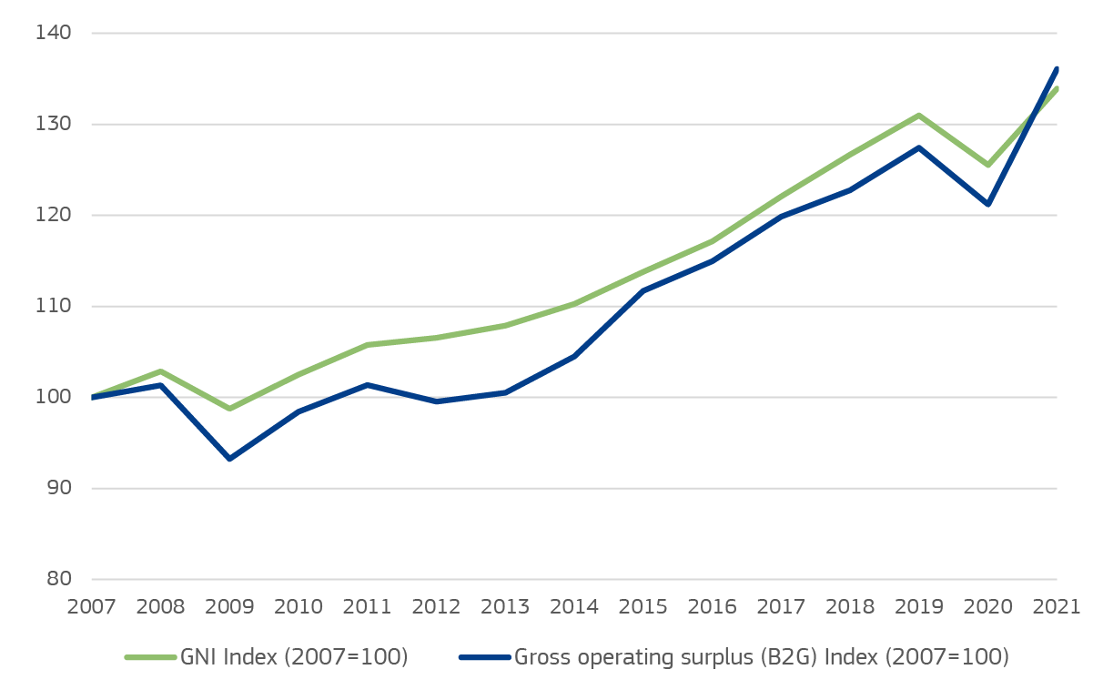

*Source:* DG BUDG calculations based on Eurostat annual NFSA data tables nasa_10_nf_tr and naidsa_10_nf_tr, data accessed on 29/03/2023 and 16/05/2023, respectively.

**Graph 13.** **Development of gross operating surplus for financial and non-financial corporations (sectors S12 and S11) and GNI, total economy (sector S1) growth, 2017-2021 annual average, by country**

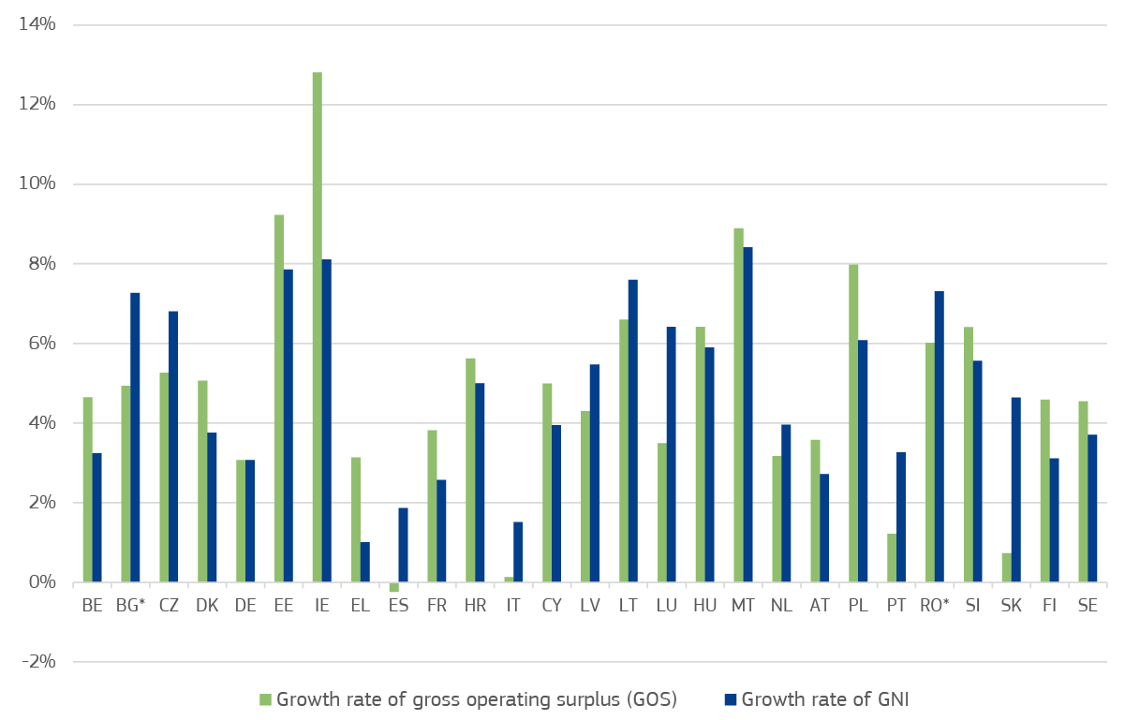

*Note:* * Missing data for BG 2018-2021 and RO 2021 estimated with annual average growth rate for EU27.

*Source:* DG BUDG calculations based on Eurostat annual NFSA data table nasa_10_nf_tr and ECFIN forecast file SF 2023, data accessed on 29/03/2023 and 02/05/2023, respectively.

**Similarly to other existing own resources built on statistics, this new own resource would be Treaty-based.** Existing own resources such as the GNI or the plastic own resource are also *statistically based*, meaning that the revenues they generate do not come from national levies or taxes such as customs duties or VAT, rather, they constitute contributions based on statistics reported by Eurostat. All statistics-based own resources are grounded in Article 311 TFEU and do not require an underlying sectoral legislation to be adopted. Once these contributions to the EU budget are established, Member States would be free to recoup them via domestic fiscal measures.

### 3.2.2. How would it work?

**This new statistics-based own resource would be calculated by applying a call rate on a base defined using sectoral national accounts data from Eurostat** (*expression* *(1)*). The statistical base would be defined using a harmonised indicator that roughly approximates company profits. This notional EU compan*y* income [or profit] base would be calculated according to the European System of Accounts 2010, which has the advantage of harmonised national accounting across Member States based on Regulation (EU) 549/2013.

|  |
| --- |
| Statistical own resource on company profits = a call rate (e.g. 0.5%) * statistical base on company profits (1) |

**The statistical base for the own resource on company profits would be defined as the gross operating surplus** **of financial and non-financial corporations** *(ESA sectors S12 and S11).* Gross operating surplus (*ESA balancing item B.2g*) equals the sector’s ‘Gross value added’ (ESA balancing item B.1g) plus ‘Other subsidies on production’ (ESA item D.39) minus ‘Compensation of employees’ (ESA item D.1) and Other taxes on production’ (ESA item D.29).

**The operating surplus constitutes a commonly used and relatively simple concept (see Box 5)**. Indeed, the operating surplus is a well-known ESA item and simple approach, which reflects the surplus (or deficit) on production activities before accounting for interest, rents or charges paid or received for the use of assets (property income). However, operating surplus is only a very rough approximation of aggregated potentially taxable company profits, as major tax-deductible items such as the cost of financing remain in the base.

**A measure in gross terms is preferable.** The decision to use a ‘gross’ versus ‘net’ concept owes to the depreciation of tangible and intangible assets. The difference between gross and net operating surplus is the consumption of fixed capital. Since the calculation methods of ‘consumption of fixed capital’ and the lifetime of assets may vary across Member States, a measure in gross terms avoids introducing methodological discrepancies in the approximation of the company profits base.

**A call rate of 0.5% would provide revenues of EUR about 16 billion** (2018 prices) **on average per year.** Revenue estimates depend on both the call rate and the statistical base (Graphs 14).

**Graphs 14. Company profit estimates based on the gross operating surplus (B.2g) variables, financial and non-financial corporations (sectors S12 and S11), in current prices**

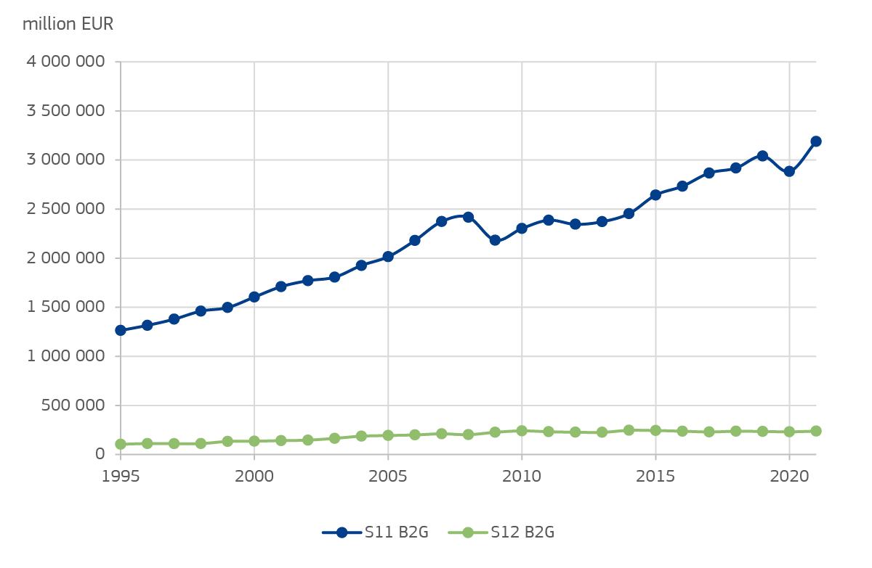

*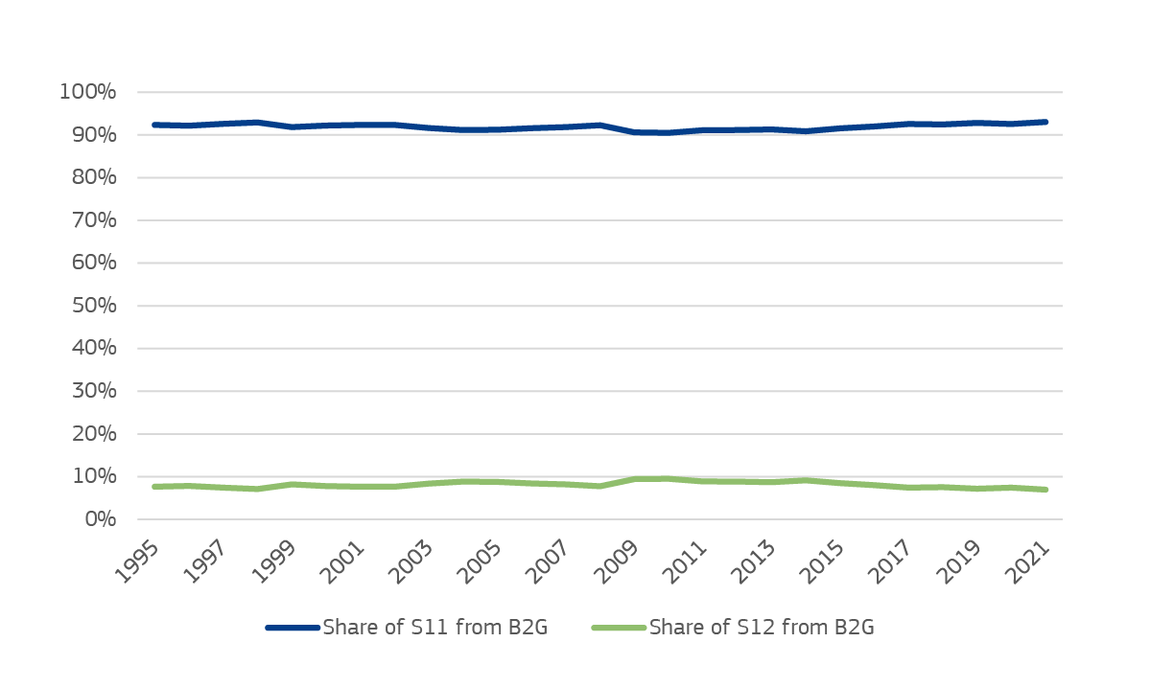Source: DG BUDG calculations based on Eurostat annual NFSA data table nasa_10_nf_tr, data accessed on 29/03/2023.*

|  |
| --- |
| **Box 5. Alternative statistical bases considered**  In the process of selecting data source to be used as the statistical base for the own resource on company profits, a number of alternatives to gross operating surplus were considered.   1. **Structural business statistics (SBS)**   SBS are compiled under the legal basis provided by European Parliament and Council Regulation (EC) No 295/2008 ([49]). SBS provides a statistical base with statics on the activities of the business economy and could allow to target large enterprises (>249 employed). SBS covers the *non-financial business economy*, including industry, construction, distributive trades, and market services. For data collection, Member States are free to choose, within quality limitations, how to produce SBS data. In some Member States either administrative records or surveys are used while others rely on both methods ([50]).  The definition of profit in SBS is *gross operating surplus* which includes value added minus personnel costs. As financial companies are not included, other Eurostat sources such as gross operating surplus (B2g) of sectoral national accounts seem more appropriate.   1. **OECD Country by Country Report (CbCR) statistics**   OECD CbCR statistics provide a range of aggregate data on the economic activities of large MNEs (revenue > EUR 750 m). This data includes the profit of MNEs.  However, several issues limit comparability of data across countries. Methodologies and requirements vary in different jurisdictions. In general, tax-exempt entities and MNE groups are included, but some jurisdictions exclude them. There is no consistent approach for treatment of dividends from constituent entities. The checks on figures submitted by MNE groups vary between jurisdictions. Differences in accounting rules between jurisdictions further affect the comparability of CbCR data across jurisdictions. Additionally, due to confidentiality, not all MS are able to provide anonymised and aggregated datasets. These challenges in comparability between jurisdiction would present a serious issue of fairness between Member States. Moreover, not all EU Member States are represented.   1. **Entrepreneurial income (ESA balancing item B.4g)**   The balancing item *entrepreneurial income* (B.4g) from Eurostat sectorial national accounts was also considered as a possible statistical base.  **Gross entrepreneurial income** (*ESA balancing item B.4g*) of non-financial (S11) and financial corporations (S12) (both including quasi-corporations)  **equals** *gross operating surplus (ESA balancing item B.2g)*  **plus** *property income received* (ESA item D.4)  **minus** *selected property income paid* / interest on debt / rents / income on insurance and pension investments, and non-financial assets (selected ESA D.4 items)  Although this concept sounds in principle to be closer to a concept of company profits at individual firm level, there are methodological issues when using statistical aggregates for sectors of companies. As the sector data is non-consolidated under ESA 2010, the amounts of profits distributed through dividends to the sector of non-financial or financial corporations within the same Member State are partially counted twice in the calculation of entrepreneurial income. This might lead to an artificial overstatement of the own resource base. |

1. () Proposal for a Council Decision on the system of own resources of the European Union (COM(2011) 510 final) suggests the introduction of a Financial Transaction Tax and a new Value Added Tax based Own Resource. As a result, a High-Level Group chaired by Mario Monti was mandated to identify possible new own resources.
2. () In December 2020, the Council established the European Union Recovery Instrument (*NextGenerationEU*) to help the EU tackle the crisis caused by the COVID-19 pandemic. It is put in place for a temporary period to be used exclusively for crisis response and recovery measures.
3. () Council Decision (EU, Euratom) 2020/2053 of 14 December 2020 on the system of own resources of the European Union and repealing Decision 2014/335/EU, Euratom.
4. () The reference year is 2016. It is applied throughout the Multiannual Financial Framework 2021-2027. The weighted average rate is determined by allocating all taxable transactions to the appropriate rate of value added tax using data from national accounts and other sources. Before the reform, the weighted average rate had to be calculated annually.
5. () Commission Staff Working Document: Financing the EU budget: report on the operation of the own resources system, SWD(2018) 172 final, accompanying the document “Proposal for a Council Decision on the system of Own Resources of the European Union”, COM(2018) 325 final. 2 May 2018.
6. () In the short run, this has a limited impact, although changes in the scope of application of reduced VAT rates could have a larger impact in the longer run.
7. () The July 2020 European Council agreed to introduce a correction mechanism mitigating the financial impact on the lower-income Member States. To sharpen incentives to reduce non-recycled waste, the correction takes the form of a lump sum, proportional to the quantity of non-recycled plastic packaging waste per capita in each country in 2017.
8. () European Parliament and Council Directive 94/62/EC of 20 December 1994 on packaging and packaging waste (Official Journal L 365, 31/12/1994, P. 0010 - 0023).
9. () ETIAS is a pre-travel authorisation system for visa exempt third country nationals and will enter into operation in November 2023. Its key function is to verify if such third country nationals meet entry requirements before travelling to the Schengen area. Revenues from fees applied under ETIAS are revenues to the EU budget (Title 6).
10. () The Regulation proposes stronger requirements for passenger cars and light duty vehicles and includes an excess emissions premium for manufacturers whose fleets of newly registered vehicles exceed a specific emission target. For the year 2019 and 2020, automotive manufacturers were required to pay excess emission premiums of around EUR 13.6 m and EUR 510 m respectively (included in Title 4).
11. () In 2019, the legislation setting CO2 emission standards for HDV was adopted. It includes an excess emissions premium for fleets of newly registered vehicle exceeding a specific emission target as of 2025. The revenues will be assigned to the EU budget as other revenues. A revision of the legislation is currently in preparation.
12. () European Court of Auditors, Opinion No 5/2018 on the Proposal for a Council Decision on the system of own resources of the European Union (COM(2018) 325 final) and related implementing acts; and Commission Staff Working Document, 'Financing the EU budget: report on the operation of the own resources system', Commission Staff Working Document No SWD(2018) 172 final of 2.05.2018, accompanying the Proposal for a Council Decision on the system of Own Resources of the European Union, No COM(2018) 325 final.
13. () See Part 1, section 1.2.
14. () Smith, S., 2015, [Taxation: A Very Short Introduction](https://global.oup.com/academic/product/taxation-a-very-short-introduction-9780199683697?cc=us&lang=en&), Oxford University Press. [Law Journal Library - HeinOnline.org](https://heinonline.org/HOL/Page?collection=journals&handle=hein.journals/cdntj63&id=1253&men_tab=srchresults).
15. () See for instance De Mooij, R. and M. Keen, 2014, [“Taxing Principles”](http://www.imf.org/external/pubs/ft/fandd/2014/12/pdf/basics.pdf), IMF Back to Basics, Finance and Development, Vol. 51, No.4.; Stiglitz, J. E., 2015, [Economics of the Public Sector](https://books.wwnorton.com/books/detail.aspx?ID=4294986932), W.W. Norton & Company, Fourth Edition, Chapter 17; Keen, M., and others, 2015, [“Current Challenges in Revenue Mobilization - Improving Tax Compliance”](https://www.imf.org/external/np/pp/eng/2015/020215a.pdf), IMF Policy Paper;  Grote, Martin, ["Establishing a Tax Policy Unit"](http://www.imf.org/en/publications/fiscal-affairs-department-how-to-notes/issues/2017/10/19/how-to-establish-a-tax-policy-unit-45322), IMF How-to-Notes, October 2017 or [The qualities of a good tax](https://www.economicshelp.org/blog/145773/economics/the-qualities-of-a-good-tax/).
16. () This refers to stable and reliable resources over time, an aspect relevant in the context of medium-term budgeting and fiscal planning, which finance ministries are encouraged to apply; indeed, Medium-Term Fiscal Frameworks (MTFFs) and Medium-Term Budget Framework (MTBF) have benefits for fiscal discipline, macro stability, control, and accountability (IMF Institute for Capacity Development).
17. () Tax wedge can happen between producer and consumer, seller and buyer, or employer and employee). To derive the behavioural responses and macroeconomic implications of tax policy changes on the labour market, investment, aggregate inflation, economic growth, partial and/or general equilibrium models are usually employed. The role of performing revenue and economic impact analyses usually belongs to Tax Policy Units (TPU). See Grote, Martin, ["Establishing a Tax Policy Unit"](http://www.imf.org/en/publications/fiscal-affairs-department-how-to-notes/issues/2017/10/19/how-to-establish-a-tax-policy-unit-45322), IMF How-to-Notes, October 2017.
18. () Stiglitz, J. E., 2000, ‘Economics of the Public Sector’, W. W. Norton & Company.
19. () EP(2023), Committee on Budgets, 2022/2172(INI) <https://www.europarl.europa.eu/doceo/document/BUDG-PR-739558_EN.pdf>.
20. () Bio-waste is defined as “biodegradable garden and park waste, food and kitchen waste from households, restaurants, caterers and retail premises, and comparable waste from food processing plants. It does not include forestry or agricultural residues, manure, sewage sludge, or other biodegradable waste such as natural textiles, paper or processed wood”.
21. () Council of the European Union Report 15178/22; Presidency report on new own resources, 25 November 2022.
22. () ECA [Opinion 03/2022: Methods and procedure for making available own resources based on the Emissions Trading System, the Carbon Border Adjustment Mechanism and reallocated profits, and measures to meet cash requirements | European Court of Auditors (europa.eu)](https://www.eca.europa.eu/en/publications/OP22_03).
23. () for instance, the Committee had doubts as to whether the Innovation Fund (IF) with revenues derived from the auctioning ETS allowances would maintain and strengthen the EU industry’s competitive position.
24. () COTER-VII/021, 152nd plenary session [The next generation of own resources for the EU budget | PES Group in the European Committee of the Regions (europa.eu)](https://www.pes.cor.europa.eu/legislativeworks/next-generation-own-resources-eu-budget).
25. BEFIT will foresee a two staged process to calculate the tax base. In the second step national adjustments will be possible.
26. () Gross operating surplus corresponds to ESA balancing item B.2g of financial and non-financial corporations (sectors S12 and S11, respectively). It equals the sectors’ gross value added (ESA balancing item B.1g) plus Other subsidies on production (ESA item D.39) minus compensation of employees (ESA item D.1) and other taxes on production (ESA item D.29). See part III for details on this measure and Box 5 for a discussion of alternative statistics.
27. () [Garment Worker Protection Act Frequently Asked Questions (ca.gov)](https://www.dir.ca.gov/DLSE/GarmentFAQs/).
28. () DAC 8 should enter into force on 1 January 2026. "https://taxation-customs.ec.europa.eu/news/new-transparency-rules-require-service-providers-report-crypto-asset-transactions-2022-12-08_en" (europa.eu).
29. () [New EU own resources: possibilities and limitations of steering effects and sectoral policy co-benefits (europa.eu)](https://www.europarl.europa.eu/RegData/etudes/STUD/2022/731895/IPOL_STU(2022)731895_EN.pdf).
30. () Crypto assets were addressed in recent guidelines of the VAT Committee (Guidelines resulting from meetings of the VAT Committee) and their VAT treatment might change as part of a review of rules on VAT for financial services.
31. () Eurostat, annual gender pay gap 2021.
32. ()  Eurostat <https://ec.europa.eu/eurostat/en/web/products-statistical-working-papers/-/ks-tc-22-002>. In the analysis employees working in ‘public administration, defence and compulsory social security’ (NACE rev.2 section O) or in enterprises with less than 10 employees have been excluded as data are not available for all Member States.
33. () Eurostat, (2022) Statistics explained: Food waste and food waste prevention – estimates.
34. () This design differs somewhat from that of other own resources based on environmental statistics, such as plastic or e-waste. Contrary to the latter, the base of a food waste own resource would use only the volume of waste generated and not the difference between the volume of waste generated and the volume of waste recycled. This is the case because, under food waste legislation, no comparable data is collected or can be derived for recycled food-waste.
35. () Directive 2008/98/EC of the European Parliament and of the Council of 19 November 2008 on waste and repealing certain Directives.
36. () Commission Delegated Decision (EU) 2019/1597 of 3 May 2019 supplementing Directive 2008/98/EC of the European Parliament and of the Council as regards a common methodology and minimum quality requirements for the uniform measurement of levels of food waste (Text with EEA relevance).
37. () The Commission so far has data only for 2020. For comparison, data on recycling of plastics have been collected since 1994 (i.e. there is almost 30 years of experience in data collection on plastics).
38. () The Commission is working on a food waste target currently planned for June 2023: <https://ec.europa.eu/info/law/better-regulation/have-your-say/initiatives/13223-Food-waste-reduction-targets_en>.
39. () Proposal for a Regulation of the European Parliament and of the Council establishing a framework for ensuring a secure and sustainable supply of critical raw materials (COM(2023) 160 final).
40. () Directive 2012/19/EU of the European Parliament and of the Council of 4 July 2012 on waste electrical and electronic equipment (WEEE) (recast) (OJ L 197, 24.7.2012, p. 38–71).
41. () Member States can report waste generation and/or electrical and electronic equipment placed on the market. The latter can be converted to waste generation according to [Commission Implementing Regulation (EU) 2017/699 establishing a common methodology for the calculation of the weight of electrical and electronic equipment (EEE) placed on the market of each Member State and a common methodology for the calculation of the quantity of waste electrical and electronic equipment (WEEE) generated by weight in each Member State](https://eur-lex.europa.eu/legal-content/EN/TXT/?uri=uriserv:OJ.L_.2017.103.01.0017.01.ENG) and using the tools provided in <https://environment.ec.europa.eu/topics/waste-and-recycling/waste-electrical-and-electronic-equipment-weee/implementation-weee-directive_en>.
42. () Illegal imports / exports of e-waste and other toxic materials are multiplying in the EU recently, increasingly affecting countries with reduced administrative capacity EUobserver (2021), ‘[After China ban, Romania hit by illegal waste imports’ (euobserver.com)](https://euobserver.com/news/151622).
43. () Communication from the Commission to the European Parliament, the Council, the European Economic and Social Committee and the Committee of the Regions, A secure and sustainable supply of critical raw materials in support of the twin transition, COM(2023) 165 final.
44. () Pursuant to Article 10c of the ETS Directive For further details see <https://climate.ec.europa.eu/eu-action/eu-emissions-trading-system-eu-ets/free-allocation/allocation-modernise-energy-sector_en> and <https://climate.ec.europa.eu/eu-action/funding-climate-action/modernisation-fund_en>.
45. () Under Article 10(2)(b) and/or Article 10c of the ETS Directive.
46. () For further details see <https://climate.ec.europa.eu/eu-action/effort-sharing-member-states-emission-targets/effort-sharing-2021-2030-targets-and-flexibilities_en>.
47. () <https://eur-lex.europa.eu/legal-content/EN/TXT/?uri=CELEX:52021SC0601>.
48. () See for example “The EU-ETS price through 2030 and beyond: A closer look at drivers, models and assumptions”, December 2022, published by Kopernikus-Projekt Ariadne.
49. () [Structural business statistics introduced - Statistics Explained (europa.eu)](https://ec.europa.eu/eurostat/statistics-explained/index.php?title=Structural_business_statistics_introduced#Summary).
50. () Section 5 Methodological manual on European Structural Business Statistics 2021 edition [Methodological manual on European Structural Business Statistics (europa.eu)](https://ec.europa.eu/eurostat/documents/3859598/13985433/KS-GQ-21-016-EN-N.pdf/e9410e2b-eba1-7a09-554b-dff3ac1df6bf?t=1639751446385).