

REPORT FROM THE COMMISSION TO THE EUROPEAN PARLIAMENT AND THE COUNCIL

on the functioning of Directive 2014/23/EU on the award of concession contracts and on the impact on the internal market of the exclusions set out in Article 12

1. introduction

The Commission estimates that the overall value of government procurement in the EU was around EUR 2 163 billion in 2018 or 13.6% of EU GDP[1], out of which around EUR 670 billion[2] was covered by the three public procurement Directives. When public authorities need to mobilise private capital and know-how to complement scarce public resources, concessions can be a very attractive way of carrying out projects of public interest while limiting public debt. Concessions are contractual arrangements where one or more public contracting authorities or contracting entities entrust the execution of works, or the provision and the management of services, to one or more private economic operators. Concession contracts, which amount to an average value of EUR 63 billion a year, underpin partnerships between the public sector and private companies in key strategic sectors. This is notably the case for the development of infrastructure, such as ports and airports, parking garages, toll roads, motorway maintenance, or the provision of services of general economic interest such as energy or waste disposal.

Directive 2014/23/EU[3] on the award of concession contracts (hereinafter the “Directive”) was adopted to address the absence of a coherent, all-encompassing EU-level framework for concessions. The aim of the Directive is to provide a clear legal framework that promotes the use of concessions while improving market access for businesses by ensuring transparency and fairness in award procedures.

The fourth paragraph of Article 53 of the Directive mandates the Commission to “review the functioning of this Directive and […] to report to the European Parliament and to the Council”, while the third paragraph of that Article requires the Commission to “assess the economic effects on the internal market of the exclusion [of the water sector]” from the scope of the Directive. This Report presents the main findings of that review and assessment. It draws on information from the Commission Staff Working Document on the application of the Directive (“Commission Staff Working Document”), which is to be read in conjunction with this Report.

The Report and Staff Working Document are based on a body of evidence coming from multiple sources, such as data extracted from the Tenders Electronic Daily database (TED); information made available by Member States in accordance with Article 45 of the Directive[4]; the Study on the implementation of the Concessions Directive carried out for the Commission by London Economics Europe and Spark Legal (2021)[5]; a survey launched by the Commission services in 2021 to collect information from Member States on the organisation of the water sector and positions expressed by stakeholders during an online stakeholder event organised by the Commission on the review of the functioning of the Directive and the assessment of water exclusion.

The late transposition of the Directive by all Member States - the Directive has been applied in the whole of the EU only since 2020 - prevents a full assessment of the functioning of the Directive and the water sector exclusion at this point in time. More experience with the Directive is necessary to make a fully-fledged assessment of its functioning as well as of the impact of excluding the water sector from the scope of the Directive. Nevertheless, the tendencies observed on the basis of available data point to increased transparency in concessions contracts, increased SME’s participation to concessions and improved administrative capacity to oversee public procurement and concessions at national level.

2. the eu concessions market

The total value of concessions covered by the Directive and awarded between 2016 and 2021 is estimated at EUR 377.5 billion. Total value of concessions represents 12 % of the yearly overall public procurement market covered by the three public procurement Directives combined[6]. The Directive applies to concessions with a value equal or greater than EUR 5 382 000[7].

The total number of concessions awarded in the EU has roughly doubled since the 18 April 2016 - the transposition deadline - and continues to increase[8]. This upwards trend can be observed in most Member States.

Figure 1: Concession award notices by year [number, value in billion EUR], EEA countries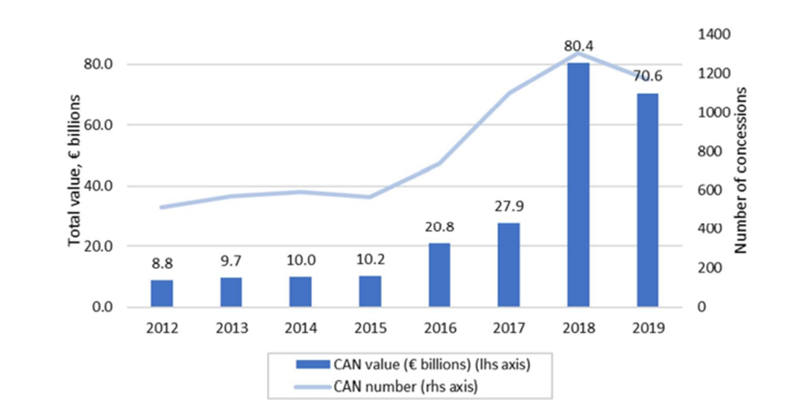

Source: Study on the implementation of the Concessions Directive - London Economics Europe and Spark Legal (2021), figure 41.

France and Italy account for more than two thirds of the EU concessions market. Together with Spain and Germany, these Member States make up for 85 % of the total increase of concession awards in the same period. Member States such as Austria, Czech Republic, Finland, Hungary, Croatia, Malta and Sweden have also registered large increases in the use of concessions.

Figure 2: Yearly average number of concessions by Member States, pre- and post-Directive [number]

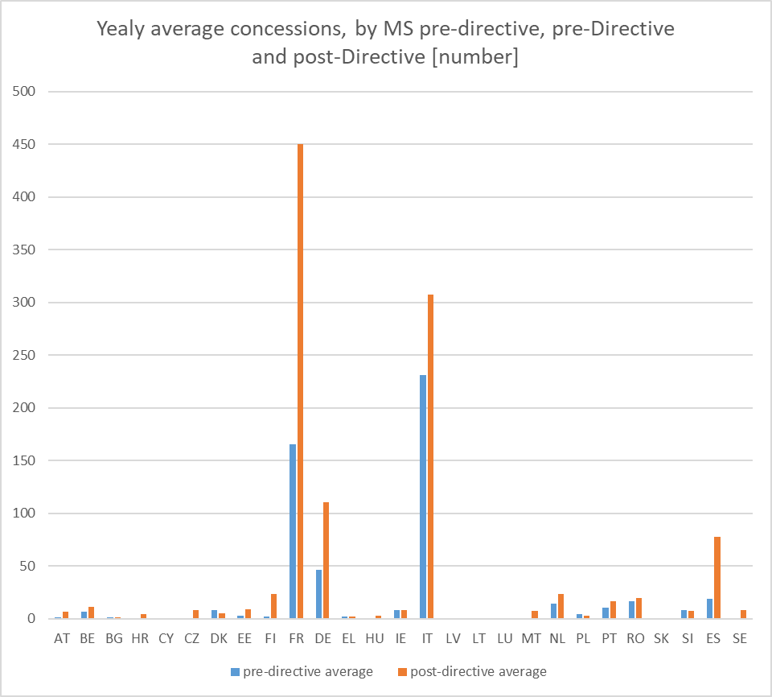

Source: In-house calculation based on Study on the implementation of the Concessions Directive - London Economics Europe and Spark Legal (2021), figure 17.

The number of service concession awards has sharply increased since 18 April 2016 - the transposition deadline. The number of works concession awards however, has been gradually decreasing before and continued on the same trend after this date.

The sectors with the largest number of concession awards since 2016 are: (1) hotel, restaurant and retail trade services; (2) recreational, cultural and sporting services; and (3) construction work.

3. transposition and infringement proceedings

The Commission’s objective is to achieve early compliance so that the benefits of EU law are felt by the people and businesses as soon as possible. This is why the Commission has increased its support to Member States over the years to prevent breaches from happening in the first place and otherwise to resolve them in the early stages of the procedure, without having to refer a Member State to the Court of Justice. This has led to a decrease in the number of cases where the Member States were late in transposing directives. To strengthen this approach, the Commission has recently proposed to set concrete targets on enforcement with the aim of limiting both the transposition as well as conformity deficit to 0.5%[9].

As regards the Directive, Member States had to transpose it into national law by 18 April 2016. At the expiry of the transposition period, only six Member States had communicated the necessary measures to the Commission and infringement cases for non-communication were launched in 2016. By February 2020[10], all EU Member States had transposed the Directive and all infringements relating to late transposition have been closed. However, three Member States did not transpose the Article which provides for specific exclusions from the application of the Directive in the field of water, and three Member States did so only partially. These Member States therefore apply (in full or partially) the Directive also to concessions for work and services in specific fields of the water sector.

An assessment of the national transposition measures identified that only ten Member States were in full conformity with all the obligations of the Directive on the date of the expiry of the transposition deadline. The Commission therefore initiated infringement proceedings against the remaining Member States in four successive waves (January 2019, October 2019, June 2021 and December 2021). Following notification of national measures and their assessment, the proceedings against eight Member States have been formally closed as a result of the corrective legislative action taken by them. The remaining proceedings are ongoing[11] and concern elements such as scope, the criteria for exclusion of economic operators, and modification of contracts.

In several Member States, national authorities have issued guidance on the rules on concessions.

4. main findings of the review of the functioning of the Directive

## The Directive pursues two principal objectives: (1) providing certainty on the legal framework by defining certain concepts and codifying certain principles relating to the award of concessions, in line with the case law of the European Court of Justice, and (2) improving access to the concessions markets by increasing transparency and fairness in award procedures.

4.1. Legal certainty

**The definition of “concession”**

The Directive provides a definition of concessions at EU level[12]. In practice, it seems that the term “concession” is often used in Member States’ legislation for sectors and issues that go beyond the scope of the Directive. Most notably, in the majority of Member States, national legislation often use the term “concession” to refer to other legal concepts, such as authorisations or licences[13].

Those discrepancies may lead to higher costs as economic operators participating in cross-border concessions cannot rely on one single meaning of “concession”. It may also lead to time-consuming misunderstandings on the side of both contracting authorities/entities and economic operators, not only about the interpretation of the applicable definition, but also about which legislation applies.

**The definition of “operating risk”**

The presence of an operating risk[14] is what differentiates concession contracts from other types of public contracts. Therefore, the transposition of this notion is key to ensure the correct implementation of the Directive. Yet, only four Member States have transposed the concept exactly as set out in the Directive. Over twenty Member States transposed the concept through a slightly different wording than the one provided in the Directive, and two Member States did not address the operating risk at all in their national legislation. At this stage it is not possible to say whether those discrepancies have practical economic impact. Different interpretations of operating risk could mean that public procurement for the same type of work or service provisions will be treated differently across Member States, or could not even be subject to the provisions transposing the Directive.

**Modifications of concession contracts**

The Directive also includes specific provisions on concession contract modification developed through case law and provides practical solutions for dealing with unforeseen circumstances requiring a concession to be modified during its term. Contract modifications need to be handled carefully, in particular modifications without a new opening of competition, to ensure effective competition and transparency.

A few Member States have developed guidance on contract modifications. Eleven Member States have introduced an explicit requirement in national legislation that any modifications must be approved by a government authority other than the procuring authority responsible for the initial contract. However, modification of contracts during their term, including wrongful extension of contracts and amendments without a new call for competition are often reported as a source of wrong application.

**Concessions and other public private partnerships**

The Directive clarifies the cases in which a contract concluded between a contracting authority and an economic operator is not subject to the concession award rules. This is guided by the principles set out in the case law of the European Court of Justice as there is no EU law defining and regulating the concept of public private partnership.

Member States have taken different approaches to legislating about public private partnerships. Some national legal frameworks include rules that specify how public private partnerships relate to the rules on concessions, while in other Member States there are diverging definitions of the term public private partners at national level and/or less clarity as to how legislation on this topic refers to the definition of, and rules on, concessions.

4.2. Application and enforcement - sources of incorrect application of the rules for the award of concession contracts

All Member States report significant and successful efforts to put in place monitoring authorities and structures to ensure correct and efficient application of the rules for award of concessions. Most Member States have appointed a single Public Procurement Monitoring Authority. The reporting by Member States does not distinguish between concessions and other types of procurements. The information on the causes of incorrect application, structural or recurring problems is therefore presented across the board for all types of procurement.

The most frequent cause of incorrect application or of legal uncertainty, as reported by Member States, is the lack of procurement skills, modification of contracts during their term, calculation of the estimated value of the procurement and artificial splitting into lots.

As regards the practical application of the rules, Member States report difficulties linked to the interpretation and verification of exclusion grounds, formulation of meaningful award criteria other than price only, including criteria linked to strategic objectives, use of negotiated procedure without publication, classification of contracts as public contracts or concession, and transparency.

Member States had put in place general anti-corruption legislation and institutions even before the adoption of the Directive. In most Member States, the national competition authorities, prosecutors and other enforcement agencies are primarily responsible for carrying out such policies. In addition to that, some Member States have specific institutions dedicated to combatting fraud or corruption.

In order to mitigate the risks of conflict of interest, corruption, collusion and cartels, most of Member States have adopted soft law measures such as national anti-corruption strategies, guidance (e.g. to detect collusive behaviour, awareness-raising and training, leniency programmes for operators that come forward with information and prevention activities), codes of conduct for civil servants and professionalisation. Furthermore, most Member States have adopted measures going beyond the requirements of the Directive, by introducing for instance broader definitions of conflict of interest, penalties or even annulment of contracts in line with the OECD guidelines[15].

***Box 1: Guidance on addressing collusion in public procurement and concessions***

*The Commission has recently published new guidance[16] for European contracting authorities and entities on how to address suspected cases of collusion in public procurement and concessions.*

*The guidance lists the tools aiming, on one hand, to support Member States and contracting authorities in building capacity to address cases of collusion and, on the other hand, to foster cooperation between national central procurement and competition authorities to ensure support to contracting authorities. The guidance also includes user-friendly tips for contracting authorities on how to apply the collusion-related exclusion ground provided for in the public procurement Directives.*

4.3. Findings related to better access to the concession market

The following factors have been considered when assessing whether the Directive improved access to the concession market: (i) transparency through publication; (ii) SME participation in concession awards; (iii) number of tender offers; and (iv) cross-border participation in the EU concessions market.

**Transparency through publication**

Data extracted from TED suggests that, since 18 April 2016, there has been an important increase in the number of published concession notices: from 664 in 2016 to 1 877 in 2021. Similarly, the yearly average of published concession award notices have increased from 143 in 2016 to 993 in 2021.

It appears, however, that the number of concession notices is still around twice as high as the number of concession award notices[17]. This discrepancy between the number of concession notices and concession award notices, appears in all Member States and seems to be driven by several factors, such as: concessions may be advertised through notices but they might not eventually be awarded, and multiple contracts notices may eventually become a single concession award[18].

Quality of data reported in TED is expected to increase with the implementation of Regulation (EU) 2019/1780[19] on new standard forms for notices (eForms) which will become mandatory as of 25 October 2023[20].

While the increased publication of concession notices and concession award notices suggests that transparency has improved since 18 April 2016, it is also notable that there has been an increase in concession awards without a prior publication of a contract notice[21] in TED. Since 2018, the total yearly value of concessions awarded without publication of a concession notice have been higher than concessions awarded following the publication of a concession notice. For instance, in 2021 the total value of concessions awarded without publication of a contract notice was EUR 44 billion, while the total value of concessions awarded with publication of a concession notice was EUR 37 billion. Concession awards without prior publication occur mainly in the electricity distribution sector which is characterised by few suppliers and where technical reasons or the existence of exclusive rights may explain the absence of competition.

**SMEs participation in concession awards**

Prior to 18 April 2016, information about contractors’ size was not recorded in TED and it is therefore not possible to compare the incidence of awards to SMEs before and after this date. However, since 2016 there has been a significant increase in the number of concessions awarded to SMEs: from 22.4 % in 2016 to 31.6 % in 2021. There are indications that Member States that provide national guidance on concessions attract more SMEs[22].

In terms of value, however, SMEs do not account for a similarly important share of contracts awarded. According to TED, SMEs were mainly awarded contracts of low value (the SME share has varied from 11.2 % in 2017 to 3.9 % in 2021). Although large concessionaires won only two in three concession contract in the relevant period, such contracts accounted for nearly 92 % of the concessions market in terms of value. The number and value of concessions awarded to SMEs is relatively low compared to their overall importance in the economy.

The SME Strategy and Action Plan on Intellectual Property Rights[23] pointed out that innovation procurement offers untapped opportunities for startups and the development of innovative solutions. Public investment and innovation are two essential ways to meet the challenges of the recovery, the green and digital transition and the creation of a more resilient economy in the EU. The Commission considers green public procurement as an important instrument to stimulate the demand for net-zero products at large scale as reflected in the Green Deal Industrial Plan[24].

Additionally, in 2021, the Commission adopted a Guidance notice on innovation procurement[25] intended to boost innovation procurement and help economic operators to develop innovative solutions in key industrial ecosystems, in particular where public buyers are critical investors.

**Number of tender offers**

Analysis of data collected from TED since 18 April 2016 shows that the yearly average of number of tender offers per concession award notice has decreased between 2016 and 2019. In 2020 and 2021, the average number of offers increased, but the 2021 figure (2.44 tender offers per award) remains below 2016 values.

**Cross-border[26] participation in the EU concessions market**

For low-value concessions falling under the Directive, the share of economic operators bidding from their home market to win a concession in another Member State (direct cross-border) is 2.4 %. The share of economic operators bidding and winning through local subsidiaries (indirect cross-border) is 15.5%. Cross-border awards for high-value concession stands at 3.4% for direct cross-border and 8.5% for indirect cross border[27].

Regarding intra-EU (cross-border) awards, firms headquartered in France but with subsidiaries in other Member States are among the most frequent winners of intra-EU (cross-border) concession contract, followed by firms from Luxembourg, Germany and Sweden[28].

A survey made as part of a recent study[29] indicated that the companies perceive the following barriers in respect to the process of cross-border and foreign participation and contract implementation: burdensome administrative requirements and legal framework, difficult access to procurement information, and language**.**

***Box 2: Foreign participation to the EU concessions market***

*When comparing the number of intra-EU (cross-border) with non-EU (foreign)[30] awards, concessionaires coming from non-EU countries prevail. Regarding non-EU awards, firms headquartered in the United Kingdom and the United States but with subsidiaries within the EU are the most frequent foreign winners of concession contracts.*

*The Commission has adopted measures to prevent distortion of the internal market due to foreign subsidies, including in the public procurement and concessions market. In this respect, the Regulation on foreign subsidies[31] adopted on 14 December 2022 aims to tackle adequately tenders benefiting from foreign subsidies in public procurement contracts and concessions which cause distortions in the internal market. The Commission has the power, upon notification prior to the award of a contract, to examine information on foreign financial contributions to the participating economic operator in the context of a public procurement and concession tender procedure. Prior notifications are mandatory above a threshold of EUR 250 Million, to capture economically significant cases. The Regulation will apply from 12 July 2023.*

*The International Procurement Instrument Regulation (IPI)[32] aims to open up the procurement and concession markets of third countries that restrict access of EU economic operators, goods or services by enabling the Commission to investigate cases and simultaneously hold consultations with the third country concerned on removing the alleged restrictions. However, if the consultations with that third country fail, the Commission can adopt IPI measures to restrict access of operators, goods and services of that third country to the EU procurement and concessions markets.*

5. findings on the impact of the Directive on the water sector

The Directive excludes concessions for the provision or operation of networks intended to provide production, distribution or transport of water as a service to the public. All concessions regarding the supply of water to these networks are excluded, as are those regarding the disposal or treatment of sewage. However, some Member States have decided to include all those activities in their national transposition measures.

**Overview of the water sector in the EU**

In 2021, the EU water industry supplied drinking water to approximately 450 million EU residents. According to Eurostat, almost 15 500 companies are active in the collection, treatment and supply of water and around 11 000 in sewage. While companies active in the water sector operate mainly at the domestic level, there is some cross-border participation mainly indirectly, through foreign-owned local subsidiaries.

From an economic perspective, water is a highly capital-intensive sector, with market failures which may require State intervention. They include, on the one hand, the essential nature of water and on the other hand, the scale of the sunk investments in networks notably in remote or scarcely populated areas which involve long timeframe to be recouped and substantial risks. The recognition of societal significance and prevention of market failures in the water sector has led to the special treatment in the Concessions Directive.

Member States apply various management models for the provision of water services. The ways water services are organised depend on a combination of historical, cultural, economic and societal factors.

Different forms of private sector involvement in the water sector in Europe can be traced back to the 19th century. The number of contracts involving private partners started to increase significantly after 1980. Factors which may have favored the involvement of the private sector would include possible improved service quality and efficiency, improved management efficiency (i.e. easier access to capital markets). Public involvement remained nevertheless important to cater for wider societal needs.

**The water sector since 18 April 2016**

Three Member States fully apply the provisions of the Directive for concessions in the water sector (Czech Republic, Poland, Romania), while three others (Bulgaria, France, Spain) apply it partially.

Based on GWI WaterData[33] historical data on the water sector, Member States that have decided to apply the Directive in the field of water already had significant experience with similar private participation in the past. Conversely, some Member States which decided to keep the water sector outside their national transposition measures had some record of private sector participation, notably Italy, Germany and Portugal.

Since April 2016, there is more transparency regarding concession contracts in the water sector. According to TED, there have been around 225 concessions award notices in the period 2016 to 2021, increasing in number from 3 concession award notices in 2016 to 66 concession award notices in 2021. The vast majority of concessions (194) were concluded by French contracting authorities, followed by authorities in the Czech Republic (18), Spain, Poland and Romania.

The total value of concessions award notices as recorded in TED in the water sector amounted to almost EUR 7 billion between 2016 and 2021. Compared to the total value of concessions awarded over the same period (EUR 377.5 billion), the value of concessions in the water sector represents less than 2 %. Also, when compared to another important utility sector, the electricity sector, the value of concessions in the water sector represents only 3.6 %. The yearly total value of the concession award notices in the water sector increased in the early years of the Directive, increasing more than tenfold between 2016 and 2018. It decreased slightly in the two following years, but the increase in 2021 compensated that decline.

The average number of offers received per tender for concessions in the water sector and the SME participation were slightly lower than the average in other sectors. This can be explained by the fact that the water sector is highly specialised and highly capital-intensive compared to other sectors. Additionally, the concessionaire needs to have the financial capacity to bear upfront the total cost of investment as well as the operating risks.

As regards cross-border participation, there seems to be a relatively high incidence of cross-border participation in tenders through local, but foreign-owned subsidiaries.

Most stakeholders are of the opinion that the current systems in place in the Member States work well and support the exclusion of the water sector from the scope of the Directive. Invoking examples of re-municipalisation of water services, they argue that involvement of the private sector is not considered necessary. On the other hand, representatives of the business sector highlighted their positive experiences brought about by the Directive. The overall conclusion was that the choice of management system is contextual depending on local societal factors (operating efficiency, long-term investment, affordability, water conservation, security of supply, public health, etc.).

Due to limited data it is not possible to draw any firm conclusions yet regarding the impact of the Directive on the water sector.

6. Outlook

The Commission is working to improve the functioning of the Directive, in particular through new initiatives on transparency and quality of data.

Transparency of concessions’ tenders and results it is key to meet the objectives of the Directive. It relies on quality data on concessions awarded by Member States, easily accessible to all actors in the internal market. The Commission is planning a number of actions and initiatives to improve transparency and the overall quality of data regarding the Directive and its implementation.

On 16 March 2023 the Commission announced the creation of the **Public Procurement Data Space (PPDS)**[34]. PPDS will connect European databases, including TED data on public procurement and concessions, and national procurement data sets available in national portals and will be at the core of the digital transformation of public procurement and concessions in the EU. PPDS will allow for data-driven policy making. Additionally, public buyers will benefit from PPDS through better planning of calls for tenders, benchmarking and knowledge-sharing, increased digitalisation, easier detection of fraud and collusion. PPSD will also improve access to calls for tender, in particular for SMEs. Transparency is also central to the EU Publications Office’s **Preparatory Action “Transparency in Public Procurement**”[35]. The Publications office identified four areas of activity that revolve around TED data: availability, quality, readability and interoperability. A number of projects are foreseen to contribute to implement the Preparatory Action.

Additionally, on the 17th of April 2023 the Commission launched the Public Buyers Community[36]. The **Public Buyers Platform** is an initiative to enhance collaboration in public procurement. Public buyers can benefit from the exchange of knowledge and best practices across the EU instead of working individually on complex issues. The community aims to empower public buyers and those working in public procurement (buyers, suppliers, academia and other stakeholders) to join together and connect with the European Commission to foster the exchange of cutting-edge market intelligence and know-how on public procurement and encourage joint action and systematic collaboration in public procurement. One of the aims of this collaboration is to improve SME’s access to public procurement and concession market.

7. conclusions

The Directive has only been applied in all Member States for three years and therefore there is little information, preventing a fully-fledged comparison with the period prior to the existence of the Directive.

At this stage, it seems too soon to conclude whether the Directive has achieved its objectives to increase legal certainty and ensure better access to the EU concessions market. Nevertheless a number of preliminary conclusions can be drawn, as summarized below.

All Member States have transposed the Directive and have put in place **monitoring authorities and structures to ensure correct and efficient implementation of the rules** for the award of concession contracts. Nevertheless, unclear interpretation and incorrect application of the rules are still detected by the vast majority of Member States.

The Directive **has also brought more transparency into the award process**. **The number of concessions published has gradually increased** since 2016. Although the highest value concessions are mainly awarded without the publication of a contract notice, hence without a call for competition, this situation can be explained by the fact that those concessions correspond mainly to the electricity distribution which, in certain Member States, is characterised by the existence of special or exclusive rights or legal monopoly. Consequently, those awards do not raise concerns from the perspective of compliance with the Concessions Directive.

Regarding the level of competition for concessions, it has been observed that the **Directive did not have a consistent impact on the level of participation in competitions for concession contracts*.***

Furthermore, despite being open to bidders from other Member States, **the EU concessions market has so far not attracted much cross-border participation**. This situation is not specific to the concession market but rather common to public procurement in general and varies greatly between Member States**.**

**The level of SME participation appears to have increased over the past 5 years**, although **the share of SMEs in the concession market is relatively low** as compared to their share in the overall economy.

Considering the importance of SMEs to the EU economy, the limited evidence available suggests that **greater focus on SMEs in the context of concessions awards should be a priority** for Member States and contracting authorities/entities.

Regarding the water sector, the limited data from a handful of Member States also does not allow for drawing firm conclusions on the impact of the Directive on the broader water sector.

The Commission has recently launched several initiatives, such as the Public Procurement Data Space, the Preparatory Action on Transparency in Public Procurement and the Public Buyers Platform to further promote transparency and quality of data in public procurement and concession markets.

With time, experience gained with the Directive will allow to make more detailed assessments. The next report to be prepared by the Commission should shed more light on the real impact of the Directive on the concession market.

1. Public Procurement Indicators 2018, DG GROW, May 17, 2021 (<https://ec.europa.eu/docsroom/documents/48156>).
2. See note 1, page 1.
3. Directive 2014/23/EU of the European Parliament and of the Council of 26 February 2014 on the award of concession contracts, OJ L 94, 28.3.2014, p. 1–64.
4. Fourth paragraph of Article 53 of the Directive indicates that the review of the functioning of the Directive shall be based on information that Member States provide in accordance with Article 45(3).
5. The Study is going to be published together with this Report.
6. 2018 data referring to Directive 2014/23/EU, Directive 2014/24/EU of the European Parliament and of the Council of 26 February 2014 on public procurement and repealing Directive 2004/18/EC, OJ L 94, 28.3.2014, p. 65–242and Directive 2014/25/EU of the European Parliament and of the Council of 26 February 2014 on procurement by entities operating in the water, energy, transport and postal services sectors and repealing Directive 2004/17/EC, OJ L 94, 28.3.2014, p. 243–374.
7. Concessions with values lower than this threshold are often published in TED.
8. Comparison between total numbers of concessions awarded in the period 2012 - 18 April 2016 and the period 19 April 2016 - 2019. For more details see Chapter 3 of the Commission Staff Working Document.
9. Communication from the Commission to the European Parliament, the Council, the European Economic and Social Committee and the Committee of the Regions - The Single Market at 30 (COM(2023) 162 final of 16 March 2023).
10. The last Member State transposed the Directive on 26.02.2020.
11. Some of the infringement procedures concern all three public procurement Directives, and will therefore be formally closed only when all issues (pertaining to the three Directives referred to in footnote 3) have been solved. In this respect, it may appear that some Member States have ongoing infringements even if, strictly speaking, issues related to the implementation of the Directive may have been solved in the meantime.
12. The Directive defines concessions as written contracts between one or more contracting authorities or contracting entities and one or more economic operators (concessionaire), where the latter is entrusted with the execution of works or the provision and management of services and is remunerated by being given the right to exploit the respective works or service, or by being given this right together with payment.
13. This is to be distinguished from “authorisations” or “licences” which involve a public authority establishing conditions for a contractor to carry out a certain operation. Whereas an authorisation or licence provides a contractor with the right to exploit that authorisation or licence, a concessionaire is under an obligation. Directive 2006/123/EC of the European Parliament and of the Council of 12 December 2006 on services in the internal market (OJ L 376, 27.12.2006, p. 36) applies to authorisations and licences.
14. The Directive defines the notion of “operating risk.” Concession contracts always involve the transfer to the concessionaire of an operating risk of economic nature. This means that the concessionaire may not recoup investments made and the costs incurred in operating the works or services awarded under normal operating conditions, even if a part of the risk remains with the contracting authority or contracting entity.
15. OECD *Recommendation on Fighting Bid Rigging in Public Procurement* available at: <https://www.oecd.org/daf/competition/oecdrecommendationonfightingbidrigginginpublicprocurement.htm>.
16. *Notice on tools to fight collusion in public procurement and on guidance on how to apply the related exclusion ground*, C (2021) 1631 of 15.03.2021.
17. Concession notices are published in the Official Journal at the beginning of the tender procedure in order to ensure adequate advertising of the tender while concession award notices are published at the end and contains information on the outcome of the tender procedure. For more details please refer to Chapter 5.2 Providing Better Access to the concessions market of the Staff Working Document accompanying the Report.
18. The difference may also be methodological as non-awarded and cancelled concessions have been removed from the database registering award notices but not from the database registering concession notices.
19. Commission Implementing Regulation (EU) 2022/2303 of 24 November 2022 amending Implementing Regulation (EU) 2019/1780 of 23 September 2019 establishing standard forms for the publication of notices in the field of public procurement OJ L 305, 25.11.2022, p. 12.
20. The Regulation (EU) 2022/2303 applies from 14 November 2022. Between that date and 24 October 2023, the use of eForms by buyers is only optional. Most Member States will switch at the end of the transition period.
21. According to Article 31(4) of the Directive, a public buyer is not obliged under certain circumstances and for certain sectors to publish a concession notice.
22. Study on the implementation of the Concessions Directive - London Economics Europe and Spark Legal (2021), p. 108.
23. Communication from the Commission. *Making the most of the EU’s innovative potential – An intellectual property action plan to support the EU’s recovery and resilience*. COM (2020)760 final, 25.11.2020.
24. Communication from the Commission to the European Parliament, the European Council, the Council, the Economic and Social Committee and the Committee of the Regions, *A Green Deal Industrial Plan for the Net-Zero Age*, COM(2023) 62 final of 1.2.2023.
25. Commission *Notice Guidance on Innovation Procurement*, C (2021) 4320, of 18.6.2021.
26. Contracts awarded intra-EU by a contracting authority or contracting entity in one Member State to an economic operator from another Member State.
27. Study on the measurement of cross-border penetration in the EU public procurement market, Final report, Prometeia SpA, BIP Business Integration Partners– Spa, Economics for Policy a knowledge Center of Nova School of Business and Economics Lisboa, March 2021, p. 66 and 78.
28. For more details please refer to Chapter 5.3 Cross-border and foreign participation in the EU concessions market of the Staff Working Document accompanying the Report.
29. See footnote 25, p. 10.
30. Contracts awarded by a contracting authority or contracting entity in one Member State to an economic operator from a third country.
31. Regulation (EU)2022/2560 of the European Parliament and of the Council of 14 December 2022 on foreign subsidies distorting the internal market, OJ L.330 of 23.12.2022, p.1.
32. Regulation (EU) 2022/1031 of the European Parliament and of the Council of 23 June 2022 on the access of third-country economic operators, goods and services to the Union’s public procurement and concession markets and procedures supporting negotiations on access of Union economic operators, goods and services to the public procurement and concession markets of third countries (International Procurement Instrument – IPI) OJ L 173, 30.6.2022, p. 1.
33. The GWI Global Ultimate Owners database contains details of municipal water and wastewater treatment projects where all or part of the capital investment cost was borne by the private sector.
34. Communication from the Commission “Public Procurement: A data space to improve public spending, boost data-driven policy-making and improve access to tenders for SMEs” (2023/C98I/01), OJ C 98I , 16.3.2023, p. 1.
35. https://simap.ted.europa.eu/web/simap/preparatory-action-on-transparency-in-public-procurement.
36. [Homepage | Public Buyers Community (europa.eu)](https://public-buyers-community.ec.europa.eu/)