- Introduction
This year marks the 30th anniversaries of the single market and European Union citizenship, both of which bring into focus the right to free movement as a major achievement of European integration. Over 55% of citizens believe that this right is good for European integration, for labour markets and for individuals in general, while 84% of citizens think that it is beneficial to the economy of their country. Intra-EU mobility allows people to “experience Europe”, gaining access to wider opportunities in education, work and life as well as the possibility to acquire new skills. It also helps increase productivity and address labour and skills shortages.
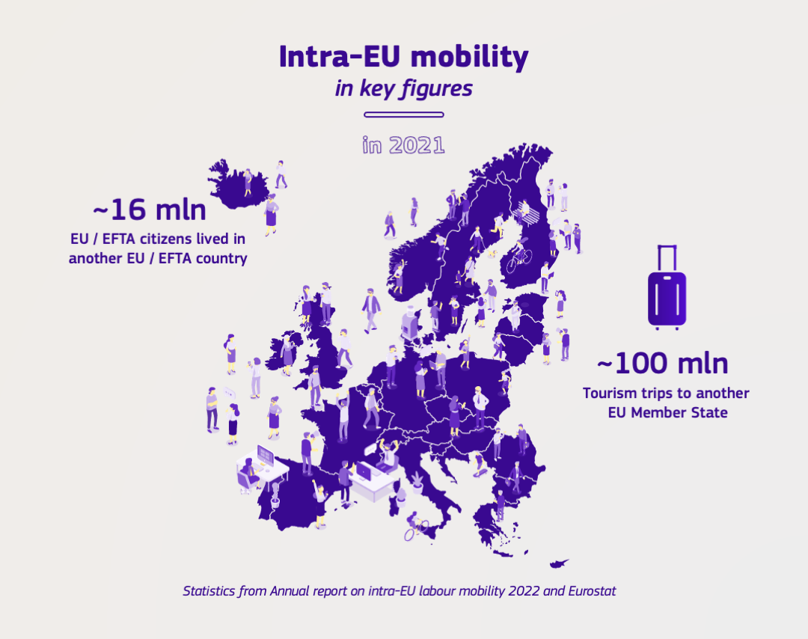
Social security coordination rules, stemming from the earliest days of European integration, protect people’s social security rights when moving within Europe. They guarantee that people continue to receive their benefits (such as old-age, unemployment or family benefits) and are covered by healthcare, even if they travel or move to another EU country. The modernisation of these rules is currently under negotiation by the European Parliament and the EU Council.
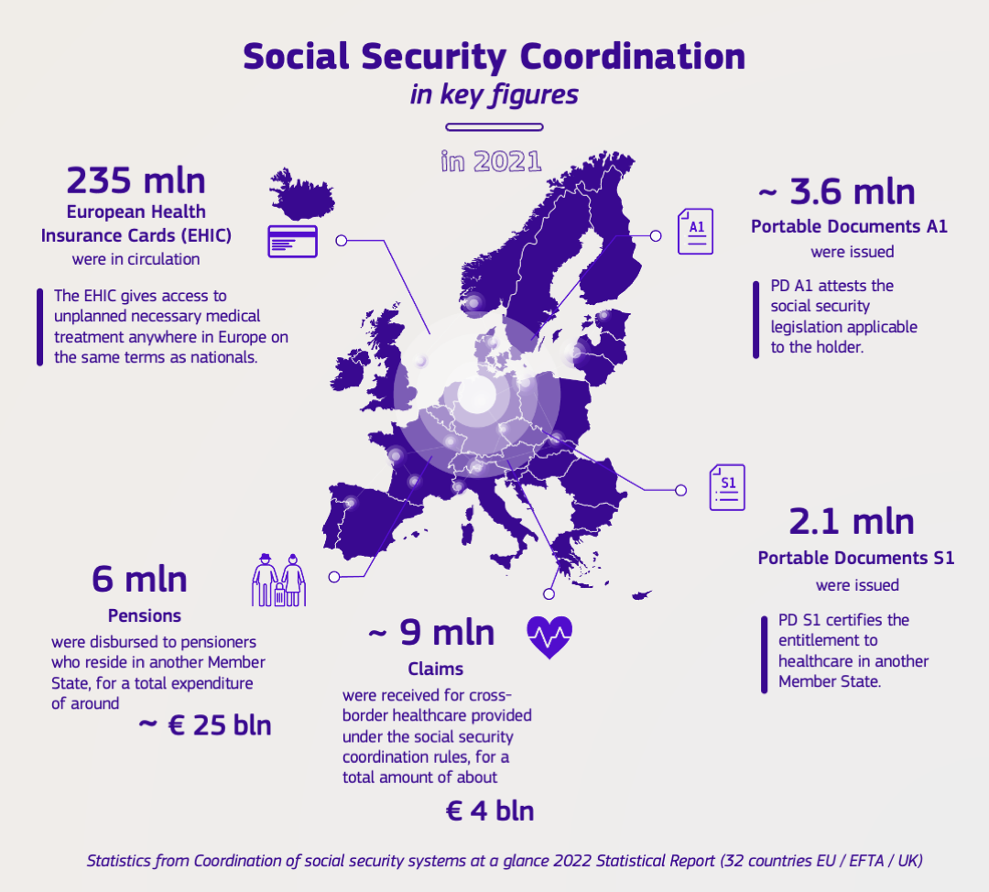
At the same time, there is still a strong potential to improve the coordination of social security systems and to support fair labour mobility through further digitalisation of this area, as part of the efforts to accelerate the digital transition in Europe, reduce administrative burden and improve the competitiveness of the European economy.
Citizens and businesses in a cross-border situation often face challenges in their interactions with social security institutions, labour inspectorates and healthcare providers. Procedures to prove and verify social security entitlements can be time consuming and administratively burdensome, as they often rely on physical presence and physical documents – ‘portable documents’, including the European Health Insurance Card (EHIC). Companies may be confronted with administrative costs and hurdles, in particular when sending their employees to work temporarily abroad. These obstacles might have a deterring effect on citizens willing to exercise their right to free movement and on companies prepared to do business abroad and reap the benefits of the single market. They were raised as important points for citizens in the Conference on the Future of Europe and in the Citizen’s Panel on Learning Mobility.
Despite the initiatives put in place in recent years to improve the information exchange, social security institutions, healthcare providers and labour inspectorates also face difficulties accessing and sharing data, due to insufficient interoperability between national systems. Costs are also incurred, for instance, in relation to issuing and verifying entitlements’ documents, the need to periodically replace them, and the risk of fraud and error linked to portable documents and incorrect use of the EHIC.
The European Parliament, Member States, social security institutions and social partners have also called for EU and national action to further simplify procedures for people and businesses, reduce administrative obstacles and move towards more interoperable, interconnected and automated social security systems. This was one of the main takeaways of a high-level Conference on “Digitalisation in social security coordination (ESSPASS) and labour cards”, held on 1 March 2023, together with the request for greater clarity on the various EU initiatives and how they complement each other.
To respond to these calls and address the challenges faced by citizens and businesses, this Communication presents an overview of the existing initiatives, as part of the overall digital landscape, and proposes further measures to be taken in the short and medium term.
Further digitalisation of this area can:
- reduce administrative hurdles and costs for mobile citizens and businesses operating abroad, including small and medium-sized enterprises (SMEs), through improved digital experiences when interacting with public bodies for social security purposes.
- increase the quality of public services and the efficiency of social security coordination processes.
- improve the exchange of information and cooperation between institutions, via better interoperability, automation and data sharing.
- reduce the risk of errors and social security fraud, including that related to falsification of documents, thus reinforcing the protection of people and fair labour mobility.
This Communication contributes to the EU’s efforts to accelerate Europe’s digital transition and promote a human-centric approach to digitalisation. A key objective of the Digital Decade Policy Programme is to ensure that our digital environment is inclusive and that public services, health and care services are accessible in a trusted and secure online environment for everyone. The Programme sets concrete targets for the digitalisation of public services, notably 100 % of key public services being accessible online by 2030. The Digital Decade Policy Programme also includes targets on digital skills, such as 80 % of those aged 16-74 having at least basic digital skills. Improving digital skills is one of the main objectives of the European Year of Skills.
The European Declaration of digital rights and principles reaffirms the central role of people in the digital transition, highlighting the importance of data protection and security as well as inclusiveness and accessibility. People should also be free to choose whether they wish to use digital tools or not.
- Seizing the opportunities of digitalisation to support free movement and fair labour mobility
2.1 Cross-sectoral EU initiatives relevant for social security coordination
The digitalisation of public services is crucial to building modern, efficient administrations that respond to the needs of citizens and businesses - by providing them with accessible and seamless digital experiences - and contribute to the success of the European single market.
Important efforts have been undertaken at EU level to advance on this path. Several cross-sectoral EU initiatives supporting the development of cross-border digital public services provide solid foundations for further digitalisation in the area of social security coordination.
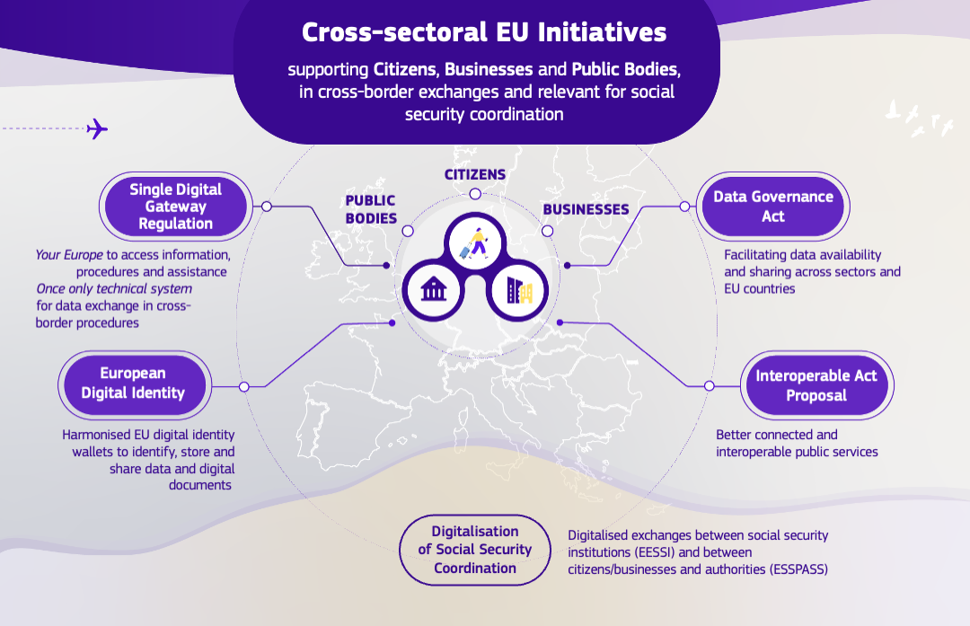

The Single Digital Gateway Regulation requires Member States to ensure that citizens and businesses can access and complete 21 administrative procedures fully online by 12 December 2023, with access to national procedures through the Your Europe website, and receive the output electronically. Three of these procedures relate to the social security coordination area: the request to determine which social security legislation covers the holder (the output of which is the portable document A1), applications for the European Health Insurance Card, and requests for pensions calculations.
The Once Only Technical system is being developed to allow national authorities to automatically exchange documents and information needed for these 21 procedures, as required by the Single Digital Gateway Regulation. The aim is to reuse information already held in electronic format by other administrations in Europe, so that no additional burden falls on citizens and businesses.
The European Digital Identity framework will allow people and businesses to identify themselves and store in their European Digital Identity Wallet a wide variety of documents in electronic format, such as driving licences, electronic prescriptions (ePrescription) and other medical documents, educational and professional qualifications and social security attestations.
The proposed Interoperable Europe Act will set up a cooperation framework for public administrations across the EU, to agree on common interoperability solutions and help increase their reuse when designing cross-border public services. Both people and businesses will benefit from more efficient public services, thanks to enhanced interoperability, better interconnected digital public administrations and improved data sharing across all sectors and EU countries.
2.2 Digital initiatives in the area of social security coordination
Beyond the cross-sectoral EU initiatives, specific initiatives have been launched to digitalise social security coordination and respond to the challenges in this area.
Significant progress has been made in recent years in the electronic exchange of social security information between institutions. The Commission and Member States also started working on further improving the interactions between people/businesses and social security institutions, labour inspectorates and healthcare providers, streamlining procedures and reducing the administrative burden for all parties involved.
2.2.1 More efficient handling of cross-border social security cases between institutions: the EESSI system

As required by the EU rules on social security coordination, the Electronic Exchange of Social Security Information (EESSI) system is built to ensure rapid and secure exchanges of information between social security institutions across Europe, replacing paper-based communication.
The EESSI project started in 2008 and since its launch in 2019, EESSI enables a faster, more efficient and more accurate handling of cases in the social security areas and branches covered by EU coordination rules (such as determination of the applicable legislation, sickness, accidents at work, pensions, unemployment, and family benefits).
The aim is to facilitate the protection of social security rights across borders by allowing quicker handling of cases, calculation and payment of benefits (e.g. pension rights for people who have worked in several countries; family and unemployment benefits).
The system standardises the information exchange and improves the efficiency of social security processes and administrative cooperation between countries and their social security institutions, without affecting any of the specific features of basic social security national systems.
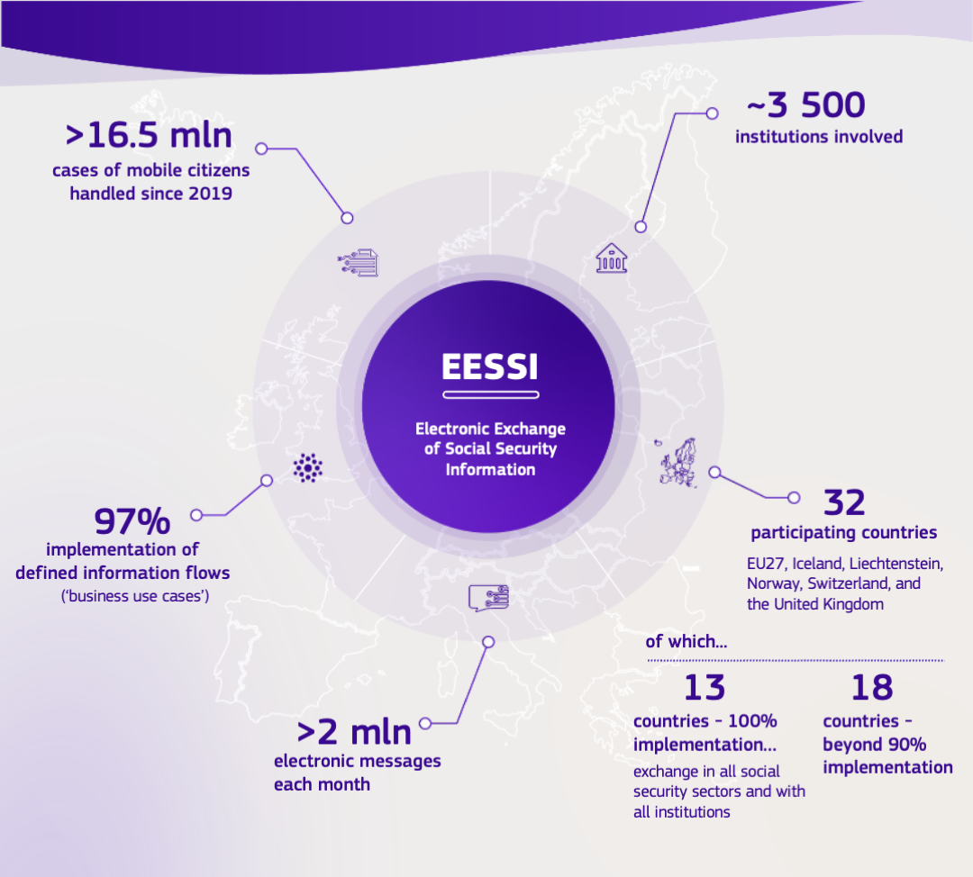
Experience with EESSI has highlighted the complexity of digitalising cross-border processes involving thousands of social security institutions and all branches of social security. Despite the commitment, time and investment by Member States to design, develop and roll out a large-scale digital solution for social security coordination across the EU, progress at EU level is slow.
While EESSI is now operational in all 32 participating countries and already streamlining the handling of cases, to the benefit of people moving around the EU, some countries still need to take steps to finalise their national implementation of the system. This concerns in particular the reimbursement of healthcare costs between countries. Until these final steps are taken, alternative ways of communication need to be used outside the system for the processes in question. It obliges the 13 countries that have already implemented EESSI fully to maintain parallel, paper-based processes for transactions with the countries that are not yet ready.
The completion of the full roll-out of EESSI is a priority. The Commission continues helping Member States’ implementation. It works with them to improve the system and its processes.
The European Labour Authority (ELA) will also help support the use of EESSI. ELA plans to launch a mutual learning and understanding programme aimed at more effective use of the EESSI system.
The Commission calls on Member States to:
- accelerate their implementation of EESSI to ensure that the system is fully implemented by the end of 2024 at the latest.
The Commission calls on the ELA to:
- launch a mutual learning and understanding programme for EESSI in 2024.
The Commission will:
- work with Member States to accelerate their implementation efforts and provide quarterly monitoring and reporting of these efforts on the Europa website .
The Commission will, in cooperation with Member States:
- continue improving the operation and maintenance of EESSI to further facilitate its use by social security institutions.

2.2.2 Facilitating mobile citizens’ interactions with national authorities across Europe: the ESSPASS initiative
While improving the electronic exchange of social security information between institutions is of paramount importance, it is only the first step. Digitalisation should benefit everyone, in particular citizens and businesses, to further facilitate the exercise of their rights in the single market by streamlining procedures and reducing administrative burden.
To that end, the European Pillar of Social Rights Action Plan announced the launch of the European Social Security Pass (ESSPASS) pilot project, to explore a digital solution for verifying people’s social security entitlement documents in other EU countries (i.e. portable documents, including the EHIC). This should make it easier for people to exercise their social security rights when travelling, moving, and working in another Member State, while reducing the risk of fraud and error. It should also simplify procedures for companies, for instance, when sending their employees to work temporarily abroad (i.e. posting of workers).
While EESSI allows exchanges only between social security institutions, ESSPASS would help people travelling or moving to another EU country or companies doing business abroad to interact digitally with social security institutions and other public bodies, such as labour inspectorates and healthcare providers, whenever needed.
ESSPASS will build on relevant EU digital initiatives. The Your Europe website will provide a possible single-entry point for citizens and companies to request the social security coordination documents to be digitised under the Single Digital Gateway Regulation. The European Digital Identity framework and the standardised EU digital wallets, once implemented, would also be used to identify mobile citizens, store and share the digital portable documents, including the EHIC.
ESSPASS would complement this by making it possible for social security institutions, labour inspectorates and healthcare providers to check in real-time whether the documents are valid, or changes have occurred.
Examples of journeys
Thanks to EU rules, if you are temporarily abroad and you need necessary healthcare, you will be treated under the same conditions and costs as locals. The doctor will ask you to show your European Health Insurance Card (EHIC). National administrations will then take care of the reimbursement. However, it may happen that you forget or lose your card. Some problems may also occur given that the hospital cannot verify the validity of the EHIC (e.g. in case of doubts, further exchanges may be needed between relevant institutions of the Member States).
- Before going on holiday in Spain, Živa should request the digital EHIC from her health insurance institution in Slovenia. To do that, she visits the Your Europe website (i.e. the Single Digital Gateway), which redirects her to the website of her institution.
- The institution issues the digital EHIC.
- Živa easily stores the EHIC in her digital wallet (i.e. future EU digital identity wallet). She does not have to carry a plastic card anymore.
- While on holiday, if Živa needs a medical treatment, she will present the EHIC in the hospital to prove that she is covered in Slovenia.
- Through ESSPASS, the hospital can verify in real-time that the EHIC is valid (i.e. it was issued by a competent institution and has not expired yet). This allows to increase confidence in the use of the EHIC and reduce the risk of refusal by the healthcare provider.

According to EU rules, if you have a company and want to send an employee to work temporarily abroad (i.e. posted worker), you need to request an attestation of the social security legislation applicable to the employee/posted worker (i.e. the portable document A1). In the receiving country, the posted worker may be asked by an inspector to show this attestation. In some cases, the inspector may have doubts on the validity of the document and further exchanges may be needed between authorities.
- Yiannis has a company and wants to send his employee, Georgios, to work temporarily in Italy. Yiannis requests the digital portable document A1 from the competent Greek institution. He visits the Your Europe website, which redirects him to the national website of the institution.
- The national social security institution verifies the request and, if the conditions are met, issues the digital document which is made available to Yiannis and Georgios.
- Georgios easily stores the document in his digital wallet (i.e. future EU digital identity wallet).
- The Greek social security institution informs in parallel the Italian one about the posting via EESSI.
- An Italian labour inspector, Nicola, requests Georgios to present the portable document A1.
- Using ESSPASS, Nicola performs a real-time verification of the document. This allows to verify the validity of the document, increasing trust.

A potential ESSPASS solution needs to be fully compliant with the EU data protection legislation, in particular the General Data Protection Regulation, and security rules. Any processing of personal data requires a legal basis, this includes situations when data already collected and processed is to be transmitted/made accessible to other public and private parties. Furthermore, only data that are strictly necessary for verifying the entitlements should be processed and made accessible to the relevant national authorities and trusted stakeholders (e.g. the healthcare provider, in the case of the EHIC). The solution also needs to comply with accessibility requirements and be inclusive of all people – especially those with disabilities, older persons, and those lacking digital skills.
The ESSPASS Pilot Project started in 2021 with a first phase of piloting activities, launched with the Italian social security institution “Istituto Nazionale della Previdenza Sociale”, which focused on the digitalisation of procedures for portable document A1. Other 13 Member States followed this first phase, mostly as observers. Its results showed how ESSPASS could help simplify the lives of mobile citizens and businesses providing services abroad, including small and medium-sized enterprises, by streamlining procedures and reducing administrative burdens.
Following up on the first phase, two consortia of Member State institutions are pursuing ESSPASS activities and further piloting the issuing and verification of portable document A1 and the European Health Insurance Card, under the Digital Europe Programme.
The Commission will keep supporting these consortia in their activities and help ensure that these activities are consistent with other EU digital initiatives.
Throughout the pilot, which will be finalised by 2025, and in view of a potential large-scale deployment of the digital solution across Europe, continued concrete political and financial commitment by Member States is essential.
The Commission calls on all Member States:
- to join the two consortia of Member State institutions piloting the digital issuing and verification of portable document A1 and the EHIC.
The Commission will:
- besides the co-financing, assist the consortia and provide technical expertise until they have completed their activities in 2025.
- following up to the ongoing pilot activities by the consortia, decide on the next steps, including the opportunity to deploy an ESSPASS solution in all EU countries and whether this would require a legislative framework.

2.3. Other initiatives facilitating free movement, labour mobility and enforcement of labour law
Several other systems and tools supporting labour mobility, social protection, cross-border healthcare and enforcement of labour law are currently being developed. They complement EESSI and ESSPASS and aim at further facilitating citizens’ and workers’ mobility, simplifying administrative procedures for people, businesses and national authorities and upholding workers’ rights.

Pensions   | A European Tracking service is being developed, with the support of the Commission, to provide mobile workers at any point in their career with information on their pension rights in the Member States where they have worked. This builds on the existing national tracking systems. The goal is to enable people to make informed decisions about their career and savings needs, to secure more adequate pensions.
Posting of workers   | The Commission and Member States are working on a common electronic form for the Declaration of posting of workers (e-Declaration). The aim of the e-Declaration is to reduce the administrative burden on businesses and facilitate information sharing with competent authorities in Member States, while also helping fight fraud and abuse.
Cross-border healthcare   | Under the upcoming European Health Data Space, the Commission and Member States aim to reach full use of the digital infrastructure MyHealth@EU across Europe, for exchanging ePrescriptions, patient summaries, laboratory results, hospital discharge reports and medical images. This could help simplify administrative procedures linked to the reimbursement of cross-border healthcare costs. In 2023, MyHealth@EU is already operational in eleven Member States with ePrescription and patient summary services.
Labour law and working conditions   | EU social partners in the construction sector will carry out a project in 2023-25, with the financial support of the Commission, to explore the potential for interoperability between labour and social identity cards of different countries. The aim is to facilitate the enforcement of labour law and working conditions, improve transparency and ensure fair labour mobility.

- Digital developments in Member States, leading to efficient cross-border social security processes
EU and national efforts must come hand in hand to achieve success in digitalisation of social security coordination.
All Member States are exploring ways to streamline processes and enable more efficient delivery of services, even if progress remains uneven across Europe and across the different national social security sectors.
Many countries have started to digitalise the management and delivery of social protection through simplified digital one-stop portals, automated processes (including for accessing some benefits), pension simulators and pre-filled application forms. These developments at national level not only improve the accessibility and efficiency of national social protection and security systems, but they are prerequisites for more efficient digitalised cross-border social security processes. They also help improve the functioning of the EESSI system and the processing of people’s cases.
Member States must ensure that their national social security websites, mobile applications and online interfaces with the public comply with the EU accessibility requirements for people with disabilities.

Examples of national digital initiatives
These efforts include the use of digital solutions to speed up the issuing of portable document A1 and to verify the relevant facts, in order to determine which social security legislation is applicable, as done by the French institution URSAFF and the Belgian National Social Security Office. For instance, in Belgium 80% of applications are processed without human intervention and portable documents A1 are issued within 24 hours. These developments also improve the accuracy of decisions and the correctness of the information contained in the documents.
Some Member States’ institutions introduced fully automated processes for granting benefits. For example, the Polish Social Insurance Institution (ZUS) and its automatic software for granting family benefits, and the Belgian Crossroads Bank for Social Security.
The Italian Istituto Nazionale della Previdenza Sociale (INPS) is using data mining and artificial intelligence to detect and prevent cases of fraud or error in the granting of social security benefits.
Member States have shown increased interest in the bilateral and multilateral exchange of information and the interconnection of social security relevant databases (e.g. the solution introduced by Finland and Estonia to automate data exchange between their national population registers).

Besides the full implementation of the Electronic Exchange of Social Security Information (EESSI) system, which is a priority, Member States should continue investing in the digitalisation of their social security systems, also with a view to ensuring seamless digital experiences for mobile citizens and businesses. To support this process, various EU funding instruments are available, such as the Digital Europe Programme (DIGITAL), InvestEU, the European Regional Development Fund, the Technical Support Instrument (TSI) and the European Social Fund Plus. Measures aimed at digitalising public services and modernising public administration processes figure in all national Recovery and Resilience Plans, which need to allocate at least 20% of the plan’s total resources to digital objectives.
The exchange of best practice on national tools and solutions should be facilitated. Considering its mandate, the European Labour Authority (ELA) could support this, by helping build a community of practice and promoting the regular sharing of experiences between national administrations.
In support of the efforts undertaken by Member States, the Commission calls on the ELA to:
- collect good practices in 2024 and to facilitate, through dedicated workshops, a regular exchange between national authorities on digital tools in social security, including cross-border services.
- building upon the results of this exercise, analyse national digital solutions covering all social security branches, the digital maturity of national systems and available resources at national level. This will inform action to better target investment and support those lagging behind.
The Commission calls on Member States to:
- finalise the full implementation of the EESSI system and the digitalisation of the three social security coordination procedures included in Annex II of the Single Digital Gateway Regulation.
- ensure that by 2025, people can also request and obtain online the other portable documents in the fields of sickness, accidents at work and occupational diseases and unemployment benefits, beyond those for which procedures are to be digitalised under the Single Digital Gateway Regulation.
- sustain the investment in automating processes for handling national and cross-border cases in social security and social protection, while working towards further interoperability between national social security systems.
- step up efforts to meet, by 2030, the Digital Decade’s objectives of 100% of key public services being available online, including in social security, and 100% of people having access to electronic identification (eID) means, to be used for key public services across the EU, including for social security.
The Commission also urges the European Parliament and the Council to:
- swiftly reach an agreement on the revision of the EU social security coordination rules. The Commission will continue to support co-legislators to achieve this objective.

- Moving towards a more digitally integrated social security coordination system
In recent years, the Commission and Member States have built the foundations of a modern and digitalised system of social security coordination, as regards both exchanges between authorities across borders and the delivery of services to citizens and businesses.
It is crucial to pursue these efforts and accelerate progress towards more citizen and business friendly, interconnected and interoperable social security systems. This depends significantly on political steer, commitment and investments and requires a vision for the longer-term.
The aim is to enable a seamless and secure flow of information across borders, to make the access to social security services quicker and simpler for citizens and businesses and to provide them with burden-free experiences when interacting with those services across the EU.
To achieve this and implement a citizen and business-centric approach, a more integrated data exchange between social security systems would be needed, with further interoperability – in line with the proposal for the Interoperable Europe Act –, automation, standardisation of social security data and direct access to the original source of data.
Such integrated approach would streamline administrative processes, reducing paperwork and manual tasks, and allowing a more efficient allocation of resources. Interoperability would enable national authorities to integrate data from multiple sources and ensure that accurate and up to date information is shared across systems. Such interoperable exchanges are also necessary with systems covering mobile workers who are outside the scope of EU social security coordination rules, such as staff of international organisations and of EU institutions and other bodies. Automated systems could help authorities to detect patterns of fraudulent activity involving multiple locations in various countries. This would lead to cost savings and ensure that benefits reach those who genuinely need them and that people are effectively protected.
People would be able to access services and receive benefits more easily, saving time and effort. Businesses providing services abroad would benefit from lighter processes and increased data accuracy.
To support a seamless experience for cross-border labour mobility – both physical and ‘virtual’ mobility – for people, businesses and national authorities, it is important to act beyond the social security domain and foster cross-sectoral interoperability. This would require examining the various processes governing not only social security coordination but also posting of workers, cross-border healthcare and the interaction between social security coordination and labour law, taxation and company law. The aim is to bring greater clarity, simplify administrative procedures, and explore synergies between digital solutions developed in the different sectors.
Any way forward would need to carefully assess the needs, added value and expected impact – including financial – of introducing additional interoperability, technical requirements and common standards for exchanging data. It should take into account the principles of subsidiarity and proportionality, as well as legal and organisational issues.
Privacy and data protection challenges would also need to be addressed, especially when enabling further data sharing. Similarly, when using algorithms or artificial intelligence, thorough safeguards would be needed, including to protect individuals from the risks of bias and discrimination.
Regular high-level exchanges will take place with Member States to discuss the main actions to be taken and to monitor and evaluate progress.
The Commission will:
- launch a study in 2024 on further developments in the longer term in digitalisation of social security coordination which will, among other things:
- analyse the needs, costs and benefits of establishing further interoperability in the national context and across borders and sectors – building on input received from the ELA, Member States, social security institutions, social partners and other relevant stakeholders.
- examine the opportunity for further simplification and streamlining in the procedures governing free movement of people and workers in the EU, with a view to achieving a seamless digital experience.
- organise, once a year, high-level meetings with Member States to discuss and support implementing further digitalisation, standardisation and automation in social security coordination, facilitating freedom of movement and labour mobility, including increased interoperability with other relevant sectors.
The Commission calls on Member States and all stakeholders to:
- actively contribute to achieving the objective of a more digitally integrated social security coordination system by continuing to invest in digitalisation efforts at national level, duly taking into account the developments at EU level and in other Member States.

- Conclusions
Digitalisation facilitates citizens’ exercise of their social security rights across borders, reducing barriers to free movement and labour mobility, thus making it easier for people to move around the EU to travel, live, work, study in other Member States. It also helps prevent fraud and lighten the administrative burden for businesses providing services abroad by simplifying procedures. This ultimately stimulates sustainable growth and improves competitiveness.
Significant progress has been made in recent years, but to achieve the objective of a seamless, burden-free experience for mobile citizens and businesses, it is essential to scale up action at EU and national levels, towards more automated, interoperable and integrated national social security systems.
The Commission is fully committed to guiding and supporting Member States and national administrations in their efforts to accelerate the digital transformation across Europe.
Member States’ continued engagement and further political and financial commitment remain prerequisites for building a more digital Europe, including in social security coordination to support free movement and fair labour mobility.

All images © Images © stock.adobe.com

Commission Communication: Single Market at 30.
Eurobarometer surveys: “Intra-EU labour mobility after the pandemic”, available through the link: Intra-EU labour mobility after the pandemic - December 2022 - Eurobarometer survey (europa.eu), and “European Union Citizens and Democracy – July 2020.
European Parliamentary Research Service (2020) – Coronavirus and the cost of non-Europe and OECD Economic Survey: Euro Area 2021, OECD Publishing, Paris.
Regulation (EC) No 883/2004 on the coordination of social security systems and Regulation (EC) No 987/2009 laying down the procedure for implementing Regulation (EC) No 883/2004. These Regulations also apply to Norway, Iceland, Liechtenstein and Switzerland. Specific rules are in place in the agreements with the United Kingdom.
COM (2016) 815 final.
See standard forms for social security rights - Your Europe (europa.eu).
The administrative burden caused by the rules on posting workers abroad is one of the main single market obstacles, according to the 2020 Commission inventory of barriers.
Conference on the Future of Europe – final report and Recommendation 20 from the Panel on learning mobility.
For cases of fraud and errors linked to portable documents and inappropriate use of the EHIC: Fraud and errors in the field of EU social security coordination and Cross-border healthcare in the EU under social security coordination – reference year 2021.
See the Resolutions of the European Parliament: P9_TA(2020)0371; P9_TA(2020)0284;P9_TA(2021)0007; P9_TA(2021)0249; P9_TA(2020)0176; P9_TA(2021)0473 ; P9_TA(2023)0203.
Decision (EU) 2022/2481 of the European Parliament and of the Council of 14 December 2022 establishing the Digital Decade Policy Programme 2030. According to a recent Eurobarometer, 74% of EU citizens think that digital technologies will be important in their life by 2030 notably for accessing services online, also in other EU countries.
European Year of Skills.
European Declaration of digital rights and principles.
Regulation (EU) 2018/1724 establishing a single digital gateway to provide access to information, to procedures and to assistance and problem-solving services and amending Regulation (EU) No 1024/2012.
These procedures cover situations relevant for working, studying, retiring, moving to another country or doing business (both in a national and cross-border context), with procedures such as registering a car or claiming a pension being fully digitalised and eliminating the need for paperwork.
https://europa.eu/youreurope/index_en.htm.
Proposed Regulation amending Regulation (EU) No 910/2014 as regards establishing a framework for a European Digital Identity. On 29 June 2023, the European Parliament and the Council reached a provisional political agreement on the proposal.
Proposal for a Regulation laying down measures for a high level of public sector interoperability across the Union.
See Articles 78 and 79 of Regulation (EC) No 883/2004 and Articles 4 and 95 of Regulation (EC) No 987/2009.
Since the start of the project in 2008, in addition to national resources, more than 120 million euros were made available from the EU budget to support the development of EESSI.
13 countries are able to exchange electronically in all social security sectors and with all institutions: BG, DK, EE, FR, CY, LV, HU, MT, PT, SE and IS, NO and UK.
The complete implementation of EESSI could effectively support cross-border labour mobility and thus help make labour markets more resilient to the economic cycle: OECD Economic Survey: Euro Area 2021 OECD Publishing, Paris.
Recital 19 and Article 7 (3) of the Regulation (EU) 2019/1149 establishing a European Labour Authority.
Electronic Exchange of Social Security Information (EESSI) - Employment, Social Affairs & Inclusion - European Commission (europa.eu).
The European Pillar of Social Rights Action Plan.
Regulation (EU) 2016/679 on the protection of natural persons with regard to the processing of personal data and on the free movement of such data, and repealing Directive 95/46/EC (General Data Protection Regulation).
See in particular Directive (EU) 2016/2102 on the accessibility of the websites and mobile applications of public sector bodies and Directive (EU) 2019/882 on the accessibility requirements for products and services, notably Annex I.
The results were presented at the Conference on digitalisation in social security coordination and labour cards. Respondents to the Conference questionnaire believed that ESSPASS would significantly help reduce barriers to free movement and labour mobility (56%) and simplify procedures for: citizens and workers (63%), institutions, labour inspectorates and healthcare providers (66%) and businesses (52%). It would also help reduce errors and social security fraud (61%).
Member State institutions in the consortium under the European Digital Identity framework (AT, BE, CZ, DK, DE, IE, IT, NL, PL, PT, ES, SE) are working on the use of EU digital identity wallets for the portable document A1 and the EHIC (among other use cases). Member State institutions in the consortium under the European Blockchain Services Infrastructure (AT, BE, DE, IT) are further exploring the use of this infrastructure and blockchain to exchange digital documents.
Directive 2014/67/EU on the enforcement of Directive 96/71/EC concerning the posting of workers in the framework of provision of services.
Proposal for a Regulation on the European Health Data Space.
Under the Directive 2011/24/EU on the application of patients' rights in cross-border healthcare.
Some of the Member States replying to the questionnaire for a working party on digitalisation on social security coordination (on 8 March 2023) highlighted the risks and challenges associated with the different degrees of digitalisation and automation in the social security domain across Member States.
See above footnote 34.
DIGITAL has a budget of 7.5. billion euros in current prices for 2021-2027, which includes 1.1 billion to ensure the wise use of digital technologies across the economy and society.
See for instance: https://reform-support.ec.europa.eu/what-we-do/labour-market-social-protection-and-migration/strengthening-administrative-capacity-italian-national-institute-social-security_en.
Several countries are using these instruments to support the initiatives on digitalising social security coordination (e.g. the European Social Fund Plus for EESSI and the RRF and DIGITAL for the ESSPASS pilot project).
Cross-border interoperability helps deliver better connected services and will lead to cost-savings for citizens and businesses dealing with public administrations. Cost savings are estimated to be between €5.5 and €6.3 million for citizens and €5.7 and €19.2 billion for businesses dealing with public administrations - Staff Working Document (2022) 721.
The need for further interoperability, standardisation of data and automation was shared by many stakeholders at the conference on digitalisation in social security coordination and labour cards and in the working party on digitalisation.
80% of respondents to the questionnaire for the conference on digitalisation of social security coordination and labour cards believed that the EU and Member States should invest more in (i) cross-border interoperability covering related policy domains and (ii) automation.
The Commission is working on ways to facilitate the implementation of taxpayers’ rights and to simplify tax obligations, as announced in the Tax Action Plan for Fair and Simple Taxation Supporting the Recovery Strategy.
For instance, Article 4 of the Commission’s proposal for a Directive to further expand the use of digital tools and processes in EU company law provides for an assessment of the potential interoperability between the Business Registers interconnection system (BRIS) and other systems, such as in the areas of taxation and social security. BRIS provides access to company information free of charge, in all EU languages, gathered directly from national business registers.

