

ANNEX I

**EUROPEAN DISABILITY CARD FORMAT**

FRONT SIDE text European Disability Card in English

BACK SIDE National information in the national language or national languages to be decided by the issuing Member State.

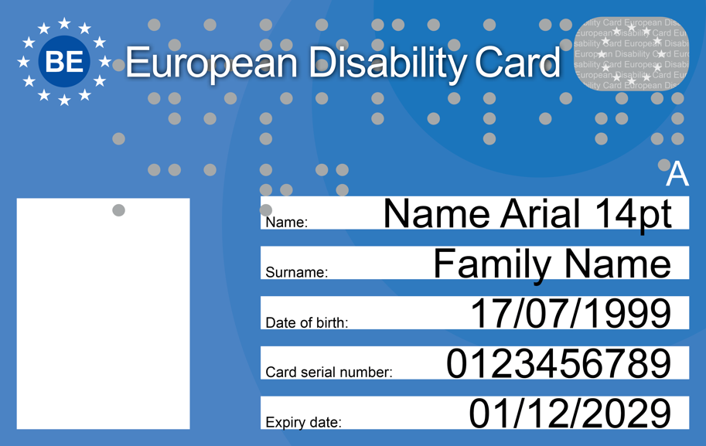

1. The size of the European Disability Card shall be in accordance with ISO 7810.
2. The Format shall be ID-1 and the Dimensions 85.6 x 53.98 mm.
3. The card shall have:

* a picture of the card holder;
* the surname and forename of the card holder;
* the date of birth of the card holder;
* the serial number of the card.

1. The colour of the card shall be light and dark blue, as set in the picture and with references:

* Dark blue: CMYK 100, 90, 10, 0

RGB 0, 68, 148

* Lighter: CMYK 94, 63, 7, 1

RGB 0, 110, 183

1. The card shall indicate the expiry date.
2. The card shall contain a country code with the blue circle around it.
3. Letters shall be type font ARIAL Regular.
4. The words European Disability Card shall be displayed using Arial font and in braille using the Marburg code dimensions.
5. The optional letter “A” (+braille sign) can be added when the card entitles accompanying by a personal assistant.
6. A digital feature/digital features using electronic means addressing fraud-prevention to be added following adoption of the technical specifications referred to in Article 6(1).

ANNEX II

**EUROPEAN PARKING CARD FOR PERSONS WITH DISABILITIES FORMAT**

FRONT

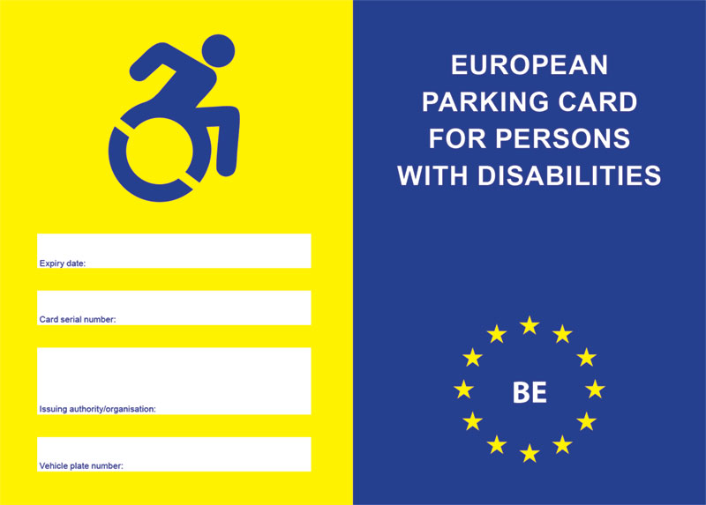

BACK

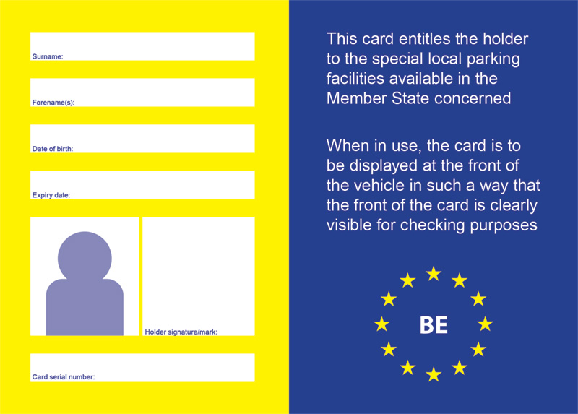

1. The size of the European Parking Card for persons with disabilities shall be:

* height: 106 mm
* width: 148 mm

1. The colour of the card shall be dark blue and yellow, as set in above picture and with references:

* Dark blue: CMYK 100, 90, 10, 0

RGB 0, 68, 148

* Yellow: CMYK 94, 63, 7, 1

RGB 255, 237, 0

1. The European Parking Card for persons with disabilities shall be divided vertically into two parts on both the front and reverse.

(a) The left-hand side of the front shall contain:

* the wheel-chair user symbol in dark blue on a yellow background;
* the date of expiry of the parking card;
* the serial number of the parking card;
* the name and stamp of the issuing authority/organisation;
* where the card is associated to a vehicle its number plate shall be visible.

(b) The right-hand side of the front shall contain:

* in capital letters, the words ‘European Parking Card for persons with disabilities’ in the language(s) of the Member State issuing the card; after a suitable space, it shall appear in small type in the other languages of the European Union;
* as background, the distinguishing code of the Member State issuing the parking card surrounded by the ring of stars symbolising the European Union.

(c ) The left-hand side of the reverse shall contain:

* the card holder’s surname;
* the card holder’s forename(s);
* the date of birth of the card holder;
* the expiry date of the card;
* a photograph of the card holder;
* the serial number of the parking card;
* the card holder’s signature or other authorised mark, if allowed under national legislation.

(d) The right-hand side of the reverse shall contain:

* the statement: ‘This card entitles the holder to local parking conditions and facilities reserved for persons with disabilities available in the Member State concerned’;
* the statement: ‘When in use, the card is to be displayed at the front of the vehicle in such a way that the front of the card is clearly visible for checking purposes’.

1. With the exception of the right-hand side of the front, entries shall be shown in the language or languages of the Member State issuing the parking card. If a Member State wishes to make the entries in a national language other than one of the following: Bulgarian, Croatian, Czech, Danish, Dutch, English, Estonian, Finnish, French, German, Greek, Hungarian, Irish, Italian, Latvian, Lithuanian, Maltese, Polish, Portuguese, Romanian, Slovak, Slovenian, Spanish, Swedish, it shall draw up a bilingual version of the card using one of the aforementioned languages, without prejudice to the other provisions of this Annex. If a Member State wishes to make entries in Bulgarian or Greek, it shall draw up a bilingual version of the card using one of the aforementioned languages, which use Latin characters.
2. A digital feature/digital features using electronic means addressing fraud-prevention to be added following adoption of the technical specifications referred to in Article 7(1).