

# INTRODUCTION

This Report is the third Annual Report by the European Commission on the application of the EU Foreign Direct Investment (FDI) Screening Regulation[1] (the “FDI Screening Regulation”, or the “Regulation”).

The Report covers the year 2022 and provides transparency around the operation of FDI screening in the EU, and developments in national screening mechanisms. It contributes to the accountability of the Union in an area where, given the security interests at stake, transparency regarding individual transactions is neither possible nor appropriate.

It is based on reports by the 27 Member States and other sources and consists of four chapters:

* Chapter 1 on trends and figures for FDI into the EU;
* Chapter 2 on legislative developments in Member States;
* Chapter 3 on FDI screening activities by Member States;
* Chapter 4 on the EU cooperation mechanism on FDI screening.

This Annual Report is an important tool for strategic trade and investment controls to ensure security and public order in the European Union.

# CHAPTER 1 – FOREIGN DIRECT INVESTMENTS INTO THE EUROPEAN UNION – TRENDS AND FIGURES

## Overall evolution

In 2022, the global FDI totalled EUR 1.2 trillion (**Figure 1**) and were 34% above the 2020 levels, after a robust post-COVID growth in 2021[2]. Yet, it displayed a year-on-year decrease of -14.3% compared to 2021.

The EU27 contributed to this global decrease in 2022, with EUR -140 billion of inward FDI, compared to the EUR +142 billion recorded for 2021. The EU27 result is primarily driven by decreases of inward FDI in Luxembourg[3]. Besides the EU27 (-199% compared to 2021), declines in FDI flows in 2022 were also observed for other important recipients, such as the US (-12%) and China (-41%).

Figure 1: World and EU27 inward FDI flows[4]

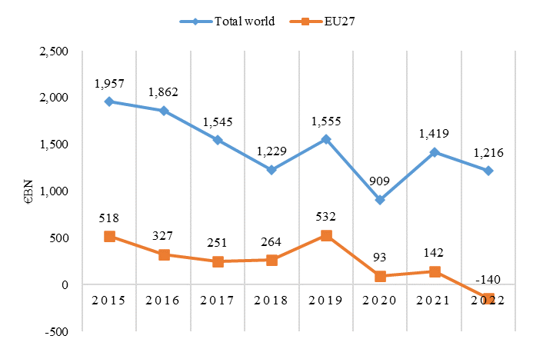

Source: [OECD data](https://stats.oecd.org/Index.aspx?DataSetCode=FDI_CTRY_IND_SUMM), extracted on 03/05/2023. Data refers to inward FDI flows.

However, the cumulated number of foreign transactions[5] into the EU27 displays an increasing trend between 2015 and 2022 (**Figure 2**). The average yearly number of foreign acquisitions and greenfield investments into the EU27 in this period were about 2 200 and 3 200, respectively. The positive trend confirms the openness of EU Member States to foreign investments.

*Figure 2: 2015-2022 yearly cumulative number of foreign transactions into the EU27*

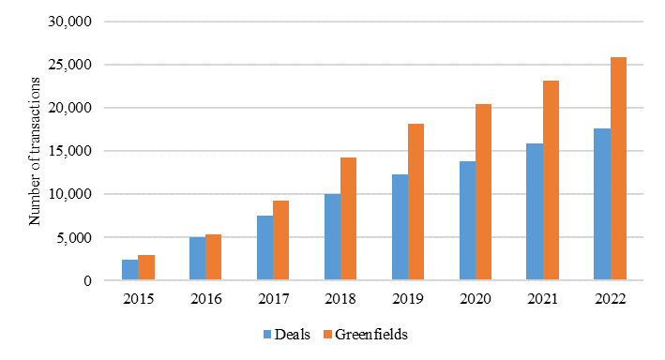

Source: JRC elaboration based on Bureau van Dijk data, extracted on 06/02/2023 (Zephyr) and on 02/02/2023 (Orbis Crossborder Investment). Data for 2015 corresponds to the flows of FDI in 2015, while data for the subsequent years correspond to the cumulated sum of yearly flows.

There was a fall in deal making, especially in the second half of 2022, resulting from the economic slowdown and rising cost of financing due to higher interest rates, decided by the main central banks to keep inflation at bay. The weakening of the confidence in global markets had some main contributing factors. Inflationary trends, worsened by Russia’s war of aggression against Ukraine, and the resulting pressure on energy and commodity prices, together with generalised supply chain disruptions, induced a prudent approach of investors waiting for more favourable conditions.

## Top Origin Countries of Foreign Investors

A comparison between 2021 and 2022 transactions data by foreign jurisdiction of origin shows differing patterns regarding the relative importance of each between acquisitions and greenfield investments (**Figure 3**).

Figure 3: Number of foreign acquisitions* (left) and greenfield investments (right) in 2022 and 2021 – Detail by foreign jurisdiction (top ten investors into EU27)

|  |  |
| --- | --- |
|  |  |

Source: JRC elaboration based on Bureau van Dijk data, extracted on 06/02/2023 (Zephyr) and on 02/02/2023 (Orbis Crossborder Investment). OFCs: Offshore Financial Centres (see footnote 1). RoW: Rest of the World. (*) Acquisitions of equity stakes above 10% of the capital of the EU27 business.

The US remained the top foreign investor in 2022*,* accounting for 32.2% of all foreign acquisitions and 46.5% of all greenfield investments, followed by the UK accounting for 25.1% and 19% of acquisitions and greenfield investments, respectively. The UK remained the second source of investment despite a decline in both the number of acquisitions (‑17.1%) and greenfield investments (‑8.9%) in 2022 compared to 2021.

However, some differences emerge between the two types of FDI: for greenfield investments, the US experienced a 13.7% year-on-year increase in 2022. The Offshore Financial Centres[6] (OFCs), the third most important origin jurisdiction for greenfield investments, also experienced an increase in 2022 compared to 2021 (+8.5%).

In 2022, the OFCs replaced China as the third most important jurisdiction of origin of greenfield investments. In fact, greenfield investments into the EU27 originating from China diminished and China was fifth, with a share of 3.9% down from 5.9% in 2021.

## Other Origin Countries of Acquisitions and Greenfield Investments

Other origin jurisdictions which experienced a decline in number of greenfield investments between 2021 and 2022 are Switzerland (‑15.5%, which represents the second largest drop in number of greenfield investments after China), Japan (‑11.8%) and Canada (‑2%). For acquisitions, OFCs (-43.2%) and Canada (-41.6%) experienced a sharp decrease in numbers in the same two years. Conversely, other jurisdictions which experienced an increase in the number of greenfield investments in 2022 are Norway (6.9%), India (9.1%) and South Africa (118.8%). For acquisitions, Japan (23.9%) and India (107.1%) registered a robust growth in investments in the EU in 2022.

## Top Destinations of Foreign Acquisitions and Greenfield Investments

The number of foreign transactions by target EU27 country records a generalised decline in 2022 compared to 2021 (**Figure 4**).

Germany, with a share of 17.2% of all acquisitions, remained the first destination of foreign direct investments in 2022. Spain, despite a -17.5% decrease in the number of acquisitions in 2022 compared to 2021, retained the second place with a 13.5% share. Italy, France and the Netherlands followed, with shares of foreign transactions of 10.6%, 10.2% and 10%, respectively. Most destination countries experienced a decline in the number of acquisitions, ranging from -3.2% in Denmark to -20% in Belgium. The only two exceptions were Sweden and Portugal, with a 1.3% and 30.6% growth in 2022, respectively.

As regards greenfield investments, Spain was in 2022 the number one destination in the EU27 (representing a 17.2% share of the total number of greenfield investments in 2022) followed by France and Germany with 14% and 11.4% respectively of greenfield investments in 2022.

France experienced an increase in 2022 of the number of greenfield investments received compared to 2021 (+20.4%), while for Spain and Germany there was a decline of 13.8% and 6.5%, respectively. Of note is that the Netherlands and Ireland saw an increase in greenfield investments by 25% and 25.7%, respectively. Romania and Poland, however, saw considerable drops in greenfield investments with -24.7%, and -15.6%, as compared to 2021.

Figure 4: Number of foreign acquisitions* (left) and greenfield investments (right) in 2022 and 2021 – Detail by destination Member State (top ten EU27 destination Member States)

|  |  |
| --- | --- |

Source: JRC elaboration based on Bureau van Dijk data, extracted on 06/02/2023 (Zephyr) and on 02/02/2023 (Orbis Crossborder Investment). RoEU stands for Rest of EU27. (*) Acquisitions of equity stakes above 10% of the capital of the EU27 business.

## Sector Specific Information

A closer look to the evolution between 2021 and 2022 of foreign acquisitions and greenfield investments by sector[7] into the EU27 shows mixed trends (**Figure 5**). The five main sectors saw a decrease in the number of acquisitions, while greenfield investments saw increases in all but one (manufacturing) sector.

Figure 5: Number of equity stakes* (left) and greenfield investments (right) in 2022 and 2021 – Detail by NACE Rev. 2.1 sectors (top five categories)

|  |  |
| --- | --- |
|  |  |

Source: JRC elaboration based on Bureau van Dijk data, extracted on 06/02/2023 (Zephyr) and on 02/02/2023 (Orbis Crossborder Investment). PST stands for professional, scientific and technical activities (NACE Rev. 2, section M), it contains among other things R&D facilities. ICT stands for Information and Communication (NACE Rev. 2, section J). (*) Acquisitions of equity stakes above 10% of the capital of the EU27 business.

The overall number of acquisitions in the ICT sector declined by 18.6% in 2022 compared to 2021. ICT was the sector receiving the highest share of investments in acquisitions in 2022 (28%). Moreover, ICT grouped 19.4% of new greenfield investments in 2022, ranking second after Retail: ICT experienced a 17.6% growth in the number of greenfield investments in 2022 compared to 2021.

Manufacturing was the second most important sector in 2022 in terms of the share of acquisitions (24.7%), but only fifth in terms of the share of greenfield investments (10.4%). This sector experienced a decline in the number of both acquisitions (-17.9%) and greenfield investments (-13.1%) in 2022, when compared to 2021.

The largest year-on-year increase in number of greenfield investments was observed in the Finance and in the Professional and Scientific activities sector categories, with 33.2% and 26.6% increases in 2022, respectively.

**Further details**

More details on the above figures are available in the accompanying Commission Staff Working Document, providing more information on the impact per Member State and sector, on the origin of foreign investors in the EU27, and on foreign state participation in foreign investors in the EU27.

**CHAPTER 2 – LEGISLATIVE DEVELOPMENTS IN MEMBER STATES IN 2022**

**The EU FDI Screening Regulation and EU Member States’ FDI screening mechanisms**

In 2022, the European Commission continued to exchange and engage with Member States to ensure that all of them adopt, adapt and implement national FDI screening mechanisms.

The Commission expects all 27 Member States to establish a comprehensive national FDI screening mechanism. To safeguard the Union against potentially risky foreign investments from third countries, a comprehensive national screening mechanism in all Member States is indispensable. With this tool, all Member States and the European Commission would be able to screen relevant FDI and Member States would be able to take informed screening decisions. This would in turn contribute to protecting the collective security of the Member States and the Union, along with the security of the Internal Market.

Furthermore, the European Commission strongly encouraged and facilitated the alignment of national screening mechanisms. It assisted Member States with technical and policy guidance, meetings and information exchange notably on best practices. Yet, despite this regular cooperation and several important similarities, noticeable divergences between national screening mechanisms remained, as highlighted in an evaluation study of the FDI Screening Regulation published in 2022[8]. These discrepancies encompassed notably what constitutes a formal screening of an FDI, timelines, sectoral coverage and notification requirements.

**Overview of Member States’ national screening mechanisms**

Russia’s war of aggression against Ukraine and uncertainties in relation to geopolitical developments have brought even more into focus the criticality of key industries such as energy, space, defence including key technologies. Consequently, many EU Member States have either adopted new national screening mechanisms or updated and expanded existing ones in reaction to the current situation. In detail, in 2022, one Member State adopted a new screening mechanism, and eight Member States amended their existing ones (see table below). By the end of 2022, eight Member States had already initiated consultative or legislative processes to establish a new national screening mechanism. Some are very close to adopting or having their mechanism entering into force in 2023. In 2022, two thirds of all EU Member States had an FDI screening legislation in place.

The map below gives an overview of the legislative situation of EU Member States.

**Produced in May 2023**

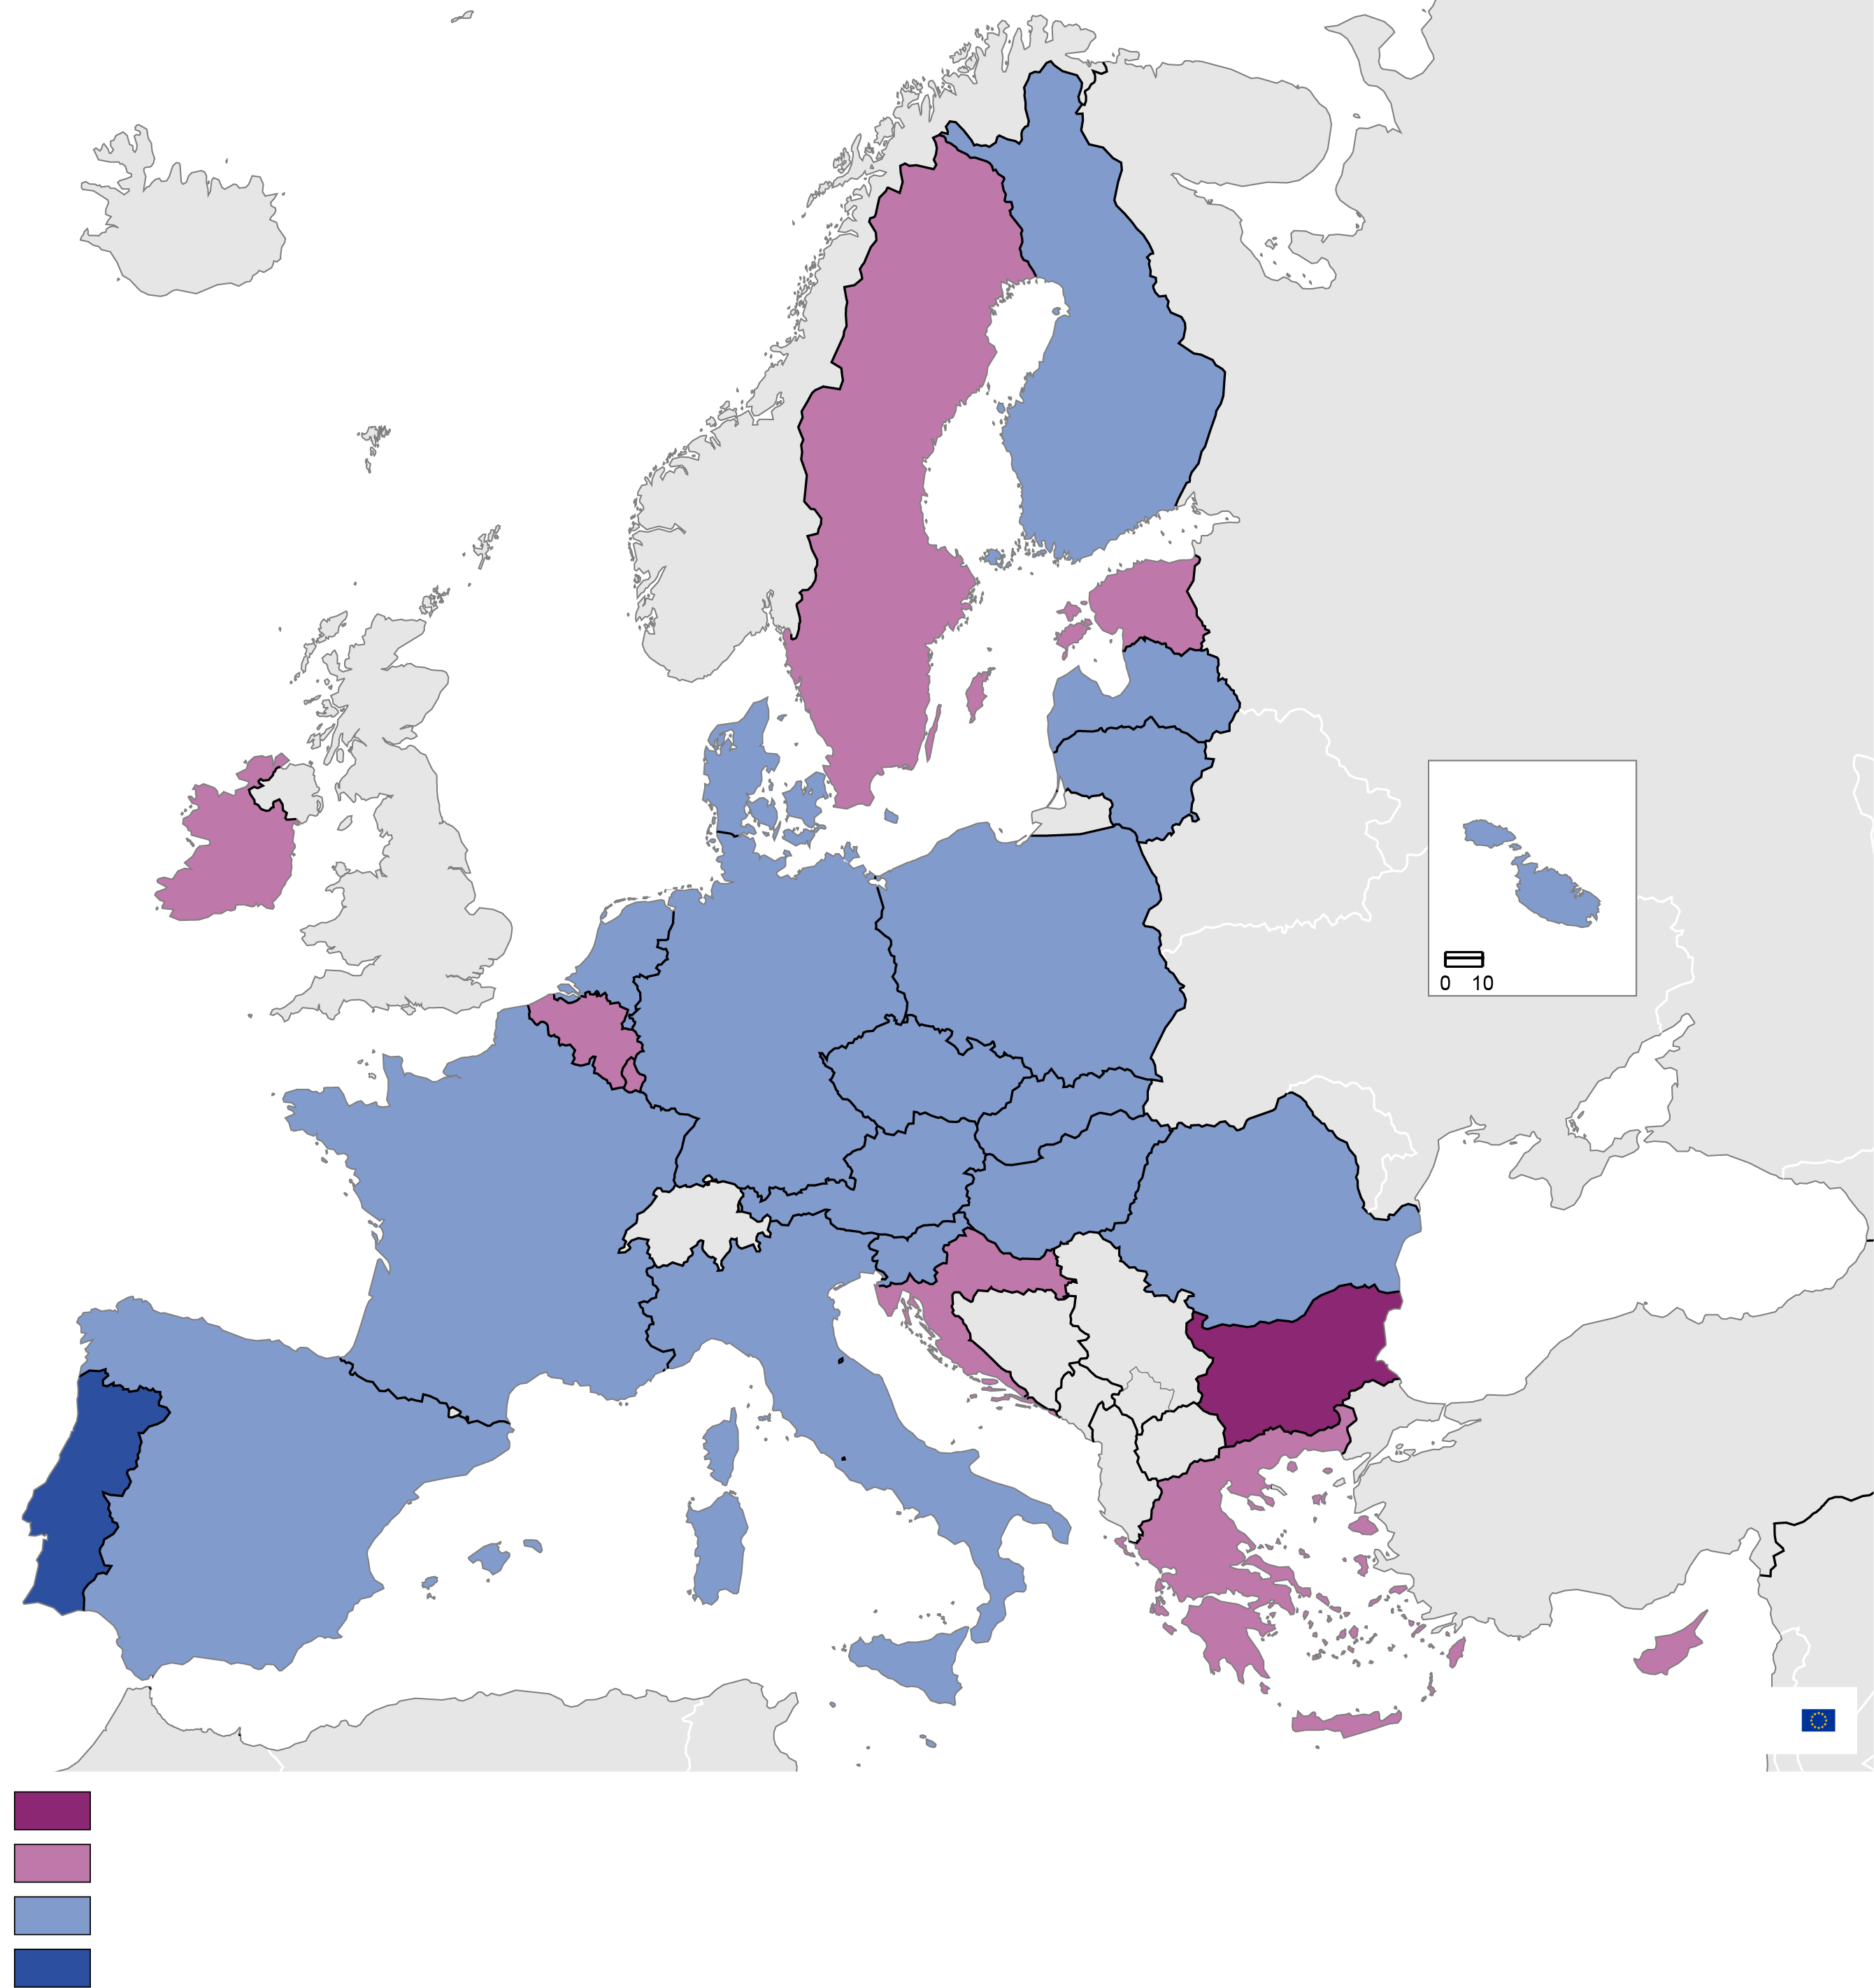

Steps initiated

Adoption of screening mechanism ongoing

Screening mechanism adopted/updated since 2017

Screening mechanism adopted before 2017

Administrative boundaries: ©EuroGeographics ©UN-FAO ©Turkstat

Cartography: Eurostat - IMAGE, 05/2023

**eurostat**

Malta

**Developments in EU Member States in 2022 – FDI screening mechanisms**

The following table gives an overview of all 27 Member States’ legislative situation and developments in 2022[9].

|  |  |
| --- | --- |
| **National FDI screening mechanism in place (no update in 2022)** | Czechia, Denmark, Germany, Finland, Malta, Portugal, Slovenia |
| **National FDI screening mechanism in place (updated in 2022)** | Austria, France, Hungary, Italy, Latvia, Lithuania, Poland, Spain |
| **Had a consultative or legislative process expected to result in updates to an existing mechanism** | The Netherlands, Romania |
| **Adopted a new national FDI screening mechanism** | Slovakia |
| **Had a consultative or legislative process expected to result in the adoption of a new mechanism** | Belgium, Croatia, Cyprus, Estonia, Greece, Ireland, Luxembourg, Sweden |
| **Initiative underway** | Bulgaria |

Most national legislative developments revolved around three main topics: (1) starting a legislative process to introduce a national FDI screening mechanism, (2) upgrading national screening procedures and expanding covered sectors, and (3) prolonging the validity of national screening mechanisms.

*New Member State’s screening mechanisms*

**Estonia** finalised the draft of the Foreign Investment Reliability Assessment Act which was approved by the Government in May 2022. The legislative procedure in the Estonian Parliament started in June 2022 and the law was adopted in January 2023. It is expected to enter into force on 1 September 2023. **Ireland** published draft legislation in 2022 to introduce a new FDI screening mechanism and the proposal is currently being considered by its Parliament. It is expected that the screening mechanism will come into force in late 2023 or early 2024. In **Luxembourg,** the initiative to create an FDI screening mechanism, approved in 2021 by the government, was reviewed for opinion by the Council of State in 2022 and amended. These amendments were approved in 2023. The new regime is applicable as of 1 September 2023. In **Belgium,** the Draft Cooperation Agreement was reviewed by nine Belgian entities (Federal Parliament and the Parliaments of the Federated Entities) and adopted in 2023. The national Belgian screening mechanism went into force on the 1 July 2023.

In 2022, **Cyprus** drafted a new law for the establishment of a national FDI screening framework, which has to be approved by the House of Representatives in Cyprus. **Bulgaria** initiated steps to establish a screening mechanism.

*On updated national FDI screening mechanisms*

In 2022, **France** prolonged by one year the temporary obligation for foreign investors to notify investments when acquiring at least 10% of the voting rights of listed companies. **Latvia** adopted amendments in reaction to Russia’s war of aggression against Ukraine by prohibiting Belarussian and Russian citizens from obtaining a qualifying holding or decisive influence in a company of significance to national security. **Italy** introduced urgent measures to react to the economic and humanitarian effects of the crisis triggered by Russia’s war (cybersecurity, raw materials, agricultural goods, etc.). **Poland** prolonged until June 2025 the temporary regulations stemming from the Act on the Control of Certain Investments, which notably added a list of new sectors to be subject to screening.

More detailed information on the legislative developments in Member States’ national screening legislations can be found in the accompanying Commission Staff Working Document. Also, a list of national legislative updates is maintained by the European Commission on its website[10].

**CHAPTER 3 - MEMBER STATES’ FDI SCREENING ACTIVITIES**

The FDI Screening Regulation establishes a cooperation mechanism on FDI screening between the European Commission and EU Member States and amongst Member States based on exchange of information on transactions subject to screening at Member State level. It is always the Member State in which the investment takes place that decides which investments to screen, approve, condition, or block. This chapter is based on – and aggregates – data provided by Member States on their screening activities. Based on aggregate data received from Member States, a total of 1 444 requests for authorisations of acquisition made by the foreign investors[11] and *ex officio* cases were handled in 2022. Not all authorisation requests resulted in a decision to screen as this largely depends on the Member States’ legislation and on how they classify and treat the requests[12].

Figure 6 - Member States’ FDI Screening Activity[13]

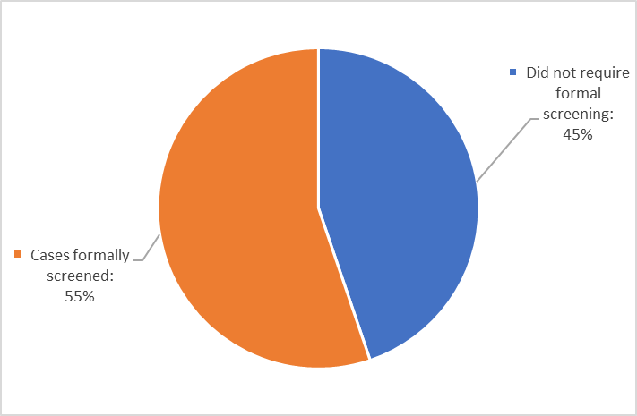

Source: Member States’ reporting.

There is a clear trend towards screening more cases formally. Indeed, out of all the authorisation requests and *ex officio* cases, roughly 55% of the cases were formally screened. This marks a significant increase in the proportion of formally screened cases compared to 2021.[14] About 45%[15] of the applications were deemed ineligible or did not require formal screening.

The number of authorisation requests is unevenly distributed across EU Member States. However, a diversification of screening among EU Member States can be observed as the top four Member States accounted for 66% of all authorisation requests in 2022, down from 70% in 2021 and almost 87% in the first report.

Out of the cases formally screened in 2022, and for which Member States have reported a decision[16], the overwhelming majority (86%) was authorised without conditions.

However, 9% of the decisions involved an approval with conditions or mitigating measures (in 2021, 23% of cases involved authorisation with conditions or mitigating measures). In these cases, national screening authorities have negotiated - or imposed, depending on the Member State - certain actions, assurances, and commitments from the investors before approving the planned foreign direct investment.

Finally, national authorities ultimately blocked transactions in 1% of all decided cases, while for a further 4% the transaction was withdrawn by the parties.

Figure 7 – Notified decisions on FDI cases

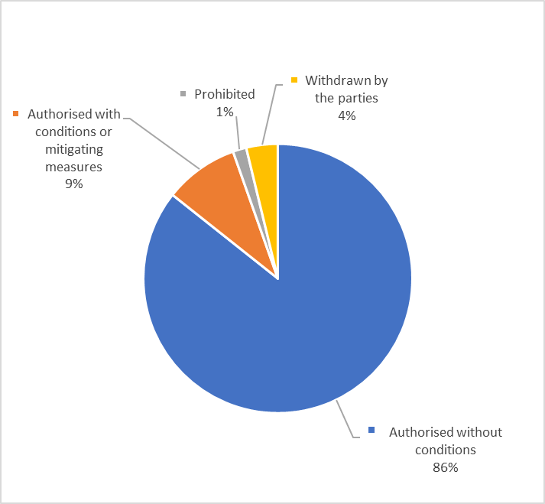

Source: Member States’ reporting.

In summary, these findings give rise to the following remarks:

* In comparison to 2021, Member States have in 2022 considered more requests for authorisations received as sensitive given that the proportion of formally screened cases has increased significantly.
* In 2022, 86 % of transactions where a decision was reported to the Commission, were authorised by the relevant Member State without any conditions; in 2021 only 73% of the transactions were authorised without conditions.
* In 9% of the transactions the Member States imposed mitigating measures as a condition for the go ahead of the transactions. In 2021 the figure was higher at 23%.
* Only 1% of the transactions were blocked by Member States (same as in the previous year). This confirms that the European Union remains open to foreign direct investments and Member States only deny transactions that pose very serious threats to security and public order.

# CHAPTER 4 – EU COOPERATION MECHANISM ON FDI SCREENING

## Notifications and other actions taken under the FDI Screening Regulation

a) Overview of activity in 2022

In 2022, 17 Member States submitted a total of 423 notifications[17], pursuant to Article 6 of the FDI Screening Regulation, compared to 13 Member States in 2021[18]. Six Member States, namely Austria, Denmark, France, Germany, Italy and Spain, were responsible for more than 90% of those notifications. The notified transactions varied greatly in terms of sectors of the target company, value of the transaction and origin of the ultimate investors, among other parameters.

The map below shows the notifications to the EU cooperation mechanism in 2022

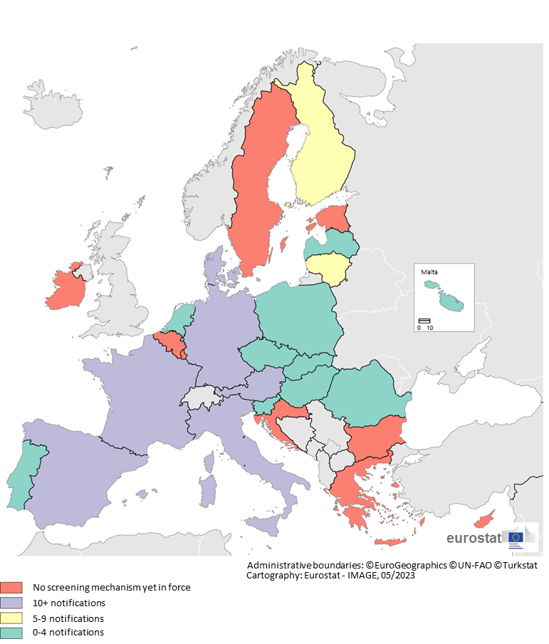

The map above indicates the number of notifications received in the framework of the EU cooperation mechanism on FDI Screening. In 2022, out of the eighteen Member States with a national screening mechanism in place, ten Member States submitted between 0-4 notifications, two submitted 5-9 notifications and six submitted more than 10 notifications.

b) Main sectors of FDI into the EU (in Phase 1)

The four sectors with the highest number of transactions in 2022 were Manufacturing[19], ICT[20], Professional Activities[21], Wholesale and Retail[22], thus following the same trend as in 2021[23]. The first two remained the same as the ones identified in the second annual report but in a different order. The sector Professional Activities took the third place (previously it was Financial Activities[24]), followed by Wholesale and Retail.

Figure 8 - Main targeted sectors overall in 2022[25]

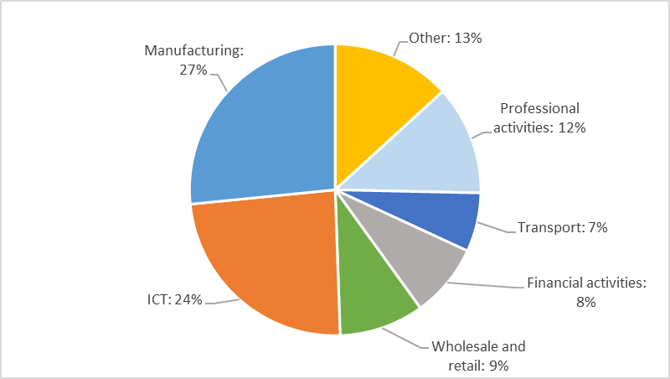

Source: Member States’ notifications.

c) Average value of FDI into the EU

Looking at the transactions’ value, almost half of them (49%) had a value[26] of less than EUR 500 million (62% in the previous report). 42% of the transactions involved a value of EUR 100 million and more (it was 55% in the previous report).

Figure 9 – Respective value per notified FDI transaction in 2022[27]

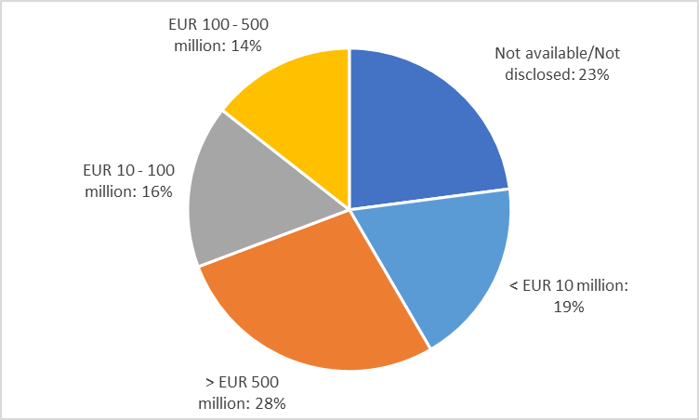

Source: Member States’ notifications.

The notified transactions show a broad range in terms of value, with the lowest deal-value at less than one euro and the highest at approximately EUR 25 billion.

d) Procedure and swiftness in closing FDI cases

In line with the FDI Screening Regulation, FDI transactions notified by the Member States are assessed by the European Commission in two possible phases:

All notified transactions are assessed under Phase 1, with only a limited number proceeding to Phase 2. Phase 2 implies a more detailed assessment of cases that could possibly affect security or public order in more than one Member State, or create risks to projects or programmes of Union interest. Cases in Phase 2 can be concluded with an opinion of the European Commission.

Figure 10 - Cases closed in Phases 1 and 2 - and ongoing ones

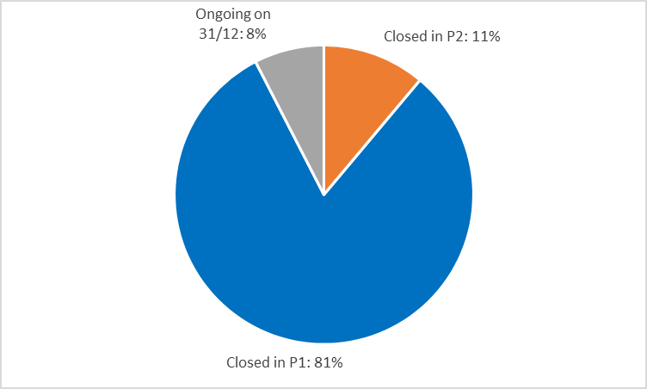

Source: Member States’ notifications.

Of the 423 cases notified in 2022 within the cooperation mechanism, 81% were closed by the European Commission in Phase 1. 11% proceeded to Phase 2 with additional information being requested from the notifying Member State. 8% of those cases were still ongoing on the cut-off date of this report, i.e. not yet closed in Phases 1 nor 2[28].

When opening Phase 2, the European Commission requests additional information which varies, depending on the transaction and detail of the information supporting the notification[29]. The information requested may include one or several elements such as: data on products and/or services of the target company; possible dual-use classification of any products involved; customers, alternative suppliers and market shares; influence of the investor on the target company after the transaction; IP portfolio and R&D activities of the target company; additional defining characteristics of the investor and its strategy. This information is requested to better assess the criticality of the target company and/or the potential threats posed by the investor.

e) Main sectors of FDI into the EU (in Phase 2)

The main sectors for Phase 2 examinations were Manufacturing and ICT. Together they accounted for 82% of all Phase 2 cases. The Manufacturing sector rose quite drastically from 44% in 2021 (in previous report) to 59% in 2022. Also compared to 2021, Transport and storage is now the third most examined sector by the Commission (it was Financial Activities in the previous report), before Wholesale and Retail. The category “Other” includes several sectors which accounted for less than 4% of the cases.

Figure 11 - Phase 2 main targeted sectors in 2022 cases[30]

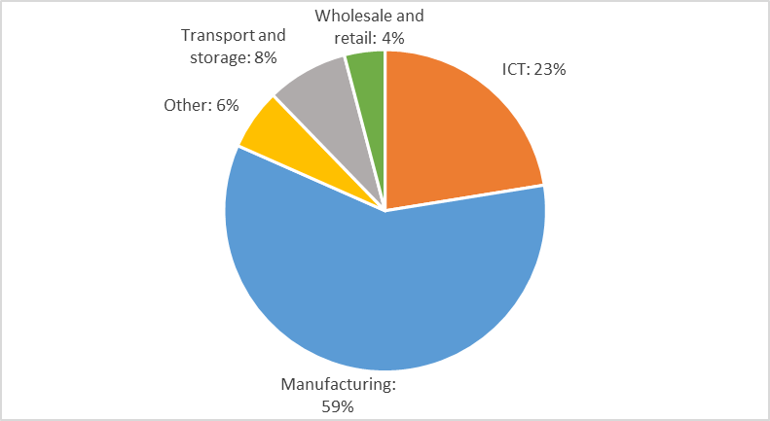

Source: Member States’ notifications.

The top sector, Manufacturing, encompasses critical infrastructures and/or technologies. Looking more closely (Figure 12), there are significant changes in the sub-sectors, notably Energy and Aerospace (both 16%, down from respectively 21% and 20% in 2021), Defence (13%, down from 25% in 2021), Semiconductors (9%, down from 18% in 2021) and Health (6%, same as in 2021). In addition, in 2022, there were more sectors above 5%: Data processing and storage as well as Communications (both 10%), Transport (7%) and Cybersecurity (6%). This indicates a greater diversity of (sub-)sectors targeted by FDI.

Figure 12 - Manufacturing sub-sectors in Phase 2 in 2022 cases[31]

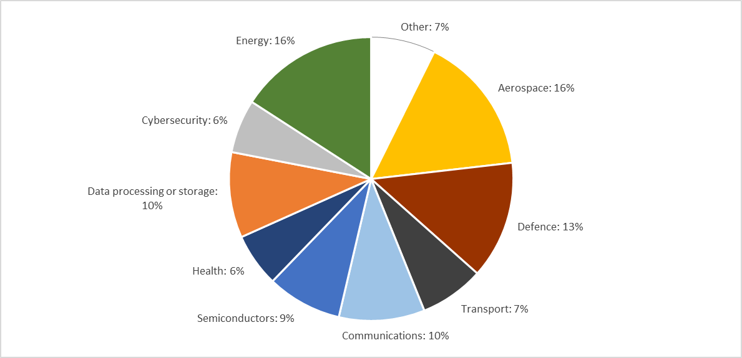

Source: Member States’ notifications

In 2022, a total of 11 Member States accounted for 56 Phase 2 cases[32]. For all Phase 2 cases, the average period of time for Member States to provide the requested information was 24 calendar days (compared to 22 in 2021), with a range from 1 to 126 days (compared to 3 to 101 calendar days in 2021). The FDI Regulation does not set precise timelines within which Member States must respond, but the timeline under the Regulation is suspended until full information is received.

f) Origin of ultimate investors

Of the 423 cases notified in 2022, the six main countries of origin were the USA, the UK, China, Japan, the Cayman Islands and Canada. Compared to 2021 , the percentage for US and UK ultimate investors went down from respectively 40% to 32% and from 10% to 7.6%. Also, the share of China origin investors decreased, from 7% down to 5.4%. The share of investors originating in Japan have increased from 3% in 2021 to 5% in 2022.

Around 40%[33] of notified cases originated from countries other than the top six compared to 2021 where the share was only 29 %. This marks a clear increase in the diversification of origin of the ultimate investors. This is also reflected in the fact that in 2022 the ultimate investors originated from 52 different countries (it was 43 in 2021).

Figure 13 - Origin of Ultimate Investors in 2022 cases

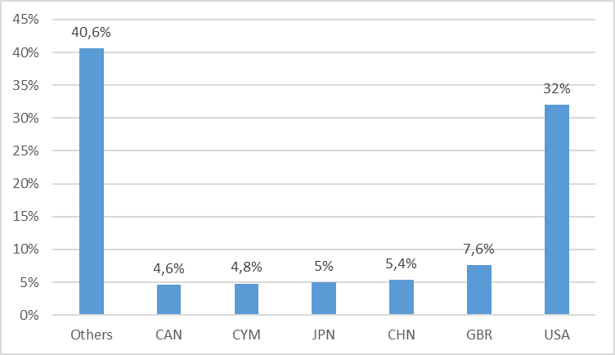

Source: Member States’ notifications.

g) Multi-jurisdiction FDI and their main sector

Of all the cases notified in 2022, 20% (compared to 28% in the second report and 29% in the first report) constituted multi-jurisdiction FDI transactions because they concerned (and were notified by) several Member States[34].

The main sectors subject of such notifications were: Manufacturing (up from 20% in the previous report), ICT (down from 39% in the previous report), Professional activities (new), Wholesale and Retail (same percentage as in the previous report) and Transport (new).

*Table – Multi-jurisdiction FDI transactions and main sectors*

|  |
| --- |
| Manufacturing 31% |
| ICT 20% |
| Professional activities 14% |
| Wholesale and retail 11% |
| Transport 8% |
| Other 16% |

Source: Member States’ notifications

h) Additional findings

In addition to the analysis of notified cases by Member States pursuant to Article 6 of the Regulation in 2022, the European Commission has in 2022 also made use of Article 7 of the Regulation. Article 7 allows the European Commission to screen *ex officio* an investment of a Member State – whether the latter has its own screening mechanism or not. As described in Article 7(5) of the Regulation, where a Member State or the European Commission considers that an FDI which is not undergoing screening is likely to affect security or public order, it may request information from the Member State where that FDI is planned or has been completed. This information would enable other Member States to possibly provide comments and/or the European Commission to issue an opinion.

The European Commission has under the Regulation the possibility to adopt opinions on FDI transactions notified by Member States. However, such opinions remain confidential pursuant to Article 10 of the Regulation and no information is provided on individual opinions in this report. Opinions have been issued in less than 3% of the cases notified by Member States under the EU cooperation mechanism and are issued only when and if required by the circumstances of a case, more specifically the risk profile presented by the investor and the criticality of a target company. When an opinion is issued, any recommended mitigating measures are proportionate and specific to the risks and criticality identified. European Commission’s opinions may also consist of sharing relevant information with a screening Member State, and may also suggest potential mitigating measures to address identified risks. It is ultimately for the Member State where the investment takes place to decide on the transaction, while it shall give due consideration to any European Commission opinion. Opinions relating to projects and programmes of Union interest are shared with all Member States.

Member States participated actively in the EU cooperation mechanism by sending comments to the notifying Member States: nine Member States sent comments concerning around 7% of the notified cases.

**The data above leads to similar but distinct key conclusions as the ones drawn for the previous report for 2021.**

a) Similar findings

First, the processing of cases through the EU cooperation mechanism continues to function very well. Of the 423 cases notified in 2022, the vast majority (81%[35]) were closed in Phase 1, i.e. very quickly, with only 11% of the notified cases closed in Phase 2 (same as in the previous report), and less than 3% of cases resulting in European Commission’s opinions.

Second, there is a continuous trend towards more diversification of screening among Member States. Yet, there are some Member States contributing with more cases: i.e. four Member States accounted for 66% of all applications received under the EU cooperation mechanism in 2022 (it was 70% in the second annual report and 86.5% in the first one).

Third, while most cases are assessed rapidly in Phase 1, within the prescribed 15 calendar days, the duration of cases entering Phase 2 shows significant variation given the time needed by Member States to provide answers to a Commission’s request for additional information, with them often depending on the investor for the requested information.

b) Distinct findings

Fourth, the main sectors of interest to foreign investors (Manufacturing, ICT, Professional activities, Wholesale and Retail, Financial activities, Transport) changed somewhat with Manufacturing being now the first one (instead of ICT in 2021) and Professional Activities taking the third place (previously it was Financial Activities). But there were more (sub-)sectors targeted by FDI in 2022, under the category Manufacturing.

Fifth, the origin of the ultimate investor (USA, UK, China, Japan, Cayman Islands, Canada) involved in cases notified under the Regulation remains approximately stable although the share of the US, UK and China decreasing somewhat in 2022 compared to 2021, while the share of Japanese investors increased. In addition, in 2022, ultimate investors originated from 52 different countries up from 43 in 2021. This could be an indicator that the EU further increased its openness to investors from more diverse countries.

Sixth, a lower number of multi-jurisdiction FDI cases have been dealt with: 20% in 2022 compared to 28% in 2021.

## FDI from Russia and Belarus in the context of Russia’s invasion of Ukraine

As already stated and detailed in the previous annual report, the European Commission adopted in April 2022 a Guidance[36] to Member States on FDI from Russia and Belarus, to ensure that particular attention is given to investments into critical EU assets from entities or persons somehow related to the Russian or Belarusian governments. In 2022, Russia accounted for less than 1.4% of the cases notified to the European Commission and Belarus for 0.2%.

## Steps taken since 1 January 2022, and looking ahead

This third report marks the further strenthening of a European policy essential for the protection of security and public order in the Union. In 2022, more Member States were about to establish a national FDI screening mechanism while others improved their frameworks. The FDI cooperation with partner countries, notably the US through the Trade and Technology Council (TTC) Working Group on FDI, allowed the EU to consolidate further the EU screening system. Almost three years after the entry into force of the Regulation, the EU is now a well-established active player in the field of FDI screening.

The present report confirms further the added-value of the FDI Regulation and of the EU cooperation mechanism which has proven to be appreciated and efficient.

In 2022, there were no reported leaks on notifications, opinions or other action undertaken under the FDI Regulation. Appropriate handling and **protection of any information submitted** for the purpose of Articles 6, 7 and 8 of the Regulation is crucialto ensure the required trust between all actors involved (parties to a transaction, the notifying Member State, the 26 other Member States and the European Commission).

The European Commission welcomes that additional Member States are about to adopt a national FDI screening mechanism or further strengthen their existing mechanisms for potentially risky foreign investments. It **firmly expects that all Member States will have a comprehensive national FDI screening mechanism in place in the near future. The Commission encourages Member States to make effective use of their screening mechanim.** This woulddirectlycontributeto the shared security objective. As stated in the recently adopted **Communication on European economic security strategy**[37],“Member States who have not yet implemented national FDI screening mechanisms should do so without further delay.” The increase in the number of Member States with a national FDI screening mechanism should logically lead to more cases notified and thus an intensification of the use of the EU cooperation mechanism. Yet, as the economic environment remains uncertain, the number and nature of future notifications is hard to predict.

On **avenues for future developments**, the European Commission had launched in 2021 a **study on the FDI cooperation mechanism** which was published in October 2022[38]. Its objective was to assess the articulation between the screenings carried out by the national authorities and the European Commission. It also aimed at identifying any significant efficiency or effectiveness issue considering the policy goals of the FDI Screening Regulation[39]. The study contributed to the Commission’s reflections on the need for a revision of the FDI Screening Regulation in 2023, together with the experience gathered since the entry into force of this instrument.

Indeed, since October 2020, the European Commission and Member States have reviewed more than 1 000 FDI transactions. In this context, a public consultation was launched on 14 June 2023 and closed on 14 July 2023. The Communication on European economic security strategy[40] of 20 June 2023 announced that **the** **Commission** is evaluating the current framework and **will propose a revision of the FDI Screening Regulation before the end of 2023**.

The Commission services are working to prepare this revision.

1. Regulation (EU) 2019/452 of the European Parliament and of the Council of 19 March 2019 establishing a framework for the screening of foreign direct investments into the Union (OJ L 79I , 21.3.2019, p. 1).
2. Pitchbook, [Global M&A report 2022](https://pitchbook.com/news/reports/2022-annual-global-ma-report), January 2023
3. OECD, FDI IN FIGURES, April 2023 – <https://www.oecd.org/corporate/mne/statistics.htm>
4. The data provided here has been revised by the OECD for the past years. Thus, it differs from the data displayed in the second annual report on FDI screening.
5. Foreign direct investment can take two different forms: greenfield, and mergers and acquisitions (M&As). International greenfield investments typically involve the creation of a new company or establishment of facilities abroad, while an international merger or acquisition amounts to transferring the ownership of existing assets relating to an economic activity to an owner abroad.
6. The main offshores by number of M&As or Greenfields are (in alphabetical order): Bermuda, British Virgins Islands, Cayman Islands, Mauritius and the United Kingdom Channel Islands. For the full list of Offshore Financial Centres, see e.g., Commission Staff Working Document - Following up on the Commission Communication “Welcoming Foreign Direct Investment while Protecting Essential Interests” – SWD(2019) 108 final – 13 March 2019.
7. The sectors used to categorise are the NACE [Nomenclature of Economic Activities] Rev. 2.1, see: https://showvoc.op.europa.eu/#/datasets/ESTAT_Statistical_Classification_of_Economic_Activities_in_the_European_Community_Rev._2.1._%28NACE_2.1%29/data.
8. OECD study – Framework for Screening Foreign Direct Investment into the EU – assessing effectiveness and efficiency – 10-11-2022 - <https://www.oecd.org/investment/investment-policy/oecd-eu-fdi-screening-assessment.pdf>
9. For more details, please see the accompanying Commission Staff Working Document on FDI screening.
10. The list of screening mechanisms notified by Member States (last update: 17 August 2023) is available under:

    <https://circabc.europa.eu/rest/download/7e72cdb4-65d4-4eb1-910b-bed119c45d47>
11. Some Member States did not report any cases under their screening legislation. Some Member States also reported ‘consultations’ on the eligibility of the cases, which are included in this number.
12. Member States have different screening procedures. So, the cases reported depend on the domestic procedures (scope, eligibility check upfront or later, etc.). For instance, some Member States declared cases ineligible before a formal screening procedure is carried out, while others first formally screened cases and then declared them ineligible. The graphs and numbers reported in this chapter aim at accurately reflecting Member States’ screening activities as reported by them, regardless of their domestic system.
13. From the total number of reported cases formally screened by Member States, cases received by one Member State were subtracted to produce the data shown in Figure 6. This is because that Member State provided partial information about cases received and did not provide information about all possible outcomes of notified cases.
14. It was 29% in the second annual report for the whole year 2021, and 20% in the first annual report for 2020.
15. It was 71% in the previous report.
16. One Member State reported a general figure on the number of requests for authorisation and two (partial) figures on outcomes.Thus, these cases were subtracted to produce the data shown in Figure 7. Moreover, some cases were carried over in 2023 and hence their outcome was unknown in 2022, thus, these have been subtracted too.
17. Yet, in 2022 there were cases dealt with from **19 Member States**: The Commission opened *ex officio* cases notably concerning Member States with no national screening mechanism in place.
18. See <https://ec.europa.eu/transparency/documents-register/detail?ref=COM(2022)433&lang=en>
19. Manufacturing encompasses activities by companies which are involved in the transformation of materials into new products. For example, this encompasses the manufacturing of electrical equipment and motors, of industrial machinery and equipment, of weapons and ammunitions, of pharmaceuticals, etc.
20. ICT stands for Information and Communication Technologies. It encompasses activities by companies providing essential infrastructures and tools for knowledge creation, sharing and diffusion. For example, this encompasses computer programming, software publishing, data processing and hosting, wireless telecommunication activities, etc.
21. Professional activities include activities by law and accounting firms, as well as consultancy and engineering activities. For example, this encompasses activities of head offices, market research and public opinion polling, consultancy, research & experimental development on biotechnology, etc.
22. Wholesale and Retail includes activities relating to pharmaceutical goods, chemical products, electronic and telecom equipment and supplies, computers, computer peripheral equipment and software, metals and metal ores, etc.
23. In the first annual report it was Manufacturing, ICT, and, Wholesale and Retail, categorised under the NACE codes C, J and G respectively. In the second annual report it was ICT, Manufacturing and Financial Activities, categorised under the NACE codes C, J and M.
24. Financial activities encompass activities by holdings, funds or similar actors in the financial sector which aim at acquiring a specific (equity) stake or control in a target company. For example, this encompasses fund management activities, activities of holding companies, financial services, insurance activities, etc.
25. As cases can cover several sectors (i.e. NACE codes), the total in the graph is higher than the total number of cases notified in 2022. The category ‘other’ encompasses all other sectors below 4%, notably: energy, water, mining, real estate, construction, health, etc.
26. The value, where available, relates to the target company which may be an EU-based subsidiary of a larger corporate target company. It relates to the total value of the transaction.
27. N/A includes blanks, not available/not disclosed and not applicable.
28. From these cases, 72% were closed in phase 1. Thus, in total, 87% of the 2022 cases were closed in phase 1.
29. The notification form - request for information from an investor for the purposes of notifications pursuant to Article 6 of the Regulation, and the Frequently Asked Questions document, serve to ensure some degree of uniformity and a minimum level of information about the transaction, the investor and the target company provided in the notification under the Regulation. Both documents are available at <https://policy.trade.ec.europa.eu/enforcement-and-protection/investment-screening_en>
30. As stated in footnote 25, one case can touch upon several sectors, thus the total in the graph is higher than the total number of cases notified in 2022.
31. See previous footnote.
32. It was nine in the second report for 47 Phase 2 cases and six Member States for 36 Phase 2 cases in the first report.
33. Other origin countries’ can be divided as follows: UAE (3.2%), SGP (2.6%), JEY (2%) AUS (1.8%), CHE (1.6%); and the remaining 28,8% is spread out all around the world.
34. “Multi-jurisdiction FDI transactions” refers in this context to FDI transactions where the target company is a corporate group with a presence in more than one Member States (and possibly also third countries), e.g., by way of subsidiaries in more than one Member State. Depending on the circumstances, and the particularities of the screening mechanism of the relevant Member States such deals are **notified by more than one Member State**, albeit rarely in a coordinated and synchronised manner.
35. See footnote 28.
36. Communication from the Commission - Guidance to the Member States concerning foreign direct investment from

    Russia and Belarus in view of the military aggression against Ukraine and the restrictive measures laid down in recent Council Regulations on sanctions (OJ C 151 I, 6.4.2022, p. 1).
37. Joint Communication to the European Parliament, the European Council and the Council on « European economic security strategy » - 20.06.2023 – JOIN(2023) 20 final <https://circabc.europa.eu/rest/download/a75f3fb8-74e3-4f05-a433-fdbf406d5de6>
38. OECD Study “Framework for Screening Foreign Direct Investment into the EU – Assessing effectiveness and efficiency” - https://www.oecd.org/investment/investment-policy/oecd-eu-fdi-screening-assessment.pdf
39. The specific objectives of the study are (i) to present an overview of the existing legislation of the Member States which currently have a screening mechanism; (ii) review how the national legislations and the FDI Screening Regulation regulate the interaction between national authorities and with the European Commission within the cooperation mechanism set up by the FDI Screening Regulation; (iii) identify any significant problems in the current system of national laws and the FDI Screening Regulation which may lead to less effective and/or less efficient outcomes in light of the policy goals of the FDI Screening Regulation, and, (iv) the need to keep administrative burden for investors and other stakeholders proportionate to the policy goals and relevant security or public order concerns.
40. See footnote 37.