

***Introduction***

Article 35 of Regulation (EU) 2018/1999[1] (“Governance Regulation”) provides that by 31 October of every year, the Commission must submit to the European Parliament and to the Council a State of the Energy Union report that must include, biennially, from 2023, a report on Union bioenergy sustainability, containing the information specified in Annex X of that Regulation.  The present report fulfils that reporting obligation and has been drafted using as a main basis the information provided by Member States in their integrated National Energy and Climate Progress Reports (NECPRs) referred to in Article 17 of the Governance Regulation.

Bioenergy produced from agricultural, forestry and organic waste feedstock continues to be the main source of renewable energy in the EU, accounting for about 59% of renewable energy consumption in 2021. For bioenergy, primary solid biofuels represent the largest share at 70.3 %. Liquid biofuels account for 12.9%, biogas/ bio-methane for 10.1% and renewable share of municipal waste for 6.6%.

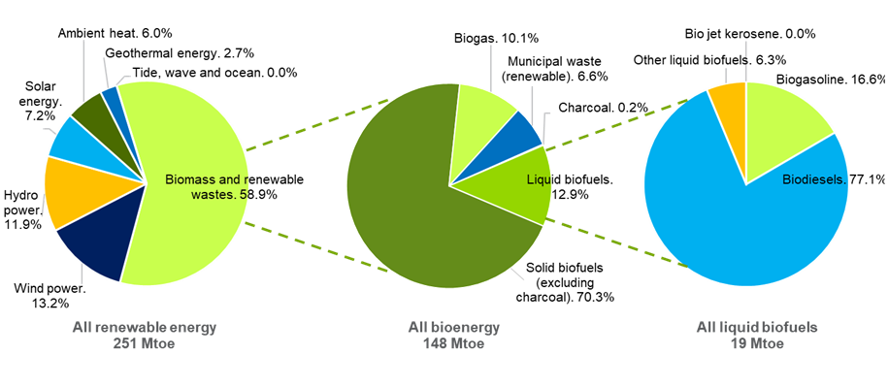

**Gross EU consumption of renewable energy per type (2021, % and Mtoe)[2]**

***Current and projected sustainable biomass availability and demand***

Twenty-six Member States have reported[3] their data on biomass supply. In the EU, woody biomass is the main feedstock reported for solid biomass production (labelled as “forest biomass” in the figure below), accounting for 66% of the total and followed by biomass from organic waste (26%) and agricultural biomass (8%). Germany records a significant production of organic waste biomass (137,675 thousand m3). It also records production of the largest share of forest biomass (66,658 thousand m3) in the EU, followed by Sweden (65,102 thousand m3). Spain records the highest volumes of agricultural biomass (20,844 thousand m3).

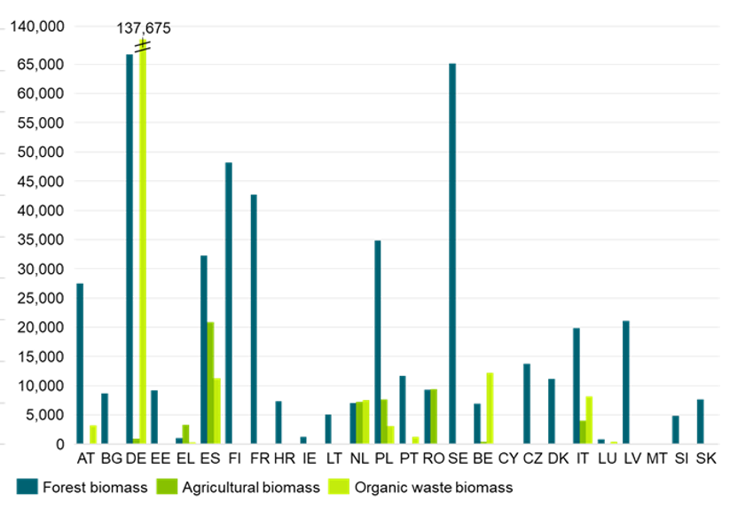

**Primary supply of solid biomass in 1000 m3 for energy production, indigenous production in 2021[4] grouped by feedstock origin**

Forest biomass was the largest reported category across all the Member States (262,858 thousand m3). Germany reported 12% of the total reported primary supply of solid biomass from forest, followed by Spain and Poland (both reported 11%), and Sweden and France (both reported 10%). The second largest reported category of supply of solid biomass was municipal waste (171,023 thousand m3 – 24% of the total). Germany reported 74% of the total renewable municipal waste, followed by Sweden (8%), Belgium (6%), Spain and the Netherlands (both reported 4% of the total), Italy (2%) and Austria and Portugal (both reported 1% of the total). The third largest reported category for primary supply of solid biomass was forest-based industry co-products (144,821 thousand m3 – 20% of the total). Sweden reported 22% of the total reported forest-based industry co-products, followed by Finland (20%), Austria (11%), Germany (10%), France (6%), Poland (5%), Estonia (4%) and Latvia (4%).

Among the different types of indigenous production of solid biomass, the largest growth in the period since 2008 has been observed[5] for wood pellets use (413%), followed by animal waste (351.9%), the renewable fraction of industrial waste (58.6%), fuelwood, wood residues and by-products (29.5%), and black liquor (25%). Other vegetal material and residues were the only solid biomass type, compared to 2008, with a decrease of 8.8%. Overall, primary supply of solid biomass in the EU has increased from 3,336,811 TJ in 2008 to 4,454,768 TJ in 2021, an increase of 33.5% overall.

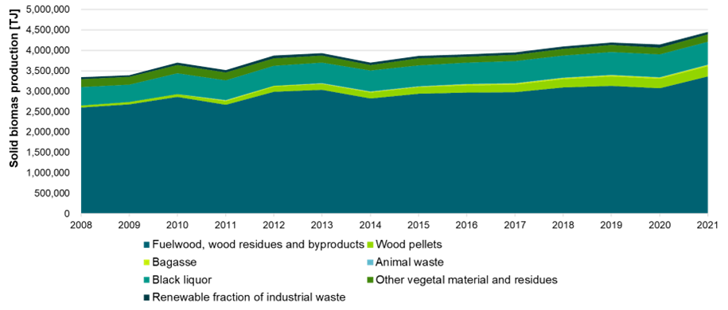

**Total EU-27 solid biomass production[6]**

The above graph on “Total EU-27 solid biomass production” refers to the categories used in the Eurostat Energy Balances. For the purposes of the NECPRs, different categories are laid down in point (m) of Part 1 of Annex IX to the Governance Regulation that have broader use than energy purposes. In 2021[7], when it comes to the Member States individually, Germany was the EU’s biggest producer of solid biomass (767,891 TJ), followed by France (530,659 TJ), Sweden (460,620 TJ), Poland (377,690 TJ) and Finland (352,535 TJ). Austria follows with 250,710 TJ, Estonia with 104,208 TJ and Greece with 33,317 TJ. Based on the reported data[8], in Germany the largest share of solid biomass came from renewable municipal waste (125,984 thousand m3). The other Member States report mainly forestry-based solid biomass, often not distinguishing between energy and material use. Member States collectively reported that roundwood is the largest category of forestry-based solid biomass (215,440 thousand m3), followed by fuelwood (176,304 thousand m3) and renewable municipal waste (171,023 m3).

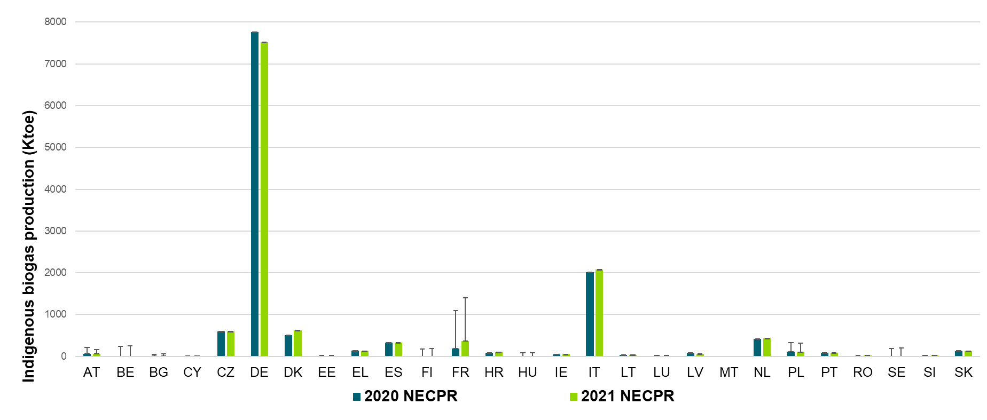

**Indigenous biogas production reported in 2020 (left bar) and 2021 (right bar) per MS. The error bars visualize the difference with the values as reported in the Eurostat energy balances. Source: NECPRs and [NRG_BAL_C]**

In the NECPRs, Member States reported their indigenous biogas production in 2020 and 2021. In 2020, according to the reported data, Germany was the largest producer of biogas, with 52.8 % of the total amount produced (7,765 ktoe), followed by Italy that accounted for 13.7% (2,018 ktoe), France 7.4% (1,090 ktoe) Czechia (4.1%, 595 ktoe), and Denmark (3.4%, 505 ktoe). In 2021, Germany remained the largest producer, accounting for 50,4% of the total production (7,518 ktoe), followed by Italy (13.9%, 2,078 ktoe), France 9.4% (1,404 ktoe) and Denmark (4.2%, 625 ktoe), which overtook Czechia (4.0%, 591 ktoe) in biogas production. Belgium, Finland, Hungary, and Sweden did not report any biogas production neither in 2020 nor 2021, whereas Estonia, Romania and Slovenia reported biogas production only in 2021. Czechia, Greece, Poland, and Latvia reported a decrease in biogas production of 18.5% from 2020 to 2021. The indigenous biogas production reported in the EU collectively in 2021 was14,929 ktoe, a 1.7% increase compared to 14,687 ktoe in 2020.

Twenty-one Member States reported in the NECPRs regarding the evolution of bioenergy supply and whether that has an impact on the overall and sectoral trajectories for renewable energy from 2021 to 2030. Eight Member States[9] stated that there were no significant impacts or updates to be reported. Of the remaining thirteen Member States, Hungary and Latvia stressed the impacts related to Russia’s war of aggression against Ukraine. Sweden emphasized that prices have risen because of the energy crisis. Some Member States (Estonia, Slovakia) reported that changes in legislation impact biomass use for energy production. Others (Italy, Slovenia) reported an expected increase in the use of biomass for energy production, in the years leading up to 2030.

***Biomass demand per sector***

Solid biomass is used in the industry, residential and energy sectors[10]. In 2021, 21.1 Mtoe of solid biomass were consumed in the industry sector, 45.1 Mtoe in the residential sector, and 33.0 Mtoe in the energy sector. Germany, France and Sweden are the largest consumers of solid biomass. The use of solid biomass in these sectors has increased by 13.4% compared to 2012.

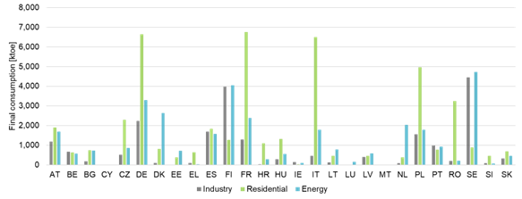

**Final consumption of solid biomass in the industry, residential and energy sectors in 2021 per EU Member State[11]**

***Transport sector***

In 2021, the final consumption of biofuels in the transport sector accounted for a total of 16.5 Mtoe in the EU[12] and has increased by 39% compared to 2013. In absolute terms, this increase is related to the increased biodiesel supply, however, in relative terms, the share of biodiesel in the total biofuel consumption in the transport sector remains quite stable at around 80%, including 2021. Biodiesel is used in all twenty-seven Member States. Bioethanol was the second most consumed fuel type and accounted for 18% but is used in all Member States except for Cyprus and Malta.

Biomethane and other liquid biofuels consumption is aggregated to less than 1% of the total amount of biofuels consumed in the transport sector. Six Member States[13] report on the use biogases in transport sector in the NECPRs. Sweden accounts for the 67.4% of the total EU biogases consumption in transport.

In 2020, primary production of liquid biofuels was 15.64 Mtoe, which, if net imports are added, amounts to 17.82 Mtoe of total energy supply. In 2021, primary production of liquid biofuels increased by 3% or to 15.96 Mtoe, with net imports growing by 7% or to 19.06 Mtoe. A similar increase is obtained when a set of multipliers on biofuels pursuant to Annex IX of the Renewable Energy Directive is applied: total RES-T denominator with multiplicators was 242.33 Mtoe (2020) and 263.80 Mtoe (2021[14]). Yet, given the return to a normal mobility in 2021, after the pandemic-related safety measures in 2020, the overall share of renewable energy in transport (RES-T) dropped from 10.25% to 9.09% from 2020 to 2021. In other words, the increase in biofuels production, together with the other renewable sources, was lower than the increase in the overall transport fuel consumption from 2020 to 2021. The largest drop in RES-T shares has been recorded for Hungary (-5.41%), although the quantity of renewable energy in transport placed on the market increased from 4.4 Mtoe in 2020 to 5 Mtoe in 2021.

Overall, in the transport sector, a continuously increasing shift towards the use of renewable energy can be observed[15]. Within the total, the use of advanced biofuels and other biofuels produced from feedstock listed in Annex IX of the Renewable Energy Directive as well as the share of renewable electricity has substantially increased over time. In 2021, such biofuels held the highest share of renewable energy in transport, representing 4.2% (with multipliers). Advanced biofuels and other biofuels produced from feedstock listed in Annex IX of the Renewable Energy Directive are mostly produced from wastes and residues and, therefore, do not have the negative impacts on land use that food and feed crops-based biofuels are associated with. However, in terms of renewable energy supplied (without multipliers), biofuels produced from food and feed crops continued to have the highest share of all renewable energy carriers (3.9% of total energy consumption in transport).

The largest consumption of biofuels produced from food and feed crops has been reported for France and Germany (2,562 ktoe and 2,122 ktoe respectively in 2021), which can be related to the country size and population. In Spain, a decreasing trend can be observed: biofuels produced from food and feed crops accounted for 1,737 ktoe in 2018 but dropped to 693 ktoe in 2021. In Finland, a large drop in food and feed crops biofuels has been obsered between 2020 and 2021 (from 303 ktoe to 65 ktoe).When it comes to the data related to the indirect land use change (ILUC) risk for biofuels, the data of fourteen Member States was incomplete. Germany reported that 42% of the food- and feed-originating biofuels were produced from feedstocks with high ILUC risk. Similarly, in Spain and Italy, more than 50% of food- and feed-originating biofuels have been reported to be produced with high ILUC risk feedstocks. According to the Renewable Energy Directive[16], the counting of biofuels with high ILUC-risk will be phased out by 2030 at the latest. Several Member States already took measures to phase out such fuels.

***Heating and cooling sector***

In 2021, biomass fuels and bioliquids were used for the production of 17.3 Mtoe of gross heat in the EU[17]. Solid biomass accounts for 76.0% of the total biomass fuel consumption for heating in the EU, followed by renewable municipal waste, accounting for 18.1%, and biogases accounting for 5.0%. Sweden is the largest consumer of solid biomass for heating purposes, using 20.8% of the whole EU consumption, followed by Finland (15.8%) and Denmark (13.1%). When it comes to biogas, this is mainly used in the heating sector by Germany and Italy.

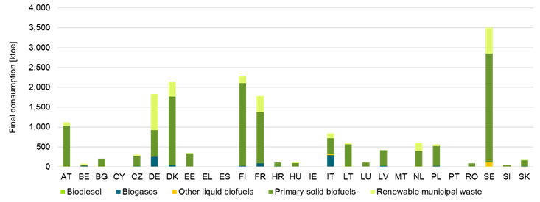

**Figure 27: Final energy consumption of biomass fuels used in heat production in 2021 per Member State**

***Electricity sector***

In 2021, 45.6 Mtoe of biomass fuels and bioliquids were used to produce 14.6 Mtoe of gross electricity[18] that made 15% of the total gross renewable electricity mix and 6% in the total gross electricity. 74% of gross electricity from biomass was produced in combined heat and power plants. Solid biomass is the most used type (54.8%), followed by biogases (31.1%). Renewable municipal waste accounts for 11.6%, whereas bioliquids account for 2.6%. Germany is the largest consumer of biomass fuels for electricity generation purposes (27.7% of the total biomass fuel consumption and 57.0% of the biogas consumption). When it comes to the consumption of solid biomass for electricity generation, Finland and Sweden are significant consumers (with 13.7% and 12.0% respectively). Belgium, Italy, and Slovenia consume, combined, only 1.1 ktoe of biodiesel for electricity generation purposes. The consumption of biomass fuels and bioliquids for electricity generation has seen a steady rise from 2012 and in 2021, mainly due to an increase of 28.7% in the use of solid biomass compared to 2012.

Overall, an increasing trend in the consumption of biomass can be observed in all three sectors.

***Outlook***

In general, Member States provided limited information on projected primary supply of biomass by feedstock and origin. From twenty-one Member States that have provided information, eight[19] state no significant impacts or updates to add. Five Member States[20] have expressed concerns meeting the demand with the indigenous supply of biomass to different sectors, given the physical constraints (limited potential, state of the forest health, limited infrastructure to have a larger bioenergy intake) and legal restrictions on the use of biomass. Five Member States[21] report stability of biomass demand, Slovenia reports an increase in woody biomass supply whereas the Netherlands introduces a cap on woody biomass for heating. France announces updates in trajectories and Spain highlights positive overall effects, without providing details. Submitted estimated trajectories for the sectoral share of renewable energy in final energy consumption by 2030 in the electricity, heating and cooling, and transport sector as well as by renewable technology, are not granulated sufficiently to provide a comprehensive insight on bioenergy demand, disaggregated between heat, electricity and transport, and on biomass supply by feedstocks and origin (distinguishing between domestic production and imports).

***Biomass Imports***

In the NECPRs, twenty-four Member States reported imported solid biomass[22]. Spain, Romania, and Luxembourg did not report any imported solid biomass. It should be noted that no Member State reported imports of agricultural biomass and stumps. Imports of solid biomass account for 19% of the total primary solid biomass for energy/bioenergy. The largest reported imported feedstock is black liquor[23] (677,404 thousand m3). Forestry-originating biomass was the second largest reported category and wood pellets were the most imported feedstock in this category (21,926 thousand m3), followed by roundwood, chips, saw dust and other wood particles.

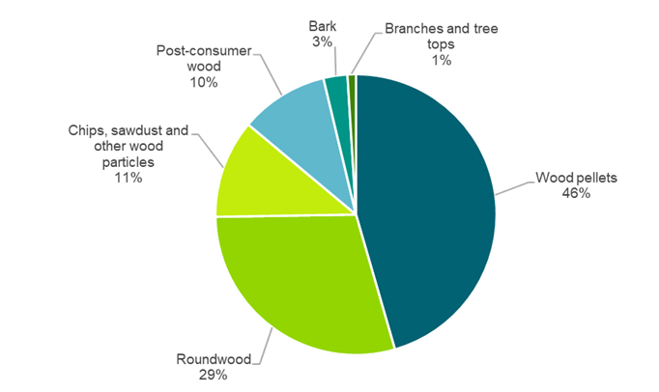

**Forest biomass feedstock used for energy production, reported as imported in EU[24]**

When it comes to wood pellet imports in the EU, the Netherlands is the largest importer[25] (almost 30% of the total EU wood pellet imports), followed by Denmark (26%)[26],[27]. Wood chip imports account for 8% of the total wood chip supply for energy consumption in 2021. France imported a third (33.2%) of the total wood chip imported volume; Lithuania followed with 22%, Latvia with nearly 10%, and Italy with nearly 9%. Overall, an increase of 27% has been observed in wood pellet imports since 2019, whereas the imports of wood chips decreased from 2019 to 2020 by 10%. Using Eurostat trade balances[28], it is possible to track the geographic origin of the wood pellets (up to 2021) and wood chips (only up to 2020). In both categories, Russia was the largest exporter to the EU, followed by the United States and Belarus in the case of wood pellets, and Belarus (that represents together with Russia 82% of the total wood chip imports), Norway (8%), Brazil (5%), Uruguay (4%) and Ukraine (2%) in the case of wood chips. After Russia’s unprovoked and unjustified military aggression against Ukraine, stakeholders have expressed concerns about the potential implications this could have on the prices of wood pellet and chip imports.

Organic waste imports account for 1% of the total organic waste supply for energy consumption in 2021. Only four Member States[29] reported importing organic waste biomass. Sweden is the largest organic waste and renewable municipal waste importer. The Netherlands and Belgium were the only Member States to report importing waste sludges, 56 thousand m3 and 4 thousand m3, respectively.

In total, in 2021, the EU imported feedstock equal to 8,194 ktoe[30] to produce biofuels. Bioethanol is mainly produced from feedstock originating from the EU (at a percentage of around 78%), whereas only around half of biodiesel (43%) is produced from EU-originating feedstock (figure below). When looking at biofuel imports, the biofuel feedstock in mainly imported from Indonesia and Malaysia with 17% of the total imports of biodiesel feedstock. The remaining 41% of the biodiesel feedstock imports is diversified across more than 9 countries worldwide.

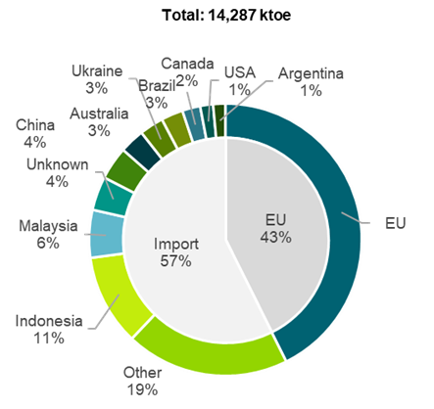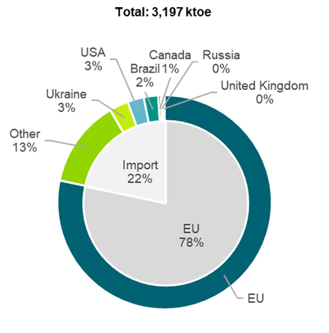

**Geographical origin of feedstock for biodiesel (left) and bioethanol (right) for the EU in 2021**

***Measures reported by the Member States to promote bioenergy and respect the sustainability criteria and GHG saving criteria set out in the Renewable Energy Directive***

The Renewable Energy Directive (RED II) promotes bioenergy as long as it is sustainable and certified as such. The Directive, including the stricter sustainability criteria in Article 29, had to be transposed by June 2021. The transposition checks are currently ongoing[31]. Most Member States have at least partially transposed Article 29 and updated their existing legislation to include the stricter rules included in the recast Directive. Some Member States have introduced, besides primary and secondary legislation, some guidelines or guidance in environmental or nature protection acts. In the NECPRs, Member States did not explicitly report on measures related to the sustainability criteria. However, Member States mentioned measures related to the transposition of the Directive (and therefore, including the implementation of the sustainability criteria). Sustainable certification was mentioned by two Member States: Spain reported a measure about renewable gas certified sustainably, while Italy reported two measures, one related to the establishment of a National Biofuels Sustainability Certification System, and the other related to an update to the certification system.

Only some Member States reported measures regarding the promotion of the sustainability of forest biomass for energy production, and only Spain reported two measures related to sustainable forest management and maintaining and improving forest reserves. No Member State reported anything about the challenges related to forest biomass availability.

As regards the LULUCF[32] criteria, Member States only provided limited information in their NECPRs. It should be noted that all EU Member States are signatory of the Paris Agreement and have submitted nationally determined contributions (NDC) to the United Nations Framework Convention on Climate Change (UNFCCC)[33]. thirteen[34] out of the eighteen Member States that reported in this section explicitly mentioned that they have implemented national or sub-national laws to ensure that emissions do not exceed removals.

To reduce the EU’s reliance on imported fossil fuels, the Commission has proposed, in the REPowerEU plan[35], to accelerate the production of sustainably produced biomethane (mainly from organic waste, forest and agricultural residues to avoid land-use change impact). A goal of 35 bcm of annual sustainable biomethane production by 2030 has been proposed to reduce imports of natural gas from Russia and to accelerate the EU’s clean energy transition. In the NECPRs, of the twenty-four Member States that already reported measures, twenty-one Member States reported measures related to the promotion of biogas and biomethane[36]and about one third of the reporting Member States mentioned measures promoting biomethane in the transport sector, mainly as a blending obligation. Other Member States reported at least one measure promoting or regulating the injection of renewable gas, namely biogas/biomethane, into the natural gas grid[37]. Sweden does not report on either the use of biomethane in transport, or biogas production in 2020 and 2021, even though it is one of the most mature biomethane markets in the EU and having the largest share of biogases use in transport. Similarly, Belgium, Finland and Hungary did not report in the NECPRs any biogas production neither for 2020 nor 2021.

In their NECPRs, some Member States referred to blending mandates and quotas for the promotion of advanced biofuels. In some cases (Denmark, France, Italy, Malta, Spain), those measures have already entered in force, whereas in others, such as Slovenia and Croatia, the measures to increase the share of advanced biofuels in the transport sector are to be introduced soon. Spain reported various measures that promote the production of advanced biofuels for use not only in road but also in the air and maritime transport sectors, but the regulatory framework for these measures is still under development.

In the NECPRs, Member States were asked to report on the changes in commodity prices and land use within their country, associated with increased use of biomass. For commodity prices, Member States have reported that even though commodity prices may have increased over the last years, this is not related to increased use of biomass for energy production. Spain reported that the share of feedstocks used for bioenergy purposes are small compared to the total amount of produced feedstocks. Cyprus and Estonia report that, in their countries, agricultural feedstocks are not used for energy production, therefore there is no correlation between the use of biomass for energy production and fluctuations in commodity prices.

When it comes to land-use, fourteen Member States have reported the relevant data[38], out of which five Member States[39] also provided quantitative data. Finland, Lithuania and Slovakia reported no change in land use. Denmark, Italy and Latvia reported an increase of land area related to bioenergy production. Denmark reported an increase in maize growing as biogas co-feedstock from 2,390 ha in 2012 to the current 17,433 ha in 2020/2021, although biogas production is relying dominantly on waste and residues. Italy reported land-use change without further details. Latvia reported an increase of 3.0% in 2021 compared to 2020 for cereals, but note that the change is negligible in comparison with the remaining cropland. Poland reported an annual 4% increase or estimated 797 kha of land for bioenergy cultivation in 2021. Luxembourg was the only Member State that reported a drop of 0.6 pp of land use for energy crops from 2018 to 2022. The dominant energy crop is maize for biogas (67% in 2022). Austria, Cyprus, Hungary, Malta, Spain and Sweden reported that there was either no or no significant amount of land used for bioenergy.

***Technological development and deployment of biofuels made from feedstocks listed in Annex IX to Directive (EU) 2018/2001***

Annex IX of the Renewable Energy Directive includes a list of feedstocks which can be used the production of biogas for transport, advanced biofuels and biofuelsto. Advanced biofuels are produced from feedstocks listed in Part A of Annex IX to the Renewable Energy Directive, whereas Part B lists feedstocks to produce biofuels and biogas for transport (together referred to in this section as “Annex IX biofuels”), the contribution of which towards the minimum share established in the first subparagraph of Article 25(1) shall be limited and may be considered to be twice their energy content. In the NECPRs, most Member States[40] have not reported the amounts of Annex IX use and production, whereas the units and years for which data has been provided differ per Member States. For the following analysis, data reported in SHARES is used.

The consumption of biofuels pursuant to Annex IX is shown in the figure below for the years 2017-2021. An overall increase is observed in Annex IX biofuels use, from 2,317 ktoe in 2017 to 5,474 ktoe in 2021. Consumption of biofuels produced from used cooking oil (UCO, Annex IX Part B (a)) is the highest of all Annex IX feedstocks. When it comes to Annex IX Part A feedstocks, consumption of biofuels derived from feedstocks listed in points (d) *biomass fraction of industrial waste not fit for use in the food or feed chain* and (g) *palm oil mill effluent and empty palm fruit bunches* is the highest. In contrast, biofuels from the following Annex IX Part A feedstocks are not used at all or used less than 1 ktoe throughout the whole EU in all considered years: (a) *algae if cultivated on land in ponds or photobioreactors*; (l) *nut shells*; (m) *husks*; (n) *cobs cleaned of kernels of corn* and; (q) *other ligno-cellulosic material except saw logs and veneer logs*.

**Trend of Annex IX biofuel demand for EU-27 from 2017 to 2021[41]**

Italy is the largest consumer of Annex IX biofuels and, along with Spain, the largest user of Annex IX Part A biofuels. Italy is also the largest consumer of Annex IX Part B biofuels, followed by Germany, Spain, the Netherlands, and Sweden. Other Member States (Romania and Latvia) did not consume any Annex IX feedstocks, while Austria consumed only a small amount (<1 ktoe).

**Split of Annex IX biofuel consumption per feedstock for each Member State in 2021[42]**

Ten Member States[43] reported on technological development and deployment of Annex IX biofuels, yet with fragmented and inconsistent data. Based on information available[44], there are at least 12 investments related to the production of hydrotreated vegetable oils (HVO) with annual capacity ranging from 24 to 1.300 kt per year in five Member States[45]. The largest single capacities are recorded in Sweden: Lysekil and Gothenburg, each of 1.300 kt of HVO production capacity. The second most represented technology is bioethanol production with six investments of 25 – 50 kt/yr capacity in six Member States[46]. Biomethanol production in five sites (capacity 5.25 – 450 kt/yr) is announced in three Member States[47]. Other investments are Fischer–Tropsch (France), biomethane, BioLPG, Naptha (all in the Netherlands) or unknown/various (Finland).

***Available scientific research results regarding indirect land-use change***

The Commission is monitoring the situation related to biofuels, bioliquids and biomass fuels with a high risk of indirect-land use change (ILUC) and will continue to regularly update the data based on latest scientific evidence. The Commission has launched two studies[48] in this regard and the assessment is currently ongoing. The results of the study will be used to support the Commission to also update, if needed, the criteria applied for identifying feedstock with high ILUC-risk and for certifying low ILUC-risk fuels.

Further guidance on the implementation of low ILUC-risk certification was included in Chapter V of the Implementing Regulation (EU) 2022/996[49] on certification rules for voluntary schemes. In Articles 24-27, the specific requirements for low ILUC-risk certification are explained, and rules for proving additionality and detailed guidance for complying with the requirements for production on unused or abandoned land and for determining additional biomass for yield increase measures are included. These technical rules aim to ensure a harmonized and robust approach across certification bodies. The Commission may further elaborate the guidance based on the results of pilot testing of the methodology that was recently completed as part of the above-mentioned studies contracted by the Commission.[50]

***Voluntary and national certification schemes under the Renewable Energy Directive***

Voluntary schemes and national certification schemes of EU countries help to ensure that biofuels, bioliquids and biomass fuels as well as renewable hydrogen and its derivatives (renewable fuels of non-biological origin or RFNBOs), and recycled carbon fuels (RCF) are sustainably produced by verifying that they comply with the EU sustainability criteria as well as with the relevant methodologies for RFNBOs and RCF.

As such, the schemes check that:

* production of feedstock used for the production of biofuels, bioliquids and biomass fuels does not take place on land with high biodiversity and that land with a high amount of carbon has not been converted for such feedstock production;
* electricity used for the production of renewable hydrogen is of renewable origin; and
* production of renewable fuels and gases leads to sufficient greenhouse gas emissions savings.

Several schemes also take into account additional sustainability aspects such as soil, water, air protection and social criteria. For the certification process, an external auditor verifies the whole production chain from the origin of the raw material and energy to the fuel producer or trader.

While the schemes are run privately, the European Commission can recognise them as compliant with the rules included in the Renewable Energy Directive. The recognition process is carried out in accordance with Article 30 (4) and (6) of the Renewable Energy Directive.

For a scheme to be recognised by the Commission, it must fulfil criteria such as:

* feedstock producers comply with the sustainability criteria and the criteria for RFNBOs production set out in the Renewable Energy Directive and its implementing legislation;
* information on the sustainability characteristics can be traced to the origin of the feedstock;
* all information is well documented;
* companies are audited before they start to participate in the scheme and recertification pr surveyance audits take place regularly; and
* the auditors have both the generic and specific auditing skills needed with regard to the scheme’s criteria.

The decision recognising a voluntary scheme has usually a legal period of validity of 5 years.

The Commission has so far formally recognised 15 voluntary and national certification schemes[51]. The Implementing Regulation (EU) 2022/996 has introduced new and strengthened rules in the area of bioenergy certification. The Commission has launched a formal process of reassessment of all the recognised schemes to ensure that they are still fit for purpose for certifying the compliance of economic operators with the sustainability criteria of the Renewable Energy Directive. This process will be completed by the end of 2023. In parallel, new assessment processes have been launched for schemes willing to certify Renewable Fuels of Non-biological Origin (RFNBOs) on the basis of newly adopted methodologies for assessing their sustainability.

The Commission plans to launch by the end of 2023 a comprehensive study on the performance of the certification system under the Renewable Energy Directive. The first results of this study can be expected at the end of 2024.

***Update on the Union database referred to in Article 28(2) of Directive (EU) 2018/2001***

Pursuant to Article 28 (2) of the Renewable Energy Directive, the Commission shall ensure that a Union database (UDB) is put in place to “*enable the tracing of liquid and gaseous transport fuels*”*.* In scope are *“biofuels, renewable fuels of non-biological origin and recycled carbon fuels in the transport sector”*. It should be noted that solid biomass fuels are excluded and the scope of the UDB currently only covers the transport sector. The Commission is in the process of putting the database into operation, which will ensure the traceability of renewable fuels and reinforce transparency. Implementing Regulation (EU) 2022/996 lays down specific rules to ensure that the compliance of biofuels, bioliquids and biomass fuels with the rules of the Renewable Energy Directive are verified in an efficient and harmonized way and that fraud is prevented.

According to the Renewable Energy Directive, Member shall require economic operators to enter information into the database, including for the sustainability and greenhouse gas emission saving characteristics of renewable transport fuels placed on the market. The UDB covers the entire supply chain, starting from the first gathering point for agricultural or forestry raw material or collection point for wastes and residues up to the point of consumption. For gathering and collecting points, this means that also the points of origin will need to be documented in the UDB and all deliveries from these points of origin will have to be registered in the UDB. Similarly, all dependent warehouses and dependent collecting points covered by group certification will need to be recorded so that the relevant material can be traced back at each location where it has been stored.

During 2022, the first pilot testing of the UDB was undertaken by around 20 economic operators. Following this process, the UDB was formally launched on 16 January 2023 with the aim to onboard all the respective economic operators, the voluntary international and national verification schemes, and EU Member States. Member State’s national databases can also be linked to the UDB. The onboarding is taking place in stages and involves the registration of all relevant user information. Economic operators have to provide information on the certified site as well as the active certificate of conformity. A National Trade Register Identifier (NTR ID)[52] is also required to ensure that each economic operator can be uniquely identified by third parties. The Commission has also launched an online Wiki page in March 2023 to support this process. This provides background information on the UDB, relevant training material, and frequently asked questions[53].

As of 1 September 2023, about 8,000 economic operators have been onboarded with the support of the voluntary schemes out of an estimated total of about 12,000. Member States have also started the process on their side by identifying and onboarding the institutional users of the system. Initial stock registration of raw materials and fuels is envisaged to commence once at least 80% of the economic operators have been onboarded. The stocks registered should correspond to the net mass balancing figure of the last mass balance period. After this time, economic operators will be able to register and manage transactions of incoming and outgoing material in the UDB. Transactions will need to be registered within 72 hours of the traded date/shipment and the accompanying sustainability certificates must be updated before the end of the mass-balance period.

1. Regulation (EU) 2018/1999 of the European Parliament and of the Council of 11 December 2018 on the Governance of the Energy Union and Climate Action, OJ Regulation (EU) 2018/1999.
2. Eurostat: Energy Balances 2021.
3. Eurostat: Supply of biomass - annual data.
4. Eurostat: Supply of biomass, annual data.
5. Eurostat: table NRG_CB_RW.
6. Eurostat: table NRG_CB_RW.
7. Ibid.
8. Eurostat: Supply of biomass, annual data.
9. AT, BG, CY, CZ, DK, EL, FI, and PT.
10. Eurostat: table NRG_BAL_C.
11. Eurostat: Energy Balances 2021 table NRG_BAL_C.
12. Ibid.
13. AT, CZ, DK, EE, FI, IT, SE.
14. Eurostat: SHARES data
15. Ibid.
16. Directive (EU) 2018/2001 on the promotion of the use of energy from renewable sources, OJ L 328, 21.12.2018, p. 82.
17. Eurostat: Table NRG_BAL_C Flow ‘Gross Heat Production’ (complementing indicator). This indicator includes: Main activity producer heat only + Main activity producer CHP + Autoproducer heat only + Autoproducer CHP. Product codes: biodiesel [R5220P + R5220B]; biogases [code: R5300]; other liquid biofuels [R5290]; primary solid biofuels [R5110-5150_W6000RI]; renewable municipal waste [W6210]. Energy Balances dataset (code: NRG_BAL_C). Please note that this indicator represents ‘Transformation output’ values. Hence, for heat production this refers to the energy that is obtained from biomass fuels and bioliquids after conversion.
18. Eurostat: Table NRG_BAL_C . Flow ‘Gross Electricity Production’ (complementing indicator). This indicator includes Main activity producer electricity only + Main activity producer CHP + Autoproducer electricity only + Autoproducer CHP. Product codes: biodiesel [R5220P + R5220B]; biogases [code: R5300]; other liquid biofuels [R5290]; primary solid biofuels [R5110-5150_W6000RI]; renewable municipal waste [W6210]. Energy Balances dataset (code: NRG_BAL_C).
19. AT, BG, CY, CZ, DK, EL, FI, and PT.
20. HR, ES, HU, LT, SE.
21. IT, MT, LV, SK, SE.
22. Eurostat: Supply of biomass, annual data.
23. Black liquor is a pulp industry by-product where each ton of wood pulp generates 7 tons of black liquor as byproduct; this means that the volume may be high but of low energy density compared to the original wood used for the pulping processing.
24. Eurostat: Supply of biomass - annual data (NRG_CB_BM).
25. Ibid.
26. More information on wood pellet imports can be found in Eurostat, EU trade since 1988 by HS2-4-6 and CN8.
27. The Netherlands and Denmark were found to be the two largest importing countries in both datasets. According to Eurostat wood pellet imports: 34% of the total imported wood pellets were imported in the Netherlands, 15% in Denmark, 12% in Belgium, and 8% in Latvia in 2021.
28. It should be noted that the reported data are for the total wood pellets imported to the EU, thus not only for energy production.
29. BE, NL, PT. SE.
30. European Commission (2023): Union Bioenergy Sustainability Report – Study to support reporting under Article 35 of Regulation (EU) 2018/1999 (draft), to be published.
31. <https://ec.europa.eu/atwork/applying-eu-law/infringements-proceedings/infringement_decisions/>
32. Land use, land use change and forestry.
33. <https://unfccc.int/NDCREG>.
34. AT, BG, CZ, DK, EE, ES, FI, HR, LT, NL, PT, SI, SE.
35. COM(2022) 230 final.
36. AT, BE, CY, DK, EE, EL, ES, FI, FR, HR, HU, IE, IT, LT, LV, NL, PT, RO, SE, SI, and SK.
37. DK, ES, FR, IT, PT, SE and SK.
38. AT, CY, DK, ES, FI, HU, IT, LV, LT, LU, MT, PL, SK and SE.
39. DK, LV, LT, LU, PL.
40. Reported amounts of Annex IX biofuels in the NECPRs: DK, ES, IE, IT, LU.
41. Source: Eurostat SHARES database.
42. Ibid.
43. BG, FI, FR, IT, NL, PL, RO, SK, ES, SE.
44. European Commission (2023): Union Bioenergy Sustainability Report – Study to support reporting under Article 35 of Regulation (EU) 2018/1999 (draft), to be published
45. FI, FR, NL, PL, SE.
46. BG, FI, IT, PL, RO, SK.
47. ES, NL, SE.
48. <https://iluc.guidehouse.com/>.
49. Commission Implementing Regulation (EU) 2022/996 of 14 June 2022 on rules to verify sustainability and greenhouse gas emissions saving criteria and low indirect land-use change-risk criteria, OJ L 168, 27.6.2022, p. 1.
50. <https://guidehouse.com/case-studies/energy/2021/biofuels-with-indirect-land-use-change-risk>.
51. More information along with the recognising decisions can be found in the following link: <https://energy.ec.europa.eu/topics/renewable-energy/bioenergy/voluntary-schemes_en>.
52. The NTR ID is country-specific and could be a VAT number, business register number, or equivalent.
53. <https://wikis.ec.europa.eu/display/UDBBIS/Union+Database+for+Biofuels+-+Public+wiki>.