Commission report on energy subsidies in the EU

Introduction and main findings
The European Union is firmly committed to reducing its greenhouse gas (GHG) emissions by at least 55% (compared to 1990) by 2030 and to become climate neutral by 2050. Subsidies and other economic and legal incentives will play an essential role in: (i) accelerating the deployment of clean-energy and energy-efficient solutions; and (ii) reducing the use of fossil fuels. Subsidies can have economic, environmental, or social welfare purposes. If they are poorly designed, subsidies can distort competition, act against the energy transition, and reduce the carbon price signal. The EU is actively engaged to phase out fossil fuel subsidies also as part of the EU’s international commitments made in the context of the G20 and in the World Trade Organization. The current report is the fourth annual report monitoring energy subsidies and progress towards phasing out fossil-fuel subsidies, as prescribed by the Regulation on the Governance of the Energy Union and Climate Action.
The energy crisis that started in 2021, and which was aggravated by the Russian aggression to Ukraine in 2022, had significant consequences for energy-related subsidies. These consequences can be seen in: (i) the amount of these subsidies; (ii) the distribution of these subsidies across technologies and beneficiaries; and (iii) the instruments used to provide these subsidies. Russia’s weaponisation of energy supplies and the progressive cuts in Russian gas supplies required a strong EU policy response, including short-term measures to ensure the affordability of energy for vulnerable consumers and industries all over Europe.
The results of this study confirm that energy subsidies followed a gradually increasing trend until 2021, and increased dramatically in 2022. Total energy subsidies in the EU rose from EUR 177 billion in 2015 to EUR 216 billion in 2021, to reach an estimated EUR 390 billion in 2022.
The trend of decline in fossil fuel subsidies continued until 2021, when they were at EUR 56 billion, before increasing rapidly to an estimated EUR 123 billion in 2022 in response to the crisis. Renewable energy subsidies fell in 2021 to EUR 86 billion - the first time since 2015 - and rose only slightly to EUR 87 billion in 2022. This was due to high prices on the wholesale electricity market that reduced the subsidy amounts paid under dynamic support instruments. On the other hand, support to energy-efficiency measures increased from EUR 22 billion in 2021 to EUR 32 billion by 2022. Support to all other forms of energy, including electricity as a carrier and nuclear amounted to EUR 180 billion in 2022.
In 2021-2022, energy subsidies linked to new national measures to protect EU consumers from the high prices accounted for an estimated EUR 195 billion. Across the EU, at least 230 temporary national measures were introduced to address the energy price crisis. Households were the main direct beneficiaries of these support measures (EUR 58 billion), followed by business and industrial consumers (EUR 45 billion) and road transport (EUR 23 billion). Cross-sectoral support was EUR 69 billion.
2022 was the first year that, as part of their integrated national energy and climate progress reports, Member States had to report on the progress they had made towards phasing out energy subsidies, in particular for fossil fuels. In addition, this report includes a new section assessing the environmental impact of fossil-fuel subsidies.
This report relies on data from an external study conducted for the Commission using an internationally accepted methodology. Some 2022 data were not fully available or validated at the time the study was completed (August 2023), so 2022 figures may rely on data gap mitigation techniques. As in previous editions, Member States were given the opportunity to provide feedback on the data used for the study.

Energy subsidy trends in the EU
Subsidies in this report are defined following the methodology set forth by the World Trade Organization (WTO), which was used in the supporting Commission study and the previous editions of this report. This methodology defines subsidies as government measures falling into one of the following four categories: (i) direct transfers of funds; (ii) government (tax) revenue that is otherwise foregone (not collected); (iii) governments providing goods and services or purchasing goods; and (iv) price and income support.
The report also examines various characteristics of subsidies: (i) the goal they seek to promote (production, consumption/demand, infrastructure or energy efficiency); (ii) the fuel type they promote (fossil fuels, renewables, nuclear); (iii) economic sectors receiving the subsidy (the energy sector, transport, industry, agriculture, residential, services, etc.); or (iv) whether they are environmentally harmful or beneficial.

Total energy subsidies in the EU
The total amount of energy subsidies in the EU-27 (Figure 1) is estimated at EUR 390 billion in 2022 (+80% compared to the EUR 216 billion in 2021).
The economic recovery in 2021 put upward pressure on energy prices and consequently on subsidies. Energy subsidies already rose from EUR 200 billion in 2020 to EUR 216 billion in 2021. The estimated 2022 data shows that due to the impact of measures taken by Member States, subsidies increased dramatically to reach EUR 390 billion in 2022. In response to the energy price crisis, at least 230 temporary subsidy measures were created or expanded in Member States across the EU to alleviate the impact of high and volatile prices.
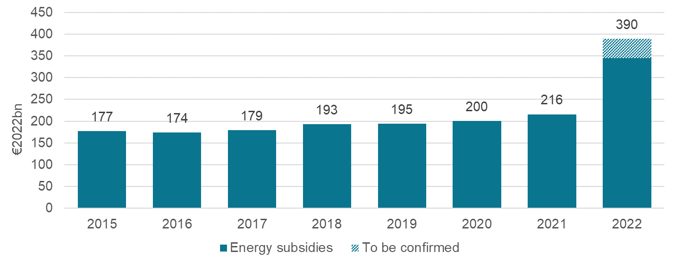
Figure 1: Total energy subsidies in the EU-27 (2015-2022; EUR2022bn)
Source: Enerdata, Trinomics, 2023. NB: 2022 estimates are represented with hatching
The subsidy support evolved differently across technologies in 2022. Electricity subsidies increased threefold, while overall fossil fuel subsidies doubled in 2022 compared with 2021. Subsidies supporting all energies (e.g. through income support) were 2.4 times higher in 2022 than in 2021. While renewable energy support remained broadly the same in 2022 as in 2020-2021, support to energy efficiency measures increased by 40% in this period, mainly due to the support for energy renovations provided as part of the Recovery and Resilience Facility (RRF).
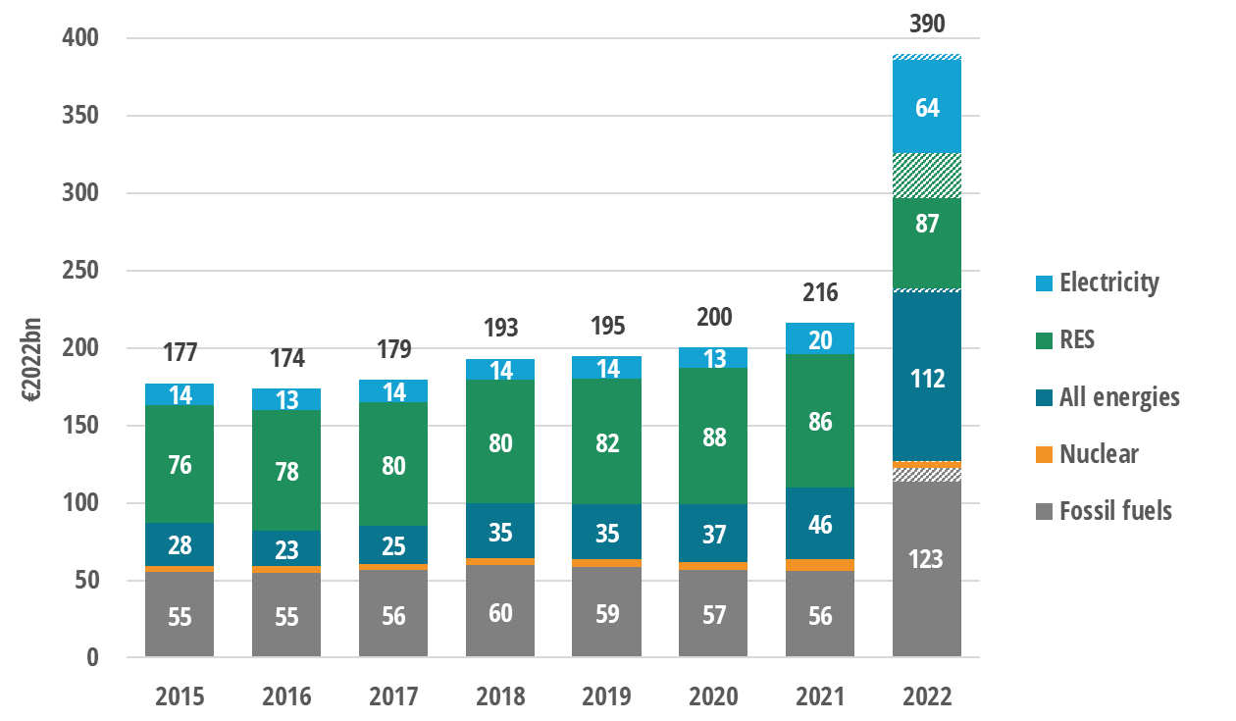
Figure 2: Subsidies by main energy source / energy carrier in the EU-27 (EUR2022bn)
Source: Enerdata, Trinomics, 2023. NB: 2022 estimates are represented with hatching
Energy subsidies in 2022 were distributed (Figure 3) primarily through income/price support measures (38%), tax reduction measures (35%) and direct transfers (25%). In 2022 fossil fuels accounted for the largest share of the total subsidies (31%), while renewable energy sources received only 22% of energy subsidies in 2022, down from 40% in 2021.
Figure 3: Subsidy distribution by instrument (2022, %)
Source: Enerdata, Trinomics, 2023

Subsidies by energy source
In 2021, fossil fuel subsidies fell to EUR 56 billion, continuing the steady downward trend observed since 2018 (Figure 4). The fall was mainly due to a large decrease (EUR 2 billion) in subsidies to the energy industry. This downward trend has been disrupted in 2022 as a direct consequence of the European response to the energy crisis. Subsidy measures were one of the primary tools to counteract the effects of high energy prices on the cost of living and on the production costs of European industries.
As a result, fossil subsidies are estimated to have more than doubled between 2021 and 2022 (from EUR 56 billion to EUR 123 billion). This increase reflects: (i) the much larger support households now receive (+500%); (ii) increased subsidies for the transport sector and the energy industry (+150% and +280% respectively); and (iii) other cross-sectoral measures (+770% through, for example, lower VAT rates). Direct support to industry and agriculture remained stable or rose only very slightly between 2021 and 2022.
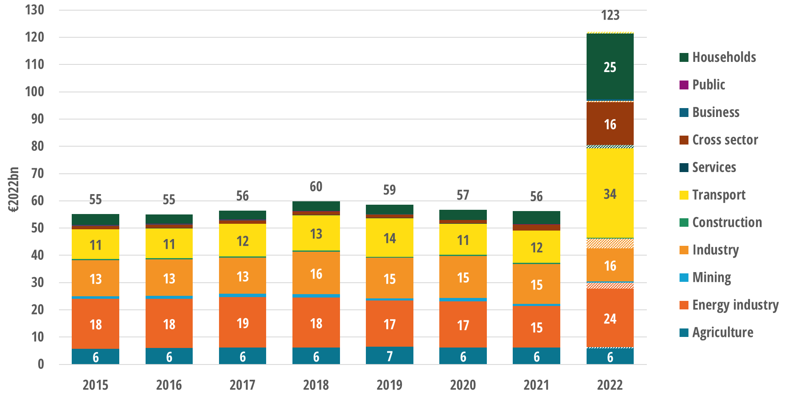
Figure 4: Fossil fuel subsidies in the EU-27 by economic sector (EUR2022bn)
Source: Enerdata, Trinomics, 2023. NB: 2022 estimates are represented with hatching
Most of the fossil fuel subsidies allocated in the EU-27 since 2015 have been intended to support consumers’ energy demand, for example by limiting the costs of energy consumption through lower tax rates on energy products. The share of these energy demand measures grew from 67% in 2015 to 74% by 2021 and estimates suggest that they will have grown to 83% of fossil fuel subsidies in 2022. Fossil fuel subsidies have aimed at supporting electricity production ranged between 20% and 30% since 2015, and are estimated to have dropped to 10% of all fossil fuel subsidies in 2022. Subsidies specifically directed to fossil fuel extraction and supporting infrastructure received EUR 13 billion and EUR 6 billion, respectively; while energy industry restructuring (such as support for closing coal/lignite power plants or mines) represented a small and decreasing share of the total fossil fuel subsidies (3.4% or EUR 1.7 billion) in 2021.
While most of the fossil fuel support went to oil and refined oil products (EUR 56 billion) in 2022 (Figure 5), subsidies aimed at natural gas tripled from 2021 to 2022 and reached EUR 46 billion. Support to coal and lignite remained the same at EUR 8 billion, while all other types of fossil, including peat, received EUR 13 billion.
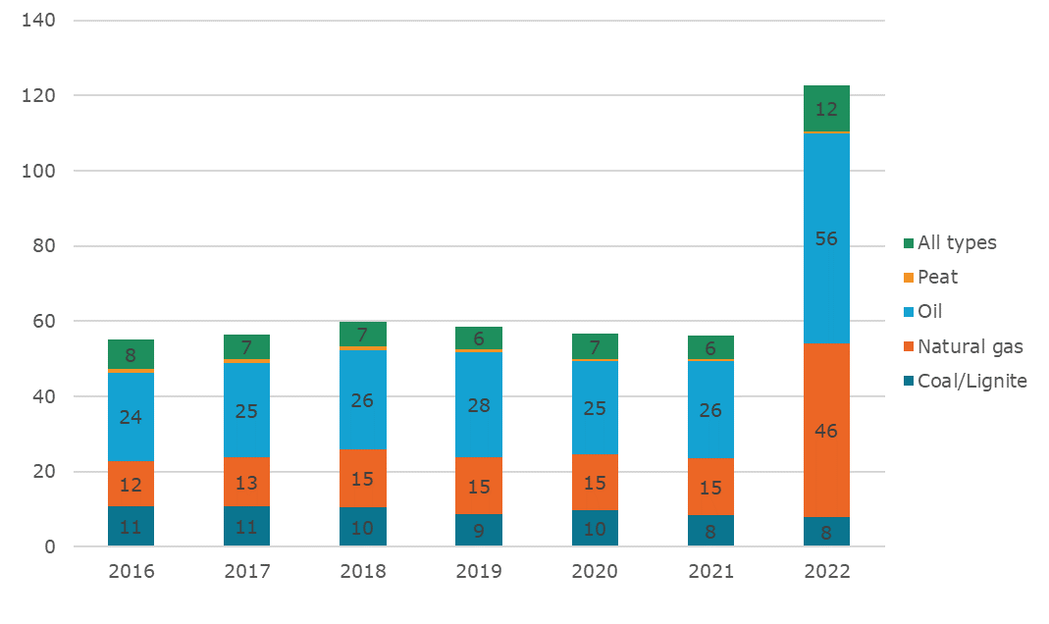
Figure 5: Fossil subsidies by type of fuel
Source: Enerdata, Trinomics, 2023.
In 2021, subsidies for renewable energy sources decreased for the first time in several years (Figure 6) to EUR 86 billion (-EUR 1.3 billion or -1.5% compared with 2020). This decline was mainly due to the increase in wholesale electricity market prices, which has led to a decrease in payments of support instruments that provide a top-up to market prices. The decline in subsidies for renewable energy came also in spite of the increase in installed and supported RES generation capacity. In 2022, RES subsidies rose only slightly to EUR 87 billion, and were below the level of fossil fuel subsidies for the first time since 2015.
In 2022, the typical instrument for providing subsidies to RES continued to be income/price support (EUR 57 billion, 65% of all RES subsidies) through, for example, measures such as feed-in tariffs and feed-in premiums (FiT/FiP) or RES quotas with tradable certificates. Direct transfers (mainly grants) increased significantly to reach EUR 8 billion in 2021 (EUR 5 billion more than in 2020) and EUR 9 billion in 2022. This increase was largely due to support for RES production and electricity infrastructure included in Member States’ recovery and resilience plans, as well as increased support for boosting renewable energy and energy efficiency in heating and cooling.
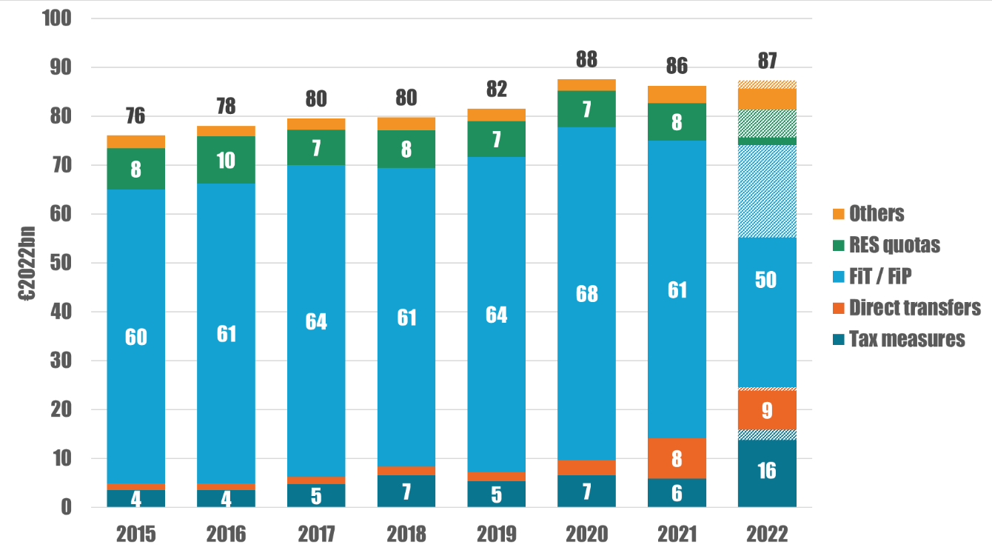
Figure 6: Renewable energy subsidies by instrument (2015-2022; EUR2022bn)
Source: Enerdata, Trinomics, 2023. NB: 2022 estimates are represented with hatching
Support for renewable technologies varies significantly across the EU (Figure 7), reflecting national priorities and RES potentials. Across all Member States, solar energy (both solar PV and concentrated solar) received the most subsidies in 2022 (EUR 25 billion), followed by wind and biomass (EUR 15 billion each). Hydropower received the least financial support (EUR 1.5 billion in 2022). Subsidies not targeted at any particular renewable technology were also widely used (EUR 24 billion).
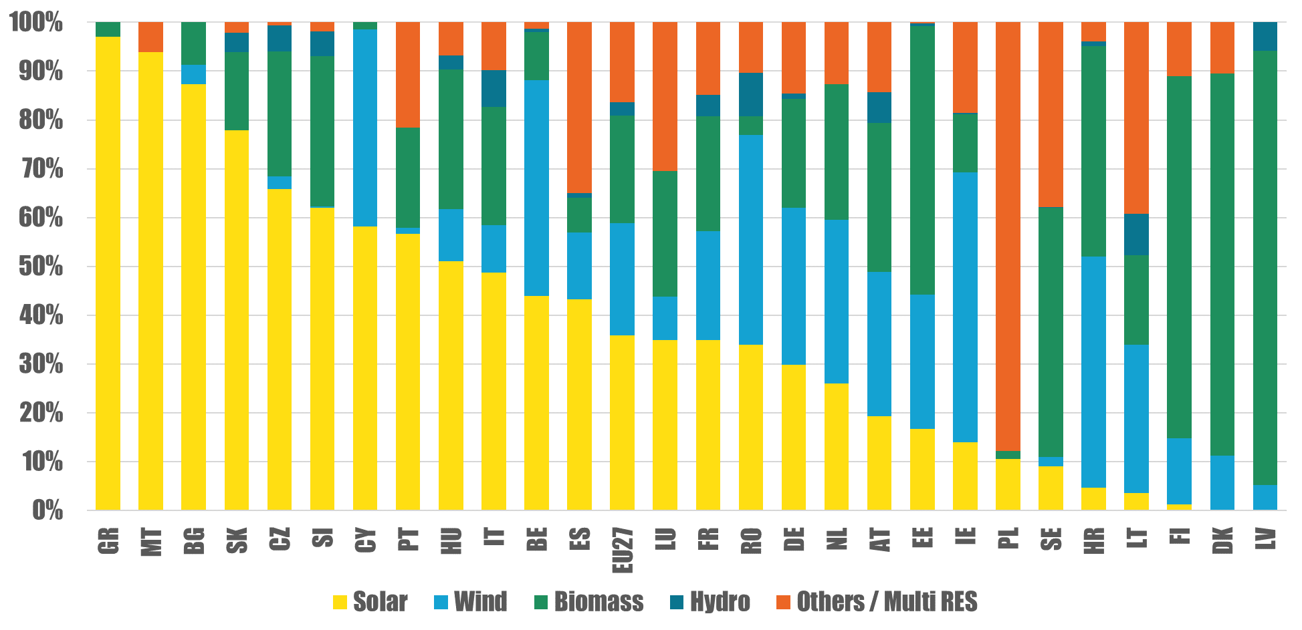
Figure 7: Share of RES subsidies by technology for selected Member State (2021; EUR2022bn)
Source: Enerdata, Trinomics, 2023
Energy-efficiency subsidies (Figure 8) have increased since 2015 and by 2022 had reached EUR 30 billion (EUR 8 billion more than in 2021). Grants were particularly significant as a support instrument, accounting for over 50% of all energy efficiency subsidies in 2022. In 2021-2022, energy efficiency grants expanded in parallel to the implementation of the investments in the Recovery and Resilience Facility, followed by tax expenditures, soft loans and energy efficiency obligations (23%, 20% and 6% of energy efficiency subsidies, respectively).
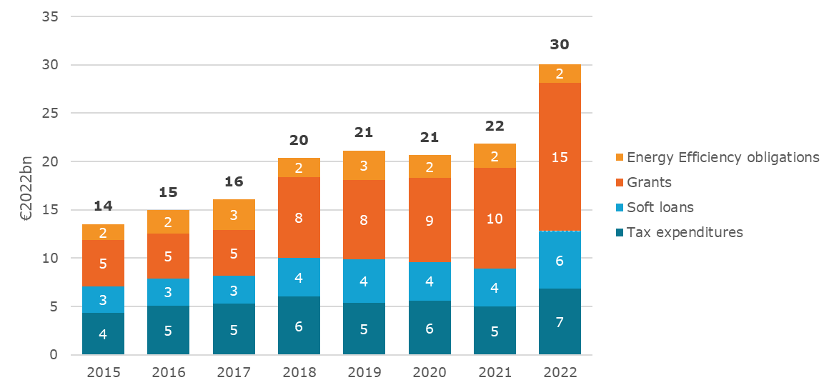
Figure 8: Support for energy efficiency instruments (2022; EUR2022bn)
Source: Enerdata, Trinomics, 2023
Subsidies for nuclear energy increased from EUR 4.3 billion in 2015 to EUR 7.6 billion in 2021 and then dropped to EUR 4.2 billion in 2022. This sudden decrease was due to: (i) the drop in the volume of capacity market mechanisms (in France, Germany and Italy); (ii) the low availability of the nuclear fleet in France; as well as (iii) the payments associated with the German decision to close three nuclear plants at the end of 2021. In 2022, France (EUR 2.3 billion) and Germany (EUR 1.1 billion) accounted for most of the nuclear subsidies in the EU.

Subsidies by economic purpose
Although the total amount of energy subsidies for the year 2022 has almost doubled compared with 2021, there was a significant difference in the categories that accounted for this growth according to the economic purpose of the subsidy (Figure 9).
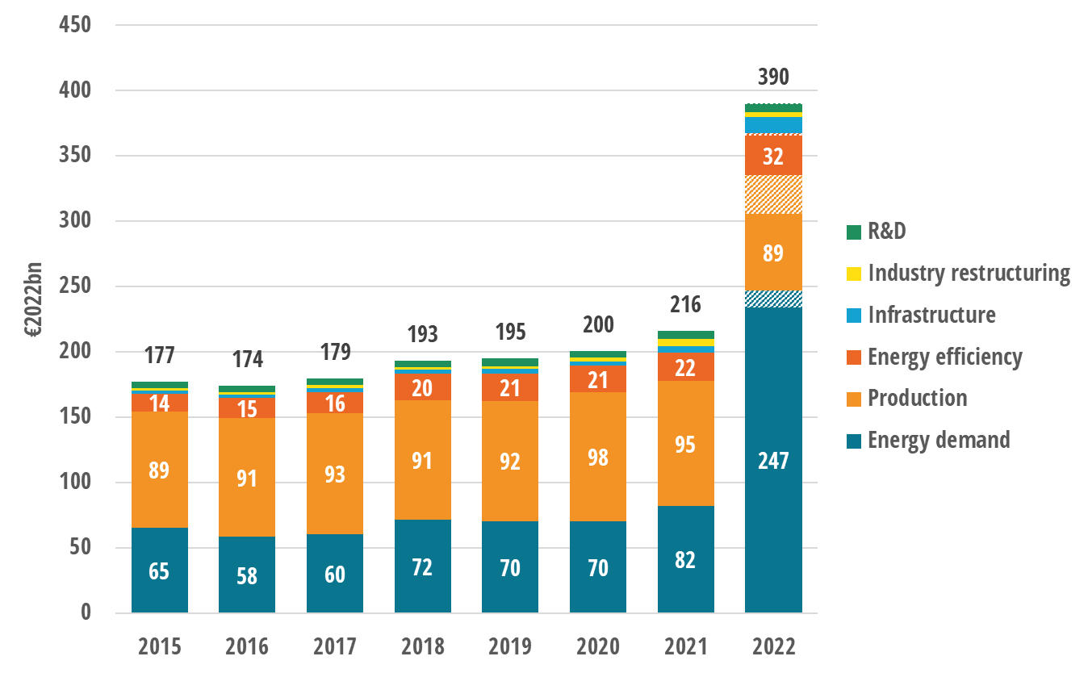
Figure 916: Energy subsidies by economic purpose (2015-2022; EUR2022bn)
Source: Enerdata, Trinomics, 2023. NB: 2022 estimates are represented with hatching
Financial support directed to energy demand has tripled in 2022 compared with 2021, reaching EUR 247 billion. In the same period, support for energy efficiency measures increased by 50% (from EUR 21.8 to EUR 32 billion), subsidies for infrastructure development increased by 250% (from EUR 4.9 billion to EUR 12 billion), while support for energy industry restructuring and energy production have decreased by 33% and by 7%, respectively.
Subsidies for energy demand include targeted or generic support measures aimed at limiting the costs of energy consumption in various economic sectors. These measures can be implemented through mechanisms like tax reductions or refunds, and they address a wide range of economic sectors, from energy-intensive industries to households. These kinds of subsidies target all types of energy including renewables, fossil fuels, electricity, and heat, regardless of their origin.
By 2020, overall subsidy support to energy demand grew to EUR 70 billion (Figure 10), increasing by 17% in 2021. This support was then estimated to have tripled between 2021 and 2022 to reach EUR 247 billion. This was the direct consequence of the cost-of-living crisis and the Russian weaponisation of gas supplies and is mostly related to policy support measures that have been put in place by governments since the end of 2021 and further strengthened in 2022.
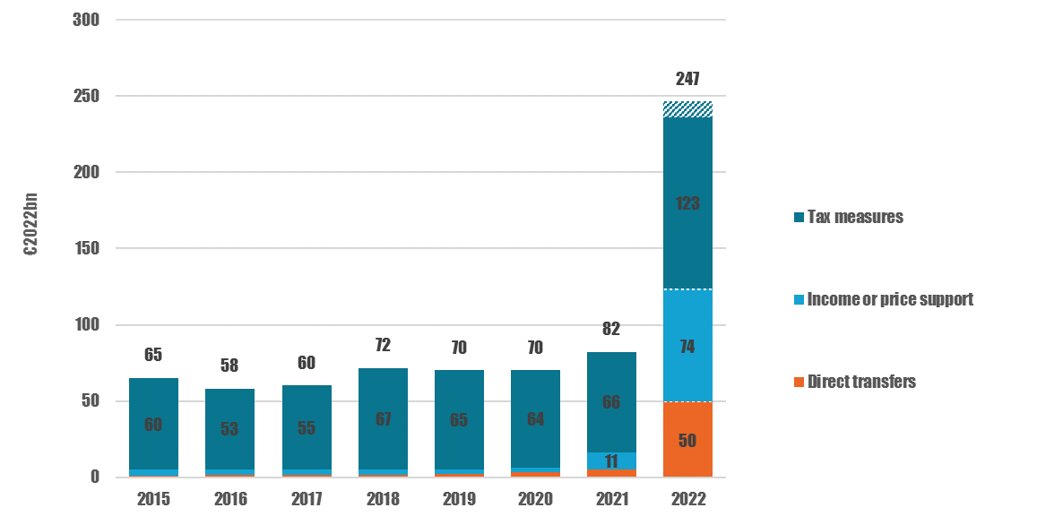
Figure 10 Subsidies supporting energy demand by instrument (2015-2022; EUR2022bn)
Source: Enerdata, Trinomics, 2023. NB: 2022 estimates are represented with hatching
Before 2021, direct tax measures represented more than 90% share of total subsidies for energy demand. However, since 2021, direct transfers and consumer price guarantees (income or price supports) have been brought back as part of the policy measures, changing the balance between these instruments for promoting energy demand. In 2022, tax expenditures represented 50% (EUR 123 billion) of the overall support to energy demand, followed by price supports and price guarantees (30%, EUR 74 billion), and direct transfers (20%, EUR 50 billion).

Focus on subsidy measures related to the energy price crisis
The European Commission has been working together with Member States to tackle the energy crisis. This has included working to: (i) secure alternative energy supplies; (ii) reduce energy demand to compensate for the shortfall of Russian gas deliveries; (iii) make greater use renewables; and (iv) increase energy efficiency. In addition to implementing measures introduced at Union level or enabled by Union-level frameworks, Member States also adopted their nationally-tailored measures to shield their citizens and their economy from damaging energy prices (Figure 11).
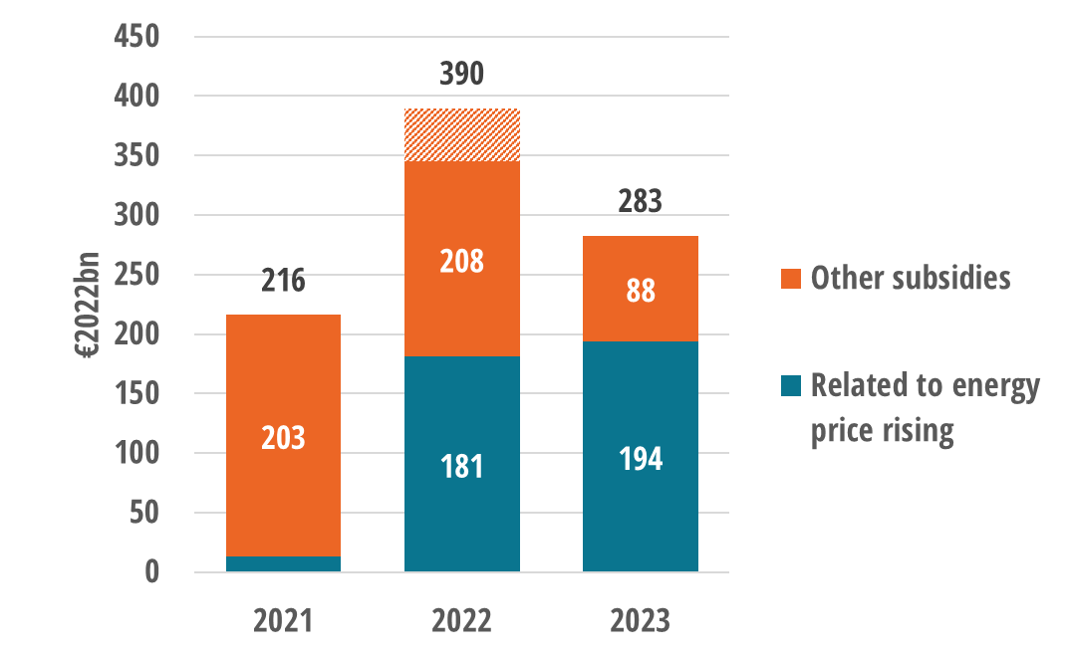
Figure 11: Relevance of energy subsidies to the energy price crisis (2021-2023; EUR2022bn)
Source: Enerdata, Trinomics, 2023
Through these new national measures, Member States provided an estimated EUR 181 billion in subsidies in 2022 for this purpose, accounting for almost 50% of total energy subsidies in the EU-27 in that year. Initial figures for 2023 show a continuation of this support but only in the medium term: almost 80% of the payments under these measures are planned to end before 2025, while 20% of payments have a planned end-date after 2025 or have no end-date at all.
Subsidies to address the energy crisis measures accounted for 1.12% of the EU’s GDP in 2022. Italy, France, and Germany accounted for almost 70% of this total spending (Figure 12). Relative to its GDP, Greece spent the most of any EU Member State in 2022 to address energy prices (5.3% of the GDP).
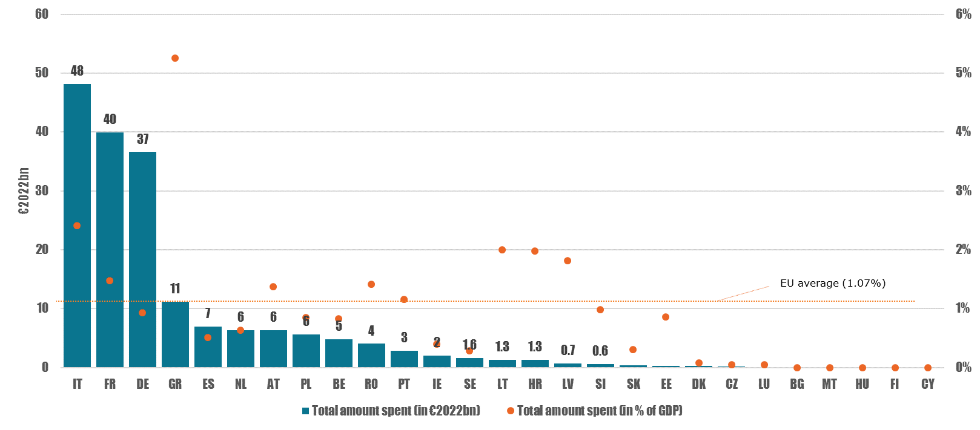
Figure 1216: Subsidies to address rising energy prices, by country, in 2022 (in EUR2022bn and % of GDP)
Source: Enerdata, Trinomics, 2023
Figure 13.a shows that, over 2021-2022, most of the targeted subsidies were aimed towards households (EUR 58 billion, 30% of the total crisis support), followed by businesses and industries (EUR 34 billion, 18%), and the transport sector (EUR 23 billion, 12%). A significant amount (EUR 69 billion, 33% of total crisis support) was untargeted and covered multiple sectors.
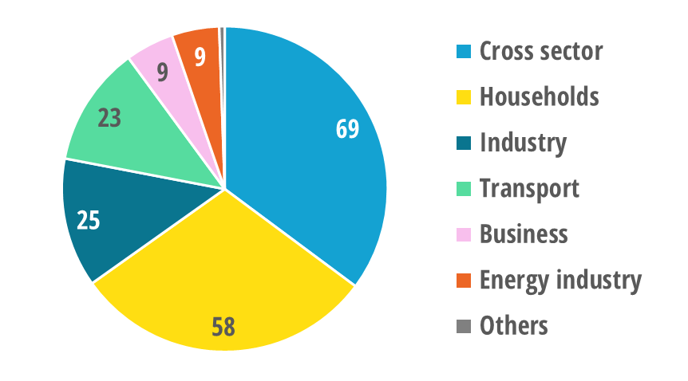
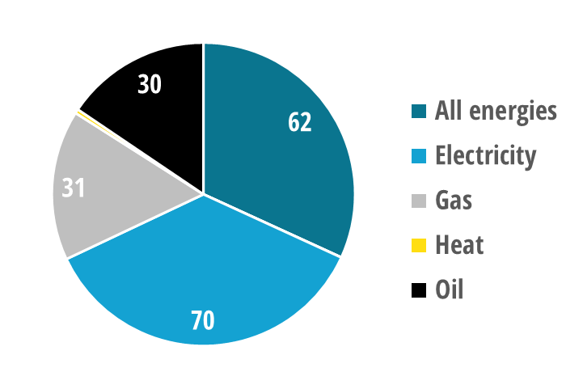
Figure 13: Distribution of subsidies addressing energy price increases in 2021-2022 (EUR2022bn)
a) by economic sector b) by energy carrier
Source: Enerdata, Trinomics, 2023
Concerning energy carriers (Figure 13.b), electricity was the main beneficiary, receiving more than a third (EUR 70 billion) of the financial support in 2021-2022. Subsidies for gas and oil accounted for EUR 60 billion, while EUR 62 billion was allocated for energy produced from a mix of both fossil fuel and low carbon sources or from unknown sources (indicated as ‘All energies’).
European governments have taken special measures in response to the crisis to provide substantial support directly to energy companies. For instance, in Germany, Uniper was supported through capital injection (EUR 34 billion), while in France, EDF was re-nationalised (EUR 9.4 billion). Since the ultimate aim of these measures was to ensure security of supply as well as lower prices to customers or the wholesale market, they were not included in the subsidy database.

Subsidies by beneficiary economic sector
The energy industry was the most subsidised economic sector in 2021, receiving more than half (EUR 111 billion, 51%) of all energy subsidies that year, of which EUR 61 billion were feed-in-tariffs / feed-in-premiums (not differentiated in Figure 14). The second and third largest recipients of energy subsidies were other industry sectors (EUR 32 billion, 15%) and households (EUR 27 billion, 13%).
Data for 2022 shows a significant change in the composition of subsidies. Support to households increased (rising by 240% from 2021 to EUR 94 billion in 2022, or 24% of all energy subsidies in that year). Cross-sectoral subsidies was the next largest category (EUR 75 billion, 20%), while industry only received a moderate increase in support between 2021 and 2022 (EUR 53 billion, 13%). By contrast, the energy industry received slightly less in subsidies for 2022 (EUR 109 billion) than it did in 2021, and its share of total subsidies dropped from 50% to 28% between 2021 and 2022.
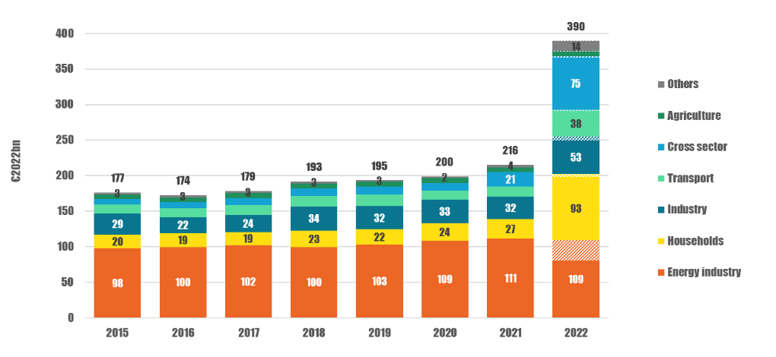
Figure 14: Energy subsidies by economic sector in the EU-27 (2015-2022; EUR2022bn)
Source: Enerdata, Trinomics, 2023. NB: 2022 estimates are represented with hatching
In 2022, total subsidies to the transport sector (Figure 14) grew to an estimated EUR 38 billion (+155% or +EUR 24 billion compared to 2021). Road transport remains by far the largest recipient, accounting for 83% of transport subsidies (EUR 31 billion). It is followed by air transport (EUR 3.6 billion), water (EUR 1.8 billion) and rail transport (EUR 1 billion).
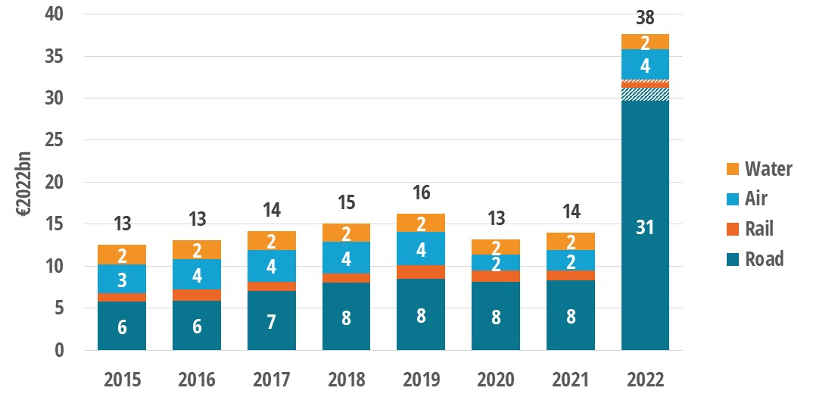
Figure 15: Energy subsidies by transport mode (2015-2021; EUR2021bn)
Source: Enerdata, Trinomics, 2023. NB: 2022 estimate are represented with hatching

Subsidies by environmental impact
The European Union, as party to the Global Biodiversity Framework (GBF), has agreed to “identify by 2025, and eliminate, phase out or reform incentives, including subsidies, harmful for biodiversity.” The Commission is preparing a methodology to map these subsidies and this report provides the first attempt to assess energy, and more specifically fossil fuel, subsidies for their environmental impact. In this report, the assessment of energy-related and environmentally harmful subsidies (EHS) focuses on fossil fuel subsidies, which are identified as being harmful if the price or cost reduction that they cause incentivises maintaining or increasing the availability and/or use of fossil fuels, regardless of whether these are unabated or abated.
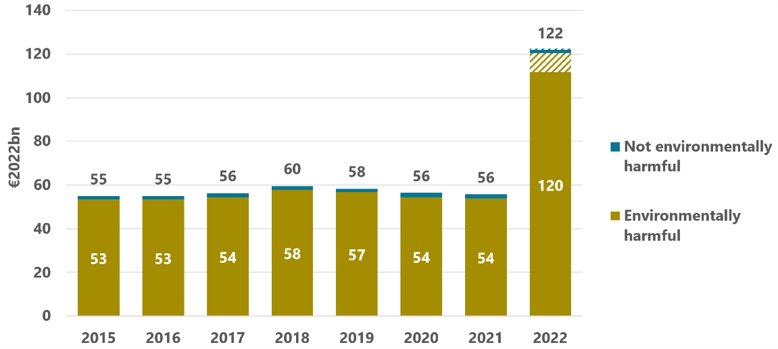
Figure 16: Fossil fuel subsidies in the EU-27 by environmental impact (2015-2022; EUR2022bn)
Source: Enerdata, Trinomics, 2023. NB: 2022 estimate are represented with hatching
Figure 16 shows that the overwhelming majority of fossil fuel subsidies (98% in 2022 or EUR 120 billion) are considered environmentally harmful. The amount of fossil fuel subsidies considered as not environmentally harmful is around EUR 3 billion. Most of these non-harmful subsidies relate to compensation to companies and workers for curtailing or closing coal mines and coal-fired power plants, or funding for rehabilitation of the areas where such closures have taken place.
Preliminary data show (Figure 17) that most of the fossil fuel subsidies considered not environmentally harmful in 2022 were provided by Germany (EUR 0.6 billion), followed by the Netherlands (EUR 0.5 billion), France and Spain (EUR 0.2 billion each). In eighteen Member States, 100% of fossil fuel subsidies were assessed as environmentally harmful.
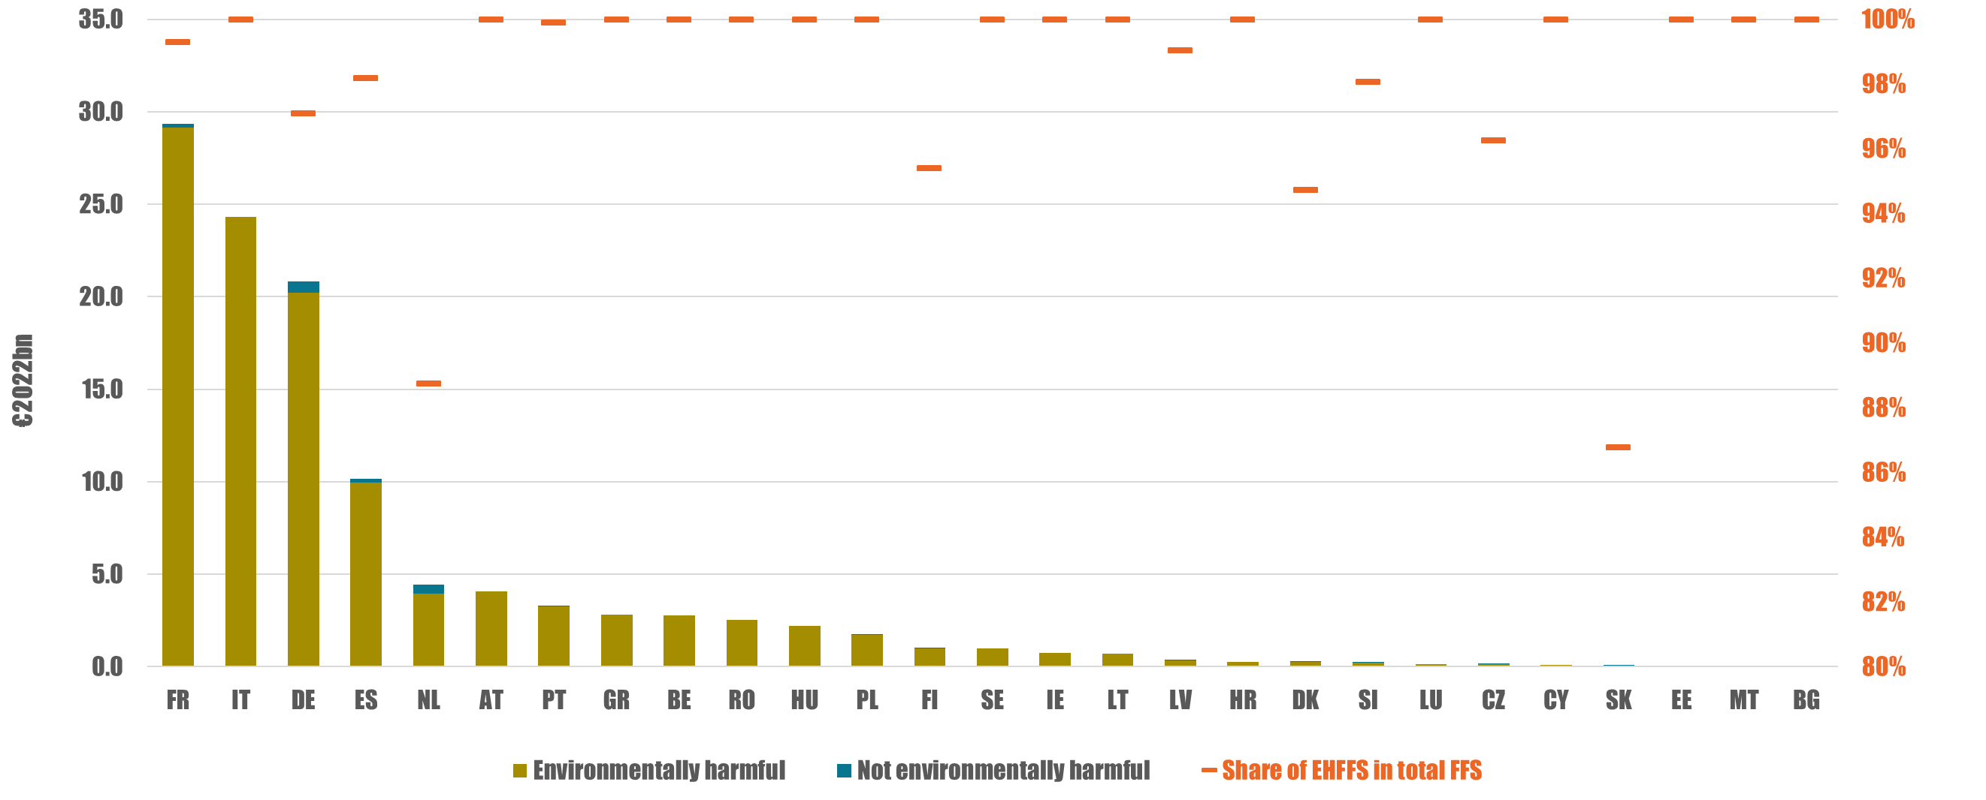
Figure 17: Fossil fuel subsidies by MS and by environmental impact (EUR2022bn)
Source: Enerdata, Trinomics, 2023

National plans on subsidies
This section focuses on the national plans to phase-out fossil fuel subsidies in Member States published as of August 2023. The general Union environment action program to 2030, also known as the 8th environment action programme, requires the Commission and/or Member States to phase out environmentally harmful subsidies, and fossil fuel subsides in particular, by ‘setting a deadline for the phasing out of fossil fuel subsidies consistent with the ambition of limiting global warming to 1.5°C.
According to 2022 data (Figure 18), 47% (EUR 58 billion) of total fossil fuel subsidies (EUR 123 billion) had a planned end-date before 2025. Only about 1% (EUR 1.7 billion) of fossil fuel subsidies have an end-date on the medium term (2025-2030). For the remaining 52% (EUR 64 billion), there is either no end-date yet or the end-date has been set after the year 2030.
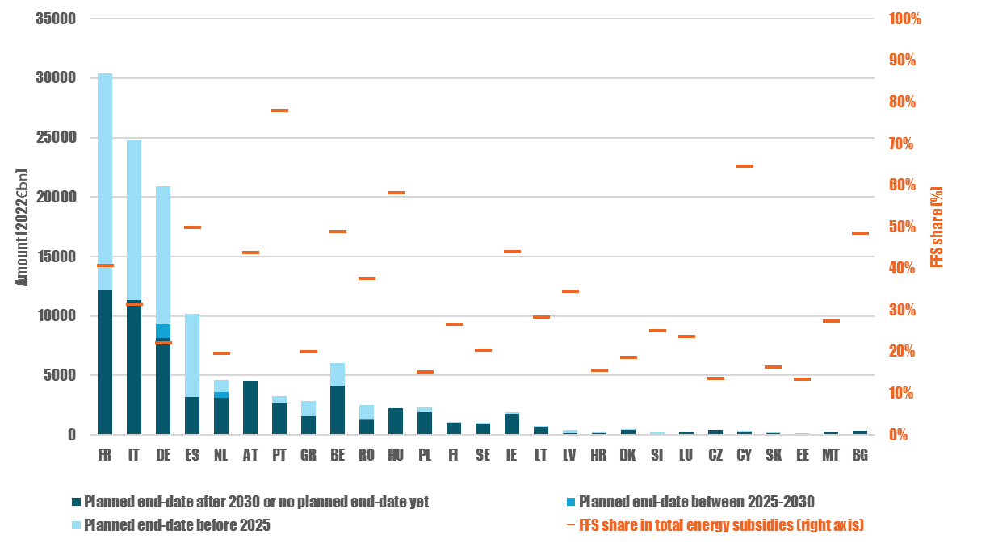
Figure 18: Fossil fuel subsidies by end-date and as a share of total energy subsidies (%) in 2021
Source: Enerdata, Trinomics, 2023
Almost all EU Member States intend to move away from fossil fuels. However, in most Member States this intention has yet to be translated into concrete plans. The power sector is where Member States have the most concrete plans to reduce their reliance on fossil fuels, especially coal. Eight Member States have also set dates for phasing out fossil fuel-based heating in buildings. For the other economic sectors (industry, transport and agriculture), end-dates for fossil fuel use are almost completely absent.
Finally, although the amount of fossil fuel subsidies more than doubled in 2022 compared with 2021 due to the support measures in response to the energy crisis, the overwhelming majority of these measures are temporary and have an end-date in the near-term. The energy crisis is unlikely to lead to a reversal of the efforts Member States have made so far in reducing fossil subsidies.
However, it will be important to continue to monitor temporary fossil fuel subsidies to limit negative impacts that could reduce incentives for investments in energy efficiency and renewable energy.
More transparency over end-dates for fossil fuel subsidies from Member States is crucial in this respect. The absence of information on end-dates for these subsidies makes it difficult to assess whether the EU is on track to phase out fossil fuel subsidies consistent with the ambition of limiting global warming to 1.5 °C.

Conclusions
The recent extraordinarily high energy prices made it necessary to take bold policy initiatives in the European Union to mitigate the social impact of the energy crisis. The temporary and exceptional measures to address the energy crisis have greatly impacted the trends in energy subsidies. The recent spike in energy prices has also affected the types of measures used to provide the subsidies and technologies promoted by subsidies, leading to a significantly increase in fossil fuel subsidies since 2022 to mitigate the high energy bills among consumers.
These increased energy subsidies did not lead to more energy consumption. Overall demand for energy decreased in 2022 compared with pre-COVID-19 levels. All economic actors reduced their gas demand by 17% with households and industry in the lead (reductions of 50% and 43%, respectively), reacting to both higher prices and policy measures encouraging demand reduction. The EU continued its support for energy efficiency investments and took significant additional steps in the area with the recast of the Energy Efficiency Directive.
The end of the long downward trend in energy subsidies was justified by the priority of shielding EU consumers from the energy bills shock. But if temporary measures are extended in the medium term, this could have a long-lasting negative impact by reducing market incentives for energy efficiency and renewable energy investments including clean heating solutions such as heat pumps.
The EU has decisively embarked on an energy transition to achieve climate neutrality by 2050. Energy savings and reduced reliance on fossil fuels in the residential, power, transport and industrial sectors should help the EU in a variety of ways: (i) reducing imports of fossil fuels; (ii) speeding up the clean-energy transition; and (iii) improving the EU’s security of energy supply. The energy transition should therefore bring about a reduction in fossil-fuel subsidies, and a significant redirection in subsidy support to renewables and energy efficiency.
Although the situation on global and European energy markets has stabilised as compared with the worst times of the energy crisis in 2022, the prices of some fuels (like natural gas) may remain volatile and at relative high level for some years compared with pre-crisis levels. This, together with the replacement of fossil fuel technologies by more sustainable solutions, should lead to a significant decline in the consumption of fossil fuels (and their subsidies) in the medium term. Policy considerations for affordability may justify temporary measures to support households and industry. However, in the longer term, the energy transition will enable efficiency and renewable technologies to increasingly redirect support away from environmentally harmful fossil fuel subsidies.

Since their 2009 Summit, G20 Leaders have called for phasing out and rationalising fossil fuel subsidies while providing targeted support for the poorest. The EU is one of the co-sponsors of the ministerial statement on fossil fuel subsidies adopted on 14 December 2021 in the context of the WTO.
Article 35, point n of the Regulation on the Governance of the Energy Union (2018/1999/EU), hereinafter: the Governance Regulation.
For previous editions: https://op.europa.eu/en/publication-detail/-/publication/34a55767-55a1-11ed-92ed-01aa75ed71a1
For missing 2022 values, 2021 data were taken as a basis for an estimate. In such cases, 2022 data are referred to in this report as ‘estimated’ and on graphs, unconfirmed data are indicated on graphs by hatching.
The analysis is based on the methodological framework used in previous Commission studies, following the Agreement on Subsidies and Countervailing Measures (ASCM) framework developed by the World Trade Organization (WTO).
See more on energy-subsidy methodology in Annex 1 of the 2023 Commission study.
Also including subsidies for fishing.
Due to data corrections in the subsidy inventory for the earlier years, and the change in the monetary basis (‘expressed in 2022 euros’ in the current report) total amounts on the charts of this report may differ from the last energy-subsidy report published in 2022 or earlier.
In this report, all figures are expressed in EUR 2022 bn. Total figures for 2022 include ~EUR 44 billion still under validation.
Data under the “To be confirmed” category amounted to 12% of the total amount included in the Subsidy inventory for the year 2022.
In certain cases, it is not possible to separate subsidies given to electricity consumption by the source of generation (fossil, nuclear or renewable), therefore this chart shows electricity (energy carrier) subsidies alongside those given to energy sources.
The term “All energies” is used here to classify subsidy measures that apply to energy produced from a mix of both fossil fuel and low carbon sources or an unknown source.
This also includes various types of economic mechanisms beyond income support for more than one type of energy, such as capacity payments, biofuels blending mandates, renewable energy quotas with tradable certificates, differentiated grid connection charges, energy efficiency obligations, interruptible load schemes, contract for difference, feed-in premiums, feed-in tariffs, consumer price guarantees (cost support), consumer price guarantees (price regulation) and producer price guarantees (price regulation)
The EUR 3.5 billion increase in fossil fuel subsidies in 2018 is partly due to the change in classification of the degressive tariff structure for gas and electricity in the Netherlands, which was not reported by the Dutch government as a subsidy before that date and therefore not included in the database. The Netherlands is the only country for which actual amounts linked to this mechanism have been declared, but they certainly also exist in other countries without being declared as such.
The term covers energy extraction, conversion, refining, infrastructure, transmission, distribution, storage, waste management and retail. In short, the energy industry.
Not all data were available for 2022, for example those related to FiP/FiT or RES quotas and the figures might be subject to revision.
E.g. supporting the use of energy through lowering its costs.
As of July 2023, the estimate of demand-oriented subsidies included EUR 12.6 billion of yet-unconfirmed payments for 2022 (~5% of the total).
FiT, FiP and RES obligations are included by convention in the energy industry, while such payments may confer benefits to actors outside of this sector.
Industry excludes Mining & Construction. Business, Construction, Public and Services sectors have been regrouped under the denomination “Others” as their individual amount for 2020 is less than €1 billion.
https://www.cbd.int/gbf/targets/
The analysis is based on the updated annexes VIII and XV of the draft National Energy and Climate Progress Reports.
Article 3 (h) (i) of Decision (EU) 2022/591 of the European Parliament and of the Council of 6 April 2022 on a General Union Environment Action Programme to 2030.
Comparing gas consumption in the Aug. 2022 – June 2023 period with the 5-year average

