- Introduction
This report presents the results of the data analysis and the assessment done on the management of mineral and synthetic lubrication and industrial waste oils in the EU with a view to considering the feasibility of adopting measures to further improve the treatment of waste oils, including quantitative targets on the collection and the regeneration of waste oils, which the Commission carried out in accordance with Article 21(4) of the Waste Framework Directive (WFD). This report draws from three extensive studies by the Commission carried out between the years 2019 and 2023.
- Background
Waste oils are defined in the WFD as “any mineral or synthetic lubrication or industrial oils which have become unfit for the use for which they were originally intended, such as used combustion engine oils and gearbox oils, lubricating oils, oils for turbines and hydraulic oils”.
Lubricating and industrial oils typically consist of base oils and additives. Engine oils, used in the automotive, marine and industrial sectors, represent up to half of all lubricant oils placed on the market. Hydraulic oils rank second representing 15% - 20% of the volume. When these oils become waste they are classified as hazardous waste and represent the most important liquid hazardous waste stream in the EU, with approximately 1.6 million tonnes of waste oils collected in 2017. Waste vegetable oils generated by kitchens and similar activities are not in the scope of the current report, nor covered by the definition of waste oil.
Waste oils have been regulated in the EU for over 40 years. Directive 75/439/EC on the disposal of waste oils required that waste oils were collected and disposed of without causing avoidable damage to man and the environment. In the year 1987 major amendments were introduced resulting in priority being given to the regeneration of waste oil over its incineration for energy recovery. The WFD requires that Member States must take stringent measures to ensure that waste oils are separately collected, avoiding mixing with other wastes and, if feasible, with other types of oil and are managed without harming human health or the environment and respecting the waste hierarchy.
As indicated in the European Green Deal Communication, the European Union strives for a climate neutral and circular economy, in the context of a toxic-free environment for which more action to prevent pollution is required. In meeting these objectives, which are further developed in the Circular Economy Action Plan and in the Zero Pollution Action Plan, the sound environmental management of waste oils, in a way that emissions and discharges are minimised and where base oils are largely regenerated, has a relevant contribution to make.
- Overview of waste oil management in the EU
In 2017, about 4.3 million tonnes of lubricant and industrial oils were placed on the EU market. The 1.64 million tonnes of waste oils collected in the EU28 in 2017 represent 38% of this amount and is 82% of the theoretically collectable waste oil (~2 million tonnes). Unavoidable losses of oil, estimated to be 2.3 million tonnes, occur during use, mostly due to burning in engines or by being disposed with other waste. It is estimated that about 18% of collectable waste oils are lost due to burning in small waste oil burners, due to illegal conversion into fuels and, to a limited extent, via direct releases into the environment. Such activities have a direct and deleterious impact on water, soil and air quality, are illegal, contrary to the waste hierarchy and may result in unfair competition with legal waste operators, thereby requiring intensified efforts in terms of collection and enforcement to avoid them.
The particular case of waste oils from ships is addressed by Directive 2000/59/EC on port reception facilities which aims to substantially reduce discharges of ship-generated waste and cargo residues into the sea. The European Maritime Safety Agency provides a pollution prevention service including earth observation services using satellite imagery.
The approach taken to manage waste oils differs largely among the Member States. Extended Producer Responsibility (EPR) schemes for waste lubricant oils are implemented in 11 Member States.
It is reported that approximately 61% of the waste oils collected are regenerated into base oils, whereas 24% are treated to produce fuels and 11% used for direct energy recovery in cement, lime, steel and power plants, with the remainder being incinerated as hazardous waste. In 2019 there were 27 waste-oil regeneration plants in the EU28, distributed throughout 11 Member States, with an approximate capacity to treat 1.5 million tonnes of waste oils. In total about 0.95 million tonnes of waste oils were treated in regeneration plants in the EU resulting in approximately 0.68 million tonnes of regenerated base oil. These figures show that regenerated base oils represent approximately 8% of the yearly amount of base oil produced in the EU and indicates that even if all waste oils available to be collected were collected and regenerated back into base oil, only a fraction of the demand can be covered by regeneration.

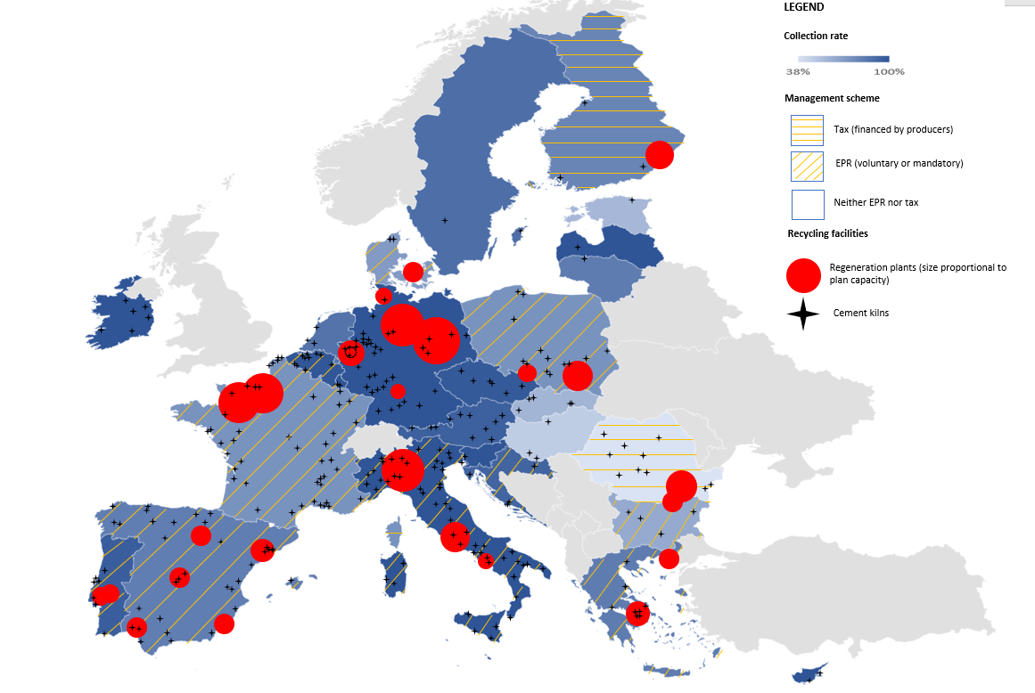
Figure 1: Waste oil management in EU27 Member States.
Despite uncertainties in the estimation of the amounts of oils placed on the market that can be collected, evidence shows there is still room for improvement, not only in the amount and quality of waste oils collected, but also in the amount of collected oils that are regenerated. The sections below outline approaches to bring about an improvement in both aspects, recognising that the starting point and the context associated to waste oil management differs largely from one Member State to another.
- Collection of waste oils
Collection rates of waste oils vary greatly between Member States. In 2018 they ranged between 38 and 100% of the collectable oils. The limited information on illegal practices that impact collection rates suggests that the main practice that negatively affects the collection of waste oils is their illegal burning. Direct discharge to the environment appears to be rare and not sufficiently significant to explain differences in collection rates.
EPR and collection schemes
Member States with high collection rates do not necessarily apply a common approach. Some have an EPR system in place (e.g. Portugal, Italy) while others do not (e.g. Germany, Austria). Similarly, for Member States with a low collection rate, a common pattern could not be found. Some have an EPR (e.g. Bulgaria) and some do not (e.g. Romania). All other things being equal, collection performance appears to be higher in countries that have a high population density, significant industrial activity and close-by regeneration or energy recovery capacity.
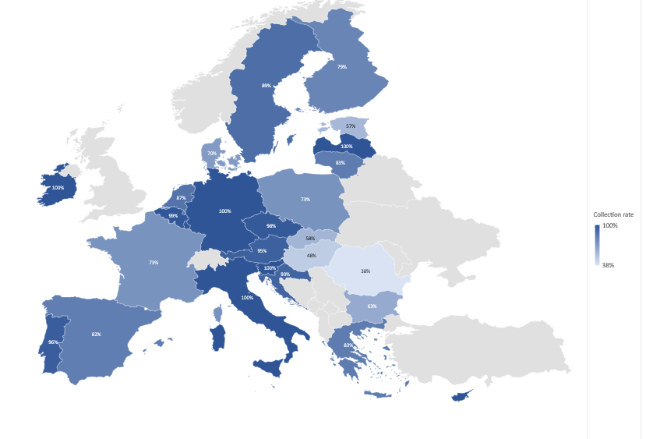
Figure 2: Waste oil collection rates in 2018 (collected/collectable)
According to a recent study, there is no clear conclusion as to whether an EPR or other formalised collection schemes (e.g. deposit-refund schemes) are necessary to ensure high collection rates. It seems clear however that two main factors drive waste oil collection performance:
- cost/benefit for waste holders: if the waste holder is paid for the waste oil the collection rates increase;
- willingness of waste holders to manage their waste legally: this is highly dependent on the awareness of holders and on enforcement by Member States.
Therefore, collection rates are high where collection is profitable, that is, where waste holders receive money for their waste, collection is for free or they are otherwise willing to pay the market price for managing their waste. Geographical areas where the cost exceeds the willingness to pay may not be serviced and this can result in illegal management. Ultimately, the characteristics of the incentive scheme appear to have more influence on collection rates than whether an EPR is in place or not.
Electric vehicles and impact on waste oil volumes
The study also provided projections for the generation of waste oils in EU-27 up to the year 2050 based on two modelling approaches, one based on lubricant demand forecasts by McKinsey & Company and a second based on the same demand growth and considering the EU regulatory targets to decrease GHG emissions from vehicles and information on lubricant use in electric vehicles. These assume that the demand for lubricant in the EU electric and fuel cell fleet will be 10% of that from a conventional fleet, predicting a decrease in use of engine oils in the EU. It is assumed that the waste oil generation from the automotive sector, which currently represents approximately 40% of the lubricating oils market, will decrease gradually from its 2035 level to 32.5 % of it in 2050. According to the referred study, the EU-27 total waste oil generation will be between 1.7 and 2 million tonnes in 2050, a value similar to the amount of collectable waste oils reported for 2017. These projections indicate that the overall amount of the waste oil available for treatment is unlikely to change very much in the next decades and can be explained by the estimation that the referred reductions in road transport oil generation will be largely offset by growth from other transport modes and from industrial / non-transport uses.

Measures to increase waste oil collection and quality
Currently, the average EU collection rate for waste oils is about 82% but with wide variation between Member States due to national and context-specific aspects. Seven Member States have legally binding waste oil collection targets in their legislation. As illustrated by the analysis made of reporting made by Member States for the year 2020, the available statistical information on waste oil collection and management is not sufficiently robust to set mandatory EU collection targets. An approach relying on national targets could however be considered by Member States.
Such approach could pivot on two target values for the year 2030, set at 80% and 95% with respect to the collectable waste oil quantities. Member States performing best could consider immediately applying the higher target or, if already met, ensuring it is at least maintained. Lower performers should focus their efforts on achieving the 80% collection target by 2030 and the 95% target by 2035. This approach has the advantage of directly addressing the objective of collecting more waste oils while providing some flexibility to Member States.
Based on the analysis of existing waste oil management systems and collection schemes in the EU (and beyond) and of the best practices applied, and on the limited information on waste oil collection and regeneration in the EU Member States, a number of measures to increase the quantity and the quality of waste oils collected could be considered:
  - The possibility for Member States to set mandatory collection targets.
    - 80% of generated waste oils (dry weight) to be collected by 2030 .
    - 95% of generated waste oils (dry weight) to be collected by 2030 for Member States that already collect more than 80%.

  - Other possible measures to increase waste oils collection
    - Introduce a subsidy for small waste holders. Approved small waste holders could receive a flat-rate annual subsidy upon request to cover collection costs.
    - Prohibit charging waste holders for collection (free collection or collector is paid), potentially subject to conditions such as minimum collection volume or quality requirements.
    - Make it mandatory for waste oil collectors to provide a spatially inclusive and comprehensive collection service, thereby guaranteeing collection in less profitable cases (remote areas, small waste oil producers, etc).
    - Give small waste holders access to municipal collection facilities (e.g. civic amenity sites). This would provide a convenient service for small waste oil producers, reducing risk of illegal disposal.
    - Define specific criteria to license waste oil collectors, defining minimum requirements e.g., in relation to geographical coverage of service, storage and quality control capacity, etc.
  - Possible measures to increase collected waste oil quality
    - Define mandatory quality control by waste collectors (including control points, frequency, parameters, etc).
    - Ensure separate collection of waste streams with potential to contaminate waste oils (e.g. vegetable and cooking oil, brake fluids).
    - Require waste holders that contaminate the waste oils (e.g. by improper segregation and subsequent contamination of batches in a lorry or storage tank) to pay for its treatment.
    - Establish detailed guidelines and provide training to clarify which waste oils should be kept segregated by the waste holder (e.g. avoid mixing with polychlorinated biphenyl oils, brake fluids, etc).
It should be noted that not all listed measures can be combined (e.g., subsidies for small waste holders + free/paid collection) and that the best way to implement measures can be very specific to the national context including, for instance, whether measures are adopted as part of an EPR scheme or otherwise via specific legal provisions, guidance, or other means. These measures should be further complemented with enforcement by Member States and with information and awareness-raising activities addressed to waste oil producers and to the general public.
- Regeneration of waste oils
The Circular Economy Action Plan aims to foster and encourage a sustainable, resource efficient and competitive economy, in which the value of materials and products is kept in circulation for as long as possible. Given that waste oils can be recycled via technically well-established processes they have the potential to significantly contribute to the circular economy objectives.
The Waste Framework Directive defines the regeneration of waste oils as “any recycling operation whereby base oils can be produced by refining waste oils, in particular by removing the contaminants, the oxidation products and the additives contained in such oils”. It also establishes a waste hierarchy that sets a preference for preparing for reuse and recycling over energy recovery. For waste oils, Article 21 indicates a priority for regeneration over other treatment options.

Figure 3: Waste oil use per treatment

Seven Member States report regeneration rates of 90% or more whereas 10 have rates below 10%. Use in cement kilns and power plants is overall not very significant, but in three Member States it accounts for more than 50% of oils collected. It is estimated that 5 - 15% of collected waste oils are of low-quality and unsuitable for regeneration and is thereby generally used in cement kilns, industrial boilers and hazardous waste incinerators. This implies a conservative upper limit of 85% collected waste oils that can be regenerated (based on current collection outcomes and technologies).
As reported in several studies, waste oils can be regenerated by different processes: in the EU approximately 32% of collected waste oils are regenerated through hydro-treatment, 46% by solvent extraction and 22% by distillation. Available regeneration capacity in the EU does not appear to be a limiting factor since it exceeds what is currently treated by regeneration and new re-refineries projects have been identified (e.g. in Portugal). However, more capacities would be needed if all waste oils being collected were sent to regeneration (and if collection rates increased).
The main reasons that seem to explain why a significant fraction of waste oils collected does not enter the regeneration pathway include: 1) uneven spread of regeneration capacities among Member States; 2) lack of incentives for regeneration due to absence in some Member States of specific instruments to support regeneration (financial support, targets) 3) increased demand of low-sulphur fuels, especially for the marine fuels market and 4) variability of virgin oil prices, making regeneration less competitive than energy recovery when virgin oil prices are on the lower end.

Comparison of waste oil regeneration vs energy recovery
The Commission has recently concluded a new state-of-art life cycle-based study to compare the overall performance of the three main waste oil regeneration technologies with different options to recover energy from waste oils. The analysis was carried out using a specific life cycle assessment (LCA) modelling tool which was applied to simulate the different waste management activities and processes included in each technology, and to calculate the respective potential environmental impacts and life cycle costs (LCC). This analysis was subsequently used to obtain insights about possible policies that could be put in place to increase waste oil flows towards the most beneficial pathways.
The study distinguishes two types of LCC. Conventional LCC describes financial cost as the sum of budgets costs and transfers, i.e., internal costs of managing waste oils. Societal LCC sums internal and external costs, both expressed as shadow prices, to quantify the total cost incurred by society, thus reflecting a social costs-and-benefits assessment and including the specific shadow price of CO₂, other emissions and resource depletion. The study also includes an analysis to check the sensitivity of the results to several factors and an assessment of the uncertainty in the final results by performing a discernibility analysis.

Outcome of the assessment of regeneration vs energy recovery
For most individual impact categories, as well as in terms of societal life cycle costing, the three regeneration pathways perform best among all waste oil treatment options. Notably, regeneration stands out as the preferred management pathway when considering only the impacts on global warming. The results are more nuanced when looking at the total societal life cycle costs (i.e. the monetised environmental emissions of all types and resource depletion), which shows that the least performing regeneration pathway (solvent-based) only generates a small benefit over the treatment to fuel (via distillation) and, under some conditions, can even fall behind this treatment. The discernibility analysis also shows that in terms of societal life cycle costing, solvent-based and distillation-based regeneration are not robustly superior to treatment to fuel (although the opposite is also true). Direct incineration pathways (e.g. combustion in cement kilns) are clearly inferior options.
In conclusion, regeneration - depending on the specific technology and context - is superior or comparable to treatment to fuel and superior to direct energy recovery, from a societal cost perspective. This analysis shows that Member States should promote options that deliver the best overall environmental outcome. For waste oil management, this means encouraging the development of installations making use of the best performing and most advanced regeneration technologies, which not only have the best overall environmental performance, but also yield the highest value base oils.

Possible measures to increase regeneration of waste oils
There are different approaches that could be implemented to increase the amount of regenerated waste oils. The most promising fall into the category of regeneration targets or price-based instruments. Regeneration targets can take the form of setting country-level mandatory minimum percentages of 1) collected waste oils that must be regenerated; 2) lubricant or base oils put on markets that must be derived from regenerated waste oils or 3) regenerated content in every lubricant product. The first approach regulates the supply of regenerated waste oils and is suitable for target setting at Member State level, whereas the other two affect the demand and represent product requirements. As regards price-based instruments, the options studied included implementing a subsidy on regeneration financed through the general budget or financed via a levy on virgin-based base oils.
An assessment of the socio-economic impacts of policies that would establish two benchmark waste oil regeneration rates, to be achieved by Member States by the year 2030, was made:
- a regeneration rate of 70% of all collected waste oils, which represents an increase from the current EU average rate of 61%.
- a regeneration rate of 85% of all collected waste oils, which corresponds to a conservative estimate of what can realistically be regenerated.
The environmental effects are by definition the same for all policies that achieve the same target. Whereas setting a mandatory minimum regeneration rate target, defined as a percentage of collected waste oils, results in a financial burden that is undefined and largely depends on the specific implementation in each Member State, the main burden of the other two options, based on setting minimum targets for the use of regenerated waste oil in lubricant products, initially falls on lubricant producers, and ultimately on lubricant consumers.
Subsidies for regeneration financed either out of the general budget or via a levy on virgin base oil lead to relatively high costs, which largely exceed expected societal life cycle cost savings. This is because the subsidies would have to be paid for all regenerated base oil, including for the large fraction (61%) already being regenerated. Assessing the outcome of the three target-based policies is not straightforward given that the expected benefits in terms of avoided societal costs are of the same order of magnitude as the estimated administrative costs, leading to the conclusion that the net benefits after accounting for the costs are expected to be rather small (and in some cases negative) and may not be sufficient to justify a policy intervention at EU level, particularly in view of the uncertainties involved.

- Conclusions
Regeneration is generally the treatment option providing the best overall performance from the environmental and socio-economic point of view. While Member States should make further efforts to implement the rules on waste oils laid down in the WFD, the rationale for proposing additional requirements at EU level is currently limited. For instance, experience in Member States shows that high waste oil collection rates can be achieved without mandatory EPR schemes, therefore not allowing to make a general case for setting a mandatory EPR system for waste oils. In addition, more robust data on the performance of different Member States with respect to waste oil generation, collection and treatment is necessary with a view to taking legislative action.
The Commission encourages Member States to take note of the findings outlined in this report and to consider them in order to improve the implementation of the EU rules on waste oils at national level, incentivise the collection of higher quality waste oils and further promote their treatment, employing the best performing regeneration technologies.
The Commission will follow closely data on waste oils submitted by Member States and will strive to support its improvement. Based on such data and other information on the implementation of the WFD as regards waste oils, the Commission may consider further EU action in the future, for instance as regards setting mandatory EU-wide waste oil collection or regeneration targets, in particular if measures taken by Member States would create barriers for the Single Market.

Directive 2008/98/EC of the European Parliament and of the Council of 19 November 2008 on waste and repealing certain Directives, OJ L 312, 22.11.2008, p. 3–30
Study to support the Commission in gathering structured information and defining of reporting obligations on waste oils and other hazardous waste” (2020). https://op.europa.eu/en/publication-detail/-/publication/73a728bc-72f5-11ea-a07e-01aa75ed71a1/language-en/format-PDF/source-123020647
Environmental and economic sustainability of waste lubricant oil management in the EU. European Commission (2023). https://publications.jrc.ec.europa.eu/repository/handle/JRC133752
Study to analyse lubricant and industrial oil EPR systems and waste oil collection schemes in EU Member States to support measures to increase collection rates. European Commission (2023). https://data.europa.eu/doi/10.2779/948514
Article 3(3) of Directive 2008/98/EC
Generation and collection figures for EU28 (see footnote 2). Eurostat reports higher figures of 4.0 - 4.5 Mt in a highly aggregated statistic which is not very meaningful or comparable.
Council Directive 75/439/EEC of 16 June 1975 on the disposal of waste oils, OJ L 194, p. 23-25, p. 31-33
Council Directive 87/101/EEC of 22 December 1986 amending Directive 75/439/EEC on the disposal of waste oils, OJ L 42, 12.2.1987, p. 43–47
Communication from the Commission to the European Parliament, the European Council, the Council, the European Economic and Social Committee and the Committee of the Regions The European Green Deal, COM(2019) 640 final
Communication from the Commission to the European Parliament, the Council, the European Economic and Social Committee and the Committee of the Regions A new Circular Economy Action Plan For a cleaner and more competitive Europe, COM(2020) 98 final
Communication from the Commission to the European Parliament, the Council, the European Economic and Social Committee and the Committee of the Regions Pathway to a Healthy Planet for All EU Action Plan: ‘Towards Zero Pollution for Air, Water and Soil’, COM(2021) 400 final
All figures in this paragraph are reported in the study referred to in footnote 2.
http://data.europa.eu/eli/dir/2000/59/2019-06-27
https://www.emsa.europa.eu/csn-menu.html
BE, BG, HR, DK, EL, ES, FR, IT, LT, PL, PT.
See footnote 2.
EU28, specifically in BG, DK, FI, FR, DE, EL, IT, PL, PT, ES, UK (the latter not shown in map)
About 8 Mt/yr of virgin base oils produced in EU28 between 2013-2018.
See footnote 4.
GEIR (2019). https://www.geir-rerefining.org.
See footnote 4.
Ibid
See footnote 4.
Ibid.
https://www.mckinsey.com/industries/oil-and-gas/our-insights/lubes-growth-opportunities-remain-despite-switch-to-electric-vehicles
The second model uses fleet composition and evolution estimates developed in the ‘EURO7 standards’ proposal (COM(2022) 586 final).
Shah, Raj, et al. "Recent trends in batteries and lubricants for electric vehicles." Advances in Mechanical Engineering 13.5 (2021).
See footnote 4.
BE, FR, EL, LT, PL, PT and ES.
See footnote 4.
As described in the study referred to in footnote 4 which analyses the economic, social and environmental impacts of such a measure.
Collection rate defined as the ratio between collected waste oil and generated (collectable) waste oil.
A 100% collection target is not proposed given that: a) in a context of disperse and low volume waste oil generation scenario this may result in disproportionate costs and environmental impacts from collecting all produced waste oils separately and b) the uncertainties in waste oil emission factors used to estimate the collectable amount of waste oil advise caution.
Any measure must be implemented in compliance with EU State aid rules as well as with the polluter pays principle.
A greater collected waste oil quality can also have a positive impact on the amount of collected oil that is regenerated.
The study referenced in footnote 4 provides an extensive analysis of how EPR schemes and other collection schemes are applied in different Member States.
Article 3(18) of Directive 2008/98/EC
As published in the report referred to in footnote 3.
DK, EL, LU, IT, NL, BE, FI and BG.
100% regeneration rates are reported by some countries. However, evidence suggests that such high regeneration rates may be accounting artefacts, as some countries report initial sediment and water separately from dry waste oils and others report only the regeneration of waste oil of sufficient quality.
HR, EE and SI.
See footnotes 2 and 4
See reference to JRC study in footnote 3.
Hydro-treatment, solvent-extraction and distillation.
Waste oil derived fuel replacing primary marine fuel (WODFa); Waste oil derived fuel replacing primary light fuel oil (WODFb); combustion in cement kiln; combustion in hazardous waste incinerator and combustion in an industrial boiler.
Life-cycle assessment software: EASETECH v3.4.0
14 impact categories were analysed
A default value of 100 euro/tonne CO₂ suggested by CE Delft and DG MOVE for 2030 was used.
Applying Monte Carlo simulations on two scenarios simultaneously, e.g., hydro-treatment versus solvent extraction.
Hydro-treatment, solvent extraction and distillation
Generally, oils belonging to API Groups II and III.
Leading to the avoidance of 0.6 Mt of CO₂-eq. emissions until 2045 for the 70% target and 1.7 Mt for the 85% target (cumulative over the time-period considered).
Resulting in a calculated cumulative benefit of 124 M€ between 2024 and 2045 in terms of avoided societal costs for the 70% target and 330 M€ for the 85% target. Cumulative administrative costs of 11-213 M€ are estimated, for the same time-period 2024-2045.

