

**Contents**

1. Introduction 2

2. The functioning of Union Market Observatories 3

a. Objectives of Market Observatories 3

b. Collect and disseminate key statistics 4

c. Expert discussion platform 6

3. Practical experience and suggestions on Market Observatories 6

a. Respondents’ assessment of the extent to which Market Observatories meet their objectives 8

i. Transparency within the food supply chain 8

ii. Informing the choices of economic operators and public authorities 9

iii. Facilitating the monitoring of market developments and threats of market disturbance 9

b. Respondents’ assessment on statistical data, information and reports 9

c. Respondents’ assessment on meetings of Market Observatories 10

d. Respondents’ suggestions for the future 11

4. Conclusion 11

# Introduction

In anticipation of the end of the milk quota regime in 2015, the Milk Market Observatory was set up in 2014 to provide the milk sector with greater transparency and enable market operators to make informed decisions. Since then, more Market Observatories have been created for other agricultural sectors depending on their needs and characteristics. These include the Market Observatories for meat (beef and pig meat), sugar, crops (cereals, oilseeds and protein crops), fruit and vegetables (citrus fruit, pip fruit, stone fruit and tomatoes) and wine. The Commission also established an observatory for fertilisers markets in the EU, following its Communication of 9 November 2022 entitled ‘Ensuring availability and affordability of fertilisers’[1], but this is not comprised in the scope of the present report, although it follows the same objectives and principles of organisation as the other market observatories, as it does not concern any of the sectors listed in Article 1(2) of Regulation 1308/2013[2] (CMO Regulation). At the time of finalising this report, work was ongoing for setting up a new observatory for olive oil.

The objectives of the various Market Observatories for agricultural products are to disseminate market data and short-term analyses on agricultural markets, meeting a growing need for transparency by providing more detailed and regular information to the marketplace. To this end, Market Observatories are designed in such a way that, on the one hand, key statistics on the sectors are published online, and, on the other hand, experts are brought together from all stages in the supply chain (production, processing, retail, wholesale and trade) in regular meetings to analyse available data, share their expert knowledge and cast a look into the short-term future to the extent possible.

A specific provision referring to Market Observatories was introduced with the latest CAP Reform in Article 222a of the CMO Regulation. A new obligation was introduced in parallel for the Commission[3] to report to the European Parliament and Council on the Union Market Observatories established in accordance with Article 222a, by 31 December 2023.

This report seeks to fulfil the reporting obligation of Article 225(da) and assesses whether the objectives set in Article 222a have been achieved. The first part of the report reviews how agricultural Market Observatories work in general. The second part of the report explains, based on an online survey carried out among stakeholders and Member States, how this works in practice and whether there are suggestions to further enhance their functioning.

# The functioning of Union Market Observatories

## **Objectives of Market Observatories**

The concept of Market Observatories for agricultural products was first introduced at EU level in 2014, with the establishment of the Milk Market Observatory. This was done in anticipation of the end of the milk quota regime in 2015, to increase transparency, provide the most accurate market data possible to the milk sector, and allow actors of the milk supply chain to take their business decisions in a market-oriented manner and the Commission to make well-informed policy decisions. Over the years, Market Observatories have been created for more sectors, depending on their needs and characteristics.

To date, six Market Observatories have been created:

* **Milk** (April 2014)
* **Meat** (beef and pig meat) (July 2016)
* **Sugar** (July 2017)
* **Crops** (cereals, oilseeds and protein crops) (July 2017)
* **Fruit and Vegetables** (July 2019) with four sub-groups:
  + **Tomatoes** (first meeting in October 2019)
  + **Citrus fruit** (first meeting in November 2019)
  + **Pip fruit** (first meeting in December 2019)
  + **Stone fruit** (first meeting in June 2020)
* **Wine** (November 2019)

To formally anchor these Market Observatories that had proved to be useful in informing the choices of economic operators and public authorities, and facilitating the monitoring of market developments, the European Parliament and the Council introduced Article 222a in the CMO Regulation. This provides a framework for the establishment and operation of Union market observatories in any agricultural sector listed in Article 1(2) and lays down the relevant notification and reporting obligations for those observatories. Overall, Article 222a sets out the following general objectives for Market Observatories:

* to improve transparency within the food supply chain,
* to inform the choices of economic operators and public authorities,
* to facilitate the monitoring of market developments and threats of market disturbance.

To achieve these objectives, Market Observatories are confirmed in their original composition consisting of two main branches: the first branch is a tool to collect and disseminate key statistics for the sector concerned and the second branch consists of an expert discussion platform. These two main branches are explained in more detail in the following sections of the report.

## **Collect and disseminate key statistics**

Market Observatories focus mainly on four strands of data:

* **Production** of raw and processed products (including **public/private** **stocks**) both at EU and international level.
* **Prices** of raw and processed products, both at EU and international level.
* **Trade flows:** extra and intra-EU trade, preferential imports, global trade of main competitors.
* **EU domestic consumption:** household confidence, development of retails sales focusing on conventional and organic products.

Statistical data on agricultural production are notified by the statistical services of the Member States mostly to Eurostat[4]. For certain products (cereals and oilseeds) there are also monthly production forecasts based on experts’ knowledge. The same goes for trade data[5]. A complementary surveillance system of early notifications is organised by DG TAXUD on imports. Data on EU prices (and in some cases production and stocks) are notified by Member States to the Commission according to Commission Implementing Regulation (EU) 2017/1185[6] and Commission Delegated Regulation (EU) 2017/1183[7] and international prices are collected from relevant data providers.

In addition, Market Observatories disseminate complementary information such as:

* **Weekly/monthly dashboards** compiling the most relevant and recent data for each sector,
* **Short and medium-term** **outlook balance sheets and reports**,
* The current **Farm** **Accountancy Data Network** (FADN) data series and reports, covering among other issues related to costs and margins, as well as income,
* **Historical time series**,
* **Market presentations** and factsheets,
* **Reports of the Economic Boards,**
* **Other reports, such as relevant studies.**

Statistical data and information on agri-food products are also centralised in the European Commission’s [Agri-Food Data Portal](https://agridata.ec.europa.eu/extensions/DataPortal/home.html), which includes a section on agri-food markets.

The Portal currently covers **12 agricultural sectors**: beef, pigmeat, eggs and poultry, sheep and goat meat, milk and dairy products, fruit and vegetables, cereals, rice, oilseeds and protein crops, sugar, olive oil and tables olives and wine.

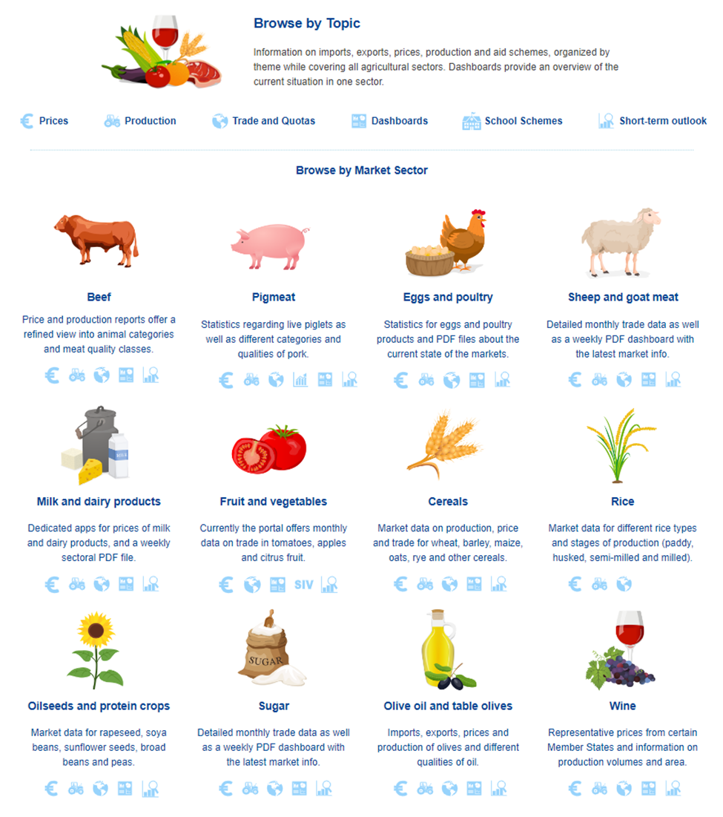

Moreover, EU market observatories provide more in-depth information on market developments on six sectors (milk, meat, sugar, crops, fruit and vegetable, wine) on a dedicated [website](https://agriculture.ec.europa.eu/data-and-analysis/markets/overviews/market-observatories_en). Table 1 in Annex gives an overview of available data and reports. In addition, the Milk Market Observatory has a dedicated X account ([EuroMMO](https://twitter.com/EuropeanMMO)), formerly known as Twitter, followed by close to 1 400 users.

## **Expert discussion platform**

Market experts actively contribute to add value to raw statistical data by providing advice, expertise and qualitative information on market developments, while avoiding policy debates. After each meeting, reports are made publicly available. The Economic Board meetings are chaired by a Commission official. The Economic Boards operate under the form of ‘Expert Groups’ and are governed by Commission Decision (2016) 3301 establishing horizontal rules on the creation and operation of Commission expert groups[8].

The unbiased work of Market Observatories makes it possible for their reports to serve as an independent support for well-informed decisions by economic actors throughout the supply chain as well as by public authorities in their fact-based decisions. A waterproof demarcation between the factual added value of the Market Observatories’ work and policy articulation by public authorities is key for guaranteeing the independency of both work streams. Market Observatories’ reports contain all presentations made during the expert meeting. Table 2 (in Annex) details the composition of the Economic Boards of Market Observatories as well as their meeting frequency.

# Practical experience and suggestions on Market Observatories

An online survey was conducted in December 2022-January 2023, containing 20 questions for stakeholders and 14 questions for Member States (MS) concerning the following aspects:

* Objectives of the Observatories
* Statistical data and information
* Meeting reports
* New developments

A total of 114 contributions from 42 stakeholders and 21 Member States were gathered during that period. Graph 1 (in Annex) shows the breakdown per Member State.

Answers to the survey are presented in two groups (stakeholders and Member States) and distinguished by sector (crops, fruits and vegetables, meat, milk, sugar and wine). At the end of this part, a summary table shows the general opinion of all the actors participating in Market Observatories but also experts from Member States who provided replies.

Graph 1. Stakeholders and Member States contribution per specific Market Observatory.

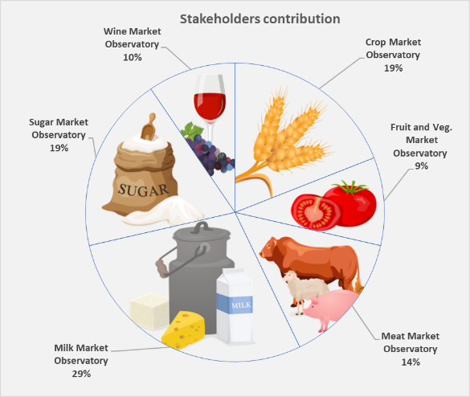

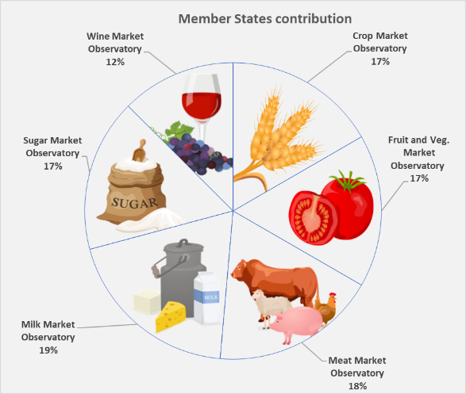

## **Respondents’ assessment of the extent to which Market Observatories meet their objectives**

### **Transparency within the food supply chain**

A vast majority of stakeholders and Member States consider the Market Observatories to be effective in providing transparency in the food supply chain (81% stakeholders and 89% respondents from MSs replied positively). Still, a reduced minority (13%) of the respondents have a negative opinion, referring to the insufficient quality of the information/analysis provided by the Market Observatory or to the poor distribution/accessibility of such information/analysis.

From specific comments made by 20 stakeholders and 9 respondents from Member States, it emerges that, in general, the Market Observatories are perceived as a useful forum for supply chain representatives to exchange on general trends, developments at global and EU level across different markets. One respondent highlights a need for more involvement of Academia in the Market Observatories. There are also calls to increase the number of meetings throughout the year and to return to in-person meetings to facilitate contacts across the chain. Some stakeholders and Member States are of the opinion that some data could be presented in more detail, for example in case of products coverage, trade, industry and retailers in the fruit and vegetable sector or consumption and usage of dairy products as well as stocks. One Member State believes that publishing retail prices would increase transparency along the supply chain. In addition, some of the information should be more timely available to improve transparency and effectiveness.

### **Informing the choices of economic operators and public authorities**

Respondents broadly agree that the information provided by the Market Observatory is useful for the economic operators to make informed choices (83% stakeholders and 70% respondents from MSs replied positively). 15% respondents from MSs could not say whether the information is useful.

Some stakeholders believe that a bigger number of participants would improve the usefulness of market observatories. Some stakeholders and Member States repeated their call for more data, for example on the use of sugar by food outlet that would provide operators with a better vision of consumption trends and allow them to better plan production. Also, up-to-date information about surfaces and wine support programmes were mentioned. Some respondents state that the exchange of information taking place at the Observatories fosters dialogue throughout the chain and allows to understand challenges faced by various actors in the food chain (primary producers, retailers, traders, etc.).

* 1. **Facilitating the monitoring of market developments and threats of market disturbance**

Respondents also agree to a great extent on the role of Market Observatories to facilitate the monitoring of developments and threats of market disturbances in the agricultural markets (85% respondents from MSs and 67% stakeholders replied positively). Only 15% of all respondents replied negatively.

The Observatories are useful fora to identify challenges at an early stage (e.g. the fertiliser price crisis hitting primary producers or the negative impact of high inflation on consumer behaviour in relation to healthier and more sustainable products). One respondent from MS highlights the fact that the Market Observatory enables quick comparison between Member States. For example, during the pigmeat crisis of 2021-2022, an analysis of the markets in the main exporting countries made it possible to objectively assess the scale of the crisis.

A few stakeholders raised about concerns about the lack of discussion regarding public authorities’ response to threats and market disturbances that has been mostly considered by the Commission as a policy discussion and therefore could not be debated during Market Observatory meetings.

## **Respondents’ assessment on statistical data, information and reports**

Respondents are almost unanimously aware of the publication by the Commission of online statistical data and information provided by the Market Observatories. Nevertheless, less than half of the stakeholders and only one fifth of respondents from Member States have subscribed for an electronic notification when new information is available from Market Observatories. Half of the respondents (45% of stakeholders and 47% of respondents from MS) did not know about this possibility.

On the use of statistical data and information provided by Market Observatories, half of stakeholders and one third of respondents from Member States consult them on a weekly basis and 32% and 55% respectively on a monthly basis. A very small number of respondents reported that they do not use them at all (5% of stakeholders and 3% of respondents from MS).

In general, the most useful tools for disseminating market information are seen as being: Market Observatory webpages, Agri-food data portal and dashboards. Newsletter subscription and transparency register website scored the lowest rates. For the latter, most respondents were unaware of its existence. In addition, 50% of stakeholders and 13% of respondents from Member States replying about the Milk Market Observatory rated tweets as very or fairly useful.

A large majority of stakeholders (83%) and respondents representing Member States authorities (81%) are of the opinion that statistical data and information provided by Market Observatories are very or fairly accurate. A slightly lower proportion of respondents had similar views on whether data was sufficient (71% of stakeholders and 81% of MS) and timely (67% of stakeholders and 81% of MS). However, one in four responding stakeholders expressed the views that data and information are not very or not at all timely and sufficient.

## **Respondents’ assessment on meetings of Market Observatories**

In parallel to the statistical data and information made available by Market Observatories, Economic Board meetings are organized several times a year to gather experts from all steps in the supply chain per sector.

When asked to rate the quality of the reports of the Economic Board, half of the respondents from Member States replied positively, while the other half was not aware of the information. In case of stakeholders, 79% replied positively and 5% negatively.

Stakeholders were asked to answer five additional questions about the meetings of Market Observatories. When it comes to usefulness of the market information provided by the experts of the Economic Board of the Market Observatory, only 2% of the stakeholders replied negatively. The discussion between experts was not very useful for 5% of the stakeholders. Three quarters of stakeholders share the outcome of the Economic Board meetings with their members. While 17% of stakeholders see no need for improvement, more than half acknowledge that meetings need to be improved, for example by inviting ad hoc experts, changing the composition of the group or adding other points to the agenda. About one quarter of stakeholders declare having consulted the minutes of the Economic Board meetings.

## **Respondents’ suggestions for the future**

Most of the respondents, both stakeholders (86%) and representatives of Member States (72%), agreed that the Observatory's role as currently defined in the CMO regulation is being fulfilled.

However, there was no clear answer on the need to improve outreach in all sectors. 45% of stakeholders and 36% of respondents from Member States believe that the coverage should be improved. A few Member States expressed their opinion that there is a need for more data on prices, costs, profits, margins, tariff quotas and import prices. There was also suggestion to follow-up on the analysis of unfair trade practices, in the framework of the Directive (EU) 2019/633[9]. It could help to understand the dynamics of the market for each of the products under Market Observatories.

A fair majority of representatives of Member States (65%) see no need for an increased role for Member States in the work of the Observatory. They prefer to keep their present role in providing market data. One quarter of respondents does not have any opinion about it. Only two respondents from MS’s authorities suggest that MS should participate in the meetings of Market Observatories. Other respondents see a potential in commenting analysis and reports prepared by international institutions like FAO, USDA etc. One believes that the relation between the observatories and decision-making process in the EU should be defined in a more precise way in the future.

# Conclusion

Market Observatories fulfil their role effectively in helping to improve market transparency in the food supply chain, informing choices of economic operators and public authorities and facilitating the monitoring of market developments and threats of market disturbance. Overall, the range of data and information analysed seems adequate, but could still be improved for some sectors.

A clear demarcation between the role of Market Observatories in establishing a solid factual basis and that of public authorities in taking policy decisions, when necessary, is crucial for maintaining impartiality and objectivity in the analysis supporting the policy process, which belongs to the institutional framework.

At this stage, there appears to be no particular call for establishing a new Market Observatory in a sector not already covered, beside the ongoing setting up of a Market Observatory for olive oil. Such needs tend to emerge when circumstances so require and experience shows that the necessary framework is in place for such needs to be addressed, should they emerge over time.

1. [COM (2022) 590 final/2](https://eur-lex.europa.eu/legal-content/EN/TXT/?uri=CELEX:52022DC0590(01))
2. Regulation (EU) No 1308/2013 of the European Parliament and of the Council of 17 December 2013 establishing a common organisation of the markets in agricultural products and repealing Council Regulations (EEC) No 922/72, (EEC) No 234/79, (EC) No 1037/2001 and (EC) No 1234/2007.
3. Reporting obligations in Regulation (EU) No 1308/2013 - Article 225(da).
4. <https://ec.europa.eu/eurostat/web/agriculture/data/database>
5. <https://ec.europa.eu/eurostat/web/international-trade-in-goods/database>
6. Commission Implementing Regulation (EU) 2017/1185 of 20 April 2017 laying down rules for the application of Regulations (EU) No 1307/2013 and (EU) No 1308/2013 of the European Parliament and of the Council as regards notifications to the Commission of information and documents and amending and repealing several Commission Regulations.
7. Commission Delegated Regulation (EU) 2017/1183 of 20 April 2017 on supplementing Regulations (EU) No 1307/2013 and (EU) No 1308/2013 of the European Parliament and of the Council with regard to the notifications to the Commission of information and documents.
8. <https://ec.europa.eu/transparency/regexpert/PDF/C_2016_3301_F1_COMMISSION_DECISION_EN.pdf>
9. [Directive (EU) 2019/633 of the European Parliament and of the Council of 17 April 2019 on unfair trading practices in business-to-business relationships in the agricultural and food supply chain](https://eur-lex.europa.eu/legal-content/EN/TXT/?uri=CELEX%3A32019L0633)