

Table of Contents

1. Summary 3

2. Introduction 3

3. Implementation of borrowing operations in the second half of 2023 4

4. Cost of funding and liquidity balances 8

5. Steps to further develop the ecosystem of EU-Bonds 9

6. Other milestones in the second half of 2023 10

7. Issuance outlook for the first half of 2024 10

**FUNDING RAISED H2 2023**

**DISBURSEMENTS**

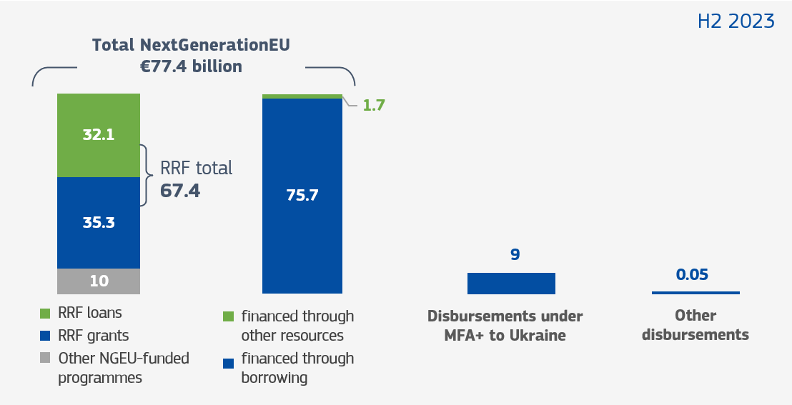

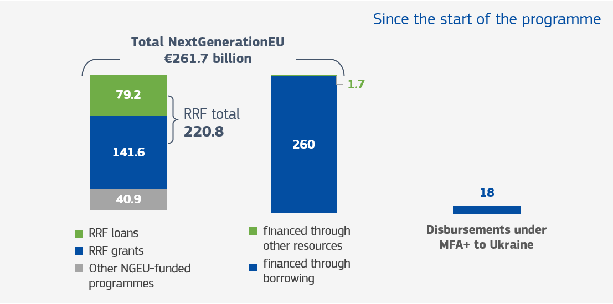

*All amounts in EUR billion*

**OUTSTANDING EU-BONDS**at 31/12/2023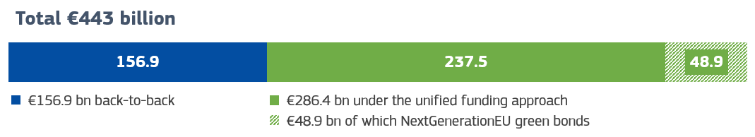

|  |
| --- |
| **KEY FACTS**   * EUR 115.9 billion was raised in 2023. * Cost of funding was 3.2% in the first half of 2023 and 3.6% in the second half of 2023. * The raised funds were mainly used to finance NextGenerationEU (including RePowerEU) and MFA+ loans for Ukraine. * NextGenerationEU makes the EU economy greener, more digital, and more diversified in its energy supply. * MFA+ loans covered a large part of Ukraine’s short-term funding needs in 2023. |

# Summary

In the second half of 2023, the Commission raised EUR 37.7 billion, bringing the total raised over 2023 to EUR 115.9 billion. In 2023, EUR 99.1 billion was disbursed under NextGenerationEU, making the EU economy greener, more digital, and more diversified in its energy supply. In 2023, Ukraine received EUR 18 billion in highly concessional loans via MFA+, covering a large part of Ukraine’s short-term funding needs for 2023.

The EU’s cost of funding during continued to increase in the second half of 2023 in line with market conditions - from 3.2% in the first half of 2023 to 3.6% in the second half. The spread between 10-year EU-Bonds and 10-year German bonds remained relatively stable, ending the year close to 73 basis points (compared to 68 basis points at 30 July 2023). However, the peak of 81 basis points reached in October 2023 underlined that since EU-Bonds are being priced against the swap curve, they have higher yields compared to European government bonds (EGBs) whenever a risk-averse sentiment takes hold. The end-of-year saw market pricing of EU debt fall sharply (from 3.7% in October to 2.8% at year-end for 10-year EU-Bonds) as expectations now favour lower interest rates at some stage in 2024.

During the second half of 2023 the Commission made further progress in strengthening the architecture underpinning its issuance programme. In addition to introducing a unified funding approach in January 2023, the Commission launched a quoting arrangement system in November 2023, and completed the EU issuance service (EIS) at the start of 2024. The completion of the EIS reflects the partnership between the Commission, the ECB and other national and EU official sector institutions in building the EU debt issuance programme. The Commission also published its first comprehensive NGEU green bonds allocation and impact report which shows how NextGenerationEU green bond issuances are supported by a pool of planned eligible expenditures across Member States and how these expenditures are helping to reduce EU greenhouse-gas emissions.

Further steps to increase liquidity will be taken in 2024, with the launch of the repurchase facility planned for the second half of 2024. Furthermore, the Commission has started to liaise with index providers on how to classify EU securities in their indices and will continue to encourage market counterparties to provide to EU-Bonds the same quality of collateral treatment in bilateral secured transactions that they provide to sovereign bonds.

# Introduction

The Commission has been borrowing funds on behalf of the European Union for over 40 years. The past 3 years have seen a marked increase in the EU’s bond issuance as it relies on capital markets to finance large programmes such as SURE[1], NextGenerationEU (NGEU), and Macro-Financial Assistance + (MFA+) for Ukraine. By end-2023 the EU had just over EUR 440 billion in outstanding liabilities resulting from its bond issuance, of which about EUR 405 billion have been issued since 2020.

In line with Article 12 of Commission Implementing Decision C(2022)9700, which lays down the arrangements for the implementation of the unified funding approach for borrowing and debt management operations[2], this half-yearly report reviews the implementation of borrowing operations between 1 July 2023 and 31 December 2023. It also presents the steps that the Commission is taking to further develop the ecosystem for EU-Bonds – with the aim of increasing the liquidity of EU-Bonds and facilitating a market standing that reflects the EU’s issuance volumes and credit strength for the benefit of the Member States. Finally, it provides an outlook for EU-Bond issuance in the first half of 2024. This report does not evaluate how the proceeds from EU-Bond issuances are used, including for green expenditure, as this is covered in separate reports under the regulations for each instrument[3].

Further to the recommendation of the European Court of Auditors[4], the annex to this report presents indicators that can be used to monitor the implementation of the overarching debt management strategy guiding the Commission’s unified funding approach[5].

# Implementation of borrowing operations in the second half of 2023

In the second half of 2023, the Commission continued to raise funds in the markets through its unified funding approach. In addition to meeting all the disbursement commitments under NextGenerationEU and MFA+ on time, issuance amounts and maturities remained within the pre-set parameters, and financing terms were in line with those of an issuer of the EU’s size and rating. The sections below present some of the key components of the Commission’s borrowing and lending operations in the second half of 2023. Further indicators used to monitor the implementation of the Commission’s funding strategy are discussed in the annex to this report.

## Execution of funding operations in the second half of 2023

In June 2023, the Commission announced its intention to issue EUR 40 billion in EU-Bonds over the period from July to end-December 2023 to finance in particular NextGenerationEU and MFA+ for Ukraine (complementing its EUR 80 billion funding plan from the first half of 2023). The funding plan reflected expected disbursements needs for the remainder of 2023 as well as the liquidity holdings at the start of the semester.

The Commission completed its funding programme for 2023 by the end of November[6], raising a total of EUR 115.9 billion over the course of the year. EUR 37.7 billion of this funding was raised in the second half of the year with an average maturity of 13 years (compared to around 14 years for the funding raised in the first half of 2023).

The Commission used a mix of syndications (64%) and auctions (36%), in keeping with the ratio achieved in the first half of 2023. The EU-Bond issuances were spread over the semester, taking into account market liquidity conditions while ensuring regular presence in the market. These transactions included the tapping of two existing NextGenerationEU green bond lines for a total   
of EUR 4.7 billion. These additional green bond issuances were undertaken following the reporting of additional climate-relevant expenditures by Member States under the Recovery and Resilience Facility (RRF).

**Chart 2: Funding raised under the unified funding approach**

* The first two NextGenerationEU transactions took place in June 2021. These have been included in the number for H2 2021 as they were part of the same Funding Plan as the transactions that took place in H2 2021.

*All amounts in EUR billion*

The transactions in the second half of 2023 brought the total outstanding amount of EU-Bonds to just over EUR 440 billion by end-2023. Of this amount, EUR 405 billion has been issued since the start of the SURE programme in 2020 with EUR 286 billion issued as EU-Bonds under the EU’s unified funding approach. The remainder of the outstanding bonds were issued under designated policies to finance loans with a matching duration (for example, SURE loans and MFA loans to Ukraine granted in 2022 are financed using this ‘back-to-back’ approach).

Of the EUR 286 billion issued under the EU’s unified funding approach, EUR 48.9 billion was issued in the form of NextGenerationEU green bonds.

In the second half of 2023, the Commission also issued 3-month and 6-month EU-Bills through bi-monthly auctions to meet short-term funding needs. The EU had EUR 15.2 billion in credit outstanding through EU-Bills at the end of December 2023. The Commission maintained issuance under the EU-Bill programme at a minimum level in light of low short-term funding needs.

## Disbursements

On the back of these transactions, the Commission continued the funding of Member States’ recovery and resilience plans through the timely disbursement of proceeds. The Commission made all disbursements to Member States under the RRF, on average within 6 working days of authorisation of the disbursement.

In the second half of 2023, the Commission disbursed EUR 67.4 billion to 18 Member States under the RRF, of which EUR 1.7 billion were pre-financing payments for REPowerEU chapters. Of this, EUR 35.3 billion was in the form of non-reimbursable support and EUR 32.1 billion was in the form of loans. As part of NextGenerationEU, the Commission also transferred EUR 10 billion to the EU budget in the second half of 2023 to contribute to programmes such as Horizon Europe, the InvestEU Fund, ReactEU, the EU Civil Protection Mechanism (RescEU), the European Agricultural Fund for Rural Development (EAFRD), and the Just Transition Fund.

Overall, since the start of NextGenerationEU in the summer of 2021, the Commission has disbursed EUR 261.7 billion: (i) EUR 141.6 billion in non-reimbursable support and EUR 79.2 billion in loans to Member States under the RRF; and (ii) EUR 40.9 billion for the other NextGenerationEU-funded spending programmes. So far, EUR 260 billion of NextGenerationEU has been financed through borrowing and EUR 1.7 billion has been financed by other sources (i.e., the Emission Trading Scheme (ETS) and the Brexit adjustment reserve (BAR)).

In addition to NextGenerationEU disbursements, in the second half of 2023, the Commission disbursed EUR 9 billion in loans to Ukraine under the MFA+ programme, funded by bond issuance under the unified funding approach. This brings the total amount of funding disbursed to Ukraine under the MFA+ programme to EUR 18 billion for 2023. Overall, in the second half of 2023 the Commission disbursed a total of EUR 86.4 billion for NextGenerationEU (including REPowerEU) and MFA+ combined. This is higher than the disbursements in the first half of 2023 (around EUR 30 billion) when the pace of outflows during the first half of the year was temporarily impacted by the need to revise national recovery and resilience plans (among others, for adding REPowerEU chapters).

## Investor demand and secondary market liquidity

Despite the volatility in rates observed over the period, EU-Bond issuances continued to enjoy demand from a well-balanced and diversified investor base with different types of investors from all across the world[7].

**Chart 3: Investor split**

New issue premiums (NIPs)[8] demanded by investors as a concession when the EU issues bonds through syndication stood at around 2.5 basis points in the second half of 2023, which is in line with those offered by other issuers on comparable transactions (measured by size and maturity) during that period.

At the same time, the secondary market liquidity of EU-Bonds was consistently in line with levels observed in the markets for the most liquid European government bonds (EGBs), when measured relative to the amounts outstanding. Secondary market liquidity for EU-Bonds was supported by the introduction on 1 November 2023 of [quoting arrangements](https://ec.europa.eu/newsroom/budget/redirection/item/810218/en) whereby EU primary dealers are encouraged to post reliable EU-Bond prices on the leading electronic bond trading platforms. Despite being in its infancy, the quoting of EU-Bonds on interdealer platforms is already comparable when measured in average daily volumes, to levels observed for sovereign issuers. Daily trading volumes of EU-Bonds averaged around EUR 900 million in November 2023 and   
EUR 550 billion in December 2023, with a maximum daily peak of above EUR 2 billion.

The combination of tapping existing lines and creating new lines (new 5-year, 7-year and 20-year EU-Bonds launched in the second half of 2023) also supported secondary market liquidity. As a result, the average amount outstanding per EU-Bond remained at around EUR 13 billion by the end of the semester, ensuring consistent liquidity of the bonds.

**Chart 4: Quarterly secondary market turnover of EU and European government bonds   
(% of outstanding volume)**

*Source:* European Commission based on data of the EFC Subcommittee on EU Sovereign Debt Markets (ESDM).

Note: European government bond (EGB) market here comprises euro-area sovereigns, the European Financial Stability Fund and the European Stability Mechanism. Data are not yet available for Q4 2023.

# Cost of funding and liquidity balances

## Cost of funding

In the second half of 2023, interest costs increased in line with general market conditions. The cost of funding[9] for July to December 2023 is estimated to be close to 3.6%, compared to 3.2% in the previous semester.

**Chart 5: Cost of funding over time**

|  |  |  |  |  |
| --- | --- | --- | --- | --- |
| **H2 2021** | **H1 2022** | **H2 2022** | **H1 2023** | **H2 2023** |
| 0.14% | 1.16% | 2.51% | 3.20% | 3.56% |

While inflation has slowed materially from its peak of above 10% in October 2022, inflationary pressures remained sticky. Until October 2023, market expectations leaned heavily towards further rate increases, leading in the third quarter of 2023 to higher issuance costs for the EU along with all other issuers.

These developments led to a steepening of government bond yield curves, reaching post-2011 highs in October 2023: above 3% for German 10-year bonds, above 3.5% for French 10-year bonds, and close to 5% for Italian 10-year bonds. The spread between 10-year EU-Bonds and   
10-year German bonds remained relatively stable throughout the second half of 2023, ending the year at close to 73 basis points (compared to 68 basis points at 30 July 2023), down from a peak of 81 basis points in October 2023. Risk-averse market sentiment in the middle of the semester led investors to pursue conservative investment policies, favouring EGBs relative to EU-Bonds and other sub-sovereign or supranational bonds (SSA) issuers. This led to a widening of spreads between EU-Bonds and the most liquid core EGBs, even though this does not reflect the fundamentals (credit quality, liquidity, volume and regularity) of the EU-Bond issuance programme. The Commission is undertaking sustained action to encourage markets to price EU-Bonds more   
in line with these underlying characteristics of the programme (see Section 4).

As inflation slowed faster than expected towards year-end, expectations of further rate hikes were replaced by expectations of earlier and bigger rate cuts in 2024. The EU saw yields on its 10-year bond fall from a peak of 3.7% in October to 2.8% at year-end and a narrowing of spreads against German and French bonds of similar maturity.

## Liquidity management

The Commission maintained a regular and predictable presence in financial markets in line with the funding plan announced in June 2023, with planned dates for auctions and syndications. However, cash outflows were slower than initially planned, leading to higher average cash holdings in the second half of 2023, averaging EUR 58.7 billion compared with EUR 36.8 billion in the previous semester. The Commission reduced its cash intake through Bill issuance to ensure continued market presence while minimising the increase in cash balances.

The higher amounts of liquidity holdings did not translate into any costs for the programmes supported. On the contrary, a net income of EUR 79.7 million was earned on the cash holdings from July to December 2023. This income will be shared proportionately between the EU budget and RRF loan beneficiaries.

In 2024, the Commission will build on its new authorisation to deploy a more active liquidity management approach in order to optimise returns on cash holdings.

# Steps to further develop the ecosystem of EU-Bonds

The establishment of a unified funding approach as of January 2023 represented a key milestone in building a robust framework for meeting the EU’s funding needs as efficiently as possible.   
This approach allows the Commission to plan, execute and communicate all issuances in an agile and consistent way, under a common risk, compliance, and governance framework for all   
borrowing operations.

Nevertheless, despite this ongoing transformation of the EU as an issuer and the gradual shift in the treatment of EU-Bonds[10], markets continue to treat and price EU-Bonds against the swap curve. In order to collect feedback from market participants on the EU issuance programme and on further steps to improve the functioning of EU-Bond markets, the Commission conducted its first investor survey in June 2023[11]. The survey showed that most (about 80%) market participants regard the EU-Bond issuance programme as comparable to those of EGBs with similar outstanding debt in terms of regular high-volume supply, market communication, the use of auctions and the overall funding strategy. The survey also confirmed the importance of quoting arrangements for EU-Bonds (subsequently introduced in November 2023, see section 2) and a repo facility (planned for the second half of 2024) in supporting the desired transition towards a pricing of EU-Bonds that better reflects the fundamentals of EU issuances. The treatment of EU-Bonds as collateral and inclusion of EU-Bonds in ‘sovereign indices’ were also highlighted as important in that respect by the investor survey[12].

In line with feedback from market participants, preparations continued in the second half of 2023 for the launch of a repurchase (‘repo’) facility to support market participants in trading EU-Bonds. Through the repo facility, the Commission will make its securities available on a temporary basis in the event of scarcity, thus helping EU primary dealers to provide liquidity in EU-Bonds. The aim is to open the repo desk in summer 2024.

Furthermore, the Commission has started to engage in joint reflections with market-leading index providers on how to classify EU securities in their indices. The issue being discussed with index providers is whether the EU-Bond issuance programme has outgrown its traditional inclusion in the SSA indices, of which it increasingly constitutes an out-sized presence in the index basket.   
The Commission will also continue to encourage market counterparties to provide to EU-Bonds   
the same quality of collateral treatment in bilateral secured transactions as that given to   
sovereign bonds.

The Commission – working in close partnership with the ECB and the National Bank of Belgium - also finalised during the second half of 2023 all the preparations for the launch of a Eurosystem-based post-trade settlement infrastructure for all new EU debt securities (i.e. new ISINs for   
EU-Bonds and EU-Bills) – known as the EU Issuance Service (EIS)[13]. The launch of the EIS aligns the settlement infrastructure for EU debt securities with those of large EU sovereign issuers which benefit from the support of national central banks as fiscal agents. It also creates a level playing field for all central securities depositories and investors that trade EU-issued bonds. The EIS also offers direct settlement of EU Bills and Bonds in TARGET2-Securities (T2S) and facilitates the use of EU debt securities as collateral by counterparties with central banks. The creation of the EIS was accompanied by a complete overhaul of the EU’s debt-issuance programme, filed with and approved by the Luxembourg Stock Exchange before year-end. This allowed the first EIS-settled transactions to go ahead smoothly in January 2024[14].

# Other milestones in the second half of 2023

## NextGenerationEU green bonds allocation and impact report

In line with the reporting requirements of the NGEU Green Bond Framework, the Commission published on 1 December 2023 the first comprehensive report on the allocation and impact of NGEU green bonds.[15]

The report provides investors and stakeholders with updated information on the allocation of proceeds as of the cut-off date of 1 August 2023 and, for the very first time, presents the climate impacts of investments financed by the NextGenerationEU green bond programme.

The report shows how NextGenerationEU green bond issuances are supported by a pool of planned eligible expenditure across Member States (EUR 190 billion of eligible investments relative to current green bond issuances of EUR 48.9 billion) and provides an update on the actual reported realised green expenditures by Member States.

In addition, the report estimates that the full implementation of NextGenerationEU green bond expenditures can permanently reduce EU greenhouse-gas emissions by up to 44 million tonnes per year, or roughly 1.2% of all EU emissions. The climate impact of already realised expenditure is calculated at 0.5% of the total estimated reduction of greenhouse gas emissions of full programme implementation. This is expected to increase progressively up to 2026, in line with increases in the fulfilled quantifiable milestones and targets. Implemented avoidance of greenhouse gas emissions will be maintained well beyond 2026 for the lifetime of the financed investments.

# Issuance outlook for the first half of 2024

On 12 December 2023, the Commission issued its half-yearly funding plan for January to end-June 2024. In the first half of 2024, the Commission intends to issue EUR 75 billion in EU-Bonds, complemented by short-term EU-Bills. The Commission will use these funds to primarily finance NextGenerationEU (including possible payments for measures included in the REPowerEU chapters). With the unified funding strategy in place, other policies can also be financed from the planned issuance upon agreement of the EU legislative authorities.

**Annex: Implementation indicators on the use of the means for delivering against the Commission’s overarching debt-management strategy’s efficiency and effectiveness objectives**

| Means | | Indicator | Value in H2 2023 (unless indicated otherwise) | Commentary on execution in H2 2023 |
| --- | --- | --- | --- | --- |
| Implementation of the EU-Bond programme | 1. Regular issuances across the curve   Regular EU-Bond (and NGEU green bond) issuances in all maturities across the curve (up to 30 years) to provide different types of investors with investment opportunities as a way of maintaining strong investor demand and thus the flexibility to determine issuance volumes and maturities for individual transactions based on market conditions. | 1. *Maturity split of issuance programme* | 1-4 years: 11%  4-8 years: 37%  8-12 years: 10%  12-17 years: 6%  17-23 years: 14%  23-31 years: 22% | In H2 2023 the Commission pursued its objective through regular bond issuances across different tenors to provide the EU curve with liquidity on all segments. The funding transactions were spread over the semester to ensure a regular presence in the market. Over the semester, fewer transactions were made than in the previous semester due to the lower H2 2023 funding target of up to EUR 40 billion (compared with EUR 80 billion in H1 2023).  While ensuring a presence in all benchmark maturity buckets, the issuances were, on average, geared slightly towards the long-end of the curve (with an average maturity of issuances of around 13 years), in light of the need to spread redemptions over time but also stronger demand from investors for long-dated EU-Bonds.  Green bond issuances were lower than in the previous semester, in line with the lower overall funding target, cumulative reported green expenditures by Member States, and appropriate calibration of green bond issuances to these expenditures. |
| 1. *Timely distribution of issuances* | 4 syndications and 4 bond auctions, resulting in 1-2 issuances per month. |
| 1. *Green issuances[16]* | Approximately EUR 5 billion through taps of 2048 and 2033 bonds. |
| 1. Achieving a proper balance of auctions and syndications   Use of different funding techniques with a proper balance, depending on total issuance volumes and market conditions, in order to manage execution risks, improve secondary market liquidity and improve borrowing costs. | 1. *Split auction / syndication in %* | 36% of bond issuances via auction. | In H2 2023, the Commission issued 36% of the  EU-Bonds via auction, which is more or less the same share as in the previous funding semester. The objective is to expand the use of this auction technique, while taking account of market specificities (e.g. market absorption capacity) and issuance needs (e.g. ability to tap existing bonds via auctions versus need for issuance of new lines via syndications). |
| 1. Establishment of large and liquid benchmark bonds   Tapping of EU-Bonds to bring the outstanding volume of different lines to levels commensurate with large and liquid benchmark lines. | 1. *Issuances via new bonds vs volume issued via taps* | * EUR 14 billion via new bonds * EUR 23.7 billion via taps | With the liquidity of its securities in mind, the Commission used its transactions to tap existing funding lines, with approximately 63% of the funding volume mobilised via taps.  New funding lines were launched to provide the market with new benchmark lines where needed on the curve and based on the recommendations of the EU primary dealers. New 5-year, 7-year and 20-year bonds were launched during the semester.  As a result, the average amount outstanding per bond remained at around EUR 13 billion by the end of the semester, ensuring consistent liquidity of the bonds. |
| 1. *Speed of tapping of new bonds[17]* | 1-2 months |
| 1. *Average size of outstanding bonds[18]* | Around 13 billion |
| 1. *Turnover relative to issuance volume* | Approximately 92% over 2023 vs 80% over H2 2022 |
| 1. *Absolute turnover* | EUR 397 billion in H2 2023 vs EUR 241 billion in H2 2022 |
|  | 1. Management of the maturity profile of EU-Bond issuances  with due regard to:  * the temporary additional headroom (for NGEU-related borrowing) and permanent headroom (for MFA+) under  the EU budget * the future redemption of disbursements in any given year * stable future roll-over needs * the need to protect the EU’s rating to ensure low borrowing costs in the long run and strong demand from its core investor base. | 1. *Average maturity of issuance* | Around 13 years | In H2 2023, the bond issuances had an average maturity of 13 years. This reflected the Commission’s objective of spreading the redemptions profile over time while, at the same time, attracting investors to EU primary market transactions. The average maturity remained below the maximum average maturity of 17 years set out in the annual borrowing decision for 2023.  The average time to maturity of outstanding debt remained stable (at around 12 years).  Refinancing also remained stable, a reflection of the past issuances and related to the redemption profile. |
| 1. *Average time to maturity of outstanding debt* | Around 12 years. |
| 1. *Refinancing in the short term, i.e. percentage of outstanding stock of bonds and bills maturing in the next 12 months* | Less than 10 % |
| 1. *Refinancing in the medium term, i.e. percentage of outstanding stock of bonds and bills maturing in the next 5 years* | Less than 35 %. |
| Implementation of the EU-Bill- programme | Regular issuance of EU-Bills with maturities of up to 1 year via auction to attract additional investors (or additional portfolios of existing investors) and support liquidity management. | 1. *Outstanding volume of EU-Bills* | EUR 15-19 billion | The Commission maintained issuances under the EU-Bills programme at the minimum level in light of liquidity needs and long-term funding volumes. Up to two auctions a month were held, just to cover redemptions. Outstanding debt under the EU-Bill programme thus remained stable at around EUR 15-19 billion over the period. |
| 1. *Number of EU-Bill auctions* | 10 |
| Liquidity management | Management of a liquidity pool in view of payment obligations, disbursement needs and costs of cash holding, with due regard to prevailing market conditions. | 1. *Number of payment failures due to lack of liquidity* | None | The Commission successfully met disbursement needs and there were no settlement failures during the semester. |
| Primary dealer network | Attracting a wide range of financial institutions showing strong commitment to support the  EU issuances. | 1. *Number of institutions which signed underwriting commitments for transactions over the past 6 months* | 16 (compared to 17 in H2 2022) | The Commission continued to be supported by EU primary dealers and rotation at the syndications helped the Commission to make best use of all banks eligible to be part of a syndicate. |
| Communication with diverse market stakeholders and peer issuers | Maintaining and building trust with investor base, market participants and peer issuers to support demand for EU debt and improve the EU’s understanding of market dynamics and investor needs. | 1. *Deviations from the pre-announced timings for the publication of funding plans* | None | The Commission maintained regular and predictable communication with the markets, in line with previous announcements. There was no deviation between the initial funding target and the announced volume for funding transactions in the current semester. However, in the bond auctions, a reduced allocation of EUR 3 billion occurred due to the securing of attractive financing conditions.  The Commission regularly published investor statistics which remained stable and continued to see an increase in its diversified investor base. |
| 1. *Deviation from the volumes announced in the funding plan* | Less than EUR 3 billion or less than 6% (compared with less than 2.5% in H1 2023). |
| 1. *Investor distribution statistics* | Per type: central banks/official institutions 30.8%, bank treasuries 30.0%, fund managers 19.1%, insurance and pension funds 11.7%, banks  5.9%, hedge funds  2.5% Per country/region:  UK 17.6%, Benelux 16.2%, France 12.3%, Asia-Pacific 10.0%, Germany 9.1%, Nordics 9.0%, Italy 7.6%, other EU 6.6%, Iberia 6.0%, Americas 2.1%,  other Europe 2.0%, Middle-East and Africa 1.5% |

1. The European instrument for temporary Support to mitigate Unemployment Risks in an Emergency (SURE).
2. In accordance with Article 220a of the Financial Regulation (Council Regulation 2018/1046) on the financial rules applicable to the general budget of the Union.
3. See for example the annual reports for [the Recovery and Resilience Facility](https://commission.europa.eu/system/files/2023-09/COM_2023_545_1_EN_0.pdf) and [Macro-Financial Assistance](https://eur-lex.europa.eu/legal-content/EN/TXT/PDF/?uri=CELEX:52023DC0409) and the [NextGenerationEU Green Bonds Allocation and Impact report](https://op.europa.eu/en/publication-detail/-/publication/a07eed09-94b8-11ee-b164-01aa75ed71a1/language-en?WT_mc_id=Searchresult&amp%3BWT_ria_c=55576&amp%3BWT_ria_f=7664&amp%3BWT_ria_ev=search&amp%3BWT_URL=https%3A//commission.europa.eu/).
4. [Special report 16/2023: NGEU debt management at the Commission](https://www.eca.europa.eu/ECAPublications/SR-2023-16/SR-2023-16_EN.pdf) and [Replies of the Commission](https://www.eca.europa.eu/Lists/ECAReplies/COM-Replies-SR-2023-16/COM-Replies-SR-2023-16_EN.pdf)
5. A description of the overarching debt management strategy can be found in the half-yearly report on the execution of the EU borrowing and lending operations 1 January 2023 – 30 June 2023, see [Fourth half-yearly report on the execution of the EU borrowing and lending operations.PDF (europa.eu)](https://commission.europa.eu/system/files/2023-07/Fourth%20half-yearly%20report%20on%20the%20execution%20of%20the%20EU%20borrowing%20and%20lending%20operations.PDF).
6. December is usually a quiet month in financial markets as investors tend to close their books ahead of year-end, making the market less attractive for primary issuance.
7. To date, EU issuances have in total attracted more than 1,700 different investors over 70 different countries. Over 60% of investment in EU-Bond syndications has come from investors located in the EU, and more than 20% has come from international investors operating from the UK. The remainder has come from international investors in Asia or other non-EU European countries like Norway and Switzerland. Over 65% of the EU-Bonds issued have been going to buy-and-hold investors (i.e., fund managers, insurance companies, pension funds and central banks / official institutions). There is also a good representation of investors demanding different maturities. Central banks / official institutions and bank treasuries (which usually prefer to invest in maturities up to 10 years) account for about 45% of purchases of EU-Bonds  
   in the primary markets, while pension funds and insurance companies (which prefer maturities above   
   10 years) account for almost 15%.
8. This new issue premium (NIP) is a premium that the issuer pays in order to persuade investors to buy its bonds in the primary market rather than in the secondary market.
9. The interest costs incurred are allocated to the budget and the Member States receiving loans in accordance with the methodology set out in Commission Implementing Decision (EU) 2021/1095 and its successor Commission Implementing Decision (EU) 2022/9701. This methodology distinguishes between three different cost categories: (i) cost of funding to finance non-reimbursable support and loan disbursements calculated for 6-monthly time compartments, (ii) cost of holding and managing liquidity, and (iii) administrative costs.
10. For example, as of 29 June 2023, the ECB applies in its ECB’s risk control framework for credit operations the same haircut (i.e., a reduction in the value if a security is used as collateral) to EU-Bonds as to debt instruments issued by central governments.
11. There were 128 respondents.
12. More detailed information on the outcomes of the survey can be found on the Commission [here](https://commission.europa.eu/document/1bcb556f-8942-488d-b54f-d4c6bc129aa4_en).
13. With this service, the Commission will move from using a settlement system comprising commercial suppliers of settlement services to a Eurosystem-based settlement infrastructure with the NBB taking on the role of the issuer central securities depository and settlement agent (Issuer-CSD) and the ECB being the paying agent. EU debt securities first issued prior to January 2024 will continue to follow the Commission’s pre-EIS post-trade arrangements, where Clearstream Luxembourg serves as CSD and BNP Paribas Luxembourg serves as settlement bank. The co-existence of the legacy and EIS settlement systems presents no operational challenges.
14. More information on these roles is available in the [Factsheet on the EU Issuance Service](https://commission.europa.eu/system/files/2023-12/Factsheet_The%20EU%20Issuance%20Service_12.12.pdf)
15. [NextGenerationEU Green Bonds Allocation and Impact report](https://op.europa.eu/en/publication-detail/-/publication/a07eed09-94b8-11ee-b164-01aa75ed71a1/language-en?WT_mc_id=Searchresult&amp%3BWT_ria_c=55576&amp%3BWT_ria_f=7664&amp%3BWT_ria_ev=search&amp%3BWT_URL=https%3A//commission.europa.eu/)
16. Additional information on the NGEU green bonds can be found in the NGEU Green Bond Dashboard here: [Dashboard (europa.eu)](https://commission.europa.eu/strategy-and-policy/eu-budget/eu-borrower-investor-relations/nextgenerationeu-green-bonds/dashboard_en)
17. Based on average number of months between new issuance and first tap when considering the new lines tapped over the semester.
18. Outstanding bonds over number of bonds as at end of semester. Based on bonds issued under the diversified funding strategy.