

1. **Introduction**

Article 17a of Regulation (EU) 2017/1938, as inserted by Article 1(5) of the Regulation (EU) 2022/1032, hereafter the “**Gas Storage Regulation**”, states that the Commission has to submit annual reports to the European Parliament and the Council, so that each report contributes to broadening the knowledge base on best practices for filling gas storage sites in the Union.

Underground gas storages (UGS) are instrumental to the security of energy supply of the EU. They provide essential seasonal flexibility to the EU gas system in winter. On cold periods, gas storages can be the main gas supply source. Gas storages also provide the electricity system with a dispatchable energy source for power generation. Typically, storages provide 25-30% of the gas consumed in the EU during winter. Furthermore, gas storages enable an efficient design of the EU gas system by reducing the need of high import flows during the winter months and prevent oversized import and transmission infrastructure. Gas imports are therefore rather stable over the year with surplus of imports injected during the summer period (April to October/November) while storage withdrawals complement gas imports during the winter period (October/November to March). Gas storages therefore contribute to price stability thanks to their long-term storage capabilities, and they contribute to absorbing supply shocks with their significant capacity (1100 TWh or 100 bcm).

In 2021, the EU experienced a prolonged period of volatile and high energy prices due to lower-than-usual storage filling levels, among other factors. The increased geopolitical tensions after Russia’s invasion of Ukraine in the beginning of 2022 amplified uncertainties and highlighted the need for well-filled gas storage for future winters.

The amendments introduced by the Gas Storage Regulation, require all Member States with gas storage capacity to ensure their underground gas storages are filled up to 90% by 1 November of each year. Member States without gas storages are also required to contribute to the overall storage objectives by ensuring 15% of their annual consumption is stored in other Member States.

Gas storage facilities are critical infrastructure in the meaning of Directive (EU) 2022/2557 on the resilience of critical entities and system storage operators falls within the scope of the directive.[1] Apart from that, all Storage System Operators (SSOs) in the EU have to go through a certification process by the beginning of 2024 at the latest, to reduce the risks of negative external interference. The Commission services have already received certifications from several Member States and are issuing the related opinions. This report takes stock of the implementation of the Gas Storage Regulation in 2023 and beginning of 2024 based on information provided by Member States regarding gas storage measures and their certification procedures, in accordance with Article 17a of Regulation (EU) 2017/1938.

1. **Legal basis and context**

On 1 November 2023, gas storages in the EU were 99.4% full, well above the 90% target. All Member States achieved their regulatory targets[2] individually. At the end of 2023, i.e. on 15 December 2023, gas storages were still 89% full. The EU entered winter 2023/2024 well prepared, considering that gas storages provide 25-30% of the EU gas demand during winter.

Article 17a of Regulation (EU) 2017/1938, inserted by Article 1(5) of the Storage Regulation, states that the Commission has to submit annual reports to the European Parliament and the Council. These reports must include:

* an overview of the measures taken by Member States to fulfil the storage obligations;
* an overview of the time needed for the certification procedure set out in Article 3a of Regulation (EC) No. 715/2009;
* an overview of the measures requested by the Commission to ensure compliance with the filling trajectories and filling targets;
* an analysis of the potential effects of this Regulation on gas prices and potential gas savings in relation to Article 6b(4).

The report contributes to broadening the knowledge base on best practices for filling storage sites.

1. **Overview of measures taken by Member States**

The amendments introduced by the Gas Storage Regulation provide that Member States must take all necessary measures to meet the filling targets. They should aim to use market-based measures where possible to avoid unnecessary market disruption. However, measures may include regulatory measures, financial incentives or compensation to market participants.

The Storage Regulation provides an illustrative and non-exhaustive list of potential measures and tools. The Commission sent a survey to Member State authorities in autumn 2023, to collect the measures and tools they have used to ensure that their storage sites were filled. The measures adopted by Member States also included agreements, Memoranda of Understanding (MoUs), or burden-sharing mechanisms signed by Member States without UGS that include arrangements for utilisation of underground storage facilities.

The Member States with underground gas storage confirmed that most measures in force in 2022 were continued in 2023. Some of the measures existed prior to the gas storage Regulation of 2022, while others were established after the gas storage Regulation. Demand reduction contributed to favourable market conditions during the 2023 injection season, with lower gas prices compared to 2022 and positive summer-winter spread, which eased the effective filling of the storage sites in time with no need to enforce the measures of last resort that were used during injection season in 2022. Member States also generally underlined the importance of flexible intermediary filling targets to provide a balance between ensuring the technical feasibility of the trajectory and offering market flexibility to storage users.

Among the most common measures implemented by Member States were:

* Minimum volume in gas storage: imposing an obligation on SSOs on the minimum filling level to achieve, in line with the national objective;
* Tender capacities: requiring SSOs to tender the capacities to market participants (via capacity auctions in most cases);
* Appointment of a dedicated entity: designating an entity to provide a last resort service for storage;
* Strategic storage: adopting effective instruments for the purchase and management of strategic stocks by public or private entities;
* Unused booked capacities: ensuring that the capacities booked are effectively used by applying use-it-or-lose-it congestion mechanisms to release booked but unused storage capacities.

On the gas storage implementation also ACER, in its opinion on ENTSOG Winter Supply Outlook 2023-2024[3], *“welcomes that the EU collective 90% storage filling rate objective was already achieved in mid-August, nearly 2-months ahead of the 1 of November deadline. Where possible, NRAs have checked the accuracy of storage filling levels reported in ENTSOG’s Winter Outlook.*” ACER further reports that “*The recently published ACER consultancy study “On the impact of EU and national gas storage regulations” shows that the measures implemented in the Members States effectively helped to reach the storage filling levels at national and European level.*”

Further details on the implementation measures are provided by ***Table* 1** and ***Annex.***

**Table 1 – Measures on implementation of filling targets as of Article 6b of the Gas Storage Regulation per Member State with Underground Gas Storage (UGS)**

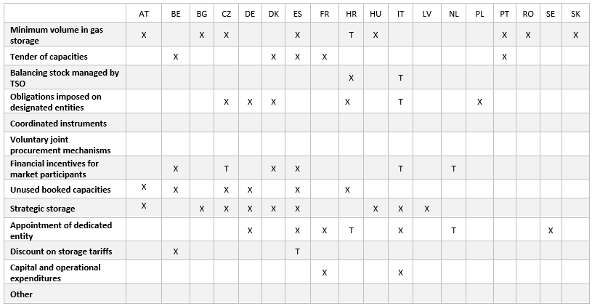

T means temporary measure

*Source: Member States' responses to EC survey and* [*ACER and VIS gas storage report 2023*](https://www.acer.europa.eu/sites/default/files/documents/Publications/VIS-Study_Gas_Storage_Report.pdf)

The burden-sharing mechanism, as identified by the Article 6*c* of the Regulation, provides that Member States without storage facilities on their territories store gas volumes in other Member States corresponding to at least 15% of their annual consumption.

The Commission survey indicates that in 2023 the burden sharing mechanism has been applied in at least three Member States without gas storage facilities. Estonia arranged the purchase of 1 TWh (30% of the annual consumption) as a national strategic reserve to be stored in Latvia. Lithuania confirmed it stored ca. 2.05 TWh stored in Latvia, equivalent to the average usage of the preceding 5 years. Slovenia also confirmed that its suppliers store gas on commercial basis corresponding to 15% of the previous 5-year consumption.

At the end of the winter 2022-2023, EU storage were 56% full. This higher-than-average level has been significantly supported by a reduced gas demand of 18% which participated to the favourable market conditions that ease the refilling. In 2023, 505 TWh (around 45 bcm) of gas was stored as a result of storage measures. Around 60% of the gas stored during the summer 2023 was injected in the months of May-July (see Figure 1), probably incentivised by the drop of gas prices at the beginning of the injection season. This early injection was decisive to achieve the 90% filling target by mid-August, more than 2 months in advance. By 1 November 2023, EU’s gas storage was 99.4% full, with all Member States exceeding the 90% filling target (Figure 2).

**Figure 1 - Net injections in EU gas storages by month**

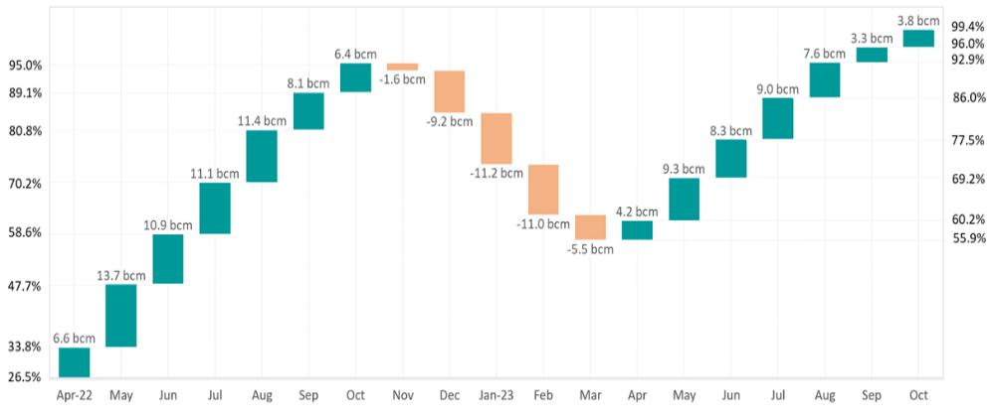

**Figure 2 - Gas in EU underground storages in the year 2022 and year 2023, in comparison with the previous 6-year average and range.**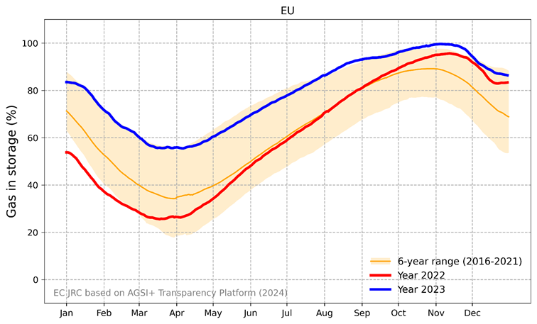

1. **Overview of the certification procedure**

According to Article 3a of the Regulation (EC) No 715/2009, as inserted by the Gas Storage Regulation, Member States have to ensure that each storage system operator, including any storage system operator controlled by a transmission system operator, is certified. In this context, the certifying authorities of Member States have to issue a draft certification decision in respect of storage system operators that operate underground gas storage facilities with a capacity of over 3.5 TWh where, regardless of the number of storage system operators, total storage facilities were filled on 31 March 2021 and on 31 March 2022 at a level which, on average, was less than 30 % of their maximum capacity by 1 February 2023. The certifying authority has to notify its draft certification decision to the Commission without delay, together with all relevant information, so that the Commission shall deliver an opinion on the draft certification decision to the certifying authority.

In 2023, several Member States submitted draft decisions for the certification of gas Storage System Operators (SSOs) to the Commission. The Commission adopted ten certification opinions which, after the confidentiality check by the certifying authority, were published in the Commission’s [Transparency Registry](https://ec.europa.eu/transparency/documents-register/) and on DG ENER [website](https://energy.ec.europa.eu/topics/energy-security/gas-storage_en). The Commission is still receiving draft certification decisions and is in close contact with the Member States experiencing delays in submitting their draft decisions. The Commission notes that many Member States, in particular those with a high number of sites, are actively working on the certification process. It is important to make timely progress to ensure a proper implementation of the Storage Regulation and strengthen the EU security of supply.

**Table 2 – Overview of the certification procedure at the end of 2023[4],[5]**

|  |  |  |  |
| --- | --- | --- | --- |
|  | **Draft certifications notified by**  **Nº Operators (Nº sites)** | **Pending draft certifications  Nº Operators (Nº sites)** | **Total Nº Operators (Nº sites)[2]** |
| **AT** | 1 (1) | 3 (7) | 4 (8) |
| **BE** | 1 (1) |  | 1 (1) |
| **BG** |  | 1 (1) | 1 (1) |
| **CZ** |  | 4 (9) | 4 (9) |
| **DE** |  | 25 (50) | 25 (50) |
| **DK** | 1 (2) |  | 1 (2) |
| **ES** | 2 (4) |  | 2 (4) |
| **FR** | 3 (16) |  | 3 (16) |
| **HR** | 1 (1) |  | 1 (1) |
| **HU** | 2 (5) |  | 2 (5) |
| **IT** |  | 3 (13) | 3 (13) |
| **LV** | 1 (1) |  | 1 (1) |
| **NL** | 3 (4) | 1 (3) | 4 (7) |
| **PL** | 1 (7) |  | 1 (7) |
| **PT** | 1 (1) |  | 1 (1) |
| **RO** | 2 (6) |  | 2 (6) |
| **SE** | 1(1) |  | 1 (1) |
| **SK** | 2 (2) |  | 2 (2) |
| **TOTAL** | **22(52)** | **37 (83)** | **59 (135)** |

To support Member States with the issuance of draft certifications, the Commission organised special sessions of the Gas Coordination Group to provide practical guidance for certifying SSOs and storage owners. The Commission recalled that the certification should reduce risk for security of gas supply at regional, national, or Union-wide level resulting, *inter alia*, from:

1. ownership, supply or other commercial relationships that could negatively affect the incentives and the ability of the storage system operator to fill the underground gas storage facility;
2. the rights and obligations of the Union with respect to a third country arising under international law, including any agreement concluded with one or more third countries to which the Union is a party, and which addresses the issue of the security of energy supply;
3. the rights and obligations of the Member States concerned with respect to a third country arising under agreements concluded by the Member States concerned with one or more third countries, in so far as those agreements comply with Union law; or
4. any other specific facts and circumstances of the case.
5. **Compliance with the storage filling objectives**

In order to ensure security of gas supply over the years and to comply with the gas storage target of 90% on 1November of each year, the Gas Storage Regulation has conferred implementing powers to the Commission to set the filling trajectory for each Member State with underground gas storage facilities from 2023 and the following years, as based on the draft filling trajectory submitted by each such Member State. In 2023, according to Article 6a of the Regulation (EU) 2017/1938, as inserted by the Gas Storage Regulation, all Member States complied with the intermediate targets set for 2023 by the Implementing Regulation (EU/2022/2301), adopted on 23 November 2022. Several Member States reached 100% (or surpassed their declared capacity[6]) before the 1 November 2023. The Commission therefore did not have to take measures in 2023 to ensure compliance with the filling trajectories and filling targets.

**Table 3 - Compliance with the filling targets of storage Regulation for 2023**

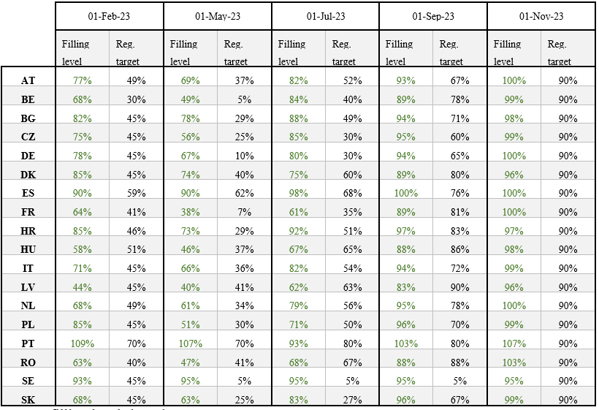

*Source: filling levels based on GIE AGSI+*

On 20 November 2023, the Commission set out, by means of an Implementing Regulation[7], the intermediate gas storage filling targets that Member States must meet in 2024. As envisaged under Article 6a(7) of the Regulation (EU) 2017/1938, as inserted by the Gas Storage Regulation, the Implementing Regulation defines the intermediate targets for each of 1 February, 1 May, 1 July and 1 September 2024 for those Member States with underground storage on their territory and connected to their market area. These targets were based on the proposals made by Member States, the filling rates of the previous 5 years and the Commission’s assessment of the general security of supply situation and aim at ensuring that the 90% overall storage filling goal is reached by 1 November 2024.

**Table 4 - Intermediate targets for 2024 for Member States with underground gas storage facilities, as adopted by Commission Implementing Regulation (EU) 2023/2633[8].**

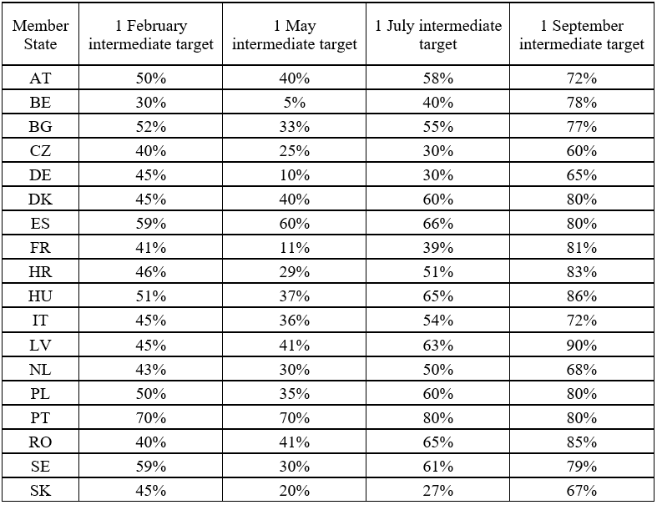

1. **Implementation of the gas Storage Regulation in 2024**

The intermediate targets of the filling trajectories are based on the input from Member States and an assessment by the Commission of the general situation of security of supply.  
The Member States’ filling trajectories proposed for 2024 were similar to the trajectories adopted in 2023. The assessment of the security of gas supply for the gas year 2023-2024 (from 1 October 2023 to 30 September 2024), based primarily on the results of the [ENTSOG Winter Supply Outlook 2023/24](https://www.entsog.eu/sites/default/files/2023-10/SO0052-23_Winter%20Supply%20Outlook%202023-24%20with%20Summer%202024%20Overview.pdf), indicates that the intermediate targets as originally proposed by Member States might require an upward adjustment if the supply-demand conditions were altered with respect to the previous year. Moreover, when following the advice of the Members of the Gas Coordination Group to keep intermediate targets aligned with 2022-2023 as proposed by Member States and give a maximum of market flexibility, the Commission had made clear that demand reduction efforts should continue in order to provide the same level of security of supply.

Based on analysis using the ENTSOG outlook[9], the Commission estimated (see recital 8 of the Implementing Act of November 2023) that the EU should reach at least 45% in May 2024 to facilitate storage refilling in the event of higher demand and/or reduced supply during summer 2024. Not reaching this target could pose a serious risk of not meeting the 90% storage target of 1 November 2024. This intermediary target ensures the necessary flexibility to meet the 90% filling target by 1 November 2024, even without Russian supplies during the summer, provided that other supplies are kept at current levels and with sustained gas demand reduction (Figure 3).

**Figure 3: Evolution of the European UGS filling level under full Russian supply disruption in a reference scenario with LNG supply potential as observed in 2022-2023 and low LNG (40% decreased) targets for February and May, aiming at reaching collectively 45% filing level in May.**

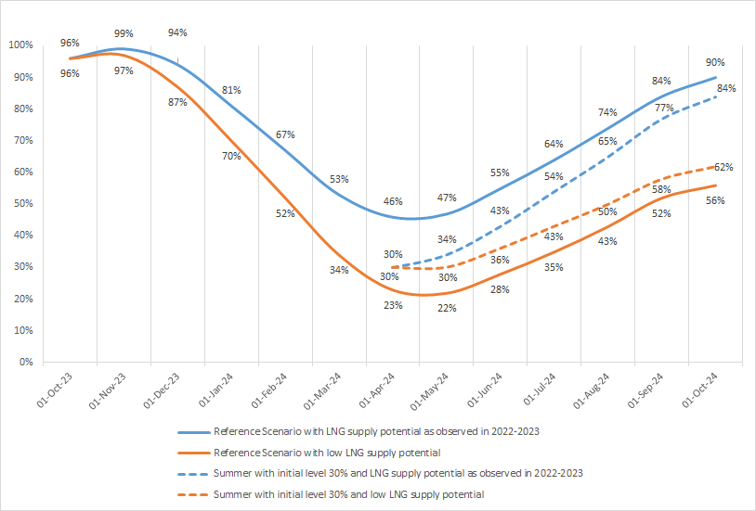

*Source: ENTSOG Winter Outlook 2023-2024*

**Energy Community outlook**

In line with the developments in the EU, the Energy Community transposed the Storage Regulation (EU) 2022/1032 at unprecedented speed. It requires the Contracting Parties to ensure that their undergoing storage is filled up to at least 90% of its capacity by 1 November. The Regulation also imposes the obligation on the Contracting Parties to ensure that storage system operators located on their territories are certified.

According to the [report by the Energy Community Secretariat on the implementation of Storage Regulation](https://www.energy-community.org/dam/jcr:5ea2bce2-c49d-4941-9eb9-181597ff76e8/Secretariat&%23039;s%20report%20on%20implementation%20of%20storage%20regulation.pdf), of 1 June 2023, Serbia and Ukraine, Contracting parties with gas storage facilities, fulfilled the targets including intermediary targets. The Report calls for Contracting Parties without storages to make additional efforts to implement the storage obligations and use available instruments in place, such as signing Burden Sharing Agreements and ensuring they have storage capacities for a portion of their annual demand (at least 15%) in the neighbouring countries.

Ukraine transposed the majority of the requirements from Regulation (EU) 2022/1032, fulfilled the obligations concerning the storage system operator and the trajectory levels of gas in the storages. Regarding the certification of SSOs in the Energy Community, only Ukraine and Serbia have storage capacities. In Ukraine, Ukrtransgaz has been certified in April 2023 and Serbia has not yet transposed the Regulation as the legal basis for certification. In addition, Ukraine storage and transmission system operators performed a storage stress-test, based on a set of selected scenarios aiming to identify whether the gas stored by foreign traders under warehouse custom regime could be evacuated to the owners in a crisis.

On 13 November 2023, the Energy Community Secretariat adopted comprehensive storage filling trajectories for 2024.

1. **Analysis of potential effects on gas prices**

Storages are key to ease tension in the markets as they can provide large quantities to the market when the supply is tight, and therefore mitigate price fluctuations and spikes.

Gas demand tends to be price-inelastic in the short term. Consequently, market tightness due to supply scarcity can rapidly translate into significant price increases. In this context, the availability of flexibility sources, such as the storage, is paramount to increase short-term available supply and preserve the demand-supply balance in the system.

The storage role in alleviating price pressure is widely acknowledged in the industry and in the economic literature.

For example, the International Energy Agency noted in the [Medium-Term Gas Report 2023](https://iea.blob.core.windows.net/assets/f2cf36a9-fd9b-44e6-8659-c342027ff9ac/Medium-TermGasReport2023-IncludingtheGasMarketReportQ4-2023.pdf) that high storage level, together with subdued demand, ‘*weighed on spot gas prices in Europe’* in the third quarter of 2023. Similarly, in its [report](https://www.acer.europa.eu/sites/default/files/documents/Publications/ACER_MMR_Key_Developments_Gas_2023.pdf) of June 2023 ACER indicated that ‘*storage filling levels are significantly above last years’ average and have contributed to driving prices down*.’

Several economic articles assessed the impact of gas storage on prices. For example, Brown and Yücel (What Drives Natural Gas Prices, 2008) looked at the US gas data between 1997 and 2007 and found that storage above the seasonal norm depresses natural gas prices. Hulshof et al. (2015)[10] analysed the TTF day-ahead spot price during the period 2011–2014 and similarly found that when the filling degree of storage facilities is below the average, spot prices tend to be higher. Obadi and Korcek (2020)[11] also looked at the TTF prices between 2016 and 2019 and concluded that storage levels below historic average result in tighter markets which inevitably lead to upward pressure on prices.

As shown in the graph below, wholesale gas prices have been fluctuating between 30 and 50 EUR/MWh in recent months. While still significantly higher than pre-crisis, prices have fallen considerably since the peak of the crisis in summer 2022 when prices reached unprecedented levels above 300 EUR/MWh.

Member States and the Commission put in place a comprehensive package of measures that together contributed to improve the market situation and helped alleviate the pressure on price. The commitment to store minimum volumes of gas prior to the winter, as set out in Regulation (EU) 2022/1032 played an important role in this set of initiatives and the very high level of storage filling observed since late Autumn 2022 has been a key (while not the unique) determinant in easing the market tension and driving gas prices down.

**Figure 4 - TTF month-ahead prices – January 2021 - September 2023**

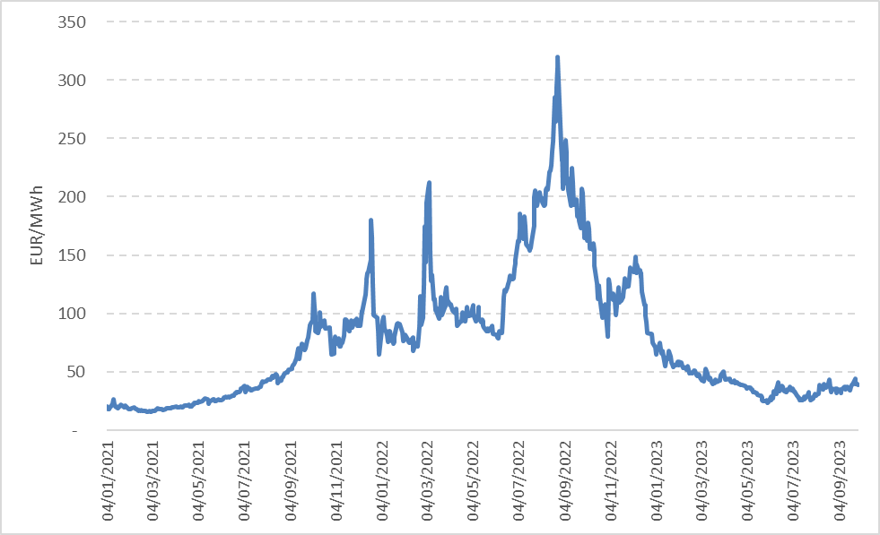

*Source: ENER based on S&P Global data*

1. **Conclusion**

In 2023, all the objectives set by the Storage Regulation have been met or surpassed. The 90% storage target was met by mid-August, and on 1 November gas storage levels were reported over 99%. At the end of 2023, the average level was still close to record high levels, above 85%[12]. The measures implemented by the Member States, supported by the gas demand reduction, both in terms of level and timing, proved efficient for market participants to keep storage levels at an adequate level through 2023 and fulfil the storage target. The fulfilment of the objectives ahead of the regulatory schedule even allowed to further inject additional 2.5 bcm in Ukraine storages over the summer mutually reinforcing the security of gas supply of the EU and Ukraine.

The mechanism of minimum intermediary targets leaves ample room for Member States to set their own measures and schedules. Achieving the objectives set by storage regulation greatly helped strengthen the security of supply in winter 2023/24, which in turn reduced the risk premium in the gas market at the end of the year.

With the obligation to certify gas storage, the Storage Regulation aims at avoiding any detrimental influence of non-EU countries on the filling of storage sites. The certification process is well advanced for a substantial share of the storage operators and sites. The Commission is in contact with the Member States which still need to submit draft certification decisions. While a number of certifications are still pending, there is currently no available evidence that storage ownership or storage operators could put the security of gas supply of the EU at immediate risk.

It is widely acknowledged that storage levels have had a positive effect with respect to gas prices although it is difficult to assess precisely to which extent. The trajectories and targets set by the regulation therefore contributed to alleviate the pressure on gas prices by setting minimum storage levels that were largely surpassed in 2023. Gas market volatility and gas prices were significantly lower in 2023 compared to 2022. Furthermore, it is essential to consider the effects of the storage together with the reduction of demand. The reduction of demand will continue to be a crucial factor to achieve a sufficient level of storage filling, which is part of the same security of supply architecture as demand-side measures.

**ANNEX - Detailed table of measures implemented per Member State with UGS**

|  |  |  |
| --- | --- | --- |
| Measure (as suggested in 6b of the Regulation) | MS | Description |
| Minimum volume in gas storage | AT | Gas suppliers of protected customers required to fulfil the Supply Standard (Art. 6 of SoS Regulation) |
|  | BG | Market participants with clients with irregular consumption obligated to maintain a strategic reserve related the security of supply and seasonal fluctuation |
|  | CZ | Gas traders directly supplying gas obligated to maintain gas stocks corresponding to 30 days of exceptionally high gas demand |
|  | ES | Suppliers obligated to maintain gas stocks corresponding to 27.5 days of their consumption in previous year |
|  | HU | Universal gas suppliers obligated to maintain security stocks based on the winter peak consumption of the last 120 months |
|  | PT | Market participants obligated to maintain security and additional reserves |
|  | RO | Gas suppliers and heat producers obligated to establish and maintain gas stocks until the end of October each year |
|  | SK | Secure gas volumes to meet the supply standard. The Ministry decides whether these volumes must be stored or contractually secured |
| 2.Tender capacities | BE | SSOs to tender capacities to market participants via auctions |
|  | DK | Tender capacities via auctions* |
|  | ES | Capacity obligation directly assigned, and the remaining is auctioned |
|  | FR | Holders of storage have the obligation to store 85% of the booked capacity by 1 November each year |
|  | IT | Increased number of auctions for monthly storage capacity products. |
|  | PT | Market participants to book capacity exclusively for the security and additional reserves |
| 3.1. Balancing stock managed by TSO | IT | Procurement of gas and injection for operation of transmission and storage |
| 3.2. Obligations imposed on designated entities | CZ | Storage users obligated to store sufficient gas in accordance with the filling trajectories |
|  | DE | Obligations of THE to conduct tenders for storage options |
|  | DK | Energinet responsible for procuring filling requirements and emergency storage |
|  | IT | Only in case of activated crisis level |
|  | PL | Gas suppliers and final consumers importing gas must maintain mandatory gas stocks covering 30 days of imports |
| 4.Coordinated instruments |  |  |
| 5.Voluntary joint procurement mechanisms |  |  |
| 6.Financial incentives for market participants | BE | Incentivize market participants to fill gas in storages* |
|  | CZ | Financial incentives provided to CEZ for delivering gas from the Dutch Eemshaven LNG terminal to the Czech VTP (3 bcm/y) |
|  | DK | Incentivize market participants to fill gas in storages* |
|  | ES | Costs of the technical manager are recovered from the state budget and from the market participants |
|  | IT | Contracts for differences. Provision of a stock premium. Penalty for stocks below the level assigned by storage operator.* |
|  | NL | Subsidy scheme extended for 2023-2024 (insurance type in case market conditions are not favorable during injection season). UGS Bergermeer not included. |
| 7. Unused booked capacities | AT | Requiring capacity holders to use or release unused booked capacities |
|  | BE | Measure approved by NRA (use-it-or-lose-it) |
|  | CZ | Releasing booked capacity back to the market if this is underutilized by a storage user |
|  | DE | SSOs release booked but unused capacity to THE |
|  | ES | Oversubscription and buy-back mechanism |
|  | HR | Automatically ceding unused capacity to other storage companies, or to state energy company HEP* |
| 8.Strategic storage | AT | 20 TWh of strategic gas reserves intended for security of supply purposes only |
|  | BG | Bulgartransgaz is obliged to maintain up to a maximum 70 mcm related to the security of supplies |
|  | CZ | ASMR to maintain gas stocks to be used in case of crisis |
|  | DE | Part of the storage options tendered by THE maintained in storage with a call-off option |
|  | DK | State-owned TSO holds strategic stocks* |
|  | ES | Gas stocks of the 20 days out of the 27.5 that are minimum obligation |
|  | HU | Maintaining two distinct gas reserves: the natural gas security stocks and the special natural gas stocks |
|  | IT | 49.3 TWh (4.62 bcm) strategic reserves that can only be withdrawn in case of emergency |
|  | LV | Strategic reserve for 2023 defined in the Law: 1.8-2.2 TWh |
| 9.Appointment of a dedicated entity | ES | The technical system manager (Enagás GTS) to cover the gas stocks’ obligations |
|  | DE | THE to purchase and inject its own gas to meet the filling targets |
|  | IT | Snam and GSE tasked to ensure that sufficient gas is in storage during winter period |
|  | FR | SSOs responsible for filling the gap to meet the filling targets, upon government request |
|  | NL | Appointment of a designated party to fill up to 20 TWh of UGS Bergermeer (actual storing 14.1 TWh) |
|  | SE | Swedegas responsible for ensuring meeting the filling targets |
| 10. Discounts storage tariffs | BE | Offering capacity at reserve prices at a discount compared to the regulated tariff |
|  | ES | Discounts offered for market participants that meet their obligation for minimum stocks and for storage users that procured capacity via auctions and filled 90% of their booked capacity on 1 November |
| 11. Capital and operational expenditures | BE | Last resort solution* |
|  | IT | In place if any cost remains uncovered. Otherwise, the system decreases the tariff scheme on final customers using the extras from storage auction revenues. |

*Measure collected by Commission that is not part of the [2023 ACER gas storage report](https://www.acer.europa.eu/sites/default/files/documents/Publications/VIS-Study_Gas_Storage_Report.pdf)

Source: Member States' responses to EC survey and ACER gas storage report 2023.

1. As defined by Directive (EU) 2022/2557 on the resilience of critical entities, ‘critical infrastructure’ means an asset, a facility, equipment, a network or a system, or a part of an asset, a facility, equipment, a network or a system, which is necessary for the provision of an essential service; according to the Annex of the Directive, Storage system operators (SSOs) fall furthermore in its scope as types of entities in energy sector, sub-sector gas.
2. Regulation (EU) 2022/1032 amending Regulations (EU) 2017/1938 and (EC) No 715/2009.
3. OPINION No 11/2023 OF THE EUROPEAN UNION AGENCY FOR THE COOPERATION OF ENERGY REGULATORS of 14 December 2023 on ENTSOG’s Winter Supply Outlook 2023/2024, [ACER_Opinion_11-2023_on_ENTSOG_Winter_Supply_Outlook_2023-2024.pdf (europa.eu)](https://www.acer.europa.eu/sites/default/files/documents/Official_documents/Acts_of_the_Agency/Opinions/Opinions/ACER_Opinion_11-2023_on_ENTSOG_Winter_Supply_Outlook_2023-2024.pdf).
4. The certifications are issued by operator and/or by storage site.
5. Based on exchange with MSs, GIE AGSI+ and [ACER and VIS Gas Storage report 2023](https://www.acer.europa.eu/Publications/VIS-Study_Gas_Storage_Report.pdf).
6. The physical storage capacity of some storage facilities could, under certain conditions, be higher than the working gas volume reported by the storage operators.
7. Commission Implementing Regulation (EU) 2023/2633.
8. The table is subject to the pro rata obligations of each Member State under Regulation (EU) 2017/1938, in particular Articles 6a, 6b and 6c thereof.
9. [entsog.eu/sites/default/files/2023-10/SO0052-23_Winter Supply Outlook 2023-24 with Summer 2024 Overview.pdf](https://www.entsog.eu/sites/default/files/2023-10/SO0052-23_Winter%20Supply%20Outlook%202023-24%20with%20Summer%202024%20Overview.pdf).
10. [What Drives Natural Gas Prices? on JSTOR](https://www.jstor.org/stable/41323156).
11. [EconPapers: Examining the Drivers of Natural Gas Price in Europe - Focus on the Role of Speculators (repec.org)](https://econpapers.repec.org/article/ecojourn2/2023-03-40.htm).
12. 86.40 % at EU level as from [Gas Infrastructure Europe - AGSI (gie.eu)](https://agsi.gie.eu/).