

COMMUNICATION FROM THE COMMISSION TO THE EUROPEAN PARLIAMENT, THE COUNCIL, THE EUROPEAN ECONOMIC AND SOCIAL COMMITTEE AND THE COMMITTEE OF THE REGIONS

on the 9th Cohesion Report

*“In order to promote its overall harmonious development, the Union shall develop and pursue its actions leading to the strengthening of economic, social and territorial cohesion.”*

(Treaty on the Functioning of the European Union Article 174)

# I. Introduction

*Economic, social and territorial cohesion is a European public good*

**The EU was founded on the values of solidarity, equal opportunities, and cohesion.** From the outset, the Treaty of Rome set the goal of “reducing the differences existing between the various regions and the backwardness of the less-favoured regions”. This economic and social cohesion, the reduction of internal disparities, has been rightly perceived as benefitting all of Europe and remains equally valid today.

Since then, Cohesion Policy has been one of the key pillars of the European project. From the creation of the Single Market, the Economic and Monetary Union, to several enlargements, Cohesion Policy has supported every step of European integration – including, in recent years, the green and digital transitions. Market forces alone cannot ensure that the benefits from these key integration steps are evenly spread across Europe, therefore Cohesion Policy is necessary to help Member States and regions contribute, benefit and reach their full potential. Over time, Cohesion Policy has also acted as an economic stabiliser, a reliable source of support and investment during the financial crisis, and, more recently, during the pandemic and Russia’s war of aggression against Ukraine, along with other instruments such as the Recovery and Resilience Facility. With its regional focus and place-based approach, Cohesion Policy is one of the most visible expressions of European solidarity, an integral part of the European growth model, and a cornerstone of our European house.

**Stakeholders confirm the key role and importance of Cohesion Policy.** They have made this clear in discussions on the future of the Policy.Over the past year, regional authorities and other stakeholders have provided inputs and 20 Member States have organised debates. A High-Level Group of Specialists published key orientations for the future policy[1] in February. The European Parliament, the Council of the European Union, the European Economic and Social Committee and the European Committee of the Regions have all adopted opinions and conclusions regarding key elements for the future of Cohesion Policy. Taken together, these inputs confirm the key role of the policy, paint a picture of emerging challenges, together with lessons learned and possible responses.

**Thirty years after the parallel launch of the European Single Market and of a reinforced Cohesion Policy, and twenty years after the 2004 enlargement, the long-term trend is clear: many parts of Europe have experienced a remarkable upward economic and social convergence.** However, socio-economic disparities persist and a growing number of regions risk struggling with new challenges. In this context, it is necessary to take stock: not just of the achievements of Cohesion Policy, but also how it can adapt. The Treaty objective of economic, social and territorial cohesion remains as relevant as ever, but the methods should evolve.

Map 1. Economic Development Index at NUTS3 level, 2001-2021

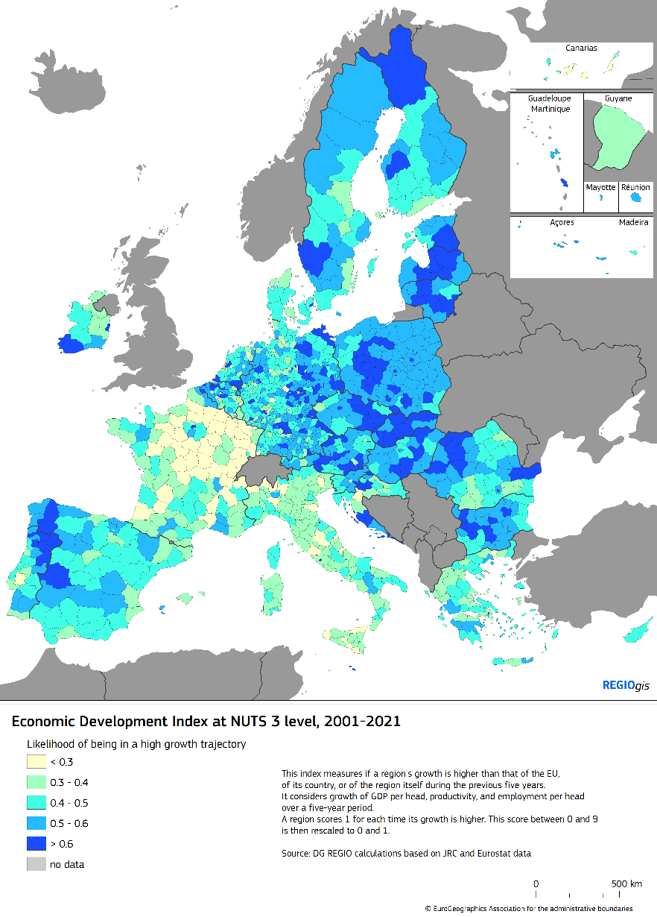

# II. Cohesion Policy: long-term growth and competitiveness, quality jobs

**The historic EU enlargement in 2004 is a clear example of the positive impact of Cohesion Policy.** Twenty years later, the average GDP per capita in the Member States that joined since then has increased from about 52 % of the EU average in 2004 to nearly 80 % in 2023. Unemployment rates in these Member States have decreased from an average of 13 % to 4 % over this period.

**This upward convergence has been driven by an increase in productivity (GDP per person employed) in less developed regions.** This testifies to the long-term improvement of the competitiveness and business environment of these regions. This catching-up also enabled tangible social progress, for instance in terms of better health outcomes, and reductions in unemployment and poverty rates across almost all regions over the last ten years.

**However, convergence has been uneven across the EU.** This reflects differences in productivity and competitiveness. Whereas several Eastern regions have experienced impressive catch-up since 2004, benefiting from a post-enlargement economic boost, many other regions have experienced a gradual divergence, meaning they fail to catch up with the EU average. This is notably the case of regions in Southern Member States, and especially since the financial crisis of 2008, but also of a group of transition regions in more developed Member States. In fact, about a third of EU regions have yet to see a return to 2008 levels of GDP per head. These regions cover all stages of development and can be found even in more developed Member States.

Real GDP per capita has even declined in several regions in Southern Member States since the turn of the century reflecting the impact of economic shocks and persisting structural challenges: productivity growth, quality of institutions and the smooth functioning of labour markets. At the same time, most Eastern regions should maintain the convergence momentum and extend their drivers of growth beyond metropolitan areas to mitigate deepening interregional disparities.

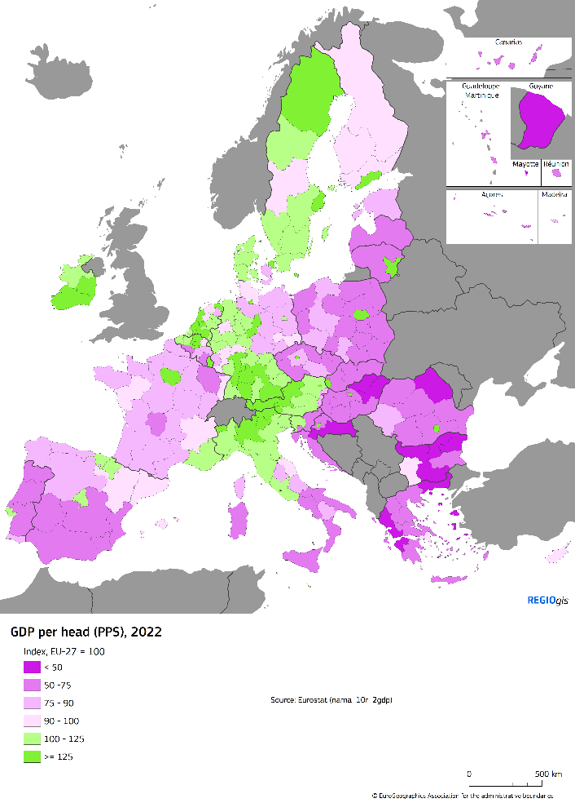

Map 2. GDP per head (pps), 2022

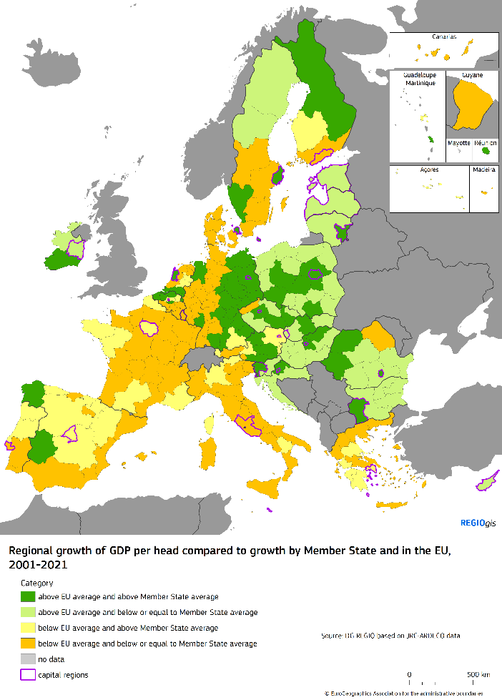

Map 3. Regional growth of GDP per head compared to EU and national averages, 2001-2021

Note: Map 3 shows regional GDP per capita growth since 2001. All the regions in green (light and dark) experienced growth above EU average, whereas the growth of regions in yellow and orange was below EU average. The shade of the colour (light and dark green, and yellow and orange) shows regional growth vis-à-vis the national average.

**Cohesion Policy has contributed to a better functioning of the Single Market by stimulating long-term growth and competitiveness.** It has improved access to goods and services through physical and digital infrastructure, increasing connectivity. Furthermore, Cohesion Policy has boosted local economies and attractiveness by improving innovation and entrepreneurship through support for SMEs, as well as reinforcing human capital with training and education. Cohesion Policy has also supported good governance, cooperation and administrative efficiency.

**Cohesion Policy has played a key role in supporting public investment.** For example, Cohesion Policy represents almost 13 % of total government investment[2] in the EU as a whole, and 51 % in less developed Member States[3]. These investments have strengthened the European growth model, spurring economic growth in line with key policy priorities from the twin transition, to innovation, business and skills, from childcare, education and health to protection from natural disasters.

Figure 1. Achievements of 2014-2020 Cohesion Policy programmes

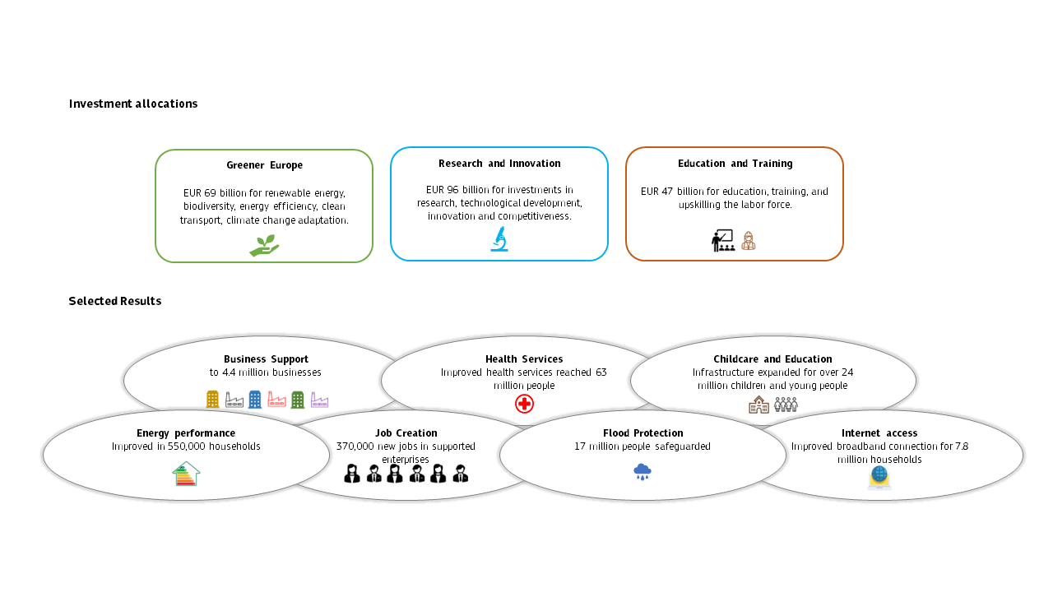

**Beyond its direct social and economic impacts, Cohesion Policy has also contributed to improving administrative capacity and the quality of governance in Member States.** Cohesion Policy investments come with pre-requisites, called “enabling conditions”. These support key EU priorities, as well as the quality and sustainability of investments. The horizontal impact of enabling conditions are complementary with the implementation of country-specific reforms promoted through the European Semester.

In addition, the fundamental principles ruling the programming and implementation of Cohesion Policy, through evaluation, partnership, transparency or audit and control requirements, have positive spillover effects on national practices.

*Cohesion Policy strengthens the Single Market and levels the playing field*

**Convergence enables every region to fully participate in the Single Market.** Removing barriers to the free movement of goods, services, capital, and workers has promoted a better allocation of resources across the EU and fostered the exchange of ideas and innovation. The growing diversity of EU regions has provided the Union and its firms with an enlarged pool of competitive advantages.By investing in infrastructure, innovation, education, and other key areas, Cohesion Policy helps all regions to participate and reap the benefits of economies of scale created by the Single Market and by international competition. A larger, well-developed, innovative, connected Single Market is crucial for the development of strong intra-EU value chains that are important for the EU’s open strategic autonomy.

**Cohesion Policy has significant and positive effects for Europe as a whole**. Macroeconomic modelling[4] suggests that the 2014-2020 and 2021-2027 programmes, taken together, could increase EU GDP by 0.9 % by the end of 2030. This impact is long-lasting: remaining at 0.6 % by 2043. The impact is, of course, much stronger in Cohesion countries[5] where support is concentrated: Croatia’s GDP will be up to 8 % higher in 2030, 6 % higher in Poland and Slovakia and 5 % higher in Lithuania than in the absence of Cohesion support. More developed regions, which receive lower per capita support from Cohesion Policy, also benefit from strong positive spillovers generated by programmes elsewhere. Developed regions gain partners in their supply chains, and markets for their exports and investments.

**The positive return on investment of Cohesion Policy to the Single Market can be illustrated by the multiplier**. Each euro invested in the 2014-2020 and 2021-2027 programmes will have generated 1.3 euros of additional GDP in the Union by 2030 and will almost triple in 2043, which is equivalent to an annual rate of return of around 4 %. Modelling also estimates around 1.3 million additional jobs for the EU as a whole by 2027, with a large share in the sectors linked to the green and digital transitions.

**The targeted nature of Cohesion Policy support largely mitigates the risk of crowding out private investment.** Cohesion Policy mostly focusses on areas where private investment is insufficient, either because of the existence of market failures (e.g. access to finance for start-ups, micro- and small enterprises) or in order to support public goods (e.g. education, childcare). Quantitative analyses underpinning the 9th Cohesion Report[6] consistently show positive net effects – confirming that the policy encourages significant private investment over and beyond the lifetime of programmes. The increased use of financial instruments can help lever in further private investment.

**Future enlargements will require the integration in the Single Market of new Member States.** The EU’s Cohesion Policy objectives remain valid in a wider Union, both in current and future Member States[7].However, socio-economic convergence with the EU should already start in the pre-accession phase. The New Ukraine Facility, the Growth Plan for the Western Balkans and the Reform and Growth Facility for the Western Balkans have the threefold objective of increased access to the EU Single Market, increased financial assistance and accelerated reform implementation.

*Cohesion Policy has helped mitigate the asymmetric impacts of recent crises*

**The series of unprecedented crises has had an uneven impact across the Union. From the COVID-19 pandemic to Russia’s war of aggression against Ukraine, different regions and social groups have been affected very differently.** For the pandemic, the effects were more severe in regions dependent on tourism, cultural industries or other labour-intensive services, as well as industries deeply integrated in global value chains. Regarding Russia’s war of aggression against Ukraine, the negative impacts were particularly felt in the border regions, as well as in regions where industry is vulnerable to high energy prices, or supply chain disruptions. In general, for all the crises, peripheral and less developed regions were more exposed. And asymmetric impacts were magnified by the uneven institutional capacity at the various levels required to respond to challenges.

**The** **EU has reacted promptly to mitigate the impacts of the crises and pave the way for a robust recovery.** Cohesion Policy has been quick in mobilising support to vulnerable regions, reducing the risk of further widening disparities. Actions included the injection of new liquidity to support investment, flexibility to support the continuation of projects, job retention schemes, and further targeted flexibilities in programming and implementation. Notably through the Coronavirus Response Investment Initiative (CRII) packages. In addition, under NextGenerationEU, comprehensive support has been channelled to Member States to foster their economic recovery process and long-term resilience, through the implementation of reforms and investments under the Recovery and Resilience Facility (RRF), as well as the Recovery Assistance for Cohesion and the Territories of Europe (REACT-EU). Together with REPowerEU, launched in the wake of Russia’s war of aggression against Ukraine, the flexibilities provided under Cohesion Policy with the Supporting Affordable Energy (SAFE) initiative, have been instrumental to support the most vulnerable, in particular, people at risk of energy poverty and SMEs vulnerable to high energy prices. In parallel, the Cohesion Actions for Refugees in Europe (CARE) provided financial support to local authorities and NGOs welcoming people fleeing Ukraine, as a result of Russia’s war of aggression.

Together with the Support to mitigate Unemployment Risks in an Emergency (SURE) and NextGenerationEU, notably the RRF, Cohesion Policy interventions contributed to a **fast economic recovery in 2021 and 2022, especially for less developed regions**, and to low unemployment rates. Whereas the COVID-19 crisis had triggered a contraction of GDP of 5.7 %, income had virtually returned to the 2019 level in two years in all categories of regions. In contrast, following the 2008 crisis, the downturn was less sharp (4.3 % of GDP), but two years later, in 2010, less developed regions had contracted even further and transition and more developed regions had barely started to recover. Supported by the mitigation measures mentioned above and national support actions, EU labour markets have shown remarkable resilience. It took just one year to return to, or surpass, 2019 employment levels in most EU regions. In contrast, during the 2008 financial crisis, the contraction in employment lasted until 2013, returning to pre-crisis levels by 2016 and only by 2019 in Southern EU countries.

The recent crises have, nonetheless, highlighted the vulnerability of many regions – and the need for more resilience in their economies and labour markets. To this end, the promotion of future-proof European value chains should be encouraged – notably through the uptake and upscaling of critical and emerging technologies in strategic sectors, as supported through the Strategic Technologies for Europe Platform (STEP)[8].

*Social convergence has progressed, although many challenges remain*

**Social convergence is driven forward by the strong commitment taken by EU institutions, Member States and social partners during the Porto Social Summit to achieve the targets of the European Pillar of Social Rights**:

* At least 78 % of people aged 20 to 64 should be in employment,
* At least 60 % of all adults should participate in training every year,
* The number of people at risk of poverty or social exclusion should be reduced by at least 15 million, including at least 5 million children.

Map 4. Employment rate (20-64 years old), 2022

* 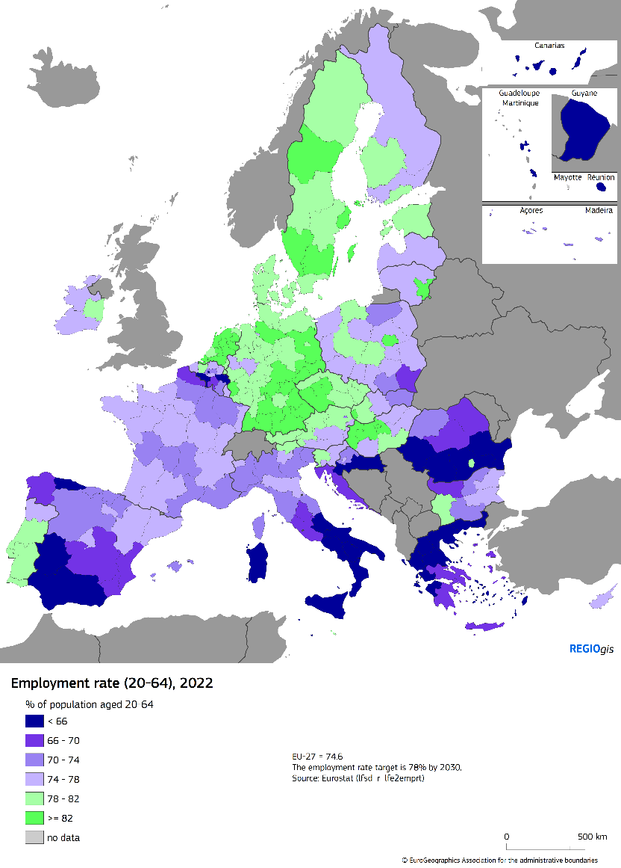

**EU Cohesion Policy has played a pivotal role in the overall improvement** of employment and social indicators in the EU in the last decade. Eastern EU countries have made significant progress in social inclusion and reducing poverty, converging to the EU average (poverty rates of 21 %). However, Southern EU countries have stagnated since 2019 (at around 25 %). The gap between more developed and less developed regions has also narrowed from around 14 pp in 2016 to 9 pp in 2022.

Yet, positive trends in social inclusion and poverty reduction could be jeopardised by inflation and high energy prices, and uneven progress across population groups. Rural areas in the East and South of the EU are the most directly affected by energy poverty. However, pockets of poverty can be found in every region – including developed urban areas. Some population groups, such as marginalised communities, live in persistent poverty, marked by housing segregation, insufficient education and employment opportunities, and limited access to basic services.

**Disparities in employment between regions have narrowed, with the active support of Cohesion Policy.** Although employment rates remain weaker in less developed regions at 68 % in 2022, compared to 78 % in more developed regions, the gap has narrowed by 5 pp since 2013.

**Unemployment rates have also converged.** The improvement is impressive in less developed regions, where the rate has almost halved, from 15.8 % in 2013 to 8 % in 2022, while the reduction in more developed regions from 8.3 % to 5 % also shows significant progress.

**However, despite progress in recent years, youth unemployment and the rate of young people not in education, employment or training (NEETs rate) in the EU remain a significant challenge, as are the persistent lower employment rates of persons with disabilities.** The decline in youth unemployment and NEET observed since 2014 resumed in 2021 and 2022 after a temporary increase in 2020 during the COVID-19 pandemic. The unemployment rate of people aged 15 to 24 has sharply dropped by more than 10 pp since 2013, to 14 % in 2022. Nonetheless, youth unemployment is more than double of overall unemployment, which has dropped to 6.2 %. The NEETs rate has declined since 2013 by more than 4 pp, to 12 % in 2022. Further progress is needed to reach the European Pillar of Social Rights target of 9 %.

**Disparities in youth unemployment between less developed regions and other regions decreased between 2013 and 2022,** thanks to higher reductions in less developed regions and in Southern EU countries. They nonetheless remain high, with the youth unemployment rate at 22 % in less developed regions being almost twice that of more developed regions. The disparities in the NEETs rate between less developed regions and other regions also declined between 2013 and 2022.Still, the NEETs rate in less developed regions remains 16 %, that is nearly double that in more developed regions.

**Increasingly, low unemployment and high labour demand put pressure on labour markets.** Labour and skill shortages are on the rise and have become a major challenge in a variety of occupations and sectors across all skills levels, and particularly in some regions. These shortages are exacerbated by the concomitant challenges of demand for specific skills to respond to the digital and green transitions, structural industrial transitions and the sharp reduction of the working age population, which is expected to shrink by 50 million by 2050. In this regard, inclusive labour market participation of underrepresented groups plays a key role in achieving convergence and addressing labour shortages in the EU, together with strengthening lifelong learning and education policies, as well as with labour market reforms. Women’s participation in the workforce continues to rise, thanks to high educational attainment, improved access to childcare services and more flexible work arrangements, and third country nationals’ employment rate rebounded after a drop in 2020.

**Despite a visible decline in disparities in labour market performance, some regions are underperforming –** the Central-Northern regions of the EU have stronger labour markets (and broadly speaking a better social situation) than Southern and South-Eastern regions. Progress in closing the gender gap in labour market participation has slowed or stagnated in recent years: for the EU as a whole, the gender gap still stands at 11 pp, which remains a contributing factor to labour market disparities.

**There has been a general increase in educational attainment.** The share of early school leavers has decreased across the EU, particularly in the less developed regions. The positive trend in tertiary educational attainment has continued across all regions, with the overall rate reaching 34 % in 2022. In contrast, adult participation in education and training decreased when COVID-19 hit, but bounced back especially in less developed regions and Eastern EU Member States.

**Skills levels and innovation play a pivotal role in driving long-term productivity growth and competitiveness.** More skilled and creative workers are key for innovation and the creation of new and competitive products and services. In 2022 there was a strong increase in adult participation in education and training, surpassing the pre-Covid pace. However, substantial progress is needed to attain the target of the European Pillar of Social Rights of 60 % of adults participating in education and training every year. Experience in some Member States with Individual Learning Accounts[9] show a clear path for progress.

**Disparities in education and training persist,** notably due to a strong concentration of tertiary graduates in cities (where most possibilities to acquire tertiary education are concentrated). These lead to imbalances, sometimes further increased by the outmigration of tertiary educated people from the regions where they had graduated. This ‘brain drain’ constitutes a serious challenge for the future sustainability of regional economies and social fabrics. These imbalances in the availability of talent across regions are due to insufficient quality job opportunities and other factors such as lower level of infrastructure endowment, access to childcare, education and training, health services and facilities and other services.

**Demographic change is expected to further exacerbate labour shortages and increase pressure on public budgets.** After decades of growth, the EU population has been declining since 2020, as net migration is no longer compensating for negative natural growth. At EU-27 level, natural population change and net migration are highest in urban regions, and lowest (and often negative) in rural ones. Moreover, remote regions experience overall negative net migration, linked to a lack of economic and employment opportunities, as well as lack of access to key services (including education, childcare and healthcare), which makes them less attractive and may cause people to move away.

Map 5. Total population change, natural growth and net migration, 2010-2021

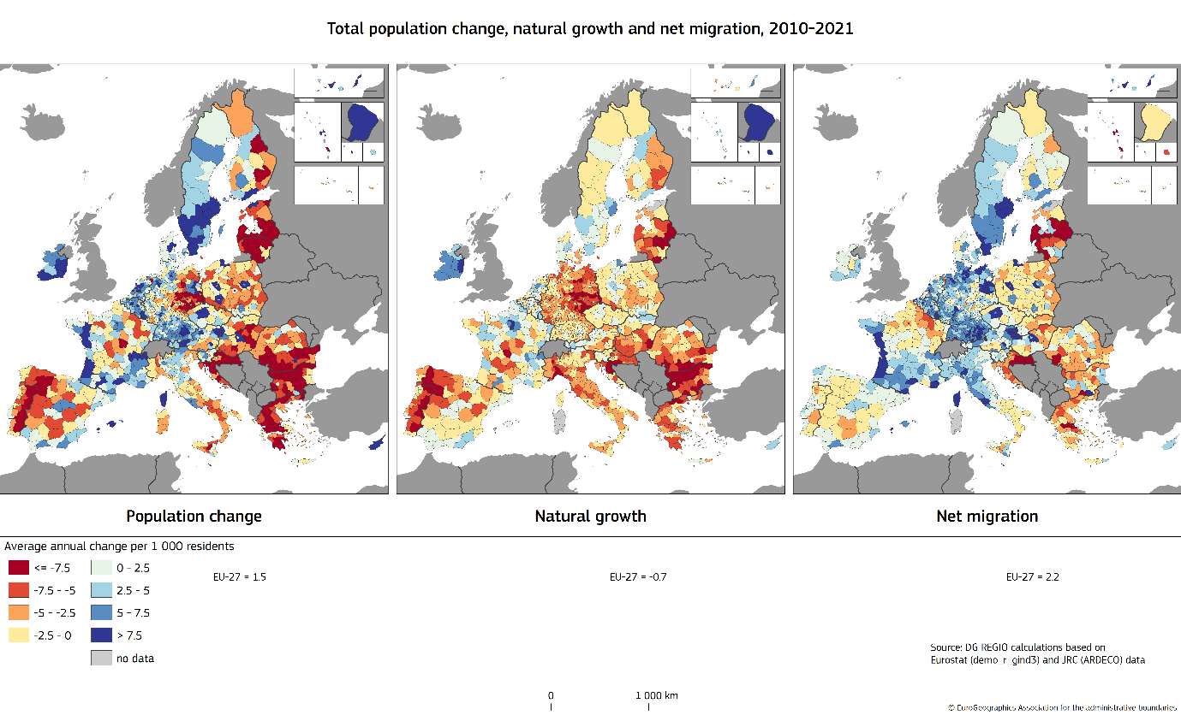

**The reduction of the working age population will require accelerated productivity gains to maintain living standards and increased employment rates,** notably for people not yet active on the labour market. In this regard, regions are unevenly equipped. Regions combining a low share of highly skilled people and outward migration of the young and educated may fall into a talent development trap, limiting their capacity to build sustainable, competitive and knowledge-based economies. As detailed in the Communications “Harnessing talent in EU regions”[10] and “Demographic change in Europe: a toolbox for action”[11], a strategic policy mix combining reforms and investments is needed to revert or adapt to this reality.

**Demographic change requires adaptation at the level of regions and cities.** For example, the integration of demographic projections into spatial policymaking, adjusting the provision of public services, adapting public governance, increasing employment rates and fostering productivity drivers. Vocational education and training has a strong capacity to address labour shortages and deliver on the green and digital transitions and play a major role in smart specialisation strategies: helping retain and attract talent, generate absorptive capacity in the societies and economies in which they are located, and to help build sustainable (and more equitable) communities.

Map 6. Regions (at risk of falling) in a talent development trap

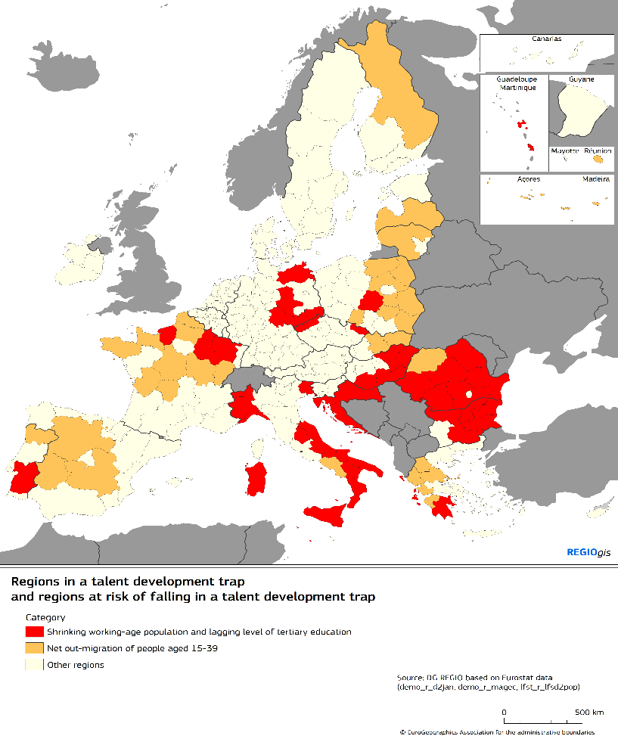

*…and not all regions benefit from the same growth dynamics*

**Economic disparities remain large across the continent**. More than one in four people in the EU (28 %) live in a region with GDP per capita below 75 % of the EU average. Most of them live in Eastern Member States, but also in Greece, Portugal, Spain, Southern Italy and outermost regions. Since 2001, real GDP per capita growth has been negative in several regions, notably in Greece and Italy, although it has recently been picking up.

**Changes in subnational disparities show different patterns across Member States.** In many Eastern Member States (such as Slovakia, Bulgaria and Romania), increases in disparities have been driven by very high growth rates in the most developed regions (typically the capital city region). In France and Greece, internal disparities have increased because growth of GDP per capita in poorer regions was particularly low. In some other Member States, such as Portugal, the decrease in regional disparities is due to the relatively poor performance of some developed, previously dynamic regions.

**In many Member States economic development is driven by the competitiveness of capital regions and major agglomerations. Coupled with a lack of catching up of other areas, this leads to internal divergence.** This spatial polarisation can be a source of negative externalities (tensions on labour and housing markets, congestion, pollution) and the underutilisation of economic potential of the whole country. This can undermine Member States’ competitiveness and in turn the sustainability of their growth pattern in the longer term.

**Rural, mountainous, island, and sparsely populated areas continue to face specific challenges that hinder economic growth and development,** stemming from lower physical and digital connectivity or limited education and training opportunities. Average income in rural areas is 87.5 % of average income in urban areas[12]. However, over the period 2001-2021, non-urban regions (on average) experienced a significantly higher GDP per capita growth than urban regions: 1.5 % as opposed to 0.8 %. The trend is nonetheless different in Eastern Member States, where the growth is more prominently driven by large agglomerations and capital cities. The public report on “The long-term vision for the EU’s rural areas: key achievements and ways forward” sets the scene for a debate on the future of rural areas.

**These territorial disparities compound a situation in which a number of regions face economic stagnation or decline,** with the risk of falling into a development trap (i.e. they fall behind EU and national average growth rates, as well as their own past performance). These include some larger former industrial poles in more developed regions. Policymakers in trapped regionsoften struggle to find solutions to regain the economic dynamism of the past. This situation fuels frustration, which is increasingly turning into political discontent.

**The root causes of development traps differ between regions.** This requires an individual diagnosis, and may involve various interlinked factors, such as insufficient specialisation, weak public governance, an inefficient innovation ecosystem, a gap in services or skills mismatches. These factors deserve dedicated analysis for each region and subsequent tailored policy responses, through a targeted set of investments and reforms.

**III. If left unaddressed, structural and emerging challenges could widen territorial disparities**

**The green and digital transitions bring new opportunities and are necessary to maintain the competitiveness of the EU in the future, to ensure a good quality of life for citizens.** **But they also require structural changes, which need to be accompanied by supporting policies –** particularly for people, companies and regions that are most vulnerable and exposed, with the risk otherwise of increasing regional and social disparities. The EU’s climate policy seeks to ensure fairness, notably with green house gas reduction targets being more stringent for wealthier Member States, whereas those with lower GDP per capita receive a larger share of the auctioning revenues from the Emissions Trading System. In addition to cross-cutting EU funds, such as Cohesion Policy and the RRF, a set of dedicated funding instruments has also been deployed to mitigate the social and economic impacts of climate transition, notably through the Just Transition Mechanism and the forthcoming Social Climate Fund.

**Climate change risks increasing regional inequalities.** The frequency and severity of weather-related disasters such as extreme temperatures, storms, inland and coastal flooding, droughts and wildfires, are increasing. For example, the floods in the regions on the Belgian-German border in 2021 have inflicted direct damage estimated at EUR 34.5 billion. Heat-related mortality has increased, especially in relation to an ageing population. These events and their impact on people and the economy, as well as their capacity to cope with them, are unevenly distributed across Europe. Coastal, Mediterranean and Eastern regions, which are already poorer than the EU average, are more vulnerable and disproportionally affected, and face estimated annual economic losses of at least 1 % of GDP and greater human exposure to climate-related harms.

Map 7. The impact of climate change under a 2°C global warming scenario, 2050

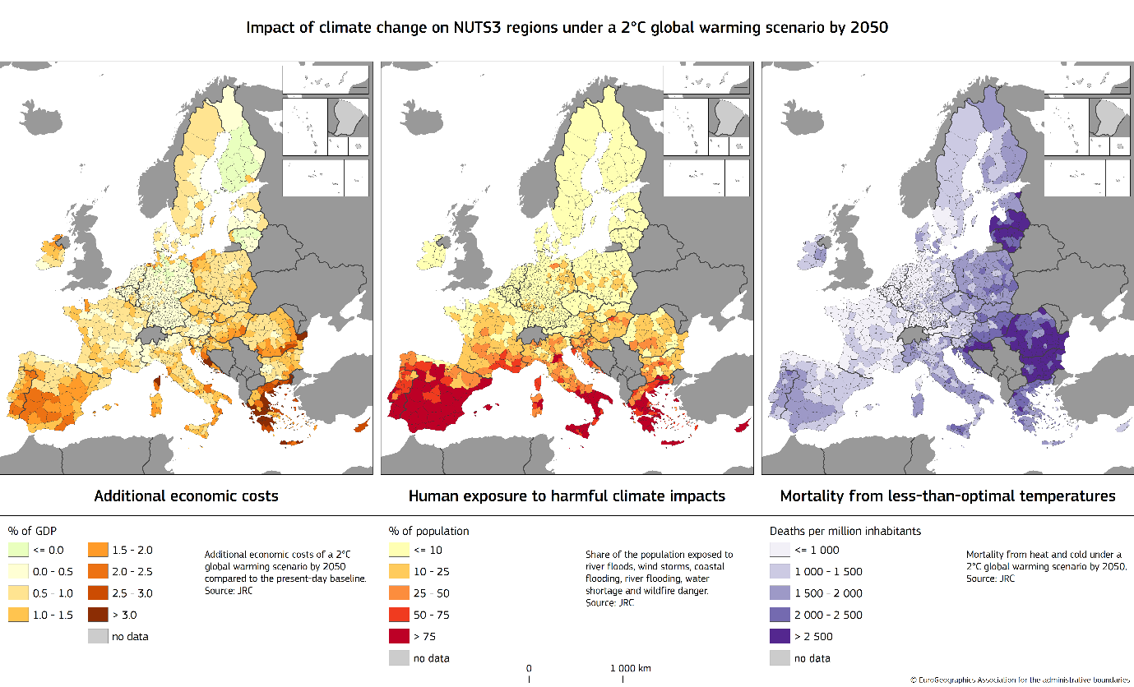

**Air pollution in the EU is still characterised by socio-economic differences.** Air pollution is generally higher in cities than in rural areas, due notably to the impact of traffic. Although air quality improved in both the richest and poorest regions of the EU over the period 2007-2020, inequalities persist as the concentration of fine inhalable particles is consistently around a third higher in the poorest regions more dependent on solid fuels for heating.

**Mitigating climate change and improving the quality of the environment demands a rapid reduction of emissions of greenhouse gases and air pollutants** in all sectors, including through the circular economy and restoration of ecosystems. This requires action at all levels of government, as these challenges tend to have strong territorial and social impacts. Natural, geographical and socio-economic differences between regions also lead to different capacities to reduce emissions.

**The transition to a climate-neutral economy needs to be accomplished in a just and fair manner.** The uneven capacity of regions to reap the benefits of this transition may exacerbate territorial disparities. The economic shift associated with this transition tends to benefit the regions that are more able to attract investment and mobilise skilled labour. At the same time, many rural and less developed regions have a high potential to produce renewable energy from wind and solar or for carbon capture and storage in natural ecosystems. The development of this potential would serve not only the regions themselves but energy security across Europe as a whole.

Map 8. Untapped potential for solar, wind and hydro power

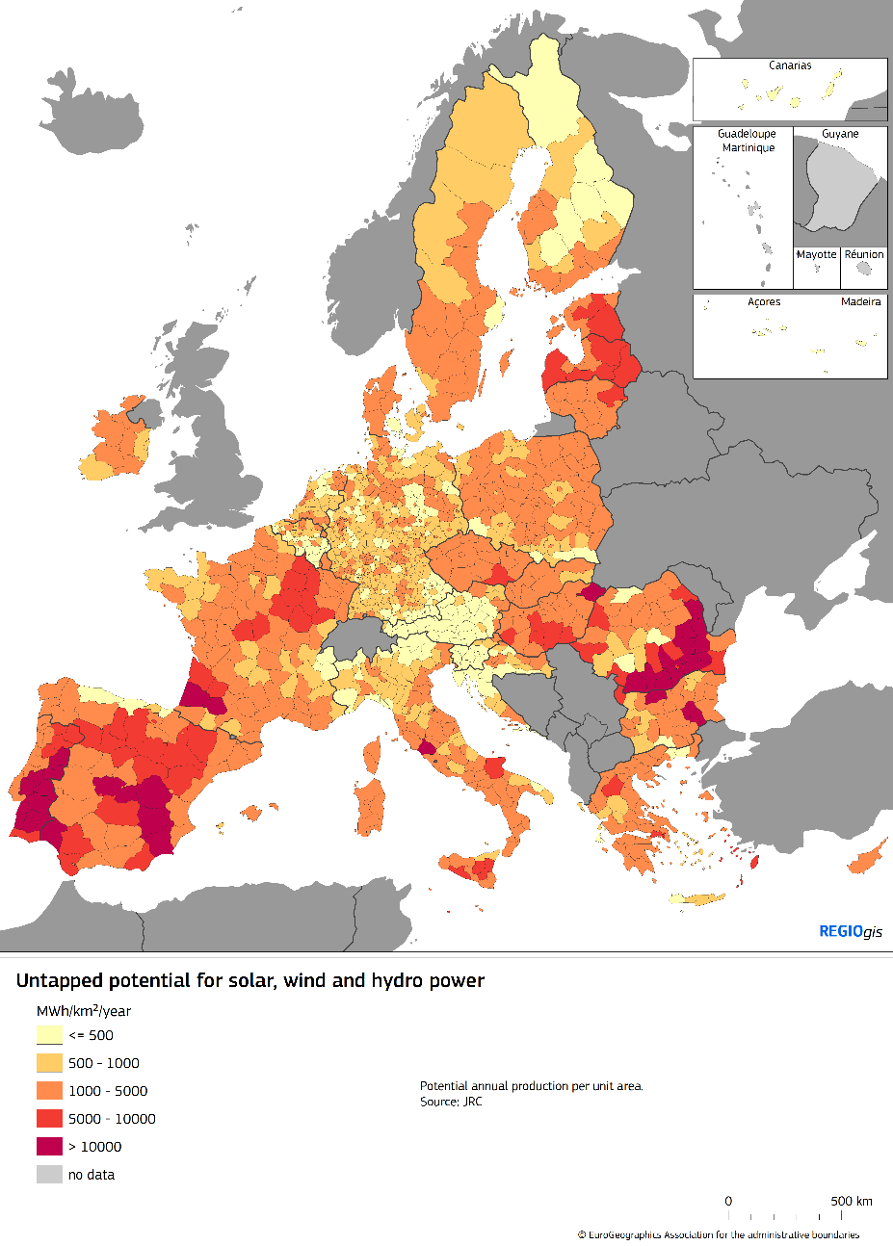

**The climate transition also brings both opportunities and challenges for employment and for households.** Certain sectors that are heavily dependent on fossil fuels are likely to be affected by job losses or restructuring. At the same time, climate change represents a challenge for traditional sectors such as agriculture, tourism, industry or even energy production, especially in areas where water scarcity becomes the norm. Workers in sectors where the impact of climate change is stronger – especially those with specific skills or limited opportunities to move into other industries – may struggle to find new jobs, leading to unemployment and pressures on household incomes. In the case of sectors that are dominant in the regional and local economies, the impacts will be of a broader scale, requiring the economies in these regions to adapt to stay competitive. In addition, the implementation of climate-friendly technologies and measures require additional investments, creating difficulties for low-income households.

**A comprehensive approach is needed to foster jobs and opportunities across regions, deal with the asymmetric costs of climate change and implement the climate and green transition,** including accelerating the mitigation of greenhouse gases and air pollutants emissions, the necessary investments in climate resilience, improving the management of natural resources and nature restoration, creating healthy ecosystems and nature-based solutions, supporting climate change adaptation and disaster risk management, investing in water efficiency and wastewater treatment (where necessary), in the circular economy, in energy efficiency of dwellings and shifting to climate-friendly transport modes.

**The digital transition provides opportunities for all regions in terms of increased productivity of businesses, innovation, resilience and access to services and an opportunity especially for rural and more remote territories.** However, the digital transition may also entail risks for cohesion, due to the uneven capacity of territories and people to adopt and make use of digital technologies - including for those in disadvantaged situations and marginalised communities.In the absence of adequate public policies, digital skills gaps may widen, potentially deepening social and regional divides within Europe. Moreover, the lack of investments in digital connectivity infrastructure and the deployment of digital technologies can hamper the long-term growth and competitiveness of affected regions. This can have a negative impact on the socio-economic attractiveness of such regions, making it more difficult to retain skilled workforce and innovative businesses.

**Continuous support for regions, especially the least prepared ones, and in particular in rural and remote areas, is needed to ensure that they can reap the benefits of the digital transformation**. Such support is in particular needed as regards investments in the rollout of advanced digital network infrastructures and services, the acquisition of basic and advanced digital skills as well as the uptake of digital technologies by businesses, citizens and public administrations.

**The new geopolitical landscape may also severely impact numerous EU regions.** Russia’s war of aggression against Ukraine led to some regions experiencing a sharp reduction of investment, trade flows and economic activities (including tourism), as well as new economic barriers and job losses. The war also resulted in an unprecedented number of people needing shelter in the EU. With a combination of legal, operational and financial support, the EU has helped ensure that both those fleeing to the EU and the Member States receiving them are well supported. However, some regions have seen a particularly high number of arrivals, putting pressure on local integration systems. Regions bordering Russia and Belarus are also facing security challenges and the threat or use of instrumentalisation of migration.

Continuous support is also needed to some Southern peripheral regions and outermost regions exposed to particular migratory pressure at the external border or experiencing an increase in irregular arrivals.

**Rising tensions and greater international competition call for more diversified value chains.** In the context of an open strategic autonomy, the diversity of EU regions and their existing and potential competitive advantages are an asset. Regional diversity can strengthen the Single Market and value chains across Europe. But to achieve this, regions must be equipped with the right physical, human and innovation resources – and be able to unleash their potential and added value.

*Governance matters*

**Deficiencies in public governance and administrative capacity hamper the development potential and remain a structural challenge in several regions and Member States.** The quality of institutions – including respect for the rule of law, and administrative capacity – is crucial for the return on public and private investment. There is a strong correlation between the quality of governance and the impact of Cohesion Policy investments. This calls for strengthening administrative capacity in European regions, including in view of future EU enlargements, since improving the quality of governance at national, regional and local level can increase the effectiveness of national and European policies and investments.

Map 9. European Quality of Government Index, 2024

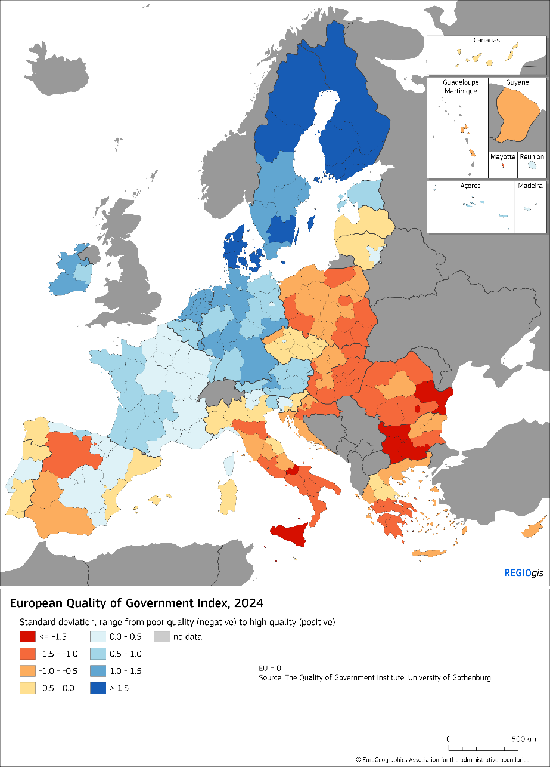

The development potential of many regions may also be affected by the lack of diversification of funding sources at regional and local levels, when relying largely on transfers from national budgets. Subnational entities are in charge, on average, of more than half of public investments. This proportion is lower, yet increasing, in less developed Member States. This type of dependence undermines the resilience of the concerned countries to shocks. Higher and diversified financing capacity of regional and local authorities, notably the possibility to mobilise private investment, together with reinforcement of their institutional capacity and administrative competences, would therefore reinforce the sustainability of their development strategies.

**IV. Taking stock of Cohesion Policy achievements and drawing lessons for the future**

**As highlighted above, while Cohesion Policy has successfully contributed to convergence between Member States, the picture at sub-national level is more nuanced.** Indeed, this national convergence process is sometimes overshadowed by increasing sub-national disparities, notably between large metropolitan areas and other regions, as well as by regions lagging behind, often caught in a ‘development trap’.

The 2021-2027 programmes started with some delay because of the impact of the pandemic and, in some Member States, due to other factors such as the need to prepare Recovery and Resilience Plans at the same time. Managing authorities in Member States and regions had to deal in parallel with different governance systems and timeframes. Less developed Member States and regions, which most need Cohesion Policy investments, often encounter design and implementation difficulties - and have more limited administrative resources. Despite the measures to simplify Cohesion Policy introduced through the 2021-2027 legislative framework and the support to administrative capacity provided over the last decades, further simplification of the policy is necessary.

To strengthen its effectiveness in delivering its Treaty objectives, notably in the light of challenges, **there is a need to reflect on how the design of Cohesion Policy could be further improved.**

*Delivering on the Treaty objective: reducing disparities in economic development*

**Cohesion Policy has constantly evolved over past periods, to adapt to new circumstances and to support EU priorities.** This has involved changes to the investments supported, geographical coverage, delivery mode, the use of conditionalities and the link with the European Semester process. At the same time, the fundamental values and principles of the policy have been maintained and even strengthened over time: a long-term framework for programming, partnership with stakeholders and civil society, multilevel governance, evaluation and data collection, and most of all, the place-based approach – where support is tailored to regional specific needs and opportunities.

**In line with its Treaty objectives, Cohesion Policy resources have been concentrated on the EU’s less developed regions and Member States:** 70 % of both the European Regional Development Fund and the European Social Fund Plus are allocated to these regions under the 2021-2027 programmes. The Cohesion Fund is entirely allocated to Member States with GNI per capita below 90% of the EU average. Although all regions receive funding from Cohesion Policy, the aid intensity in 2014-2020 is higher in the less developed regions, with around EUR 297 being allocated per inhabitant and per year on average, against EUR 117 for the average EU.

While maintaining the main focus on less developed regions, attention should also be paid to development dynamics and long-term trends, tackling problems before they become ingrained and helping regions caught (or at risk of being caught) in development traps. In short, taking a more pro-active approach to delivering on the Treaty objective of promoting harmonious development.

*Different regions have different starting points – and different development paths*

**Regions have different development starting points, needs, and capacities.** They are also unevenly equipped to cope with emerging challenges, given their different administrative and financial capacities. **They will therefore take different development paths to manage ongoing and future transformations**.

The EU, through Cohesion Policy (but not only), should channel targeted, place-based support focusing on the specific needs of each region, consistent with EU priorities and with due attention to the challenges, frameworks, and policies in each Member State.

Regional development programmes have long been the mainstay of Cohesion Policy, but the Just Transition Fund has illustrated how support can be further tailored to specific territories’ development needs, with a view to addressing pre-identified climate transition challenges. Similarly, smart specialisation strategies have proven to be helpful in strengthening regional innovation ecosystems: based on local capacities and assets, relying on a network of local and regional stakeholders, and addressing the innovation divide.

The green and digital transitions, the demographic transformation, changing global economic trends and climate change will affect all regional economies. But the scale and nature of these challenges will differ between regions – as well as their ability to face them.

Therefore, **a thorough reflection is needed on how to best further tailor the policy to the different economic profiles and geographical features of regions to strategically target investments.** There is a growing need to reflect better multiple development challenges, reform needs and differing social and employment circumstances in order to facilitate more efficient programming of EU funds in outermost, sparsely populated, islands, mountainous, border regions, rural areas and areas affected by industrial transition and beyond.

*Promoting more balanced territorial development*

**Sub-national economic development is often characterised by strong polarisation between capital regions and large metropolitan centres on the one hand, and regions with lower population density on the other.** The uneven distribution of growth drivers leads more developed regions to perform better in terms of innovation and competitiveness, quality of public governance and administration, and education attainment. This can also mean that significant economic and quality job creation potential remains to be exploited in less developed rural and intermediate regions.

**Metropolitan areas, cities and their surroundings play a central role in regional development.** They concentrate human capital (including universities, vocational training centres and R&D centres) and ensure high connectivity and high quality services. Because of this, they naturally attract investment. But their attractiveness comes at a price: higher congestion, social challenges, and housing costs – which, coupled with higher wage costs, may undermine their competitiveness.

**Small towns and medium-sized cities also** **play a pivotal role in territorial development, by fostering the growth of their surrounding areas.** They are key in the provision of public and private services and offer employment and education opportunities to the surrounding areas.

Better cooperation across EU regions can also contribute to achieving more balanced territorial development. Cohesion Policy, especially through Interreg programmes, has helped to support interregional collaboration through cross-border and transnational cooperation, including through macro-regional strategies. These foster innovation, development, and better governance. There is nonetheless room for strengthening regional cooperation at different levels – notably in delivering common public goods across borders, given the added-value of supporting cross-border investments with the European budget.

Territorial imbalances could be mitigated by a more polycentric development model: building on small and medium-sized cities and promoting accessibility of public services in areas far from large urban centres. Regional cooperation could be strengthened by building the capacity of relevant authorities and stakeholders.

*Partnership, multilevel governance and empowerment of stakeholders*

**People on the ground have more knowledge of the exact needs of their territory.** As such they must be involved in decision and policy making. This inclusion and empowerment can also serve to counteract rising political discontent[13] and distrust of public authorities.

The 2021-2027 framework reinforced partnership and the involvement of regional and local actors, civil society, and social partners. Actions included the promotion of territorial delivery models, such as Community-led local development (CCLD) or integrated territorial investments. These combine funding from multiple sources to serve the implementation of a territorially based strategy, involving local partnership, bottom-up approaches and territorial governance. Further reflection is needed on how to best involve sub-national authorities and other relevant stakeholders, and enhance territorial multi-level governance mechanisms. The aim is to better respond to the needs of economic and social partners and citizens, in line with EU priorities. This enhanced role for local partners requires improving their administrative capacity – how best to do this should be part of the debate.

*Promoting institutional convergence by addressing existing public governance and administrative capacity shortcomings*

**Good governance, strong institutions, respect for the rule of law, and strong administrative capacity are a precondition for effective and efficient design and implementation of any development strategy, and more generally for economic and social progress.** Administrative and governance weaknesses impede some Member States and regions in reaping the full benefits of Cohesion Policy – notably due to their difficulties in preparing and implementing investments.

Weaknesses in governance and capacity are still widespread. Current support from Cohesion Policy, through technical assistance, mostly fills capacity gaps in fund management and delivery arrangements, including when they relate to combating fraud and corruption.

Other EU instruments have also contributed to reinforcing administrative capacity, mostly the Technical Support Instrument, which increasingly supports regional and local authorities. Reforms of public administrations supported by the RRF (for example in permitting procedures or public procurement) have benefited investments financed both by the RRF and Cohesion Policy.

A more ambitious and comprehensive approach is necessary to address weaknesses in the national and regional administrations, as well as among beneficiaries and partners. Such a strategic approach could combine tailored technical support with reform requirements in certain domains.

Addressing administrative shortcomings would not only improve the effectiveness of Cohesion Policy, but also contribute to stimulate investments and exchanges within the Single Market, increase the attractiveness of the concerned regions and Member States and improve their capacity to implement the EU acquis.

*Enhancing the effectiveness of Cohesion Policy investments and promoting reforms*

**Investments are a necessary, but not sufficient, condition to ensure economic development. Some regions, despite receiving Cohesion Policy support for many years, still experience weak economic performance.** **Reforms are needed to remove obstacles to regional development** – be it specific investment barriers, regulatory obstacles or measures to improve the functioning of the labour market and the business environment.

Cohesion Policy, under the 2021-2027 framework, has promoted stronger linkages between investments and reforms through enabling conditions, and alignment with the European Semester. By removing obstacles to regional growth and development, such linkages can have a positive impact on the Single Market.

**Enabling conditions establish a uniform framework to increase the effectiveness of Cohesion Policy investments,** ensuring for example the economic relevance and financial sustainability of transport investment planning or the coherence of water management with EU priorities and requirements. However, the application of these conditions, through a common set of requirements established in the regulatory framework, may limit their capacity to take account of Member States’ specific difficulties, needs and challenges as they evolve over time.

**A stronger coordination has also been put in place between the European Semester and Cohesion Policy investments.** While the European Semester focuses on national reforms, the strengthened territorial and social dimension in the Semester since 2018 has increased its role in guiding Member States to harness the economic potential of their whole territory and reduce inequalities. Indeed, the investment-related country-specific recommendations steered the 2021-2027 Cohesion Policy programmes and the use of the Just Transition Fund. The 2024 recommendations will have a key role in the mid-term review and adjustments of programmes in 2025 with an enhanced focus on regional specificities and challenges.

In order to further stimulate regional growth and convergence, **there is a need to explore how the link between investments and reforms could be further strengthened to maximise the impact of Cohesion Policy.** This reflection should take into account the experience of other EU instruments – notably the RRF, which has introduced a stronger complementarity of investment policy and reforms in Member States. Reflections should cover the scope of the reforms needed, the role of the European Semester, and the coordination between European, and national and regional policies.

*Better coordination and coherence with national policies*

**Promoting cohesion is not the responsibility of Cohesion Policy alone.** Leveraging the economic potential of all EU regions, while reducing socio-economic inequalities, requires common effort – and should be a shared objective of investment policies, at EU and national levels. This has not always been sufficiently the case. Hence, there is need to further reflect on how EU and national action to address disparities and to promote the Treaty objective of economic, social and territorial cohesion should work together, reinforcing each other and tailoring support to different types of territory.

**For instance, integrating, where relevant, the territorial dimension into policy design could reinforce greater coherence between regional-specific needs and horizontal (European and national) policies.**

*Making delivery more effective*

Delays in programming and implementation of Cohesion Policy programmes (partially rooted in the backloading of financial implementation, coupled with administrative shortcomings in some Member States and regions) suggest that the delivery mode of the policy can be improved. This can be done notably by ensuring further simplification for administrations and beneficiaries.

**The 2021-2027 framework has put forward important simplification measures** – including a reduced list of policy objectives, a clearer intervention logic through indicators, lighter reporting, and single audit arrangements. It also extended possibilities to use alternative payment options beyond invoice-based costs, i.e. financing not linked to costs, or simplified costs options. This has paved the way for simpler implementation, with quicker payment possibilities. However, Member States have not yet made full use of these options.

**The positive experiences that have been gained through the implementation of the ESF and ESF+, moving towards a performance-based delivery model, can help provide lessons for the future.** It is important to assess whether this delivery model, with payments linked to the achievement of outputs (instead of the reimbursement of incurred costs), could bring a reduction of administrative burden for programme authorities and beneficiaries, accelerate financial implementation, and increase the result orientation of the policy.

The **mid-term evaluation of the RRF[14] has also provided some important reflection** to consider for the future design of EU funding instruments. The associated consultations show that there is broad support for performance-based funding instruments at EU level. Funds under the RRF are disbursed upon the achievement of milestones and targets, which represent concrete steps in the implementation of reforms and investments by Member States, thus rewarding progress along the way.

The mid-term evaluation also finds that combining reforms and investments in an integrated manner provides effective incentives to deliver on long-standing reform needs – and can lead to more coherent and efficient implementation. The recovery and resilience plans foster holistic policymaking by incentivising Member States to design a coherent set of reforms and investments, with clear deliverables, that address both EU policy priorities and country-specific challenges. At the same time, the evaluation shows that local and regional authorities, stakeholders, and social partners, have been pointing to their insufficient involvement, and recalls the importance of their effective involvement – not only in the design, but also in the implementation and monitoring of the measures that affect them. Finally, the evaluation also underlines potential areas for future simplification to ensure sufficient flexibility in the design and implementation of the plans, notably regarding their revision procedure, the formulation of milestones and targets as well as the current audit and control framework.

Any future change to Cohesion Policy or any new delivery model needs to be aligned with the Treaty objective of economic, social and territorial cohesion, and take into account the experience from Cohesion Policy programming and its regional and place-based approach, as well as lessons learned from the RRF. There are also practical issues which would have to be considered – for example, implications for the audit and control system.

*Reaching long-term objectives – but with built-in flexibility, for unforeseen circumstances*

**Cohesion Policy programmes pursue long-term development objectives** with an implementation period spanning over a decade.

**The existing possibility to amend Cohesion Policy programmes already allows for flexible adjustment** to take account of changing circumstances. This flexibility has increased over time. It has been used to great effect in response to economic crises and unexpected shocks, notably in the areas of emergency management, recovery and prevention. The legislative framework includes options for a swift reallocation of funds between and within programmes, the mid-term review exercise, and specific provisions for temporary derogations in response to exceptional or unusual circumstances.

**While it was crucial for Cohesion Policy to contribute to the EU’s response to the socio-economic fallout of the COVID-19 pandemic and of Russia’s war of aggression against Ukraine, its main focus must remain on the achievement of long-term structural objectives.** Economic resilience can only be achieved through long term investments, notably in the diversification of regional economies, building adaptability to technological and demographic change and upskilling the labour force.

**CONCLUSION**

**The 9th Cohesion Report highlights significant achievements of Cohesion Policy in terms of fostering upwards economic and social convergence in the Union. Challenges remain especially at regional level, and these will be further impacted by structural transformations. Lessons learned from past implementation periods, and from the interplay with other instruments, underline the need for further improvement of the design of Cohesion Policy. A stronger and modernised policy is essential to fortify Europe’s growth model, to build an inclusive Union, and to deliver on the Treaty objective of economic, social and territorial cohesion.**

1. [Forging a sustainable future together - Cohesion for a competitive and inclusive Europe: report of the High-Level Group on the Future of Cohesion Policy](https://op.europa.eu/en/publication-detail/-/publication/c6e97287-cee3-11ee-b9d9-01aa75ed71a1)
2. Gross fixed capital formation of general government.
3. Member States with Gross National Income per capita below 90 % of the EU average.
4. The impact of the 2014-2020 and 2021-2027 programmes was assessed using RHOMOLO, a European Commission spatial computable general equilibrium model. See Chapter 9 of the 9th Cohesion Report for a more detailed analysis.
5. Czechia, Poland, Slovakia, Croatia, Bulgaria, Romania, Estonia, Greece, Cyprus, Latvia, Lithuania, Hungary, Malta and Slovenia.
6. See Chapter 9 of the 9th Cohesion Report.
7. COM(2024) 146 final, 20.3.2024.
8. [Regulation (EU) 2024/795 establishing the Strategic Technologies for Europe Platform (STEP)](https://eur-lex.europa.eu/legal-content/EN/TXT/PDF/?uri=OJ:L_202400795)
9. Individual learning accounts give people of working age a budget to spend on quality training to improve their skills and employability.
10. COM(2023) 32 final, 17.1.2023.
11. COM(2023) 577 final, 11.10.2023.
12. [Urban-rural Europe - income and living conditions - Statistics Explained (europa.eu)](https://ec.europa.eu/eurostat/statistics-explained/index.php?oldid=589523)
13. A. Rodriguez-Posé, L. Dijkstra and H. Poelman: The Geography of EU Discontent and the Regional Development Trap, [Regional Policy Working Papers 03/2023](https://ec.europa.eu/regional_policy/whats-new/newsroom/06-12-2023-geography-of-discontent-regional-development-traps-lead-to-less-support-for-european-integration-and-values_en)
14. COM(2024) 82 final, 21.2.2024.