

## Foreword

I am glad to present this report covering the 2023 cycle of the Technical Support Instrument (TSI). At its third recurrence, the TSI confirms to be a successful policy instrument that is of tangible benefit to Member States. Yet again, the number of requests for support from the national authorities was considerably larger than the number of requests that DG REFORM was able to serve.

The evidence we present in this report shows that the TSI helps Member States to improve their administrative capacity to design, develop and implement reforms, and contributes to achieving sustainable growth and ease the green and digital transitions. With no preallocation of funds based on geographic or thematic factors, the TSI remains a flexible and demand-driven instrument that allows adapting to emerging needs and fast-changing environments.

Remarkably, Member States’ interest in taking part in multi-country projects continued to rise, with 34 such projects under TSI 2023. Member States also demonstrated their interest in strengthening cooperation at regional level through 10 multi-regional projects. Similarly, there was a strong uptake by Member States of the 12 flagship projects for technical support that were selected on the basis of Member States’ needs and linked to EU top priorities.

In 2023, the majority of reforms supported by the TSI was linked to the implementation of national recovery and resilience plans. Furthermore, in the context of the Commission’s political priority to accelerate the integration and accession process, the TSI opened beyond the EU boundaries and launched a pilot with enlargement countries as observers of selected technical support projects.

Another important milestone in 2023 was the adoption of the [Communication on Enhancing the European Administrative Space (ComPAct)](https://reform-support.ec.europa.eu/public-administration-and-governance-coordination/enhancing-european-administrative-space-compact_en), which proposed concrete actions to help public administrations meet the needs of people and businesses across Europe. Linked to the ComPAct, the Public Administration Cooperation Exchange (PACE) was also launched in 2023 as a TSI flagship project. This initiative aims to promote peer-learning and the exchange of best practices among civil servants of different Member States to strengthen administrative capacity, policymaking and implementation skills. PACE saw a significant take-up with more than 300 civil servants taking part in 70 exchanges across Member States.

With this report we also highlight the significant contribution of the TSI to competitiveness, a key EU priority. This overview of TSI support to Member States on competitiveness during 2023 is structured along the nine competitiveness drivers identified in the ‘[Single Market at 30’ Communication](https://eur-lex.europa.eu/legal-content/EN/TXT/PDF/?uri=CELEX:52023DC0162) and the [2024 annual single market and competitiveness report](https://eur-lex.europa.eu/legal-content/EN/TXT/PDF/?uri=CELEX:52024DC0077). The report presents concrete cases in which the TSI supported European businesses in driving Member States’ economies creating jobs, cohesion, innovation, and prosperity.

I am confident that the TSI will keep supporting the design and implementation of reforms in line with key EU policies and priorities, addressing national and transnational challenges, and thus having a clearly positive EU-wide impact in the years to come.

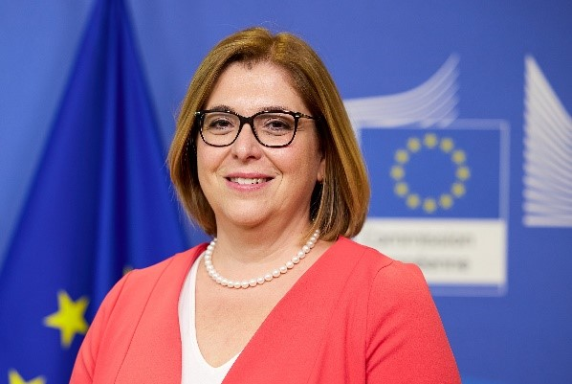

Judit RÓZSA

Acting Director-General DG REFORM

Table of Contents

Foreword 1

The Technical Support Instrument 4

The TSI in 2023 5

I. Highlights 5

Public administration and governance 6

II. The TSI 2023 cycle - facts and figures 6

Launch of the TSI 2023 cycle 6

TSI 2023 requests for support 7

TSI 2023 projects 9

Flagship projects 12

RRP support 12

Pilot for enlargement countries as observers 13

III. Project execution 13

IV. Cooperation and support plans 14

V. Communication on the TSI 14

VI. Evaluation of the TSI 16

The TSI as a key instrument to support EU competitiveness 16

I. Functioning single market 19

II. Access to private capital 20

III. Public investment and infrastructure 21

IV. Research and innovation 22

V. Energy 23

VI. Circularity 24

VII. Digitalisation 25

VIII. Education and skills 26

IX. Trade and open strategic autonomy 27

Conclusion 28

Annex 1 – The TSI annual cycle 29

Annex 2 – 2023 TSI general call: requests by Member State 30

# The Technical Support Instrument

Since 2021, the **Technical Support Instrument**[1] **(TSI) is the EU programme providing tailor-made technical expertise to Member States to improve their capacity to design and implement their reform agenda, including via their national resilience and recovery plans**. Its general objective is to promote the EU’s economic, social and territorial cohesion by supporting Member States’ efforts to implement the necessary reforms to achieve economic and social recovery, resilience and upward economic and social convergence.

Managed by the European Commission’s DG REFORM, the TSI is available to any Member State facing challenges in the process of designing and implementing reforms. This includes reforms that aim to address challenges identified in the **European Semester** process of economic policy coordination, the **EU’s policy priorities** or reforms undertaken at a **Member State’s own initiative**. The TSI **does not pre-allocate funds** by Member State or policy area.

The TSI does not require co-financing from Member States. Its overall budget for the 2021-2027 multiannual financial framework stands at **EUR 864.4 million**. In addition, Member States may request additional technical support via a direct contribution or as part of their recovery and resilience plans.

|  |  |  |  |  |  |  |  |
| --- | --- | --- | --- | --- | --- | --- | --- |
| 2021 | 2022 | 2023 | 2024 | 2025 | 2026 | 2027 | Total |
| 116.4 | 118.7 | 121.1 | 123.5 | 126.0 | 128.5 | 130.4 | 864.4 |

Figure 1 - TSI budget programming 2021-2027 (million euro)

The TSI offers beneficiary authorities in Member States a unique project-based access to technical expertise and peer-learning opportunities to help them tackle reform challenges. It is an **instrument** driven by the demands of the Member States and it is organised in **annual cycles**, as described in Annex 1. TSI support covers the provision of expertise and experts related to policy advice, policy change, formulation of strategies and reform roadmaps and support to legislative, institutional, structural and administrative reforms. It also covers institutional, administrative or sectoral capacity building, seminars, conferences and workshops, exchanges of best practices and training actions, development of common methodologies, IT capacity building and carrying out studies.

The TSI therefore strengthens the institutional and administrative capacity of EU Member States. The support is tailored to reform needs and the capacity endowment of each beneficiary authority. Each project receives a unique combination of expertise provided by the European Commission’s (hereinafter referred to as ‘the Commission’) in-house experts, and experts from EU Member State national administrations (e.g. via the Technical Assistance and Information Exchange instrument of the Commission, TAIEX[2]), international organisations or the private sector. When needed, the Commission contracts in external expertise via direct management (mainly private sector) or indirect management[3] (mainly international organisations). DG REFORM staff are fully involved throughout the process of implementing each project.

# The TSI in 2023

## Highlights

As in previous years, in 2023 the TSI provided technical support to all Member States in a **wide range of policy areas** following the requests submitted by the national authorities. These included public administration and governance, the green and digital transition, competitiveness, health and long-term care, revenue administration and customs, public financial management, justice, rule of law, anti-corruption, integrity and public procurement, the labour market and social protection skills, education and training and migration.

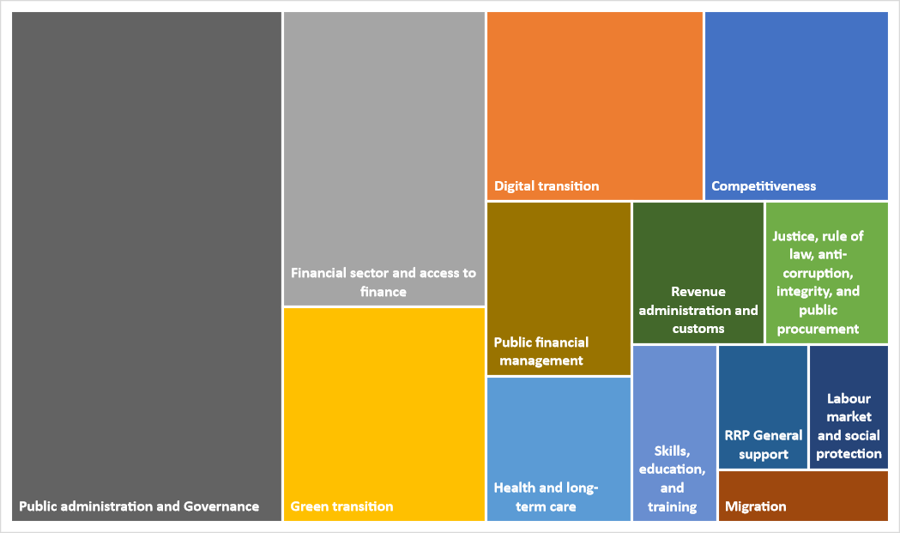

Figure 2 - TSI 2023: Contribution to key policy priorities

The TSI 2023 projects also strongly supported the implementation of national **recovery and resilience plans**[4](RRPs). The TSI continued to support Member States in designing and implementing reforms for the **green and digital transitions**. To strengthen solidarity with Ukraine, the TSI also supported Member States in implementing restrictive measures against Russia. And in line with the 2023 European Year of Skills, the TSI supported several Member States in building their national skills strategy to overcome skill shortages and mismatch.

At interinstitutional level, on 7 November 2023 the Commissioner for Cohesion and Reforms, Elisa Ferreira, met with the Budgets Committee and the Committee for Economic and Monetary Affairs at the European Parliament for an exchange of views on TSI implementation.

### Public administration and governance

On 25 October 2023, the Commission adopted a new [**Communication on Enhancing the European Administrative Space (ComPAct)**](https://reform-support.ec.europa.eu/public-administration-and-governance-coordination/enhancing-european-administrative-space-compact_en), which proposed concrete actions to help public administrations meet the needs of people and businesses across Europe. On 7 December 2023, Commissioner Ferreira presented the **ComPAct at the** [**Competitiveness Council**](https://www.consilium.europa.eu/en/meetings/compet/2023/12/07/) (Internal market and industry).

The ComPAct was a response to calls by the Member States, the European Parliament and the Committee of the Regions to the Commission to foster cooperation and policy dialogue as well as to help improve the capacity and the quality of public administrations at central, regional and local levels in the EU. The ComPAct also addresses Europeans’ expectations as expressed in the [**Eurobarometer survey on reforms and public administrations**](https://europa.eu/eurobarometer/surveys/detail/3054) launched in spring 2023 by DG REFORM. Through this survey, citizens called for public administrations to become less bureaucratic, faster in delivering services, more transparent and closer to the people. ComPAct is the Commission’s first ever comprehensive set of actions to support the modernisation of national administrations and to strengthen their cross-country collaboration so that they can address common challenges together.

The ComPAct’s objective is to **foster cooperation and policy dialogue** as well as to help **improve the capacity and the quality of public administrations at central, regional and local levels in the EU**. It proposes a strategic set of actions to enhance the European Administrative Space by promoting a common set of overarching principles underpinning the quality of public administration and reinforcing its support for the administrative modernisation of the Member States.

Linked to the ComPAct, a specific new TSI flagship initiative - the Public Administration Cooperation Exchange (PACE) – was launched in 2023. This initiative aims to promote peer-learning and the exchange of best practices among civil servants of different Member States in order to strengthen administrative capacity, as well as policymaking and implementation skills. The close alignment between the ComPAct and the TSI helps maintain a strong policy focus on improving the operational capacity and efficiency of Member States’ public administrations.

## The TSI 2023 cycle - facts and figures

### Launch of the TSI 2023 cycle

The TSI cycle 2023 was launched during the [**TSI annual conference**](https://reform-support.ec.europa.eu/tsi-2022-annual-conference_en) **‘Building Resilience of the Member States’**, which took place online on 5 May 2022. The conference showcased how the TSI can support Member States with the successful design and implementation of resilience-enhancing reforms, in particular in the context of the recent crises (COVID-19 pandemic, Russia’s invasion of Ukraine). It also presented the main priorities for the TSI in 2023, notably:

* providing continuous support to the implementation of recovery and resilience plans (RRPs);
* focusing support on selected EU priorities, through DG REFORM’s innovative concept of flagship projects, which are project concepts proactively proposed by the Commission to Member States; and
* encouraging the design and implementation of multi-country and multi-regional projects.

The conference also provided the opportunity to present the **12 ‘flagship’ technical support project ideas**, put forward because they address reform needs across several Member States and are linked to top EU priorities which the Member States are in the process of implementing. As such, they aim to support Member States in achieving resilience and growth-enhancing reforms.

Furthermore, the TSI 2022 flagship initiative ‘[EU Supervisory Digital Finance Academy to enhance the skills of the financial supervisory authorities](https://commission.europa.eu/document/download/cbc14b0f-a302-41b9-960d-0065959b77c1_en?filename=b5_-_digital_finance_academy.pdf)’ was proposed again for the TSI 2023 cycle.

**TSI 2023 flagship technical support projects**

* [Integration of environmental dimensions in public finances – Implementing the ‘Do No Significant Harm’ (DNSH) principle in public funding programmes](https://reform-support.ec.europa.eu/integration-environmental-dimensions-public-finances_en)
* [Accelerating permitting for renewable energy](https://reform-support.ec.europa.eu/accelerating-permitting-renewable-energy_en)
* [Support for Climate Adaptation](https://reform-support.ec.europa.eu/support-climate-adaptation_en)
* [ESG Risk Management for the Financial Sector](https://reform-support.ec.europa.eu/esg-risk-management-framework-financial-sector_en)
* [Support for industrial ecosystems](https://reform-support.ec.europa.eu/support-industrial-ecosystems_en)
* [Migration and Talent Attraction](https://reform-support.ec.europa.eu/migrant-integration-and-talent-attraction_en)
* [Towards person-centred integrated care](https://reform-support.ec.europa.eu/towards-person-centred-integrated-care_en)
* [YOUTH FIRST – supporting children and youth wellbeing, education, training, social protection and labour prospects](https://reform-support.ec.europa.eu/youth-first-supporting-children-and-youth-wellbeing-education-training-social-protection-and-labour_en)
* [PACE – Public Administration Cooperation Exchange](https://reform-support.ec.europa.eu/pace-public-administration-cooperation-exchange_en)
* [Enhancing the quality and use of tax information exchanged between Member States in the context of the Directive on Administrative Cooperation (DAC)](https://reform-support.ec.europa.eu/enhancing-quality-and-use-tax-information-exchanged-between-member-states_en)
* [Professionalization of public procurement personnel: fostering strategic methodologies, integrity and transparency](https://reform-support.ec.europa.eu/professionalization-public-procurement-personnel_en)
* [Digital transformation for regional and local public administrations](https://reform-support.ec.europa.eu/digital-transformation-regional-and-local-public-administrations_en)

### TSI 2023 requests for support

By 31 October 2022, **27** **Member States had submitted 530 requests** for technical support in response to the TSI 2023 general call, for a total amount of EUR 256 million, more than double the amount of funding available. While all submitted requests were deemed eligible[5], seven were withdrawn by the requesting Member States during the assessment phase. As a result, 523 requests were assessed for selection.

DG REFORM has ensured through a well-defined decision-making process (see Annex 1) that projects are selected based on the assessment criteria defined in the TSI Regulation article 9(5). Requests are analysed based on the urgency, breadth and depth of the challenges identified, the support needs in respect of the policy areas concerned, as well as the analysis of socioeconomic indicators and institutional and general administrative capacity of the Member States concerned. Through an eligibility screening, DG REFORM also ensures that actions are eligible in accordance with article 8 of the TSI regulation.

The Commission can support Member States with **special measures** in the event of urgent needs. Indeed, according to Article 12(7) of the TSI Regulation, DG REFORM can also adopt special measures in accordance with the objectives and actions set out in the TSI Regulation to provide technical support to national authorities in addressing **urgent needs**. Such special measures are *interim* in nature and linked to the specific circumstances laid down in Article 9(3), (*inter alia*, preparation or implementation of Recovery and resilience plans under the Recovery and Resilience Facility, reforms in the context of economic governance process such as CSRs, implementation of Economic adjustment programmes). In 2023, DG REFORM did not support any special measure.

DG REFORM consulted the other Commission departments/Directorates-General to ensure that the technical support provided under the TSI 2023 was aligned with EU policies, did not duplicate other EU actions and funding, and complemented and built on other EU programmes.

More broadly, the submitted requests addressed support needs for reforms identified in different circumstances, including Member States’ own reform priorities as well as reforms to tackle challenges identified through the EU’s economic governance process, as well as those linked to the implementation of EU priorities.

Figure 3 - TSI 2023: Circumstances of Member States’ requests

Following the assessment and selection process outlined in Annex 1, **231 requests** covering key EU priorities **were selected for EUR 119.7 million under the TSI 2023** general call, including[6]:

* 90 requests related to the implementation of national RRPs;
* 69 requests related to the digital transition;
* 83 requests related to the European Green Deal;
* 34 requests related to equality: support for women, people with disabilities, the Roma community, migrants, older people and the LGBTIQ+ community.

The TSI 2023 support covered measures in all Member States.

### TSI 2023 projects

Following the [adoption of the Financing Decision and annual work programme](https://ec.europa.eu/commission/presscorner/detail/en/ip_23_1625) on 21 March 2023 setting out the measures needed to implement the TSI 2023[7], the **231 selected** **requests were streamlined into 151 projects,** as multiple requests were sometimes merged into a single project to take advantage of economies of scale, promote synergies and facilitate peer-learning opportunities. In turn, those 151 projects supported the **27 Member States** in preparing, designing and implementing **326 cutting-edge reforms**[8].

Figure 4 - TSI 2023: Number of reforms supported in each Member State

Interest by Member States in taking part in multi-country projects continued to rise in 2023, leading to a steep increase from two multi-country projects under TSI 2021 to 21 under TSI 2022 and **34 multi-country projects under TSI 2023**. Member States also demonstrated their interest in strengthening cooperation at regional level through **10 multi-regional projects.**

The **public administration cooperation exchange** (PACE) multi-country flagship project - aimed at promoting cooperation and cross-border exchanges among Member States to build administrative capacity and prepare the next generation of policymakers in the European Union - saw significant take-up with the objective to implement **70 exchanges across 17 Member States for more than 300 participants**.

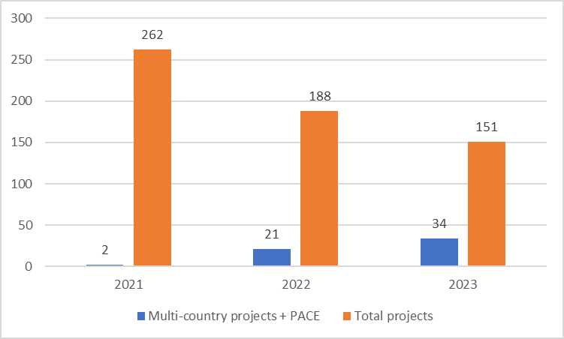

Figure 5 - TSI 2021-2023: Change in the number of multi-country projects

TSI 2023 projects included two multi-country projects supporting Member States’ industrial ecosystems (EL, ES, FI, PT and SE) and helping them accelerate permitting for renewable energy (LT and NL), with both projects contributing to **fostering the competitiveness** of the EU economy. They also included the multi-country project *Measuring Citizen’s Satisfaction with Key Government Services for Better Performance and Enhanced Trust* (AT, BE, EE, EL, ES, FI, HR, IE, LT, LV and SI), and the project *ESG risk management framework for the financial sector* (BG, CY, EL, FI, FR, HR, IE, IT, LV, RO and SI) to enhance financial supervisors’ capacity to react to challenges associated with environmental, social and governance (ESG) risks, and a project on *Enhancing the quality and use of tax information exchanged between Member States in the context of the Directive on Administrative Cooperation (DAC)* in Croatia and Ireland.

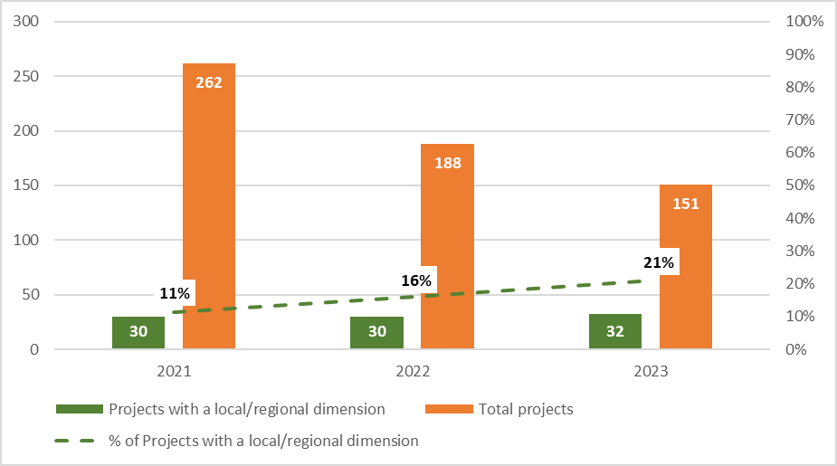

Figure 6 - TSI 2021-2023: Evolution of the number of projects with a regional/local dimension

Over the years, an increasing share of TSI projects supported Member States in carrying out reforms at the regional and local level in line with EU priorities. For example, in 2023, the TSI supported 10 regions in 5 Member States in [enhancing EU mining regional ecosystems to support the green transition and secure mineral raw materials supply](https://reform-support.ec.europa.eu/what-we-do/green-transition/enhancing-eu-mining-regional-ecosystems-support-green-transition-and-secure-mineral-raw-materials_en).

### Flagship projects

TSI 2023 also showed a **strong uptake of flagship projects** compared to TSI 2022 when the concept was first introduced. Of the 151 TSI 2023 projects, 50 were linked to flagship projects, including in the fields of green, digital, energy, public administration, public finance, integration of migrants and healthcare.

The TSI 2023 call also gave eight new beneficiary authorities from Member States the opportunity to join the [EU Supervisory Digital Finance Academy](https://commission.europa.eu/document/download/cbc14b0f-a302-41b9-960d-0065959b77c1_en?filename=b5_-_digital_finance_academy.pdf), originally designed under TSI 2022, bringing the total to 32 authorities from 25 Member States.

### RRP support

**The TSI has been supporting the implementation of reforms and investments included in the RRPs, across the policy areas** of governance and public administration, digital, sustainable growth and business environment, labour market, health, education, social services, revenue administration and public financial management, as well as in the financial sector.

In 2023, **66% of the TSI 2023 projects were directly or indirectly linked to national recovery and resilience plans**, helping Member States further increase their capacity to implement the RRPs, including RRP monitoring and project management methods, reporting mechanisms, audit and control frameworks, communication strategy, governance structures, IT systems and applying the ‘do no significant harm’ principle.

**FOCUS ON TSI PROJECTS WITH DIRECT LINKS TO THE RRPs**

Under TSI 2023, DG REFORM supported reform projects directly linked to the implementation of the RRPs.

* **10 Member States** (BE, BG, CY, ES, IE, LV, PT, RO, NL and SI) received general support for their RRP. A multi-country project on communicating the RRPs’ impact to the general public was, for example, officially launched on 27 November 2023 with representatives from eight beneficiary Member States (BE, BG, CY, ES, LV, NL, PT, and RO), DG REFORM, DG COMM, SG RECOVER, DG ECFIN and the European Semester Officers from all participating Member States. It aimed to strengthen the communication capacities of the Member States and provide them with country-specific technical support measures to improve their communication on the benefits of their RRP. The project design was based on two successful RRP communication projects implemented in Slovakia and Czechia.
* **16 Member States** (BE, BG, CY, CZ, DK, EE, EL, HR, HU, IT, LV, MT, PL, PT, RO and SK) received support for implementing specific reforms and investments included in their RRPs. Examples include support for institutionalising the new academic careers framework in Latvia, supporting businesses to achieve a higher level of digitalisation in Czechia, and support for optimising strategic plans to further develop e-health in Poland.

The midterm evaluation of the Recovery and Resilience Facility (RRF)[9] highlights that: “*Coherence between the RRF and the TSI is due to built-in synergies between the two instruments and the alignment of their assessment criteria. The RRF Regulation actively promotes synergies between the RRF and TSI by enabling Member States to allocate up to 4% of their total allocation to technical support in RRP implementation, an option used by four Member States. The alignment of the assessment criteria of the RRF and of TSIs emphasises that both instruments have the same policy objectives and that their priorities are aligned. For example, the relevance of CSRs is one of the assessment criteria used both for selecting TSI projects and for approving RRPs. The coherence of the two instruments is evident in the fact that over 400 projects approved under the TSI are linked to the preparation or implementation of Member States’ RRPs, highlighting the crucial role of TSIs in the Facility*.”*.*

### Pilot for enlargement countries as observers

In the context of the Commission’s political priority to accelerate the integration and accession process for enlargement countries[10], DG REFORM and DG NEAR developed a TSI pilot to allow enlargement countries to be ‘observers’ of selected TSI projects in 2023. This was done with the agreement of the respective beneficiary authorities in the Member States and without the TSI funding their involvement.

The pilot started on the 13 September 2023 with the participation of eight enlargement countries, namely Bosnia and Herzegovina, Moldova, North Macedonia, Albania, Serbia, Türkiye, Georgia and Kosovo[11]. The projects selected by the enlargement countries were primarily multi-country TSI projects. The public administrations involved both in enlargement countries and Member States welcomed the cooperation opportunities offered through the pilot.

## Project execution

The TSI requires the constant involvement of DG REFORM, from the project design phase through to project implementation, monitoring and evaluation.

DG REFORM is active from the early stages of project identification, with extensive outreach activities addressed to national authorities, constant interaction between DG REFORM’s country coordinators and the corresponding coordinating authorities and meetings between DG REFORM senior managers and national authorities in each Member State.

Once the TSI 2023 requests were selected and their methods of implementation decided, policy officers in DG REFORM regularly liaised with national authorities to determine the project outputs and shape the related activities and work plans. They were involved as members in all related project teams, together with the selected providers, and cooperated in the daily management of the project. They also ensured smooth communication between providers and national authorities, promoting mutual understanding to safeguard the success of the projects.

DG REFORM also coordinated work with other Commission departments via a permanent network of representatives of other Directorates-General. This was to ensure that the technical support provided with the TSI was aligned with EU policies, did not duplicate other projects, and complemented and built on other EU programmes (including by facilitating access to technical expertise available within the Commission or easily mobilised by other EU programmes).

Finally, a DG REFORM staff member was included in each project steering committee, together with senior officials from the national authorities, to ensure that projects continued to align with national priorities and adapted to the changing landscape, if necessary. The aim was to contribute to national reform agendas while striving for EU added value.

## Cooperation and support plans

**Cooperation and support plans[12] were concluded** with all 27 Member States in 2023 to set out the guiding principles and working methods for the support provided by the TSI. These were shared with the Council and the European Parliament in September 2023. Each plan describes the policy areas covered and the scope of support measures to be implemented for the Member State, as well as indicative timelines and estimated budgets. It therefore gives each Member State a strategic overview of the implementation of TSI support measures at national and regional levels.

In 2023, these plans also included a proposal for the mandate of the TSI national coordinating authorities, describing their role at each step of the TSI cycle, including potential involvement in communication and evaluation activities, and their participation in a coordinating authorities network which is chaired by DG REFORM. In 2023, this network met five times (four times online and once in person on 12 September 2023 in Madrid). The physical meeting in particular was an opportunity to underline the importance of the role of Member State’s coordinating authorities for a smooth-functioning TSI and to discuss how best to gather and coordinate ideas and stakeholders to build multi-country requests for the TSI.

## Communication on the TSI

The Technical Support Instrument is unique in its design and its flexibility. It works with national administrations to support the design and implementation of their reforms, for the benefit of individuals and businesses. To ensure the **visibility of the EU funding**, DG REFORM promotes the work of the TSI and the related TSI projects and their results in collaboration with the beneficiary authorities, the support providers and the representation offices of both the European Parliament and the Commission in each Member State. Communication activities via dedicated channels (the Reform support website, social media, publications, events, and so on) provide **targeted information to multiple audiences**, including the media and the public.

In 2023, communication activities relating to the TSI and to policymaking on public administration and governance became more results-oriented. In concrete terms, DG REFORM held the yearly [TSI 2023 press conference](https://reform-support.ec.europa.eu/events-0/technical-support-instrument-2023-press-conference_en) on 21 March 2023 to mark the adoption of the TSI 2023 work programme. DG REFORM also organised the [**TSI annual conference**](https://reform-support.ec.europa.eu/events-0/2023-technical-support-instrument-annual-conference_en) on a **‘**[**Public Administration fit for the future and adaptable to change**](https://reform-support.ec.europa.eu/events-0/2023-technical-support-instrument-annual-conference_en)**’** heldon 25 May 2023. This conference marked the launch of the TSI 2024 cycle. Its TV-show format kept the 1 600 online participants engaged during the entire event.

DG REFORM co-organised and/or participated in [**public events**](https://reform-support.ec.europa.eu/events-0_en), both locally and online, in order to showcase success stories and disseminate information on TSI results. These included:

* DG REFORM at the Delphi Economic Forum VIII, 26-29 April 2023
* Supporting skills development through reforms, 25 May 2023
* Tourism data sharing, governance and integration, 27-28 September 2023
* Science for policy in Europe, 10-11 October 2023
* Sustainable finance - COP 28 side event, 4 December 2023.

Departing from the project-oriented approach of the early TSI years and focusing more on reforms and their impact on people’s lives, DG REFORM also increased its **press activities** through interviews and **press events.**

The [**Reform Support website**](https://reform-support.ec.europa.eu/index_en), browsed by more than **160 000 unique visitors in 2023**, was also given a more user-friendly format to provide detailed information on reforms and reform projects by [**policy area**](https://reform-support.ec.europa.eu/what-we-do_en)and by [**country**](https://reform-support.ec.europa.eu/our-projects/country-factsheets_en). By the end of December 2023, more than 350 projects descriptions were online.

In line with the transparency requirement set out in Article 17 of the TSI Regulation, the Reform support website hosts a [**single online public repository**](https://reform-support.ec.europa.eu/publications-0_en?f%5B0%5D=funding_programme_funding_programme%3A1027) of final studies or reports produced as part of the TSI support projects. The repository is searchable by year, topic and Member State, to help disseminate the different publications to a wide audience. At the end of December 2023, 45% of the closed TSI projects already had a final study available online.

DG REFORM remained active on social media, with **3 500 followers on its** [**@EU_reforms**](https://twitter.com/EU_reforms) X (formerly Twitter) account while, at the same time, overhauling its [**YouTube** **DG REFORM channel**](https://www.youtube.com/@dgreform) with new content and original audiovisual products. DG REFORM also increased its internal video production capacity in 2023 and produced several videos to support the [**Project in the spotlight series**](https://reform-support.ec.europa.eu/our-projects/projects-spotlight_en).

EU‑wide communication campaigns and reports also often refer to the TSI as an important source of support for Member States to achieve their reform agenda, in line with EU priorities. The TSI was mentioned in this context seven times in the [**EU General Report 2023**](https://op.europa.eu/webpub/com/general-report-2023/en/), with specific references to the work done to support the RRPs, the Capital Market Union, RePowerEU, education and health. This report also included two references to the ComPAct communication.

## Evaluation of the TSI

DG REFORM assesses the support it provides to Member States both at programme level and at project level. The evaluation of the TSI programme and projects provides evidence of the achievements for Member States and for people on the ground. It is important to share those results with our stakeholders and the wider public to demonstrate that EU action brings positive change.

The [*ex post* evaluation of the Structural Reform Support Programme](https://commission.europa.eu/publications/ex-post-evaluation-structural-reform-support-programme_en) (SRSP *ex post*), the predecessor to the TSI, was published in October 2023. This evaluation provided key insights into the design, implementation and effects of technical support projects implemented by DG REFORM (and the Structural Reform Support Service). According to the report, the SRSP’s general objective of supporting institutional, administrative and growth-sustaining structural reforms in the Member States was successfully achieved. The SRSP was found to be a highly relevant instrument well-tailored to enhancing the administrative capacities of Member States to design and implement reforms and address challenges. Key factors included the strong involvement of the national administrations and their ownership of projects.

In 2023, DG REFORM started preparations for launching the midterm evaluation of the TSI, in line with Article 16 of the TSI [Regulation](https://eur-lex.europa.eu/eli/reg/2021/240/oj). This evaluation will be delivered by February 2025 and is expected to play an important role in shaping the future of the programme for the next multiannual financial framework. Besides assessing the early implementation of the TSI along the five mandatory better regulation evaluation criteria (effectiveness, efficiency, relevance, coherence and EU added value), the midterm evaluation will also analyse the long-term effects and sustainability of the predecessor programme, the SRSP.

In addition to the programme-level evaluation, DG REFORM has put in place a two-stage procedure to collect evaluation data on all TSI technical support projects. The first stage, beginning shortly after project closure, will assess the level of satisfaction of the main stakeholders involved in the project design and delivery. The second stage, at least 1 year after project closure, will assess the extent to which the project has delivered on its expected outcomes.

During 2023, DG REFORM received satisfaction questionnaires completed by beneficiary authorities for 94 TSI projects, i.e. a 72% response rate. Feedback from beneficiary authorities indicates an average satisfaction rating of 9 out of 10 for the support provided by DG REFORM and 8.7 out of 10 for the success of the projects. While project duration can vary, it takes an average of 24 months to complete a TSI project. As such, it is still too early to provide an assessment of projects’ achievements on the ground.

# The TSI as a key instrument to support EU competitiveness

European businesses drive Member States’ economies, creating jobs, cohesion, innovation and prosperity. Yet supply chain disruptions and high inflation at the back of the recent successive crises have accentuated **longer-standing concerns about weak productivity and competitiveness in the EU**. The Commission responded to these challenges, among others, with the [European industrial strategy](https://commission.europa.eu/strategy-and-policy/priorities-2019-2024/europe-fit-digital-age/european-industrial-strategy_en), the [Green Deal industrial plan](https://commission.europa.eu/strategy-and-policy/priorities-2019-2024/european-green-deal/green-deal-industrial-plan_en), a [Communication on long-term competitiveness](https://www.europarl.europa.eu/RegData/docs_autres_institutions/commission_europeenne/com/2023/0168/COM_COM(2023)0168_EN.pdf) and initiatives to strengthen [the EU’s economic security](https://commission.europa.eu/news/new-tools-reinforce-eus-economic-security-2024-01-24_en). As the President emphasised in her [State of the Union address](https://state-of-the-union.ec.europa.eu/state-union-2023_en), ‘Europe will do “whatever it takes” to keep its competitive edge.’

This section provides an **overview of DG REFORM’s support to Member States on competitiveness during 2023**, structured along the nine competitiveness drivers identified in the ‘[Single Market at 30’ Communication](https://eur-lex.europa.eu/legal-content/EN/TXT/PDF/?uri=CELEX:52023DC0162) and the [2024 annual single market and competitiveness report](https://eur-lex.europa.eu/legal-content/EN/TXT/PDF/?uri=CELEX:52024DC0077) (see Figure 3). To provide effective support to Member States aligned with EU priorities, DG REFORM collaborated closely on the support projects with the relevant Directorates-General of the Commission, including CLIMA, CNECT, COMP, DIGIT, EAC, ENER, ENV, ECFIN, EMPL, ESTAT, FISMA, GROW, HOME, JRC, MOVE, REGIO, RTD, SG RECOVER, SG, TAXUD and TRADE.

Figure 7 - Examples of TSI Support in 2023 on the nine competitiveness drivers

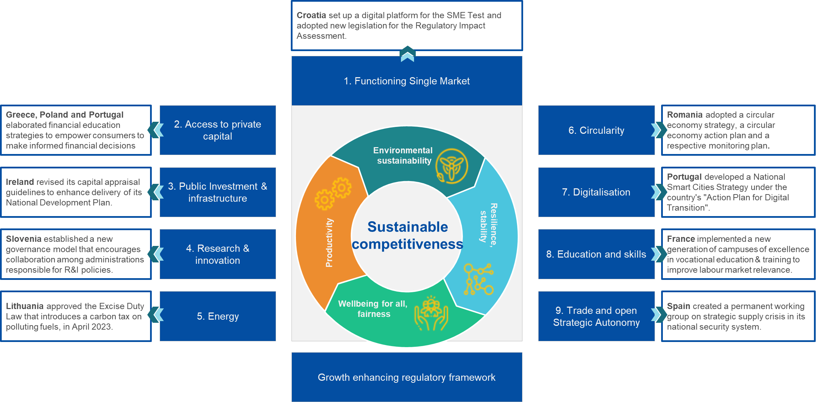

## Functioning single market

DG REFORM’s support to Member States helps them to increase their capacity to deliver reforms for a **functioning single market and competitiveness.** The support covers a wide range of policy areas, ranging from industry and innovation to transport and the digital transition.

|  |
| --- |
| **FOCUS ON FLAGSHIP INITIATIVES**  In 2023, DG REFORM engaged in **two flagship initiatives** in the area of the single market and competitiveness:   * **Seven Member States** (HR, EL, IT, MT, PT, SI and ES) received support under the [**TSI 2022 flagship initiative** **on a more sustainable, resilient and digital tourism ecosystem**](https://commission.europa.eu/document/download/8855c795-7b04-4b93-849d-32197805e838_en?filename=b3_tourism.pdf). As part of these projects, DG REFORM and DG GROW held a two-day expert workshop on tourism data sharing, governance and integration in September 2023, which gathered around 300 participants from three continents. * **11 Member States** (CY, DK, FI, GR, LV, PT, RO, SK, SI, ES and SE) received support under the [**TSI 2023 flagship initiative on strengthening EU industrial ecosystems**](https://reform-support.ec.europa.eu/support-industrial-ecosystems_en) focusing on industrial strategies, national market surveillance and intellectual property systems, as well as on reskilling and upskilling the industrial workforce. |

In 2023, DG REFORM provided support to **26 Member States** (AT, BE, BG, CY, CZ, DE, DK, EE, EL, ES, FI, FR, HR, HU, IE, IT, LT, LV, MT, NL, PL, PT, RO, SE, SI and SK), including under TSI flagship projects, to: (i) develop their **industrial** strategies and improve their national market surveillance and intellectual property systems; (ii) promote sustainable, resilient and digital **tourism** ecosystem; and (iii) accelerate the **digital transition.**

|  |
| --- |
| **ACHIEVEMENTS**  **Specific examples of reforms and capacity building** in the area of single market and competitiveness in 2023 with TSI support include the following:   * **Croatia** set up a digital platform for the SME Test and adopted new legislation for the regulatory impact assessment. * **The Autonomous Province of Trento (Italy)** approved new legislation adopting the risk-based approach for administrative procedures, including inspections. * **Slovenia** improved its research and innovation system by putting in place a new governance model, including an inter-ministerial programme board for strategic initiatives. * **Romania** adopted new national legislation to better align its framework on corporate governance of State-owned enterprises with the OECD guidelines. |

## Access to private capital

DG REFORM’s support helps to improve Member States’ capabilities to execute reforms that **facilitate access to much-needed private capital for driving digital and sustainable transformations.** The support covered a wide range of policy areas, including the Capital Markets Union, the Banking Union and the implementation of the digital finance strategy and the EU sustainable finance framework.

|  |
| --- |
| **FOCUS ON FLAGSHIP INITIATIVES**  In 2023, DG REFORM engaged in **two** **flagship initiatives** on access to private capital:   * 12 national supervisory authorities from **11 Member States** (BG, HR, CY, FI, FR, EL, IE, IT, LV, RO and SI) received support under the [**TSI 2023** **flagship initiative** **on environmental social governance (ESG) risk management** **for the financial sector**](https://reform-support.ec.europa.eu/esg-risk-management-framework-financial-sector_en), to address the need for effective ESG supervision and help to steer capital towards the green economy. * 34 financial supervisory authorities from **25 Member States** received support through the [**TSI 2022 flagship initiative on EU Supervisory Digital Finance Academy**](https://commission.europa.eu/document/download/cbc14b0f-a302-41b9-960d-0065959b77c1_en?filename=b5_-_digital_finance_academy.pdf)to enhance their supervisory capacity in the area of digital finance, in line with the digital finance strategy. |

In 2023, DG REFORM helped all **27 Member States** to expand their investment opportunities and to build a more stable, resilient and competitive financial system, necessary for increasing private investment. DG REFORM provided recommendations and helped Member States to put in place a strategic approach on developing local capital markets. This consisted of developing policies to make the transition to a sustainable economy, modernising insolvency frameworks, boosting the supervisory capacities of national authorities through digitalisation, supervisory convergence, supporting the development of both the private and public investors bases and improving the financial literacy of people and businesses.

|  |
| --- |
| **ACHIEVEMENTS**  **Specific examples of reforms and capacity building** on access to private capital in 2023 with TSI support include the following:   * **Romania, Croatia, Poland** and **Malta** enhanced the capacity of their financial sector supervisors and achieved convergence by working together to develop disclosure supervision practices and arrangements for reporting on sustainable finance requirements. The aim of this collaboration was to create a more stable and predictable environment for sustainable investments by private sector companies. * **Bulgaria** and **Greece** developed in-depth analyses and recommendations aimed at developing their capital markets. The aim was to improve market efficiency, foster investor confidence and facilitate broader access to finance for businesses. * **Estonia** and **Latvia** jointly developed their approach to implementing the EU taxonomy and sustainable finance strategy, aligning their financial and non-financial sectors more closely with sustainable investment goals and enhancing the green finance market in both countries. * **Greece, Poland** and **Portugal** developed their financial education strategies to empower consumers to make informed decisions about their investments. |

## Public investment and infrastructure

DG REFORM’s support to Member States helps them boost their capacity to deliver reforms on **public investment management and infrastructure governance.** The support covers a wide range of policy areas, taking both a cross-cutting and a sector-specific angle, from optimising public investment management practices to enhancing infrastructure planning to deliver on the green and digital transition.

|  |
| --- |
| **FOCUS ON FLAGSHIP INITIATIVES**  In 2023, DG REFORM engaged in **two flagship initiatives** on public investment and infrastructure:   * **Eight Member States** (AT, BE, HU, IT, LV, SK, SI and ES) received support under the [**TSI 2023 flagship initiative on application of the DNSH principle to public investments**](https://reform-support.ec.europa.eu/integration-environmental-dimensions-public-finances_en) from EU and national funds and programmes, including from the Recovery and Resilience Facility (RRF). Another three Member States (FI, CZ and PL) received such support under TSI 2022. * **Seven Member States** (IT, EL, NL, MT, BE, PL and SK) received support under the [**TSI 2022 flagship initiative to promote sustainable urban mobility**](https://commission.europa.eu/document/download/96a18ef4-ae1b-4490-bcbf-8686ca0e9706_en?filename=b3-recharge_and_refuel.pdf), including through the uptake of zero and low emission vehicles and the implementation of sustainable urban mobility plans. |

In 2023, DG REFORM provided support to **20 Member States** (AT, BE, BG, CZ, DE, EL, ES, FI, HU, IE, IT, LT, LV, MT, NL, PL, PT, RO, SK and SI), including under TSI flagship initiatives, to: (i) optimise the allocation of public funds; (ii) ensure their efficient utilisation and alignment with overarching EU and national policy objectives, such as the Green Deal; (iii) strengthen the institutional capabilities of Member States in project planning, execution and evaluation; and (iv) develop and improve public infrastructure in areas such as energy, transport and digital connectivity. Through this support, DG REFORM aimed to elevate the quality and impact of public investments for sustainable growth and resilience in the EU.

|  |
| --- |
| **ACHIEVEMENTS**  **Specific examples of reforms** on public investments and infrastructure completed in 2023 with TSI support include the following:   * **Ireland** revised its capital appraisal guidelines to speed up delivery of its national development plan. * **Greece** improved its IT system and reporting mechanisms aimed at streamlining the monitoring of the public investment budget. It also prepared an extensively revised legislative framework to present to Parliament in 2024. * **Slovakia** launched an investment management reform aimed at increasing the economic value of newly implemented investment projects and obtaining a higher return on every euro. * **Belgium** set up a Study Committee on Public Investments to prepare reports and opinions on the trends, needs, implementation and consequences of public investment and the TSI is supporting its operationalisation. * **Romania** published guidelines on public-private partnerships to support local and national authorities to successfully launch and implement investment projects. * **Greece** adopted a strategy and a roadmap for introducing building information modelling (BIM) in public infrastructure projects. This will lead to significant cost savings and a better use of resources. * **Belgium**’s Port of Antwerp adopted measures to improve inland navigation and traffic conditions in the Antwerp port area with TSI support. |

## Research and innovation

DG REFORM’s support to Member States boosts their capacity to deliver reforms **for enhanced research and innovation**. It has also helped them achieve the objectives of the **Commission Communication on a new Research Area for Research and Innovation[13]** and of the **European Strategy for Universities[14].** The support covers a wide range of policy areas, ranging from decarbonisation and digitalisation to demographics. It includes the promotion of strategies, policies and tools to promote new knowledge and breakthrough innovation that will drive the green and digital transformations. It also includes the re-engineering of national research and innovation institutions.

In 2023, DG REFORM provided support to **16 Member States** (BG, CY, CZ, DE, EE, ES, FR, HR, HU, IT, LV, NL, PL, PT, SI and SK) on research and innovation, which created opportunities to **modernise** **higher education** to better address labour market needsandboost **knowledge exchange between universities, research and businesses**. **Evidence-based policymaking** was also strengthened through facilitating peer learning, partnerships and policy experimentation. This helped to potentially create long-term benefits in the area of **competitiveness, social progress and sustainable economic development**.

|  |
| --- |
| **ACHIEVEMENTS**  **Specific examples of reforms and capacity building** on research and innovation in 2023 with TSI support include the following:   * **Latvia** developed a new academic career model in line with international good practice and is currently receiving help with its implementation. * **Italy** created a dynamic and robust framework for knowledge exchange and cooperation. * **Hungary** made its quality assurance system for higher education more fit for the digital age. * **Spain** improved the scope, quality and efficiency of knowledge exchange between universities, research institutes and businesses. * **Croatia** assessed the digital readiness of higher education institutions. * **Slovenia** enhanced its research and innovation system by putting in place a new governance model that encourages collaboration among relevant administrations responsible for R&I policies to better align their plans. * **Cyprus** improved the capacity of its Broadband Competence Office of the Deputy Ministry of Research, Innovation and Digital Policy and created a voucher scheme and technical specifications for tendering out investments. |

## Energy

DG REFORM’s support to Member States **boosts their capacity to deliver energy reforms.** The support covers a wide range of policy areas, ranging from sourcing renewable energy to the Just Transition and energy efficiency.

|  |
| --- |
| **FOCUS ON FLAGSHIP INITIATIVES**  In 2023, DG REFORM engaged in **three flagship initiatives** on the single market and competitiveness:   * **Six Member States** (CY, SK, FI, NL, LT and IE) received support under the [**TSI 2023 flagship initiative on accelerating permitting for renewable energy projects**](https://reform-support.ec.europa.eu/accelerating-permitting-renewable-energy_en). DG REFORM worked to create clearer, faster and more transparent processes for applying for and granting permits for renewable energy projects, in line with applicable EU legislation and upcoming EU initiatives. * **Five Member States** (IT, SE, HR, HU and SK) received support under the [**TSI 2022 flagship initiative to support the implementation of a Just Transition**](https://commission.europa.eu/document/download/c98f6786-bc6e-4cfb-a222-fb8a55e95833_en?filename=b3-just_transition.pdf). DG REFORM helped Member States to address specific challenges in the regions and sectors affected by the transition. * **Eight Member States** (BE, CY, EE, HU, IE, LT, MT and SK) received support under the [**TSI 2022 flagship initiative to support the Renovation Wave**](https://commission.europa.eu/document/download/b518c6c4-8705-4dbf-a8ec-25747fe2b43e_en?filename=b3-renovation_wave_.pdf). DG REFORM helped Member States address some of the key barriers to building renovation. |

In 2023, DG REFORM provided support to **23 Member States** (AT, BE, BG, CZ, DK, EE, FI, FR, EL, HR, HU, IE, LV, LT, MT, NL, PL, PT, RO, SK, SI, ES and SE), including under TSI flagship initiatives, to accelerate **permits for renewable** energy projects; to support the implementation of the **Just Transition**; and to support the **Renovation Wave**.

|  |
| --- |
| **ACHIEVEMENTS**  **Specific examples of reforms and capacity building** on the single market and competitiveness in 2023 with TSI support include the following:   * In the immediate aftermath of Russia’s war of aggression against Ukraine, the TSI supported **17 Member States** (BE, BG, CY, CZ, EE, EL, ES, FI, HR, HU, IE, IT, PL, PT, RO, SI and SK) in identifying reforms and investments to reduce dependencies on fossil fuel imports from Russia and implement the REPowerEU plan. * **Slovenia** adopted a law on the deployment of installations for the generation of electricity from renewable energy sources. * **Romania** endorsed its Hydrogen Strategy and Action Plan for 2030. * **Romania** submitted its draft long-term strategy for reducing greenhouse gas emissions for public consultation. * **Lithuania** approved an excise duty law introducing a carbon tax on polluting fuels. |

## Circularity

DG REFORM’s support to Member States **boosts their capacity to deliver reforms to move towards a more circular and competitive economy.** The support covers, among others, waste management and critical raw materials.

In 2023, DG REFORM provided support to **11 Member States** (AT, CZ, DK, EL, ES, FI, HU, IT, PT, RO and SE), including under a TSI flagship initiative, to: (i) develop national circular economy **strategies**, action plans and monitoring mechanisms; (ii) build a knowledge base for the transition of **SMEs**; (iii) introduce regulations for **waste** management; (iv) create a data set and planning tool for **raw material** flows and stocks; and (v) enhance the circularity of **mining**.

|  |
| --- |
| **ACHIEVEMENTS**  **Specific examples of reforms and capacity building** on circularity in 2023 with TSI support include the following:   * **Romania** adopted a circular economy strategy, a circular economy action plan and a corresponding monitoring plan. Furthermore, Romania passed new secondary legislation on the calculation of waste tariffs in order to incentivise more circularity. * **Spain** provided municipalities with communication materials and capacity-building tools to improve the circularity of waste management. |

## Digitalisation

DG REFORM’s support to Member States contributes to their digital transformation, aligning with the Commission priority of a **Europe fit for the digital age** and achieving the targets of the **Digital Decade**. The digitalisation of public administration is essential for individuals and businesses to prepare the ground for a competitive EU economy. The support covers a **wide range of policy areas**, ranging from interoperability, artificial intelligence (AI) and business process re-engineering and data-informed decision making to digital skills.

|  |
| --- |
| **FOCUS ON FLAGSHIP INITIATIVES**  In 2023, DG REFORM engaged in **two flagship initiatives** on digital transformation:   * **Nine Member States** (DK, IT, EL, LV, PT, SK, CY, IE and NL) received support under the [**TSI 2022 flagship initiatives on the development of resilient, innovative and human-centric digital government services**](https://commission.europa.eu/document/download/b2729e3b-ad6d-4d27-9eaf-86497d219fcc_en?filename=b2-digital_government_services.pdf). The projects help to set-up strategies and action plans that will help achieve the digital transition of the EU public sector. * **Four Member States** (PT, ES, DK and RO) received support under the[**TSI 2023 flagship initiative on digital transformation for regional and local public administrations**](https://reform-support.ec.europa.eu/digital-transformation-regional-and-local-public-administrations_en)**.** For example, **Denmark** received support on developing tools for assessing risks in AI projects undertaken by local, regional and national authorities. This involves building a repository of existing AI use cases within the Danish administration, with the aim of fostering reusability both nationally and in the European context. |

In 2023, DG REFORM provided support to all Member States, including under TSI flagship initiatives, to progress with their digitalisation and improve digital service delivery, data-management, employing AI and ensuring system interoperability.

|  |
| --- |
| **ACHIEVEMENTS**  **Specific examples of reforms and capacity building** on digitalisation in 2023 with TSI support include the following:   * **Slovakia** took a comprehensive approach to enhancing digital government services by integrating AI and the eIDAS framework for digital identification. It adopted strategies for data governance, digital-ready legislation and institutional design, including considerations for human resources and technologies, security and financial impacts of both EU and national digital legislation. * **Finland** optimised efforts to digitalise the judiciary and improve operational efficiency by implementing an ICT governance strategy. * **Italy** put in place a new organisational structure and adapted business processes at the Ministry of Economy and Finance with the help of comprehensive support measures focusing on change management and culture change. * **Portugal** developed, with the involvement of over 400 stakeholders, a National Smart Cities Strategy under the country’s ‘Action Plan for Digital Transition’. |

## Education and skills

DG REFORM’s support to Member States contributed to boostingtheir **education, skills and talent attraction policies** aimed at ensuring a skilled workforce. The support enhanced their capacity to design and implement reforms to lay the foundations for inclusive skills development from an early age and to provide systematic upskilling and reskilling opportunities, including for disadvantaged groups. Additional reforms were also aimed at attracting talent from outside the EU.

|  |
| --- |
| **FOCUS ON FLAGSHIP INITIATIVES**  In 2023, DG REFORM launched **two flagship initiatives** on education and skills:   * **10 Member States** (AT, CY, CZ, ES, FI, IE, LV, PL, PT and SI) received support under the [**TSI 2023 flagship initiative ‘Youth FIRST**](https://reform-support.ec.europa.eu/youth-first-supporting-children-and-youth-wellbeing-education-training-social-protection-and-labour_en)**’** which aims to underpin reforms that improve educational, health and social outcomes for children and young people. Support covers key areas for the future European workforce, such as access to inclusive and quality education and training and support for upskilling and reskilling. * **Seven Member States** (BE, CY, DK, ES, MT, NL and SE) received support under the [**TSI 2023 flagship initiative ‘Migrant integration and talent attraction’**](https://reform-support.ec.europa.eu/migrant-integration-and-talent-attraction_en) targeted at Member States wishing to benefit from the social and economic gains of **enhanced** **integration, labour market participation and labour mobility for third country nationals in a context of deepening skills shortages and growing global competition for talent.** |

In 2023, DG REFORM provided support to all **27 Member States** through individual, multi-country and TSI flagship projects to improve the quality and labour market relevance of school education, vocational education and training, higher education, adult education, as well as systems for reskilling and upskilling, to ensure high quality in the teaching workforce, to retain and attract skilled workers from outside the EU, to accelerate the recognition of foreign skills and qualifications and to facilitate access to high-quality early childhood education and care so parents can work outside the home.

|  |
| --- |
| **ACHIEVEMENTS**  **Specific examples of reforms and capacity building** to increase competitiveness by investing in education and skills in 2023 with TSI support include the following:   * **France** implemented a new generation of campuses of excellence in vocational education and training with a focus on improving labour market relevance, using guidance developed through a TSI project. * In **Belgium**, the Walloon government developed upskilling partnerships among adult training providers seeking to develop joint training courses and cooperation arrangements. * **Malta** updated its quality assurance framework of schools, using a revised set of standards that combine self-assessment of schools with external inspection. * **Estonia** integrated its systems of formal education and non-formal learning (including youth activities) to allow young people develop skills through more flexible learning pathways. * **Spain** began developing a strategy to facilitate labour market inclusion and attraction for people from other countries, including through the use of a digital platform. |

## Trade and open strategic autonomy

DG REFORM’s support to Member States boosts their capacity to deliver reforms **for trade and open strategic autonomy.** Support in this area includes the development of strategies, policies and tools to facilitate foreign investments, reduce dependencies, promote competition and enhance economic security and resilience.

In 2023, DG REFORM provided support to **eight Member State** (EL, ES, FI, LV, PL, PT, RO and SE) to develop and enhance the resilience of their industrial ecosystems, mitigate the reliance to essential resources and promote more resilient supply chains.

|  |
| --- |
| **ACHIEVEMENTS**  **Specific examples of reforms and capacity building** on trade and strategic autonomy in 2023 with TSI support include the following:   * **Spain** created a permanent working group on strategic supply crisis in its national security system. * **Croatia** strengthened the strategic framework for promotion and facilitation of Foreign Direct Investment. |

Overall, in 2023, DG REFORM effectively supported Member States in key reforms and capacity building on competitiveness. However, in future, Member States will continue to face significant challenges in building a more competitive and resilient economic base that is fit for the green and digital transitions.

# Conclusion

In 2023, DG REFORM stepped up its communication activities to make national authorities aware of the opportunities available under the TSI and further increase accountability of support provided through this instrument. This led to the receipt of 530 high-quality requests for support in the TSI 2023 cycle, a total which again exceeded the programme’s capacity and was testament to the national authorities’ interest in the opportunities offered by this instrument.

Following the assessment and selection process, **231 requests were selected for EUR 119.7 million under the TSI 2023** general call, leading to the design of **151 projects** to support **326 cutting-edge reforms** in all Member States. 30% of the 231 selected requests were related to the digital transition, and 35% were related to the European Green Deal. Furthermore 66% of the 151 TSI 2023 projects are directly or indirectly linked to national recovery and resilience plans.

The steep **increase in multi-country projects** over the last 3 years is an indicator of the capacity of the TSI to bring further ‘EU added value’ and to facilitate the exchange of good practices and mutual learning opportunities among national administrations. The TSI 2023 also showed a **strong uptake of TSI flagship projects** compared to TSI 2022 when the concept was first introduced.

DG REFORM supported Member States with the implementation of the TSI projects, including those from previous cycles, ensuring these were successful and that their outputs remained in line with Member States’ objectives. The projects covered a wide range of policy areas, in line with requests by national authorities. One area, highlighted in this report, was **competitiveness,** for which all 27 Member States received support, ranging from support for a functioning single market to public investment and infrastructure, digitalisation and education and skills.

The adoption in October 2023 of the [Communication on Enhancing the European Administrative Space (**ComPAct**)](https://reform-support.ec.europa.eu/public-administration-and-governance-coordination/enhancing-european-administrative-space-compact_en), which proposes concrete actions to help public administrations meet the needs of people and businesses across Europe, strengthens the role the TSI can play in helping national administrations build capacity to design and implement reforms and to exchange best practices, in particular through the **PACE** TSI flagship project.

Based on feedback received from beneficiary authorities at project level and from coordinating authorities at country level, **Member States appreciated the support** provided through the TSI, in particular the active role they can play in designing and implementing projects and the **effective communication by DG REFORM**.

## Annex 1 – The TSI annual cycle

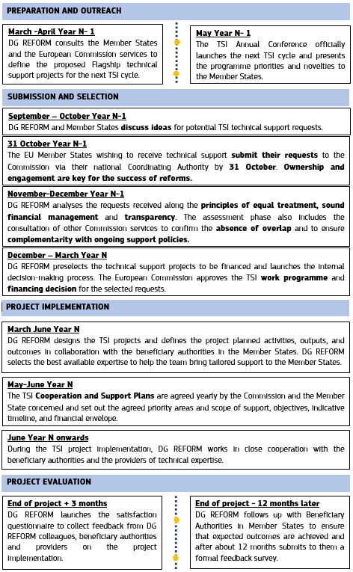

## Annex 2 – 2023 TSI general call: requests by Member State

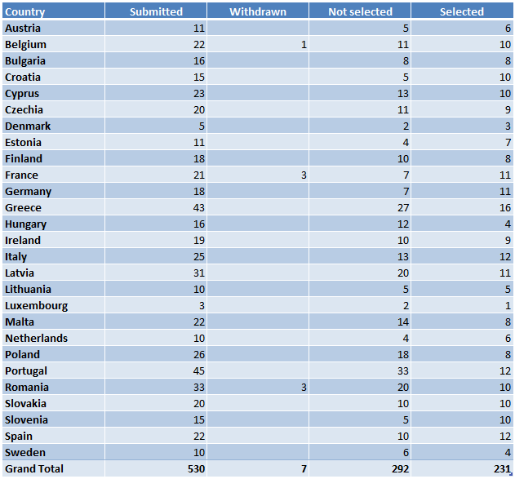

1. Regulation (EU) 2021/240 of the European Parliament and of the Council of 10 February 2021 establishing a Technical Support Instrument, OJ L 57, 18.2.2021, p. 1-16 (the ‘TSI Regulation’).
2. https://neighbourhood-enlargement.ec.europa.eu/funding-and-technical-assistance/taiex_en.
3. The list of entities implementing EU funds under indirect management for the Technical Support Instrument is provided on the [Technical Support Instrument website](https://commission.europa.eu/funding-tenders/find-funding/eu-funding-programmes/technical-support-instrument/technical-support-instrument-tsi_en).
4. Regulation (EU) 2021/241 of the European Parliament and of the Council of 12 February 2021 establishing the Recovery and Resilience Facility, OJ L 57, 18.2.2021, p. 17-75 (the ‘RRF [Regulation’](https://eur-lex.europa.eu/eli/reg/2021/241/oj) , Article 7.2).
5. The eligibility of requests is verified based on the criteria set out in the TSI Regulation, namely in Articles 8 and 9. The eligibility of potential beneficiaries is also verified based on the criteria set out in the TSI Regulation, namely in Article 2.
6. A single request for technical support may contribute to several EU priorities.
7. Commission Implementing Decision C(2023)1 786 of 20.3.2023 on the financing of the Technical Support Instrument and the adoption of the work programme for 2023.
8. The total number of reforms supported for TSI 2023 is higher than the total number of supported projects and the total number of selected requests as multi-country projects and multi-country requests corresponded to multiple reforms in different Member States under TSI 2023.
9. Staff working document - Mid-term evaluation of the Recovery and Resilience Facility (page 62).
10. Bosnia and Herzegovina, Montenegro, Moldova, North Macedonia, Albania, Serbia, Türkiye, Ukraine, Georgia and Kosovo.
11. Montenegro and Ukraine did not participate in the pilot due to limited administrative capacity but have expressed strong interest to participate in the future.
12. As referred to in Article 9(5) of the TSI Regulation.
13. COM(2020) 628 final.
14. COM(2022) 16 final.