Table of Contents

1. Introduction 3
2. General Framework for applying financial corrections 4
2.1. Legislation and rules on net financial corrections 4
2.2. Budgetary and accounting treatment of amounts subject to net financial corrections – the assigned revenue instrument 6
3. Sector specific rules for net financial corrections 7
3.1. Agriculture 7
3.1.1. Legal provisions always provide for net financial corrections 7
3.1.2. Legal Mechanisms for net financial corrections will be further consolidated 9
3.1.2.1. Focus on more risky expenditure 9
3.1.2.2. No discretion and few flat-rate corrections 10
3.1.2.3. Shorter conformity procedure 11
3.1.3. Interruption and suspension for CAP will be aligned with Cohesion Policy Funds 12
3.2. Cohesion Policy Funds 13
3.2.1. New legal provision for the Commission to impose net financial corrections on a Member State 13
3.2.2. Financial corrections for irregularities / deficiencies identified before 15 February each year 14
3.2.3. Commission assessment of legality and regularity on the basis of the accounts, audit opinion and accompanying documents submitted by 15 February each year 14
3.2.4. Identification by EU audits of irregularities indicating a serious deficiency after 15 February each year 15
3.2.5. Convergence of good practices for the Commission’s supervisory system under shared management 19

Introduction
As a reaction to the increase of the error rate reported by the European Court of Auditors (ECA) in its Annual report on the financial year 2012, the Discharge Rapporteur and the Co-ordinators of the main Political Groups in the European Parliament's Budgetary Control Committee addressed a letter to President Barroso asking the Commission to submit a Communication clearly establishing how it will introduce for the financing period 2014-2020 a more effective form of net financial corrections for Member States where weaknesses are observed as regards programmes under shared management. Net financial corrections mean that there is a definitive reduction of funds to the Member State concerned.
The present Communication addresses this request by explaining how the Commission intends to apply new instruments and requirements linked to net financial corrections which are provided for in the legal framework for the financing period 2014-2020 and how this will impact on Member States.
In the area of Agriculture net financial corrections leading to a loss of EU funds for the Member State concerned were already the standard. The new rules for the financing period 2014-2020 maintain that situation while focusing on the consolidation of existing mechanisms.
For Cohesion Policy, net financial corrections leading to the return of previously paid amounts to the EU budget were the exception. For the new programming period 2014-2020 there is a major change in the new legislation to be adopted which will extend the Commission's powers to impose net financial corrections on Member States where serious deficiencies in management and control systems have been identified. The framework for net financial corrections envisaged for the period 2014-2020 leaves no discretion to the Commission in the adoption of a correction decision. Net financial corrections will become the standard reaction in case of serious deficiencies and will be applied according to a clear set of transparent criteria and conditions.
When applying net financial corrections for the measures and programmes under the
2014-2020 financing period, the services involved will, through application of best practice, ensure for these two areas of shared management a convergence of effective use of this important corrective instrument to protect the Union budget. Such a convergence of best practices will also be applied with regards to the instruments of interruptions and suspensions of payments. The model which is successfully applied in the area of Cohesion has been introduced mutatis mutandis also in the area of Agriculture for 2014-2020.
The Commission considers that all financial corrections, including those where Member States are allowed to bring in new projects and new expenditure to re-use the corrected amounts, protect the EU Budget. Nevertheless, the deterrent effect of net financial corrections, whereby Member States cannot re-use the corrected and recovered amounts and therefore lose the funds, is certainly higher. It incentivises Member States to detect and correct errors themselves and therefore contributes to the improvement of management and control systems.

General Framework for applying financial corrections

Legislation and rules on net financial corrections
In line with Article 317 TFEU, the legislation for the application of net financial corrections is set out in the Financial Regulation (FR) and further elaborated in the sector-specific regulations adopted by the European Parliament and the Council. Within this legal framework, the Commission adopts delegated acts and implementing acts and may also issue guidelines clarifying specific issues.
The following diagram gives an overview on the relevant levels of the general framework for applying financial corrections:
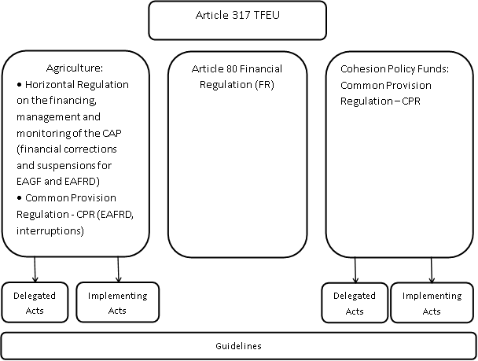
The new FR introduces a coherent framework across all policy areas which includes in particular the principles for financial corrections on Member States:
Article 80 FR - Rules on recovery
…
4. The Commission shall make financial corrections on Member States in order to exclude from Union financing expenditure incurred in breach of applicable law. The Commission shall base its financial corrections on the identification of amounts unduly spent, and the financial implications for the budget. Where such amounts cannot be identified precisely, the Commission may apply extrapolated or flat-rate corrections in accordance with the sector-specific rules.
The Commission shall, when deciding on the amount of a financial correction, take account of the nature and gravity of the breach of applicable law and the financial implications for the budget, including the case of deficiencies in management and control systems.
The criteria for establishing financial corrections and the procedure to be applied may be laid down in the sector-specific rules.
5. The methodology for applying extrapolated or flat-rate corrections shall be laid down in accordance with the sector specific rules with a view to enabling the Commission to protect the financial interests of the Union.
As provided for in Article 80 FR and sector-specific regulations, the Commission applies the following three types of financial corrections:
- Financial corrections on individual cases, based on a precise identification of amounts unduly spent, and the financial implications for the budget;
- Extrapolated financial corrections; and
- Flat-rate financial corrections.
Extrapolated and flat-rate financial corrections can only be applied if it is not possible to identify the precise amount for the correction. Extrapolated financial corrections have to be based on a representative sample which enables the related amount to be quantified with a sufficient level of confidence.
The following diagram gives an overview of relevant mechanisms for the application of financial corrections:

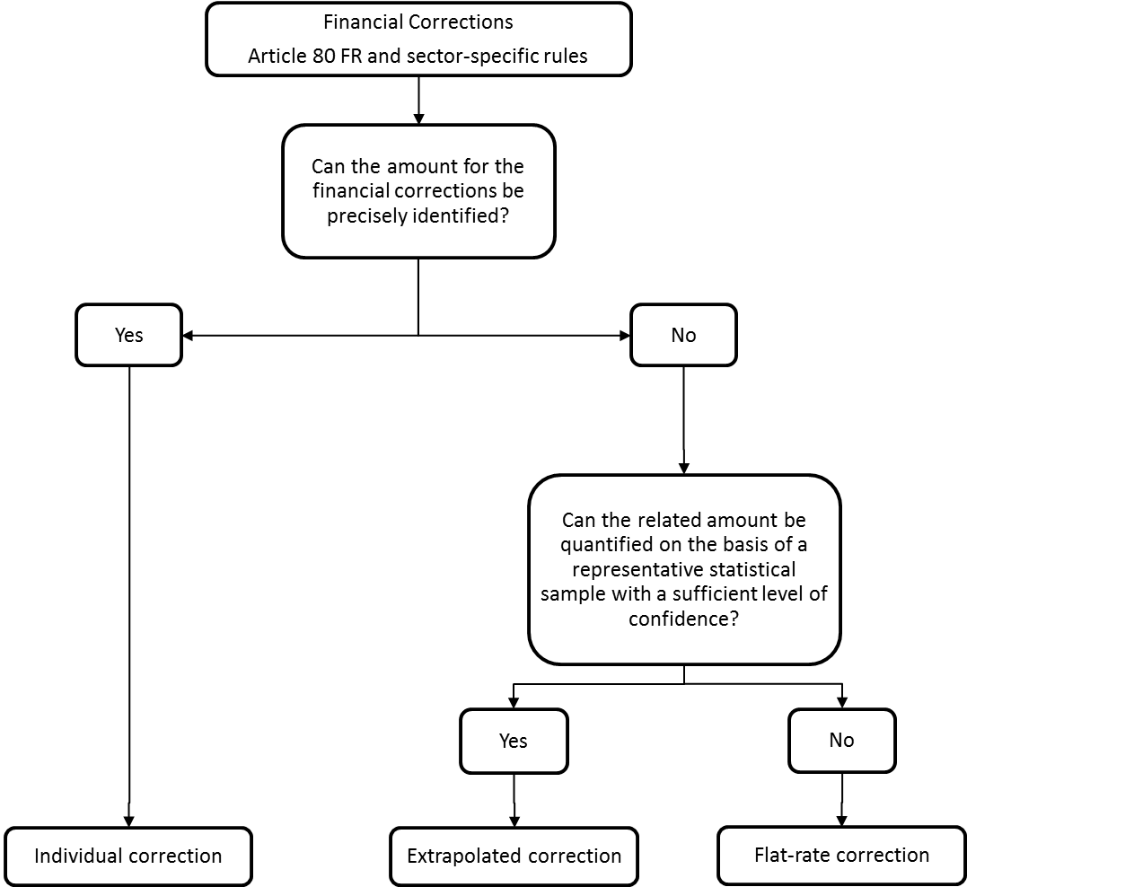
Details concerning the implementation of financial corrections in the different policy areas under shared management are provided in section 3 of this Communication.

Budgetary and accounting treatment of amounts subject to net financial corrections – the assigned revenue instrument
Financial corrections lead to "revenue arising from the repayment,…, of amounts wrongly paid" and are treated as assigned revenue (Art. 21(3)(c) FR).
Apart from two exceptions, the Financial Regulation does not include specific provisions on how the assigned revenue generated by a net financial correction can be used.
Net financial correction
Assigned revenue
Article 21 (3) (c) FR

However, Article 7 of the Rules of Application of the Financial Regulation (RAP) determines that the budget commentary shall show which budget lines may receive the appropriations corresponding to the assigned revenue. Thus net financial corrections returning to the EU budget in the form of assigned revenue are not earmarked for specific Member States.
Assigned revenue
Article 21 (3) (c) FR
Appropriation in the EU budget
Article 7 RAP

Sector specific rules for net financial corrections
  - Agriculture
    - Legal provisions always provide for net financial corrections
According to the Common Agricultural Policy (CAP) legal framework, financial corrections imposed by the Commission on Member States upon completion of a conformity clearance procedure have always been net corrections since the first clearance of accounts decision in 1976 and will continue to be net corrections for both European Agricultural Guarantee Fund (EAGF) and European Agricultural Fund for Rural Development (EAFRD) as:
- the corrected amounts are actually reimbursed by the Member States to the EU budget; and
- the amounts received are treated as assigned revenue to the EU budget. They are used to finance CAP expenditure as a whole without being earmarked for any particular Member State (see also box below).
Every year the Commission adopts between 2 and 4 conformity clearance decisions on a package of individual financial corrections. In 2013 the Commission adopted 4 such decisions, covering 147 individual net financial corrections for a total amount of 1,1 billion EUR (2 % of the CAP expenditure budgeted for 2013). This confirms the increasing trend reported by the Court in its 2012 Annual Report, paragraph 4.29.

Net financial corrections adopted in 2013 (amounts in EUR):
Decision: | 40 | 41 | 42 | 43 | TOTAL
EAGF | 285.582.274 | -130.136.896,33 | -142.637.397 | -303.566.912 | -861.923.480
EAFRD | -104.699.558 | -88.444.255 | -32.467.218 | -10.598.290 | -236.209.321
OTHERS | -7.091.796 | -8.757.551 | -2.661.224 | -121.357 | -18.631.930
TOTAL | -397.373.628 | -227.338.703 | -177.765.840 | -314.286.560 | -1.116.764.733
70 % of the financial corrections adopted in 2013 are concentrated in 4 Member States (GR, UK, FR and PL). However, the concentration on the four Member States is not a stable pattern but can change from year to year depending on the evolution of the quality of the national or regional control systems.
For EAGF, financial corrections are executed by deducting the amounts concerned from the monthly payments made by the Commission in the second month following the Commission decision on a financial correction to the Member State concerned.
For EAFRD, the financial corrections are executed through a recovery order requesting the Member State concerned to reimburse these amounts to the EU budget.
Treatment of assigned revenue
The amounts corrected and clawed back by the Commission are credited to the EU budget as assigned revenue on specific budget lines (item 67 01 for EAGF, item 67 11 for EAFRD).
In the EAGF the resulting assigned revenue can be used to finance expenditure budget lines to cover any type of EAGF expenditure without being targeted to any specific Member State. The budget remarks for chapters 05 02 (markets) and 05 03 (direct payments) clearly show that the financing needs of the EAGF are systematically reduced during the budget procedure by an amount representing the estimated assigned revenue which will be available from financial corrections during the budget year concerned. For instance EUR 600 million of financial corrections were initially budgeted for the 2012 budget, whereas EUR 647,8 million of assigned revenue became actually available and were used in that budget year).
For EAFRD, as the budgetary commitments have already been consumed by the Member State when it declared expenditure for reimbursement by the Commission, the recovered amounts cannot be used anymore. The payment appropriations from the assigned revenue are available for payments under the budget line for the EAFRD. They can be used for any open payment for any rural development programme. Hence, the EAFRD assigned revenue reduces the overall need for payment appropriations and has been used to reduce requests for additional payment appropriations. In 2012 assigned revenues from EAFRD financial corrections amounted to EUR 55 million.
Net financial corrections do put a real strain on the national budgets of Member States. Therefore, an option was introduced according to which corrections of a certain volume can be executed in three annual instalments on request of the Member State concerned. Execution in instalments was so far accepted for Bulgaria, Greece, Portugal, Romania, Spain and Lithuania. In addition, Member States under EU financial assistance may once request the Commission to defer the execution of financial corrections for a period of up to 18 months subject to the implementation of targeted remedial action plans. After the expiry of the deferral period the corrections are executed in three annual instalments. Deferrals were so far granted to Portugal and Greece. The deferrals granted will expire on 31 December 2013 for Greece and on 31 May 2014 for Portugal.
Impact of net financial corrections on Member States
In all Member States the national and regional authorities responsible for implementing the CAP are directly affected by EU net financial corrections. Such corrections which relate to expenditure made by Member States in previous budget years lead to a reduction of EU financing in the current budget year. This requires Member States in many cases to find the financial means necessary to fill the gap by making budget transfers or amending budgets. Against this background net financial corrections have led to concrete budgetary and administrative reactions. For instance:
- in Germany the Constitution was amended in 2006 following repeated disputes between the federal level and the Länder to clarify the burden-sharing with regard to financial corrections;
- in Denmark following a significant financial correction in 2009 a specific burden-sharing mechanism between the Ministry of Finance and the Ministry of Agriculture was recently put in place.

    - Legal Mechanisms for net financial corrections will be further consolidated
      - Focus on more risky expenditure
DG AGRI audit activities are driven by risk analysis, i.e. more audits focus on Member States, measures and programmes affected by higher risks. Once a year, DG AGRI conducts a central risk analysis covering all CAP expenditure in all Member States: evidence from previous DG AGRI audits, from the ECA, from OLAF and from the national certification bodies are collected and computed with a view to identify the most risky areas where future audits shall focus. For instance as a result of the higher error rate reported by the Court in its DAS 2011 and DAS 2012 the number of EAFRD audits were increased significantly in 2013 (35) and will further increase in 2014 (to 45), thus doubling compared to 2012 (23). Another consequence is that some Member States are audited every year, until all serious deficiencies are remedied, as illustrated below with the example.
Example of intense supervision
DG AGRI audits of the Integrated Administrative and Control System (IACS) in 2008 and 2009 revealed and confirmed serious deficiencies: on-the-spot-controls were late and the Land Parcel Identification System (LPIS) was outdated and not precise enough. An audit mission in March 2011 concluded that the initial action plan requested by the Commission to remedy these deficiencies by 2011 had been only partially implemented. The failure to timely implement the remedial actions triggered a reservation in DG AGRI's 2010 Annual Activity Report (AAR), accompanied by a new action plan to remedy the deficiencies by 2013. In its AAR 2012 DG AGRI reported that an audit mission in March 2013 had confirmed that the action plan could be considered as finalised; but DG AGRI maintained the reservation because solid evidence that the updated LPIS is correctly used would not be available before a first cycle of claims/controls/payments. In the meantime, a first financial correction was imposed in relation to 2008 related expenditure, a second one for 2009; the conformity clearance procedure for 2010, 2011 and 2012 will be finalised by end 2014 and another conformity clearance procedure for 2013 related expenditure should be finished by end 2015.
The audit strategy for the period 2014-2020 will be based on a reinforced risk analysis rolling three years programme which will ensure a better coverage of the overall expenditure. However, more intensive audit activities will continue to cover the most risky areas.
      - No discretion and few flat-rate corrections
Any identified risk to the EU budget systematically triggers a net financial correction. The Commission has no discretion to not correct as it is legally bound to exclude any identified illegal expenditure from EU financing. For both EAGF and EAFRD financial corrections are governed by the new CAP Horizontal Regulation which frames the procedure even more tightly to the effect that the method and the criteria for fixing the amount of financial corrections will now be set out in a delegated act. The adoption of that delegated act is planned for the first quarter of 2014.
As provided for in the Horizontal regulation, the delegated act will establish the criteria for estimating the risk to the EU budget (see Annex 1). In the case of flat-rate corrections, it is intended to specify how the severity of the deficiency shall be assessed, taking into account its nature (key or ancillary control) but also its recurrence (repetition from a previous year without improvement) and the accumulation with other deficiencies (the risk of errors is likely to be higher when there are several deficiencies). The ECA findings in its 2012 Annual Report, paragraph 4.30, will thus be addressed, notably for cases where several deficiencies are present for the same population. Once the delegated act is in force, Commission guidelines will further detail the more technical elements.
Both the Financial Regulation and the new CAP Horizontal Regulation provide for a ranking of types of financial corrections where flat-rate corrections may only be used if calculated or extrapolated corrections cannot be established with proportionate efforts flat-rate
Calculated and extrapolated corrections are currently based on DG AGRI auditors' findings and information provided by Member States during the contradictory procedure. In the future, DG AGRI will have more information to feed into the process from the yearly opinions to be delivered as from claim year 2014 by the certifying bodies carrying out the new task assigned to them examining representative samples of transactions.
      - Shorter conformity procedure
Carrying out a contradictory procedure is legally indispensable before making financial corrections. Prior to implementing any net financial correction, the Commission must therefore offer the Member States the opportunity to provide evidence and arguments that may contradict its initial findings. Indeed the current CAP financing regulation and the new CAP Horizontal Regulation provide that "Member States shall be given the opportunity to demonstrate that the actual extent of the non-compliance is less than the Commission's assessment". The principle of a contradictory process between the auditor and the auditee is also an essential element of audit quality standards.
In addition to the contradictory procedure, Art 52(3) of the CAP Horizontal Regulation provides for a "procedure aimed at reconciling each party's position" if an agreement is not reached at the end of the contradictory procedure. The duration of the conciliation as such is limited to 4 months. But the whole process from the request of the Member State concerned to the final result of the analysis by the Commission of the recommendations of the conciliation body takes at least 6 months.
The Commission has engaged in and will continue actions aiming at streamlining the whole procedure. Firstly, the new CAP Horizontal Regulation describes precisely the nature, scope and sequence of the successive steps, as well as the different types of financial corrections. Secondly, provisions in the delegated act (method and criteria for calculating the financial correction) and implementing acts (details of the conformity procedure, with mandatory deadlines) are intended to further streamline the legal framework and limit the risk of unnecessary delays. Thirdly, on that stronger basis, DG AGRI will intensify its monitoring of the progress of the conformity procedures to ensure a strict respect of the deadlines.
Details concerning the envisaged procedure for applying net financial corrections for Common Agricultural Policy are provided in Annex 1.

The following diagram describes the successive steps of a conformity clearance procedure leading to a net financial correction carried out under the new CAP Horizontal Regulation. As indicated in the Commission's answer to paragraph 4.31 of the ECA's 2012 Annual report on the excessive length of the conformity procedure, there is scope for significantly speeding up the conformity procedure so that in standard cases the financial corrections can be decided two years after the initial audit took place.
    - Interruption and suspension for CAP will be aligned with Cohesion Policy Funds
Following the adoption of the new CAP Horizontal Regulation by the legislator, a new legal framework for interruptions and suspension of CAP funds will enter into force in 2014 which will strengthen the Commission’s powers to suspend EU financing in cases where risks of irregular payments have been identified.
Accordingly the Commission may reduce or suspend monthly (EAGF) or interim payments (EAFRD) on the following conditions:
where "one or more of the key components of the national control system in question do not exist or are not effective due the gravity or persistence of the deficiencies found" (or there are similar serious deficiencies in the system for the recovery of irregular payments) and:
- either the deficiencies are of a continuous nature and have already been the reasons for at least two financial correction decisions,
or
- the Commission concludes that the Member State concerned is not in a position to implement the necessary remedial measures in the immediate future, in accordance with an action plan with clear progress indicators to be established in consultation with the Commission.
The first indent corresponds to the present situation under Regulation (EC) No 1290/2005; the second indent is new. It is in essence the legislative response to the recommendation by the European Parliament in its 2011 discharge resolution according to which the suspension rules for the CAP should be aligned with those of the Cohesion Funds.
For EAGF, according to the new rules, monthly payments to Member States may continue until the conditions for a suspension decision are met, the rhythm of the monthly payments would not allow using an interruption procedure. However, for EAFRD, the new Common Provisions Regulation (CPR) will provide in addition for the interruption of interim payments by the Authorizing Officer by Delegation (i.e. the Director-General) as an additional, quick and reactive tool in case of concerns on the legality and regularity of payments.
The combination of both preventive actions (interruption for EAFRD, suspension for both Funds) and net financial corrections will allow the Commission to act promptly and effectively and protect the EU budget: no new payments will be made or they will be reduced up to the level of the estimated risk during the suspension; irregular payments already made will be fully covered via the financial corrections.

Cohesion Policy Funds

New legal provision for the Commission to impose net financial corrections on a Member State
A significant change is introduced for the 2014-2020 programming period. Under certain conditions laid down in Article 145(6) of the Common Provisions Regulation (CPR), the Commission must adopt a decision applying a net financial correction. In such cases the current possibility for the Member State to accept the correction and to re-use the amount of EU funds thus made available is removed.
Within the new financial management cycle, 15 February following each accounting year is the cut-off date for the application of the new provision on net financial corrections in relation to expenditure of the preceding accounting year. By that date, Member States must submit to the Commission the programme’s accounts, management declaration, audit opinion and corresponding reports. This means that all national control and verification work has to be finalised so that the Member State can certify the legality and regularity of expenditure included in the annual accounts.

Financial corrections for irregularities / deficiencies identified before 15 February each year
The rules of the 2014-2020 programming period concerning financial corrections for irregularities identified before 15 February each year are similar to those of the current programming period which were of general application regardless of the date of detection. The objective is to maintain incentives for Member States to detect and correct irregularities and to exclude the amounts from the expenditure declared to the Commission and thus avoid a loss of EU funds (see 3.2.5).
Irregular expenditure detected through national verifications or audits has to be deducted from the accounts to be submitted to the Commission by 15 February each year. Having done so, the Member State will be able to re-use the amounts thus corrected for new eligible operations under the programme, as in the current programming period.
In the case of EU audits which are carried out on expenditure before certified accounts are submitted to the Commission and which detect irregularities requiring financial corrections, two scenarios are possible, as in the current period. If the Member State agrees on the financial correction to be made and takes action, it will be able to re-use the corrected amounts for new eligible operations (Article 145(4) CPR). If the Member State does not agree, the Commission will adopt a financial correction decision, following the contradictory procedure provided for in Article 145 CPR. This financial correction will always be net and the programme and Member State allocation will be reduced proportionally. The Member State will not be able to re-use this amount.

Commission assessment of legality and regularity on the basis of the accounts, audit opinion and accompanying documents submitted by 15 February each year
The introduction of the new provision on annual reporting by the Member State and on net financial corrections implies changes in the way the Commission will carry out its responsibilities. The Commission will assess and review the audit opinions (elements relating to the functioning of systems and legality and regularity) and annual control reports, including the reported error rates, as well as the management declarations and annual summaries, within three months of reception of these documents provided by 15 February. The Commission will on this basis make its risk-assessment and establish its audit plan determining the required risk-based audits targeted to the selected programmes.
The Commission will carry out its risk-based audits by the end of the calendar year in which the Member State submitted the audit opinions, management declarations and related documents. It will examine, through desk and on-the-spot audit work and re-performance of samples of national audits, whether reported information is reliable and therefore constitutes an adequate basis for assurance on legality and regularity. Priority will be given to auditing programmes that have a material impact on the Commission payments for the corresponding Fund in the accounting year. The past performance of Member States authorities will also be taken into account in the risk-based definition of audit priorities.

Identification by EU audits of irregularities indicating a serious deficiency after 15 February each year
If EU (Commission or European Court of Auditors) audits carried out after 15 February each year detect irregularities demonstrating a serious deficiency affecting the corresponding accounting year the Commission has the obligation to take a formal decision applying a financial correction, if the conditions defined in the regulation are fulfilled. The Commission has no discretionary power in the matter. The resulting financial correction will always be net. This means that the allocation to the programme and the total allocation of the Member State will be automatically reduced by the amount of the correction, even if during the contradictory procedure the Member State accepts the audit results and agrees to the financial correction. As a consequence there is no possibility for the concerned Member State to re-use the amount subject to such a net financial correction in another programme.
The conditions set-out in the regulation obliging the Commission to apply net financial corrections are the following:
- The irregularities detected by EU audits show a serious deficiency affecting an accounting period for which the Member State submitted a management declaration and an audit opinion which did not identify the problem.
- After 15 February and prior to detection by the EU audits, the Member State has not identified the problem in other audit reports submitted to the Commission (with the appropriate measures) or has not taken appropriate remedial measures.
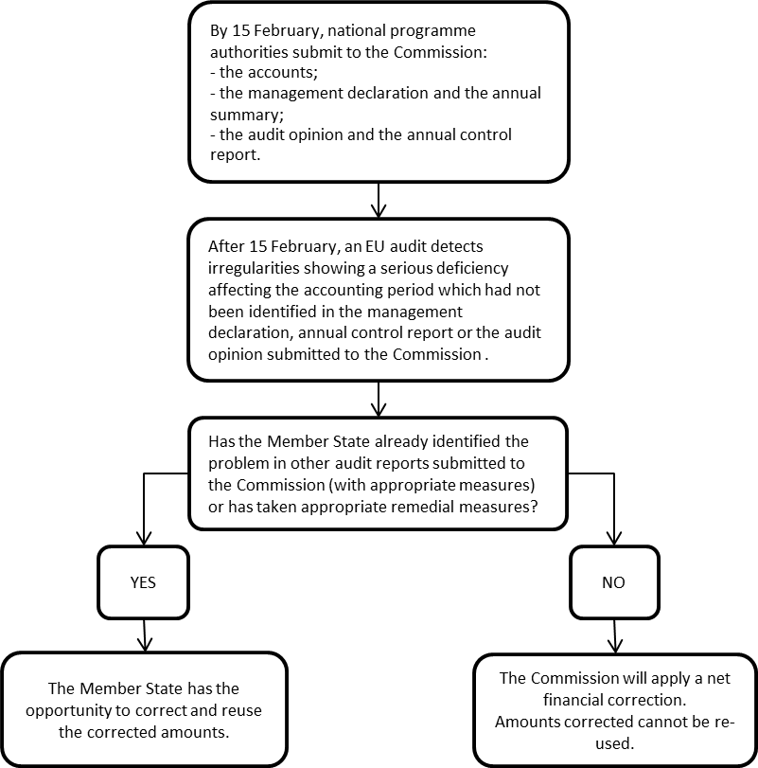
When the conditions for a net financial correction are met, the Member State will have the right to present its observations within two months, and any additional audit evidence in a hearing, before the financial correction decision is adopted by the Commission. The timing of this contradictory procedure with the Member State is clearly framed in the regulation. Finally, independently from whether the Member State eventually accepts or not the Commission position as regards the required financial correction, the Commission has to adopt a formal decision within maximum six months of the hearing with the Member State.
Definition of a serious deficiency
To ensure legal security, the notion of “serious deficiency in the effective functioning of a management and control system” is defined in the CPR itself (Article 2). Essentially it means that if the deficiency in one of the key requirements of the system is such as to give rise to a risk of material error, it is serious.
Article 2 (39) CPR:
…
'serious deficiency in the effective functioning of a management and control system' means, for the purposes of implementation of the Funds and the EMFF under Part Four, a deficiency for which substantial improvements in the system are required, which exposes the Funds and the EMFF to a significant risk of irregularities, and the existence of which is incompatible with an unqualified audit opinion on the functioning of the management and control system.
…
Under the CPR, the Commission is empowered to lay down in a delegated act detailed rules concerning the criteria for the assessment of the functioning of management and control systems, including the main types of serious deficiencies, the criteria for establishing the level of financial correction to be applied and the criteria for applying flat-rates or extrapolated financial corrections. The delegated act will be of general application regardless of the timing of the detection of the deficiencies.
The delegated act will be based on the current guidance framework for the assessment of the key requirements of management and control systems and for setting the level of flat-rate corrections. The Commission will therefore have a stronger legal basis compared to the current programming period, and intends to adopt the delegated act in early February 2014. The criteria for the assessment and the levels of flat-rate corrections will therefore be well-known in advance to all programme stakeholders.
The approach foreseen by the Commission is that it will conclude on the existence of a serious deficiency based on its assessment of the system key requirements (see diagram below) when at least one of the main key requirements (in bold in the diagram below) or two of the other key requirements are considered as working partially or not functioning. In such cases it will apply a flat-rate financial correction, unless the Member State can provide within four months a more precise estimate of the risk through the audit of an appropriate and representative sample of the concerned expenditure as a basis for an extrapolated correction.
It is envisaged that current levels for flat-rate correction will be maintained: 5%, 10%, 25% and 100%. This approach for the application of flat-rate corrections has been confirmed by the case law of the Court of Justice.
Nonetheless the decision to apply any level of financial correction must take account of proportionality and of the residual risk to the Union budget, as required in the CPR. Therefore in exceptional cases the Commission may apply an intermediate level of flat-rate correction (e.g. 50% or 20%).
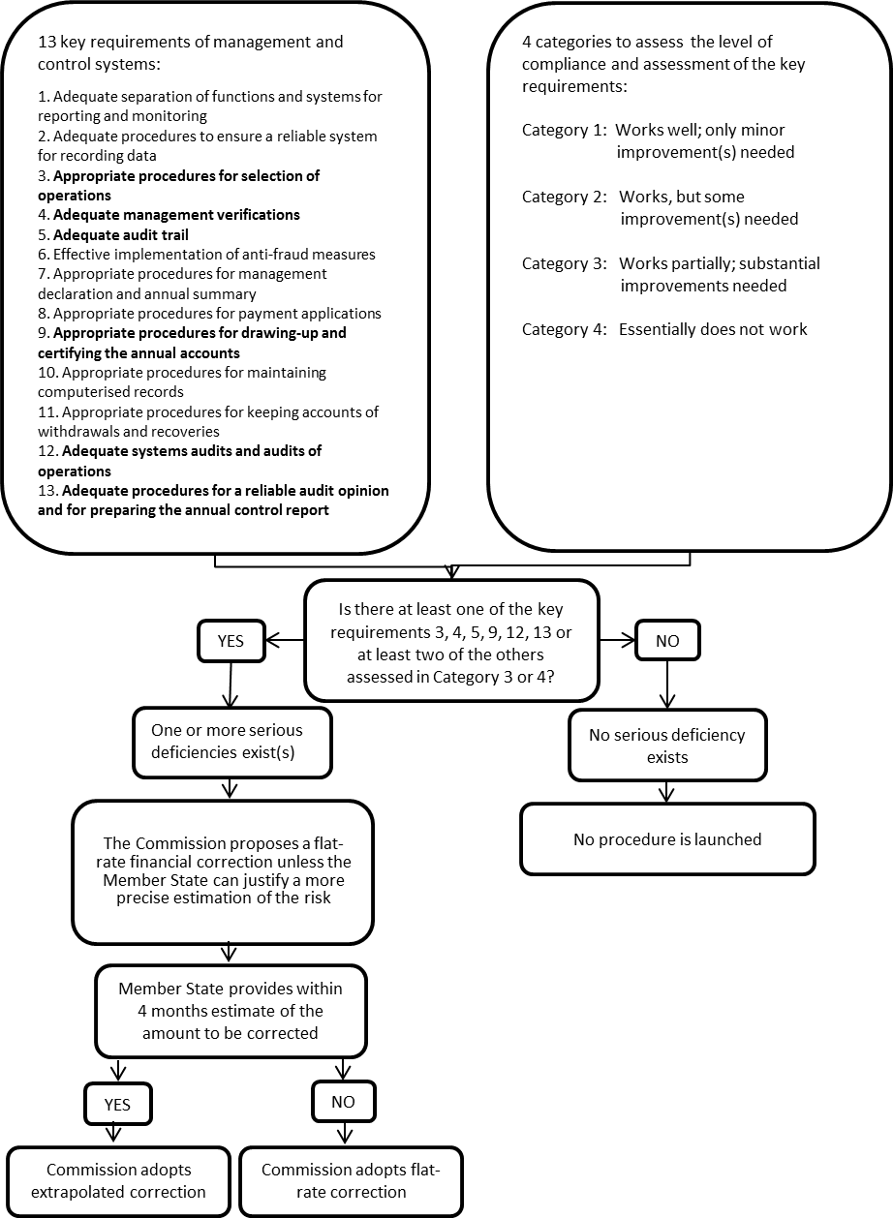

Increased level of correction for repeated deficiencies
When the same deficiencies have been detected by EU audits despite a previous financial correction, the Commission intends to include a provision in the delegated act allowing for a higher rate of correction than in the case of the first correction. This will be a clear message to Member States that they need to ensure a rapid and permanent adjustment of their management and control systems once a serious deficiency has been detected.
Details concerning the envisaged procedure for applying net financial corrections for Cohesion Policy Funds are provided in Annex 2.

Convergence of good practices for the Commission’s supervisory system under shared management
For the 2007-2013 period the main preventive legal instrument putting pressure on Member States to put in place effective management and control systems consists of procedures to interrupt payments or the suspension of payments to (part of) an Operational Programme. The Commission considers that these procedures have been instrumental in improving substantially error rates compared to the 2000-2006 period.
Interruption and suspension procedures 2012-2013 combined
 | ERDF and Cohesion Fund | ESF
Warnings | 175 | 16
Interruptions | 184 | 60
Pre-suspensions | 137 | 34
Suspension decisions | 6 covering 13 programmes | 11 covering 11 programmes
Nevertheless, the progress made in reducing error rates has proved to be insufficient, and for the next programming period the existing preventive instruments will be complemented with stronger corrective ones, extending best practices across shared management policy areas.
The key components of the Commission’s supervisory system for the 2014-2020 programming period are therefore:
- Interruptions and suspensions (respectively Articles 83 and 142 of the CPR), existing for Cohesion policy under the current programming period 2007-2013,
- Compulsory net financial corrections for serious systems deficiencies on the basis of a new provision (Article 145(7)) introduced in the CPR.
The introduction of the legal basis for compulsory net financial corrections under certain conditions in the next programming period addresses a weakness in the current legal framework, reported by the European Parliament and the Council in their discharge recommendations of the last years. The deterrent effect of the new net financial correction provisions, whereby Member States cannot re-use the corrected and recovered amounts and therefore lose the funds, will be significantly higher than in the current period, and will provide strong incentives for effective control arrangements.
This convergence with practices already existing for Common Agricultural Policy will complete the legal arsenal for the Commission to exercise its supervisory role under Cohesion Policy Funds, including on the corrective side, and will further enhance harmonization of the legal framework across EU budget areas under shared management.

The letter also referred to the Communication on the Protection of the EU budget (COM(2013) 682 final/2) which was published on 30 September 2013 as requested by the European Parliament in its resolution on the budgetary discharge for the financial year 2011
For European Agricultural Guarantee Fund (EAGF) the appropriation are assigned to the ''origin of the revenue'' (Art. 174(1) FR) and for financial instruments to the ''same financial instrument'' (Art.140(6) FR).
In 2012, the Commission took three conformity decisions, leading to financial corrections of 651 million euro (503 million euro relating to EAGF and 148 million euro to EAFRD). The average amount of financial corrections in the last five-year period (2008 - 2012) was 30 % higher than in the preceding period (2003 - 2007), taking into account the budget increase between those two periods.
ECA Annual report 2012 paragraph 4.30: ''The use of flat-rate corrections does not sufficiently take into account the nature and gravity of the infringement, as the same flat-rate correction of 5% is applied, regardless of whether weaknesses were found for a single key control or for many such controls.''
This date can be extended to 1st March in exceptional cases at the request of the Member State, cf. Article 59(5) of the Financial Regulation (EU, Euratom) N° 966/2012 of the European Parliament and of the Council.
It can take even longer if the whole case has to be re-examined.
ECA Annual report 2012 paragraph 4.31 Commission reply: "Notably in the framework of the preparation for the implementation of the CAP reform, the Commission will continue in its efforts to improve and speed up the process, bearing in mind the need to maintain quality standards and the Member State's right of reply."
? This date can be extended to 1st March in exceptional cases at the request of the Member State, cf. Article 59(5) of the Financial Regulation (EU, Euratom) N° 966/2012 of the European Parliament and of the Council.
With an additional two months allowed in case of proposed extrapolated or flat-rate correction for the Member State to demonstrate that the actual extend of the irregularity is less than that assessed by the Commission.

