Table of Contents

1. INTRODUCTION 3
2. EU ETS INFRASTRUCTURE 5
2.1. Coverage of activities, installations and aircraft operators 5
2.2. Union Registry 7
3. FUNCTIONING OF THE CARBON MARKET IN 2015 8
3.1. Supply: allowances put in circulation 8
3.1.1. Cap 8
3.1.2. Issued allowances 9
3.1.2.1. Free allocation 9
3.1.2.2. NER 300 programme 11
3.1.2.3. Auctioning of allowances 12
3.1.2.4. Derogation from full auctioning for the power sector 14
3.1.3. International credits 17
3.2. Demand: allowances taken out of circulation 18
3.3. Balancing supply and demand 19
4. AVIATION 23
5. MARKET OVERSIGHT 25
5.1. The legal nature of emission allowances and fiscal treatment 26
6. MONITORING, REPORTING AND VERIFICATION OF EMISSIONS 27
7. OVERVIEW OF ADMINISTRATIVE ARRANGEMENTS IN MEMBER STATES 30
8. COMPLIANCE AND ENFORCEMENT 31
9. CONCLUSIONS AND OUTLOOK 34

INTRODUCTION
Since 2005, the EU Emissions Trading System (EU ETS) has been the cornerstone of EU strategy for reducing greenhouse gas emissions from industry and the power sector cost-effectively. The system contributes significantly to the achievement of the EU's emissions reduction target for 2020 - the EU is on track to meet and even surpass its target. However, to achieve the target of cutting emissions by at least 40% by 2030 – agreed by EU leaders in October 2014 as part of the EU's 2030 climate and energy policy framework – continued progress needs to be ensured. This domestic target will be delivered collectively by the EU in a cost-effective manner, with reductions in the ETS and non-ETS sectors. A well-functioning, reformed EU ETS will constitute the main mechanism to achieve this target, which amounts to the decrease of 43% of emissions compared to 2005 in the sectors covered by the EU ETS.
In July 2015 the Commission presented a legislative proposal to revise the EU ETS for the next decade. Reforming and revising the EU ETS constitutes an integral part of the work on achieving a resilient Energy Union which is a key policy area in the current Commission.
The key aspects of the Commission's proposal of July 2015 on the revision of the EU ETS for phase 4 (2021-2030):
- The overall number of allowances is to decline at an annual rate of 2.2% from 2021 onwards, compared to 1.74% currently
- Better targeted allocation of free allowances, including:
o update of benchmark values to reflect technological progress
o more targeted carbon leakage groups
o amount of free allocation better aligned with production levels
- Several support mechanisms help the industry and the power sector meet the innovation and investment challenges of the transition to a low-carbon economy.
  - Two new funds:
    - Innovation Fund – extending existing support for the demonstration of innovative technologies to breakthrough innovation in industry
    - Modernisation Fund – facilitating investments in modernising the power sector and wider energy systems and boosting energy efficiency in 10 lower-income Member States
Free allowances continue to be available to modernise the power sector in these lower-income Member States.
In July 2016, the Commission presented a package of measures to accelerate the shift to low-carbon emissions in all sectors of the economy in Europe. One of the legislative proposals sets binding annual greenhouse gas emission targets for Member States for the period 2021–2030 for sectors not regulated under the EU ETS. Overall, the new framework is based on the principles of fairness, solidarity, cost-effectiveness and environmental integrity.
A stronger, better functioning European carbon market has the potential to make a major contribution to the transition to a low-carbon and more energy-secure economy in Europe. As the world's first major carbon market and the biggest one, the EU ETS also plays an important role in contributing to the global efforts agreed last December in Paris as part of the world's first universal climate change agreement.
The first report on the state of the European carbon market was published in November 2012 (Carbon Market Report 2012). Its purpose was to analyse the functioning of the carbon market and to consider whether regulatory action was needed in the light of a growing surplus in allowances. In the context of the first State of the Energy Union report, in November 2015 the European Commission adopted a second report on the functioning of the European carbon market (Carbon Market Report 2015) as part of the Climate action progress report. This report covered years 2013 and 2014 presenting also certain initiatives adopted in 2015.
The present Report on the functioning of the European carbon market required under Article 10(5) and Article 21(2) of Directive 2003/87/EC (EU ETS Directive) covers year 2015 but it also presents certain initiatives proposed or agreed in 2016. Unless otherwise indicated, data used for this report were the ones publicly available and at the disposal of the Commission by June 2016.
General information on different aspects of the EU ETS which was already provided in previous carbon market reports is indicated in boxes throughout the report.

EU ETS INFRASTRUCTURE

Coverage of activities, installations and aircraft operators

EU ETS operates in the 28 EU Member States, Iceland, Liechtenstein and Norway. It covers approximately 11,000 power plants and manufacturing installations as well as emissions from approximately 520 airlines flying between European airports. Around 45% of the EU's greenhouse gas emissions are covered by the system.
As of phase 3 (2013-2020), the sectors with stationary installations covered by the EU ETS are energy intensive industries, including power stations and other combustion plants, with >20MW thermal rated input (except hazardous or municipal waste installations), oil refineries, coke ovens, iron and steel, cement clinker, glass, lime, bricks, ceramics, pulp, paper and board, aluminium, petrochemicals, ammonia, nitric, adipic, glyoxal and glyoxylic acid production, CO₂ capture, transport in pipelines and geological storage of CO₂. The aviation scope of the EU ETS is limited to flights within the EEA until the end of 2016.
The EU ETS covers carbon dioxide (CO₂) emissions, nitrous oxide (N₂O) emissions from all nitric, adipic, glyoxylic acid and glyoxal production and perfluorocarbons (PFC) emissions from aluminium production.
EU Member States may add more sectors and greenhouse gas emissions to the EU ETS (opt-in procedure).

According to the Article 21 reports submitted in 2016 for the 2015 reporting year, there is now a total of just under 10 950 permitted installations compared to approximately 11 200 in the previous year and approximately 11 400 the year before.
The fuels combusted within EU ETS activities remained overwhelmingly fossil in 2015. However, 27 Member States also reported biomass use in connection with nearly 2000 installations (1966, 18% of installations overall). Only 4 Member States did not report any use of biomass (FR, LI, LT, MT). Indication of biomass related emissions was not complete in all Member State Article 21 reports (DK, IE, LV, PT, RO), but based on data actually provided emissions from biomass used amounted to approximately 125 million tonnes CO₂ (ca. 7% compared to EU ETS reported emissions). Only two Member States (DE and SE) reported a small use of biofuel involving a total of four aircraft operators.
Within the categories based on annual emissions, the data for 2015 shows that as for 2014, 72% of installations remain category A, 21% category B and only 7% category C. In 2015 over 5700 installations (excluding IT) were reported as 'installations with low emissions' (57% of the total excluding IT). The high percentage of installations with low emissions and category A confirms the relevance of the tier-based and other simplifications architecture of the monitoring, reporting and verification system designed with proportionality in mind.
Although the split of installations between category A, B and C, and installations with low emissions, within Member States generally follow the same overall trend, there are greater differences in the industry sectors or activities covered. EU ETS installations involving combustion activities are found in all Member States. Other activities reported by the majority of Member States are oil refining, steel production, cement, lime, glass, ceramics and pulp and paper production. Only two countries (FR and NO) report CO₂ capture and storage activities with issued permits. Regarding EU ETS activities additionally listed for non-CO₂ greenhouse gas emissions, permits are reported as issued for primary aluminium and PFCs in 13 countries (DE, ES, FR, GR, IS, IT, NL, NO, RO, SE, SI, SK, UK), while for nitric acid production and N₂O in 20 countries (the exceptions being CY, DK, EE, IE, IS, LI, LU, LV, MT, PT, SI). The other N₂O sectors are only reported in three Member States, involving adipic acid production (DE, FR, IT) and glyoxal and glyoxylic acid production (DE, FR).
As reported in 2015, only a very small number of Member States have made use of the possibility to exclude small emitters from the EU ETS in line with Article 27 of the EU ETS Directive. This possibility is offered by the Directive in order to reduce the administrative costs for small emitters still further and is allowed where equivalent measures for GHG emissions reduction are in place. According to reports submitted in 2016, 8 countries (DE, ES, FR, HR, IS, IT, SI, UK) are making use of this possibility, especially for installations involving a combustion activity and ceramics production. The overall amount of emissions excluded for 2015 was about 4 million tonnes CO₂ (some 0.22% of total verified emissions), compared to 3.9 million tonnes in 2014 and 4.7 million tonnes CO₂ in 2013.
It is notable that according to Member States' Article 21 submissions in 2016 that only a very small number of Member States have taken advantage of the provision offered by Article 13 of the Monitoring and Reporting Regulation (MRR) to allow use of simplified monitoring plans in low risk cases. Only BE (Flanders), FR, HR, HU, LI and LT report use in the case of installations, and only FI, IS and PL in the case of aviation.
As far as the coverage of aircraft operators is concerned, the number of aircraft operators reported with EU ETS monitoring plans is now less than 530 for 2015, compared to over 610 reported for 2014.

Union Registry

The Union Registry tracks the ownership of allowances and the transactions concerning allowances similar with a bank, recording the amounts owned on its accounts and the transactions between accounts. This single registry is operated and maintained by the Commission, whereas national registry administrators in all 31 countries participating in the EU ETS remain the point of contact for the representatives of more than 20 000 accounts (companies or physical persons).
The single registry offers European emitters, traders and 31 national authorities the means to carry out their EU ETS business: e.g. allocate free allowances to the stationary and aviation operators, record emissions of emitters (stationary installations and aviation), allow emitters, professional traders as well as physical persons to execute completed trades by transferring allowances between accounts, allow the emitters to compensate for their emissions by surrendering allowances. In addition the registry is used to implement the Effort Sharing Decision* and for auctioning of allowances.
At the same time the Union Registry enables the participating countries to comply with the United Nations' Kyoto Protocol rules: e.g. retirement or cancellation of Kyoto protocol units.
*Decision No 406/2009/EC of the European Parliament and of the Council of 23 April 2009 on the effort of Member States to reduce their greenhouse gas emissions to meet the Community’s greenhouse gas emission reduction commitments up to 2020, OJ L 140, 5.6.2009, p. 136.

In 2016 the Union Registry will connect Malta and Cyprus to the United Nations International Transaction Log (ITL), as well as implement, in coordination with the United Nations the necessary functionalities to carry out the processes defined in the Decision 3/CMP.11 of the Conference of the Parties of the Kyoto Protocol.
The Commission as the central administrator of the Union Registry in consultation with national registry administrators continuously seeks the improvement of registry functionalities, security and user friendliness.
Further detailed information on the EU ETS can be found in the ETS Handbook.

FUNCTIONING OF THE CARBON MARKET IN 2015
This chapter provides information on the supply and demand side of the EU ETS covering the cap, free allocation, NER300 programme, auctioning, the derogation from full auctioning for the power sector in certain Member States and the use of international credits.
On the demand side, it provides information on the verified emissions and on the balancing of the supply and demand.

Supply: allowances put in circulation

Cap

The EU ETS works on the 'cap and trade' principle. The cap is the absolute quantity of greenhouse gases which can be emitted in the system to ensure the emission reduction target is met and corresponds to the number of allowances put in circulation over a trading phase.
As from phase 3 an EU-wide cap is determined by the EU ETS Directive. The cap decreases each year by a linear reduction factor of 1.74% of the average total quantity of allowances issued annually in 2008-2012.

Table 1 shows the figures for the cap for each year during the period 2013-2020 (phase 3).
Table 1: EU ETS cap 2013-2020

Year | Annual cap (excluding aviation)
2013 | 2 084 301 856
2014 | 2 046 037 610
2015 | 2 007 773 364
2016 | 1 969 509 118
2017 | 1 931 244 873
2018 | 1 892 980 627
2019 | 1 854 716 381
2020 | 1 816 452 135

Issued allowances

Free allocation

Although in phase 3 auctioning is the default method for allocating emission allowances to companies participating in the EU ETS, some allowances continue to be allocated for free until 2020 and beyond. The following principles apply:
- electricity production no longer receives any free allowances (see section 3.1.2.4.)
- allowances are distributed for free according to EU-wide harmonised rules
- free allocation is based on performance benchmarks to strengthen the incentives for greenhouse gas emissions reductions and reward the most efficient installations
- an EU-wide new entrants' reserve (NER) is foreseen equivalent to 5% of the total amount of allowances for phase 3 (monetisation of 300 million allowances from this reserve funded NER300 programme, see section 3.1.2.2.)
Free allocation is provided to industrial installations to address the potential risk of carbon leakage (companies transferring production for reasons of costs related to climate policies to third countries with laxer constraints on greenhouse gas emissions leading potentially to an increase in their total emissions).

The sectors and sub-sectors deemed to be exposed to a significant risk of carbon leakage are placed on an official list which currently covers the period 2014-2019.
Over phase 3, 39% of the total quantity of allowances available will be allocated for free to industry and electricity-generating installations for the heat they produce. This share of free allocation will be further increased due to allocations to new entrants until 2020. Currently, it is not possible to determine how much of the new entrants reserve will be used in the next years. However, in line with the trends, it is expected that no more than 2% of the cap may additionally be allocated for free from NER. Therefore, over phase 3 the free allocation is expected to amount to around 41% of the total amount. Further, some 2% of the total cap is used to fund the NER300 programme (see section 3.1.2.2.). Therefore, the auction share in phase 3 amounts to 57%.
New installations covered by the EU ETS and installations that increase capacity are eligible for additional free allocation from the NER in phase 3. The initial NER, after deducting 300 million allowances for the NER300 programme, held 480.2 million allowances. Until July 2016, 109.2 million allowances have been reserved for 492 installations for the entirety of phase 3. The remaining NER which amounts to 371.0 million allowances can be distributed in the future for further new installations or existing installations increasing their capacity. However, it is expected that a significant number of these allowances will remain unallocated.
Until July 2016, allocation has been reduced by around 231.4 million allowances due to installations that have closed or reduced their production or their production capacity compared to the one initially used to calculate phase 3 allocation.
Table 2: The number of allowances (in millions) allocated to the industry for free in 2013, 2014, 2015 and 2016
 | 2013 | 2014 | 2015 | 2016
Free allocation  (EU28+EEA states) | 903.0 | 874.8 | 847.6 | 821.4
Allocation from the new entrants reserve (greenfield investments and capacity increases) | 11.0 | 14.2 | 14.9 | 14.5
Free allowances remaining unallocated due to closures or changes in production or production capacity | 40.7 | 58.4 | 68.6 | 63.7

As the demand for free allocation exceeded the amount available, the allocation for all installations under the ETS has been reduced by the same percentage through the application of a "cross-sectoral correction factor" (in accordance with the ETS Directive provisions). The correction factor represents a reduction in free allocation of approximately 6% in 2013 that is increasing annually until reaching approximately 18% in 2020. Following a number of requests for preliminary ruling from national courts, in April 2016 the European Court of Justice in its judgment invalidated as of 1 March 2017 the currently applicable cross-sectoral correction factor values. The cross-sectoral correction factor will have to be re-calculated by observing the approach indicated by the European Court of Justice regarding the extended scope of the EU ETS (including new activities and gases as of 2013). The revised values will apply to free allocations in the years 2018 to 2020 and will reduce free allocation to industry, while increasing the auction volumes for those years.

NER 300 programme

NER 300 is one of the world's largest funding programmes for innovative low-carbon energy demonstration projects. It is funded from the monetisation of 300 million emission allowances from the NER set up for the third phase of the EU ETS. The programme is aimed at demonstrating environmentally safe carbon capture and storage (CCS) and innovative renewable energy (RES) technologies on a commercial scale within the European Union.

The funds from the monetisation were awarded to projects selected through two rounds of calls for proposals in December 2012 and July 2014. In total, €2.1 billion has been awarded to one CCS and 37 renewable energy projects in 19 EU Member States. They are expected to leverage € 2.7 billion of private investments. Three NER 300 projects are operational at the moment: bioenergy project BEST in Italy, bioenergy project Verbiostraw in Germany and Windpark Blaiken in Sweden (see Carbon Market Report 2015 for details).
Table 3: NER 300 projects awarded under the first call for proposals

Projects outstanding | 16
Projects in operation | 3
Projects withdrawn | 1
Total | 20

Auctioning of allowances

Auctioning is a transparent allocation method that allows market participants to acquire allowances at the market price. From the start of phase 3 of the EU ETS, auctioning via the primary market became the default mode for allocating allowances; this means that more than half of the allowances are to be auctioned, with this proportion continually rising throughout the trading period. Auctions are governed by the Auctioning Regulation* which specifies the timing, administration and other aspects of how auctions should take place to ensure an open, transparent, harmonised and non-discriminatory process.
* Commission Regulation (EU) No 1031/2010 Commission Regulation (EU) No 1031/2010 of 12 November 2010 on the timing, administration and other aspects of auctioning of greenhouse gas emission allowances pursuant to Directive 2003/87/EC of the European Parliament and of the Council establishing a scheme for greenhouse gas emission allowances trading within the Community, OJ L 302, 18.11.2010, p.1.

The auctions took place over the reporting period through the following auction platforms:
- European Energy Exchange AG ("EEX"), auctioning as the common auction platform for 25 Member States participating in a joint procurement procedure and for Poland which chose to opt-out from the joint procurement procedure but has not appointed its own auction platform yet; as of 5 September 2016 EEX is conducting the auctions as the second common auction platform appointed on 13 July 2016.
- EEX, auctioning for Germany as an 'opt-out' auction platform;
- ICE Future Europe ("ICE"), auctioning for the United Kingdom as an 'opt-out' auction platform.
Iceland, Liechtenstein and Norway have not started auctioning of allowances yet.
EEX, auctioning on behalf of 27 Member States (25 Member States cooperating on a common auction platform, Germany and Poland) auctioned 88% of the total auctioned amount, with ICE, auctioning 12% of the total volume on behalf of the UK.
By 30 June 2016, more than 820 auctions have been conducted for phase 3. The table hereafter provides an overview of the volumes of allowances of phase 3 auctioned by EEX and ICE in 2012 (so called early auctions), 2013, 2014, 2015 and 2016. The volumes of general allowances have been determined taking into account the decision to backload 900 million allowances from 2014, 2015 and 2016 to 2019 and 2020, in accordance with Commission Regulation (EU) No 176/2014, and the volumes of aviation allowances have been determined taking into account the temporary derogations for the aviation sector set out in Decision No 377/2013/EU and Regulation (EU) No 421/2014.

Table 4: Volumes of allowances of phase 3 auctioned by EEX and ICE
Year | Amount of general allowances auctioned | Amount of aviation allowances auctioned
2012 | 89 701 500 | 2 500 000
2013 | 808 146 500 | 0
2014 | 528 399 500 | 9 278 000
2015 | 632 725 500 | 16 390 500
2016 | 380 585 000 | 3 028 000

The auctions were generally conducted smoothly and the auction clearing prices were generally in line with the secondary market prices, without the occurrence of significant problems or incidents. One auction conducted by EEX for Poland was cancelled in the reporting period. This cancellation comes after only three cancellations which occurred in 2013, shortly after the start of the phase 3 auctions. An overview of the auction clearing prices for all the general allowances auctions from 2013 to 30 June 2016, including the number of participants and the cover ratio, is provided in Appendix 2 to Annex.
The auction platforms publish detailed results of each auction in dedicated websites. In addition, Germany, Poland and the UK as well as the Commission on behalf of the Member States making use of the common auction platform, publish monthly reports on the auctions where further information on the performance of the auctions can be found, including on the participation, cover ratio and prices.
The total revenues generated from the auctions between 2012 and June 2016 exceeded € 14 billion. The EU ETS Directive provides that at least 50% of auction revenues, including all revenues generated from allowances distributed for the purposes of solidarity and growth, should be used by Member States for climate and energy related purposes. In 2015, the auctioning of ETS allowances generated € 4.9 billion of revenues for the Member States. On average in 2015, according to the information submitted to the Commission, the Member States spent or planned to spend 77% of these revenues for specified climate and energy related purposes. More information on the use of auctioning revenues will be available in the State of the Energy Union report of 2016.
In December 2015, the Commission launched a public consultation on the functioning of the Auctioning Regulation. Except for a few aspects where possible technical improvements could be contemplated, the results of the auctions and the responses to the public consultation confirm that the current architecture of the Auctioning Regulation generally provides smooth, efficient and effective execution of the auctions and allocation of allowances, including the limited opt-out system.

Derogation from full auctioning for the power sector

A derogation from the general rule of auctioning has been provided for in Article 10c of the EU ETS Directive to support investments in the modernisation of the electricity sector in certain Member States. Eight out of ten eligible Member States* make use of this derogation and allocate to electricity generators a number of allowances for free provided corresponding investments are carried out. The free allowances under Article 10c are deducted from the quantity that the respective Member State would otherwise auction. Depending on the national rules for the implementation of the derogation, electricity generators can receive free allowances of an equivalent value to the investments they carry out or have carried out from investments listed on the National Investment Plan, or to payments made into a national fund through which such investments are financed.
*Bulgaria, Cyprus, Czech Republic, Estonia, Hungary, Latvia, Lithuania, Malta, Poland and Romania are eligible for the derogation. Malta and Latvia decided not to make use of it.

The number of free allowances allocated for free to electricity generators in 2015 is indicated in Table 5. The maximum number of allowances per year is indicated in Appendix 1 to Annex. If the number of allowances allocated is lower than the maximum allowed, these 'unused' allowances may be allocated for free in the following year(s), depending on the relevant national rules of the Member State. Ultimately, allowances not allocated for free pursuant to the derogation will be auctioned. In the first year, investments that had been undertaken from June 2009 onwards from the national plan could be reported. For 2013 and 2014, costs were reported for 500 investments, out of which 135 were completed and 22 investments were reported to be cancelled and the rest are ongoing but not yet completed.
The total value of reported investment support during the years 2009 to 2015 is around € 9.49 billion. About 80% of this was dedicated to upgrading and retrofitting infrastructure, while the rest of the investments related to clean technologies or diversification of supply. Examples of investments include a new cogeneration-condensing steam turbine in Estonia (upgrade of infrastructure), rehabilitation of district heating networks in Bulgaria (retrofitting of infrastructure), substitution of coal by renewable energy sources through waste utilization in the Czech Republic (clean technologies) and the construction of an interconnector pipeline for natural gas in Hungary (diversification of supply).
Table 5: Number of free allowances issued pursuant to Article 10c
 | Number of free allowances requested by Member State
MS | 2013 | 2014 | 2015
BG | 11 009 416 | 9 779 243 | 8 259 680
CY | 2 519 077 | 2 195 195 | 1 907 302
CZ | 25 285 353 | 22 383 398 | 20 623 005
EE | 5 135 166 | 4 401 568 | 3 667 975
HU | 7 047 255 | 0 | -
LT | 322 449 | 297 113 | 269 475
PL | 65 992 703 | 52 920 889 | 43 594 320
RO | 15 748 011 | 8 591 461 | 9 210 797
Total | 133 059 430 | 100 568 867 | 87 532 554

Figure 1: Free allowances issued pursuant to Article 10c
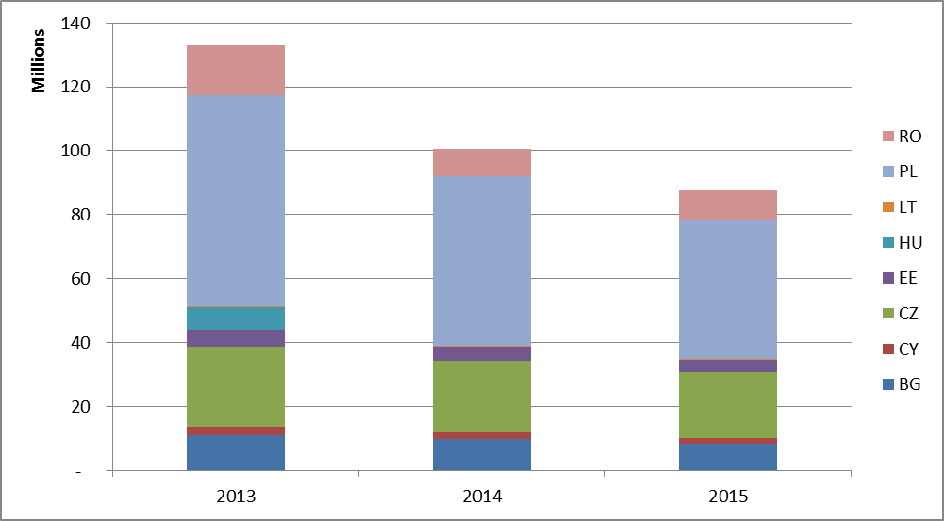

The EU ETS Directive requires Member States making use of the derogation to publish annual reports on the implementation of investments from their national plans. The applications should also be published. Experience shows that the existing reports that have been published vary in format and content. In some cases Member States restrict or aggregate the information provided on investment costs with reference to business confidentiality. Typically, the reports are published on the website of the responsible ministry e.g. Ministry for Energy (Bulgaria, Romania, Lithuania) or the Ministry for Environment (the Czech Republic, Cyprus, Estonia, Hungary, Poland).
Any allowances which are not given for free are auctioned. The figures below show the current distribution of the allowances for 2013, 2014 and 2015. For example, Poland has around 50 million unused allowances that have been deducted from its share of allowances auctioned in 2013 and 2014 but were not yet given for free.
Figure 2: Distribution of allowances (allocated, auctioned, unused remaining)
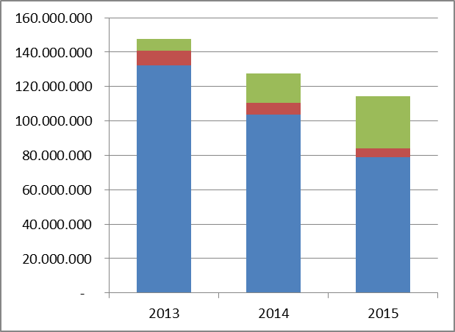

Allocated allowances
Auctioned allowances
Unused remaining allowances

International credits

The EU ETS allows participants to use credits from the Clean Development Mechanism (CDM) and Joint Implementation (JI) – two UN-level crediting programmes – towards fulfilling part of their EU ETS obligations*. This is foreseen until 2020. In phase 3 credits are no longer surrendered directly, as in phase 2, but instead exchangeable at any time throughout the calendar year for allowances.
A number of rules apply to the use of credits by EU ETS participants e.g. quality standards, no nuclear and afforestation and reforestation projects, no credits from new projects registered after 2013 in countries other than least developed countries. There are also quantitative rules on the maximum levels of credits that can be used by operators and aircraft operators**.
* Both CDM and JI projects generate Kyoto carbon credits: Certified Emission Reductions (CERs) and Emission Reduction Units (ERUs) respectively, each equivalent to 1 tonne of CO2.
**Commission Regulation (EU) No 1123/2013 of 8 November 2013 on determining international credit entitlements pursuant to Directive 2003/87/EC of the European Parliament and of the Council, OJ L 299, 9.11.2013, p. 32
Although the exact amount of credit entitlements over phase 2 and 3 will partially depend on the amount of future verified emissions, market analysts estimate that it will amount to around 1.6 billion credits. As of 30 April 2016 the total number of international credits used or exchanged amounts to 1.468 billion, accounting for over 90 % of the allowed maximum.
After 2020, the European Council has decided on a domestic emissions reduction target meaning the use of international credits in the next trading period of the EU ETS is not foreseen.
The graphs below illustrate the international credits exchange. For the full overview see Appendix 3 to Annex.

Figure 3: Summary of international credits exchange until 31 October 2016

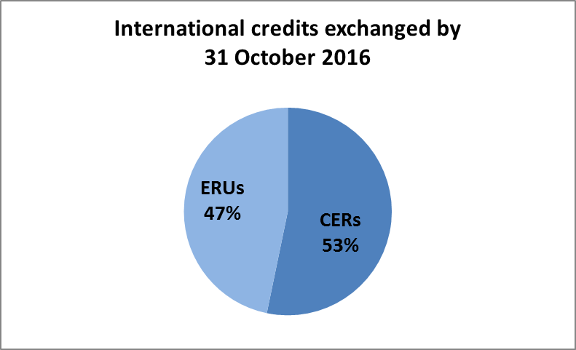
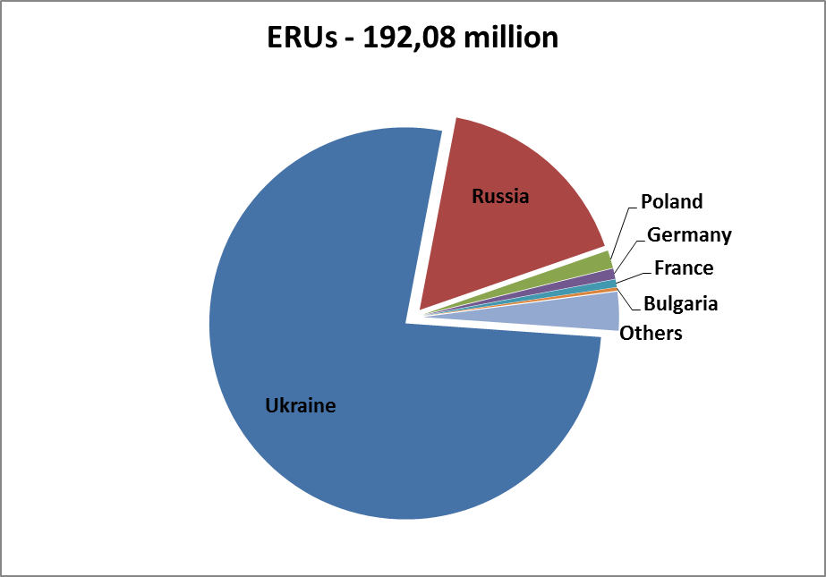
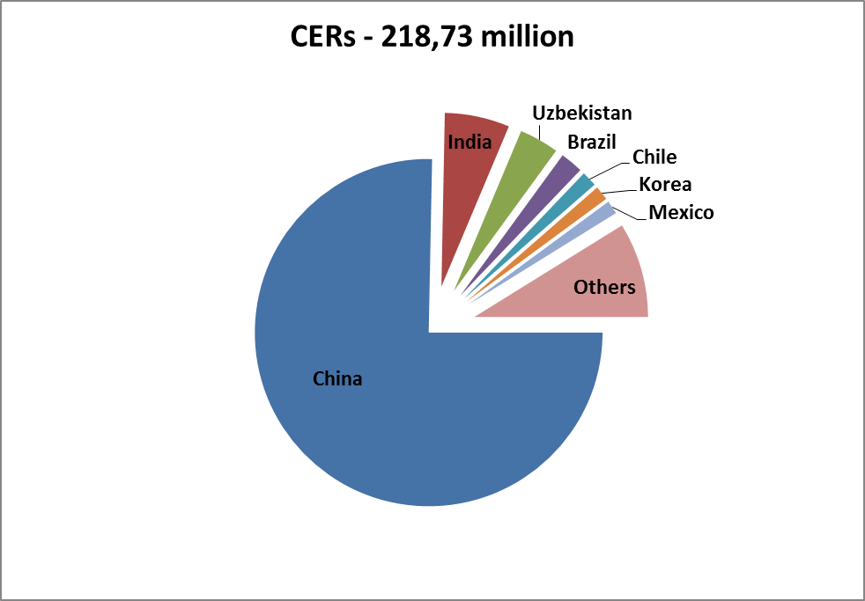

Demand: allowances taken out of circulation

In 2015, emissions of greenhouse gases from installations participating in the EU Emissions Trading System (EU ETS) are estimated to have decreased by just under 0.4% according to the information recorded in the Union Registry. This confirms the decreasing trend over the last five years of the functioning of the system.
Table 6: Verified emissions
Year | 2011 | 2012 | 2013 | 2014 | 2015
Verified emissions (in million tonnes CO₂ equivalents) | 1886 | 1867 | 1895 | 1812 | 1800
Change to year x-1 | -1.8% | -2% | -3% | -4.5% | -0.4%
Real GDP growth rate EU28 | 1.7% | -0.5% | 0.2% | 1.5% | 2.2%
Source: European Union Transaction Log (EUTL) public website (http://ec.europa.eu/environment/ets/)
GDP data as reported on: http://epp.eurostat.ec.europa.eu/tgm/table.do?tab=table&init=1&plugin=1&language=en&pcode=tec00115
(accessed in September 2016). Verified aviation emissions are reported separately in section 4.
The number of allowances cancelled (not used for compliance) on a voluntary basis amounts to 69 627 allowances in 2015. In total, cancellations of 130 124 allowances have been recorded so far.

Balancing supply and demand

At the start of phase 3, the EU ETS was characterised by a large imbalance between supply and demand of allowances, resulting in a surplus of around 2.1 billion in 2013. In 2014, it has been slightly reduced to some 2.07 billion and in 2015 it fell significantly to 1.78 billion allowances.
The decline in the surplus reflects the reduction in auction volumes due to the implementation of the back-loading measure, which postponed the auctioning of 400 million allowances in 2014, 300 million in 2015 and 200 million in 2016. Ultimately these allowances will be transferred to the Market Stability Reserve. In the absence of back-loading the surplus in 2015 would have been more than 40% higher. Emissions declined by only a small percentage in 2015, which lead to a significant net reduction in the difference between supply and demand.
To address the structural imbalance between the supply and demand for allowances, a legislative proposal was introduced to establish a Market Stability Reserve and render the auction supply of emission allowances more flexible. The Market Stability Reserve was agreed in 2015 and will be implemented as of 2019.
A key notion for the functioning of the Market Stability Reserve is the total number of allowances in circulation (TNAC). Allowances will be added to the reserve, if the TNAC is above a predefined upper threshold (833 million allowances) and allowances will be released from the reserve, if the number is below a predefined lower threshold (below 400 million allowances or where measures are adopted under Article 29a of the EU ETS Directive). Thus the Market Stability Reserve absorbs or releases allowances, if the TNAC is outside of a predefined range. Backloaded and so-called unallocated* allowances will also be absorbed by the reserve.
The supply of emission allowances consists of the allowances banked from phase 2 (2008-2012), auctioned allowances, allowances allocated for free and the allowances in the NER; while the demand is determined by the emissions of the installations and the cancelled allowances. For more details, see Table 1 in Appendix 4 to Annex.
The starting point for determining the total number of allowances in circulation is the total number of allowances remaining after phase 2 of the EU ETS which were not surrendered or cancelled.** This 'banking total' of 1 749 540 826 allowances (this number does not include early auctions of phase 3 allowances taking place in 2012 but does reflect the use of international credits before the start of phase 3. The total amount of international credits used since 2008 is listed in section 3.1.3.) thus represents the exact number of ETS allowances in circulation at the start of the third trading period of the EU ETS.
The total number of allowances in circulation relevant for determining feeds and releases in the Market Stability Reserve is calculated by the following formula:
TNAC = Supply – (Demand*** + allowances in the MSR)
*Unallocated allowances are allowances not allocated pursuant to Article 10a(7) of the EU ETS Directive, i.e. allowances remaining in the new entrants' reserve, and resulting from the application of Article 10a(19) and (20), i.e. allowances foreseen for free allocation to installations but remaining unallocated because of (partial) cessation of operations or significant capacity reductions.
** These allowances were replaced by phase 3 allowances at the end of the second trading period. No other allowances from before the third trading phase contribute to the total number of allowances in circulation. For the explanation on banking of the emission allowances see: http://ec.europa.eu/clima/policies/ets/registry/faq_en.htm
*** This also includes cancelled allowances.

The annual carbon market report allows the consolidation of the figures for supply and demand which are published according to the timeline of reporting obligations stemming from the EU ETS Directive and its implementing provisions. This timeline, relevant data and scope are outlined in Table 2 in Appendix 4 to Annex.
As the Market Stability Reserve becomes operational in 2019, the Commission will regularly publish as of 2017 in mid-May the total number of allowances in circulation for the preceding year.
Figure 4 presents the cumulative supply and demand figures for ETS until the end of 2014, respectively. The total supply in 2013 was about 2.18 billion allowances, and the total demand was about 1.96 billion allowances. In 2014, both the total supply and demand decreased to around 1.87 billion allowances. In 2015, supply decreased to 1.58 billion allowances, while demand reduced marginally to 1.85 billion allowances. As a result, the surplus grew in 2013 by about 220 million allowances to over 2 billion allowances, remained stable in 2014 and subsequently fell in 2015 to around 1.78 billion allowances. The surplus is thus at the lowest level since the start of the current trading period. Reduced supply in 2014 and 2015 reflected lower auction volume due to the implementation of backloading. Figure 5 shows the development of supply and demand between 2013 and 2015.

Figure 4: Balance between cumulative supply and demand until the end of 2015
Supply (cumulative, millions) Demand (cumulative, millions)
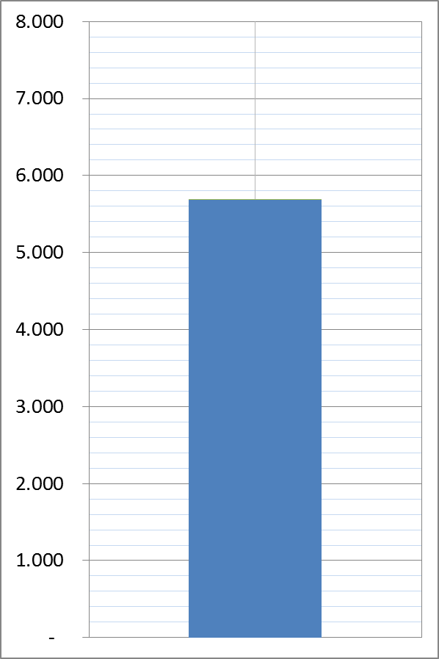
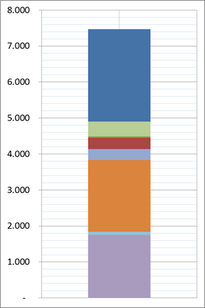

 | Free allocation |  |  | Cancellations
 | International credits exchanged |  |  | Verified emissions
 | Free allocation (NER)
 | Free allocation (10c)
 | NER 300 monetisation by EIB
 | Auctioning
 | Early auctioning
 | Banking

Figure 5: Development of supply and demand in 2013-2015
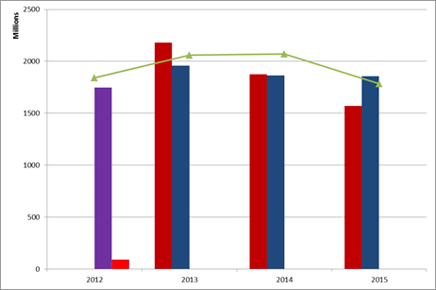
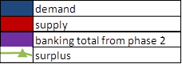

AVIATION

Since the start of 2012, emissions from all flights between airports in the European Economic Area (EEA), from flights departing from airports in the EEA to third countries and, if not exempted through delegated legislation, from incoming flights to airports in the EEA from third countries are included in the EU ETS. However, in the response to the ICAO Assembly agreement to develop by 2016 a global market-based mechanism (MBM) to be implemented from 2020 to tackle emissions from international aviation, the scope the EU ETS is temporarily reduced to emissions from flights within the EEA between 2013 and 2016.

According to the Article 21 reports submitted in 2016, 524 aircraft operators now have a monitoring plan (compared to 611 reported for the year before). Of these, 56% (296) were Commercial Aircraft Operators and the other 44% (228) were Non Commercial Aircraft Operators. A total of 274 (52% of the total) qualified as small emitters (compared to 329, 54%, the year before).
Verified emissions from flights between airports located in the EEA amounted to 56.9 million tonnes of carbon dioxide in 2015, an increase of 3.6 % compared to 54.9 million tonnes in 2014.
Aircraft operators' initial allocation was also adjusted to the reduced intra-EEA scope. The adjusted free allocation amounted to 32.3 million allowances in 2015.
The amount of allowances to be auctioned for 2015 as determined on the basis of an expected annual amount of 5.7 million, following the adjustments made to auction volumes in accordance with Regulation (EU) No 421/2014. These allowances were auctioned between May and December 2015.
These figures show around 19 million tonnes of net demand for allowances created by aviation in 2015.

MARKET OVERSIGHT

A significant part of daily transactions in emission allowances is in the form of derivatives (futures, forwards, options, swaps), which are already subject to EU financial markets regulation. This is being replaced by the MiFID2 package, which will be applicable as of January 2018. This package requires the adoption of a number of implementing measures.
Under MiFID2 also emission allowances will be classified as financial instruments. This means that MiFID2 rules applicable to traditional financial markets (those including carbon derivatives trade on leading platforms) will also apply to the spot segment of the secondary carbon market (transactions in emission allowances for immediate delivery in the secondary market, currently unregulated at EU level), putting it on an equal footing with the derivatives market in terms of transparency, investor protection and integrity.*
Moreover, by virtue of cross-references to MiFID2 definitions of financial instruments, other pieces of financial market legislation will apply. This is in particular the case of the Market Abuse Regulation (MAR), which will cover transactions and conduct involving emission allowances, both on secondary markets and in the EU ETS auctions in the primary market. Similarly, a cross-reference to MiFID2 in the Anti-Money Laundering Directive will trigger a mandatory application of customer due diligence checks by MiFID-licensed carbon traders to their clients in the secondary spot market in emission allowances.**
* Oversight in the primary market will continue to be covered by the Auctioning Regulation, other than issues related to market abuse, where the Market Abuse Regulation will be directly applicable.
** Due diligence checks are already mandatory in the primary market and in the secondary market in emission allowances' derivatives.
MiFID2 and MAR, both adopted in 2014, envisage certain adaptations of the general regime to carbon market specificities (see Carbon Market Report 2015).
Several level 2 measures covering details of provisions under MiFID2 and MAR are being adopted in 2015 and 2016.
Moreover, following-up on a recommendation by the European Court of Auditors, the Commission has increased the frequency of contacts amongst services within the Commission involved in drafting legislation with a bearing on European carbon markets.

The legal nature of emission allowances and fiscal treatment

The legal nature of emission allowances and their fiscal treatment are not defined at EU level. However, despite non-harmonisation, a mature and very liquid market has developed over the last decade. The current regulatory framework provides the necessary legal underpinnings for a transparent and liquid carbon market, whilst ensuring the market's stability and integrity.
Only one country (IS) has not reported something in relation to the legal nature of an emission allowance within their legal system. Emission allowances are described variably as financial instruments, intangible assets, property rights and commodities. At least three countries (LU, NO, DE) foresee revised legislation in the near future.
As regards the fiscal treatment of allowances, according to Article 21 reports submitted in 2016, only a low number of Member States (DK, PT, UK) report that value added tax (VAT) applies to the issuance of emission allowances. In contrast, VAT is due on transaction of emission allowances on the secondary market in most Member States (all except CY, EE, IS, LI). The majority of Member States report that they do apply the reverse-charge mechanism on transactions involving emission allowances. Emission allowances for corporations can additionally be taxed. Sixteen Member States reported that there was no such taxation.
Following the recommendation of the European Court of Auditors, in September 2016 the Commission launched a study on the legal nature of EU ETS allowances. This study will inter alia outline the legal characteristics of allowances based on the current EU legislation, case law and the national Member Sates regime as reported in Article 21 Report under the ETS Directive.

MONITORING, REPORTING AND VERIFICATION OF EMISSIONS

The monitoring, reporting and verification (MRV) of greenhouse gas emissions must be robust, transparent, consistent and accurate for the EU ETS to operate effectively. It is supplemented by a sound accreditation system to assure adequate quality of third-party verifiers. MRV requirements are harmonised in the Monitoring and Reporting Regulation (MRR) and the Accreditation and Verification Regulation (AVR).
The monitoring system in the EU ETS is designed as a 'building block' system which allows a high degree of flexibility for operators to ensure cost-efficiency, while at the same time to achieve a high reliability of the monitored emissions data. For this purpose, several monitoring methods ('calculation-based' or 'measurement-based', as well as by exception 'fall-back approaches') are allowed. Methods may be combined for individual parts of an installation. The requirement for installations and aircraft operators to have a monitoring plan approved by the competent authority on the basis of the MRR prevents arbitrary selection of monitoring methods and temporal variations.
With the Accreditation and Verification Regulation for phase 3 and beyond an EU-wide harmonised approach towards the accreditation of verifiers has been introduced. Verifiers who are a legal person or a legal entity must be accredited by a National Accreditation Body (NAB) in order to carry out verifications in compliance with the AVR. Only in the case of a natural person may a Member State allow for certification as an alternative to accreditation. The new uniform accreditation system has the advantage of allowing verifiers to operate with mutual recognition across all Member States, thereby taking full advantage of the internal market and helping to ensure sufficient availability overall.

  - General Developments
The Commission continues to seek continuous improvements in the guidance and templates that it makes available to facilitate consistent implementation of MRR and AVR requirements by Member States. One new initiative concerns development of 'Quick Guides' to help stakeholders understand and identify the most important EU ETS considerations more quickly and succinctly. Each Quick Guide is approximately 10 pages in length with links provided to more detailed guidance and templates where relevant. Separate Quick Guides are being produced for installation operators, aircraft operators, competent authorities, verifiers and NABs.
Another new initiative concerns drafting of guidance on EU ETS inspection. This is intended to help coordinate Member State response to a recommendation from the European Court of Auditors for them to implement a more coherent and effective EU ETS implementation control frameworks inclusive of inspections.
The Commission continues to monitor MRVA implementation across all Member States. The 2014 Compliance Cycle Evaluation, Article 21 reports submitted for 2013 and 2014 and information submitted in response to requests for further information have all been further evaluated to produce a bespoke Action Plan for each country advising them of potential improvements that could be made to their implementation of EU ETS MRVA. Where relevant, guidance has been clarified and training events arranged to address some of the issues more commonly found in most Actions Plans. Other follow-up actions have taken the form of arranging Member State MRVA peer reviews, regional capacity building and bilateral meetings.
It is recognised that the efficiency of the compliance system has improved since the MRR allowed Member States to make electronic reporting mandatory. Most Member States report the use of templates or systems based on the minimum requirements set by Commission publications. Thirteen Member States have reported in 2016 that they use some form of automated IT system for EU ETS reporting (compared to 10 in 2015).
In order to assist Member States further regarding availability of an automated system, the Commission has launched DECLARE ETS MRVA (in May 2016). This web-based system is designed to promote administrative efficiency and a more harmonised approach. It is developed to support obligations related to EU ETS monitoring plans, annual emission reports, verification reports and improvement reports within Member States. The European Commission developed and hosts the platform, but access is restricted to the responsibilities attributed under the MRR and AVR, i.e. to competent authorities, operators and where relevant the operator's selected verifier. The system also allows participating Member States to extract data into overall reports.
  - Monitoring applied
According to the Article 21 reports submitted by Member States to the Commission that cover the application of the ETS Directive in 2015, most of the installations use the calculation-based methodology. Only 151 installations (in 22 Member States) were reported to use continuous emissions measurement systems, most frequently in Germany (CO₂ 28, N₂O 10, both 1) and the Czech Republic (CO₂ 14, N₂O 4).
Only 13 Member States reported the use of the fall-back approach by 40 installations in total and covering some 6.6 million tonnes CO_{2e} (compared to 6.1 million tonnes CO_{2e} in the previous year). Over half of this overall emission is accounted for by 12 installations in the Netherlands.
The flexibility in the choice of the allowed monitoring methodologies supports cost-effectiveness in the MRV framework. Another important element designed for this purpose is the tier-based approach. For all the parameters required for the determination of emissions data, so-called 'tiers' are defined to make efforts or uncertainty level requirements proportionate to the size of the installation. The MRR requires all operators to meet certain minimum tiers, with larger emission sources required to meet higher tiers (involving more reliable data quality), while for cost-efficiency reasons less strict requirements apply for smaller sources.
The minimum tier defaults of the MRR are met by the vast majority of installations. Only 113 category C installations (compared to 118 in the previous year), 14% (the same as in the previous year), were reported to deviate for at least one parameter from the requirement to apply the highest tiers for the major source streams (for 2013, there were 137 installations, 16% of total). These deviations are only allowed where the operator demonstrates that the highest tier is technically not feasible or incurs unreasonable costs. If those conditions are found not to apply anymore, operators have to improve their monitoring systems. In a similar way, Member States have reported the number of category B installations which do not meet the highest tier requirements for major source streams or emission sources. Reports in relation to this were received from 22 Member States (the same as in the previous year) indicating that overall 26% of category B installations are permitted with some form of deviation from the MRR default requirements (compared to 28% in the previous year).
The above confirms that the MRR provisions for such deviations (bearing in mind that they have to be duly justified by the operator and approved by the competent authority) are applicable in practice, and compliance by operators overall is good.
For aircraft operators, there are fewer options applicable for the monitoring of emissions. Only calculation based approaches are feasible, with the fuel consumption being the central parameter to be determined for the flights covered by the EU ETS.
  - Accredited verification
According to Member State Article 21 reports submitted in 2016, the number of verifiers accredited per accreditation scope totalled 1077 verifiers accredited across all scopes. More often than not, individual verifiers are accredited for more than one scope and so this figure does not equal the total number of verifiers. The overall number of verifiers is not reported in Member State Article 21 reports, but a reasonable estimate based on the number accredited for combustion (the primary scope of accreditation) is that there were at least 130 different verifiers accredited overall concerning 2015 verifications. The Member State Article 21 reports submitted in 2016 indicate that there were 51 individual verifiers accredited for 2015 verifications concerning aviation. The AVR requires each NAB to maintain a database containing up to date information on the verifiers they have accredited, including the scopes of accreditation. The European cooperation for Accreditation (EA) provides a central link to relevant NABs and their lists of EU ETS accredited verifiers.
The mutual recognition of verifiers among Member States is working successfully: most Member States (28, all except FR, LV, SI) reported that at least one foreign verifier is active in their territory. Availability of verifiers has not constituted a bottleneck in the system in any of the first three years of implementation of the AVR.
Compliance of verifiers with the AVR is found to be high, as evident from the infrequent administrative measures reported by Member States. No Member State reported suspensions or withdrawals of accreditation (compared to one suspension and one withdrawal the year before). Only four Member States (compared to three the year before) reported reductions made in the scope of a verifier's accreditation, concerning only five verifiers (compared to 6 the year before). Although a greater number of Member States have reported complaints received about verifiers this year (nine compared to seven), the number of complaints are 20% less and 96% of the complaints received are also reported resolved (compared to 99% the year before). Eleven Member States reported identification of verifier non-conformities as part of the information exchange process between NABs and competent authorities (compared to eight in the previous year).

OVERVIEW OF ADMINISTRATIVE ARRANGEMENTS IN MEMBER STATES

Member States use different approaches regarding the competent authorities in charge of the implementation of the EU ETS. In some Member States several local authorities are involved, while in others the approach is much more centralised. Article 21 reports provide a high level overview of the organisational structure of each Member State.

According to the Member State Article 21 reports submitted in 2016, there are on average four different competent authorities involved in EU ETS implementation in each Member State. However, it should be noted that in some cases Member States may be reporting a multiple number of regional/local authorities as one competent authority.
Coordination between competent authorities is one of the most important issues in order to ensure a uniform and correct application of the legal requirements within each Member State and this is promoted by appropriate provisions of the MRR. For coordination between competent authorities, Member States reported that they use different tools where relevant.
For 2015, 12 Member States reported that they have legislative instruments in place for central management of monitoring plans or emission reports (compared to 10 previously). In 10 cases a central body provides binding instructions and guidance (compared to 8 reported the year before). Fourteen Member States reported that a central competent authority reviews and provides advice on monitoring plans, notifications and emission reports on a voluntary basis (compared to 11 the year before). Fourteen Member States also reported that they hold regular working groups or meetings for authorities (compared to 12 before) and 9 reported organisation of shared training (compared to 8 previously). The use of a joint IT platform was reported by 10 Member States as another means of ensuring coordination (compared to 9 the year before). Only seven Member States (CY, EE, HU, IT, LI, LU, MT) indicated none of the above in place; some do not involve multiple or complex competent authority structures.
On administrative fees charged by Member States (in relation to permitting and approved monitoring plans), 16 countries reported that they do not charge any fees to installation operators (CY, DE, EE, FR, GR, IE, IT, LI, LT, LU, LV, MT, NL, SE, SK). Aircraft operators do not pay fees in 16 countries (BE, CY, CZ, DE, EE, ES, GR, IT, LI, LT, LU, LV, MT, NL, SE, SK). Where charges are made, they vary according to Member State and for the particular service involved. For example, the fees associated with permit and monitoring plan approval for installations vary from 10€ to 7690€, and for a permit update from 10€ to 2481€. Similar variations are seen regarding aviation, with the fees for monitoring plan approval ranging from 10€ to 2400€ and for a monitoring plan update from 10€ to 827€.
Overall it is inferred that the Member State systems are largely effective as aligned to the country's administrative organisation. The principle of subsidiarity is applied. Communication between Member States local authorities and the sharing of best practices among Competent Authorities, including via the activities of the EU ETS Compliance Forum, should continue to be reinforced and encouraged.

COMPLIANCE AND ENFORCEMENT

The EU ETS has a very high compliance rate: each year around 99% of the emissions are actually covered by the required number of allowances. In the reporting period the level of compliance with the EU ETS rules was again high. Less than 1% of the installations which reported emissions for 2015 did not surrender allowances covering all their emissions by the deadline of 30 April 2016. These (typically small) installations account for approximately 0.5% of emissions covered by the EU ETS. In the aviation sector the level of compliance was also very high: aircraft operators responsible for more than 99 % of aviation emissions covered under the EU ETS complied. This also includes more than 100 commercial aircraft companies based outside EU, which operated flights within the EEA.

The EU ETS Directive provides for an 'excess emissions penalty' in the form of €100 (indexed) for each tonne of CO₂ emitted for which no allowance has been surrendered in due time. Other penalties applicable to infringements in implementation of EU ETS are according to national provisions set by the Member State concerned.
The competent authorities in the Member States continue to contribute significantly to the high level of compliance of operators, by carrying out different compliance checks on the annual emissions reports. According to the information in the Article 21 reports submitted in 2016, all Member States (except SE and IT) checked 100% (except FR, 90%) of annual emission reports for completeness and internal consistency. Furthermore, indications are that on average Member States are checking over 80% of reports for consistency against monitoring plans and 70% against allocation data. Twenty-four Member States reported that they also carry out cross-checks with other data/detail.
Based on Article 21 reports submitted by Member States in 2016, competent authorities in 16 Member States (AT, BG, DK, ES, FI, FR, HR, LV, NL, NO, PL, PT, RO, SE, SK, UK) were required to make conservative estimates in the case of only 45 installations overall (less than 0.5%). This compares to 37 installations (0.3%) in the previous year, but associated emissions of only 8.3 million tonnes CO₂ compared to 9.1 million tonnes the year before (less than 0.5% of overall emissions in both cases). The most common reasons given for such estimates were the absence of an emission report by 31 March or emission reports that were not fully in line with MRR/AVR requirements.
Conservative estimates for aircraft operators were higher, 103 (PT 47; FR 21; RO 16; UK 10; IT 6; AT, ES, and IE one each), all except one due to the absence of an emission report by 31 March. This is nearly 20% of all aircraft operators, but in all cases involved small emitters (in the majority of cases very small emitters), affecting a very small amount of overall emissions.
Competent authority checks remain important to supplement the verifier’s work and to ensure the high quality level of the MRV system. For 2015, all Member States (except GR, LU, MT, SE, IT) confirmed that they carry out further spot checks and inspections to check on implementation and compliance of installations with monitoring plans, the MRR and AVR. Thirteen Member States (AT, BE, BG, DK, FI, HR, IE, LV, NL, PL, RO, SI, SK) indicated such checks are also extended to aircraft operators.
For 2015, the application of 'excess emissions penalty' was reported in the case of a very low number of installations (only 12) by 6 Member States (DE, NL, PL, PT, RO, UK). For aviation, excess emission penalties were reported for a total of 9 aircraft operators by ES, IS, SE, UK, 47 aircraft operators were reported by one Member State (PT) which would appear to coincide with the same number of reported conservative estimates, suggesting a link to very small emitters.
Other penalties possible in the Member States vary significantly regarding the type of infringement covered and the level of penalty. Some Member States reported that the penalties will be set by the court based on the relevant case. Most Member States reported a lower and/or upper limit for the penalty (as applicable), with the minimum ranging from tens of Euro to as much as €50 000, and the maximum ranging from €100 to €16 million. Nine Member States (BE, CY, DK, EE, FR, IE, LU, NO, SE) also reported possible penalties in the form of imprisonment ranging from 3 months to ten years.
Eleven Member States confirmed issue of this latter category of penalties during the 2015 reporting period. No imprisonments were reported, but fines concerning 35 installations and 5 aircraft operators were given fines totalling €13 356 036, although €12 327 070 was attributed to just one installation (in IT) for operating without a permit. The most common offence was reported as failure to submit verified annual emission reports by the due deadline (11 cases), followed by failure to comply with the approved monitoring plan/MRR (6 cases), failure to report capacity changes (5 cases) and failure to comply with permit conditions (4 cases). Other cases involved failure to submit an improvement report, failure to notify changes to the monitoring plan, failure to surrender a sufficient number of allowances by 30 April and failure to hold a monitoring plan.
The EU ETS Compliance Forum continues to provide an effective mechanism for sharing MRV information between Member States and competent authorities and identifying best practice for efficient implementation. An annual Compliance Conference was held most recently in November 2016. This helps to ensure widest awareness of Compliance Forum activities in particular concerning its five Task Forces on Monitoring and Reporting, Accreditation and Verification, Aviation, Electronic-reporting and Carbon Capture and Storage. In the meantime, details concerning the meetings and on-going work of the Task Forces are made available to all EU ETS competent authorities via a shared web-site.
The Registry Administrators' Working Group is a cooperation forum between Member States and the Commission as the central administrator on issues and procedures linked to the operation of the Union Registry and the implementation of the Registry Regulation.

CONCLUSIONS AND OUTLOOK

In 2015 the EU ETS has delivered further emissions reductions in the EU, remaining the EU's flagship tool for tackling climate change and an effective instrument to cut emissions cost-effectively. The decrease of emissions of greenhouse gases from installations participating in the system by around 0.4% confirms the decreasing trend over the last five years.
Also, 2015 marks the first year in which the surplus of allowances that has built up in the system since 2009 - largely due to the deep and sustained economic recession which reduced emissions more than anticipated – showed for the first time a material decline. This is the result of the implementation of the short-term measure to address the growing imbalance between supply and demand, so-called backloading which postponed the auctioning of 300 million allowances from 2015 to 2019-2020, combined with stable emissions. Its effect will be complemented by the Market Stability Reserve which will start operating in as of January 2019.
Moreover, the third year of phase 3 further indicated that the EU ETS architecture is robust. Since 2005 the system provides a price signal for power plants and other installations, to promote research, development and investment in clean, low-carbon technologies.
Under the revised rules which are proposed to apply as of phase 4 (2021-2030), the EU ETS will continue to be a cost-effective driver for low-carbon investments for the years to come. A stronger, better functioning European carbon market has the potential to make a major contribution to the transition to a low-carbon and more energy-secure economy in Europe. It will also contribute to the global low-carbon transition which is already underway and gaining momentum, following the adoption of the first universal climate change agreement last December in Paris.
The Commission will continue to monitor the carbon market and provide the next report in late 2017.

COM (2015) 337, http://eur-lex.europa.eu/legal-content/EN/TXT/?uri=CELEX:52015PC0337
http://ec.europa.eu/clima/news/articles/news_2016072001_en.htm
COM(2016) 482 final, http://eur-lex.europa.eu/legal-content/EN/TXT/?uri=CELEX:52016PC0482
COM(2012) 652 final, http://ec.europa.eu/clima/policies/ets/reform/docs/com_2012_652_en.pdf
COM(2015) 576 - ANNEX 1, http://ec.europa.eu/clima/policies/strategies/progress/docs/com_2015_576_annex_1_cover_en.pdf
Directive 2003/87/EC of the European Parliament and of the Council of 13 October 2003 establishing a scheme for greenhouse gas emission allowance trading within the Community and amending Council Directive 96/61/EC, OJ L 275, 25.10.2003, p. 32.
For the reference to Article 21 reports, 'Member States' include the 28 EU Member States plus EEA countries (Iceland, Norway and Liechtenstein).
Article 21 reported emissions concerning use of biofuel are equal to 0.001% of the overall emissions of the aircraft operator involved.
See Commission Regulation (EU) No 601/2012 of 21 June 2012 on the monitoring and reporting of greenhouse gas emissions pursuant to Directive 2003/87/EC of the European Parliament and of the Council, OJ L 181, 12.7.2012, p. 30, where category C installations emit more than 500 000 tonnes CO₂e per year, category B installations emit between 500000 and 50000 tonnes CO₂e per year, and category A installations emit less than 50000 tonnes CO₂e per year. Furthermore, 'installations with low emissions' are a sub-set within category A installations which emit less than 25000 tonnes CO₂e per year.
Italy continues to omit data on the number of installations that are installations of low emissions.
Commission Regulation (EU) No 601/2012, see footnote 8.
http://unfccc.int/resource/docs/2015/cmp11/eng/08a01.pdf
http://ec.europa.eu/clima/publications/docs/ets_handbook_en.pdf
The figures include notifications received until July 2016 and may be subject to large changes due to later notifications by Member States.
Initial amount, before application of the reductions mentioned below in the table.
Joined Cases C-191/14, C-192/14, C-295/14, C-389/14 and C-391/14 to C-393/14.
In line with the Commission Decision 2010/670/EU (NER 300 Decision), those projects awarded under the first call in 2012 must take a final investment decision by the end of 2016, while for projects awarded under the second call this is foreseen by the end of June 2018.
Early auctions of allowances of phase 3 were performed in 2012 in view of the widespread commercial practice in the electricity sector of selling power on a forward basis and purchasing the required inputs (including allowances) when they sell their output.
Such reports are available at the Commission’s dedicated website where other information on the auctioning may also be found at http://ec.europa.eu/clima/policies/ets/auctioning/documentation_en.htm
Please see Article 10(3) of the EU ETS Directive.
http://ec.europa.eu/clima/consultations/articles/0028_en.htm
Decision No 1359/2013/EU of the European Parliament and of the Council of 17 December 2013 amending Directive 2003/87/EC clarifying provisions on the timing of auctions of greenhouse gas allowances, OJ L 343, 19.12.2013, p. 1.
Decision (EU) 2015/1814 of the European Parliament and of the Council of 6 October 2015 concerning the establishment and operation of a market stability reserve for the Union greenhouse gas emission trading scheme and amending Directive 2003/87/EC, OJ L 264, 9.10.2015, p. 1.
These figures related to 2013 -2015, are based on the most recent data related to these years, as can be derived from the European Union Transaction Log (EUTL). This means that they can include recent data relating to 2013, 2014 and 2015.
Data as of September 2015.
Special Report on the integrity and implementation of the EU ETS, http://www.eca.europa.eu/Lists/ECADocuments/SR15_06/SR15_06_EN.pdf.
Emission allowances are subject to VAT as they are a taxable supply of services.
The reverse charge moves the responsibility for the payment of the VAT transaction from the seller to the buyer of a good or service and constitutes an effective safeguard against VAT fraud.
Commission Regulation (EU) No 600/2012 of 21 June 2012 on the verification of greenhouse gas emission reports and tonne-kilometre reports and the accreditation of verifiers pursuant to Directive 2003/87/EC of the European Parliament and of the Council, OJ L 181, 12.7.2012, p. 1.
Article 26 of Commission Regulation (EU) No 601/2012.
EA list of access points to NABs accrediting verifiers for EU ETS: http://www.european-accreditation.org/information/national-accreditation-bodies-having-been-successfully-peer-evaluated-by-ea

