

REPORT FROM THE COMMISSION TO THE EUROPEAN PARLIAMENT AND THE COUNCIL

on the implementation of Regulation (EC) No 428/2009 setting up a Community regime for the control of exports, transfer, brokering and transit of dual-use items

**1. Introduction**

Article 23(3) of Regulation (EC) No 428/2009 calls for the Commission to submit an annual report to the European Parliament on the activities, examinations and consultations of the Dual-Use Coordination Group (DUCG). Furthermore, the Commission Communication (COM(2014)244) recognises that the publication of reports and non-sensitive control information could be critical steps to enhance transparency and improve operators' compliance and their capacity to implement controls. This report, prepared by the Commission with inputs from Member States' in the DUCG[1], provides information on the implementation of the Regulation in 2016, and includes aggregated export control data for 2015.

**2. Evolution of the policy & regulatory framework**

**2.1. Export control policy review**

Further to the adoption of Communication (COM(2014)244) of 24 April 2014, the Commission conducted an impact assessment in 2015 with a view to evaluating the costs and benefits associated with the various review options and identifying the most suitable regulatory and non-regulatory actions. The impact assessment report[2] was presented to the Regulatory Scrutiny Board (RSB) in March 2016 and received a positive opinion with comments[3]. A legislative proposal was prepared in light of the conclusions of the impact assessment and the Commission adopted on 28 September 2016 a proposal for a regulation COM(2016)616 providing for a modernisation of EU export controls[4]. The proposal aims at enhancing the *effectiveness* of controls and adjusting them to evolving security threats, rapid technological and economic developments, and, at the same time, enhancing their *efficiency* by simplifying the administration of controls and reducing the administrative burden for exporters and competent authorities of the Member States. The overall objectives are thus to enhance security – including the protection of human rights – and to ensure the competitiveness of EU exporters.

The proposal provides for adjustments for controls to operate effectively and efficiently in a globalised economy and consists essentially in:

* a "system upgrade" which aims at improving current control regulations and make them more efficient and more effective;
* the introduction of a new "human security" dimension, on the other, to respond to the challenge posed by the emergence of new cyber-surveillance technologies and their impact on human rights and the EU's security.

The Commission regularly consulted the Council's Dual-Use Working Party, providing in particular updates on the impact assessment and preparation of the proposal. The export control policy review was also on the agenda of the European Parliament on several occasions, and the proposal was presented at the Parliament at a technical briefing on 20 October 2016.

The Commission conducted targeted consultations and outreach to key stakeholders and presented the proposal to industry and civil society organisations on the occasion of a Civil Society Dialogue on 3 October 2016. Moreover, an Export Control Forum was organised on 12 December 2016, jointly with the Slovak Presidency of the EU, to exchange views with industry and civil society stakeholders[5].

**2.2. Amendments to Regulation (EC) No 428/2009**

Council Regulation (EC) No 428/2009 was amended once over the reporting period. Commission Delegated Regulation (EU) No 2016/1969[6] of 12 September 2016 updated the EU Control List in Annex I to the Regulation, and incorporated modifications agreed at the multilateral export control regimes in 2015. The 2016 EU control list thus incorporates approx. 200 amendments, most of which stem from the Wassenaar Arrangement and the Missile Technology Control Regime. These amendments concern, in particular updates to the control of laser measuring system, new controls for electronic equipment for high-speed analogue-to-digital conversions, software for the operation and maintenance of guidance sets, gel propellant rocket motors, as well as structural changes to Category 5 Part 2 - “Information Security”. The chemical diethylamine and two new viruses - SARS-related coronavirus and Reconstructed 1918 influenza virus - were added to the control list. The update also provides for the removal of several controls, including those on aerospace/missile seals, some hydraulic fluids and underwater cameras.  A "Comprehensive Change Note" was published as guidance providing an overview of all technical changes to the 2016 EU Dual-Use Control List[7].

Annexes II and IV of the Dual-Use Regulation were also updated in line with the Annex I amendments. The new updated and consolidated EU Control List became applicable on 16 November 2016, thereby allowing the EU to adhere to its international commitments with regard to export controls and helping EU exporters where control parameters were relaxed.

**2.3. National implementing measures**

The Regulation is binding in its entirety and directly applicable in all Member States, but foresees that Member States should take measures for the implementation of certain provisions, and that information on those measures should be published in the Official Journal of the European Union. An Information Note was published in the Official Journal of 20 August 2016[8], providing an overview of measures taken by Member States including, inter alia, the extension of brokering and transit controls, the extension of controls to non-listed items for reasons of public security and human rights consideration, the introduction of national general export authorisations, the application of intra-EU transfer controls for non-listed items, the enforcement of controls, as well as information relating to national export control authorities.

**3. Activities of the Dual-Use Coordination Group**

Article 23 of the Regulation sets up a Dual-Use Coordination Group (DUCG) bringing together experts from the Commission and Member States to examine any issue concerning the application of export controls with a view to practically improving their consistency and effectiveness throughout the EU. The DUCG held 6 meetings over the reporting period, thus providing a forum for consultations on a number of topical issues concerning the implementation of the Regulation.

**3.1. Consultations on implementation issues**

The DUCG held technical exchanges of information on specific control issues such as the application of the cryptography note (Cat. 5 Part 2 of the EU control list) and the interpretation of controls of encrypted technology transfers, the application of controls on frequency changers (inverters), the definition of "exporter" under Article 2.3 of Regulation (EC) 428/2009 and its application in specific situations when exports involve a reseller, and the application of controls on export of dual-use items that may be misused for terrorist end-uses. The DUCG also discussed the use of digital equivalents of End-User Certificates (EUCs) in connection with export licence applications, and the use of electronic signatures and the requirement for hard copy licences.

The DUCG conducted a general exchange of information regarding the implementation of national measures, and prepared an updated Information Note on national measures for publication in the Official Journal on 20 August 2016.

The DUCG reviewed the methodology and approach for data exchange, and conducted a comprehensive licensing data collection exercise (on 2015 data) in order to enhance information exchange between MS and to increase public transparency on EU dual-use export controls. The DUCG also contributed to the preparation, by the Commission, of an impact assessement in the context of the export control policy review.

In light of the recommendations prepared by the "AEO-ICP Technical Expert Group" - a joint (with customs) technical sub-group examining the potential convergence of customs' "Authorised Economic Operators" (AEO) programmes with export control "internal compliance programmes" (ICP) – the DUCG supported information exchange regarding MS follow-up on the recommendations and prepared terms of reference for a Technical Expert Group dedicated to the development of ICP Guidelines.

The DUCG supervised the activity of the "Surveillance technology expert group" ("STEG"), bringing together experts from Member States and the Commission to discuss issues related to the control of cyber-surveillance technology. The STEG monitored relevant technology and policy developments, reviewed licensing and denials trends and provided expertise in support of the Commission's impact assessment and preparation of a legislative proposal for the modernisation of EU export controls.

**3.2. Technical support to the preparation of updates to the EU control list**

The DUCG held technical consultations in support of the preparation of a Commission Delegated Regulation updating the EU Control List. National experts shared technical expertise and training with competent authorities highlighting the most important changes to the control list on the occasion of a special session of the DUCG.

**3.3. EU Guidelines on Dual-Use Export Controls**

The DUCG prepared EU Guidelines supporting structured exchange of information and consultations between Member States with respect to the application of note 3 to Category 5 Part 2 of Annex I to Regulation (EC) No 428/2009 - the "cryptography note" – and regarding the definition of "exporter" in situations in which a reseller is involved. As a result, Guidance notes 1/2016 and 2/2016 were published on 25 October 2016[9].

**3.4. Exchange of information between competent authorities**

The DUCG continued to support the further development of the Dual-use e-System (DUeS), a secure and encrypted electronic system hosted by the Commission, to support enhanced exchange of information between export control authorities and the Commission.

In the course of 2016, the DUCG agreed on specific improvements to DUeS, in particular regarding the efficiency and security of *user management*. The DUCG also supported and steered the development of new functionalities of the DUeS, in particular:

- a new functionality to support *information exchange on Iran dual-use sanctions*, specifically regarding authorisations for export, brokering and technical assistance concerning certain dual-use items listed in Annex II of Regulation (EU) 267/2012;

- a new functionality to provide 'web-services' allowing the *interconnection of national electronic licensing systems with the DUeS*, in order to provide easy access, through a web-based interface, to DUeS information.

The DUCG also continued discussions regarding the development of an "electronic licensing" platform to be used by competent authorities on a voluntary basis, and supported consistent and efficient approaches to the development of electronic information platforms on security trade controls throughout the EU.

**3.5. Transparency and dialogue with industry and academia**

The DUCG supported the organisation of an "Export Control Forum" on 12 December 2016 in Brussels with industry associations, dual-use companies and civil society organisations to discuss review options and the findings of the online public consultation in the context of the export control policy review[10].

The DUCG also prepared documentation to support exporters' implementation of the regulations. In particular, a "Comprehensive Change Note" summarises, for information purposes, the control text changes to the EU control list introduced under Commission Delegated Regulation (EU) No 1969/2016[11]. Also, as indicated above, Guidance notes 1/2016 and 2/2016 were published to support industry implementation of controls.

**3.6. Export control monitoring and enforcement**

The Commission promotes effective monitoring and enforcement of export controls within the EU through various support actions. In 2016, the Commission released a new version of the 'correlation table'[12] linking customs codes with dual-use classifications and continued inclusion of export control parameters into the EU's online customs tariff database (TARIC).

**3.7. EU Dual-use Pool of Experts**

In 2016, the EU Dual-use Pool of Experts operated by Commission’s Joint Research Centre (JRC) and experts made available by Member States continued to provide support to Member States export control authorities requesting advice in relation to concrete licensing cases. In total, 5 technical advices on commodity classification were provided to 6 competent authorities over the reporting period.

**3.8. Capacity building**

In 2016, the Commission’s JRC continued the series of technical seminars in collaboration with the US Department of Energy, and held the 9th seminar on 16-17 June 2016 in Ispra, Italy. The event was attended by licensing officers and technical experts from export control authorities, as well as exporters, academia and research organisations.

**4. EU export controls – Key Data**

It is difficult to get reliable information on dual-use exports as there is no correspondingly defined economic sector. However the Commission and Member States collect data that allow for approximate estimates of exports of dual-use goods based, on the one hand, on specific licensing data collected by competent authorities and, on the other hand, on statistics for customs commodities which include dual-use goods. 2015 export data estimates are presented below. To be noted, estimates presented hereafter do not include services and intangible technology transfers associated with the trade in dual-use goods.

**4.1. EU dual-use trade: items and destinations**

In 2016, the Regulation primarily applied to the export of about 1892 dual-use "items" listed in Annex I (the "EU Control List") and classified in 10 categories (Figure 1). These dual-use items relate to circa 1000 customs commodities, including chemicals, metals and non-metallic mineral products, computers, electronic and optical products, electrical equipment, machinery, vehicles and transport equipment etc. and typically fall at the high–tech end of this large, mixed commodity area.



*Figure 1: Number of dual-use items listed in Categories of Annex I further to the adoption of Regulation (EU) 2016/1969, compared to Regulation (EU) No 2015/2420.*

Statistical estimates of the relative importance of dual-use trade indicate that dual-use exports represent about 2.6% of EU total exports (intra and extra-EU), within a broad ‘dual-use export domain’[13] of customs commodities (Figure 2).

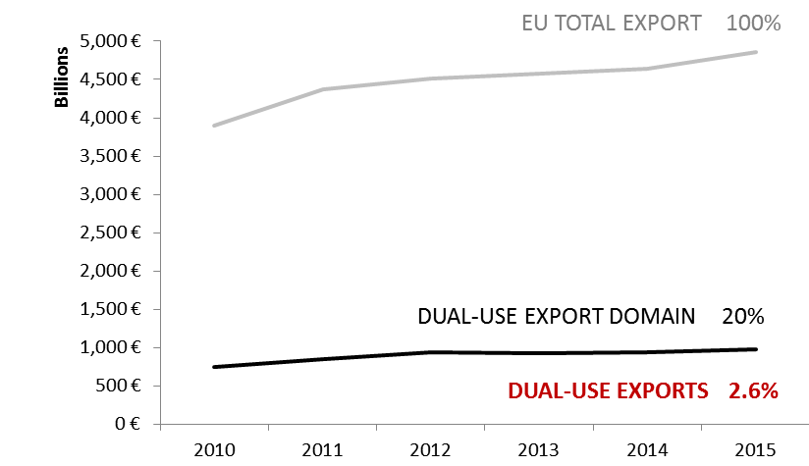

*Figure 2: Statistical estimates of dual-use intra and extra-EU exports.*

Statistical estimates also show the main dual-use export destinations and indicate that a large part of the these exports are directed towards 'EU001 countries' benefiting from union general export authorisations (EUGEAs). The destination countries reflect the EU export market structure in the relevant commodities as well as trade facilitation under EUGEAs (Figure 2, 3 and 4)[14].



*Figure 3: EU dual-use export extimates: top 25 export destination countries and their sub-regions in 2015.*



*Figure 4: EU dual-use export extimates: destination countries by world regions and sub-regions in 2015.*

**4.2. Applications, licences, denials**

The DUCG has collected and exchanged information and licensing data, in order to improve the understanding of export controls and their economic effect. Some data collected for the reporting period is reported below; it should be noted however that not all Member States collect all data. The information provided below thus represents approximate estimates of aggregate quantities and values within the limits of the data made available by Member States.



*Figure 5: Volume (number) of authorisations and denials in 2010-2015[15].*



*Figure 6: Value (mln EUR) of authorisations and denials in 2010-2015.*

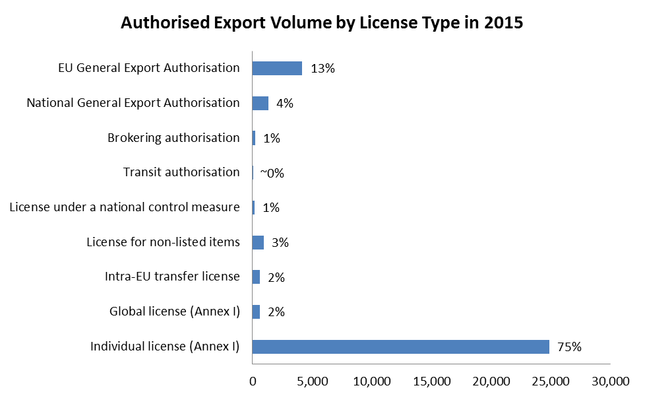

*Figure 7: Volume (number) of authorisations per category in 2015.*



*Figure 8: Value (mln EUR) of authorisations per type in 2015.*

The total value[16] of applications reached EUR 44 bn and controlled dual-use exports thus represented 2.5% of total extra-EU exports. Authorised dual-use trade amounted to EUR 33.7 bn, representing 1.9% of total extra-EU exports, with a majority of transactions authorised under individual licenses (approx. 25.000 single licenses issued in 2015) and global licenses (by their value). Only a small portion of exports were actually denied: approx. 640 denials were issued in 2015, representing about 4.5% of the value of controlled dual-use exports in that year, and 0.1% of total extra- EU exports.

1. Some MS competent authorities also publicly report on trade in dual-use items.
2. The Impact Assessment report is available at http://trade.ec.europa.eu/doclib/docs/2016/october/tradoc_155008.pdf
3. The RSB opinion is available at http://ec.europa.eu/smart-regulation/impact/iab/iab_en.htm.
4. The proposal for a regulation is available at <http://eur-lex.europa.eu/legal-content/EN/TXT/?qid=1476175365847&uri=CELEX:52016PC0616>
5. The report of the Forum is available at: http://trade.ec.europa.eu/doclib/docs/2016/december/tradoc_155125.pdf.
6. OJ L 307, 15.11.2016.
7. The Summary Note is available at: http://trade.ec.europa.eu/doclib/docs/2016/october/tradoc_155058.pdf.
8. OJ C304/03, 20.08.2016.
9. http://trade.ec.europa.eu/doclib/cfm/doclib_section.cfm?sec=192
10. http://trade.ec.europa.eu/doclib/docs/2016/december/tradoc_155193.pdf
11. http://trade.ec.europa.eu/doclib/docs/2016/october/tradoc_155058.pdf
12. http://trade.ec.europa.eu/doclib/docs/2016/february/tradoc_154240.pdf
13. The statistical methodology developed by the Commission's Joint Research Centre makes use of a correlation table, developed by DG TAXUD, between dual-use classification numbers and customs codes and of Eurostat’s COMEXT data, as well as of licensing data. The notion of *dual-use export domain* refers to a large mixed commodity area which includes dual-use items. Trade in dual-use items takes place *within* this commodity area, but is not identical to it, since by far, not all of the commodities within the *dual-use export domain* are really dual-use.
14. "Stores and provisions extra" are defined as delivery of ships' and aircraft's stores. ”Miscellaneous –countries not specified extra” includes countries and territories not specified within the framework of trade with third countries (i.e., these codes are usually used for goods delivered for offshore installations).
15. In Figure 6 and Figure 7, "Applications" data include all applications for licenses, including notifications under general authorisations, thus providing an indication of "controlled exports", i.e. the value of extra-EU exports subject to an authorisation process. In cases where no application data is available, the charts make use of authorisation data as estimate for application data. "Authorisations" data refers to dual-use exports authorised under individual and global licences. It should be noted that applications do not necessarily correspond to the sum of authorisations and denials, as a number of applications may be cancelled and some applications may not be finalised within the same year. "Denial" refers to the volume and value of denied exports.
16. This figure includes value for licence applications and notifications under General Export Authorisations.