

ê 1113/2015 Art. 1 and Annex (adapted)

ANNEX I

**List of authorities referred to in Articles *8* *20* and *11* *23* and address for notifications to the European Commission**

A. *Authorities of the Member States*

BELGIUM

Federale Overheidsdienst Economie, K.M.O., Middenstand en Energie

Algemene Directie Economische Analyses en Internationale Economie

Dienst Vergunningen

Vooruitgangstraat 50

B-1210 Brussel

BELGIË

Service public fédéral économie, PME, classes moyennes et énergie

Direction générale des Analyses économiques et de l'Economie internationale

Service licences

Rue du Progrès 50

B-1210 Bruxelles

BELGIQUE

Tel. +32 22776713, +32 22775459

Fax +32 22775063

E-mail: [frieda.coosemans@economie.fgov.be](mailto:frieda.coosemans@economie.fgov.be)

[johan.debontridder@economie.fgov.be](mailto:johan.debontridder@economie.fgov.be)

BULGARIA

Министерство на икономиката

ул. ‘Славянска’ № 8

1052 София/Sofia

БЪЛГАРИЯ/BULGARIA

Ministry of Economy

8, Slavyanska Str.

1052 Sofia

BULGARIA

Tel. +359 29407771

Fax +359 29880727

E-mail: [exportcontrol@mi.government.bg](mailto:exportcontrol@mi.government.bg)

CZECH REPUBLIC

Ministerstvo průmyslu a obchodu

Licenční správa

Na Františku 32

110 15 Praha 1

ČESKÁ REPUBLIKA

Tel. +420 224907638

Fax +420 224214558

E-mail: [dual@mpo.cz](mailto:dual@mpo.cz)

DENMARK

*Annex III, No 2 and 3*

Justitsministeriet

Slotsholmsgade 10

DK-1216 København K

DANMARK

Tel. +45 72268400

Fax +45 33933510

E-mail: [jm@jm.dk](mailto:jm@jm.dk)

*Annex II and Annex III, No 1 and 4*

Erhvervs- og Vækstministeriet

Erhvervsstyrelsen

Eksportkontrol

Langelinie Allé 17

DK-2100 København Ø

DANMARK

Tel. +45 35291000

Fax +45 35291001

E-mail: [eksportkontrol@erst.dk](mailto:eksportkontrol@erst.dk)

GERMANY

Bundesamt für Wirtschaft und Ausfuhrkontrolle (BAFA)

Frankfurter Straße 29—35

D-65760 Eschborn

DEUTSCHLAND

Tel. +49 6196 908 2217

Fax +49 6196 908 1800

E-mail: [ausfuhrkontrolle@bafa.bund.de](mailto:ausfuhrkontrolle@bafa.bund.de)

ESTONIA

Strateegilise kauba komisjon

Islandi väljak 1

15049 Tallinn

EESTI/ESTONIA

Tel. +372 6377192

Fax +372 6377199

E-mail: [stratkom@vm.ee](mailto:stratkom@vm.ee)

IRELAND

Licensing Unit

Department of Jobs, Enterprise and Innovation

23 Kildare Street

Dublin 2

ÉIRE

Tel. +353 16312121

Fax +353 16312562

E-mail: [exportcontrol@djei.ie](mailto:exportcontrol@djei.ie)

GREECE

Υπουργείο Ανάπτυξης, Ανταγωνιστικότητας, Υποδομών, Μεταφορών και Δικτύων

Γενική Διεύθυνση Διεθνούς Οικονομικής Πολιτικής

Διεύθυνση Καθεστώτων Εισαγωγών-Εξαγωγών, Εμπορικής Άμυνας

Ερμού και Κορνάρου 1,

GR-105 63 Αθήνα/Athens

ΕΛΛΑΔΑ/GREECE

Ministry of Development, Competitiveness, Infrastructure, Transport and Networks

General Directorate for International Economic Policy

Directorate of Import-Export Regimes, Trade Defence Instruments

Ermou and Kornarou 1,

GR-105 63 Athens

GREECE

Tel. +30 2103286021-22, +30 2103286051-47

Fax +30 2103286094

E-mail: [e3a@mnec.gr](mailto:e3a@mnec.gr), [e3c@mnec.gr](mailto:e3c@mnec.gr)

SPAIN

Subdirección General de Comercio Internacional de Material de Defensa y Doble Uso

Secretaría de Estado de Comercio

Ministerio de Economía y Competitividad

Paseo de la Castellana 162, planta 7

E-28046 Madrid

ESPAÑA

Tel.: +34 913492587

Fax: +34 913492470

E-mail: [sgdefensa.sscc@comercio.mineco.es](mailto:sgdefensa.sscc@comercio.mineco.es)

FRANCE

Ministère des finances et des comptes publics

Direction générale des douanes et droits indirects

Bureau E2

11 Rue des Deux Communes

F-93558 Montreuil Cedex

FRANCE

Tel.: +33 1 57 53 43 98

Fax: + 33 1 57 53 48 32

E-mail: [dg-e2@douane.finances.gouv.fr](mailto:dg-e2@douane.finances.gouv.fr)

CROATIA

Ministarstvo vanjskih i europskih poslova

Samostalni sektor za trgovinsku politiku i gospodarsku multilateralu

Trg Nikole Šubića Zrinskog 7-8

10 000 Zagreb

REPUBLIKA HRVATSKA

Tel. +385 1 6444 625 (626)

Fax + 385 1 6444 601

ITALY

Ministero dello Sviluppo Economico

Direzione Generale per la Politica Commerciale Internazionale

Divisione IV

Viale Boston, 25

00144 Roma

ITALIA

Tel. +39 0659932439

Fax +39 0659647506

E-mail: [polcom4@mise.gov.it](mailto:polcom4@mise.gov.it)

CYPRUS

Υπουργείο Εμπορίου, Βιομηχανίας και Τουρισμού

Υπηρεσία Εμπορίου

Μονάδα Έκδοσης Αδειών Εισαγωγών/Εξαγωγών

Ανδρέα Αραούζου 6

CY-1421 Λευκωσία

ΚΥΠΡΟΣ/CYPRUS

Ministry of Commerce, Industry and Tourism

Trade Service

Import/Export Licensing Unit

6 Andreas Araouzos Street

CY-1421 Nicosia

CYPRUS

Tel. +357 22867100, +357 22867197

Fax +357 22375443

E-mail: [pevgeniou@mcit.gov.cy](mailto:pevgeniou@mcit.gov.cy)

LATVIA

Ārlietu ministrija

K. Valdemāra iela 3

LV-1395 Rīga

LATVIJA

Tel. +371 67016426

Fax +371 67828121

E-mail: [mfa.cha@mfa.gov.lv](mailto:mfa.cha@mfa.gov.lv)

LITHUANIA

*Annex II and Annex III, Nos 1, 2*, *3* and 5*:*

Policijos departamento prie Vidaus reikalų ministerijos

Viešosios policijos valdybos Licencijavimo skyrius

Saltoniškių g. 19

LT-08105 Vilnius

LIETUVA/LITHUANIA

Tel.: +370 82719767

Fax: +370 52719976

E-mail: [leidimai.pd@policija.lt](mailto:leidimai.pd@policija.lt)

*Annex III, No 4*

Valstybinė vaistų kontrolės tarnyba prie Lietuvos Respublikos sveikatos apsaugos ministerijos

Žirmūnų g. 139 A,

LT-09120 Vilnius

LIETUVA/LITHUANIA

Tel.: +370 852639264

Fax: +370 852639265

E-mail: vvkt@vvkt.lt

LUXEMBOURG

Ministère de l'Economie

Office des Licences

19-21, boulevard Royal

L-2449 Luxembourg

BP 113/L-2011 Luxembourg

LUXEMBOURG

Tel.: +352 22 61 62

Fax: +352 46 61 38

E-mail: [office.licences@eco.etat.lu](mailto:office.licences@eco.etat.lu)

HUNGARY

Magyar Kereskedelmi Engedélyezési Hivatal

Németvölgyi út 37-39

H-1124 Budapest

MAGYARORSZÁG/HUNGARY

Tel. +36 14585599

Fax +36 14585885

E-mail: [armstrade@mkeh.gov.hu](mailto:armstrade@mkeh.gov.hu)

MALTA

Dipartiment tal-Kummerċ

Servizzi ta' Kummerċ

Lascaris

Valletta VLT2000

MALTA

Commerce Department

Trade Services

Lascaris

Valletta VLT2000

MALTA

Tel. +356 21242270

Fax +356 25690286

NETHERLANDS

Ministerie van Buitenlandse Zaken

Directoraat-Generaal Buitenlandse Economische Betrekkingen

Directie Internationale Marktordening en Handelspolitiek

Bezuidenhoutseweg 67

Postbus 20061

2500 EB Den Haag

NEDERLAND

Tel. +31 703485954, +31 703484652

AUSTRIA

Bundesministerium für Wissenschaft, Forschung und Wirtschaft

Abteilung ‘Außenwirtschaftskontrolle’ C2/9

Stubenring 1

A-1011 Wien

ÖSTERREICH

Tel. +43 1711008341

Fax +43 1711008366

E-mail: [post.c29@bmwfw.gv.at](mailto:post.c29@bmwfw.gv.at)

POLAND

Ministerstwo Gospodarki

Departament Handlu i Usług

Plac Trzech Krzyży 3/5

00-507 Warszawa

POLSKA/POLAND

Tel. +48 226935553

Fax +48 226934021

E-mail: [SekretariatDHU@mg.gov.pl](mailto:SekretariatDHU@mg.gov.pl)

PORTUGAL

Ministério das Finanças

AT- Autoridade Tributária e Aduaneira

Direcção de Serviços de Licenciamento

Rua da Alfândega, n. 5, r/c

P-1149-006 Lisboa

PORTUGAL

Tel. +351 218813843

Fax +351 218813986

E-mail: [dsl@at.gov.pt](mailto:dsl@at.gov.pt)

ROMANIA

Ministerul Economiei, Comerțului și Turismului

Departamentul pentru Comerț Exterior și Relații Internaționale

Direcția Politici Comerciale

Calea Victoriei nr. 152

București, sector 1

Cod poștal 010096

ROMÂNIA

Tel. +40 214010552, +40 214010504, +40 214010507

Fax +40 214010568, +40 213150454

E-mail: [adrian.berezintu@dce.gov.ro](mailto:adrian.berezintu@dce.gov.ro)

SLOVENIA

Ministrstvo za gospodarski razvoj in tehnologijo

Direktorat za turizem in internacionalizacijo

Kotnikova 5

1000 Ljubljana

REPUBLIKA SLOVENIJA

Tel. +386 14003521

Fax +386 14003611

SLOVAKIA

Ministerstvo hospodárstva Slovenskej republiky

Odbor výkonu obchodných opatrení

Mierová 19

827 15 Bratislava

SLOVENSKO

Tel. +421 248542163

Fax +421 243423915

E-mail: [lucia.filipkova@economy.gov.sk](mailto:lucia.filipkova@economy.gov.sk)

FINLAND

Sisäministeriö

Poliisiosasto

PL 26

FI-00023 Valtioneuvosto

FINLAND

Inrikesministeriet

Polisavdelningen

PB 26

FI-00023 Statsrådet

SUOMI/FINLAND

Tel. +358 295 480 171

Fax +358 9 160 44635

E-mail: [kirjaamo@intermin.fi](mailto:kirjaamo@intermin.fi)

SWEDEN

Kommerskollegium

PO Box 6803

SE-113 86 Stockholm

SVERIGE

Tel. +46 86904800

Fax +46 8306759

E-mail: [registrator@kommers.se](mailto:registrator@kommers.se)

UNITED KINGDOM

*Import of goods listed in Annex II:*

Department for Business, Innovation and Skills (BIS)

Import Licensing Branch (ILB)

E-mail: [enquiries.ilb@bis.gsi.gov.uk](mailto:enquiries.ilb@bis.gsi.gov.uk)

*Export of goods listed in Annexes II or III, and supply of technical assistance related to goods listed in Annex II as referred to in Articles 3(1) and (4)(1):*

Department for Business, Innovation and Skills (BIS)

Export Control Organisation

1 Victoria Street

London

SW1H 0ET

UNITED KINGDOM

Tel.: +44 2072154594

Fax: +44 2072152635

E-mail: [eco.help@bis.gsi.gov.uk](mailto:eco.help@bis.gsi.gov.uk)

B. *Address for notifications to the European Commission*

European Commission

Service for Foreign Policy Instruments

Office EEAS 027/30999

B-1049 Bruxelles/Brussel

BELGIUM

E-mail: [relex-sanctions@ec.europa.eu](mailto:relex-sanctions@ec.europa.eu)

_____________

ê 775/2014 Art. 1.1 and Annex I (adapted)

è1 2016/2134 Art. 1.22(a)

ANNEX II

**List of goods referred to in Articles 3 and 4**

***Introductory Note:***

The ‘CN codes’ in this Annex refer to codes specified in Part Two of Annex I to Council Regulation (EEC) No 2658/87 of 23 July 1987 on the tariff and statistical nomenclature and on the Common Customs Tariff[1].

Where ‘ex’ precedes the CN code, the goods covered by this Regulation (EC) No 1236/2005 constitute only a part of the scope of the CN code and are determined by both the description given in this Annex and the scope of the CN code.

***Notes:***

1. Items 1.3 and 1.4 in Section 1 concerning goods designed for the execution of human beings do not cover medical-technical goods.

2. The object of the controls contained in this Annex should not be defeated by the export of any non-controlled goods (including plant) containing one or more controlled components when the controlled component or components are the principal element of the goods and can feasibly be removed or used for other purposes.

***NB:***In judging whether the controlled component or components are to be considered the principal element, it is necessary to weigh the factors of quantity, value and technological know-how involved and other special circumstances which might establish the controlled component or components as the principal element of the goods being procured.

|  |  |
| --- | --- |
| CN code | Description |
|  | 1. *Goods designed for the execution of human beings, as follows:* |
| è1 ex44219097  ex82089000 ç | è1 1.1. Gallows, guillotines and blades for guillotines ç |
| ex85437090  ex94017900  ex94018000  ex94021000 | 1.2. Electric chairs for the purpose of execution of human beings |
| ex94060038  ex94060080 | 1.3. Airtight vaults, made of e.g. steel and glass, designed for the purpose of execution of human beings by the administration of a lethal gas or substance |
| ex84138100  ex90189050  ex90189060  ex90189084 | 1.4. Automatic drug injection systems designed for the purpose of execution of human beings by the administration of a lethal chemical substance |
|  | 2. *Goods which are not suitable for use by law enforcement authorities to restrain human beings, as follows:* |
| ex85437090 | 2.1. Electric shock devices which are intended to be worn on the body by a restrained individual, such as belts, sleeves and cuffs, designed for restraining human beings by the administration of electric shocks |
| ex73269098  ex76169990  ex83015000  ex39269097  ex42033000  ex42034000  ex42050090 | 2.2. Thumb-cuffs, finger-cuffs, thumbscrews and finger-screws  Note:  This item includes both serrated and non-serrated cuffs and screws |
| ex73269098  ex76169990  ex83015000  ex39269097  ex42033000  ex42034000  ex42050090  ex62171000  ex63079098 | 2.3. Bar fetters, weighted leg restraints and gang chains comprising bar fetters or weighted leg restraints  ***Notes:***  1. Bar fetters are shackles or ankle rings fitted with a locking mechanism, linked by a rigid bar which is typically made of metal  2. This item includes bar fetters and weighted leg restraints which are linked to ordinary handcuffs by means of a chain |
| ex73269098  ex76169990  ex83015000  ex39269097  ex42033000  ex42034000  ex42050090  ex62171000  ex63079098 | 2.4. Cuffs for restraining human beings, designed to be anchored to a wall, floor or ceiling |
| ex94016100  ex94016900  ex94017100  ex94017900  ex94018000  ex94021000 | 2.5. Restraint chairs: chairs fitted with shackles or other devices to restrain a human being  Note:  This item does not prohibit chairs only fitted with straps or belts |
| ex94029000  ex94032020  ex94032080  ex94035000  ex94037000  ex94038100  ex94038900 | 2.6. Shackle boards and shackle beds: boards and beds fitted with shackles or other devices to restrain a human being  Note:  This item does not prohibit boards and beds only fitted with straps or belts |
| ex94029000  ex94032020  ex94035000  ex94037000  ex94038100  ex94038900 | 2.7. Cage beds: beds comprising a cage (four sides and a ceiling) or similar structure enclosing a human being within the confines of the bed, the ceiling or one or more of the sides of which are fitted with metal or other bars, and which can only be opened from outside |
| ex94029000  ex94032020  ex94035000  ex94037000  ex94038100  ex94038900 | 2.8. Net beds: beds comprising a cage (four sides and a ceiling) or similar structure enclosing a human being within the confines of the bed, the ceiling or one or more sides of which are fitted with nets, and which can only be opened from outside |
|  | 3. *Portable devices which are not suitable for use by law* enforcement *authorities for the purpose of riot control or self-protection, as follows:* |
| ex93040000 | 3.1. Batons or truncheons made of metal or other material having a shaft with metal spikes |
| ex39269097  ex73269098 | 3.2. Shields with metal spikes |
|  | 4. *Whips as follows:* |
| ex66020000 | 4.1. Whips comprising multiple lashes or thongs, such as knouts or cats o'nine tails |
| ex66020000 | 4.2. Whips having one or more lashes or thongs fitted with barbs, hooks, spikes, metal wire or similar objects enhancing the impact of the lash or thong |

_____________

ê 775/2014 Art. 1.2 and Annex II (adapted)

ANNEX III

**List of goods referred to in Article 5 11**

***Introductory Note:***

The CN codes in this Annex refer to codes specified in Part Two of Annex I to Regulation (EEC) No 2658/87 on the tariff and statistical nomenclature and on the Common Customs Tariff.

Where ‘ex’ precedes the CN code, the goods covered by this Regulation (EC) No 1236/2005 constitute only a part of the scope of the CN code and are determined by both the description given in this Annex and the scope of the CN code.

***Notes:***

1. The object of the controls contained in this Annex should not be defeated by the export of any non-controlled goods (including plant) containing one or more controlled components when the controlled component or components are the principal element of the goods and can feasibly be removed or used for other purposes.

***NB:***In judging whether the controlled component or components are to be considered the principal element, it is necessary to weigh the factors of quantity, value and technological know-how involved and other special circumstances which might establish the controlled component or components as the principal element of the goods being procured.

2. In some instances chemicals are listed by name and CAS number. The list applies to chemicals of the same structural formula (including hydrates) regardless of name or CAS number. CAS numbers are shown to assist in identifying a particular chemical or mixture, irrespective of nomenclature. CAS numbers cannot be used as unique identifiers because some forms of the listed chemical have different CAS numbers, and mixtures containing a listed chemical may also have different CAS numbers.

|  |  |
| --- | --- |
| CN code | Description |
|  | 1. *Goods designed for restraining human beings, as follows:* |
| ex73269098  ex76169990  ex83015000  ex39269097  ex42033000  ex42034000  ex42050090  ex62171000  ex63079098 | 1.1. Shackles and gang chains  ***Notes:***  1. Shackles are restraints consisting of two cuffs or rings fitted with a locking mechanism, with a connecting chain or bar  2. This item does not control the leg restraints and gang chains prohibited by item 2.3 of Annex II  3. This item does not control ‘ordinary handcuffs’. Ordinary handcuffs are handcuffs which meet all the following conditions:   * their overall dimension including chain, measured from the outer edge of one cuff to the outer edge of the other cuff, is between 150 and 280 mm when both cuffs are locked; * the inside circumference of each cuff is a maximum of 165 mm when the ratchet is engaged at the last notch entering the locking mechanism; * the inside circumference of each cuff is a minimum of 200 mm when the ratchet is engaged at the first notch entering the locking mechanism; and * the cuffs have not been modified to cause physical pain or suffering. |
| ex73269098  ex76169990  ex83015000  ex39269097  ex42033000  ex42034000  ex42050090  ex62171000  ex63079098 | 1.2. Individual cuffs or rings fitted with a locking mechanism, having an inside circumference exceeding 165 mm when the ratchet is engaged at the last notch entering the locking mechanism  Note:  This item includes neck restraints and other individual cuffs or rings fitted with a locking mechanism, which are linked to ordinary handcuffs by means of a chain |
| ex65050010  ex65050090  ex65069100  ex65069910  ex65069990 | 1.3. Spit hoods: hoods, including hoods made of netting, comprising a cover of the mouth which prevents spitting  Note:  This item includes spit hoods which are linked to ordinary handcuffs by means of a chain |
|  | 2. *Weapons and devices designed for the purpose of riot control* or *self-protection, as follows:* |
| ex85437090  ex93040000 | 2.1. Portable electric discharge weapons that can target only one individual each time an electric shock is administered, including but not limited to electric shock batons, electric shock shields, stun guns and electric shock dart guns  ***Notes:***  1. This item does not control electric shock belts and other devices falling within item 2.1 of Annex II  2. This item does not control individual electronic shock devices when accompanying their user for the user's own personal protection |
| ex85439000  ex93059900 | 2.2. Kits containing all essential components for assembly of portable electric discharge weapons controlled by item 2.1  Note:  The following goods are considered to be essential components:   * the unit producing an electric shock, * the switch, whether or not on a remote control, and * the electrodes or, where applicable, the wires through which the electrical shock is to be administered |
| ex85437090  ex93040000 | 2.3. Fixed or mountable electric discharge weapons that cover a wide area and can target multiple individuals with electrical shocks |
|  | 3. *Weapons and equipment disseminating incapacitating or* irritating *chemical substances for the purpose of riot control or self-protection and certain related substances, as follows:* |
| ex84242000  ex84248900  ex93040000 | 3.1. Portable weapons and equipment which either administer a dose of an incapacitating or irritating chemical substance that targets one individual or disseminate a dose of such substance affecting a small area, e.g. in the form of a spray fog or cloud, when the chemical substance is administered or disseminated  ***Notes:***  1. This item does not control equipment controlled by item ML7(e) of the Common Military List of the European Union[2]  2. This item does not control individual portable equipment, even if containing a chemical substance, when accompanying their user for the user's own personal protection  3. In addition to relevant chemical substances, such as riot control agents or PAVA, the goods controlled by items 3.3 and 3.4 shall be deemed to be incapacitating or irritating chemical substances |
| ex29242998 | 3.2. Pelargonic acid vanillylamide (PAVA) (CAS RN 2444-46-4) |
| ex33019030 | 3.3. Oleoresin capsicum (OC) (CAS RN 8023-77-6) |
| ex29242998  ex29399900  ex33019030  ex33021090  ex33029010  ex33029090  ex38249097 | 3.4. Mixtures containing at least 0,3 % by weight of PAVA or OC and a solvent (such as ethanol, 1-propanol or hexane), which could be administered as such as incapacitating or irritating agents, in particular in aerosols and in liquid form, or used for manufacturing of incapacitating or irritating agents  ***Notes:***  1. This item does not control sauces and preparations therefor, soups or preparations therefor and mixed condiments or seasonings, provided that PAVA or OC is not the only constituent flavour in them  2. This item does not control medicinal products for which a marketing authorisation has been granted in accordance with Union law[3] |
| ex84242000  ex84248900 | 3.5. Fixed equipment for the dissemination of incapacitating or irritating chemical substances, which can be attached to a wall or to a ceiling inside a building, comprises a canister of irritating or incapacitating chemical agents and is activated using a remote control system  Note:  In addition to relevant chemical substances, such as riot control agents or PAVA, the goods controlled by items 3.3 and 3.4 shall be deemed to be incapacitating or irritating chemical substances |
| ex84242000  ex84248900  ex93040000 | 3.6. Fixed or mountable equipment for the dissemination of incapacitating or irritating chemical agents that covers a wide area and is not designed to be attached to a wall or to a ceiling inside a building  ***Notes:***  1. This item does not control equipment controlled by item ML7(e) of the Common Military List of the European Union  2. This item also controls water cannons  3. In addition to relevant chemical substances, such as riot control agents or PAVA, the goods controlled by items 3.3 and 3.4 shall be deemed to be incapacitating or irritating chemical substances |

_____________

ê 2016/2134 Art. 1.22(c) and Annex I

ANNEX IIIa IV

**Goods that could be used for the purpose of capital punishment referred to in Article *7b* *16***

|  |  |
| --- | --- |
| CN code | Description |
|  | 1. Products which could be used for the execution of human beings by means of lethal injection, as follows: |
|  | 1.1. Short and intermediate acting barbiturate anaesthetic agents including, but not limited to: |
| ex29335390 [(a) to (f)]  ex29335995 [(g) and (h)] | (a) amobarbital (CAS RN 57-43-2)  (b) amobarbital sodium salt (CAS RN 64-43-7)  (c) pentobarbital (CAS RN 76‑74‑4)  (d) pentobarbital sodium salt (CAS 57‑33-0)  (e) secobarbital (CAS RN 76-73-3)  (f) secobarbital sodium salt (CAS RN 309-43-3)  (g) thiopental (CAS RN 76-75-5)  (h) thiopental sodium salt (CAS RN 71‑73-8), also known as thiopentone sodium |
| ex30039000  ex30049000  ex38249096 | **Note:**  This item also controls products containing one of the anaesthetic agents listed under short or intermediate acting barbiturate anaesthetic agents. |

_____________

ê 2016/2134 Art. 1.22(d) and Annex II

ANNEX IIIb V

**Union general export authorisation EU GEA *1236/2005* *[…]***

Part 1 — Goods

This general export authorisation covers the goods listed in any entry in Annex IIIa IV to Council Regulation (EC) No 1236/2005 (EU) […] of the European Parliament and of the Council[4].

It also covers supplies of technical assistance to the end-user to the extent that such assistance is necessary for the installation, operation, maintenance or repair of those goods whose export is authorised, if such assistance is provided by the exporter.

Part 2 — Destinations

An export authorisation under Regulation (EC) No 1236/2005 (EU) […] is not required for supplies to a country or territory that is part of the customs territory of the Union, which for the purpose of this Regulation includes Ceuta, Helgoland and Melilla (Article 18 34(2)).

This general export authorisation is valid throughout the Union for exports to the following destinations:

Danish territories not included in the customs territory:

* Faroe Islands
* Greenland

French territories not included in the customs territory:

* French Polynesia,
* French Southern and Antarctic Territories,
* New Caledonia and Dependencies,
* Saint-Barthélemy,
* Saint Pierre and Miquelon,
* Wallis and Futuna Islands

Dutch territories not included in the customs territory:

* Aruba,
* Bonaire,
* Curaçao,
* Saba,
* Sint Eustatius,
* Sint Maarten

Relevant British territories not included in the customs territory:

* Anguilla,
* Bermuda,
* Falkland Islands,
* Gibraltar,
* Montserrat,
* Saint Helena and Dependencies,
* South Georgia and the South Sandwich Islands,
* Turks and Caicos Islands

Albania

Andorra

Argentina

Australia

Benin

Bolivia

Bosnia and Herzegovina

Canada

Cape Verde

Colombia

Costa Rica

Djibouti

ê 2018/181 Art. 1(1)

Dominican Republic

ê 2016/2134 Art. 1.22(d) and Annex II

Ecuador

Former Yugoslav Republic of Macedonia

Gabon

Georgia

Guinea-Bissau

Honduras

Iceland

Kyrgyzstan

Liberia

Liechtenstein

Mexico

Moldova

Mongolia

Montenegro

Mozambique

Namibia

Nepal

New Zealand

Nicaragua

Norway

Panama

Paraguay

Philippines

Rwanda

San Marino

ê 2018/181 Art. 1(2)

Sao Tome and Principe

ê 2016/2134 Art. 1.22(d) and Annex II

Serbia

Seychelles

South Africa

Switzerland (including Büsingen and Campione d'Italia)

Timor-Leste

ê 2018/181 Art. 1(3)

Togo

ê 2016/2134 Art. 1.22(d) and Annex II

Turkey

Turkmenistan

Ukraine

Uruguay

Uzbekistan

Venezuela

Part 3 — Conditions and requirements for using this general export authorisation

(1) This general export authorisation may not be used if:

(a) the exporter has been prohibited from using this general export authorisation in accordance with Article 8 20(1) of Regulation (EC) No 1236/2005 (EU) […];

(b) the competent authorities of the Member State in which the exporter is resident or established, have informed the exporter that the goods in question are or may be intended, in their entirety or in part, either for re-export to a third country or to be used for the purpose of capital punishment in a third country;

(c) the exporter knows or has reasonable grounds to believe that the goods in question are intended, in their entirety or in part, either for re-export to a third country or to be used for the purpose of capital punishment in a third country;

(d) the relevant goods are exported to a customs free zone or free warehouse which is located in a destination covered by this general export authorisation;

(e) the exporter is the manufacturer of the medicinal products in question and has not made a legally binding agreement with the distributor requiring the latter to make all supplies and transfers subject to the conclusion of a legally binding agreement requiring, preferably subject to a dissuasive contractual penalty, the customer

(i) not to use any of the goods received from the distributor for capital punishment;

(ii) not to supply or transfer any of these goods to a third party, if the customer knows or has reasonable grounds to believe that the goods are intended to be used for the purpose of capital punishment; and

(iii) to impose the same requirements on any third party to which the customer might supply or transfer any of these goods.

(f) the exporter is not the manufacturer of the medicinal products in question and has not obtained a signed end-user declaration from the end-user in the country of destination;

(g) the exporter of medicinal products has not concluded a legally binding agreement with the distributor or end-user requiring, preferably subject to a dissuasive contractual penalty, the distributor or, if the agreement was concluded by the end-user, the end-user to obtain prior authorisation from the exporter for

(i) any transfer or supply of any part of the shipment to a law enforcement authority in a country or territory that has not abolished capital punishment;

(ii) any transfer or supply of any part of the shipment to a natural or legal person, entity or body procuring relevant goods for or providing services involving use of such goods to such a law enforcement authority, and

(iii) any re-export or transfer of any part of the shipment to a country or territory that has not abolished capital punishment; or

(h) the exporter of goods other than medicinal products has not concluded a legally binding agreement referred to in point (g), with the end-user.

(2) Exporters that use this general export authorisation EU GEA 1236/2005 […] shall notify the competent authorities of the Member State where they are resident or established of their first use of this general export authorisation no later than 30 days after the date when the first export took place.

Exporters shall also report in the customs declaration the fact that they are using this general export authorisation EU GEA 1236/2005 […] by indicating in box 44 the relevant code found in the TARIC database.

(3) Reporting requirements attached to the use of this general export authorisation and any additional information that the Member State from which the export is made might require on items exported under this general export authorisation are defined by Member States.

A Member State may require exporters resident or established in that Member State to register prior to the first use of this general export authorisation. Without prejudice to Article 8 20(1) of Regulation (EC) No 1236/2005 (EU) […], registration shall be automatic and acknowledged by the competent authorities to the exporter without delay and in any case within ten working days of receipt.

_____________

ê 1236/2005 (adapted)

è1 Corrigendum, OJ L 79, 16.3.2006, p. 32

ANNEX IV VI

**List of territories of Member States referred to in Article 5 11(2)**

**DENMARK:**

* Greenland

**FRANCE:**

* New Caledonia and Dependencies,
* French Polynesia,
* French Southern and Antarctic Territories,
* Wallis and Futuna Islands,
* Mayotte,
* St Pierre and Miquelon.

**GERMANY:**

* Büsingen

_____________

ANNEX V VII

**Export or import authorisation form referred to in Article 9 21(1)**

***Technical specification:***

The following form shall measure 210 × 297 mm with a maximum tolerance of 5 mm less and 8 mm more. The boxes are based on a unit of measurement of one tenth of an inch horizontally and one sixth of an inch vertically. The subdivisions are based on a unit of measurement of one tenth of an inch horizontally.

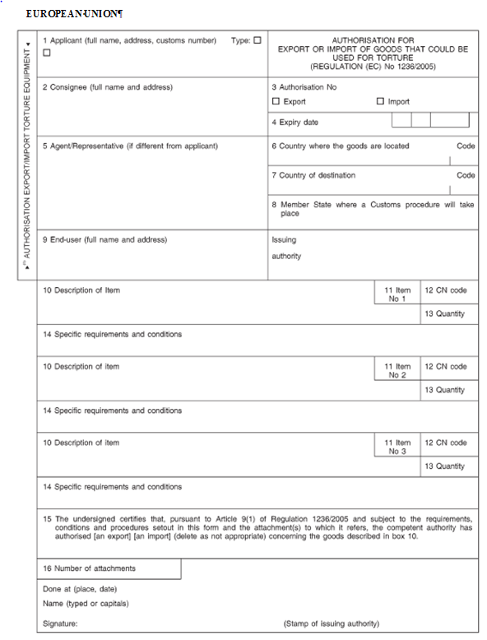

è1 ç

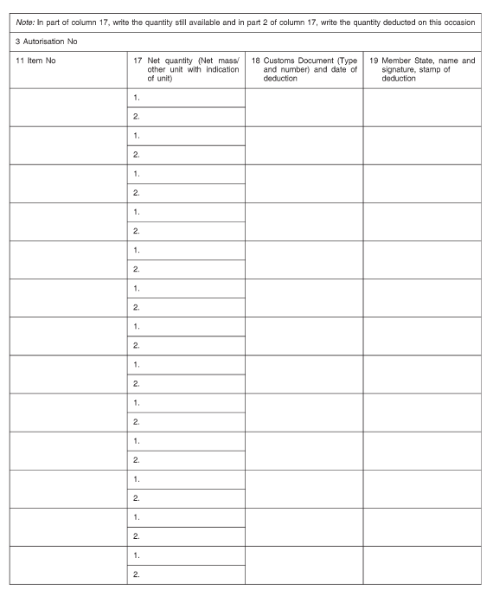

***Explanatory notes to the form***

‘Authorisation for export or import of goods that could be used for torture (Regulation (EC) No 1236/2005 (EU) […])’.

This authorisation form shall be used to issue an authorisation for an export or import of goods in accordance with Regulation (EC) No 1236/2005 (EU) […] of the European Parliament and of the Council concerning trade in certain goods which could be used for capital punishment, torture or other cruel, inhuman or degrading treatment or punishment[5]. It should not be used to authorise the supply of technical assistance.

Issuing authority is the authority defined in Article 2(h) of Council Regulation No 1236/2005 (EU) […] which is set out in Annex I to this Ö that Õ Regulation.

Authorisations shall be issued on this single page form, which should be printed on both sides. The competent customs office deducts the exported quantities from the total quantity available. It has to make sure that the different items subject to the authorisation are clearly separated for this purpose.

Where national procedures of the Member States require additional copies of the form (as for example for the application) this authorisation form may be included in a form set containing the necessary copies following the national rules applicable. In the box above box 3 of each specimen and in the margin on the left it should be clearly indicated for which purpose (e.g. application, copy for applicant) the relevant copies are intended. One specimen only shall be the authorisation form set out in Annex V VII to Regulation (EC) No 1236/2005 (EU) […].

|  |  |  |
| --- | --- | --- |
| Box 1: | *Applicant:* | Please indicate the applicant's name and the full address.  The applicant's customs number may also be indicated (optional in most cases).  The type of applicant should be indicated (optional) in the relevant box, using the numbers 1, 2 or 4 referring to the points set out in the definition in Article 2(i) of Regulation (EC) No 1236/2005 (EU) […]. |
| Box 3: | *Authorisation No:* | Please fill out the number and tick either the export or the import box. è1 See Article 2(d) and (e) and Article l8 34 of the Regulation Ö (EU) […] Õ ç for the definitions of the terms ‘export’ and ‘import’. |
| Box 4: | *Expiry date:* | Please state day (two digits), month (two digits) and year (four digits). |
| Box 5: | *Agent/representative:* | Please indicate the name of a duly authorised representative or (customs) agent acting on behalf of the applicant, if the application is not presented by the applicant. See also Article 5 18 of Council Regulation (EEC) No 2913/92 (EU) No 952/2013. |
| Box 6: | *Country where the goods are located:* | Please state both the name of the country concerned and the relevant country code taken from the codes established pursuant to Council Regulation (EC) No 471/2009 of the European Parliament and of the Council[6] 1172/95 (OJ L 118, 25.5.1995, p. 10). è1 See Commission Regulation (EU) No 1106/2012[7] (EC) No 1779/2002 (OJ L 269, 5.10.2002, p. 6). ç |
| Box 7: | *Country of destination:* | Please state both the name of the country concerned and the relevant country code taken from the codes established pursuant to Council Regulation (EC) No 471/2009 1172/95, (OJ L 118, 25.5.1995, p. 10). è1 See Commission Regulation (EU) No 1106/2012 (EC) No 1779/2002 (OJ L 269, 5.10.2002, p. 6). ç |
| Box 10: | *Description of item:* | Please consider including data on packaging of the goods concerned. Note that the value of the goods may also be indicated in box 10.  If there is not sufficient space in box 10, please continue on an attached blank sheet, mentioning the authorisation number. Please indicate the number of attachments in box 16.  This form is designed for use for up to three different types of goods (see Annexes II and III to the Regulation (EU) […]). If it is necessary to authorise the export or import of more than three types of goods, please grant two authorisations. |
| Box 11 | *Item No:* | This box needs to be completed on the back of the form only. Please ensure that the Item No corresponds to the printed item number in box 11 found next to the description of the relevant item on the view side. |
| Box 14: | *Specific requirements and conditions:* | If there is not sufficient space in box 14, please continue on an attached blank sheet, mentioning the authorisation number. Please indicate the number of attachments in box 16. |
| Box 16: | *Number of attachments:* | Please indicate the number of attachments, if any (see explanations to boxes 10 and 14). |

_____________

ê 2016/2134 Art. 1.22(e) and Annex III

ANNEX VI VIII

**Authorisation form for the supply of brokering services referred to in Article *9* *21*(1)**

***Technical specification:***

The following form shall measure 210 × 297 mm with a maximum tolerance of 5 mm less and 8 mm more. The boxes are based on a unit of measurement of one tenth of an inch horizontally and one sixth of an inch vertically. The subdivisions are based on a unit of measurement of one tenth of an inch horizontally.

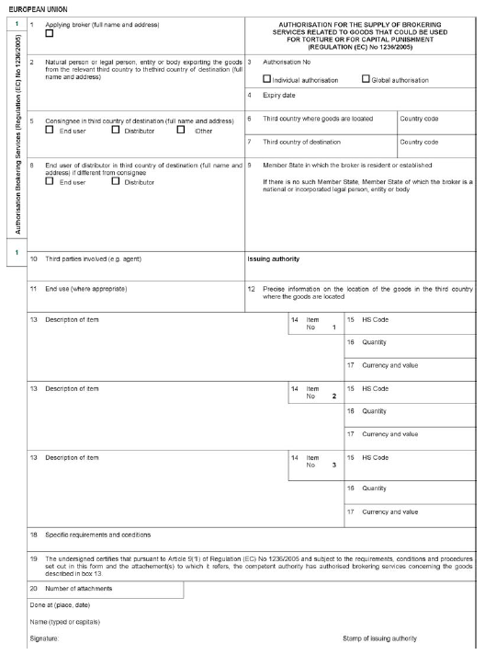

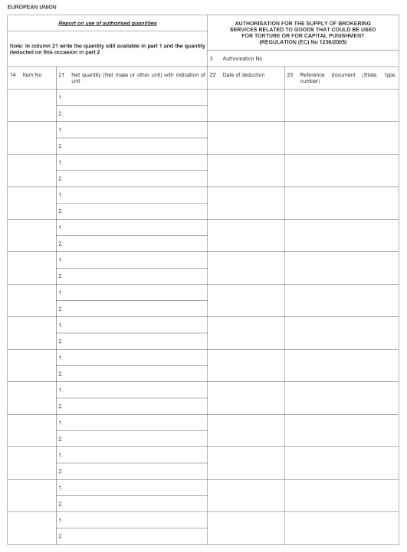

***Explanatory notes to the form***

‘Authorisation for the supply of brokering services related to goods that could be used for torture or for capital punishment (*Council* Regulation *(EC) No 1236/2005* (EU) […] of the European Parliament and of the Council[8])’.

This authorisation form shall be used to issue an authorisation for brokering services in accordance with Regulation (EC) No 1236/2005 (EU) […].

The issuing authority is the authority defined in point (h) of Article 2 of Regulation (EC) No 1236/2005 (EU) […]. It is an authority that is included in the list of competent authorities in Annex I to that Regulation.

|  |  |  |
| --- | --- | --- |
| Box 1 | *Applying broker* | Please indicate the name and full address of the applying broker. Broker is defined in point (l) of Article 2 of Regulation (EC) No 1236/2005 (EU) […]. |
| Box 3 | *Authorisation No* | Please fill out the number and tick the appropriate box indicating whether the authorisation is an individual or global one (see points (p) and (q) of Article 2 of Regulation (EC) No 1236/2005 (EU) […] for the definitions). |
| Box 4 | *Expiry date* | Please state day (two digits), month (two digits) and year (four digits). The period of validity of an individual authorisation is from three months to twelve months and that of a global authorisation from one year to three years. When the period of validity comes to an end an extension can be requested, if necessary. |
| Box 5 | *Consignee* | Please indicate, in addition to the name and address, whether the consignee in the third country of destination is an end-user, a distributor as referred to in point (r) of Article 2 of Regulation (EC) No 1236/2005 (EU) […] or a party having another role in the transaction.  If the consignee is a distributor but also uses part of the shipment for a specific end-use, please tick both ‘Distributor’ and ‘End-user’ and mention the end-use in box 11. |
| Box 6 | *Third country where the goods are located* | Please state both the name of the country concerned and the relevant country code taken from the codes established pursuant to Regulation (EC) No 471/2009 of the European Parliament and of the Council[9]. See Commission Regulation (EU) No 1106/2012[10]. |
| Box 7 | *Third country of destination* | Please state both the name of the country concerned and the relevant country code taken from the codes established pursuant to Regulation (EC) No 471/2009. See Regulation (EU) No 1106/2012. |
| Box 9 | *Issuing Member State* | Please state in the appropriate line both the name of the Member State concerned and the relevant country code taken from the codes established pursuant to Regulation (EC) No 471/2009. See Regulation (EU) No 1106/2012. |
| Box 11 | *End use* | Please give a precise description of the use that will be made of the goods and also indicate whether the end user is a law enforcement authority as defined in point (c) of Article 2 of Regulation (EC) No 1236/2005 (EU) […] or a supplier of training on the use of the brokered goods.  Leave blank if the brokering services are supplied to a distributor, unless the distributor itself uses part of the goods for a specific end-use. |
| Box 12 | *Precise location of the goods in the third country from which they will be exported* | Please describe the whereabouts of the goods in the third country from which they will be supplied to the person, entity or body mentioned in box 2. The location must be an address in the country mentioned in box 6 or similar information describing the whereabouts of the goods. Note that it is not allowed to put a post office box number or similar postal address. |
| Box 13 | *Description of item* | The description of the goods should include a reference to a specific item of Annex III or IIIa IV to Regulation (EC) No 1236/2005 (EU) […]. Please consider including data on packaging of the goods concerned.  If there is not sufficient space in box 13, please continue on an attached blank sheet, mentioning the authorisation number. Please indicate the number of attachments in box 20. |
| Box 14 | *Item No* | This box needs to be completed on the back of the form only. Please ensure that the Item No corresponds to the printed item number in box 14 found next to the description of the relevant item on the view side. |
| Box 15 | *HS code* | The HS code is a customs code assigned to the goods in the Harmonised System. Where the code from the EU Combined Nomenclature is known, that code may be used instead. See Commission Implementing Regulation (EU) 2015/1754 2016/1821[11] for the current version of the Combined Nomenclature. |
| Box 17 | *Currency and value* | Please indicate the value and currency using the price that is payable (without converting it). If that price is not known, the estimated value should be stated, preceded by the mention EV. The currency has to be indicated using the alphabetic code (ISO 4217:2015). |
| Box 18 | *Specific requirements and conditions* | Box 18 concerns the item 1, 2 or 3 (please specify where appropriate) described in the boxes 14 to 16 preceding it. If there is not sufficient space in box 18, please continue on an attached blank sheet, mentioning the authorisation number. Please indicate the number of attachments in box 20. |
| Box 20 | *Number of attachments* | Please indicate the number of attachments, if any (see explanations to boxes 13 and 18). |

_____________

ê 2016/2134 Art. 1.22(f) and Annex IV

ANNEX VII IX

**Authorisation form for the supply of technical assistance referred to in Article 9 21(1)**

***Technical specification:***

The following form shall measure 210 × 297 mm with a maximum tolerance of 5 mm less and 8 mm more. The boxes are based on a unit of measurement of one tenth of an inch horizontally and one sixth of an inch vertically. The subdivisions are based on a unit of measurement of one tenth of an inch horizontally.

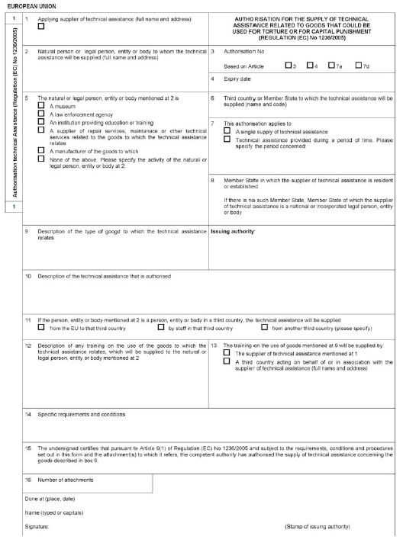

***Explanatory notes to the form***

‘Authorisation for the supply of technical assistance related to goods that could be used for torture or for capital punishment *Council* (Regulation *(EC) No 1236/2005* (EU) […] of the European Parliament and of the Council[12])’.

This authorisation form shall be used to authorise a supply of technical assistance in accordance with Regulation (EC) No 1236/2005 (EU) […]. If the technical assistance accompanies an export for which an authorisation is granted by or in accordance with Regulation (EC) No 1236/2005 (EU) […], this form should not be used, except in the following cases:

* the technical assistance relates to goods listed in Annex II to Regulation (EC) No 1236/2005 (EU) […] (see Article 3(2)); or
* the technical assistance relating to goods listed in Annex III or in Annex IIIa IV to Regulation (EC) No 1236/2005 (EU) […] goes beyond what is necessary for the installation, operation, maintenance or repair of the exported goods (see Article 9 21(2) and, as regards goods listed in Annex IIIa IV, Part 1 of the Union General Export Authorisation EU GEA 1236/2005 […] at Annex IIIb V to Regulation (EC) No 1236/2005 (EU) […]).

The issuing authority is the authority defined in point (h) of Article 2 of Regulation (EC) No 1236/2005 (EU) […]. It is an authority that is included in the list of competent authorities in Annex I to that Regulation.

Authorisations shall be issued on this single page form with attachments as necessary.

|  |  |  |
| --- | --- | --- |
| Box 1 | *Applying supplier of technical assistance* | Please indicate the applicant's name and full address. Supplier of technical assistance is defined in point (m) of Article 2 of Regulation (EC) No 1236/2005 (EU) […].  If the technical assistance accompanies an export for which an authorisation is granted, please also indicate the applicant's customs number, if possible, and indicate the number of the related export authorisation in box 14. |
| Box 3 | *Authorisation No* | Please fill out the number and tick the appropriate box indicating the Article of Regulation (EC) No 1236/2005 (EU) […] on which the authorisation is based. |
| Box 4 | *Expiry date* | Please state day (two digits), month (two digits) and year (four digits). The period of validity of an authorisation is from three months to twelve months. When the period of validity comes to an end an extension can be requested, if necessary. |
| Box 5 | *Activity of the natural or legal person, entity or body mentioned at 2* | Please indicate the main activity of the person, entity or body to which the technical assistance will be supplied. The term law enforcement authority is defined in point (c) of Article 2 of Regulation (EC) No 1236/2005 (EU) […].  If the main activity is not in the list, tick ‘None of the above’ and describe the main activity using generic words (e.g. wholesaler, retailer, hospital). |
| Box 6 | *Third country or Member State to which the technical assistance will be supplied* | Please state both the name of the country concerned and the relevant country code taken from the codes established pursuant to Regulation (EC) No 471/2009[13] of the European Parliament and of the Council. See Commission Regulation (EU) No 1106/2012[14].  Note that in box 6 a Member State should only be mentioned, if the authorisation is based on Article 4 of Regulation (EC) No 1236/2005 (EU) […]. |
| Box 7 | *Type of authorisation* | Please indicate whether the supply of technical assistance is provided during a particular period and, if so, state the period in days, weeks or months during which the supplier of technical assistance has to respond to requests for advice, support or training. A single supply of technical assistance concerns one specific request for advice or support or a specific training (even if it concerns a course given during several days). |
| Box 8 | *Issuing Member State* | Please state in the appropriate line both the name of the Member State concerned and the relevant country code taken from the codes established pursuant to Regulation (EC) No 471/2009. See Regulation (EU) No 1106/2012. |
| Box 9 | *Description of the type of goods to which the technical assistance relates* | Please describe the type of goods concerned by the technical assistance. The description should include a reference to a specific item of Annex II, III or IIIa IV to Regulation (EC) No 1236/2005 (EU) […]. |
| Box 10 | *Description of the technical assistance that is authorised* | Please describe the technical assistance in a clear and precise manner. Insert a reference to the date and number of an agreement concluded by the supplier of technical assistance or attach such an agreement, where appropriate. |
| Box 11 | *Mode of supply* | Box 11 should not be filled out if the authorisation is based on Article 4 of Regulation (EC) No 1236/2005 (EU) […].  If the technical assistance is supplied from a third country other than the third country where the recipient is resident or established, please state both the name of the country concerned and the relevant country code taken from the codes established pursuant to Regulation (EC) No 471/2009. See Regulation (EU) No 1106/2012. |
| Box 12 | *Description of training on the use of goods to which the technical assistance relates* | Please indicate whether the technical support or technical service covered by the definition of technical assistance in point (f) of Article 2 of Regulation (EC) No 1236/2005 (EU) […] is accompanied by training for users of the relevant goods. Please state which type of users will receive such training and specify the objectives and contents of the training programme. |
| Box 14 | *Specific requirements and conditions* | If there is not sufficient space in box 14, please continue on an attached blank sheet, mentioning the authorisation number. Please indicate the number of attachments in box 16. |
| Box 16 | *Number of attachments* | Please indicate the number of attachments, if any (see explanations to boxes 10 and 14). |

_____________

é

ANNEX X

**Repealed Regulation with list of its successive amendments**

|  |  |  |  |
| --- | --- | --- | --- |
| Council Regulation (EC) No 1236/2005 (OJ L 200, 30.7.2005, p. 1) | |  | |
| Commission Regulation (EC) No 1377/2006 (OJ L 255, 19.9.2006, p. 3) | |  | |
| Council Regulation (EC) No 1791/2006 (OJ L 363, 20.12.2006, p. 1) | | Only the thirteenth indent of Article 1(1) as regards Regulation (EC) No 1236/2005, and point 13(5) of the Annex | |
| Commission Regulation (EC) No 675/2008 (OJ L 189, 17.7.2008, p. 14) | |  | |
| Commission Regulation (EU) No 1226/2010 (OJ L 336, 21.12.2010, p. 13) | |  | |
| Commission Implementing Regulation (EU) No 1352/2011 (OJ L 338, 21.12.2011, p. 31) | |  | |
| Council Regulation (EU) No 517/2013 (OJ L 158, 10.6.2013, p. 1) | | Only Article 1(1)(n), fourth indent, and point 16(4) of the Annex | |
| Commission Regulation (EU) No 585/2013 (OJ L 169, 21.6.2013, p. 46) | |  | |
| Regulation (EU) No 37/2014 of the European Parliament and of the Council (OJ L 18, 21.1.2014, p. 1) | | Only point 12 of the Annex | |
| Commission Implementing Regulation (EU) No 775/2014 (OJ L 210, 17.7.2014, p. 1) | |  | |
| Commission Delegated Regulation (EU) 2015/1113 (OJ L 182, 10.7.2015, p. 10) | |  | |
| Regulation (EU) 2016/2134 of the European Parliament and of the Council (OJ L 338, 13.12.2016, p. 1) | |  | |

|  |  |
| --- | --- |
| Commission Delegated Regulation (EU) 2018/181 (OJ L 40, 13.2.2018, p. 1) |  |

_____________

ANNEX XI

**Correlation Table**

|  |  |
| --- | --- |
| Regulation (EC) No 1236/2005 | This Regulation |
| Article 1 | Article 1 |
| Article 2 | Article 2 |
| Article 3 | Article 3 |
| Article 4 | Article 4 |
| Article 4a | Article 5 |
| Article 4b | Article 6 |
| Article 4c | Article 7 |
| Article 4d | Article 8 |
| Article 4e | Article 9 |
| Article 4f | Article 10 |
| Article 5 | Article 11 |
| Article 6(1) | Article 12(1) |
| Article 6(2), first subparagraph | Article 12(2), first subparagraph |
| Article 6(2), second subparagraph, introductory wording | Article 12(2), second subparagraph, introductory wording |
| Article 6(2), second subparagraph, first indent | Article 12(2), second subparagraph, point (a) |
| Article 6(2), second subparagraph, second indent | Article 12(2), second subparagraph, point (b) |
| Article 6(2), third subparagraph | Article 12(2), third subparagraph |
| Article 6(3), introductory wording | Article 12(3), first subparagraph |
| Article 6(3), point 3.1 | Article 12(3), second subparagraph |
| Article 6(3), point 3.2 | Article 12(3), third subparagraph |
| Article 6a | Article 13 |
| Article 7 | Article 14 |
| Article 7a | Article 15 |
| Article 7b | Article 16 |
| Article 7c(1) | Article 17(1) |
| Article 7c(2) | Article 17(2) |
| Article 7c(3), introductory wording | Article 17(3), first subparagraph |
| Article 7c(3), point 3.1 | Article 17(3), second subparagraph |
| Article 7c(3), point 3.2 | Article 17(3), third subparagraph |
| Article 7c(3), point 3.3 | Article 17(3), fourth subparagraph |
| Article 7c(4) | Article 17(4) |
| Article 7d | Article 18 |
| Article 7e | Article 19 |
| Article 8 | Article 20 |
| Article 9 | Article 21 |
| Article 10 | Article 22 |
| Article 11 | Article 23 |
| Article 12 | Article 24 |
| Article 12a | Article 25 |
| Article 13(1), (2) and (3) | Article 26(1), (2) and (3) |
| Article 13(3a) | Article 26(4) |
| Article 13(4) | Article 26(5) |
| Article 13(5) | Article 26(6) |
| Article 13a | Article 27 |
| Article 14 | Article 28 |
| Article 15a | Article 29 |
| Article 15b | Article 30 |
| Article 15c | Article 31 |
| Article 15d | Article 32 |
| Article 17 | Article 33 |
| Article 18 | Article 34 |
| – | Article 35 |
| Article 19 | Article 36 |
| Annex I | Annex I |
| Annex II | Annex II |
| Annex III | Annex III |
| Annex IIIa | Annex IV |
| Annex IIIb | Annex V |
| Annex IV | Annex VI |
| Annex V | Annex VII |
| Annex VI | Annex VIII |
| Annex VII | Annex IX |
| – | Annex X |
| – | Annex XI |

_____________

1. Council Regulation (EEC) No 2658/87 of 23 July 1987 on the tariff and statistical nomenclature and on the Common Customs Tariff (OJ L 256, 7.9.1987, p. 1).
2. Latest version adopted by the Council on 17 March 2014 (OJ C 107, 9.4.2014, p. 1).
3. See in particular Regulation (EC) No 726/2004 of the European Parliament and of the Council of 31 March 2004 laying down Community procedures for the authorisation and supervision of medicinal products for human and veterinary use and establishing a European Medicines Agency (OJ L 136, 30.4.2004, p. 1) and Directive 2001/83/EC of the European Parliament and of the Council of 6 November 2001 on the Community code relating to medicinal products for human use (OJ L 311, 28.11.2001, p. 67).
4. Regulation (EU) […] of the European Parliament and of the Council of […] concerning trade in certain goods which could be used for capital punishment, torture or other cruel, inhuman or degrading treatment or punishment (OJ L […], […], p. […]).
5. Regulation (EU) […] of the European Parliament and of the Council of […] concerning trade in certain goods which could be used for capital punishment, torture or other cruel, inhuman or degrading treatment or punishment (OJ L […], […], p. […]).
6. Regulation (EC) No 471/2009 of the European Parliament and of the Council of 6 May 2009 on Community statistics relating to external trade with non-member countries and repealing Council Regulation (EC) No 1172/95 (OJ L 152, 16.6.2009, p. 23).
7. Commission Regulation (EU) No 1106/2012 of 27 November 2012 implementing Regulation (EC) No 471/2009 of the European Parliament on Community statistics relating to external trade with non-member countries, as regards the update of the nomenclature of countries of countries and territories (OJ L 328, 28.11.2012, p. 7).
8. Council Regulation (EC) No 1236/2005 (EU) […] of the European Parliament and of the Council of 27 June 2005 […] concerning trade in certain goods which could be used for capital punishment, torture or other cruel, inhuman or degrading treatment or punishment (OJ L 200, 30.7.2005, p. 1 […], [….], p. […]).
9. Regulation (EC) No 471/2009 of the European Parliament and of the Council of 6 May 2009 on Community statistics relating to external trade with non-member countries and repealing Council Regulation (EC) No 1172/95 (OJ L 152, 16.6.2009, p. 23).
10. Commission Regulation (EU) No 1106/2012 of 27 November 2012 implementing Regulation (EC) No 471/2009 of the European Parliament and of the Council on Community statistics relating to external trade with non-member countries, as regards the update of the nomenclature of countries of countries and territories (OJ L 328, 28.11.2012, p. 7).
11. Commission Implementing Regulation (EU) 2015/1754 2016/1821 of 6 October 2015 2016 amending Annex I to Council Regulation (EEC) No 2658/87 on the tariff and statistical nomenclature and on the Common Customs Tariff (OJ L 285, 30.10.2015, p. 1 OJ L 294, 28.10.2016, p. 1).
12. Council Regulation (EC) No 1236/2005 (EU) […] of the European Parliament and of the Council of 27 June 2005 […] concerning trade in certain goods which could be used for capital punishment, torture or other cruel, inhuman or degrading treatment or punishment (OJ L 200, 30.7.2005, p. 1 […], […], p. […]).
13. Regulation (EC) No 471/2009 of the European Parliament and of the Council of 6 May 2009 on Community statistics relating to external trade with non-member countries and repealing Council Regulation (EC) No 1172/95 (OJ L 152, 16.6.2009, p. 23).
14. Commission Regulation (EU) No 1106/2012 of 27 November 2012 implementing Regulation (EC) No 471/2009 of the European Parliament and of the Council on Community statistics relating to external trade with non-member countries, as regards the update of the nomenclature of countries of countries and territories (OJ L 328, 28.11.2012, p. 7).