Table of Content

1. Introduction 2
2. Background 2
3. The evaluation of EUROSUR 3
3.1. Scope of the evaluation 3
3.2. State of play of implementation of EUROSUR 4
3.3. Results of the evaluation 5
3.3.1. Relevance 5
3.3.2. Effectiveness 7
3.3.3. Efficiency 8
3.3.4. Coherence 9
3.3.5. EU added value 9
3.4. Compliance with and impact on fundamental rights 10
3.4.1. Third Countries and Non-Refoulement 10
3.4.2. Handling of personal data 10
3.4.3. Suggested improvements 10
4. Issues warranting further attention 11
4.1. Improving the functioning of EUROSUR 11
4.1.1. Reinforcing the competences of the National Coordination Centres 11
4.1.2. Improving the governance of EUROSUR 11
4.1.3. Reducing technical requirements 11
4.1.4. Capitalizing on the EUROSUR Fusion Services 12
4.2. Enlarging the scope of EUROSUR 12
4.2.1. Inclusion of border checks at border crossing points 12
4.2.2. Air border surveillance 12
4.2.3. Cooperation with neighbouring third countries 13
4.2.4. EUROSUR and Integrated Border Management 13
5. Conclusions and follow up 13

Introduction
An efficient management of the external borders of the Union is a top priority and a condition to properly implement and preserve the Schengen area of free travel, which is one of the major achievements of European integration.
Adopted in 2013, Regulation (EU) No 1052/2013 establishing the European Border Surveillance System (EUROSUR) provides a common framework for the exchange of information and for the cooperation between Member States’ border surveillance authorities and the European Border and Coast Guard Agency (Frontex), hereafter referred to as "the Agency". The EUROSUR framework is operational since 2 December 2013. The Regulation provides for an overall evaluation of EUROSUR by the Commission every four years accompanied, where necessary, by appropriate proposals to amend the Regulation.
The European Border and Coast Guard Regulation adopted on 14 September 2016 established the European Border and Coast Guard (EBCG) as a shared responsibility between the Agency and the Member States, expanded the mandate of the Agency and defined the components of the European Integrated Border Management. Given that the Agency has a significant role in the implementation of EUROSUR, the novelties introduced by the EBCG Regulation have a major impact on the daily implementation of EUROSUR and to be taken into account when further developing EUROSUR.
To take into account the full implementation of the EBCG Regulation and its impact on EUROSUR, the EUROSUR evaluation, which was initially foreseen for December 2016, was postponed to September 2018.

Background
EUROSUR establishes a mechanism for information exchange and cooperation, which enables the different national authorities carrying out border surveillance activities to exchange information and to cooperate at tactical, operational and strategic levels both within and between the Member States as well as with the Agency.
The purpose of EUROSUR is to detect, prevent and combat irregular immigration and cross-border crime and to contribute to the protection and saving the lives of migrants. EUROSUR aims to improve the situational awareness and to increase the reaction capability at the external borders of the Member States.
EUROSUR applies to the surveillance of the external land and sea borders. On a voluntary basis, it can be applied also to air border surveillance and to border checks at border crossing points. The surveillance activities of EUROSUR include the monitoring, detection, identification, tracking, prevention and interception of unauthorised border crossings.
EUROSUR does not apply to any legal or administrative measure taken once the responsible authorities of a Member State have intercepted cross-border criminal activities or unauthorised crossings by persons at the external borders and in particular, it does not cover the aspects related to prosecution.
The main components of EUROSUR are:
- National Coordination Centres, which serve in each Member State as hubs for interagency cooperation and information exchange in the area of border surveillance;
- A communication network, which supports the information exchange within EUROSUR, including also sensitive and EU classified information, and hosting a videoconferencing service operated by the Agency;
- The EUROSUR Fusion Services provided by the Agency, which supply the Member States and the Agency with surveillance services on the external borders and the pre-frontier area based on a combination of surveillance activities and information sources, such as satellite imagery, ship reporting services and weather and environmental services;
- Different situational pictures, which contain information on events and patrolling assets as well as analytical information. Each Member State manages its own National Situational Picture. The Agency manages the European Situational Picture, which is covering Member States’ territory as well as the Common Pre-frontier intelligence picture which is covering the area beyond the external borders.

The Regulation also provides for an enhanced reaction capability, in particular through the establishment of external border sections by the Member States. Based on a risk analysis and in agreement with the Member State concerned, the Agency attributes different impact levels (low, medium, high) to these border sections. The attributed impact levels trigger corresponding response measures by the Member States and the Agency.
The Regulation also frames the information exchange and cooperation with neighbouring third countries for the purpose of EUROSUR on issues such as the exchange of personal data, which is strictly limited by Regulation (EU) No 1052/2013.

The evaluation of EUROSUR

Scope of the evaluation
The evaluation covers the entire scope of Regulation (EU) No 1052/2013, focusing on its implementation by the Member States and by the Agency. In line with Article 22(2) of this Regulation and with the guidelines on better Regulation it includes an assessment of the:
- Relevance of EUROSUR and of the continuing validity of its underlying rationale;
- Effectiveness of EUROSUR through an assessment of the results achieved against the objectives set;
- Efficiency of EUROSUR including a cost benefit evaluation;
- Coherence of EUROSUR with other policies and legal acts and
- EU added value of the regulation through a subsidiarity check.
The evaluation also includes an independent assessment by the Fundamental Rights Agency of the compliance with and impact on fundamental rights.

State of play of implementation of EUROSUR
EUROSUR encompasses both a governance framework and an information exchange system. Generally, the implementation of the EUROSUR framework took place as provided for in the Regulation:
- All Member States have established their National Coordination Centre as a focal point for border surveillance at national level, usually operating on 24/7 basis. Depending on both the division of competencies and the geographical situation of the Member State, the National Coordination Centre is used either to command and control border guards or only as a "hub" for coordinating border surveillance activities. All National Coordination Centres cooperate and exchange information with the centres in other Member States and with the Agency and almost all of them with other national authorities belonging to the same Member State. However, several Member States still need to bring their centres fully into line with the requirements of Regulation (EU) No 1052/2013, as identified during the Schengen Evaluation Mechanism.
- All Member States have established a National Situational Picture of their border situation, sharing border incidents (events layer) and analytical reports (analysis layer). However, currently only half of the Member States share nationally the positions of their patrolling assets through the operational layer. Half of the Member States also share information from their National Situational Picture with neighbouring Member States.
- All Member States have defined their border sections to which the Agency has attributed and adapted impact levels in agreement with the Member States concerned. The Agency's support for border sections with a high impact level has been provided to all Member States concerned, such as Italy and Greece.
- All Member States have reported to the Commission on their cooperation with neighbouring third countries. Such cooperation usually takes place in the framework of regional cooperation networks or via bilateral agreements. As part of the evaluation, Member States shared the texts of selected bilateral agreements concluded with third countries with the Commission.
- The Agency is delivering currently thirteen EUROSUR Fusion Services. These services provide high added value information services to all National Coordination Centres via the EUROSUR communication network and directly to Joint Operations coordinated by the Agency. These services are used to support border operations, to detect and analyse cross border criminal activities, such as smuggling of migrants, arms, drugs, cigarettes and other contraband, and to detect migrants in distress. They are also used to support Member States’ patrolling activities.
The EUROSUR Fusion Services are the result of the daily cooperation of the Agency with the European Maritime Safety Agency (EMSA), the European Fisheries Control Agency (EFCA) and the EU Satellite Centre and they have been expanded with the financial support of the EU Space Programme COPERNICUS. A new service called Multipurpose Aerial Surveillance (M.A.S.) is currently being tested in the framework of the European Cooperation on Coast Guard Functions and of the tripartite working arrangement between EMSA, EFCA, and the Agency.
- The EUROSUR communication network is being deployed and operated by the Agency. Since December 2013, more than 184 000 border related events have been reported to and exchanged via the European Situation Picture. In January 2018, the Agency has officially finalised the security accreditation of this network, enabling it to exchange EU Restricted information with the National Coordination Centres.
With a view to making the information exchange more user-friendly, the availability of the network and its user interface still needs to be improved. This would allow Member States to make faster and better use of the available information. And while there is already a certain degree of heterogeneity in the information reported in EUROSUR, both on the type of incidents as well as on the time periods for reporting in the situational pictures, the use of the available information for analytical purposes could still be improved by allowing for more automated information management.
- The EUROSUR communication network between the National Coordination Centres and the Agency has been deployed along with another information system managed by the Agency, which is dedicated to the Agency’s Joint Operations Reporting Application (JORA) performing similar functions. This redundancy has been a source of confusion for the Member States and impacted negatively on the quality of reporting at the external borders. The situation is improving since the Agency is progressively merging JORA and the EUROSUR communication network, which should, in the mid-term, become one single tool.
- In 2015, the Commission adopted the EUROSUR Handbook containing technical and operational guidelines, recommendations and best practices, including on cooperation with third countries.

Results of the evaluation

Relevance
The migratory crisis, in particular along the Western Balkan Route in 2015/2016, and the terrorist attacks that took place in Europe are the two main crisis situations that the EU had to face since the adoption of EUROSUR. Both crisis situations clearly demonstrated the need to have a robust and comprehensive information exchange and cooperation framework for the European Border and Coast Guard in place. EUROSUR should be further developed in this regard.
EUROSUR is relevant to prevent irregular immigration and to fight cross border crime. Many examples were reported of cases where the information exchanged via EUROSUR with the Agency and between Member States prevented cases of smuggling of drugs, weapons, cigarettes and other illicit goods as well as of human beings and led to apprehending the smugglers who were then brought to court.

Examples of use of EUROSUR Fusion Services to fight cross border crime
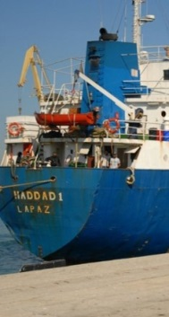
On 29 November 2014, Hellenic Coast Guard personnel, exploiting available intelligence, detected a car ferry sailing under Tanzanian flag, carrying 9 trucks. The vessel was extensively tracked through the EUROSUR Fusion Services for a long time period. Inside the trucks a notable quantity of tobacco was found, more than 60 million of cigarettes, without any legal possession documents. By that time, it was the second largest quantity that Hellenic Coast Guard ever seized, with a rough estimated value of 30 000 000 €.

For a few months the vessel ‘Haddad I’ (sailing under Bolivian flag) was identified as potentially suspicious, and tracked via the EUROSUR Fusion Services. In September 2015, following unusual behaviour at sea, the vessel was stopped and checked by Greek authorities. This operation resulted with the discovery on board the vessel of around 5,000 weapons and 500,000 bullets, together with smuggled cigarettes; the vessel was bound for Libya.
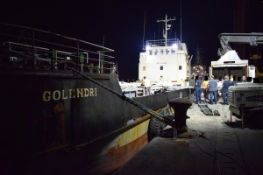
On 15 June 2017, the Hellenic Coast Guards (HCG) detained a cargo vessel (Golendri) with smuggled cigarettes and arrested 6 smugglers. The use of the EUROSUR Fusion Services based on a HCG request complemented the monitoring of the smuggling vessel from Montenegro to Crete.


In July 2017 the EUROSUR Fusion Services contributed to the interception of the cargo vessel ‘Falkvag’. The vessel was spotted by an aerial asset and its movements were monitored by the Agency. All information collected was delivered to the Spanish National Coordination Centre. Six containers of smuggled cigarettes were seized. As it was stated by Spanish media, “this was the biggest quantity seized in the history of Spanish customs”.

In several cases EUROSUR contributed directly to saving hundreds of migrant's lives by first detecting them at sea and triggering the Search and Rescue mechanisms. Indirectly EUROSUR saved many more lives by establishing and ensuring the cooperation and information exchange between the border and coast guards working in the National Coordination Centres and the Maritime Rescue Coordination Centres.

Examples of contributions of EUROSUR Fusion Services to saving g migrant lives

In October 2015, the Agency, using the EUROSUR Fusion Services, detected unidentified objects at sea in the area close to the Libyan coast. The information has been swiftly forwarded to Italian authorities, which notified the EUNAVFOR MED flagship present in the area leading to the rescue of migrants.

In September 2016 the EUROSUR Fusion Services, using state-of-the-art satellite radar technology, contributed to saving people in distress at sea north of Morocco. Spanish authorities were notified by Moroccan officials of a boat lost in the area, but without an indication of the exact location. A satellite scan of the area requested by the Agency as part of EUROSUR Fusion Services pointed to an object at sea. The information was swiftly forwarded to Spanish authorities who launched a search and rescue operation. A boat with 35 migrants, including women and children, was encountered in the indicated zone and the people were rescued by a French boat deployed in the Joint Operation Indalo.

On 24 June 2017 two small rubber boats with 73 people on board were detected by a Joint Operation Indalo 2017 asset performing a follow-up flight for vessel detection. The recently enhanced EUROSUR Fusion Services confirmed the boats’ position north of the North African coast, showing its capacity to detect even small objects (5 to 7m) on the sea. The people on the boats were rescued and brought to safety in the Spanish port of Motril.

In October 2017, the new EUROSUR Fusion Service for Multi-purpose Aerial Surveillance contributed to Search and Rescue Operations involving 19 different vessels in the Mediterranean Sea, which resulted in the rescue of approximately 716 migrants. In November 2017, a total of 8 vessels were detected in the Central Mediterranean resulting in the rescue of approximately 314 migrants.

Effectiveness
The EUROSUR framework is effective to promote information exchange and cooperation.
The creation of the National Coordination Centres has brought added value by improving the interagency cooperation and information exchange at national and regional levels, with neighbouring Member States and with the Agency. The role of the National Coordination Centres could be further reinforced by ensuring a better coordination with local and regional border management levels, and could cover other aspects of integrated border management such as the monitoring of secondary movements.

Examples of EUROSUR contributing to improving reaction capabilities in Member States
In Portugal EUROSUR lead to establishing direct communication lines between the National Command and Control Centre that operates the National Surveillance System (SIVICC), the Maritime Rescue Coordination Centre (Navy-Maritime Authority) and the Air Command (Air Force). This step increased the capability to react to crisis situations in a very significant way.

In Switzerland, International cargo trains crossing the country may have irregular migrants on-board. Information on these trains from neighbouring Member States’ National Coordination Centres helped saving migrants from hypothermia and serious injuries on these trains.
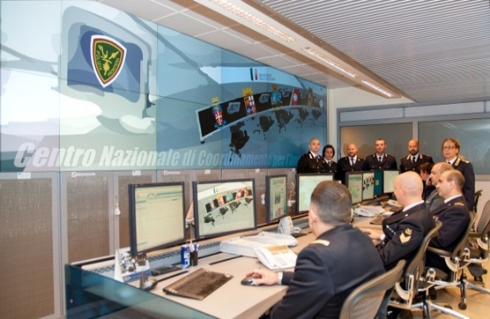
To the left: In the Italian National Coordination Centre State Police, Carabinieri, Coast Guard, Guardia di Finanza, the Navy and Customs work side-by-side.

Below: The Spanish National Coordination Centre reports in EUROSUR the interception of a speedboat smuggling drugs.

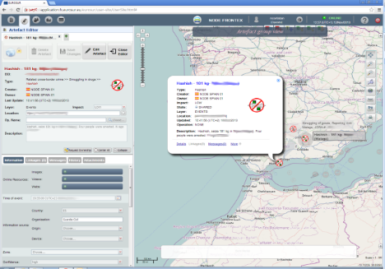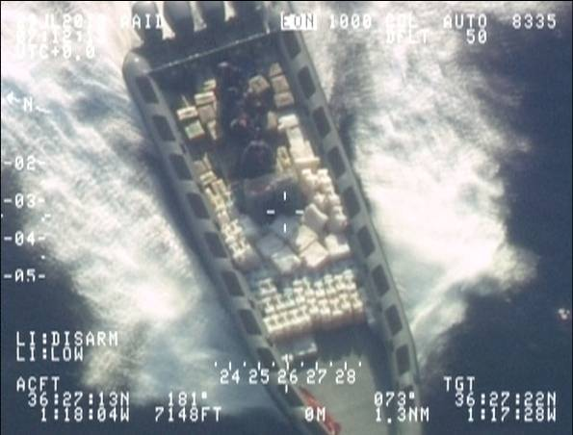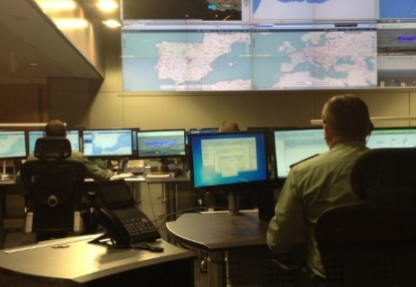
The quality of information shared between the Agency and Member States via the European Situational Picture could be improved. As already mentioned above, the different information systems used by the Agency, such as the Joint Operations Reporting Application (JORA) and the EUROSUR communication network should be merged. Automation and user uptake should be improved using state of the art technology. The Agency should monitor and, if need be, also enforce the quality of service and information shared in EUROSUR.
Overall, to be more effective, EUROSUR should evolve from a system to a more general governance framework for information exchange and cooperation.

Efficiency
The costs for implementing EUROSUR which are supported by national budgets, by EU funding instruments and by the Agency are estimated to amount to around M€130 ; they are well within the M€ 208 estimated in the impact assessment accompanying the EUROSUR legislative proposal in 2011.
The EU provides financial support to Member States for the implementation of EUROSUR via the External Borders Fund (EBF) covering the period 2007-2013 and the Internal Security Fund (ISF)/ Borders and Visa of the current Multiannual Financial Framework both under shared and direct management. These instruments undergo specific evaluations of their implementation.
EUROSUR created limited administrative burden. One source for the administrative burden pointed out by the stakeholders consulted is the manual intervention for the exchange of information.
According to the stakeholders the advantages of improving situational awareness and reaction capabilities brought by EUROSUR overweigh the costs linked to the EUROSUR implementation: EUROSUR contributed to enforcing synergies at European level, hence limiting costs at national level.

Coherence
EUROSUR fosters synergies and thus coherence with other policies: the National Coordination Centre is a focal point for operational cooperation with other policy actors in areas such as maritime affairs, security and customs control. It is also a good example for civil/military cooperation as several National Coordination Centres are hosting also military actors such as Navy officers.
At EU level the EUROSUR Fusion Services is a tool which can be used for other coast guard functions such as fisheries control. There are also mutual benefits for external security as for instance EUROSUR information products have been shared via the Agency with the CSDP operation EUNAVFOR Med Sophia.
The EUROSUR Fusion Services are also a tool to operationalise research projects and programs and are a concrete outcome of the EU Space Programme Copernicus.
EUROSUR should be amended to adapt to the novelties introduced by the EBCG Regulation and to reflect both the new mandate of the Agency and the implementation of the EU Integrated Border Management.

EU added value
The EU added value of EUROSUR is fully acknowledged by the EU border management community. Removing the EUROSUR framework is not conceivable since most Member States now depend on it for border surveillance.
The EUROSUR Fusion Services bring a real added value to the end users involved in border surveillance. No national border guard organisation alone could afford the space based surveillance services and other long range platforms offered by the EUROSUR Fusion Services.

Compliance with and impact on fundamental rights
The Fundamental Right Agency (FRA) evaluated EUROSUR. In its report, FRA concludes that EUROSUR is compliant both with fundamental rights and data protection principles while suggesting several possible improvements.

Third Countries and Non-Refoulement
FRA has paid particular attention at the issue of non-refoulement when cooperating with third countries on border management, and did not detect any non-compliance:
The majority of the 20 Member States, which concluded bilateral agreements with third countries in the area of border surveillance, use a general assessment of the fundamental rights’ situation in third countries while 11 Member States incorporated fundamental rights safeguard clauses in their agreements.
FRA has reviewed seven randomly selected bilateral agreements, none of which contained provisions contradicting the fundamental rights provisions enshrined in the EU Charter and in Recital (15) and Article 2 (4) of Regulation (EU) No 1052/2013. In particular, according to FRA's evaluation most agreement include a general reference stating that the agreement must be implemented in accordance with the Parties' international obligations and could be clarified with an express safeguards to promote a fundamental rights compatible implementation.

Handling of personal data
Overall, personal data are properly handled within EUROSUR through proper training and guidance in the EUROSUR Handbook.
Except for ship identification numbers, no personal data is exchanged between the Agency and the Member States in the context of EUROSUR. Only 6 Member States are processing personal data in the context of their national implementation of EUROSUR.

Suggested improvements
In its report, FRA suggested several possible evolutions of EUROSUR such as the inclusion of specific clauses according to which the agreement must be applied in accordance with fundamental rights, in full respect of the principle of non-refoulement and reflecting the core data protection safeguards in future agreements with third countries. As a possible alternative it suggested the development of technical and procedural solutions to better document events linked to Search and Rescue, and events involving vulnerable groups of persons such as children. FRA considers that this may mitigate the risk of human rights violations.

Issues warranting further attention
The following improvements may be achieved by the planned amendment to the EUROSUR Regulation.

Improving the functioning of EUROSUR
From a system, EUROSUR should evolve into a governance framework fostering information exchange and cooperation at national, regional and EU level and with third parties.

Reinforcing the competences of the National Coordination Centres
The establishment of the National Coordination Centres (NCC) in the Member States is one of the biggest achievements of the EUROSUR Regulation. When several national authorities are involved in border control, the National Coordination Centre is often used as a "platform" to foster interagency cooperation among several organizations belonging to different ministries.
The National Coordination Centre has also helped structuring interagency cooperation beyond and above the national level, and fostering bi- and multilateral cooperation in the area of border surveillance. The National Coordination Centre model is now being exported to third countries enabling the development of regional cooperation networks.
Any further development of EUROSUR with a view to promote Integrated European Border Management should take into account the variety of administrative structures and cultures in the Member States. Reinforcing and clarifying the role and the competences of the National Coordination Centre would allow to maintain a necessary degree of flexibility in the implementation while increasing information exchange and cooperation.

Improving the governance of EUROSUR
The EUROSUR Regulation should better define the roles and responsibilities of the various actors so as to improve information exchange and build trust among the stakeholders.
For instance, the reporting of events and the delivery of information services in EUROSUR should be clarified more in detail, in particular in defining which are the responsible entities as well as who has the ownership of information and what is the time-frame to report incidents.
Standards should be established to converge the reporting procedures, the type of events reported and the technical interfaces to foster machine to machine connection. An automated mechanism should be set up to control and enforce the quality of the information exchanged within EUROSUR.

Reducing technical requirements
The rapid development of technology is an enabler which also allows for new and more efficient implementation of information exchange solutions.
While it was crucial to provide strict technical requirements, for instance on the structure of the situational pictures, to set up EUROSUR within a very short time, these requirements can quickly turn into an obstacle for fast and efficient information exchange and thereby hinder further improvements.
For example, in addition to the exchange of information between the national and EU level described in the EUROSUR Regulation, tactical and operational information could be exchanged faster at local level between Member States on a bi- or multilateral basis in the "global" framework of EUROSUR.
The same also applies to the information exchange within Joint Operations through the Agency's JORA system, which is also a primary source to feed information to EUROSUR.

Capitalizing on the EUROSUR Fusion Services
The EUROSUR Fusion Services are a toolbox of information services generated via a strong interagency cooperation at EU level. There is a general agreement that this mechanism brings a real EU added value to border management operations.
With the evolution of border surveillance, new tools are being developed such as the Multipurpose Aerial Surveillance. EUROSUR should allow a rapid deployment of such new Services while ensuring that Fundamental Rights and data protection requirements are met.

Enlarging the scope of EUROSUR
Based upon the lessons learned and the success of EUROSUR as a legal framework for information exchange and cooperation between the Member States and the Agency, the scope of the Regulation could be progressively enlarged to address several aspects of border management.

Inclusion of border checks at border crossing points
As foreseen in Article 2.2 of Regulation (EU) No 1052/2013, information related to the checks at border crossing points and to the surveillance of air borders is provided by a considerable number of Member States on a voluntary basis. In the current situation many incidents happening at those borders may "escape" the European situational picture as they are not reported by all Member States.
It is therefore necessary to include incidents at border crossing points on a systematic basis.

Air border surveillance
Besides the issues of the airports, which are addressed above, the question of the surveillance of air borders deserves specific attention. New criminal activities are being reported using small aircraft, including Remotely Piloted Aircraft Systems for smuggling of drugs and cigarettes. Both technical and organisational solutions could be addressed in a further development of the EUROSUR Framework.

Cooperation with neighbouring third countries
Exchanging information and closer cooperation with neighbouring third countries is essential for managing migration flows and preventing crime at the external borders.
Articles 54 and 55 of the EBCG Regulation offer new and further reaching possibilities to the Agency in this regard than Article 20 of the EUROSUR Regulation.
There is a need to improve the coherence of the framework for information exchange and cooperation with third countries in the two regulations so as to avoid overlaps and to ensure complementarity with other legislative acts such as the ILO Regulation.

EUROSUR and Integrated Border Management
The EBCG Regulation defines the European Integrated Border Management (IBM) as a shared responsibility between the Member States and the EBCG Agency. To this end, there is no general common framework for IBM for the exchange of information and cooperation.
EUROSUR has successfully implemented such a framework in the area of border surveillance. The opportunity to expand the concept of a common framework of Integrated Border Management should be considered including the monitoring of secondary movements.

Conclusions and follow up
In the light of the findings of the evaluation SWD(2018) 410 and of the discussions with Member States’ and the Agency’s experts, the Commission draws the following conclusions:
While the EUROSUR Framework has registered progress towards meeting its objectives, its functioning could be improved by evolving from a technical information system into a governance framework for information exchange and cooperation, covering border control and possibly also other selected components of European Integrated Border Management.
Follow up:
In line with Article 22(3) of the EUROSUR Regulation, the Commission is therefore accompanying this report on the evaluation of EUROSUR with a proposal to amend the EUROSUR Regulation and to encompass EUROSUR in the proposal amending the European Border and Coast Guard Regulation.

Regulation (EU) No 1052/2013.
Regulation (EU) No 2016/1624.
30 Member States are applying the EUROSUR Regulation, i.e. 26 EU Member States (without UK and Ireland) and the four Schengen associated Countries (Iceland, Norway, Liechtenstein, and Switzerland).
In EUROSUR information is exchanged and distributed in a de-centralised manner by each Member State and the Agency. No personal data is exchanged via the EUROSUR communication network and only few Member States exchange personal data through their National Coordination Centres.
Commission Recommendation of 15.12.2015 adopting the Practical handbook for implementing and managing the European Border Surveillance System (EUROSUR Handbook)
COM(2011) 873 final.
Fundamental Rights Agency: How the Eurosur Regulation affects fundamental rights, http://fra.europa.eu/en/publication/2018/evaluation-impact-eurosur-fundamental-rights
Council Regulation (EC) No 377/2004 of 19 February 2004 on the creation of an immigration liaison officers network

