

Table of Contents

List of acronyms and abbreviations 3

SUMMARY…………………………………………………….............................................................5

1. INTRODUCTION 6

2. THE EU ETS FRAMEWORK IN PHASE 4 (2021-2030) 8

2.1. A strengthened EU ETS 8

2.2. Better targeted carbon leakage rules 9

2.3 Funding low-carbon innovation and energy sector modernisation 10

3.1 Coverage of activities, installations and aircraft operators 12

3.2 Union Registry and the European Union Transaction Log (EUTL) 14

4. FUNCTIONING OF THE CARBON MARKET IN 2017 15

4.1. Supply: allowances put in circulation 16

4.1.1. Cap 16

4.1.2. Issued allowances 18

4.1.3. International credits 28

4.2. Demand: allowances taken out of circulation 29

4.3. Balancing supply and demand 29

5. AVIATION 33

6. MARKET OVERSIGHT 35

6.1. The legal nature and fiscal treatment of emission allowances 36

7. MONITORING, REPORTING AND VERIFICATION OF EMISSIONS 37

8. OVERVIEW OF ADMINISTRATIVE ARRANGEMENTS 39

9. COMPLIANCE AND ENFORCEMENT 40

10. CONCLUSIONS AND OUTLOOK 43

ANNEX 45

# List of acronyms and abbreviations

AVR Accreditation and Verification Regulation

CA Competent Authority

CCS Carbon Capture and Storage

CCU Carbon Capture and Utilisation

CDM Clean Development Mechanism

CERs Certified Emission Reductions

CSCF Cross-Sectional Correction Factor

EA European Cooperation for Accreditation

EEA European Economic Area

EEX European Energy Exchange

EIB European Investment Bank

ERUs Emission Reduction Units

EU ETS European Union Emissions Trading System

EUTL European Union Transaction Log

GHG Greenhouse Gas

ICAO International Civil Aviation Organization

ICE ICE Future Europe

JI Joint Implementation

MAR Market Abuse Regulation

MiFID2 Directive on Markets in Financial Instruments

MRR Monitoring and Reporting Regulation

MRVA Monitoring, Reporting, Verification and Accreditation

MSR Market Stability Reserve

NAB National Accreditation Body

NER New Entrants Reserve

PFCs Perfluorocarbons

RES Renewable Energy Sources

TNAC Total Number of Allowances in Circulation

**SUMMARY**

In 2017, emissions from installations covered by the European Emissions Trading System (EU ETS) increased slightly by 0.18% compared to 2016. While this breaks the decreasing emissions trend since the start of the system’s third trading period (2013-2020), it can be explained by growth in real GDP of 2.4%, which is higher than in any year since the beginning of the period. The increase was mainly driven by industry, while emissions from the power sector decreased slightly for the fourth consecutive year (see Table 7 in section 4.2). Verified emissions from aviation continued to grow, marking an increase of 4.5% compared to 2016 (see Table 8 in section 5).

The revised EU ETS Directive, reforming the system for the next decade, was published on 14 March 2018. The reform aims to facilitate a 43% GHG emissions reduction from EU ETS sectors by 2030 (in line with the EU's 2030 climate objectives and its commitments under the Paris Agreement), safeguard industrial competitiveness, and foster low-carbon modernisation and innovation.

Over the last three years, the surplus of allowances in the European carbon market has been steadily declining, by an overall amount of almost half a billion allowances, mainly due to the so-called backloading, i.e. postponed auctioning of allowances (see Figure 3 in section 4.3). The reformed ETS will further address the surplus by reinforcing the Market Stability Reserve - the EU's mechanism established in 2015 to reduce the oversupply of allowances and to improve the EU ETS's resilience to future shocks. From 2019 (when the reserve will start operating) to 2023, the percentage of the surplus to be placed in the Market Stability Reserve will be doubled from the initially agreed 12%, to 24%. Moreover, as of 2023, reserve holdings exceeding the previous year's auction volume will no longer be valid. Together with the second publication of the Market Stability Reserve surplus indicator in May 2018, these reforms will lead to placing almost 265 million allowances (16% of the surplus) into the Market Stability Reserve from January to August 2019 instead of auctioning them. This will reduce the auction volume over the first 8 months of 2019 by some 40% compared to the corresponding volume in 2018.

To provide continued momentum to the international process of establishing a global scheme to curb aviation emissions, and to facilitate its future implementation in the EU, the limited scope for aviation to only flights within the European Economic Area has been extended until 2023. As from 2021, a linear reduction factor will for the first time apply to the aviation sector, reducing the cap on aviation emissions by 2.2% annually.

**1. INTRODUCTION**

The EU Emissions Trading System (EU ETS) has been the cornerstone of the EU's strategy for reducing greenhouse gas (GHG) emissions from industry and the power sector since 2005. It contributes significantly to the achievement of the EU's target of cutting GHG emissions by 20% from 1990 levels by 2020. While the EU is on track to surpass this target[1], cutting GHG emissions by at least 40% by 2030 – as part of the EU's 2030 climate and energy policy framework – requires continued progress[2]. A well-functioning EU ETS constitutes the main mechanism to achieve the EU's 2030 target, by facilitating a decrease of 43% of GHG emissions compared to 2005 levels in the sectors covered by the system.

To enable the EU ETS to accomplish this goal, in 2015 the Commission adopted a proposal[3] to revise the EU ETS for its fourth trading period (2021- 2030). After extensive negotiations, the European Parliament and the Council formally supported the revision in February 2018, and the revised EU ETS Directive[4] entered into force on 8 April 2018.

In 2017, the EU ETS Directive was further revised[5] to accommodate the development of a global measure for reducing aviation emissions by the International Civil Aviation Organisation (ICAO), by continuing to keep the systems' coverage confined to flights within the European Economic Area (EEA). 2017 also marked the signature of an agreement[6] between the EU and Switzerland on linking the Swiss greenhouse gas emissions trading system to the EU ETS - the first such agreement for the EU.

This Report on the functioning of the European carbon market is presented in accordance with the requirements of Articles 10(5) and 21(2) of Directive 2003/87/EC[7] (EU ETS Directive). As stipulated by the Directive, the objective of the report is to provide a regular snapshot of developments in the European carbon market on an annual basis.

The report covers the year 2017, but also presents initiatives proposed or agreed in the first half of 2018. Compared to last year's report[8], it contains a new chapter on the EU ETS framework in phase 4 and a new appendix on implementation progress, as well as information on the 2018 Market Stability Reserve (MSR) surplus indicator and the Member States' contributions to the MSR in 2019. Following the enhanced transparency and reporting requirements of the revised EU ETS Directive, this year's report provides for the first time an overview of the actual amounts of state aid spent by Member States on indirect carbon cost compensation in 2017.

Unless otherwise indicated, data used for this report were the ones publicly available and at the disposal of the Commission by end June 2018[9]. General and descriptive information on the EU ETS is included in boxes throughout the report.

# THE EU ETS FRAMEWORK IN PHASE 4 (2021-2030)

The revised EU ETS Directive for phase 4 aims to facilitate the achievement of the threefold objective of a 43% GHG emissions reduction for EU ETS sectors by 2030, safeguarding industrial competitiveness, and fostering low-carbon modernisation and innovation by a series of interlinked measures.

**Figure 1: Breakdown of phase 4 cap**

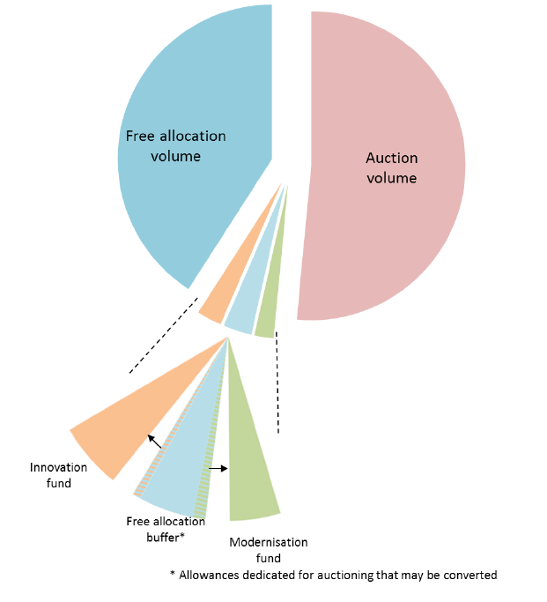

**2.1. A strengthened EU ETS**

To increase the pace of emissions cuts, the overall number of emission allowances will decline at an annual rate of 2.2% from 2021 onwards, compared to 1.74% currently. This increase implies a steady reduction of some 48 million allowances annually, compared to 38 million currently, and is consistent with a 43% reduction in GHG emissions from ETS covered sectors by 2030, compared to 2005 levels.

Moreover, the Market Stability Reserve (MSR), as a mechanism set in place for reducing the imbalance on the carbon market, will be substantially reinforced. Between 2019 and 2023, the rate at which allowances will be placed in the MSR will be doubled to 24% in order to restore the balance of emission allowances in the carbon market more swiftly.

To further improve the functioning of the EU ETS from 2023 onwards the number of emission allowances held in the MSR will be limited to the auction volume of the previous year. Holdings above that amount will lose their validity, unless otherwise decided in the first MSR review in 2021.

Member States may voluntarily cancel allowances from the total auction volume available to them in case of closure of electricity generation capacity resulting from additional national measures. If power plants are closed without the Member State concerned opting to cancel allowances, the MSR rules will capture the effect, by increasing the reserve feeds or by later releases of allowances from the reserve.

More information on the implementation of the revised MSR provisions is available in chapter 4.3 (Balancing supply and demand).

**2.2. Better targeted carbon leakage rules**

The existing free allocation framework will be broadly maintained in phase 4 to ensure predictability and transparency for European industry, addressing the competitiveness concerns of industry in a globalised world. Free allocation will continue to be predictable and transparent, based on benchmark values derived with reference to the performance of the 10% most efficient installations in the EU. However, a number of practical improvements have been introduced based upon implementation experience from the current trading period.

In phase 4, free allocation will be focused on sectorsat the highest risk of relocating their production outside of the EU. The level of carbon leakage exposure of sectors will be assessed on the basis of an indicator reflecting trade and emissions intensity. Highly exposed sectors will be placed on a carbon leakage list and will receive allowances equivalent to 100% of the relevant benchmark for free. For less exposed sectors, free allocation will amount to 30% up to 2026 and will be phased out thereafter by 2030. The Commission is currently in the process of establishing the carbon leakage list for the next trading period (see Appendix 6 to the Annex) which will be valid for the entirety of phase 4.

To avoid windfall profits and reflect the progress of technology and innovation since 2008, the 54 benchmark values determining the level of free allocation to each installation will be updated twice in phase 4, on the basis of real data. An annual reduction rate will be determined for each benchmark. It will vary between a minimum annual rate of 0,2% for the sectors with lower innovation uptake and a maximum annual rate of 1,6% for the sectors with higher innovation uptake. While the minimum rate will ensure contribution from sectors having slower emission reduction paths, the maximum one will provide an incentive for innovative sectors to reduce emissions more quickly. Work on the delegated act on revising the free allocation rules for 2021-2030 is underway, while work on updating the benchmark values for free allocation for 2021-2025 is expected to commence in late 2019 (see Appendix 6 to the Annex).

Moreover, allocations to individual installations may be adjusted annually to reflect significant increases and decreases in production. The threshold for adjustments is set at 15% and will be assessed on the basis of a rolling average of two years. To prevent manipulation and abuse of the allocation adjustment system, the Commission may adopt implementing acts to define further arrangements for the adjustments. Work on the implementing act is expected to commence in late 2018 (see Appendix 6 to the Annex).

To avoid the application of a cross-sectoral correction factor (CSCF) in the next trading period, a major new safeguard in the form of a "free allocation buffer" has been introduced. If a correction factor would need to be applied, the buffer will be deployed by reducing the share of allowances to be auctioned over phase 4 by up to 3% of the total quantity of allowances, thus increasing the amount available for free allocation. If the allowances set aside for the free allocation buffer remain unused, they will be made available to "top-up" the newly established Innovation and Modernisation Funds (see section 2.3).

The possibility for Member States to provide state aid to sectors exposed to a carbon leakage risk due to significant indirect carbon costs (i.e. costs resulting from increased electricity prices) will be continued in phase 4 (see section 4.1.2.1.2). It will furthermore be accompanied by enhanced transparency and reporting provisions. Member States should seek to use no more than 25 % of auction revenues for this purpose, and if they exceed this amount they will have to provide justifications for doing so in a report for the sake of transparency. They will also have to regularly publish the amount paid out to beneficiaries of the compensation, both per sector and in total. In view of the new provisions, the Commission has initiated a revision of the EU ETS State Aid Guidelines[10] for the next trading period (see Appendix 6 to the Annex).

**2.3 Funding low-carbon innovation and energy sector modernisation**

Several low-carbon funding mechanisms will help industrial sectors and the power sector meet the innovation and investment challenges of the transition to a low-carbon economy in phase 4. These include two new funds:

* The **Innovation Fund** will support, on a competitive basis, the demonstration of innovative technologies and breakthrough innovation in sectors covered by the EU ETS, including innovative renewables, carbon capture and utilisation (CCU) and energy storage. The resources available will correspond to the market value of at least 450 million allowances at the time of their auctioning. They will be supplemented by any undisbursed budget from the NER 300 Programme, and up to 50 million allowances which may be made available to the fund if not needed for the free allocation buffer as explained previously. Projects in all Member States, including small scale projects, will be eligible for support from the Innovation Fund. Work on establishing the Innovation Fund has commenced with a public consultation at the start of 2018[11] (see Appendix 6 to the Annex).
* The **Modernisation Fund** will support investments in modernising the power sector and wider energy systems, boosting energy efficiency and renewable energy, and facilitating a just transition in carbon-dependent regions in the 10 lowest-income Member States.[12] Energy generation facilities using solid fossil fuels will not be eiligible for support.[13] The fund will be sourced with allowances corresponding to 2 % of the total quantity in phase 4, auctioned in accordance with the rules and modalities set out for auctions taking place on the common auction platform. Depending on the extent to which the auction share is reduced for the purposes of the free allocation buffer, the amount of allowances available for the fund may increase by up to 0.5% of the total quantity of allowances. Work on establishing the Modernisation Fund has commenced with preparatory workshops in beneficiary Member States starting in September 2018 (see Appendix 6 to the Annex).

In addition to the two new funds, the optional transitional free allocation under Article 10c of the EU ETS Directive will continue to be available for modernising the energy sectors in the same lower-income Member States eligible for the Modernisation Fund. Transparency of the resource allocation procedures has been much enhanced. Projects with a value of over EUR 12.5 million will be selected by competitive bidding, while investments below that value will have to be selected based on clear and transparent criteria, with selection results being subjected to public consultation (unless such projects are also selected via competitive bidding). The revised EU ETS Directive provides that unallocated Article 10c allowances from the third trading period (2013-2020) may be allocated in 2021-2030 to investments selected through such competitive bidding, unless the Member State concerned decides not to do so in full or in part and informs the Commission accordingly by **30 September 2019**. Moreover, according to the new provisions, eligible Member States may use all or part of their Article 10c allocation to support investments within the framework of the Modernisation Fund, provided they notify the respective amounts to the Commission by **30 September 2019**.

**3. EU ETS INFRASRUCTURE**

# 3.1 Coverage of activities, installations and aircraft operators

The EU ETS operates in the 31 countries of the European Economic Area (EEA). It limits emissions from nearly 11,000 power plants and manufacturing installations as well as over 500 aircraft operators flying between EEA's airports. It covers around 40% of the EU's GHG emissions.

As of phase 3 (2013-2020)*, the sectors with stationary installations regulated by the EU ETS are energy intensive industries, including power stations and other combustion plants with >20MW thermal rated input (except hazardous or municipal waste installations), oil refineries, coke ovens, iron and steel, cement clinker, glass, lime, bricks, ceramics, pulp, paper and board, aluminium, petrochemicals, ammonia, nitric, adipic, glyoxal and glyoxylic acid production, CO2 capture, transport in pipelines and geological storage of CO2.

The aviation scope of the EU ETS was limited to flights within the EEA in the period 2013-2016, pending the adoption of a global approach by the International Civil Aviation Organization (ICAO). In 2016, the ICAO agreed on a resolution on the Carbon Offsetting and Reduction Scheme for International Aviation (CORSIA), to start in 2021. Following the agreement and pending the application of CORSIA, in 2017 the intra-EEA scope for aviation was prolonged until 2023 (see Section 5).

The EU ETS covers carbon dioxide (CO2) emissions, but also nitrous oxide (N2O) emissions from all nitric, adipic, glyoxylic acid and glyoxal production, and perfluorocarbons (PFC) emissions from aluminium production. Even though participation in the EU ETS is mandatory, in some sectors only installations above a certain size are included. Moreover, participating countries can exclude small installations (emitting less than 25 000 tonnes of CO2e) from the system if alternative and equivalent measures are in place. The revised EU ETS Directive additionally provides that in phase 4 very small emitters (with reported emissions of less than 2 500 tonnes of CO2e in the last three years) can be excluded from the EU ETS subject to the existence of simplified monitoring arrangements to assess the quantity of their emissions. If the emissions of the very small installations exceed this amount in any one calendar year, they will be reintroduced into the system. Participating countries may also add more sectors and GHGs to the EU ETS.

* Information on phases 1 and 2 of the EU ETS can be found here: https://ec.europa.eu/clima/policies/ets/pre2013_en

According to the Article 21 reports submitted by participating countries[14] in 2018, there were a total of 10 688 permitted installations in 2017, compared to 10 790 in 2016 and approximately 10 950 in 2015.

As was the case in previous years, the fuels combusted within the EU ETS in 2017 remained overwhelmingly fossil. However, 28 countries also reported biomass use (compared to 29 last year) in connection with 2 181 installations (20.4% of all installations). This compares to 2079 installations making up 19% of all installations last year. Three countries (LI, LV and MT) did not report any use of biomass[15]. Emissions from biomass in 2017 amounted to approximately 145 million tonnes CO2 (8% of ETS reported emissions), only a slight increase from the approximately 141 million tonnes CO2 in 2016 (then also some 8% of ETS reported emissions). For 2017, only Sweden reported use of biofuel for two aircraft operators (for 2016 and 2015, both Germany and Sweden reported such use for three and four aircraft operators, respectively).

Within the installation categories based on annual emissions[16], the data for 2017 shows that, as in previous years, 72% of installations are category A, nearly 21% are category B and slightly over 7% are category C. 6 110 installations were reported as 'installations with low emissions' (57% of the total).

EU ETS installations involving combustion activities can be found in all participating countries, while oil refining, steel production, cement, lime, glass, ceramics, pulp and paper production can be found in the majority of them. Regarding EU ETS activities additionally listed for non-CO2 emissions, permits are reported as issued in 12 countries for primary aluminium and perfluorocarbons (PFCs) (DE, FR, EL, IS, IT, NL, NO, RO, SE, SI, SK, UK), while for nitric acid production and N2O permits are reported as issued in 20 countries (all except CY, DK, EE, ES, IE, IS, LI, LU, LV, MT, and SI). The other N2O sectors – adipic acid production and glyoxal and glyoxylic acid production are reported in 3 (DE, FR, IT) and 2 (DE, FR) countries, respectively. Only Norway declared CO2 capture and storage activities.

Seven countries (ES, FR, HR, IS, IT, SI, UK) have made use of the possibility to exclude small emitters from the EU ETS in line with Article 27 of the EU ETS Directive). Emissions excluded for 2017 amounted to 2.85 million tonnes CO2 (some 0.16% of total verified emissions).

According to Article 21 submissions in 2018, so far eight countries (BE, DK, FR, HR, HU, LI, LT, NL) have taken advantage of the provision offered by Article 13 of the Monitoring and Reporting Regulation (MRR)[17] to allow use of simplified monitoring plans in low risk cases for stationary installations. Only the Netherlands has joined since 2016. In the case of aircraft operators with low emissions, three countries reported use of this provision for 2017 (BE, IS and PL).

In 2017, 541 aircraft operators were reported to have a monitoring plan (compared to 503 for 2016, and 524 for 2015). 58% (316) of the reported operators were commercial, while the other 42% (225) were non-commercial.[18] A total of 280 (nearly 52%) qualified as small emitters (compared to 249 (50%) in 2016 and 274 (52%) in 2015).

# 3.2 Union Registry and the European Union Transaction Log (EUTL)

The Union Registry and the European Union Transaction Log (EUTL) track the ownership of general and aviation allowances by recording the amounts owned in the accounts and the transactions between accounts. They are operated and maintained by the Commission, whereas the national registry administrators in the 31 participating countries remain the point of contact for the representatives of around 15 000 accounts (companies or natural persons). While the Union Registry holds accounts for stationary installations and for aircraft operators, the EUTL automatically checks, records and authorises all transactions between accounts, thus ensuring that all transfers comply with EU ETS rules.

The data recorded in the Union Registry and the EUTL is an important source of information for various types of ETS reporting, such as the calculation of the Market Stability Reserve surplus indicator (see section 4.3) and the reporting done by the European Environment Agency (EEA). The EUTL also provides transparency in the EU ETS, publishing* information on allocation rights and on the compliance of stationary installations and aircraft operators with ETS provisions.

* The information published by the EUTL can be found at: http://ec.europa.eu/environment/ets/

The Union Registry and the EUTL were fully operational for 365 days around the clock throughout 2017, with only minor interruptions adding up to a total of approximately 17 hours due to technical upgrades.

In 2017, the Commission started to move to a more modern and secure hosting platform for both the Union Registry and the EUTL. The move was finalised in June 2018. Moreover, the Commision, in agreement with Member States, started implementing several changes aimed at improving the efficiency of working with the Union Registry.

In February 2018, the EU ETS Registry Regulation[19] was amended to implement safeguard measures to protect the environmental integrity of the EU ETS in cases where EU law ceases to apply to a Member State withdrawing from the EU.

# 4. FUNCTIONING OF THE CARBON MARKET IN 2017

This chapter provides information on aspects relating to the supply and demand of allowances in the EU ETS. The supply side section includes information on the cap, free allocation, the NER300 programme, auctioning, the derogation from full auctioning for the power sector (Article 10c), the use of international credits, and a chapter on indirect carbon cost compensation schemes.

On the demand side, information is provided on the number of verified emissions and on the methods of balancing the supply and demand of allowances, such as the Market Stability Reserve (MSR).

## 4.1. Supply: allowances put in circulation

### 4.1.1. Cap

The cap is the absolute quantity of GHGs which may be emitted by entities covered by the system to ensure the emission reduction target is met and that it corresponds to the number of allowances put in circulation over a trading period. In phase 3 a common EU-wide cap applies, replacing the previous system of national caps.

The 2013 cap for emissions from stationary installations was set at 2 084 301 856 allowances. This cap decreases each year by a linear reduction factor of 1.74% of the average total quantity of allowances issued annually in 2008-2012, thus ensuring that the number of allowances that can be used by stationary installations will be 21% lower in 2020 than in 2005.

The aviation sector cap was originally set at 210 349 264 aviation allowances per year, which is 5% below the average annual level of aviation emissions in 2004-2006. It increased by 116 524 aviation allowances on 1 January 2014 to accommodate Croatia joining the EU ETS. This cap was meant to reflect the 2008 legislation* which stated that all flights from, to and within the EEA would be included in the EU ETS. However, the scope of the EU ETS was temporarily limited to flights within the EEA between 2013 and 2016 to support the development of a global measure by the ICAO to stabilise emissions from international aviation at 2020 levels. Therefore, the number of aviation allowances put into circulation in 2013-2016 was significantly lower than the original cap. In 2017, pending the application of the ICAO global measure, the intra-EEA scope for aviation was prolonged until 2023 (see section 5).

* Directive 2008/101/EC of the European Parliament and of the Council of 19 November 2008,amending Directive 2003/87/EC so as to include aviation activities in the scheme for greenhouse gas emission allowance trading within the Community

Table 1 shows the figures for the cap for stationary installations and the number of aviation allowances put annually into circulation[20] for each year during phase 3 of the EU ETS.

**Table 1: EU ETS cap 2013-2020**

|  |  |  |
| --- | --- | --- |
| **Year** | **Annual cap (installations)** | **Annual aviation allowances put into circulation[21]** |
| 2013 | 2 084 301 856 | 32 455 296 |
| 2014 | 2 046 037 610 | 41 866 834 |
| 2015 | 2 007 773 364 | 50 669 024 |
| 2016 | 1 969 509 118 | 38 879 316 |
| 2017 | 1 931 244 873 | 38 711 651 |
| 2018 | 1 892 980 627 | 38 703 971[22] |
| 2019 | 1 854 716 381 |  |
| 2020 | 1 816 452 135 |  |

### 4.1.2. Issued allowances

#### 4.1.2.1.Free allocation

Although in phase 3 of the EU ETS auctioning is the default allocation method, a significant amount of allowances continue to be allocated for free. The following principles apply:

* Electricity production no longer receives free allowances;
* Free allowances are distributed according to EU-wide harmonised rules;
* Free allocation is based on performance benchmarks to strengthen the incentives for GHG emission reductions and innovation and reward the most efficient installations;
* An EU-wide New Entrants' Reserve (NER) for new installations and installations significantly increasing capacity has been established, equivalent to 5% of the total amount of allowances for phase 3.

Free allocation is provided to industrial installations to address the risk of carbon leakage (a situation where companies transfer production to third countries with laxer constraints on GHG emissions, which may lead to an increase in their total emissions). The sectors and sub-sectors deemed to be exposed to a significant risk of carbon leakage are placed on a carbon leakage list*. While originally the list covered the period 2015-2019, the revised EU ETS Directive prolonged its validity to 2020.

* The current carbon leakage list can be found here: http://eur-lex.europa.eu/legal-content/EN/ALL/?uri=CELEX:32014D0746

In the course of phase 3, about 43% of the total quantity of available allowances will be allocated for free to industry and electricity-generating installations, while the share of allowances to be auctioned by Member States amounts to 57%.

The initial New Entrants Reserve (NER), after deducting 300 million allowances for the NER300 programme, held 480.2 million allowances. Until June 2018, 153.1 million allowances have been reserved for 780 installations for the entirety of phase 3. The remaining NER, which amounts to 327.1 million allowances, can be distributed in the future. However, it is expected that a significant number of these allowances will remain unallocated.

Until June 2018, free allocation has been reduced by around 376 million allowances due to installations that have closed or reduced their production or production capacity compared to the one initially used to calculate phase 3 allocation.

Table 2: The number of allowances (in millions) allocated to industry for free from 2013 to 2018[23]

|  |  |  |  |  |  |  |
| --- | --- | --- | --- | --- | --- | --- |
|  | **2013** | **2014** | **2015** | **2016** | **2017** | **2018** |
| **Free allocation[24]  (EU28+EEA EFTA states)** | 903.0 | 874.8 | 847.6 | 821.3 | 796.2 | 771.9 |
| **Allocation from the new entrants reserve (greenfield investments and capacity increases)** | 11.5 | 14.7 | 17.8 | 20.3 | 20.7 | 20.0 |
| **Free allowances remaining unallocated due to closures or changes in production or production capacity** | 40.2 | 58.6 | 70.0 | 66.1 | 68.9 | 72.2 |

As the demand for free allocation exceeded the amount available, the allocation for all installations under the EU ETS was reduced by the same percentage through the application of a "cross-sectoral correction factor (CSCF)"[25]. In January 2017, the Commission revised[26] the original CSCF values following a judgment[27] of the Court of Justice.

#### 4.1.2.1.1. NER 300 programme

The NER300 is a large-scale funding programme for innovative low-carbon energy demonstration projects. It is aimed at demonstrating environmentally safe carbon capture and storage (CCS) and innovative renewable energy (RES) technologies on a commercial scale within the EU.

The NER 300 is funded from the monetisation of 300 million emission allowances from the NER. The funds were awarded to projects selected through two rounds of calls for proposals in December 2012 and July 2014.

As a result of the two calls for proposals, 38 RES projects and 1 CCS project were awarded in total, in 20 EU Member States and amounting to EUR 2.1 billion. Of them, 6 are operational: bionergy projects BEST in Italy and Verbiostraw in Germany, on-shore wind projects Windpark Blaiken in Sweden and Windpark Handalm in Austria, and offshore wind projects Veja Mate and Nordsee One in Germany.

13 more projects have so far reached their final investment decision, while 14 projects have been cancelled. 11 projects are under various stages of preparation. The NER 300 Decision was amendend on 20 November 2017[28] to allow for re-investment of the released funds from the cancelled projects of the first call (EUR 487 million so far) in existing financial instruments - the InnovFin Energy Demo Projects and the Connecting Europe Facility Debt Instrument, both managed by the European Investment Bank.

The released funds from the cancelled projects of the second call (EUR 515 million so far) will be added to the resources avaible for the Innovation Fund (see Chapter 2.3 and Appendix 6).

**Table 3: NER 300 projects awarded under the first and second calls for proposals[29]**

|  |  |  |
| --- | --- | --- |
|  | **1st Call for proposals** | **2nd Call for proposals** |
| **Projects in preparation** | 8 | 11 |
| **Projects in operation** | 6 | 0 |
| **Projects withdrawn** | 6 | 8 |
| ***Total*** | *20* | *19* |

#### 4.1.2.1.2. Compensation of indirect carbon costs

In addition to free allocation to cover direct carbon costs, EU Member States may grant State aid to compensate some electro-intensive industries for indirect carbon costs, i.e. costs resulting from increased electricity prices due to power generators passing on the costs of purchasing allowances to consumers.

To ensure harmonized application of indirect carbon cost compensation across Member States and minimize competition distortions in the internal market, the Commission has adopted the EU ETS State Aid Guidelines*, which are valid until end of 2020. The Guidelines determine, inter alia, eligible sectors and maximum amounts for compensation of indirect carbon costs. The Guidelines only allow for a partial and degressive compensation of eligible costs**, therefore retaining the incentives for electricity efficiency and the transition to ‘green’ electricity, in line with the EU's decarbonisation objectives. The revised ETS Directive allows Member States to continue providing indirect carbon cost compensation in phase 4, and complements it with enhanced transparency and reporting provisions (see section 2.2). In view of the new provisions, the Commission has initiated a revision of the EU ETS State Aid Guidelines for the next trading period (see Appendix 6 to the Annex)

* Guidelines on certain State aid measures in the context of the greenhouse gas emission allowances trading scheme post 2012,OJ C158, 05.06.2012, p.4

** The maximum share of eligible costs declines from 85% for the period 2013-2015, to 80% for the period 2016-2018 and to 75 % for the period 2019-2020.

To date, the Commission has approved 12[30] indirect carbon cost compensation schemes in 11 Member States. The latest additions are the Walloon scheme, which entered into force on 16.03.2018 and the Luxembourgish scheme, which received state aid clearance on 6 July 2018.

As set out in section 2.2., new transparency and reporting requirements entered into force in 2018 as part of the revised EU ETS Directive. As a result, within three months of the end of each year, Member States that have such financial measures in place should make available to the public, in an easily accessible form, the total amount of compensation provided and a breakdown per benefitting sector and subsector.

A summary of the data published by the Member States for compensation paid out in 2017 is set out in Table 4.

**Table 4: Indirect carbon cost compensation paid out by Member States in 2017**

|  |  |  |  |  |  |
| --- | --- | --- | --- | --- | --- |
| **Member State** | **Duration of the scheme** | **Compensation disbursed in 2017 for indirect costs incurred in 2016 (in million EUR)** | **Number of beneficiaries (installations)** | **Auction revenue 2016 (in million EUR)** | **Percentage of auction revenues spent on indirect cost compensation** |
| UK[31] | 2013 - 2020 | 19[32] | 95 | 419 | 4,6% |
| DE[33] | 2013 - 2020 | 289 | 902 | 846 | 34,1% |
| BE (FL)[34] | 2013 - 2020 | 46,7 | 107 | 107 | 43,6% |
| NL[35] | 2013 - 2020 | 53,5 | 92 | 145,5 | 37% |
| EL[36] | 2013 - 2020 | 12,4 | 52 | 147 | 8,4% |
| LT[37] | 2014 - 2020 | 1 | 1 | 21 | 4,8% |
| SK[38] | 2014 - 2020 | 10 | 5 | 65 | 15,4% |
| FR[39] | 2015 - 2020 | 140 | 296 | 231 | 60,0% |
| FI[40] | 2016 - 2020 | 38 | 55 | 71 | 40,0% |
| ES[41] | 2013 - 2020 | 84 | 136 | 365 | 23% |

The combined indirect cost compensation paid out by the 10 Member States in 2017 amounted to about EUR 694 million. The Member States in which compensation schemes are in place account for some 70% of EU GDP. The largest recipients of compensation were, respectively, the chemical sector, the non-ferrous metals sector, and the iron and steel sector.

One of the transparency provisions in the revised EU ETS Directive determines that Member States that have spent more than 25% of their auction revenues on indirect cost compensation in any year have to publish a report setting out the reasons why this amount was exceeded. Concerned Member States therefore compared their indirect cost pay-outs in 2017 with the auction revenues in calendar year 2016.[42] In 2017, Belgium (Flanders), Finland, France, Germany and the Netherlands exceeded the 25% threshold and produced a report accordingly.

*4.1.2.2. Auctioning of allowances*

As of Phase 3 of the EU ETS, auctioning via the primary market is the default mode for allocating allowances. Primary auctions are governed by the Auctioning Regulation* which specifies the timing, administration and other aspects of how auctions should take place to ensure an open, transparent, harmonised and non-discriminatory process.

* Commission Regulation (EU) No 1031/2010 of 12 November 2010 on the timing, administration and other aspects of auctioning of greenhouse gas emission allowances pursuant to Directive 2003/87/EC of the European Parliament and of the Council establishing a scheme for greenhouse gas emission allowances trading within the Community, OJ L 302, 18.11.2010, p.1.

In 2017, the Auctioning Regulation was amended to reappoint ICE Future Europe (ICE) as UK's auction platform from 10 November 2017. The amendment also covered provisions made necessary by the forthcoming implementation of the Market Stability Reserve (MSR). The Auctioning Regulation is currently being amended further to relist EEX as Germany's auction platform and to enable the auctioning of the first 50 million allowances for the Innovation Fund taken from the Market Stability Reserve in 2020.

The auctions over the reporting period took place through the following auction platforms:

* European Energy Exchange AG ('EEX'), auctioning as the common auction platform for 25 Member States participating in a joint procurement procedure, and for Poland, which opted-out from the joint procurement procedure but has not appointed a separate auction platform. As of 5 September 2016, EEX is conducting auctions as the second common auction platform appointed on 13 July 2016;
* EEX, auctioning for Germany as an 'opt-out' auction platform;
* ICE, auctioning for the UK as an 'opt-out' auction platform.

Iceland, Liechtenstein and Norway have not started to auction allowances yet. Work is ongoing to enable auctioning of these allowances on the common auction platform.

In 2017, EEX, auctioning on behalf of its 27 Member States auctioned 89% of the total auctioned amount, while ICE auctioned 11% of the total amount on behalf of the UK. More than 1270 auctions were held by 30 June 2018.

Table 5 provides an overview of the volumes of allowances[43] auctioned by EEX and ICE up to 30 June 2018, including the early auctions[44] of general allowances.

**Table 5: Total volume of phase 3 allowances auctioned in 2012-2018**

|  |  |  |
| --- | --- | --- |
| Year | General allowances | Aviation allowances |
| 2012 | 89 701 500 | 2 500 000 |
| 2013 | 808 146 500 | 0 |
| 2014 | 528 399 500 | 9 278 000 |
| 2015 | 632 725 500 | 16 390 500 |
| 2016 | 715 289 500 | 5 997 500 |
| 2017 | 951 195 500 | 4 730 500 |
| 2018 (until 30 June 2018) | 482 921 500 | 1 930 000 |

The auctions were generally conducted smoothly and the auction clearing prices were generally closely aligned with secondary market prices.

Between January 2017 and June 2018 four auctions were cancelled due either to the reserve price not being met or due to the total bid volume falling short of the auctioned volume. With these four, a total of nine auctions have been cancelled out of the more than 1270 auctions held since late 2012. An overview of the auction clearing prices, number of participants and cover ratio for the auctions of general allowances from 2013 to 30 June 2018 is provided in Appendix 2. The auction platforms publish detailed results of each auction on dedicated websites and in a timely manner. Further information on the performance of the auctions, including on the participation, cover ratios and prices, can be found in the Member States' reports published on the Commission's website[45].

The total revenues generated by Member States from the auctions between 2012 and 30 June 2018 exceeded EUR 26 billion (in 2017 alone, the generated total revenues were EUR 5.6 billion). The EU ETS Directive provides that at least 50% of auction revenues, including all revenues generated from allowances distributed for the purposes of solidarity and growth, should be used by Member States for climate and energy related purposes. According to the information submitted to the Commission, Member States spent or planned to spend approximately 80% of these revenues for specified climate and energy related purposes in 2017[46].

#### 4.1.2.3. Derogation from full auctioning for the power sector

Article 10c of the EU ETS Directive provides a derogation from the general rule of auctioning to support investments in the modernisation of the electricity sector in certain lower income EU Member States. Eight out of ten eligible Member States* make use of this derogation and allocate to electricity generators a number of allowances for free provided corresponding investments are carried out.

The free allowances under Article 10c are deducted from the quantity that the respective Member State would otherwise auction. Depending on the national rules for the implementation of the derogation, electricity generators can receive free allowances of an equivalent value to the investments they carry out from their National Investment Plans, or to payments made into a national fund through which such investments are financed. As the free allocation of allowances to electricity generators under Article 10c of the ETS Directive would in principle involve State aid, the national schemes for the implementation of the Article 10c derogation have been cleared under state aid rules and are subject to the requirements of the State Aid Guilelines.**

Transitional free allocation under Article 10c will continue to be available in the next trading period, but with enhanced transparency provisions and with the option for eligible Member States to use all or part of their Article 10c allocation to support investments within the framework of the Modernisation Fund (see section 2.3).

*Bulgaria, Cyprus, Czech Republic, Estonia, Hungary, Latvia, Lithuania, Malta, Poland and Romania are eligible for the derogation. Malta and Latvia decided not to make use of it.

** Guidelines on certain State aid measures in the context of the greenhouse gas emission allowances trading scheme post 2012,OJ C158, 05.06.2012, p.4

The number of allowances allocated for free to electricity generators in 2017 is indicated in Table 1, Appendix 1 to the Annex, while the maximum number of allowances per year is indicated in Table 2 of Appendix 1.

The total value of reported investment support during the years 2009 to 2017 is around EUR 11.3 billion. About 80% of this amount was dedicated to upgrading and retrofitting infrastructure, while the rest of the investments were in clean technologies or diversification of supply.

Unallocated allowances may either be auctioned or, following the provisions of the revised EU ETS Directive, may be allocated in 2021-2030 to Article 10c investments selected through competitive bidding (see section 2.3). Figure 2 shows the number of allowances that have been allocated during the years 2013-2017.

**Figure 2: Allowances allocated for free pursuant to Article 10c**

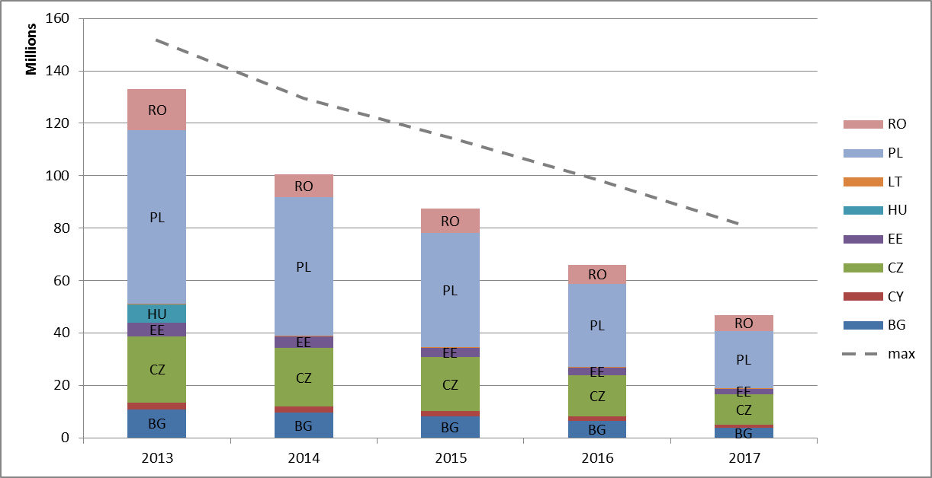

Figure 3 shows, for 10c allowances, the extent to which they have been allocated, added to the auctions, or remain unused (neither allocated nor added to the auctions). For example, 113 million of the allowances that have been deducted from Poland's share of allowances to auction between 2013 and 2017 for the purpose of Article 10c, have not yet been allocated or added to the auctions.

**Figure 3: Distribution of allowances (allocated, auctioned, unused remaining)**

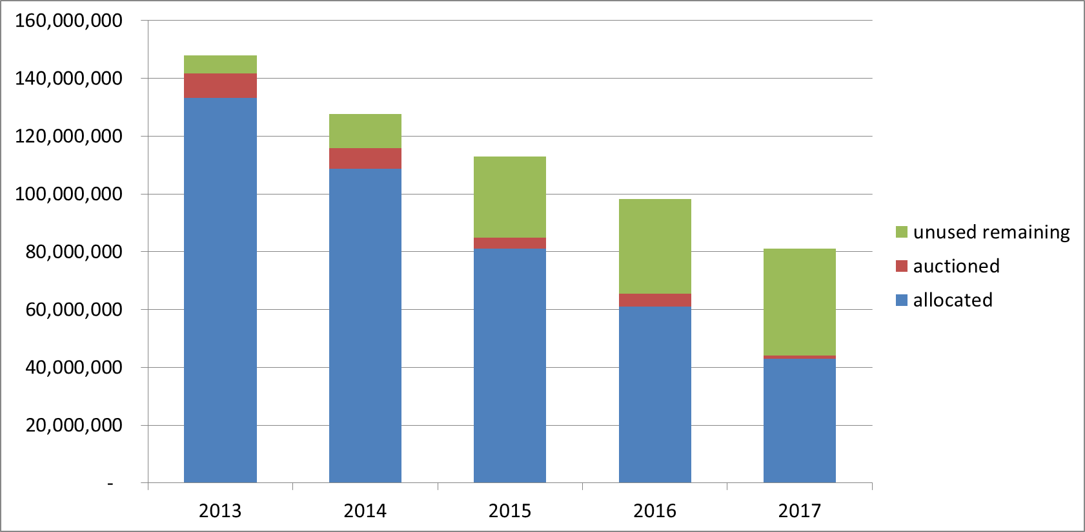

|  |  |
| --- | --- |
|  | Allocated allowances |
|  | Auctioned allowances |
|  | Unused remaining allowances |

Table 6 shows the number of 10c allowances for the years until 2017 which have been auctioned in the period 2013-2017, as well as the number of remaining unused allowances. The last column of the table indicates how many allowances so far may be transferred and allocated in 2021-2030 to investments selected through competitive bidding processes.

**Table 6: Treatment of unused 10c allowances 2013-2017**

|  |  |  |
| --- | --- | --- |
| **Member State** | **Number of 10c allowances**  **which have been auctioned (in million)** | **Number of remaining unused allowances[47] (in million)** |
| **BG** | 7,8 | 1,1 |
| **CY** | 0,0 | 0,0 |
| **CZ** | 0,2 | 0,2 |
| **EE** | 0,3 | 0,4 |
| **HU** | 0 | 0,9 |
| **LT** | 0,7 | 0,4 |
| **PL** | 0,0 | 113,3 |
| **RO** | 12,4 | 4,4 |
| **Total** | 21,4 | 119,6 |

### 4.1.3. International credits

Participants in the EU ETS can use international credits from the Kyoto Protocol's Clean Development Mechanism (CDM) and Joint Implementation (JI) towards fulfilling part of their EU ETS obligations until 2020*. These credits are financial instruments that represent a tonne of CO2 removed or reduced from the atmosphere as a result of an emissions reduction project. In phase 3 credits are no longer surrendered directly, but instead may be exchanged for allowances at any time during the calendar year.

A number of qualitative standards apply to the use of credits by EU ETS participants: credits are not accepted from nuclear, afforestation and reforestation projects, and new projects registered after 2012 must be in least developed countries. There are also maximum levels of credits that can be used by stationary installations and aircraft operators**.

According to the provisions of the revised EU ETS Directive, international credits will no longer be used for EU ETS compliance in the next trading period.

* CDM and JI projects generate Kyoto carbon credits: Certified Emission Reductions (CERs) and Emission Reduction Units (ERUs) respectively. Commission Regulation (EU) No 389/2013 stipulates that ERUs issued by third countries which do not have legally binding quantified emission targets from 2013 to 2020 as set out within the Doha amendment to the Kyoto Protocol or that have not deposited an instrument of ratification relating to the amendment, should only be held in the Union Registry if they have been certified to relate to emission reductions verified as having taken place before 2013.  
**Commission Regulation (EU) No 1123/2013 of 8 November 2013 on determining international credit entitlements pursuant to Directive 2003/87/EC of the European Parliament and of the Council, OJ L 299, 9.11.2013, p. 32

Although the exact quantity of international credit entitlements over phases 2 and 3 (2008-2020) will partially depend on the quantity of future verified emissions, market analysts estimate that it will amount to approximately 1.6 billion credits. As of 30 June 2018, the total number of international credits used or exchanged amounts to 1.49 billion, accounting for over 90% of the estimate for the allowed maximum.

For a full overview of the international credits exchange, see Appendix 3 to the Annex.

## 4.2. Demand: allowances taken out of circulation

In 2017, emissions from installations participating in the EU ETS are estimated to have increased slightly by 0.18% compared to 2016 based on the information recorded in the Union Registry. While the slight increase breaks the decreasing emissions trend since the start of phase 3 in 2013, it can be explained by a growth in real GDP of 2.4%, which is higher than in any year since the beginning of the current trading period.

Table 7: Verified emissions (in million tonnes CO2 equivalents)

|  |  |  |  |  |  |  |  |
| --- | --- | --- | --- | --- | --- | --- | --- |
| **Year** | **2011** | **2012** | **2013** | **2014** | **2015** | **2016** | **2017** |
| **Verified total emissions** | 1904 | 1867 | 1908 | 1814 | 1803 | 1751 | 1754 |
| **Change to year x-1** | -1.8% | -2% | 2.2% | -4.9% | -0.6% | -2.9% | 0.2% |
| **Verified emissions from power sector** | 1.155 | 1.153 | 1.101 | 1.011 | 1.005 | 957 | 949 |
| **Change to year x-1** |  | -0,2% | -4,5% | -8,1% | -0,6% | -4,8% | -0,8% |
| **Verified emissions from industrial installations** | 749 | 714 | 807 | 803 | 798 | 794 | 805 |
| **Change to year x-1** |  | -4,7% | 13,1% | -0,6% | -0,6% | -0,5% | 1,4% |
| **Real GDP[48] growth rate EU28** | 1.7% | -0.5% | 0.2% | 1.7% | 2.2% | 1.9% | 2.4% |

GDP data as reported on: <http://epp.eurostat.ec.europa.eu/tgm/table.do?tab=table&init=1&plugin=1&language=en&pcode=tec00115>

(accessed in July 2018). Verified aviation emissions are reported separately in section 5.

As the table demonstrates, the increase in emissions was mainly driven by industry, whereas emissions from the power sector slightly decreased.

The number of allowances cancelled on a voluntary basis amounts to 84 827 allowances in 2017. In total, voluntary cancellations of 300 181 allowances have been recorded until end June 2018.

## 4.3. Balancing supply and demand

At the start of phase 3 in 2013, the EU ETS was characterised by a large structural imbalance between the supply and demand of allowances, equaling 2.1 billion allowances. The surplus has been decreasing steadily over the course of the current trading period, remaining stable in 2014 and falling significantly to 1.78 billion allowances in 2015, 1.69 billion allowances in 2016, and 1.65 billion allowances in 2017. This amounts to an overall decrease of almost half a billion over three years. The decrease reflects the impact of the back-loading measure[49] applied in 2014 to 2016, which has been counter-balanced partially by declining emissions in the period from 2013 to 2016.

Figure 4 presents the development of the surplus in the European carbon market by end 2017.

**Figure 4: Development of the surplus in the European carbon market in 2013-2017**

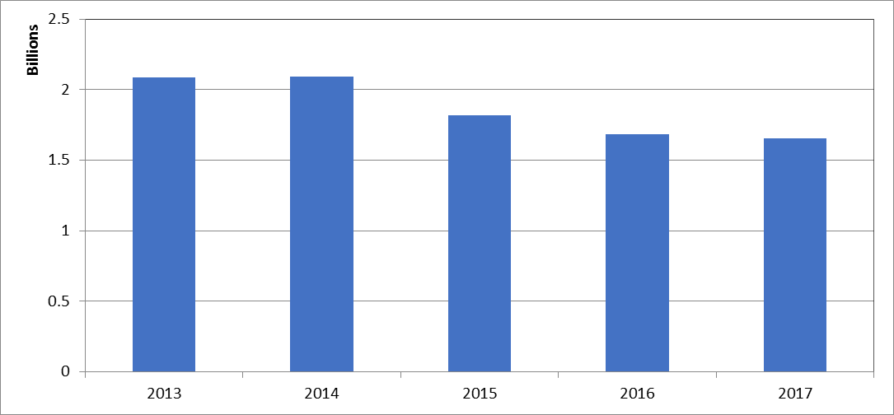

To address the structural imbalance between the supply and demand of allowances, a Market Stability Reserve (MSR) was created in 2015[50] to render the auction supply of emission allowances more flexible. The MSR will start operating in 2019.

A key notion for the functioning of the MSR is the total number of allowances in circulation (TNAC). Allowances will be added to the reserve, if the TNAC is above a predefined upper threshold (833 million allowances) and will be released from the reserve, if the number is below a predefined lower threshold (below 400 million allowances)*. Thus, the MSR absorbs or releases allowances if the circulating ones are outside of a predefined range. Back-loaded and so-called unallocated** allowances will also be put in the reserve.

The total number of allowances in circulation relevant for determining the MSR feeds and releases is calculated on the basis of the following formula:

TNAC = Supply – (Demand + allowances in the MSR)

The components of supply and demand used in the formula are described in detail in Table 1 in Appendix 4 to the Annex.

*Or where measures are adopted under Article 29a of the EU ETS Directive

**Unallocated allowances are allowances not allocated pursuant to Article 10a(7) of the EU ETS Directive, i.e. allowances remaining in the new entrants' reserve, and resulting from the application of Article 10a(19) and (20), i.e. allowances foreseen for free allocation to installations but remaining unallocated because of (partial) cessation of operations or significant capacity reductions. De facto "unallocated" allowances stemming from the application of the relevant carbon leakage factor to sectors not included in the carbon leakage list during the current period, as well as any allowances that are not allocated under Article 10c of the ETS Directive, are not foreseen to be placed in the Market Stability Reserve under Article 1(3) of Decision (EU) 2015/1814. Such allowances are therefore not covered (please refer to p. 225 of the Impact Assessment (SWD(2015) 135 final) accompanying the proposal for a revision the EU ETS Directive in phase 4.

The carbon market report allows for the consolidation of supply and demand figures which are published according to the timeline of reporting obligations stemming from the EU ETS Directive and its implementing provisions. This timeline, relevant data and scope are outlined in Table 2, Appendix 4 to the Annex. Figure 5 shows the composition of supply and demand in 2017. The relevant data have also been published as part of the communication on the total number of allowances in circulation (TNAC) for MSR purposes[51].

**Figure 5: Composition of cumulative supply and demand until the end of 2017**

**Supply** (cumulative, millions) **Demand** (cumulative, millions)

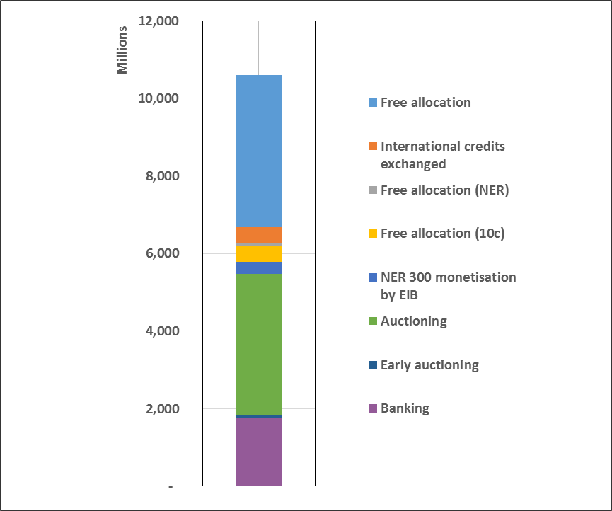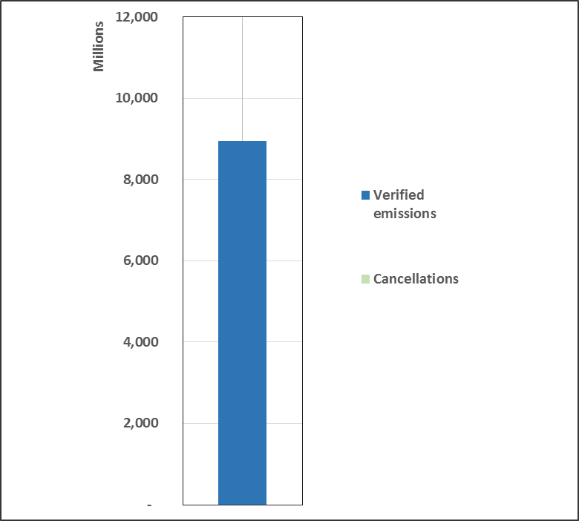

|  |  |
| --- | --- |
|  | Free allocation |
|  | International credits exchanged |
|  | Free allocation (NER) |
|  | Free allocation (10c) |
|  | NER 300 monetisation by EIB |
|  | Auctioning |
|  | Early auctioning |
|  | Banking |

|  |  |
| --- | --- |
|  | Verified emissions |
|  | Cancellations |

In preparation for the MSR becoming operational in 2019, the Commission has regularly published as from mid-May 2017[52] the TNAC for the preceding year. In May 2018, the TNAC was published for the second time, corresponding to 1 654 574 598 allowances[53]. The 2018 publication will for the first time lead to placing allowances in the MSR, reducing the auction volume over the first 8 months of 2019.

The revised EU ETS Directive makes two notable changes to the functioning of the MSR (see also section 2.1). First, the percentage of the TNAC to be placed in the reserve from 2019 to 2023 is doubled from 12% to 24%. This substantially increases the pace of reducing the surplus. Second, from 2023, allowances held in the MSR exceeding the previous year's auction volume will no longer be valid.

Thus, on the basis of the 2018 TNAC and the revised legislation, the 2019 auction volumes will be reduced by close to 265 million allowances over the first 8 months of 2019, corresponding to 16% of the surplus. As a result, in the first eight months of 2019 some 40% fewer allowances will be auctioned than in the corresponding period in 2018. Based on the auction volume for 2019, Appendix 7 provides information on the contributions by Member State to the MSR from January to August 2019.

# 5. AVIATION

The aviation sector has been part of the EU ETS since 2012. The original legislation covered all flights in and out of the European Economic Area (EEA). However, the EU limited the obligations for 2012-2016 to flights within the EEA, in order to support the development of a global measure by the International Civil Aviation Organisation (ICAO) for reducing aviation emissions.

In October 2016, the ICAO Assembly agreed on a resolution on the Carbon Offsetting and Reduction Scheme for International Aviation (CORSIA), to start in 2021. CORSIA is conceived as a carbon offsetting scheme with the objective of stabilising emissions from international aviation at 2020 levels. In light of this outcome, the EU ETS Directive was amended in 2017 to prolong the intra-EEA scope for aviation until 2023.

Pending the ICAO's adoption of the relevant CORSIA instruments and subsequent decisions by the EU on the possible implementation of CORSIA in the EU, and to provide continued momentum to the international process, the EU decided in 2017 to extend the current derogation from EU ETS obligations for flights to and from third countries until 31 December 2023, subject to review.[54] The current intra-EEA scope is thus maintained until 2023. After that, in the absence of a review, it would revert back to the original "full scope".

Moreover, the revised EU ETS Directive foresees that the European Commission should report to the European Parliament and to the Council on ways to implement CORSIA in EU law through a revision of the Directive. It also provides for the application of the linear reduction factor of 2.2% to aviation allowances as from 2021.

In 2017, allowances were issued in line with the intra-EEA scope. The free allocation amounted to slightly over 33.1 million allowances. This number comprises the free allocation (slightly over 32.0 million allowances) and nearly 1.1 million free allowances allocated from the special reserve for new entrants and fast growing operators. Allocations from this reserve are doubled in 2017-2020 as they relate to the full period 2013-2020.

With regard to developments in aviation emissions, verified emissions continued to grow and amounted to 64.2 million tonnes of CO2 in 2017, an increase of 4.5% compared to 2016.

The volume auctioned between January and December 2017 was approximately 4.7 million allowances.

Table 8 shows a summary of verified emissions, free allocation, and auction volumes for the aviation sector since the start of phase 3.

**Table 8: Verified emissions and allocation to the aviation sector**

|  |  |  |  |  |  |  |
| --- | --- | --- | --- | --- | --- | --- |
| **Year** | **2013** | **2014** | **2015** | **2016** | **2017** | **2018** |
| **Verified emissions (in million tonnes CO2)** | 53.5 | 54.8 | 57.1 | 61.5 | 64.2 |  |
| **Change of verified emissions to year x-1** |  | 2.5% | 4.1% | 7.6% | 4.5% |  |
| **Free allocation (EU28+EEA EFTA states, in million allowances)[55]** | 32.5 | 32.4 | 32.2 | 32.0 | 32.0 |  |
| **Free allocation from special reserve for new entrants and fast growing operators (in million allowances)** | 0 | 0 | 0 | 0 | 1.1 | 1.1 |
| **Volumes of allowances auctioned (in millions)** | 0 | 9.3 | 16.4 | 5.9 | 4.7 | 1.9[56] |

The volumes of aviation allowances auctioned over the period 2013-2015 reflect the 2013 co-legislator's decision to "stop the clock"[57] and limit climate obligations only to flights within the EEA. Compliance for the aviation sector was postponed for 2012 and 2013. The postponed 2012 volumes were thus auctioned in 2014, while compliance took place between January and April 2015 for aviation emissions from 2013 and 2014.

# 6. MARKET OVERSIGHT

Under the new Directive on Markets in Financial Instruments* (MiFID2) emission allowances are classified as financial instruments as of 3 January 2018. This means that rules applicable to traditional financial markets (those including carbon derivatives trade on leading platforms or over-the-counter (OTC)) also apply to the spot segment of the secondary carbon market (transactions in emission allowances for immediate delivery in the secondary market). This segment is thus put on equal footing with the derivatives market in terms of transparency, investor protection and integrity. Oversight in the primary market continues to be covered by the Auctioning Regulation, other than issues related to market abuse.

By virtue of cross-references to MiFID2 definitions of financial instruments, other pieces of financial market legislation apply. This is in particular the case for the Market Abuse Regulation (MAR)**, which covers transactions and conduct involving emission allowances, on both primary and secondary markets. Similarly, a cross-reference to MiFID2 in the Anti-Money Laundering Directive*** will trigger a mandatory application of customer due diligence checks by MiFID-licensed carbon traders to their clients in the secondary spot market in emission allowances. ****

* Directive 2014/65/EU of the European Parliament and of the Council of 15 May 2014 on markets in financial instruments and amending Directive 2002/92/EC and Directive 2011/61/EU

** Regulation (EU) No 596/2014 of the European Parliament and of the Council of 16 April 2014 on market abuse (market abuse regulation) and repealing Directive 2003/6/EC of the European Parliament and of the Council and Commission Directives 2003/124/EC, 2003/125/EC and 2004/72/EC

*** Directive (EU) 2015/849 of the European Parliament and of the Council of 20 May 2015 on the prevention of the use of the financial system for the purposes of money laundering or terrorist financing, amending Regulation (EU) No 648/2012 of the European Parliament and of the Council, and repealing Directive 2005/60/EC of the European Parliament and of the Council and Commission Directive 2006/70/EC

****Due diligence checks are already mandatory in the primary market and in the secondary market in emission allowances' derivatives.

MiFID2 and MAR, both adopted in 2014, envisage certain adaptations of the general regime to carbon market specificities (see Carbon Market Report 2015)[58].

Several measures regulating detailed aspects of the provisions under MiFID2[59] and MAR[60] were adopted in the period 2016 - 2018.

## 6.1. The legal nature and fiscal treatment of emission allowances

The legal nature and fiscal treatment of emission allowances vary across countries, since these two aspects are not defined in the ETS Directive. Countries are obliged to report annually on their national regimes related to the legal nature and fiscal treatment of allowances as part of their Article 21 reports. Despite non-harmonisation, a mature and very liquid market has developed over the last decade. The current regulatory framework provides the necessary legal underpinnings for a transparent and liquid carbon market, whilst ensuring the market's stability and integrity.

The legal nature of allowances across countries ranges from financial instruments and intangible assets to property rights and commodities. According to Article 21 submissions in 2018, at least five participating countries (DE, IE, IT, NO, SE) reported implemented or envisaged changes to national legislation, mostly regarding the implementation of MiFID2[61].

As regards the fiscal treatment of allowances, only three countries report that value added tax (VAT) applies to the issuance of emission allowances. In contrast, VAT is due on transaction of emission allowances on the secondary market in most participating countries (all except CY, EE, IS, LI).

The majority of countries report that they apply the reverse-charge mechanism on domestic transactions involving emission allowances. The reverse charge derogation moves the responsibility for the payment of the VAT transaction from the seller to the buyer of a good or service and constitutes an effective safeguard against VAT fraud. In November 2018, the Council adopted an amendment[62] to Directive 2006/112/EC (the VAT Directive) in order to extend the application of the derogation beyond the end of 2018, until 30 June 2022. Member States are encouraged to keep applying the reverse charge mechanism in order to provide continued adequate protection to the carbon market.

Emission allowances for corporations can additionally be taxed (e.g. via the application of a corporate tax or a corporate income tax). Sixteen countries reported that there was no such taxation.

# 7. MONITORING, REPORTING AND VERIFICATION OF EMISSIONS

The monitoring, reporting, verification and accreditation (MRVA) requirements of the EU ETS are harmonised in the Monitoring and Reporting Regulation (MRR)* and the Accreditation and Verification Regulation (AVR)**.

The monitoring system in the EU ETS is designed as a 'building block' approach which allows a high degree of flexibility for operators to ensure cost-efficiency, while at the same time to achieve a high reliability of the monitored emissions data. For this purpose, several monitoring methods ('calculation-based' or 'measurement-based', as well as by exception 'fall-back approaches') are allowed. Methods may be combined for individual parts of an installation. For aircraft operators, only calculation-based approaches are feasible, with fuel consumption being the central parameter to be determined for the flights covered by the EU ETS. The requirement for installations and aircraft operators to have a monitoring plan approved by the competent authority on the basis of the MRR prevents arbitrary selection of monitoring methods and temporal variations.

With the AVR for phase 3 and beyond an EU-wide harmonised approach towards the accreditation of verifiers has been introduced. Verifiers who are a legal person or a legal entity must be accredited by a National Accreditation Body (NAB) in order to carry out verifications in compliance with the AVR. This uniform accreditation system provides the advantage of allowing verifiers to operate with mutual recognition across all participating countries, thereby taking full advantage of the internal market and helping to ensure sufficient availability overall.

* Commission Regulation (EU) No 601/2012 of 21 June 2012 on the monitoring and reporting of greenhouse gas emissions pursuant to Directive 2003/87/EC of the European Parliament and of the Council, OJ L 181, 12.7.2012, p. 30.

** Commission Regulation (EU) No 600/2012 of 21 June 2012 on the verification of greenhouse gas emission reports and tonne-kilometre reports and the accreditation of verifiers pursuant to Directive 2003/87/EC of the European Parliament and of the Council, OJ L 181, 12.7.2012, p. 1.

**7.1. General Developments**

The Commission continues to encourage improvements in countries' implementation of the MRR and AVR, based on the guidance and templates provided[63].

Experience with the implementation of these two regulations has shown the need for further improvement, clarification and simplification of the MRVA rules to further promote harmonisation, reduce administrative burden for the operators and participating countries, and further enhance the efficiency of the system.

Starting in February 2017, participating countries have been consulted with a view to updating these two Regulations so as to prepare for phase 4 of the EU ETS, and to improve and simplify the MRVA processes.

It is recognised that the efficiency of the compliance system has improved since the MRR allowed countries to make electronic reporting mandatory. In 2018, 16 participating countries reported the use of electronic templates or specific file formats for monitoring plans, emissions reports, verification reports and / or improvement reports based on the minimum requirements set by the Commission. Twelve participating countries report that they use some form of automated IT system for EU ETS reporting.

**7.2. Monitoring applied**

According to the Article 21 reports submitted in 2018, most installations use the calculation-based methodology[64]. Only 179 installations (1.7%) in 23 countries were reported to use continuous emissions measurement systems, most frequently in Germany, France, and the Czech Republic. While the number of countries is the same as last year, there are 29 more installations overall using this approach.

Only 11 countries reported the use of the fall-back approach by 36 installations, covering approximately 3.4 million tonnes CO2e (compared to 5.1 million tonnes CO2e the year before). One installation in the Netherlands is responsible for 35% of the overall emissions reported in relation to fall-back methodology.

The minimum tier defaults[65] of the MRR are met by the vast majority of installations. Only 106 category C installations (one more than last year), that is 13.7% (compared to 13% last year) were reported to deviate for at least one parameter from the requirement to apply the highest tiers for the major source streams. These deviations are only allowed where the operator demonstrates that the highest tier is technically not feasible or incurs unreasonable costs. Once these conditions no longer apply, the operator has to improve their monitoring system accordingly. In the 2013 reporting period, 16% of the total category C installations were reported as not meeting highest tiers in one way or another. Therefore, an improvement in category C installation highest tier compliance can be seen since the beginning of phase 3.

Similarly, reports from 23 participating countries indicate that overall 21% of category B installations are permitted with some form of deviation from the MRR default requirements, compared to 22% last year and 26% the year before, demonstrating a steady improvement in highest tier compliance.

**7.3. Accredited verification**

The total number of verifiers is not reported in Article 21 reports, but a reasonable estimate based on the number accredited for combustion (the primary scope of accreditation) is that there were at least 124 different accredited verifiers overall concerning 2017 verifications. Concerning aviation, Article 21 submissions in 2018 indicate that there were 46 individual verifiers accredited for 2017. The European cooperation for Accreditation (EA) provides a central link to relevant National Accreditation Bodies (NABs) and their lists of EU ETS accredited verifiers[66].

The mutual recognition of verifiers among participating countries is working successfully: twenty-six countries reported that at least one foreign verifier is active in their territory.

Compliance of verifiers with the AVR is found to be high. Poland reported a suspension of one verifier, while two countries (PL and CZ) reported withdrawals of accreditation in 2017 of one and two verifiers, respectively. This compares to one suspension and one withdrawal for 2016 and no reported suspensions or withdrawals for 2015. Only Poland reported a reduction made in the scope of two verifiers' accreditation for 2017, compared to one reduction for one verifier in 2016, and four countries reporting such reductions for five verifiers in 2015.

Nine countries reported complaints received about verifiers this year (one more than last year). The overall number of complaints is however 12% lower. 95% of the complaints received are reported as resolved (similar to last year when this rate was 96%). Twelve countries reported identification of verifier non-conformities as part of the information exchange process between NABs and competent authorities (compared to nine last year).

# 8. OVERVIEW OF ADMINISTRATIVE ARRANGEMENTS

Countries participating in the EU ETS use different approaches regarding the competent authorities in charge of its implementation. In some countries several local authorities are involved, while in others the approach is much more centralised.

No significant changes have been observed in the administrative arrangements of participating countries since the last reporting period. According to Article 21 submissions in 2018, there were, on average, 5 competent authorities involved in EU ETS implementation per country.[67] With regard to the coordination between authorities, different tools and methods were reported, such as legislative instruments for central management of monitoring plans or emission reports (in 13 countries), provision of binding instructions and guidance by a central competent authority to local authorities (in 9 countries), regular working groups or meetings between authorities (in 15 countries), and the use of a joint IT platform (in 11 countries), among others. Eight countries (CY, EE, IE, IS, IT, LI, LU, MT) indicated that none of the above are in place.

On administrative fees charged in relation to permitting and approved monitoring plans, 14 countries reported in 2018 that they do not charge any fees to installation operators (CY, DE, EE, FR, GR, IE, LI, LT, LU, LV, MT, NL, SE, SK), the same as last year. Again with no difference to last year, aircraft operators in 15 countries do not pay fees (BE, CY, CZ, DE, EE, ES, GR, LI, LT, LU, LV, MT, NL, SE, SK). Charges vary significantly according to country and the particular service involved. For example, the fees for permit and monitoring plan approval for installations vary from EUR 5 to EUR 7690, while for aviation the fees for monitoring plan approval range from EUR 5 to EUR 2400.

Overall, participating countries' systems are largely effective as aligned to their administrative organisation. Communication between local authorities and the sharing of best practices among Competent Authorities, including via the activities of the EU ETS Compliance Forum and the annual EU ETS Compliance Conference, should continue to be reinforced and encouraged.

# 9. COMPLIANCE AND ENFORCEMENT

The EU ETS Directive provides for an excess emissions penalty in the form of EUR 100 (indexed) for each tonne of CO2 emitted for which no allowance has been surrendered in due time. Other penalties applicable to infringements in implementation of EU ETS are according to the national provisions set by the concerned country.

The EU ETS has a very high compliance rate: each year around 99% of the emissions are covered by the required number of allowances on time. In 2017 approximately 1% of the installations reporting emissions did not surrender allowances covering all their emissions by the deadline of 30 April 2018. These installations accounted for approximately 0.4% of EU ETS emissions. In the aviation sector the level of compliance was also very high: aircraft operators responsible for 98% of EU ETS aviation emissions complied.

The competent authorities continue to carry out different compliance checks on the annual emissions reports. According to Article 21 submissions in 2018, all participating countries check annual emission reports for completeness (100% of reports except ES 95%, FR 99%, SE 3%, and UK 59%). The reports further indicate that on average countries check close to 80% of reports for consistency against monitoring plans (all countries) and about 74% against allocation data (all countries except FI, IT, MT, NO, and SE). Twenty four countries reported that they also carry out cross-checks against other data.

Based on Article 21 submissions in 2018, competent authorities in fifteen countries carried out conservative estimates regarding missing data in the case of 131 installations. However, 79 of these were reported by the UK for emissions in years prior to 2017, based on newly discovered historic errors. Discounting the UK data from the totals for 2017, conservative estimates were reported for 52 installations (approximately 0.5% of installations overall), compared to 57 installations (0.5%) for 2016 and 45 (0.4%) for 2015. The reported quantity of affected 2017 emissions was 2.8 million tonnes CO2 (compared to 1.9 million tonnes CO2 last year and 8.3 million tonnes the year before), approximately 0.2% of overall emissions (compared to 0.1% and 0.5% for 2016 and 2015, respectively). The most common reasons given for making conservative estimates were the absence of an emission report by 31 March or emission reports that were not fully in line with MRR/AVR requirements.

Conservative estimates regarding missing data for aviation were reported by 8 countries concerning 33 aircraft operators (6.1% of the total), and 0.8% of aviation emissions. This compares to 18 aircraft operators (3.5%) reported by four countries last year.

Competent authorities' checks also remain important to supplement the verifier’s work. For 2017, all countries confirmed that they carry out further checks in the case of installations. Most countries reported a similar approach regarding aircraft operators (all except CY, EL, IT, LI, and RO). Most countries (all except EL, IT, LU, MT, and SE) reported that they carried out spot checks at installations in 2017.

For 2017, the application of excess emissions penalty was reported for 30 installations by nine countries (BE 1, BG 3, CZ 1, FR 1, IT 8, PL 1, PT 1, RO 6 and UK 8). For aviation, excess emission penalties were reported for 61 aircraft operators (DE 7, ES 3, FR 1, IT 6, LT 1, NL 1, PL 1, PT 6, and UK 35).

Nine countries confirmed issue of penalties (other than excess emissions penalties) in the 2017 reporting period. No imprisonments were reported, but fines, formal notices, or final warning letters concerning 73 installations and 27 aircraft operators were noted amounting to a total financial value of EUR 37,8 million.[68]

The most common offences reported for 2017 were failure to report capacity changes (24 cases), failure to submit verified annual emission reports by the due deadline (23 cases), operation without a permit (17 cases), and failure to hold a duly approved monitoring plan (11 cases).

A fifth EU ETS compliance cycle evaluation has started at the beginning of 2018. This evaluation aims to identify EU ETS compliance issues at the level of participating countries and support them in improving their implementation of the EU ETS by identifying improvement options, best practices, and training needs. The new evaluation will build on the previous evaluation in 2014 and on further compliance review work conducted in the EU ETS MRVA Support project in 2015-2016 in which action plans were formulated to support participating countries in their EU ETS compliance.

A key novelty of the new evaluation is a proficiency test in which a Competent Authority representative of each country is requested to review a sample monitoring plan, an annual emission report and further reports of an installation. In addition, a set of EU ETS MRVA documents for one specific installation in each country will be analysed and country-specific surveys will be formulated to complete the understanding of the implementation of EU ETS permitting, inspection and enforcement as well as MRVA.

# 10. CONCLUSIONS AND OUTLOOK

The most important development over the course of the past year has been the adoption of an ambitious reform of the EU ETS for its next trading period. The reform enables the EU ETS to contribute to achieving the EU's 2030 climate objectives and deliver on its commitments under the Paris Agreement. The reformed ETS will deliver reductions in emissions by 43% by 2030 whilst at the same time safeguarding the competitiveness of European industry. Moreover, it will assist industry and the power sector in meeting the innovation and investment challenges of the low-carbon transition. Following the adoption of the revised legislation, the focus has now shifted towards implementing the new provisions ahead of the start of phase 4. Implementation work, in particular on carbon leakage and free allocation, as well as on the Innovation Fund is in full swing (see Appendix 6).

The legislative changes agreed in recent years to address the surplus of allowances also start bearing fruit. Mainly due to back-loading, the surplus of allowances has already fallen significantly and in 2017 reached its lowest level since the start of phase 3. This year's second publication of the Market Stability Reserve surplus indicator triggers for the first time a transfer of allowances to the reserve. Combined with the strengthening measures of the reformed ETS, this will reduce the auction volume over the first 8 months of 2019 by some 40% compared to the corresponding volume in 2018. Due to the doubled amount of allowances to be placed in the reserve for the first five years of its operation, it is widely expected that the surplus will continue to decline substantially in the coming years. Progress on these fronts has translated into increased confidence by market participants as illustrated by the reinforced carbon price signal over the last year.

Important progress has also been achieved in the field of aviation. To provide continued momentum to the international process of establishing a global scheme to curb aviation emissions, and to facilitate its future implementation in the EU, the intra-EEA scope for aviation has been extended until 2023. The level of ambition has also been raised – as from 2021, the same linear reduction factor as for installations will for the first time apply to aviation and the cap on aviation allowances will thus decrease by 2.2% annually.

Also in the fifth year of phase 3, the EU ETS architecture has remained robust and the administrative organisation across Member States has proven to be effective. Moreover, the overall level of transparency, investor protection, and integrity in the carbon market has increased with the classification of emission allowances as financial instruments under the new financial market rules. An important step has also been taken towards the continued protection of the European carbon market against VAT fraud, with the adoption of an amendment to the VAT Directive to extend the application of the reverse charge mechanism derogation beyond the end of 2018.

The reinforced and strengthened ETS also underlines the case of active collaboration with other regulators and partners outside Europe developing or implementing carbon markets.

The Commission will continue to monitor the European carbon market and provide the next report in late 2019.

ANNEX

**Appendix 1**

**Table 1: Number of free allowances allocated for modernising the electricity sector**

|  |  |  |  |  |  |
| --- | --- | --- | --- | --- | --- |
|  | **Number of free allowances requested by Member State pursuant to Article 10c** | | | | |
| **Member State** | **2013** | **2014** | **2015** | **2016** | **2017** |
| **BG** | 11 009 416 | 9 779 243 | 8 259 680 | 6 593 238 | 3 812 436 |
| **CY** | 2 519 077 | 2 195 195 | 1 907 302 | 1 583 420 | 1 259 538 |
| **CZ** | 25 285 353 | 22 383 398 | 20 623 005 | 15 831 329 | 11 681 994 |
| **EE** | 5 135 166 | 4 401 568 | 3 667 975 | 2 934 380 | 2 055 614 |
| **HU** | 7 047 255[69] | n.a. | n.a. | n.a. | n.a. |
| **LT** | 322 449 | 297 113 | 269 475 | 237 230 | 200 379 |
| **PL** | 65 992 703 | 52 920 889 | 43 594 320 | 31 621 148 | 21 752 908 |
| **RO** | 15 748 011 | 8 591 461 | 9 210 797 | 7 189 961 | 6 222 255 |
| **Total** | 133 059 430 | 100 568 867 | 87 532 554 | 65 990 706 | 46 985 124 |

**Table 2: Maximum number of free allowances per year under the derogation from full auctioning for the power sector**

|  |  |  |  |  |  |  |  |  |
| --- | --- | --- | --- | --- | --- | --- | --- | --- |
| **Member State** | **Maximum number of allowances per year** | | | | | | | |
| **2013** | **2014** | **2015** | **2016** | **2017** | **2018** | **2019** | **Total** |
| BG | 13 542 000 | 11 607 428 | 9 672 857 | 7 738 286 | 5 803 714 | 3 869 143 | 1 934 571 | 54 167 999 |
| CY | 2 519 077 | 2 195 195 | 1 907 302 | 1 583 420 | 1 259 538 | 935 657 | 575 789 | 10 975 978 |
| CZ | 26 916 667 | 23 071 429 | 19 226 191 | 15 380 953 | 11 535 714 | 7 690 476 | 3 845 238 | 107 666 668 |
| EE | 5 288 827 | 4 533 280 | 3 777 733 | 3 022 187 | 2 266 640 | 1 511 093 | 755 547 | 21 155 307 |
| HU | 7 047 255 | 0 | 0 | 0 | 0 | 0 | 0 | 7 047 255 |
| LT | 582 373 | 536 615 | 486 698 | 428 460 | 361 903 | 287 027 | 170 552 | 2 853 628 |
| PL | 77 816 756 | 72 258 416 | 66 700 076 | 60 030 069 | 52 248 393 | 43 355 049 | 32 238 370 | 404 647 129 |
| RO | 17 852 479 | 15 302 125 | 12 751 771 | 10 201 417 | 7 651 063 | 5 100 708 | 2 550 354 | 71 409 917 |
| **Total** | 151 565 434 | 129 504 488 | 114 522 628 | 98 384 792 | 81 126 965 | 62 749 153 | 42 070 421 | 679 923 881 |

**Appendix 2**

**Figure 1: Overview of general allowances auctions from 2013 to 30 June 2018**

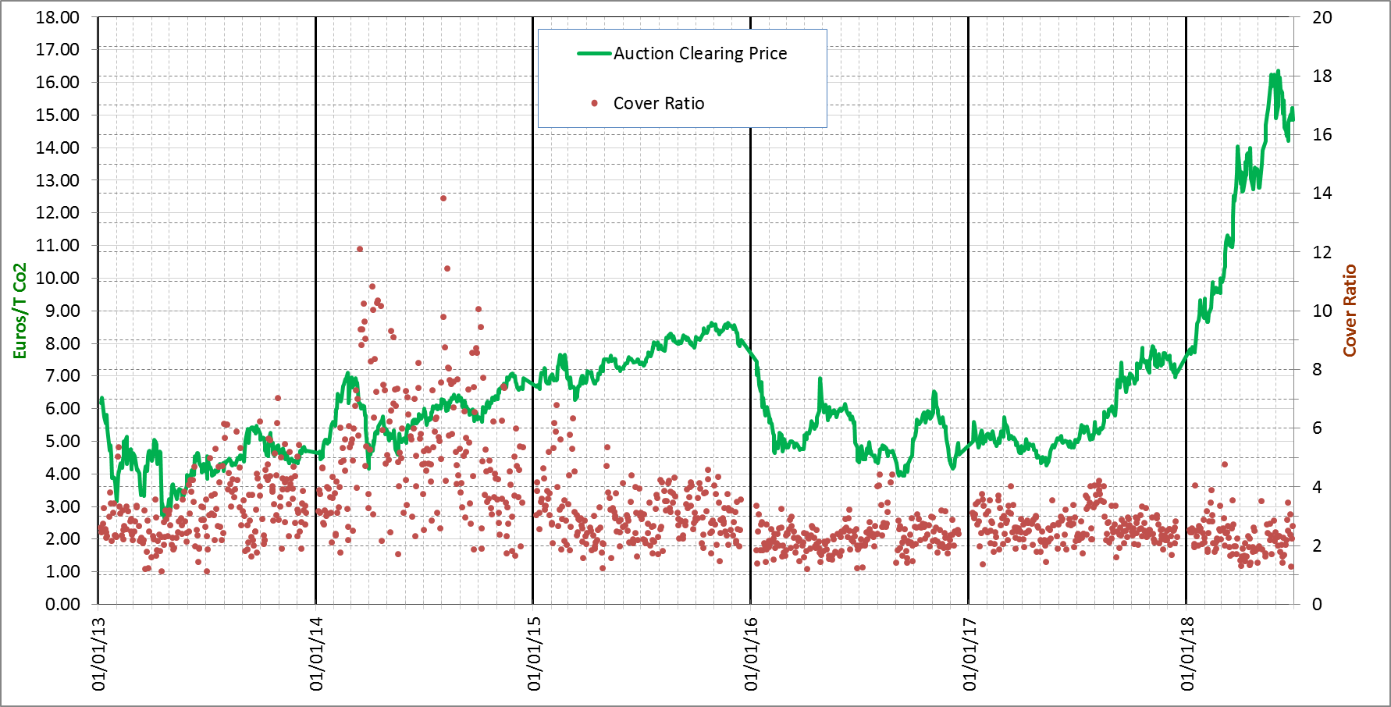

**___** Auction Clearing Price

**.** Cover Rate

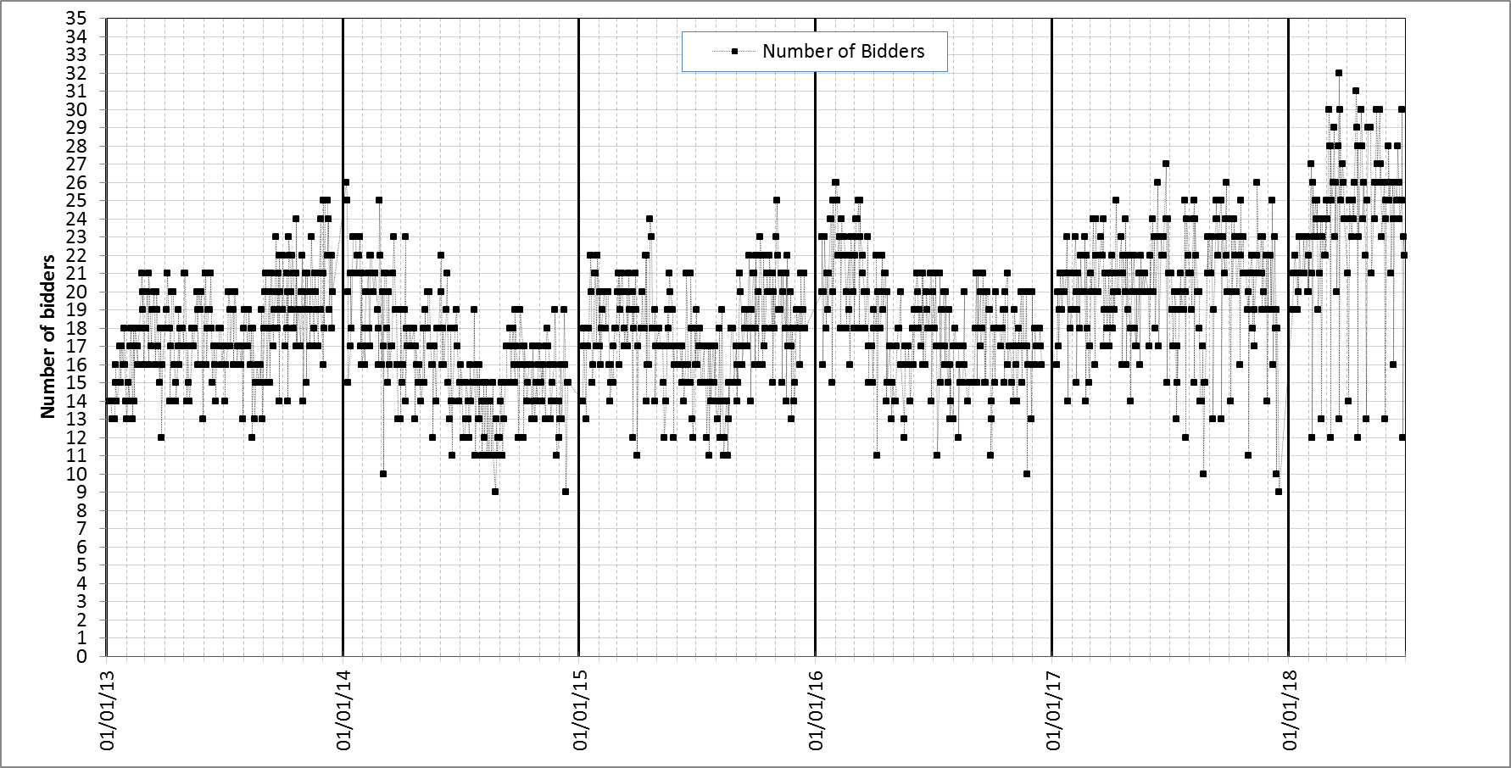

**Appendix 3**

**Table 1: Summary of international credits exchange until end June 2018**

|  |  |  |  |  |  |
| --- | --- | --- | --- | --- | --- |
| **International credits exchanged by end June 2018** | **million** | **percentages** | **International credits exchanged by 30 June 2018** | **million** | **percentages** |
| **CERs** | **243,66** | **55,91%** | **ERUs** | **192,07** | **44,09%** |
| China | 181,41 | 74,45% | Ukraine | 147,69 | 76,89% |
| India | 15,78 | 6,48% | Russia | 32,06 | 16,69% |
| Uzbekistan | 9,44 | 3,87% | Poland | 2,82 | 1,46% |
| Brazil | 5,27 | 2,16% | Germany | 1,65 | 0,85% |
| Chile | 3,16 | 1,30% | France | 1,24 | 0,64% |
| Korea | 2,93 | 1,20% | Bulgaria | 0,50 | 0,26% |
| Mexico | 2,86 | 1,17% | Others | 6,11 | 3,21% |
| Others | 22,81 | 9,36% |  |  |  |
|  |  |  |  |  |  |
| **TOTAL CERs and ERUs** | **435,73** | **100%** |  |  |  |

**Appendix 4**

Table 1: ETS supply and demand elements

|  |  |  |  |
| --- | --- | --- | --- |
| **Element** | **Supply or demand?** | **Publication** | **Update and uncertainties** |
| **Banking total phase 2** | Supply | Carbon market report | No update is foreseen as phase 2 ended. Final figure. |
| **Early phase 3 auctions** | Supply | DG Climate website, EEX and ICE websites | Not part of phase 2 banking total. Final figures. |
| **Allowances for NER 300** | Supply | EIB website | 300 million allowances were monetised in 2012-2014. Final figures. |
| **Aviation auctions** | Supply | DG Climate website, EEX and ICE websites | No – adjustments are reflected in the volumes for the following year.  2013 and 2014 auctions took place in 2015. |
| **Phase 3 auctions** | Supply | DG Climate website, EEX and ICE websites | No - the figure is not subject to revision. However, allowances (e.g. due to delays to start of auctioning for certain Member States, e.g. those for EEA-EFTA) withheld from auctions can be auctioned in subsequent years. |
| **Free allocation (NIMs)** | Supply | EUTL, tables | These figures are updated throughout the year.  - Member State may provide late submissions for previous years or actual allocation can be lower than the amount initially foreseen.  The EUTL provides an accurate state of play of actual allocation. |
| **Free allocation (NER)** | Supply | EUTL, tables |
| **Free allocation**  **(aviation)** | Supply | EUTL, MS publication of allocation tables |
| **Free allocation**  **(Article 10c)** | Supply | EUTL, status table |
| **Emissions (stationary installations)** | Demand | EUTL, compliance data | Compliance data made public on 1 May shows emissions and surrendered allowances for installations that are in compliance (i.e. those installations reporting for all years concerned).[70] |
| **Emissions (aviation)** | Demand |  | Compliance for aviation operators for both 2013 and 2014 took place in 2015. |
| **Allowances cancelled** | Demand |  | Carbon market report |

Table 2: Timeline for data publication

|  |  |  |
| --- | --- | --- |
| **Timing** | **Data** | **Scope** |
| 1 January – 30 April year x | Updates to free allocation to power (Article 10c) | Year x-1 |
| 1 April year x | Verified emissions  Free allocation (Article 10a(5) – NIMs) | Year x-1 |
| 1 May year x | Compliance deadline: verified emissions and surrendered allowances | Year x-1 |
| May/October year x | International credits exchanged |  |
| Last quarter of year x | Carbon Market report | Year x-1 |
| January/July year x | Status of new entrants' reserve - NER table |  |
| Not published at EU level | Free allocation to aviation published at Member States level |  |

**Appendix 5**

**Table 1: Rulings of the Court of Justice of the EU relevant to the functioning of the EU ETS in the period July 2017 to June 2018**

|  |  |  |  |  |  |
| --- | --- | --- | --- | --- | --- |
| **Case reference** | **Legislation Concerned** | **Parties** | **Context of the case** | **Date** | **Finding by the Court** |
| C-302/17 | Directive 2003/87/EC | PPC Power a.s./ Financial Directorate of SK, Tax Office for selected tax subjects | Request for a preliminary ruling: Is it in line with the Directive 2003/87/EC to tax emission allowances allocated free of charge which have not been used or have been transferred? | 12.04.2018 | The tax is not compatible with the EU ETS Directive. |
| C-229/17 | Directive 2003/87/EC,  Decision 2011/278/EU | Evonik Degussa GmbH / DE | Request for a preliminary ruling: Does the definition of "production of hydrogen" within the meaning of Annex I of Decision 2011/278/EU include the isolation of hydrogen already contained in a gas mixture? | 17.05.2018 | No, the definition of "production of hydrogen" within the meaning of Annex I of Decision 2011/278/EU does not include the isolation of hydrogen already contained in a gas mixture. |
| Case C-577/16 | Directive 2003/87/EC,  Decision 2011/278/EU | Trinseo Deutschland Anlagengesellschaft mbH/ DE | Request for a preliminary ruling: Does Article 1 of Directive 2003/87/EC cover the production of polymers in installations with a production capacity exceeding 100 tonnes? If so, can such an installation receive free allocation even if the Member State in question did not include this activity in its national transposing legislation? | 28.02.2018 | An installation for the production of polymers, in particular the polymer polycarbonate, which obtains the heat needed for that production from a third-party installation, does not fall within the scope of the EU ETS, since it does not generate direct CO2 emissions |
| C-572/16 | Directive 2003/87/EC,  Decision 2011/278/EU | INEOS Köln GmbH / DE | Request for a preliminary ruling: Is it in line with Directive 2003/87/EC and with Decision 2011/278/EU for Germany to set a deadline for operators to submit applications for the allocation of free emissions allowances to the national competent authority? Can the submissions be corrected after the deadline has passed? | 22.02.2018 | Directive 2003/87/EC and Decision 2011/278/EU do not preclude national provisions laying down a mandatory time limit for the submission of an application for free allocation, after which the applicant has no means of correcting its application. |
| Case C‑80/16 | Directive 2003/87/EC, Decision 2011/278/EU | ArcelorMittal Atlantique et Lorraine / Ministry of Ecology, Sustainable Development and Energy of FR | Validity of the method for determining the product benchmark for hot metal | 26.07.2017 | The Court confirmed the validity of Commission's methdology used to determine the hot metal and sintered ore benchmarks (see also -180/15 and C-506/14). |
| Case C-5/16 | Decision 2015/1814/EU | PL/ European Parliament, Council of the EU | PL contested the adoption procedure and content of Decision 2015/1814/EU establishing the Market Stability Reserve and requested its annulment, claiming that it constitutes a measure significantly affecting a Member State’s choice between different energy sources and the general structure of its energy supply, which should have been adopted by the Council unanimously, in accordance with first subparagraph of Article 192(2) TFEU. | 21.06.2018 | The Court dismissed the action. |
| Case C-58/17 | Decision 2011/278/EU | INEOS Köln GmbH/ DE | Request for a preliminary ruling: Does the definition of ‘process emissions sub-installation’ in Article 3(h) of Decision 2011/278/EU cover only incompletely oxidised carbon in a gaseous state, or does it also include incompletely oxidised carbon in a liquid state? | 18.01.2018 | The Court found that it is possible to exclude incompletely oxidised carbon in a liquid state from the definition of process emissions. |

**Appendix 6**

**Table 1: State of play of EU ETS phase 4 implementation**

|  |  |  |  |
| --- | --- | --- | --- |
| **Measure** | **Purpose** | **Type of legislative act** | **Foreseen adoption** |
|
| Carbon Leakage List for 2021-2030 | Establishing the new Carbon Leakage List for phase 4 of the EU ETS based on the criteria for determining sectors significantly exposed to the risk of carbon leakage | Delegated act | 1st quarter 2019 |
| Revision of the free allocation rules for 2021-2030 | Revising Commission Decision 2011/278/EU on determining transitional union-wide rules for harmonised free allocation so as adapt it to the new legal context set for phase 4 | Delegated act | December 2018 |
| Adjustment to free allocation due to production changes | Defining the arrangements for the operationalisation of the adjustment of the level of free allocation to installations on the basis of changing levels of production of more than 15% upwards or downwards on average over a period of two years | Implementing act | 2019 |
| Update of the benchmark values for free allocation for 2021-2025 | Determining updated benchmarks for 2021-2025 on the basis of data submitted by Member States for the years 2016 and 2017. | Implementing act | 2020 |
| Establishment of the Innovation Fund | Determining the rules on the operation of the Innovation Fund, including the selection procedure and criteria | Delegated act | 2019 |
| Establishment of the Modernisation Fund | Determining the rules for the operation of the Modernisation Fund | Implementing act | 2020 |
| Revision of Regulation (EU) No 389/2013 (the Registry Regulation) | Laying down the requirements for the Union Registry for phase 4 in the form of standardised electronic databases containing common data elements to track the issue, holding, transfer and cancellation of allowances, and to provide for public access and confidentiality | Delegated act | 1st quarter 2019 |
| Amendment of Regulation (EU) No 1031/2010 (the Auctioning Regulation) | Enabling the auctioning of the first 50 million allowances for the Innovation Fund taken from the Market Stability Reserve (MSR) in 2020 | Delegated act | October 2018 |
| Revision of Regulation (EU) No 1031/2010 (the Auctioning Regulation) | Revising some aspects of the auctioning process to implement requirements for phase 4, in particular to enable the auctioning of allowances for the Innovation Fund and the Modernisation Fund, as well as to reflect the classification of EU ETS allowances as financial instruments under Directive 2014/65/EU on markets in financial instruments (MiFID2). | Delegated act | 2019 |
| Revision of Regulation N° 601/2012 on Monitoring and Reporting | Simplifying, improving and clarifying the monitoring and reporting rules and reducing administrative burden, based on implementation experience from phase 3 | Implementing act | 4th quarter 2018 |
| Revision of Regulation N° 600/2012 on Verification and Accreditation | Simplifying, improving and clarifying the accreditation and verification rules and reducing administrative burden to the extent possible, based on implementation experience from phase 3 | Implementing act | 4th quarter 2018 |
| EU ETS State Aid Guidelines 2021-2030 | Revising the EU ETS State Aid Guidelines for phase 4 to accommodate the new provisions on enhanced transparency and reporting introduced by the revised EU ETS Directive for indirect carbon cost compensations schemes | Communication from the Commission | 2020 |

|  |
| --- |
| **State of play** |
| Planned |
| Ongoing |
| Done |

**Appendix 7**

**Table 1: Member State contributions to the Market Stability Reserve from January to August 2019**

|  |  |
| --- | --- |
| **Member State/ EEA**  **EFTA State** | MSR contributions[71] (January-August 2019) |
| Austria | 3 956 898 |
| Belgium | 6 564 219 |
| Bulgaria | 5 528 107 |
| Croatia | 1 076 583 |
| Cyprus | 621 854 |
| Czech Republic | 10 270 545 |
| Denmark | 3 560 260 |
| Estonia | 1 936 082 |
| Finland | 4 753 029 |
| France | 15 563 476 |
| Germany | 56 922 669 |
| Greece | 8 455 757 |
| Hungary | 3 410 242 |
| Iceland | 110 959 |
| Ireland | 2 660 749 |
| Italy | 26 868 005 |
| Latvia | 576 962 |
| Liechtenstein | 2 483 |
| Lithuania | 1 194 802 |
| Luxembourg | 311 575 |
| Malta | 236 516 |
| Netherlands | 9 526 964 |
| Norway | 2 209 564 |
| Poland | 26 186 345 |
| Portugal | 4 318 892 |
| Romania | 9 960 187 |
| Slovakia | 3 168 128 |
| Slovenia | 1 051 738 |
| Spain | 21 772 019 |
| Sweden | 2 304 582 |
| United Kingdom | 29 651 746 |
| **Total** | 264 731 936 |

1. In 2015, EU GHG emissions were already 22% below 1990 levels.
2. According to national projections, emissions will further decrease until 2020, but additional policies will need to be implemented to achieve the 2030 target.
3. COM (2015) 337, <http://eur-lex.europa.eu/legal-content/EN/TXT/?uri=CELEX:52015PC0337>
4. Directive (EU) 2018/410 of the European Parliament and of the Council of 14 March 2018 amending Directive 2003/87/EC to enhance cost-effective emission reductions and low-carbon investments, and Decision (EU) 2015/1814, OJ L 76, 19.03.2018, p.3
5. Regulation (EU) 2017/2392 of the European Parliament and of the Council of 13 December 2017 amending Directive 2003/87/EC to continue current limitations of scope for aviation activities and to prepare to implement a global market-based measure from 2021, OJ L 350, 29.12.2017, p. 7
6. Agreement between the European Union and the Swiss Confederation on the linking of their greenhouse gas emissions trading systems, OJ L 322, 07.12.2017, p.3
7. Directive 2003/87/EC of the European Parliament and of the Council of 13 October 2003 establishing a scheme for greenhouse gas emission allowance trading within the Community and amending Council Directive 96/61/EC, OJ L 275, 25.10.2003, p. 32.
8. Reports published in previous years can be accessed at: https://ec.europa.eu/clima/policies/ets_en#tab-0-1
9. The cut-off date used is 29 June 2018.
10. Guidelines on certain State aid measures in the context of the greenhouse gas emission allowances trading scheme post 2012,OJ C158, 05.06.2012, p.4
11. Information on the public consultation can be found here: https://ec.europa.eu/clima/consultations/public-consultation-establishment-innovation-fund_en
12. Bulgaria, the Czech Republic, Croatia, Estonia, Hungary, Latvia, Lithuania, Poland, Romania and Slovakia
13. An exception has been made for efficient and sustainable district heating in Member States with a GDP per capita at market prices below 30 % of the EU average in 2013 (Bulgaria and Romania). This exception only concerns 30 % of available funds for these Member States.
14. For the reference to Article 21 reports, "participating countries" or simply "countries" include the 28 EU Member States plus EEA countries (Iceland, Norway and Liechtenstein).
15. Biomass emissions are zero-rated in the EU ETS, i.e. emissions have to be reported but no allowances have to be surrendered for them.
16. Category C installations emit more than 500 000 tonnes CO2e per year, category B installations emit between 500000 and 50000 tonnes CO2e per year, and category A installations emit less than 50000 tonnes CO2e per year. Furthermore, 'installations with low emissions' are a sub-set within category A installations which emit less than 25 000 tonnes CO2e per year. See Commission Regulation (EU) No 601/2012 of 21 June 2012 on the monitoring and reporting of GHG emissions pursuant to Directive 2003/87/EC of the European Parliament and of the Council, OJ L 181, 12.7.2012, p. 30
17. Commission Regulation (EU) No 601/2012 of 21 June 2012 on the monitoring and reporting of greenhouse gas emissions pursuant to Directive 2003/87/EC of the European Parliament and of the Council, OJ L 181, 12.7.2012, p. 30.
18. An example of a commercial aircraft operator would be a passenger airline providing services to the general public. An example of a non-commercial aircraft operator would be a privately owned aircraft.
19. Commission Regulation (EU) 2018/208 of 12 February 2018 amending Regulation (EU) No 389/2013 establishing a Union Registry, OJ L 39/3, 13.02.2018, p.3
20. The number of aviation allowances put into circulation since 2013 is the result of a bottom-up approach starting from free allocation (determined on the basis of activity-based benchmarks for operators' activity within the EEA). The number of allowances auctioned is then derived based on the fact that free allocation (including a special reserve for later distribution to fast-growing aircraft operators and new entrants) should be 85% of the total and auctioning should be 15%.
21. The updated figures include exchanges of international credits besides the free allocation and auctioned amounts.
22. Includes information from the 2018 aviation auction calendar.
23. The figures include notifications by Member States received until June 2018 and may be subject to large changes due to later notifications.
24. Initial amount, before application of the reductions mentioned below in the table.
25. Commission Decision 2013/448/EU, OJ L 240, 7.9.2013, p.27.
26. Commission Decision 2017/126/EU, OJ L 19, 25.1.2017, p. 93.
27. Judgment of the Court of Justice of 28 April 2016 in Joined Cases C-191/14, C-192/14, C-295/14, C-389/14 and C-391/14 to C-393/14 Borealis Polyolefine GmbH and Others v Bundesminister für Land- und Forstwirtschaft, Umwelt und Wasserwirtschaft and Others, EU:C:2016:311.
28. Commission Decision (EU) 2017/2172 of 20 November 2017 amending Decision 2010/670/EU as regards the deployment of non-disbursed revenues from the first round of calls for proposals.
29. In line with Commission Decision 2010/670/EU, projects awarded under the first call had to reach final investment decision by end 2016, while projects awarded under the second call had to do so by end June 2018.
30. In addition, modificantions have been adopted to the French and Spanish schemes.
31. <https://assets.publishing.service.gov.uk/government/uploads/system/uploads/attachment_data/file/723181/Indirect_Cost_Compensation_EU_ETS_UK_Publication_2017_Revised.pdf>
32. Based on the average EUR/GBP exchange rate over 2017 of 0.88723.
33. <https://www.strompreiskompensation.de/SPK/SharedDocs/news/SPK-Auswertungsbericht.html?__site=SPK>
34. https://www.cnc-nkc.be/sites/default/files/report/file/2018-08-13_rapportering_icl_2017_goedgekeurd_door_nkc_fr_en_nl.pdf
35. https://www.rvo.nl/subsidies-regelingen/subsidieregeling-indirecte-emissiekosten-ets
36. <http://www.lagie.gr/anakoinoseis/anakoinoseis/anakoinosi/article/1605/>
37. <http://ukmin.lrv.lt/lt/veiklos-sritvs/versloaplinka/pramone/valstybes-pagalba>
38. <http://www.envirofond.sk/_img/Prehlady/Dotacie/Dotacie_2017.pdf>
39. <https://www.ecologique-solidaire.gouv.fr/sites/default/files/Informations%20sur%20la%20compensation%20des%20coûts%20indirects%20en%20France.pdf>
40. <https://tem.fi/documents/1410877/2414868/Päästökauppadirektiivin+mukaiset+tiedot+2017+maksetusta+kompensaatiotuesta/86ca7fc7-04f7-446b-843d-c4c6fb861386/Päästökauppadirektiivin+mukaiset+tiedot+2017+maksetusta+kompensaatiotuesta.pdf>
41. <http://www.mincotur.gob.es/PortalAyudas/emisionesCO2/concesion/2017/Paginas/Resolucion.aspx> and http://www.mincotur.gob.es/PortalAyudas/emisionesCO2/concesion/2017/Paginas/PropComplementaria.aspx
42. The reason for comparing 2017 pay-outs with 2016 auction revenues is that 2017 pay-outs constitute compensation for indirect costs incurred by consumers for power purchases in calendar year 2016.
43. The volumes of general allowances have been determined taking into account Decision 1359/2013/EU. The volumes of aviation allowances have been determined taking into account Decision No 377/2013/EU and Regulation (EU) No 421/2014.
44. Early auctions of allowances in phase 3 were performed in 2012 in view of the widespread commercial practice in the electricity sector of selling power on a forward basis and purchasing the required inputs (including allowances) when they sell their output.
45. <http://ec.europa.eu/clima/policies/ets/auctioning/documentation_en.htm>
46. More information on the use of auction revenues by Member States is available in the 2018 Climate Action Progress Report: COM/2018/716 final, https://eur-lex.europa.eu/legal-content/EN/TXT/?uri=COM:2018:716:FIN
47.
48. GDP data as reported on: <http://epp.eurostat.ec.europa.eu/tgm/table.do?tab=table&init=1&plugin=1&language=en&pcode=tec00115>

    (accessed in July 2018)
49. Decision No 1359/2013/EU of the European Parliament and of the Council of 17 December 2013 amending Directive 2003/87/EC clarifying provisions on the timing of auctions of greenhouse gas allowances, OJ L 343, 19.12.2013, p. 1.
50. Decision (EU) 2015/1814 of the European Parliament and of the Council of 6 October 2015 concerning the establishment and operation of a market stability reserve for the Union greenhouse gas emission trading scheme and amending Directive 2003/87/EC, OJ L 264, 9.10.2015, p. 1.
51. C(2018) 2801 final, https://ec.europa.eu/clima/sites/clima/files/ets/reform/docs/c_2018_2801_en.pdf
52. C(2017) 3228 final, https://ec.europa.eu/clima/sites/clima/files/ets/reform/docs/c_2017_3228_en.pdf
53. C(2018) 2801 final, https://ec.europa.eu/clima/sites/clima/files/ets/reform/docs/c_2018_2801_en.pdf
54. Regulation (EU) 2017/2392 of the European Parliament and of the Council of 13 December 2017 amending Directive 2003/87/EC to continue current limitations of scope for aviation activities and to prepare to implement a global market-based measure from 2021, OJ L 350, 29.12.2017, p. 7
55. These numbers do not take into account closures of aircraft operators.
56. Until end June 2018.
57. Decision No 377/2013/EU of the European Parliament and of the Council of 24 April 2013 derogating temporarily from Directive 2003/87/EC establishing a scheme for greenhouse gas emission allowance trading within the Community Text with EEA relevance, OJ L 113, 25.4.2013, p. 1.
58. COM(2015) 576 final, https://ec.europa.eu/clima/sites/clima/files/strategies/progress/docs/com_2015_576_annex_1_cover_en.pdf
59. https://ec.europa.eu/info/law/markets-financial-instruments-mifid-ii-directive-2014-65-eu/amending-and-supplementary-acts/implementing-and-delegated-acts_en
60. https://ec.europa.eu/info/law/market-abuse-regulation-eu-no-596-2014/amending-and-supplementary-acts/implementing-and-delegated-acts_en
61. MiFID2's classification of emission allowances under financial instruments at the EU level does not automatically require legal (re)classification of the allowances under national law, since it is made for the purposes of applying the EU financial markets regulation and is not aimed to deal with the legal nature of emission allowances (on the grounds of private law) or their accounting treatment.
62. Council Directive (EU) 2018/1695 of 6 November 2018 amending Directive 2006/112/EC on the common system of value added tax as regards the period of application of the optional reverse charge mechanism in relation to supplies of certain goods and services susceptible to fraud and of the Quick Reaction Mechanism against VAT fraud, OJ L 282, 12.11.2018, p. 5–7
63. MRR and AVR templates and guidance documents can be found here: https://ec.europa.eu/clima/policies/ets/monitoring_en#tab-0-1
64. The main reason for this is that the measurement-based methodology involves the deployment of significant resources and know-how for the continuous measurement of the concentration of relevant GHGs, which a lot of smaller operators do not have.
65. Commission Regulation (EU) No 601/2012 requires all operators to meet certain minimum tiers, with larger emission sources required to meet higher tiers (involving more reliable data quality), while for cost-efficiency reasons less strict requirements apply for smaller sources.
66. EA list of access points to NABs accrediting verifiers for EU ETS: <http://www.european-accreditation.org/information/national-accreditation-bodies-having-been-successfully-peer-evaluated-by-ea>
67. In some cases countries may be reporting a multiple number of regional/local authorities as one competent authority.
68. This total excludes fines imposed to the aviation sector in Portugal as the fine values were not yet determined due to ongoing sanctioning processes.
69. HU made use of the Article 10c derogation only in 2013.
70. Compliance data for previous years can be retroactively corrected due to e.g. late submissions.
71. Communication from the Commission C(2018) 2801 final of 15.5.2018, available on <https://ec.europa.eu/clima/sites/clima/files/ets/reform/docs/c_2018_2801_en.pdf> published pursuant to Decision (EU) 2015/1814 of the European Parliament and of the Council of 6.10.2015 ('MSR Decision').