

# Introduction

Undeclared work, understood as any paid activities that are lawful as regards their nature but not declared to public authorities[1], can take various forms, ranging from a complete lack of documentation to under-reporting of hours, envelope wages and bogus self-employment. Undeclared work puts workers at a multitude of risks, undermines public finances and wider social cohesion. In a fast changing and increasingly mobile labour market, it fuels social dumping and distorts fair competition within and between Member States. On average, undeclared work is estimated to represent about 14.3% of gross value added (GVA) in the private sector in the EU, with large variation across Member States[2]. A recent Eurobarometer survey also shows that around one in ten Europeans (10%) reported having acquired goods or services, which they believe involved undeclared work, in the past year. 3% say they themselves have carried out undeclared activities in the last twelve months although a third know someone who has[3].

Tackling undeclared work requires a holistic approach combining policies in various fields (such as labour law, social security, taxes) and their implementation through both deterrence (e.g. inspections and sanctions) and prevention measures (such as better information). Policy measures’ effectiveness varies importantly between Member States. Besides, while tackling undeclared work is primarily in the hands of national authorities, this persistent challenge has an important cross-border dimension.

The European Platform tackling undeclared work was launched in 2016 to enhance cooperation between Member States in tackling undeclared work, under Decision (EU) 2016/344[4]. In a context where cooperation across borders used to be mostly *ad hoc*, the Platform has acted as a catalyst for change. It has brought together Member States’ enforcement authorities and social partners into a unique network to learn from each other and act together, contributing to a fairer European labour market. In doing so, it also contributed to delivering on the European Pillar of Social Rights.

In the area of labour mobility, an important recent development has been the setting up in 2019 of the European Labour Authority[5] (ELA), which will ensure that EU rules on labour mobility are enforced in a fair, simple and effective way. Regulation (EU) 2019/1149 of the European Parliament and of the Council of 20 June 2019 establishing a European Labour Authority foresees the integration of the Platform into ELA as a permanent working group, which will presumably take place in 2021[6]. This move will allow the Platform activities in the area of tackling undeclared work to benefit from ELA’s broader enforcement and prevention perspective and to develop synergies to other ELA tasks such as information provision, joint and concerted inspections and capacity building. The launch on 2 March 2020 of the first European campaign for declared work, #EU4FairWork, with the participation of the ELA, is an important step in this respect.

This report on the application and the added value of Decision (EU) 2016/344 reviews progress achieved in its implementation, following on from the Platform's Biennial Report adopted in 2018[7]. Pursuant to Article 12 of the Decision, it assesses the extent to which the Platform has achieved the objectives in Article 4, fulfilled its mission as set out in Article 5, carried out the activities in Article 6 and addressed the priorities in its work programme. The report integrates the results from a specific survey among Platform members in 2019 as well as ongoing monitoring of Platform activities.

|  |
| --- |
| **The European Platform tackling undeclared work, in a nutshell**  The European Platform tackling undeclared work (hereafter ‘the Platform’) was set up in 2016 to enhance cooperation between Member States, further to the 2003 Council Resolution and 2007 Commission Communication on tackling undeclared work[8].  It aims at contributing to more effective EU and national actions by a) enhancing cooperation between Member States’ relevant authorities and other relevant actors, b) improving the capacity of Member States’ relevant authorities and actors to tackle undeclared work with regard to cross-border aspects, and c) increasing public awareness of issues relating to undeclared work and encouraging Member States to step up their efforts (Article 4 ’Objectives’). These objectives should be achieved through a) exchanging best practices and information; (b) developing expertise and analysis; (c) encouraging and facilitating innovative approaches to effective and efficient cross-border cooperation and evaluating experiences; (d) contributing to a horizontal understanding of matters relating to undeclared work (Article 5 ‘Mission’).  The Platform brings together over 50 stakeholders. Members are senior representatives from ministries and enforcement authorities (labour inspectorates, tax and social security authorities), as well as cross-sectoral social partners. They act as a single point of contact, liaising with national stakeholders and disseminating learning outcomes. Observers include 14 social partner organisations from key sectors, as well as Eurofound, the European Agency for Safety and Health at Work and the International Labour Organisation, Norway and Iceland as members of the European Economic Area. The Bureau, consisting of a chair from the Commission and two co-chairs elected among senior representatives, steers the Platform’s work and gives strategic direction, with support from the Secretariat, based at the Commission. The Platform’s plenary meets twice a year.  An annual budget of EUR 1.35 million under the EU Programme for Employment and Social innovation (EaSI) supports the Platform. In addition, five cross border cooperation projects on tackling undeclared work have been supported (through EaSI) following calls for proposals for an amount of EUR 1.67 million, contributing to the Platform’s objectives. |

# Progress in Fulfilling platform mission and delivering activities

After the Platform adopted its initial work programme in May 2016, activities kicked off smoothly. It has since delivered on average 15 yearly activities and brought together over 1450 stakeholders to learn together and cooperate on issues ranging from promising policy approaches to organisational structures and cross-border action.

This section reports on these activities and how they contributed to delivering on the Platform's mission (article 5). It is structured along and highlights how the Platform has addressed the three strategic priorities identified in its 2017-2018 and 2019-2020 work programmes[9], namely 1) cooperation and joint action, 2) mutual learning and 3) increasing knowledge.

**Overview of Platform activities since 2016**[10]

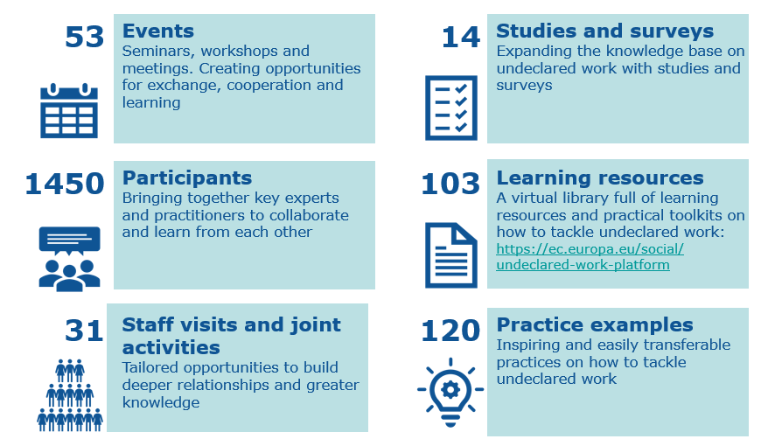

Most Platform members and observers (84%) share the opinion that the Platform made good or very good progress towards the achievement of its mission according to the 2019 survey[11]. Among the main activities contributing to this, are: seminars (84%), thematic review workshops (74%), working groups (68%), staff learning visits (45%).

## Cooperation and joint action

Between its start in 2016 and the end of 2019, the Platform organised **31 staff visits and joint activities** in 14 hosting countries, whereby travel and accommodation were covered through the contract supporting the Platform. They were used specifically to support joint inspections carried out in one country with participation of other national authorities (42%), mostly in the construction and agriculture sectors. Other types of visits (e.g. learning exchange, training, joint activities) helped members build a deeper knowledge on a topic, practice or process through first-hand and practical learning experience. They addressed in particular issues related to enforcement bodies' organisational structures; risk assessment, data mining and analysis; information systems, databases and online tools for information sharing; fraudulent posting of workers. Staff learning visits are considered by around half of respondents to the 2019 survey as one of the top five activities contributing to achieving the Platform’s objectives and mission.

|  |
| --- |
| **Supporting a joint inspection in the agricultural sector in Spain**  In July 2019, the Spanish Labour Inspectorate invited the Romanian Labour Inspectorate, along with the Spanish and Romanian police, to carry out joint inspections during the garlic harvesting season in Albacete, with operational support from the Platform. Interviews and inspections were carried out with Spanish employers, Spanish temporary employment agents, and Romanian intermediaries. More than 500 workers were identified and informed about their rights. Investigations are on-going, with four people arrested for human trafficking crimes and labour exploitation. |

**A total of seven working groups** brought together members of the Platform in a joint reflection on fundamental issues they face, giving them an active role in shaping Platform activities. The groups have developed a variety of practical outputs, such as a proposal for stepping up information exchange between national authorities through a potential **Internal Market Information System** module on undeclared work, as well as a glossary of terms and measures for tackling undeclared work.[12] Other working groups have developed the Platform’s work programme and responded to national and social partner priorities. Most Platform members (68%) consider working groups as one of the top five activities contributing to the Platform’s objectives and mission.

### **Mutual assistance projects (MAPs)** have been successfully delivered in Bulgaria, Cyprus, Greece, Latvia, Lithuania, Romania and Slovakia[13]. They have given members the opportunity to be counselled by a team of Platform experts in strategic areas of enforcement authorities. These projects often arose out of national priorities for structural reform, including those highlighted through the European Semester country-specific recommendations. An approach involving self-reflection, practical support from peers during two visits and the development of an action plan has helped to bring about significant changes, such as the design of new measures and enhanced cooperation between enforcement bodies. The 2019 survey indicated that this is one of the activities that contributed the most to fulfilling the Platform’s mission.

|  |
| --- |
| **Mutual assistance outcomes in Latvia**  Further to a 2017 Platform mutual assistance project visit in 2017, the Latvian State Labour Inspectorate revised its strategy on undeclared work, modernised strategic objectives and adopted new key performance indicators. The outcome has been a shift towards more emphasis on preventative measures. Focus is now on transforming undeclared work into declared work, with 74% of all identified cases of undeclared work now being transformed into declared work[14]. |

## Mutual learning

Mutual learning and the systematic exchange of information have been key to the Platform’s activities, contributing to improve the effectiveness of efforts to tackle undeclared work across the EU.

**Platform seminars** have explored pressing issues and emerging practices (e.g. prevention, holistic approaches to tackle undeclared work, awareness-raising), as well as key sectors affected by undeclared work (e.g. construction, agriculture, transport). The findings from these events were documented in learning resource papers which are publicly available on the Platform’s website[15].

Six **thematic review workshops** have supported members in improving their efficiency and stepping up cross-border cooperation, through more in-depth mutual learning and problem-solving (which include a follow-up visit and the production of a toolkit for practitioners). The selected themes included bilateral agreements and memorandums of understanding; data mining; risk assessment; outreach to workers and companies; cross-border concerted and joint actions, and the future role and competence profile of labour inspectorates. Platform seminars (84%) and thematic review workshops (74%) were frequently indicated as activities contributing the most to fulfilling the Platform’s mission in the 2019 survey.

|  |
| --- |
| **Sharing ideas and transforming effective practices in Greece**  The thematic review workshop on risk assessment that took place in Spain in 2018 inspired the Hellenic Labour Inspectorate (HLI) to refine its Risk Analysis Tool to improve detection of illegal employers. The HLI used this new risk assessment method to send notification letters to businesses potentially at risk. The announced inspections letters resulted in an increase of 31 % in the number of full-time contracts declared in the first month after the letter was sent. |

In addition, the **biannual plenary meetings allocated a thematic** day to discuss a particular area of undeclared work and potential successful policy approaches. These include priorities highlighted in the Decision establishing the Platform such as letterbox companies, data protection and data exchange.

## Increasing knowledge

Finding solutions to tackle undeclared work is complex, and expanding the knowledge-base on all its aspects contributes to the expertise of relevant actors on specific issues related to undeclared work. The Platform has produced **new knowledge** on specific types of undeclared work (e.g. envelope wages, undeclared work in the collaborative platform economy, bogus self-employment) as well as measures to prevent and deter them, with more than 100 learning resources and 120 fiches presenting good practices.

Overall, **14 studies and surveys** have been published, contributing to a more evidence-based approach. These have synthesised existing expertise and produced new knowledge on specific types of undeclared work, emerging trends and policy approaches. As per the priorities set out in the Decision, the focus of these studies has included bogus self-employment, under-declared employment, data protection and exchange of information, preventative approaches, cross-border cooperation, and documenting stories of social partners’ successful engagement. The studies and surveys produced by the Platform have harnessed collective experiences and know-how to put forward evidence-based solutions. However, only 32% of the Platform members place them among the top five activities contributing to the Platform’s objectives and mission. Translation was suggested as way forward to improve their usefulness.

|  |
| --- |
| **The scale of undeclared work**  The magnitude of undeclared work in Europe is difficult to estimate given that, by definition, it is hidden from view. As a first step, factsheets summarised the characteristics of undeclared work across all EU countries, and the institutions involved in addressing it[16]. A study on the scale of undeclared work across Europe was also produced in 2017. Based on the discrepancies between the reported labour inputs from workers and businesses, the study estimated that 9.3% of total labour input in the private sector in the EU is undeclared work, and that undeclared work constitutes 14.3% of gross value added (GVA) in the private sector.[17] However, there are marked differences in its size across Member States, ranging from 7% to 27% of GVA. |

## Communication activities

The Platform has developed evidence-based resources on how best to tackle undeclared work. Its **virtual library**[18] contains valuable information and practices generated by the Platform’s work. A biannual newsletter, sent out after the plenary meetings, provides an up-date to interested stakeholders on the Platform, activities and members. For internal communication, Platform members and observers share documents and announce events on their own collaborative workspace. On 2 March, the Platform launched #EU4FairWork, the first European campaign for declared work.

## Thematic scope of the Platform: building evidence on a wide range of issues

Over its first years of operations, the Platform has consolidated knowledge and built further evidence on a wide array of issues, ranging from policy approaches to strategic management and cross-border cooperation.

**Some key topics addressed through learning activities**

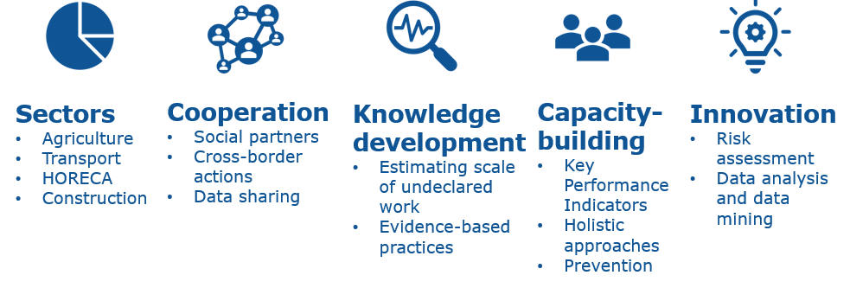

|  |
| --- |
| **Effective approaches: lessons learnt**  Key elements of successful approaches, highlighted in the first years of operation, include:  **Collaboration:** Responsibility for tackling undeclared work usually lies with multiple government departments, which can result in the lack of a coordinated approach. The extent to which Member States involve social partners is often limited to mutual exchange and consultation. A cross-agency strategic approach provides better access to data and information, helps develop mutual understanding, joint strategies and concrete actions.  **Focusing efforts and resources - risk assessment and data analysis:** Some Member States have developed risk assessment models, enabling enforcement authorities to highlight the riskiest cases of undeclared work. This approach targets resources effectively and improves the success rates of inspections. Using data more effectively is an essential part of risk assessment.  **Combining deterrent and preventative approaches:** There is a need to develop an approach which combines more effective controls and enforcement after undeclared work has occurred, with measures to prevent it from arising in the first place. Platform members are using a range of different preventative approaches including supply-side and demand-side incentives, awareness raising campaigns (aimed at employers, workers and the public) as well as reforming institutions to support this.  **Holistic approaches, using a range of measures in parallel:** Using both direct and indirect measures produces the most effective and efficient way to tackle undeclared work. A holistic approach is both strategic and coordinated, using a combination of direct (e.g. workplace inspections and peer-to-peer surveillance) and indirect (e.g. awareness raising campaigns and educational initiatives) approaches, to help transform undeclared work into declared work. |

According to the respondents to the 2019 survey, the Platform should in the future focus more on awareness raising and trust-building initiatives (65% of respondents), incentives to operate on a declared basis[19] (55%) and operations at the cross-border level (55%). Respondents do not see a need for major changes in activities. The focus still should be on events bringing members together to exchange practices in seminars (74%), thematic review workshops (65%), working groups (61%) and staff learning visits (52%). Sharing good practice fiches and success stories should be continued according to 48% of respondents.

# Progress achieved towards achieving the Platform's objectives

This section examines progress towards the Platform’s objectives under Article 4 of the Decision.

**Platform achievements: an overview**

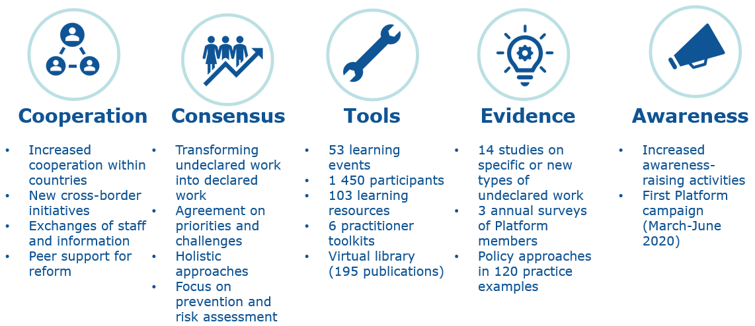

## Enhancing cooperation between Member States’ relevant authorities and other relevant actors in order to tackle undeclared work more efficiently and effectively

*Building a multi-faced network*

The Platform has brought together over 50 stakeholders into a unique network, in a context where responsibility for tackling undeclared work is typically spread across different bodies and social partner involvement, uneven. Prior to the Platform, instances of cooperation at EU level were few and mostly ad hoc (e.g. through the Senior Labour Inspectors Committee, the Expert Committee on Posting of Workers, and the Employment Committee, which do not primarily focus on combatting undeclared work), with little knowledge exchange and cooperation.

The Platform has **widened existing networks and strengthened cooperation** in tackling undeclared work, both within countries and across borders. Almost all respondents (94%) to the 2019 survey indicated that its activities contributed to widening their organizations’ networks and contacts. Most (68%) share the view that the Platform has also contributed to enhancing cooperation between Member States’ relevant authorities and other relevant actors.

Members and observers have been generally active, with all having taken part in activities. However, there have been varying levels of commitment and participation in the Platform between countries. The network is still maturing and there is much untapped potential for members and observers, including social partners, to fully engage, and better disseminate the learning to achieve wider buy-in and impact.

*Developing a consensus on effective policy approaches*

When the Platform initiated its work, Member States were at very different starting points in terms of the level and nature of their overall approach, organisational capacity and the extent to which undeclared work was perceived as a priority. The Platform has since **helped determine the fight against undeclared work as priority action and forge a consensus on effective policy approaches**. Through cooperation with peers and in particular Mutual Assistance, Platform members have received direct support in designing and delivering such approaches.

Members’ feedback suggests that the Platform has contributed, in particular, to the **development of a more holistic approach to tackling undeclared work**. Beyond a strong emphasis on information and awareness-raising, it has also encouraged a shift towards transforming undeclared into declared work through more effective deterrence approaches such as inspections and sanctions, underpinned by risk assessment and better data exchange. Platform members indicated that their country or organisation made or are planning to make changes (for instance in policy frameworks and implementation measures) as a result of involvement in Platform activities, in relation to: awareness raising and trust-building initiatives (52%), deterrence and detection measures (39%), operations at the cross-border level (32%), incentives to operate on a declared basis (23%), organisational models (16%) and wider structural reforms (16%).

However, in terms of approaches to fight undeclared work, the Platform’s emphasis has been primarily on tackling labour law violations, rather than tax and social security non-compliance, reflecting the composition of its membership. Besides, the limited evidence-base to build upon also hampered further progress in this area.

|  |
| --- |
| **Towards a more holistic approach**  Consensus amongst Platform members and observers has emerged that a ‘holistic approach’ is required to tackle undeclared work at the policy and operational level, using the full range of policy measures available and cooperation across key bodies and with social partners.  The 2019 Platform survey highlighted major improvements in this regard, with new national coordinating bodies set up in France, Lithuania and Romania and a national pilot in Finland[20], and more comprehensive range of measures and/or new strategies in France, Greece, and Latvia. |

## Improving the capacity of Member States’ relevant authorities and actors to tackle undeclared work with regard to cross-border aspects

Specific types of cross-border undeclared work, for instance by undeclared mobile EU workers or related to fraudulent posting of workers - including through letterbox companies ~~-~~ require broader and better cross-border cooperation. Cooperation channels currently typically range from information and staff exchange to joint inspections, underpinned by bilateral agreements and memorandums of understanding.

|  |
| --- |
| **Joint Nordic undeclared work project**  Supported by EU funding under the EU Programme for Employment and Social Innovation (EaSI), Denmark, Estonia, Finland, Iceland, Latvia, Norway and Sweden have joined forces to cooperate in a joint Nordic undeclared work project. The project focuses on joint inspections, sharing good practices (particularly on communication and preventative approaches) and evaluating results. It aims at better equipping the Nordic countries to tackle undeclared work through information sharing, collaboration, possibilities for assistance, and knowledge sharing. |

**The Platform has helped Member States step up partnerships in tackling cross-border undeclared work**, paving the way for further cooperation under the European Labour Authority. Thanks to increasing mutual trust and regular contacts, Members States have consolidated existing partnerships and engaged with new countries. Besides, the work programme has put an increasing focus on cross-border aspects and delivered tools supporting them improve their practices through studies (e.g. on cross-border cooperation), working groups (on data exchange) and thematic review workshops and toolkits (on bilateral agreements and memorandums of Understanding, Joint and Concerted Inspections).

However, the level of **engagement in cross-border cooperation remains uneven**. National authorities predominantly focus on ad hoc cooperation with neighbouring countries, responding to immediate challenges rather a strategic plan. Most labour inspectorates rarely engage in concerted and joint cross-border inspections (1-2 times annually)[21]. Cooperation in the context of the European Labour Authority, including with social partners’ organisations, could allow addressing some of these challenges and overcome the Platform’s limited operational capacity.

|  |
| --- |
| **Surge in cross-border collaboration and progress on improving capacity**  In the 2019 survey, 61% of respondents stated that the Platform contributed to improving the capacity of Member States' relevant actors to tackle undeclared work with regard to its cross-border aspects. Organisations undertook or plan to engage in cross-border activities in the next year, including: cross-border meetings of officials (52%), staff exchanges / joint actions (41%), joint inspections (39%). |

## Increasing public awareness of issues relating to undeclared work and encouraging Member States to step up their efforts

The Platform has contributed to a **stronger emphasis on awareness raising among its membership**, with half of the members reporting changes in this area. Work has focused primarily on encouraging members to share their learning on awareness-raising campaigns through specific activities (e.g. thematic review workshop and a toolkit[22], seminars on preventative approaches and dissemination of Platform activities).

However, **direct impact in increasing public awareness has been slower to develop**. Only 35% respondents to the 2019 survey agree the Platform made very good or good progress towards this objective. Recognising the need to translate this into action, the 2019-2020 work programme had a stronger focus on communication and awareness-raising. The first Platform campaign on the benefits of declared work, developed by members and observers, will run from March to June 2020. It will be underpinned by a week of action calling on members to join up their efforts.

# Conclusions

Since its start in 2016, the European Platform tackling undeclared work has facilitated greater cooperation between and across countries. Building on a strong governance, comprehensive work programme and active involvement of members, it has contributed to efficiency gains and the modernisation of enforcement bodies across the EU. It has produced solid evidence-based knowledge enabling Member States and social partners to learn from each other, innovate and act together.

As regards remaining challenges, the Platform’s activities have highlighted the need to enhance the commitment from all members and to increase the Platform’s operational capacity. Enforcement bodies and social partners need to continue to develop more effective cooperation, both at national level and cross-border, by further developing strategic and operational approaches towards tackling undeclared work. There is much potential for deepening mutual learning between Member State authorities and improving effectiveness of measures tackling undeclared work in particular through better data sharing, data analysis and risk assessment, as well as through better cross-border cooperation. In part, such improvements can be achieved by further developing EU-level information systems, which would be used not only for identifying high risk businesses for inspection purposes but also for better targeting preventative approaches. Further developing synergies with key EU initiatives and policies (for instance those related to the labour conditions of platform workers, the European Semester and the implementation of the European Pillar of Social Rights, exchange of information for tax purposes including employment income[23]) and funding instruments (such as the European Social Fund +) is also essential in this regard. It is important to further develop a comprehensive approach which combines efficient and effective deterrence measures with measures aimed at preventing undeclared work from occurring in the first place. Further emphasis can also be put in the future on education and awareness-raising with citizens, workers and employers about their rights, responsibilities and obligations. #EU4FairWork, the first Platform information and awareness-raising campaign, running between March and June 2020, is an important step in this direction, which will need to be built upon.

The cooperation of Member States within the European Labour Authority can build on the high levels of trust and well-established cooperation between Platform members and observers. This will provide a solid basis for better cross-border cooperation and capacity building in the initial phase of the ELA, which has a much broader mandate. The wider scope of ELA will compensate for the Platform’s more limited operational capacity and uneven involvement within its membership.

The Platform's 2019-2020 work programme will be implemented as planned, allowing for a smooth transition. Decision(EU) 2016/344 will be repealed once the ELA has reached full operational capacity, however the Platform’s current objectives, missions and activities have been largely confirmed in the Regulation establishing the ELA (Article 12 and Annex) [24]. Besides, the establishment of the ELA provides the opportunity for further change and addressing the challenges emerging from the Platform’s initial configuration.

The European Labour Authority will set priorities and propose how to address the challenges highlighted above in the long run. It can be envisaged that the Platform, as a permanent working group of ELA, focuses on its core task of tackling undeclared work while certain more horizontal tasks such as support to operational cross-border cooperation, capacity building in enforcement bodies and developing EU-wide tools can be more coherently addressed by wider ELA activities. The Platform will benefit from a comprehensive operational structure within ELA and from specialised staff expertise in different areas. Because of synergies with other ELA activities and a strong mandate to tackle undeclared work, the activities run by the Platform can be scaled up, refined, targeted and planned over a longer timeframe. The participation of ELA in the Platform campaign on the benefits of declared work in 2020[25] is a good example for the synergies and the alignment of EU-level initiatives to support fairness on the European labour market.

The establishment of the ELA will provide increased impetus to tackle undeclared work more effectively and transform it into declared work, contributing to fair working conditions, fair competition and fair mobility for the benefits of workers, the economy and society at large.

1. Commission Communication 'Stepping up the fight against undeclared work', COM(2007)628
2. Williams, C.C., Horodnic, I.A., Bejakovic,P., Mikulic. D.,Franic, J., Kedir, A. (2017) An evaluation of the scale of undeclared work in the European Union and its structural determinants: estimates using the Labour Input Method (LIM)
3. Special Eurobarometer survey 498, Undeclared Work in the EU, September 2019
4. Decision (EU) 2016/344 of the European Parliament and of the Council of 9 March 2016 on establishing a European Platform to enhance cooperation in tackling undeclared work
5. <https://ela.europa.eu/index.html>
6. Regulation (EU) 2019/1149 of the European Parliament and of the Council of 20 June 2019 establishing a European Labour Authority, amending Regulations (EC) No 883/2004, (EU) No 492/2011, and (EU) 2016/589 and repealing Decision (EU) 2016/344
7. Biennial report <https://ec.europa.eu/social/BlobServlet?docId=20472&langId=en>
8. Council Resolution on transforming undeclared work into regular Employment (2003/C 260/01) and European Commission Communication ‘Stepping up the fight against undeclared work’ (COM(2007)628)
9. The 2017-2018 and 2019-2020 Work Programmes can be found on the following links: <https://ec.europa.eu/social/BlobServlet?docId=22305&langId=en>, <https://ec.europa.eu/social/BlobServlet?docId=16358&langId=en>.
10. Figures cover activities up to the end of 2019
11. In total 31 Platform members and observers responded to the 2019 satisfaction and take-up survey, including 27 Platform members representing their Member State; as well as 1 observer and 3 social partner representatives
12. https://ec.europa.eu/social/main.jsp?catId=1323&langId=en Available on: <https://ec.europa.eu/social/main.jsp?catId=1323&langId=en>
13. Support to Belgium is planned in 2020
14. This can include for instance ensuring undeclared workers receive a formal labour agreement.
15. <https://ec.europa.eu/social/undeclared-work-platform>
16. <https://ec.europa.eu/social/main.jsp?catId=1322&langId=en>
17. Williams, C.C., Horodnic, I.A., Bejakovic,P., Mikulic. D., Franic, J., Kedir, A. (2017) An evaluation of the scale of undeclared work in the European Union and its structural determinants: estimates using the Labour Input Method (LIM), available on <http://ec.europa.eu/social/BlobServlet?docId=18799&langId=en>
18. <https://ec.europa.eu/social/undeclared-work-platform>
19. Such incentives cover a large range of measures including, for instance, advisory inspections, formalisation services and targeted VAT reduction in sectors at risk.
20. The national pilot on work-related crime included OSH, tax and police authorities to cooperate in a more strategic way in joint actions and cooperation projects.
21. Stefanov R., Mineva D., Terziev P. (2019). Cross-border actions tackling undeclared work. European Platform tackling undeclared work: Brussels
22. Information tools and approaches to reach out to employers and workers in the fight against undeclared work <https://ec.europa.eu/social/BlobServlet?docId=20864&langId=en>
23. Directive on Administrative Cooperation in the field of taxation, Council Directive 2011/16/EU of 15 February 2011
24. Regulation (EU) 2019/1149 of the European Parliament and of the Council of 20 June 2019 establishing a European Labour Authority, amending Regulations (EC) No 883/2004, (EU) No 492/2011, and (EU) 2016/589 and repealing Decision (EU) 2016/344
25. European Labour Authority, Work Programme 2020, <https://ela.europa.eu/documents/ELA_Work_Programme_2020.pdf>